Dissertation Training
at

MyHealthcare Technologies Pvt Ltd.

Employee Resistance in the implementation of Hospital Information Systems: Determining the causes and suggesting workable solutions

by

Dr. Yamini Panwar (PT)
Enroll No.- PG/23/129

Under the guidance of

Dr. Vinay Tripathi

PGDM (Hospital and Health Management)
2023-25



International Institute of Health Management Research New Delhi

Dissertation Training
at

MyHealthcare Technologies Pvt Ltd.

Employee Resistance in the implementation of Hospital Information Systems: Determining the causes and suggesting workable solutions

by

Dr. Yamini Panwar (PT)
Enroll No.- PG/23/129

Under the guidance of

Dr. Vinay Tripathi

PGDM (Hospital and Health Management)
2023-25

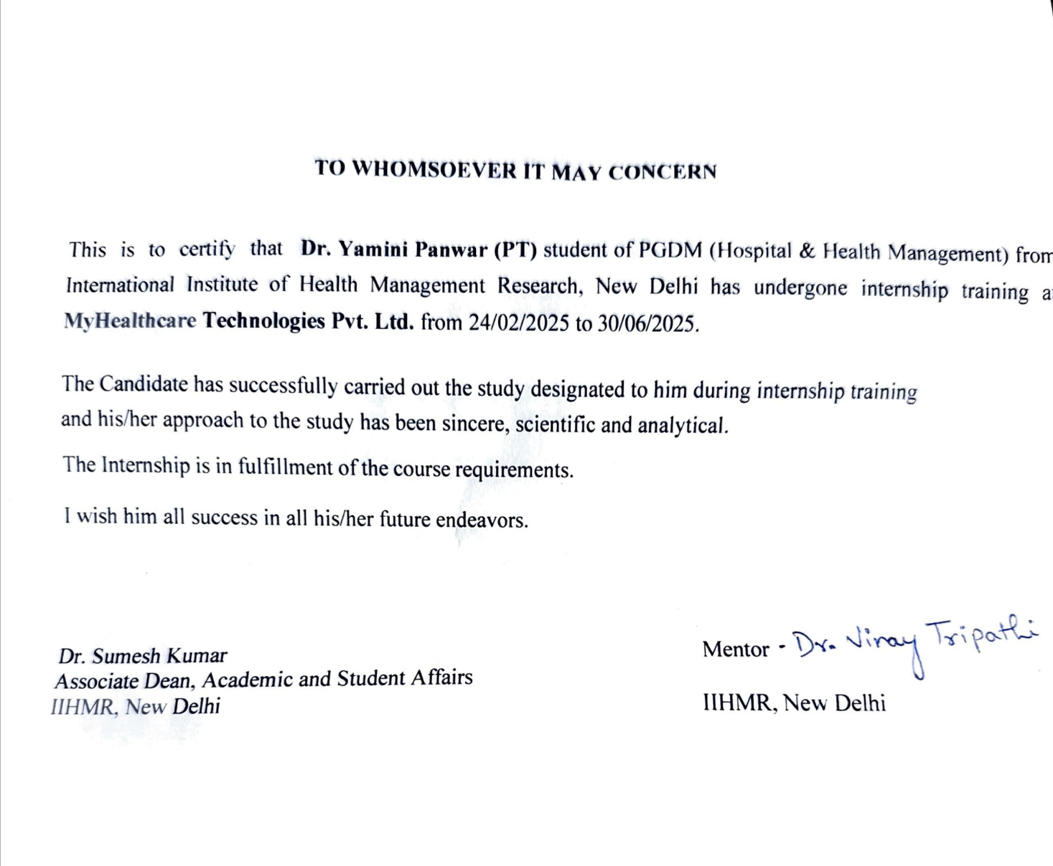

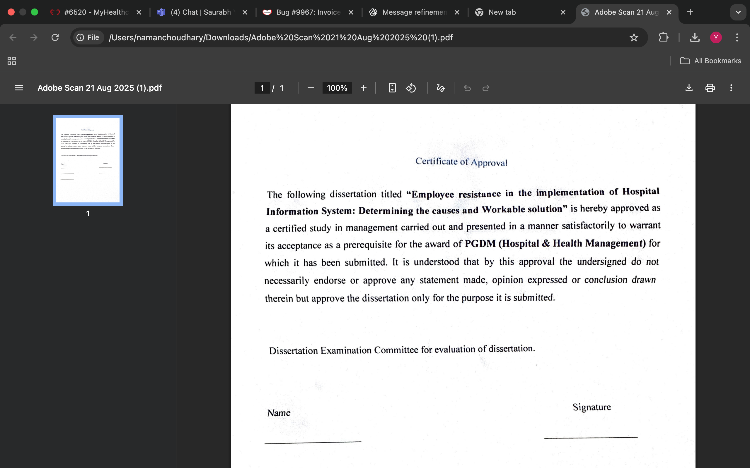

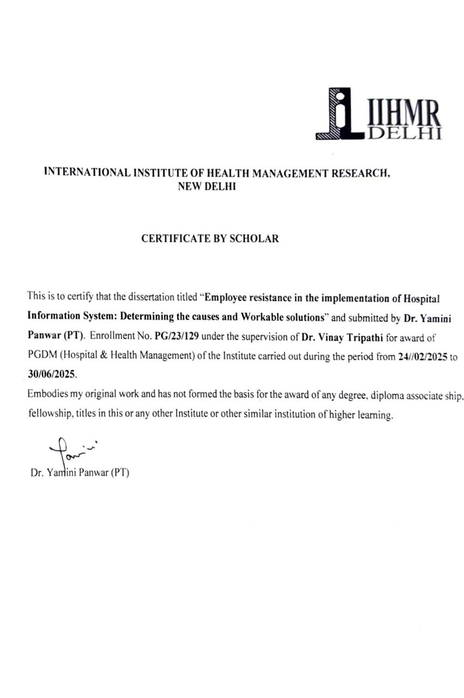






Acknowledgement:
This dissertation has been a rewarding journey of learning and professional development. I'm grateful for the opportunity to have conducted my research at MyHealthcare Technologies. The expertise and knowledge I gained from the professionals there have been incredibly valuable.
I want to sincerely thank IIHMR Delhi academics and team. My academic path has been greatly impacted by their commitment to creating a favorable learning atmosphere.
I would like to thank my mentor, Dr. Vinay Tripathi, without his advice, assistance and knowledge I would not have been able to complete this endeavor. I'm particularly thankful to Shyatto Raha, Divya Laroyia and Diwakar Bhowmik for their valuable insights. Their prompt aid, motivation and steadfast support greatly influenced the direction of my research.
I would also like to thank Saurabh Yadav for his active collaboration and mentoring
Finally, my appreciation goes to my colleagues and the entire staff at MyHealthcare
Technologies for their support. Their contribution significantly aided the success of this project.
Thank you to everyone who played a role in this journey.

Table of Contents:
S. No. |  | Components | Page No.
1 | Abbreviations |  | 11
2 | Scope of the Project |  | 12
3 | About the Industry |  | 13
4 | About the Organization |  | 15
5 | Project Title |  | 22
6 | Abstract |  | 22
7 | Introduction |  | 23
8 | Research Objective |  | 24
9 | Research Questions |  | 24
10 | Review of Literature |  | 26
11 | Methodology |  | 27
12 | Result |  | 28
13 | Conclusion |  | 30
14 | Limitations |  | 33
15 | Recommendations |  | 34
16 | References |  | 38

LIST OF ABBREVIATIONS
HMIS- Hospital Management Information System
OPD- Out-patient Department
IPD- In-patient Department
EMR- Electronic Medical Record
EHR-Electronic Health Record
CPOE- Computerized physician order entry
HIS- Hospital Information System
AI- Artificial Intelligence

Scope of the Project:
With a focus on both clinical and business settings, this dissertation explores the causes of staff opposition to the deployment of hospital information systems (HIS) in certain healthcare facilities. To attain an understanding about resistance factors, it involves physicians, nurses, administrative staff, and IT personnel. The study examines organizational, technical, and individual factors that affect acceptance, such as perceived job security threats, staff preparedness, communication, training, and workflow disruptions. It attempts to give hospital administrators practical suggestions to lessen resistance and enhance system adoption, even though it does not evaluate the technical architecture of HIS or vendor-side procedures

ABOUT THE INDUSTRY:
The Hospital Management Information System (HMIS) is a complete software program made to automate and simplify several clinical, financial, and administrative procedures in healthcare institutions. It acts as a single location to store and manage patient data, medical records, inventory, financial information, and other vital information pertaining to the healthcare facility.
HMIS is crucial to the healthcare industry because it boosts operational effectiveness, enhances patient care, and encourages improved decision-making. The following are some of HMIS's primary features and benefits:
- Patient Management: Health care providers may efficiently manage patient admissions, appointments, discharges, and registrations with the use of HMIS. Better care coordination and continuity are made possible by its easy access to patient information, medical histories, and diagnostic reports.

- HMIS eliminates the need for paper-based records by simplifying the creation, storing, and retrieval of electronic health records (EHRs). EHRs enable doctors to make well-informed treatment decisions by providing them with a comprehensive picture of a patient's health, including test results, prescriptions, allergies, and medical history.

- Financial Management: HMIS includes modules for managing insurance claims, billing, invoicing, and financial transactions. It helps healthcare businesses evaluate financial performance, streamline revenue cycles, and ensure correct billing and reimbursement procedures..

- Inventory Management: Effective management of pharmaceuticals, medical supplies, and equipment is made feasible by HMIS. By keeping an eye on inventory levels, automating reordering processes, and ensuring the timely availability of critical items, it reduces stockouts and costs.

- Reporting and Analytics: Financial performance, patient outcomes, resource utilization, and quality indicators are just a few of the healthcare operations subjects on which HMIS generates comprehensive reports and analytics. This data-driven approach improves overall efficacy and patient care by identifying trends and guiding informed decision-making.

Government Initiatives: To encourage the adoption of HMIS in all the nation's healthcare facilities, the Indian government has launched several initiatives. The government's flagship initiative, the National Health Mission (NHM), has been instrumental in promoting the use of HMIS in public healthcare facilities. States and union territories have been urged to adopt HMIS under NHM to enhance health information management and monitoring systems.

Adoption by the Private Sector: The Indian private healthcare industry has been actively integrating HMIS solutions into its facilities after realizing the advantages of this system. HMIS has been implemented by large corporate hospitals, multispecialty clinics, and diagnostic centres in order to improve patient care, streamline operations, and increase overall efficiency.

ABOUT THE ORGANIZATION:
Building an integrated, digital patient care ecosystem is the main goal of MyHealthcare Technologies, a digital health technology company. In order to develop a comprehensive healthcare platform focused on patient-centric care delivery, the company works with hospitals and clinics. Both in-person and virtual doctor consultations, home diagnostics, pharmacy services, home healthcare, remote patient monitoring, preventive health, immunization programs, and more are all included in the platform.

One of My Healthcare’s main objectives is to close the gap in healthcare delivery by utilizing the most recent developments in digital technology. In order to improve patient engagement and give people the ability to take charge of their own and their families' healthcare, the company wants to develop a data-driven care continuum process.

The idea of a structured repository of clinical data and medical history is central of MyHealthcare ecosystem. It provides a thorough overview of the patient's healthcare journey by integrating all interventions and services made available through the platform. Better care coordination and continuity are made possible by this method.

MyHealthcare, which has its headquarters in Gurgaon (Delhi NCR), also maintains technology centers in Dehradun and Bangalore. Additionally, the business has sales offices in several nations, including Singapore, Indonesia, Malaysia, Thailand, India, the Philippines, Vietnam, and Hong Kong.
A 360-degree clinical management system for physicians and nurses is part of MyHealthcare's digital healthcare ecosystem. This system includes several platforms, including electronic medical records (EMRs), practice management, and patient management. EMRs are available for a variety of specialties, such as pediatrics, cardiology, endocrinology, and general physician/internal medicine. There will soon be more EMRs available for specialties like neurology, ophthalmology, dentistry, oncology, and obstetrics and gynecology.
Clinicians, physicians, and nurses can use web and mobile platforms to manage patient care with MyHealthcare's cloud-based solution. It has an integrated virtual consultation platform that enables physicians to safely consult with patients via audio or video. The platform also makes it easier to review patient records and manage prescriptions remotely. The EMR ecosystem incorporates augmented intelligence and seven artificial intelligences to analyze a patient's medical history, map diagnoses to international standards like SNOMED CT and ICD10, and improve patient care management effectiveness.
MyHealthcare AI creates augmented intelligence modules using clinical data, treatment protocols, and big data produced by partner hospitals. These modules use data analytics and artificial intelligence to help diagnose conditions and provide comprehensive cure process protocols.
Fig.1:
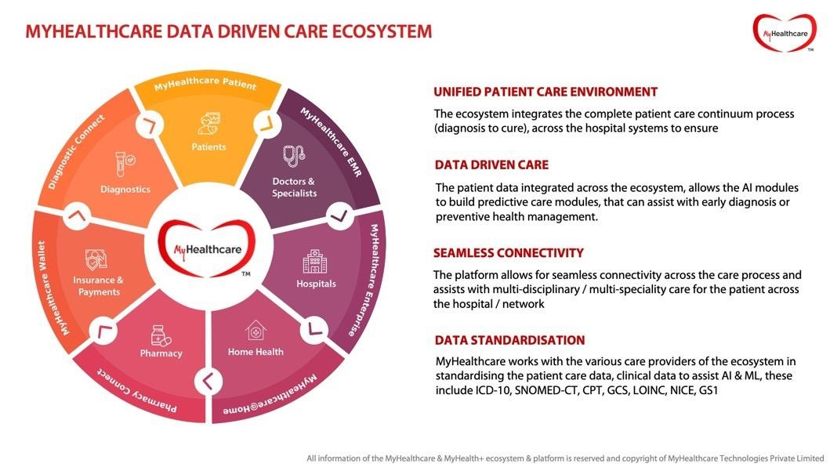
To create a connected care ecosystem, the MyHealthcare platform combines a number of essential platforms and functionalities. These consist of:
Patient Ecosystem (Web and Mobile): Patients can communicate with physicians, schedule online or in-person consultations, upload notes and documents, and get prescriptions after a consultation.
Hospital Portal: A platform that helps the hospital staff manage patient-related information and activities.
Electronic medical records (EMRs), and care of patient managed via physicians and nurses using web, mobile, and tablet platforms.
MyHealthcare@Home Command Centre is an online platform that facilitates centralized patient management and monitoring, including home isolation monitoring and remote patient monitoring.

Homecare nursing platform: Web and mobile platforms for managing homecare nursing services. Remote patient monitoring: Web and mobile platforms for monitoring patients remotely, including vital signs and health data.
Queue Management System (mobile): A mobile application to manage patient queues and appointments efficiently.
Experience Feedback System: A system to collect and analyze patient feedback to improve the healthcare experience.
Lead Management System (CRM)-web: An online platform for healthcare providers to manage leads and customer relationships 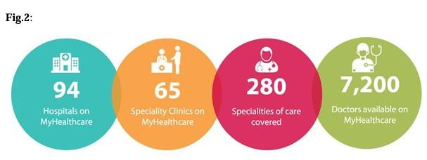

Through the MyHealthcare Patient Platform, patients from different areas can communicate with physicians, schedule in-person or virtual consultations, upload notes and documents, get prescriptions, and manage their medical needs. The platform facilitates remote patient monitoring, home isolation monitoring, home care, pharmacy services, and diagnostics at home.
High levels of security and encryption are guaranteed by MyHealthcare's virtual consultation platform. Patients can use the MyHealthcare patient mobile apps to access video consultations. Doctors can view the patient's entire medical history, pertinent test results, previous clinical history, and any documents the patient uploads in real time during virtual consultations.

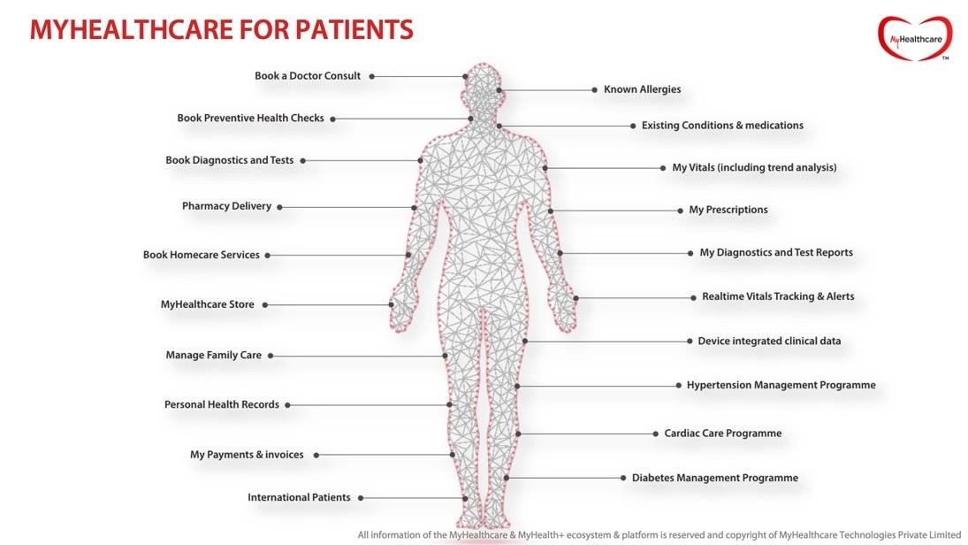
MYHEALTHCARE PATIENT APPLICATION
Patients and their families can manage their healthcare needs with the help of the MyHealthcare Patient Application, which is an integrated ecosystem. Patients can register, schedule consultations, schedule secure video consultations, store prescriptions and reports centrally, schedule diagnostic tests and health check-up packages, schedule homecare services, order from e-pharmacies, manage their profiles, register family members, pay online, use coupon codes for promotions, track bookings, upload documents, manage allergies and pre-existing conditions, manage patient history, manage personal health records (PHR), track vitals, integrate devices for monitoring, view family prescriptions, receive invoices, and participate in a loyalty and rewards program.
All things considered, the MyHealthcare platform provides a thorough and intuitive experience for patients to manage their medical records, obtain healthcare services, participate in remote monitoring and virtual consultations, and more.

TITLE:
Employee Resistance in the implementation of Hospital Information Systems: Determining the causes and suggesting workable solutions
Abstract:
Hospital information systems (HIS) are crucial for enhancing patient care, operational efficiency, and data management in healthcare institutions. However, employee opposition remains a significant barrier to their successful implementation, often leading to underutilization of technology, delays, and increased costs. This study aims to explore the root causes of this reluctance and provide practical, context-specific solutions to facilitate adoption. A comprehensive literature review process was used to collect pertinent papers published between 2005 and 2025 from databases like PubMed, ScienceDirect, Scopus, JSTOR, and Google Scholar.
The Staff attitudes, training programs, and user interface design are among the organizational, technological, and individual factors that influence the adoption of HIS that are the focus of the review. The project is expected to produce a comprehensive list of internal and external resistance factors as well as a framework of best practices for hospital administrators and policymakers. By addressing the human aspects of HIS installation, the study hopes to improve healthcare delivery results, increase staff engagement, and speed up system rollouts.

INTRODUCTION:
The rapid digitization of the healthcare sector has made hospital information systems (HIS) crucial for handling clinical and administrative data, streamlining operations, and enhancing patient care. Processes are streamlined, errors are reduced, and informed decision-making is encouraged by HIS. Even with these proven advantages, implementing HIS successfully in many healthcare organizations is still difficult, mostly due to resistance from the very staff members who are meant to use the systems.
Employee resistance can seriously hinder the implementation of HIS. This opposition can be attributed to a variety of factors, such as a lack of technical expertise, concerns about the system's effectiveness, a fear of an increased workload, or perceived threats to job security. This type of resistance can lead to underutilization of systems, disruptions in workflow, financial inefficiencies, and delays in achieving desired health outcomes. Therefore, optimizing the return on HIS investments requires overcoming these human and organizational barriers.
Examining the underlying causes of employee resistance to HIS deployment and providing practical, evidence-based solutions are the objectives of this dissertation. By examining organizational, technical, and individual-level issues, the study aims to provide healthcare managers and policymakers with useful insights that can enable more seamless technology changes. In the end, the study emphasizes how crucial it is to match human flexibility with technological advancement to guarantee that advancements in digital health result in noticeable enhancements in patient care ability to give accurate and timely access to patient information. HIS also helps to lower costs, boost productivity, and provide high-quality healthcare services.

Objectives:

To identify the key factors contributing to employee resistance during HIS implementation.
To assess the efficiency of current tactics for reducing employee resistance in the implementation of hospital information systems.

Research Questions:
What are the causes of employee resistance in HIS implementation?

What role do individual characteristics have in the adoption of HIS?

What is the impact of various training programs and continuous assistance on hospitals' adoption of HIS?

Review of Literature:
Significant gains in the effectiveness, precision, and quality of healthcare delivery are anticipated with the deployment of HIS. The successful deployment and use of these systems, however, may be hampered or even derailed by the workforce's frequent resistance to their implementation. Successful HIS implementation depends on identifying the reasons behind resistance and creating mitigation plans.

Source Authors (country) | Year | Methodology | Findings | Recommendations
Chinecherem Umezuruike, Wilson Nwanko, Margaret Kareyo (Nigera) | 2017 | Systematic secondary research as done; 150 published articles were analyzed | Insufficient facilities for information and communication technology with a knowledge gap and a shortage of qualified professionals  Opposition to Change | It is necessary to conduct a thorough evaluation of the healthcare delivery system's infrastructure at all levels. .
Winny Setyonugroho, Almira D Puspitarinin Yunita C Kirana, Muhammad Ardianysyah | 2020 | Secondary research | Insufficient instruction, inadequate IT assistance, and a shortage of electricity | The implementation of HIS should be carefully and comprehensively planned, taking into account data users, policy, and hardware-software aspects.
Ebrahimzadeh and Somayeh Ezhari Nikkar | 2014 | Cross sectional descriptive and analytic study | users' inability to comprehend how to operate the system. The system's usefulness is not demonstrated. The design process did not involve end users. lack of organizational training. | Careful planning and a large financial, time, and effort commitment are required before implementing a health information system.
Sandra hakiemafrizala  Putuwurihandayani  Bachmadnizarhidayantobtriseryandoam  eiwutabudiharsanaaevimartha | 2019 | Qualitative study | Lack of planning, project management, computer proficiency, and IT training, as well as resistance to change

Research Methodology:

A systematic review of the literature is used in this dissertation to support goals of the study. Electronic and educational databases, including Pub Med, Science Direct, Scopus, Jstor, Google Scholar, and the libraries of different universities, were used to search the literature. The following keywords were used: #Barcode, #factors impacting, #attitude affecting, #Barrier affecting, #evaluating affecting, #opinion affecting, #perception affecting, #resistance, and #acceptability.

Inclusion Criteria:
English-language research studies published between 2005 and 2025 that focus on the impact of HIS implementation and factors influencing healthcare staff acceptability (such as user interface design, training, and individual characteristics).
Only fully downloaded and accessible publications were included in the study.
Exclusion Criteria:
Excluded were research that did not directly connect to healthcare HIS, except from those that did not fit the time limit.
Research articles and chapters that have not been published in blind peer-reviewed journals or working papers were not included in the study.
The reviewed research papers were not included in the analysis.
Both duplicate and full-text references without abstracts were eliminated.

Data sources of literatures:
PubMed, National Library of Medicine, Google Scholar were the data sources where the key terms were searched.
Data Extraction:
From a few chosen studies, pertinent data will be extracted, such as sources of resistance and elements influencing acceptability theoretical frameworks and strategies.
Data Analysis:
Compare the results of various studies to identify commonalities and differences for future research and improvement. Additionally, ensure that the data analysis is logically organized, clear, and succinct.

Results:
The assessment of current methods for reducing employee resistance to the deployment of Hospital Information Systems (HIS) identified several interventions, their efficacy, and related difficulties.
1. Education and Training
1.1 Extensive Training Courses
Effectiveness: By demystifying technology, addressing concerns, and enhancing user confidence and competence, well-structured programs (Holden et al., 2012) dramatically lower resistance.
Challenges: Relevance and quality are crucial. Resistance may rise because of poorly planned or infrequent training. Maintaining system updates requires ongoing training.
1.2 Support and Training for Peers
Effectiveness: Peer trainers, also known as "super users," foster trust, offer helpful advice, and assist reluctant users in adjusting.
Challenges: Choosing qualified trainers and allocating enough time and resources are essential for effectiveness.
2. Effectiveness of Communication and Change Management: Positive attitudes, less uncertainty, and acceptance are all facilitated by clear and consistent leadership communication (Kotter, 1996).
Challenges: Inconsistent or ambiguous communication can cause resistance or confusion.

3. Effectiveness of End User Involvement in Planning and Execution: According to Kappelman et al. (2006), involving users in system design and testing boosts buy-in, satisfies practical requirements, and enhances usability.
Difficulties: Needs patience, sincere dedication, and juggling the priorities of various stakeholders.

4. Incentives and Reward Systems
Effectiveness: According to Bassi and McMurrer (2007), both monetary and non-monetary rewards boost compliance and lower resistance.
Problems: Relying too much on financial incentives could result in transient compliance rather than long-term involvement.

5. Effectiveness of Technical Support and Infrastructure: Good technical support reduces frustration, boosts user confidence, and quickly fixes problems (Boonstra & Broekhuis, 2010).
Challenges: Delays can erode user trust; access and support quality may differ.

6. User-Friendly System Architecture and Interface Efficiency: According to Davis (1989), intuitive designs increase acceptance rates and lower resistance.
Challenges: Creating user-friendly healthcare systems necessitates a lot of testing and striking a balance between functionality and simplicity.

7. Effectiveness of Leadership and Organizational Culture: Transformational leadership (Kotter, 1996) encourages change, lessens resistance, and cultivates an accepting culture.
Challenges: Poor leadership can sabotage change initiatives and impede stakeholder engagement

8. Fostering Creativity Culture Effectiveness: Fostering a culture of continuous experimentation and learning encourages receptivity to the adoption of HIS.
Challenges: Needs ongoing leadership support, resources, and effort to maintain.

Conclusion:

There are several managerial, technical, and human challenges associated with HIS implementation that call for specific solutions.
A significant challenge from the standpoint of human resources is the lack of skilled health IT specialists and the in-depth understanding necessary for efficient HIS implementation. Progress may also be further slowed by users' unwillingness to attend training sessions on time.
Healthcare organizations should hire personnel who can address problems at the operational level, conduct regular hands-on training sessions, and use notifications or reminders to ensure that training sessions are attended on time in order to address the obstacles . In terms of technological hurdles recurring needs and adequate software testing before deployment are common issues. These can be reduced by giving a thorough documentation top priority and putting automated testing techniques in place prior to system launch..
Examples of managerial problems include poor master data management, a lack of investment in automation in some healthcare settings, and delays in software execution. Promoting routine debugging techniques to ensure project completion on schedule, doing cost-benefit analyses to highlight the advantage of automation, and encouraging the exchange of master data throughout hospital departments are all essential to overcoming these challenges. Training offers a solid basis for upcoming improvements and ongoing system uptake.
In conclusion, evaluating the effectiveness of worker resistance mitigation strategies throughout the implementation of HIS demonstrates dependence of various strategies. To effectively handle the resistance, a coordinated integrated strategy that includes many interventions tailored to the needs of the healthcare institutions is required.
All-inclusive training courses: Training programs that are well designed are crucial for preparing healthcare practitioners to use HIS efficiently. These programs equip users with the knowledge and skills necessary to operate the system with assurance. If they are to be successful, they must be tailored to the responsibilities and needs of the employees and offer ongoing assistance to address emerging problems and user concerns.
Peer Training and Support: The HIS transition can be substantially aided by the use of peer training, in which seasoned “super users” assist their peers. This approach fosters a collaborative learning environment by addressing problems in a relatable manner and utilizing the authority and confidence of knowledgeable staff members. The effectiveness of this strategy hinges on selecting capable, motivated trainers and providing them with the time and tools necessary to support their peers.
Transparent Communication: Clear, consistent and transparent communication is essential for controlling expectations and coordinating stakeholders during HIS implementation process. Employee uncertainty can be reduced, and optimism increased by clearly conveying the system’s goals, benefits, and anticipated changes. The leadership should openly describe the system’s purpose, expected outcomes and available support. 1
Participation of end users: Including end users in the planning, design and implementation phases ensures that their demands are considered and that their requirements are fulfilled. Through enhancing user satisfaction and fostering a sense of ownership, this participative method enhances acceptability. However, for implementation to be successful, many viewpoints must be balanced, and recommendations must be deftly into the final system design.
Employees can be encouraged to use HIS by both monetary and non-monetary incentives. Monetary benefits like bonuses can promote immediate compliance, but non-monetary incentives like recognition and opportunities for career growth can inspire long term loyalty.
Strong Technical Help: Reliable technical help is crucial to promptly resolving issues during implementation. Friendly, responsive and informed support agents can prevent minor technical problems from developing worse, maintaining user confidence and happiness. Sufficiently resourced support functions minimize operational disruptions and ensure ongoing help.
Leadership Commitment and Organizational Culture: Strong leadership is essential to the successful deployment of HIS. Leaders that aggressively promote the system, explain its significance , and provide ongoing support have a big impact on worker acceptance.

Limitations:
A few limitations must be noted, even though this study offers insightful information about the difficulties and solutions for reducing workforce resistance in the deployment of hospital information systems (HIS).
First off, the conclusions are mostly predicated on documented difficulties—managing, technical, and human—that were found in the chosen healthcare environments. These difficulties might not accurately reflect the range of problems encountered by other organizations, especially those that function in environments with distinct legal requirements, financial limitations, or cultural norms. Consequently, the results' generalizability is restricted.
Second, the assessment of mitigation techniques, including thorough training, peer support, open communication, end-user participation, incentives, technical assistance, and leadership dedication, was mostly qualitative. The study is unable to conclusively evaluate the long-term efficacy of these interventions due to the lack of reliable quantitative measures or longitudinal tracking. Furthermore, the relationship between these tactics and particular organizational contexts was not thoroughly investigated, which may have an impact on the success or failure of implementation initiatives.
Thirdly, information about leadership influence and organizational culture was taken from secondary sources and stakeholder perceptions, which could be biased. The objectivity of reported results may have been impacted by participant roles, past technological experiences, or personal attitudes toward change, which could have affected responses.
Lastly, this study did not take into consideration outside variables that can have a big impact on HIS adoption and resistance management, like abrupt technological advancements, vendor-related delays, or changes in government policy. Although they are outside the purview of this study, these outside factors could have a significant impact on the results of actual implementation.
Recommendations:
The analysis of existing strategies and their observed effects leads to the following recommendations.
- Tailor Instruction to Particular User Requirements
The unique roles, duties, and skill levels of the different user groups within the hospital should be taken into consideration when designing training programs. Prior to creating focused training modules that offer real-world, hands-on experience with the HIS, a thorough needs assessment should be conducted to determine knowledge and skill gaps. Training should be scenario-based, interactive, and offered in a variety of formats to suit various schedules and learning styles, including online courses, in-person sessions, and on-the-job training. Over time, maintaining user competency will be facilitated by a tiered approach that includes introductory sessions, advanced workshops, and recurring refreshers.
- Create a Framework for Structured Peer Support
It is recommended that a structured peer mentoring program be established, in which seasoned "super users" offer advice and troubleshooting assistance to their peers. In addition to being carefully chosen for their knowledge, approachability, and credibility within their teams, peer supporters should also be given precise job descriptions, set-up times for interactions, and the tools they need to do their jobs well. To keep them involved, their efforts should be recognized and rewarded, and the success of the program should be evaluated on a regular basis based on input from mentees and mentors.
- Boost Your Communication Techniques
For effective implementation of HIS clear communication should be established. Key messages, deadlines, and channels of communication—such as intranet postings, town hall meetings, newsletters, and email updates—should all be outlined in this plan. An atmosphere where employees feel free to voice their concerns and questions should be actively promoted by the leadership. Building a feedback loop to gather employee opinions and responding quickly to problems found will increase acceptance and trust. Without overburdening them with information, communication should be customized to address the unique concerns of various staff categories.
- Involve End Users in System Design and Testing To make sure the system fits their real-world requirements and current workflows; end users should be actively involved from the very beginning of HIS implementation. To do this, user advisory committees comprising representatives from various departments can be established to help with workflow integration, system design, and functionality decisions. Before a full-scale rollout, conducting pilot runs or beta testing phases with specific user groups can assist in identifying and resolving potential issues. By incorporating user feedback into system improvements, resistance is decreased because it shows responsiveness and encourages ownership. Keep improving: Ask staff for feedback throughout the training and after they start using the new system. This will help identify areas where the training can be improved in the future.
- Put in place a well-rounded incentive program.
To promote adoption and ongoing involvement, a well-thought-out incentive structure that includes both monetary and non-monetary rewards should be implemented. Bonuses and allowances are examples of financial incentives, whereas opportunities for professional growth, career advancement, or public recognition are examples of non-monetary rewards. Staff input and quantified results should be used to inform periodic reviews of the program's fairness, relevance, and alignment with organizational goals.
- Improve the Infrastructure for Technical Support
Sustaining user confidence and guaranteeing continuous system use require a strong technical support system. Support staff should have the tools and training necessary to handle a variety of technical problems. There should be a variety of ways to get help, including specialized help desks, online chat services, and thorough user manuals. Prioritizing requests, tracking response times, and evaluating the efficacy of resolutions can all be facilitated by putting in place a ticketing and tracking system. Consistent evaluation of support performance data will enable ongoing enhancement.
- Encourage an innovative culture and strong leadership.
For HIS adoption to be successful, leadership commitment must be evident and consistent. Leaders’ ought to actively promote the system, explain its advantages, and set an example of positive attitudes toward its application. At the same time, it is important to foster an organizational culture that values experimentation, constant improvement, and adaptability to technological change. Staff attitudes can be greatly impacted, and a more seamless integration of HIS into daily operations can be encouraged, by educating and assisting leaders in change management techniques and by acknowledging and celebrating accomplishments.

Healthcare organizations can lower employee resistance, encourage user engagement, and guarantee the successful and long-term adoption of HIS by putting these suggestions into practice holistically. This will ultimately improve operational effectiveness and the standard of healthcare delivery.

References:
1. Al-Hazmi, S., Alshammari, F., & Househ, M. (2018). The impact of electronic health records on healthcare quality: A systematic review and meta-analysis. Journal of Medical Systems, 42(11), 226.
2. Lorenzi, N. M., Kouroubali, A., Detmer, D. E., & Bloomrosen, M. (2000). How to successfully select and implement electronic health records (EHR) in small ambulatory practice settings. BMC Medical Informatics and Decision Making, 5(1),
3. Hsiao, J. L., & Chen, R. F. (2016). Critical factors influencing physicians' intention to use computerized clinical practice guidelines: An integrative model of activity theory and the technology acceptance model. BMC Medical Informatics and Decision Making, 16(1),

4. Kukafka, R., Johnson, S. B., Linfante, A., & Allegrante, J. P. (2003). Grounding a new information technology implementation framework in behavioral science: A systematic analysis of the literature on IT use. Journal of Biomedical Informatics, 36(3), 218-227.
5. Ludwick DA, Doucette J. Adopting electronic medical records in primary care: lessons learned from health information systems implementation experience in seven countries.
Int J Med Inform. 2009;78(1):22-31.
6. Buntin MB, Burke MF, Hoaglin MC, Blumenthal D. The benefits of health information technology: a review of the recent literature shows predominantly positive results. Health Aff (Millwood). 2011;30(3):464-471.
7. Hung SY, Chen C, Wang KH. Critical success factors for the implementation of integrated healthcare information systems projects: an organizational fit perspective.
Commun Assoc Inf Syst. 2014;34:775-794.
8. Jha AK, DesRoches CM, Campbell EG, Donelan K, Rao SR, Ferris TG, Shields A, Rosenbaum S, Blumenthal D. Use of electronic health records in U.S. hospitals. N Engl J Med. 2009;360(16):1628-1638.
9. Venkatesh V, Sykes TA, Zhang X. 'Just what the doctor ordered': a revised UTAUT for EMR system adoption and use by doctors. In: Proceedings of the 2011 44th Hawaii International Conference on System Sciences; 2011. p. 1-10.\
10. Adler-Milstein J, Jha AK. No evidence found that hospitals are using new electronic health records to increase Medicare reimbursements. Health Aff (Millwood).
2017;36(3):484-490.
11. Furukawa MF, King J, Patel V, Hsiao CJ, Adler-Milstein J, Jha AK. Despite substantial progress in EHR adoption, health information exchange and patient engagement remain low in office settings. Health Aff (Millwood). 2013;32(8):1368-1375.
12. Bates DW, Leape LL, Cullen DJ, Laird N, Petersen LA, Teich JM, Burdick E, Hickey
M, Kleefield S, Shea B, Vander Vliet M, Seger DL. Effect of computerized physician order entry and a team intervention on prevention of serious medication errors. JAMA.
2003;280(15):1311-1316.
13. Chaudhry B, Wang J, Wu S, Maglione M, Mojica W, Roth E, Morton SC, Shekelle PG.
Systematic review: impact of health information technology on quality, efficiency, and costs of medical care. Ann Intern Med. 2006;144(10):742-752.
14. Gans D, Kralewski J, Hammons T, Dowd B. Medical groups' adoption of electronic health records and information systems. Health Aff (Millwood). 2005;24(5): 1323-1333.
15. Menachemi N, Chukmaitov A, Saunders C, Brooks RG. Hospital quality of care: does information technology matter? The relationship between information technology adoption and quality of care. Health Care Manage Rev. 2008;33(1):51-59.
16. Lapointe L, Rivard S. A multilevel model of resistance to information technology implementation. MIS Q. 2005;29(3):461-491.
17. Greenhalgh T, Stramer K, Bratan T, Byrne E, Mohammad Y, Russell J. Adoption and non-adoption of a shared electronic summary record in England: a mixed-method case
study. BMJ. 2009;338
18. Jha AK, DesRoches CM, Campbell EG, Donelan K, Rao SR, Ferris TG, Shields A, Rosenbaum S, Blumenthal D. Use of electronic health records in U.S. hospitals. N Engl J
Med. 2009;360(16):1628-1638.
19. Blumenthal D. Wiring the health system--origins and provisions of a new federal
20. Gagnon MP, Ghandour EK, Talla PK, Simonyan D, Godin G, Labrecque M, Ouimet M, Rousseau M. Electronic health record acceptance by physicians: testing an integrated theoretical model. J Biomed Inform. 2012;45(4):727-736

