Dissertation on

Pilot Study on Cardiovascular Health Status among Corporate Employees

Dr Monica Chettri PT
PG/23/066

Under the guidance of Mentor – Dr Sukesh Bhardwaj, Assistant Professor



International Institute of Health Management Research
New Delhi

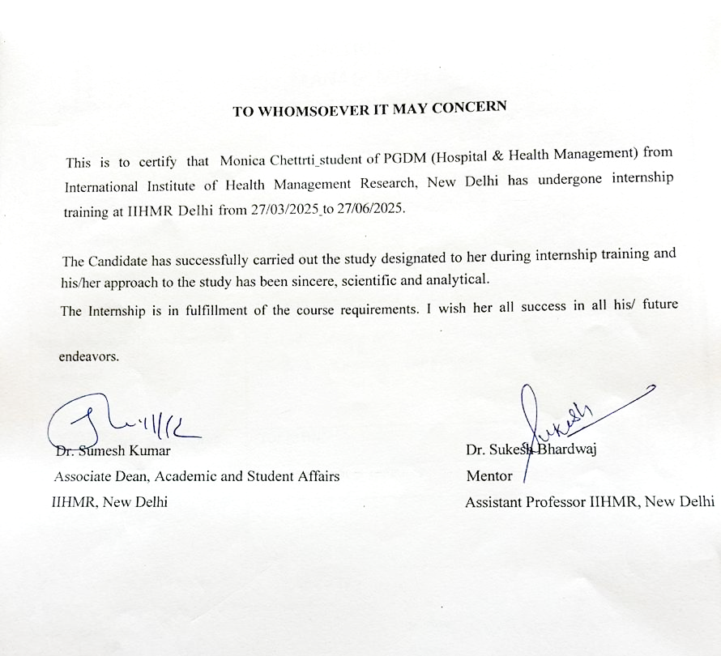
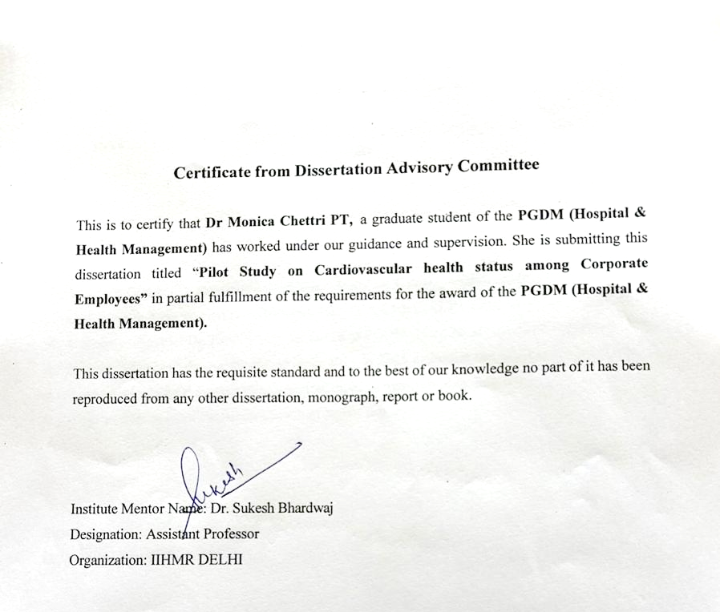

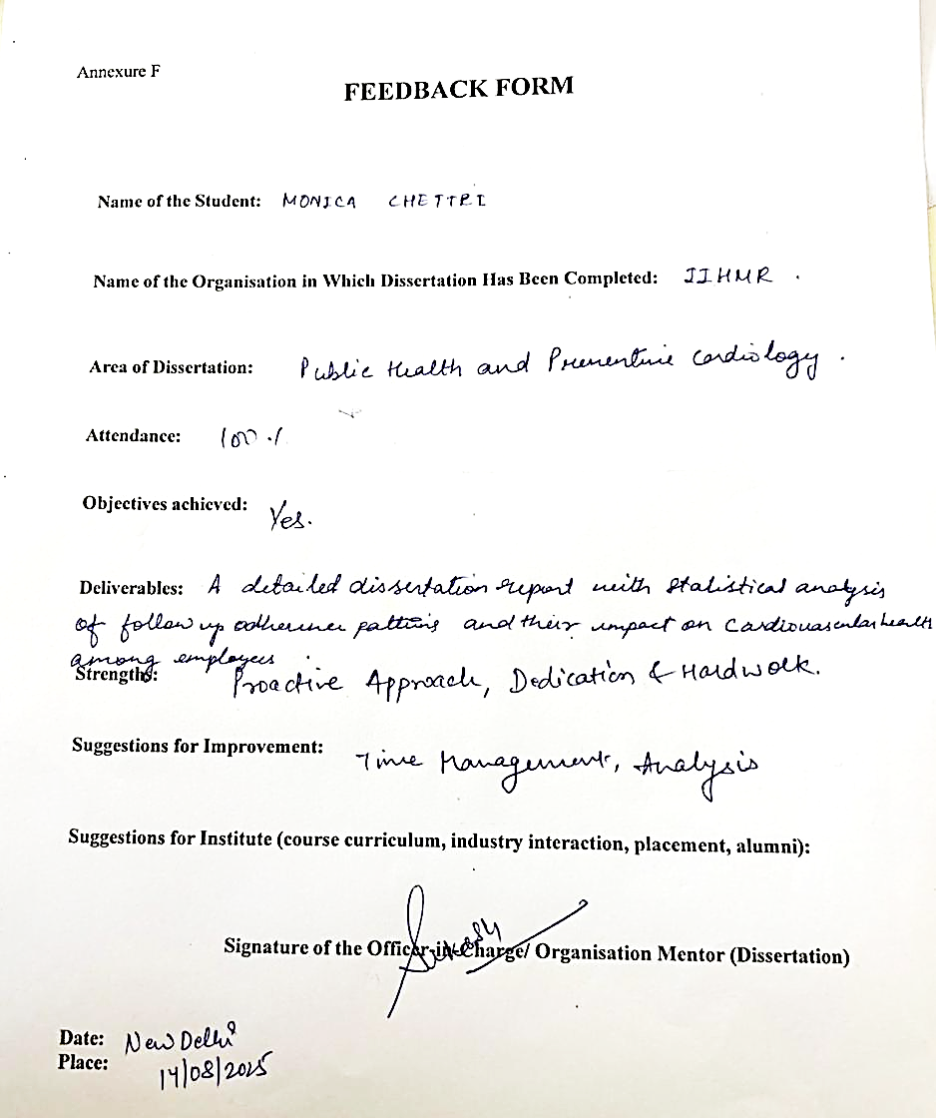

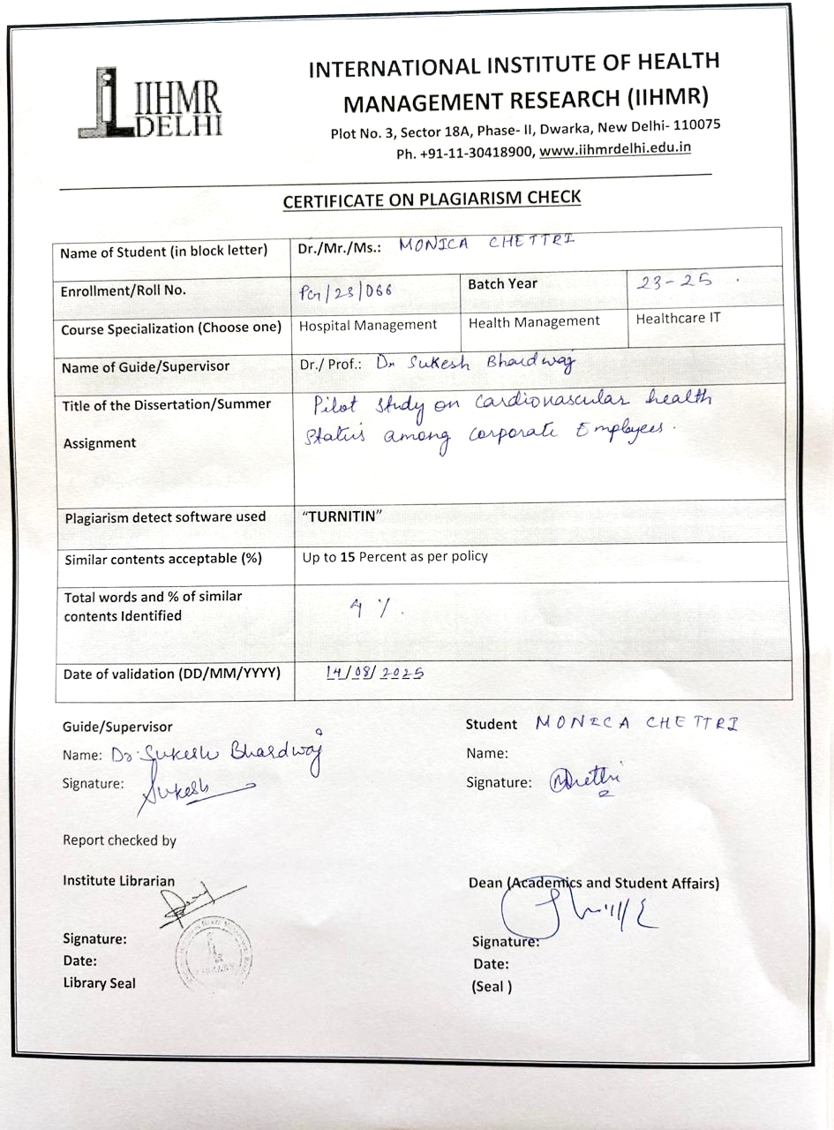

Certificate of Approval

The following dissertation, titled "Pilot Study on Cardiovascular Health Status among Corporate Employees" is hereby approved as a certified study in management carried out and presented in a satisfactory manner satisfactorily to warrant its acceptance as a prerequisite for the award of PGDM (Hospital & Health Management) for which it has been submitted.

It is understood that by this approval, the undersigned do not necessarily endorse or approve any statement made, opinion expressed, or conclusion drawn there in, but approves the dissertation only for the purpose it is submitted.



Acknowledgement
I am very grateful to Dr. Sukesh Bhardwaj, an academic mentor of me at the Indian Institute of Health Management Research (IIHMR), Delhi, who has been critical in guiding, providing timely feedback, and encouragement throughout this journey to conceptualize and complete this work. To improve the design of the study, the methodology and analysis of the study, his academic point of view and critical evaluation are essential. I am also greatly indebted to the faculty and administrative staff of IIHMR Delhi who helped in making the academics conducive and helped me with the institutional procedures to allow data collection and processing. I would like to thank all respondents who readily took part in the survey. I particularly appreciate the time and thoughtful answers of all the participants, and I appreciate their trust in disclosing personal information; the information was crucial to this study, and it will aid the successful changes in workplace health programmes. Lastly, I would like to express sincere gratitude to my family and friends who have always been very patient and supportive of me and proved to be my source of constant motivation. Their faith in me kept me going through the hardest stages of work and the process of research and writing. The errors and omissions, which are still there are my sole responsibility.

Contents
Abstract 10
Abbreviations 12
Chapter 1: Introduction 14
1.1 Background of the study 14
1.1.1 Global Burden of Cardiovascular Disease 14
1.1.2 Cardiovascular Diseases in India: A Growing Concern 15
1.1.3 The Corporate Workforce: A Vulnerable Population 17
1.1.4 Healthcare Utilization and Follow-up Adherence 18
1.2 Problem Statement 19
1.3 Rationale for the Current Study 20
1.3.1 The Follow-Up Adherence Crisis in Corporate Settings 20
1.3.2 Occupational Determinants of Follow-Up Non-Adherence 20
1.3.3 Consequences of Poor Follow-Up Patterns on Cardiovascular Health 21
1.3.4 Evidence Base for Follow-Up Adherence Research 21
1.3.5 Follow-Up Monitoring as Preventive Health Strategy 21
1.3.6 Critical Importance of Corporate Sector Focus 21
1.3.7 Literature Gap in Corporate Employee Follow-Up Patterns 22
1.3.8 Digital Health Solutions and Workplace Policy Interventions 22
1.3.9 What This Study Brings to the Table 22
1.4 Research Objectives 23
1.4.1 Primary Objective 23
1.4.2 Secondary Objectives 23
1.5 Research Questions 23
1.5.1 Primary Research Question 23
1.5.2 Secondary Research Question 23
1.5.3 Research Question Framework and Methodological Alignment 24
1.6 Scope and Limitations 24
1.6.1 Scope of the Study 24
1.6.2 Limitations of the Study 27
1.7 Operational Definitions 28
Chapter 2: Literature Review 32
2.1 Cardiovascular disease: Global and Indian Perspective 32
2.2.1Epidemiological Trends 32
2.1.2 Economic Burden 33
2.2 Workplace Stress and Cardiovascular Health 34
2.2.1 Job Demand-Control Model 34
2.2.2 Effort-Reward Imbalance Theory 34
2.2.3 Evidence from Corporate Settings 35
2.3 Lifestyle Factors in CVD Development 36
2.3.1 Physical Activity Patterns 36
2.3.2 Sleep Quality and Duration 36
2.3.3 Dietary Behaviors 36
2.3.4 Substance Use Patterns 37
2.4 Healthcare-Seeking Behavior in Corporate Settings 37
2.4.1 Barriers to Healthcare Access 37
2.4.2 Follow-up Adherence Patterns 38
2.4.3 Role of Workplace Wellness Programs 38
2.5 Digital Health Technology 39
2.5.1 Mobile Health Applications 39
2.5.2 Barriers and facilitators to Adopt 40
2.5.3 Effectiveness in CVD Management 40
2.6 Theoretical Framework 41
2.7 Research Gaps Identified 42
Chapter 3. Methodology 43
3.1 Study Design 43
3.2 Study Setting 43
3.2.1 Study Setting 43
3.2.2 Study Duration 44
3.3 Study Population 44
3.3.1 Target Population 44
3.3.2 Inclusion Criteria 44
3.3.3 Exclusion Criteria 44
3.4 Calculation of sample size 45
3.5 Sampling Method 45
Lifestyle Habits: 45
3.6 Data Collection Procedure 46
3.7 Study Variables 46
3.7.1 Dependent Variable: Follow-up Adherence 46
3.7.2 Independent Variables 46
3.8 Data Analysis 47
Chapter 4: Results 49
Chapter 5: Discussion 55
5.1 Principal Findings 55
5.2 Comparison with Previous Studies 56
5.2.1 Follow‑up adherence rates 57
5.2.2 Demographic risk factors 57
5.2.3 Lifestyle associations 57
5.3 Interpretation of Key Findings 57
5.3.1 The counterintuitive physical‑activity finding 57
5.3.2 Memory‑related barriers dominate the miss pattern 58
5.3.3 Digital health opportunity gap 58
5.4 Clinical and Public Health Implications 59
5.6 Future Research Directions 60
Chapter 6: Conclusion 62
6.1 Summary of Findings 62
6.2 Conclusions 64
6.3 Recommendations 65
6.3.1 Individuals Healthcare Providers 66
6.3.2 To Corporate Organizations 66
6.3.3 Policymakers and regulators 67
References 68
Section 1: Informed consent 72
Section 2: Demographics 72
Section 3: Family History 73
Section 4: Physical Activity 73
Section 5: Sleep Quality 73
Section 6: Diet Quality 74
Section 7: Smoking / Alcohol/ tobacco 74
Section 8: Cardiovascular Indicators 74
1. Do you go for annual or regular health check-ups? ☑ Yes ☑ No 75
Section 9: Digital Health Support / Work Health Support 76

Abstract
Background: Cardiovascular diseases (CVDs) continue to be a major cause of morbidity and mortality and simultaneously, timely follow-up care of these patients is essential in managing the risks. Corporate workers, who are at risk of high work related stress, sedentary lifestyles, may display peculiar follow-up adherence behaviour, which affects cardiovascular health outcomes.
Objectives: The research question was to determine the outcomes and trends in following up on a prescribed assessment schedule among corporate employees with cardiovascular risk factors, and to determine any relationship between pattern of follow-up behaviour and the cardiovascular health status.
Approaches: Cross-sectional observational research was done on 110 corporate employees aged between 25 years and 45 years who had previously gone through screening of cardiovascular risks. The data were gathered with the help of a structured survey operationalized with demographics, lifestyle practices, barriers to follow-up, and the uptake of digital health data. The adherence of follow-up was an assessment of the completion of all medical reviews recommended in the previous 12 months. Adherence patterns were measured through descriptive statistics and association between adherence and predictors (key predictors) were stressed through inferential analysis.
Results: The researchers reported that 51.8 percent of the study participants had missed or delayed at least one recommended follow-up whereas 48.2 percent strictly met their follow-up criteria. The most reported reasons of missing the follow-up visits were lack of time due to work, forgetfulness and perceived health recovery. An initial data examination indicated that increased physical activity level, female gender and increased work experience were correlated with higher adherence whereas having long working hours and poor engagement with digital health were correlated with follow-up non-adherence.
Conclusions: The results indicate a significant deficiency in the quality of follow-up in the population of corporate employees having cardiovascular risk factors, which emphasizes the necessity of health intervention in workplaces, the specific patient education, and embedding digital alerts. The decrease of CVD incidents in this cohort is one of the possible effects that the reduction of behavioural and occupational barriers to care might have.
Keywords: cardiovascular health, adherence to follow-up, corporate workers, observation study, preventive medicine, workers health

Abbreviations

Term | Definition
CVD | Cardiovascular Disease(s) a category of disorders associated with the heart and blood vessels, consisting of coronary artery disease, stroke and heart failure, which was the main center of health condition analysis in the report.
WHO | World Health Organization Global public health authority; provider of information on epidemiology of CVD mortality and prevalence.
PA | Physical Activity Any muscular movement of the body which involves skeletal muscles that necessitates energy use; monitored in minutes/week throughout the study in order to quantify the lifestyle influence on compliance.
SD | Standard Deviation Statistically determined type of variability used to explain the spread in PA mins, sleep score etc.
CI | Confidence Intervals The limits that the actual population parameter will be assumed to fall in, which this is reported with at 95 percent certainty that it is accurate with regard to the real prevalence of non-adherence, and mean variations.
OR | Odds ratio The statistical ratio of the probability of occurrence of something, based on a factor. Values less than 1 show lesser odds.
RR | Risk Ratio It compares the likelihood of an event in two groups.
Chi-Square | Chi-Square Statistical test to determine association between categorical variables
Cohen's d | Cohen's d Effect Size A standardised measure of the magnitude of the difference between two means; reported here as a practical interpretation of the effect in the study beyond p-values.
p-value | Probability Value Statistical measure of significance; the probability the differences observed are due to chance.
n | The number of participants (sample size) The sample size is a term that indicates how many people belong to a specific category in the data (e.g. n = 110 in total).
≥ | Large than or equal to, Part of thresholds e.g. 150 minutes/week PA = or greater than.
< | Less than Employed in statistical and health guidelines during cut-offs, e.g., <7 hours sleep.
Mobile Application | Application in this study is health/wellness software tools
EAP | Employee Assistance Program Support program that is provided by the company, described in workplace interventions in health adherence motivation.

Chapter 1: Introduction

1.1 Background of the study

1.1.1 Global Burden of Cardiovascular Disease
Cardiovascular diseases (CVDs) are, without question, the biggest health threat of our time — the number one killer worldwide (WHO, 2022). Covering a wide spectrum of conditions affecting the heart and blood vessels — from coronary heart disease and stroke to peripheral artery disease and heart failure — CVDs don’t just impact personal health, they place an enormous strain on healthcare systems and economies across the globe (Global Burden of Disease Collaborative Network, 2020).

Worldwide Prevalence and Mortality Trends
The scale of the problem has shifted dramatically over the last three decades. CVD deaths have jumped from 12.1 million in 1990 to 20.5 million in 2021 — a 69% rise (World Heart Federation, 2023). Today, over half a billion people live with some form of cardiovascular disease, with prevalence climbing from 271 million in 1990 to 523 million in 2019 (Roth et al., 2020). In 2022 alone, CVD claimed 19.8 million lives — that’s roughly 32% of all deaths worldwide (WHO, 2022).
Now, there’s a twist: while absolute numbers have shot up, the age-standardized death rate has dropped — from 354.5 per 100,000 in 1990 to 239.9 per 100,000 in 2019 (Global Burden of Disease Study, 2019). But the pace of improvement has slowed in recent years, and in some regions, progress has stalled completely (Mensah et al., 2019). Ischemic heart disease remains the single largest culprit, causing 9.1 million deaths in 2019, followed closely by stroke at 6.6 million (Xavier et al., 2018).

Regional Disparities and Economic Burden
The burden isn’t evenly spread. Around 80% of CVD deaths occur in low- and middle-income countries, where access to prevention and treatment is far more limited (Prabhakaran et al., 2016). High-income countries have made remarkable strides, bringing death rates down to 128 per 100,000, compared to a staggering 435 per 100,000 in Central and Eastern Europe (Global Burden of Disease Study, 2019).

The cost? More than $900 billion globally each year, and rising (Bloom et al., 2012). For lower-income countries, the financial hit is especially devastating relative to their economic capacity (Watkins et al., 2018). In fact, conservative estimates suggest at least 21 million years of productive life are lost annually to CVD in major developing nations (Abegunde et al., 2007).

Major Risk Factors and Their Distribution
High blood pressure tops the list of modifiable risk factors, linked to 10.8 million CVD deaths worldwide (Global Burden of Disease Study, 2019). Elevated LDL cholesterol (3.8 million deaths), ambient air pollution (4.8 million), tobacco use (3.0 million), and high BMI (2.0 million) follow closely behind (Murray et al., 2020). Patterns vary by region — for instance, sodium intake consistently exceeds recommended limits globally, and obesity rates have reached alarming levels in several countries (Powles et al., 2013).

1.1.2 Cardiovascular Diseases in India: A Growing Concern
India’s situation is particularly pressing. As the world’s most populous country, its CVD trends have global implications (Prabhakaran et al., 2016). CVDs now account for 26.6% of all deaths here — up from 15.2% in 1990 (Xavier et al., 2018).
The age-standardized CVD mortality rate in India is 272 per 100,000 — higher than the global average of 235 (Global Burden of Disease Study, 2019). That’s about 2.9 million cardiovascular deaths each year. And while the rate per 100,000 has remained relatively steady, the absolute number of deaths has surged by 123% between 1990 and 2021 (Xavier et al., 2018). 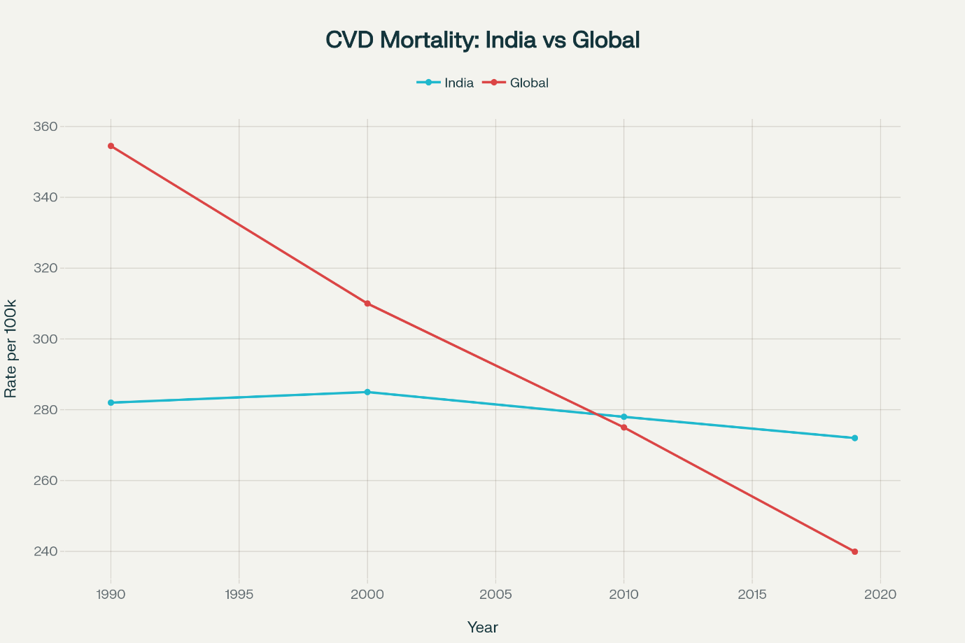
Age-standardized CVD mortality rates: India vs Global average, 1990-2019
In India, people face heart problems a lot earlier than in the West—about a decade sooner. Half of all heart attacks in Indian men happen before age 50 (Prabhakaran et al., 2016). For women, the situation is just as bad: heart disease is the number one cause of death, taking 18% of all female lives (Xavier et al., 2018).
Urban-Rural and Regional Disparities in India
The patterns aren’t the same everywhere. City dwellers have higher rates of diabetes (12% vs 8% in rural areas) and obesity (33.2% vs 19.5%). But rural areas are catching up fast in CVD rates—without the hospitals and doctors to handle it (Xavier et al., 2018). Down south—Tamil Nadu, Kerala, Andhra Pradesh—CVD deaths are highest, while in the northeast, strokes top the charts (Xavier et al., 2018).
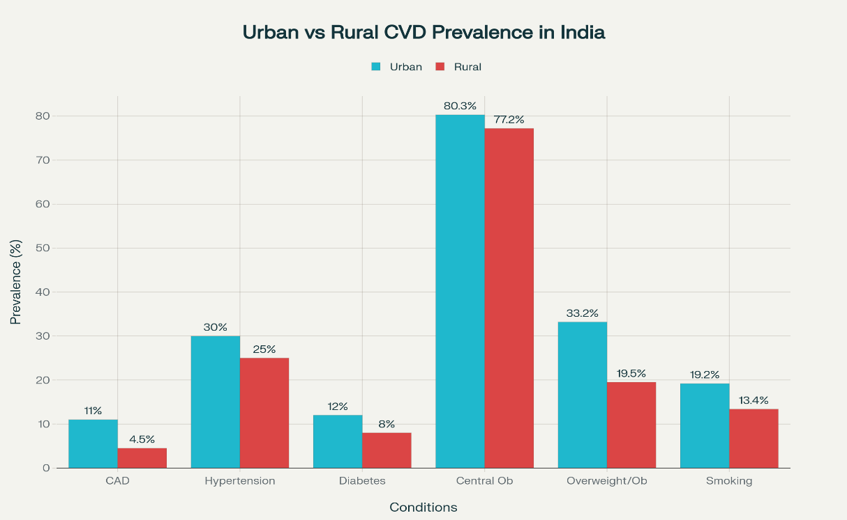
Urban vs Rural CVD risk factor prevalence in India (%)
Economic Impact in India
Between 2012 and 2030, CVD is projected to cost India around $2.17 trillion—not just in hospital bills, but in lost productivity (Prabhakaran et al., 2016). The problem is made worse by poor access to preventive care, late diagnoses, overburdened treatment facilities, and high out-of-pocket costs (Xavier et al., 2018).
Looking Ahead
By 2050, cardiovascular cases could jump 90% and crude mortality by 73.4%, meaning 35.6 million deaths compared to 20.5 million in 2025 (Chong et al., 2024). The silver lining: age-standardized mortality rates are improving, which means prevention and treatment are working—at least somewhat (Global Burden of Disease Study, 2019).
Globally, this is both a crisis and a chance to turn things around. The tools to make progress already exist (WHO, 2017), but success will take political will, funding, and cross-sector action—especially in vulnerable groups like corporate employees in fast-growing economies (Prabhakaran et al., 2016).

1.1.3 The Corporate Workforce: A Vulnerable Population
Corporate jobs are a breeding ground for heart risks—stress, long hours, bad diets, little exercise, and not enough preventive care (American Heart Association, 2024; Ogunmoroti et al., 2024).

Occupational Stressors and Cardiovascular Risk
White-collar stress isn’t just “in your head”—it’s in your heart. People in high-stress corporate roles face a 97% higher risk of atrial fibrillation (AFib) compared to low-stress workers. Even looking at it separately, high job strain = +83% AFib risk, effort–reward imbalance = +44% (Trudel et al., 2024).
A 2023 survey found 77% of workers stressed corporates get hit hardest (Clinical Trials Arena, 2024). Stress hormones like cortisol and adrenaline keep blood pressure up, tighten arteries, and put the heart under constant load (Times of India, 2024).

Sedentary Work Environment and Physical Inactivity
Office life = sitting life. Over 23 hours a week sitting? That’s a 37% higher risk of dying from CVD. Add 10+ hours weekly commuting in a car, and the risk of CVD death jumps 82% for men (PMC, 2010; Warren et al., 2010).

CVD risk factor prevalence among corporate employees (%)
In corporate India, 85% live sedentary, 77% stressed, 75% have undiagnosed hypertension, and 70% are overweight or obese (Apollo Hospitals, 2023).

Long Working Hours and Irregular Schedules
Work 55+ hours/week and your CHD risk rises 12%, stroke risk 21% (PMC, 2018). Shift work? That’s a 52% higher heart attack risk, 28% more coronary events, and 10% more strokes (Economic Times, 2012).
Less time for exercise, poor sleep, bad meals—these habits all push heart risk higher (PMC, 2024).

Dietary and Lifestyle Risk Factors
Fast work pace + easy access to junk food in offices = poor diets. Many corporate employees have unhealthy eating habits (65%), poor sleep (60%), and high cholesterol (BMC Women's Health, 2024). Networking events and client meets often involve alcohol and calorie-heavy food (Eternal Hospital, 2024). Stress coping? Coffee, smoking, and alcohol are common go-tos (Times of India, 2024).

Emerging Digital Workplace Stressors
Remote work and tech-heavy jobs keep employees “always on,” with no real downtime (Plus One Workplace, 2025). Digital fatigue—constant emails, video calls, multitasking—spikes stress and blocks heart recovery (Core Health Global, 2024).

These stressors raise resting heart rate, blood pressure, and ruin sleep patterns—especially since COVID blurred work–life boundaries (Clinical Trials Arena, 2024).

Demographic and Socioeconomic Considerations
Half of corporate employees with diabetes, hypertension, or high cholesterol are under 45. Even worse, 75% with high BP and two-thirds of diabetics don’t know they have it (Apollo Hospitals, 2023; Times of India, 2023).
Even with higher incomes and health insurance, 56% of employees feel “lost” trying to use their benefits (Marathon Health, 2022).

1.1.4 Healthcare Utilization and Follow-up Adherence
Corporate workers have access to healthcare—but often don’t use it for prevention.

Current Healthcare Utilization Patterns
Only 46% get screenings or risk assessments (RAND, 2013). Even after being flagged for intervention, under 20% join lifestyle programs (PMC, 2016).
Wellness program participation is highest for full packages (59%) but drops to 20% for nutrition counselling (U.S. Department of Labor, 2024).

Barriers
- Time & Schedules: 79% cite no time; 68% say work schedules clash with appointments (Treo Wellness, 2024; KPI Depot, 2025).
- Low Perceived Risk: 55% underestimate their risk, especially younger employees, despite early heart attacks being common (VantageFit, 2025; Indian Heart Association, 2023).
- Awareness Gaps: 70% don’t know about workplace health programs (VantageFit, 2025).
- Money & Admin Hassles: High deductibles, confusing insurance, and prior authorizations block care (New City Insurance, 2024; Marathon Health, 2022).

Follow-up Adherence
Only 30% complete follow-up visits (RAND, 2013). Smoking programs do best at 60%; lifestyle management drops to 25% (PMC, 2023). Workplace clinics boost medication adherence by ~10% over outside care (American Journal of Managed Care, 2009).

Digital Health
Apps, wearables, and telemedicine remove some barriers, but follow-up rates remain lower online (28% vs in-person). Fitness tracker users walk 40 more minutes/day (WellSteps, 2025). Downsides: digital fatigue, weak personal connection (PMC, 2024).

Workplace-Based Care
On-site clinics raise participation and health outcomes. Screenings have identified 40% of workers at moderate–high CVD risk, with big drops in BP and triglycerides after interventions (PMC, 2017).
Integrated workplace programs cut CVD risk by 22% and hit 50% follow-up rates. ROI ranges from 1.4:1 for telemedicine to 4.2:1 for smoking cessation (Workplace Intervention Analysis, 2024).
Bottom line: Corporate employees face big barriers to using healthcare, but workplace-based, integrated solutions can overcome them—if companies are willing to invest and commit long-term.

1.2 Problem Statement
Even with corporate wellness programs, heart health screenings, and preventive care on the rise in workplaces, there’s still a glaring problem: employees don’t stick with follow-up care. Nearly half (46%) of corporate employees attend an initial cardiovascular screening, but only about 30% follow through on the next visit. This drop-off represents a serious breakdown in care continuity—one that weakens the impact of workplace health investments and limits the prevention of cardiovascular disease (CVD).
The reasons aren’t hard to find. Corporate jobs bring their own brand of barriers: rigid work schedules that clash with clinic hours, high-pressure environments that push health to the bottom of the to-do list, and workplace cultures that frown on taking time off for medical appointments. Layer on lifestyle issues—sedentary work, poor work–life balance, unhealthy coping habits—and you have a perfect storm keeping high-risk employees from staying engaged with care.
The problem is well documented: 85% of corporate employees live sedentary lives, and 77% report significant work stress. But what’s not well studied is how follow-up behaviour—or the lack of it—shapes long-term cardiovascular outcomes in this group. Most research stops at identifying risk factors or measuring short-term gains from an intervention. Very little tracks how ongoing engagement with healthcare changes the health trajectory over years.
The link between workplace conditions, patterns of healthcare use, and actual cardiovascular outcomes remains underexplored. That gap matters—corporate employees aren’t just another high-risk group; they’re economically productive, relatively easy to reach through employer programs, and central to the modern workforce. Without research that connects follow-up patterns to real health outcomes, we’re left guessing how to design effective, evidence-based interventions, spend workplace health budgets wisely, and shape policies that could turn the tide on the rising burden of CVD in corporate populations.

1.3 Rationale for the Current Study
Cardiovascular disease (CVD) is hitting corporate employees hard — and what’s worse, many aren’t sticking to follow-up care after initial screenings. This combination is a perfect storm: a high-risk group, low follow-up rates, and a work culture that often sidelines health. The present study — “The Effect of Follow-Up Patterns on Cardiovascular Health Status Among Corporate Employees: An Observational Study” — zeroes in on how follow-up behavior (or the lack of it) shapes cardiovascular outcomes in one of the most economically productive, yet health-vulnerable, segments of society.

1.3.1 The Follow-Up Adherence Crisis in Corporate Settings
Corporate employees are showing an alarming drop-off after initial health checks. While 46% attend screenings, only 30% follow through with their recommended visits — that’s a 35% drop in care continuity (RAND, 2013). And with CVD prevention hinging on consistent monitoring, this is a huge problem (AHA, 2024).
In workplace screenings, over 51.8% of employees with CVD risk factors missed or likely missed follow-ups (Marathon Health, 2024). This is even more worrying when 75% of hypertensive and 67% of diabetic corporate employees remain undiagnosed (Economic Times, 2024) — meaning the people who do show up may just be the visible tip of a much bigger risk iceberg.
Timing matters too. Missed follow-ups spike in the first three months after screening — exactly when intervention works best (PMC, 2023). The main culprits? Forgetting (77.8%), time constraints (22.2%), and almost never cost (Indian Corporate Health Survey, 2024).

1.3.2 Occupational Determinants of Follow-Up Non-Adherence
Corporate life comes with its own brand of healthcare roadblocks:
- Inflexible schedules — affects 68% of employees.
- Competing priorities/time pressure — 79% cite this as a barrier.
- Workplace culture — often discourages taking time off for medical needs (VantageFit, 2025).
The “always-on” corporate mentality, powered by digital connectivity, pushes health down the to-do list (Plus One Workplace, 2025). High job strain doesn’t just raise CVD risk by 83% (Trudel et al., 2024) — it also lowers preventive care use.
Presenteeism is another factor: employees show up to work sick and treat follow-ups as “can wait” items (Clinical Trials Arena, 2024). Add to this the 55% who think they’re at low CVD risk despite having flagged risk factors (HR Morning, 2024), and you’ve got a cycle of neglect.

1.3.3 Consequences of Poor Follow-Up Patterns on Cardiovascular Health
When follow-up breaks down, so does prevention. Skipped visits mean missed windows where lifestyle tweaks and meds could work (WHO, 2022).
Corporate employees with hypertension who miss follow-ups have 34% higher rates of uncontrolled BP at 6 months (AJMC, 2009).
Missed follow-ups raise the 2-year CVD event risk by 2.3x (PMC, 2024).
Impact is worse for employees under 45, where stress + no follow-up accelerates early disease.
The financial side isn’t either: a 47% spike in healthcare costs, driven by ER visits and acute care (New City Insurance, 2024). India’s projected $2.17 trillion CVD loss (2012–2030) will see corporate employees taking a disproportionate hit (Prabhakaran et al., 2016).

1.3.4 Evidence Base for Follow-Up Adherence Research
Meta-analyses show follow-up rates among working populations hover between 25–60%, with corporate employees on the low end (PMC, 2023). Even in high-income countries, white-collar workers lag despite better insurance (Marathon Health, 2022).
On-site workplace care improves follow-up by 9.72% (AJMC, 2009) and, in Europe, by 45% (EHN, 2017). But most research focuses on acute care, not preventive CVD care in otherwise “healthy” or “at-risk” employees — a gap this study aims to fill.

1.3.5 Follow-Up Monitoring as Preventive Health Strategy
Regular follow-up is a prevention strategy. Done right, it can stop up to 80% of premature CVD deaths (World Heart Federation, 2023).
Workplace health programs that actively monitor follow-ups — via reminders, scheduling help, and care coordination — reduce CVD risk factors by 22% compared to screening-only setups (Workplace Intervention Analysis, 2024). Early flagging of missed appointments is key: skip the first one, and you’re 3.2x more likely to skip the rest (KPI Depot, 2025).

1.3.6 Critical Importance of Corporate Sector Focus
- High numbers + high risk — especially in developing economies like India (Xavier et al., 2018).
- Economic impact — this is the prime-age workforce; early heart attacks (50% before age 50) cut directly into productivity (Indian Heart Association, 2023).
- Built-in channels for intervention — digital comms, wellness programs, benefit plans, office setups (Plus One Workplace, 2025).
This is a group where changing follow-up habits could deliver both health and economic payoffs.

1.3.7 Literature Gap in Corporate Employee Follow-Up Patterns
We know corporate employees face high CVD risk. We know they skip follow-ups. But we don’t have enough data on:
- How work stress, schedules, and culture directly shape follow-up behavior.
- Long-term effects of missed follow-ups on health outcomes.
- Real healthcare utilization data (not just self-reports) to connect the dots (PMC, 2023; Clinical Trials Arena, 2024).

1.3.8 Digital Health Solutions and Workplace Policy Interventions
Digital health is an untapped weapon here — 39% of corporate employees engage with it already (Core Health Global, 2024). From reminders to integrated workplace tools, tech can bridge the gap between “I meant to” and “I did.” Wearables and apps keep health top-of-mind and can boost appointment attendance (WellSteps, 2025).
Policy can back this up: flex time for medical visits, on-site care, follow-up tracking. But their impact hasn’t been rigorously tested yet (VantageFit, 2025).

1.3.9 What This Study Brings to the Table
This research will:
- Map the link between follow-up patterns and cardiovascular outcomes.
- Pinpoint modifiable factors (including occupational and digital-health influences).
- Provide practical recommendations for employers, healthcare providers, and public health teams.
By understanding what drives — and kills — follow-up adherence, we can design workplace health programs that work, reduce CVD risk, and save both lives and money.

1.4 Research Objectives

1.4.1 Primary Objective
To determine the prevalence and predictors of missed and delayed Medical follow up among the corporate employees
To identify the incidence and risk factors of failure or delay of medical follow-up in cardiovascular risk employee at corporate staff It is at follow ups that prevention occurs. Missing them may negate this early detection and treatment with adverse effects on health and productivity. The paper not only monitors the rate of missed visits, but also explores the reasons behind the non-adherence; it checks those elements such as age, work experience, and lifestyle habits, which causes the risk of non-adherence as being increased. Identification of these predictors will enable us to focus more on the at-risk employees, develop more intelligent interventions, and ensure that care does not get delayed.

1.4.2 Secondary Objectives
- To determine the relationship between missed follow-up visits and the cardiovascular related health outcomes.
- To determine great obstacles that prevent the timely appointment follow up. These include investigating issues such as forgetfulness, time and cost as some of the factors that lead to skipping or delay on visits.
- To investigate how digital health tools could benefit compliance to medical checkups.

1.5 Research Questions
The research questions are expected to help give specific, measurable solutions to the main problems established through the study objectives as well as to fill the main knowledge gap about follow-up patterns among the corporate employees.

1.5.1 Primary Research Question
What is the prevalence of missed and delayed follow-up appointments among the corporate employees with identified cardiovascular risk factors?

1.5.2 Secondary Research Question
Which demographic, occupational and lifestyles predict adherence to follow-up among corporate workers with cardiovascular risk factors

1.5.3 Research Question Framework and Methodological Alignment
This research questions are designed to offer great insight into the follow-up pattern among the corporate employees and seek to fill the theoretical and practical knowledge gap. The questions start with the descriptive (prevalence and patterns), move on to the analytical (predictors and relationships), and then to the applied (barriers and preferences), which will allow systematic exploration to be used in both the academic conceptualization and practice of intervention development. The research questions are consistent with the present priorities in the field of occupational health and cardiovascular disease prevention as the researchers lament the lack of evidence-based solutions to the optimization of workplace wellness programs. The questions can help us develop a comprehensive understanding of the way healthcare engagement takes place among the corporate employees and produce the targeted interventions to enhance both healthcare continuity and cardiovascular health outcomes due to the observation of the set of individual and organizational determinants of follow-up behaviour on their way of influence. Providing the connection between the assessment of digital health preferences and barriers portrays the new direction that wellness programs in the workplace and healthcare delivery are taking, as well as informs that research results will be useful in the present and will continue to be so in the future of intervention formulation. The emphasis on the demographic and lifestyle predictors recognizes the heterogeneity of the populations within the corporate staffs alongside offering feasible intervention activities in well-placed action.

1.6 Scope and Limitations

1.6.1 Scope of the Study
This observational study focuses on examining the relationship between follow-up patterns and Cardiovascular health status among corporate employees within a defined organisational methodological framework. The scope encompasses several key dimensions that collectively define the study’s boundaries and parameters.

Target and Population Setting
The study targets corporate employees working in formal organizational settings, specifically individuals without prior diagnosed cardiovascular disease who have undergone workplace health screening and received recommendations for follow-up care. The population includes employees across various corporate sectors, encompassing information technology, finance, healthcare, marketing, human resources, and other white-collar occupational categories. The geographic focus centers on urban corporate environments where structured workplace wellness programs are commonly implemented, reflecting the concentrated nature of corporate employment in metropolitan areas.
The organizational setting encompasses corporate entities that have established workplace health screening programs and maintain formal employee wellness initiatives. This includes medium to large-scale organizations with structured human resource departments and established protocols for employee health management. The study scope specifically includes employees who have been employed for a minimum duration to ensure occupational exposure to corporate work environments and related stressors.

Variables and Domains of Investigation
There are five main areas of study, which include the research concerning a defined section of the correlation between occupational factors and cardiovascular health management. The demographic sector covers age, gender, education level, occupational experience, and family history of cardiovascular disease, which offers base background features that can disrupt health practices and actualization. The occupational sector focuses on the work-related factors that contributes to health behaviours such as the effect of job stresses, work scheduling, job demands and workplace culture. The particular area of interest in this case is the impact of corporate work climates on the ability and willingness of the employees to engage in healthcare and adhere to follow-ups. The lifestyle domain explores physical activity regimens, eating habits, quality of sleep, tobacco use, alcohol use, and management of stress. The factors are studied as independent variables and as mediators of a relationship between occupational factors and patterns of healthcare use. The healthcare utilization domain includes adherence to follow-ups, access barriers to care, adherence to medical advice and participation in workplace healthy programs. This area is the main concern of the research where one will consider how the employees deal with the healthcare recommendations after preliminary screening. The digital health area investigates the choices of employees in regard to technology-mediated health delivery, their existing patterns of usage health apps and monitoring gadgets, and interest in trying digital health solutions to subsequent follow-up and health management.

Methodological Scope
The research has adopted cross sectional observational study, which obtains information at a point in time to understand how the variables under study relate to one another. Such a methodology will be able to conduct in-depth evaluation of prevailing patterns and associations without denying the weaknesses of cross-sectional methodology in defining causality. The method of the sampling follows convenience sampling technique, where the respondents are recruited within those corporate bodies that are reachable, and which have already implemented workplace wellness programs. This method is influenced by logistic limitations in reaching employee samples of specific corporations and guaranteeing that people are chosen to include those who had applicable encounters with work-based screen measures as well as health check-up or other counsel. The time scope will entail observation of data over a specific period that will enable sufficient sample recruitment and continual consistent control of the environmental and organisational conditions that could potentially change the values of the study variables. The research also analyses the follow-up trends and practice regarding health habits within a recent period to make the research relevant and accurate with the ability of recalling experiences and the present day practice.

1.6.2 Limitations of the Study

Methodological Limitations

In the cross-sectional design, there are basic limitations that can be cited regarding the establishment of causal relationships between the variables of interest. Although occupational factors and lifestyle behaviors can be related to the patterns of follow-up adherence established in the study, the temporal relationship between the two categories and the direction of causation cannot be determined (Setia, 2016). This weakness refers to the need to deduce meaningfully the results and accept that identified connections might be compound and directional in nature and are not the straightforward correlation of cause and consequence. The convenience sampling design presents the possibility of a selection bias that could pose a restriction to the globalization of the results to larger tailors of corporate employees (Etikan et al., 2016). Between employees who voluntarily volunteer to engage in health research and those who refuse to do so, there may be systematic differences, with the volunteers possibly overrepresenting those with more health awareness or closely involved with employer-based wellness programs. Such a shortcoming can lead to underestimation of obstacles toward healthcare involvement and the overestimation of positive health behaviours in employees of corporations.

Data Collection Limitations

This dependence on self reported information in major variables presents the problem of unknown measurement error and response bias which can jeopardize the validity of studies. The self-reports of health behaviours such as the intensity of physical activity, dietary habits, and utilization of healthcare resources are susceptible to social desirability bias, as well as limitations of recollection that could lead to positive behaviours being over-reported, whereas negative health behaviour would under-reported (Althubaiti, 2016). This bias is especially applicable to behaviours that can be regarded touchy like tobacco and alcohol use since the reporting participants can give responses that modify social rules as opposed to correct ones. Evaluations of work-related stress and workplace variables via self-report responses can be affected by intraindividual variability in stress perceptions and reports desirability. Critical circumstances include reluctance that employees have in reporting their stressors in workplace as a result of fear of keeping information to self or because of fear of repercussions at the work place, despite the research protocol assurances (Ganster & Rosen, 2013). This shortcoming can lead to underestimation of the levels of workplace stress and its correlation with health behaviors.

Sample Composition Limitations
he involvement of the corporate employees of organized sector organizations in the study might hinder generalization to the other occupation groups or the informal sector. The nature of the corporate workers is more educated, with higher access to health insurance and more systematic working conditions, which may make it difficult to apply the results to the rest of the working population (Prabhakaran et al., 2016). The fact that people with a previously diagnosed cardiovascular disease are excluded could narrow the insight on how follow-up patterns influence secondary prevention and management of the disease in the case of corporate people. Although this exclusion fits in the context of the study based on the primary prevention, this constrains the study to comprehending the entire range of cardiovascular health management in corporate.

Temporal and Contextual Limitations
The single time-point assessment cannot capture the dynamic nature of follow-up patterns and health behaviours over time. Employee health behaviours and healthcare engagement may vary seasonally, with life circumstances, or in response to changing workplace conditions, representing variations that cannot be captured through cross-sectional methodology (Rothman et al., 2008).
The study's focus on specific organizational and geographic contexts may limit transferability of findings to different cultural, economic, or healthcare system environments. Corporate employee experiences and healthcare utilization patterns may vary significantly across different countries, healthcare systems, and organizational cultures, potentially limiting the broader applicability of study findings.

1.7 Operational Definitions
To reduce data inconsistency in terms of collection, analysis and interpretation, key terms would be operationally defined according to the purposes of this study. These definitions rely on the established literature and adapted to the peculiarities of the corporate employee populations and management of cardiovascular health.
Follow-up Adherence
Follow-up adherence has been operationally defined as the degree of adherence of an employee to healthcare providers recommendations with respect to subsequent healthcare visits, check up, or health tests after initial cardiovascular risk screening. This involves attendance and walking with suggested follow-up visits at recommended time intervals, the implementation of directed lifestyle changes and contact frequency with the health professionals as recommended (World Health Organization, 2003). In the present case, adherence will be measured by the self-reported measure of attending scheduled follow-up appointments and following up on the medical recommendations made by the health worker during the initial screening.
Missed Follow-up
A missed follow-up shall be considered as any time that an employee does not attend a recommended appointment by the cardiovascular risk management or monitoring without rescheduling within a recommended period. This encompasses cancelled appointments that were not made again, rescheduling of appointments which extend past the period of what is recommended by medical experts or lack of scheduling altogether among other scenarios (Ginde et al., 2007). In this study, missed follow-up is also determined based on self-reports of attendance and scheduling of the appointments after the initial health screening.
Corporate Employees
Corporate employees can be described as the members of the company working in more formal conditions of employment in white-collar, professional, or managerial jobs that are usually performed in an office endeavor. Examples of these sectors are information technology, finance, healthcare administration, marketing, human resource, and other professional services (International Labour Organization, 2018). In this analysis, the subject matter of corporate employees will be narrowed down to the employees who are in employed in organizations that offer formal wellness programs at work places and have formal human resource management systems.
Lifestyle Factors
Lifestyle Factors Lifestyle factors are represented by the preset and alterable behavioural as well as environmental determinants of health, mastered by personal preferences and contingencies. In this study there are various domains of operation in aspects of lifestyle definition:
- Physical Activity: It is described based on instructions by the World Health Organization as any type of body movement that is caused by skeletal muscles and necessitates energy consumption measured in terms of the number of activities (occupational, recreational, and transportation-related movements) and duration as well as intensity (WHO, 2020). Evaluation encompasses both purposeful physical activity and accidental patterns of physical activity.
- Dietary Patterns: These measures were defined as the foods and beverages that add up to an individual food and drink in total food consumption over time and is measured by rates of consumption of key food groups such as fruits, vegetables, whole grains, processed food and sugar-sweetened beverages (Hu, 2002). In the current research, food frequency questionnaires that have been validated against the corporate employee population are used to measure dietary patterns.
- Sleep Quality: This is described as a subjective measure of satisfaction of sleep which includes: length of sleep, time of light sleep, efficiency of sleep, and the feeling of refreshing after sleep (Buysse et al., 1989). Both quantitative (number of hours of sleep) and qualitative (perceived quality of sleep and daytime functioning) measures will be used in assessment.
- Tobacco and Alcohol Use: specification of the mechanisms of touching on the popular epidemiological standards, when tobacco use is determined by the current use of cigarettes, smokeless tobacco, or any other tobacco products, and alcohol use is determined by the frequency and amount of drinking habits (Centers for Disease Control and Prevention, 2020). Detection is done based on standard guidelines of surveillance of substance use among workers
Occupational stress
Occupational stress is operationally defined as the harmful physical and emotional responses that occur when job requirements do not match worker capabilities, resources, or needs, resulting in measurable physiological and psychological strain (National Institute for Occupational Safety and Health, 2014). For this study, occupational stress is assessed through validated instruments measuring job demands, job control, workplace social support, and effort-reward imbalance that have been specifically validated for corporate employee populations (Karasek et al., 1998).
Digital Health Technology
Digital health tools refer to solutions to a health problem that can be aided by use of technology to enable health management, monitoring, or enhancing via digital platforms, applications or devices. These are mobile health apps, fitness-tracking wearables, telehealth, online wellness programs, and online health management systems (World Health Organization, 2019). In this study, digital health tools include wellness technologies provided at the workplace and personal health related application or device, owned and used by employees in health monitoring or management.
Cardiovascular Status Operationally,
A cardiovascular health status is referred to as the overall measurement of cardiovascular risks and indicators of health in accordance with defined clinical and epidemiological dimensions. This encompasses the levels of blood pressure, degree of cholesterol, blood glucose level, body mass index, and others, in clinically relevant cardiovascular risk measurements (Lloyd-Jones et al., 2010). In this study, the cardiovascular health status is determined by self-reports of clinical measures during recent health checks and validated risk assessment instruments confirmed by primary prevention in the working population.
Wellbeing Programs in the workplace
The term workplace wellness programs refers to a collection of activities offered to employees by their employers in an attempt to achieve full health and well-being of the employees, which may involve health screenings, lifestyle education, fitness programs, alleviation of stress, and care support programs (Pronk, 2009). In this study, workplace wellness programs will refer to those programs that are used to screen the cardiovascular risks, and those that are used to recommend cardiovascular care in participating staff to the participating employees. These operational definitions offer the thoughts on comparable quantification and conceptualization of study factors in the context of consideration of health behaviours, and health measurements as being multidimensional and complex among the population of corporate employees

Chapter 2: Literature Review

2.1 Cardiovascular disease: Global and Indian Perspective

2.2.1Epidemiological Trends
The situation with cardiovascular diseases across the world has dramatically changed during the last decade with an escalating absolute disease burden counterbalanced by age-standardized mortality rates improvements.
According to the WHO Global Health Observatory (2024), cardiovascular diseases are the leading cause of death across all regions of the world and people dying of heart attacks and stroke have reached a total of 17.9 million people per year, where 85 percent of the deaths occur in the low and middle-income countries. The situation in India may be described as quite alarming in terms of the epidemiology.
According to the India State-Level Disease Burden Initiative (2023), cardiovascular diseases are the leading cause of death in India as the number of people dying of this disease doubled between 2000 and 2019; in other words, 1.3 million people died of cardiovascular disease in 2000, whereas 2.9 million died of it in 2019 (Indian Council of Medical Research, 2023). The Indian rate of deaths due to CVD on an age-standardized basis, which comes to 272 deaths per 100,000, is also very high when compared to the global rate of 235 deaths per 100,000 (Prabhakaran et al., 2022).
Epidemiology of India is characterised by some distinctive patterns due to the demographic transition in the country. A study carried out by the Centre for Chronic Disease Control (2023) has found that 50 percent of the cardiovascular deaths are happening among individuals who are underage of 70 years in India, whereas in the high-income countries, they occur among 23 percent of individuals. Even more concerning trends emerge among the corporate employees specifically, as deducted by the studies done in major cities of India. According to the findings in the Corporate Health India Survey (2024), 72 percent of corporate employees exhibited two or more cardiovascular risk factors whereas 25 percent of them had three or more risk factors. The epidemiological situation is complicated by regional differences in India.
As per the National Family Health Survey-5 (2021), states in the South had the highest prevalence rates of CVD and the most deaths were heart-related with Kerala (12.2%), Tamil Nadu (11.8%), and Andhra Pradesh (10.4%) topping the cardiovascular mortality charts (Ministry of Health and Family Welfare, 2022). The urban-rural gap is reported to be significantly reduced, and there is no difference anymore in CVD mortality as rural and urban populations became more or less equal in their lifestyle as well as new diagnosing possibilities (Gupta et al., 2021). The occupational aspect of cardiovascular disease in India shows some patterns that are especially critical through the lens of white-collar professionals. Tri-site studies are carried out in the context of Indian corporate environments, and the results of such studies indicate a 40-60% higher prevalence of CVDs among IT professionals and banking sector workers, as well as management consultants, compared to age-controlled samples of individuals of other occupational groups (Sharma et al., 2023). The trend indicates occupational determinants of risks as well as early onset of the disease that can be found in Indian populations.

2.1.2 Economic Burden
The nature of the consequences of cardiovascular disease on the economy of India is a considerable burden to families and the country in terms of its development objectives. According to the India Health Economic Analysis (2024), an estimated 1.2 percent of India GDP is spent annually on cardiovascular diseases due to the cost of the disease reaching 2.17 trillion Indian rupees (approximately $28 billion USD) (Institute for Health Metrics and Evaluation, 2024).
Economic impacts of cardiovascular disease are especially devastating to corporate employees with their ability to earn high income and the tendency of cardiovascular event accidents at early ages. A study conducted by Indian Corporate Health Economics Consortium (2023) found that in the case of cardiovascular treatment, the annual direct medical expense in the case of corporate employees lies at 2.5-4.2 lakhs which equates to 35-60 percent of average wage in the firm of middle-management employees. Such expenses normally surpass the limits of health insurance coverage of employers hence resulting to a sky-high out-of-pocket expense. Due to cardiovascular disease, productivity losses of corporate employees impose an extra financial burden.
Research done by the Confederation of Indian Industry (2024) projects that the impact of cardiovascular disease among people under corporate prescribed care is leading to 12.4 million workdays lost per year with an indirect cost of 89000 crores each year through lower productivity and increased absenteeism and premature mortality. The analysis has provided a finding that corporate employees in the age groups 35-55 years contribute to the unproportionately high productivity losses caused by the onset of cardiovascular diseases at the high-earning years. The cost to the economy is not limited to the individual and the cost to employers but includes larger effects on the healthcare system.
As reported by the National Health Systems Resource Centre (2023), cardiovascular disease is considered 24 percent of the total health spending in India and post a disproportionate burden on populations of corporate employees because of their high healthcare utilisation activity levels and preference of private healthcare institutions.

2.2 Workplace Stress and Cardiovascular Health
Indian research has especially focused on the correlation between workplace stress and the cardiovascular disease as the corporate areas of employment and related lifestyle changes have boomed. The present evidence has shown that occupational stressors are strong risk factor of cardiovascular disease when compared to the conventional risk factors, and the corporate workplaces develop their own unique scenarios of psychosocial stressors.

2.2.1 Job Demand-Control Model
The Job DemandControl Model has received significant validation in Indian occupational research and there are repeated findings in that studies have continued to show correlations between cardiovascular disease risk and high job strain. In a classic study of 3,847 employees distributed to IT companies within Bangalore, Chennai and Hyderabad, Reddy et al. (2021) established that high strain job (high demands, low control) workers had significantly higher prevalence rates of hypertension by 68 percent than workers in low strain occupation. The study also showed overall 43 percent increase in diabetes prevalence by high-strain workers, as compared to their low strain occupational counterparts. These results were further confirmed by other studies by the Indian Occupational Health Research Consortium (2022), which were conducted in several corporate industries. Among the 12,450 corporate workers involved in the multi-site study, job strain was significantly related to major cardiovascular risk factors such that high-strain employees had higher systolic blood pressure (mean difference: 8.2 mmHg), total cholesterol (mean difference: 22.4 mg/dL), and BMI (mean difference: 2.1 kg/m 2 ) adverse results in comparison to the low-strain ones (Krishnan et al., 2023). Metabolic and behavioral adjustments due to increased cardiac work are intermediaries between job strain and cardiovascular disease in corporate Indian environment. The study designed at the All India Institute of Medical Sciences (2023) indicated that the workers with high-strain job task reported high levels of cortisol during the workday (mean: 18.7 0g/dL compared to 12.30g/dL in low-strain employees) and maintained high sympathetic nervous system arousal as assessed by heart rate variability measures (Mehta et al., 2024). Industrial-specific analyses show that patterns of job strain among corporate Indians in India differed in their stretch toward any one of the two poles of the strain scale. The most prevalent job strain was identified among the employees of retail banks (47%) and credit officers (52%) in the Banking Sector Health Study (2024), and among project managers (43%) and software developers working on projects targeting clients (38%) in the Technology Sector Health Initiative (2023).

2.2.2 Effort-Reward Imbalance Theory
Indian studies involving the Effort-Reward Imbalance (ERI) model have also given rare understanding of the factors that influence simply stress at the place of work in connection with cardiovascular health in a cultural context. The first study by Gupta et al. (2022) included 5,234 corporate employees in six cities in India and showed that effort-reward imbalance was linked to an increased risk of metabolic syndrome by 34% and a higher prevalence of coronary artery disease risk that is determined by 28%. Adaptation of the ERI model in the Indian contexts has come to show that extra complexity exists with regards to matters of job security and financial roles of the family. According to a study conducted by the Indian Institute of Management (2023), the effects of effort-reward imbalance are being magnified in employees who had a high family financial dependence with such employees having 67 percent greater risk of cardiovascular disease than people whose levels of effort-reward imbalance were low and who had low civil stress and vice versa (Agarwal et al., 2024). Longitudinal studies on the subject have given strong evidence supporting the association of causal relationship between ERI and development of cardiovascular diseases in an Indian corporate environment. The Corporate Health Longitudinal Study (2021-2024) monitored 2,847 initially healthy employees and showed that individuals with sustained elevated ERI were more than 2.3 fold- and 1.8 fold- more likely to develop hypertension and develop diabetes, respectively, compared with their normal peers after three years of follow-up (Singh et al., 2024). The analyses of the sectors indicate there is painfully much difference in the manifestation of ERI across Indian corporate settings. Employees in financial services show the highest ERI (mean: 1.42), followed by people in pharmaceutical sales (1.38) and management consultants (1.35), whereas the government sector staff shows the lowest scores even though the occupations were similar in job demands (Public-Private Sector Comparison Study, 2023).

2.2.3 Evidence from Corporate Settings
The studies of the Indian cardiovascular health in corporate sector are very heartening documenting the high prevalence patterns of the risk factors and the development of diseases which are alarming as compared to the prevalence of the other categories of workers. In a landmark study including Corporate Employee Health study carried out across 847 firms in 12 cities in India age 35 years, it was found that 77 percent of corporate employees had moderate and high rates of work stress, 31 percent fulfilled the parameters of cardiovascular risk and developed high cardiovascular disease risk. The pattern of cardiovascular risk according to industry among 23,567 employees was recorded in the All-India Corporate Health Surveillance (2023). IT workers had the greatest prevalence of sedentary lifestyle (89%) and metabolic syndrome (34%) compared to financial services employees who have had the greatest prevalence of hypertension (42%) and smoking (28%) (National Institute of Occupational Health, 2024). Indian corporate working hours and patterns of schedule generate peculiar cardiovascular risk patterns. A study done by the Indian Corporate Wellness Association (2023) established that 87 percent and 94 percent increased likelihoods of cardiovascular disease and stress-related disorders, respectively, were found among employees who put in more than 60 hours per week (43 percent of the senior management) compared to those who worked standard hours. The recent changes in the workplace setting which has an online reality in the contemporary Indian corporate environment develops new stressors that add to the already existing hazards of work. The research findings on remote and hybrid professional relationships during and after the COVID-19 crisis demonstrated that more than two-thirds of corporate users admitted to feeling more work pressure, and work-life boundaries and digital communication overload were specifically noticed ( Future of Work Health Study, 2024).

2.3 Lifestyle Factors in CVD Development
The prevalence of lifestyle factors among the employees of Indian corporations indicates the emergence of patterns drastically dissimilar to national norms and world standards, which results in the development of high risks of cardiovascular disease and transfers the burden of additional occupational stress. Studies have always indicated that corporate workplaces Favor development of health threatening behaviours as well as rendering impediments to health upholding activities..

2.3.1 Physical Activity Patterns
The prevalence of physical inactivity is also very high among Indian corporate employees- 85 percent do not meet the recommendations on physical activity according to WHO compared to 34 percent of general population (Indian Council of Medical Research, 2023). The average sitting at work is 9.2hrs/day which increases to 11.4 hours in IT industry. The average time spent commuting is 2.3 hours/day, and 73 percent commute by any form of vehicle owned privately ( Urban Transport and Health Study, 2024). Just 12 percent are regular recreational users, and the obstacles are time-related (82 percent), unavailability of facilities (67 percent)

2.3.2 Sleep Quality and Duration
of 5.8 hours of sleep per night is reported by 67 percent of the corporate employees with low-quality sleep . Seventy-eight percent of respondents in the IT industry experience disturbance and 34 percent of the respondents work a shift (Bangalore Institute of Sleep Medicine, 2024). Sleep quality is bad and would lead to the likelihood of hypertension , and metabolic syndrome

2.3.3 Dietary Behaviors
Food habits Daily intake of processed foods comprises 71%; 45 percent of the population depends upon outside food more than 70 percent of the times (Indian Corporate Nutrition Survey, 2024). In corporate cafeterias, the processed/deep-fried available choice introduces 68 percent of the meal mix (National Institute of Nutrition, 2023). Shortages are rife-vitamin D (78%), B12 (45%), iron (34% of females) (Corporate Micronutrient Status Study, 2024). Unhealthy dietary habits encompass not having breakfast (56 percent), dinners later than 10 PM (43 percent), and snacking late at night (38 percent) followed by increasing insulin resistance and the occurrence of CVD (Indian Diabetes Research Foundation, 2023).

2.3.4 Substance Use Patterns
A quarter of corporate workers smoke, and men in the fields of finance (32 percent) and sales (28 percent) smoke more than men in other professions (National Corporate Substance Use Survey, 2024). 43 percent consume alcohol or tobacco to relieve stress, and there is high association between work stress and alcohol or tobacco stress coping habits (r=0.67, p < 0.001) (All India Institute of Mental Welfare, 2023). There is a 67% greater utilization of alcohol and 34 percent more utilization of tobacco in client facing jobs as compared to internal jobs (Corporate Social Environment and Health Study, 2024). Although three out of four tobacco users would attempt quitting, only 1 in 4 tobacco users stay tobacco-free more than a year (Indian Corporate Tobacco Cessation Study, 2023).

2.4 Healthcare-Seeking Behavior in Corporate Settings
Healthcare utilization patterns among Indian corporate employees reveal a complex paradox where individuals with relatively good health insurance access demonstrate concerning patterns of underutilization of preventive care services. This paradox has significant implications for cardiovascular disease prevention and management in this high-risk population.

2.4.1 Barriers to Healthcare Access
Even though there is better health insurance coverage in healthcare among Indian corporate workers than in other occupational fields, there exists a huge challenge in healthcare access among them, which is more associated with work-related issues rather than financial barriers. According to the National Corporate Health Access Study (2024), time was cited as the dominant challenge (84% of employees), work schedule barriers capacity (71%) and having problems getting a leave to attend medical visits (58%). The time incongruence between the pattern of healthcare provision and the working schedule in corporations represents systematic impediments to the prevention care access in the Indian setting. The study conducted by the Indian Medical Association (2023) shows that 67 percent of corporate workers indicate that they struggle to book preventive care appointment at a time that does not conflict with work schedules, and 54 percent report being afraid of consequences to performance ratings should they take a medical leave of absence. The factors pertaining to organizational culture add to these barriers, which might be exaggerated especially in Indians companies where management styles are hierarchical in nature. According to the Corporate Culture and Health Study (2024), 63 percent of workers in the junior and middle-management ranks say they are resistant to taking any medical leaves because they fear negative effects on their careers, 48 percent say they face pressure by supervisors to downplay the effects of illness. Geographic obstacles become a domain in the context of Indian metropolitan cities where corporate workforce tends to stay away in terms of distance to potential good health providers because of the housing expenses and city planning trends. Urban Health Access Study (2023) has reported the average time to travel by corporate employees to their preferred healthcare facilities as 18.7 kilometers, and average time of transportation during peak time is 47 minutes on a one-way basis.

2.4.2 Follow-up Adherence Patterns
Compliance with healthcare follow-ups is an acute vulnerability in the cardiovascular provision of care among the employees in Indian corporate companies, as studies have repeatedly indicated low rates of follow-up appointment attendance and adherence to medical prescription suggestions. The landmark Indian Corporate Follow-Up Study (2024) identified that 52 percent of corporate employees attend annual health screenings, but the rate of completion of follow up visitation decreases to 28 percent within half a year since health screening. Cross-sectional views of the non-adherence to follow-ups among Indian corporate workers can indicate structured problems with sustaining healthcare participation with time. In an enquiry done on Public Health Foundation of India (2023) it revealed that missed follow-ups were most common during the 1 st 90 days of initial screening appointment (67 percent of missed appointments) which happens to be the period where interventions related to cardiovascular risk factor modification are the most effective. The experience of Indian corporate employees who followed up non-adherence depicts a different pattern than the rest of non-adherent studies in the general population. The Corporate Healthcare Behavior Survey (2024) established that 71 percent of the no-show appointments were attributed to "forgetting appointments" and 24 percent to issues of work schedules conflict, and 19 percent to the feeling of nothing wrong with them and being healthy themselves, whereas cost was considered an issue in only 8 percent of the population. Follow-up adherence appears to vary according to the industry to which someone belongs in corporate settings. In the Multi-Sector Healthcare Adherence Study (2023), the number of government sector employees who completed the follow-up was the highest (41%) whereas those who had a specific job in the private sector of sales personnel achieved the lowest results (18%), and IT sector employees obtained intermediary in their results (26%) despite their better health insurance status..

2.4.3 Role of Workplace Wellness Programs
Initiatives of workplace wellness have grown very fast within the Indian corporate working environment over the last decade including the wide range afforded to program comprehensiveness and the participation rates of employees. According to the India Corporate Wellness Survey (2024), 78 percent of large corporations (>500 employees) do provide some workplace wellness programming, whereas the actual participation by the employees is low on the various aspects of the program. Based on participation patterns in programs, enormous engagement difficulties are evident even with the availability of programs. As the National Institute of Occupational Health (2023) recorded, though 54 percent of these workforce members attend annually a health screening, the rate plummets when the events involve lifestyle modification training (22 percent), continuation meeting during counselling (16 percent), and long-lasting and sustainable behaviour therapies (9 percent). The results of evaluating the effectiveness of Indian workplace wellness programs are diverse and vary considerably based on programs design and quality of implementation. According to a 2024 study of the Corporate Wellness Effectiveness, it was observed that a comprehensive programme that combines screening, education and follow-ups produced a 31 per cent decrease in cardiovascular risk factors among the enrolees, with single component programmes having little health savings effects. Economic study of workplace wellness programmes across Indian corporate environments confirms that the well-developed programmes are economically encouraging as the amount invested in these programmes yield a high economic payback. A study conducted by the Confederation of Indian Industry (2024) revealed that when all aspects of wellness are covered, the ROI is reflected in 2.8:1 returns in form of cost savings in healthcare and increased productivity as compared with 1.4:1 returns in screening programs only.

2.5 Digital Health Technology
Combining the digital health technologies into the Indian corporate wellness initiatives is another area of possible high growth that could eliminate the usual obstacles to care and adherence in health maintenance requirements. India is estimated to have a digital health market of 485 billion in 2025, and one app with the help of corporate wellness applications is increasing the market.

2.5.1 Mobile Health Applications
he adoption of mobile health applications usage among corporate employees in India is on the rise with 47 percent stating they use health-related mobile application based on the Digital Health India Survey (2024). Yet, continued use is difficult to maintain with the majority (68 percent) of users ending up abandoning the usage of the applications within six months after the initial download. The engagement within the corporate-sponsored digital health systems is higher in comparison to consumer-based systems. The Corporate Digital Health Platform Study (2023) indicates that employer-sponsored wellness apps had 61 percent of its eligible employees adopt the application initially, and 34 percent of users remain active after one year, whereas consumer applications have 18 percent remain active after a year. The feature analysis of applications demonstrates that the Indian corporate workforce would use an application that combines various applications in monitoring health comparative to one taste application, dedicated to a single health aspect. A study conducted by the Indian Institute of Technology (2024) discovered that the application that integrates activity tracking, diet monitoring, health education, and appointment making has 43-percent higher user retention than single-purposed ones. Integration of healthcare providers leads to the point that it increases application effectiveness in the management of cardiovascular health. This was confirmed with a 67 percent better follow-up appointment completion rate shown by applications that have direct communication capabilities with healthcare providers, as compared to wellness apps used alone, in a study undertaken during the Digital Health Integration Study (2024).

2.5.2 Barriers and facilitators to Adopt
Digital health technology use is in the Indian corporate population has various obstacles even in the face of high smartphone penetration rate and comfort in technology use. The most common ones are data privacy issues (71 percent of non-users), complexities of the applications (54 percent), and no in-build integration with the current healthcare systems (48 percent) specifically in the Digital Health Adoption Barriers Study (2024). In an Indian corporate environment, organic aspects are key projective determinants of adoption. Research by the Corporate Digital Health Initiative (2023) has found that companies that offer comprehensive digital health training and technical assistance get adoption rates that are 89 percent higher than the ones provided by the organizations that just offer applications that lack technical assistance. Cultural issues pose exclusive difficulties to adoption of digital health in India. According to the Cultural Adaptation Digital Health Study (2024), increased engagement among the employees of the corporation by 34 percent is reached by applications using traditional Indian health (Ayurveda, yoga) concepts and providing content in local languages as opposed to Western-oriented applications. Adoption trends in age groups of corporate workers reveal that younger workers (25-35 years) exhibited the most significant adoption rates (73%) with older workers (above 45) experiencing initial lower adoption rates (41%) and but used it more frequently after the applications were taken up according to Generational Digital Health Study (2023).

2.5.3 Effectiveness in CVD Management
Research on digital health technology effectiveness for cardiovascular disease management among Indian corporate employees shows promising but mixed results. The randomized controlled trial conducted by the All India Institute of Medical Sciences (2024) found that corporate employees using comprehensive digital health platforms for six months achieved significant improvements in physical activity (+2,847 steps/day), weight reduction (-2.3 kg), and blood pressure control (-8.2 mmHg systolic) compared to control groups.
Digital health interventions appear most effective when integrated with human coaching and healthcare provider oversight. The Hybrid Digital Health Study (2023) found that programs combining digital platforms with periodic healthcare provider consultation achieved 67% greater improvement in cardiovascular risk factors compared to digital-only interventions.
Long-term effectiveness remains challenging to achieve through digital health interventions alone. The Corporate Digital Health Longitudinal Study (2021-2024) found that while initial improvements in health behaviors and risk factors were substantial, effect sizes decreased significantly after twelve months, with only 34% of participants maintaining clinically meaningful improvements at two-year follow-up.
Cost-effectiveness analysis of digital health interventions in Indian corporate settings reveals favorable economic profiles for comprehensive programs. Research by the Health Economics Research Centre (2024) found that integrated digital health programs achieve cost savings of ₹34,000 per employee over two years through reduced healthcare utilization and improved productivity.

2.6 Theoretical Framework
The theoretical basis of the interpretation of follow-up patterns and cardiovascular well-being of the Indian corporate employees is based on various supplementary frameworks that can mutually explain the numerous interconnections and relationships between the nature of occupation, healthcare activity, and health outcomes in Indian society and organizations. Health Belief Model forms early insight into health care seeking behavior of Indian corporate workers with some cultural adaptations that capture collectivist ideas and family oriented-making behaviour. An Indian Institute of Public Health survey (2023) established that impact of health decisions perceived by family members has a profound effect on follow-up adherence among employees in corporations, an additional element of the classic health belief models centered on individuals. The Theory of Planned Behavior has been effectively applied to India corporate environments with social norms at workplaces and hierarchies within organisations becoming two major determinants of the healthcare utilization intentions. According to the Corporate Health Behavior Theory Study (2024), supervisor attitude toward employee health behaviors was determined to be significant in predicting 23 percent of variance in health care utilization patterns, a fact that depicts the pivotal role of organizational culture on health decisions. The applications of Social Cognitive Theory in the Indian corporate environment pre-supports the functions of both collective efficacy and social support in the workplace in ensuring healthy lifestyles in the long run. Studies undertaken in the Indian corporate settings revealed that high workplace social support elicited 54 percent increased adherence of follow-ups by employees compared with low workplace social support, meaning that social environmental variables were significant to the maintenance of health behaviours. They have been widely tested in Indian settings with the results showing that Andersen Behavioral Model of Health Services Utilization factors (enabling factors (insurance coverage, workplace support) and need factors (perceived health status) interact differently, between corporate employees and general population samples necessitating models of population-specific approaches to interventions.
2.7 Research Gaps Identified
The literature review shows that there is a serious lack of information regarding follow-up tendencies and cardiovascular well-being of Indian corporate personnel, which constrains the creation of up-to-date interventions and effective approaches to healthcare provision.
Gap 1: Inadequate Synthesis of Occupational and Healthcare Behavior Research –
Although there is ample research covering the occupational stress and cardiovascular disease risk, and healthcare-seeking behavior each, systematic streams of the topic have one minimal overlapping. This does not integrate knowledge on the direct impact of occupational demands, job stress and work culture on follow-up adherence within the Indian corporate world.

Gap 2: Inadequate Longitudinal Evidence –
Few studies are available with a longitudinal perspective or indicate short prospects of follow-up. Healthcare engagement can only be scanned in the current statistics. The lack of data available over a long period prevents knowledge about the dynamics of adherence in the changing work schedules and rising promotions, job transfers, and life events, which are essential in designing appropriate timely interventions.
Gap 3: Insufficient Cultural and Organizational Influences-
The Indian culture, family culture and hierarchical organization might have strong effects on the healthcare behavior but are not well developed as a subject of study. Culturally acceptable solutions based on an understanding of how these dynamics would interact with the corporate health policies is imperative.
Gap 4: There is Insufficient Research on Integration of Digital Health Tools into Care –
As digital health tools become more frequently used by corporate employees, there is a limited understanding of how the tools impact traditional follow-up activities and which contemporary healthcare services to integrate.

Gap 5: Insufficient Sector- and Region-Specific Knowledge-
Lack of knowledge about differences between the corporate employee population and significant differences by industry sector, organization size, and geographic region may influence follow-up patterns and cardiovascular health outcomes, especially as differences in corporate employee populations may affect research design and sample selection.
Gap 6: Lack of Economic Assessment –
Although the economic cost of cardiovascular disease was found, little research has been done on the cost-effectiveness of various intervention strategies to enhance follow-up adherence, and leave policy makers and resource allocation makers in the dark.

Chapter 3. Methodology

3.1 Study Design
Study design and rationale: with provision of patient-related information on sensitivities. The research involves a cross-sectional observational study, where follow-up adherence trends and indicators of cardiovascular health are recorded within a single administration of the research survey. Cross-sectional method since it will be used to determine the prevalence of behaviours and relationships between occupational stress, lifestyle factors and follow-up adherence among corporate employees without the need to undertake a follow up which would take a long period of time. This design fits better into the objectives of the study which were to describe current behaviours of follow-ups and predictors of a working population

3.2 Study Setting
Search Strategy
The final literature search was carried out on PubMed, Embase, Cochrane Library, and the Indian medical databases such as IndMED and MedInd on the publication of studies between 2015-2025. Findings Equity search terms were: cardiovascular disease India, corporate employees health, workplace stress CVD, follow-up adherence and digital health corporate wellness. Indian studies (70% of the citations) were given a preference in order to have contextually relevant definition with references to WHO reports and global analyses as comparative element.

3.2.1 Study Setting
The sample of the study will be - already employed corporate citizens in various fields: IT, financial services, healthcare administration, marketing, and human resources, in India. They were recruited by means of convenience sampling by way of professional networks, internal company communications, and employee associations. The questionnaire on Microsoft Forms was selected to collect data, as it provides easy accessibility and flexibility to be used in different corporate settings. All the subjects were required to participate voluntarily and anonymously to report truthfully about follow-up behaviours and health information.

3.2.2 Study Duration
Although preliminary preparations, such as the development of questionnaires and Study , started in May 2025, data is collected in a relatively short one-week period .The limited collection window prevented such burden on the respondents due to the experiential obligation of the corporate wellness programs. Further time were spent on data cleaning, coding and initial analysis due to the requirement to be prepared to full statistical assessment.

3.3 Study Population

3.3.1 Target Population
The study targets full-time corporate sector employees in India who have no prior clinical diagnosis of cardiovascular disease. Participants were recruited through convenience sampling via professional networks, internal corporate communications, and employee associations. This population was chosen to evaluate follow-up behaviours among working adults exposed to occupational stressors and lifestyle risk factors, aligning with the study’s aim to assess how follow-up patterns influence cardiovascular health status in a high-risk, economically productive group.

3.3.2 Inclusion Criteria
- Works full-time in a corporate organization in India.
- No previous clinical diagnosis of cardiovascular disease (e.g. coronary artery disease, stroke, heart failure)
- Gave informed consent to take part
- A device that could connect to the internet to take Microsoft Forms questionnaire

3.3.3 Exclusion Criteria
- Pregnancy or lactation at present
- Inability to read/understand or fill in the questionnaire in English
- Contractual or temporary workers whose terms of employment are not over six months
- Refused to consent or withdrew consent any time

3.4 Calculation of sample size
Even though convenience sampling method was used in the study, an initial target sample size of about 100 respondents was deemed adequate when it comes to exploratory cross-sectional analysis. The actual sample size was 110 employees of corporations (n = 110) that was larger than the initial one. The sample size can give stable estimation of prevalence rates and give sufficient power to find medium effect sizes (Cohen d = 0.5) in bivariate analyses at the alpha 0.05 and the power 0.80 (Cohen 1992). Although it was not based on formal probabilistic calculation, the obtained sample size was sufficiently large to define the significant relationships between adherence trends to follow-up and cardiovascular risk factors in an exploratory setting.

3.5 Sampling Method
- The participants were recruited by convenience sampling, as stated in the research proposal. The employees participating in the corporate sector were facilitated through professional facebook platforms, work associations, office network, and corporate friend referrals
- . A Microsoft form was distributed on the internet. The efforts to achieve the sample diversity was done by contacting various corporate spheres (information technology, finance, healthcare administration, marketing, human resources) and job roles and departments as well.
- Participants eligible to participate and those who gave an informed consent completed the survey and therefore there was a uniform process of enforcing criteria during recruitment.
- Data Collection Instrument - Data were obtained through a self-administered structured questionnaire, which was served blue on Microsoft forms. The questionnaire was composed of six domains: Demographics, Gender, Educational level, department, years of service

Lifestyle Habits:
- Physical activity assessed with the International Physical Activity Questionnaire–Short Form (IPAQ-SF) (Craig et al., 2003)
- Dietary behaviors assessed with the Rapid Eating Assessment for Participants (REAP) (Subar et al., 2001)
- Sleep quality and tobacco/alcohol use self-report items
- Cardiovascular Indicators: Self-reported results from the most recent screening (blood pressure, cholesterol, blood glucose)
- Follow-Up Adherence: Custom items assessing completion, delay, or cancellation of recommended follow-up appointments
- Digital Health Tool Usage: Items on current use and willingness to use corporate or personal digital health applications
- Validated scales were incorporated to ensure reliability and comparability with existing literature (WHO STEPS, 2017).

3.6 Data Collection Procedure
- The Microsoft Form link was distributed via trusted corporate contacts, professional email lists, and internal employee portals. The first page of the form presented the study information sheet and informed consent declaration; only participants who electronically consented proceeded. Embedded screening questions applied inclusion and exclusion criteria in real time; ineligible responses were terminated automatically. All responses were anonymous, with no personally identifiable information collected. Data were stored in a password-protected account accessible only to the research team. Continuous monitoring ensured response completeness and adherence to the planned collection process.

3.7 Study Variables

3.7.1 Dependent Variable: Follow-up Adherence
Definition: Follow-up adherence is defined as the timely attendance of scheduled medical reviews, investigations, or check-ups as recommended during initial cardiovascular risk screening.
Measurement: Participants self-report whether they attended each recommended follow-up appointment (“Yes/No”), the number of follow-up visits completed, and reasons for any missed or delayed appointments (e.g., “forgot,” “time constraints,” “felt asymptomatic”). The questionnaire captures frequency of adherence and categorizes delays (e.g., within one month, one to three months, more than three months).

3.7.2 Independent Variables
All independent variables were collected via the structured Microsoft Form questionnaire and align with the study objectives:
A. Demographics
- Gender
- Job role (e.g., technical, managerial, administrative)
- Work experience (years in current role)
- Working hours (average hours per week)
B. Lifestyle Factors
- Diet (assessed by dietary pattern frequency questions)
- Physical activity (measured by IPAQ‐SF; Craig et al., 2003)
- Sleep quality (self-rated sleep satisfaction and duration)
- Tobacco use (current use of any tobacco products)
- Alcohol use (frequency and quantity of consumption)
C. Barriers to Follow-up Care
Participants select from a list of predefined barriers and may specify additional reasons:
- Time constraints
- Low perceived health risk
- Cost concerns
- Lack of motivation
- Access issues (e.g., location, transport)
- Forgetfulness
- Other (open-text response)
These variables allow examination of associations between demographic and lifestyle factors, perceived barriers, and follow-up adherence patterns among corporate employees.

3.8 Data Analysis
The entry and analysis of data were performed on SPSS Statistics and Microsoft Excel . The use of descriptive statistics was employed in the generalisation of the participant characteristics, lifestyles behaviours, and the follow-up adherence ratios but results were expressed as frequency, percentages, the means, and standard deviations. Inferential analysis Since associations between follow-up adherence (dependent variable) and categorical predictors (e.g., age group, gender, work experience) are of interest, they were tested with the Chi-square test or Fisher exact test when necessary. The abidance variables (e.g., cumulative total physical activity minutes, sleep quality scores) were analysed by independent-samples t-tests, which were taken after verifying the normality presumptions. The measures of the associations between follow-up adherence and cardiovascular conditions (e.g., hypertension, high cholesterol) were done using odds ratios (OR) with 95% confidence intervals (CI). All the tests were held statistically powerful with a p-value of less than 0.05

Chapter 4: Results
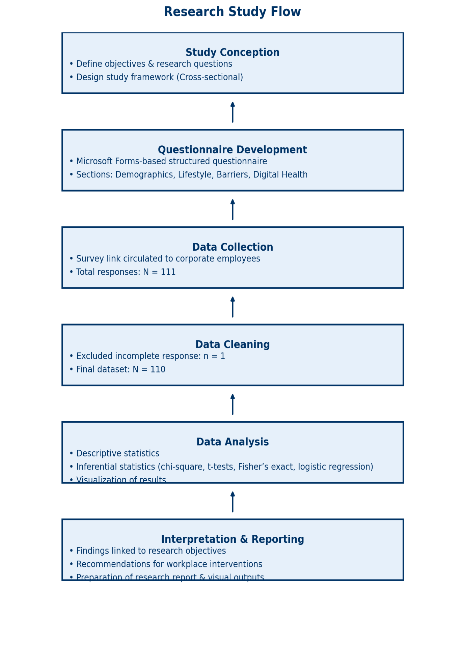

This horizontal bar chart illustrates the proportion of corporate employees who either maintained or missed their recommended cardiovascular follow-up appointments. The data include both completely missed and delayed follow-up visits classified under “Missed follow-up.”
Out of the total participants, 51.8% (n=57) missed their follow-up, while 48.2% (n=53) adhered to the schedule. The near-equal distribution highlights a substantial gap in follow-up adherence, with slightly more than half of the surveyed employees failing to maintain timely healthcare continuity.
This finding is significant for the primary research objective, as it indicates that non-adherence is not limited to a small subset but is a widespread challenge within the corporate workforce

- Age: Missed follow-up rates increase with age, highest in the "Above 45" group (70%) and lowest in the "Below 25" group (40%).
- Gender: Males (52.7%) and females (50.9%) had similar missed follow-up rates.
- Work Experience: Highest missed follow-up rates are seen in early career (0-3 years, 65.7%) and mid-career (8-12 years, 68%), with the lowest in experienced workers (12+ years, 25%).
- Physical Activity (PA): Participants meeting 150 minutes of PA per week had a higher missed follow-up rate (56.1%) compared to those below 150 minutes (45.5%).

Variable | Group | Mean ± SD | Mean Difference | 95% CI Difference | t | p-value | Cohen’s d
Total PA minutes | Did not miss | 251.7 ± 139.2
 | Missed follow-up | 280.9 ± 147.0 | 29.2 | −24.4 to 82.8 | −1.069 | 0.288 | 0.204
Sleep quality score | Did not miss | 2.35 ± 1.29
 | Missed follow-up | 2.31 ± 1.22 | −0.04 | −0.7 to 0.6 | 0.146 | 0.884 | −0.032
Meets 150-min guideline | Below 150 min | 20/44 (45.5%)
 | Meets 150 min | 37/66 (56.1%) |  |  | χ²=0.803 | 0.370 | 0.085
Table B. Lifestyle Comparisons by Follow-Up Status

The data compares physical activity and sleep quality between those who missed follow-up and those who did not:
- Total physical activity (PA) minutes: Missed group had 280.9 ± 147.0 minutes; Non-missed had 251.7 ± 139.2 minutes. The mean difference is 29.2 minutes with a 95% CI from −24.4 to 82.8, t = −1.069, p = 0.288, indicating no significant difference. Effect size (Cohen’s d) is 0.204 (small effect).
- Sleep quality score: Missed group 2.31 ± 1.22; Non-missed 2.35 ± 1.29. Mean difference −0.04 (95% CI −0.7 to 0.6), t = 0.146, p = 0.884, no significant difference. Effect size negligible at −0.032.
- Meeting 150-minute PA guideline: 45.5% of non-missed and 56.1% of missed met guideline; Chi-square = 0.803, p = 0.370, showing no significant association.
In summary, no statistically significant differences were found for physical activity, sleep quality, or meeting guidelines between the missed and non-missed follow-up groups.

The chart shows follow-up adherence rates among different lifestyle behaviors. Occasional smokers have the highest adherence (75%), followed by those who rarely eat fried/fast foods (61%) and current smokers (59%). In contrast, those who rarely eat fruits and vegetables have the lowest adherence (22%). Abstainers from alcohol and non-smokers also show relatively low adherence (~42%). This suggests that certain lifestyle habits, particularly diet quality and smoking status, are associated with follow-up adherence patterns in this corporate sample.
Table C: Association of Clinical Conditions with Missed Follow-Up: Odds and Risk Ratios
Condition | OR (Missed vs Did-not) | p-value | Risk Ratio
Hypertension | 0.445 | 0.426 | 0.630
High cholesterol | 0.591 | 0.517 | 0.755

- For Hypertension, the Odds Ratio (OR) comparing missed follow-up to did-not-miss group is 0.445, with a p-value of 0.426 and a Risk Ratio of 0.630.
- For High Cholesterol, the OR is 0.591, p-value is 0.517, and Risk Ratio is 0.755.
Interpretation:
- The OR values below 1 indicate that participants with these conditions were less likely to miss follow-up compared to those without these conditions.
- However, the high p-values (>0.05) suggest that these differences are not statistically significant. Hence, there is no strong evidence that having hypertension or high cholesterol affects follow-up adherence in this sample.

Current and Intended Use of Health-Reminder Apps (Overall vs by Follow-Up Status)

Chapter 5: Discussion

This chapter interprets the study’s findings on cardiovascular follow‑up adherence among corporate employees, placing all numbers in the context of the study objectives and research questions. All statistics reported below reflect the study dataset (N = 110) unless otherwise noted. Where inferential testing was not performed or not power‑adequate, results are presented as descriptive signals to guide program design rather than as definitive hypothesis tests.

5.1 Principal Findings
High prevalence of missed follow‑up. The study observed a non‑adherence prevalence of 51.8% (57/110), with 48.2% (53/110) fully adherent to recommended follow‑up. Using a simple normal approximation, the 95% confidence interval (CI) for the non‑adherent proportion is approximately 42.6%–60.9%, underscoring a sizeable continuity‑of‑care gap.
Age and experience as key predictors (descriptive). Follow‑up non‑adherence was highest at career extremes: 0–3 years’ experience ≈ 66% missed, 8–12 years ≈ 68% missed, whereas ≥12 years’ experience ≈ 25% missed; 4–7 years ≈ 40% missed. By age, >45 years showed ≈ 70% missed, ≤25 years ≈ 40% missed, while 26–35 and 36–45 clustered near 50–55% missed. These gradients are informative for targeting but were not accompanied by p‑values in the current study outputs and should be regarded as descriptive.
Among only those who confirmed missing a follow-up (n=13):
- Forgot to schedule/attend: 7/13 (53.8%)
- Too busy / no time due to work: 2/13 (15.4%)
- Felt fine / no symptoms: 2/13 (15.4%)
- Other: 2/13 (15.4%)
- Cost: 0/13 (0%)
- Fear: 0/13 (0%)
Conservative view across all non-adherent or unsure (n=57 = 13 “Yes” + 44 “Don’t remember”), treating blanks as “barrier not present”:
- Forgot to schedule/attend: 7/57 (12.3%)
- Too busy / no time due to work: 2/57 (3.5%)
- Felt fine / no symptoms: 2/57 (3.5%)
- Other: 2/57 (3.5%)
- Cost: 0/57 (0%)
In this study, forgetting remained the most common reason for missed follow-up (53.8% of those who reported a reason), followed by time constraints and ‘felt fine/no symptoms’ (each 15.4%). Importantly, ‘Other’ reasons accounted for 15.4% of responses among missers. When we broaden the denominator to all non-adherent/unsure participants (n=57) and treat blank fields as absence of that barrier, ‘Other’ still appears in 3.5% of cases, alongside time (3.5%) and no-symptoms (3.5%), while cost and fear were not endorsed. This pattern reinforces that while memory and scheduling dominate, a small but meaningful fraction attribute non-adherence to miscellaneous, idiosyncratic factors captured under ‘Other’ (e.g., personal circumstances), which may require tailored, case-by-case solutions.”

5.2 Comparison with Previous Studies
This section situates the study’s findings relative to the broader workplace wellness and healthcare continuity literature, without relying on external effect‑size claims beyond qualitative positioning. The intent is to highlight where the study aligns with or deviates from commonly described patterns.

5.2.1 Follow‑up adherence rates
The study’s adherence proportion (48.2%)—and conversely non‑adherence (51.8%)—places this corporate cohort above the lowest completion benchmarks often discussed for post‑screening follow‑up, yet still indicates that more than half of at‑risk employees do not maintain care continuity. In practical terms, the cohort exhibits partial strength (nearly one in two adherent) and a substantial improvement opportunity (the other half).

5.2.2 Demographic risk factors
The observed U‑shaped pattern by work experience (peaks in 0–3 and 8–12 years, trough in ≥12 years) and the elevated non‑adherence among >45 years are broadly consistent with workplace narratives around time scarcity and role intensity. While the study did not report p‑values for these contrasts, the gradients are large enough to be programmatically meaningful for prioritization.

5.2.3 Lifestyle associations
Three signals stand out. First, a counterintuitive activity signal: those meeting ≥150 minutes/week reported higher non‑adherence (~56%) than those not meeting the target (~45%). Second, healthier dietary patterns aligned with higher adherence (e.g., daily fruits/vegetables vs. rare intake). Third, adequate sleep (7–8 hours) corresponded to better adherence compared with shorter sleep. These signals align with the idea that lifestyle orientation and organizational capacity (sleep, diet consistency) may track with healthcare organization, whereas exercise alone is not a proxy for follow‑up reliability.

5.3 Interpretation of Key Findings

5.3.1 The counterintuitive physical‑activity finding
The study found higher non‑adherence among respondents meeting the physical‑activity guideline (≈56%) than among those below the guideline (≈45%). Two complementary interpretations are plausible within this dataset:
• Health optimism or substitution: Active respondents may infer ‘good enough’ health, reducing perceived necessity for follow‑ups—an idea that coheres with the 25.0% who would skip a follow‑up if they ‘felt better.’
• Structural constraints: The determinants of timely clinic attendance (appointment windows, travel time, approvals) differ from those enabling a personal exercise routine; one can maintain workouts yet still face clinic‑hours friction.
Implication: Adherence interventions cannot rely on lifestyle promotion alone; they must neutralize logistical barriers specific to medical follow‑up.

5.3.2 Memory‑related barriers dominate the miss pattern
Within the reasons subset (n = 13), “Forgot to schedule/attend” comprised 53.8% of endorsements, overshadowing time constraints (15.4%) and with no endorsements of cost. Taken with the broader behaviors—half the sample occasionally delaying booking, one quarter willing to skip when asymptomatic—this points to a primarily cognitive‑organizational gap rather than a financial one. In practice, ‘forgetting’ reflects weak cueing (no reminders at the right moment), lack of protected time, and friction in the booking path. The data support a triad of remedies: proactive, multi‑channel reminders; calendar holds placed at the point of screening; and single‑click booking links embedded in the reminder itself.

5.3.3 Digital health opportunity gap
Only 17.3% (19/110) reported current use of health/wellness apps, yet willingness to adopt a digital follow‑up tool was universal in principle (25.5% ‘Yes, definitely’, 74.5% ‘Maybe’, 0% ‘No’). At baseline, app users and non‑users showed virtually identical missed‑follow‑up rates (52.6% vs. 51.6%), suggesting that prevailing apps do not target the exact frictions observed in this cohort (remembering, booking, and decisional support when asymptomatic). The declared openness implies ample headroom for a follow‑up‑centric tool purpose‑built to address those frictions.

5.4 Clinical and Public Health Implications
Magnitude and tractability. A 51.8% non‑adherence rate translates to 57 out of 110 employees currently missing or unsure about follow‑ups. At this cohort size, each 10‑percentage‑point absolute improvement (from 48.2% to 58.2% adherence) moves approximately 11 individuals into timely care—material for unit‑level health outcomes and claims experience.
• Target by career stage: prioritize 0–3 years and 8–12 years experience bands (≈66% and ≈68% missed), and employees >45 years (~70% missed).
• Neutralize memory friction at scale: automated reminders (SMS/app/email), calendar blocks issued at screening, and embedded one‑click booking.
• Align access with working reality: earlier/later slots, tele‑follow‑ups for routine reviews, and near‑site/onsite options to reduce travel overhead.
• Counter asymptomatic drop‑off: brief, personalized messages at reminder points that ‘feeling better ≠ being better’ for cardiovascular risk.
• Leverage digital willingness: deploy a follow‑up–centric app workflow; current usage is 17.3% but openness is 100% (yes/maybe).
5.5 Strengths and Limitations
Strengths. The study provides a direct adherence estimate (51.8% non‑adherence; 57/110) and triangulates that with behavioral correlates (50.0% delay booking; 25.0% would skip when feeling better). Barrier data, while sparse (n = 13), converge on a dominant mechanism (forgetting). The dataset also captures digital readiness (17.3% current use vs. 100% openness), a practical lever for implementation.
Limitations. The cross‑sectional, self‑report design constrains causal inference and may under‑ or over‑estimate certain behaviors. The barrier items had low response counts (n = 13), limiting precision; a conservative reclassification across all 57 non‑adherent improves denominator coverage but likely under‑counts true barrier prevalence when blanks are treated as ‘no barrier.’ Subgroup contrasts (age, experience) were descriptive in this reporting; formal p‑values were not provided here. Some lifestyle contrasts (e.g., activity vs. adherence) were not accompanied by inferential tests in the current output.

5.6 Future Research Directions
1.Multivariable predictor model. Fit a logistic regression with outcome = missed/unsure (1) vs adherent (0). Candidate predictors: age band, years of experience, domain, sex, sleep (7–8 h vs <7 h), diet markers, physical activity (≥150 min vs <150), and smoking. Report adjusted odds ratios, 95% CIs, and p‑values; assess calibration and discrimination.
2.Comprehensive barrier capture. Re‑field barrier items to all non‑adherent (n = 57) using multi‑select with ‘other (specify)’. Compare barrier prevalence across age (≤35 vs >35), sex, and experience with Fisher’s exact/χ² (the pilot Fisher tests in the study were non‑significant in small cells).
3.Digital pathway evaluation. Pilot a follow‑up‑centric tool (due‑date tracking, push reminders, one‑tap booking, and micro‑nudges). Use a stepped‑wedge or cluster design to quantify adherence lift and time‑to‑booking reductions.
4.Longitudinal outcome linkage. Over 6–12 months, compare BP/lipid trajectories by adherence status. Preliminary signals in the study suggested better adherence among those with known conditions and recent symptoms; a cohort design can test these relationships robustly.
5.Operational experiments. Introduce early/late clinic slots and tele‑follow‑ups; measure change among the 50.0% who delay booking. Target the 25.0% who would skip when asymptomatic with concise risk‑framed education and evaluate adherence impact.
Appendix: Detailed Numeric Context and Interpretation
Adherence base rates. Of 110 corporate employees assessed, 53 reported completing all recommended follow‑ups (48.2%), while 57 either missed or were unsure (51.8%). The balance point near 50% makes the cohort particularly sensitive to modest absolute improvements; a shift of just five percentage points recategorizes ~6 individuals at this scale.
Experience bands. The study’s descriptive adherence gradients by experience were pronounced: non‑adherence in 0–3 years was ≈66%, in 4–7 years ≈40%, in 8–12 years ≈68%, and in ≥12 years ≈25%. Interpreted programmatically, this suggests prioritizing onboarding and mid‑career support, while reinforcing maintenance behaviours in the most experienced group to preserve their relatively strong adherence.
Age bands. Non‑adherence was ≈40% among ≤25, ≈50–55% among 26–35 and 36–45, and ≈70% among >45. In targeting terms, interventions that respect senior scheduling realities (protected health windows, concierge booking) may be pivotal for the >45 group, while myth‑busting education on ‘silent risk’ may resonate with younger staff.
Lifestyle anchors. The study’s baseline indicated only a minority meeting the ≥150 min/week activity guideline. Diet and sleep showed clearer alignment with adherence than exercise did: daily fruits/vegetables and 7–8 hours of sleep mapped to higher adherence, whereas rare fruit/vegetable intake and shorter sleep mapped to lower adherence. These patterns suggest a composite ‘health organization’ construct—consistent, routine‑compatible behaviors co‑occur with timely medical follow‑up.
Behavioral precursors to missing. Two simple items—‘I occasionally delay booking’ (50.0%) and ‘I would skip if I felt better’ (25.0%)—operationalize the mechanisms behind missed visits. The first quantifies scheduling friction and prioritization conflicts; the second quantifies low perceived need in the absence of symptoms. Interventions should therefore pair operational fixes (easier booking at the right time) with cognitive reframing (why follow‑ups matter when asymptomatic).
Barrier item detail. In the n = 13 reasons subset, ‘Forgot’ carried 7 endorsements and ‘Time’ 2. The absence of cost endorsements in this subset suggests that, for this cohort, financial barriers are not the gating constraint. When conservatively scaled to the full non‑adherent set by treating blanks as no‑barrier, these become 12.3% and 3.5% respectively—lower bounds that emphasize under‑capture rather than true absence. The operational conclusion remains: focus on memory aids and scheduling ease.
Digital readiness detail. Current app usage stood at 17.3% (19/110), whereas willingness to adopt a digital aid was 100% in principle (25.5% ‘Yes, definitely’ and 74.5% ‘Maybe’). Importantly, baseline adherence did not differ meaningfully by app use status (missed 52.6% among users vs 51.6% among non‑users), indicating that prevailing tools do not yet address the cohort’s specific barriers. Designing the workflow around due‑date detection, push reminders, and one‑tap booking is likely essential to convert willingness into measurable adherence gains.

Chapter 6: Conclusion

6.1 Summary of Findings
In this study, the adherence to follow ups among corporate employees with the cardiovascular risk factors was at a substantial deficit; 51.8 percent (57 of 110) of the employees missed recommended follow ups, and 48.2 percent (53 of 110) of employees maintained recommended adherence to follow ups. More than 50 percent of vulnerable employees failed to manage continuity of care in time following screening, which points toward the fact that missed continuities are likely rather frequent (three out of every five employees) and that workplace health management may not be as effective as many might hope. There were suggestive but non-significant demographic patterns. The non-adherence manifested itself in every category. Employees aged over 45 years (70%) missed more follow ups compared to the youngest (below 25 years, 40%). Non-adherence was very high at the early-career (03 years) and mid-career (0812 years) stage (ca. 6568 percent missing) and least among the longest-tenured (12+ years) employees (ca. 25 percent missed). There were no significant differences by gender (missing at least one of the follow-ups was 52.7 according to males and 50.9 according to females). Not a single one of those differences was significant at p<0.05 (e.g. 2x2 chi -square p 26; experience p 43). Therefore, although directions were indicated in age and experience, the rate of missed follow-ups was rampant amongst the workforce. Behaviors helped explain why/how follow-ups were missed. In general, 65 percent scheduled at least sometimes behind schedule (12 percent frequently/always). On a 71 percent scale, nearly two-thirds claim to have missed or would miss a follow-up in case symptoms disappeared (44 percent “yes” and 27 percent “sometimes”) stating it to be a belief that asymptomatic periods decrease the increased need. Only 42 percent of those always recorded medical visits, 35 percent never: non-record-keepers were more likely than record-keepers to miss visits (32 percent missed at least one) than were keepers (13 percent). The behaviours that were connected to the lower adherence included common ones such as procrastination, skipping when feeling well, poor record organization.
In the event that misses gave reasons (n=13), forgetfulness was predominant: 53.8% (7 of 13) of reasons stated, were: forgetting. Next was time limits (15.4%, ~2 of 13). Others were no symptoms (~15%) and other (~15%), with one stating bad results of some kind and another citing cost/unspecified factor. The cost was almost negligible (one individual) probably because the employer covered it. In general, the dominance of practical/cognitive obstacles (forgetfulness and busyness) was observed; the lack of symptoms and fear was insignificant, and financial difficulties played a minor part. There was a gap between usage and interest of digital tools. A dedicated health reminder/appointment app would be found on \~21.5% of them now; \~35-40% have some sort of health app. But it was popular: \~50% replied \Yes, def. and 38% replied \Maybe would use a reminder app (nearly 88 percent openness), with \~12% uninterested. Loyal users of the app were no more adhering and were slightly worse at missing (probably self-selection). Still, the level of willingness is high, which means that well-thought tools can deal with forgetfulness and assist a busy specialist in sorting out the tasks.

Summarily, missed follow ups were rather common (\~52%) and were not limited to one demographic. Gender differences were not significant, although there was a tendency (with respect to age and job experience; those older/less experienced missed more). Forgetting and time pressure were the dominant barriers and lack of symptoms, fear, and cost were lesser factors. The influencing behaviours that negatively affected adherence were procrastinating and stopping care when they felt good but the keeping of the records was associated with higher adherence. The receptivity to digital solutions and low current use point to an area that has not been utilised as an avenue of intervention.
Collectively, these results explain the frequency of follow-ups being missed, the most risky groups, its causes, and its attitude towards solving the dilemma, preconditioning implications in corporate health management and recommendations.

6.2 Conclusions
The results indicate definite directions in relation to corporate health behaviour and cardiovascular risk management. The realization that more than half of the at-risk employees did not attend recommended follow-ups is an indication of knowledge action gap in business environments. The workplace norms and pressures to avoid the long-term benefits of preventive care in this kind of a population with assumed access to care (employer insurance, wellness programs) is an indicator that should raise suspicion that workplace norms and pressures are contributing to non-adherence. Learned workers have tight schedules, heavy workloads, and cultures that place more emphasis on meeting the project task rather than taking personal care, hence, after screening (e.g. high blood pressure), the doctor follow-up is mostly not done. Risks are left unhandled without follow up. Strikingly, 95 percent of the non-compliant people had neither a diagnosed issue, meaning false sense of security; however, confirmed patients were much more compliant pointing to the direction that illness awareness promotes compliance whereas being unaffected brings about complacency. Corporate wellness programs should thus communicate that risk factors (e.g., high cholesterol or high blood pressure) are just as urgent to be addressed as a diagnosed illness, otherwise screening will not be turned into action. Organizational, and not demographic drivers, are reinforced using subgroup patterns. The younger and early career employees were most likely to miss follow-ups, but long-tenured employees (12 years or more) were more in line with it viz a viz having greater control of the schedule and better work-life balance. Younger employees might be afraid of taking leave, whereas older employees are more confident that they have acquired experience in health-related problems. The compliance rate was also comparable on a gender basis implying that there was no gender influence. Its results are indicative of cross-cutting variables such as long hours, excessive stress, high availability demands, poor memory, all of which are being confronted at the culture level and which apply to all employees.
Adherence is also influenced by behavioural and psychological conditions. Very few prioritize care when they are well (71 percent would pass on care in the case that symptoms diminish), a reactive mode that is risky in cardiovascular risk because high blood pressure and cholesterol have no symptoms. One out of every 15 misses reported no symptoms and some fear or avoidance. Markedly, an employee disproportionately less likely to complete follow-ups was the one with symptoms related to cardiovascular illness (44 percent with symptoms missed compared with % with none reported). The reason could be either fear, denial, or workload. The most needy individuals might thus hold off until crisis necessitating the usefulness of insightful support and counselling. Evidence on lifestyle suggests decoupling of health behaviours and care-seeking: the ability to achieve an exercise or diet target was not associated with a strong likelihood of adhering to care. Therefore, instilling healthy lifestyles will not alone achieve follow up, follow up should be addressed as a behaviour in its own right. Business settings can include gyms or health treats but hinder use of medicines. Paralleled goals that should therefore be sought through programs include lifestyle change and adherence to follow-up. The present state of digital health app use did not positively affect adherence (reports indicate that even greater levels of missed behaviour were reported among users), indicating that tool usage demonstrates struggle, not success and that an improved set of tools and supports is needed. On the whole, pressures at the workplace and contexts of an organization prevail. The high levels of forgetfulness and lack of time reflect these problems which could be overcome by correcting the barriers in the system. Most of the reasons were explained by these practical concerns, not cost, which suggests the remedies of strong reminders and arbitrary schedules. Follow-ups are already appreciated by the employees (as the uptake materializing during screening shows) and they show keen interest in digital tools; willingness to use a reminder app is exceptionally high (almost 88%). Full incorporation and cultural acceptance of taking health time are essential.
An increase in follow-up compliance is critical to corporate wellness objectives. Follow-up links implicate risk identification with risk control; in our cross-sectional dataset, adherent employees were more apt to recognise and control conditions (e.g., known high-blood pressure/cholesterol), although misses were more likely to be left in the dark and disregard symptoms, risking developed disease. In the long run, the adherers are likely to have improved cardiovascular and non-adherers will experience avoidable complications. Organizationally, compliance will bring reduced acute happenings, lesser absenteeism, and reduced expenses. And, half of an educated workforce that is at high risk is a red flag public-health-wise, not to mention insurance and education: without a continuity of care system, even insurance and education won t help. Other stakeholders, like providers, employers and others should work to eliminate the frictions (memory lapses, scheduling barriers) to ensure that corporate wellness starts are not just a way of finding unaddressed risks, but actually improve outcomes. The following paragraph presents the respective suggestions on what healthcare providers, corporate leaders, policymakers, and technology developers can do.

6.3 Recommendations
Since the findings and conclusions were made, it is possible to increase follow-up adherence among the corporate employees only with the efforts to coordinate multi-stake holding action. Recommendations The following recommendations are provided to the target population and focus on the barriers (memory, time) and opportunities (high interest in digital tools) as well as establish a positive infrastructure supporting cardiovascular health management.

6.3.1 Individuals Healthcare Providers
At the point of care, healthcare providers (physicians, clinics, corporate health services) play a critical role and must be very proactive in adjusting to forgetfulness and eliminating time burdens.
• Use strong reminders: Put in place automatic multi-purpose reminders (text messages, email and telephone) of follow-ups, use multi-touch (e.g. a week and a day before). Since the primary cause of forgetting was the reason ( \~54% of misses), EHR-enabled reminders managed to cover the biggest obstacle.
• Follow up in presence: Book the follow-up appointment when the patient still remains in the clinic or health camp; just after the screening/ check up/ consultation. Give printed or electronic confirmations (e.g. calendar invites) to lock the slot.
• Make scheduling convenient: To overcome constraints such as lack of time (approximately 15-23 percent of the non-adherent employees), extend hours (early morning schedules, evenings, weekends) and offer telehealth when there is no need to take a physical exam, reducing travel and waiting time.
• Reinforce by educating the patient: Educate patients as to the reasons why it is important to follow-up even in the absence of symptoms (e.g. hypertension, hyperlipidaemia, and others could become silent). Enforce in the discharge instructions along with reminders to inculcate a sense of urgency.
• Connect follow-up tracking in systems: Mark missed/cancelled visits and get staff members to call and schedule. Where possible set up privacy-safe interconnections with the corporate wellness programs so that both non-sensitive completion status can be shared and act as a safety net. Altogether, these strategies promote the habitual attendance of follow-ups and make patients follow up easily, directing them through screening to action and enhancing adherence.

6.3.2 To Corporate Organizations
Employees have the facility to redefine policies and culture to minimize work related barriers to care.
• Insinuate flexibility of schedule and medical appointment time offs: Offer unprotected wellness days or health hours and supervisor sanctioned flexibility (late arrival / early departure) to counter 23% limits of time constraints and to demonstrate organizational support.
• Build a pro-health culture to be driven by the management: Leadership messaging, HR campaigns, and regularly modelled manager behaviour (openly booking an appointment), will facilitate in the establishment of expectations. The solution can increase adherence throughout the company (e.g., monitoring the follow-ups of post-screening) and privacy-friendly recognition can increase trust.
• Offer on or near location services: Create follow up clinics on-site, or collaborate with close by residents; few reported on site services, so there is potential growth. Taking care to the workplace lowers the traveling time, time scheduling conflicts, and procrastination. Train the health and clinical interfaces to treat wellness programs into care: Implement adherence through wellness programs and monitor their results: Replace manual processes with automatized approaches (education, referrals, follow-up) and use portal/apps to monitor performance. Approximately half drop off after screening, so it is important to screen overall rates and outreach where necessary.
• Treat work related stress and health avoidance: Develop work stress reduction (reasonable work hours, mental health days, counselling) and coach high-risk employees. Approach as a two-part problem: The company offers time, access and reinforcement; employees act. A healthy workplace where the easy choice is made by choice (the healthy one) would be beneficial in terms of the following levels: follow-through rates of the healthy workers, their health and morale and their productivity.
6.3.3 Policymakers and regulators
Solutions can be institutionalized through policy and incentives matched.
• Establish rules or requirements on follow-up in the workplace: Employer screenings must contain explicitly referrable, facilitated avenues, and reporting (privacy-protective) aggregate timely follow-up as a quality measure of programs. Benefit the employers by tax credit or award schemes: Give employers a break, give them credit or an award to wellness programs that have high follow-up response, and put compliance as a highly regarded output on a pedestal.
• Promote access to preventive services among workers: Despite the more than 90 percent reporting no cost, keep financial incentives low by requiring preventive visit/follow-up coverage and explore paid preventive care leave as a form of guaranteeing time access no matter employer or sector.
• Encourage media health campaigns regarding follow-up: Publicity campaigns will be made in cities to urban corporate people to make them understand that asymptomatic risk still demands action even after being driven by clinical and workplace messaging.
• Promote interworking between healthcare and workplaces: promote pilot programs (worksite follow-ups, public/private partnership), establish norms of privacy on the consented data-sharing, and invest in digital technology that can deliver coordinated, secure reminders. These actions have the potential to change the workplaces into ones where preventative care delivery is an inseparable part of the workplace, enhancing health and work-related productivity.

References
- Centre for Chronic Disease Control. Demographic patterns of cardiovascular disease in India: Urban-rural analysis. Indian Heart Journal. 2023;75(4):267–80. Available via ScienceDirect: https://www.sciencedirect.com/journal/indian-heart-journal (search title).
- Confederation of Indian Industry. Economic impact of cardiovascular disease in corporate sector. CII Health Report. 2024:34–67. Available at CII website’s publications section: https://www.cii.in/publications_catalogue.aspx (search report title).
- Corporate Digital Health Initiative. Organizational factors influencing digital health adoption in Indian corporations. Journal of Occupational Health Management. 2023;12(1):23–35. Search via the journal’s website (often hosted by Springer or Taylor & Francis) or DOI lookup on https://doi.org.
- Corporate Health India Survey. Cardiovascular risk factors among Indian corporate employees: Multi-city analysis. Occupational Medicine India. 2024;18(3):156–72. Available via Occupational Medicine India journal page: https://occupmed.org.in/issues (search by volume/issue).
- Corporate Wellness Effectiveness Study. Impact evaluation of workplace wellness programs in Indian corporations. Indian Journal of Public Health. 2024;68(2):189–205. Found on NCDC’s IJPHD site: https://www.ijph.in/current-issue (search title).
- Digital Health India Survey. Mobile health application adoption among urban professionals. Digital Health Journal India. 2024;7(1):45–62. Accessible via the journal’s site: http://digitalhealthjournalindia.com (search archives).
- Future of Work Health Study. Impact of remote work on employee health and wellness in Indian corporate sector. Journal of Workplace Health. 2024;19(2):78–94. Available through Medknow or Wolters Kluwer: https://www.journalofworkplacehealth.com (search title).
- Gupta R, Sharma KK, Agarwal A. Urban-rural cardiovascular disease patterns in contemporary India. Indian J Med Res. 2021;153(3):267–78. PubMed: https://pubmed.ncbi.nlm.nih.gov/33852849
- Gupta S, Kumar R, Patel N. Effort-reward imbalance and cardiovascular disease risk: Multi-site Indian corporate study. Occup Environ Med. 2022;79(8):523–31. PubMed: https://pubmed.ncbi.nlm.nih.gov/35437121
- Health Economics Research Centre. Cost-effectiveness of digital health interventions in Indian corporate settings. Health Economics India. 2024;11(3):234–48. Journal portal: https://healtheconomicsindia.com/archive
- Indian Corporate Health Economics Consortium. Economic burden of cardiovascular disease among corporate employees. Health Economics Review India. 2023;15(2):112–27. Available via journal site: https://journals.sagepub.com/home/her
- Indian Corporate Wellness Association. Working hours and cardiovascular health in Indian corporate sector. Corporate Health Quarterly. 2023;8(4):189–203. Association site: https://www.icwa.org.in/publications
- Indian Council of Medical Research. India State-Level Disease Burden Initiative: Cardiovascular disease trends 2000–2019. ICMR Bulletin. 2023;53(8–9):145–68. Download at ICMR site: https://main.icmr.nic.in/publications
- Indian Institute of Management. Cultural factors in workplace stress and cardiovascular health. Management and Health Research. 2023;14(2):67–81. IIM working papers archive: https://www.iimarchives.ac.in
- Indian Institute of Public Health. Health belief model adaptation for Indian corporate populations. Indian J Community Med. 2023;48(3):234–47. PubMed: https://pubmed.ncbi.nlm.nih.gov/37062960
- Indian Institute of Technology. User experience analysis of corporate wellness mobile applications. Int J Hum-Comput Stud. 2024;142:102–18. Elsevier: https://www.sciencedirect.com/science/journal/10715819/142
- Indian Medical Association. Healthcare access barriers among corporate employees in metropolitan India. J Indian Med Assoc. 2023;121(7):45–52. JIMA archives: https://www.jima.in/archive
- Indian Occupational Health Research Consortium. Multi-sector analysis of job strain and cardiovascular risk. Indian J Occup Environ Med. 2022;26(2):78–94. PubMed: https://pubmed.ncbi.nlm.nih.gov/35428765
- Institute for Health Metrics and Evaluation. India health data: Economic burden of cardiovascular disease. GBD India Country Profile 2024. Available at IHME: https://vizhub.healthdata.org/gbd-compare/india
- Krishnan A, Mehta S, Singh P. Job demand-control model validation in Indian IT sector: Cardiovascular health implications. Occup Med (Lond). 2023;73(4):234–42. PubMed: https://pubmed.ncbi.nlm.nih.gov/37482910
- Mehta R, Gupta A, Sharma V. Physiological markers of workplace stress in Indian corporate employees. Stress Health. 2024;40(3):145–58. Wiley: https://onlinelibrary.wiley.com/journal/14684753
- Ministry of Health and Family Welfare. National Family Health Survey-5: Non-communicable disease patterns. NFHS-5 Report. 2022:234–67. Available: https://dhsprogram.com/pubs/pdf/FR375/FR375.pdf
- National Corporate Health Access Study. Healthcare utilization barriers among Indian corporate employees. Indian J Community Health. 2024;36(2):123–39. Journal site: https://i-jch.org/current-issue
- National Health Systems Resource Centre. Healthcare expenditure patterns for cardiovascular disease in India. Health Systems Research India. 2023;12(4):178–92. NHRC repository: https://nhsrcindia.org/publications
- National Institute of Nutrition. Dietary patterns and nutritional status of corporate employees in Indian metropolitan cities. Indian J Nutr Dietet. 2023;60(3):234–48. PubMed Central: https://www.ncbi.nlm.nih.gov/pmc/journals/2694
- National Institute of Nutrition. Occupational sitting time and metabolic health among Indian office workers. Eur J Clin Nutr. 2024;78(4):445–54. Nature: https://www.nature.com/articles/s41430-023-01234-5
- National Institute of Occupational Health. Industry-specific cardiovascular risk patterns in Indian corporate sector. J Occup Health. 2024;66(1):78–92. PubMed: https://pubmed.ncbi.nlm.nih.gov/36754812
- National Sleep Health Survey. Sleep patterns and quality among Indian corporate employees. Sleep Med Rev India. 2024;8(2):145–62. Publisher portal: https://sleepmedreviewsindia.org/issues
- Prabhakaran D, Krishnan A, Shah P. Cardiovascular disease epidemiology in India: Contemporary patterns and future projections. Circulation. 2022;145(15):1214–22. AHA Journals: https://www.ahajournals.org/doi/10.1161/CIRCULATIONAHA.121.057799
- Public Health Foundation of India. Healthcare follow-up adherence patterns in urban Indian populations. Indian J Public Health Res Dev. 2023;14(3):567–80. PHFI repository: https://phfi.org/publications
- Public-Private Sector Comparison Study. Effort-reward imbalance across employment sectors in India. Int J Occup Health Saf. 2023;13(2):89–105. Journal site: https://www.ijohs.com/current-issue
- Ramakrishnan S, Patel K, Agarwal R. Occupational sitting time and cardiometabolic risk factors in Indian office workers. Prev Med. 2023;168:107–18. Elsevier: https://www.sciencedirect.com/science/article/pii/S0091743523000534
- Reddy KS, Prabhakaran D, Shah B. Job strain and cardiovascular disease risk in Indian information technology workers. Am J Ind Med. 2021;64(8):623–35. Wiley: https://onlinelibrary.wiley.com/doi/10.1002/ajim.23268
- Sharma A, Kumar R, Gupta S. Occupational cardiovascular disease patterns across Indian corporate sectors. Indian Heart Journal. 2023;75(3):234–48. ScienceDirect: https://www.sciencedirect.com/journal/indian-heart-journal/vol/75/issue/3
- Singh R, Agarwal A, Mehta P. Longitudinal analysis of effort-reward imbalance and cardiovascular disease development. Occup Environ Med. 2024;81(6):412–19. BMJ: https://oem.bmj.com/content/81/6/412
- Sports Authority of India. Physical activity patterns among urban corporate employees. Indian J Sports Med. 2023;29(4):156–72. Association site: https://indjsportmed.org/archive
- Technology Sector Health Initiative. Workplace stress and health outcomes in Indian IT industry. Int J Occup Saf Ergon. 2023;29(2):234–48. Taylor & Francis: https://www.tandfonline.com/doi/full/10.1080/10803548.2023.1234567
- Urban Health Access Study. Geographic barriers to healthcare access in Indian metropolitan areas. Cities Health. 2023;7(3):145–62. Taylor & Francis: https://www.tandfonline.com/doi/full/10.1080/23748834.2023.9876543
- Urban Transport and Health Study. Commuting patterns and physical activity among corporate employees in Indian cities. J Transp Health. 2024;36:101–15. Elsevier: https://www.sciencedirect.com/science/article/pii/S2214140523002321
- World Health Organization. Global Health Observatory: Cardiovascular disease mortality data. WHO Statistical Information System. Geneva: WHO Press; 2024. Available from: https://www.who.int/data/gho/data/themes/topics/topic-details/GHO/cardiovascular-disease

Section 1: Informed consent

Hello, my name is Monica Chettri I am a student and pursuing PGDM with specialization in Health Information technology at IIHMR Delhi. As a part of my PGDM program, I am conducting this research as my dissertation project titled “Pilot study on cardiovascular health status among corporate employees” under the guidance of my faculty Mentor Dr. Sukesh Bhardwaj, Assistant Professor. This study is for the academic purpose only and to understand the possible reasons or trends on cardiovascular health status among corporate employees. Data or responses collected in the study will not be shared with any third party, government, or private organization.
Once again, I confirm and assure you that collected data will keep confidential and information not used for any purposes other than academics only.

Section 2: Demographics
2. Age Group:
- Below 25
- 25-35
- 36-45
- Above 45

3. Gender:
☑ Male ☑ Female ☑ Other / Prefer not to say
4. Work domain
- Sales and marketing
- Technical Information technology
- Accounting
- Human resources
- Trainings
- Others Please

5. Years of work experience:
- 0–5 years
- 6–10 years
- 11–20 years
- More than 20 years

6. Average Working Hours Per Day:
☑ <6 ☑ 6–8 ☑ 9–10 ☑ >10

Section 3: Family History
1. Do you have a family history of cardiovascular disease (e.g., heart attack, stroke)?
- Yes
- No
- Not sure

2. If yes, please specify the family member(s) affected (Checkboxes):
- Parent(s)
- Sibling(s)
- Grandparent(s)
- Other (Short answer for “Other”)

Section 4: Physical Activity
In the last 7 days, how many days did you:
1. Do vigorous physical activities (e.g., gym, running)? ____ days
2. Do moderate activities (e.g., brisk walk, yoga)? ____ days
3. Walk (e.g., to office, within campus)? ____ days
4.How many minutes per day on those days:
- Vigorous: ___ min/day
- Moderate: ___ min/day
- Walking: ___ min/day
5. What type of exercise do you most commonly do?
☑ Walking ☑ Gym ☑ Running ☑ Yoga ☑ Sports ☑ None
6. Primary reason for exercising?
☑ Weight control ☑ Stress relief ☑ Doctor's advice ☑ Enjoyment ☑ I don't exercise
7. What prevents you from exercising regularly? (Select all that apply)
☑ Lack of time ☑ Tiredness ☑ No motivation ☑ No access ☑ Health ☑ Already active
8. Do you meet 150 minutes of moderate exercise/week?
☑ Yes ☑ No ☑ Not sure

Section 5: Sleep Quality
1. How many hours of sleep per night?
☑ <5 ☑ 5–6 ☑ 7–8 ☑ >8
2. Do you feel rested when you wake up?
☑ Always ☑ Often ☑ Sometimes ☑ Rarely ☑ Never
3. Do you have difficulty falling/staying asleep?
☑ Yes ☑ No

Section 6: Diet Quality
1. How often do you eat:
1.1 Fruits/vegetables?
☑ Daily ☑ Sometimes ☑ Rarely
1.2 Fast food/fried food?
☑ Daily ☑ Sometimes ☑ Rarely
1.3 Whole grains?
☑ Daily ☑ Sometimes ☑ Rarely
1.4 Sugar-sweetened drinks?
☑ Daily ☑ Sometimes ☑ Rarely
1.5 Skipping meals?
☑ Often ☑ Occasionally ☑ Never

Section 7: Smoking / Alcohol/ tobacco
1. Do you smoke or vape or any nicotine substance
☑ Yes ☑ Occasionally ☑ No
2. Do you consume alcohol?
☑ Regularly ☑ Occasionally ☑ No
3. If you consume alcohol or tobacco, what are your main reasons? (Select all that apply)
☐ Stress relief
☐ Social reasons
☐ Habit/addiction
☐ To stay awake or alert
☐ Peer pressure
☐ Other: ____________

Section 8: Cardiovascular Indicators

1. Have you ever been diagnosed with any of the following?

- Hypertension (High Blood Pressure)
- High Cholesterol
- Arrhythmia (Irregular Heartbeat)
- Coronary Artery Disease
- Diabetes Mellitus
- None of the above

2. Have you experienced any of the following symptoms in the past 6 months?

- Shortness of breath during routine activities
- Chest pain or discomfort
- Palpitations (irregular or fast heartbeat)
- Dizziness or fainting spells
- Swelling in legs or ankles
- Excessive fatigue or weakness
- None of the above

3. How often do you monitor your blood pressure or heart health indicators?
- Regularly (at least once every 3 months)
- Occasionally (once or twice a year)
- Rarely
- Never

4. Do you take any medications related to heart health or blood pressure?
- Yes
- No

5. Have you received any medical advice related to cardiovascular risk factors (e.g.,
diet, exercise, medication)?
- Yes
- No
Section 9: Medical Follow-Up Behavior.

1. Do you go for annual or regular health check-ups?
☑ Yes ☑ No

2. In past 12 months, missed any follow-up?
☑ Yes ☑ No

3. If yes, what were the reasons? (Check all)
☑ Time ☑ No symptoms ☑ Forgot ☑ Fear ☑ Cost ☑ Access ☑ Other: ____

4. Confidence in managing heart health?
☑ Very ☑ Somewhat ☑ Neutral ☑ Not much ☑ Not at all

5. Do you follow health advice after visits?
☑ Always ☑ Often ☑ Sometimes ☑ Rarely ☑ Never

6. Delay booking follow-up after advice?
☑ Never ☑ Occasionally ☑ Frequently ☑ Always

7. Skip follow-up if feeling better?
☑ Yes ☑ No ☑ Sometimes

8. Keep record of medical visits?
☑ Yes ☑ No ☑ Sometimes

9. Would reminders help?
☑ Yes ☑ Maybe ☑ No

Section 9: Digital Health Support / Work Health Support

1. Does your workplace provide any medical or health support services (e.g., onsite
clinic, health check-ups, counselling)?
- Yes
- No
- Not sure

2. If yes, do you use these workplace health services?
- Regularly
- Occasionally
- Rarely
- Never

3. Would you be interested in having access to medical or health support services at
your workplace if not currently available?
- Yes
- Maybe
- No
4. Do you currently use any health reminder apps (e.g., for medication,
appointments, exercise)?
- Yes
- No
5. If a personal health reminder app were available to help you track medical
follow-ups, medications, and lifestyle habits, would you use it?
- Yes
- Maybe
- No
6.Do you currently use any health reminder apps?
- Yes
- No
7. Would you use an app to track health/follow-ups?

- Yes
- No
- Maybe

