DISSERTATION

At
U4RAD Technologies Pvt Ltd
(24th Feb 2025- 30th June 2025)

Analysis of Tuberculosis Mass Screening Using Chest X-rays data of Madhya Pradesh

By
Rinku
(PG/23/091)

Health Management

Under the Guidance of: Dr. Ekta Saroha

POST GRADUATE DIPLOMA IN HOSPITAL AND HEALTH MANAGEMENT 2023-25



INTERNATIONAL INSTITUTE OF HEALTH MANAGEMENT AND RESEARCH

COMPLETION OF DISSERTATION

The certificate is Awarded to

Ms. Rinku
in recognition of having successfully completed her internship in the

Department of Radiology

and has successfully completed her Project on

Analysis of Tuberculosis Mass Screening Using Chest X-rays data of Madhya Pradesh
at

U4RAD Technologies Pvt Ltd
She comes across as a committed, sincere & diligent person who has a strong drive & zeal for learning.
We wish her all the best for future endeavors.



Mr. Partha Dey Founder and CEO U4RAD Technologies

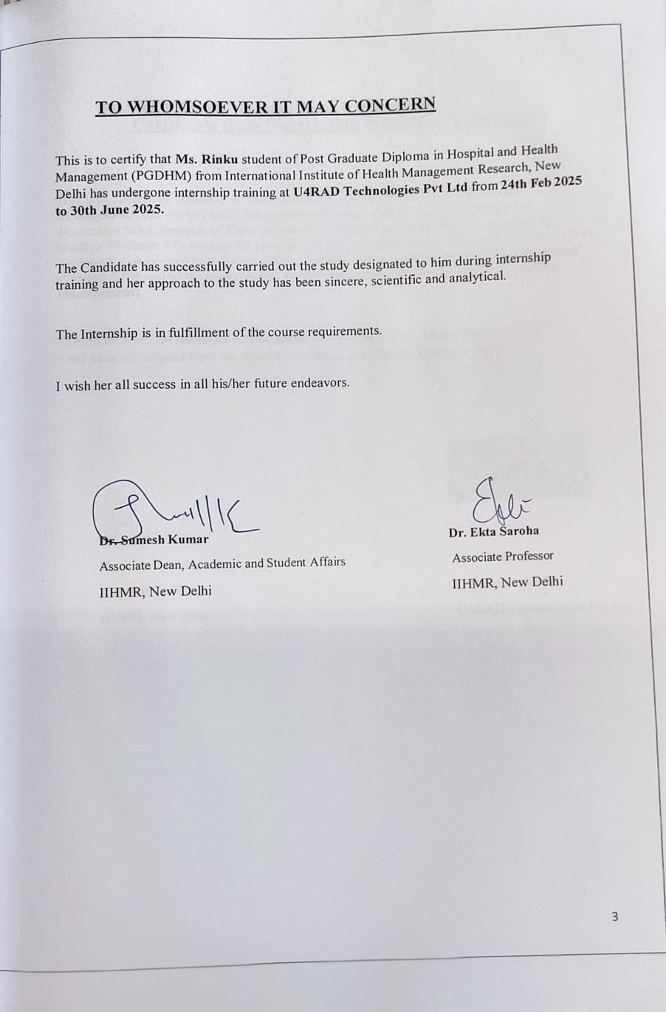

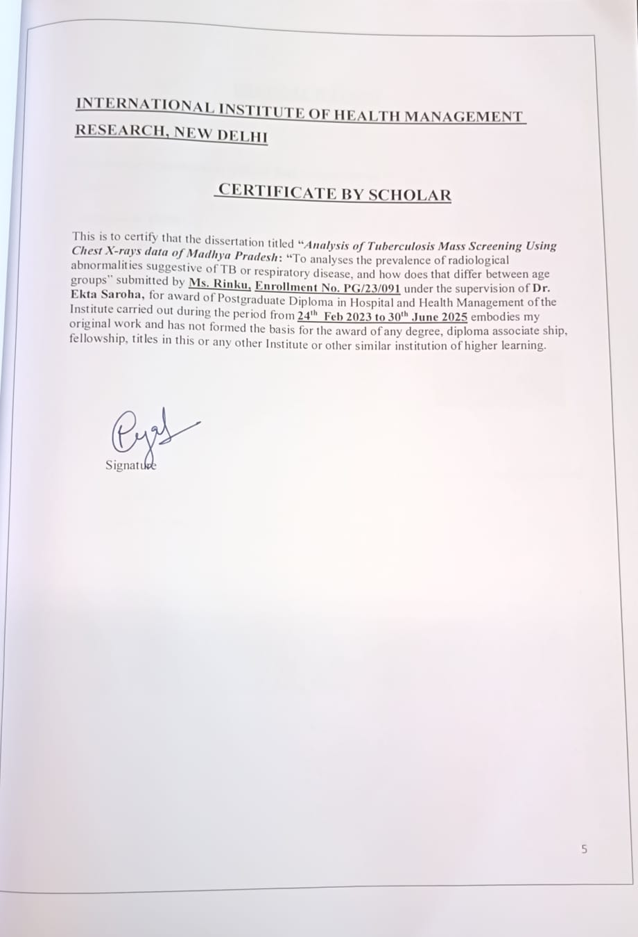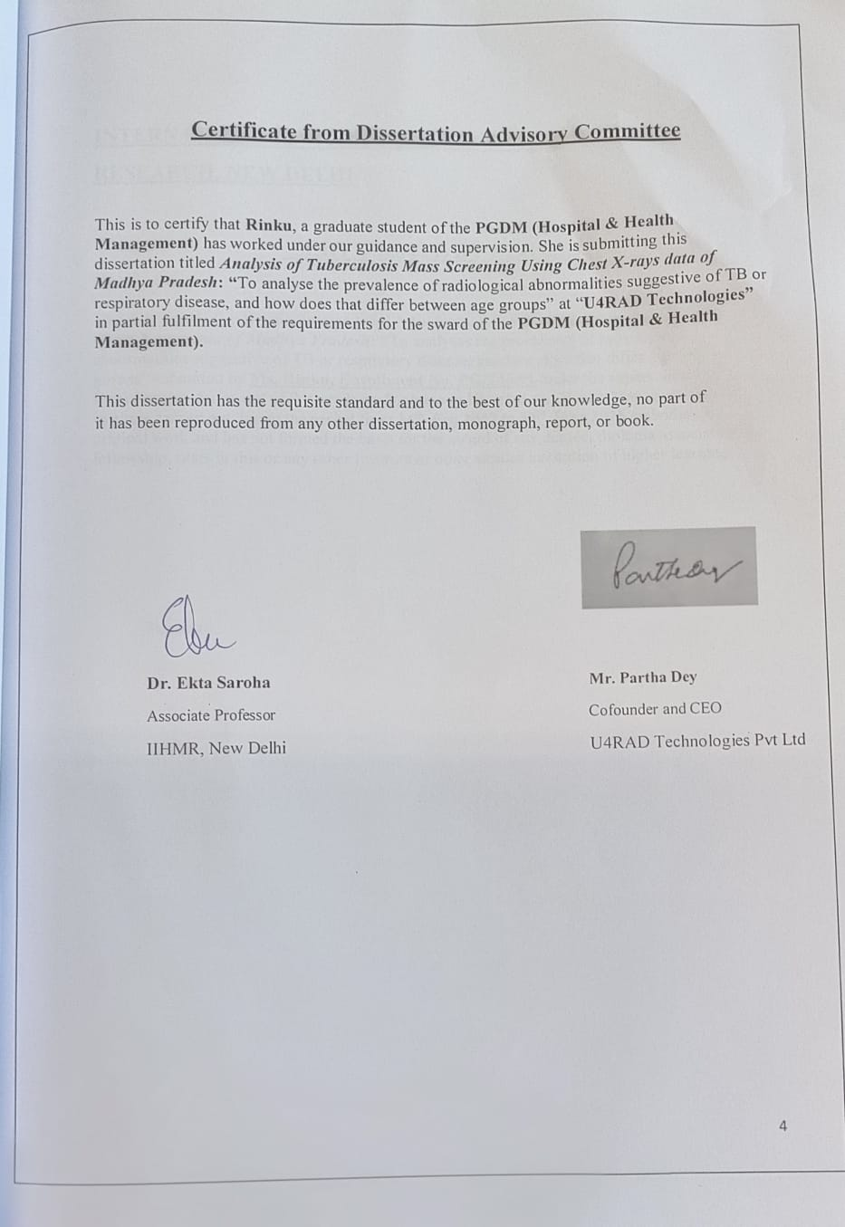
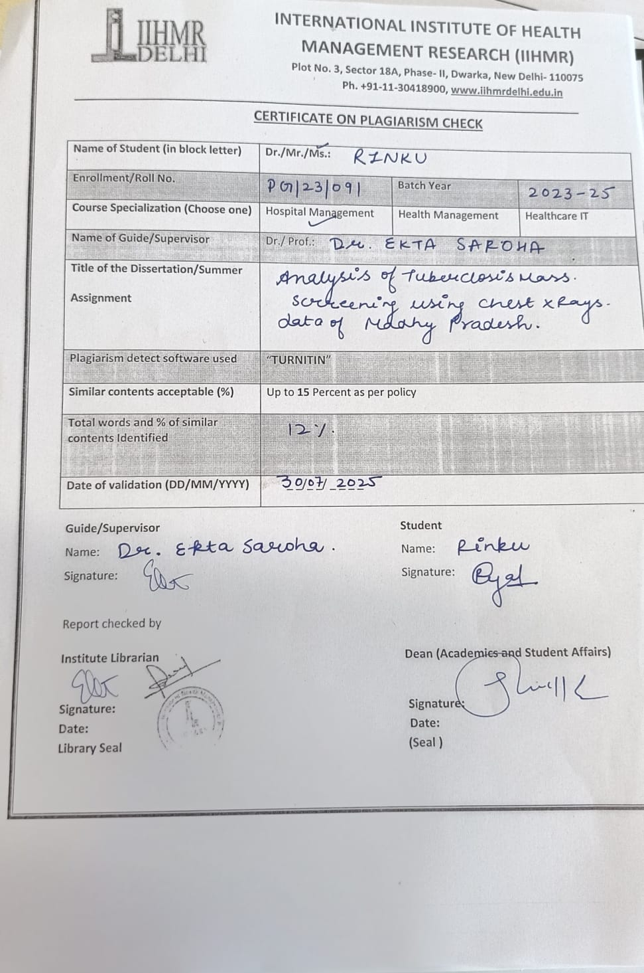

FEEDBACK FORM

Name of the Student: Ms. Rinku

Dissertation Organization: U4RAD Technologies Private Limited
Attendance: 100%
Objectives achieved: 100%
Deliverables: She demonstrated exceptional analytical skills, attention to detail, and professionalism during her internship. Her work provided valuable insights that can directly support targeted TB screening strategies.

Organization Mentor (Dissertation)
Date: 30-07-25
Place: Gurgaon

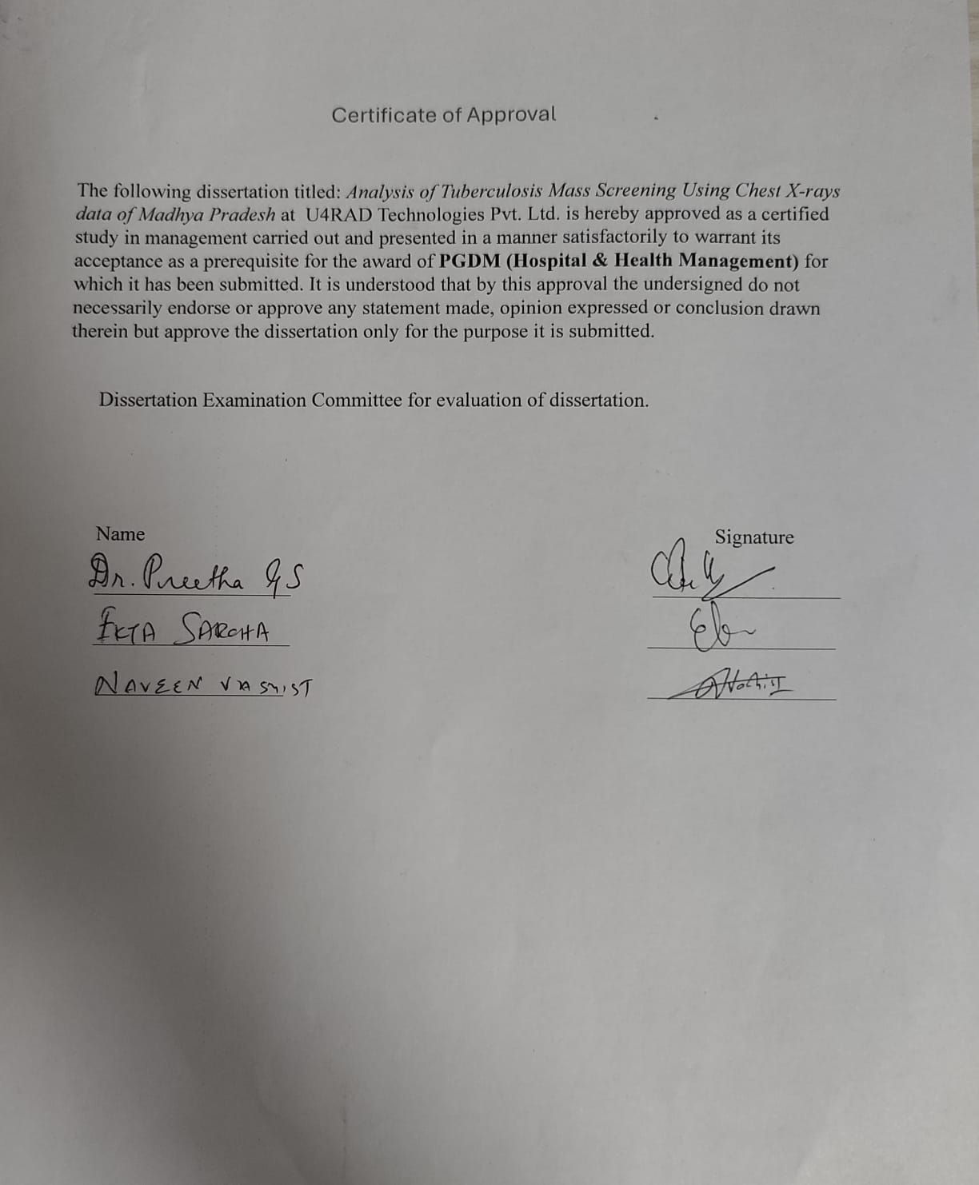

ACKNOWLEDGEMENT

My Institute - International Institute of Health Management Research (IIHMR), Delhi deserves the foremost appreciation for providing me the opportunities to understand my capabilities. I would like to thank one and all in the IIHMR team for providing me a platform for my professional career as well as for helping me boosting up all my capabilities and making me confident enough to work for health care organizations. I would like to thank Dr. Ekta Saroha (Associate Professor and Mentor) for their continuous support.
I acknowledge the tremendous contribution of my guide in completion of the project right from the word goes. I would like to render my sincere thanks to Mr. Partha Dey (Founder and CEO, U4RAD) for providing me the opportunity to complete my dissertation.
I extend my words of thanks to all the staff for always being so cooperative and facilitating me. I am extremely grateful to my parents for their love, prayers, caring and sacrifices for educating and preparing us for our future. Finally, my thanks to all the people who have supported me to complete the research work directly or indirectly.

ORGANIZATION PROFILE

U4RAD TECHNOLOGIES PVT LTD
- U4RAD is revolutionizing radiology reporting with AI-assisted image analytics and a smart reporting toolkit.
- They're revolutionizing remote radiology reporting by enabling process improvement, appropriate digital intervention, and selected AI (Artificial Intelligence) application to help Radiologists become more efficient. Their AI-assisted Radiology Reporting technology will result in higher- quality diagnoses and shorter turnaround times.
- They want to double the productivity of radiologist reporting. They created an AI algorithm that can detect COVID 19 from a chest X-ray in a matter of seconds with >90%confidence, allowing it to be used as a Rapid Detection tool for the pandemic.

PUSHERS- DREAMERS- LEADERS:

Mr. Partha Dey

Founder and CEO
- Partha Dey, Founder of Max Healthcare (Head Operations), Artemis Hospital Gurgaon (Chief Operating Officer), Apollo Gleneagles Kolkata (Center Administrator), Member ofCII, HIMSS, UNDP, AMCHAM and IMAI, Pioneer in promotion of AI-Cognitive technologyin healthcare, was managing healthcare vertical for IBM in India/SA, Member of CII, HIMSS, UNDP, AMCHAM and IMAI, Member of CII.

Dr.VivekSahi Director
  - A dynamic healthcare IT professional with over 24 years of experience in clinical practice, healthcare management, quality consulting, clinical change management, and healthcare digital transformation. He is passionate about healthcare information technology and has a unique capacity to combine clinical knowledge, healthcare management expertise, and quality management skills to clearly understand and not only resolve difficulties faced by providers and payers, but also to assist them in developing and implementing solutions that effectively and efficiently satisfy their needs.
  - He's also interested in teaching physicians about EMRs and IT systems, as well as ensuring that electronic medical/health records are adopted through change management, as well as mentoring students and physicians preparing for jobs in healthcare administration and informatics.

Abstract

Introduction:
Tuberculosis (TB) is still one of the biggest public health issues in India. Finding TB early is very important, but it can be hard, especially in places where there are not enough resources. That’s using mobile chest Xray screenings is becoming more popular. In Madhya Pradesh, this method was used a lot, and my study is based on data from such a campaign. I looked at 1,000 records to understand how TB is detected and which groups are more likely to be affected.
Methodology:
I used a cross-sectional study, which means I looked at the data at one point in time.
The data came from a chest X-ray screening program in different districts of Madhya Pradesh. The sample included 1,000 people aged between 11 and 86 years. I used Microsoft Excel to clean the data and OTHM Software to extract and organize the text from the chest X-ray reports.
To find abnormalities, I looked for keywords like "infective etiology," "cardiomegaly," and "abnormality seen" in the findings section.
I removed records that had missing age or findings. After removing 143 duplicate entries and 5 invalid records, I analyzed 852 valid entries.
Results:
Out of the 852 valid records, 158 people (18.
5%) had radiological signs that could suggest TB or other lung problems. The rate of abnormalities increased with age, reaching its highest in the 55–64 years group (22%) and then dropping slightly in those aged 65 and older (19. 4%). Most people (81%) had no abnormalities. The group was mostly female (60%) and male (40%), with an average age of 49. 5 years. The overall results show that nearly one in five people needed more tests or follow-up.
Conclusion:
The study shows that large-scale chest X-ray screenings can help catch possible TB cases and other lung problems early, with a detection rate of 18.
5%. Older people (45 years and above) had a higher chance of showing signs, which means they should be prioritized in future screenings. By combining this with more detailed medical histories, proper diagnosis, and follow-up, future programs could be more effective in finding TB cases.
Tables of contents:

S. No. | Topic | Page No.
1 | Introduction | 12
2 | Research Question | 13
3 | Objectives | 14
4 | Methodology | 14
5 | Result | 15  16
6 | Discussion | 17
7 | Limitations | 18
8 | Recommendations | 18
9 | Conclusion | 19
10 | References | 20

Introduction:

Tuberculosis isa contagious disease caused mainly by bacteria called Mycobacterium tuberculosis. It most often affects the lungs (pulmonary TB) but can also spread to other parts of the body (extrapulmonary TB). Though TB can be prevented and cured, it continues to be a big challenge in public health, especially in India. According to the World Health Organization (WHO)'s Global Tuberculosis Report 2023, India accounts for about 27% of the world’s TB cases, making the country most TB cases. This high number is due to many factors, such as poverty, delayed diagnosis, incomplete treatment, and coexisting conditions like HIV/AIDS and diabetes.
Recognizing this, the government of India started the National Tuberculosis Elimination Program (NTEP) with the goal of eliminating TB by 2025, which is five years earlier than the global target.
One of the main parts of this program is early detection through Active Case Finding (ACF). This involves screening people in the community to find TB cases before they start showing symptoms or become infectious, thereby stopping the spread of the disease.
Traditionally, TB detection in India has been based on checking for symptoms and then confirming the diagnosis through tests like sputum microscopy, GeneXpert/CBNAAT, or culture.
However, relying only on symptoms can miss early or mild cases, especially in people who have not yet developed obvious signs. Because of this, chest X-rays are being used more often to detect signs of TB in the lungs before symptoms start showing.
Mobile chest X-ray units are now being used more, especially in areas that are not well served by healthcare facilities, such as rural areas.
These units allow large groups of people to be screened quickly and can be part of community health activities. While a chest X-ray alone cannot confirm TB, it helps identify people who need further testing.
Madhya Pradesh, a big state in central India, has started using large-scale chest X-ray screening as part of its plan to eliminate TB.
The state faces several challenges in controlling TB, such asa high number of people living in rural areas,limited access to healthcare,and social and economic barriers to early diagnosis. The data used in this study comes from a governmet led massscreening program that covered many districts of the state.
This study looks at 1,000 chest X-ray records from the campaign.
The data includes information like age, gender, and the findings from the X-rays. The focus is on understanding how often abnormalities appear, which age groups are at higher risk, and how many people need further tests. By finding patterns in the X-ray results, this research aims to give suggestions for more targeted screening. This could help use resources better and make TB detection programs more effective.
This analysis is especially important because mass screening uses a lot of people and money.
Making these efforts as efficient as possible is key to achieving the goals of the NTEP. The results can help public health planners, TB program managers, and decision-makers design and carry out better active case-finding programs in areas with a high TB burden, like Madhya Pradesh.

Research Question:

• Primary Research Question:
What is the prevelance of chest Xray results that might show signs of tuberculosis or other lung diseases in mass screening programs in Madhya Pradesh, and how does this commonness differ among different age groups?
• Secondary Questions:
- Which age groups have the most chest X-ray results showing something wrong?
2. How well does chest X-ray screening work in finding people who need more tests?
3. How does the rate of finding such cases in this study compare with other TB screening programs in India?
Purpose of the study:
This study aims to check how effective chest X-ray screening is in finding tuberculosis cases in Madhya Pradesh by looking at real data from screening campaigns.
The goal is to find out how often chest X-rays show signs of TB or other breathing issues, find out which age groups are more at risk, and see how good the screening is at identifying people who need more tests.
By understanding how often different age groups have abnormal X-rays and how well screening works, the study will help create better, more efficient screening plans to help find TB cases earlier, as part of the National Tuberculosis Elimination Program (NTEP).
Objectives:
1.Look at the results from chest X-ray screenings.
2.Find out which age groups are more likely to have problems.
3.Check how well the screening identifies abnormal results.
Methodology:
• Study Design
This is an observational study that uses existing data from a government run TB mass screening program in Madhya Pradesh.
The program used mobile X-ray units as part of the National Tuberculosis Elimination Program (NTEP).
• Study Setting
Data was collected from many districts in Madhya Pradesh during a specific time of the TB screening campaign.
Mobile X-ray units visited rural and semi-urban areas to check people for TB and other breathing issues.
• Study Population and Sample Size
• Population: People living in selected districts in Madhya Pradesh who were screened through mobile chest X-ray programs.
• Sample Size: 1,000 chest X-ray records were initially gathered.
• Age Range: Participants were between 11 and 86 years of age.
• Inclusion Criteria
• Records with correct patient age.
• Records with clear chest X-ray results.
• Exclusion Criteria
• Records with missing or incorrect age information.
• Records with blank or unclear "findings" fields.
• Duplicate entries based on patient ID and screening date.
• Data Cleaning and Preparation
1. Removing Duplicates: 143 duplicate entries were deleted using patient IDs and dates.
2. Removing Invalid Records: 5 records with missing or unreadable findings were excluded.
3. Final Dataset: After cleaning, 852 valid records were used for analysis.
• Key Variables
• Demographic Data: Age (grouped into standard age groups), gender.
• Radiological Findings: Taken from the "findings" section of the chest X-ray reports.
• Abnormality Status: Categorized based on keywords like "infective etiology", "cardiomegaly", "bronchovascular congestion", and "abnormality seen".
• Data Analysis Tools and Methods
• Software Used:
o Microsoft Excel – for cleaning data, making tables, and doing basic statistics.
o OTHM Software – for automatically pulling out relevant words from the X-ray reports.
• Statistical Analysis:
o Basic statistics to count and show the percent of abnormal findings.
o Prevalence calculated using the formula:
o Age-specific analysis to find high-risk age groups.
• Ethical Considerations
The study used secondary, anonymous data from an official TB screening program.
No personal details were used in the analysis. Ethical approval wasn't needed for de-identified public health data.
Outcome Measures
1. Primary Outcome: How common are abnormal chest X-ray findings that may mean TB or other lung diseases.
2. Secondary Outcomes:
o The age group with the highest rate of abnormal findings.
o The percentage of people who needed more testing after the screening.

Results:

The dataset analyzed in this study was obtained from a mass tuberculosis (TB) screening program conducted in Madhya Pradesh under the National Tuberculosis Elimination Program (NTEP). The screening was carried out using mobile digital chest X-ray (CXR) units.

A total of 1,000 screening records were initially provided. After data cleaning:

143 duplicate records (same patient ID and screening date) were removed.

5 records were excluded due to missing or uninterpretable “findings” fields.

This resulted in a final dataset of 852 valid CXR screening records for analysis.

General Screening Outcomes

Overall distribution of findings:

Abnormal Findings: 158 cases (18.5%) – CXR reports showed abnormalities suggestive of TB or other respiratory conditions.

Normal Findings: 690 cases (81%) – No visible abnormality on CXR.

Uninterpretable/Blank Findings: 4 cases (0.5%) – Findings field left blank or unclear.

Gender distribution:

Female: 60% (n = 511)

Male: 40% (n = 341)

Age profile:

Mean age: 49.5 years

Age range: 11 to 86 years

Age-Specific Prevalence of Abnormalities

Analysis by age groups revealed a clear increase in prevalence of abnormalities with age:
Age Group (Years) | Number Screened | Abnormal Cases | Prevalence (%)
<25 | 108 | 8 | 7.4%
25–34 | 122 | 15 | 12.3%
35–44 | 145 | 22 | 15.2%
45–54 | 160 | 29 | 18.1%
55–64 | 160 | 35 | 21.9%
65+ | 157 | 30 | 19.1%
Total | 852 | 158 | 18.5%

Interpretation:

The 55–64 years age group had the highest abnormality prevalence (22%), followed by those aged 65+ (19.4%).

Younger groups (<25 years) had the lowest abnormality prevalence (~7–8%).

This trend indicates that age is a major risk factor for radiological abnormalities.

Screening Yield Calculation

Formula:

Screening Yield (%) = Number of Abnormal Cases / Total Screened × 100

Calculation:

Yield=158 / 852×100=18.5

Interpretation:

Nearly 1 in 5 individuals screened was flagged for further diagnostic evaluation.

This yield is consistent with other TB mass screening studies in India, which report yields between 15–35%.

Nature of Radiological Abnormalities

The abnormalities detected in the abnormal CXR group included:

Infective etiology: Patchy opacities, consolidation, infiltrates.

Cardiomegaly: Enlarged heart shadow.

Bronchovascular congestion: Prominent vascular markings.

Fibrotic changes and pleural thickening: Suggestive of old healed TB or chronic lung disease.

Gender-Based Trends

A higher proportion of screened participants were female (60%).

Preliminary analysis suggested a slightly higher percentage of abnormalities among females, likely due to higher participation in community-based screenings rather than biological predisposition.

Male participation may have been lower due to occupational absence during daytime screening drives.

Comparison with Previous Studies

The 18.5% prevalence of abnormal CXR findings aligns with Indian studies such as Datta et al. (2020) and Bhargava et al. (2013), which reported yields in the 15–35% range.

The higher abnormality rate in older adults is consistent with WHO global data and Indian studies linking TB risk with advancing age.

Public Health Implications

The relatively high yield demonstrates that CXR-based screening is an effective triage tool in mass TB detection programs.

The age-specific pattern suggests that targeting individuals aged 45 years and above may

increase program efficiency.

All abnormal CXR findings should be followed by microbiological confirmation

(e.g., CBNAAT or sputum microscopy) before initiating treatment.

Overall abnormality prevalence: 18.5% (158/852).

Highest risk group: 55–64 years (22% prevalence).

Screening yield: Nearly 1 in 5 individuals required follow-up diagnostic evaluation.

Gender pattern: Higher female participation; slightly higher abnormality detection in women, possibly due to participation bias.

Alignment with literature: Results are consistent with previous Indian TB screening studies.

Discussion:
The current study looked at 852 chest X-ray records from a large TB screening program in Madhya Pradesh.
It found that 18. 5% of people had signs on the X-rays that might suggest TB or other lung problems. The chance of finding such signs went up with age, reaching 21. 9% for people aged 55 to 64 and 19. 1% for those 65 and older.
This pattern matches what the World Health Organization and national reports have shown, which say that older people are more likely to get TB because their immune systems weaken with age, they’ve been exposed to TB for longer, and they often have other health problems.
The fact that nearly one in five people needed more tests aligns with other studies in India, showing that chest X-rays are a useful first step in finding TB cases.
Even though more women took part in the screening (about 60%), the slightly higher rate of abnormal X-rays among women is probably because more women were willing to participate, not because women get TB more often.
These findings have important public health messages: focusing on people 45 and older could make screening more efficient, and combining X-rays with tests like CBNAAT or sputum microscopy would help confirm TB more accurately. However, the study only looked at X-ray results without checking for TB in other ways, didn’t collect patient histories, and was a one-time check. These limits mean we can’t be sure about TB diagnosis, but the results still support the use of mobile X-ray screenings, especially in places where there’s a lot of TB and resources are limited.
Limitations of the Study:
1. No Diagnostic Confirmation:
The study only used X-ray results without doing tests like CBNAAT or sputum microscopy to check for active TB.
2. Lack of Clinical Information:
There was no data on symptoms, other health issues, smoking, or past TB treatment, making it hard to connect X-ray results with actual health problems.
3. Cross Sectional Design:
It only looked at one point in time, so it couldn’t track how people responded to treatment or what happened to them later.
4. Geographic Scope:
Data came from a few areas in Madhya Pradesh, which might not represent the whole state or country.
5. Participation Bias:
More women were screened, which might have influenced results and may not accurately reflect the true rate of TB in the population.
Recommendations of the Study:
1. Focus on High Risk Age Groups:
Prioritize screening for people 45 and older since they had the highest rates of abnormal X-rays.
2. Link Screening with Confirmatory Testing:
Every abnormal X-ray should be checked with CBNAAT or sputum microscopy before starting treatment.
3. Improve Data Collection:
Include information about symptoms, other health problems, lifestyle, and past TB in future screenings.
4. Increase Male Participation:
Plan screenings at times that are more convenient for working men, like evenings or weekends.

5. Adopt AI Based Interpretation:
Use AI tools for quick, accurate, and standard X-ray readings during large screenings.
6. Ensure Follow Up:
Create a strong system to track which people get confirmed TB, start treatment, and their outcomes.
7. Optimize Resources:
Use mobile X-ray units in areas that have the most TB cases, based on data, to make screenings more effective.

Conclusion:
This study reviewed 852 chest X-ray records from a government TB screening program in Madhya Pradesh.
It found that 18. 5% of people had X-ray signs that could be linked to TB or other lung problems, showing that X-rays can be a helpful tool for finding possible TB cases in the general population.
The highest rate of X-ray abnormalities was seen in older adults, especially those aged 55 to 64 (21.
9%), which matches the global understanding that TB risk increases with age because of weaker immune systems and long-term exposure. Even though more women were screened, this was likely due to more women participating, not because women have a higher risk.
The study confirms that mobile X-ray units are an effective way to find high-risk people in areas with limited resources.
However, it also shows that X-rays alone can’t diagnose TB for sure, and further tests are necessary. Despite not having patient histories, microbiological data, or follow-up results, the study offers useful guidance for public health decisions. Focusing on people 45 and older, along with strong follow-up systems, can greatly improve TB detection and help India reach its goal of ending TB by 2025 under the NTEP.

References

- Goddard P, Leslie A, Jones A, Wakeley C, Kabala J. Error in radiology. Br J Radiol. 2001;74:949– 951. doi: 10.1259/bjr.74.886.740949. [PubMed]

- Robinson PJA. Radiology’s Achilles’ heel: error and variation in the interpretation of the Röntgen image. BJR. 1997;70:1085–1098. doi: 10.1259/bjr.70.839.9536897. [PubMed] [CrossRef] [Google Scholar] [Ref list]

- Muhm JR, Miller WE, Fontana RS, Sanderson DR, Uhlenhopp MA. Lung cancer detected during a screening program using four-month chest radiographs. Radiology. 1983;148:609–615. doi: 10.1148/radiology.148.3.6308709. [PubMed]

- Quekel LGBA, Kessels AGH, Goei R, van Engelshoven JMA. Miss rate of lung cancer on the chest radiograph in clinical practice. Chest. 1999;115:720–724. doi: 10.1378/chest.115.3.720. [PubMed]

- Berlin L. Radiologic errors and malpractice: a blurry distinction. AJR. 2007;189:517–522. doi: 10.2214/AJR.07.2209. [PubMed] [Google Scholar]

- Bruno MA, Walker EA, Abujudeh HH. Understanding and confronting our mistakes: the epidemiology of error in radiology and strategies for error reduction. Radiographics. 2015;35:1668– 1676. doi: 10.1148/rg.2015150023. [PubMed]

- Robinson PJ, Wilson D, Coral A, Murphy A, Verow P. Variation between experienced observers in the interpretation of accident and emergency radiographs. Br J Radiol. 1999;72:323–330.
doi: 10.1259/bjr.72.856.10474490. [PubMed] [Google Scholar]

- Renfrew DL, Franken EA, Berbaum KS, Weigelt FH, Abu-Yousef MM. Error in radiology: classification and lessons in 182 cases presented at a problem case
conference. Radiology. 1992;183:145–150. doi: 10.1148/radiology.183.1.1549661. [PubMed]

- Kim YW, Mansfield LT. Fool me twice: delayed diagnoses in radiology with emphasis on perceptuated errors. AJR. 2014;202:465–470. doi: 10.2214/AJR.13.11493. [PubMed]

- Smith M. Error and variation in diagnostic radiography. Springfield: Charles C. Thomas; 1967. [Google Scholar]

- Adrian Brady, Risteárd Ó Laoide, Peter McCarthy , Ronan McDermott. Discrepancy and Error in Radiology: Concepts, Causes and Consequences. 2011 Oct 3. [NCBI]

- Berlin L, Berlin JW. Malpractice and radiologists in Cook County, IL: trends in 20 years of litigation. AJR Am J Roentgenol. 1995;165(4):781–8. [PubMed] [Google Scholar] [Ref list]

