Internship Training
at
Centre For Sight, Dwarka, New Delhi
Title: Understanding the perspective of patients on cataract surgery in an eye care hospital, New Delhi
Centre for Sight
by
Name: Priyansha Srivastava
Enroll No. PG/23/086
Under the guidance of
Dr.Rupsa Banerjee
PGDM (Hospital & Health Management)
2023-25



International Institute of Health Management Research
New Delhi

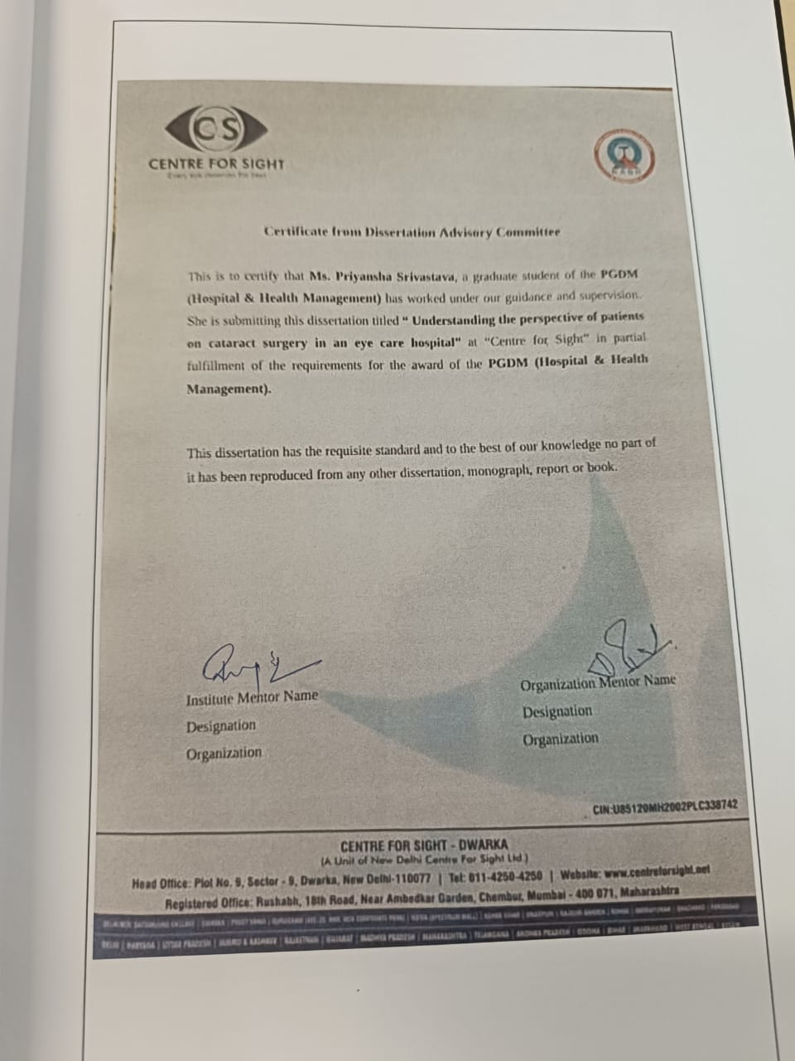

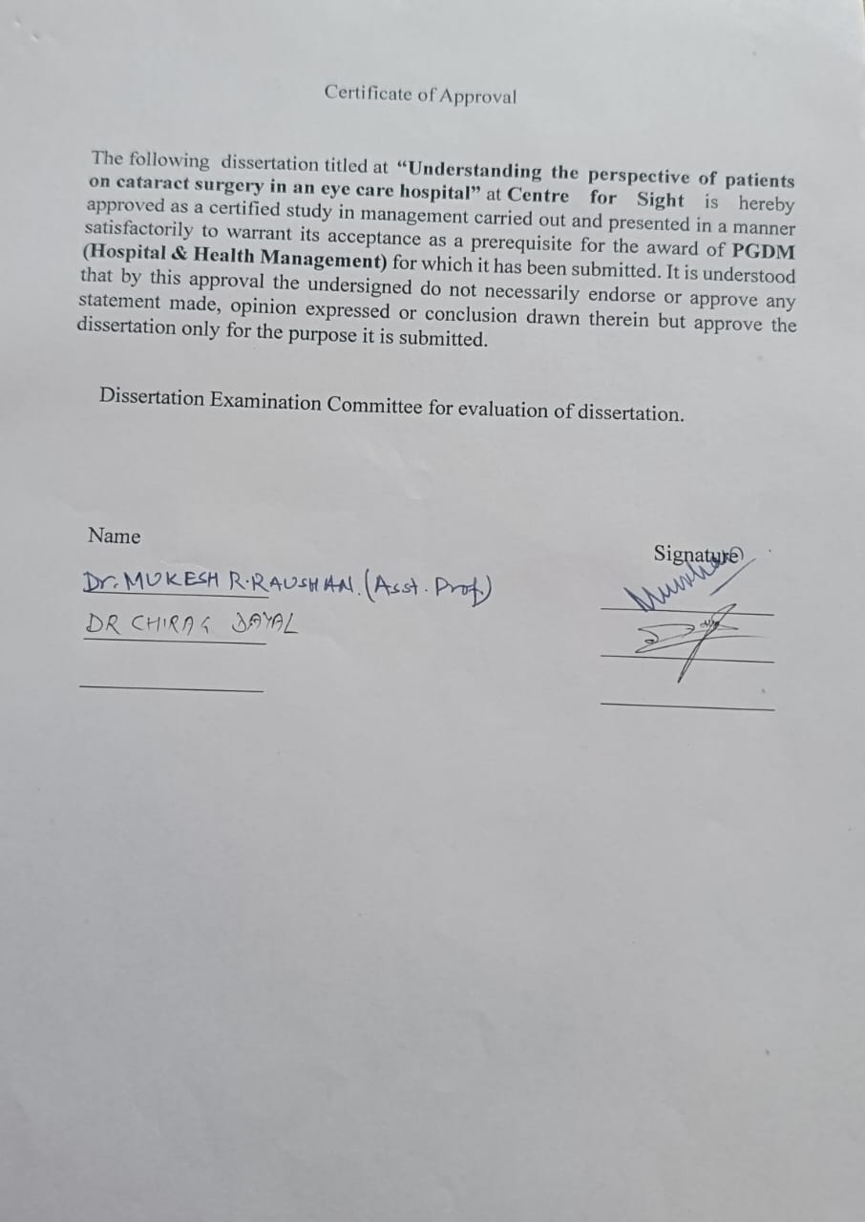

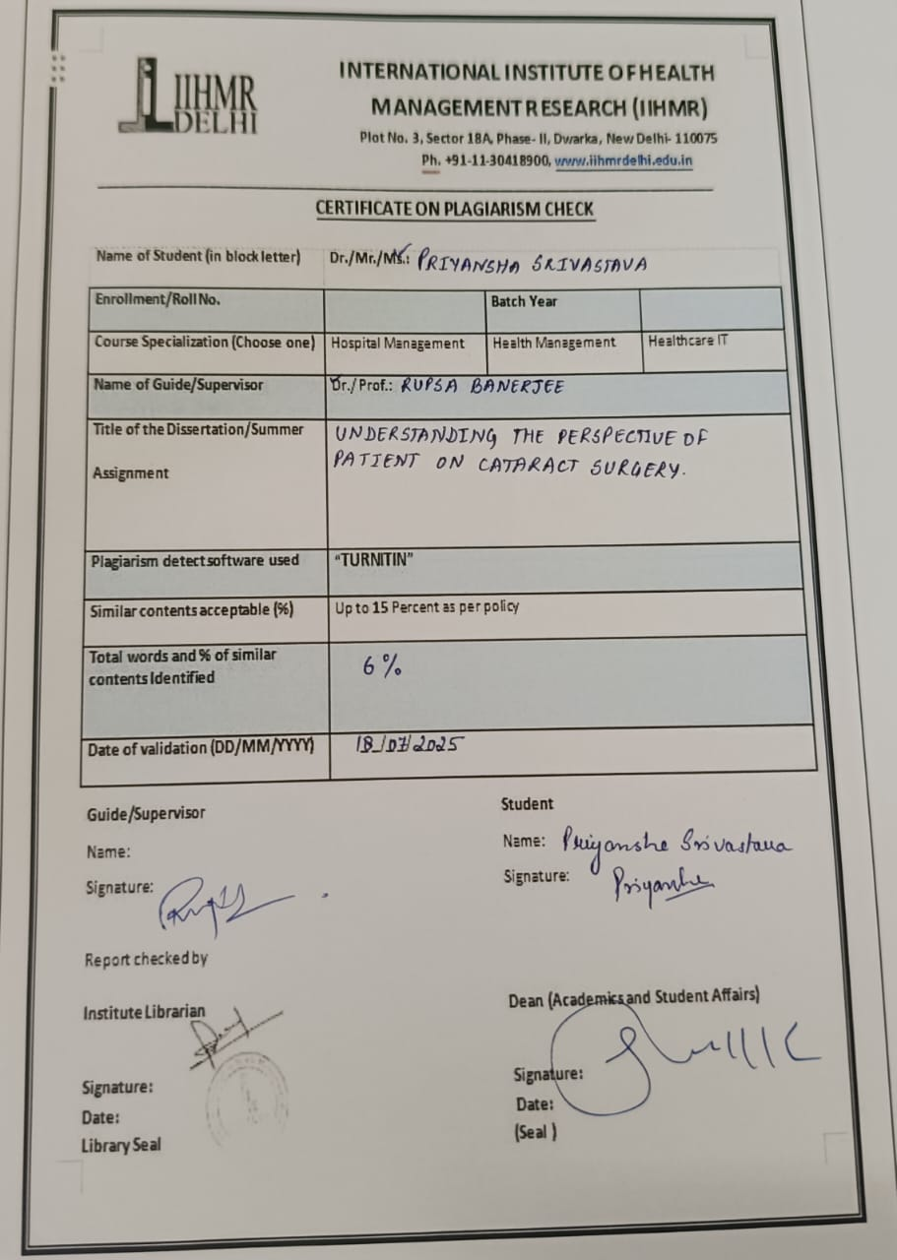

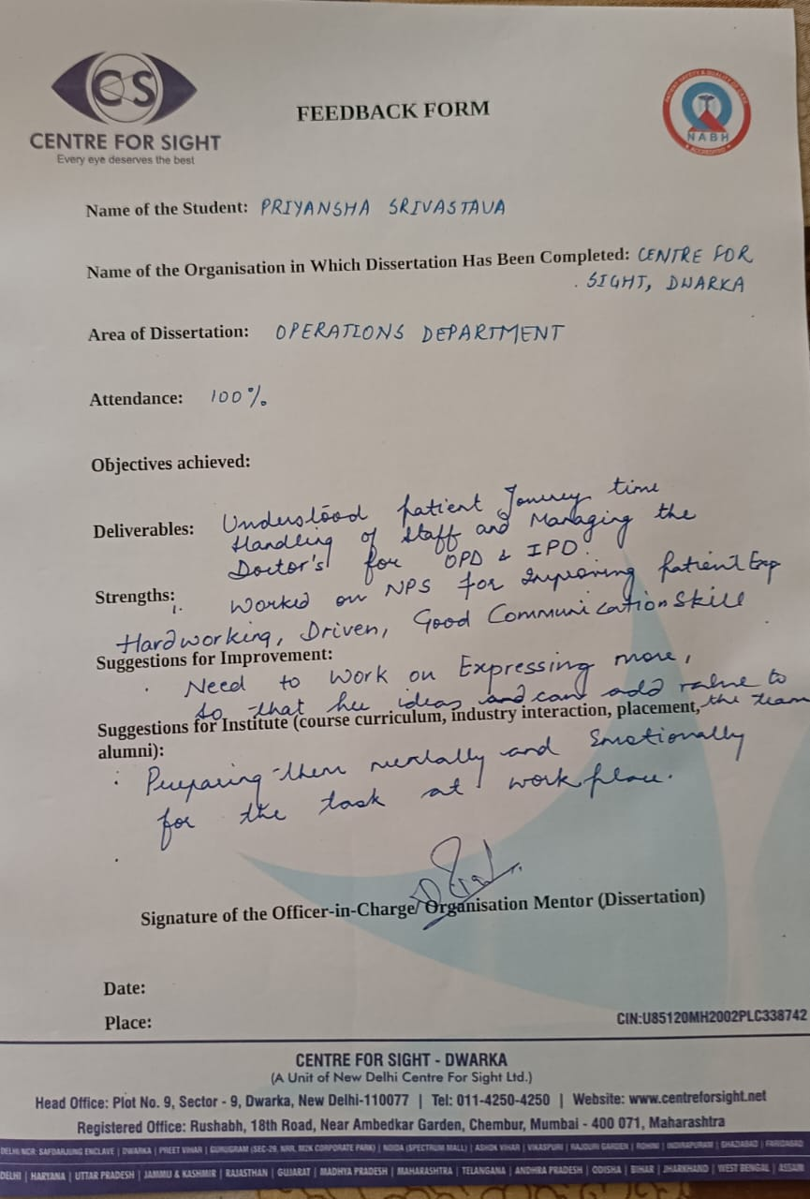

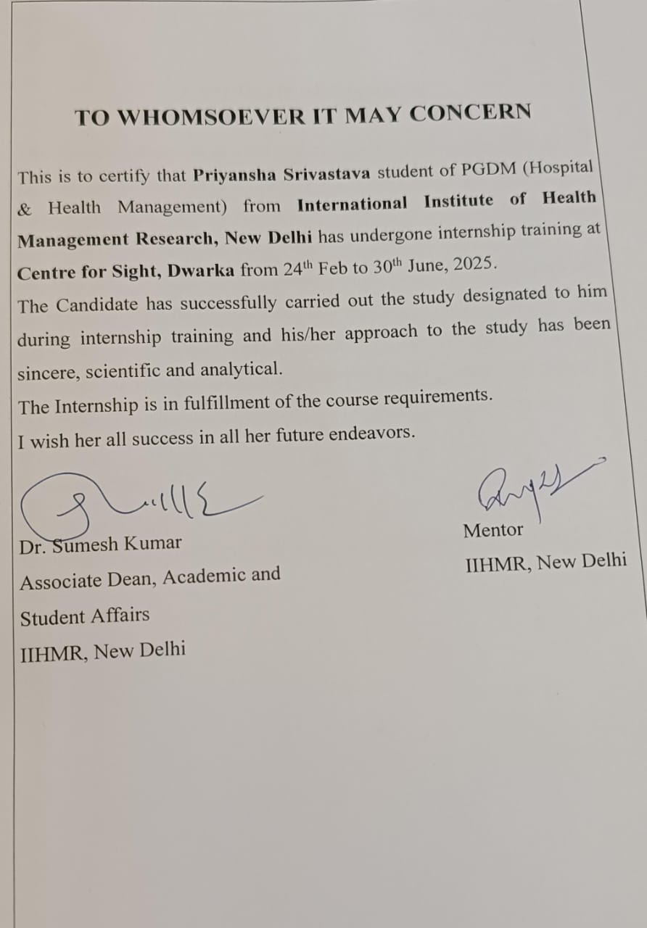

Table of Content

- Acknowledgement
- Abbreviations
- Introduction of the organization
- Abstract
- Review of literature
- Scope of study
- Methodology
- Objective of the study
- Rationale of the study
- Introduction of the topic
- Results and interpretation
- Conclusion
- Limitations
- Suggestion to the organization
- Reference
- Annexure

ACKNOWLEDGEMENT

I wanted to take this opportunity to sincerely thank everyone who helped me finish this dissertation successfully titled “Understanding the Perspective of Patients on Cataract Surgery in an Eye Care Hospital”. Without the support and encouragement of others, preparing a project report is impossible. This is by no means an exception.

I would specially like to thanks my parents for their unwavering support during my internship. My hearthfelt thanks goes to IIHMR, Delhi.

First and foremost, I extend my sincere thanks to my mentor Dr. Rupsa Banerjee whose invaluable guidance, constructive feedback, and constant encouragement have been instrumental in shaping this work from inception to completion.

Besides this,I would like to express my heartfelt gratitude to Centre For Sight, Mr.Dharmender Rawat (Centre Manager),who assisted me tremendously during my project. I would also like to give my priceless thanks to Ms.Monika Sharma (Deputy Manager) and Mr. Narinder Singh (Assitant Manager) for their meticulous supervision at each and every phase of work and helping me out in every circumstances.
All of the patients who took part in the study have my sincere gratitude for their time, candor, and readiness to share their stories. This study would not have been feasible without their insightful contributions.

ABBREVIATIONS

- CFS: Centre For Sight
- IOL: Intra Ocular Lens
- NABH: National Accredited Board For Hospital and Healthcare Provider
- RNFL: Retinal Nerve Fiber Layer
- OCT: Optical Coherence Tonography
- FFA: Fundus Florescence Angiography
- AR-NCT: Auto Refraction and Non-Contact Tonometry
- HVF: Humphery Visual Field
- PMT: Post Mediatric Test
- OPD: Outpatient Department
- IPD: Inpatient Department
- FICCI: Federation of Indian Chambers of Commerce and Industry
- TPA: Third Party Administrator

INTRODUCTION OF THE ORGANIZATION

Founded in 1996 by Prof. Dr. Mahipal S. Sachdev, an eminent ophthalmologist, and Padma Shree awardee,Centre for Sight (CFS) is a leading eye care provider in India. Centre for Sight has been on a mission to eradicate preventable blindness in India by delivering world-class eye care. Through the incorporation of cutting-edge technology and top-tier medical professionals, we have become pioneers in the field of eye care. Our exceptional team, consisting of 350+ renowned doctors handpicked from premier institutions, ensures that you receive the highest standard of care. With a wide-reaching network of 85+ eye care centers nationwide, we make top-quality eye health services accessible to all. Our Centre for Sight Eye Institute in Dwarka, Delhi, stands as North India’s largest private comprehensive super-specialty eye institute, a testament to our commitment to excellence.

Patients at the Centre for Sight have access to the full spectrum of contemporary ophthalmic treatments. The Directorate General of Health Services has registered it under the Nursing Home Act in numerous states. The eye bank of the Centre for Sight is located in Delhi's Preet Vihar.

We have gained the confidence of prestigious public sector organizations, businesses, and TPAs by being registered in several states under the Nursing Home Act by the Directorate General of Health Services.We leverage world-class technology to deliver advanced solutions and uphold a patient- centric approach that prioritizes your well-being. We are NABH accredited which strengthens people’s trust in us and aids in our mission to enhance lives through superior vision care.

Centre for Sight won the prestigious Frost & Sullivan award as the eyecare provider company of the year 2010 & 2014, an affirmation of its value. It was awarded the prestigious FICCI Healthcare Excellence award for operational excellence in 2012. CFS also won ET Now leaders of Tomorrow award for business excellence in 2014. It also received the “Best Single Speciality Hospital Chain 2016” at Business world’s 3rd healthcare summit & awards.



ABOUT CENTRE FOR SIGHT DWARKA
The largest private comprehensive super specialty eye institute in North India is the Centre for Sight Eye Institute in Dwarka, which offers a one-stop shop for all things connected to eye disorders and issues. CFS distinguishes itself with state-of-the-art infrastructure facilities and eye care technologies. It arrives to provide a range of internationally recognized eye specialties along with comprehensive treatments, surgical procedures, and diagnostic services.
- It occupies 90,000 square feet
- It includes six storeys with seventeen examination rooms.
- It has almost twenty consultation rooms.
- It features nine cutting-edge, technologically sophisticated modular operating rooms.
AWARDS AND ACCREDIATIONS
- Padma Shri Award to Dr. Mahipal S. Sachdev in year 2007
- Times Healthcare Achiever’s Award for best single superspeciality hospital in 2017
- Centre for Sight has been recognized by the Federation of Indian Chambers of Commerce and Industry (FICCI) for excellence in patient safety, innovation, and use of technology in eye care.
- Several Centre for Sight centres are accredited by the National Accreditation Board for Hospitals & Healthcare Providers (NABH)
- Best healthcare brands by “The Economic Times 2021”

VISION:
“To establish the most preferred brand of super specialized world class eye care facilities in an daround India by 2025”

MISSION:
Centre for Sight is committed to deliver best quality care with personalized touch and cutting edge technology to enhance patient satisfaction and provide continual improvement in our services”

VALUES:
“Efficiency, precision, compassion and integrity”

QUALITY POLICY AND OBJECTIVES:
- To provide quality of care that exceeds the patient’s expectations
- To adhere to operational protocols of the institute, in order to reduce errors and enhance patient safety
- To comply with all statutory and regulatory requirements
- To provide on the job training to improve skills and competence of the staff
- To enhance health and safety of the staff members

Eye Care Specialities & Treatments

Cataract Eye Surgery
Get brilliant, sharp eyesight with a quick, outpatient surgery. The clouded lenses are taken out and swapped out by artificial lenses, which people can select according on their needs.

Smart Surface LASIK
The cornea's surface is reshaped using ExpeA, a no-touch, flapless laser treatment, to improve clarity and hasten healing.

Custom Eyes LASIK
Sharper, higher-definition vision with less nighttime glare is possible with a customized laser vision correction that uses wavefront technology.

PRK (Photorefractive Keratectomy)
A surface laser eye surgery that removes the epithelium before reshaping the cornea, ideal for thin corneas and active lifestyles.

LASIK Surgery: Everything You Need to Know
LASIK surgery, generally known as laser eye surgery, It is defined as a revolutionary procedure designed to correct refractive errors such as myopia (near-sightedness)

Contoura Vision Surgery
In order to provide individualized treatment for refractive flaws such as myopia, hyperopia, and astigmatism, as well as corneal abnormalities and visual axis problems, this laser technology maps and reshapes the cornea.

SMILE Eye Surgery

Gain crystal-clear vision with SMILE, the most advanced refractive surgery which is minimally invasive, precise, and offers quick recovery. It corrects myopia and astigmatism. So, rediscover clarity effortlessly.

Elita SILK Surgery
Smooth Incision Lenticule Keratomileusis, or SILK, is a next-generation laser vision correction technique that makes use of a second-generation femtosecond laser.
India's ICL (Implantable Collamer Lens) Surgery
In contrast to conventional contact lenses, ICL involves implanting a pair of lenses into the eyes, which eliminates the need for removal.

Glaucoma Surgery
Find individualized treatment for glaucoma, including genuine and efficient drugs and precisely calibrated operations that guarantee precise intraocular pressure control and protect your eyesight for a better future.
Oculoplasty
Oculoplastic surgery is performed by our talented ophthalmologists to treat orbit (eye socket), eyebrow, eyelid malposition, and tear drainage abnormalities in order to improve function, comfort, and beauty.
Keratoconus treatment
Keratoconus is a progressive corneal disorder that can be treated with contact lenses, cross-linking therapy, and, if required, corneal transplant surgery to provide the best possible visual results

Retinoblastoma
Our exceptional Retinoblastoma treatment offers precise and effective solutions for children with eye cancer, like highly-advanced chemotherapy, laser therapy, and surgical interventions.

Squint Surgery for Adults – It’s Time to Restore Your Confidence
For the best alignment and visual enhancement, we offer complete squint eye treatment using cutting-edge diagnostics such as vision therapy, corrective lenses, and, if necessary, precise eye muscle surgery.

Paediatric Ophthalmology & Squint
Discover the best in pediatric ophthalmology. Squint treatment with our highly qualified surgeons who specialize in using cutting-edge technologies to treat children's eye diseases and misalignments.
Cornea Transplant
Corneal problems cause the cornea to become deformed, hazy, and scarred; they can even cause blindness. However, we provide exact care to cure illnesses and provide comfort and clarity through therapeutic interventions and transplants.
Uvea and Retina
With their knowledge, cutting-edge technology, and equipment for vitreoretinal surgery and vitrectomy surgery, highly qualified eye surgeons provide top-notch therapy for retinal problems.
Types of doctor’s specialization at CFS:
- Cataract
- Glaucoma
- Anterior segment and refractive
- Cornea specisalization
- Retina
- Pediatric
- Squint

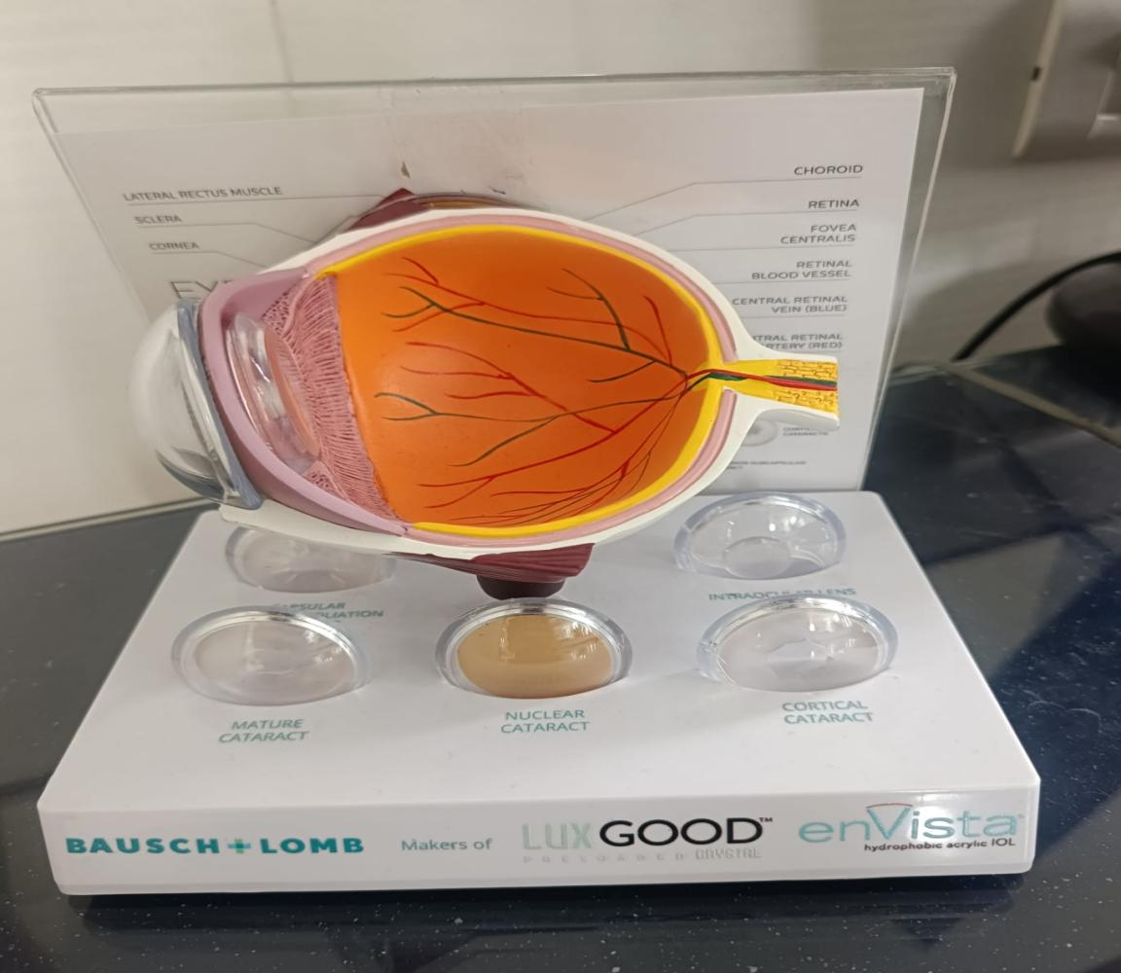
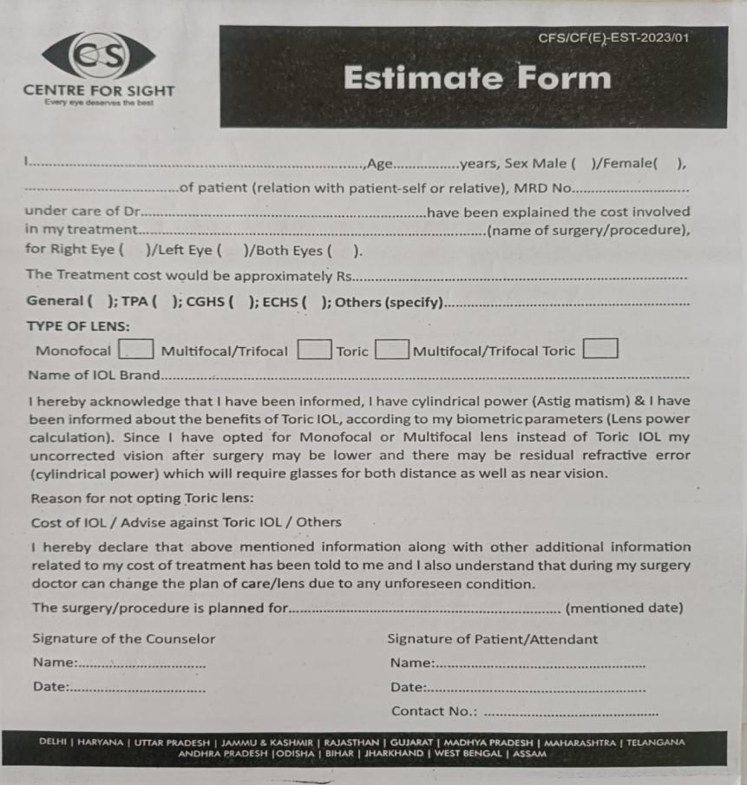

SCOPE OF SERVICES
Table 1:
Anesthesiology | Orbit surgery
Ophthalmic emergency | Ocular oncology
Comprehensive ophthalmic services | Cornea service
Cataract services | Refractive services
Glaucoma services | Uvea services
Vitreo retina services | Squint services
Oculoplasty & reconstructive surgery | Optical
Pediatric ophthalmology | Pharmacy

DIAGNOSTIC SERVICES
Table 2:
A Scan biometry | Gonioscopy
IOL Master biometry | Keratoconus workup
OCT | HVF
Fundus Fluorescein Angiography | Auto- refractometry
Fundus Photography | Diplopia charting
Keratometry | Sqquint work up
Pachymetry | Anterior segment photography
Corneal Topography | Specular microscopy
Tonometry | Contact lens/ soft lens workup
OUT-SOURCED SERVICES AT CENTRE FOR SIGHT
- Security: Tiger Security Services
- Emergency & Ambulance: Aakash hospital & Ayushman Hospital, Dwarka., New Delhi
- Laundry: Amit laundry and dry cleaners
DEPARTMENT WISE OBSERVATION (OPERATIONS)
During my tenure as an Operations Management Trainee at Centre for Sight Eye Institute, I gained hands-on experience and insights into various operational aspects of the hospital. The key observations and learnings are as follows:
- Acquired foundational knowledge of hospital operations, with a focus on staff management involving doctors, front desk executives, OPD attendants, counselors, and optometrists.
- Managed doctor scheduling through the HMIS system and oversaw appointment planning and rescheduling based on doctor availability, leaves, OT schedules, and emergency cases in the IPD.
- Developed a working understanding of the roles and responsibilities across key departments, including the front desk, diagnosis, pharmacy, counseling, optometry, floors, and impatient services.
- Prepared the Daily Operational Report to support routine performance monitoring.
- Participated in Medical Records Department (MRD) audits and contributed to clinical audits in line with NABH Accreditation standards.
- Gained exposure to the admission and discharge process for patients, ensuring a smooth patient journey and compliance with institutional protocols.

Patient Flow
CHECK-IN

APPOINTMENT/WALK-IN

REGISTRATION

AR-NCT

OPTOMETRIST CHECK UP

IF DILATION REQUIRED
IF DILATION NOT REQUIRED

TOOK AROUND 30-45 MINS TO DILATE
DIRECT CONSULTATION TO DOCTOR

DOCTOR CONSULTATION
PATIENT CHECK OUT

PATIENT CHECKOUT
ABSTRACT
Cataract remains one of the leading and growing causes of avoidable blindness in India, despite the availability of effective and affordable surgical interventions. This study aims to explore and understand the perspectives of patients regarding cataract surgery and this study is conducted in Centre for Sight Eye Institute, an eye care hospital in New Delhi. The research adopts a patient-centered approach to identify key factors that influence the decision-making process around undergoing cataract surgery.
A quantitative survey was conducted among patients who were aged 40 years and above who were diagnosed with cataract but had either accepted or deferred surgical intervention. Data was collected on socio-demographic variables, awareness levels (57%), perception of surgery benefits and risks (53%), financial considerations (46%), trust in healthcare providers, and the role of family and community opinions.
Preliminary findings indicate that while a majority of patients were aware of cataract and its treatability, several barriers hinder timely acceptance of surgery. These included fear of complications, lack of clear communication from doctors, financial constraints, and influence of negative experiences from peers or relatives. On the positive side, patients who trusted the hospital and received adequate counseling from clinicians were more likely to proceed with the recommended surgery.
The study highlights the need for targeted awareness programs, empathetic patient communication, and affordable care models to bridge the gap between diagnosis and surgical treatment. Enhancing the patient experience and addressing their concerns could significantly improve surgical uptake, thereby reducing the burden of avoidable visual impairment.
Keywords: Cataract, Patient perspective, Eye care, Barriers, Awareness, Surgery acceptance, Centre for Sight, New Delhi.

REVIEW OF LITERATURE
Cataract is the leading and growing cause of blindness throughout the world, responsible for around 51% of world blindness (WHO, 2021). In India although there is high caseload of cataract surgeries, there is still a large backlog due to a variety of reasons related to patients, system, and socio-cultural (Murthy et al., 2012).
It has been demonstrated that patient perception and knowledge is a key determinant for cataract surgey uptake. A study by Fletcher et al. (1999) in South India identified that unawareness regarding cataract and the availability of treatment was one of the key reasons for delayed surgery. Similarly, Dandona et al. 3 and Seg'orbe et al. (2001) also showed that many patients had not consulted an appropriate doctor in time, E3ecas (2000-2001) that in- adequate knowledge of the disease and fear of the disease.
Fear of complications with surgery is frequently cited as a barrier. In a rural Maharashtra study, Gogate et al. (2007) reported that nearly 40% of patients feared blindness after surgery. Often this worry is based on anecdotal stories that the patient hears from neighbors or family members, not on first hand experience.
Provider communication and counseling strongly affect decision making. In a study by Ramke et al. (2010), good patient–doctor communication and empathetic counseling were the best predictors of higher surgical acceptance, particularly in elderly and illiterate subjects.
Additionally, socioeconomic factors, including income, employment situation and educational status, have a well-established effect on the stage of surgical readiness of the d3subtype patient. Venkatesh et al. (2005), cataract surgery can be seen as not affordable for lower income patient groups even though subsidized programs exist. Which is why shared information about services that are already free or very low cost is of paramount importance.
Community and family act as an influencer of health decision making. In collectivist cultures as in India, adult children or spouse were found to influence positively as well as negatively to undergo cataract surgery among elderly members (Briesen et al., 2010).
Belief in other system of medicine is revolt in recent literature. Others who have minimally operable cataracts use traditional eye drops or village service providers and are slow to seek modern surgery based on research findings (Thulasiraj et al., 2003).
To conclude, based on the review, cataract surgery denial or delay has been identified as a multi-factorial phenomena that ranges from psychological, financial, misinformation to mistrust in the system. Such observations emphasise the importance of a multidisciplinary, patient-centric approach in eye care hospitals, such as the Centre for Sight, especially in urban but deprived areas.

Key References:
- WHO (2021). World report on vision.
- Dandona, R., & Dandona, L. (2001). Review of findings of the Andhra Pradesh Eye Disease Study. Indian Journal of Ophthalmology.
- Fletcher, A.E., et al. (1999). Low uptake of eye services in rural India: a challenge for programmatic strategies. British Journal of Ophthalmology.
- Gogate, P., et al. (2007). Why do phacoemulsification? Manual small-incision cataract surgery is almost as effective, but less expensive. BMJ.
- Ramke, J., et al. (2010). Patient perspectives on cataract surgery: barriers, facilitators, and solutions. Community Eye Health Journal.
- Venkatesh, R., et al. (2005). Social and economic factors in cataract surgery uptake in South India. Indian Journal of Ophthalmology.
- Briesen, S., et al. (2010). Family dynamics in cataract surgery decisions: qualitative insights from India. Ophthalmic Epidemiology.
- Thulasiraj, R.D., et al. (2003). Barriers to cataract surgery in South India. Community Eye Health Journal.

SCOPE OF THE STUDY
This study is conducted within the premises of Centre for Sight, New Delhi, a leading super-speciality eye care hospital in PAN India. The scope of this research is centered on exploring the perceptions, beliefs, attitudes, and decision-making processes of patients who are advised cataract surgery by ophthalmologists but may delay, deny, or hesitate to undergo the procedure.
Key dimensions within the scope include:
- Patient Awareness and Understanding
To assess the level of awareness among patients regarding cataract as a disease, the availability of treatment options, expected outcomes, and the consequences of delayed surgery.
- Attitudinal and Psychological Factors
To study fears, anxieties, and personal beliefs (including fear of blindness, pain, or surgical failure) that influence patients’ decisions.
- Role of Health Communication
To examine the impact of doctor-patient communication, clarity of explanation regarding the procedure, and the time given by healthcare providers on patient trust and willingness to proceed.
- Socioeconomic and Educational Influences
To explore how education level, employment status, monthly income, and cost perception act as facilitators or barriers to surgery uptake.
- Influence of Community and Social Networks
To understand the impact of family, peers, and community opinions—including prior experiences with surgery—on individual decision-making.
- Cultural and Alternative Beliefs
To identify the extent to which traditional healing practices, home remedies, or spiritual beliefs affect the acceptance of modern cataract surgery.
- Hospital Trust and Infrastructure Perception
To evaluate patient trust in the hospital’s infrastructure, staff behavior, and overall service quality as a determinant of their final decision.

Institutional Scope
- Location: Centre for Sight, New Delhi
- Target Population: Patients aged 40 years and above diagnosed with cataract
- Departments Involved: Outpatient Department (OPD), Cataract Services, Patient Counseling Unit

Operational Utility of the Study in the Hospital
- Improved Counseling Protocols: Findings will help in designing better pre-surgical counseling tools and checklists.
- Awareness Campaigns: Identification of knowledge gaps will assist in developing targeted awareness materials for the OPD waiting areas.
- Policy and Planning: The hospital administration can use insights to introduce financial counseling or community outreach programs.
- Enhanced Patient Experience: Addressing patients’ fears and improving trust-building can result in higher surgical conversions and satisfaction scores.

OBJECTIVES OF THE STUDY
- To examine the key reasons patients refuse cataract surgery.
- To assess financial, psychological, and cultural influences on decision-making.
- To evaluate the role of healthcare communication and trust in doctors on decision-making.
- To develop strategies to improve patient acceptance rates.

METHODOLOGY
- Study Design: Cross sectional descriptive study
- Sample Size: 100 patients who refused or delayed cataract surgery
- Sampling method: Consecutive sampling method
- Study setting: Centre for sight, Dwarka
- Data Collection: Primary data
- Structured questionnaires for quantitative analysis.
- Timeline: 3 months

RATIONALE OF THE STUDY
Cataract remains the leading cause of blindness globally and in India, despite the availability of effective and affordable surgical treatment. While advances in technology and infrastructure have improved access to cataract surgery, a significant proportion of patients still delay or refuse surgery. Understanding the reasons behind such decisions is critical to closing the gap between clinical recommendations and patient actions.
The need for research into psychological, social, economic, and personal aspects influencing people's decisions about cataract surgery is the basis of this study. Hesitancy or non-compliance may be caused by a variety of factors, including patient perceptions, awareness levels, fears (such as fear of surgery or blindness), financial limitations, a lack of family support, and myths or misinformation. Conventional hospital practices, which prioritize clinical indicators over patient-centered concerns, frequently overlook these obstacles.
In order to help eye care hospitals like Centre for Sight create better patient education programs, enhance counseling techniques, and maximize service delivery, this study attempts to gather practical insights from patients' perspectives. In the end, the results may help reduce avoidable blindness, improve visual outcomes, and increase the number of surgeries performed.

INTRODUCTION
Cataract, a progressive clouding of the eye's natural lens, is one of the most common preventable causes of blindness worldwide. Over 50% of blindness cases worldwide are caused by cataracts, which are especially common in developing nations like India, according to the World Health Organization (WHO, 2021). Despite being a common, safe, and successful procedure, cataract surgery acceptance delays continue to be a problem in the provision of eye care.
Patients' decisions to have cataract surgery are frequently impacted by a variety of factors, including their own opinions, socioeconomic circumstances, cultural beliefs, prior medical experiences, and the caliber of information given by medical specialists. Despite the procedure's demonstrated advantages, dread of surgery, financial worries, and peer or family pressure can frequently cause people to put it off or refuse it.
Counselors play a major role in bridging the gap between diagnosis and decision-making. In eye care hospital (Centre for Sight), the counselor acts as the link between the ophthalmologist and the patient, ensuring that information about the surgery, its benefits, potential risks, and postoperative expectations is communicated clearly and properly to the patients. Counseling can help address patient fears, clarify misconceptions, and highlight the positive impact of timely surgery on quality of life. Also, it helps in better conversions from OPD to surgery which leads to high revenue to the hospital.
This study, conducted at Centre for Sight, New Delhi, focuses on understanding the perspectives of patients regarding cataract surgery after being counseled by trained counselors. By assessing patients’ awareness levels, perceptions of surgical outcomes, and the effectiveness of counseling, this research aims to identify the factors that encourage or discourage surgery acceptance. The counsellors counsel the patients regarding the surgery, the cost of the surgery, the brand of the lens which can be operated with all the details, benefits, risks etc and estimate sheet. The findings were expected to provide insights for improving patient education, counseling protocols, and overall surgical uptake, ultimately reducing the burden of avoidable vision impairment.
Types of eye surgeries performed at CFS:
An overview of the main types of eye surgeries,

1. Cataract Surgery
Through this surgery, the cloudy lens (cataract) are removed and replaced with an artificial intraocular lens (IOL).
Phacoemulsification (Phaco): Uses ultrasound waves for the breakage of the lens before removal; most common modern method.
Manual Incision Cataract Surgery (MICS): Uses a slightly larger incision; often used in resource-limited settings.
Femtosecond Laser-Assisted Cataract Surgery (FLACS): It uses laser for precision cuts before lens removal.

Categories of Intraocular Lenses (IOLs)
Intraocular lenses are artificial lenses that are implanted in the eye to correct refractive defects or to replace the natural lens that was removed during cataract surgery.

1. Based on Focusing Ability

a. Monofocal IOLs
Provide clear vision at a single focal distance (usually set for distance vision).
Patients may still need glasses for near or intermediate tasks.
Example: Standard IOLs covered under many insurance/government schemes.

b. Multifocal IOLs
Designed with multiple zones or rings to provide vision at near, intermediate, and far distances
Reduce dependency on glasses, but may cause glare or halos at night.

2. Based on Optical Design

a. Aspheric IOLs
Reduce spherical aberrations for sharper, high-contrast vision, especially in low-light conditions.

b. Spherical IOLs
Standard design, lower cost, but may cause slight reduction in image quality compared to aspheric lenses.

3. Based on Correction of Astigmatism

a. Toric IOLs: Correct corneal astigmatism in addition to replacing the lens, Reduce the need for glasses in patients with significant astigmatism.

4. Based on Material

a. Hydrophobic Acrylic IOLs: Popular choice; low rate of posterior capsule opacification (PCO), Foldable for small-incision surgery

b. Hydrophilic Acrylic IOLs: Flexible and biocompatible; good for certain surgical situations.

c. Silicone IOLs
Light Adjustable Lenses (LALs): Post-surgery lens power can be adjusted using UV light treatment

2. Refractive Surgeries
Improves vision by reshaping the cornea or replacing the natural lens.
LASIK (Laser-Assisted In Situ Keratomilesusis): For myopia, hyperopia, and astigmatim.
PRK (Photorefractive Keratectomy): For patients with thin corneas.
SMILE (Small Incision Lenticule Extraction): Minimally invasive laser procedure for myopia/astigmatism
Implantable Collamer Lens (ICL): Inserts a synthetic lens into the eye without taking out the original one.
Refractive Lens Exchange (RLE): Removes natural lens and replaces it with an artificial one for high refractive errors.

3. Glaucoma Surgeries
Lowers intraocular pressure to prevent optic nerve damage.
Trabeculectomy: Creates a drainage flap for aqueous humor to escape.
Glaucoma Drainage Devices (Tubes/Shunts): Channels fluid out of the eye.
Laser Trabeculoplasty: Improves fluid drainage using laser.
Minimally Invasive Glaucoma Surgery (MIGS): Newer, less invasive drainage techniques.

Corneal Surgeries
Treats corneal diseases, injuries, or opacities.
Penetrating Keratoplasty (PK): Full-thickness corneal transplant.
Lamellar Keratoplasty (DALK, DSEK, DMEK): Partial-thickness corneal transplants.
Corneal Cross-Linking (CXL): Strengthens the cornea for keratoconus.
Pterygium Excision: Removes non-cancerous growth on the cornea.

6. Oculoplastic Surgeries
Focuses on eyelids, orbit, and tear ducts.
Blepharoplasty: Eyelid surgery for drooping lids.
Ptosis Repair: Corrects eyelid drooping.
Dacryocystorhinostomy (DCR): Restores tear drainage.
Orbital Fracture Repair: For trauma cases.
7.Pediatric Eye Surgeries
Specialized for children’s eye problems.
Strabismus Surgery: Aligns crossed eyes.
Pediatric Cataract Surgery: Early cataract removal in children.

RESULTS & INTERPRETATION
The data set contains 100 responses with 23 variables, each representing aspects of the patient's demographics, knowledge, beliefs, fears, and influencing factors regarding cataract surgery.

1. Demographic Profile

Age Distribution
Range: 41 to 80 years
Majority concentrated between 50–75 years

Gender

Male, Female, and "Other/Prefer not to say" are represented

Education Level

From "No formal education" to "Graduate+"

Employment Status

Employed, Unemployed, Retired – mixed representation

Monthly Income

Categories: Below 25k, 25–50k, 50–75k, 75k and above
Gender:

Gender | Frequency | %age
Male | 55 | 55%
Female | 45 | 45%
Education level:
Education level | Frequency | %age
Primary | 39 | 39%
No formal education | 26 | 26%
Secondary | 20 | 20%
Graduate+ | 15 | 15%
Monthly income:
Monthly income | Frequency | %age
Below 25k | 27 | 27%
25-50k | 18 | 18%
50-75k | 30 | 30%
Above 75k | 25 | 25%
Employement status:
Employement status | Frequency | %age
Employed | 35 | 35%
Retired | 33 | 33%
Unemployed | 32 | 32%

- Awareness and Understanding
Indicator | Percentage
Heard of cataract | 70%
Understands benefits of surgery | 53%
Doctor explained clearly | 45%
Interpretation:
- Awareness about cataracts is moderate, but only about half of the patients understand its benefits.
- The majority of respondents (70%) were aware of cataracts, but only 50% were aware of their advantages.
- There are gaps in patient education, since only about 40% of respondents said that a clinician clearly explained the operation, highlighting a gap in patient communication.
- Financial Factors
Indicator | Frequency
Average cost of the surgery | 20,443%
Cost as a barrier | 60%
Aware of government schemes | 51%
Would consider surgery if aid is provided | 60%
Interpretation:
- The "Below 25k" income group accounted for 60% of respondents who cited cost as a barrier.
- Nearly half of the respondents find cost to be a major barrier. However, many could be convinced if financial aid was available, indicating that expanding awareness and access to schemes can increase uptake.
- Psychological Factors
Indicator | Frequency
Afraid of surgery | 45%
Fear of complications | 51%
Heard negative experiences | 61%
Most Common Negative Experiences:
- Pain
- Didn’t improve vision
- Complications
- Costly
Interpretation:
Fear and misinformation are significant deterrents. Over half of the patients have encountered negative stories, many citing pain or ineffectiveness, underscoring the need for better patient education and reassurance.

- Social and Cultural Influences
Indicator | Frequency
Relatives had cataract surgery | 57%
Belief in alternative treatments | 49%
Community View:
Discourage: 30%
Encourage: 35%
Neutral: 35%
Interpretation:
While family history of surgery exists, nearly half believe in alternatives. Moreover, community discouragement (30%) can shape patient choices. Engagement at community level may help shift perceptions.
- Hospital Experience
Indicator | Frequency
Doctor gave enough time | 49%
Trust in hospital | 57%
Top Convincing Factors:
Family support (30%)
Free surgery (35%)
Better explanation (20%)
Nothing would convince (15%)
Interpretation:
Just under half felt the doctor did not give enough time, yet most still trust the hospital. Emotional and financial support, along with clearer communication, can significantly improve acceptance
CONCLUSION
The findings of this study reveal that the decision to undergo cataract surgery is shaped by an interplay of clinical needs, financial considerations, and psychological readiness. Among the most influential factors are the extent of visual impairment—particularly when it begins to interfere with essential daily activities—along with strong recommendations from the treating ophthalmologist and the perceived advantages of advanced intraocular lens (IOL) options.
Equally significant is the role of the patient counsellor, whose ability to provide clear, empathetic, and comprehensive communication directly impacts patient confidence and decision-making. Counsellors serve as a vital link between diagnosis and treatment, addressing patients’ fears, clarifying misconceptions, and ensuring that individuals fully understand the benefits, safety, and expected outcomes of surgery.
The study further underscores that awareness-building—through targeted educational interventions, visual aids, and real-life patient success stories—greatly enhances surgical acceptance rates. By fostering trust, providing transparent cost information, and tailoring discussions to each patient’s needs, counsellors can bridge the gap between medical advice and patient action, ultimately contributing to timely intervention and reduced burden of preventable vision loss.
Availability of advanced IOL options plays a crucial role in the process of making decisions. The role of the counsellor in patient education and trust-building emerges as a critical factor in bridging the gap between diagnosis and surgery acceptance.

SUGGESTIONS TO THE ORGANIZATION
1.Strengthen Counsellor Training: Enhance soft skills and communication techniques for explaining surgery benefits, risks, and IOL options in simple language.
2. Introduce Visual Aids and Demo Models: Use videos, patient testimonials, and IOL samples to help patients make informed choices.
3. Implement Financial Counselling: Provide transparent cost breakdowns, EMI options, and guidance on insurance/government scheme benefits.
4. Track Post-Counselling Conversion Rates: Maintain records to identify which counselling methods have the highest surgery acceptance.
5. Community Awareness Programs: Conduct outreach camps and awareness drives in nearby communities to dispel myths about cataract surgery.
6. Feedback and Follow-up: Take post-surgery feedback to improve the counselling process and measure long-term patient satisfaction.

LIMITATIONS
- The study was conducted in a single speciality eye care hospital, which may limit the generalizability of findings to other settings.
- Responses were self-reported and subjected to recall or social desirability bias.
- The sample size, although representative for the hospital, may not reflect regional or national trends.
- Only patients who interacted with the hospital’s counsellors were included, excluding those who never reached the counselling stage.
- The study did not account for long-term patient satisfaction post-surgery.

REFERENCE
- The Effect of Counseling on Cataract Patient Knowledge, Decisional Conflict, and Satisfaction. Aravind Eye Hospital, Madurai. PubMed.
- Barriers to the uptake of cataract surgery in patients presenting to a hospital. PubMed.
- Understanding the cataract treatment disparities among older adults in India. Singh & Mohanty (2024). Frontiers in Public Health.
- Social determinants of cataract surgery utilization in South India. The Operations Research Group (1991). Arch Ophthalmol.
- The Role of Patient Counsellors in Increasing the Uptake of Cataract Surgeries and IOLs. PMC.
- Eye care in India: Government initiatives and service coverage. Wikipedia/contextual data.
- 5 myths preventing timely cataract surgery in India. Times of India (2025).
- Insurance coverage among elderly cataract patients in southern India. The Lancet Regional Health - Southeast Asia (2025).
- Yousef A Fouad, Amr Mohamed ElGwaily & Yasmine Maher Shaaban. (2025) Screening for Occult Macular Pathology Prior to Cataract Surgery Using Optical Coherence Tomography. Clinical Ophthalmology 19, pages 317-324.
- McGhee CNJ, Zhang J, Patel DV. A perspective of contemporary cataract surgery: the most common surgical procedure in the world. J R Soc New Zeal. 2020; doi:10.1080/03036758.2020.1714673
- Finger, R. P., et al. (2011). “Predictors of cataract surgery uptake: findings from the Andhra Pradesh Eye Disease Study.” British Journal of Ophthalmology, 95(5), 624–628.
- Lewallen, S., & Courtright, P. (2000). “Recognizing and reducing barriers to cataract surgery.” Community Eye Health, 13(34), 20–21. https://www.ncbi.nlm.nih.gov/pmc/articles/PMC1705916/
- Ramke, J., et al. (2018). “Effective cataract surgical coverage: an indicator for measuring quality-of-care in the context of Universal Health Coverage.”

ANNEXURE
Sample questionnaire for Patients
Section A: Demographics
1.Age: ____
2.Gender: Male/ Female/ Others
3.Education Level: No Formal Education/ Primary/ Secondary/ Graduate+
4.Employment Status: Employed/ Unemployed/ Retired
5.Monthly household income

Section B: Knowledge and Awareness
6.Have you heard about cataract before your diagnosis? Yes/No
7.Do you understand the benefits of cataract surgery? Yes/No
8.Did the doctor explain the risks and benefits of surgery clearly? Yes/No

Section C: Financial Barriers
9. How much will your surgery cost as informed to you by the counseller? _________
10.Is cost a major reason for refusing surgery? Yes/No
11.Are you aware of government/insurance schemes covering cataract surgery? Yes/No
12.Would you consider surgery if financial aid was available? Yes/No

Section D: Psychological & Emotional Barriers
13.Are you afraid of undergoing surgery? Yes/No
14.Do you fear post-surgery complications? Yes/No
15.Have any of your relatives/ known contacts undergone cataract surgery in the past? Yes/No
16.If yes, how many months/years ago? ____________
17.Have you heard negative experiences from others regarding cataract surgery? Yes/No
If yes, specify what you have heard? ____________

Section E: Social and Cultural Factors
18.Did family members influence your decision to refuse surgery? Yes/No
19.Do you believe in alternative treatments instead of surgery? Yes/No
20.Does your community encourage or discourage cataract surgery? Encourage/ Discourage/ Neutral

Section F: Doctor-Patient Communication
21.Did the doctor give you enough time to discuss concerns? Yes/No
22.Did you trust the hospital and medical team for your treatment? Yes/No
23.What could have convinced you to accept cataract surgery? ____________________

