Dissertation Report At
International Institute of Health Management Research, New Delhi

Topic: Inventory Analysis of Medical Supplies in the OPD Pharmacy of a Tertiary Care Hospital (Pilot Study)

Submitted by Akhil Bokra PG/23/009

Under the guidance of Dr. Ratika Samtani

Post Graduate Diploma in Hospital and Health Management (2023-2025)


International Institute of Health Management Research, New Delhi


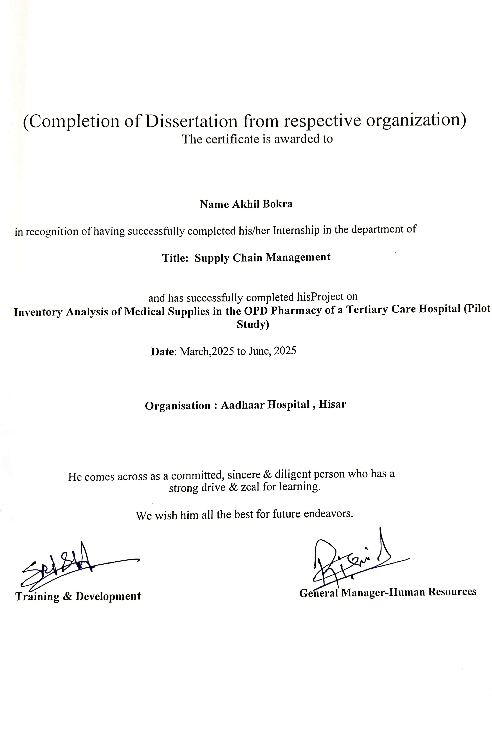

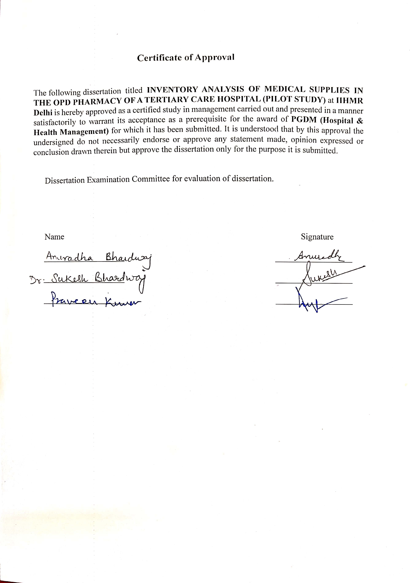

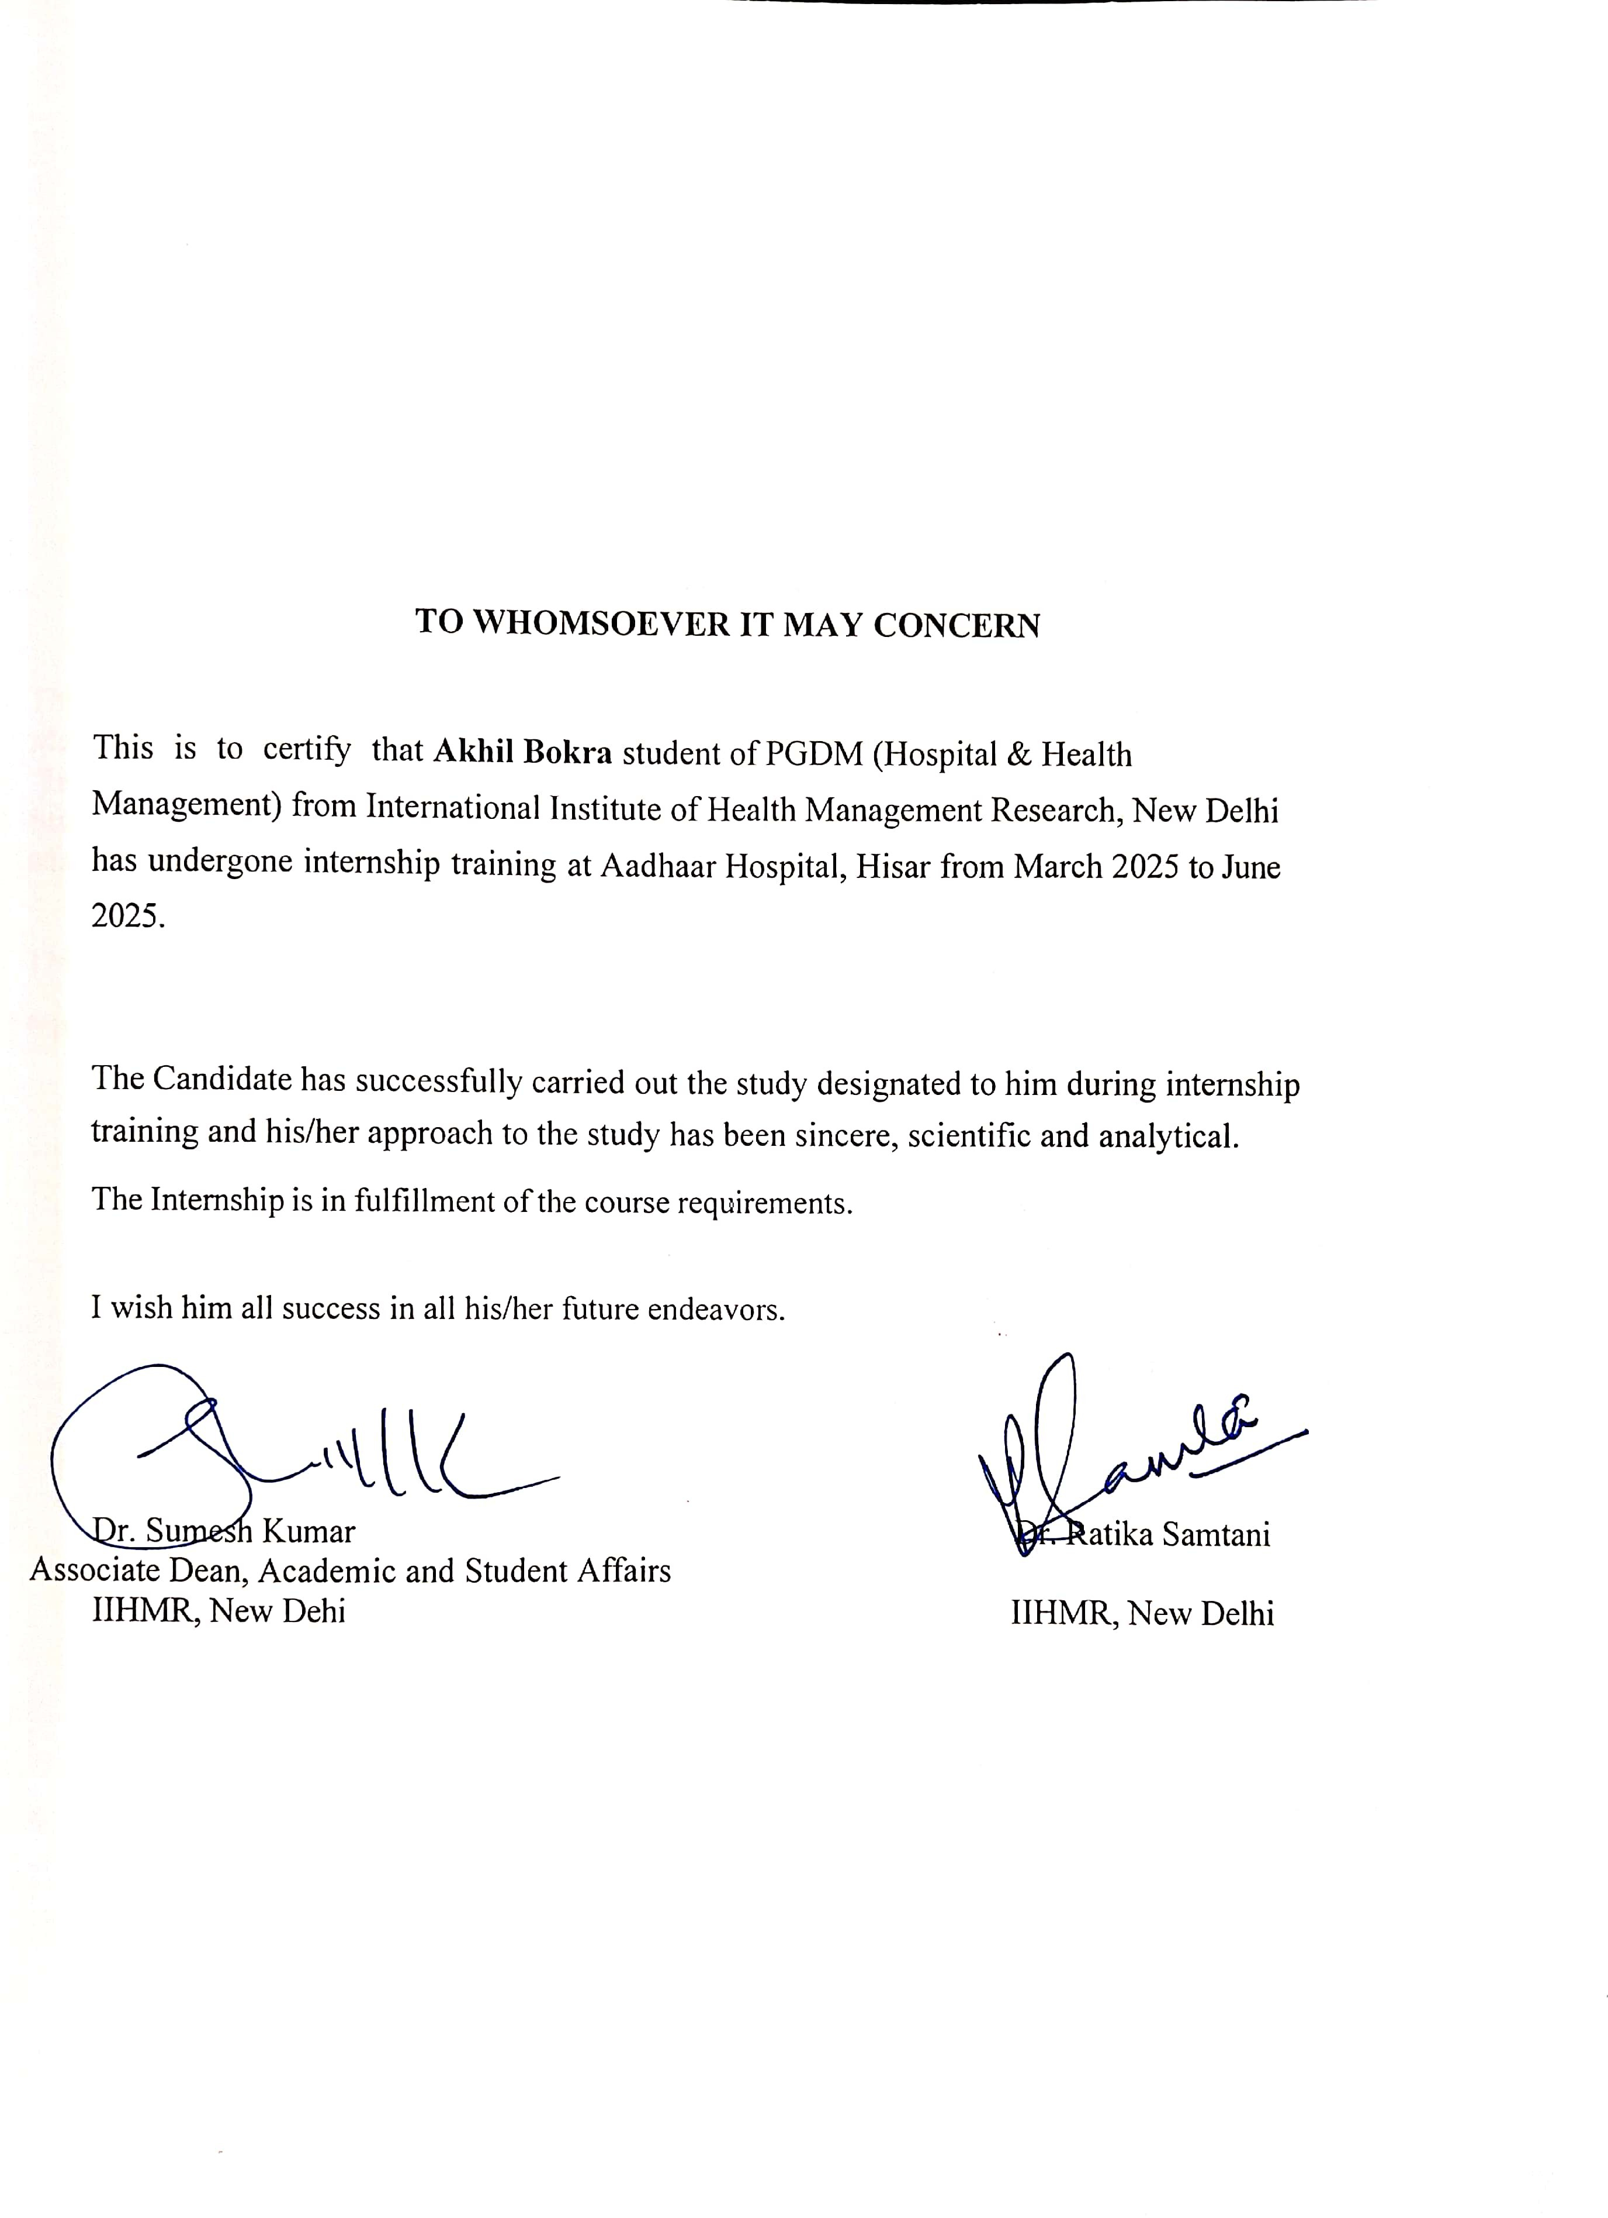

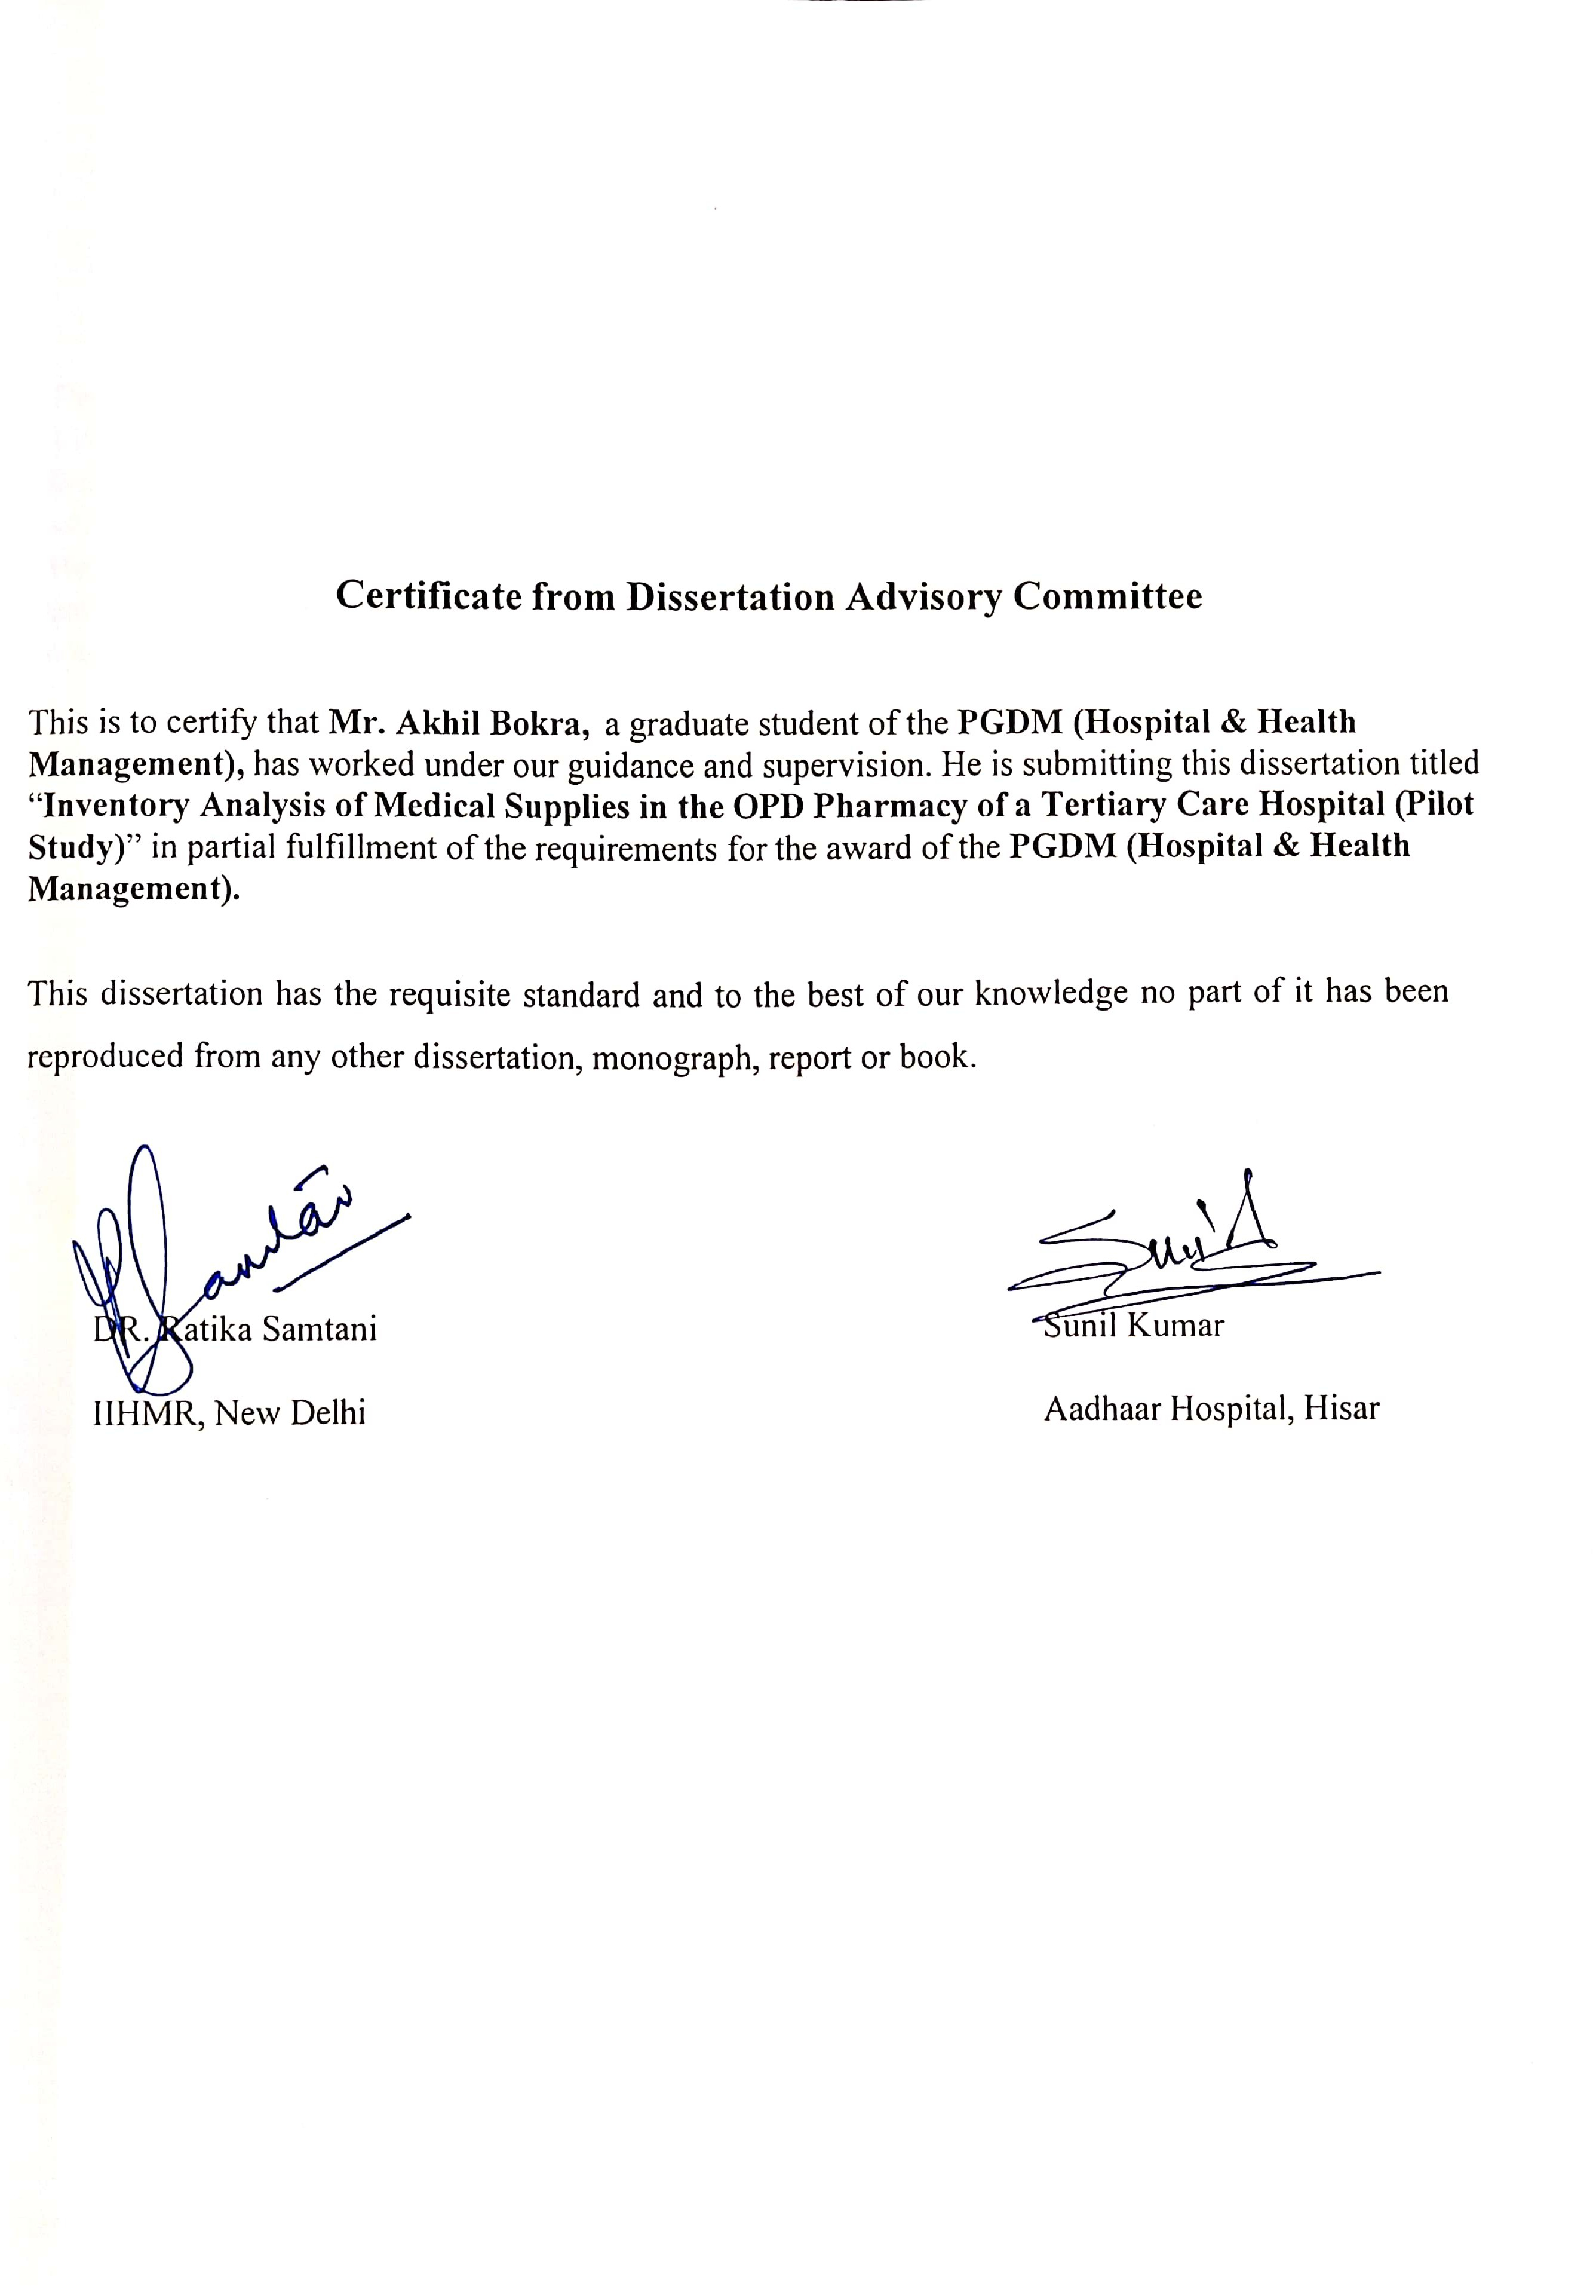

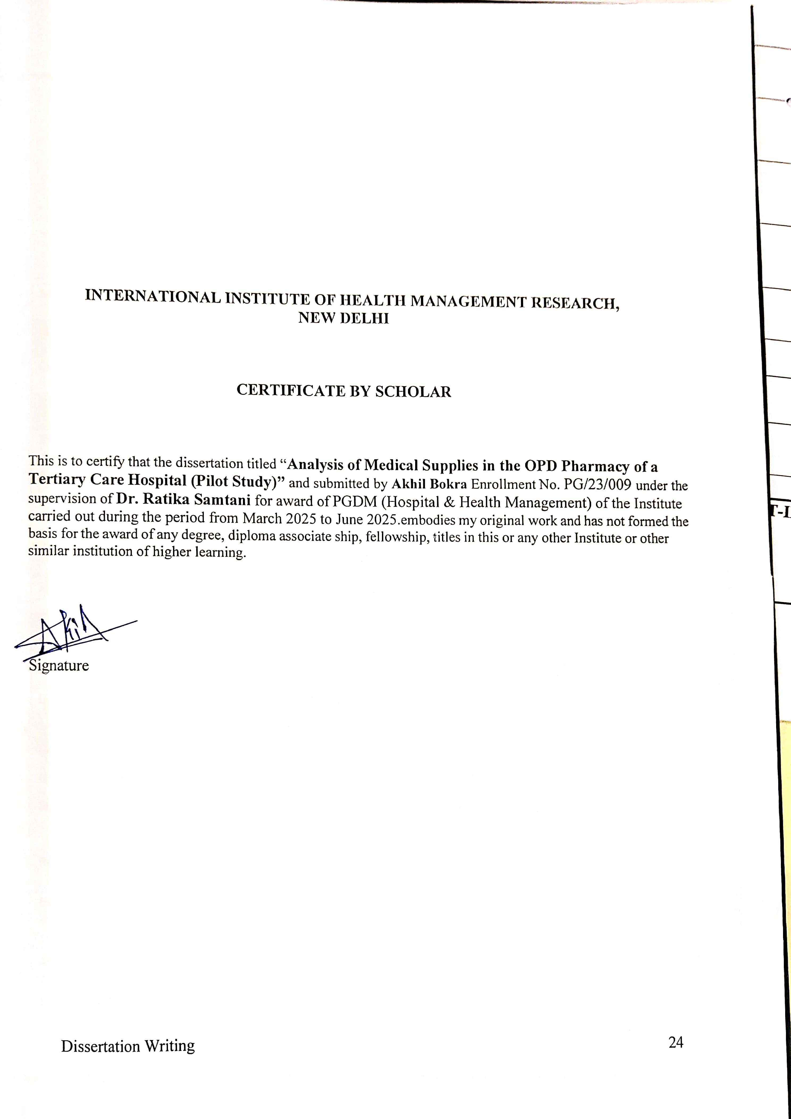

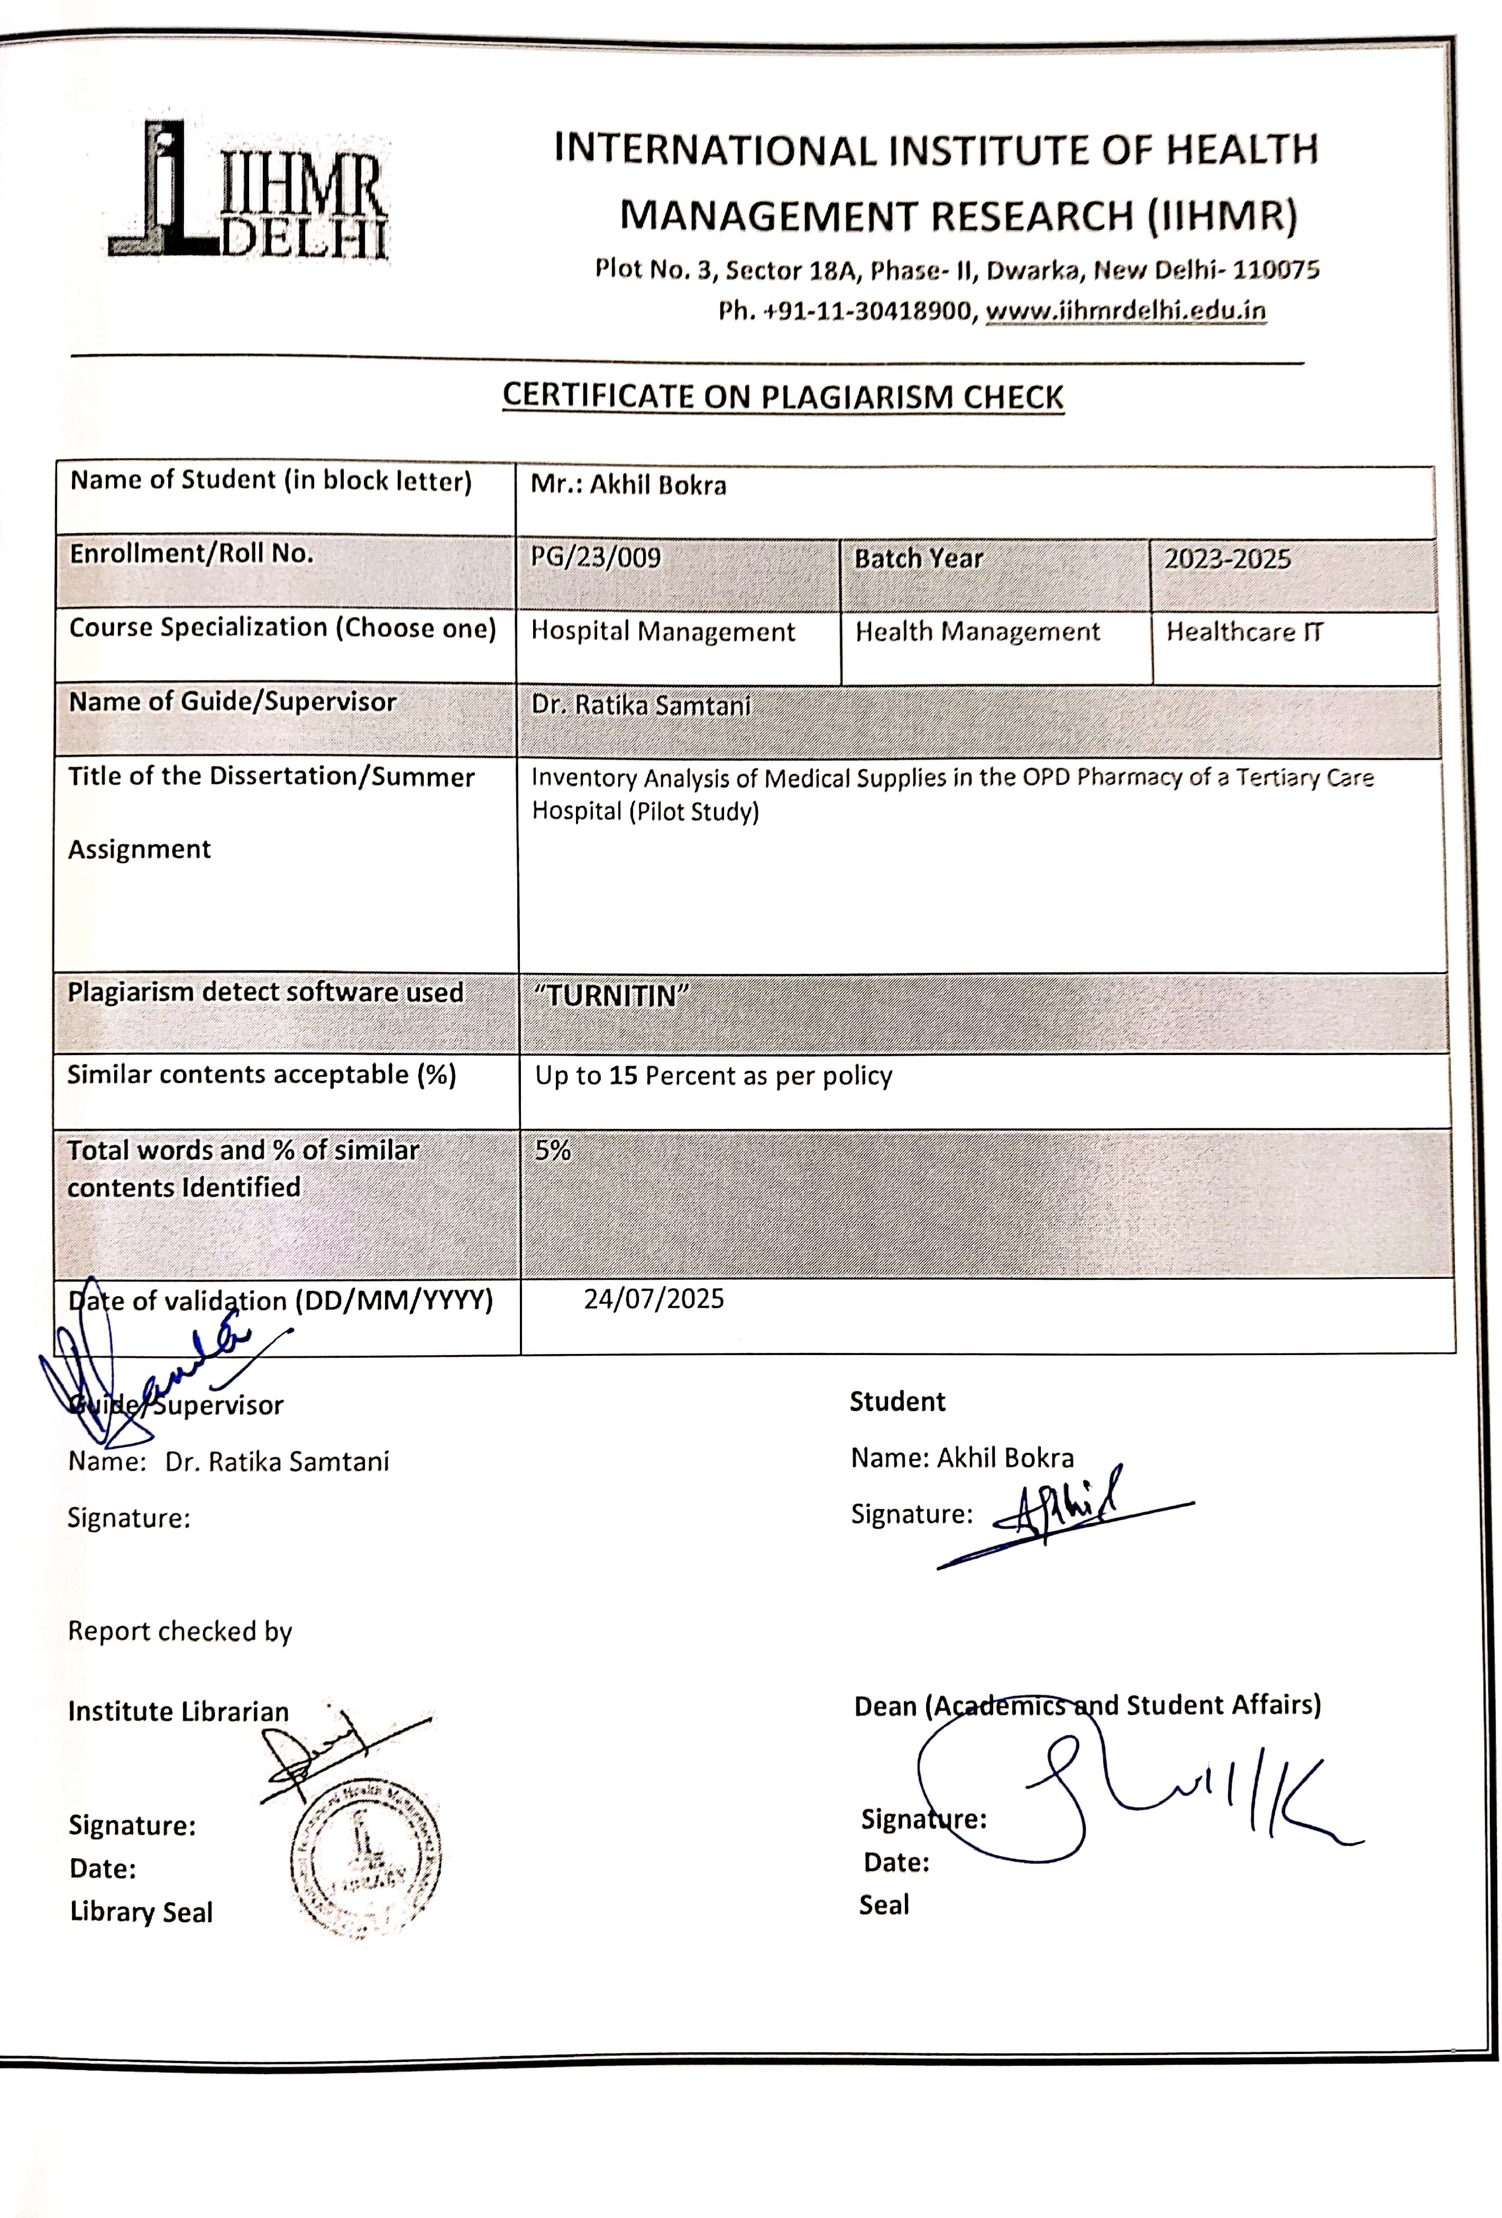

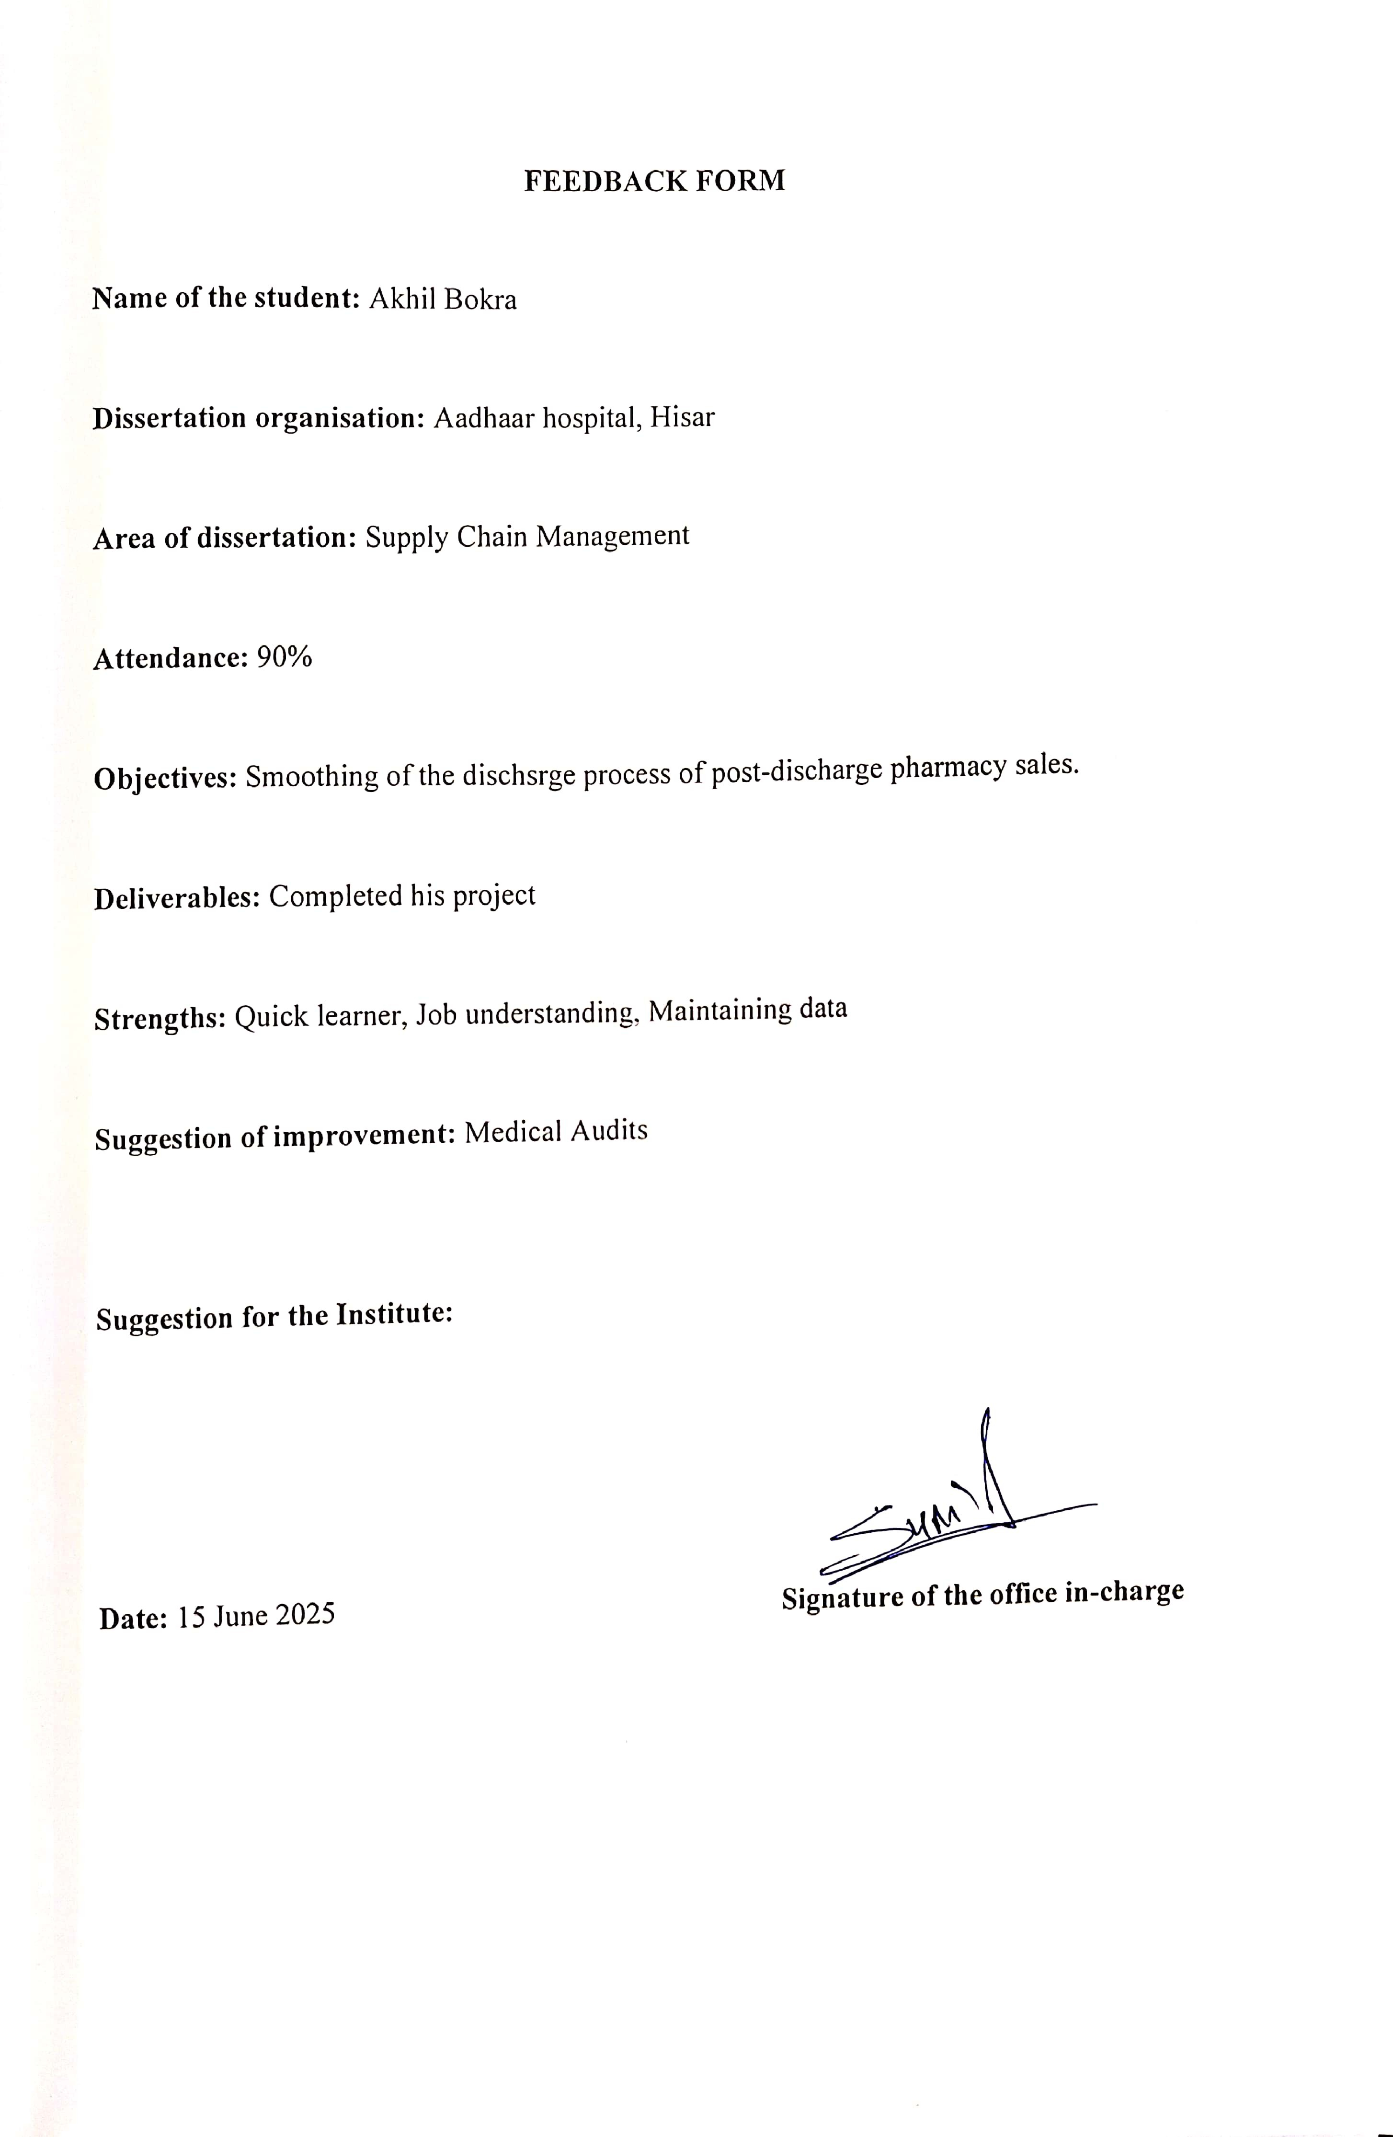

Index

S.no. | Topic | Page no.
1 | Introduction | 4
2 | Overview of Supply Chain Management | 6
3 | Workflow of Supply Chain Management | 8
4 | Importance of Inventory analysis | 10
5 | Review of literature | 11
6 | Objectives | 15
7 | Rationale | 15
8 | Methodology | 16
10 | Result & Discussion | 19
11 | Conclusion | 30
12 | List of few drugs | 32
13 | References | 34

Abbreviations:
ABC – Always Better Control

FSN – Fast-moving, Slow-moving, Non-moving

VED – Vital, Essential, Desirable

HML – High-cost, Medium-cost, Low-cost

ABC-VED – ABC and VED Combined Analysis

ABC-VED– ABC, VED, and FS Combined Analysis

SCM – Supply Chain Management

IPD – Inpatient Department

OPD – Outpatient Department

HMIS – Hospital Management Information System

IV – Intravenous

CV – Cumulative Value

AV- Expensive and vital drugs

AE-Expensive and Essential drugs AD- Expensive and Desirable drugs BV- Moderate and Vital drugs
BE- moderate and Essential drugs BD- Moderate and Desirable drugs CV- Low and Vital drugs
CE- Low and Essential drugs

CD- Low and Desirable drugs

Acknowledgements

I want to express my deep gratitude to everyone who helped complete this dissertation.

First, I thank my mentor, Dr. Ratika Samtani, for their invaluable guidance, support, and encouragement throughout this study. Their feedback and patience have been crucial in shaping this work.
I also appreciate my colleagues- Anand Kumar, and Vishwas for their emotional support and understanding during this difficult process.
I acknowledge the other faculty at IIHMR for the support that made this research possible.

Finally, I thank all those who contributed to this project in various ways, whether through discussions, technical help, or simply offering encouraging words.

Thank you all for your support and contributions.

Abstract
Efficient inventory management in hospital pharmacies is crucial for keeping essential medicines available, reducing waste, and managing costs. This pilot study aimed to assess and improve inventory control of medicines in the Outpatient pharmacy of a private tertiary care hospital. The main goal was to classify medicines by their cost significance and usage frequency to better guide procurement and stock management decisions.
The study used a quantitative, descriptive design relying on secondary data from the Hospital Management Information System (HMIS) for the months of March to May 2025. ABC analysis was performed to categorize medicines by annual consumption value, while VED analysis grouped items by how frequently they moved. A combined ABC-VED matrix was developed to identify critical drugs that need close monitoring. Medicines were sorted into A, B, and C classes based on cost, and into Vital, Essential, and Desirable groups according to daily usage rates, using clearly defined thresholds.
The results of this study should help pharmacy managers prioritize high-value and frequently used medicines, optimize inventory levels, and increase overall efficiency. The insights from the combined classification model can help reduce stockouts and overstocking, ensure better resource allocation, and support uninterrupted healthcare delivery in outpatient settings.

Introduction

Managing inventory may not be the most visible aspect of hospital operations, but it plays a much larger role than most people realize. In a healthcare setting, where every minute counts and the needs of patients can change quickly, having the right medicines available at the right time is critical. This is especially true in hospital pharmacies, where delays or shortages in medication can directly affect treatment outcomes and patient trust. [1]
During my field observations at a tertiary care hospital’s OPD pharmacy, I came to understand just how challenging it can be to maintain a well-balanced inventory. Unlike inpatient care, where medication use is often planned and controlled, the OPD pharmacy serves a high volume of walk-in patients with varied and unpredictable needs. Ensuring that frequently prescribed medicines are available, while also keeping stock levels under control, is a daily balancing act for the pharmacy team. [2]
Unfortunately, in many hospitals, inventory decisions are still made through experience or trial-and-error, rather than through structured analysis. This often leads to stockouts of essential drugs or overstocking of items that eventually expire unused. Both situations are costly—not only in terms of money, but in terms of lost opportunities to serve patients effectively. [1]
With rising drug prices, limited storage space, and pressure to cut operational costs, there is a growing need for a smarter, more analytical approach to inventory management. This is where tools like ABC and VED analysis become highly relevant. These methods help categorize inventory based on factors like cost and criticality, which in turn allows pharmacy staff to focus their attention and resources where they matter most. [3]
This dissertation presents a pilot study conducted at the OPD pharmacy of a private tertiary care hospital, where I analysed drug inventory data over three months (March to May 2025). The goal was to apply basic inventory analysis techniques—specifically ABC analysis (which focuses on cost) and VED analysis (which looks at the importance of each drug for patient care). By combining these two approaches in the ABC-VED matrix, the study aimed to identify which medicines need strict monitoring and which can be managed more flexibly. [4]

The idea behind this project wasn’t just to crunch numbers—it was to understand how a pharmacy can better manage its stock without compromising on patient care. Inventory might seem like a routine administrative task, but when done well, it supports the entire clinical process. When done poorly, it can disrupt treatments and inflate costs unnecessarily. [1]
By sharing the findings from this pilot study, I hope to contribute to ongoing conversations about improving supply chain practices in healthcare. Even small changes—like identifying which 20% of drugs consume 80% of the budget—can lead to smarter procurement decisions and better use of limited resources. [3]

Types of inventory analysis:

- ABC Analysis (Always Better Control) Based on annual consumption value.

  - A Items are few but expensive – need strict control.

  - B items are moderately priced – moderate control.

  - C items are low-cost – basic control.

- VED Analysis (Vital, Essential, Desirable)

  - Based on criticality to patient care.

  - Vital items are life-saving – must always be in stock.

  - Essential items are important but manageable.

  - Desirable items are optional – least priority.

- FSN Analysis (Fast, Slow, Non-moving)

  - Based on movement frequency.

  - Fast-moving items are used often.

  - Slow-moving are used occasionally.

  - Non-moving are rarely used – may expire.

- HML Analysis (High, Medium, Low Cost): Based on unit cost of items.

- ABC-VED Matrix: Combines cost (ABC) and criticality (VED).

- ABC-FSN Matrix: Combines cost (ABC) with movement (FSN).

- ABC-VED-FSN Matrix: Combines cost, criticality, and usage frequency. [5]

Overview of SCM

People mostly thought of hospitals in terms of doctors, nurses, and patient care. But once I stepped into the operational side of a hospital, I started to see how deeply every clinical outcome depends on systems we rarely notice. One of the most essential of these systems is Supply Chain Management (SCM). Mainly, SCM is about ensuring that the right products— whether medicines, surgical items, or consumables—are available at the right time, in the right quantity, and at the right cost. However, in a hospital setting, this job becomes significantly more challenging. It’s not just about cost efficiency or timely delivery—it’s also about patient safety, legal compliance, clinical urgency, and trust.
What makes SCM in healthcare unique is its direct link to patient care. Unlike in other industries, where a supply chain delay might affect production or sales, here it can affect someone’s health—or even life. A missing medicine, a delayed surgical kit, or a wrong batch number can have serious consequences.
In a hospital, SCM involves multiple departments—each playing a role at different stages. It starts with demand forecasting, where departments like the OPD pharmacy estimate what they’ll need based on past usage and upcoming patient loads. Then comes procurement, where approved vendors are contacted, orders are placed, and delivery timelines are negotiated. Once the items arrive, they go through quality checks—to ensure they’re not expired or damaged—and are logged into the Hospital Management Information System (HMIS). From there, the supplies are stored, tracked, and eventually distributed to departments as and when needed. [6]
There are 3 types of flow in SCM:

- Material Flow

- Information Flow

- Financial (or Cash) Flow

Material Flow: This is the most visible part: the actual movement of goods. Medicines, gloves, syringes, and equipment are shipped from suppliers, stored in medical stores, and issued to different departments. Any delay here—like a vendor being late or a delivery being incomplete—can immediately disrupt patient care.

Information Flow: This is the less visible but equally important part. It includes requisitions, stock updates, purchase orders, billing info, and usage data. If this communication isn’t clear or timely, even a well-stocked hospital can face shortages or duplication. I noticed that when information doesn’t move as smoothly as the material, things start to fall apart.

Financial (or Cash) Flow: This involves budgeting, payments, reimbursements, and vendor credits. Even if everything else works well, delayed payments or funding issues can break vendor relationships. Hospitals operate under financial constraints, so this part of the supply chain needs just as much attention as physical stock management. [7]

Workflow of SCM

Demand Forecasting and Requisition:

The first step is for the departments to project their immediate needs. This is predicated on past months' trends, the anticipated patient volume, and any known seasonal need (such as an increase in cold and cough medications in the winter). These estimates are sent to the medical store by the pharmacy or department in the form of official requests, or requisitions.
Although it seems easy, doing this correctly is difficult. Shortages will occur if the forecast is too low. Medicines may expire unused if it is excessively high.

Purchase Planning:

The supply or procurement team determines how much stock is available, what is running low, and how much money may be spent after receiving the requisitions. They make decisions about what to order and when based on this. This is when financial constraints frequently become relevant. Due to budgetary constraints, sometimes even necessities cannot be ordered right away. Setting priorities becomes crucial.

Choosing suppliers and Generating Purchase Orders (POs):

Hospitals typically collaborate with approved suppliers who are chosen on the basis of quality, cost, and performance history. Purchase orders are made and submitted to the selected vendors as soon as the list of items required is complete. Here, having a positive vendor relationship is quite beneficial. I've observed that deliveries happen more quickly when there is trust.

Goods receipt and quality check:

Upon delivery, the supplies are meticulously examined in comparison to the purchase order. The employees check product quantities, batch numbers, expiration dates, and general quality. This is a crucial step, particularly when it comes to medications. Anything that doesn't fit the requirements is marked or returned right away.

Storage and Documentation:

Following approval, items are properly stored, some in refrigerators and others in dry, temperature-controlled areas. Every input in the system is normally recorded using the Hospital Management Information System (HMIS). Using digital documentation and precise storage makes it easier to keep track of what is available and what is about to expire.

Distribution to Departments:

An internal request is made by a department when they require medications or medical supplies. The store then issues the necessary goods based on that. I found that in order to avoid abuse or duplication, appropriate documentation—such as indent slips or digital issue notes—is essential in this case.

Billing and Vendor Payment:

After the stock is accepted and confirmed, the finance department processes payment to the vendor. Delays in payment can affect future deliveries, so timely processing is essential to keep the cycle running smoothly. This step depends heavily on coordination between procurement and accounts.

Handling Returns, Recalls, and Disposal:

Sometimes, medicines may expire before they are used or need to be returned due to damage or recall. The hospital has to follow strict protocols for disposal, usually through authorized waste management agencies. I noticed that this part often gets less attention but is just as important for safety and compliance.

Monitoring and Auditing:

Finally, periodic audits are done to ensure that the stock recorded in the system matches the physical inventory. These checks also help identify non-moving items or those nearing expiry. Based on this, better planning decisions can be made in the next cycle. [8]

Inventory Storage & Documentation

Demand Forecasting & Requisition Generation

Purchase Planning
Billing & Vendor Payment
Vendor Selection & Purchase Order (PO) Creation
Return, Disposal, or Recall Handling
Goods Receipt & Quality Check
Distribution to Departments

Monitoring & Auditing

Importance of inventory analysis

- Continuous Patient Care: Maintaining a stock of required drugs is one of the primary goals of inventory analysis. With monitoring patterns of consumption and dividing products into usage and criticality groups, pharmacies can make demand more accurately forecasted and maintain adequate inventory levels. In the OPD environment, where even a moment's delay in drug distribution may compromise the continuum of care, it becomes especially vital.

- Saves on Waste and Expiration Losses: Overstocking and subsequent expiration of unwanted items are common consequences of ineffective stock management. To align stocking and buying choices with actual usage rates, inventory analysis helps identify slow-moving and non-movers. This improves shelf-space utilization and minimizes the financial loss due to expired drugs.

- Enhances Economic Efficiency: Hospitals operate under tight monetary constraints. More effective allocation of financial resources is facilitated by analysis of inventory, as it categorizes items into high-value (A class in ABC analysis) and non-essential (D class in VED analysis) items. It helps shift focus and management energy to items that consume most of the pharmacy's budget.

- Enhances Procurement and Supply Chain Planning: Accurate inventory analysis is supported by purchase decisions that are data-driven. It is made simpler to order in a timely manner, vendor management is enhanced, and ensures that lead times are properly managed. Procurement cycles become more responsive and predictable to actual demand using analytical insights.

- Fosters Regulatory Compliance and Audit Preparation: Maintaining accurate and up-to-date inventory records is important for compliance with the health regulatory

authorities and being ready for audits. Improved documentation, routine stock counts, and transparency in drug use are all fostered through inventory analysis and are required for accreditation and institutional accountability.

- Increases Operational Efficiency: Time utilized for manual stock counting, order modifications, and extraordinary procurement is reduced with a competent inventory system. It enhances the overall operational flow of the pharmacy staff and allows them to focus more on patient care than stock management issues. [9]

Review of literature

  - Raj (2023) conducted an ABC analysis at a pharmacy of a recently established National Institute in Eastern India. From the survey, 69.98% of total annual drug expenditure was accounted for by Category A, consisting of 22.8% of all items. With 20% and 10.07% of the budget, respectively, the rest of the products fell under Category B (24.06%) and Category C (53.14%). For focused monitoring and budgeting, the research served to underscore the usefulness of ABC analysis in highlighting expensive medications. [3]
  - ​
In 2025, Sundaram and colleagues performed an ABC-VED matrix analysis in some Puducherry public health units. 15.4% of items were classified as Category A (70% of total expenditure), 22.2% as Category B (20%), and 62.4% as Category C (10%) according to the 2019–2020 drug procurement data. In the tertiary care facilities, the authors concluded that the incorporation of ABC and VED analysis minimized waste and rationalized drug stock. [10]

  - In Maharashtra's pharmacy department of a tertiary care teaching hospital, Patil et al. (2017) carried out research. Based on the ABC research for the 2016–2017 fiscal year, drugs constituted 14.51% of the total budget, or 79.28%. Category B and Category C accounted for 17.35% and 3.37% of the expenses, covering 16.94% and 68.55% of the items, respectively. The research highlighted the need for periodic ABC reviews to ensure the availability of costly essentials and avoid overstocking of low-cost drugs. [11]

  - Tadesse et al. (2020) employed the ABC and VED approaches to examine drug utilization at Dessie Referral Hospital in Ethiopia. It was found that 17% of the drug products accounted for 70.08% of the hospital's annual drug spending during the 2013–2017 period. 19.87% and 10.05% of the total cost was accounted for by the remaining 20.18% and 62.83% of goods, respectively. ABC analysis was supported by the study as a viable approach to allocating procurement priorities based on cost. [12]

  - A 2023 survey of health facilities and hospitals in Ethiopia's West Shewa Zone was conducted by Belay et al. Their ABC analysis revealed that 70.34% of the total drug cost was due to 11.9% of the products. 18% and 70.1% of the products in category B and C, respectively, represented 20% and 9.72% of the budget. In accordance with the findings of the study, ABC classification is useful in determining costly items which require a close watch on the finances. [13]

  - ABC-VED analysis was implemented by Kumar et al. (2024) in an Indian tertiary care referral hospital. Based on the survey, 13.78% of the products were under Category A, representing 69.97% of the cost of drugs, while Category B and C are responsible for 19.95% and 10.08% of the cost, respectively. Based on the study, ABC-VED classification struck a balance between clinical importance and cost reduction to optimize drug stock. [12]
  - Mathew Binu et al. (2016) conducted ABC–VED matrix analysis in the pharmacy department of tertiary care teaching hospital (N.E.T. Pharmacy College, Raichur). Of a review of 886 drugs, 21.22% of the items, or 68.50% of the annual drug cost (ADE), belonged to Category A. Category C accounted for 51.13% of items but only 9.59% of ADE, while Category B comprised 27.65% of items (21.91% of ADE). 25.40% of the items in the combined ABC–VED matrix was in Category I (highest priority) and comprised 70.38% of the ADE. The authors recommended employing these tools routinely to focus control over significant and valuable drugs. [10]

  - Narang S., Raju S.K., and Kumar R. (2018) performed an ABC study of anticancer medicines at the tertiary care ESIC Hospital, Basaidarapur, Delhi. 12.2%, 16.3%, and 71.4% of 98 cancer drugs fell under Category A, B, and C, respectively. This illustrated the effectiveness of ABC analysis in specialized clinical environments through enabling a clear recognition of costly items that necessitated greater managerial control. [8]

  - Between April 2015 and March 2016, Reddy & Sankar (2018) performed pharmacoeconomic ABC-VED study in a government tertiary care medical

college in Vijayawada. Only 4% of the 299 drugs under analysis belonged to Category A (68.92% of total expenditure), followed by B-category (9.36%) and C-category (86.64%) (11.03%). Based on VED classification, 22.4% of the products were classified as desirable, 45.5% as essential, and 32.1% as crucial. An ABC–VED matrix showed 34.1% of drugs belonged to high- control Category I, which covered 80.76% of annual expenditures. [4]

  - A study by Khurana et al. (2013) conducted an ABC–VED matrix analysis for the medicated shop of a Delhi tertiary-care neuropsychiatry hospital. Whereas 6.9% and 89.65% of medicines were under categories B and C, accounting for 19.68% and 9.83% of the annual drug cost (Rs. 13.55 million), respectively, they found that only 3.45% of the medicines (5 products) belonged to Category A, which made up 70.5% of the expenditure. They emphasized that in the absence of VED classification; essential but cost-effective medicines could be overlooked despite their clinical importance. [14]

Objectives

To conduct a pilot inventory analysis of medicines in the OPD pharmacy of a tertiary care private hospital over March, April, and May. This includes:

- To classify inventory items based on their value (ABC) and criticality (VED).
- To identify key inventory items that require strict monitoring and control.
- To optimize inventory levels and reduce carrying costs without compromising operational efficiency.
- To propose an integrated approach (ABC-VED matrix) for more effective and strategic inventory control.

Rationale

A proper inventory control is critical to the hospital pharmacy practice, particularly in a high- demand environment such as the hospital OPD. The availability of required medications not only affects the quality of patient care but also reflects how cost-saving and efficient the health care system is. However, many hospitals still employ outdated stock processes without the aid of structured analytical tools, which leads to problems such as stockouts, wastage due to expiration, and prohibitively high holding costs.
By using systematic inventory analysis methods—namely, ABC analysis based on consumption value and VED analysis based on criticality to patient care—on the inventory data of an OPD pharmacy within a tertiary care private hospital, the pilot project seeks to combat these problems. The research, to be conducted in March, April, and May, aims to generate useful information regarding which drugs require strict regulation and uninterrupted availability and which can be monitored less frequently.
To determine top-priority items to be monitored more closely, the study categorizes drugs based on their clinical and economic importance. Ultimately, this will help pharmacy managers maximize inventory levels, reduce unnecessary inventory carrying costs, and improve supply chain planning and procurement decisions—while ensuring that critical patient needs are fulfilled.

Methodology

Study Design: This study was a pilot descriptive analysis of inventory data of the OPD pharmacy.

Data Collection:

- Source: The data was sourced from Hospital Management Information System (HMIS) – specifically from medical store and pharmacy records on weekends (Saturday and Sunday).

- Nature of Data: Secondary and confidential; no hospital identifiers disclosed; for academic use only.

- Time Frame: Data was collected from March to May 2025 via HMIS.

- Study setting: Medical store of the Hospital and OPD pharmacy.

- Inclusion Criteria: All medicines (Tablets, Capsules, Injections, Syrups)

- Exclusion criteria: All items other than medicine will be excluded, like: - Surgical Items, surgical sutures, and implants, Medical Consumables: syringes, IV sets, catheters, gloves, bandages, dressings, and others.

- Analysis: The information which is collected are compiled and tools like Excel is used for ABC analysis, VED analysis, ABC-VED matrix.

ABC Analysis – Steps and Data Required Data Required:
Drug name Unit cost Usage
Cost value (Usage × Unit cost)

Steps:
- Sort items by Cost Value (highest to lowest)
- Calculate Cumulative Cost Value (CV): CV1 = Cost of Drug1
CV2 = Drug1 + Drug2, and so on
- Compute Cumulative % of Total Inventory Value
- Categorize into:
A Category: Top 10–20% items → 70% of value
B Category: Next 20–30% → 20% of value
C Category: Remaining 50% → 10% of value

VED Analysis – Methodology Data Source:
Three months of OPD pharmacy data (March to May), analyzed using standard criteria provided by the data source.

Steps
- Identify and List All Drugs
- Categorize Drugs Based on Criticality Vital (V)
Essential (E) Desirable (D)
- Consult with Medical/Pharmacy Experts
- Classify Drugs into VED Categories
- Create a VED Matrix or Table

Result & Discussion

Drug Analysis | A | B | C | Total
Total Consumption % | 70% | 20% | 10% | 100%
Value of Consumption | ₹  1,10,67,506 | ₹ 31,38,606 | ₹ 14,93,017 | ₹  1,56,99,129
No. of Items | 144 | 188 | 261 | 593
% of Items | 24% | 32% | 44% | 100%
Table 1 – ABC Analysis of Items

Fig 1
No. of Items

144, 24%
A
261, 44%
B
C

188, 32%
Fig 2
1,50,00,000
Annual Drug Expenditure
1,00,00,000
50,00,000
0
10%
20%
70%
Total Consumption %
₹ 14,93,017
₹ 31,38,606
₹ 1,10,67,506
Value of Consumption
C
B
A

ABC analysis reveals that:

A Class: A major 70% of the total annual consumption value, i.e., ₹1,10,67,506, came from high-value goods, which accounted for 24% of the total goods (144 out of 593). The control has to be strict.
B Class: medium-value goods accounted for 20% of the total consumption value, or
₹31,38,606, and accounted for 32% of all goods (188 out of 593). - modest management.

C Class: 40% of the articles (261 out of 593) are low-value, though these constitute merely
10% of the overall worth (₹14,93,017). - easy control.

Table 2 – VED Analysis of Items

Category | No .of  drugs | % of  Drugs | Annual Drug  Expenditure | %age of ADE
V | 88 | 15% | ₹  26,14,728.00 | 16%
E | 296 | 50% | ₹  76,57,030.00 | 49%
D | 209 | 35% | ₹  54,27,371.00 | 35%
Total | 593 | 100% | ₹  1,56,99,129.00 | 100%

Figure 3

0
 |  | Annual Drug Expenditure
 | 90,00,000
 | 80,00,000
 | 70,00,000
 | 60,00,000
 | 50,00,000
 | 40,00,000
 | 30,00,000
 | 20,00,000
 | 10,00,000
 |  | V | E | D
 | Annual Drug Expenditure | 26,14,728 | 76,57,030 | 54,27,371

Figure 4






NO. of Drugs

V, 88, 15%
D, 209, 35%

E, 296, 50%

V E D

VED Analysis reveals that:

- 88 drugs (15%) are regarded as essential, accounting for ₹26,14,728 (16%) of the annual medicine budget. They are vital for availability despite accounting for a smaller proportion of the cost and quantity.
- Out of the total expenditure, 296 drugs (50%) belonged to the essential category and
constituted the highest proportion at ₹76,57,030 (49%). To prevent

both stock-out and overstocking, it requires careful planning, ensuring timely procurement and optimal stock levels.

- 209 drugs (35%) costing ₹54,27,371 (35%) annually were in the ideal category. While less of a priority in availability, these need proper inventory control to avoid unnecessary capital hold-ups and costs due to expiration.

Table 3 – ABC-VED Matrix Analysis of Items

ABC-VED | No. of Drugs | % of Drugs | ADE | % ADE
AD | 49 | 8% | 3785940 | 24%
AE | 70 | 12% | 5318150 | 34%
AV | 25 | 4% | 1963416 | 13%
BD | 65 | 11% | 1097602 | 7%
BE | 98 | 17% | 1605443 | 10%
BV | 25 | 4% | 435561 | 3%
CD | 95 | 16% | 543829 | 3%
CE | 128 | 22% | 733437 | 5%
CV | 38 | 6% | 215751 | 1%
Total | 593 | 100% | 15699129 | 100%

Figure 5
























No.of Drugs
CV, 38, AD, 49,
6% 8%
AD
AE CE, 128,
AE, 70,
12%
AV 22%
BD
AV, 25,
4%
BE
BV CD
BD, 65,
11%
CE
CV
CD, 95,
16%
BV, 25,
4%
BE, 98,
17%

Figure 6
Annual Drug Expenditure
6000000
5000000
4000000
3000000
2000000
1000000
0
ADE % ADE

 | AD | AE |  | AV |  |  | BD |  |  | BE |  | BV | CD | CE | CV
ADE | 3785940 | 5318150 |  | 1963416 |  |  | 1097602 |  |  | 1605443 |  | 435561 | 543829 | 733437 | 215751
% ADE | 24% | 34% |  | 13% |  |  | 7% |  |  | 10% |  | 3% | 3% | 5% | 1%

ABC-VED matrix reveals that:

AE: Of 70 medicines (12%), this category contributed to the highest proportion of total expenditure, at ₹53,18,150 (34%). These are essential, high-use medicines. They require reliable suppliers and watchful monitoring.

AD: This group had 49 medicines (8%) at a considerable cost of ₹37,85,940 (24%). Although they are considered desirable, their cost necessitates cautious thought to assess ongoing clinical need and minimize waste or overstocking.
AV: 25 drugs (4%) accounted for 13% of the total expenditure, or ₹19,63,416. In terms of availability, they are the most crucial. Severe clinical consequences can arise from stock-outs in this class. Procurement and surveillance procedures must ensure no errors.
BE: 98 products (17%) constituted the category of BE, which had a share of 10% in the total cost of ₹16,05,443. These require sensible control and inspection cycles that provide a balance of availability and cost.
BD and BV: These accounted for 25 (4%) and 65 (11%) moderately priced drugs, respectively. While BD (₹10,97,602; 7%) is manageable with moderate stock levels and monitoring, BV drugs (₹4,35,561; 3%), even with their relatively lower expenditure, call for clinical priority.
CE, CD, and CV: Together, they form the largest volume-based category (261 drugs, 44%) but the smallest percentage of expenditure:
CD: 95 drugs (16%), ₹5,43,829 (3%), CV: 38 drugs (6%), ₹2,15,751 (1%), CE: 128 drugs
(22%), ₹7,33,437 (5%). These drugs are cost-effective and may not have to be regulated at all.
CV drugs, on the other hand, being essential, should never run out even though they constitute just 1% of total cost.

Previous Study Data

Table 4

Study | Year | Category A Items / % Value | Category B Items / % Value | Category C Items / % Value
1 | 2023 | 11.9% / 70.34% | 18.0% / 20.0% | 70.1% / 9.72%
2 | 2020 | 17.0% / 70.08% | 20.18% / 19.87% | 62.83% / 10.05%
3 | 2023 | 22.8% / 69.98% | 24.06% / 20.00% | 53.14% / 10.07%
4 | 2008–10 | 13.78% / 69.97% | 21.85% / 19.95% | 64.37% / 10.08%
5 | 2017 | 14.51% / 79.28% | 16.94% / 17.35% | 68.55% / 3.37%
6 | 2025 | 15.4% / 70.00% | 22.2% / 20.00% | 62.4% / 10.00%

Table 5

ABC Category | Average % of Items | Average % of Expenditure
A | 16.23% | 71.27%
B | 20.54% | 19.86%
C | 63.22% | 8.87%

According to an analysis of six tertiary care hospital studies carried out between 2017 and 2025:

- Category A items made up only 11.9% to 22.8% of all items, but they were responsible for roughly 70% of all drug expenditures, which is in line with the conventional ABC model.

- A moderate level of financial impact was indicated by the category B products, which typically made up 16.9% to 24.1% of the inventory and accounted for 20% of the total cost. This illustrates the anticipated trend in which B items need to be regularly monitored but do not take up the majority of the budget. In terms of item quantity, category C goods made up the biggest share (varying from 53.1% to 70.1%), but their cost contribution was still quite little, usually less than 10.1%. This demonstrates that the vast majority of medications in these hospitals are inexpensive goods that may be controlled with laxer regulations.
- The six studies' combined ABC classification closely resembles the traditional 70/20/10 expense allocation, confirming the usefulness of this approach in directing inventory and procurement choices in tertiary care settings.

Comparison of my data vs the study average. Data

 | % of Items (My Data) | % of Items (Study Average) | % of Cost (My Data) | % of Cost (Study Average)
A | 24% | 16.23% | 70% | 71.27%
B | 32% | 20.54% | 20% | 19.86%
C | 44% | 63.22% | 10% | 8.87%

Interpretation:

Category A: The OPD pharmacy has a higher percentage of items in Category A (24%) compared to the research average of 16.23%. Despite this, cost contribution remains at a steady 70%, indicating that high-value products are well prioritized. As in typical OPD environments, this would mean a broader coverage of costly medications under stringent inventory controls.
Category B: Category B contains 32% of the drugs compared with a mean of 20.54%, and both show ~20% of the price. This accounts for a higher range of reasonably priced, commonly used drugs in OPD practice. Therapeutic availability can be maintained with elimination of surplus stock, perhaps possible with periodic review.
Category C: The Category C item percentage in OPD pharmacy is 44%, lower than the research average of 63.22%. The cost contribution is at around 10%, indicating effective control of low-value items. This suggests lower stockpile and store overhead via effective procurement of non-essential drugs.

Conclusion

My first objective in starting this pilot project was to find out if an organised method of inventory management might help in a real hospital context, especially in a high-volume sector like the OPD pharmacy. During this study, I learnt that even a simple analytical instrument, when used carefully, can clarify a difficult and frequently disregarded procedure. The ABC analysis's findings revealed that almost 70% of the entire spending was spent on a relatively small number of medications, which made up less than 25% of the total items. This supported the notion that a small number of expensive drugs, which need deeper scrutiny, account for the majority of hospital medication budgets. Without this degree of insight, costly goods can easily expire unused or hospital budgets can spiral out of control.
However, concentrating just on price doesn't provide the whole picture. VED analysis was quite helpful in this situation. Although they were necessary for treatment, some of the most clinically significant drugs weren't the priciest. I discovered that even inexpensive medications could be quite important, particularly in dire circumstances. This section of the data made me realise that availability frequently mattered more in the healthcare industry than rupee worth.

A more strategic and well-rounded understanding of inventory priorities was produced by combining the two assessments into the ABC-VED matrix. High-value and vital (AV category) commodities, for instance, were obviously of the utmost importance and needed strict stock control and availability assurance. Conversely, non-essential and inexpensive medications could be handled less urgently. This matrix provided decision-makers with a path to follow in addition to sorting the stock. The fact that this degree of insight didn't require sophisticated software or costly systems was among the most exciting discoveries. This research was carried out in a fashion that is repeatable and practical in real-world situations using only Excel and high-quality data from the Hospital Management Information System. The study also brought attention to another often overlooked aspect of management: the importance of coordination. Inventory control is not a standalone process. Effective communication between the clinical, financial, procurement, and pharmacy departments is essential. Any one of these gaps, such as a late request or payment, might result in stockouts, overstocking, or resource misallocation.

In conclusion, this study demonstrated that, even when used on a small scale, data-based inventory planning is effective and realistic. Hospitals may cut down on waste, avoid shortages, and make better use of their funds with the correct techniques and a little self- control. This type of targeted, operational improvement can help healthcare organisations remain resilient and patient-responsive while they continue to face financial and logistical challenges.

List of a Few Drugs

 | Item name | Usage | Value | ABC | VED
1 | DEPLATT CV 20MG CAPSULE | 3073 | 79898 | A | E
2 | PREGALIN 75MG CAPSULE | 2840 | 79520 | A | D
3 | MAXVOID 8MG TABLETS | 2740 | 79460 | A | V
4 | PREGABID 75MG CAPSULE | 3053 | 79378 | A | E
5 | PETRIL MD 0.25 MG TABLETS  (1X15) | 2267 | 79345 | A | D
6 | GP-0.5MG TABLETS | 2833 | 79324 | A | E
7 | DYTOR 20MG TABLETS | 1933 | 79253 | A | V
8 | ESOVIK L CAPSULE | 2640 | 79200 | A | E
9 | EMESET 8 MG TABLETS | 1840 | 79120 | A | E
10 | NODOSIS-DS TABLETS | 1720 | 79120 | A | E
11 | PANTOCID 40 MG TABLET 1 X 20 | 2327 | 79118 | A | V
12 | NEUROBION FORTE TABLETS | 1387 | 79059 | A | V
13 | NULONG 20MG TABLETS | 2027 | 79053 | A | D
14 | ECOSPRIN AV 150 MG/10 MG  CAPSULE | 1520 | 79040 | A | D
15 | FEBUMOST 40MG TABLET | 1520 | 79040 | A | D
16 | METOLAR XR 25MG CAPSULE | 1613 | 79037 | A | E
17 | DICLOMOL TABLETS | 987 | 78960 | A | E
18 | PANTOCID 20 MG TABLETS | 1067 | 78958 | A | E
19 | GLYCOMET GP 0.5/500 MG  TABLETS | 1067 | 78958 | A | E
20 | EBAST 10MG TABLETS | 2467 | 78944 | A | E
21 | DYTOR 10MG TABLETS | 1973 | 78920 | A | D
22 | ESOVIK D 20 MG Capsule | 1793 | 78892 | A | D
23 | CLOPIVAS 75MG TABLETS | 1127 | 78890 | A | E
24 | ESOVIK D 40 MG CAPSULE | 1127 | 78890 | A | E
25 | GANATON 50MG TABLETS | 1753 | 78885 | A | E
26 | NULONG 10MG TABLETS | 1293 | 78873 | A | E

27 | AVAS 40MG TABLETS | 1213 | 78845 | A | E
28 | NUROKIND LC TABLETS | 1460 | 78840 | A | D
29 | LEVERA 500MG TABLETS | 1407 | 78792 | A | D
30 | DYTOR 100MG TABLETS | 780 | 78780 | A | V
31 | GEMER 2 MG TABLETS | 450 | 78750 | A | V
32 | DYTOR 5MG TABLETS | 450 | 78750 | A | E
33 | FAROBACT 200 MG TABLETS  (1X10) | 620 | 78740 | A | D
34 | ECOSPRIN AV 75/20 CAPSULE | 2540 | 78740 | A | E
35 | GEMER 1 MG TABLETS | 480 | 78720 | A | D
36 | DEFCORT 6MG TABLETS | 820 | 78720 | A | D
37 | JUNIOR LANZOL 30MG TABLETS | 480 | 78720 | A | E
38 | SHELCAL 500 MG TABLETS | 384 | 78720 | A | E
39 | GANATON OD 150MG CAPSULE | 667 | 78706 | A | E
40 | CARDACE 5 MG TABLETS | 667 | 78706 | A | V
41 | CAL MD3 TABLETS (1X15) | 495 | 78705 | A | D
42 | ECOSPRIN 75 MG TABLETS | 423 | 78678 | A | D
43 | FLUDAC 10MG CAPSULE | 447 | 78672 | A | E
44 | SINAREST TABLETS | 345 | 78660 | A | D

Reference

- Jana S, Roy K, Kundu S, Ghosh R, Datta S, Mandal AK. Assessment of drug inventory using ABC–VED matrix analysis in selected public health facilities of Puducherry, India. J Family Med Prim Care. 2025 Apr 25 [cited 2025 Jun 26];13(4): [about 7 p.]. Availablefromhttps://pubmed.ncbi.nlm.nih.gov/38666336/
- Deshpande SN, Gupta A, Agrawal RK, Kumar S, Deshpande S. A Study to Carry out Always better control and Vital, Essential, and Desirable Analysis in the Dispensary of a Tertiary Care Teaching Hospital. Int J Med Res Prof. 2024;10(1):164–7. Available from: https://ijmrp.com/abstract_full.php?id=3830
- Ahmed B, Mulugeta H, Kebede A, Abegaz TM. Critical Analysis of Pharmaceuticals Inventory Management Using the ABC-VEN Matrix in Dessie Referral Hospital, Ethiopia: A Five-Year Retrospective Study. J Drug Assess. 22AD Sep 9;9(1):145–54. Available from: https://www.ncbi.nlm.nih.gov/pmc/articles/PMC7497187/
- Jain R, Bhide P, Roy R, Singh A, Singh AK. The ABC and VED analysis of the medical store of the tertiary care teaching hospital in Maharashtra, India. Int J Basic Clin Pharmacol. 2017 Dec;6(12):2923–7. Available from: https://www.ijbcp.com/index.php/ijbcp/article/view/1785
- Pal A, Singh N, Singh JP. ABC, FSN ANALYSIS OF DRUG STORE OF A TERTIARY CARE HOSPITAL. IJPSR. 2023;14(11):5806-5813. Available from:
https://ijpsr.com/bhtml/IJPSR_BHTML_4861.html
- Sharma N, Verma M. ABC and VED Analysis of the Pharmacy Store of a Tertiary Care Teaching, Research and Referral Healthcare Institute of India. Int J Sci Stud. 2024;12(1):47-51. Available from: https://www.ijss-sn.com/home/vol-12-issue-1- january-2024
- Mathew Binu K M, Panavila L, Sindhu K, Rajaneesh P, Bharath V, Doddayya H, et al. A study on inventory management by ABC, VED and ABC-VED matrix analysis in the pharmacy department of a tertiary care teaching hospital. Asian J Pharm Health Sci. 2016;6(4):1563-8. Available from: https://ajphs.com/sites/default/files/AsianJPharmHealthSci-6-4-1563.pdf
- Narang S, Raju SK, Kumar R. Application of ABC analysis for inventory control of anticancer drugs in ESIC hospital, Delhi. Int J Community Med Public Health. 2018;5(12):5217-21. Available from: https://www.ijcmph.com/index.php/ijcmph/article/view/2848

- Khurana S, Sharma RK, Gupta P. Inventory control techniques in medical stores of a tertiary care neuropsychiatry hospital in Delhi. Health (N Y). 2013;5(8):20-26. Available from: https://file.scirp.org/Html/2-8201562_26512.htm
- Reddy YBSK, Sankar P. Pharmacoeconomic ABC–VED analysis in a tertiary care hospital, Vijayawada. Int J Basic Clin Pharmacol. 2018;7(5):873-7. Available from: http://dx.doi.org/10.18203/2319-2003.ijbcp20181627
- Economic analysis of drug expenditure in a government medical college hospital. Indian J Pharmacol. 2004;36(1):15–19. https://pmc.ncbi.nlm.nih.gov/articles/PMC4297849/
- Rahmawati F, Wahyuningsih S, Cahyani D. Effectiveness of Supply Chain Management Using Kanban System in Hospital Pharmacy Logistics: A Case Study. e- Journal UNAIR. 2023. https://oamjms.eu/index.php/mjms/article/download/10383/8022/100274
- Yusuf AM, Mekonnen AB. Optimizing Pharmaceutical Inventory Management: A Global Framework for Efficiency and Cost Reduction. Res Pharm Health Sci. 2023;9(1):45–53. https://www.researchgate.net/publication/384987682
- The ABC and VED analysis of the medical store of the tertiary care teaching hospital in Maharashtra, India. Int J Basic Clin Pharmacol. 2017;6(9):2183–2188. https://www.researchgate.net/publication/376061975_Inventory_Control_Mechanism
_of_the_Pharmacy_Store_of_a_Recently_Established_National_Institute_in_Eastern_ India_A_Cross-Sectional_Investigative_Analysis
- ABC and VED analysis of the pharmacy store of a tertiary care teaching, research and referral healthcare institute of India. J Young Pharm. 2010;2(2):201–205. https://www.researchgate.net/publication/228106041_Medical_Store_Management_A n_Integrated_Economic_Analysis_of_a_Tertiary_Care_Hospital_in_Central_India

Akhil bokra D
ORIGINALITY REPORT
5

%
SIMILARITY INDEX

5%
INTERNET SOURCES

3%
PUBLICATIONS

2%
STUDENT PAPERS

PRIMARY SOURCES

1

2

3

4

5

6

7

8

9

10

turkishjic.org
Internet Source

www.ejmanager.com
Internet Source

www.dovepress.com
Internet Source

www.coursehero.com
Internet Source

www.researchgate.net
Internet Source

Submitted to Darton State College
Student Paper

Submitted to IIHMR Delhi
Student Paper

Submitted to Odisha State Open University
Student Paper

aithor.com
Internet Source

Deepak Bahadur Prachhai, Sujan Dawadi, Sagun Kharel, Binita Lamichhane et al.
"Strategic Inventory Control in Hospital Pharmacies: An ABC-VED Approach in a Hospital of Developing Country, Nepal",
1%
1%
<1%
<1%
<1%
<1%
<1%
<1%
<1%
<1%

11

12

13

14

15

16

International Journal of Silkroad Institute of Research and Training, 2025
Publication

proceedings.science
Internet Source

s3-ap-southeast-1.amazonaws.com
Internet Source

Sharma, K., and S. Zodpey. "Demand and Supply Analysis of Human Resource Capacity for Hospital Management in India", Journal of Health Management, 2011.
Publication

pmc.ncbi.nlm.nih.gov
Internet Source

www.ncbi.nlm.nih.gov
Internet Source

www.ijbcp.com
Internet Source

<1%
<1%
<1%

<1%
<1%
<1%

Exclude quotes On Exclude bibliography On
Exclude matches Off

