Dissertation Training At
Fortis Hospital, Shalimar Bagh, New Delhi

Asssessing awareness of Bio-Medical Waste management among hospital staff through KAP based study

by

Simran Anand PG/23/116
Under the guidance of

Dr. Divya Aggarwal

PGDM (Hospital & Health Management) 2023-25


Dissertation Training At
Fortis Hospital, Shalimar Bagh, New Delhi

Asssessing awareness of Bio-Medical Waste management among hospital staff through KAP based study

by

Simran Anand PG/23/116
Under the guidance of

Dr. Divya Aggarwal

PGDM (Hospital & Health Management) 2023-
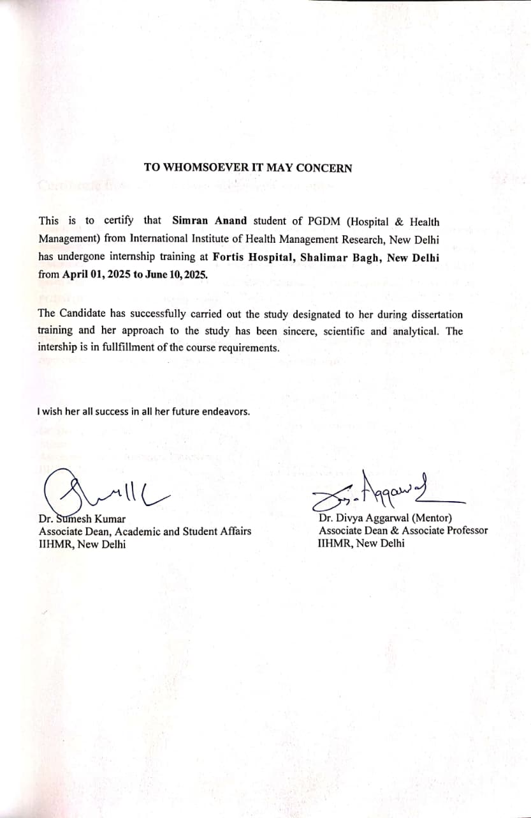

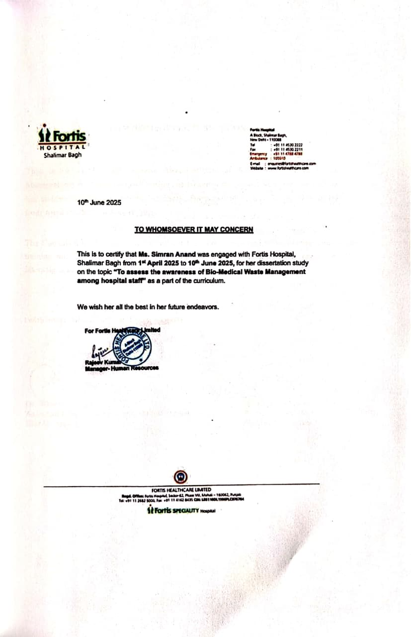

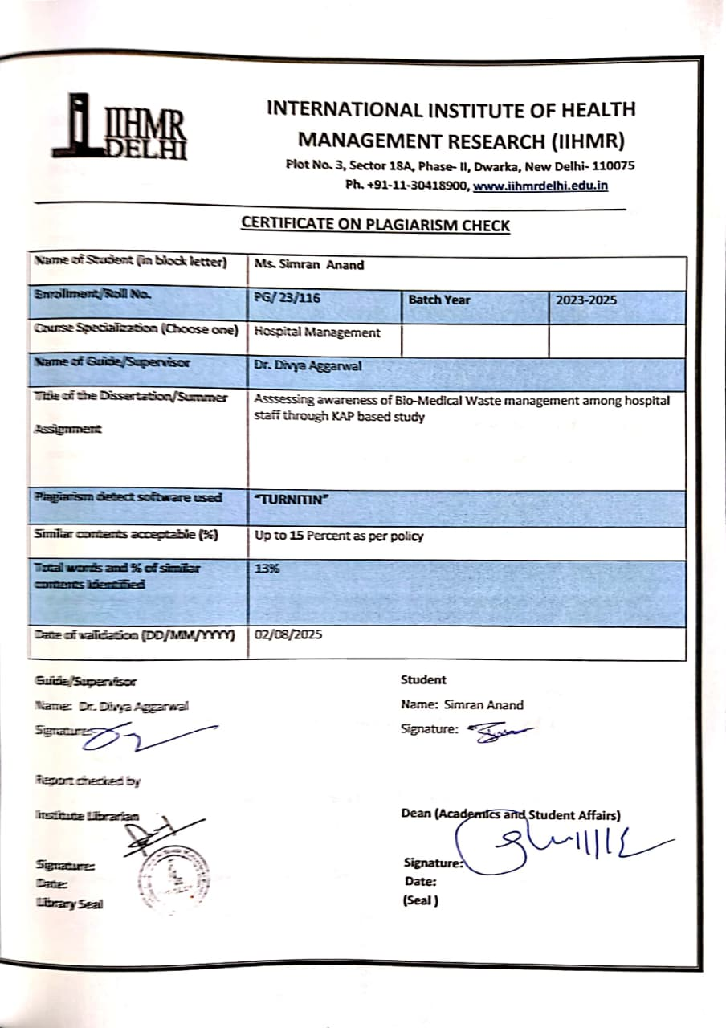

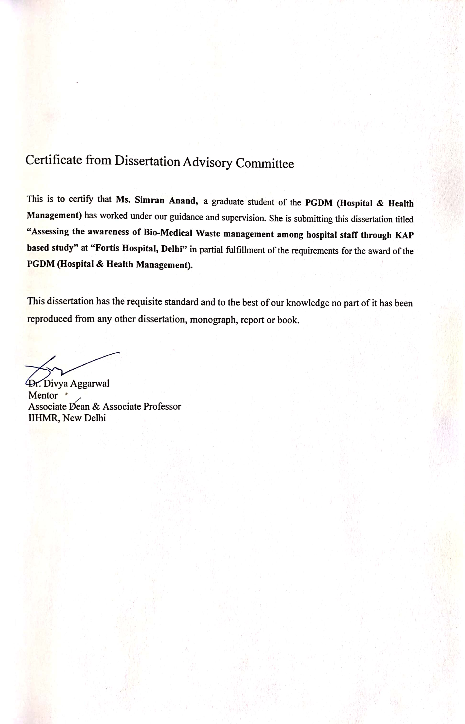

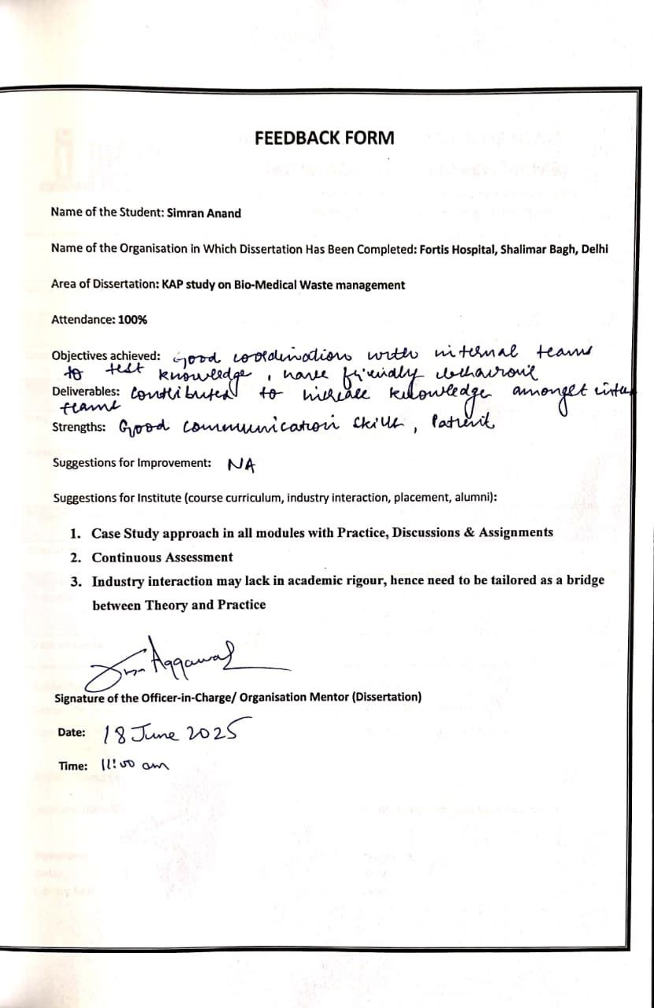

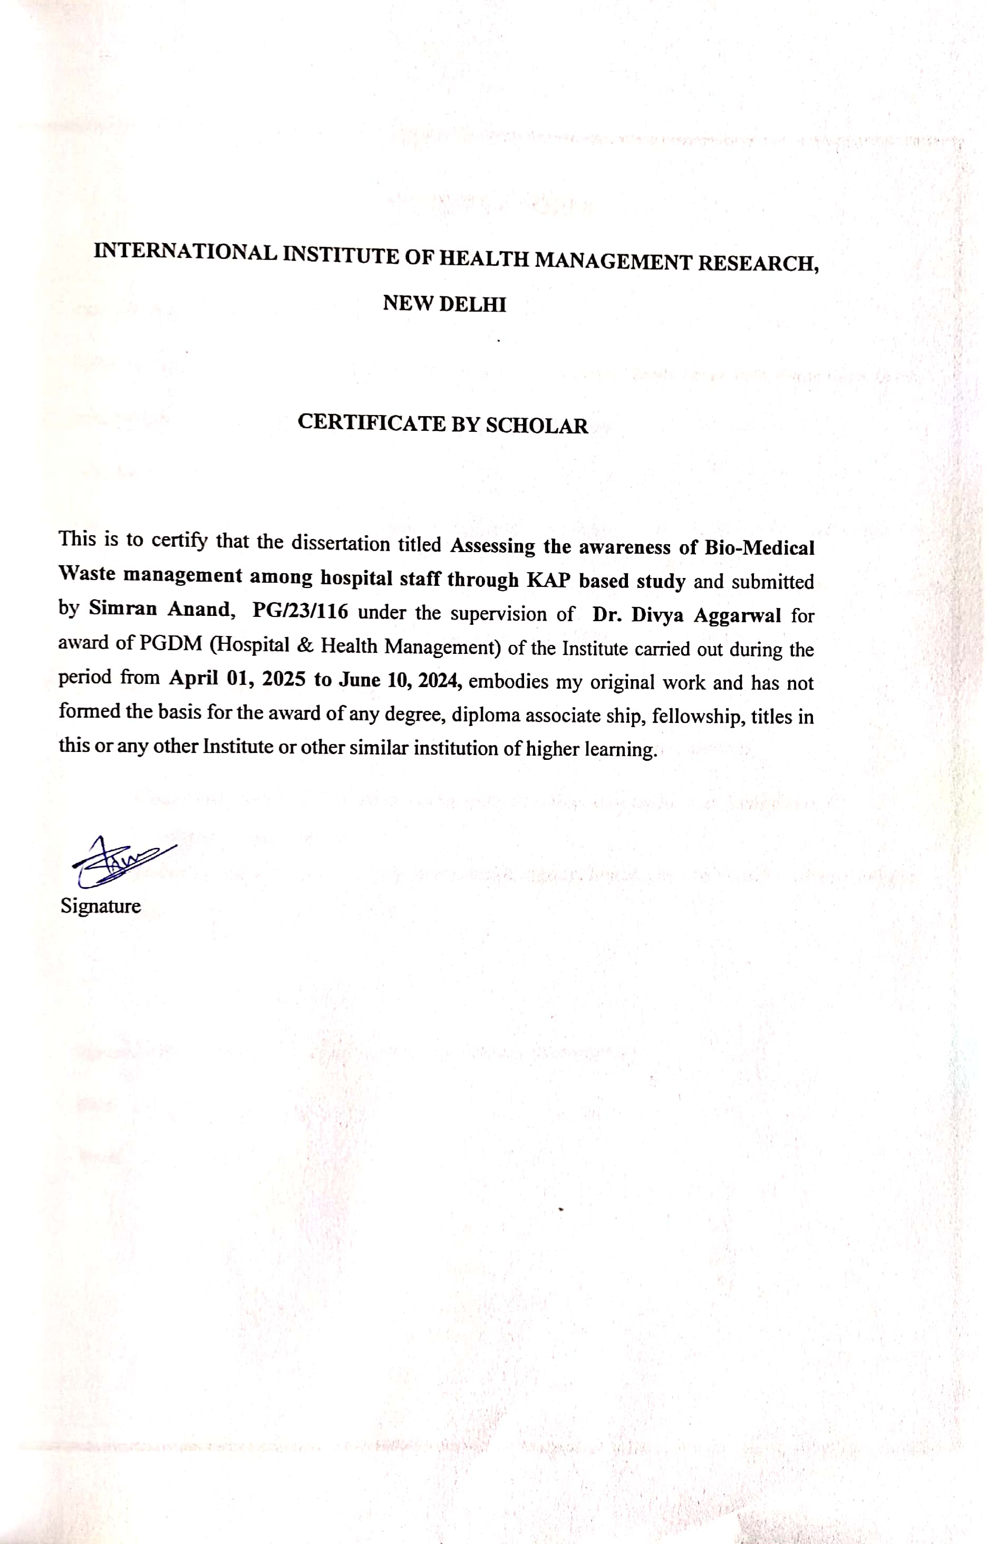

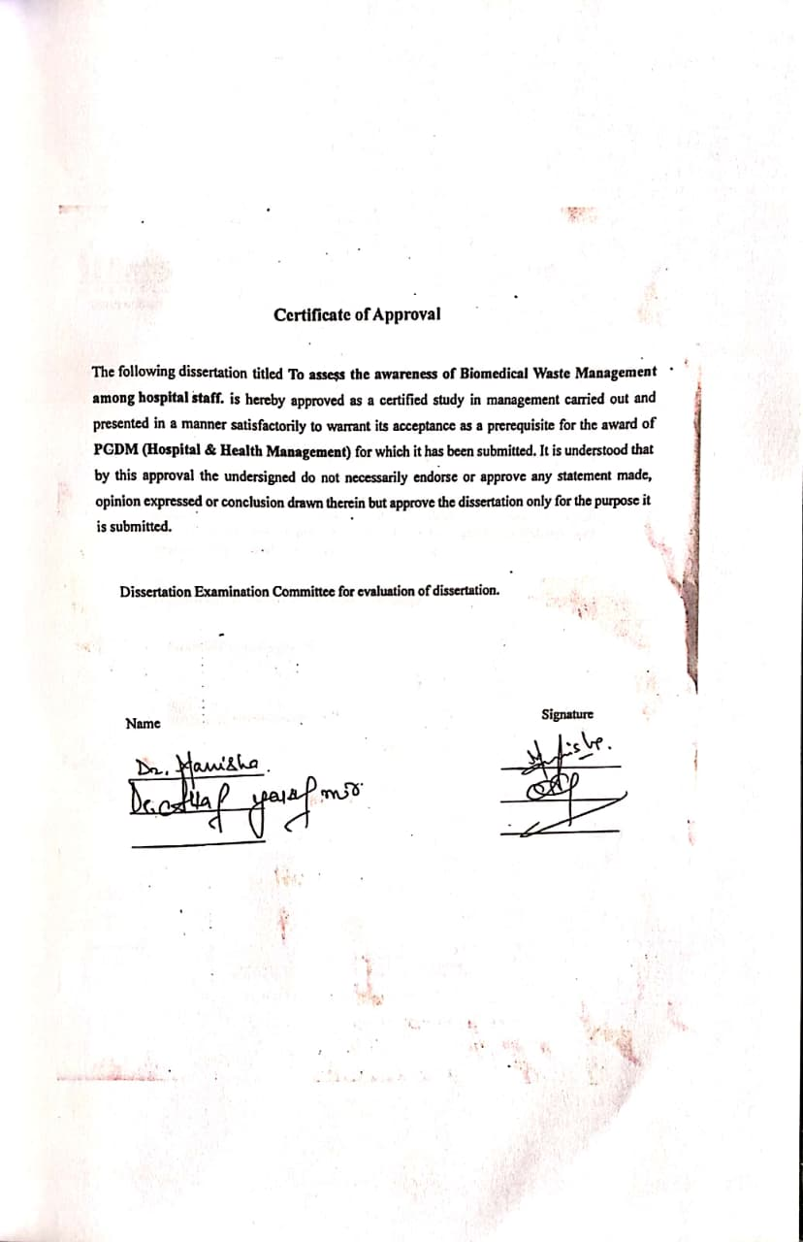

Abstract

Background:

Biomedical Waste (BMW) poses significant health and environmental hazards if not managed properly. Despite the introduction of the Bio-Medical Waste Management Rules, 2016 in India— which aim to ensure safer handling, segregation, and disposal—there remains a gap in compliance across many healthcare facilities. Knowledge, Attitude, and Practices (KAP) of hospital staff are crucial determinants of effective implementation.

Objective:

To assess the knowledge, attitude, and practices of hospital staff regarding biomedical waste management, evaluate the impact of training, and identify existing gaps in compliance.

Methodology:

A cross-sectional KAP-based study was conducted among 280 hospital staff (clinical and non- clinical) using a structured questionnaire. The responses were analyzed to categorize participants based on their KAP levels and explore the correlation between training received and actual practices.

Results:

- Knowledge: 66% of staff had good knowledge, 32% moderate, and only 2% poor knowledge.
- Attitude: 73% showed a positive attitude, while 26% were moderate, and 1% had a negative attitude.
- Practice: 55% demonstrated good practices, 31% moderate, and 14% poor.

- Training Impact: While 88% of participants had received BMW training, the correlation between training and knowledge was weak. However, training showed moderate influence on attitude and a slight positive impact on practice.

Conclusion:

While awareness and attitude toward BMW management were relatively strong, a gap exists between knowledge and consistent practice. The findings highlight the need for improved, hands- on training, regular audits, and behavioral reinforcement, particularly among non-clinical and moderately performing staff. Strengthening institutional support and monitoring mechanisms is essential for ensuring full compliance with the BMW Management Rules, 2016.

Acknowledgements

First and foremost, I express my deepest gratitude to the Almighty for granting me the strength, perseverance, and clarity of mind to complete this dissertation.
I would like to express my heartfelt gratitude for the support and guidance I have received throughout my dissertation from various people. I would also like to thank everyone for sharing their wonderful experiences and giving me an opportunity to grow under their guidance. Their collective wisdom has not only enriched my academic pursuits but has also broadened my perspectives, fostering personal and professional growth. My sincere appreciation goes out to each individual who has contributed to my learning and development during this transformative journey.
I extend my heartfelt thanks to my mentor, Dr. Divya Aggarwal, from IIHMR Delhi, whose insightful guidance, constant support, and invaluable feedback have been instrumental in shaping this work. His encouragement and expertise inspired me to explore new perspectives and maintain a rigorous approach throughout this study.
I would also like to sincerely thank Dr. Bharat Bansal, from my hospital where i did my dissertation project, Delhi for his unwavering support and generous guidance during the course of this dissertation. His constructive inputs and critical insights were crucial in refining the review and enriching the overall quality of this work.
I am grateful to my friends and collegues, Anand, Anushi and Eshika, for their assistance and cooperation.
Finally, I thank everyone who contributed, directly or indirectly, to this dissertation. Simran Anand

Table of contents

Sr. No. | Content | Page. No.
1 | Abstract | 1-2
2 | Acknowledgement | 3
3 | Table of contents | 4
4 | Abbreviations | 5
5 | Introduction | 6
6 | Ojectives | 7
7 | Literature Review | 7
8 | Methodology | 10
9 | Result | 14
10 | Discussion | 21
11 | Gap and Recommendations | 21-22
12 | Conclusion | 24
13 | References | 26
14 | Plagiarism Report | 28
15 | Questionnaire

List of Abbreviations

Abbreviation | Full Form
BMW | Bio-Medical Waste
CPCB | Central Pollution Control Board
AYUSH | Ayurveda, Yoga & Naturopathy, Unani, Siddha and Homeopathy
KAP | Knowledge, Attitude, Practice
TPA | Third Party Administrator
PPE | Personal Protective Equipment
WHO | World Health Organization
GPS | Global Positioning System
HR | Human Resource
HWC | Health and Wellness Centers
ASHAs | Accredited Social Health Activists
NGOs | Non-Governmental Organizations

Introduction

Biomedical waste (BMW) refers to any waste generated during the diagnosis, treatment, or immunization of humans or animals, or in related research activities. Proper management of BMW is critical to prevent hospital-acquired infections, environmental contamination, and occupational hazards among healthcare workers.
In India, the Biomedical Waste Management Rules, 2016, framed under the Environment

(Protection) Act, 1986, mandate all healthcare facilities to segregate, handle, and dispose of BMW safely. These rules outline clear responsibilities for color-coded segregation, storage limits (within 48 hours), transportation, and treatment.
However, compliance with these regulations remains a concern. According to a CPCB report (2020), around 25–30% of Indian healthcare facilities were found non-compliant with BMW management rules. Studies have shown that improper BMW disposal contributes to increased risks of hospital-acquired infections, needle-stick injuries, and cross-contamination, particularly in facilities with poor segregation practices.
Assessing the Knowledge, Attitude, and Practices (KAP) of hospital staff is essential, as they are the first point of contact for waste generation. This study aims to evaluate the awareness and behavioral patterns of hospital staff regarding BMW handling to identify knowledge gaps and improve compliance with national regulations.

Objectives

- To assess the level of knowledge among hospital staff regarding BMW segregation, risks, and disposal methods.
- To evaluate attitudes toward BMW management, including perceptions of its importance and barriers to compliance.
- To analyze current practices related to BMW handling, including adherence to hospital guidelines and regulations.
- To identify gaps between knowledge, attitude, and practice and propose interventions for improvement.

Literature Review

Biomedical waste (BMW) is a significant byproduct of healthcare delivery, and its mismanagement poses serious health and environmental threats. Recognizing the rising burden of healthcare waste and gaps in implementation of earlier policies, the Government of India introduced the Bio-medical Waste Management Rules, 2016, which replaced the 1998 rules under the Environment (Protection) Act, 1986 [6]. These new rules were a major overhaul, aimed at improving clarity, accountability, and compliance across all healthcare settings.

Key Improvements in BMW Rules, 2016:

  - Color-coded segregation simplified to four categories (Yellow, Red, White, Blue), making compliance easier.

  - Rules now extended to include dentists, AYUSH hospitals, HWC’s, blood banks, animal houses, and vaccination camps.
  - Mandatory barcoding and GPS tracking of waste from source to disposal.

  - Prescribed a 48-hour limit for storage of untreated BMW at healthcare facilities.

  - Introduction of annual training and mandatory display of waste disposal practices at site.

  - Amendments in 2018 and 2019 further emphasized pre-treatment of lab and microbiology waste and phasing out of chlorinated plastic bags.
These changes addressed many of the gaps seen in the pre-2016 system, which lacked clarity in segregation, monitoring, and accountability. However, as studies show, implementation remains a challenge.

Research-Based Evidence on KAP and Compliance-

In their review of the 2016 policy changes, Kharat (2016) and Singhal et al. (2017) acknowledged the improved scope and structure of the updated rules but stressed that actual field compliance depends heavily on human behavior — especially staff knowledge, attitude, and practice [1,2]. Both studies argue that without effective training, monitoring, and supervision, the expected impact of these rules cannot be realized.
To assess these behavioral components, many researchers have applied the KAP (Knowledge, Attitude, and Practices) model. In a study conducted at a tertiary hospital in Northern India, Abas Khan et al. (2023) found that although a majority of healthcare staff were aware of BMW rules and had received training, this did not always translate into correct practices such as PPE use and proper color-coded segregation.

Similarly, Mehta (2019) reported that even with a fairly positive attitude among health workers in Western Uttar Pradesh, practice adherence was suboptimal, especially among non-clinical staff. The study emphasized that attitude and institutional reinforcement played a more critical role than knowledge alone.
Parida et al. (2019) extended this by including awareness of the 2018 amendments and comparing KAP levels across different cadres of staff. Their study confirmed that while clinical staff had higher awareness, support and housekeeping staff demonstrated poor understanding of even basic waste segregation protocols — indicating a clear training and communication gap.

Institutional and Policy-Level Gaps-

Despite the structured framework of the 2016 guidelines, literature highlights ongoing gaps:

  - Inconsistent training and follow-up

  - Lack of accountability and real-time monitoring

  - Poor implementation of barcoding and waste tracking

  - Minimal involvement of non-clinical and contractual staff in training sessions.

Relevance of Current Study-

Given the updated regulatory framework and ongoing compliance challenges, KAP-based assessments like the present study are crucial to identify behavioral gaps and evaluate training effectiveness at the institutional level. Furthermore, this study includes correlation analysis, offering insights into how knowledge and attitude influence actual practices — an area still under- explored in existing Indian literature.

Methodology

  - Study Design: Quantitative study including cross-sectional KAP (knowledge, attitude and practices) based survey of hospital staff.
  - Study Population: Hospital staff (doctors, nurses, housekeeping, technicians).

Inclusion criteria-

    - Clinical and Non- Clinical staff ( involved in handling of Bio-medical waste).

    - Staff working with minimum 6 months of experience.

Exclusion criteria-
- Staff including administrative staff such as Billing , HR, TPA, Medical Record Department, IT technicians.
- Temporary Staff (interns, students, replacement staff)
- Staff not willing to participate.

  - Sampling: Stratified random sampling to include different hospital departments.
  - Sample Size: 280
As per Cochran Formula-
n₀ = z²ρ (1-ρ) / e² where, n₀ = Required sample size
z = z score corresponding to 95% confidence interval level (i.e. z = 1.96)
ρ = estimated proportion of the population (for maximum variability, ρ = 0.5)

e = margin of error ( commonly 0.05 or 5%)

here, for large infinite populations, n₀ = 384.16 (≈ 384 respondents)

As it is a 266 beded hospital, minimum no. of hospital staff required is approximately 1000.

So, applying Cochran formula for finite population where, N = 1000 n = n₀ / 1+ ( n₀-1/ N)
it gives, n = 277.7 ( ≈ 278)

So, desired sample size can be taken as 280.

  - Timeline : 3 months

Ethical Consideration:
    - Informed consent before proceeding with survey.

    - Completely Anonymous as it doesn’t require any personal detail.
    - Volunteer participation with right to refuse anytime during survey.

Limitations:
    - Variability in training policies.

    - No response bias from staff who are not willing to participate.

    - Time constraints.

Data Collection Tool-

A structured questionnaire with three sections:

- Knowledge: Multiple-choice questions on BMW rules, risks, and segregation categories.
- Attitude: Likert scale questions on beliefs, concerns, and motivation toward BMW compliance.
- Practice: Self-reported and observational data on daily BMW handling.

Data Analysis Plan-

  - Knowledge scores categorized as poor, moderate, or good to summarize the central tendencies and distribution of responses.
(each correct answer = 1 point and each incorrect answer = 0 point) By categorising knowledge levels as-
<50% = Poor

50-75% = Moderate

>75% = Good

  - Attitude assessment using descriptive statistics by using Likert scale responses (varying from Strongly Agree to Strongly Disagree).
Scoring given out of 5 and categorization is done as Positive, Neutral or Negative attitudes

Interpret mean scores out of 5:

3.75–5.0 = Strongly Positive Attitude (>75% of 5)

2.5–2.75 = Neutral/Mixed Attitude (50-75% of 5)

Below 2.5 = Negative Attitude (<50% of 5)

Assuming 6 questions × max score 5 = 30, so
>75% = Positive attitude 50% to 75%= Neutral attitude
<50% = negative attitude

  - Practice assessment comparing self-reported vs. observed behaviors by calculating percentage of staff following proper disposal protocols by calculating practice scores.
(each correct answer = 1 point and each incorrect answer = 0 point) By categorising practice scores as-
<50% = Poor

50-75% = Moderate

>75% = Good

Tools – Like Pie charts, Bar charts, frequency tables and measures of central tendency can be used to present data outcomes.
  - Correlation analysis to examine links between independent variables (i.e. training provided to the staff) to dependent variables (i.e. knowledge, attitude and practice)
For example-

- Does better training relate to better knowledge?

- Does better training relate to better attitude?

- Does better training relate to better practice?

Training is a key intervention point in any hospital’s infection control and waste management policy. Since proper BMW handling depends not just on rules but on how well staff are trained and engaged. That is why, I included 'training received' as an independent variable to correlate with knowledge, attitude, and practice. This allows me to measure the real-world impact of training programs on behavior and awareness, and identify whether current training is effective or needs improvement. My findings can directly inform hospital policy for staff development.

Results

Experience-Wise Responses

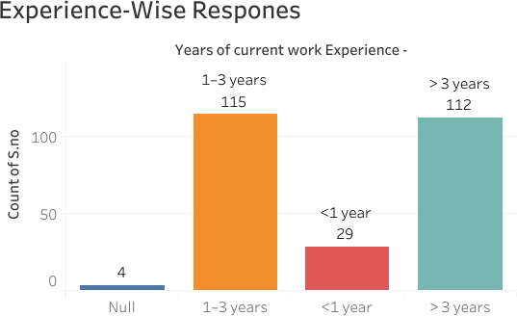

This graphical representation categorizes respondents based on their current work experience in the hospital:

  - The majority of respondents (115 individuals) have 1–3 years of experience, indicating a relatively early-stage workforce.
  - A close second group consists of those with more than 3 years of experience (112 individuals), suggesting a well-represented segment of experienced staff.
  - A smaller group of 29 respondents reported having less than 1 year of work experience, likely new recruits or trainees.
  - 4 responses were marked as "Null" (representing those respondants who didn’t provided consent for participation).
Interpretation:
The sample includes a balanced mix of mid-level and senior staff, with fewer newcomers. This can be beneficial for assessing practices influenced by experience levels.

Training Responses

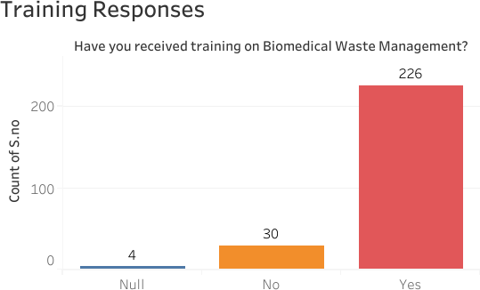

This graphical representation illustrates whether the participants have received formal training in Biomedical Waste Management (BMW):
  - A large majority (226 respondents) confirmed receiving training, reflecting strong institutional emphasis on BMW education.
  - 30 individuals reported they had not received any training, indicating gaps in outreach or onboarding processes.
  - Again, 4 responses are marked "Null".

Interpretation:

With nearly 88% of participants trained, the organization appears compliant on the surface. However, the remaining 12% untrained staff still present a risk to BMW compliance, especially if they are directly handling waste.

Designation-Wise Responses

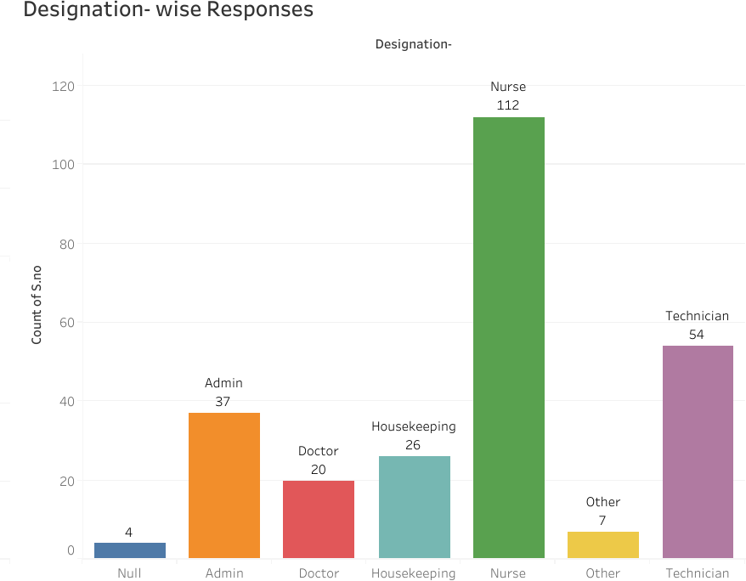

This graph represents respondents based on their professional role within the hospital:

  - Nurses form the largest group with 112 responses, highlighting their significant involvement in patient care and BMW handling.
  - Technicians (54) and admin staff (37) follow next, indicating diverse departmental input.

  - Housekeeping staff (26) and doctors (20) also participated, though in smaller numbers.

  - A small number (7) marked "Other" (likely pharmacists, interns, etc.), while 4 entries were Null.

Interpretation:

The sample is multidisciplinary, with the largest representation from nursing and technical staff, who are typically the most involved in biomedical waste handling. However, lower participation from housekeeping and doctors may indicate either sampling imbalance or reduced involvement in waste segregation responsibilities.

Knowledge Levels of Staff
Categorization based on Knowledge levels of staff
Poor 2%
Moderate 32%
Good Moderate
Poor
Good 66%

This pie chart reflects how staff members were categorized based on their knowledge about biomedical waste management:
  - 66% of respondents demonstrated good knowledge, indicating that the majority are well- informed about waste segregation, handling, and disposal procedures.
  - 32% showed moderate knowledge, suggesting they are aware of basic rules but may lack clarity on details or updated guidelines.
  - Only 2% were found to have poor knowledge, a relatively small but important group to target for immediate training.

Interpretation:
This result is encouraging as two-thirds of the participants possess adequate knowledge. However, the presence of a moderate group implies there is still room for improvement through targeted educational programs.

Attitude Toward Biomedical Waste Management


Categorization based on Attitude
Moderate Attitude 26%
Moderate Attitude Negative Attitude
Positive Attitude
Negative Attitude 1%
Positive Attitude 73%

This chart showcases how the hospital staff perceive and value BMW practices:

  - 73% of the respondents showed a positive attitude, indicating they understand the importance of proper BMW management and are likely to support safe practices.
  - 26% had a moderate attitude, which might reflect uncertainty, lack of motivation, or the perception that BMW management is not their responsibility.
  - A very small group (1%) held a negative attitude, which could stem from lack of awareness or systemic negligence.

Interpretation:

The overwhelmingly positive attitude is a strong foundation for improving practices. The moderate group needs further reinforcement through behavioral interventions and consistent leadership emphasis on compliance.

Current Practices Followed by Staff



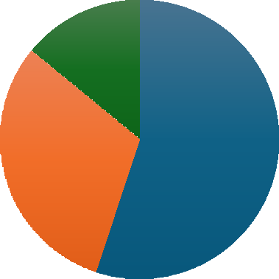
Categorization Based on Practice by Staff
Poor Practice 14%
Good Practice
Moderate Practice Poor Practice
Moderate Practice 31%
Good Practice 55%

This pie chart assesses the actual on-ground implementation of BMW practices:

  - 55% of staff are practicing good biomedical waste management, implying compliance with protocols such as segregation, use of PPE, and correct disposal methods.
  - 31% exhibit moderate practices, which may involve occasional lapses or lack of adherence to the complete procedure.
  - 14% follow poor practices, which is concerning as it directly increases risk of infection, contamination, and regulatory violations.

Interpretation:

While the majority are following good practices, nearly half the staff are not consistently compliant. This highlights the need for routine audits, supervised follow-up, and hands-on practical training, especially for the moderate and poor-performing groups.

Correlation analysis of Training with other variables i.e. Knowledge, Attitude and Practice

Relationship | Correlation (r) | p-value | Interpretation
Training ↔ Practice | 0.223 | .000 | Weak but statistically significant positive correlation
Training ↔ Attitude | 0.327 | .000 | Moderate positive correlation, statistically significant
Training ↔ Knowledge | 0.008 | .899 | No correlation, not statistically significant

Discussion

Inferences from Correlation Analysis
- Training Received vs Knowledge Score

  - Implication: Training has no clear effect on knowledge scores, suggesting the training might not be effectively improving theoretical understanding — or that knowledge may already be high across participants.

Training Received vs Attitude Score

  - Implication: Training appears to have a noticeable impact on improving employee attitude toward biomedical waste management.

Training Received vs Practice Score

  - Implication: Employees who received biomedical waste training tend to follow better practices, but the relationship is not very strong.

Gaps

Weak Link Between Knowledge and Practice

  - Despite many staff scoring high in knowledge, this did not strongly translate into practice (r = 0.205).
  - Indicates a gap between theoretical understanding and practical implementation of BMW rules.

Moderate Attitude–Practice Link

  - While attitude showed a moderate correlation with practice (r = 0.434), it still suggests that a positive attitude alone may not ensure correct behavior.
  - This highlights a need for behavioral reinforcement through monitoring and accountability.

Limited Effectiveness of Training

  - A significant number of staff reported receiving training, yet:

    - Knowledge scores were still varied.

    - Some trained staff demonstrated poor or average practices.

  - Indicates gaps in training content, delivery, or follow-up.

Inconsistent Practice Compliance

  - Not all staff follow essential practices like:

    - Correct color-coded segregation

    - Use of PPE

    - Reporting unsafe disposal

  - This shows gaps in daily routine monitoring and supervision.

Lack of Regular Evaluation

  - No system appears in place for periodic assessment of staff KAP toward BMW.

  - Indicates a need for institutional policies on regular KAP audits.

Gaps Among Non-Clinical Staff

  - Often housekeeping, security, and administrative staff are less trained or aware.

  - Points to uneven dissemination of BMW guidelines across departments.

Recommendations

Strengthen Training Programs

  - Conduct mandatory, periodic training sessions for all hospital staff — including non- clinical workers.
  - Include practical demonstrations, visual aids, and real-life case scenarios to improve retention.
  - Develop department-specific training modules to address role-based BMW handling.

Bridge Knowledge–Practice Gap

  - Reinforce learning through hands-on supervision and routine demonstrations.

  - Introduce on-the-spot checks and “buddy systems” for new staff.

  - Use infographics/posters in wards and waste zones to reinforce daily reminders.

Enhance Attitude through Awareness Campaigns

  - Conduct awareness drives highlighting the risks of improper BMW handling (e.g., infections, legal issues).
  - Recognize and reward model staff behavior to build motivation and positive reinforcement.

Implement Monitoring & Evaluation Systems

  - Set up a BMW audit team to conduct regular spot checks and feedback sessions.

  - Use simple tools (e.g., checklists or mobile apps) for daily compliance monitoring.

  - Conduct quarterly KAP assessments to track improvements over time.

Policy-Level Interventions

  - Make BMW compliance part of staff performance appraisals.

  - Ensure every department designates a BMW compliance officer or liaison.

  - Display color-coded BMW disposal guidelines at all critical waste zones.

Focus on Non-Clinical Staff

  - Design custom training sessions in local languages or with visual tools for housekeeping, admin, and security staff.
  - Ensure they are included in hospital safety briefings and have access to protective equipment.

Conclusion

This study highlights significant insights into the knowledge, attitude, and practices of hospital staff regarding biomedical waste management. While the majority of staff showed positive attitudes and had received training, a noticeable gap persists between knowledge and actual practice. The correlation analysis further revealed that attitude plays a more significant role in influencing proper waste handling than knowledge alone.
These findings underscore the need for more effective, hands-on training, regular monitoring, and behavioral reinforcement strategies. Bridging these gaps is essential not only for compliance with BMW Management Rules, 2016, but also for ensuring patient safety, infection control, and environmental sustainability within healthcare settings.

References-

- Abas Khan DA, Gupta M, Udhampur J, Gupta M. A cross-sectional study of Knowledge, Attitude and Practices regarding Biomedical waste management among the healthcare workers at a tertiary care teaching hospital in Northern India. https://ijlbpr.com/uploadfiles/70vol14issue3pp395-400.20250314071826.pdf
- Mehta A. A study of knowledge, attitude, and practices regarding biomedical waste management among the health care workers at a tertiary care teaching hospital of western uttar pradesh. International Journal of Medical and Biomedical Studies. 2019;3:12. https://doi.org/10.32553/ijmbs.v3i12.786
- Lipika Singhal, Arpandeep Kaur Tuli, Vikas Gautam, Biomedical Waste Management Guidelines 2016: What’s done and what needs to be done, Indian Journal of Medical Microbiology, Volume 35, Issue 2, 2017 https://doi.org/10.4103/ijmm.IJMM_17_105
- Kharat, Dr. D.S.. (2016). Biomedical Waste Management Rules, 2016: A review.

International of advanced Research and Development. 1. 48-51. https://www.researchgate.net/publication/317305231_Biomedical_Waste_Management_
Rules_2016_A_review

- Parida A, Capoor MR, Bhowmik KT. Knowledge, attitude, and practices of Bio-medical Waste Management rules, 2016; Bio-medical Waste Management (amendment) rules, 2018; and Solid Waste Rules, 2016, among health-care workers in a tertiary care setup. Journal of laboratory physicians. 2019 Oct;11(04):292-6. https://www.thieme-
connect.com/products/ejournals/abstract/10.4103/JLP.JLP_88_19?device=mobile&inner
Width=416&offsetWidth=417

- https://dhr.gov.in/sites/default/files/Bio-medical_Waste_Management_Rules_2016.pdf

- Bio-medical_Waste_Management_Rules_2016.pdf https://share.google/IyXUNRl4PSChudDwf

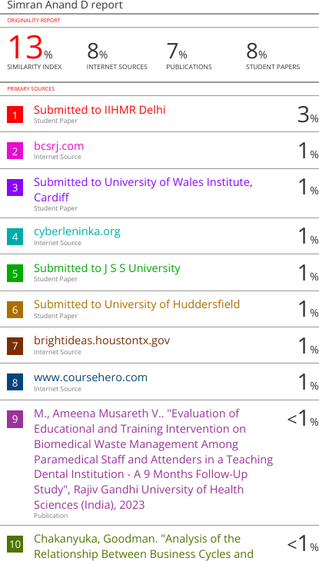

4/7/25, 3:04 AM Study Title: Assessing Awareness of Biomedical Waste Management among Hospital Staff

Study Title: Assessing Aareness of Biomedical Waste Management among Hospital Staff
This study aims to evaluate the knowledge, attitude, and practices (KAP) of hospital staff regarding the management of biomedical waste.
* Indicates required question

Consent Form for Participation in Survey Participation Details:
- Participation is voluntary and anonymous.
- The survey will take approximately 5–7 minutes to complete.
- All responses will be kept conﬁdential and used only for academic research purpose only.
- You have the right to refuse or withdraw from the survey at any time.
There are no risks or direct beneﬁts involved in participation. However, your responses will help improve awareness and waste management practices in hospital settings.
By proceeding with the questionnaire, you acknowledge that :

-You have read the above information.

-You voluntarily agree to participate in this study.

-You are a staff member working in a hospital.

- Do you consent to participate in this survey? *
Mark only one oval.

 Yes, I agree to participate
 No, I do not want to participate.

Demographic Information

4/7/25, 3:04 AM Study Title: Assessing Awareness of Biomedical Waste Management among Hospital Staff
- Age group- *
Mark only one oval.

 Under 20 years
 21-30 years
 Above 30

- Designation- *
Mark only one oval.

 Doctor  Nurse  Technician
 Housekeeping  Admin
 Other

- Years of current work Experience - *
Mark only one oval.

 <1 year
 1–3 years
> 3 years

- Have you received training on Biomedical Waste Management? *
Mark only one oval.

 Yes  No

4/7/25, 3:04 AM Study Title: Assessing Awareness of Biomedical Waste Management among Hospital Staff

Knowledge based questions (Objective MCQs – Score-based)

- Which color-coded bin is used for human anatomical waste? *
Mark only one oval.

 Red  Yellow  Blue  Black

- Biomedical waste should be segregated at: *
Mark only one oval.

 The time of disposal  The storage room
 The point of generation  The incinerator

- Sharp waste (needles, blades) should be disposed of in: *

Mark only one oval.

 Red bag  Blue bin
 Puncture-proof container  Black bag

4/7/25, 3:04 AM Study Title: Assessing Awareness of Biomedical Waste Management among Hospital Staff
- Maximum time allowed to store biomedical waste at a facility before disposal is: *
Mark only one oval.

 12 hours
 24 hours
 48 hours
 72 hours

- Which of the following is considered hazardous biomedical waste? *
Mark only one oval.

 Used gloves  Paper
 Kitchen waste  Clean cotton

- Who is responsible for segregating biomedical waste in a hospital setting? *

Mark only one oval.

 Ward boy
 Every healthcare worker generating the waste  Supervisor
 Waste handler

Attitude (Likert Scale – Strongly Agree to Strongly Disagree)

5= strongly agree | 4= agree | 3= not agree | 2= disagree | 1= strongly disagree

4/7/25, 3:04 AM Study Title: Assessing Awareness of Biomedical Waste Management among Hospital Staff
- Proper disposal of biomedical waste is essential for infection control. *

Mark only one oval.

1 2 3 4 5





Stro Strongly Agree
ngly
Disag
ree

- BMW management is everyone's responsibility in the hospital. *

Mark only one oval.

1 2 3 4 5





Stro Strongly Agree
ngly
Disag
ree

- Segregating waste into different bins is time-consuming. *

Mark only one oval.

1 2 3 4 5






Stro Strongly Agree
ngly
Disag
ree

- Hospital administration supports proper BMW management. *

Mark only one oval.

1 2 3 4 5






Stro Strongly Agree
ngly
Disag
ree

4/7/25, 3:04 AM Study Title: Assessing Awareness of Biomedical Waste Management among Hospital Staff
- Training on BMW should be mandatory for all staff. *

Mark only one oval.

1 2 3 4 5





Stro Strongly Agree
ngly
Disag
ree

Practice (Self-report – Yes/No/Sometimes)

- Do you segregate waste into the correct color bins? *

Tick all that apply.
 Yes No
Sometimes

- Do you wash your hands after handling biomedical waste? *

Tick all that apply.
Yes No
Sometimes

- Do you report when you notice improper waste disposal? *

Tick all that apply.
Yes No
Sometimes

4/7/25, 3:04 AM Study Title: Assessing Awareness of Biomedical Waste Management among Hospital Staff
- Do you follow BMW guidelines in your department every day? *

Tick all that apply.
Yes No
Sometimes

- Have you ever attended a BMW management training session in your current *
hospital?
Mark only one oval.

 Yes  No
 Sometimes

This content is neither created nor endorsed by Google.

 Forms

