Dissertation
At
NUTRITION INTERNATIONAL PROJECT IIHMR, Delhi

A Project Report On
“A Qualitative Research on Experience of Anaemic Women Pre- and Post-Partum”
By
Dr SRISHTI SHOKEEN
PG/21-23/112

Under the guidance of

Dr Pijush Kanti Khan
Assistant Professor, IIHMR, New Delhi

PGDM (Hospital & Health Management)
2021-2023
International Institute of Health Management Research
New Delhi

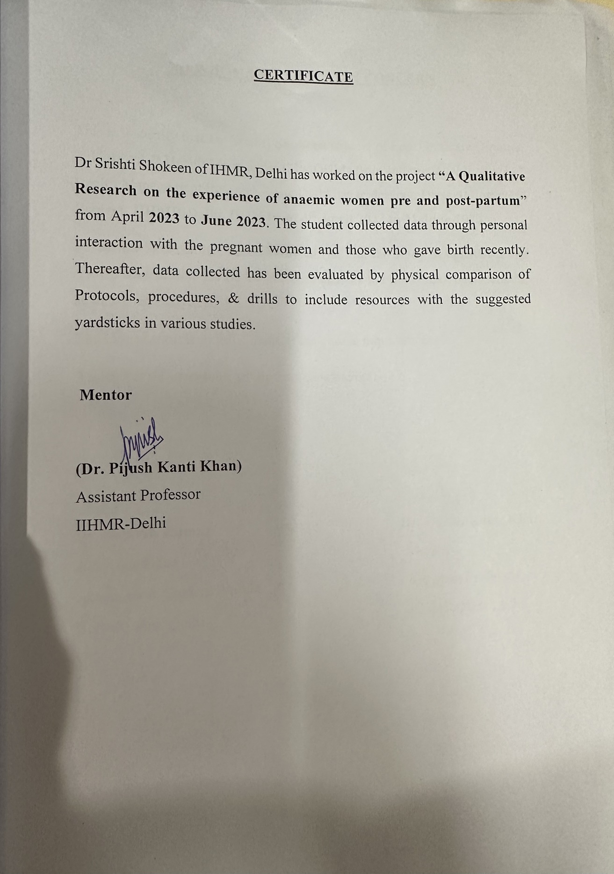

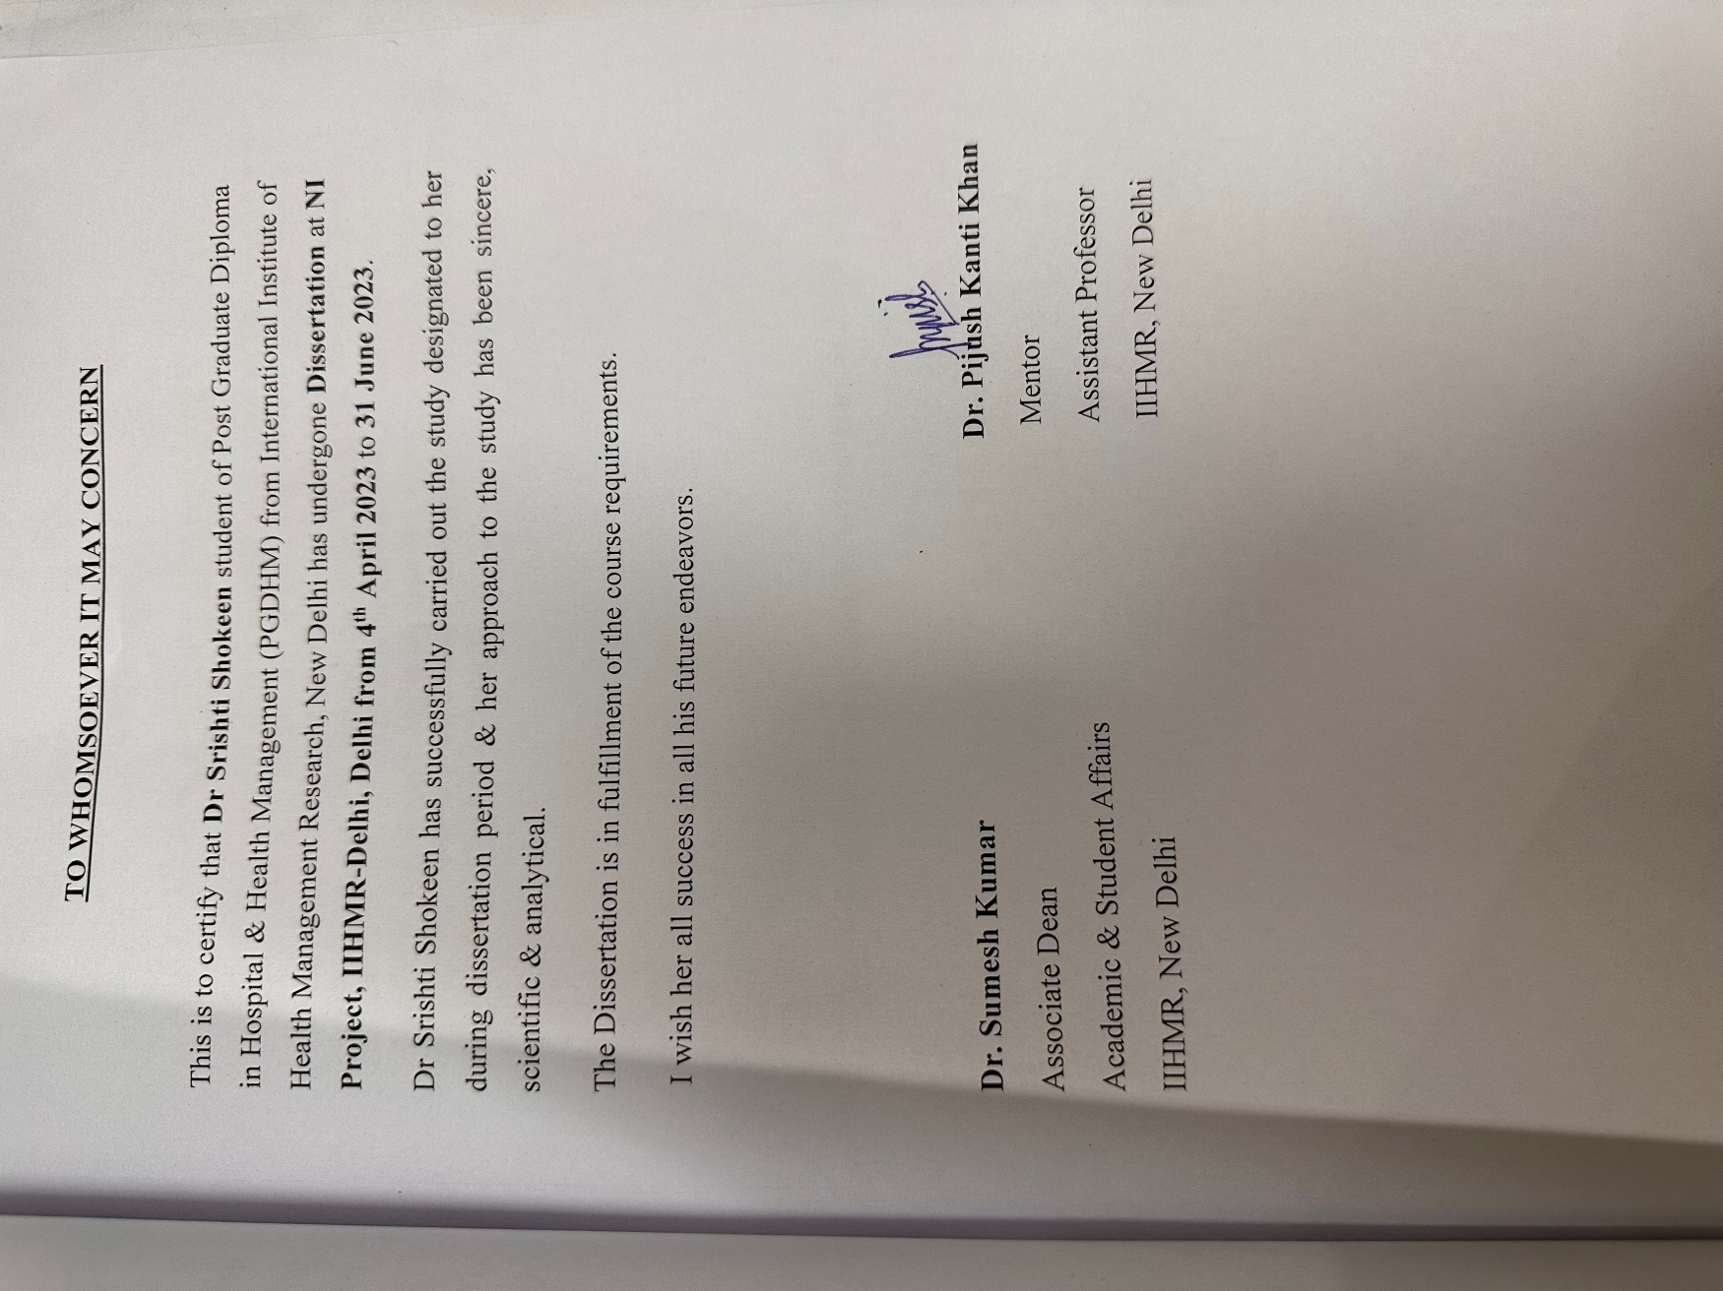

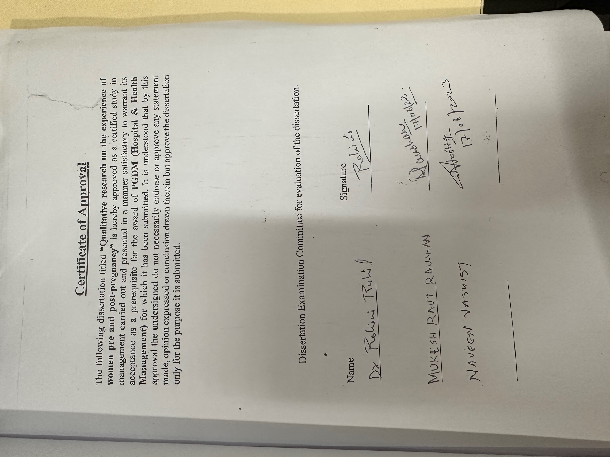

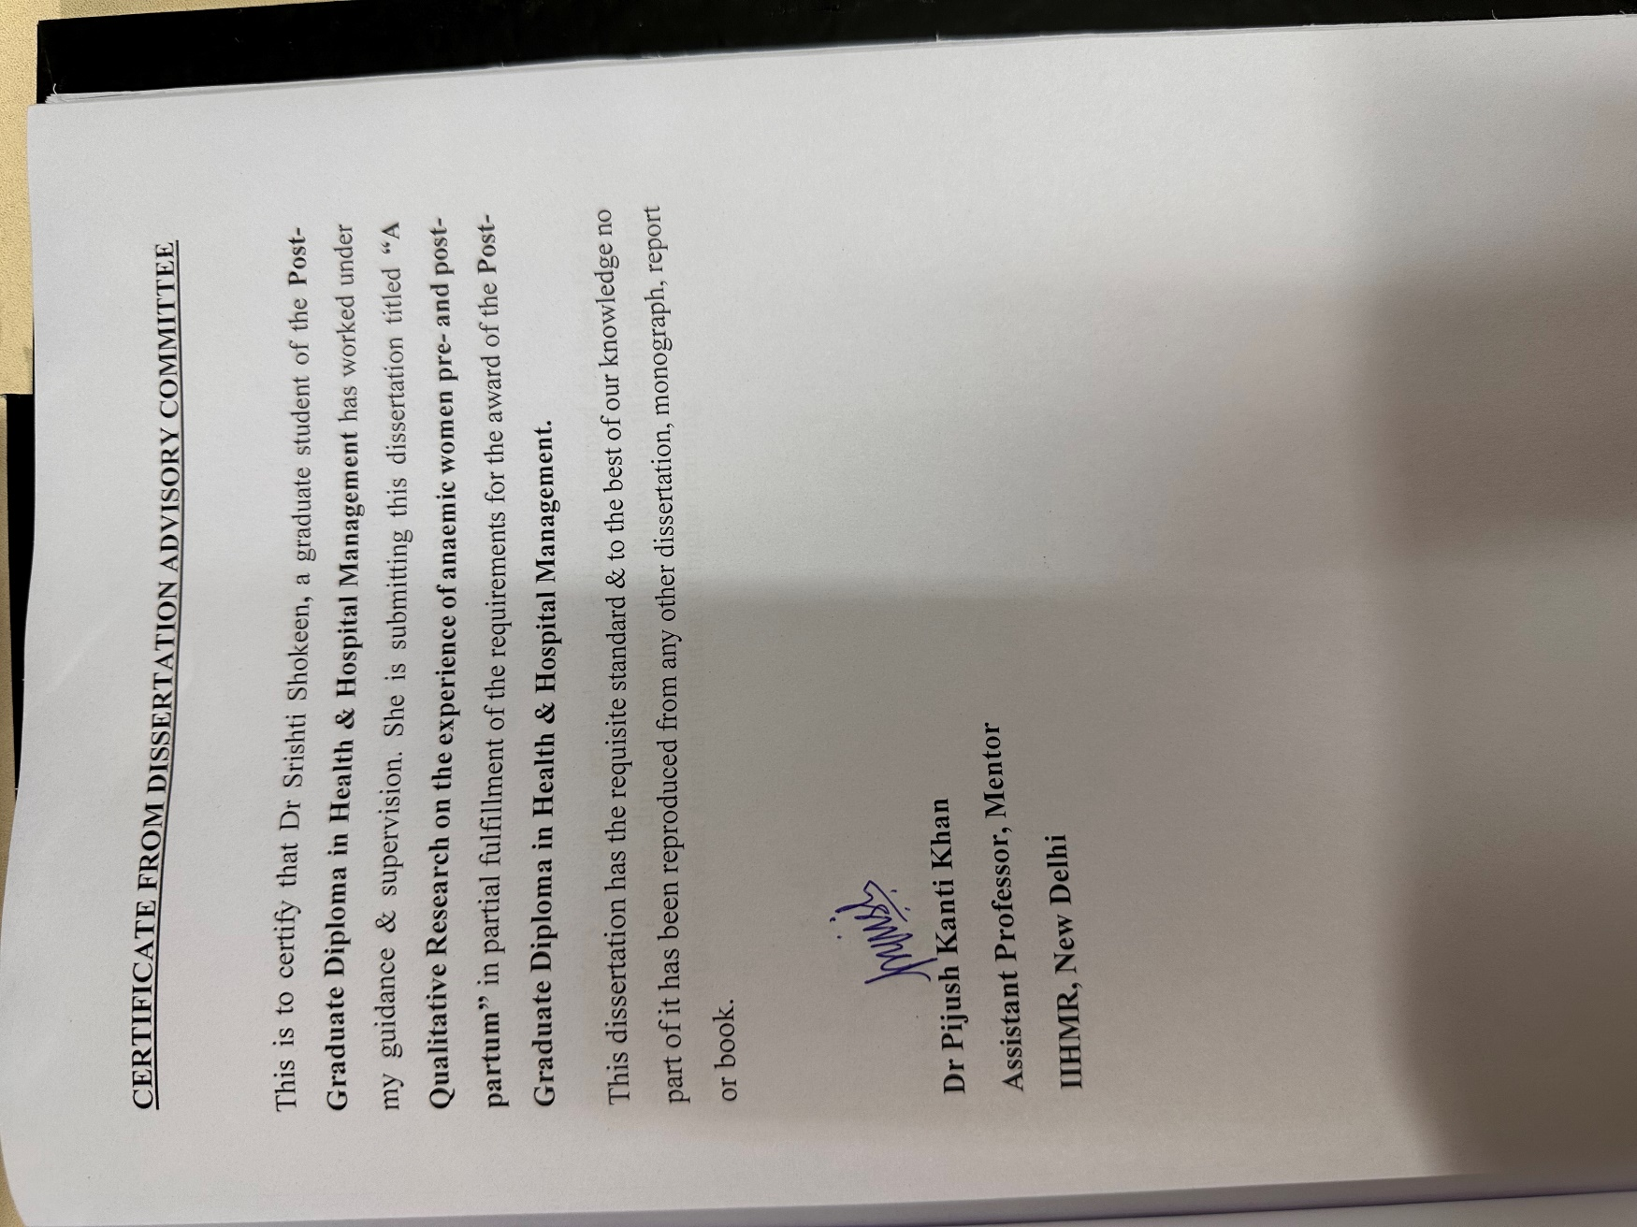

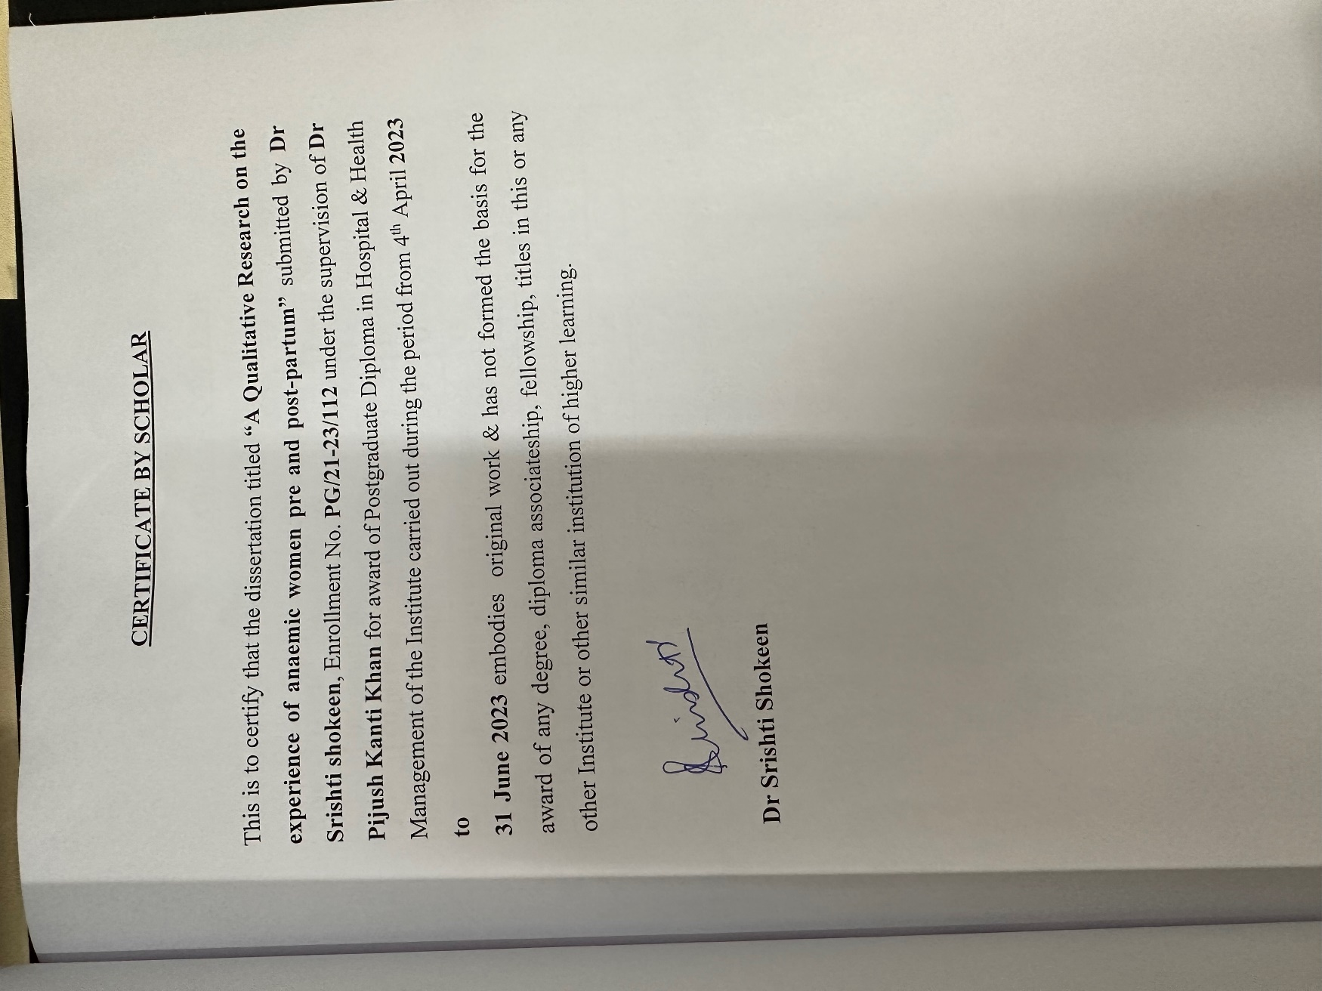

TABLE OF CONTENTS

S No | TOPIC | PAGE No.
1. | Introduction | 8
2. | Objectives | 10
3. | Methodology | 11
4. | Data management and analysis | 13
5. | Results | 14
6. | Conclusion | 22
7. | References | 23
8. | Annexure | 26

Introduction
A condition known as anaemia occurs when the blood's haemoglobin concentration is below 11 g/dl. In India, there are 52.2% of women who are anaemic, which is higher than the NFHS-4 data (50.2%), according to the NFHS-5 data. Pregnant women who are anaemic in urban areas are 45.7% and 54.3% in rural regions. It was anticipated that this proportion would have dropped despite the abundance of health awareness activities for expectant mothers and the development of medical care⁶. Two-thirds of expectant mothers experience anaemia. One of the leading causes of mortality and poor pregnancy outcomes is anaemia⁶. Anaemia during pregnancy should be promptly diagnosed and properly treated to enhance maternal and newborn outcomes. The prevalence of anaemia among women is disproportionately high in South Asia.
According to Development Initiatives (2020), 49% of pregnant women in South Asia are anaemic, which is abnormally high (Development Initiatives, 2020). The World Health Organisation (WHO) states that taking iron supplements can reduce anaemia by about 50%. Iron and folic acid supplementation (IFA) lowers the risk of maternal anaemia and is advised by the WHO to be taken throughout pregnancy. But taking the iron and folic acid as directed by the doctor must be done religiously in order for the treatment to be effective⁹.
This report is about experience of women during pre- and post-partum phase. There is a need to understand women experiences to identify ways to improve the health outcomes. About the experiences of anaemic women during and after pregnancy, including their physical, emotional, and social requirements, as well as the effectiveness and acceptability of various treatment choices, this research attempts to close knowledge gaps. The results of this study can assist medical professionals in creating focused treatments to enhance the health outcomes of anaemic pregnant women.
According to the research, early availability to foods high in micronutrients, IFA pills, and quality prenatal care can all help prevent anaemia and lower the risk of moderate or severe anaemia.

PROBLEM STATEMENT
Anaemia is a common condition among pregnant women, particularly in low- and middle-income countries. It is associated with a range of adverse health outcomes for both the mother and developing foetus, including preterm birth, low birth weight, and increased maternal and neonatal morbidity and mortality^{1,3}. While iron supplementation is the most common treatment for anaemia during and after pregnancy, there is limited evidence on the optimal dose, duration, and timing of iron supplementation⁴.
Moreover, the experiences of anaemic women during and after pregnancy are not well understood. Anaemia during and after pregnancy can have significant psychosocial implications, including feelings of fatigue, weakness, and depression, which can impact a woman's ability to care for herself and her newborn. Understanding the experiences of anaemic women during and after pregnancy is crucial to identify the challenges they face and develop targeted interventions to improve their health outcomes.
There is a need to better understand the experiences of anaemic women during and after pregnancy and to identify ways to improve their health outcomes. This research aims to fill the gaps in knowledge regarding the experiences of anaemic women during and after pregnancy, including their physical, emotional, and social needs, as well as the efficacy and acceptability of different treatment options. The findings from this study can help healthcare providers develop targeted interventions to improve the health outcomes of anaemic women during and after pregnancy.

IMPORTANCE OF THE RESEARCH
The research topic of the experience of anaemic females during pregnancy and post-pregnancy is important for several reasons:
Prevalence: Anaemia is a common condition during pregnancy, affecting around 41.8% of pregnant women globally. It is particularly common in low- and middle-income countries, where it is often associated with poor maternal and foetal outcomes. By investigating the experiences of anaemic women during and after pregnancy, researchers can identify the challenges faced by this vulnerable population and develop targeted interventions to improve their health outcomes.
Health implications: Anaemia during pregnancy is associated with a range of adverse health outcomes, including preterm birth, low birth weight, and increased maternal and neonatal morbidity and mortality. Anaemia post-pregnancy can also have long-term health implications, including increased risk of chronic diseases such as cardiovascular disease. Understanding the experiences of anaemic women during and after pregnancy can help healthcare providers identify and address the physical and emotional needs of these women to prevent negative health outcomes.
Treatment options: Iron supplementation is the most common treatment for anaemia during pregnancy and post-pregnancy. However, there is limited evidence on the optimal dose, duration, and timing of iron supplementation. By studying the experiences of anaemic women during and after pregnancy, researchers can better understand the efficacy and acceptability of different treatment options and identify ways to improve adherence to treatment.
Psychosocial implications: Anaemia during and after pregnancy can have significant psychosocial implications for women, including feelings of fatigue, weakness, and depression. These experiences can impact a woman's ability to care for herself and her newborn, potentially affecting the long-term health outcomes of both. By understanding these experiences, healthcare providers can better address the emotional and social support needs of anaemic women during and after pregnancy.
In summary, the research topic of the experience of anaemic females during pregnancy and post-pregnancy is important for improving maternal and foetal health outcomes, identifying effective treatment options, and addressing the psychosocial implications of anaemia during and after pregnancy.

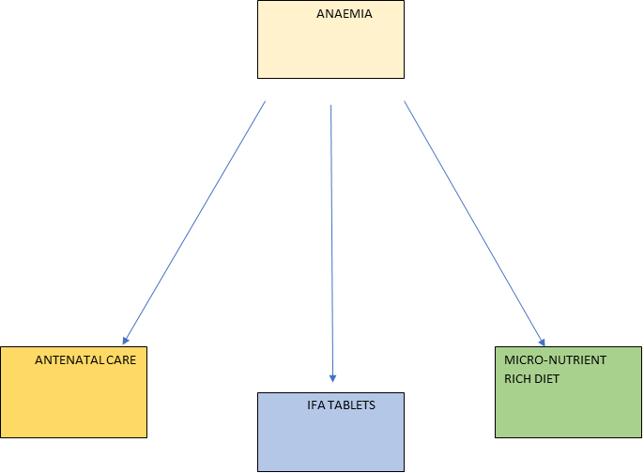

Figure 1:- Flow Diagram of main components contributing to Experiences of women during pregnancy and post partum
LITERATURE REVIEW
Anaemia is a widespread global health issue that affects millions of women, especially during pregnancy and the postpartum period. Anaemia can have a negative impact on both maternal and foetal outcomes throughout these vital stages, providing major challenges to both mother and child's well-being⁶. Understanding anaemic women's pre- and postpartum experiences is critical for informing effective therapies and support systems for this vulnerable demographic. This review of the literature attempts to synthesise current studies on the experiences of anaemic women throughout pregnancy and postpartum, as well as to throw light on potential areas for improvement in their care.
Anaemia in Pregnancy: Prevalence and Impact
Numerous studies have found that anaemia is common among pregnant women all around the world. Not only does the disease have an impact on mother health, but it also raises the chance of preterm birth, low birth weight, and infant death⁸. Women who have anaemia during pregnancy frequently suffer exhaustion, weakness, dizziness, and a decreased capacity to conduct everyday tasks.
Anaemia Knowledge & Awareness:
Several research have looked into pregnant women's anaemia knowledge and awareness. While some women have a rudimentary awareness of anaemia, there is a dearth of in-depth information regarding its origins, implications, and preventative strategies, according to the findings. Improving health literacy among expecting moms may enable them to seek early care and effectively control anaemia⁹.
Health-Seeking Habits:
Research has shown that anaemic pregnant women may face challenges in seeking appropriate healthcare due to various reasons such as financial constraints, lack of access to healthcare facilities, or cultural beliefs. Some may delay seeking medical attention until the symptoms become severe, compromising both maternal and fetal health. Understanding the barriers to accessing healthcare is vital in developing targeted interventions to improve healthcare-seeking behaviours⁷.
Emotional and psychological consequences
Anaemia during pregnancy can have serious emotional and psychological consequences for women. Anaemic women frequently experience anxiety, tension, and dread about their own health and the health of their unborn child. These emotional elements can have an impact on their pregnant experience and possibly contribute to postpartum mental problems¹².
Care and Support Perceptions:
Anaemic women's experiences with care and assistance throughout pregnancy and after childbirth are critical factors of their well-being. Positive and bad experiences have been emphasised in studies. Positive experiences include obtaining appropriate information and assistance from healthcare personnel, but bad experiences can involve feeling neglected or being treated insensitively by healthcare workers¹³.
The Effect on Postpartum Recovery:
For anaemic women, the postpartum period might be very difficult. Fatigue, weakness, and trouble caring for the infant may impede recovery and bonding. Adequate postpartum care is critical to their physical and mental well-being, including dietary support and counselling¹².
Anaemic women's pre- and postpartum experiences are varied, spanning physical, emotional, and social components. Addressing the needs of anaemic pregnant women necessitates a multifaceted strategy that involves increasing health literacy, improving access to healthcare, giving emotional support, and delivering focused therapies throughout both prenatal and postnatal care. Healthcare practitioners may play a critical role in promoting pleasant pregnancy and postpartum experiences, leading to better mother and child outcomes, by recognising and understanding the special requirements of this vulnerable group. More research is needed to investigate and develop effective therapies that might empower anaemic women while also reducing the burden of anaemia during pregnancy and afterwards¹⁵.

Objectives

The objectives of this research are aimed at improving the understanding of the experiences of anaemic women during and after pregnancy and identifying effective strategies to improve their health outcomes.

The findings of this study can inform the development of targeted interventions to improve the physical, emotional, and social well-being of anaemic women during and after pregnancy

1. To explore the experiences of anaemic women during and after pregnancy, including their physical, emotional, and social needs, and the challenges they face.

2. To identify the factors that influence the adherence to iron supplementation among anaemic women during and after pregnancy.

3. To identify the psychosocial implications of anaemia during and after pregnancy, including the impact on maternal mental health and the ability to care for oneself and the new-born.

METHODOLOGY

SETTING

Janakpuri, New Delhi, on India's plains, with a population of about Janakpuri is in West Delhi district, with a population of 231688.

The female population is estimated to be 107328 people. The region is approximately 9.33 square kilometres in size.

Both Hindi and English are widely spoken.West Delhi has an approximate literacy rate of 87%.

According to the population census, Hinduism accounts for 81.68% of the Delhi population.

STUDY DESIGN

The study has used purposive sampling of anaemic women who are currently pregnant or have recently given birth.

SAMPLE SIZE

The sample size of 30 women is determined by the saturation of data, ensuring that the sample is sufficient to capture the range of experiences and perspectives of anaemic women during and after pregnancy.

STUDY POPULATION

anaemic women who are currently pregnant or have recently given birth.

SAMPLE SELECTION All the participants were clearly informed an out the research and their participation was completely voluntary.

STUDY TOOLS

The questionnaire was administered to the participants during face-to-face interviews or through online surveys.

The medical records of the participants will be reviewed to collect data on their anaemia diagnosis, treatment, and complications during and after pregnancy.

INCLUSION CRITERION

all the anaemic women visiting the clinic.

EXCLUSION CRITERION

all the respondents who were not willing to participate

STUDY VARIABLES

all the pregnant women who are anaemic or the women who gave birth recently and are also anaemic. I selected three different clinics for antenatal care, where around 30 women were interviewed one on one.

Data collection-

I recruited women who are currently pregnant or have recently given birth with the help of their treating doctor at the clinic.

All the participants signed the consent form to participate. There was no refusal from any participants and all of them cooperated during the interview.

Between April and May 2023, we conducted 30 interviews with pregnant women and who gave birth recently.

Three main focus areas that we wanted to explore were taking IFA tablets, micronutrient rich diet and the kind of antenatal care they are getting as the area that we chose has easy access when it comes to healthcare.

DATA MANAGEMENT AND ANALYSIS

I have recorded the data digitally, transcribed in Hindi and translated it to English for analysis.

After conducting descriptive content analysis, comparing data collected from different participants.

After discussing, the codes were developed, and the transcripts were coded in NVivo qualitative analysis software.

I used three main division to analyse the data.

1) Individual level – characteristics of individual and knowledge of individual.

2) Family level – norms and the positionality in the family.

3)community level-norms and knowledge of the people around them.

There were many sublevels which were interrelated and so it is important to study these levels independently.

Descriptive statistics was used to analyse the quantitative data collected through the survey questionnaire and medical records review.

The data was analysed using software NVivo. Thematic analysis will be used to analyse the qualitative data collected through the semi-structured interviews

Ethical considerations

All the information gathered will be kept private and used solely for the purpose of this study; no data will be misused.

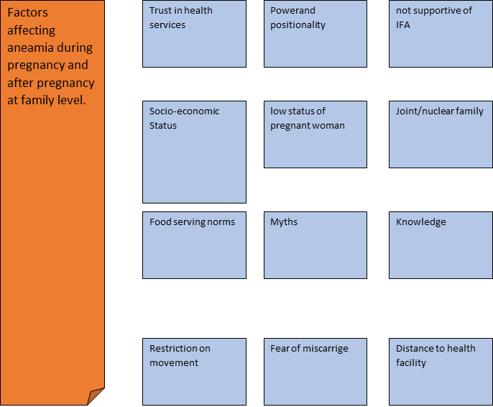

Figure 2 :- Diagram Summarizing the Factors Affecting Women During Pregnancy and Post-Partum

Results

IFA Tablets-

In this study after interviewing 30 women, we find out that all women believed that it is good for them and their baby. Those who have been pregnant before took it religiously, they understand it importance more.

However, few first-time mothers did not as people around them told them not to take it as it will not do any good, one of them said ‘someone told her if she takes it the baby weight will increase and it will lead to caesarean delivery’, some believed that one should consume more iron rich diet instead of relying on medicines.

The second time mothers obviously had more knowledge about the importance of consuming IFA tablets. They even said that after taking it they don’t feel weak or have breathlessness and it increases the blood.

IFA Side Effects-

Few women experienced side effects such as digestive problems, diarrhoea, vomiting, having black stool and dizziness. Few women had nausea as they did not like the smell.

Few who experienced nausea after taking them said they avoided taking it, few threw it away as their family kept a check on them. There was one woman who believed it will increase the baby weight and will lead to caesarean delivery.

Few women who experienced side effects and still had to take these tablets as their family members kept a check on them, be it their husband or mother in-law.

But there was completely opposite scenario in different household where they did not believe in taking IFA as they feel they should not take any medicine during this time for the baby to be healthy.

Micronutrient-rich diet

Digestive issues -

Most of the women during interview said that they had digestive issues. Nausea, vomiting, diarrhoea, gas and bloating were the most common problems. Women were not able to eat due to these problems.

Few said they forced themselves to eat, few were not able to consume more than 2 meals and few who were able to eat without throwing up, they tried to have a good nutrient rich diet.

One of the respondents reported that

‘The ladies don't even take iron pills. Keep it at home because they do not like its taste’.

Anjali a 32 year a pregnant women said that

“If anyone is having even the slightest pain [pain] or dizziness. So he (private doctor) gives them two injections for that too…. If the patient is recovering from medicine, then why should the injection be given? But he injects for small things. Villagers have a lot of interest in them. This is the biggest problem. People prefer private over government facility. People here still believe on blind faith?”.

Knowledge

All the participants were aware that the kind of food they will eat will affect their and baby health.

Balanced diet was especially important during pregnancy and afterwards for the health of the mother as well as the baby. Although they were more concern about the health of the baby, everyone said during the interview if we eat good balanced diet then baby will get all the nutrition required. Green leafy vegetables, eggs, milk, and fruit were mentioned to be the most important for the balanced diet.

Beetroot and pomegranate and spinach were mentioned by all the participants to increase the blood and to prevent anaemia.

Few women were believed that heating in iron pots and pan will help. Vegetable juice consumption was also mentioned as to increase the blood.

Sashmita 32 years old a respondent reported that

“She is aware about Green vegetable, fruits, pulses, jaggery , milk product ,fish, eggs and chicken to PW/LW. In Poshan Pakhwada they also show them the Tringa Thali (With full of Nutritional Food). During ANC checkup ANM and MO is also tell them about Nutritional food”

Role of family

Family was very supportive in terms of taking care of the pregnant women during pregnancy be it food or medicines.

Although there were restrictions on the younger women for going out alone, lack of access to household money and cultural norms such as women ate in the end, mother in-law taking all the decisions about what to be made. Few women were free to eat whatever they like and whenever they felt hungry.

Most women had to cook and serve food during pregnancy that made them the last eater, so if the food is finished then women did not cook again. Most of them mentioned that their mother in-laws took care of their nutrition and even prepared healthy meals for them whenever they are hungry.

As one lactating woman said that

‘My mother-in-law does not allow me to go for check-up as a child of our village died in a government hospital’.

Antenatal care

There was a stigma attached to it of miscarriage for one woman who said if she visits her doctor more often for ultrasound and blood tests. Those who were pregnant for the first time they were worried about how others would feel.

Women felt motivated after hearing the baby’s heartbeat and the follow up more they visited more they got to know more about the nutrition value Most the women trusted the healthcare facility which made their life easy. Few of them waited till third month to visit the clinic whereas most of them visited even just to confirm the pregnancy.

Few of them were not comfortable visiting going outside their home alone as they were shy. Most women felt that the healthcare providers have adequately addressed your concerns related to anaemia post-pregnancy.

Coping up with the challenges of anaemia post-pregnancy women mentioned that talking to family and friends, seeking professional support and few even made lifestyle changes, beetroot and spinach were mentioned by almost everyone. Lifestyle changes also includes cooking food in iron utensils.

Few of the women mentioned that them being anaemic has made their baby anaemic one of the woman even mentioned that because of this baby does breath holding spell. Timely antenatal care helped in management of anaemia mentioned by women.

Few women who had severe anaemia they took IV and it improved their health. Few who had mild anaemia they did dietary changes and consumed IFA tablets timely.

Symptoms like fatigue, shortness of breath weakness, dizziness were mentioned by all the women many times, that affected their daily routine, as they were not able to do much. Women mentioned that they used to feel lightheaded even after doing light activity.

CONCLUSION

¨ The daily supplementation of pregnant women with iron (60mg) and folic acid (400 mg) as earliest as possible in pregnancy for a total of 6 months during pregnancy ¨Continuing the Iron and folic acid tablet through 3 months postpartum in areas where maternal anaemia is more than40%.

¨ Awareness programmes for adolescents and women prior to conception with iron folate tablets. Informing them about the dietary strategies for increased intake of bioavailable iron/folate. The impact of the above would be prevention/control of iron deficiency and anaemia.

Anaemic women's pre- and postpartum experiences are varied, spanning physical, emotional, and social components. Addressing the needs of anaemic pregnant women necessitates a multifaceted strategy that involves increasing health literacy, improving access to healthcare, giving emotional support, and delivering focused therapies throughout both prenatal and postnatal care. Healthcare practitioners may play a critical role in promoting pleasant pregnancy and postpartum experiences, leading to better mother and child outcomes, by recognising and understanding the special requirements of this vulnerable group. More research is needed to investigate and develop effective therapies that might empower anaemic women while also reducing the burden of anaemia during pregnancy and afterwards.

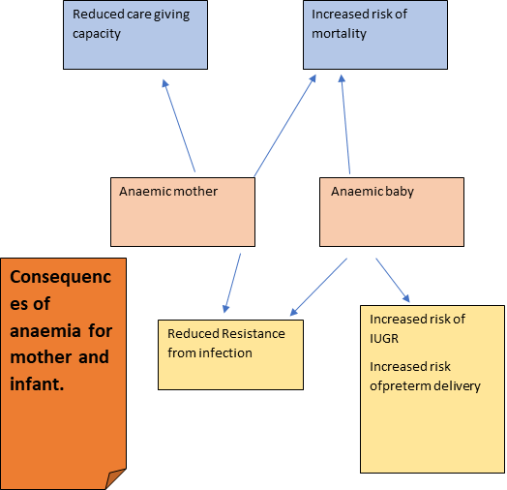

Figure 3:- Diagram shows the Consequences For Anaemic mother and infant

REFERENCES
- Lone FW, Qureshi RN, Emanuel F. Maternal anaemia, and its impact on perinatal outcome. Tropical medicine & international health. 2004 Apr;9(4):486-90.
- Barroso F, Allard S, Kahan BC, Connolly C, Smethurst H, Choo L, Khan K, Stanworth S. Prevalence of maternal anaemia and its predictors: a multi-centre study. European Journal of Obstetrics & Gynecology and Reproductive Biology. 2011 Nov 1;159(1):99-105.
- Singla PN, Tyagi M, Kumar A, Dash D, Shankar R. Fetal growth in maternal anaemia. Journal of tropical pediatrics. 1997 Apr 1;43(2):89-92.
- Abu-Ouf NM, Jan MM. The impact of maternal iron deficiency and iron deficiency anemia on child’s health. Saudi medical journal. 2015;36(2):146.
- Lone FW, Qureshi RN, Emmanuel F. Maternal anaemia and its impact on perinatal outcome in a tertiary care hospital in Pakistan. EMHJ-Eastern Mediterranean Health Journal, 10 (6), 801-807, 2004. 2004.
- Imdad A, Bhutta ZA. Routine iron/folate supplementation during pregnancy: effect on maternal anaemia and birth outcomes. Paediatric and perinatal epidemiology. 2012 Jul;26:168-77.
- Zhang Q, Ananth CV, Li Z, Smulian JC. Maternal anaemia and preterm birth: a prospective cohort study. International journal of epidemiology. 2009 Oct 1;38(5):1380-9.
- Nair M, Choudhury MK, Choudhury SS, Kakoty SD, Sarma UC, Webster P, Knight M. Association between maternal anaemia and pregnancy outcomes: a cohort study in Assam, India. BMJ Global Health. 2016 Apr 1;1(1):e000026.
- Rusia US, Madan NI, Agarwal NE, Sikka ME, Sood SK. Effect of maternal iron deficiency anaemia on foetal outcome. Indian journal of pathology & microbiology. 1995 Jul 1;38(3):273-9.
- Ahmad MO, Kalsoom U, Sughra U, Hadi U, Imran M. Effect of maternal anaemia on birth weight. Journal of Ayub Medical College Abbottabad. 2011 Mar 1;23(1):77-9.
- Godfrey KM, Redman CW, Barker DJ, Osmond C. The effect of maternal anaemia and iron deficiency on the ratio of fetal weight to placental weight. BJOG: An International Journal of Obstetrics & Gynaecology. 1991 Sep;98(9):886-91.
- Hussein KL, Mogren I, Lindmark G, Massawe S, Nystrom L. The risks for pre-term delivery and low birth weight are independently increased by the severity of maternal anaemia. South African Medical Journal. 2009 Feb 6;99(2):98-102.
- Medina Garrido C, León J, Romani Vidal A. Maternal anaemia after delivery: prevalence and risk factors. Journal of Obstetrics and Gynaecology. 2018 Jan 2;38(1):55-9.
- KHAN MM. Effect of maternal anaemia on fetal parameters. Journal of Ayub Medical College Abbottabad. 2001;13(2):38-41.
- Rajaratnam J, Abel R, Ganesan C, Jayaseelan SA. Maternal anaemia: a persistent problem in rural Tamil Nadu. National Medical Journal of India. 2000 Jan 1;13(5):242-5.
- Kaur M, Chauhan A, Manzar MD, Rajput MM. Maternal anaemia and neonatal outcome: a prospective study on urban pregnant women. Journal of clinical and diagnostic research: JCDR. 2015 Dec;9(12):QC04.
- Gaillard R, Eilers PH, Yassine S, Hofman A, Steegers EA, Jaddoe VW. Risk factors and consequences of maternal anaemia and elevated haemoglobin levels during pregnancy: a population‐based prospective cohort study. Paediatric and perinatal epidemiology. 2014 May;28(3):213-26.
- Goshtasebi A, Alizadeh M, Gandevani SB. Association between maternal anaemia and postpartum depression in an urban sample of pregnant women in Iran. Journal of health, population, and nutrition. 2013 Sep;31(3):398.
- Gaillard R, Eilers PH, Yassine S, Hofman A, Steegers EA, Jaddoe VW. Risk factors and consequences of maternal anaemia and elevated haemoglobin levels during pregnancy: a population‐based prospective cohort study. Paediatric and perinatal epidemiology. 2014 May;28(3):213-26.
- Harrison KA, Ibeziako PA. Maternal anaemia and fetal birthweight. BJOG: An International Journal of Obstetrics & Gynaecology. 1973 Sep;80(9):798-804.
- Macgregor MW. Maternal anaemia as a factor in prematurity and perinatal mortality. Scottish Medical Journal. 1963 Apr;8(4):134-40.
- Singal N, Setia G, Taneja BK, Singal KK. Factors associated with maternal anaemia among pregnant women in rural India. Bangladesh Journal of Medical Science. 2018;17(4):583.Goswami TM, Patel VN, Pandya NH, Mevada AK, Desai KS, Solanki KB. Maternal anaemia during pregnancy and its impact on perinatal outcome. Int J Biomed Adv Res. 2014 Feb 28;5(02):99-102.

ANNEXURE

CONSENT FORM

Title of Study: Qualitative Study on women Experience with Anaemia Pre and Post-Partum Researcher: Dr Srishti Shokeen Introduction: You are being invited to participate in a research study to explore the experiences of pregnant and postpartum women with anaemia, and how they cope with the condition.

The purpose of this study is to gain a better understanding of the experiences of women with anaemia during pregnancy and postpartum, and to use this information to inform healthcare professionals on how to better support women with anaemia during this time.

Procedures: If you decide to participate in this study, you will be asked to take part in a semi-structured interview that will last approximately 60 minutes. During the interview, you will be asked questions about your experience with anaemia during pregnancy and postpartum, and the coping strategies you used to manage the condition. The interview will be audio or video recorded for later transcription, but your name will not be used in any publications.

Benefits: There may not be any direct benefits to you for participating in this study. However, your participation will help to increase understanding of the experiences of women with anaemia during pregnancy and postpartum and may help to improve the support and care provided to women in the future.

Risks: There are no known risks to participating in this study, although you may feel uncomfortable discussing individual experiences. You may choose not to answer any questions that you do not feel comfortable with, or you may choose to withdraw from the study at any time.

Confidentiality: All information collected during this study will be kept confidential. Only the researcher and members of the research team will have access to the information. Your name and other identifying information will not be used in any publications. Audio or video recordings will be destroyed after transcription.

Voluntary Participation: Your participation in this study is voluntary. You may choose not to participate, or you may withdraw from the study at any time without any penalty or loss of benefits. Consent: By signing below, you indicate that you have read and understood the information in this form, that you have had the opportunity to ask questions, and that you voluntarily agree to participate in this study.

Participant Signature: _________________________________

Date: ____________________

Researcher Signature: _________________________________

Date: __________________

QUESTIONNAIRE

Pregnancy-related questions:

1. What is your age?

2. How many weeks pregnant are you?

3. Have you been diagnosed with anaemia during your pregnancy? (Yes/No)

4. If yes, how severe is your anaemia? (Mild/Moderate/Severe)

5. How long have you known about your anaemia diagnosis during pregnancy?

6. What symptoms have you experienced related to anaemia during your pregnancy? (e.g., fatigue, weakness, dizziness, shortness of breath, palpitations, etc.)

7. How have these symptoms affected your daily life during pregnancy?

8. Have you received treatment for your anaemia during pregnancy? (Yes/No)

9. If yes, what kind of treatment have you received? (e.g., iron supplements, blood transfusions, dietary changes, etc.)

10. Have you experienced any side effects from your anaemia treatment during pregnancy? (Yes/No)

11. If yes, what side effects have you experienced?

12. How satisfied are you with the treatment you have received for your anaemia during pregnancy? (Very satisfied, somewhat satisfied, neutral, dissatisfied, very dissatisfied)

13. How have you coped with the challenges of anaemia during pregnancy? (e.g., talking to friends and family, seeking professional support, adjusting your lifestyle, etc.)

14. Do you feel that your healthcare providers have adequately addressed your concerns related to anaemia during pregnancy? (Yes/No)

15. If no, what concerns do you feel have not been addressed?

16. What advice would you give to other women who are experiencing anaemia during pregnancy?

Post-pregnancy-related questions:

1. How long ago did you give birth?

2. Did your anaemia persist after giving birth? (Yes/No)If yes, how long did it take for your anemia to resolve?

3. What symptoms have you experienced related to anaemia post-pregnancy? (e.g., fatigue, weakness, dizziness, shortness of breath, palpitations, etc.)

4. How have these symptoms affected your daily life post-pregnancy?

5. Have you received treatment for your anaemia post-pregnancy? (Yes/No)

6. If yes, what kind of treatment have you received? (e.g., iron supplements, blood transfusions, dietary changes, etc.)

7. Have you experienced any side effects from your anaemia treatment post-pregnancy? (Yes/No)

8. If yes, what side effects have you experienced?

9. How satisfied are you with the treatment you have received for your anaemia post pregnancy? (Very satisfied, satisfied, neutral, dissatisfied, very dissatisfied)

10. How have you coped with the challenges of anaemia post-pregnancy? (e.g., talking to friends and family, seeking professional support, adjusting your lifestyle, etc.)

11. Do you feel that your healthcare providers have adequately addressed your concerns related to anaemia post-pregnancy? (Yes/No)

12. If no, what concerns do you feel have not been addressed?

13. What advice would you give to other women who are experiencing anaemia post-pregnancy?
