Dissertation Training

at
Foundation for Research in Health System (FRHS), New Delhi

Diagnostic Landscape Review of Brucellosis: A Neglected Zoonotic Disease in the Indian Public Health System
by

Dr. Divyanshu (PT)

PG/23/034

Under the guidance Of

Dr. Ekta Saroha

PGDM (Hospital & Health Management) 2023-25


International Institute of Health Management Research New Delhi

Dissertation Training
at
Foundation for Research in Health System (FRHS) New Delhi

Diagnostic Landscape Review of Brucellosis: A Neglected Zoonotic Disease in the Indian Public Health System
by

Dr. Divyanshu (PT)

PG/23/034

Under the guidance Of

Dr. Ekta Saroha

Dr. Meenakshi Jain

PGDM (Hospital and Health Management) 2023-25

International Institute of Health Management Research New Delhi

The certificate is awarded to

Dr. Divyanshu (PT)

in recognition of having successfully completed

her dissertation

At FRHS Delhi

and has successfully completed his/her Project on

Diagnostic Landscape Review of Brucellosis: A Neglected Zoonotic Disease in the Indian Public Health System

Date-1st April 2025 to 30th June 2025

Foundation for Research in Health System (FRHS) New Delhi

She comes across as a committed, sincere & diligent person who has

strong drive & zeal for learning.

We wish her all the best for future endeavors.

Training & Development Zonal Head-Human Resources

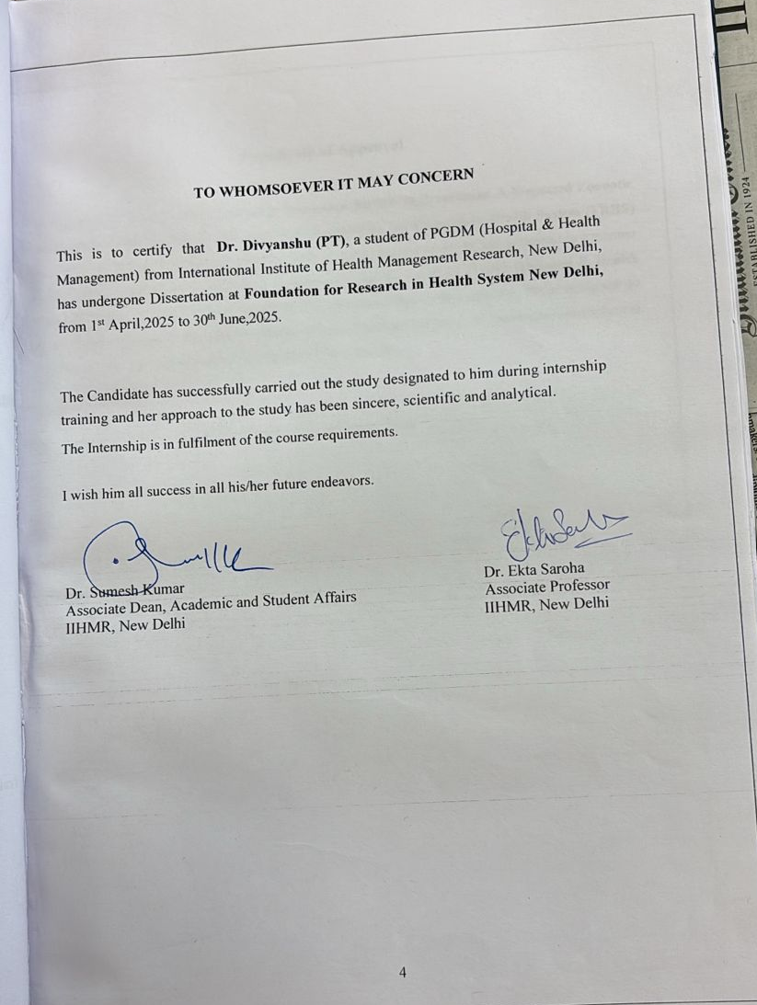


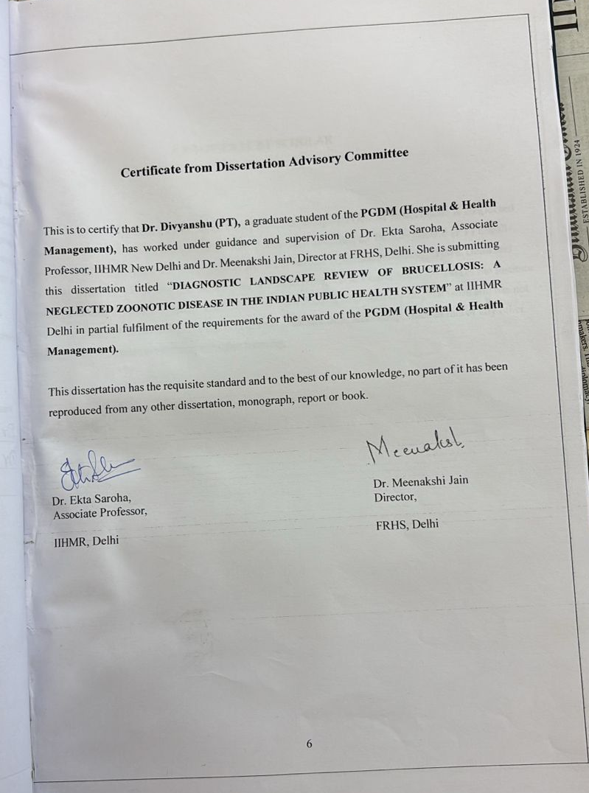

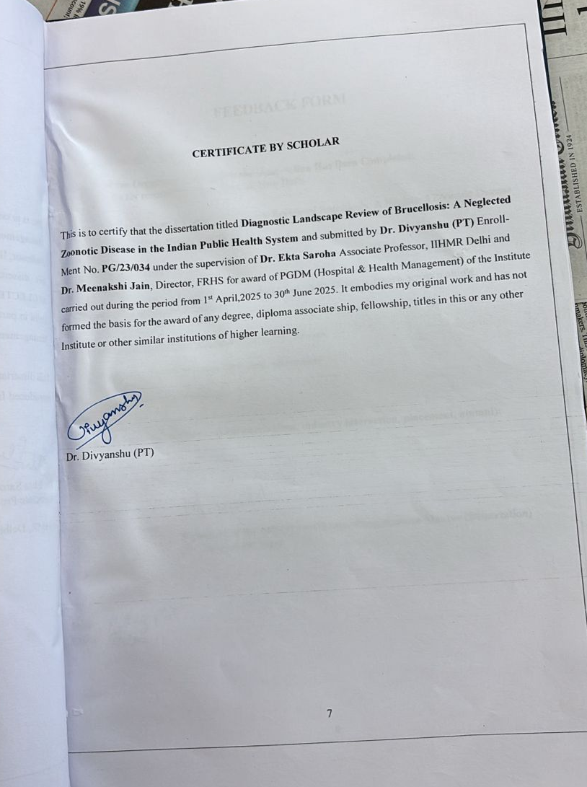

FEEDBACK FORM

Name of the Student: Dr. Divyanshu (PT)

Name of the Organisation in Which the Dissertation Has Been Completed:
Foundation for research in health systems, New Delhi

Area of Dissertation: Diagnostic Landscape Review of Brucellosis: A Neglected Zoonotic Disease
In the Indian Public Health System

Attendance: 100%

Objectives achieved: Learnt how to conduct a systematic literature review across multiple
Databases, manuscript Preparation

Deliverables: Systematic review and Landscape Review

Strengths: Motivates, Diligent, Proficient, Meticulous

Suggestions for Improvement: NoNe

Suggestions for Institute (course curriculum, industry interaction, placement, alumni):



Signature of the Officer-in-Charge/ Organization Mentor (Dissertation)
(Dr. Meenakshi Jain)

Date: 11Aug,25
Place:
Delhi

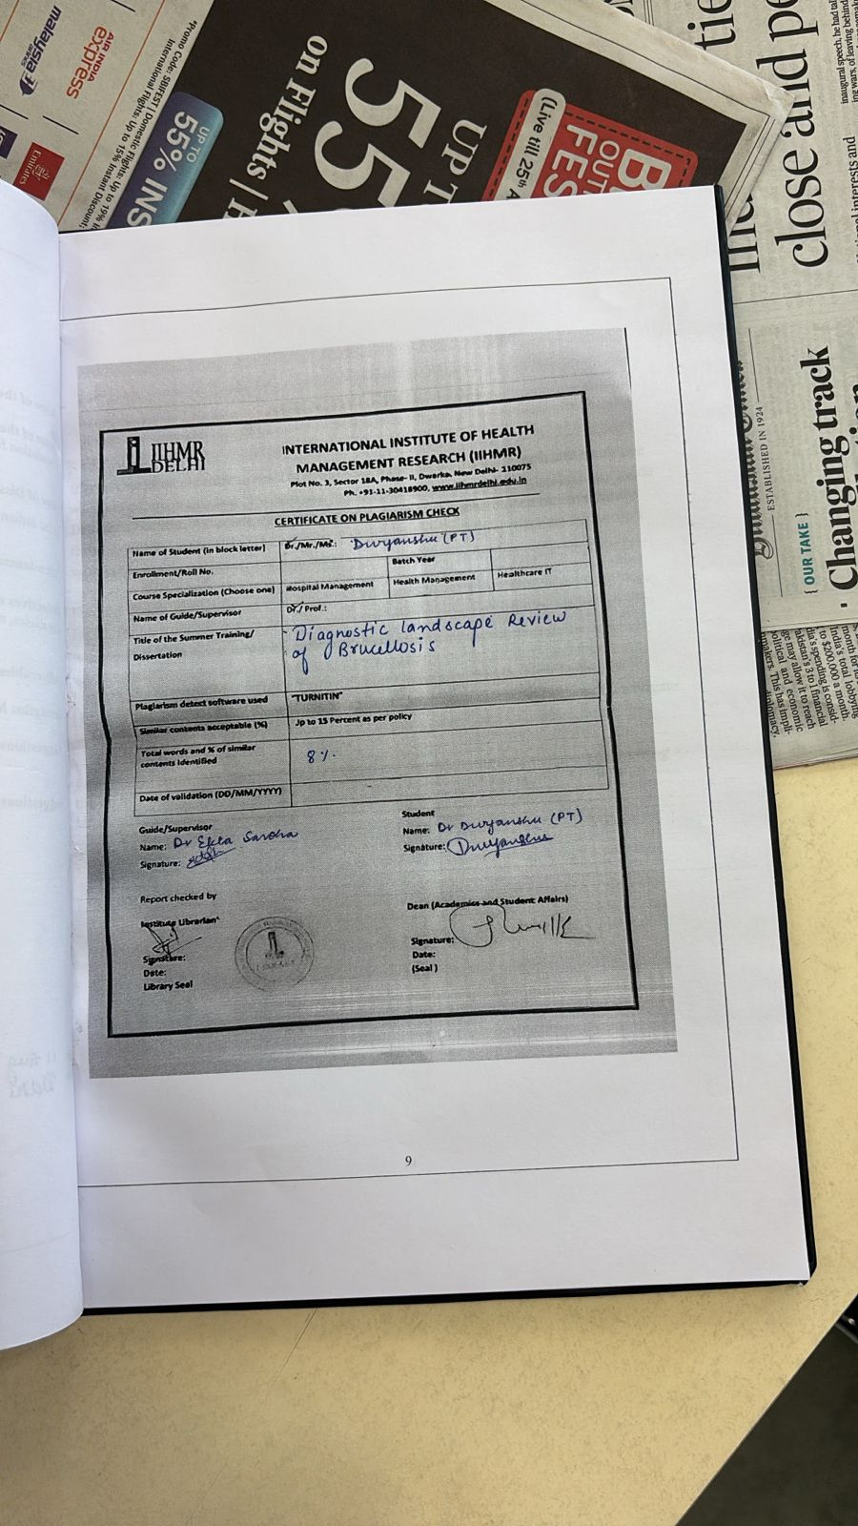

ACKNOWLEDGEMENT

It is an esteemed pleasure to present this research project by thanking each and every one
who helped me in this task. I would like to express my sincere gratitude towards my guide
Dr. Ekta Saroha, Associate Professor, IIHMR, New Delhi, who helped me immensely
throughout the tenure of my dissertation. She inspired me greatly to work on this project
with her valuable guidance, support, interest, encouragement, involvement and advice.

I would like to express my special thanks to Dr. Meenakshi Jain, (Director) FRHS, New
Delhi, for her support and guidance in providing such a great opportunity, which helps in
to grow and learn about many interesting aspects.

I would like to thank Mr. Ashish Yadav, Senior Consultant, FRHS, New Delhi, for
His constant support, insights, and encouragement have been crucial in helping me navigate
and make the most of this experience.

Lastly, I am thankful to my friends Kanishka and Sandhya for their collaboration during
the completion of this dissertation. Special thanks to my sister and mother for their
Unwavering support. Thank you all for making this dissertation a success.

Table of Contents

Certificates 3-7
Acknowledgment 10
Abbreviations 13-14
List of Tables and Flowcharts 15
ABSTRACT 16

CHAPTER 1: INTRODUCTION 17
  - Overview and Burden of Brucellosis 17
  - Overview of Brucellosis Prevalence in India 17
  - Review of Epidemiology of Brucellosis 18
  - Overview of brucellosis diagnostics 18
  - Rationale 19
  - Research question/Problem statement 19
  - Objectives of the study 20

CHAPTER 2 METHODOLOGY 21
  - Study Registration 22
  - Search Strategy 22
  - Searches 22
  - Conditions or domain being studied 23
  - Population 23
  - Inclusion Criteria and Exclusion Criteria 23
  - Intervention(s) 24
  - Comparator 24
  - Context: 24
2.10 Main Outcome 24
2.11 Data synthesis, statistical analysis, and investigation heterogeneity 27

CHAPTER 3 LITERATURE REVIEW 29
3.1-3.7 Literature review 29-31

CHAPTER 4 RESULTS 32
4.1 Diagnostic Test Selection 36
4.2 Current landscape of human Brucella diagnostics 37
4.3 Performance summary of human Brucella diagnostics 38
4.4 Current landscape of animal Brucella diagnostics 39
4.5 Performance summary of animal Brucella diagnostics 40
4.6 Recommendations 42
4.8 Recommended Strategies for stakeholders 44

CHAPTER 5 DISCUSSION 46
CHAPTER 6 LIMITATIONS 49
CHAPTER 7 CONCLUSION 50
REFERENCES 53
ANNEXURE 56
Annexure 1 Human diagnostic kits data set 56
Annexure 2 Animal diagnostic kits data set

PLAGARISM REPORT 60

ABBREVIATIONS

- ICAR Indian Council of Agricultural Research
- DALY Disability-adjusted life years
- RBT Rose Bengal Test
- STAT Standard Tube Agglutination Test
- ELISA Enzyme-linked immunosorbent assay
- RT-PCR Real-time polymerase chain reaction
- CFT Complement Fixation Test
- ICMR Indian Council for Medical Research
- CDSCO Central Drugs Standard Control Organisation
- NCDC National Centre for Disease Control (NCDC)
- PRISMA Preferred Reporting Items for Systematic Review
- ScR Scoping Review
13 MRT Milk Ring Test
14 IVD In-Vitro Diagnostic
15 ELISA Enzyme Linked Immuno-Sorbent Assay
16 LOD Level of Detection
17 STATS Standard Tube Agglutination Test
18 OIE World Organisation for Animal Health
19 WHO-GMP World Health Organization Good Manufacturing Practices
20 ISO Internation Organisation for Standardization
21 VRDL Veterinary Research Diagnostic laboratories
22 BAPAT Buffered Acidified Plate Antigen Test
23 TB-FMD Tuberculosis and Foot and Mouth Disease
24 QA Quality Assurance
25 RBPT Rose Bengal Plate Test
26 QUADAS-2 Quality Assessment of Diagnostic Accuracy Studies
27 DTA Diagnostic Test Accuracy
28 MeSH Medical Subject Headings terms

LIST OF TABLES AND FLOWCHARTS

Diagram1: Stakeholders in the Diagnostic Landscape Review | Pg.25
Flowchart 1: PRISMA ScR Chart | Pg.33
Flowchart 2: Animal Brucellosis Diagnostic Tests | Pg.34
Flowchart 3: Human Brucellosis Diagnostic Tests | Pg.35
Table 1: Keywords (PICO format) | Pg.25-26
Table 2: Current Landscape of Human Brucella Diagnostics | Pg.37
Table 3: Performance Summary of Human Brucella Diagnostics | Pg.38
Table 4: Current Landscape of Animal Brucella Diagnostics | Pg.40
Table 5: Performance Summary of Animal Brucella Diagnostics | Pg.41
Table 6: Diagnostics for Confirmatory Testing at Health System Level | Pg.42

ABSTRACT

Introduction
Brucellosis remains a neglected zoonotic disease of significant public health and veterinary concern in India, driven by underdiagnosis, inadequate surveillance, and gaps in diagnostic infrastructure. Strengthening diagnostic systems is essential for timely detection, control, and integration into a One Health approach.

Methods
A scoping review was conducted following PRISMA-ScR guidelines to map commercially available brucellosis diagnostic tools in India and globally. Literature from 2000–March 2025 was sourced from peer-reviewed databases, institutional/government repositories, and manufacturer records. Inclusion criteria required ≥95% sensitivity and specificity,5% of ≤₹6,602 per test, and approval from recognized regulatory bodies. Data were synthesized into a comparative matrix evaluating assay type, cost, field versus laboratory suitability, and regulatory status.

Results
Of 106 identified articles, only seven diagnostic kits met the criteria. For human brucellosis, real-time PCR demonstrated the highest accuracy but required advanced laboratory capacity, while ELISA and rapid diagnostic tests (RDTs) offered practical, scalable solutions for primary and peripheral healthcare settings. For animals, the Buffered Acidified Plate Antigen Test (BAPAT) showed the highest sensitivity and specificity but had cross-reactivity limitations; rapid tests provided field-level applicability despite slightly reduced accuracy.

Discussion/Conclusion
A tiered diagnostic strategy deploying RDTs and ELISA at primary levels and PCR at reference laboratories can enhance detection, surveillance & outbreak response. Integration of diagnostics into a One Health framework, combined with capacity building, quality assurance & DALY-based procurement prioritization, can significantly strengthen India’s brucellosis control efforts.

CHAPTER 1: INTRODUCTION

  - Overview and Burden of Brucellosis

Approximately 500,000 global cases of brucellosis occur in humans annually, although the actual figure is likely higher due to widespread under-reporting ^{[1]}. As a result, the World Health Organization (WHO) lists brucellosis among the top neglected zoonotic diseases ^{[8]}.
India, home to over one billion people, is the world’s leading milk producer, contributing approximately 17% of global milk output. It also possesses the world’s largest dairy cattle population—around 300 million animals, including both buffaloes and cows. According to the 19th Livestock Census (2012), India hosts about 190 million cattle, 108 million buffaloes, 135 million goats, 65 million sheep, and 10 million pigs. This accounts for 57% of the global buffalo and 14% of the cattle population ^{[4]}.
In India, brucellosis is an emerging and serious public health issue. Although the disease has been eradicated in many developed nations, it remains largely uncontrolled in India. Approximately 80% of the Indian population lives in close contact with domestic or wild animals, particularly in agricultural settings, increasing their risk of exposure to brucellosis ^{[1,9]}

1.2 Overview of Brucellosis Prevalence in India

Several studies across different Indian states—such as Karnataka, Punjab, Maharashtra, and Assam—have reported varying brucellosis prevalence rates among high-risk groups like veterinary professionals, ranging from 2.4% to 55.0%. Earlier serological evidence also suggests that the disease is endemic across most parts of the country. For example, seroprevalence has ranged from 6.6% in Madhya Pradesh to 60% in Assam, with Punjab reporting the highest prevalence due to sustained screening efforts and a dense bovine population ^{[3]}.
Brucellosis was first recognized in India in 1942 and is now considered endemic throughout the country. As per Indian Council of Agricultural Research (ICAR) monitoring from 2012–2013, the national seroprevalence in cattle stands at approximately 13.5%, indicating a stable endemic equilibrium ^{[3]}. Human brucellosis in India is estimated to result in 177,601 disability-adjusted life years (DALYs), with a rate of 0.15 per thousand persons annually. Occupational populations suffer a higher burden (0.29 DALYs per thousand), compared to non-occupational adults (0.13 per thousand). ^{[5]}
The disease has significant economic and health consequences, especially in rural India, where livestock serves as a primary source of income. Brucellosis contributes to reduced milk production, abortions (resulting in calf loss), infertility, weak offspring, weight loss, and poor semen quality. The average economic loss per abortion has been estimated at approximately Rs 1.25 lakhs. These factors make brucellosis one of the most serious livestock diseases, hindering trade and export of animals, semen, meat, and milk products ^{[4]}. The socio-economic burden is particularly severe for rural households that rely on livestock for sustenance and daily wages. ^{[1}}

1.3 Review of Epidemiology of Brucellosis

Brucellosis is caused by bacteria of the genus Brucella, with twelve identified species to date. These bacteria can infect multiple species of animals, including humans ^{[6]}. In cattle, Brucella abortus is the predominant species, while B. Melitensis and B. Suis are also occasionally involved. Brucella melitensis is the most virulent species in humans, although both B. Abortus and B. Melitensis are the principal agents in bovine and caprine brucellosis. ^{[4]} Transmission to humans primarily occurs through direct contact with animal fluids, consumption of raw dairy products, and ingestion of undercooked meat (Kang et al., 2014). Inhalation of Brucella aerosols is another significant route, especially in occupational environments like slaughterhouses and veterinary laboratories ^{[3]}. Human brucellosis presents highly variable and often non-specific symptoms such as undulant fever, chills, headache, arthralgia, and myalgia. More severe complications may include splenic abscess, spondylitis, endocarditis, renal failure, orchitis, and encephalitis ^{[9,13,14,15]}. Its non-specific presentation often leads to misdiagnosis, as it resembles many other febrile illnesses including malaria, typhoid, dengue, leptospirosis, rickettsial diseases, Q fever, tuberculosis, endocarditis, and rheumatic fever ^{[9,13]}.

1.4 Overview of brucellosis diagnostics

Diagnosing brucellosis is challenging due to its clinical mimicry of other diseases. Serological tests such as the Rose Bengal Test (RBT), Standard Tube Agglutination Test (STAT), and enzyme-linked immunosorbent assay (ELISA) are commonly used. The Rose Bengal Test and SAT are standard tools for detecting infections by B. Abortus, B. Melitensis, and B. Suis. A miniaturized SAT is now employed in regions with high endemicity. ^{[10, 11]} Although blood culture is the gold standard for diagnosis, its sensitivity is limited, particularly in chronic cases. Molecular methods like real-time polymerase chain reaction (RT-PCR) offer rapid, specific, and highly sensitive detection, though they depend on the availability of target DNA in serum samples. A combined diagnostic approach is thus recommended—typically screening with SAT and confirmation using the Coombs’s test or Complement Fixation Test (CFT). ^{[12,7]} Preventive efforts in India are hindered by a lack of awareness. For instance, buffalo keepers were found to be completely unaware of brucellosis or the availability of its vaccine ^{[3]}.
_
1.5 Rationale

Effective prevention requires health education, improved disease awareness, promotion of hygiene practices, and stricter food safety standards. Additionally, regulations must be enforced at both national and international levels to control the movement of animals and animal products. These limitations result in misdiagnosis, underreporting and uncontrolled spread of the disease, leading to significant public health and veterinary challenges. To inform evidence-based decision-making for brucellosis control in India, it is essential to understand the range of available diagnostic tools, particularly those that are cost-effective, accurate, field- and lab-suitable, performance-validated, and approved by regulatory bodies such as ICMR, CDSCO, and WHO, etc. This diagnostic landscape review aims to assess the availability, performance, operational suitability, and regulatory status of brucellosis diagnostics across various levels of the Indian public health system. The goal is to strengthen diagnostic capacity from decentralised rural health settings to central reference laboratories, to support disease surveillance, vaccination planning, and outbreak response. The findings will provide actionable recommendations to stakeholders like health program planners, technical partners (e.g., ICMR, NCDC), procurement and logistics agencies (e.g., MoHFW, state health missions), diagnostic manufacturers, field implementers, and community representatives.

1.6 Research Question
What are the currently available diagnostic tools for brucellosis in India, and how do they compare in terms of assay type, regulatory approval, field vs. lab suitability, accuracy, and integration into the public health system?
Population (P): Human cases and Animal cases of Brucellosis in India, within the context of the Indian public health system.
Intervention (I): Use of currently available diagnostic tools for Brucellosis both nationally and internationally.
Comparator (C): Comparison between different diagnostic tools in terms of assay type, lab vs. field applicability, and regulatory status.
Outcome (O): Evaluation of diagnostic performance (sensitivity, specificity, accuracy), regulatory approval, and integration into national or subnational public health programs.

  - Objective of Review

Primary Objective:
- To review and map available diagnostic tools for brucellosis using gold standard benchmarks and evaluate their suitability across different levels of the public health system, including veterinary clinics
Secondary Objectives:
- To assess diagnostic tools for field-level screening.
- To evaluate the appropriateness of diagnostics for confirmatory testing at district/state-level labs.
- To identify gaps and recommend strategies for diagnostic strengthening in the brucellosis control effort.

CHAPTER 2: METHODOLOGY

We undertook a comprehensive literature search and systematic review to assess the availability, performance, and policy relevance of brucellosis diagnostic methods, with a specific focus on kits that are commercially available in India and globally. PRISMA-ScR was suitable as it helps systematically map the breadth of evidence, identify research gaps, and describe characteristics of diagnostic tools without assessing intervention effectiveness. The outcomes included the evaluation of diagnostic tools used in both human and veterinary settings, encompassing serological, molecular, rapid, and culture-based techniques. These diagnostic methods were chosen based on their relevance to the Indian public health and animal husbandry systems and global reference standards such as those recommended by the WHO and OIE.
Our definition of “diagnostic kits” referred to any commercially manufactured test kits—approved or in regular use—that detect Brucella infection in humans or animals through clinical, field, or laboratory settings. The review includes various categories of kits (e.g., ELISA, RBT, PCR, MRT, LAMP, rapid tests), the platforms they are based on, and the context in which they are deployed (public health labs, veterinary hospitals, border checkpoints, or community-level screening). Kits used exclusively for research or without verified regulatory clearance were excluded.
Employing Boolean operators, we searched PubMed, Scopus, Google Scholar, WHO IRIS, OIE Database, and the websites of ICMR, IVRI, NCDC, and CDSCO, along with commercial manufacturer portals such as DRG Diagnostics, J Mitra, Diachemix, Bruker, and TIB MOLBIOL for resources related to brucellosis diagnostics in both human and animal populations.
To search for additional citations, we also examined the reference lists of eligible studies and technical guidelines. If the full text of any eligible document was not accessible, we attempted to contact the corresponding authors or companies involved. Every article, datasheet, or report published between 2000, and March 2025 was reviewed for inclusion. First, we constructed a core search string for PubMed, then modified keywords and combinations to suit the syntax and scope of other platforms.
Before finalizing the search, we conducted an updated review to capture any new literature or regulatory updates. Extracted information was compiled into a structured MS Excel matrix and duplicates were removed. Key data fields included diagnostic type, use-case (human or animal), test name, manufacturer, performance characteristics, regulatory status, integration in surveillance, and cited references.

2.1 Study Registration:

This landscape/Scoping Review adhered to the Preferred Reporting Items for Systematic Review (PRISMA-ScR) guidelines, and the protocol was registered at the International Prospective Register of Systematic Reviews (registration ID: CRD42024510001).

2.2 Search Strategy:

Keywords were used to create a search strategy for addressing research questions. Systematic search was performed by combining every feasible sequence of all the categories of keywords. The Medical Subject Headings (MeSH) terms and truncated keywords were mixed using the relevant Boolean logic operators i.e., AND, OR, and NOT. The author DU pretested the search strategy to ensure appropriateness of the search strategy in retrieving the relevant articles and subsequent modifications. Based on the inclusion criteria, review was done on the following search engines and other sources. Major databases like PubMed, Science Direct, Web of Science, and Google scholar were used to review published studies. Along with this institutional/govt. sources like Product company websites, govt websites like WHO, ICMR, NCDC, IVRI, and the Ministry of Health & Family Welfare (MoHFW). Grey literature, including national program reports, diagnostic validation data, and disease control guidelines, will also be reviewed. The regulatory lists of already identified studies were also searched to retrieve additional articles. All published articles from 2000 till March 2025 were included in this review, all studies, irrespective of country, economy, demography, etc., were included in review. The search was done using the following search terms using PICO format given in Table 1.

2.3 Searches:

An extensive literature search was carried out on PubMed, Web of Science, Google Scholar, and institutional/govt. sources like Product company websites, govt websites like WHO, ICMR, NCDC, IVRI, and the Ministry of Health & Family Welfare (MoHFW) and preprint servers. Also, we checked the regulatory lists of eligible studies for citation searching. We contacted the study investigators and experts to see if the eligible study was not available for full text. We assessed all articles published between 2000 and March 2025. We initially created a search string for PubMed. We adapted the search teams, keywords, and search strings with other electronic databases mentioned above. We used specific filters for study design such as English language, time-period, etc. where appropriate. We repeated the search before submitting the manuscript to include newer articles.

2.4 Condition or domain being studied:

- Studies addressing diagnostic performance, implementation, or economic burden related to Brucellosis.
- Laboratory-based diagnostic evaluations linked to public health settings (PHC, CHC, Veterinary clinics).
2.5 Participants/population:

Human cases and Animal cases of Brucellosis in India, within the context of the Indian public health system.
  - Inclusion and exclusion criteria:

We included original research published in peer reviewed journals, thesis, dissertation to ensure the selection of diagnostically sound, economically viable, and operationally feasible tools for Brucellosis detection, this study employed strict inclusion criteria. Only assays demonstrating a diagnostic performance with ≥95% sensitivity and ≥95% specificity were considered, reflecting a high standard of clinical accuracy critical for disease surveillance and control. Economic feasibility was addressed by limiting selection to tests costing ≤₹6,602 per unit—equivalent to 5% of India’s per capita annual health expenditure—thereby aligning with national affordability benchmarks. Further, regulatory credibility was ensured by including only those diagnostics approved or certified by recognized authorities such as CDSCO, ICMR, WHO, WOAH/OIE, or those bearing CE/ISO 13485 certification. Emphasis was also placed on the assay’s operational adaptability, with only those suitable for either field-level application or laboratory-based settings included. Lastly, the study records screening included diagnostics for which complete performance, cost, and regulatory data were publicly accessible through peer-reviewed literature, validated grey sources, or official documentation. These criteria collectively ensured that the diagnostics reviewed were both scientifically robust and contextually relevant to India’s public health system.

Studies and reports were excluded if they lacked primary data, did not meet the minimum diagnostic sensitivity threshold of ≥95%, or failed to provide validated specificity information. Diagnostic kits missing cost details, regulatory approvals, or performance indicators were excluded. Additionally, literature with poor methodological rigor, anecdotal evidence, or non-peer-reviewed sources such as Those studies in which the follow-up period was not defined clearly were also excluded from our review. In addition, those studies whose full text articles were unavailable were excluded from our review and publication language was restricted to English language only.

  - Intervention(s):

Use of currently available diagnostic tools for Brucellosis.

2.8 Comparator(s):

Comparison between different diagnostic tools in terms of assay type, lab vs. field applicability, and regulatory status.

2.9 Context:

All studies, irrespective of country, economy, demography, etc., will be included in the review.

2.10 Main outcome(s):

Evaluation of diagnostic performance (sensitivity, specificity), regulatory approval, field-lab suitability, and integration into national or subnational public health programs.

Diagram1: Stakeholders in the Diagnostic Landscape Review

- International Technical Partners
- Procurement and Logistics Agencies
- Manufacturers and Distributors
- End Users and Community Representatives
- Field Implementers

Table 1: Keywords (PICO format)
Population | “Brucella” OR “brucellosis”  "Brucellosis" OR "Brucella melitensis" OR "Brucella abortus"  One Health India  One Health surveillance brucellosis
Intervention | AND "diagnostic test" OR "ELISA" OR "PCR" OR "RBT" OR "LAMP" OR "serological test" AND  Brucellosis diagnostic kits AND India (2000–2025)  "Brucellosis"[Mesh] AND ("Diagnostic Kits" OR "Serological Tests" OR "PCR" OR "ELISA" OR "Rapid Test") AND ("India" OR "Veterinary" OR "Public Health")  "Brucellosis" + "approved diagnostic methods" + "animal health" OR "human health"  "Brucellosis diagnostic" site: cdsco.gov.in OR site: icmr.gov.in  RBT STAT MRT India, PCR for Brucella spp.
Comparator | Sensitivity and specificity of brucella ELISA/PCR, RBT STAT MRT tests India  "Brucellosis diagnostic kits" + India + (ELISA OR RBT OR PCR OR LAMP) + sensitivity + specificity  Brucella ELISA sensitivity specificity  ("sensitivity" OR "specificity" OR "accuracy")
Outcome | OIE prescribed tests, and India livestock brucellosis testing  One Health India, and Zoonosis surveillance kits  ("India" OR "Indian public health system") AND  ("CDSCO" OR "WHO" OR "OIE" OR "ICMR" OR "validation" OR "surveillance system".

2.11 Data synthesis, statistical analysis, and investigation heterogeneity:

Using the search strategy and other additional sources, the title/abstract of all the studies were retrieved for all studies. The reviewer (DU) and (KG) independently screened the search results to identify the studies that potentially met the inclusion criteria outlined above. Data was stored and arranged in structured Microsoft Excel matrix for reference management and removing duplicates. A manual search was also conducted to check for any missed duplicates. Only articles published in English language were considered. Discrepancies in selecting articles based on title/abstract screening were resolved by a 2nd reviewer (SB).

The selected articles then underwent a full-text screening by DU. Any difference in study selection was discussed amongst the reviewers to prepare a final list for the review. Justification was given to excluding the studies (if any) for further analysis. Discrepancies were resolved by a 2nd reviewer. All the decisions were recorded on a Microsoft Excel spreadsheet. The search process was presented in a PRISMA flow chart. Data was extracted by DU independently. Any differences in data extraction were discussed amongst the reviewers to prepare a final extracted spreadsheet. Discrepancies were resolved by 3rd reviewer.

A data extraction sheet was prepared in MS Excel, and the following fields were included for data extraction:
- Diagnostic Assay/method name
- Usage (IVD, Research, serological)
- Kit name and manufacturer
- Validated sensitivity and specificity
- Regulatory approvals (CDSCO, CE, WHO/OIE, etc.)
- Cross-reactivity data
- Level of Detection (LOD)
- Approximate Cost (per piece) in Rs
- Availability in India or not
- Regulatory/Certified approvals
- Approved by any other Certification.
- Field suitability (PHC, district, state, veterinary clinic)
- Reference source (with link)

Study characteristics (author name, year of publication, country), study population (Animal or Human). If the information was insufficient to support data extraction, we wrote to the authors to share the data. The same was noted and reported appropriately. For missing data, a thorough search was conducted, and studies with more than 50% missing data were excluded from the analytical analysis to generate more robust study results.

Analysis and Interpretation for Kits will be comparatively assessed using a scoring matrix, and data will be charted using tables and summarized descriptively. A scoring matrix was created to compare kits across different parameters, including performance (sensitivity/specificity), feasibility (cost, availability), regulatory status, and relevance to India’s public health priorities. Where possible, kits were rated comparatively to highlight the most viable options for integration into a national One Health brucellosis diagnostic framework.
Discrepancies in reported values (e.g., sensitivity claimed vs. field performance) were highlighted and backed by cited sources.

CHAPTER 3: Review of Literature (ROL)

3.1 FAO (2003) emphasized the importance of adopting a One Health approach for effective brucellosis control, advocating for integrated surveillance between the human and animal health sectors. The guidelines recommend the Rose Bengal Plate Test (RBPT) as a practical screening tool for use in field settings and suggest ELISA and Complement Fixation Test (CFT) for confirmatory diagnosis in laboratory environments. While bacterial culture is recognized as the diagnostic gold standard, the report notes its limited applicability in low-resource settings due to biosafety concerns and infrastructure constraints. Furthermore, the document underscores the need for local validation of diagnostic assays, enhancement of laboratory capacities, and cross-sectoral data integration to strengthen disease surveillance and response mechanisms.^{[17]}

3.2 Deka et al. (2018) presented a comprehensive review of bovine brucellosis in India, highlighting its extensive prevalence and the key risk factors contributing to its persistence, such as inadequate vaccination efforts, poor biosecurity, and suboptimal animal husbandry practices. The study outlined the significant economic consequences of the disease, including reduced milk production, increased veterinary expenditure, and restrictions on trade. A critical issue identified was the unavailability of reliable confirmatory diagnostics at the field level, compounded by the continued use of outdated and low accuracy testing methods. These diagnostic shortcomings were found to hinder timely detection and effective control, underscoring the need for improved diagnostic tools and standardized protocols to enhance brucellosis management in the livestock sector.^{[18]}

3.3 Lindahl et al. (2019) documented the fragmented state of brucellosis diagnostics in India, noting a clear lack of harmonization between the human and veterinary sectors. At a One Health workshop organized by the International Livestock Research Institute in 2017, stakeholders—including experts from academic, research institutions, and government—convened to prioritize strategies for brucellosis control. Through structured risk assessment and discussion, they identified several key action points: improving inter-sectoral collaboration; gathering more epidemiological data in humans, cattle, and small ruminants; conducting economic cost-effectiveness studies; enhancing livestock vaccination access; improving management of infected animals (especially given restrictions on bovine slaughter); strengthening laboratory capacities and diagnostic quality; and raising awareness among farmers, health workers, and the public. These recommendations underscore diagnostics as a critical gap—emphasizing the need for validated rapid tests and equitable access to diagnostic infrastructure across sectors to enable effective, integrated disease surveillance and control.^{[19][20]}

3.4 Upadhyay (2020) investigated the state of brucellosis diagnostics in India from the perspective of veterinary public health, pointing out that ELISA and the Rose Bengal Plate Test (RBPT) are among the most widely used methods for identifying the disease in animals. Nonetheless, the study highlighted issues related to the absence of standardization, validation at the field level, and quality assurance in the implementation of these tests. In numerous cases, diagnostic methods are utilized without following appropriate performance protocols, which can lead to erroneous or inconsistent results, especially in rural or resource-constrained veterinary environments. The review emphasizes the necessity for validated quality-assured diagnostic tools and advocates for the enhancement of diagnostic capabilities through training, improved infrastructure, and regulatory oversight to better the precision and dependability of brucellosis detection in animals.^{[21]}

3.5 PMC (2021) conducted a detailed review on the laboratory diagnosis of human brucellosis, highlighting that bacterial culture is often viewed as the gold standard due to its high specificity, but is frequently impractical because of its lengthy processing time and biosafety issues. The review noted that serological methods remain the foundation of routine diagnosis, even though performance can vary across different environments. It also recognized that PCR-based molecular techniques offer superior sensitivity and specificity, which can greatly improve diagnostic accuracy. However, these methods are rarely accessible in public healthcare facilities in India, especially at the peripheral level. The study stressed the critical need to standardize diagnostic protocols and broaden equitable access to molecular diagnostics, particularly in endemic areas, to enhance early detection and public health responses.^{[22]}

3.6 Parai et al. (2022) conducted a comprehensive sero-surveillance study to evaluate the prevalence of human brucellosis among tribal and non-tribal communities in Eastern India. The results indicated a significantly high seroprevalence, suggesting that the disease burden in both population groups may be underestimated. The research employed serological diagnostic tools to identify Brucella exposure and highlighted the diagnostic difficulties encountered in rural and peripheral areas, where healthcare infrastructure is frequently inadequate and clinical presentations may be vague or wrongly attributed. The authors called for enhancements in diagnostic capabilities at the primary healthcare level, particularly emphasizing the need for accessible and dependable screening methods tailored for low-resource environments. These results highlight the urgent need for better surveillance and focused diagnostic approaches in areas that are both endemic and underserved.^{[1]}

3.7 Praharee (2023) emphasized the significant economic impact that bovine brucellosis has in India, especially within the livestock and dairy industries. The article connected the inefficacy of existing control measures to ongoing diagnostic difficulties at the local level. It specifically noted that standard diagnostic techniques, such as bacterial culture and the Complement Fixation Test (CFT), are largely unavailable in field and district veterinary labs, which hampers timely and accurate detection of the disease. Consequently, numerous cases remain undiagnosed or are misidentified, undermining surveillance and control efforts. The study highlighted the critical need for cost-effective, field-appropriate, and validated diagnostic tools, in addition to enhanced training and infrastructure to facilitate effective brucellosis management in areas where the disease is prevalent.^{[23]}

3.8 In a study conducted by Kalambhe et al. (2025), previously unrecognized cases of human brucellosis were identified in Punjab. The researchers attributed the challenges in detection primarily to the non-specific clinical symptoms of the disease, which closely resemble those of other febrile illnesses. The findings highlighted ongoing diagnostic difficulties at the primary healthcare level, resulting from limited awareness among clinicians and the unavailability of reliable and accessible diagnostic tools. This combination has led to underdiagnosis and inaccurate reporting of brucellosis cases. The study emphasizes a critical gap in frontline healthcare capabilities, where low clinical suspicion and inadequate diagnostic infrastructure hinder timely identification and treatment of the disease. To improve the situation, the authors call for enhanced training for healthcare professionals, the development of better case definitions, and the incorporation of brucellosis testing into standard diagnostic protocols. These measures aim to strengthen disease surveillance and response in regions where brucellosis is prevalent.^{[2]}

CHAPTER 4: RESULTS

4.1 Diagnostic Test Selection:

A total of 106 articles were initially retrieved from various databases. After removing 4 duplicates, 102 articles were taken forward for title and abstract screening.

For animal diagnostic tests (n=48), 20 articles were excluded due to mismatched interventions or outcomes, 12 were found to be purely research-based and not applicable for programmatic use, and 13 lacked complete performance data or reported sensitivity and specificity below the threshold of 95%. Additionally, 3 studies were excluded due to the absence of regulatory approval or because the cost of the diagnostic kit exceeded ₹6,602, which represents 5% of India’s per capita annual health expenditure.

Similarly, for human diagnostic tests (n=58), 25 studies were excluded for exploring unrelated interventions or outcomes, 19 were research-focused and lacked applicability to field settings, and 10 presented incomplete diagnostic parameters or failed to meet the minimum performance threshold. A further 3 studies lacked regulatory approval or were found to be cost-ineffective based on the inclusion criteria. After this rigorous screening process, only 7 articles fulfilled all eligibility parameters and were selected for full-text review.

Thus, during this process, 99 articles were excluded as they did not meet the predefined inclusion criteria related to diagnostic tools for Brucellosis in human and animal health.

Thus, out of the 106 articles initially identified, only 7 diagnostic tests were included in the final scoping review for comparative assessment of Brucellosis diagnostic tools.

Flowchart 1: PRISMA ScR Chart

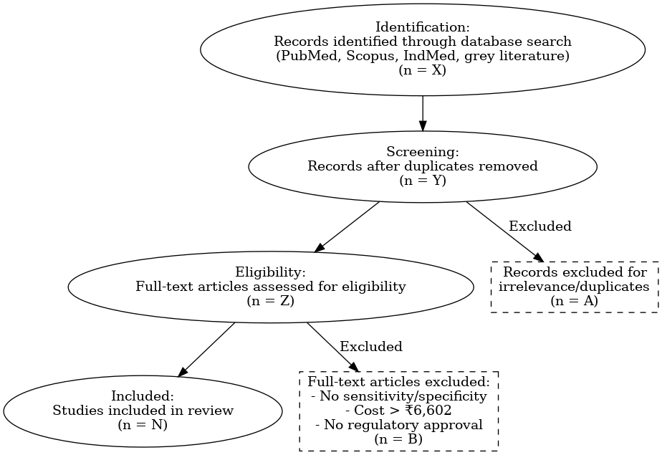

Flowchart 2: Animal Brucellosis Diagnostic Tests

Animal Brucellosis Diagnostic Tests

Diagnostic Test identified :48

45
3

Flowchart 3: Human Brucellosis Diagnostic Tests

Human Brucellosis Diagnostic Tests

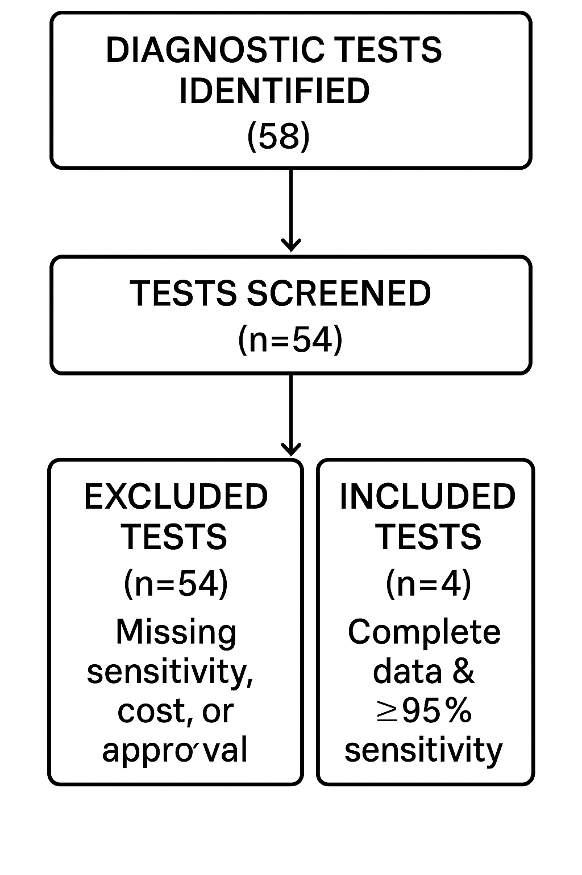

4.2 Current Landscape of Human Brucella Diagnostics

- The present state of diagnostics for human Brucella illustrates a structured and multi-layered system that includes various types of assays such as IgG/IgM ELISA, rapid antibody tests (immunocapture-agglutination), rapid antigen tests, and real-time PCR.

- These diagnostic tools are produced by both international companies (for instance, IBL International from Germany and Vircell SL from Spain) and Indian manufacturers (such as Biotrol Laboratories and HiMedia Laboratories), showcasing a combination of global standards and local resources.

- Most of these assays possess critical certifications like CE & IVD marking, ICMR approval, and comply with WHO-GMP and ISO norms, ensuring their reliability and adherence to both international and national regulatory requirements.

- The application of these diagnostics is systematically allocated throughout the healthcare system: ELISA kits are assigned to Primary and Community Health Centers (PHC/CHC), rapid tests are conducted in District laboratories, referral centers, and veterinary clinics for quicker screening, while real-time PCR is utilized in State-level and VRDL laboratories for definitive molecular diagnosis.

- This tiered diagnostic approach improves early detection, maintains quality control, and aids in the effective management of human brucellosis across different levels of healthcare delivery.

Table 2: Current Landscape of Human Brucella Diagnostics

ASSAY TYPE | NAME/BRAND | MANUFACTURER | APPROVED/  CERTIFED | USE LEVEL
IgG/IgM ELISA | Brucella  IgG/IGM  ELISA Kits | IBL International, Hamburg, Germany | CE& IVD marked | PHC/CHC
Rapid Test (Antibody) (Immunocapture-Agglutination Test) | Brucellacapt  BCAP Test | Vircell SL, Santa Fe, GRANADA, SPAIN | CE& IVD marked | District Lab/Referral/  Veterinary clinics
Rapid Test (Antigen) | Brucella IgG/IgM Rapid Test, Class Type: Class B | Biotrol Laboratories Pvt. Ltd. | ICMR | District Lab/Referral/Vet clinics
Real Time PCR | Hi‐PCR® Brucella Probe PCR Kit | HIMEDIA Laboratories Private Limited, | WHO GMP certified ISO 9001-2015 CERTIFIED  ISO 13485-2016 CERTIFIED | State/VRDL

4.3 Performance Summary Human Brucella Diagnostics
The evaluation of various Brucella diagnostic kits reveals significant variations in sensitivity, specificity, detection thresholds, cost, and cross-reactivity. The IgG/IgM ELISA kit exhibited excellent sensitivity, achieving 95% for IgM and 100% for IgG, alongside specificities of 95% and 98.78% respectively. It showed no instances of cross-reactivity and is reasonably priced at ₹250 per test.
1. The Rapid Antibody Test (Immunocapture-Agglutination) achieved a sensitivity rate of 97.29% and a specificity of 97.08%, with the highest price of ₹300; however, information regarding its cross-reactivity and limit of detection (LOD) was not provided.
2. The Rapid Antigen Test demonstrated a sensitivity of 96.5% and a high specificity of 99.6%, being the most economical option at ₹50 per test, yet details about its LOD and cross-reactivity were lacking.
3. The Real-Time PCR kit showed an analytical sensitivity of 100%, capable of detecting as few as 9 copies/μL of Brucella DNA. It also indicated no cross-reactivity and was cost-effective at ₹154 given its advanced diagnostic capabilities.

Table 3: Performance Summary of Human Brucella Diagnostics
KITS TYPE | SENSITIVITY | SPECIFICITY | LOD | COST | CROSS REACTIVITY
IgG/IgM ELISA | For IgM: 95%,  For IgG: 100% | For IgM: 95%,  IgG: 98.78% | _ | 250 | No cross reactivity
Rapid Test (Antibody) (Immunocapture-Agglutination Test) | 97.29 | 97.08 | Not available | 300 | Not available
Rapid Test (Antigen) | 96.5 | 99.6 | _ | 50 | _
Real Time PCR | Analytical sensitivity: 100% | Provides rapid, accurate, sensitive and specific detection of Brucella strains. | 9 copies/µL | 154 | No cross reactivity

4.4 Current Landscape of the Animal Brucella Diagnostics
- The present situation of animal Brucella diagnostics features a variety of rapid and antigen-based testing techniques, each designed for different tiers of veterinary and public health systems. The Bovine Brucella Antibody Rapid Test created by Ubio Biotechnology Systems Pvt. Ltd. holds ISO 13485:2016 certification and is aimed at use in primary healthcare centers (PHC) and community healthcare centers (CHC), facilitating point-of-care detection.

- The Buffered Acidified Plate Antigen Test (BAPAT), which employs the BAPA Antigen Suspension developed by ICAR-IVRI, is endorsed by OIE, ICAR, and GMP and is mainly utilized for screening at the primary healthcare level.

- For more extensive detection, the Brucella/TB/FMD Combo Rapid Test, also produced by Ubio Biotechnology, is approved by ICMR and is appropriate for application in district laboratories, referral institutions, and veterinary clinics, providing a multiplex method for disease monitoring.

- Importantly, there is currently no specific animal Brucella test designated for implementation at the State/VRDL level, highlighting a possible void in confirmatory or molecular testing capabilities in higher-level laboratories. This tiered approach facilitates efficient screening and early detection at lower levels while underscoring the necessity for
- enhanced diagnostic capacity at advanced levels.

Table 4: Current Landscape of Animal Brucella Diagnostics

ASSAY TYPE | NAME/BRAND | MANUFACTURER | APPROVED/  CERTIFED | USE LEVEL
Rapid Test | Bovine Brucella Ab Rapid Test | Ubio Biotechnology Systems Private Limited | ISO 13485:2016 | PHC/CHC
Buffered acidified plate antigen test (BAPAT) | BAPA Antigen Suspension | ICAR-IVRI | OIE, ICAR, GMP lab manufacturing license | PHC Screening
Rapid Test | B.Brucella/TB-FMD Combo Rapid Test | Ubio Biotechnology Systems Private Limited | ICMR | District Lab/Referral/Vet clinics
No test | _ | _ | _ | State/VRDL

4.5 Performance Summary Animal Brucella Diagnostics
The evaluation of diagnostic kits for animal Brucella showed high sensitivity and specificity in all formats, confirming their applicability in both field and laboratory environments.

1. The Rapid Test achieved a sensitivity of 96.8% and a specificity of 99.1%, exhibiting no cross-reactivity, thus making it a dependable point-of-care diagnostic choice despite the lack of limits of detection (LOD) information.

2. The Buffered Acidified Plate Antigen Test (BAPAT) demonstrated the highest sensitivity at 98.04% and a specificity of 99%, although it did show cross-reactivity with Yersinia enterocolitica and Francisella tularensis. This test is qualitative and maintains a cost-effective price of ₹250 per test.
3. A different Rapid Test kit displayed a sensitivity of 97.4% and a specificity of 98.8%, costing ₹330 per test, yet it lacked information on LOD and cross-reactivity.

Table 5: Performance Summary of Animal Brucella Diagnostics

KITS TYPE | SENSITIVITY | SPECIFICITY | LOD | COST | CROSS REACTIVITY
Rapid Test | 96.8 | 99.1 | Not available | 350 | No cross reactivity
Buffered acidified plate antigen test (BAPAT) | 98.04 | 99.0 | Qualitative | 250 | Yersinia enterocolitica, Francisella tularensis
Rapid Test (Antigen) | 97.4 | 98.8 | _ | 330 | _

Table 6: Diagnostics for Confirmatory Testing at Health System Level

System level | Human | Animal | Rationale for Test
State/VRDL | Real Time PCR | No Test available | Confirm atypical cases, leverage molecular platforms
District Labs | Rapid Test (Antigen) | TB-FMD Combo Rapid Test | Reliable confirmation for surveillance, Point-of-care results in minutes
District Labs | Rapid Test (Antibody) | TB-FMD Combo Rapid Test
Field (PHC/CHC)  PHC Screening | IgG/IgM ELISA | Buffered acidified plate antigen Test (BAPAT) | Quick, easy, useful during outbreaks, Batch testing; minimal equipment

4.6 RECOMMENDATIONS
To strengthen diagnostic capacity and ensure quality assurance in disease surveillance, the following systematic recommendations are proposed

1. Rapid Diagnostic Tests (RDTs)
Selection Criteria: Only acquire RDT kits that are approved by the Central Drugs Standard Control Organisation (CDSCO) and assessed by ICMR or IVRI, ensuring they have independently validated sensitivity of at least 95%.
Approved Manufacturers: Focus on purchasing from recognized and reputable manufacturers (such as Ubio for animal diagnostics).
Deployment: Use RDTs at the grassroots level, which includes district hospitals, veterinary clinics, and mobile diagnostic camps to facilitate quick and accessible screening.

2. Enzyme-Linked Immunosorbent Assay (ELISA) Kits
Certification: Only utilize IgG/IgM ELISA kits that are certified by ICMR-NIV or IVRI. Brands like IBL International are preferred for human diagnostics.
Supplementary Options: When necessary, consider adding CE/ISO-marked kits, making sure they comply with validated sensitivity and specificity standards.

3. Polymerase Chain Reaction (PCR) Kits
Vendor Support: Purchase PCR kits exclusively from vendors who provide dependable maintenance and calibration services for the equipment as part of their post-procurement assistance.

4. Agglutination Tests / Confirmatory Testing
Rapid Confirmation: For field verification, standardize the procurement of Rose Bengal Plate Test (RBPT) kits from suppliers listed by ICMR/IVRI to guarantee rapid and cost-effective results.
Laboratory Confirmation: In lab diagnostics, prioritize the use of immunocapture agglutination kits (like Brucellacapt) or tube agglutination kits, ensuring all selected kits have documented regulatory approval.

5. Training and Quality Assurance (QA) Materials
Capacity Building: Make training supported by supplier’s compulsory, including proficiency assessments for personnel managing diagnostics.
Standard Documentation: Confirm the availability and implementation of standard operating procedures (SOPs), quality control (QC) logs, and other relevant documentation.
External Quality Assurance: Incorporate External Quality Assurance (EQA) frameworks as an essential component of all procurement agreements.

6. Stock Monitoring and Inventory Control
Real-Time Monitoring: Implement real-time stock tracking and reporting within procurement systems to avoid delays or shortages.
Inventory Thresholds: Set minimum and maximum inventory levels throughout the healthcare system to ensure ongoing availability and to deter stockouts or wastage.

4.7 Recommended Strategies for Stakeholders in Strengthening Diagnostics for Brucellosis Control-Effective brucellosis control requires a multi-stakeholder approach, with each stakeholder playing a critical role in advancing diagnostic capacity, quality assurance, and accessibility. The following are strategic recommendations tailored to key stakeholders:

1. Health Program Planners (MoHFW, State Health Missions)
Focus on investing in validated, effective, and cost-efficient diagnostic tools to optimize resource use. Create and enforce procurement guidelines that standardize diagnostic platforms across different states, improving comparability and readiness for outbreak responses. Integrate brucellosis diagnostics into national and state disease control initiatives, ensuring alignment with One Health strategies.

2. Technical Partners (ICMR, NCDC, IVRI)
Carry out gap analyses on existing diagnostic tools and expedite validation studies for promising technologies suitable for Indian field conditions. Regularly publish and update technical guidelines for the adoption of diagnostics, including suggested algorithms, test combinations, and frameworks for performance monitoring. Support the development of training modules for stakeholders at various levels to ensure proper test selection, usage, and interpretation.

3. Procurement and Logistics Agencies
Negotiate framework agreements to obtain competitive prices while ensuring compliance with regulations (CDSCO/ICMR/IVRI). Incorporate diagnostic procurement into established platforms like the NHM supply chain and State e-procurement portals, allowing for real-time tracking and stock management. Establish centralized forecasting systems based on disease burden and usage trends to reduce stockouts and minimize waste.
4. Diagnostic Manufacturers
Ensure product development aligns with field needs, emphasizing user-friendliness, shelf stability, and compatibility with peripheral laboratories.
Aim for prompt regulatory clearances and maintain transparency regarding product performance data through independent reviews. Offer end-user support that includes field training, technical assistance, and post-market surveillance to ensure continued test quality.

5. Field Implementers and Laboratory Personnel
Engage in organized training programs that emphasize test protocols, biosafety, and reporting standards. Implement SOPs and participate in external quality assurance (EQA) programs to guarantee consistent test performance across laboratories and field locations. Encourage timely feedback communication with district and state authorities to tackle diagnostic challenges and share insights from the field.

6. Community Representatives and Civil Society
Promote awareness regarding the significance of accurate and timely diagnosis in preventing complications related to brucellosis. Advocate for fair access to approved diagnostic methods and support initiatives that ensure affordability for at-risk populations. Supervise transparency and accountability in diagnostic procurement and service delivery, thus enhancing public trust in government health efforts.

CHAPTER 5: DISCUSSION

Appropriate methods of diagnosis are important in the control of brucellosis, both in humans and animals. This study highlights specific gaps in the diagnostic system that are driven by deficits and emerging global practices that require the most attention.

1. Available Diagnostic Options for Each Level Require Validation
Every level of the healthcare system has specific diagnostic tools that are suitable for that level. For instance, RDTs and agglutination tests are usable at the primary level and are inexpensive and easy to deploy whereas ELISA and PCR are the gold standards at the secondary and tertiary laboratories. However, there is no rigorous data on the performance of these tests at field level, especially in resource constrained and rural settings. The gaps in accuracy for many tests suggest the need for bespoke validation studies. Tools, such as QUADAS-2, provide standard approaches to evaluation for bias risk and applicability in diagnostic accuracy studies which enhances the selection of appropriate tests for field use (Whiting et al., 2011).

2. Challenges in Animal Diagnostics: MRT and ELISA Remain Common
Troubles Encountered in Animal Screenings: MRT And ELISA Continue To Be Prevalent in the industry of animal medicine, the Milk Ring Test (MRT) and ELISA are the most common tests conducted to screen for possible cases of brucellosis. Their accessibility and affordability make them economically favourable, however, their biological and logistical effectiveness in the field is often limited due to cold chain compliance, reagents, or cross-reactive other pathogens (OIE, 2021). This contributes to both false positive and negative results and undermines the control and surveillance strategies put into place. In endemic regions, it is more appropriate to switch to more reliable confirmatory tools such as Elisa or Brucellacapt. Furthermore, the consistency of diagnosis from area to area can be improved by conducting inter-laboratory comparisons and external quality assurance initiatives.

P.T.O
3. Implementing DALY-Based Costing for Procurement Decisions
Analytic methods like costing based on life years lost often emphasize the wrong logic of diagnostic prioritization based on the lowest monetary value. As a logic-based alternative, the use of DALY-based (Disability Adjusted Life Year) costing frameworks for diagnosis shifts the priority to the value, cost, and its impact on public health. Focusing on cost per DALY averted allows policymakers to target diagnostics that are most cost effective in promoting population health (Jo, 2014; Bertram et al., 2016).
For conditions such as brucellosis—where underdiagnosis leads to chronic health problems, economic losses, and zoonotic risks—integrating DALY-based assessments can guide evidence-based investments at both national and state levels. Incorporating these factors in procurement policies would further align diagnostic selections with Universal Health Coverage (UHC) objectives.

4. Utilizing One Health for Joint Human-Animal Diagnostics
Integrated surveillance systems are necessary in controlling zoonotic diseases such as brucellosis. It is equally important that humans, animals, and environmental health are monitored simultaneously as they are interrelated. A shared diagnostic system and data infrastructure based on state prevalence and risk assessment of a disease is capable of minimizing duplication of work, improving early response to outbreaks, and streamlining resource allocation (FAO-OIE-WHO, 2019). The use of RDTs, ELISAs, and PCR kits are applicable in both human and veterinary disciplines. Their use in intersectoral integrated disease surveillance is especially beneficial in regions of high burden. These collaborations also resolve other emerging zoonotic diseases, thereby providing brucellosis long term management despite being intended only as a temporary solution.

5. Enhancing Ecosystem Capacity for Enduring Diagnostics
The effectiveness of a specific diagnostic strategy, in this case, the diagnostic strategy's effectiveness, heavily relies on the supply chains, quality assurance systems, and the workforce's capability. Test effectiveness is frequently hindered by stock shortages, untrained personnel, and poorly calibrated equipment, especially in peripheral regions (Peeling and Mabey, 2010).
The following is needed to improve the ecosystem:
- Real-time inventory monitoring systems
- External quality assessment programs
- Adherence to regulations and oversight of marketed diagnostics
- Training programs backed by suppliers and standard operation procedures (SOPs)
By addressing these issues, both more consistent diagnostic performance and improved strength in the management of other disease programs will be achieved.

6. Importance of Diagnostic Evaluation Tools: QUADAS-2
Similarly, evidence-based decisions in diagnostic procurement and policy also require evaluative of evidence. The QUADAS-2 tool is a validated method for assessing bias, applicability, and methodological quality in diagnostic test accuracy (DTA) as defined by Whiting et al.
The use of the QUADAS-2 by developers of national or state-level guidelines will help to differentiate tests that are likely candidates for widespread acceptability and those where validation has not been as rigorous, with consequent implications for evidence-based choices. Finally, using QUADAS-2 in systematic reviews of the available tests can assist policymakers and technical partners in revising testing algorithms based on pragmatic performance experiences.

CHAPTER 6: Limitations of Study

1. One of the key limitations of this study was the incomplete diagnostic data, as several diagnostic kits lacked essential information such as sensitivity, specificity, cost, or regulatory approval, which hindered comprehensive comparison across platforms.

2. Additionally, the study is subject to potential reporting bias, given that much of the information was derived from published studies and manufacturer datasheets, which may selectively highlight favorable outcomes.

3. The findings also reflect a time-bound nature, as regulatory approvals and kit availability are dynamic and may have changed since the time of data collection, thereby limiting the longitudinal relevance of the results.

4. Moreover, there was limited field-level validation for many of the diagnostic assays evaluated. Most kits had not been tested extensively in rural or resource-limited settings, affecting the generalizability of their performance in real-world scenarios.

5. Lastly, regulatory gaps in veterinary kits were evident, with many veterinary diagnostic products not appearing in the CDSCO database. This raises concerns about regulatory oversight, standardization, and quality assurance of such kits in the context of animal health diagnostics.

CHAPTER 7: CONCLUSION

As brucellosis is a zoonotic chronic debilitating disease of global public health and veterinary importance, the infection continues to be major challenge for public health as well as veterinary action in India and worldwide where it may especially lead variety of complications due to its potential transmission from animals to human hosts, persistently causing more diagnostic difficulties. The review was comprehensive in providing a critical appraisal of diagnosis for brucellosis in humans and animals, considering test performance, field utility and operational feasibility from the perspective of diverse healthcare and veterinary contexts.

6.1 Human Brucellosis: Diagnostic Implications
The higher sensitivity and specificity, low turnaround time makes Real-Time PCR as the superior diagnostic approach for human brucellosis. Detection of Brucella DNA at molecular level gives great confirmatory help, particularly for larger tertiary care or reference laboratories. However, this comes at a price since its diagnostic accuracy is excellent, but it requires upper high level lab facilities and skilled personnel, which restricts its broader application in resource-limited environments.
In contrast, rapid diagnostic tests (RDTs) and ELISA-based assays showed moderate to high levels of sensitivity and specificity, providing practical and scalable options for initial screenings, particularly in primary and peripheral healthcare settings. Their user-friendliness, minimal equipment requirements, and quick result delivery make them especially effective for early case identification and surveillance in areas where the disease is common. Collectively, these tools advocate for a tiered diagnostic strategy, where ELISA and RDTs enable swift screening, and PCR acts as the definitive confirmation method when clinically or epidemiologically warranted.

6.2 Animal Brucellosis: Diagnostic Findings and Field Relevance
Regarding animal brucellosis, the results of the study support the diagnostic reliability of the Buffered Acidified Plate Agglutination Test (BAPAT), which demonstrated the highest accuracy among the examined methods. This positions it as a crucial asset for extensive surveillance and control initiatives, particularly in regions with a high prevalence of brucellosis. Nonetheless, its potential for cross-reactivity with other bacterial pathogens requires careful interpretation and the utilization of differential diagnostic approaches, especially in scenarios involving mixed infections.
Although rapid tests for animals exhibited slightly lower sensitivity and specificity, they offer significant practical advantages for field screening, particularly in remote or under-resourced veterinary environments. Their portability, speed, and minimal technical training requirements make them well-suited for mobile veterinary units, livestock outreach programs, and decentralized disease surveillance efforts. When combined with more definitive laboratory tests (like ELISA or culture), they can greatly improve the efficiency and scope of strategies for controlling animal brucellosis.

6.3 Cross-Cutting Themes and Strategic Takeaways
Integration Under One Health: The research emphasizes the necessity of having shared diagnostic platforms and protocols that function across the human-animal interface. Creating a One Health-centric diagnostic system, customized to local epidemiological circumstances, will be vital in facilitating synchronized surveillance and control of brucellosis and similar zoonotic diseases.

Diagnostic Tiering and Access: The results advocate for a tiered diagnostic approach that matches advanced confirmatory methods like PCR with tertiary levels, while also equipping peripheral facilities with validated rapid diagnostic tests (RDTs) and ELISAs. This framework has the potential to noticeably diminish diagnostic delays and enhance brucellosis management at every level.

Capacity Building and QA: The precision and dependability of diagnostics rely heavily on comprehensive system support. It will be essential to bolster quality assurance processes, training initiatives, and supply chain infrastructures to ensure consistency in diagnostic results, particularly in rural and under-resourced regions.

Policy and Procurement Implications: Implementing DALY-based costing methods in the selection and procurement of diagnostics can enhance cost-effectiveness and prioritize investments that drive impact. It is crucial for policymakers to focus on securing regulatory-approved, locally validated, and context-specific diagnostics across various sectors.

Need for Field-Level Evidence: In spite of advancements in technology, there exists a notable gap in performance data from field settings, especially in practical, decentralized environments. Additional operational research and pilot projects are necessary to validate diagnostic tools in real-world conditions and to inform the development of national guidelines.

Final Remarks: In summary, enhancing diagnostic systems for brucellosis demands a comprehensive strategy that incorporates scientifically validated tools, cross-sector collaboration, and strong implementation frameworks. By utilizing tier-specific diagnostics, improving system capacities, and aligning policies with public health priorities, India can make significant progress towards effective brucellosis control, lessen disease impact, and move closer to achieving the objectives of zoonotic disease eradication within the One Health framework.

References
1. Parai D, Sahoo SK, Patnaik M, Swain A, Peter A, Samanta LJ, Pradhan R, Choudhary HR, Nahak KC, Pati S and Bhattacharya D (2022) Seroprevalence of human brucellosis among the tribal and non-tribal population residing in an eastern state of India: Findings from the state-wide serosurvey. Front. Microbiol.13: 1070276.doi:10.3389/fmicb.2022.1070276
2.Kalambhe DG, Sundar B, and Bedi JS (2025) Seroprevalence of brucellosis in humans with non-specific clinical symptoms in Punjab, India, Veterinary World, 18(4): 819–826.
3.Status of Brucellosis in India: A review MaansiCPFA. K. Upadhyay received : July 2020 Accepted : August 2020 Published: December 2020 Indian J. Vet. Public Hlth. (December 2020)
4.IMPACT OF BOVINE BRUCELLOSIS ON THE ECONOMY & PUBLIC HEALTH IN INDIA
5.Suresh KP, Patil SS, Nayak A, Dhanze H, Rajamani S, Shivam Allu C, Cull CA and Amachawadi RG (2022) Prevalence of brucellosis in livestock of African and Asian continents: A systematic review and meta-analysis. Front. Vet. Sci. 9:923657.doi: 10.3389/fvets.2022.923657
6.Indian Journal of Animal Sciences 93 (7): 663–669, July 2023/Articlehttps://doi.org/10.56093/ijans.v93i7.132586Systematic review and meta-analysis on brucellosis seroprevalence in ruminants (1970 – 2020) of India Michael V LALRINZUALA1, VINODHKUMAR O R1*, SHIKHA TAMTA1, D K SINGH, CLALSANGZUALA1, DAMINI KHAWASKAR1, ROTLUANGKIMI1, B R SINGH1 and D K SINHA1
7.Global prevalence of human brucellosis: A systematic review and meta-analysis Riyaz Sherasiya
8.WHO. (2011).Seven Neglected Endemic Zoonoses-Some Basic Facts. Geneva: World Health Organization.
9.Mantur, B. G., and Amarnath, S. K. (2008). Brucellosis in India – a review. J.
Biosci. 33, 539–547. Doi: 10.1007/s12038-008-0072-1
10. Di Bonaventura G, Angeletti S, lanni A, Petitti T, Gherardi G. Microbiological Laboratory Diagnosis of Human Brucellosis: An Overview. Pathogens. 2021; 10(12):1623, https://doi.org/10.3390/pathogens10121623
11. Feng Qiangsheng, Ha Xiaoqin, Lin Tong, Guo Wenyen, Song Yuejuan, Brucella cultures characteristics, clinical characteristics, and infection biomarkers of human Brucellosis, Journal of Infection and Public Health, Volume 16, Issue 3, 2023, Pages 303-309, Doi https://doi.org/10.1016/j.jiph.2023.01.002
12. Hassan L, Ali S, Syed MA, Shah AA, Abbasi SA, Tabassum S, Saeed U, Melzer F, Khan AU, El-Adawy H and Neubauer H (2022) Risk Factors for Acute Brucellosis in Patients on the Day of AdmissionatSelectedHospitalsofAbbottabad
13. Kang, G. J., Gunaseelan, L., and Abbas, K. M. (2014). 13. Epidemiological modeling
of bovine brucellosis in India. Proc. IEEE Int. Conf. Big Data 2014, 6–10. Doi:
10.1109/BigData.2014.7004420
14.Buzgan, T., Karahocagil, M. K., Irmak, H., Baran, A. I., Karsen, H., Evirgen, O.,
et al. (2010). Clinical manifestations and complications in 1028 cases of brucellosis:
a retrospective evaluation and review of the literature. Int. J. Infect. Dis. 14, e469–
e478.doi:10.1016/j.ijid.2009.06.031
15.Dagli, O., Dokur, M., Guzeldag, G., and Ozmen, Y. (2011). Acute renal failure due
to Brucella melitensis. J. Infect. Dev. Ctries. 5, 893–895. doi: 10.3855/jidc.1442
16.Zhong, Z., Yu, S., Wang, X., Dong, S., Xu, J., Wang, Y., et al. (2013). Human
brucellosis in the People’s republic of China during 2005–2010. Int. J. Infect. Dis. 17,
e289–e292. Doi: 10.1016/j.ijid.2012.12.030

17. Available from: FAO, 2003 – Guidelines for coordinated human and animal brucellosis surveillance.FAO, 2003 – Guidelines for coordinated human and animal brucellosis surveillance.

18.Bovine brucellosis: Prevalence, risk factors, economic cost and control options with particular reference to India – a review [Internet]. International Livestock Research Institute. 2018. Available from:https://www.ilri.org/knowledge/publications/bovine-brucellosis-prevalence-risk-factors-economic-cost-and-control-options

19. Lindahl JF, Vrentas CE, Deka RP, Hazarika RA, Rahman H, Bambal RG, et al. Brucellosis in India: results of a collaborative workshop to define One Health priorities. Tropical Animal Health and Production [Internet]. 2019 Oct 15 [cited 2025 Feb 19];52(1):387–96. Available from: https://pubmed.ncbi.nlm.nih.gov/31620958

20.Tropmedhealth.biomedcentral.com. BMC; [cited 2020 Oct 20]. Available from: https://tropmedhealth.biomedcentral.com/articles/10.1186/s41182-020-00272-1

‌
21.Upadhyay M. Status of Brucellosis in India: A review [Internet]. Vet. Public Hlth. 2020 [cited 2025 Jun 10]. Available from: https://ijvph.org/wp-content/uploads/2024/01/Review_7__1_3.pdf

22.Yagelski P, Morata P, Colmenero JD. Laboratory Diagnosis of Human Brucellosis. Clinical Microbiology Reviews. 2019 Nov 13;33(1).
‌
23. Team Pashudhan Praharee. IMPACT OF BOVINE BRUCELLOSIS ON THE ECONOMY & PUBLIC HEALTH IN INDIA [Internet]. Pashudhan Prahree. 2022 [cited 2025 Aug 9]. Available from: https://www.pashudhanpraharee.com/impact-of-bovine-brucellosis-on-the-economy-public-health-in-india/

24.Bertram MY, Lauer JA, De Joncheere K, Edejer T, Hutubessy R, Kieny MP, et al. Cost–effectiveness thresholds: pros and cons. Bulletin of the World Health Organization [Internet]. 2016 Sep 19;94(12):925–30. Available from: https://www.who.int/bulletin/volumes/94/12/15-164418/en/

25.Lee J. Case Reports in the Korean Journal of Family Medicine. Korean Journal of Family Medicine.2014;35(2):55.https://doi.org/10.4082/kjfm.2014.35.2.55
Codes and Manuals [Internet]. WOAH - World Organisation for Animal Health. Available from: https://www.woah.org/en/what-we-do/standards/codes-and-manuals/https://www.woah.org/en/what-we-do/standards/codes-and-manuals/terrestrial-manual-online-access/

26. Peeling RW, Mabey D. Point-of-care tests for diagnosing infections in the developing world. Clinical Microbiology and Infection. 2010 Aug;16(8):1062–9..
https://doi.org/10.1111/j.1469-0691.2010.03279.x

27. Whiting PF. QUADAS-2: A Revised Tool for the Quality Assessment of Diagnostic Accuracy Studies. Annals of Internal Medicine [Internet]. 2011 Oct 18;155(8):529. Available from: https://pubmed.ncbi.nlm.nih.gov/22007046/

28. J CM, and F, World Health Organization, World. Brucellosis in humans and animals. Whoint [Internet]. 2024 [cited 2025 Mar 13]; Available from: https://iris.who.int/handle/10665/43597

‌

Annexure 1
Human Diagnostic kits data sets

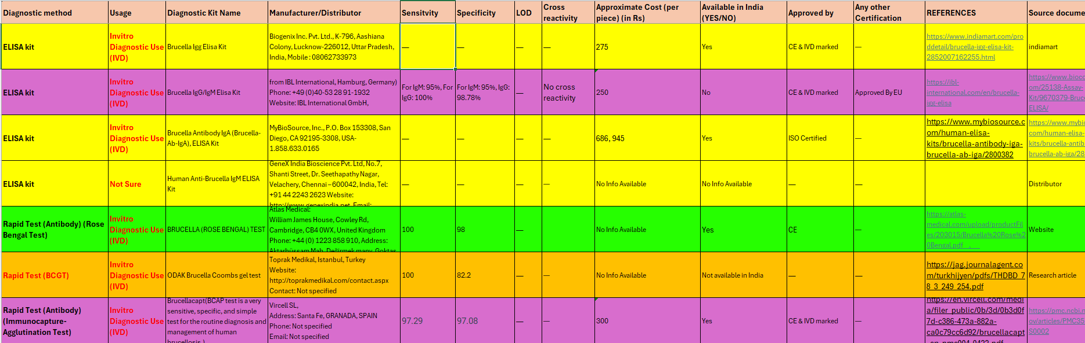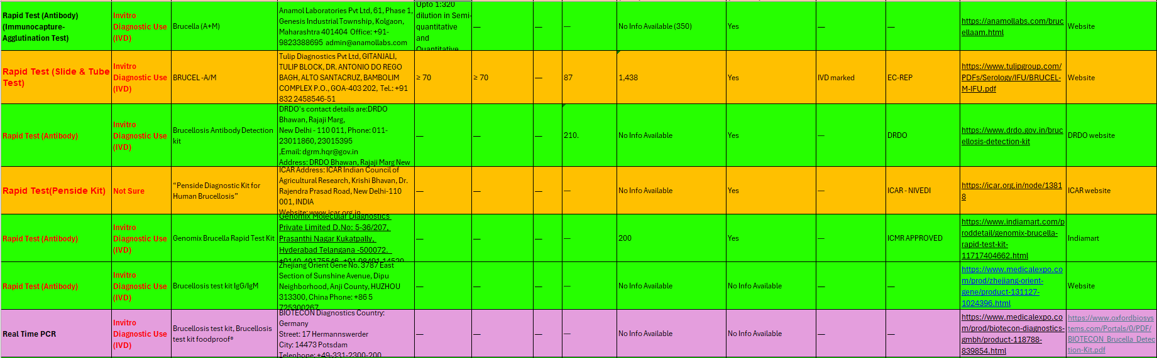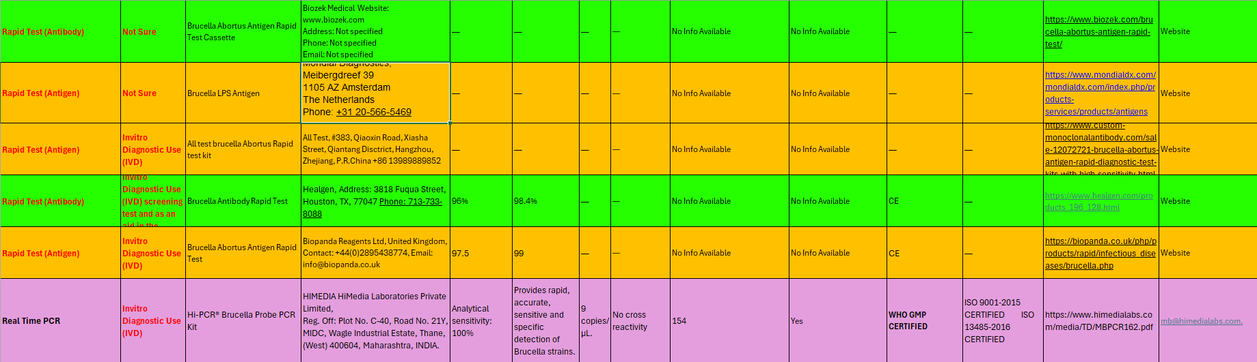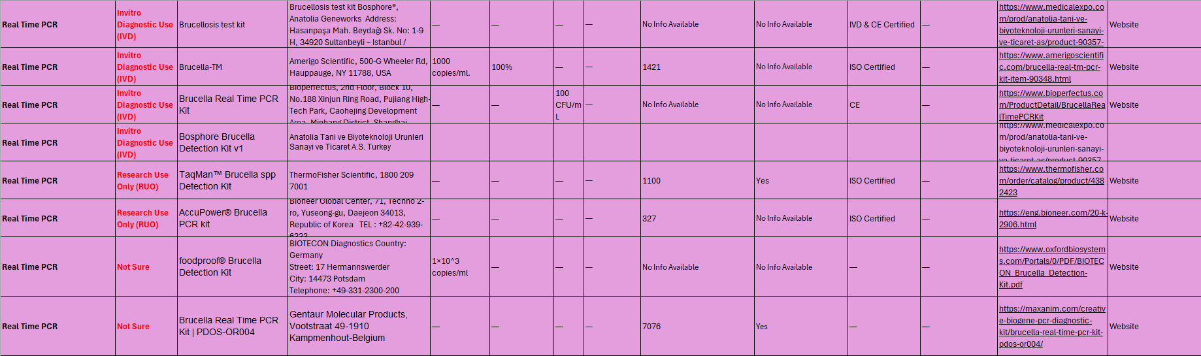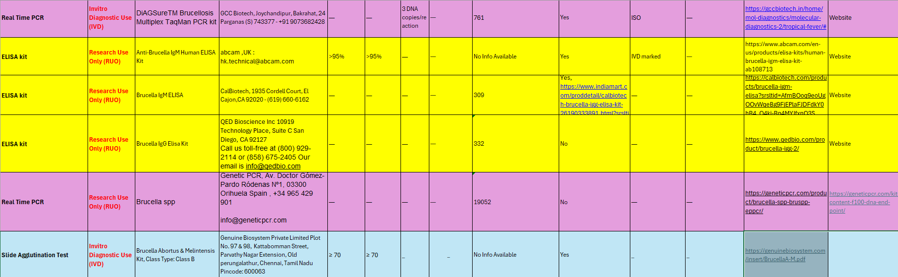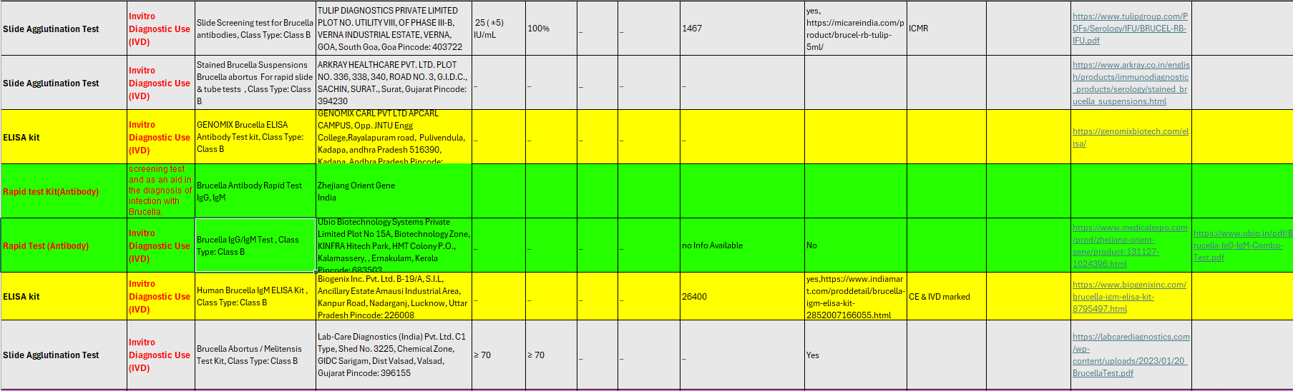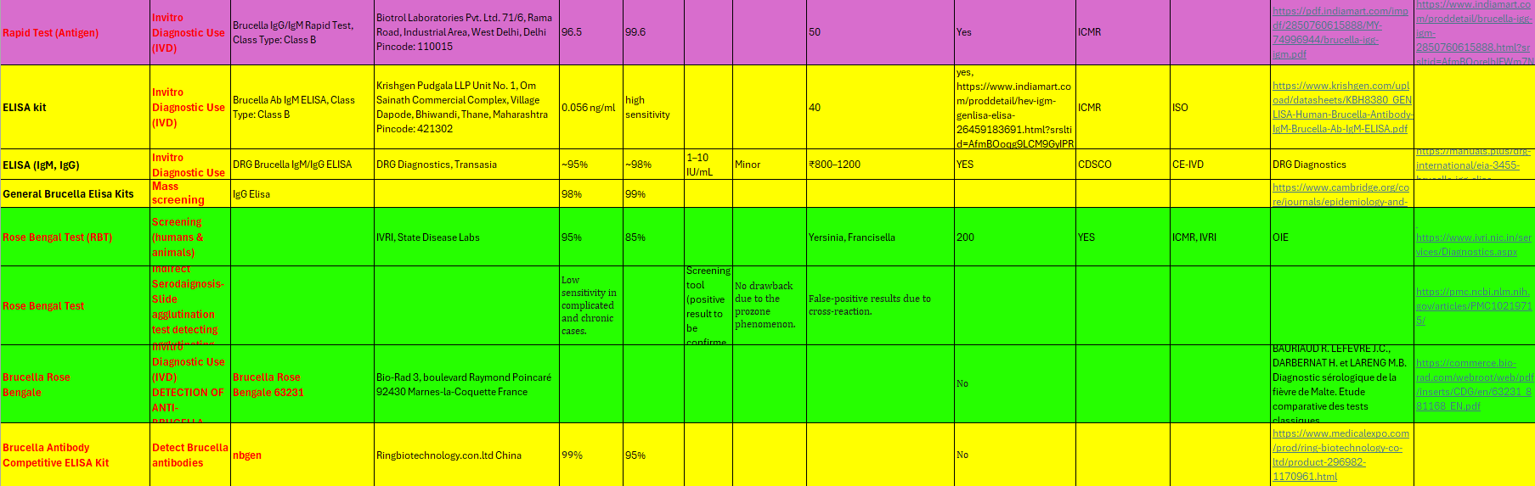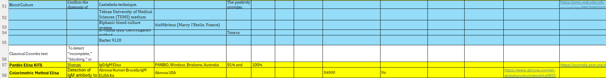
Annexure 2
Animal Diagnostic Kits data sets

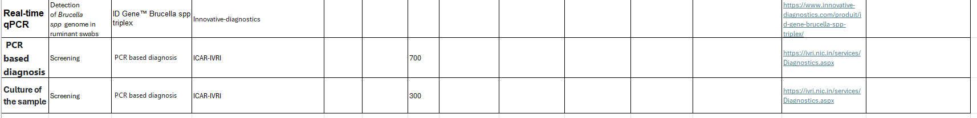
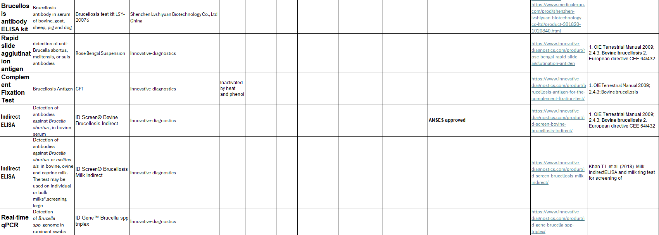
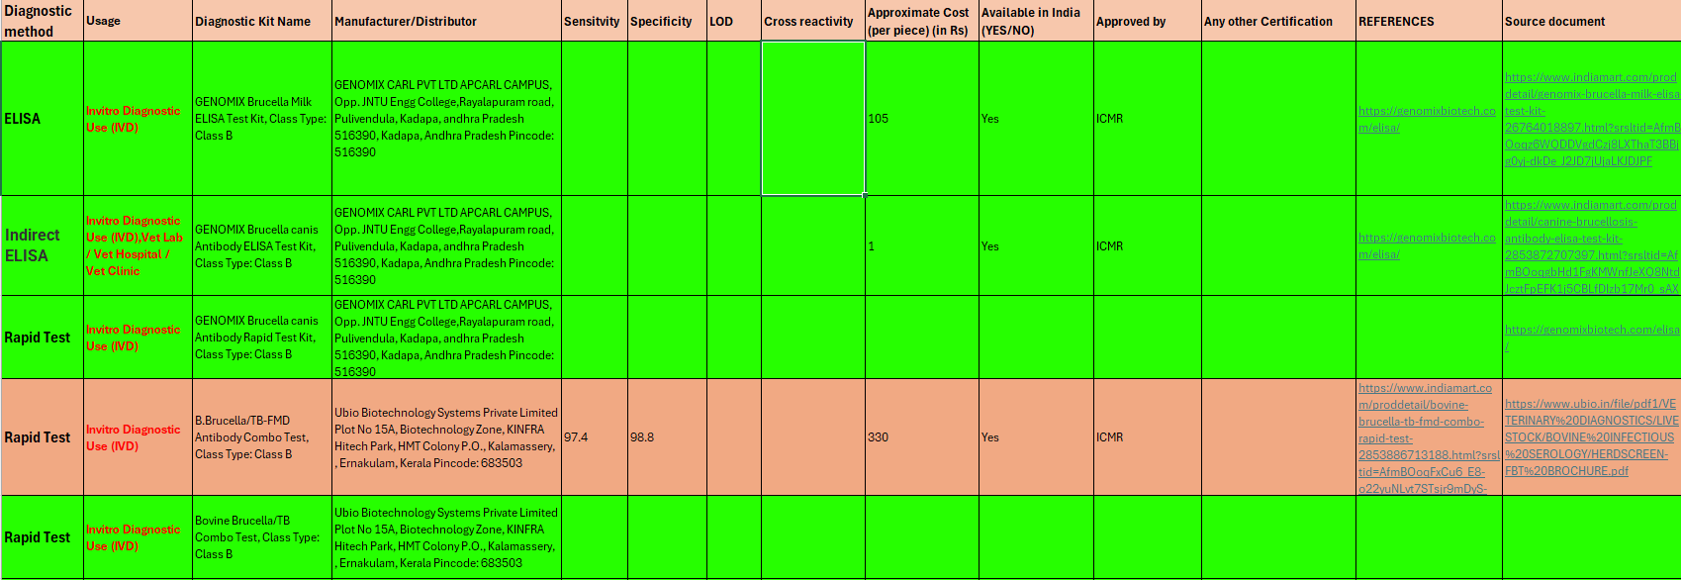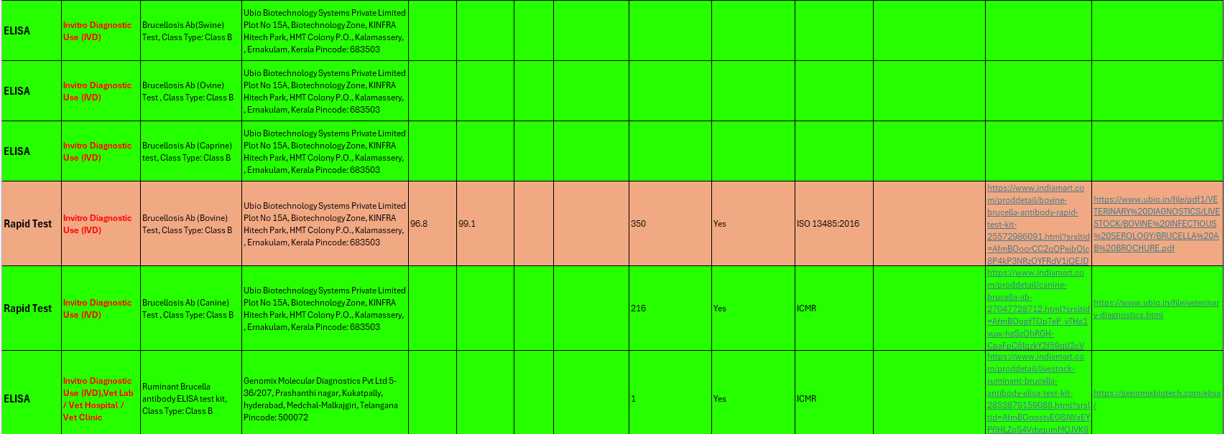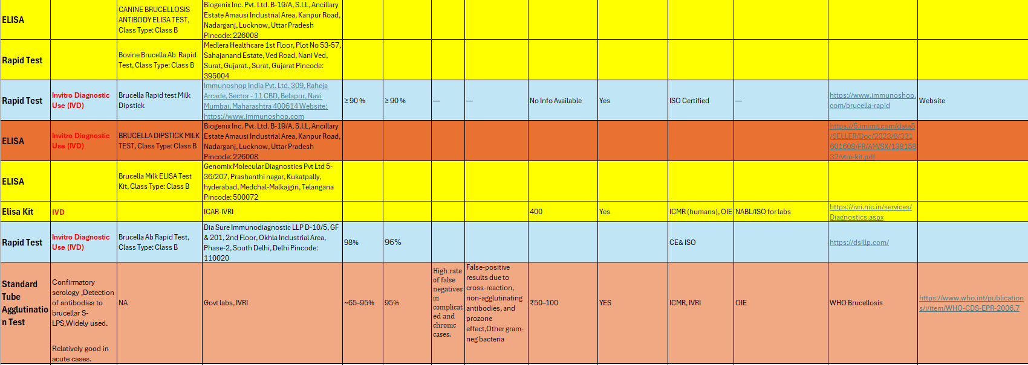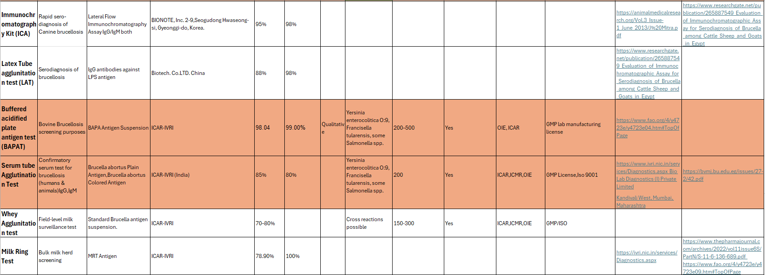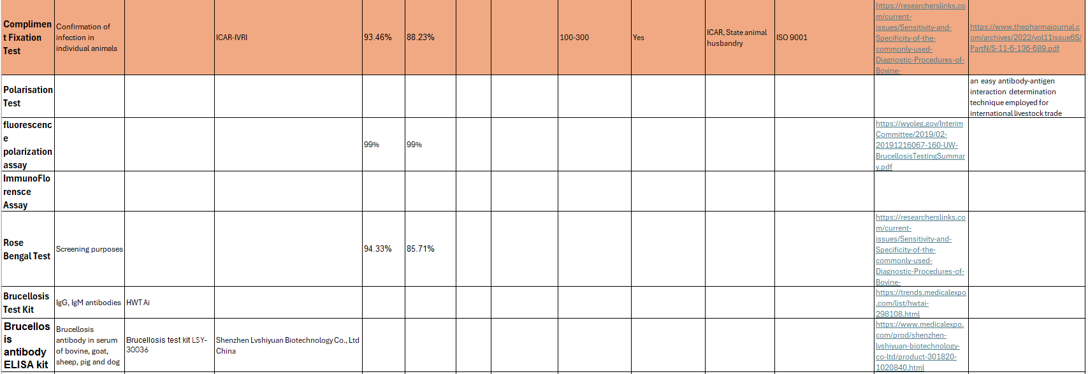

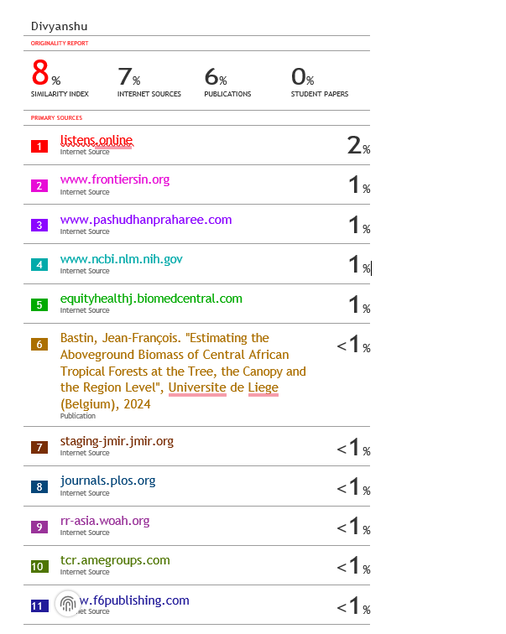
PLAGARISM REPORT
