Dissertation Training

at

UNICEF, Bihar

Impact of VHSND Strengthening on Immunization Coverage in Rural Bihar
by

Nisha Sharma

PG/23/074

Under the guidance of

DR. Divya Aggarwal

PGDM (Hospital & Health Management)

2023-25



International Institute of Health Management Research New Delhi

Dissertation Training

at

UNICEF , Bihar

Impact of VHSND Strengthening on Immunization Coverage in Rural Bihar
by

Nisha sharma
PG/23/074

Under the guidance of
DR. Divya Aggarwal

PGDM (Hospital and Health Management)

2023-25

International Institute of Health Management Research
New Delhi

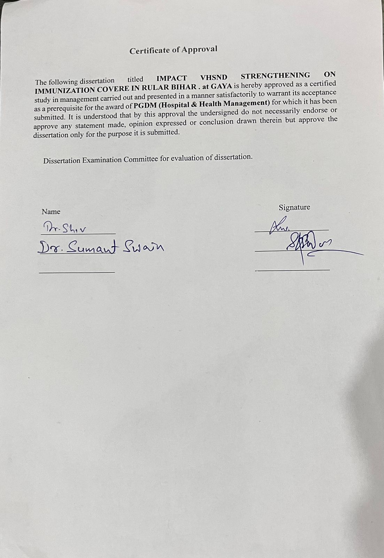
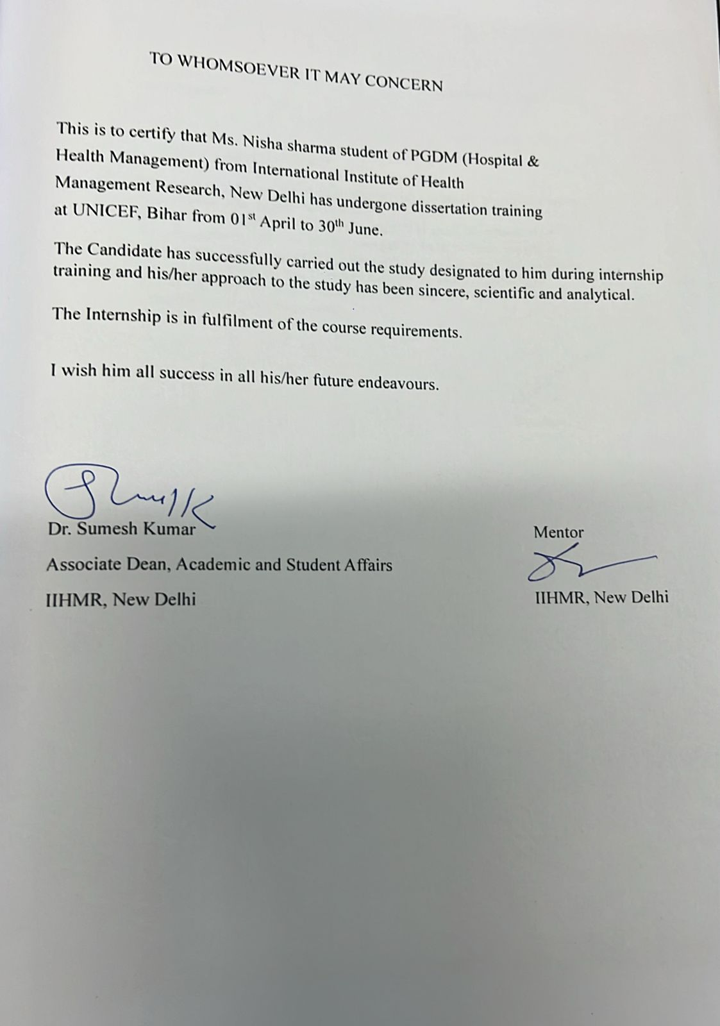

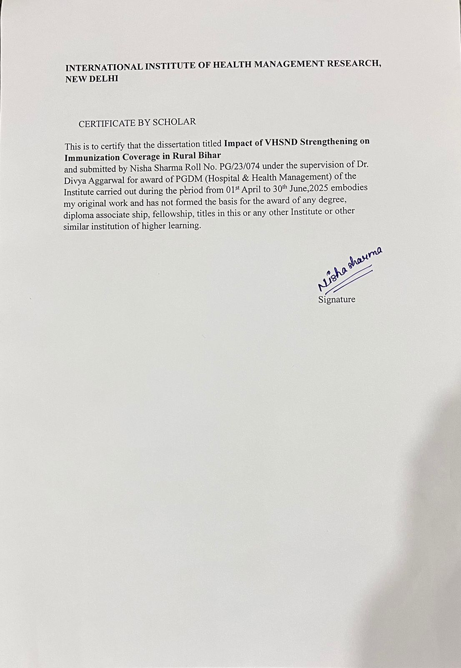

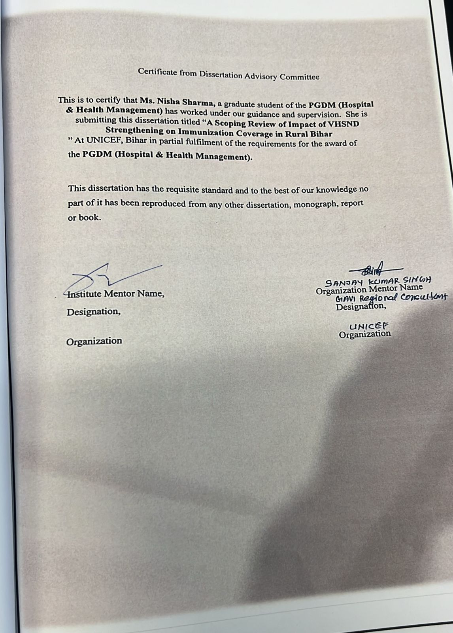
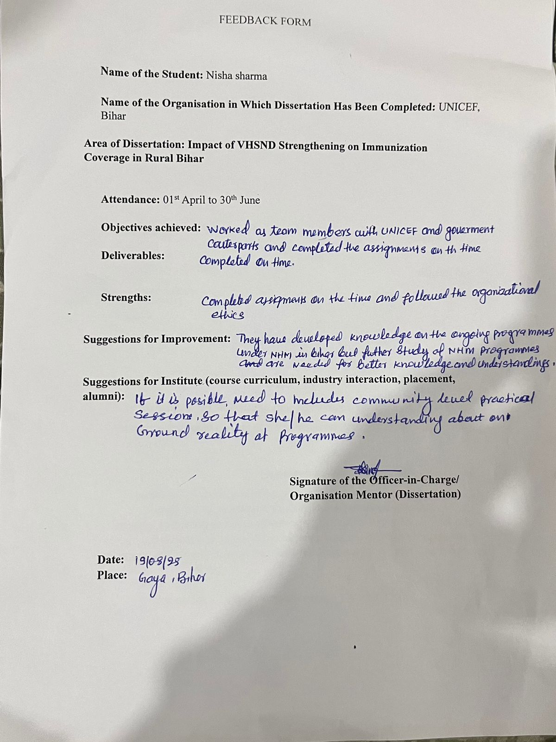

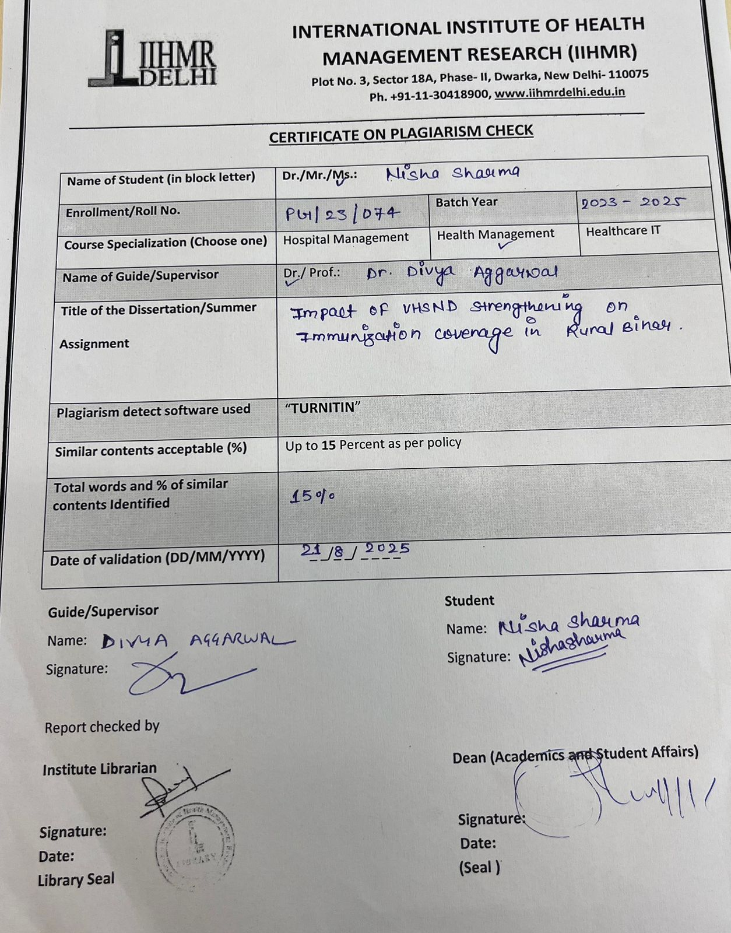

ACKNOWLEDGEMENT
The internship opportunity I had with UNICEF, Bihar was a great chance for learning and professional development. Therefore, I consider myself very fortunate as I was provided with an opportunity to be a part of it. I am also grateful for having a chance to meet so many wonderful people and professionals who led me through this internship period.
Bearing in mind, I am using this opportunity to express my deepest gratitude and special thanks to Dr. Sala Siddhartha Sankar Reddy (Health Specialist, UNICEF, Bihar) who despite being extraordinarily busy with his duties, took time out to hear, guide, and keep me on the correct path and allowing me to carry out my project at their esteemed organization and extending during the training.
I express my deepest thanks to Dr. Ansuman Das (Health Officer, UNICEF, Bihar), Mr. Sanjay Kumar Singh (Gavi Regional Consultant, UNICEF Bihar, Gaya District) for taking part in useful decision & giving necessary advice and guidance and arranged all facilities to make my project easier. I choose this moment to acknowledge their contribution gratefully.
I would like to express my sincere gratitude towards my mentor Dr. Divya Aggarwal, (Associate Dean, IIHMR Delhi) who helped me immensely throughout the tenure of my internship. He inspired me greatly to work in this project with his valuable guidance, support, interest, encouragement, involvement, and advice.
It is my radiant sentiment to place on record my best regards, and deepest sense of gratitude to Dr. Sutapa Bandyopadhyay Neogi, (Director, IIHMR Delhi) for her careful and precious guidance which was extremely valuable for my study both theoretically and practically.
I perceive this opportunity as a big milestone in my career development. I will strive to use the gained skills and knowledge in the best possible way and continue to work on their improvement to attain desired career objectives. Hope to continue cooperation with all of you in the future.
Sincerely,
Nisha sharma
PG/23/074

TABLE OF CONTENT

SR NO | CONTENT | PAGE NO
1 | Acknowledgement | 9
2 | Table of content | 10
3 | Acronyms | 12
4 | Organization profile | 13
5 | Abstract | 14
6 | Introduction | 15-16
7 | Methodology | 17
8 | Result | 18-28
9 | Discussion | 29
10 | Conclusion | 30
11 | Reference | 30-31

LIST OF TABLES AND FIGURES

- Table 1: Key characteristics of included studies on VHSND strengthening in rural Bihar
- Table 2: Thematic analysis of barriers and enablers to effective VHSND implementation
- Table 3: Excluded studies and programme reports with reasons for exclusion

ACRONYMS
SL NO | Acronyms | Full form
1 | VHSND | Village Health, sanitation and nutrition Day
2 | VHSNC | Village Health Sanitation and Nutrition Committee
3 | AEFI | AEFI
4 | MCP Card | Mother and Child Protection Card
5 | ANM | Auxiliary Nurse Midwife
6 | ASHA | Accredited Social Health Activist
7 | AWW | Anganwadi Worker
8 | HWC | Health &Wellness Centre
9 | PHC | Primary Health Centre
10 | CHC | Community Health Centre
11 | DH | District Hospital
12 | MoHFW | Ministry of Health and Family Welfare
13 | NHM | National Health Mission
14 | SHSB | State Health Society Bihar
15 | RMNCH+N | Reproductive, Maternal, Newborn, child Health and Nutrition.
16 | NCD | Non-communicable Disease
17 | SC | Sub centre
18 | SNCU | Specialized New born Care Unit
19 | UNICEF | United National Children’s Fund
20 | WHO | World Health Organization
21 | EVM | Effective Vaccine Management
22 | RCH | Reproductive and child Health Programme

ORGANIZATION PROFILE

UNICEF works to promote and protect the rights of children across India. We have spent 74 years in India working to improve the lives of children and their families.
UNICEF India is committed in its continued support to the Government in this extraordinary journey of development to reach every child everywhere in India. Our goal is to enable every child born in India to have the best start in life, to thrive and to develop to her or his full potential. To achieve this we use our technical expertise together with partners to tackle the root of several, deeply entrenched structural challenges.
We have been present in India for 74 years. UNICEFs key strength lies in our evidence-based technical expertise that informs policy action and implementation, while at the same time building the capacity of partners. With some 450 staff members working in 17 states that together cover 90 per cent of India’s child population - largest field presence among UN agencies – we are well positioned to reach the country’s most vulnerable children.

UNICEF believes, all children have a right to survive, thrive and fulfil their potential – to the benefit of a better world.

ABSTRACT:
Background: Village Health, Sanitation, and Nutrition Days (VHSNDs) are an important part of India's plan for providing maternity, child health, and nutrition services at the village level, with immunization being a vital component. In rural Bihar, which has dispersed populations, migrant work patterns, and poor health infrastructure, VHSNDs have been enhanced in recent years through supportive monitoring, integrated service delivery, and targeted mobilization. However, there is significant variety within districts in terms of coverage, session quality, and community participation. This scoping assessment aimed to synthesise the available research on VHSND implementation in rural Bihar, identify important hurdles and enablers, and highlight lessons for increasing vaccination coverage.
Methods: Using the PRISMA-ScR principles, a scoping review process was employed. The literature published between 2010 and 2025 was searched using PubMed, Google Scholar, and relevant government and development partner reports. The inclusion criteria focused on research that assessed VHSND implementation or its influence on immunization in rural Bihar. After removing duplicates, evaluating the title and abstract, and reviewing the complete text, 14 studies and program reports satisfied the eligibility criteria. Data were graphed in Excel, and thematic synthesis was utilized to discover repeating patterns and gaps.

Results: The most often discussed VHSND components were session frequency, microplanning, vaccine and logistics availability, frontline health worker (FHW) capacity, community mobilization, and documentation quality. Common challenges included a dearth of experienced workers, frequent vaccine stockouts, poor adherence to microplans, inconsistent monitoring, and vaccine reluctance. Supportive supervision, on-site mentorship, integrated service delivery, state-led efforts like Mission Indradhanush, and the implementation of SOPs and checklists all contributed to success. Key evidence gaps were identified for post-intervention sustainability, long-term health outcomes, and caregiver perspectives.
Conclusion: Strengthened VHSNDs have helped to increase vaccination coverage in some rural parts of Bihar, but obstacles remain in attaining equitable and long-term results. To make further progress, systemic concerns such as human resource shortages, supply chain reliability, and data quality must be addressed, as well as increased community engagement. Embedding VHSND strengthening within broader health system changes, together with ongoing quality monitoring and leadership at the block and district levels, will be important to achieving and maintaining universal vaccination coverage in rural Bihar.

INTRODUCTION:
Immunization stands as one of the most effective public health strategies worldwide, significantly reducing childhood morbidity, disability, and mortality. In a country like India—home to one of the largest birth cohorts in the world—universal immunization plays a critical role in improving child survival and achieving key health indicators. National initiatives such as the Universal Immunization Programme (UIP) and Mission Indradhanush have been central to increasing vaccine coverage, particularly among children under five and pregnant women.
Despite these efforts, challenges persist—especially in rural and underserved states like Bihar. The state continues to report gaps in full immunization coverage, attributed to weak health systems, difficult terrain, supply-side constraints, and low community awareness. To address these challenges and strengthen last-mile service delivery, the Government of India institutionalized the Village Health, Sanitation, and Nutrition Day (VHSND).
VHSND is a monthly outreach platform that provides comprehensive maternal and child healthcare, including standard immunizations, prenatal and postnatal care, and nutrition counselling. VHSND sessions are led at the village level by a team of frontline health workers, including the Auxiliary Nurse Midwife (ANM), Accredited Social Health Activist (ASHA), and Anganwadi Worker (AWW). This trinity is crucial for mobilizing communities, providing services, and maintaining critical health records.

While the VHSND platform has been extensively thought out, its real-world efficacy is heavily dependent on how regularly and efficiently sessions are executed. Field experiences in rural Bihar suggest a number of challenges, including irregular sessions, vaccination stockouts, low community engagement, insufficient recordkeeping, and inadequate health worker training. In contrast, studies show that stronger VHSNDs—with adequate planning, supervision, and community engagement—can greatly boost immunization coverage and follow-up care.

Immunization is one of the most cost-effective public health interventions to date, avoiding an estimated 2 to 3 million deaths in young children each year. According to a recent World Health Organization (WHO) bulletin, these lifesaving vaccines have successfully prevented around 20 million premature deaths and 500 million disease cases. Despite this progress, routine immunization coverage is slow to increase, since problems persist for underserved, inaccessible, and vulnerable children. As a result, it is critical to assess immunization coverage on a regular basis and take the necessary steps to improve vaccination rates in Bihar.

As a monthly event, Village Health Sanitation and Nutrition Day (VHSND) was created under the National Rural Health Mission (NRHM) to increase village-level access to nutrition, child health, and maternal health services. Under the Integrated Child Development Services Scheme, an Anganwadi Center was created for every 1000 people. It was intended to serve as the center of service delivery for VHSND at the village level, where frontline health workers would interact with the community on a specified day. In 2007, the guidelines for Village Health and Nutrition Day (VHSND) were released. However, the Prime Minister's Overarching Scheme for Holistic Nourishment (POSHAN) Abhiyaan, which was introduced in 2018 with the goal of enhancing the nutritional.
Despite the monthly scheduling of the VHSNDs, a number of issues impact service delivery. The scope of VHSND has been diluted, according to field experience, and the majority of sites currently only offer routine vaccinations under the name of VHSND. Additionally, the three main frontline workers—the Accredited Social Health Activist (ASHA), the Auxiliary Nurse Midwife (ANM), and the Anganwadi Worker (AWW)—do not converge as expected, which results in inefficient service delivery and beneficiary coverage.

METHODOLOGY:
This study follows a scoping review design based on secondary data analysis. The methodology draws upon the Arksey and O’Malley (2005) scoping review framework and aligns with PRISMA-ScR guidelines to ensure systematic identification, selection, and synthesis of relevant literature. Data sources included peer-reviewed articles, government reports, VHSND guidelines, and supervision records, focusing on rural Bihar.

- RESEARCH QUESTIONS-
- What evidence exists on the role of VHSND in improving immunization coverage in rural Bihar?
- How have VHSND strengthening activities—such as microplanning, supportive supervision, and community engagement—affected full immunization coverage among children?
- What are the key barriers and facilitators influencing the effectiveness of VHSND in delivering immunization services?

- INCLUSION CRITERIA-
I. Studies, reports, or supervision records focusing on VHSND implementation and its impact on immunization coverage in rural Bihar.
II. Publications and reports produced between 2014–2025.
III. Evidence from village-level or block-level public health platforms (e.g., HWC, PHC, outreach sites) where VHSND sessions were conducted.
IV. Data covering at least one VHSND component related to routine immunization (e.g., vaccine delivery, coverage rates, follow-up care).
- EXCLUSION CRITERIA-
I. Studies from outside Bihar.
II. Articles or reports not related to VHSND or immunization.
III. Publications focusing solely on other VHSND components (nutrition or sanitation) without reference to immunization outcomes.
IV. Studies solely based in urban or private healthcare settings.
- DATA SOURCES-
- Search scientific databases: PubMed, Google Scholar, Scopus, ResearchGate.
- Include grey literature: NHM Bihar reports, MoHFW documents, VHSND guidelines, block/district supervision reports, and conference papers.
- Review of field visit reports and microplans.
- SEARCH STRATEGY-
- Use keywords such as: “VHSND”, “Village Health Sanitation and Nutrition Day”, “Immunization”, “Bihar”, “Rural health”,“Community health workers”, “ANM”, “ASHA”, “Coverage improvement”.
- Apply Boolean operators: “VHSND” AND “Bihar” AND “Immunization”, “Village Health Sanitation and Nutrition Day” AND “Coverage” AND “Bihar”.
STUDY SELECTION-
- Screen titles and abstracts using inclusion and exclusion criteria (as defined earlier).
- Conduct full-text review of selected articles and reports for final inclusion in the scoping review.
DATA EXTRACTION AND CHARTING-
I. Use Excel/Google Sheets to chart key fields such as:
- Author and Year
- District covered
- VHSND service site type (HWC, PHC outreach, Anganwadi centre)
- VHSND components assessed (e.g., microplanning, supportive supervision, vaccine availability, documentation)
- Key findings related to immunization coverage.
II. Systematically collect and organize data from included studies and field supervision reports.

RESULT:
- STUDY SELECTION PROCESS:
The study selection process followed the PRISMA-ScR (Preferred Reporting Items for Systematic Reviews and Meta-Analyses Extension for Scoping Reviews) guidelines.
- Database and grey literature searches initially identified 42 records from PubMed, Google Scholar, ResearchGate, NHM Bihar reports, and VHSND guidelines.
- 6 duplicates were removed, leaving 36 records for title and abstract screening.
- 24 full-text articles/reports were assessed for eligibility.
- 10 were excluded due to lack of focus on VHSND, absence of immunization-specific data, or not being Bihar-specific.
- The final review included 14 studies/reports.
A PRISMA-ScR flow diagram was prepared to illustrate the study selection process.
PRISMA-ScR flow diagram study selection
Records identified from databases and grey literature (n=42)

Records after duplicates removed (n=36)

Records screened (n=36)

Records excluded (n=12)

Full- texts articles/reports assessed for eligibility (n=24)

Full-text articles/reports excluded (n=10) – not related to VHSND or immunization

cfr
Re

Studies/reports included in final scoping review (n=14)

DATA CHARTING AND STUDY CHARACTERISTICS:
In order to systematize the evidence, an Excel-based data charting tool was designed. It retrieved the following variables for each included study or report:
- Author and Year
- District covered
- VHSND site type (e.g., HWC, PHC outreach, Anganwadi centre)
- VHSND components assessed (e.g., microplanning, supportive supervision, vaccine availability, documentation)
- Key findings related to immunization coverage
TABLE 2: THEMATIC ANALYSIS
VHSND Component | No. of Studies | coverage
Session Regularly & Microplanning | 13/14 | 93%
FLW | 12/14 | 86%
Vaccine availability & cold chain | 10/14 | 71%
Community Mobilization | 9/14 | 75%
Documentation & Due List use | 9/14 | 64%
Supportive Supervision & On-site Mentoring | 8/14 | 57%

TABLE 3: EXCLUDED STUDIES FOR SCOPING REVIEW
SL NO | TITLE | SOURCE | REASON FOR EXCLUSION
1 | Village Health, Sanitation & Nutrition Day: Lesson From Uttar Pradesh | PubMed | Geographical mismatch
2 | Strengthening Immunization through Community Platforms in Madhya Pradesh | Google scholar | Geographical mismatch
3 | Nutrition -Focused VHSND Evaluation in Jharkhand | PubMed | No immunization data
4 | Urban Outreach Immunization Models. | PubMed | Urban focus
5 | Role of VHSND in sanitation Improvement | Google scholar | Not immunization specific
6 | Immunization Barriers in Rajasthan | PubMed | Not Bihar- specific
7 | Community Health Worker Motivation in Tamil Nadu | Google scholar | Not VHSND specific
8 | Mobile outreach clinics in Odisha | PubMed | Different delivery mode

BARRIERS TO EFFECTIVE VHSND IMPLEMENTATION:

- Inadequate Health Infrastructure & Workforce Capacity
The study highlights that Bihar’s health infrastructure falls short given the rising population demands, including at VHSND sites. Overloaded facilities and staff hinder effective microplanning, session conduct, and timely outreach. There’s a critical need for both infrastructure expansion and workforce capacity-building to ensure consistent and high-quality VHSND services. [1]
- Child Absence on Vaccination Day
The most frequently cited barrier was the unavailability of the child on the day of the VHSND session—the child might be at home, sick, or out visiting relatives—which resulted in missed vaccination opportunities.
- Child Illness [2]
A significant proportion of caregivers reported that their child was unwell on the scheduled immunization day, preventing attendance at the VHSND session and [3] contributing to incomplete vaccination. [2]
- Home Deliveries and Lack of Birth Institutionalization
Place of birth was strongly associated with immunization coverage (AOR 29.04, p < 0.001). Children born at home were far less likely to be fully immunized compared to those born in health facilities. This barrier reflects missed opportunities for early counselling and initial vaccination (e.g., BCG, OPV-0, HepB-0) at birth, which is often facilitated in institutional deliveries. [3]
- Lack of Convergence of Frontline Workers
The study identified that inadequate coordination among ANMs, ASHAs, and AWWs was a key challenge affecting the delivery of maternal, child health, and nutrition services at VHSND sites. Poor convergence led to fragmented service delivery and reduced efficiency of sessions. [4]

ENABLERS OF EFFECTIVE VHSND IMPLEMENTATION:
- Supportive Supervision and On-site Mentoring: he quality of VHSND sessions has been demonstrated to be enhanced by frequent supportive supervision visits and on-the-spot mentorship by block or district health teams. Service delivery improved in the Gaya district when ANMs, ASHAs, and AWWs were given clear instructions on how to manage the cold chain, use due lists appropriately, and document MCP cards. The technical precision of vaccination administration and documentation was improved by these mentorship relationships, and frontline staff members' confidence in managing session logistics and community involvement was also increased.
- Community Mobilization by ASHAs and VHSND Engagement: Accredited Social Health Activists (ASHAs) who actively participated in door-to-door mobilisation and follow-up visits prior to VHSND sessions raised attendance rates considerably, particularly in hard-to-reach hamlets. The involvement of Village Health Sanitation and Nutrition Committees (VHSNCs) in session planning and awareness campaigns boosted community participation. This collaboration between health workers and community leaders helped alleviate vaccine reluctance and enhance trust in immunization services.
- checklist and SOPs: Facilities and blocks that used standardised checklists for VHSND preparation (including cold chain readiness, vaccination stock verification, session site cleaning, and paperwork checks) provided more consistent service quality. SOPs were used as visual reminders and training aids, reducing procedural errors and facilitating peer-to-peer learning for new frontline staff.
- Leadership Engangement: Blocks with proactive Medical Officers in Charge (MOICs) or block programme managers demonstrated more preparation and smoother VHSND execution. Effective leadership encouraged timely audits, fast issue solutions, and accountability among employees. Leaders collaborated with panchayats for logistical support and infrastructure improvements, such as shaded waiting rooms and drinking water amenities at VHSND sites.
- State-led initiatives Supporting VHSND Quality: State and national quality initiatives, like as Mission Indradhanush for increased immunization drives and Kayakalp for hygiene and infrastructure improvements, have contributed to strengthen VHSND platforms. Kayakalp's enhancements in trash management, signage, and seating locations indirectly improved the organization and customer experience throughout VHSND sessions.
- Integrated Service Delivery:VHSND sessions that included immunization with additional maternal and child health services (ANC, PNC, growth monitoring, and nutrition counseling) had increased attendance and service uptake. Families were more likely to attend when numerous health needs could be handled in a single visit, making outreach efforts more efficient.

DISCUSSION:
- This scoping review brings together information from 14 studies, program reports, and field supervision data to investigate the role of Village Health, Sanitation, and Nutrition Days (VHSNDs) in increasing immunization coverage in rural Bihar. The synthesis identifies common themes such as session consistency, microplanning, labor capacity, supply chain reliability, community participation, and data quality. While various measures have resulted in meaningful coverage gains, considerable hurdles still exist that prevent VHSND systems from reaching their full potential.

- Session Regularly, Microplanning and Outreach: Session regularity and adherence to microplans emerged as the most frequently discussed determinants of VHSND effectiveness. Studies (Singh & Kumar, 2021; Mohanty & Prasad, 2020) and Gaya field reports demonstrated that blocks with consistent session schedules, full participation of ANM, ASHA, and AWW, and targeted mobilisation achieved higher coverage rates, particularly for Penta-3 and measles vaccines. Conversely, irregular or poorly coordinated sessions—often due to competing priorities or weak communication—resulted in missed vaccination opportunities, especially among migratory and hard-to-reach populations.

- Workforce capacity and skill Development: The shortage of trained frontline workers remains a critical limiting factor. Several VHSND sites operated with insufficient ANMs and overburdened ASHAs, reducing the time available for defaulter tracking, counselling, and proper documentation (Rajpur Block Supervision, 2025). However, capacity-building efforts such as supportive supervision and on-site mentoring have been linked to improved technical accuracy in vaccine administration, better recordkeeping, and higher staff confidence
- Vaccine Availablity and Supply chain Management: Frequent stock-outs of vaccines—particularly Rotavirus and Vitamin A—as well as shortages of cold boxes, MUAC tapes, and due list registers were reported across multiple studies and supervision reports (UNICEF India, 2021; Bhandari & Sharma, 2022). The eVIN system has improved cold chain monitoring, but its benefits are undermined when local storage capacity, electricity supply, or transport arrangements are inadequate. These supply gaps contribute directly to missed opportunities for immunization.
- Community Engagement and Demand -side Factor: Strong mobilisation by ASHAs, with support from Village Health Sanitation and Nutrition Committees (VHSNCs) and local leaders, has been shown to increase attendance at VHSND sessions (UNICEF India, 2021). However, low caregiver awareness of vaccine schedules and fear of adverse events following immunization (AEFI) remain persistent challenges. Studies in low-performing blocks (Pandey et al., 2019) also identified child illness on session days and family migration as major reasons for missed doses.Strong mobilisation by ASHAs, with support from Village Health Sanitation and Nutrition Committees (VHSNCs) and local leaders, has been shown to increase attendance at VHSND sessions (UNICEF India, 2021). However, low caregiver awareness of vaccine schedules and fear of adverse events following immunization (AEFI) remain persistent challenges. Studies in low-performing blocks.
- Documentation and Data Quality: Accurate recordkeeping through MCP cards, due lists, and U-WIN portal entries is essential for follow-up and monitoring. However, several sources (Mohanty & Prasad, 2020; Gaya supervision data) reported incomplete or inconsistent entries, as well as poor tracking of reasons for non-vaccination. Where documentation was complete and updated in real time, health teams were able to conduct targeted follow-up visits, resulting in improved full immunization rates.
LIMITATIONS:
This review has certain limitations. It is based on a small number of Bihar-specific research and programme reports, which may not represent the full range of VHSND implementation experiences across the state. The included studies vary in design, geographic coverage, and end measures, limiting the comparability of findings and the capacity to generalize results. Furthermore, the majority of the examined literature focused on procedural indicators, such as session frequency, vaccine availability, and documentation quality, rather than long-term child health outcomes or maintained immunization coverage across time. The limited incorporation of community opinions and cost-effectiveness assessments further limits the range of conclusions that may be reached.
CONCLUSION:
This scoping review summarizes the available information on the effect of Village Health, Sanitation, and Nutrition Days (VHSNDs) in increasing immunization coverage in rural Bihar. The findings, which are based on 14 studies, programme reports, and field supervision data, illustrate both the successes and the ongoing shortcomings in VHSND's capacity to serve as a community-based healthcare delivery platform. Session regularity, frontline health worker collaboration, microplanning, vaccination and logistical availability, and community mobilization have all demonstrated significant increases in a variety of contexts. Interventions like as supportive monitoring, on-site mentorship, the implementation of standard operating procedures (SOPs), integrated service delivery, and state-led programs like Mission Indradhanush have all helped to improve service quality and raise immunization rates.
Despite these advances, long-standing challenges—such as a lack of educated people, variable vaccination supply, insufficient paperwork, irregular supervisory monitoring, and chronic vaccine hesitancy—continue to impede the achievement of universal immunization coverage. There are also gaps in evidence regarding long-term health outcomes, cost-effectiveness, and caregiver and community viewpoints. To accelerate results, future efforts should prioritize long-term capacity building for frontline workers, boosting block and district leadership, increasing real-time data administration, and integrating VHSND gains into broader health system reforms. Achieving and maintaining high vaccination coverage in rural Bihar would necessitate a VHSND model that is egalitarian, dependable, and responsive to community needs, backed by strong governance, ongoing quality monitoring, and active community involvement.

REFERENCES:
- Ratna M, Singh SK, Sinha NK, Kannure M, Bhatia M, Aggarwal MK, Dalpath SK, Sharma S, Shah V. Developing a roadmap to reach and sustain 90% full immunization coverage through a cross-sectoral system strengthening strategy in Bihar, India. BMC Health Serv Res. 2024 Aug 14;24(1):933. doi: 10.1186/s12913-024-11380-7. PMID: 39143542; PMCID: PMC11325628.
- Sharma N, Sharma M, Jagtap D, Deshmukh A, Hegde S, Kumar A. Revamping village health sanitation and nutrition days for improved delivery of maternal and child health services at village level - Experiences from a pilot phase study. Indian J Public Health. 2020 Oct-Dec;64(4):345-350. doi: 10.4103/ijph.IJPH_444_19. PMID: 33318383.
- Kumar, P., & Das, A. (2023). Monitoring and Evaluation of Immunization Programs in Bihar: Gaps and Opportunities. Indian Journal of Health Management, 38(1), 45–52
- Mohanty, S., & Prasad, R. (2020). Evaluation of Immunization Services During VHSNDs in Rural Bihar: A Secondary Data Analysis. Journal of Epidemiology and Global Health, 10(4), 305–312.
- Berman, P., & Ahuja, R. (2021). Improving the Reach of Routine Immunization through Strengthened Outreach Platforms: Evidence from Bihar. Harvard School of Public Health Working Paper Series.
- Kar, A., & Meena, R. (2023). Community Engagement and Frontline Worker Performance in VHSNDs: Findings from a Block-Level Assessment in Bihar. Indian Journal of Health and Development, 29(2), 108–115.
- Desai, D., & Verma, P. (2022). Impact of Training and Supervision on VHSND Functioning in Low-Performing States. Health Policy and Planning, 37(9), 1124–113
- Ratna M, Singh SK, Sinha NK, Kannure M, Bhatia M, Aggarwal MK, Dalpath SK, Sharma S, Shah V. Developing a roadmap to reach and sustain 90% full immunization coverage through a cross-sectoral system strengthening strategy in Bihar, India. BMC Health Serv Res. 2024 Aug 14;24(1):933. doi: 10.1186/s12913-024-11380-7. PMID: 39143542; PMCID: PMC11325628.
- Singh, R., & Kumar, A. (2021). Effectiveness of Village Health Sanitation and Nutrition Day (VHSND) in Delivering Immunization Services in Rural India: A Review. Indian Journal of Public Health, 65(3), 205–210.
- Pandey, A., & Rai, R. K. (2022). Barriers to Full Immunization Coverage in Bihar: A Systematic Review. BMC Public Health, 22(1), 1187.
- Gupta, S., & Bhatia, P. (2020). Role of Frontline Health Workers in Strengthening VHSND Services in India: A Literature Review. Journal of Community Medicine, 47(2), 113–118.
- UNICEF India. (2021). Evaluation of VHSND Platforms in Low-Coverage Rural Areas of Bihar and Uttar Pradesh. Retrieved from: www.unicef.org/india
- Sharma N, Sharma M, Jagtap D, Deshmukh A, Hegde S, Kumar A. Revamping village health sanitation and nutrition days for improved delivery of maternal and child health services at village level - Experiences from a pilot phase study. Indian J Public Health. 2020 Oct-Dec;64(4):345-350. doi: 10.4103/ijph.IJPH_444_19. PMID: 33318383.

