Dissertation Report
At
Central TB Division, Ministry of Health and Family Welfare (MoH&FW)

A Report on
Determinants of Loss to Follow Up during treatment among Tuberculosis patients in various states of India.

By
KANISHKA GARJOLA
Public Health Batch
(PG/23/046)

Under the guidance of Dr. Punit Yadav
PGDM (Hospital and Health Management)

2023-2025
International Institute of Health Management Research
NAAC ‘A’ Grade
Plot No-3, Sector-18A Dwarka, New Delhi-110075 Ph:- 011-30418900, Email:- info.delhi@iihmr.edu.in Website:-www.iihmrdelhi.edu.in
Internship Training at

Central TB Division
on
Determinants of Loss to Follow Up during treatment among Tuberculosis patients in various states of India.
by

Name: KANISHKA GARJOLA

Enroll No. PG/23/046

Under the guidance of

Dr. Punit Yadav



International Institute of Health Management Research New Delhi

Central TB Division (MoH&FW)

The certificate is awarded to

Name: KANISHKA GARJOLA

in recognition of having successfully completed his/her dissertation in the department of

Title: Monitoring, Evaluation and Learning

and has successfully completed his/her Project on

Determinants of Loss to Follow Up during treatment among Tuberculosis patients in various states of India.

Date: 26/06/2025

She comes across as a committed, sincere & diligent person who has a strong drive & zeal for learning.

We wish her all the best for future endeavors.

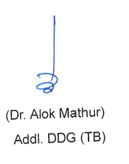


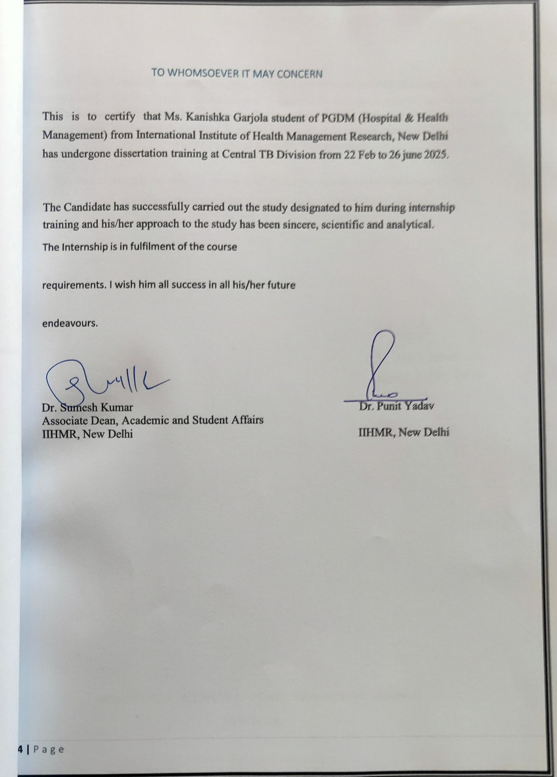
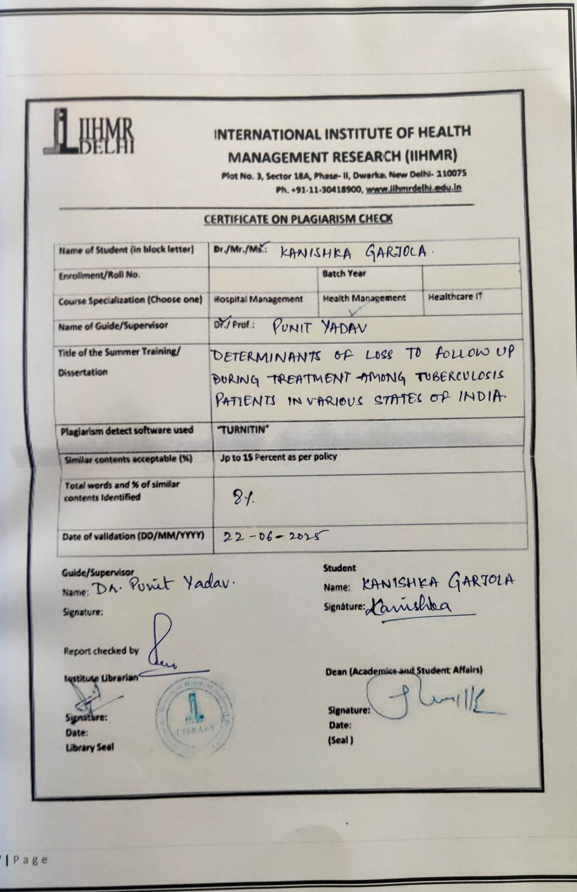
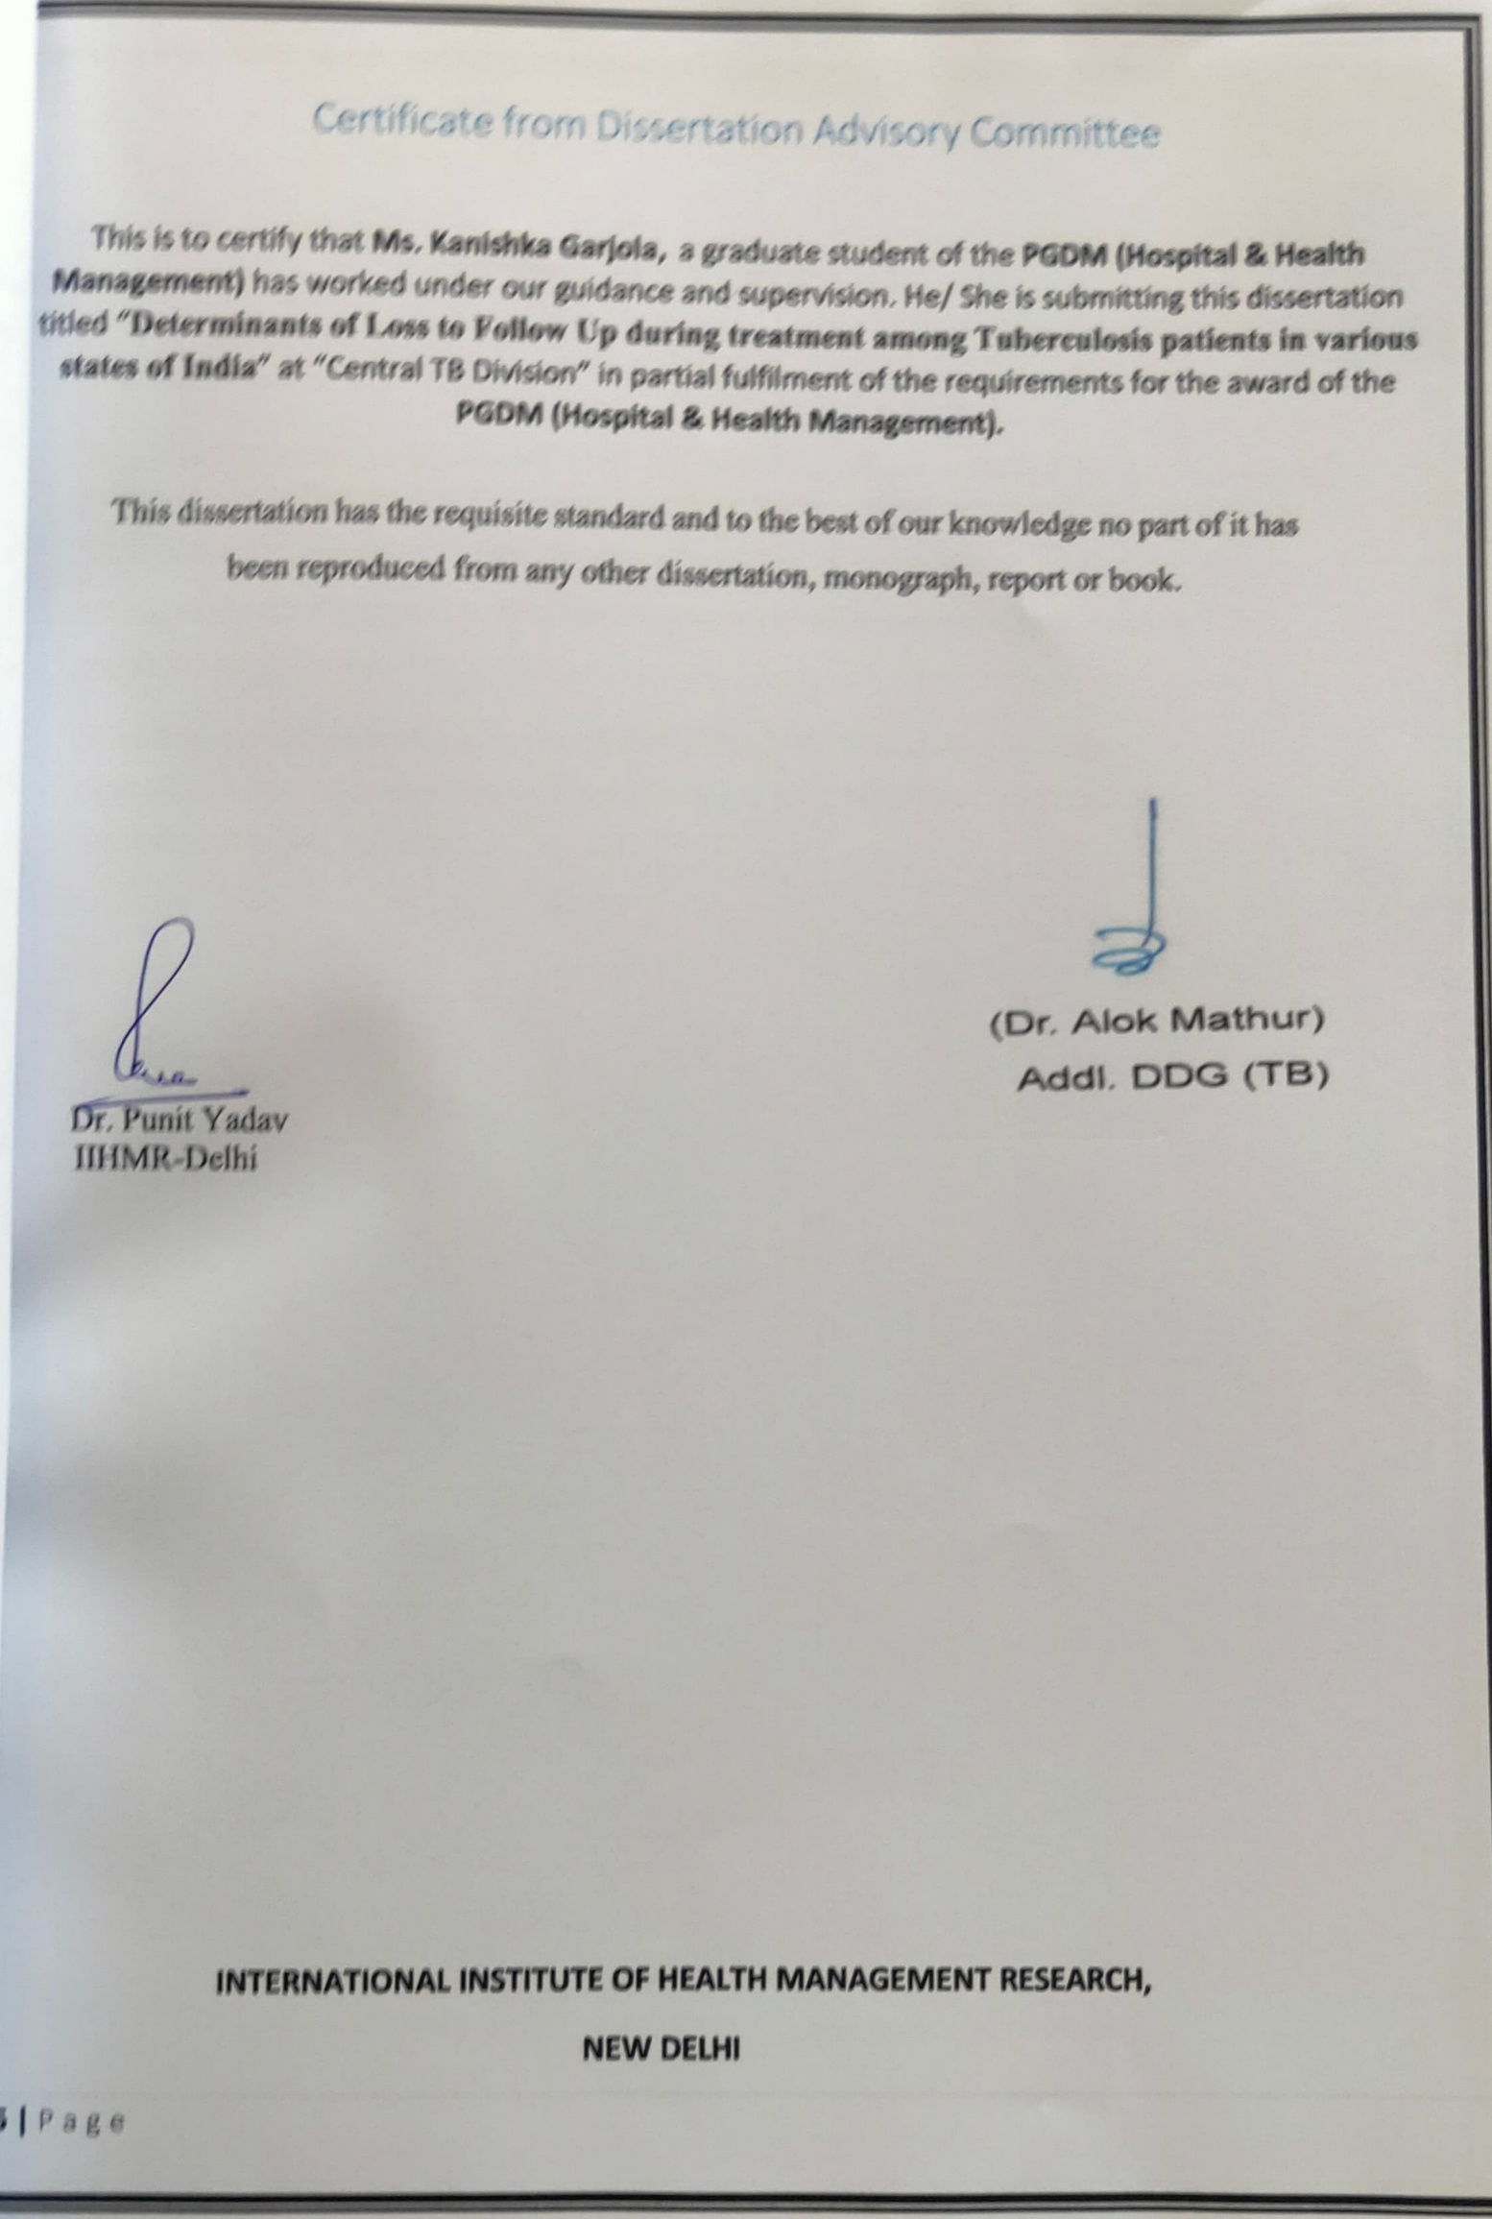
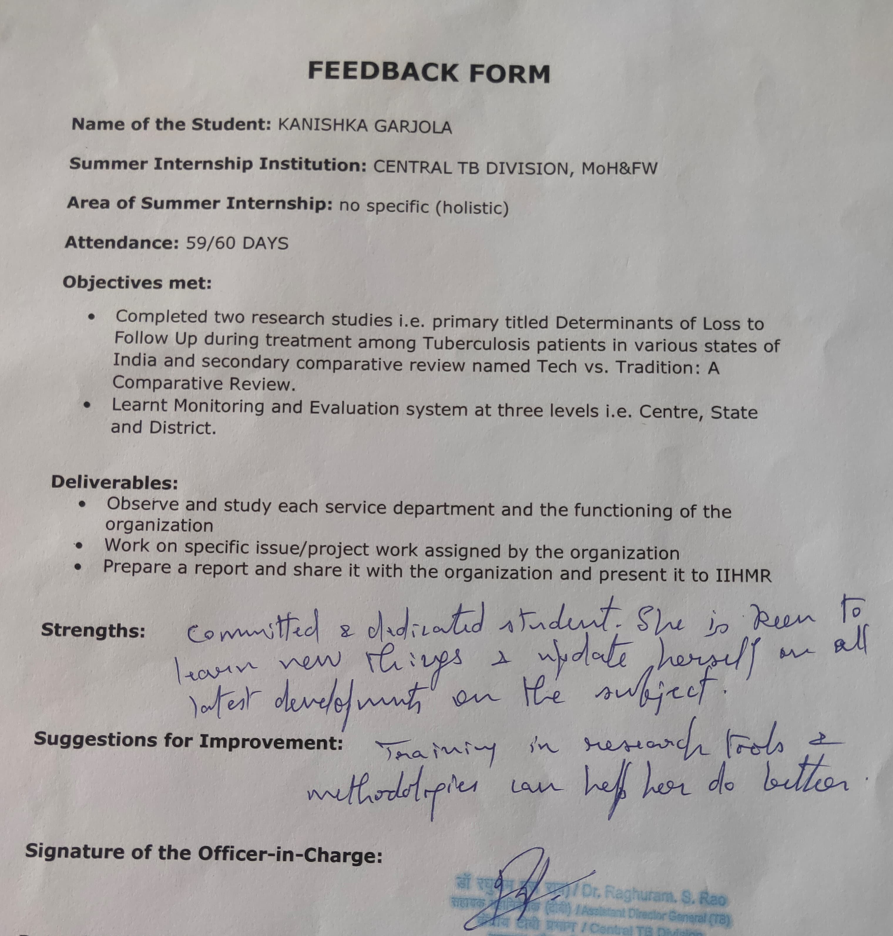

TABLE OF CONTENTS

S.no. | INDEX | PAGE NO.
1. | Acknowledgements | 3
2. | Abbreviations | 4
3. | About the Organization | 5
4. | Core Purpose / Vision | 5
5. | Core Ideology / Core Values | 6
6. | List of Departments | 7
7. | Department's Observation Findings and Recommendations
8. | Public-Private Mix | 8-12
9. | HR and Training | 12-13
10. | Procurement and Supply Chain | 14-16
11. | BCG revaccination | 16
12. | TB and Co-morbidity | 17
13. | PTB and EPTB Management | 19-20
14. | Monitoring and Evaluation | 21-23
15. | ACSM and Laboratory Management | 24
16. | Project Report | 26
17. | Annexure | 31
18. | References | 34

ACKNOWLEDGEMENT

I would like to extend my heartfelt gratitude to the following individuals for their invaluable contributions to the development and successful execution of this module: Dr. Alok Mathur, Additional ADG TB (SAG), for his exceptional guidance on multi-sectoral engagement and public-private partnerships; Mr. Vikas Kumar, for his unwavering mentorship; Mrs. Sayaju, for her outstanding efforts in HR training and capacity building; Dr. Veena Dhawan, Additional Commissioner, for her expert guidance on procurement and supply chain management; Mr. Farhan Mughees, for his exceptional mentorship in Ni-Kshay Aushadhi, monitoring, operations, and research; Mrs. Samridhi, for her vital role in procurement indenting; Dr. Sanjay Kumar, Joint Commissioner, for his insightful guidance on TB co-morbidities and management; Dr. Lalit, for being the mentor of the entire module; Dr. Raghuram Rao, Assistant Director General TB, for his expert guidance on monitoring, evaluation, and research; Mr. Ajay Mohanty, for his dual role as mentor and researcher; and Dr. Nishant Kumar, Joint Director, for his guidance on laboratory services and management. Your collective efforts and dedication have been instrumental in the successful implementation and progress of my initiatives.

ABBREVIATIONS

1. | ADG | Additional Director General
2. | CTD | Central TB Division
3. | DST | Drug Susceptibility Testing
4. | EQA | External Quality Assessment
5. | LPAs | Line Probe Assays
6. | MDR-TB | Multidrug-Resistant Tuberculosis
7. | MoH&FW - | Ministry of Health and Family Welfare
8. | NTEP | National Tuberculosis Elimination Program
9. | NGOs | Non-Governmental Organizations
10. | PGDM | Post Graduate Diploma in Management
11. | RNTCP | Revised National Tuberculosis Control Program
12. | SAG | Senior Administrative Grade
13. | SOPs | Standard Operating Procedures
14. | TB | Tuberculosis
15. | WGS | Whole-Genome Sequencing
16. | PTB | Pulmonary TB
17. | EPTB | Extra Pulmonary TB
18. | ACSM | Advocacy Communication and Social Management

Abstract
Title: Determinants of Loss to Follow-Up During Treatment Among Tuberculosis Patients in Various States of India
Author: Kanishka Garjola
Background:
Tuberculosis (TB) continues to be a major public health challenge globally, ranking as the second leading cause of death from infectious diseases after HIV. India bears the highest TB burden, reporting over two million cases annually. While advancements in diagnosis and treatment have improved disease management, non-adherence to TB treatment regimens remains a critical issue, significantly impacting treatment success and contributing to increased morbidity, drug resistance, and mortality. Understanding the socio-demographic and behavioral factors influencing treatment default is vital for strengthening TB control efforts.
Objectives:
The primary aim of this study is to identify and analyze the socio-demographic determinants of treatment non-compliance among Drug-Sensitive Tuberculosis (DSTB) patients diagnosed with pulmonary and extra-pulmonary TB across different Indian states. Specific objectives include examining the association of socio-economic status with treatment adherence and evaluating the influence of occupation, tobacco use, alcohol consumption, and marital status on the risk of loss to follow-up (LTFU). Recommendations will be proposed to support policy-level interventions aimed at minimizing treatment default.
Methods:
A retrospective cohort study design will be employed using secondary data from the Ni-Kshay portal—a national digital surveillance platform under the Central TB Division, Ministry of Health and Family Welfare. The study will include patients aged 18 years and above, registered with confirmed drug-sensitive TB between 2022 and 2023. Six states, representing the North, South, East, West, Northeast, and Central zones, will be selected using simple random sampling based on TB burden and LTFU rate. Data collection will be purposive, including all reported LTFU cases from selected states.
The independent variables considered include age, gender, place of residence, type of TB (pulmonary or extra-pulmonary), alcohol consumption, smoking status, and socio-economic status (above or below poverty line). The outcome variable, LTFU, is defined as patients who discontinued TB treatment for two or more consecutive months without medical approval. Patients diagnosed with drug-resistant TB, those transferred out, migratory populations, pediatric cases, or those with comorbidities like HIV, COVID-19, and diabetes will be excluded.
Data Analysis:
Descriptive statistics will summarize frequencies and percentages. Bivariate analysis using the Chi-square test will assess associations between independent variables and treatment adherence. Variables with a p-value <0.25 will be included in multivariable logistic regression to identify significant predictors of LTFU, with statistical significance set at p<0.05. SPSS software will be used for data analysis.
Ethical Considerations:
Formal written permission will be obtained from the Monitoring and Evaluation Division of the Central TB Division for use of Ni-Kshay data. Ethical clearance will also be secured from the Institutional Review Board, as the research forms part of an academic dissertation.
Conclusion:
By identifying key determinants of treatment non-compliance, this study aims to contribute actionable insights to improve adherence, enhance patient outcomes, and support the national goal of TB elimination in India.

CENTRAL TB DIVISION

About the Organization
The Central TB Division (CTD), a key part of India’s Ministry of Health and Family Welfare, is tasked with the formidable mission of eradicating tuberculosis (TB) through the National Tuberculosis Elimination Program (NTEP), previously known as the Revised National Tuberculosis Control Program (RNTCP). Established in response to the significant TB burden, the CTD’s mandate is to implement, monitor, and continuously improve TB control strategies across India. The division operates under the Directorate General of Health Services and is headed by the Deputy Director General (TB). It functions through a decentralized network of state TB cells, district TB centers, and peripheral health institutions, ensuring the reach and efficacy of its interventions. The CTD's responsibilities encompass policy formulation, program planning, and operational guidance, aiming to set national targets and allocate resources effectively. It monitors program progress through a robust surveillance system that collects and analyzes data to inform decision-making. Capacity building is another critical function, involving training healthcare workers in TB diagnosis, treatment, and management to maintain service quality. Ensuring a continuous supply of quality-assured anti-TB drugs is crucial, and the CTD oversees the entire supply chain from procurement to distribution. Advocacy, communication, and social mobilization efforts are vital for public awareness, reducing stigma, and encouraging early diagnosis and treatment. The division’s research initiatives foster collaborations with national and international institutions to develop innovative TB control tools and strategies. Over the years, the CTD has achieved significant milestones, including improved case detection and treatment success rates, and reduced TB mortality. Innovations such as the GeneXpert MTB/RIF test for rapid diagnosis reflect its commitment to leveraging technology. Despite these successes, TB remains a significant public health challenge in India, necessitating continuous efforts and adaptation of strategies. The CTD’s work is indispensable in the broader context of public health in India, underscoring the importance of a coordinated, well-resourced, and strategically dynamic approach to TB control and eventual elimination.

Core purpose / Vision
The core purpose of the Central TB Department is to spearhead comprehensive efforts aimed at preventing, controlling, and ultimately eradicating tuberculosis (TB) across the nation. This involves meticulous surveillance and data analysis to guide public health actions, developing and implementing national policies aligned with international standards, and executing effective prevention and control programs. The department also focuses on advancing research to improve diagnostics, treatments, and vaccines while addressing challenges such as drug-resistant TB. Enhancing healthcare professionals' capabilities through training and support, and fostering partnerships with national and international organizations, are crucial components of its strategy. The vision of the Central TB Department is to achieve a TB-free nation where everyone has access to quality healthcare for TB prevention, early detection, and effective treatment, ensuring a healthy and productive life for all. This vision includes the complete eradication of TB, universal health coverage, and the adoption of innovative solutions to improve TB care. It also emphasizes community engagement to combat stigma and support patients, the development of resilient healthcare systems, and establishing the department as a global leader in TB control, contributing to international eradication efforts and setting benchmarks for excellence.
Core Ideology / Core Values
The Central TB Department's core ideology is rooted in the commitment to public health, equity, and innovation in the fight against tuberculosis (TB). Central to this ideology is the unwavering belief that every individual, regardless of socioeconomic status, deserves access to high-quality TB care. This drives the department's dedication to developing and implementing effective TB control strategies that are inclusive and equitable. Key values guiding the department include integrity, where transparency and accountability are paramount in all operations; compassion, ensuring that patient care is centered around dignity and empathy; and excellence, striving for the highest standards in research, diagnostics, and treatment. Collaboration is also a fundamental value, as the department actively engages with global health organizations, local communities, and various stakeholders to foster a unified and robust response to TB. Innovation is encouraged to continuously improve TB control measures and embrace new technologies and methodologies. Lastly, sustainability is emphasized to build resilient healthcare systems capable of enduring public health challenges. These values collectively underpin the Central TB Department's mission to eradicate TB and enhance the overall health and well-being of the population.

List of department 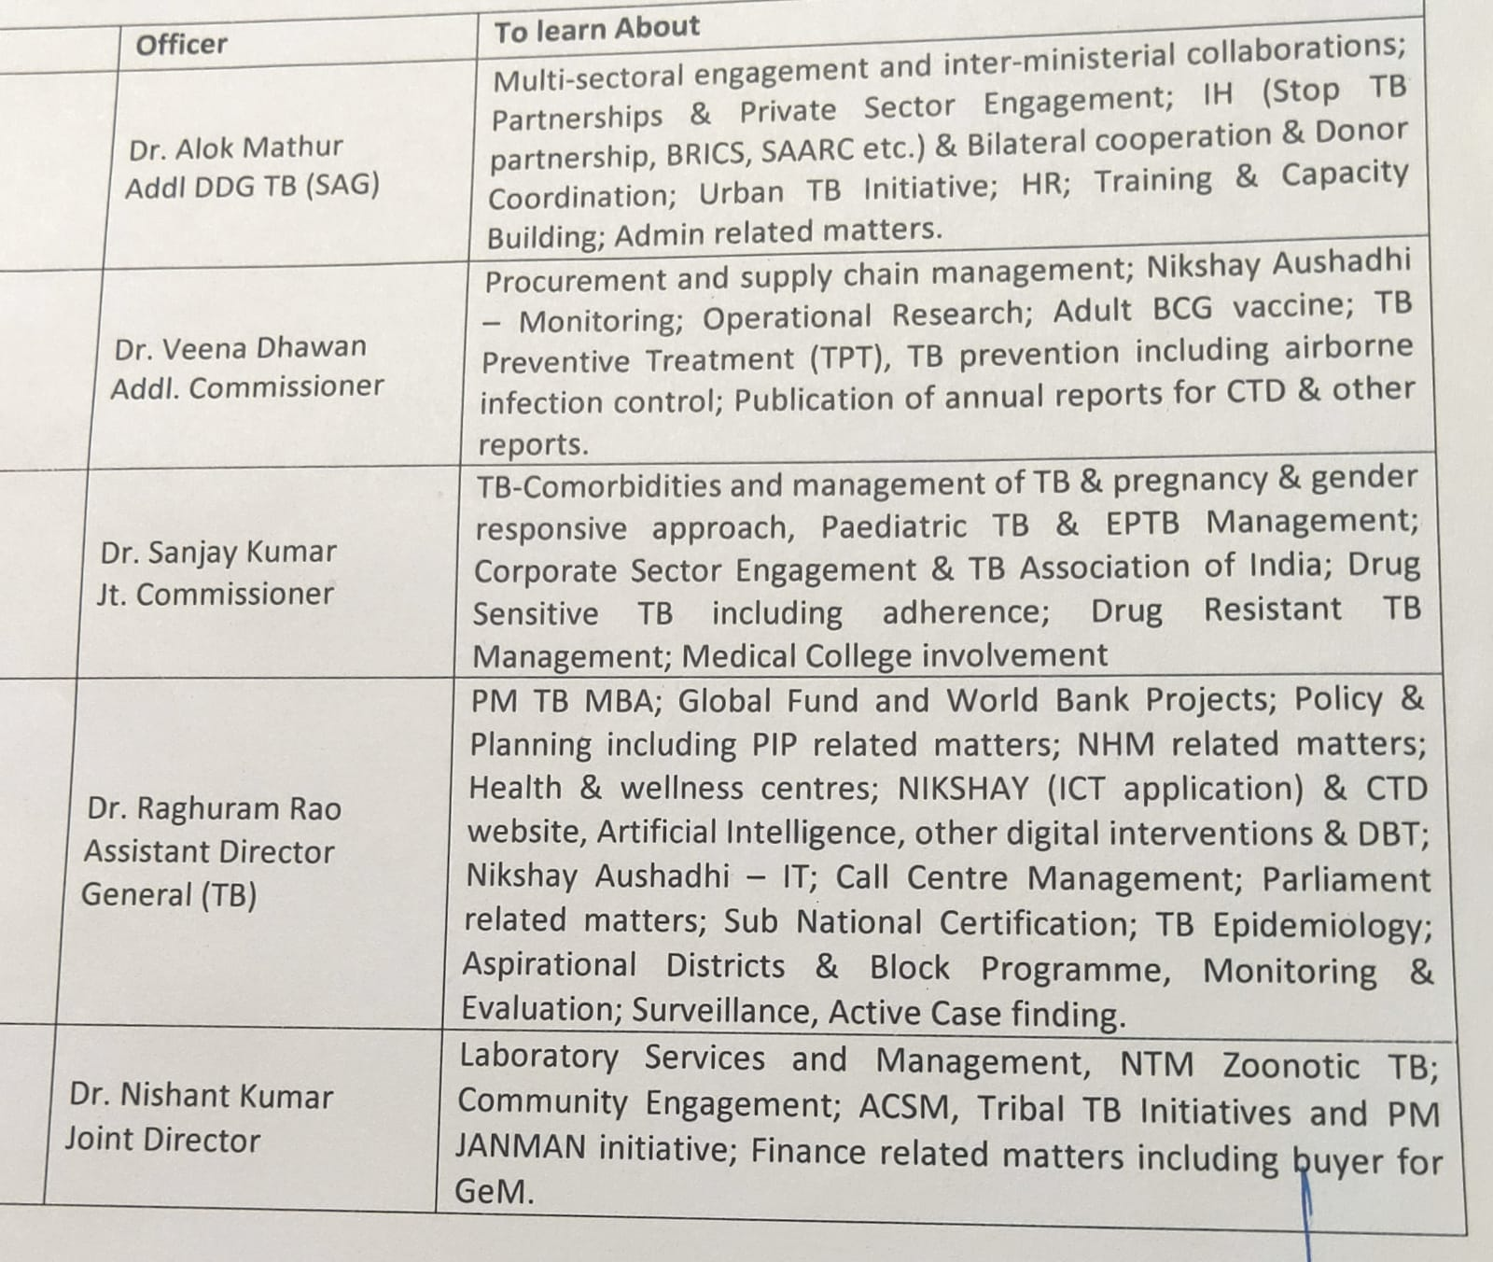

Department’s Observation, Findings and Recommendations

- Department dealing with Push Notification of Tb:
TB Notification in India
Background
Tuberculosis (TB) remains a major public health issue in India. The cornerstone of TB prevention and control is early diagnosis and complete treatment. The National TB Control Programme (NTP) ensures that all patients have access to quality-assured diagnostic and treatment services, including mechanisms to ensure treatment adherence. However, India has a large and rapidly growing private health sector, where substantial amounts of anti-TB drugs are sold. Non-standardized prescribing practices and unsupervised treatment regimens often lead to treatment interruptions and the development of drug resistance. The Revised National TB Control Programme (RNTCP) provides mechanisms for treatment adherence, including Directly Observed Therapy (DOT), but many patients do not benefit from these services, leading to incomplete treatments and multidrug-resistant TB (MDR-TB).
To mitigate these issues, the Government of India declared TB a notifiable disease on May 7, 2012. All public and private health providers are required to notify TB cases to public health authorities, enabling the extension of RNTCP services to these patients.

Objectives
The primary objectives of TB notification are to ensure proper diagnosis and case management, reduce TB transmission, and address the emergence and spread of drug-resistant TB. This involves obtaining complete information on all TB cases diagnosed and treated across various sectors to facilitate effective public health interventions.

Minimum Information Requirement for TB Notification
For effective TB notification, certain minimum information is required:
1. Patient details (name, age, gender, address)
2. Diagnostic details (date of diagnosis, type of TB)
3. Treatment details (start date, treatment regimen)
4. Healthcare provider details (name, contact information).

Mechanisms for TB Notification
1. Direct Notification by Healthcare Providers: Healthcare providers report TB cases directly to the local public health authority.
2. Online Notification Systems: Utilization of digital platforms to facilitate real-time notification and data collection.
3. Collaborative Notification: Coordination between different healthcare facilities and providers to ensure comprehensive reporting of TB cases.

Responsibilities
District Level Nodal Officer
1. Overseeing the TB notification process within the district.
2. Ensuring all healthcare providers are aware of their notification obligations.
3. Providing support and training to healthcare providers on TB notification procedures.
4. Monitoring and evaluating the notification data to identify gaps and areas for improvement.

Local Public Health Authority
1. Receiving TB notifications from healthcare providers.
2. Verifying and consolidating the notified data.
3. Ensuring the notified patients are linked to appropriate TB care and treatment services.
4. Reporting the consolidated data to higher authorities.

Health Worker
1. Identifying and reporting TB suspects.
2. Ensuring that diagnosed patients are registered for treatment.
3. Following up with patients to ensure treatment adherence and completion.
4. Educating patients and communities about TB and the importance of treatment adherence.

Conclusion
The guidance tool aims to streamline the TB notification process, ensuring accurate and comprehensive data collection. This facilitates better TB case management, reduces transmission, and addresses the challenge of drug-resistant TB. The collaborative effort between public and private sectors is crucial for the success of TB control programs in India.

Findings:
- It highlights several key findings essential for the effective notification and management of tuberculosis (TB) cases. The document emphasizes that TB notification is critical for early diagnosis and appropriate treatment, thereby reducing transmission and preventing complications. It outlines the importance of accurate and timely notification for monitoring and evaluating TB control programs, enabling better resource allocation and intervention planning. The notification process is essential for managing multidrug-resistant TB (MDR-TB) by ensuring adherence to standardized treatment protocols.
- The primary objectives of TB notification are to ensure comprehensive case detection, enhance patient management, and strengthen public health surveillance. Comprehensive case detection involves capturing all TB cases diagnosed and treated across both public and private healthcare sectors, ensuring a complete picture of the TB burden in the country. Enhancing patient management is achieved by linking notified patients to appropriate TB care and treatment services, ensuring adherence to treatment regimens, and preventing treatment interruptions that can lead to drug resistance.
- The document defines specific categories for TB notification to standardize the process, including new cases, previously treated cases, and drug-resistant TB cases. These definitions help in categorizing and managing TB cases more effectively, ensuring that each patient receives the appropriate level of care and monitoring.
- Various mechanisms for TB notification are outlined, including direct notification by healthcare providers, online notification systems, and collaborative notification. Direct notification requires healthcare providers, including laboratories, private practitioners, clinics, hospitals, and nursing homes, to report TB cases directly to the designated nodal officers. This process ensures that all TB cases are captured and reported promptly. The use of online notification systems, such as the Ni-Kshay portal, facilitates real-time data collection and transmission, making the notification process more efficient and accessible. The document also discusses the future integration of mobile communication methods, such as phone calls, Interactive Voice Response Systems (IVRS), and SMS, to further streamline the notification process.
- Collaborative notification involves coordination between healthcare providers and local public health authorities, particularly in regions where a bilateral understanding exists. This approach ensures that TB cases are reported accurately and promptly, even in remote and rural areas. It requires prior consultation and approval from the district nodal officer to ensure that all notifications are appropriately recorded and monitored.
- The responsibilities of various stakeholders in the TB notification process are clearly outlined. District-level nodal officers are responsible for overseeing the notification process within their districts, ensuring that all healthcare providers are aware of their notification obligations, and providing necessary support and training. They are also tasked with verifying and consolidating notification data, ensuring that notified patients are linked to appropriate TB care services, and reporting consolidated data to higher authorities.
- Local public health authorities play a crucial role in receiving TB notifications from healthcare providers, verifying the data, and ensuring that patients receive the necessary care and treatment. They are also responsible for reporting the data to district-level authorities and providing support to healthcare providers in the notification process. Health workers at the ground level are essential for identifying and reporting TB suspects, ensuring that diagnosed patients are registered for treatment, and following up with patients to ensure treatment adherence and completion. They also play a key role in educating patients and communities about TB and the importance of treatment adherence.
- The document includes various forms and formats to facilitate the TB notification process. These include the Health Establishment Registration Form, which collects details about the health establishment, such as the name, type, registration number, contact person, and contact details. The TB Notification Reporting Format is used by medical practitioners and healthcare establishments to report TB cases, capturing patient details, diagnosis information, treatment initiation dates, and other relevant data. There is also an undertaking form for healthcare providers who do not routinely diagnose or treat TB cases, allowing them to declare their non-involvement in TB case management while agreeing to notify any future TB cases they may encounter.
- The guidance tool underscores the importance of regular monitoring and evaluation of the TB notification process to identify gaps and areas for improvement. District-level nodal officers are responsible for conducting regular reviews of the notification progress within their districts and ensuring that all notified TB cases are entered into the Ni-Kshay portal within two weeks of submission. This continuous monitoring helps in maintaining the accuracy and completeness of TB notification data, which is crucial for effective TB control and prevention efforts.
- In addition to the notification mechanisms, the document emphasizes the need for effective communication and collaboration among various stakeholders involved in TB control. This includes healthcare providers, public health authorities, non-governmental organizations (NGOs), and community health workers. By fostering a collaborative approach, the TB notification process can be more efficient and comprehensive, ensuring that all TB cases are captured and managed appropriately.
- The document also highlights the importance of training and capacity-building for healthcare providers and public health authorities. Regular training sessions and workshops are necessary to ensure that all stakeholders are well-versed in the TB notification process, understand their roles and responsibilities, and are equipped with the skills needed to effectively manage TB cases. This training is crucial for maintaining high standards of TB care and ensuring that patients receive the best possible treatment and support.
- Furthermore, the guidance tool discusses the integration of TB notification with other health information systems to streamline data collection and reporting. By leveraging existing health information infrastructure, the TB notification process can be made more efficient, reducing the burden on healthcare providers and improving the accuracy and timeliness of data. This integration also facilitates better coordination between different health programs, promoting a more holistic approach to public health management.
HR and Training:

- Human Resources (HR) and training in the central TV division in India are critical to fostering a dynamic and efficient work environment. The HR department is tasked with several key responsibilities that ensure the smooth operation and success of the organization. One of the primary functions of HR is recruitment and staffing, which involves identifying staffing needs and managing the hiring process. This includes collaborating with department heads to determine the required skill sets and qualifications for various roles, conducting interviews, evaluating candidates, and making hiring decisions. Effective recruitment ensures that the organization attracts and retains top talent, which is essential for maintaining high standards of production and creativity in the TV industry.
- Once new employees are hired, the onboarding and orientation process becomes crucial. This phase helps new hires acclimate to the company culture, understand organizational policies, and become familiar with their specific roles and responsibilities. A well-structured onboarding process not only helps new employees feel welcomed but also sets the foundation for their future success within the organization.
- Training and development are central to maintaining a skilled and knowledgeable workforce. The HR team in the central TV division is responsible for assessing training needs across various departments and developing tailored programs to address these needs. This can include workshops, seminars, on-the-job training sessions, and continuous learning opportunities that keep employees updated on the latest industry trends and technological advancements. By investing in employee development, the organization enhances its overall performance, promotes innovation, and ensures that its staff remains competitive in a rapidly evolving industry.
- Performance management is another vital area where HR plays a crucial role. Implementing effective performance appraisal systems helps set clear performance standards and provides a framework for regular evaluations. Through these evaluations, HR can offer constructive feedback and coaching, helping employees to improve their skills and achieve their career goals. Recognizing and rewarding high performers not only boosts morale but also encourages a culture of excellence and continuous improvement within the organization.
- Employee relations are also a significant aspect of HR’s responsibilities. This involves addressing employee grievances, resolving conflicts, and fostering a positive work environment. Good communication and a supportive workplace culture are essential for employee satisfaction and retention. HR also plays a role in promoting work-life balance and ensuring the well-being of employees, which can include implementing policies for flexible work arrangements and providing access to health and wellness programs.
- Compliance and legal matters are another area where HR’s expertise is essential. Ensuring adherence to labor laws and regulations is crucial for avoiding legal issues and maintaining a fair and equitable workplace. This includes managing employee records, maintaining confidentiality, and conducting training on workplace ethics and harassment prevention.
Recommendations:
- Department is Running Efficiently without any error.
Procurement and Supply chain

Introduction
Efficient supply chain and procurement management are critical to the success of health programs, particularly those aimed at combating communicable diseases such as tuberculosis (TB). The "Guidelines for Programmatic Management of Tuberculosis Preventive Treatment in India" provide a comprehensive framework for managing the procurement and supply chain for TB preventive treatment (TPT). This observation focuses on the procurement processes, distribution flow, inventory management, and the overall efficacy of these systems in ensuring the availability and accessibility of TPT drugs across India.
Procurement Process
The procurement of TPT drugs is centralized and managed by the Central TB Division, Ministry of Health and Family Welfare (MoHFW), Government of India (GoI). This centralized approach helps in maintaining uniformity and quality of the drugs supplied. The annual state-specific planning is crucial for forecasting the demand for various TPT regimens. This forecasting contributes to the national level quantification, ensuring that adequate quantities of drugs are procured and supplied to meet the needs of the states.
The procurement process also involves outsourcing laboratory tests and kits for TB infection (TBI) detection, materials for adherence technologies like 99DOTS/MERM, and other necessary supplies such as silica gel desiccants and educational posters. This comprehensive procurement strategy ensures that all necessary components for effective TPT are available.
Drug Distribution Flow
Once procured, the drugs are stored at the Government Medical Store Depot (GMSD) and Central Medical Services Society (CMSS) stores. The centralized storage ensures that drugs are maintained under optimal conditions before being distributed to state drug stores (SDS). The distribution to states is planned and communicated in advance to ensure that SDS can prepare adequate storage space.
From the SDS, the drugs are distributed to district drug stores (DDS) with a buffer stock of three months on a quarterly basis. The DDS then supplies the treatment units (TUs) on a monthly basis, maintaining a buffer stock of two months. Finally, TUs supply the health facilities (HFs) with a one-month buffer stock. This multi-tiered distribution system ensures that drugs are available at every level of the healthcare delivery system, minimizing the risk of stock-outs.
Inventory Management
Inventory management is a critical component of the supply chain for TPT drugs. The guidelines stipulate the use of the Ni-Kshay Aushadhi Software for tracking the receipt and distribution of drugs at the SDS level. This software aids in maintaining real-time data on drug availability, facilitating better inventory control and timely replenishment of stocks.
The guidelines also provide detailed stocking norms for various levels of the healthcare system. For example, the treatment supporter is required to maintain a full course of TPT drugs for each beneficiary. Health facility drug stores must maintain a reserve stock of two months, while district drug stores and state drug stores must keep a three-month reserve stock. These norms help in ensuring that adequate quantities of drugs are always available, thereby preventing interruptions in treatment.
Challenges and Recommendations
Despite the comprehensive framework, the supply chain and procurement processes for TPT in India face several challenges. These include delays in procurement and distribution, inadequate storage facilities at various levels, and issues with inventory management such as overstocking or stock-outs. To address these challenges, the following recommendations are proposed:
1. Strengthening the Forecasting Mechanism: Improving the accuracy of demand forecasting at the state level can help in better national level quantification and procurement. This can be achieved through enhanced data collection and analysis techniques.
2. Capacity Building: Training healthcare workers and supply chain managers on effective inventory management practices can reduce the risks of overstocking or stock-outs. Regular training programs should be conducted to keep the personnel updated on the latest practices and technologies.
3. Infrastructure Development: Upgrading storage facilities at the state, district, and health facility levels can ensure that drugs are stored under optimal conditions, reducing the risk of spoilage and wastage.
4. Technological Integration: Expanding the use of digital platforms like the Ni-kshay Aushadhi Software can improve transparency and efficiency in drug distribution and inventory management. Integrating these platforms with other healthcare information systems can provide a holistic view of the supply chain.
5. Monitoring and Evaluation: Regular monitoring and evaluation of the supply chain processes can help identify bottlenecks and areas for improvement. This should be coupled with feedback mechanisms to ensure that corrective actions are implemented promptly.

BCG Revaccination Introduction:

Introduction
As I delve into the topic of the Bacille Calmette-Guérin (BCG) vaccine, I'm reminded of its pivotal role in the fight against tuberculosis (TB). The BCG vaccine, the only one available for TB prevention, has been integral to global TB control efforts since its inception in the early 20th century. India, a country with a high TB burden, has extensively utilized the BCG vaccine in its immunization programs. This brief aims to summarize these aspects, underscoring the BCG vaccine's importance in India's TB prevention strategy.
Historical Context
The BCG vaccine was first developed by Albert Calmette and Camille Guérin in 1921. Its journey in India began in the 1940s and it was incorporated into the National Tuberculosis Program (NTP) in 1962. Reflecting on this historical timeline, it's clear that the widespread adoption of the BCG vaccine aimed to curtail TB incidence, particularly among children. Over the years, the vaccine has become a cornerstone of India's TB control strategy, significantly contributing to the decline in TB cases and mortality rates.
Efficacy of BCG Vaccine
Understanding the efficacy of the BCG vaccine requires acknowledging its variability across different regions and populations. Research indicates that the vaccine offers substantial protection against severe TB forms like TB meningitis and miliary TB in children. However, its effectiveness in preventing pulmonary TB, the most common TB form, varies. This variability is influenced by genetic factors, environmental conditions, and the presence of non-tuberculous mycobacteria. Despite these differences, I recognize the BCG vaccine as an essential tool in protecting children from severe TB in high-burden countries like India.
Implementation Strategies
India's approach to BCG vaccination is systematic and comprehensive. The vaccine is part of the Universal Immunization Program (UIP), ensuring that all new-borns receive it. The implementation involves coordination between government bodies, healthcare providers, and international organizations like the World Health Organization (WHO). Typically, the BCG vaccine is administered at birth or as soon as possible thereafter. Additionally, special campaigns are organized to reach unvaccinated children, especially in remote and underserved areas, demonstrating a commitment to universal coverage.
Challenges in BCG Vaccination
Despite the structured approach, several challenges persist in the BCG vaccination program. One significant challenge is the variability in vaccine efficacy, complicating the assessment of its overall impact on TB control. Logistical issues, such as maintaining the cold chain, ensuring timely vaccine delivery, and reaching remote populations, pose substantial hurdles. Moreover, managing vaccine-related adverse events, although rare and generally mild, adds another layer of complexity.

TB and Co-morbidity
The comprehensive document, “Guidelines for Programmatic Management of Tuberculosis Preventive Treatment in India,” sheds light on various aspects of TB management and its intersection with other health conditions. Here, I delve into the key insights and observations related to TB comorbidities.
- As I explored the guidelines, it became evident that TB is not an isolated health issue; it intertwines with numerous other diseases, exacerbating their impact and complicating treatment protocols. The document emphasizes the critical need for integrated care approaches to effectively manage TB alongside its comorbidities.
- One of the most significant comorbidities discussed in the guidelines is HIV. The immune- compromised state of individuals living with HIV makes them particularly vulnerable to TB. The document highlights the necessity of routine TB screening for people living with HIV (PLHIV) and underscores the importance of initiating antiretroviral therapy (ART) alongside TB treatment to improve patient outcomes. The synergy between HIV and TB necessitates a coordinated response to address the dual burden these diseases impose.
- Diabetes is another major comorbidity that complicates TB management. The document points out that individuals with diabetes have a threefold increased risk of developing TB. This bidirectional relationship means that TB can worsen glycemic control in diabetic patients, while diabetes can hinder the body’s ability to fight TB. Thus, the guidelines recommend regular screening for diabetes in TB patients and vice versa. Managing both conditions concurrently requires careful monitoring and tailored treatment plans to ensure effective control of both diseases.

- Malnutrition is also highlighted as a critical factor influencing TB outcomes. Malnourished individuals are more susceptible to contracting TB due to their weakened immune systems. The guidelines stress the importance of nutritional support as an integral part of TB treatment. Ensuring adequate nutrition not only helps in faster recovery but also improves the overall health and resilience of TB patients.
- The document also brings attention to the co-occurrence of TB with chronic respiratory diseases. Conditions such as chronic obstructive pulmonary disease (COPD) and silicosis increase the risk of TB due to impaired lung function and damaged respiratory tissues. For individuals with such conditions, the guidelines recommend vigilant screening for TB and adopting preventive measures to mitigate the heightened risk.
- Mental health, often overlooked in the context of TB, is another crucial aspect discussed. TB and its prolonged treatment can lead to mental health issues such as depression and anxiety. Conversely, pre-existing mental health conditions can negatively impact TB treatment adherence and outcomes. The guidelines advocate for integrating mental health services into TB care programs to provide comprehensive support to patients.
- Furthermore, the document addresses the comorbidity of TB with lifestyle diseases such as cardiovascular diseases and smoking-related conditions. Smoking, in particular, is identified as a significant risk factor for TB, as it damages the respiratory system and compromises immune function. The guidelines recommend smoking cessation programs as part of TB management strategies to improve treatment efficacy and patient health.
- The guidelines also highlight the challenges posed by TB in populations with other infectious diseases, such as hepatitis. Co-infection with hepatitis B or C can complicate TB treatment due to potential drug interactions and the added burden on the liver. Managing such co-infections requires careful selection of medications and monitoring to avoid adverse effects and ensure successful treatment outcomes.
- From my perspective, understanding and addressing TB comorbidities is crucial for a holistic approach to TB management. The interplay between TB and other health conditions creates a complex web that requires integrated, patient-centred care strategies. By acknowledging and addressing these comorbidities, healthcare providers can improve the quality of care and outcomes for TB patients.
Management of Extra-pulmonary Tuberculosis (EPTB) and Pulmonary Tuberculosis (PTB)
As an active participant in the fight against tuberculosis (TB) under the Central TB Division, I am acutely aware of the diverse challenges and complexities involved in managing both Pulmonary Tuberculosis (PTB) and Extra-pulmonary Tuberculosis (EPTB). The successful management of TB, whether it affects the lungs or other parts of the body, requires a thorough understanding of its clinical presentation, diagnostic strategies, treatment protocols, and the provision of holistic care to patients.
Understanding PTB and EPTB
Pulmonary Tuberculosis (PTB) is the most common form of TB, primarily affecting the lungs. It is characterized by symptoms such as a persistent cough, chest pain, hemoptysis (coughing up blood), fever, night sweats, and weight loss. PTB is highly infectious, spreading through airborne droplets when an infected person coughs or sneezes. Due to its infectious nature, PTB poses significant public health challenges, especially in densely populated areas.
Extra-pulmonary Tuberculosis (EPTB), on the other hand, occurs when Mycobacterium tuberculosis infects organs other than the lungs. EPTB can affect various parts of the body, including the lymph nodes, pleura (lining around the lungs), bones and joints, genitourinary system, central nervous system (CNS), abdomen, and even the skin. The symptoms of EPTB vary widely depending on the organs involved, making its diagnosis more challenging compared to PTB.
Diagnostic Strategies
Pulmonary Tuberculosis (PTB):
1. Sputum Microscopy and Culture: Sputum samples are examined under a microscope for the presence of acid-fast bacilli (AFB). Culture tests, although time-consuming, provide definitive results and help in drug susceptibility testing.
2. Chest X-ray: Imaging studies such as chest X-rays are used to detect lung abnormalities indicative of TB.
3. GeneXpert MTB/RIF: This molecular test detects TB bacteria and identifies rifampicin resistance, providing results within a few hours.
4. Clinical Evaluation: Symptoms, medical history, and physical examination are crucial for diagnosing PTB.
Extra-pulmonary Tuberculosis (EPTB):
1. Site-Specific Samples: Depending on the site of infection, samples such as lymph node aspirates, pleural fluid, cerebrospinal fluid (CSF), urine, or tissue biopsies are collected for testing.
2. Imaging Studies: Imaging techniques such as ultrasound, CT scans, MRI, and X-rays help visualize TB involvement in various organs.
3. Histo-pathological Examination: Biopsy samples are examined microscopically for TB granulomas.
4. Molecular Tests: GeneXpert and other nucleic acid amplification tests (NAATs) are used to detect TB bacteria in EPTB samples.
5. Clinical Evaluation: Detailed history and examination, along with site-specific diagnostic tests, guide the diagnosis of EPTB.
Treatment Protocols
Pulmonary Tuberculosis (PTB):
1. Standard Treatment Regimen: PTB is treated using a combination of first-line anti-TB drugs, typically including isoniazid, rifampicin, ethambutol, and pyrazinamide. The intensive phase lasts two months, followed by a continuation phase of four months.
2. Drug-Resistant TB: In cases of drug-resistant TB (DR-TB), second-line drugs and longer treatment regimens are required. Drug susceptibility testing guides the selection of appropriate medications.
3. Directly Observed Treatment, Short-course (DOTS): Ensuring patient adherence to the treatment regimen through DOTS is critical to prevent relapse and drug resistance.
Extra-pulmonary Tuberculosis (EPTB):
1. Standard Treatment Regimen: Similar to PTB, EPTB is treated with first-line anti-TB drugs. However, the treatment duration may be extended to 9-12 months, especially for TB meningitis or bone and joint TB.
2. Site-Specific Considerations: The treatment approach may vary based on the site of infection. For instance, TB meningitis requires higher doses of anti-TB drugs due to the need to penetrate the blood-brain barrier.
3. Adjunctive Therapies: Corticosteroids may be used in cases of TB meningitis or pericarditis to reduce inflammation and prevent complications.
4. Surgical Intervention: In some cases of EPTB, surgical procedures may be necessary to manage abscesses, drain fluid collections, or stabilize affected bones and joints.

Conclusion
I understand that the management of PTB and EPTB requires a comprehensive, patient-centered approach. By employing robust diagnostic strategies, adhering to standardized treatment protocols, and providing continuous monitoring and support, we can effectively manage TB in all its forms. Addressing the challenges of delayed diagnosis, drug resistance, and patient adherence through a multifaceted approach is crucial for achieving successful treatment outcomes. By strengthening our healthcare systems and fostering collaboration, we can move closer to the goal of eliminating TB and improving the health and well-being of those affected by this devastating disease.

- Monitoring and Evaluation
The Ni-Kshay portal, developed by the Central TB Division in India, is a comprehensive online platform that revolutionizes the monitoring and management of tuberculosis (TB) cases. This digital tool enables seamless data collection, reporting, and analysis, ensuring effective supervision and control of TB across the country. The process of monitoring through the Ni-Kshay portal involves several key steps, from case notification and diagnostic information entry to treatment monitoring and adherence tracking, ultimately enhancing the efficiency and effectiveness of TB control efforts.

CASE NOTIFICATION
The monitoring process begins with the registration of TB cases on the Ni-Kshay portal. Healthcare providers, including those from both the public and private sectors, identify and register new TB patients. This registration includes detailed information such as the patient's demographics, clinical history, and diagnostic test results. Each registered patient is assigned a unique identification number, known as the Ni-Kshay ID, which serves as a reference for all subsequent monitoring activities. This unique ID ensures that patient information is accurately tracked throughout their treatment journey.

DIAGNOSTIC INFORMATION ENTRY
Following the initial case notification, detailed diagnostic information is entered into the Ni-Kshay portal. This includes results from various diagnostic tests such as sputum smear microscopy, X-rays, GeneXpert, and culture tests. By centralizing this diagnostic data, the portal facilitates timely and accurate diagnosis, which is critical for the initiation of appropriate treatment regimens. The entry of diagnostic information ensures that all TB cases are systematically documented, allowing for a comprehensive overview of the TB burden and the effectiveness of diagnostic tools in different regions.

TREATMENT INITIATION AND MONITORING
Once a TB case is confirmed through diagnostic tests, the treatment initiation phase begins. Healthcare providers use the Ni-Kshay portal to document the prescribed treatment regimen, including the type and duration of anti-TB drugs. The portal also tracks patient appointments and medication dispensation, ensuring that patients receive their medications on time. This systematic tracking helps in monitoring treatment adherence, which is crucial for preventing the development of drug-resistant TB strains.

Regular updates on patient progress and treatment outcomes are recorded in the portal, allowing for real-time monitoring and intervention if necessary.

ADHERENCE TRACKING AND SUPPORT
One of the critical components of the Ni-Kshay portal is its focus on treatment adherence. Non-adherence to TB treatment can lead to incomplete treatment, relapse, and the emergence of drug-resistant TB. To address this, the portal includes features for monitoring patient adherence to their treatment regimen. Healthcare workers can record patient visits, medication pickups, and directly observed therapy (DOT) sessions. Additionally, the portal can generate reminders and alerts for both patients and healthcare providers, ensuring that missed doses are promptly addressed. By providing a structured system for adherence tracking, the Ni-Kshay portal plays a vital role in improving treatment outcomes and reducing the incidence of drug-resistant TB.

DATA ANALYSIS AND REPORTING
The Ni-Kshay portal is equipped with robust data analysis and reporting capabilities. The data collected from various healthcare facilities are aggregated and analyzed to provide insights into TB trends, treatment outcomes, and program performance. The portal generates detailed reports that help the Central TB Division and other stakeholders in making informed decisions. These reports include information on case detection rates, treatment success rates, and the geographical distribution of TB cases. By providing a comprehensive view of the TB situation in the country, the portal enables targeted interventions and resource allocation to areas with higher TB burdens.

SUPERVISION AND ACCOUNTABILITY
Effective supervision is crucial for the success of any TB control program. The Ni-Kshay portal enhances supervision by providing real-time data access to program managers at various levels. Supervisors can monitor the performance of healthcare facilities, track the progress of TB cases, and identify gaps in service delivery. The portal also includes features for conducting regular audits and evaluations, ensuring that healthcare providers adhere to standardized protocols and guidelines. By enhancing supervision and accountability, the Ni-Kshay portal helps in maintaining the quality of TB care and ensuring that program objectives are met.

INTEGRATION WITH OTHER HEALTH SYSTEMS
The Ni-Kshay portal is designed to integrate seamlessly with other health information systems. This integration allows for a holistic approach to healthcare delivery, where TB control activities are aligned with other public health initiatives. For instance, the portal can interface with HIV/AIDS programs, maternal and child health services, and non-communicable disease programs. This integrated approach ensures that TB patients receive comprehensive care, addressing co-morbid conditions and improving overall health outcomes. Furthermore, the integration facilitates data sharing and coordination among different health programs, enhancing the overall efficiency of the healthcare system.

FUTURE DIRECTIONS AND CHALLENGES
While the Ni-Kshay portal has significantly improved TB monitoring and management in India, there are still challenges that need to be addressed. Ensuring data quality and completeness is an ongoing concern, as accurate data is crucial for effective decision-making. Additionally, the portal needs continuous updates and enhancements to keep up with evolving healthcare needs and technological advancements. Expanding the coverage of the portal to include all healthcare providers, especially in remote and underserved areas, is also essential for achieving universal TB care. Addressing these challenges will require sustained efforts and collaboration among all stakeholders, including government agencies, healthcare providers, and the community.

- ACSM and Laboratory Management According to the Central TB Division

I was deeply involved in two crucial aspects of tuberculosis (TB) control: Advocacy, Communication, and Social Mobilization (ACSM) and laboratory management. These components are integral to our comprehensive approach to TB control, ensuring that we not only detect and treat TB cases effectively but also engage communities, improve awareness, and foster supportive environments for TB patients. In this narrative, I will elaborate on the roles and strategies of ACSM and laboratory management in our TB control efforts.

Advocacy, Communication, and Social Mobilization (ACSM)
Advocacy is the cornerstone of our TB control strategy. Central TB Division aim to influence policy, secure funding, and garner support from key stakeholders, including government bodies, non-governmental organizations (NGOs), and the private sector. Advocacy efforts focus on highlighting the burden of TB, the importance of sustained investment in TB control, and the need for integrating TB services into the broader healthcare system. By engaging with policymakers and stakeholders, we strive to ensure that TB remains a priority on the national health agenda and that sufficient resources are allocated for TB control activities.

Communication:
Effective communication is essential to raising awareness about TB, reducing stigma, and promoting early diagnosis and treatment. Our communication strategies involve disseminating accurate information about TB symptoms, transmission, prevention, and treatment through various channels, including mass media, social media, community outreach programs, and educational materials. We tailor our messages to different audiences, ensuring that they are culturally appropriate and easily understood. By empowering individuals with knowledge, we encourage timely healthcare-seeking behavior and adherence to treatment regimens, ultimately reducing TB transmission and improving patient outcomes.

Social Mobilization:
Social mobilization involves engaging communities and building partnerships to create a supportive environment for TB patients. We work closely with community leaders, health workers, volunteers, and TB survivors to mobilize support for TB control activities. Community engagement efforts include organizing awareness campaigns, health fairs, and support groups, as well as training community health workers to identify and refer TB cases. By fostering a sense of ownership and responsibility within communities, we aim to break down barriers to TB care, such as stigma and discrimination, and ensure that TB patients receive the support they need throughout their treatment journey.

Laboratory Management
Laboratory management is a critical component of TB control, as accurate and timely diagnosis is essential for effective treatment and prevention of TB transmission. Our efforts in laboratory management encompass strengthening diagnostic capacity, ensuring quality assurance, and implementing advanced diagnostic technologies.

Strengthening Diagnostic Capacity:
To enhance our diagnostic capacity, we have established a network of laboratories across the country, ranging from peripheral laboratories to advanced reference laboratories. We have invested in infrastructure, equipment, and human resources to ensure that laboratories are equipped to perform a wide range of diagnostic tests, including sputum smear microscopy, culture, drug susceptibility testing (DST), and molecular tests such as GeneXpert MTB/RIF. By decentralizing diagnostic services and improving access to quality diagnostics, we can promptly identify TB cases and initiate appropriate treatment.

Quality Assurance:
Maintaining high standards of quality assurance is paramount to ensuring the reliability and accuracy of TB diagnostic tests. We have implemented a robust quality assurance system that includes regular training and certification of laboratory personnel, proficiency testing, and external quality assessment (EQA) programs. Our quality assurance measures also involve developing and adhering to standard operating procedures (SOPs), conducting routine equipment maintenance, and monitoring laboratory performance through supervisory visits and audits. By upholding stringent quality standards, we can confidently rely on laboratory results to guide clinical decision-making and TB management.

Advanced Diagnostic Technologies:
The integration of advanced diagnostic technologies has revolutionized TB diagnosis and management. One of the key advancements is the use of molecular diagnostic tests, such as GeneXpert MTB/RIF, which detect TB bacteria and identify rifampicin resistance within a few hours. This rapid diagnostic tool is particularly valuable for detecting multidrug-resistant TB (MDR-TB) and ensuring timely initiation of appropriate treatment. Additionally, we are exploring the use of newer technologies, such as line probe assays (LPAs) and whole-genome sequencing (WGS), to enhance our diagnostic capabilities and support comprehensive drug resistance surveillance.

Integration with Healthcare Systems:
Effective laboratory management requires seamless integration with the broader healthcare system. We have established robust referral systems to ensure that patients with suspected TB are promptly referred to diagnostic facilities. Laboratory results are integrated into our digital health information systems, such as the Ni-Kshay portal, enabling real-time data sharing and monitoring. This integration facilitates efficient case management, treatment follow-up, and program evaluation. By linking laboratory services with clinical care, we can provide a continuum of care for TB patients and improve overall health outcomes.

Capacity Building:
Capacity building is a continuous process aimed at enhancing the skills and competencies of laboratory personnel. We conduct regular training programs and workshops to update laboratory staff on the latest diagnostic techniques, quality assurance practices, and biosafety protocols. Additionally, we provide technical support and mentorship to laboratories, helping them address challenges and improve their performance. By investing in the professional development of laboratory personnel, we ensure that our diagnostic services remain up-to-date and of high quality.

Challenges and Solutions:
Despite our efforts, we face several challenges in ACSM and laboratory management. These include limited resources, infrastructure constraints, workforce shortages, and the need for continuous quality improvement. To address these challenges, we advocate for increased funding, strengthen partnerships with stakeholders, and leverage technology to optimize our operations. For instance, the use of digital tools for training, data management, and communication has enhanced our efficiency and effectiveness in TB control.

PROJECT REPORT

Determinants of Loss to Follow Up during treatment among Tuberculosis patients in various states of India.

INTRODUCTION
Tuberculosis (TB) remains one of the most critical public health concerns worldwide, affecting millions annually and continuing to rank among the leading causes of death from infectious diseases, alongside COVID-19 and HIV (World Health Organization, 2023). The WHO Global TB Report 2023 estimates that 10.6 million people developed TB in 2022, with 1.3 million deaths reported among HIV-negative individuals and an additional 167,000 deaths among those living with HIV. The persistence of drug-resistant TB, particularly multidrug-resistant and rifampicin-resistant forms (MDR/RR-TB), is especially alarming, with approximately 410,000 new cases identified globally in 2022 (World Health Organization, 2023).
India continues to shoulder the heaviest burden, accounting for nearly 28% of the global TB caseload. With more than 2.8 million estimated cases annually, India plays a pivotal role in the global fight against TB. The WHO-endorsed Directly Observed Treatment, Short-course (DOTS) strategy has been a foundational component of TB management worldwide, emphasizing supervised treatment and routine home-based patient support to enhance treatment adherence (World Health Organization, 2023).
India adopted this approach through the Revised National Tuberculosis Control Programme (RNTCP) launched in 1997. In 2020, the program was rebranded as the National Tuberculosis Elimination Programme (NTEP) to align with the national target of eradicating TB by 2025—five years ahead of the global Sustainable Development Goals (SDG) timeline. Currently, India operates one of the most expansive DOTS programs in the world, refining its methods to address both drug-sensitive and drug-resistant TB cases (World Health Organization, 2023).
The persistence and spread of TB are closely linked to socio-economic and environmental factors such as poverty and unregulated urban expansion. Substandard living conditions, overcrowding, and population migration associated with rapid urbanization contribute significantly to TB transmission. Densely populated areas with inadequate ventilation and poorly constructed housing have been strongly linked to increased infection rates and the rise of multidrug-resistant TB (World Health Organization, 2023). Furthermore, poor indoor air quality—due to mould, dampness, and smoke from biomass fuels—amplifies the risk of infection and progression of the disease.
TB treatment typically involves a combination of antimicrobial drugs administered over six to twelve months, depending on the strain and resistance profile. This extended and complex regimen often causes fluctuations in patient motivation and leads to treatment interruption or drop-out (Munro et al., 2007). Maintaining adherence throughout the entire treatment course remains a significant hurdle, as global treatment success rates remain at an unsatisfactory level, with only around 60% of TB cases achieving successful outcomes (World Health Organization, 2023).
Poor adherence poses a substantial risk not only to individual health but also to the wider community by enabling further transmission, fostering drug resistance, and depleting limited healthcare resources (Cramm et al., 2010). Multiple factors contribute to treatment non-compliance, including economic hardship, long treatment duration, side effects, patients' perception of disease severity, and prior experiences with the healthcare system (Munro et al., 2007). Additionally, social determinants such as the distance to healthcare facilities, financial costs, gender-related disparities, substance use, homelessness, and inadequate communication with healthcare providers have all been identified as barriers to consistent treatment adherence (Cramm et al., 2010; Munro et al., 2007).
When anti-TB therapy is not completed as prescribed, it results in prolonged bacterial shedding, delayed sputum clearance, increased disease severity, and higher mortality, all of which escalate the economic burden on national TB programs (World Health Organization, 2023). Critically, such interruptions in therapy are a key driver in the emergence of highly drug-resistant TB strains, including extensively drug-resistant TB (XDR-TB) and totally drug-resistant TB (TDR-TB). TDR-TB, first identified in India in 2012, is resistant to all first- and second-line drugs and presents one of the most formidable challenges to current TB control strategies (Udwadia et al., 2012). The management of MDR-TB, XDR-TB, and TDR-TB necessitates prolonged, toxic, and cost-intensive treatment regimens, placing immense pressure on healthcare infrastructure—especially in low- and middle-income countries (World Health Organization, 2023).
MATERIAL AND METHODS
Study Area
The present study was conducted across five major regions of India, namely the North, South, East, West, Center and Northeast regions. Each region comprises multiple states with varied socio-demographic, economic, and healthcare characteristics influencing tuberculosis (TB) outcomes. To ensure representative sampling, states within each region were systematically arranged in ascending order based on their TB burden scores combined with respective Loss to Follow-Up (LTFU) percentages. From this ordered list, states were selected using a stratified random sampling approach to ensure that both high and low TB burden states were included for comparative analysis. By selecting diverse states across regions, the study captures geographic, socio-economic, and healthcare access variations that may influence TB treatment adherence patterns. Data from these states were aggregated to provide a comprehensive national overview of the determinants of treatment non-compliance among TB patients registered under the national TB surveillance system.
Study Design
This investigation employed a retrospective cohort study design. The study involved secondary data analysis of tuberculosis patients registered on the Ni-Kshay portal, which is maintained by the Central TB Division, Ministry of Health and Family Welfare, Government of India. Ni-Kshay is an electronic surveillance system that tracks TB cases across India from diagnosis through treatment completion. It integrates information from public and private healthcare facilities, thus offering a robust and nationally representative dataset.

The retrospective nature of the study enabled the examination of existing data over a defined timeframe, specifically between the cohorts registered from the year 2022 to 2023. Patients included in the study were those diagnosed with either pulmonary or extra-pulmonary drug-sensitive tuberculosis (DSTB) and registered in the Ni-Kshay system during the specified period. A sub-sample of 2,000 patients was randomly selected from the broader dataset to maintain consistency and control for variability across the different states. This sampling ensured the study had sufficient statistical power while maintaining feasibility for in-depth analysis.
Data Collection
Data for the study were retrieved from the Ni-Kshay database, comprising detailed socio-demographic, clinical, and behavioral information of TB patients. Specific variables extracted included age, gender, marital status, occupational status, type of TB (pulmonary or extra-pulmonary), education level, place of residence (categorized based on proximity to TB treatment facilities), alcohol consumption status, tobacco smoking status, family history of TB, and socio-economic status (classified into upper, middle, and lower/poor classes).
The dependent variable for the analysis was the loss to follow-up (LTFU) status. Patients were classified as LTFU if they had discontinued TB treatment for two or more consecutive months (eight weeks) without medical approval. Independent variables included age (adults over 18 years), gender (male, female, transgender), marital status (married/unmarried), occupational status (unemployed including students and housewives, self-employed/daily wager, or formally employed), education level (higher secondary and above, primary level, or uneducated), and lifestyle factors such as alcohol and tobacco use (categorized into users and non-users). Place of residence was assessed by state of registration and distance from the nearest TB treatment facility. Family history of TB was documented if any immediate family member had previously been diagnosed with TB.
Statistical analysis was conducted using SPSS version 22. Descriptive statistics were used to summarize patient characteristics, presenting categorical variables as frequencies and percentages. The Chi-square test was employed to examine bivariate associations between independent variables and the dependent variable (LTFU status), with statistical significance set at a p-value of less than 0.05. Variables demonstrating an association at a p-value threshold of less than 0.25 in bivariate analysis were included in multivariable logistic regression models to control for potential confounding. The final logistic regression model provided adjusted odds ratios with 95% confidence intervals, identifying factors independently associated with the risk of treatment loss to follow-up among TB patients.

Manipur:

Table 1. Baseline characteristics of the study population
Type of TB |  | Treatment  (N) | Completed  (%) | LTFU  (N) | Percent
 | Extra Pulmonary | 353 | 21.1% | 43 | 2.5%
 | Pulmonary | 1219 | 73.03% | 54 | 3.2%
 | Total | 1572 | 94.13% | 97 | 5.7%

As detailed in Table 1, the study cohort included a total of 1,669 tuberculosis (TB) patients. Among these, 1,572 individuals (94.13%) successfully completed their treatment, while 97 (5.7%) were classified as lost to follow-up (LTFU). Of those who completed treatment, the majority—1,219 (73.03%)—had pulmonary TB, and 353 (24.2%) were diagnosed with extra-pulmonary TB. Among those lost to follow-up, 54 individuals (3.2%) were pulmonary TB cases and 43 (2.5%) had extra-pulmonary TB.

Table-2: Socio –demographic characteristics of the study population
VARIABLE |  | Count | Table N %
Age | 18-30 | 654 | 39.2%
Age | 31-50 | 512 | 30.7%
Age | 51 and above | 503 | 30.1%
Gender | Female | 603 | 36.1%
Gender | Male | 1066 | 63.9%
Site of TB | Extra Pulmonary | 396 | 23.7%
Site of TB | Pulmonary | 1273 | 76.3%
Residence | Maharashtra | 649 | 38.9%
Residence | Manipur | 1020 | 61.1%
Alcohol status | No | 908 | 54.4%
Alcohol status | Unknown | 55 | 3.3%
Alcohol status | Yes | 706 | 42.3%
Socio-economic status | APL | 723 | 43.3%
Socio-economic status | BPL | 776 | 46.5%
Socio-economic status | Unknown | 170 | 10.2%
Tobacco status | Negative | 880 | 52.7%
Tobacco status | Positive | 531 | 31.8%
Tobacco status | Unknown | 258 | 15.5%
Table 2: Presents the socio-demographic characteristics of the study. The age distribution indicated a balanced spread across economically active groups: 39.2% were aged 18–30 years, 30.7% were between 31–50 years, and 30.1% were over 51 years of age. The cohort was predominantly male, comprising 1,066 participants (63.9%), with females accounting for 603 (36.1%). Pulmonary TB was the most common form, affecting 1,273 individuals (76.3%), whereas 396 (23.7%) had extra-pulmonary TB. Geographically, a larger proportion of patients (61.1%, n=1,020) resided in Manipur, while 649 (38.9%) were from Maharashtra.
Alcohol consumption was reported by 706 patients (42.3%), while 908 (54.4%) were non-drinkers, and alcohol use data were missing for 55 individuals (3.3%). In terms of socio-economic classification, 776 patients (46.5%) were from Below Poverty Line (BPL) households, 723 (43.3%) were from Above Poverty Line (APL) backgrounds, and 170 (10.2%) had unreported socio-economic status. Tobacco use was reported by 531 participants (31.8%), with 880 (52.7%) identified as non-users; tobacco usage status was unrecorded for 258 individuals (15.5%). These descriptive results highlight that the study group largely consisted of middle-aged males, with a predominance of pulmonary TB, and showed considerable prevalence of alcohol and tobacco use, along with economic disadvantage.

Table-3: Univariate logistic regression analysis between socio-demographic factors and defaulting.
VARIABLE |  | p-value | OR | 95% C.I.for OR
 |  | p-value | OR | Lower | Upper
 | Tobacco status | .982 | 1.004 | .696 | 1.450
 | Socio-economic status | .000 | 51.190 | 18.503 | 141.619
 | Alcohol status | .011 | .673 | .497 | .913
 | Residence | .000 | 1377.518 | 233.417 | 8129.484
 | Site of TB | .000 | .225 | .126 | .402
 | Gender | .701 | 1.117 | .636 | 1.963
 | Age | .000 | 2.128 | 1.534 | 2.950
 | Constant | .000 | .000

Univariate analysis (Table 3) identified several factors significantly associated with treatment non-compliance. Patients from the BPL group had markedly increased odds of becoming LTFU compared to those from the APL group (OR = 51.190; 95% CI: 18.503–141.619; p < 0.001). Regional disparities were also evident, with individuals from Manipur being 1,377.5 times more likely to be LTFU compared to those from Maharashtra (p < 0.001). Age also played a significant role; older individuals had 2.1 times higher odds of LTFU than younger ones (OR = 2.128; 95% CI: 1.534–2.950; p < 0.001). Moreover, pulmonary TB patients were more prone to default compared to those with extra-pulmonary TB (OR = 0.225; 95% CI: 0.126–0.402; p < 0.001).
Alcohol use emerged as a critical factor. Those who did not consume alcohol had 49% lower odds of being lost to follow-up, while alcohol users had a 1.49-fold higher risk (p < 0.001). However, no statistically significant association was observed between LTFU and either gender (p = 0.701) or tobacco use (p = 0.982), suggesting these variables did not independently influence treatment default.

Table-4. Multivariate Predictors of Treatment Adherence vs. Loss to Follow-Up in TB Cohort
Loss to Follow Up |  | p-value | OR | 95% Confidence Interval for OR
 |  | p-value | OR | Lower Bound | Upper Bound
No  SES  Alcohol  Residence  Site of TB  Age | Intercept | .037
No  SES  Alcohol  Residence  Site of TB  Age | BPL | .000 | 2026.822 | 261.277 | 15722.819
No  SES  Alcohol  Residence  Site of TB  Age | APL | .000 | 43.303 | 9.430 | 198.846
No  SES  Alcohol  Residence  Site of TB  Age | Unknown | . | . | . | .
No  SES  Alcohol  Residence  Site of TB  Age | Non-Alcohol user | .003 | .383 | .202 | .723
No  SES  Alcohol  Residence  Site of TB  Age | Alcohol user | .000 | .022 | .004 | .120
No  SES  Alcohol  Residence  Site of TB  Age | unknown | . | . | . | .
No  SES  Alcohol  Residence  Site of TB  Age | Maharashtra | .000 | 5863.882 | 485.996 | 70751.890
No  SES  Alcohol  Residence  Site of TB  Age | Manipur | . | . | . | .
No  SES  Alcohol  Residence  Site of TB  Age | Extra-Pulmonary | .000 | .247 | .138 | .444
No  SES  Alcohol  Residence  Site of TB  Age | Pulmonary | . | . | . | .
No  SES  Alcohol  Residence  Site of TB  Age | 18-30 | .000 | 5.100 | 2.540 | 10.237
No  SES  Alcohol  Residence  Site of TB  Age | 31-50 | .014 | 2.216 | 1.176 | 4.176
No  SES  Alcohol  Residence  Site of TB  Age | 51 and above | . | . | . | .

A multinomial logistic regression analysis was conducted to identify independent predictors of treatment default. In this model, LTFU served as the reference category. Socio-economic status emerged as a strong independent predictor. BPL patients had extremely high odds of LTFU compared to their APL counterparts (OR = 2026.82; 95% CI: 261.28–15722.82; p < 0.001), and even patients from the APL group displayed a significantly elevated risk (OR = 43.30; 95% CI: 9.43–198.85; p < 0.001).
Alcohol consumption again proved to be a significant factor. Non-drinkers had lower odds of LTFU (OR = 0.383; 95% CI: 0.202–0.723; p = 0.003), while those with unreported alcohol status were at significantly higher risk (OR = 0.022; 95% CI: 0.004–0.120; p < 0.001). Patients from Maharashtra showed significantly lower odds of LTFU compared to those from Manipur (OR = 5863.88; 95% CI: 485.99–70751.89; p < 0.001). Additionally, those with extra-pulmonary TB were less likely to default compared to pulmonary TB cases (OR = 0.247; 95% CI: 0.138–0.444; p < 0.001).
Age was also a consistent predictor across models. Compared to individuals aged 51 and above, younger patients had significantly better adherence. The 18–30 age group had five times the odds of completing treatment (OR = 5.10; 95% CI: 2.54–10.24; p < 0.001), and the 31–50 group had 2.22 times higher odds (OR = 2.22; 95% CI: 1.18–4.18; p = 0.014), reaffirming that older age is a strong risk factor for treatment interruption.

GOA:

Table 1. Baseline characteristics of the study population
Type of TB |  | Treatment  (N) | Completed  (%) | LTFU  (N) | Percent
 | Extra Pulmonary | 332 | 17.04% | 24 | 1.2%
 | Pulmonary | 1543 | 79.2% | 49 | 2.5%
 | Total | 1875 | 96.25% | 73 | 3.7%

As shown in Table 1, the total study population comprised 1,948 individuals diagnosed with tuberculosis (TB). Among them, 1,875 patients (96.25%) successfully completed the treatment regimen, while 73 individuals (3.7%) were categorized as lost to follow-up (LTFU). Among those who completed treatment, 1,543 patients (79.2%) had pulmonary TB, whereas 332 (17.04%) were diagnosed with extra-pulmonary TB. Among those who were LTFU, 49 patients (2.5%) had pulmonary TB, and 24 (1.2%) were diagnosed with extra-pulmonary TB.

Table-2: Socio –demographic characteristics of the study population
VARIABLE |  | Count | Table N %
Age | 18-30 | 529 | 27.2%
Age | 31-50 | 733 | 37.6%
Age | 51 and above | 686 | 35.2%
Gender | Female | 781 | 40.1%
Gender | Male | 1167 | 59.9%
Site of TB | Extra Pulmonary | 356 | 18.3%
Site of TB | Pulmonary | 1592 | 81.7%
Residence | Goa | 1262 | 64.8%
Residence | Karnataka | 102 | 5.2%
Residence | Maharashtra | 584 | 30.0%
Alcohol status | No | 1287 | 66.1%
Alcohol status | Unknown | 189 | 9.7%
Alcohol status | Yes | 472 | 24.2%
Socio-economic status | APL | 511 | 26.2%
Socio-economic status | BPL | 1154 | 59.2%
Socio-economic status | Unknown | 283 | 14.5%
Tobacco status | Negative | 1100 | 56.5%
Tobacco status | Positive | 540 | 27.7%
Tobacco status | Unknown | 308 | 15.8%

The socio-demographic and behavioral characteristics of the study participants are presented in Table 2. Of the total participants, males made up 59.9%, while females accounted for 40.1%. Regarding age distribution, 37.6% belonged to the 31–50 age category, followed by 35.2% in the 51 and above group, and 27.2% were between 18–30 years. The majority of cases (81.7%) involved pulmonary TB, while 18.3% were extra-pulmonary TB. In terms of geographical representation, 64.8% of participants resided in Goa, 30.0% were from Maharashtra, and 5.2% from Karnataka.
Behavioral data indicated that 24.2% of the cohort reported alcohol use, while 66.1% did not, and 9.7% had missing information. Tobacco use was observed in 27.7% of patients; 56.5% reported no tobacco use, and 15.8% had missing data. Regarding socio-economic classification, 59.2% were from Below Poverty Line (BPL) households, 26.2% from Above Poverty Line (APL), while 14.5% did not have a recorded socio-economic status.

Table-3: Univariate logistic regression analysis between socio-demographic factors and defaulting.

VARIABLE |  | p-value | OR | 95% C.I.for OR
 |  | p-value | OR | Lower | Upper
 | Tobacco status | .971 | .994 | .718 | 1.376
 | Socio-economic status | .016 | .610 | .408 | .913
 | Alcohol status | .934 | .988 | .743 | 1.314
 | Residence | .000 | .227 | .115 | .446
 | Site of TB | .001 | .419 | .250 | .704
 | Gender | .002 | 2.569 | 1.406 | 4.695
 | Age | .682 | .939 | .693 | 1.271
 | Constant | .676 | .667

A binary logistic regression (refer to Table 3) was conducted to evaluate the independent effect of selected socio-demographic and behavioral factors on the likelihood of being LTFU. The final model included tobacco use, alcohol consumption, socio-economic status, place of residence, type of TB, age group, and sex. Socio-economic status showed a significant association with treatment adherence. Individuals from lower SES groups had 39% lower odds of being LTFU than those in higher SES groups (OR = 0.610; 95% CI: 0.408–0.913; p = 0.016), indicating relatively improved treatment retention among higher-income individuals. Patients residing in Maharashtra or Goa demonstrated 77.3% lower odds of being LTFU compared to those in the reference region (Manipur) (OR = 0.227; 95% CI: 0.115–0.446; p < 0.001), highlighting stark regional disparities.
Furthermore, patients with extra-pulmonary TB had significantly lower odds of being LTFU compared to those with pulmonary TB (OR = 0.419; 95% CI: 0.250–0.704; p = 0.001), suggesting a higher risk of treatment discontinuation in pulmonary TB cases. Gender emerged as another important predictor: females had 2.57 times higher odds of being lost to follow-up than males (OR = 2.569; 95% CI: 1.406–4.695; p = 0.002), suggesting potential gender-based barriers to treatment continuation. However, other variables such as tobacco use (OR = 0.994; p = 0.971), alcohol use (OR = 0.988; p = 0.934), and age group (OR = 0.939; p = 0.682) were not statistically significant predictors of LTFU in the adjusted analysis.

Table-4. Multivariate Predictors of Treatment Adherence vs. Loss to Follow-Up in TB Cohort
Loss to Follow Up |  | P-value | OR | 95% Confidence Interval for OR
 |  | P-value | OR | Lower Bound | Upper Bound
No  SES  Residence  Site of TB  Gender | Intercept | .000
No  SES  Residence  Site of TB  Gender | APL | .198 | .613 | .291 | 1.291
No  SES  Residence  Site of TB  Gender | BPL | .214 | 1.604 | .761 | 3.381
No  SES  Residence  Site of TB  Gender | Unknown | . | . | . | .
No  SES  Residence  Site of TB  Gender | Goa | .000 | .026 | .004 | .191
No  SES  Residence  Site of TB  Gender | Karnataka | .008 | .044 | .005 | .436
No  SES  Residence  Site of TB  Gender | Maharashtra | . | . | . | .
No  SES  Residence  Site of TB  Gender | Extra- Pulmonary | .001 | .428 | .255 | .720
No  SES  Residence  Site of TB  Gender | Pulmonary | . | . | . | .
No  SES  Residence  Site of TB  Gender | Male | .001 | 2.816 | 1.535 | 5.164
No  SES  Residence  Site of TB  Gender | Female | . | . | . | .

A multinomial logistic regression analysis (Table 4) further explored associations between clinical and demographic variables and treatment retention, using “Yes” to LTFU as the reference category. Hence, odds ratios below 1 suggest a higher likelihood of being LTFU. Place of residence proved to be a robust predictor. Patients from Goa had 97.4% lower odds of being LTFU (OR = 0.026; 95% CI: 0.004–0.191; p < 0.001), and those from Karnataka had 95.6% lower odds (OR = 0.044; 95% CI: 0.005–0.436; p = 0.008), compared to the reference group. These findings imply that TB patients residing in Maharashtra were significantly more likely to discontinue treatment than those in Goa or Karnataka.
Similarly, patients diagnosed with extra-pulmonary TB had 57.2% lower odds of being LTFU compared to pulmonary TB patients (OR = 0.428; 95% CI: 0.255–0.720; p = 0.001), confirming a consistent pattern of increased default risk among pulmonary TB cases. A significant sex-based difference in treatment retention was again observed: males had 2.82 times higher odds of remaining in care than females (OR = 2.816; 95% CI: 1.535–5.164; p = 0.001), indicating a heightened vulnerability to treatment drop-out among women.
Unlike the binary model, socio-economic status did not retain statistical significance in the multinomial model. Participants from the APL category had lower odds of treatment retention (OR = 0.613; p = 0.198), while those from the BPL group had slightly higher odds (OR = 1.604; p = 0.214), although these results were not statistically significant.

Karnataka:
Table 1. Baseline characteristics of the study population
Type of TB |  | Treatment  (N) | Completed  (%) | LTFU  (N) | Percent
 | Extra Pulmonary | 344 | 17.20% | 149 | 7.4%
 | Pulmonary | 1116 | 55.2% | 390 | 19.5%
 | Total | 1460 | 73.03% | 539 | 27%

As illustrated in Table 1, the study comprised 1,999 individuals diagnosed with tuberculosis (TB). Of these, 1,460 patients (73.03%) successfully completed their treatment, whereas 539 (27%) were categorized as lost to follow-up (LTFU). Among those who completed treatment, 1,116 (55.2%) had pulmonary TB and 344 (17.20%) had extra-pulmonary TB. In contrast, within the LTFU group, 390 (19.5%) had pulmonary TB and 149 (7.4%) were diagnosed with extra-pulmonary TB.

Table-2: Socio –demographic characteristics of the study population
VARIABLE |  | Count | Table N %
Gender | Female | 687 | 34.4%
Gender | Male | 1312 | 65.6%
Site of TB | Extra Pulmonary | 493 | 24.7%
Site of TB | Pulmonary | 1506 | 75.3%
Residence | Karnataka | 395 | 19.8%
Residence | Kerala | 594 | 29.7%
Residence | Madhya Pradesh | 1010 | 50.5%
Alcohol status | No | 1111 | 55.6%
Alcohol status | Unknown | 116 | 5.8%
Alcohol status | Yes | 772 | 38.6%
Socio-economic status | APL | 982 | 49.1%
Socio-economic status | BPL | 1017 | 50.9%
Tobacco status | Negative | 1098 | 54.9%
Tobacco status | Positive | 901 | 45.1%
Age | 18-30 | 688 | 34.4%
Age | 31-50 | 687 | 34.4%
Age | 51 and above | 624 | 31.2%

The socio-demographic and behavioral characteristics of the participants are presented in Table 2. Males constituted the majority of the cohort, accounting for 65.6% of participants, while females made up 34.4%. Most individuals (75.3%) were diagnosed with pulmonary TB, while 24.7% had extra-pulmonary manifestations. Geographically, half of the participants (50.5%) were from Madhya Pradesh, followed by Kerala (29.7%) and Karnataka (19.8%).
In terms of behavioral risk factors, 38.6% of participants reported alcohol consumption, 55.6% reported no alcohol use, and alcohol use data were missing for 5.8%. Tobacco use was prevalent among 45.1% of the cohort, with the remaining 54.9% identified as non-users. Socio-economic classification was nearly balanced, with 50.9% belonging to the Below Poverty Line (BPL) group and 49.1% in the Above Poverty Line (APL) category. Age was evenly distributed: 34.4% were aged 18–30, 34.4% were 31–50, and 31.2% were aged 51 and above.

Table-3: Univariate logistic regression analysis between socio-demographic factors and defaulting
VARIABLE |  | P-value | OR | 95% C.I.for OR
 |  | P-value | OR | Lower | Upper
 | Tobacco status | .272 | 1.189 | .873 | 1.620
 | Socio-economic status | .703 | 1.065 | .772 | 1.469
 | Alcohol status | .000 | .083 | .067 | .104
 | Residence | .091 | 1.176 | .974 | 1.419
 | Site of TB | .000 | 2.146 | 1.616 | 2.850
 | Gender | .000 | .483 | .341 | .683
 | Age | .004 | 1.294 | 1.085 | 1.543
 | Constant | .000 | 14.933

To determine independent predictors of LTFU, binary logistic regression analysis was conducted. The outcome variable was LTFU status, with higher odds ratios indicating a greater likelihood of treatment retention. Gender did not show a significant relationship with LTFU (p = 0.272); although females had slightly better odds of retention compared to males (OR = 1.189; 95% CI: 0.873–1.620), this difference was not statistically meaningful. Likewise, the type of TB (pulmonary vs. extra-pulmonary) was not significantly associated with LTFU (OR = 1.065; 95% CI: 0.772–1.469; p = 0.703).
Place of residence was a strong predictor. Compared to the reference category (Madhya Pradesh), participants from other states showed significantly lower odds of treatment retention (OR = 0.083; 95% CI: 0.067–0.104; p < 0.001), indicating a higher likelihood of being LTFU. Alcohol use showed a borderline association with retention (p = 0.091); alcohol users had slightly higher odds of remaining in care (OR = 1.176; 95% CI: 0.974–1.419), though the confidence interval crossed unity. Socio-economic status had a significant effect: individuals from the BPL category had more than twice the odds of remaining in care than their APL counterparts (OR = 2.146; 95% CI: 1.616–2.850; p < 0.001).
Tobacco use emerged as a significant risk factor for LTFU. Tobacco users were 51.7% less likely to remain in treatment compared to non-users (OR = 0.483; 95% CI: 0.341–0.683; p < 0.001). Age group was also significantly associated with retention (p = 0.004); participants in the younger age group had 29.4% higher odds of completing treatment (OR = 1.294; 95% CI: 1.085–1.543).

Table-4. Multivariate Predictors of Treatment Adherence vs. Loss to Follow-Up in TB Cohort
Loss to Follow Up |  | p-value | OR | 95% Confidence Interval for OR
 |  | p-value | OR | Lower Bound | Upper Bound
No  Age  Tobacco  SES  Alcohol  Residence | Intercept | .000
No  Age  Tobacco  SES  Alcohol  Residence | 18-30 | .009 | 1.631 | 1.131 | 2.353
No  Age  Tobacco  SES  Alcohol  Residence | 31-50 | .853 | 1.031 | .745 | 1.428
No  Age  Tobacco  SES  Alcohol  Residence | 51 and above | . | . | . | .
No  Age  Tobacco  SES  Alcohol  Residence | Tobacco user | .000 | .263 | .172 | .402
No  Age  Tobacco  SES  Alcohol  Residence | Tobacco non-user | . | . | . | .
No  Age  Tobacco  SES  Alcohol  Residence | BPL | .000 | 2.241 | 1.676 | 2.997
No  Age  Tobacco  SES  Alcohol  Residence | APL | . | . | . | .
No  Age  Tobacco  SES  Alcohol  Residence | Non- alcohol user | .000 | 2.355 | 1.492 | 3.716
No  Age  Tobacco  SES  Alcohol  Residence | Alcohol user | .000 | .149 | .071 | .310
No  Age  Tobacco  SES  Alcohol  Residence | Unknown | . | . | . | .
No  Age  Tobacco  SES  Alcohol  Residence | Kerala | .000 | 1.332E-10 | 9.907E-11 | 1.791E-10
No  Age  Tobacco  SES  Alcohol  Residence | Maharashtra | . | 5.582E-10 | 5.582E-10 | 5.582E-10
No  Age  Tobacco  SES  Alcohol  Residence | Karnataka | . | . | . | .
Further analysis using multinomial logistic regression assessed the impact of socio-demographic and behavioral characteristics on treatment adherence, using LTFU (“Yes”) as the reference category. Participants aged 18–30 had significantly higher odds of remaining in treatment compared to those aged 51 and above (OR = 1.631; 95% CI: 1.131–2.353; p = 0.009), while the middle age group (31–50) did not show a significant difference (OR = 1.031; p = 0.853).
Tobacco use remained a strong negative predictor of treatment adherence. Individuals who used tobacco had 73.7% lower odds of remaining in care than non-users (OR = 0.263; 95% CI: 0.172–0.402; p < 0.001). Socio-economic status continued to play a significant role, with BPL patients more than twice as likely to remain in care compared to APL individuals (OR = 2.241; 95% CI: 1.676–2.997; p < 0.001).
Interestingly, alcohol consumption was positively associated with adherence; alcohol users had over twice the odds of completing treatment compared to non-users (OR = 2.355; 95% CI: 1.492–3.716; p < 0.001), whereas participants with unknown alcohol use status had substantially lower odds of remaining in care (OR = 0.149; 95% CI: 0.071–0.310; p < 0.001).
Geographical location showed the strongest association with LTFU. Patients from Kerala and Maharashtra had dramatically reduced odds of remaining in care (OR ≈ 0; p < 0.001), indicating an almost complete association with treatment discontinuation in those regions.
Chhattisgarh:
Table 1. Baseline characteristics of the study population
Type of TB |  | Treatment  (N) | Completed  (%) | LTFU  (N) | Percent
 | Extra Pulmonary | 226 | 11.30% | 198 | 9.9%
 | Pulmonary | 1154 | 57.7% | 421 | 21.0%
 | Total | 1380 | 69.03% | 619 | 30.9%

As detailed in Table 1, the total study cohort comprised 1,999 tuberculosis (TB) patients. Among them, 1,380 individuals (69.03%) successfully completed their treatment, while 619 (27%) were classified as lost to follow-up (LTFU). Of those who completed treatment, 1,154 (57.7%) had pulmonary TB and 226 (11.30%) had extra-pulmonary TB. Among the LTFU group, 421 (21.0%) were diagnosed with pulmonary TB and 198 (9.9%) with extra-pulmonary TB.

Table-2: Socio –demographic characteristics of the study population
VARIABLE |  | Count | Table N %
Gender | Female | 735 | 36.8%
Gender | Male | 1264 | 63.2%
Site of TB | Extra Pulmonary | 424 | 21.2%
Site of TB | Pulmonary | 1575 | 78.8%
Residence | Chhattisgarh | 1993 | 99.7%
Residence | Madhya Pradesh | 6 | 0.3%
Alcohol status | No | 1074 | 53.7%
Alcohol status | Yes | 925 | 46.3%
Tobacco status | Negative | 1035 | 51.8%
Tobacco status | Positive | 648 | 32.4%
Tobacco status | Unknown | 316 | 15.8%
Socio-economic status | APL | 1133 | 56.7%
Socio-economic status | BPL | 866 | 43.3%
Age | 1.00 | 840 | 42.0%
Age | 2.00 | 593 | 29.7%
Age | 3.00 | 566 | 28.3%

The demographic and behavioral profile of the study population (Table 2) revealed that 63.2% were male, while females accounted for 36.8%. A large majority (78.8%) of participants had pulmonary TB, and 21.2% had extra-pulmonary TB. Nearly all participants were residents of Chhattisgarh (99.7%), with only a small representation from Madhya Pradesh (0.3%). Alcohol consumption was reported by 46.3% of the patients, while 53.7% were non-users. Tobacco use was recorded for 32.4% of the cohort, with 51.8% being non-users and 15.8% missing this information. Socio-economic classification showed 56.7% of participants belonged to the Above Poverty Line (APL) category, while 43.3% were categorized as Below Poverty Line (BPL). Age-wise, the largest segment of participants (42.0%) fell in the 18–30 age group, followed by 29.7% in the 31–50 category, and 28.3% in the 51 and above group.

Table-3: Univariate logistic regression analysis between socio-demographic factors and defaulting
VARIABLE |  | p-value | OR | 95% C.I.for OR
 |  | p-value | OR | Lower | Upper
 | Gender | .005 | 1.361 | 1.096 | 1.691
 | Site of TB | .000 | .354 | .278 | .452
 | Residence | .815 | 1.249 | .193 | 8.069
 | Alcohol status | .000 | .349 | .282 | .431
 | Tobacco status | .404 | 1.060 | .924 | 1.216
 | SES | .000 | 1.734 | 1.412 | 2.131
 | Age | .000 | 1.554 | 1.373 | 1.758
 | Constant | .971 | 1.038

Binary logistic regression was conducted to identify factors independently associated with treatment adherence (retention), using “LTFU = Yes” as the reference category. Female patients had significantly higher odds of remaining in treatment compared to males (OR = 1.361; 95% CI: 1.096–1.691; p = 0.005). Pulmonary TB was found to be a significant risk factor for treatment discontinuation; those with pulmonary TB had 64.6% lower odds of retention than patients with extra-pulmonary TB (OR = 0.354; 95% CI: 0.278–0.452; p < 0.001).
Alcohol consumption emerged as a strong predictor of treatment non-adherence. Alcohol users had 65.1% reduced odds of being retained in care (OR = 0.349; 95% CI: 0.282–0.431; p < 0.001). Socio-economic status was also significantly associated with retention: APL participants had 1.73 times greater odds of completing treatment compared to those in the BPL group (OR = 1.734; 95% CI: 1.412–2.131; p < 0.001). Younger individuals were more likely to adhere to treatment, with those in the lower age brackets having 1.55 times higher odds of treatment completion compared to older age groups (OR = 1.554; 95% CI: 1.373–1.758; p < 0.001). Neither place of residence (OR = 1.249; p = 0.815) nor tobacco use (OR = 1.060; p = 0.404) showed significant associations with retention in this model.

Table-4. Multivariate Predictors of Treatment Adherence vs. Loss to Follow-Up in TB Cohort
Loss to Follow Up |  | p-value | OR | 95% Confidence Interval for OR
 |  | p-value | OR | Lower Bound | Upper Bound
No  SES  Alcohol  Site of TB  Age  Gender | Intercept | .000
No  SES  Alcohol  Site of TB  Age  Gender | APL | .000 | 1.712 | 1.391 | 2.106
No  SES  Alcohol  Site of TB  Age  Gender | BPL | . | . | . | .
No  SES  Alcohol  Site of TB  Age  Gender | Alcohol user | .000 | .340 | .274 | .421
No  SES  Alcohol  Site of TB  Age  Gender | Alcohol non-user | . | . | . | .
No  SES  Alcohol  Site of TB  Age  Gender | Pulmonary TB | .000 | .347 | .271 | .443
No  SES  Alcohol  Site of TB  Age  Gender | Extra-pulmonary | . | . | . | .
No  SES  Alcohol  Site of TB  Age  Gender | 18-30 | .000 | 2.372 | 1.837 | 3.062
No  SES  Alcohol  Site of TB  Age  Gender | 31-50 | .164 | .835 | .648 | 1.076
No  SES  Alcohol  Site of TB  Age  Gender | 51 and above | . | . | . | .
No  SES  Alcohol  Site of TB  Age  Gender | Male | .003 | 1.397 | 1.122 | 1.739
No  SES  Alcohol  Site of TB  Age  Gender | Female | . | . | . | .
To further explore predictors of LTFU, a multivariate logistic regression analysis was performed, reversing the outcome variable to focus on the likelihood of being LTFU rather than retained. The results indicated that APL participants had 41.6% lower odds of being LTFU compared to BPL patients (1/1.71 = 0.584). Alcohol users were significantly more likely to default on treatment, with nearly three times the odds of being LTFU compared to non-users (OR = 2.94; 95% CI: 2.38–3.65; p < 0.001, based on inverse OR calculation: 1/0.340).
Patients diagnosed with pulmonary TB had 2.88 times higher odds of being lost to follow-up compared to those with extra-pulmonary TB (OR = 2.88; 95% CI: 2.26–3.69; p < 0.001, inverse of OR = 1/0.347). Age also showed a significant relationship with LTFU. Participants aged 18–30 had 57.8% lower odds of being lost to follow-up compared to those in the oldest age group (OR = 0.422; 95% CI: 0.33–0.54; p < 0.001), whereas the middle age category (31–50) did not significantly differ from the oldest group (OR = 0.835; p = 0.164). Lastly, males had 1.40 times higher odds of being LTFU compared to females (OR = 1.397; 95% CI: 1.12–1.74; p = 0.003).

Punjab:
Table 1. Baseline characteristics of the study population
Type of TB |  | Treatment  (N) | Completed  (%) | LTFU  (N) | Percent
 | Extra Pulmonary | 317 | 15.85% | 128 | 6.4%
 | Pulmonary | 1103 | 55.17% | 451 | 22.6%
 | Total | 1420 | 71.03% | 579 | 28.9%

As presented in Table 1, the study involved a total of 1,999 tuberculosis (TB) patients. Of these, 1,420 individuals (69.03%) completed their treatment, while 579 patients (28.9%) were categorized as lost to follow-up (LTFU). Among those who successfully completed treatment, 1,103 (55.17%) had pulmonary TB and 317 (15.85%) were diagnosed with extra-pulmonary TB. Within the LTFU group, 451 patients (22.6%) had pulmonary TB, and 128 (6.4%) had extra-pulmonary TB.
Table-2: Socio –demographic characteristics of the study population
VARIABLE |  | Count | Table N %
Age | 18-30 | 655 | 32.8%
Age | 31-50 | 667 | 33.4%
Age | 51 and above | 677 | 33.9%
Gender | Female | 669 | 33.5%
Gender | Male | 1330 | 66.5%
Site of TB | Extra Pulmonary | 445 | 22.3%
Site of TB | Pulmonary | 1554 | 77.7%
Residence | Delhi | 2 | 0.1%
Residence | Haryana | 608 | 30.4%
Residence | Punjab | 1380 | 69.0%
Residence | Uttar Pradesh | 9 | 0.5%
Alcohol status | No | 1625 | 81.3%
Alcohol status | Yes | 374 | 18.7%
SES | APL | 720 | 36.0%
SES | BPL | 1279 | 64.0%
Tobacco status | Negative | 1611 | 80.6%
Tobacco status | Positive | 388 | 19.4%

The demographic and behavioral characteristics of the study cohort (Table 2) revealed a higher proportion of male participants (66.5%) compared to females (33.5%). A majority of patients (77.7%) were diagnosed with pulmonary TB, while 22.3% had extra-pulmonary TB. The age distribution was relatively even across the three predefined groups: 32.8% in age group 1 (18–30 years), 33.4% in group 2 (31–50 years), and 33.9% in group 3 (51 years and above). Regarding regional distribution, most participants were residents of Punjab (69.0%), followed by Haryana (30.4%), with minimal representation from Uttar Pradesh (0.5%) and Delhi (0.1%). A significant proportion of the cohort reported abstaining from alcohol (81.3%) and tobacco (80.6%). Socio-economic classification showed that 64.0% of participants belonged to the Below Poverty Line (BPL) category, while 36.0% were classified as Above Poverty Line (APL).

Table-3: Univariate logistic regression analysis between socio-demographic factors and defaulting
VARIABLE |  | p-value | OR | 95% C.I.for OR
 |  | p-value | OR | Lower | Upper
 | Tobacco status | .040 | 1.756 | 1.025 | 3.009
 | SES | .000 | .015 | .010 | .021
 | Alcohol status | .007 | .450 | .252 | .802
 | Residence | .000 | 136.262 | 69.014 | 269.039
 | Site of TB | .316 | 1.232 | .819 | 1.852
 | Gender | .676 | 1.077 | .760 | 1.525
 | Age | .382 | .916 | .752 | 1.116
 | Constant | .000 | .000

Univariate Logistic Regression Findings:
Tobacco use was significantly associated with a greater risk of LTFU. Individuals using tobacco had 1.76 times higher odds of being LTFU compared to non-users (OR = 1.756; 95% CI: 1.025–3.009; p = 0.040). Socio-economic status emerged as a strong protective factor; individuals from the APL category had 98.5% reduced odds of being LTFU compared to those in the BPL group (OR = 0.015; 95% CI: 0.010–0.021; p < 0.001). Alcohol use was also significantly linked with treatment default. Alcohol users had 55% lower odds of treatment retention, corresponding to increased risk of LTFU (OR = 0.450; 95% CI: 0.252–0.802; p = 0.007). Place of residence exhibited a substantial effect, with participants from specific regions (e.g., Punjab) showing drastically increased odds of LTFU (OR = 136.262; 95% CI: 69.014–269.039; p < 0.001), reflecting sharp regional disparities in adherence.
Other factors such as TB site (pulmonary vs. extra-pulmonary; p = 0.316), sex (p = 0.676), and age group (p = 0.382) were not significantly associated with LTFU in the univariate analysis.

Table-4. Multivariate Predictors of Treatment Adherence vs. Loss to Follow-Up in TB Cohort
Loss to Follow Up |  | p-value | OR | 95% Confidence Interval for OR
 |  | p-value | OR | Lower Bound | Upper Bound
No  Alcohol  SES  Residence  Tobacco | Intercept | .001
No  Alcohol  SES  Residence  Tobacco | Alcohol user | .018 | .481 | .263 | .880
No  Alcohol  SES  Residence  Tobacco | Alcohol non- user | . | . | . | .
No  Alcohol  SES  Residence  Tobacco | APL | .000 | .013 | .009 | .019
No  Alcohol  SES  Residence  Tobacco | BPL | . | . | . | .
No  Alcohol  SES  Residence  Tobacco | Punjab | .647 | .266 | .001 | 77.311
No  Alcohol  SES  Residence  Tobacco | UP | .000 | 162.019 | 12.638 | 2076.990
No  Alcohol  SES  Residence  Tobacco | Delhi | .095 | .161 | .019 | 1.369
No  Alcohol  SES  Residence  Tobacco | Haryana | . | . | . | .
No  Alcohol  SES  Residence  Tobacco | Tobacco user | .012 | 2.024 | 1.170 | 3.499
No  Alcohol  SES  Residence  Tobacco | Tobacco non- user | . | . | . | .

Multivariate Logistic Regression Results:
In the adjusted model, tobacco use remained a significant predictor. Tobacco users had nearly twice the odds of being LTFU compared to non-users (OR = 1.950; p = 0.018). Alcohol consumption was also independently associated with LTFU, with alcohol users showing approximately 2.05 times higher odds of being lost to follow-up than participants with unknown alcohol status (p = 0.020).
Socio-economic status retained its strong protective effect in the multivariate model. Individuals from the APL group had a 76-fold reduction in the odds of LTFU compared to those from the BPL category (p < 0.001), indicating that economic advantage significantly enhances treatment adherence.
Geographic region remained a dominant factor; patients from Punjab exhibited about 140 times higher odds of LTFU when compared to those residing in Uttar Pradesh (p < 0.001), underscoring critical regional gaps in TB program implementation and access to care.
Consistent with unadjusted results, sex, site of TB, and age group were not found to be statistically significant in predicting LTFU after adjusting for other covariates, suggesting that these variables did not independently influence treatment discontinuation in this cohort.

Bihar:
Table 1. Baseline characteristics of the study population
Type of TB |  | Treatment  (N) | Completed  (%) | LTFU  (N) | Percent
 | Extra Pulmonary | 193 | 9.6% | 132 | 6.4%
 | Pulmonary | 987 | 49.3% | 687 | 34.3%
 | Total | 1180 | 59.02% | 819 | 40.9%

As detailed in Table 1, the study cohort comprised 1,999 individuals diagnosed with tuberculosis (TB). Of these, 1,180 patients (59.03%) successfully completed their treatment, while 819 (40.9%) were categorized as lost to follow-up (LTFU). Among those who completed treatment, 987 (49.3%) had pulmonary TB and 193 (9.6%) had extra-pulmonary TB. Conversely, within the LTFU group, 687 (34.3%) were diagnosed with pulmonary TB and 132 (6.4%) with extra-pulmonary TB.

Table-2: Socio –demographic characteristics of the study population
VARIABLE |  | Count | Table N %
Age | 18-30 | 947 | 47.4%
Age | 30-51 | 526 | 26.3%
Age | 51 and above | 526 | 26.3%
Gender | Female | 780 | 39.0%
Gender | Male | 1219 | 61.0%
Site of TB | Extra pulmonary | 325 | 16.3%
Site of TB | Pulmonary | 1674 | 83.7%
Residence | Bihar | 1146 | 57.3%
Residence | Delhi | 251 | 12.6%
Residence | Haryana | 87 | 4.4%
Residence | UP | 515 | 25.8%
Alcohol | No | 847 | 42.4%
Alcohol | Yes | 1152 | 57.6%
SES | APL | 1088 | 54.4%
SES | BPL | 911 | 45.6%
Tobacco | Negative | 1379 | 69.0%
Tobacco | Positive | 620 | 31.0%

Table 2 summarizes the socio-demographic and behavioral characteristics of the cohort. The age distribution was skewed toward the youngest group (18–30 years), which accounted for 47.4% of participants. The remaining participants were equally distributed across the middle-aged (31–50 years) and older (51 years and above) groups, each comprising 26.3% of the total. Males made up 61.0% of the sample, while females constituted 39.0%.
Regarding the clinical profile, a significant proportion of the cohort (83.7%) had pulmonary TB, whereas only 16.3% had extra-pulmonary manifestations. Geographically, most patients were residents of Bihar (57.3%), followed by Uttar Pradesh (25.8%), Delhi (12.6%), and Haryana (4.4%). More than half of the participants (57.6%) reported alcohol use, while 42.4% abstained. In terms of tobacco use, 31.0% were users, and 69.0% were non-users. Socio-economic data indicated that 54.4% of patients were classified as Above Poverty Line (APL), and the remaining 45.6% as Below Poverty Line (BPL).

Table-3: Univariate logistic regression analysis between socio-demographic factors and defaulting
VARIABLE |  | p-value | OR | 95% C.I.for OR
 |  | p-value | OR | Lower | Upper
 | Tobacco status | .000 | 1.930 | 1.444 | 2.578
 | SES | .000 | 1.787 | 1.392 | 2.293
 | Alcohol status | .997 | 1.000 | .769 | 1.299
 | Residence | .000 | .069 | .049 | .098
 | Site of TB | .494 | 1.119 | .811 | 1.546
 | Gender | .742 | .959 | .748 | 1.230
 | Age | .887 | .989 | .856 | 1.144
 | Constant | .001 | 4.952

Univariate Logistic Regression Analysis (LTFU as Outcome)
A binary logistic regression was performed to identify independent predictors of being lost to follow-up. Tobacco use emerged as a statistically significant risk factor. Patients who reported tobacco use had nearly twice the odds of being LTFU compared to non-users (OR = 1.930; 95% CI: 1.444–2.578; p < 0.001). Similarly, socio-economic status showed a strong association with LTFU; patients from the BPL group had 1.79 times higher odds of LTFU compared to those from the APL group (OR = 1.787; 95% CI: 1.392–2.293; p < 0.001).
Geographic location was also significantly associated with treatment adherence. Patients residing in Bihar had 93% lower odds of being LTFU compared to those from other regions (OR = 0.069; 95% CI: 0.049–0.098; p < 0.001), indicating better treatment retention in Bihar. This highlights substantial inter-state differences in follow-up rates.
On the other hand, no significant associations were found for alcohol use (OR = 1.000; p = 0.997), sex (OR = 0.959; p = 0.742), site of TB (pulmonary vs. extra-pulmonary; OR = 1.119; p = 0.494), or age group (OR = 0.989; p = 0.887), suggesting these variables were not independent predictors of LTFU.

Table-4. Multivariate Predictors of Treatment Adherence vs. Loss to Follow-Up in TB Cohort
Loss to Follow Up |  | p-value | OR | 95% Confidence Interval for OR
 |  | p-value | OR | Lower Bound | Upper Bound
Yes  Tobacco  SES  Residence | Intercept | .000
Yes  Tobacco  SES  Residence | Non- tobacco user | .000 | .486 | .366 | .645
Yes  Tobacco  SES  Residence | Tobacco users | . | . | . | .
Yes  Tobacco  SES  Residence | APL | .000 | .554 | .430 | .714
Yes  Tobacco  SES  Residence | BPL | . | . | . | .
Yes  Tobacco  SES  Residence | Bihar | .000 | 162.619 | 76.123 | 347.400
Yes  Tobacco  SES  Residence | Delhi | .075 | 2.484 | .911 | 6.769
Yes  Tobacco  SES  Residence | Haryana | .162 | 2.672 | .674 | 10.592
Yes  Tobacco  SES  Residence | UP | . | . | . | .
An alternative logistic regression model was also applied, treating “LTFU = Yes” as the reference category, allowing interpretation of odds ratios (ORs) < 1 as higher risk of being lost to follow-up.
Tobacco use remained a robust predictor. Non-users were significantly more likely to remain in care, with users showing more than twice the odds of being LTFU (OR = 0.486; 95% CI: 0.366–0.645; p < 0.001). Socio-economic status also remained significant; APL individuals had 44.6% reduced odds of being LTFU compared to their BPL counterparts (OR = 0.554; 95% CI: 0.430–0.714; p < 0.001).
Place of residence exhibited a profound influence on treatment outcomes. Patients from Bihar had dramatically higher odds of treatment retention compared to those from Uttar Pradesh (OR = 162.6; 95% CI: 76.1–347.4; p < 0.001), suggesting notable regional disparities. While participants from Delhi (OR = 2.484; p = 0.075) and Haryana (OR = 2.672; p = 0.162) also had higher odds of being retained in treatment, these associations did not reach statistical significance.
DISCUSSION
This study is not without its limitations, which must be carefully considered while interpreting the findings. The analysis was based on secondary data extracted from the Ni-Kshay portal, a national digital database maintained under the National Tuberculosis Elimination Program (NTEP). While the portal provides a valuable and comprehensive source of TB-related data, its reliance on routine reporting and manual entry introduces potential concerns regarding data accuracy, completeness, and timeliness. As a result, there may be inconsistencies or missing values that could affect the reliability of certain variables and outcomes examined in this study.
One significant limitation was the inconsistent availability of crucial socio-demographic variables such as education level, occupation, and marital status. Due to their partial or complete absence from several regional datasets, these factors could not be comprehensively included in the regression models, limiting the scope of socio-behavioral analysis. Additionally, behavioral and psychosocial factors that are known to influence treatment adherence—such as perceived stigma, psychological distress, depression, family support, and personal beliefs about tuberculosis and its treatment—were not captured in the Ni-Kshay dataset. The exclusion of such qualitative determinants restricts a more nuanced understanding of the complex interplay between individual experiences and treatment behavior.
Moreover, the categorization of patients as "lost to follow-up" (LTFU) may not always reflect true treatment discontinuation. In several cases, patients may have migrated to another location or sought care from private or alternate public health facilities without formal transfer or documentation, leading to potential misclassification of outcomes. This challenge is particularly relevant in regions with high rates of internal migration or poor inter-state record portability. Such misclassification may result in overestimation of LTFU rates and could obscure the actual reasons behind disengagement from care.
Another methodological limitation relates to the inability to track patients longitudinally. The data, being cross-sectional and retrospective, do not allow for follow-up over time to observe how individual circumstances, behavior, or system-level interventions might influence treatment outcomes. Consequently, causal inferences should be drawn cautiously.
To address these gaps, future research should prioritize mixed-method approaches combining quantitative cohort tracking with qualitative tools such as in-depth interviews and focus group discussions. Such methodologies would enable a richer, more contextual exploration of barriers to adherence, especially among high-risk subgroups like migrants, substance users, economically disadvantaged individuals, and those with pulmonary TB. Additionally, integrating real-time monitoring systems and improving interoperability across state and district health platforms could help reduce data fragmentation and improve outcome classification accuracy.
Despite these limitations, the present study offers valuable insights into region-specific determinants of LTFU and highlights the need for tailored, patient-centric interventions to support sustained engagement in tuberculosis care across India.

REFERENCES:
- Cramm, J. M., Finkenflügel, H. J. M., Møller, V., & Nieboer, A. P. (2010). TB treatment initiation and adherence in a South African community influenced more by perceptions than by knowledge of tuberculosis. BMC Public Health, 10, 72. https://doi.org/10.1186/1471-2458-10-72
- Munro, S. A., Lewin, S. A., Smith, H. J., Engel, M. E., Fretheim, A., & Volmink, J. (2007). Patient adherence to tuberculosis treatment: a systematic review of qualitative research. PLoS Medicine, 4(7), e238. https://doi.org/10.1371/journal.pmed.0040238
- Thomas, B. E., Shanmugam, P., Malaisamy, M., Ovung, S., Suresh, C., & Subbaraman, R. (2015). Psycho-socioeconomic issues challenging multidrug resistant tuberculosis patients: A systematic review. PLOS ONE, 10(1), e0117038. https://doi.org/10.1371/journal.pone.0117038
- Tola, H. H., Shojaeizadeh, D., Garmaroudi, G., Tol, A., & Yekaninejad, M. S. (2015). Psychological and educational intervention to improve tuberculosis treatment adherence in Ethiopia based on health belief model: A cluster randomized control trial. PLOS ONE, 11(5), e0155147. https://doi.org/10.1371/journal.pone.0155147
- Udwadia, Z. F., Amale, R. A., Ajbani, K. K., & Rodrigues, C. (2012). Totally drug-resistant tuberculosis in India. Clinical Infectious Diseases, 54(4), 579–581. https://doi.org/10.1093/cid/cir889
- World Health Organization. (2023). Global tuberculosis report 2023. Geneva: World Health Organization. https://www.who.int/publications/i/item/9789240076729
- World Health Organization (WHO). (2021). Global Tuberculosis Report 2021. Geneva: WHO.
- Central TB Division. (2022). National Tuberculosis Elimination Program (NTEP) Annual Report 2022. Ministry of Health and Family Welfare, Government of India.
- Ministry of Health and Family Welfare. (2023). Revised National Tuberculosis Control Program (RNTCP) Guidelines. Government of India

