Internship Training
At
International Institute of Health Management Research New Delhi

Study/Project Title
“Interconnected Risks” – Network Analysis of Psychosocial Risk Factors in Maternal Prepartum and Postpartum Period”
by

Name: DR. ANSHUMA MAHALLE

Enroll No. PG/23/021

Under the guidance of
DR. Anandhi Ramachandran

PGDM (Hospital & Health Management) 2023-25


International Institute of Health Management Research

New Delhi

Internship Training
At
International Institute of Health Management Research New Delhi

Study/Project Title
“Interconnected Risks” – Network Analysis of Psychosocial Risk Factors in Maternal Prepartum and Postpartum Period”
by

Name: DR. ANSHUMA MAHALLE

Enroll No. PG/23/021

Under the guidance of
DR. Anandhi Ramachandran

PGDM (Hospital & Health Management) 2023-25

International Institute of Health Management Research

New Delhi

Completion of Dissertation from respective organization

The certificate is awarded to
DR. ANSHUMA MAHALLE

in recognition of having successfully completed
his/her internship in the department of
Healthcare IT
and has successfully completed his/her Project on
“Interconnected Risks” – Network Analysis of Psychosocial Risk Factors in Maternal Prepartum and Postpartum Period

Date:22-6-2025
Organization: IIHMR DELHI

and has successfully completed his/her Project on

She comes across as a committed, sincere & diligent person who has a strong
drive & zeal for learning.

We wish him/her all the best for future endeavors.

Training & Development Zonal Head-Human Resources

TO WHOMSOEVER IT MAY CONCERN



Certificate of Approval

Certificate from Dissertation Advisory Committee

INTERNATIONAL INSTITUTE OF HEALTH MANAGEMENT RESEARCH,
NEW DELHI

CERTIFICATE BY SCHOLAR

.



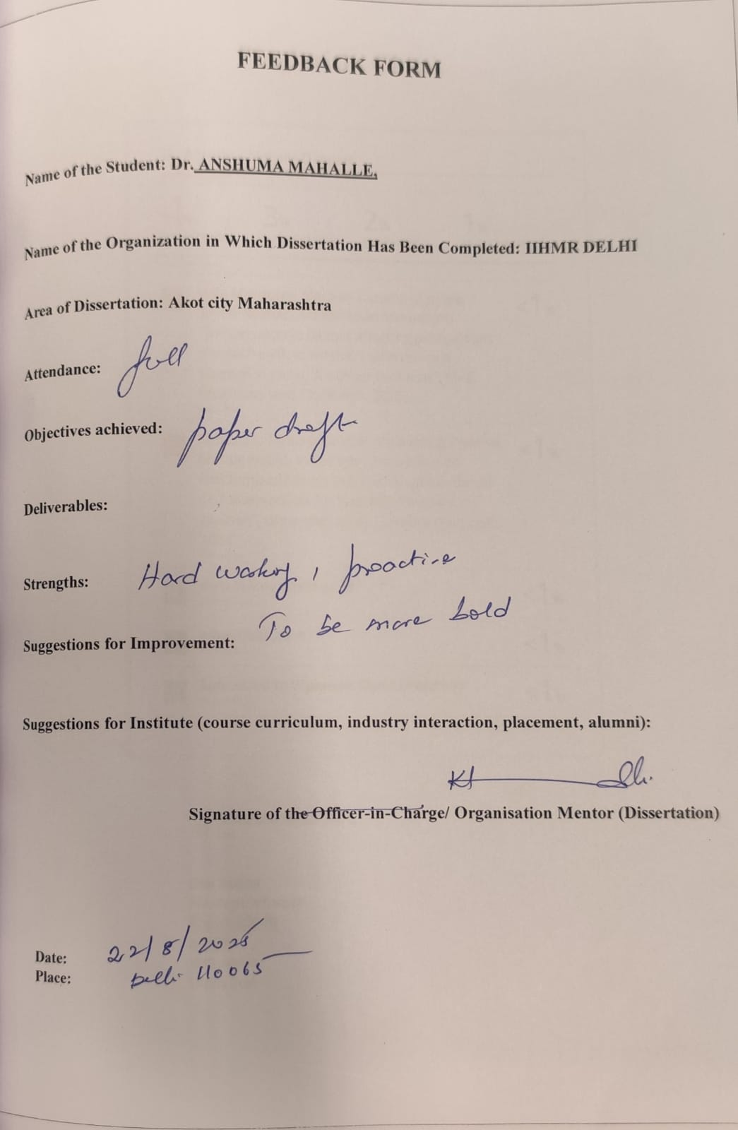

FEEDBACK FORM



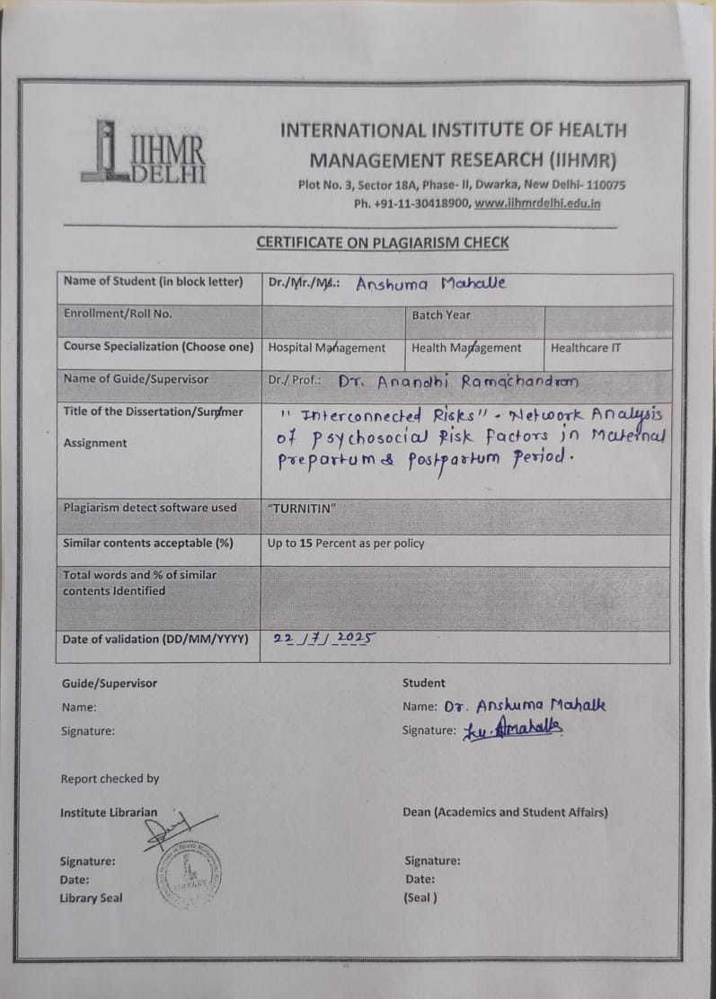
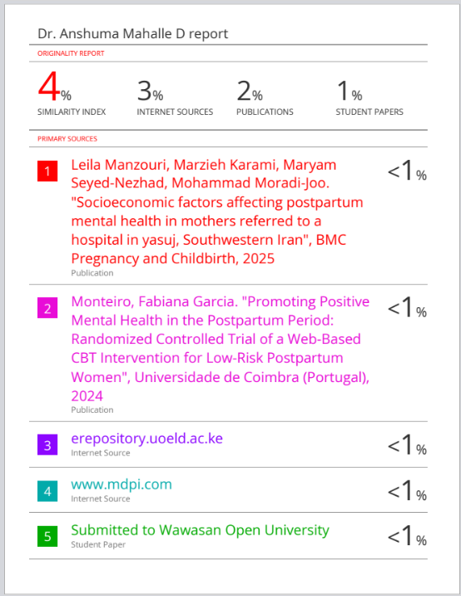
DR. Anandhi Ramachandran
Plagiarism Check


“Interconnected Risks” – Network Analysis of Psychosocial Risk Factors in Maternal Prepartum and Postpartum Period

“Interconnected Risks” – Network Analysis of Psychosocial Risk Factors in Maternal Prepartum and Postpartum Period

Submitted by: Dr. Anshuma Mahalle (PG/23/021)
Under the Guidance of: Dr. Anandhi Ramchandran
PGDM in Healthcare Management
IIHMR Delhi
Academic Year: 2025

Table of Contents

Content |  | Page NO
Chapter 1: | Introduction | 4-6
Chapter 2: | Literature Review | 7-8
Chapter 3: | Methodology | 9-12
Chapter 4: | Framework of Psychosocial Assessment Tools | 13-15
Chapter 5: | Data Analysis & Results | 16-23
Chapter 6: | Discussion | 24-27
Chapter 7: | Conclusion and Recommendations | 28-30
References
Annexures

Figures |  | Page No
Figure 1 | Histogram of PSS Scores – Prenatal Phase | 17
Figure 2 | Stacked Bar Chart of PPP Responses – Prenatal | 16
Figure 3 | Scatter Plot – PPP vs. PSS | 17
Figure 4 | Network Graph – Prenatal Phase | 18
Figure 5 | Histogram of EPDS Scores – Postnatal Phase | 21
Figure 6 | Bar Chart – Financial Strain Scores – Postnatal | 20
Figure 7 | Scatter Plot – EPDS vs. Financial Strain | 20
Figure 8 | Network Graph – Postnatal Phase | 22
List of Figures

Abstract

Maternal mental health remains a critical yet under-addressed public health priority, particularly in low- and middle-income settings like India. The perinatal period is marked by significant emotional, social, and economic changes, often amplifying psychosocial risks. This study, titled “Interconnected Risks – Network Analysis of Psychosocial Risk Factors in Maternal Prepartum and Postpartum Period”, aims to map and analyse these risks using a systems-oriented and network-based approach. Conducted at Amrutesh Private Hospital, Maharashtra, the research included 80 women (40 prenatal, 40 postpartum) selected through systematic sampling. Data were collected via validated tools such as the Prenatal Psychosocial Profile (PPP), Perceived Stress Scale (PSS), Edinburgh Postnatal Depression Scale (EPDS), Multidimensional Scale of Perceived Social Support (MSPSS), and a Financial Strain Index. Quantitative analysis using correlation, regression, and network visualization identified key stressors and protective factors. Results showed that prenatal participants generally had moderate to high support and low stress, whereas postpartum women experienced higher depressive symptoms, with financial strain emerging as a persistent stressor. Social support consistently acted as a buffer, reducing the impact of stress and depression. Network analysis revealed central nodes; emotional support, financial hardship, and self-esteem; as pivotal influences on maternal wellbeing. The study underscores the need to integrate psychosocial screening, prenatal education, and financial counselling into routine maternal care. Policy recommendations include strengthening frontline worker training, expanding support networks, and tailoring interventions to socio-economic contexts. Findings highlight that addressing maternal mental health requires holistic, context-sensitive strategies aligned with SDG Goal 3.

Introduction

Maternal mental health is increasingly recognized as a public health priority across the world, yet it remains severely under-addressed; especially in low- and middle-income countries (LMICs) like India. The perinatal period, comprising both prenatal (antenatal) and postnatal (postpartum) phases, is a time of intense biological, emotional, and social change. While it is often associated with joy and new beginnings, it also represents a period of significant psychological vulnerability for many women.
Globally, maternal mental health disorders affect approximately one in five women during pregnancy or after childbirth, with rates often higher in resource-constrained settings. Conditions such as prenatal anxiety, antenatal depression, and postpartum depression are not merely transient emotional states; they are serious health concerns with long-term consequences. When left unrecognized or untreated, they can impair a mother's ability to bond with her infant, reduce caregiving capacity, and disrupt child development. These mental health challenges can also strain relationships within the household, increase the risk of chronic emotional disorders, and negatively influence family wellbeing.
India, with its vast and diverse population, faces a particularly complex scenario. While progress has been made in improving maternal health outcomes in terms of reducing maternal mortality and increasing institutional deliveries, maternal mental health has yet to receive similar attention in national programs or policy frameworks. The stigma associated with mental illness, especially during pregnancy or the postpartum period, leads many women to suffer in silence. Moreover, healthcare systems often prioritize physical over psychological wellbeing, resulting in maternal mental health remaining a hidden epidemic.
Multiple psychosocial factors have been identified as contributing to maternal distress during this critical life phase. These include perceived stress, low social support, financial strain, marital conflict, emotional isolation, and lack of autonomy. However, most existing studies in India and elsewhere have focused on these factors in isolation, examining each variable separately without acknowledging how they might interact, compound, or reinforce one another. This reductionist approach fails to reflect the complexity of women lived experiences and may lead to ineffective or incomplete interventions.
Understanding how these risk factors are interconnected is essential for developing effective preventive and therapeutic strategies. A woman who is financially stressed may also be more socially isolated, and that isolation may, in turn, worsen her feelings of depression or anxiety. A more integrative and systems-level approach is required, one that can capture the structure and dynamics of multiple, interacting psychosocial risks.
In this context, network analysis offers a promising methodological framework. Unlike traditional statistical models that assume independence among variables, network analysis allows researchers to visualize and quantify the relationships and dependencies among symptoms or risk factors. It helps to identify “central nodes” (i.e., most influential factors) and “bridge symptoms” that link otherwise separate clusters of stressors. Applying this technique to maternal mental health can provide actionable insights into which factors should be prioritized for screening and which connections may offer the greatest leverage for interventions.
This study aims to adopt a network-based approach to analyses the interconnected risks faced by women during the prenatal and postnatal periods in India. By mapping these psychosocial networks, we hope to offer a more context-sensitive, empirically grounded understanding of maternal mental health an understanding that can inform clinical practices, guide community-based interventions, and influence health policy.
Furthermore, this study emphasizes the importance of addressing maternal mental health as an equity issue. Women in rural and semi-urban areas often face overlapping forms of marginalization not just in terms of gender, but also geography, socio-economic status, and healthcare access.
These intersecting forms of disadvantage make it even more critical to identify the nuanced patterns of risk and resilience within these communities. If maternal mental health continues to be neglected, it may compromise broader public health goals, including those related to maternal and child health, early childhood development, and sustainable development (SDG Goal 3: Good Health and Wellbeing).
Through this research, we strive to contribute both to scientific understanding and to the real-world application of mental health screening, diagnosis, and care in maternal health programs. We hope to move beyond fragmented views of maternal mental distress and toward a more holistic, network-informed, and equity-driven model of care.

  - Problem Statement

Despite growing global and national recognition of perinatal mental health issues, significant gaps remain in identifying and supporting women at risk, especially in rural and semi-urban settings of India. Women in these communities often face limited access to mental health care, compounded by low health literacy, societal stigma surrounding mental illness, and a lack of culturally adapted screening tools. These structural barriers delay diagnosis and restrict access to timely care.
Moreover, even when some risk factors are recognized, healthcare systems tend to treat them in isolation, overlooking how multiple stressors can co-occur and intensify psychological distress. For instance, financial strain might not only contribute to anxiety but could also reduce a woman’s access to social support and health services, creating a ripple effect of vulnerability. The absence of tools or frameworks to detect and interpret these interlinked factors leaves many women unsupported, exacerbating existing health disparities. There is an urgent need to shift toward integrated models of understanding and care that reflect the realities of women lived experiences during this critical phase of life.

  - Rationale

This study is motivated by a developing perception that is revolving around the idea that paying attention to symptoms of mother mental health is a meaningless strategy. The social, economic and relationship aspects are very vital to the emotional wellbeing of a woman during the perinatal period of life. Even though some past research helped in identifying the risk factors related to an individual, most research does not recognize how the factors interact, relate and influence one another in the real world. The current study is more systemic and hotter mistic in its approach because it is taking a networked approach to understanding the psychosocial stressors that women are subjected to during pregnancy and postpartum period. Stress, depressive symptoms, money pressures as well as the presence of social support is not considered isolated and inert since they are considered in how they connect with each other and in how each of them interact with others. Its main objective seems to manifest itself not only in identifying which of the stressors participate but also in defining what became bridge ones or those that have the most influence in the system of mental health of motherhood. In possession of this information about these relationships, the research is aimed at disclosing the tendencies behind the outcomes and problems with mental health in this vulnerable step of life. This representation of gender and gender power is a move between the individual symptoms and broader image of interdependence which comes with a better depiction of how women go through gender and gender power. Such a system level description of the service provides deep implications in practice as to how a maternal mental health intervention can be shaped. Rather than the resources being overextended to address every possible risk factor, the health focus can be reduced to the most productive ones those that arouse or connect a number of stress lines. Evidence-based prioritization can have the promise of leading to more focused, effective and sustainable efforts particularly within settings where health financial resources are limited and must be utilized judiciously. Only through this study will not only contribute towards the knowledge base but would also contribute towards delivering responsive, context-sensitive approach that would be useful in helping maternal wellbeing where it is needed the most.
  - Research Qnestions

To guide this inquiry, the study is centered around the following research questions:
- How do psychosocial risk factors interconnect in prepartum versus postpartum women?
This question aims to uncover the structure of psychosocial stress networks during pregnancy and after childbirth. Lt investigates whether the relationships among stressors shift as women transition into the postpartum phase.
- Do these interconnected risks increase vulnerability beyond individual factor analysis?
This question probes whether viewi psychological vulnerability that might not be apparent when examining each factor on its own.
- Which psychosocial factors serve as central or bridging nodes in the maternal
mental health network?
Central or bridging nodes refer to the most influential stressors in the network, those that connect various other risk factors or are highly interrelated. Identifying them could provide strategic targets for clinical and policy interventions.
- How do these networks differ between demographic and clinical subgroups? This question explores whether the structure of risk networks changes based on variables like age, socioeconomic status, education, parity (number of children), or prior mental health history. Such subgroup analysis can support more personalized, context-sensitive interventions.

1.4 Objectives Primary Objective
To correlate and compare psychosocial risk factor networks between,, anent in prenatal and postnatal women with correlation and network analysis. The main purpose of the study is to analyze and illustrate the structure of psychosocial risks both before and after childbirth to determine how it happens differently. With the application of a network and correlation analyses, the research intends to make comparisons between these two important stages of maternal life.

Secondary Objectives

- To estimate the occurrence of perceived stress and depressive symptoms amongst prenatal and postnatal women.
This goal will entail measuring the prevalence of these psychological symptoms in each group and compare the values as well as setting a standard or baseline of mental health screening and micy advice.
- To ascertain the effect of economic burden on maternal mental health.
Given the contribution of economic adversity, this goal aims at exploring the impact of financial stress on maternal mental wellbeing and its value as a major motivator of distress as studief11 the psychosocial network.
- The study aimed to assess the protective value of the perceived social support against stress and depression.
Psychological distress has a recognized buffer in the form of social support. This goal examines the effect of perceived support and its relation to other stressors that can counteracting risks as a network reveal heightened their adverse impacts on mental health.
- To find out the essential variables and chain reactions that have an impact on the outcomes of maternal mental health.
This is the process of identifying the most effecting variables i.e. factors (that have the greatest connectivity or bridging power) in the psychosocial risk network. These variables can be placed in top priority in the screening tools and community programs in addition to clinical care pathways.

Literature Review

- Perinatal mental health has emerged as a critical area of focus in global public health. During the prenatal and postnatal periods, women undergo complex physiological, emotional, and social transitions that can lead to increased vulnerability to psychological disorders. Depression and anxiety are among the most common mental health challenges reported during these stages. According to Biaggi et al. [1], antenatal anxiety and depression are prevalent and often
underdiagnosed, particularly in low-re...
- Traditional approaches in maternal health research often study psychosocial factors such as stress, social support, and financial strain in isolation. However, these factors frequently overlap, interact, and reinforce each other. Shorey and Chan [2] emphasized the importance of understanding the multiplicity of risks that contribute to postpartum depression. Similarly, Grote et al. [3] in a meta-analysis reported that antenatal depression significantly increases the risk of adverse birth outcomes...
- Financial stress has shown consistent associations with poor mental health outcomes in mothers. Howard et al. [4] found that economic strain could exacerbate symptoms of depression and anxiety. In the Indian context, women from rural or semi-urban backgrounds often face financial burdens, limited health access, and cultural stigma,all of which contribute to increased mental health risks.
- Social support has been widely recognized as a protective factor. The buffering hypothesis suggests that strong interpersonal relationships, particularly with partners and family members, can mitigate the negative psychological effects of stressors. The Multidimensional Scale of Perceived Social Support (MSPSS) has been validated across several populations and is frequently used to assess emotional and practical support in maternal mental health studies.
- A novel contribution of the present study lies in its use of network analysis systems-based approach that captures the structure and interaction among multiple psychosocial risk variables. Fonseca et al. [5] and Stein et al. [6] note that interconnected risk patterns offer a more realistic representation of mental health challenges than single-variable models. Network models allow the identification of central (hub) symptoms and bridge nodes, helping to inform early detection and targeted intervent...
In summary, this chapter underlines the relevance of an integrated framework for assessing psychosocial risks in maternal health. The current study builds on the existing literature by mapping the structure and interplay of stress, depression, social support, and financial strain across prepartum and postpartum periods.

Methodology

3.1 Study Design

This study is formulated as an observational and cross-sectional one. A cross-sectional design will be most suitable where there is a need to measure and examine the variables at a given point in time without any manipulation in the study setting. Here, the objective is ensuring that psychosocial risk factors among prepartum and postpartum women in the process of attending a healthcare facility are in a snapshot of their mental health status and psychosocial conditions. The research will use a systems perspective philosophy in view of the fact that psychosocial risk factors like perceived stress, fmanci'9train, or no social support would not exist in a vacuum. Rather, they engage dynamically to affect the mental wellbeing of mothers. In the proposed study, employing network analysis in this cross-sectional design is expected to address these challenges by going beyond the classic linear models and being able to comprehend how such risk factors are connected, mutually supporting and possibly having the interventions that could address them.

3.2 Study Site

The research was carried out in a good gynecology and maternity center Amrutesh Private Hospital situated in Ako! Maharashtra. This hospital was selected considering some of the main criteria: the availability of the given facility to the local population, the amount of pregnant and postpartum women attending the facility and accommodative environment to conduct research that is ethically approved. This research was carried out successfully due to the contribution and advice of two senior maternity care professionals, Dr. Harish Jyot and Dr. Madhavi Jyot, working at the hospital. The fact that they were endorsed formally and had a clinical oversight throughout the research did not only facilitate logistics coordination but also played an important role in the establishment of rapport and trust among the participants. Their presence instilled confidence to the women involved and also provided a safe atmosphere free of disrespect which is a key factor in any study that deals with controversial matters like maternal mental health.

3.3 Study Population

The sample of this study comprised women 18 years and above pregnant or postnatal who were receiving care over antenatal or postnatal services in the selected hospital in the duration of time that the data was being collected. Such participants represent more general population of Indian mothers and specifically such who have to deal with the distinctive psychosocial issues that may occur in the context of the use of semi-urban or resource-constrained medical facilities. The emphasis on this segment helped the study to enter the realities of women who underwent the drastic experience of becoming a mother under limited conditions. This was to record not only the emotional and social pressure that they must endure, but also how these challenges come about and grow in this so fundamentally vulnerable and formulate time in life, particularly when systems of support are cut short.

3.4 Sampling Technique

The study utilized a systematic random sampling technique, which offers both structure and randomness, minimizing bias. Every alternate eligible woman attending the clinic; either in her third trimester of pregnancy or within six weeks postpartum, was approached for participation.
This approach ensured a balanced representation from both the prepartum and postpartum cohorts, while also remaining feasible within the available timeframe and resource constraints. Systematic sampling enhances the representativeness of the sample while simplifying field-level implementation.
Sample Size Determination

The sample size was calculated using Yamane’s formula, appropriate for studies involving a known and finite population:
n=N1+N(e2)n = \frac{N}{1 + N(e^2)}n=1+N(e2)N​
Where:
- N = 80 (estimated number of women attending the hospital over the 2-month data collection period),
- e = 0.05 (margin of error or desired precision level).
Applying the formula:
n=801+80(0.0025)=801.2≈66.7n = \frac{80}{1 + 80(0.0025)} = \frac{80}{1.2} \approx 66.7n=1+80(0.0025)80​=1.280​≈66.7
To ensure statistical adequacy, the sample size was rounded up to 70, and adjusted further for a 10% non-response rate, resulting in a final sample of 80 participants. The sample was divided equally into two groups:
- 40 prepartum women (≥26 weeks gestation)
- 40 postpartum women (within 6 weeks of delivery)

3.5 Inclusion Criteria

To ensure relevance and data quality, participants were included if they met all of the following criteria:
- Aged between 18 to 45 years, representing the standard reproductive age range.
- Belonging to one of the two categories:
  - Prepartum Group: Women in their third trimester (≥26 weeks).
  - Postpartum Group: Women within 6 weeks after delivery.
- Attending outpatient clinics or admitted in the maternity ward during the study period.
- Willing and able to provide informed consent, acknowledging their voluntary participation.
- Able to comprehend the study language (English, Marathi, or Hindi), based on questionnaire language.
These criteria helped ensure that participants had sufficient emotional maturity, were at an appropriate stage of the maternal journey, and could provide informed responses relevant to psychosocial risk assessment.

3.6 Exclusion Criteria

Participants were excluded if they met any of the following conditions:
- Diagnosed with major psychiatric disorders (e.g., schizophrenia, bipolar disorder, or major depression under psychiatric treatment), since such conditions involve complex clinical pathways not suitable for network-level screening.
- Cognitive impairment or neurological disorders that would interfere with comprehension or accurate completion of the questionnaire.
- Currently under psychiatric treatment or taking psychotropic medications, unless their symptoms are mild and stable.
- Unable or unwilling to provide informed consent, including language barriers or disinterest.
- Suffering from severe medical illnesses unrelated to pregnancy (e.g., cancer, cardiac failure), which could independently distort psychosocial stress patterns.
This exclusion framework ensures the reliability and internal validity of the data by minimizing confounding variables.

3.7 Data Collection Tools and Techniques

Data was collected using a structured questionnaire, consisting of both self-reported and interviewer-administered items. The questionnaire covered three main domains:
A. Sociodemographic and Obstetric Information
- Age, education, occupation, marital status, family structure
- Parity, history of pregnancy, complications, mode of delivery
B. Psychosocial Risk Assessment Tools
- Prenatal Psychosocial Profile (PPP) – assesses self-esteem and social support.
- Perceived Stress Scale (PSS) – measures how unpredictable, uncontrollable, or overloaded respondents perceive their lives to be.
- Edinburgh Postnatal Depression Scale (EPDS) – widely used to screen for symptoms of postpartum depression.
- Multidimensional Scale of Perceived Social Support (MSPSS) – evaluates perceived support from family, friends, and significant others.
- Social Support Questionnaire (SSQ) – captures both quantitative and qualitative support levels.
- Domestic Violence Screening Questions – adapted to detect history or risk of partner violence (if applicable).
- Financial Strain Subscale – captures the degree of economic stress experienced.
- Responses were captured using Yes/No options and 5-point Likert scales.
- The questionnaire was available in Marathi (regional language), as well as English and Hindi, ensuring linguistic accessibility.
- Administration was either self-reported or conducted by a trained interviewer, based on participant preference and literacy level.

3.8 Data Collection Process

The data collection took place over a two-month period, integrated into routine clinical workflows.
- Eligible women were approached during antenatal/postnatal visits or during admission.
- Informed consent was obtained prior to questionnaire administration.
- Each participant completed the questionnaire once only, with no follow-up required.
- Data was entered and reviewed for accuracy at the end of each day.

Quality Assurance Measures
- Participant privacy was strictly protected during interviews.
- Data confidentiality was maintained by assigning unique ID codes and securing digital and physical records.
- Ethical protocols were observed at all stages of data handling.

3.9 Ethical Considerations

This study adheres to the highest ethical standards in accordance with institutional and national research guidelines.
- Approval was obtained from the Hospital administrative authority prior to commencement.
- Participants were informed of their rights, including the right to withdraw at any time without consequences.
- Written informed consent was secured from each participant before data collection. All data were anonymized, de-identified, and stored in secure formats to uphold privacy and confidentiality.

3.10 Limitations of the Study Study Limitations
Though this research supplies valuable evidence regarding the psychosocial aspect of maternal mental health, it is necessary to admit some limitations that could influence interpretation and generalization of the results.
- Cross-sectional design the study measures only the snapshot of information at a specific time and that is a drawback as it reduces the chances of investigating how the risk factors of psychosocial risk profile change in various phases of perinatal period. Consequently, the creation of causal relations among variables cannot be made within such a design.
- Single-center study Only one private hospital in a semi urban area was used to conduct research, and this can restrain the generalizability of the results. Women living in urban centers or in underserved areas like tribal communities may have different experiences because of differences in healthcare access, culture, and social support system and access.
- Self-reported data It used the self-reporting method of the participants, which is subject to the bias of recalling or wanting to give socially desirable answers. It is especially important in the instance when one is covering rather sensitive things like emotional distress or interpersonal conflict or episodes of domestic violence.
- Assessment tools instead of diagnostic tools Even though the assessment of psychosocial risk factors involved validated and internally used instruments, they are only meant to screen. They are not substitutes for formal clinical assessments or psychiatric diagnoses.

Nevertheless, even with these limitations, the paper can be viewed as a good starting point in the unraveling of the complexity and interdependence of psychosocial stressors of the perinatal period. It highlights the need to support future research with an increased amount of work by using longitudinal methods in studies as well as a variety of health care facilities.
These attempts would aid in creating a broader and more encompassing representation of maternal mental health in the diverse social and healthcare environments in India.

Framework of Psychosocial Assessment Tools

Assessment Tools Used in the Study
To achieve a more detailed and sophisticated insight into the emotional and social experiences of women in the context of being pregnant and after giving birth, a well-chosen combination of the validated assessment tools was used in this study. These instruments are selected on basis of their clinical validity whic, ·s accompanied with its solid research base and also its capability of its application within low and middle-income countries such as India. All the tools represent distinct but, at the same time, interrelated elements of maternal wellbeing, which include emotional resilience, perceived stress, the quality of social support, and financial strain.

1.Prenatal Psychosocial Profile (PPP) Key Domains Assessed:
- Self-esteem Perceived social support (from partner, family, and friends)
- Relationship satisfaction
- Emotional wellbeing
- Feelings of isolation or encouragement
Purpose and Relevance:
The Prenatal Psychosocial Profile (PPP) provides a general perspective of how a pregnant woman is surrounded by spirits in terms of emotions and interpersonal relationships. It looks at her sense of self worth, emotional strength, and the perceived quality of support her partner, family and social network is providing to her. This tool is especially useful in maternal mental health research because it shows an emotional preparedness of a woman to motherhood and her ability to handle physical and mental pressures of motherhood. A low score is likely to indicate a weaker emotional support system and resources whereas a high score would indicate that a individual has a better emotional strength that would hold the person against stress and depression during pregnancy.

2. Perceived Stress Scale (PSS) Key Domains Assessed:
- Personal perception of stress
- Feelings of unpredictability and loss of control Overwhelm or helplessness,
- Confidence in managing daily challenges
- Emotional strain

Purpose and Relevance:
Perceived Stress Scale (PSS) offers a sense of how people feel stress and take it in. The PSS does not target stress-related events; it measures the perception of life, how difficult a life is, or how hard it is to handle by the respondent. This instrument is critical when conducting research in maternal mental health since two women experiencing the same scenario in their lives may interpret and react to stress marks differently. In the present investigation, the effectivity of the PSS along with the emotional burden of the women, both prenatally and postpartum, regardless of the surrounding circumstances, received attention.
3. Edinburgh Postnatal Depression Scale (EPDS)
Key Domains Assessed:
- Depressive symptoms (e.g., sadness, crying spells)
- Anhedonia (loss of interest or pleasure)
- Anxiety and panic-related symptoms feelings of guilt, self-blame, or inadequacy
- Thoughts of self-harm or suicidal ideation
Purpose and Relevance:
EPDS is a common screening questionnaire used in the detection of various symptoms of postnatal depression even though it works well during pregnancy. It is a prompt and responsive means of identification of emotional distress like anxiety, low mood and emotional numbness. The EPDS was especially significant in this research since it was used to recognize the women who have the potential of developing clinical depression, especially in regions, where stigma and lack of mental health support exist. The use of it contributes to the fact that they are referred to and supported in time before their condition develops or is not detected.

4.Multidimensional Scale of Perceived Social Support (MSPSS)
Key Domains Assessed:
- Depressive symptoms (e.g., sadness, crying spells)
- Anhedonia (loss of interest or pleasure)
- Anxiety and panic-related symptoms, feelings of guilt, self-blame, or inadequacy
- Thoughts of self-harm or suicidal ideation
Purpose and Relevance:
EPDS is a common screening questionnaire used in the detection of various symptoms of postnatal depression even though it works well during pregnancy. It is a prompt and responsive mean of identification of emotional distress like anxiety, low mood and emotional numbness. The EPDS was especially significant in this research since it was used to recognize the women who have the potential of developing clinical depression, especially in regions, where stigma and lack of mental health support exist. The use of it contributes to the fact that they are referred to and supported in time before their condition develops or is not detected.

5. Financial Strain Index Key Domains Assessed:

- Worries about medical and maternity-related expenses,
- Difficulty affording essential care or services reliance on others for financial decisions or
- Basic needs emotional toll of financial insecurity, inability to provide for infant and household needs.
Purpose and Relevance:
financial Strain Index is a measure of how people feel as well as how the issue of economic hardship affects them during their perinatal period. Contrary to the general income estimates, the tool investigates the impact of financial strains on daily activities, health access, and emotional wellness. Economic pressure to women in little resource settings is not merely a background factor, it can easily form the removal of or otherwise seek care, compliance or emotional stability. The wealth load at the study also was not assessed purely as an independent variable, but also as the cause or aggravating element of other psychosocial risks.

Integrated Insight from the Tools

All five instruments gave a comprehensive description of maternal psychosocial health:

- The quality and sources of emotional and social support were brought to light by the PPP and MSPSS;
- The PSS reflected the way stress is received and perceived;
- The EPDS revealed symptoms of depression and anxiety;
- And these findings placed the Financial Strain Index into the economic contexts that define maternal health.
- Using the combination of these tools helped the study to create a networked explanation of the intersection points of different forms of support, stress, emotional distress and financial hardship.
It is a method that gave the possibility of a more detailed, practical understanding of maternal mental health that could be pivotal to developing specific policy, enhancing clinical care, and community-based interventions responsive to the lived experience of women throughout the perinatal pathway.

Data Analysis and Results

For Prenatal Group

4.1 Descriptive Statistics

Prenatal Psychosocial Profile (PPP)

The mean PPP score among the participants was 21.1, with a median of 21.5 and a mode of 25. These values suggest that most respondents perceived themselves to have moderate to high levels of psychosocial support and self-esteem during their third trimester of pregnancy.

Perceived Stress Scale (PSS)

The PSS scores reflected relatively low levels of perceived stress overall. The mean was 5.13, the median 4.5, and the mode 2. Most participants selected lower-scoring options on the scale, indicating that general stress levels were mild, although notable variations were present in individual cases.

Financial Strain Subscale

Visualizations of item-wise responses revealed a high frequency of ratings in the upper range (scores of 4–5) on items related to financial dependency and the emotional toll of economic hardship. This pattern indicates that, while perceived stress was generally low, financial strain remained a prominent concern for many women in the sample.

4.2 Frequency Distributions

To better understand the distribution of responses across key psychosocial instruments, stacked bar charts were generated for individual items in the PPP, PSS, and Financial Strain subscales:
- For the PPP, responses were largely concentrated in the upper range, reflecting high levels of perceived emotional and social support.
- The PSS revealed that while most participants reported lower stress, a subset endorsed higher levels, suggesting the presence of mild to moderate emotional distress.
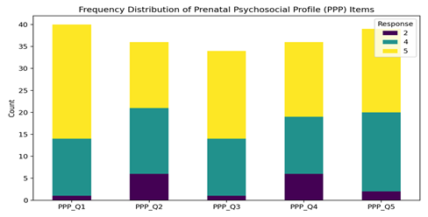
- Responses on the Financial Strain Subscale varied, but several participants reported significant economic pressure, particularly related to decision-making autonomy and household dependence.
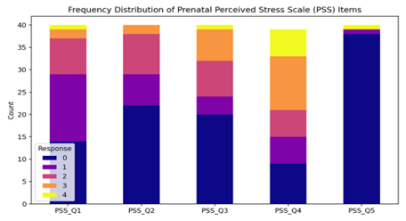
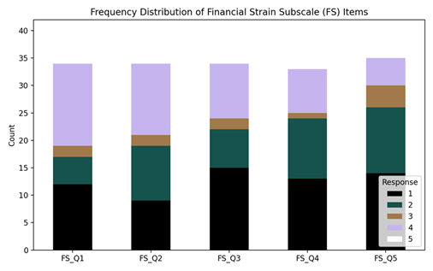

4.3 Correlation Analysis

Bivariate Correlations (Pearson)

- PPP and PSS: A mild negative correlation (r ≈ -0.23) was observed, suggesting that higher psychosocial support and self-esteem were associated with lower levels of perceived stress.
- PSS and Financial Strain: A weak positive correlation (r ≈ 0.27) was noted, indicating that higher financial strain correlated with increased stress.
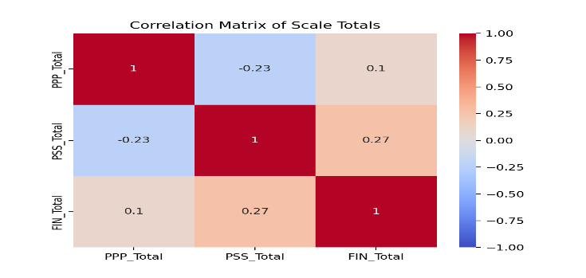
- PPP and Financial Strain: Virtually no correlation was found (r ≈ 0.10), suggesting that perceived support and financial concerns may operate independently in this context.

4.4 Regression Analysis

A multiple regression model was used to identify predictors of perceived stress (PSS score):
- PPP Total Score: A one-point increase in the psychosocial profile score was associated with a 0.47-point decrease in perceived stress, indicating that support and self-esteem are protective factors.
- Group (Prenatal Class vs. Comparison): Women who did not attend prenatal classes reported significantly higher stress levels.
The model yielded an R² value of 0.39, suggesting that approximately 39% of the variance in stress levels could be explained by the included predictors. Interestingly, once these key variables were controlled for, financial strain, education, and occupation did not emerge as significant predictors within the multivariate framework.

4.5 Network Analysis (R Studio)

To gain a visual and structural understanding of how psychosocial variables interact, a network analysis was performed using R Studio:
- Only correlations ≥ 0.3 were included in the graph for clarity.
- The network displayed strong intra-subscale connections, particularly within the PPP and PSS, reinforcing the internal consistency of these tools.
- Notable negative correlations (e.g., between specific stress and support items) illustrated inverse relationships between domains.
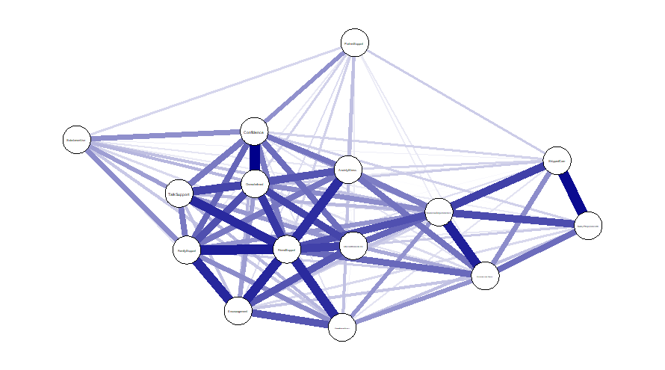
- Several variables emerged as central nodes or bridges—particularly those related to perceived support and emotional wellbeing.
These findings offer a system-based perspective of maternal stress during the prenatal period and highlight specific variables that could serve as strategic intervention points.

The analysis indicates that psychosocial risks in the prenatal period are deeply interconnected, rather than isolated. Social support, as captured through the Prenatal Psychosocial Profile, appears to play a critical protective role in lowering perceived stress. On the other hand, financial strain, while relevant, lost statistical strength in the presence of stronger predictors like psychosocial resources and prenatal class participation.
Participation in prenatal educational classes also emerged as a significant contributor to better mental health outcomes, likely due to the combination of informational support, peer interaction, and anticipatory guidance these sessions provide.
While demographic variables such as age and education showed weak to moderate associations with financial strain and stress, they were not found to be statistically significant predictors in the final regression model, highlighting the primary role of psychosocial and contextual resources.
The network analysis further supports these findings by visualizing core and bridging nodes, which offer valuable insights for designing targeted screening and intervention strategies within maternal health programs.

Conclusion

The findings from the prenatal group contribute to a more integrated understanding of how psychosocial risk factors are structured and interrelated during pregnancy. Using a combination of traditional statistical methods and network analysis, the study identified key influences on maternal mental health.

Key Conclusions:
- Stress, social support, and financial strain are interdependent, with each influencing maternal wellbeing in varying degrees.
- Psychosocial support, measured by self-esteem and perceived interpersonal support, emerges as a protective buffer against stress.
- Participation in prenatal education classes is linked to lower stress levels and higher perceived support.
- Financial strain, while impactful in bivariate analyses, does not retain significance in multivariate models when psychosocial factors are accounted for.
- Network analysis identifies central psychosocial symptoms and linkages, offering direction for early intervention and community-level mental health support.

For Postnatal Group

5.1 Descriptive Statistics

Edinburgh Postnatal Depression Scale (EPDS)

The mean EPDS score was 14.9, with a median of 15 and a mode of 16. Most participants scored between 12 and 17, indicating a clustering of responses in the mild to moderate depression range. The histogram displayed a left-tailed distribution, with only a few outliers scoring particularly high. A corresponding box plot confirmed a tight interquartile range around the median, suggesting that moderate levels of depressive symptoms were common in the postnatal sample.

Multidimensional Scale of Perceived Social Support (MSPSS)

The MSPSS scores revealed a mean of 4.19, median of 4.21, and mode of 4.17 on a 1–7 scale. These values suggest that participants generally perceived a moderate level of emotional and practical support from their social networks. Though variability existed, the central tendency indicates that most mothers had some degree of consistent interpersonal support.

Financial Strain Subscale

The financial strain scores were concentrated in the high 20s, with 29 emerging as the most commonly reported score. The histogram showed a slight left skew, meaning that only a few mothers reported very low levels of financial stress. This distribution highlights that moderate financial pressure was a prevalent concern during the postpartum period.

5.2 Frequency Distributions
Frequency tables and visual charts were created to provide a detailed view of response patterns across all three key domains:

Depression (EPDS):

The bar chart of total EPDS scores showed that the majority of mothers fell within the mild-to-moderate depression range. Severe depressive symptoms were infrequent, though subclinical symptoms were widespread, warranting attention in clinical screening practices.

Perceived Social Support (MSPSS):

Most responses were concentrated between the mid-60s to mid-80s range, indicating moderate to high levels of perceived support. This reflects a generally positive emotional environment, with variability suggesting that some mothers may still be at risk due to limited social connections.

Financial Strain:

Scores showed a notable clustering around 27 to 29, with 29 being the most frequent score. This trend confirms that a considerable portion of participants were experiencing financial hardship, though extreme cases were less common. The data indicate that economic challenges are a persistent stressor for many women following childbirth.
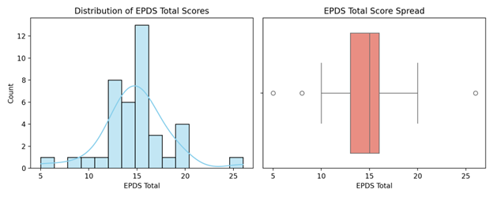
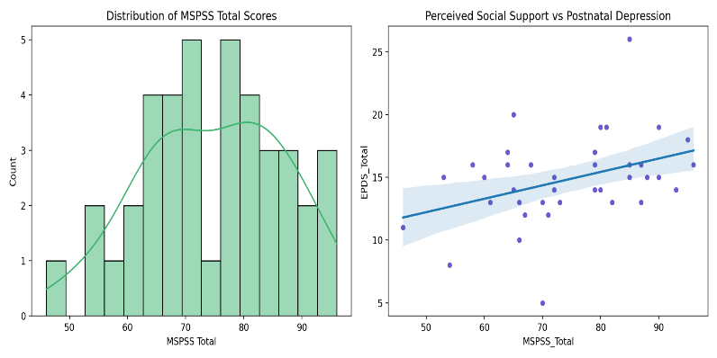

5.3 Correlation Analysis

Two key relationships were explored to understand how financial pressure and social support relate to postpartum mental health:

EPDS and Financial Strain:
- Pearson’s correlation coefficient (r) = 0.26,
- Spearman’s rho (ρ) = 0.28
These values indicate a weak-to-moderate positive relationship, suggesting that higher financial strain tends to be associated with higher depressive symptoms. While the p-values (~0.08–0.10) did not reach conventional levels of statistical significance, the trend is marginally suggestive of a meaningful association.

EPDS and MSPSS:
A weak negative trend was observed in the scatter plot, implying that higher perceived social support may correlate with lower depression scores. Although the strength of the relationship was modest, the direction aligns with existing literature and the buffering hypothesis, which posits that social support mitigates the psychological impact of stress.

5.5 Regression and Visual Interpretation

A scatter plot with a fitted regression line further illustrated the positive association between financial strain and EPDS scores. The line of best fit reaffirmed the trend observed in correlation analyses, suggesting that as financial stress increases, depressive symptoms tend to rise as well.
While the observed relationships were not statistically significant within this sample, they were consistent with theoretical expectations and previous findings, highlighting the need for further multivariate analysis and a larger sample size to confirm these patterns with greater confidence.
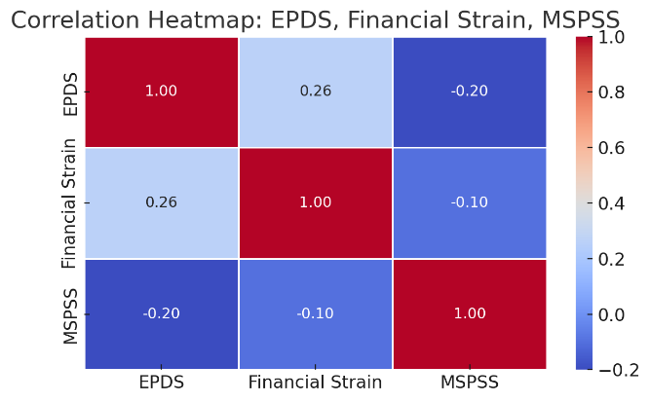

Network Analysis

1. EPDS Inter-Item Connectivity:
Items EPDS_Q3 & EPDS_Q4 show a strong negative correlation (r = -0.60), indicating inverse symptom responses, likely measuring contrasting aspects of mood or behavior.
Moderate internal correlations (r = 0.39 between Q1 & Q2) suggest good coherence within the depression scale, though some weak or negative links point to diverse symptom patterns.
2. MSPSS (Social Support) Clusters:
MSPSS items form dense internal clusters, especially:
MSPSS_Q5–Q8 and MSPSS_Q11–Q12 share strong connections
(e.g., Q5-Q8 = r = 0.64; Q11–Q12 = r = 0.42)
Suggests internal consistency within perceived support from family/friends/significant others.
These clusters act like “resilience hubs” in the network.

3. EPDS vs. MSPSS Relationships:
- Mostly negative correlations between EPDS items and MSPSS items (e.g., EPDS_Q1 vs MSPSS_Q10 = r = -0.34), indicating:
- Higher perceived support is associated with lower depression symptoms.
- This supports the buffering hypothesis, where social support mitigates depressive risk.
4. EPDS vs. Financial Strain:
- Modest positive links (e.g., EPDS_Q2 with Financial_Q2 = r = 0.28; EPDS_Q7 with Financial_Q1 = r = 0.22)
- Implies increased financial difficulty is related to higher depressive symptoms.
- Though correlations are not strong, they’re consistent across multiple EPDS items, reinforcing the trend.
5. MSPSS vs. Financial Strain:
- Mostly weak or negative correlations between MSPSS and financial strain variables.
- Example: MSPSS_Q12 vs Financial_Q3 = r = -0.36
- Suggests those with greater support may perceive less financial strain or cope better with it.
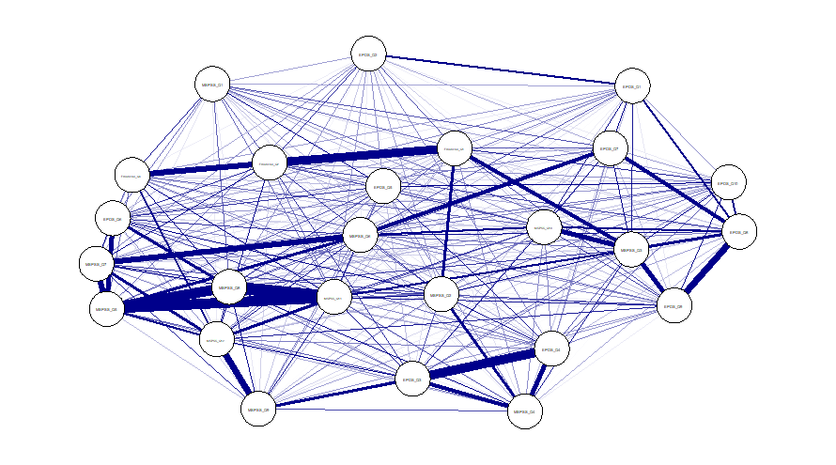

The results of the postnatal group analysis confirm the complicated nature of economic stress, perceived support, and the maternal mental health relationship. The findings recorded on the EPDS scales show that during the postpartum period, a significant proportion of the mothers were scoring moderate depressive symptoms, an important stage of maternal recovery as well as infants’ growth. It has been noted that one of the trends is that there is an increase in depressive symptoms when mothers report high finance pressure. Even though the correlation could have been observed as marginally significant, the trend is in the context with the current state of research that suggests the connection between postpartum mood disturbances and economic vulnerability.
The perceived social support was observed to be at a medium scale in the majority of the participants, but its negative correlation with the symptoms of depression opens a possibility of introducing preventative measures. Increasing support systems, both official, i.e. medical and community-based services, and unofficial, like family and support of friends, can go a long way to protecting the health of the mother during this stressful period. Although this research is highly insightful, it is important to remember that the sample is fairly small and there are no multivariate controls, thus the results should be considered rather carefully.
Future studies need to involve more and different women groups, and long term study designs in order to better comprehend the factors as they change as time goes by.
Conclusion for Postnatal Group
Postnatal data analysis reveals the issues associated with emotional and social problems encountered by the women during the weeks of life after giving birth that require assessment and reaction. The results indicate that there is an observable relation between the financial pressure, and the symptoms of depression whereby social support is one of the potential refuges which can provide relief of such burden.
Key Conclusions:
- Financial strain shows a positive association with depressive symptoms, suggesting that mothers facing economic hardship are more vulnerable to emotional distress.
- Moderate levels of social support may help offset the severity of postpartum depression, reinforcing the protective role of supportive environments.
- Mothers with higher financial stress reported elevated EPDS scores, emphasizing the need for targeted mental health screening within this subgroup.
- Although statistically suggestive rather than definitive, the results call attention to the need for routine mental health evaluation and financial counselling as part of comprehensive postnatal care.
These insights contribute to a growing body of evidence that advocates for a holistic approach to maternal health, addressing not only physical recovery but also emotional and economic wellbeing during the postnatal period.

Discussion

Prenatal Phase

The above discussion of women in their third trimester is a strong testimonial into the experience of psychosocial problems in pregnancy, not experienced as isolated problems but as a complex connected mesh. All these problems, along with the support mechanisms that assist them in juggling them, go on to determine the emotional and psychological health of a woman at this transitional period. The Psychosocial Risks are lnterconnected An important lesson on this stage is the obvious relation between stress, financial pressure as well as the availability of social support. These factors are not in vacuums, instead, they relate with each other such that they may worsen or even ease the emotional load of the women. To demonstrate, money concerns can initiate a sense of stress, which can be mitigated by the influence of high emotional support. It is important to shape the view of the problem of maternal mental health in a systems manner, especially in low-resource context, where various stressors may occur, accumulating and increasing each other.

Social Support as a Protective Resource

Results of the Prenatal Psychosocial Profile (PPP) showed that a large number of women were responding to be moderately or highly supported and emotionally resilient. These answers are indications of availability of helpful emotional support in family, partners, or inner resources. It is a positive indicator because social support has been acknowledged as an effective protective factor of emotional distress. A feeling of being recognized, appreciated, and included does not only lessen the isolation women may generalize, but it also prepares them to address forthcoming emotional challenges of pregnancy.

Financial Strain and its Psychological Impact

Although overall, the social support was good, financial strain remained another issue that appeared with high frequency among the participants. Females with a greater perception of being economically impaired or burdened emotionally with regard to financial matters were also likely to report greater levels of stress. Even though the connection between financial strain and all the other variables was not statistically significant in multivariate models, it is impossible to ignore the significance of the role of financial strain as background stressor. Economic vulnerability can restrain access to medical attention, cause tensions in the household, or reduce the sense of agency as factors that may contribute to psychological vulnerability among expectant women.

Role of Prenatal Class Participation

It was also discovered that attending prenatal classes on education played an important role in lowering stress levels. Women who participated in such sessions were found to be experiencing less stress and higher psychosocial scores with the implication that formal educational interventions during pregnancy can improve a woman in terms of emotional preparedness, confidence-building, and a sense of community feeling. It is also possible that these benefits are a result of the information given (e.g. about labor, delivery, and self-care) as well as an interpersonal interaction with peers and facilitators which leads to the enhancement of emotional resilience.

Demographic Variables: Age and Education
Bigio and Bigio examined the correlation of age and education in relation to perceived stress and financial strain with a weak to moderate correlation in bivariate analyses but not significant in the final regression models. This implies that the experiences psychosocially might be made up of age and educational level; however, these factors play a secondary role formed by the direct psychosocial factors like support systems or parenthood in prenatal care programs. ft supports the idea that emotional and environmental resources and not background demographics are more active in influencing stress levels during pregnancy.
Network Analysis insider information Application of network analysis took a deeper meaning to the knowledge of maternal mental health in prenatal period. Having visualized the relationship of each variable, the analysis could also determine not only central symptoms (hubs) such as items that concerned perceived support, but also bridging symptoms which related the various domains of psychosocial experience. These bridges are key intervention points: so, e.g. a symptom that links financial strain to low self-esteem might be tackled as a target of work in a supportive counseling set-up or support group.
The network map provided a structural understanding of how emotional, financial, and relational factors interact during pregnancy. Such visual tools are not only analytically valuable but can also inform programmatic decisions, helping healthcare providers prioritize high-impact areas for screening and intervention.

Conclusively, it can be seen that the discussion of the prenatal data shows that: Psychosocial support is a powerful source of protection against perceived stress among pregnant women.
- Although in less statistically dominant forms, the financial strain is an important background element that affects emotional wellbeing.
- Attendance of prenatal classes presents definite mental health benefits informational and social.
- Although demographic factors are limited as compared with emotional and situational variables, age and education are considered as a limited role in demographics.
- The network analysis helps to determine the important nodes that can be used in early intervention and systems-based mental health care.
- These results support the necessity of integrated but also culturally competent maternal mental health prevention and care which should cover emotional, social and economic aspects of care, especially at times of increased vulnerability such as prenatal time.

Postnatal Phase

Throughout the postnatal period, which is a highly sensitive and transitioning moment ofa new mother, there are significant physical, emotional, and social changes. The results of the analysis of the women in the group of postnatal periods in this study showed valuable trends concerning depressive symptoms, social support, and financial stress. Even though the sample group was rather small, the insights received form a significant understanding of how these factors interact within the first few weeks after childbirth.

Prevalence of Depressive Symptoms
Edinburgh Postnatal Depression Scale (EPDS) scores indicated that multitudes of women were having minor to moderate levels of depression. The score was significantly high hence emotion distress is very prevalent during early postpartum days- even though it might not be at a level where healthy individuals pass a clinical diagnosis. These facts give insight into the emotional problems that several mothers experience once they have delivered. The possible causes are hormonal changes, sleep deprivation, sheer change in self-identity, and lack of supportive regularity. Postnatal care, although it may be emotionally exhausting in itself, may be more concentrated on physical recovery of the mother and the health of the newborn child, and little is done to ensure the recovery of the mother in a mental and emotional sense. This discussion provides a strong argument in support of inclusion of regular mental health screening to postnatal check-ups. Emotional support of a mother during this period is not only helpful; it is part of complete recovery and long-term wellbeing.

Financial Strain as a Contributing Factor
Among the significant findings within this category were the positive links between an experience to likely negative financial strain and depressive symptoms. Although the
relationship was not significant at traditionally accepted levels (p = 0.08 0.10), the correlation
was directionally, as well as statistically, significant. Individuals who reported greater financial stress were more likely to have their EPDS score and therefore economic stress could be one of the factors associated with emotional distress during the post-partum period. The result is consistent with past studies that show how financial weakness may contribute to anxiety, insecurity, and emotional burnout, especially where mothers are managing to accommodate the needs of their infants. The marginal statistical significance in this case most probably represents the small sample size of the study and demonstrates that future studies with larger sample size are needed to investigate this relationship. However, the potential implications are enormous in practice--that is, the usefulness of financial counselling, resource linkage or community-based support program as components of postnatal care in general.
m

Role of Perceived Social Support
The particular analysis indicated the presence of moderate values of perceived social support among the respondents according to the Multidimensional Scale of Perceived Social Support (MSPSS). Although the overall support levels were promising, the fact that there is the variability among people indicates that not all the mothers could equally access emotional and practical help. otably, the data indicated the negative correlation between the perceived social support and depression symptoms. Although this trend is weak, it confirms the buffering hypothesis present in the maternal mental health research, which implies that positive social conditions can neutralize the adverse mental consequences of stress. Even incremental gains on the support front either by partners, the family or tangential, can aid in lessening the feelings of loneliness, add to self-efficacy, and provide coping responses to going through a troublesome phase in life. These results indicate a possibility of specific interventions, especially in mothers who are socially isolated, or those who do not have family support. Peer-support groups, home-based community health workers, or tele­ counselling services can be important in boosting postnatal emotional wellbeing.

Interrelatedness of Variables and Study Limitations
In summary, the discussion of postnatal findings suggests that:
The difference between the groups (high and low financial strain) and correlation analysis brought out emerging trends of relationships between the most important psychosocial variables. Although the findings were not statistically strong; they noted some tendencies that will be clinically and contextually significant. As another example, the mothers who experienced more financial pressure were more likely to describe the symptoms of depression and the ones who rated their perceived support higher were less depressed. evertheless, since the sample size is comparatively small this reduces the level of generalizing these results to larger groups. The trends revealed are to be viewed as first and tentative, and call to larger, longitudinal, multivariate examinations that would be better equipped to assess the interaction between economic, emotional, and social factors regarding maternal mental health.

A significant section of antepartum mothers has been found to experience depressive symptoms on moderate levels within the community out of the clinical setting as well.
- The economic burden will worsen the emotional tension and, therefore, maternal care requi.res a combination of economic and psychological support.
- The perceived social support is also a guardian variable, which is consistent with the international data according to which emotional and instrumental support helps decrease the risk of postpartum depression.
- Although the statistical significance was low, the trends provide research-informed programmatic solutions informing maternal mental programming in similar socio­ economic conditions.
- These findings imply that postnatal care cannot be restricted to the biomedical paradigm, that psychosocial screening, early prevention, and support structures are much needed, and that they should be individualized to the particularities of new mothers in the semi-urban and rural settings in India.

Conclusion and Recommendations
Conclusion

This paper has analyzed the psychosocial chains of risks that affect the mental health of mothers before and after childbirth. A network-based method aimed at limiting the consideration of individual factors in a separate form and thus learn how stress, depression, financial difficulties and social support influence and interact with each other to determine the emotional state of a woman at the most vulnerable period in her life. Two influences on mental health were always strong in both populations as pointed out in the analysis: financial pressure and perceived social support. Several pregnant women claimed to be relatively less stressed during pregnancy since people around them would provide them with emotional support and since the prenatal education classes positively influenced them. Conversely, the postnatal showed a striking rise in depressive symptoms and would thus suggest better after birth mental filth support systems.

Some of the factors such as emotional wellbeing, family support, and financial issues were
the main nodes of the network. These factors acted as central links, affecting and being affected by other stressors at the right proportion that greatly affected the whole mental health of a woman. The fact that they are central indicates that they ought to become the points of future interventions in maternal health initiatives. The statistics also indicated the safeguarding power of sentimental preparation and training. Those women, who attended prenatal classes and had higher Prenatal Psychosocial Profile (PPP) score, tended to report lower stress levels, which suggests that the knowledge and emotional preparedness improves the resilience in pregnancy. In the same manner, in the post-birth sample a moderately high level of social support mediated the emotional effects of financial strain, providing confirmation of the relevance of connection, reassurance, and support in the development of early motherhood.

Noteworthily, the research revealed the expediency of implementing network analysis in research on public health. The visual representation of the relationships between psychosocial risks made it possible to detem1ine which areas of screening and intervention should be given a priority. The integrative method demonstrated good prospects in informing predictive techniques, creating more efficient screening protocols, and developing multi-layer support plans that would react to the conditions of maternal mental well-being, particularly in the environment where resources are scarce and demands are high.
Policy Recommendations
To translate these findings into practice, the following policy-level recommendations are proposed:

- Integrated Mental Health Screening into Routine Maternal Care
We must include certain tools like the Edinburgh Postnatal Depression Scale (EPDS) and
perceived stress scale (PSS) checked during normal antenatal and postnatal routine check-up both in the primary and secondary health care facilities. This coordination is able to facilitate early identification of psychological distress and prompt care referrals.

- Expanding Access to Prenatal Education Programs

Prenatal education must be organized and preferably given to expectant women residing in the rural and semi-urban regions through healthcare and governmental facilities where the availability of information is minimal. It is not enough that these programs should deal with physical health education but should also prepare the women emotionally, arm them with practical coping skills, and should make them aware of the support networks that they can resort to.

- Introducing Financial Counseling in Maternity Care Packages

Taking into account the high level of the influence of financial stress on mental health, maternity interventions also need to provide support on financial planning, make women aware of the possible government welfare schemes, and make referrals to social support services when necessary. There is less stress associated with affordability thus there is some control in that the woman during the perinatal stage can be more integrated.

- Train Frontline Health Workers in Psychosocial Screening

Healthcare providers working in the frontline: such as Auxiliary nurse Midwives (A MS),
Accredited Social Health Activists (ASHAs) and Anganwadi workers should also be trained in early signs of emotional distress, easy screening tools as well as referrals to professional mental health care. The close contact they have with the community makes them one of the best resources in decentralized mental health support.
- Develop System-Wide Maternal Mental Health Policies

Issues concerning psychosocial risks are systemic and health policies should shift toward approaches that involve one-factor interventions. The integrated care strategies should reinforce the association of physical, emotional, and financial wellbeing (especially in vulnerable populations living below the poverty line).

Community Health Action Points
Community unconsciously, grassroots action can be an effective force to facilitate maternal mental health. It is recommended to:
- Mother support groups developed Promote the emergence of peer support groups at community centers, health sub centers or GOs. Such groups enable women to open and communicate among one another; minimize isolation and develop emotional resilience.
- Consultation with Women Organizations (Mahila Mandals) Utilize any existing women self-help group to create awareness on maternal mental health and to end social stigma and get care that is needed. It is also possible to spread the word about government schemes and networks of referrals in these forums.
Mobile Based Counselling in Regional Languages Help via tele­ counselling and the mobile health system (local languages), to bring psychological help to the underserved regions where actual mental health facilities might not exist. Involve husbands and families in total care of a mother.
Awareness Campaign to Partners and Family Members where the members are made aware of how they can be of support to the individual psychologically and in shared responsibility and in curbing stigmatization of the individual. Involved families have the potential to make enom10us differences in the way in which maternal outcomes are viewed by developing a more supportive home environment.

6.4 Future Research Directions
Though the study has yielded valuable information, there is a need to conduct farther research as it will lead to better comprehension and extension of the range of applicability of the research:
- Bigger and variant Sample Sizes The generalizability of the findings can be improved by increasing the number of participants in different locations including tribal and urban slums and eventually research should be conducted in more portions.
- Longitudinal Design Types Make use of long-term follow-up designs to evaluate the change in the psychosocial networks over the perinatal lifespan, joining early pregnancy to the initial year of childbirth. This would assist in the interpretation of alterations of risk and resilience.
- Addition of other Variables To continue, the psychosocial model will benefit learning more about the aspects of intimate partner violence, occupation, cultural values, and how people coped with the struggles and challenges on a spiritual or religious level.
- Feedback Based Intervention Trials Future research can plan, and evaluate interventions based on network analysis, interventions that maximize network-level consequences by intervening on central symptoms and bridge symptoms.

This study contributes to a growing body of evidence advocating for a holistic, integrated approach to maternal mental health, one that reflects the complex realities of women's lives in India and beyond. With sustained policy attention, community engagement, and evidence­ based strategies, maternal mental health can be effectively supported across the continuum of care.
References

- Biaggi A, Conroy S, Pawlby S, Pariante CM. Identifying the women at risk of antenatal anxiety and depression: A systematic review. J Affect Disord. 2016;191:62–77.

- Shorey S, Chan V. Prevalence and incidence of postpartum depression among healthy mothers: A systematic review and meta-analysis. J Psychiatr Res. 2021;135:137–147.

- Grote NK, Bridge JA, Gavin AR, Melville JL, Iyengar S, Katon WJ. A meta-analysis of depression during pregnancy and the risk of preterm birth, low birth weight, and intrauterine growth restriction. Arch Gen Psychiatry. 2010;67(10):1012–22.

- Howard LM, Molyneaux E, Dennis CL, Rochat T, Stein A, Milgrom J. Non-psychotic mental disorders in the perinatal period. Lancet. 2014;384(9956):1775–1788.

- Fonseca A, Gorayeb R, Canavarro MC. Women’s use of coping strategies: Association with postpartum depressive symptoms. Women Health. 2020;60(1):95–110.

- Stein A, Pearson RM, Goodman SH, Rapa E, Rahman A, McCallum M, et al. Effects of perinatal mental disorders on the fetus and child. Lancet. 2014;384(9956):1800–1819
- O’Hara MW, Wisner KL. Perinatal mental illness: Definition, description and aetiology. Best Pract Res Clin Obstet Gynaecol. 2014;28(1):3–12.

- Biaggi A, Conroy S, Pawlby S, Pariante CM. Identifying the women at risk of antenatal anxiety and depression: A systematic review. J Affect Disord. 2016;191:62–77.

- Howard LM, Molyneaux E, Dennis CL, Rochat T, Stein A, Milgrom J. Non-psychotic mental disorders in the perinatal period. Lancet. 2014;384(9956):1775–1788.

- Fonseca A, Gorayeb R, Canavarro MC. Women’s use of positive, negative, and disorganized coping strategies: Association with postpartum depressive symptoms. Women Health. 2020;60(1):95–110.

- Shorey S, Chan V. Prevalence and incidence of postpartum depression among healthy mothers: A systematic review and meta-analysis. J Psychiatr Res. 2021;135:137–147.
- Stein A, Pearson RM, Goodman SH, Rapa E, Rahman A, McCallum M, et al. Effects of
perinatal mental disorders on the fetus and child. Lancet. 2014;384(9956):1800–1819.
- Edge D, Ramsay R. Mapping maternal mental health: a network analysis. J Affect Disord. 2020;276:58–65.
- Levinson CA, Sala M, Zilka L, Wardenaar KJ, van Borkulo CD, Millner AJ, et al. Identifying central symptoms of maternal depression using network analysis. Psychol Med. 2018;48(7):1104–1110.
- Santos H, Tan X, Salomon R. A systematic review of perinatal depression risk factors. J Womens Health (Larchmt). 2017;26(9):835–846.
- Bringmann LF, Lemmens LH, Huibers MJ, Borsboom D, Tuerlinckx F. Network dynamics in symptom-level analysis of maternal mental health. Clin Psychol Sci. 2019;7(4):853–868.
- van Borkulo CD, Boschloo L, Borsboom D, Penninx BW, Waldorp LJ, Schoevers RA. Bridge symptoms in depression and anxiety networks. Psychol Med. 2015;45(8):1763–1772.
- Grote NK, Bridge JA, Gavin AR, Melville JL, Iyengar S, Katon WJ. A meta-analysis of depression during pregnancy and the risk of preterm birth, low birth weight, and intrauterine growth restriction. Arch Gen Psychiatry. 2010;67(10):1012–1024.
- Fawcett EJ, Fairbrother N, Cox ML, White IR, Fawcett JM. The prevalence of anxiety disorders during pregnancy and the postpartum period: A multivariate Bayesian meta-analysis. J Clin Psychiatry. 2019;80(4):18r12527.
- Leight KL, Fitelson EM, Weston CA, Wisner KL. Childbirth and mental disorders. Int Rev Psychiatry. 2010;22(5):453–471.

Annexures
Hospital Consent Form

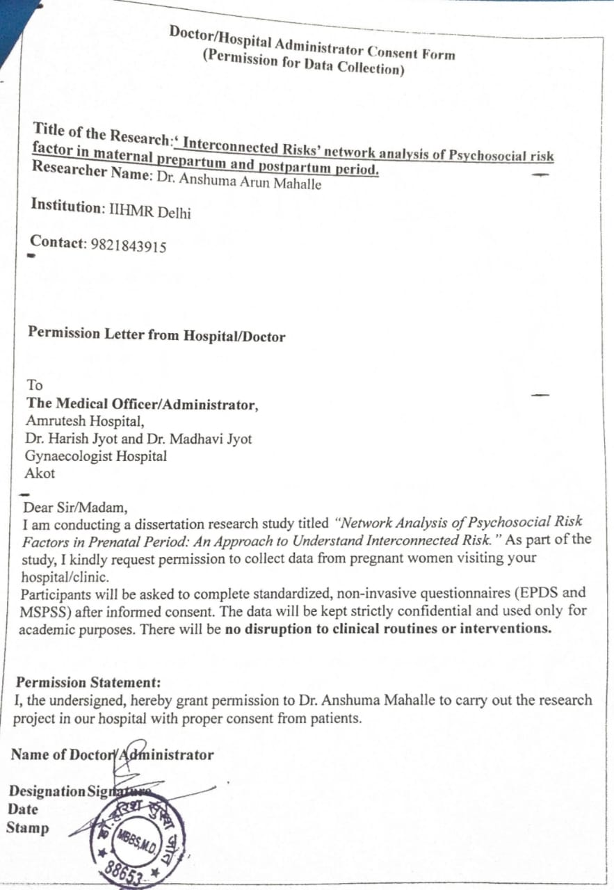

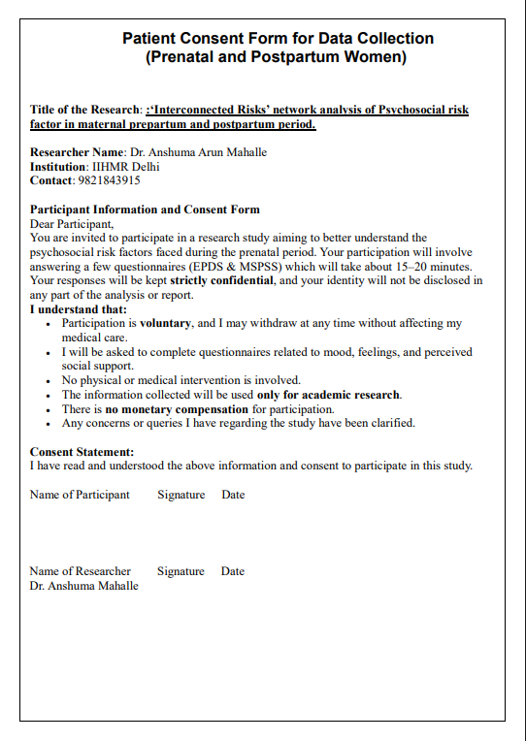
Patient Consent form

Questionnaire

Questionnaire for Prenatal Period Data Collection

Instructions:
This questionnaire is part of a research study on maternal mental health during the prenatal period. Your responses will remain confidential and anonymous. Please answer honestly. There are no right or wrong answers. Respond based on your experience over the past month.
Demographic Questions:
Age: ____________________
Gender: ☐ Female
Education: ____________________
Occupation: ____________________
Weeks of Pregnancy: ____________________
Consent:
I understand that my participation in this research is voluntary. By completing this questionnaire, I consent to the use of my responses for academic research purposes.

Yes
No

Prenatal Psychosocial Profile (PPP) – Self-esteem & Support

Instructions: Please rate your agreement with the following statements.
- My partner is supportive of my pregnancy. (domestic violence)
1 = Strongly disagree
2 = Disagree
3 = Neutral
4 = Agree
5 = Strongly agree

- I have someone I can talk to when I feel down. (isolation)
1 = Strongly disagree
2 = Disagree
3 = Neutral
4 = Agree
5 = Strongly agree

- I feel supported by my family. (support from family)
1 = Strongly disagree
2 = Disagree
3 = Neutral
4 = Agree
5 = Strongly agree

- My friends are available when I need help.
1 = Strongly disagree
2 = Disagree
3 = Neutral
4 = Agree
5 = Strongly agree

- I receive encouragement and reassurance from those close to me. (lack of social support)
1 = Strongly disagree
2 = Disagree
3 = Neutral
4 = Agree
5 = Strongly agree

Prenatal Perceived Stress Scale (PSS - Short Form)
Instructions: Indicate how often you have felt or thought a certain way during the last month.
- In the last month, how often have you felt nervous and stressed? (anxiety ,depression)
0 = Never
1 = Almost Never
2 = Sometimes
3 = Fairly Often
4 = Very Often

- In the last month, how often have you felt that you were unable to control the important things in your life?
0 = Never
1 = Almost Never
2 = Sometimes
3 = Fairly Often
4 = Very Often

- In the last month, how often have you felt that difficulties were piling up so high that you could not overcome them?
0 = Never
1 = Almost Never
2 = Sometimes
3 = Fairly Often
4 = Very Often

- In the last month, how often have you felt confident about your ability to handle personal problems?
0 = Never
1 = Almost Never
2 = Sometimes
3 = Fairly Often
4 = Very Often

- How often have you used substances (such as alcohol, tobacco, or illicit drugs) during your pregnancy to cope with stress or emotional difficulties? ( substance abuse)
0 = Never
1 = Almost Never
2 = Sometimes
3 = Fairly Often
4 = Very Often

Financial Strain Subscale
Instructions: Please rate your agreement with the following statements about your financial situation during pregnancy.
1 = Strongly disagree | 2 = Disagree | 3 = Neutral | 4 = Agree | 5 = Strongly agree

- I am concerned about affording the medical expenses of this pregnancy.
1 = Strongly disagree
2 = Disagree
3 = Neutral
4 = Agree
5 = Strongly agree

- I worry that I do not have enough resources to prepare for the baby.
1 = Strongly disagree
2 = Disagree
3 = Neutral
4 = Agree
5 = Strongly agree

- I have had to postpone or skip antenatal care because of financial issues.
1 = Strongly disagree
2 = Disagree
3 = Neutral
4 = Agree
5 = Strongly agree

- I am financially dependent on others to meet basic pregnancy-related needs.
1 = Strongly disagree
2 = Disagree
3 = Neutral
4 = Agree
5 = Strongly agree

- Financial stress is affecting my emotional well-being during pregnancy
1 = Strongly disagree
2 = Disagree
3 = Neutral
4 = Agree
5 = Strongly agree
Comments or Suggestions:
__________________________________________________________________
__________________________________________________________________
__________________________________________________________________
Thank You
Thank you for taking the time to complete this questionnaire. Your input is valuable and appreciated.

Questionnaire for Postnatal Period Data Collection

Instructions:
This questionnaire is part of a research study on maternal mental health during the Postpartum period. Your responses will remain confidential and anonymous. Please answer honestly. There are no right or wrong answers. Respond based on your experience over the past month.
Demographic Questions:
Age: ____________________
Education: ____________________
Occupation: ____________________
Days after Delivery (Post Partum) : ____________________

Consent:
I understand that my participation in this research is voluntary. By completing this questionnaire, I consent to the use of my responses for academic research purposes.

Yes
No

Edinburgh Postnatal Depression Scale (EPDS)

Instructions: Please check the answer that comes closest to how you have felt in the past 7 days, not just how you feel today.

- I have been able to laugh and see the funny side of things
0 = As much as I always could
1 = Not quite so much now
2 = Not so much now
3 = Not at all

- I have looked forward with enjoyment to things
0 = As much as I ever did
1 = Rather less than I used to
2 = Less than I used to
3 = Hardly at all

- I blamed myself unnecessarily when things went wrong
3 = Yes, most of the time
2= Yes, some of the time
1= Not very often
0 = No, never

- I have been anxious or worried for no good reason.
0 = As usual
1 = Not quite so much
2 = Less
3 = Hardly at all

- I have felt scared or panicky for no very good reason.
0 = As usual
1 = Not quite so much
2 = Less
3 = Hardly at all

- Things have been getting on top of me
3 = Yes, most of the time I haven’t been able to cope
2 = Yes, sometimes I haven’t been coping as well as usual
1 = No, most of the time I have coped quite well
0 = No, I have been coping as well as ever

- I have been so unhappy that I have had difficulty sleeping.
0 = As usual
1 = Not quite so much
2 = Less
3 = Hardly at all

- I have felt sad or miserable.
0 = As usual
1 = Not quite so much
2 = Less
3 = Hardly at all

- I have been so unhappy that I have been crying.
0 = As usual
1 = Not quite so much
2 = Less
3 = Hardly at all

- The thought of harming myself has occurred to me.
0 = As usual
1 = Not quite so much
2 = Less
3 = Hardly at all

Multidimensional Scale of Perceived Social Support (MSPSS)

Instructions: Indicate how strongly you agree with each statement using the scale:
1 = Very strongly disagree with 7 = Very strongly agree

- I have a special person who is around when I am in need.
1=Very strongly disagree
2=Strongly disagree
3=Mildly disagree
4=Neutral
5=Mildly agree
6=Strongly agree
7=Very strongly agree

- My family really tries to help me during my pregnancy.
1=Very strongly disagree
2=Strongly disagree
3=Mildly disagree
4=Neutral
5=Mildly agree
6=Strongly agree
7=Very strongly agree

- I get the emotional help and support I need from my friends.
1=Very strongly disagree
2=Strongly disagree
3=Mildly disagree
4=Neutral
5=Mildly agree
6=Strongly agree
7=Very strongly agree

- I have a special person who is a real source of comfort to me.
1=Very strongly disagree
2=Strongly disagree
3=Mildly disagree
4=Neutral
5=Mildly agree
6=Strongly agree
7=Very strongly agree

- My family is willing to help me make decisions related to my pregnancy.
1=Very strongly disagree
2=Strongly disagree
3=Mildly disagree
4=Neutral
5=Mildly agree
6=Strongly agree
7=Very strongly agree

- I can count on my friends when things go wrong in this phase.
1=Very strongly disagree
2=Strongly disagree
3=Mildly disagree
4=Neutral
5=Mildly agree
6=Strongly agree
7=Very strongly agree

- I have a special person with whom I can share my joys and sorrows.
1=Very strongly disagree
2=Strongly disagree
3=Mildly disagree
4=Neutral
5=Mildly agree
6=Strongly agree
7=Very strongly agree

- My family is supportive of my pregnancy decisions.
1=Very strongly disagree
2=Strongly disagree
3=Mildly disagree
4=Neutral
5=Mildly agree
6=Strongly agree
7=Very strongly agree

- My friends really try to help me cope with pregnancy stress.
1=Very strongly disagree
2=Strongly disagree
3=Mildly disagree
4=Neutral
5=Mildly agree
6=Strongly agree
7=Very strongly agree

- I can talk about my problems with my special person.
1=Very strongly disagree
2=Strongly disagree
3=Mildly disagree
4=Neutral
5=Mildly agree
6=Strongly agree
7=Very strongly agree

- My family helps me feel that I am not alone.
1=Very strongly disagree
2=Strongly disagree
3=Mildly disagree
4=Neutral
5=Mildly agree
6=Strongly agree
7=Very strongly agree

- I can share my concerns with friends during pregnancy.
1=Very strongly disagree
2=Strongly disagree
3=Mildly disagree
4=Neutral
5=Mildly agree
6=Strongly agree
7=Very strongly agree

Financial Strain Subscale

Instructions: Please rate your agreement with the following statements. Use the scale:

- I worry about having enough money to cover basic needs (e.g., food, housing, baby supplies).
1= Strongly disagree
2 = Disagree
3 = Neutral
4 = Agree
5 = Strongly agree

- I feel financially overwhelmed by the costs of caring for my baby.
1= Strongly disagree
2 = Disagree
3 = Neutral
4 = Agree
5 = Strongly agree
- I have had to delay or avoid healthcare appointments because of financial constraints.
1= Strongly disagree
2 = Disagree
3 = Neutral
4 = Agree
5 = Strongly agree

Comments or Suggestions:
________________________________________________________________
________________________________________________________________
_______________________________________________________________

Thank You
Thank you for taking the time to complete this questionnaire. Your input is valuable and appreciated.

