Dissertation Training

at

TrioTree Technologies Pvt. Ltd.

A Comparative Study of Indian and Omani Healthcare Systems: Insights and Recommendations from Migrant Indian Doctors

by

Sweksha Gupta

PG/23/121

Under the guidance of

Dr. Ratika Samtani

Associate Professor


PGDM (Hospital & Health Management) 2023-25

International Institute of Health Management Research

New Delhi

Internship Training at

Trio Tree Technologies Pvt. Ltd.

A Comparative Study of Indian and Omani Healthcare Systems: Insights and Recommendations from Migrant Indian Doctors

by

Sweksha Gupta PG/23/121
Under the guidance of

Dr. Ratika Samtani

Associate Professor

PGDM (Hospital & Health Management) 2023-25

International Institute of Health Management Research New Delhi

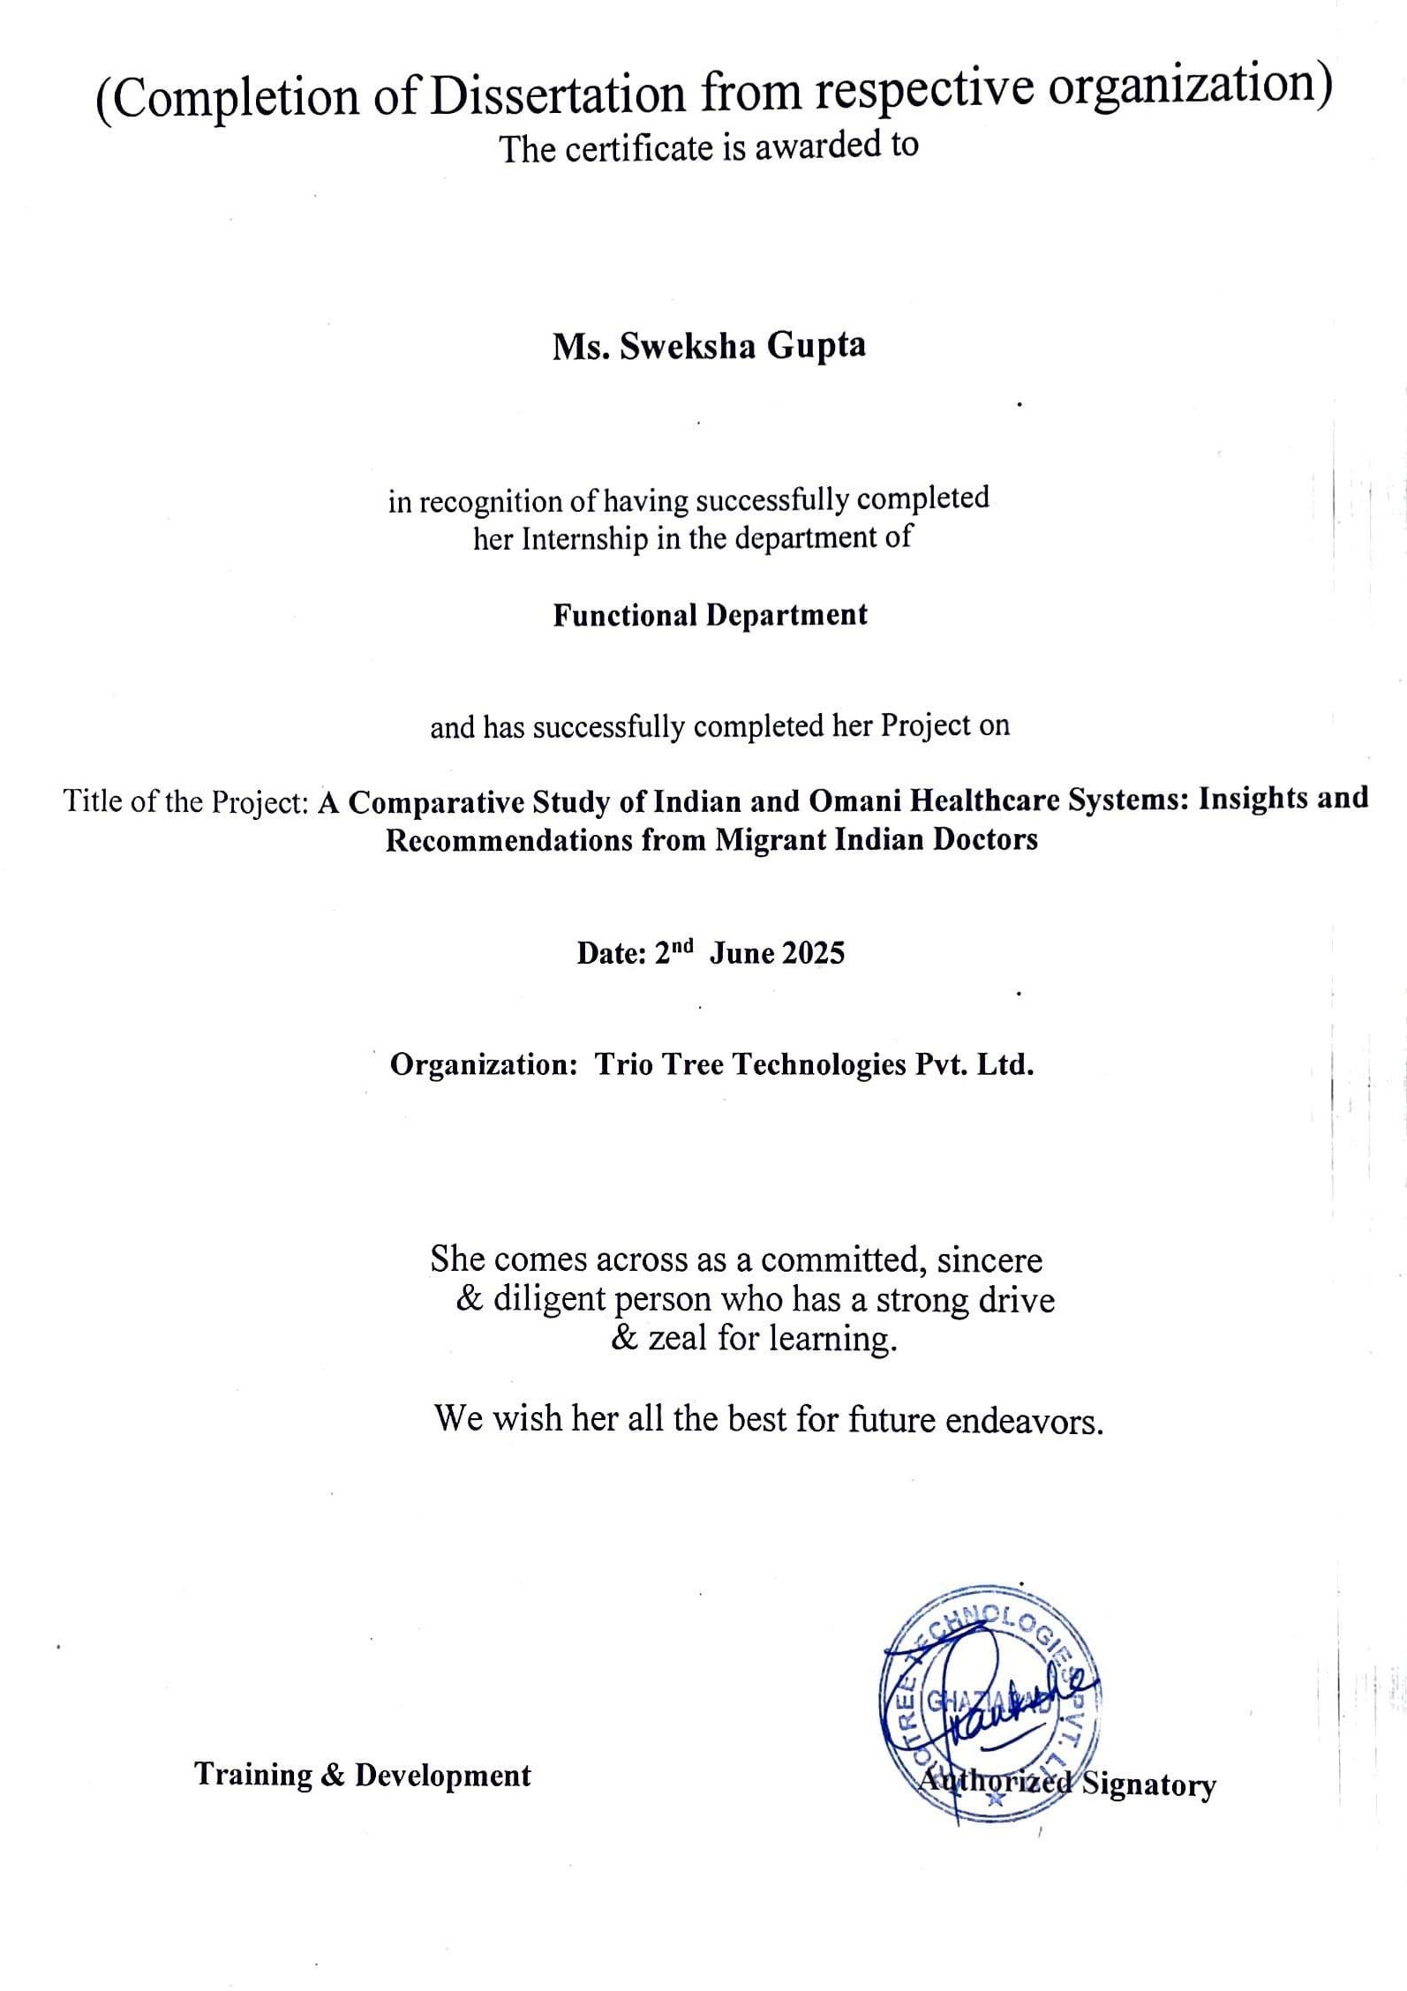

TO WHOMSOEVER IT MAY CONCERN

This is to certify that Sweksha Gupta student of PGDM (Hospital & Health Management) from International Institute of Health Management Research, New Delhi has undergone internship training at TrioTree Technologies Pvt. Ltd. from 02nd April 2025 to 02nd June 2025.

The Candidate has successfully carried out the study designated to her during internship training and her approach to the study has been sincere, scientific and analytical.
The Internship is in fulfillment of the course requirements. I wish her all success in all her future endeavors.
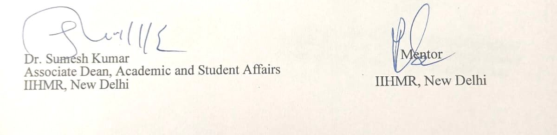

Certificate of Approval

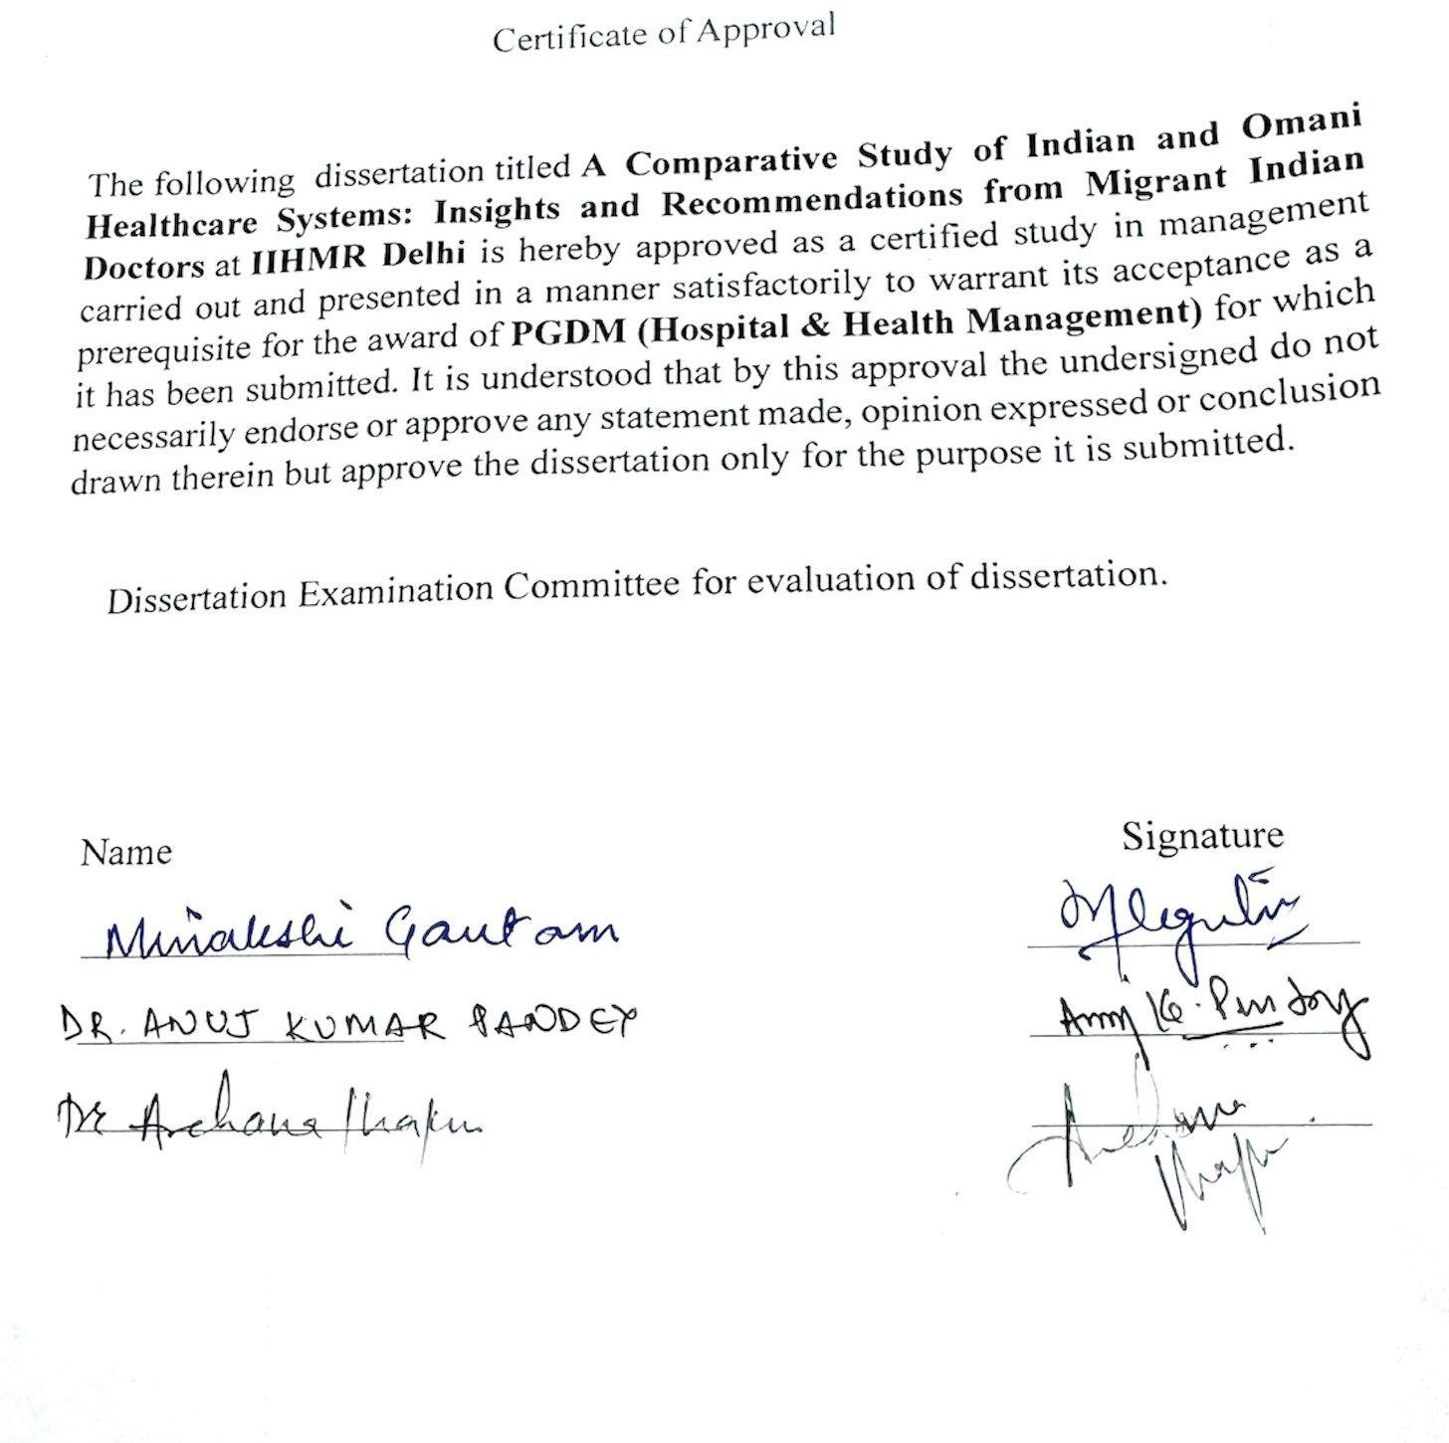

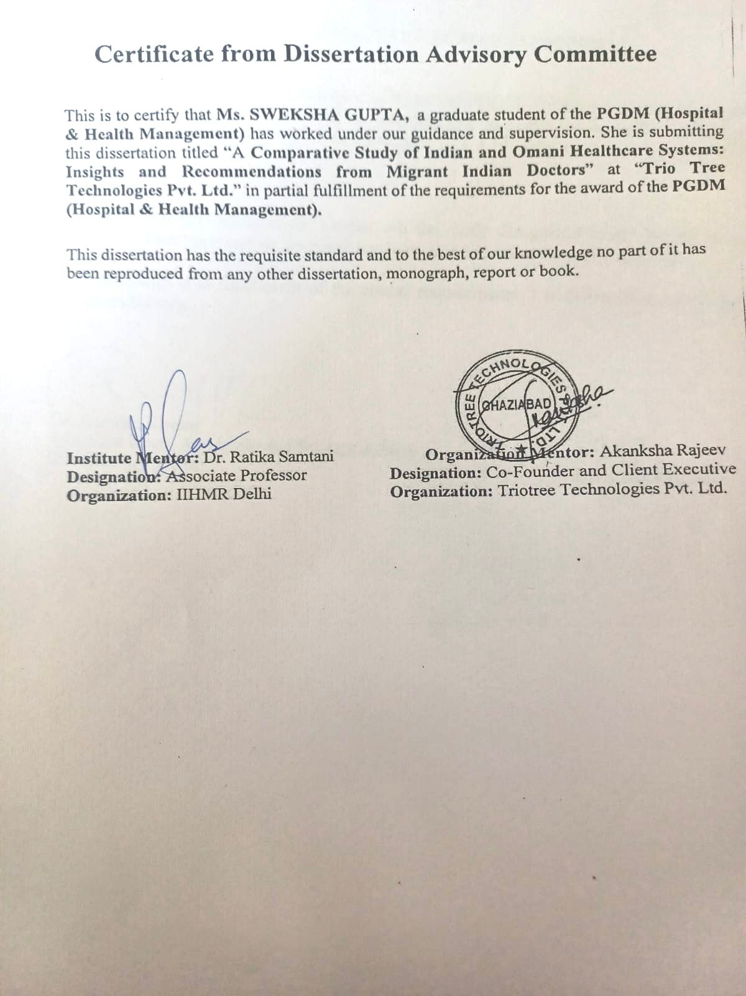

INTERNATIONAL INSTITUTE OF HEALTH MANAGEMENT RESEARCH, NEW DELHI

CERTIFICATE BY SCHOLAR

This is to certify that the dissertation titled “A Comparative Study of Indian and Omani Healthcare Systems: Insights and Recommendations from Migrant Indian Doctors”
and submitted by Sweksha Gupta Enrollment No. PG/23/121 under the supervision of Dr. Ratika Samtani for award of PGDM (Hospital & Health Management) of the Institute
carried out during the period from 02nd April 2025 to 02nd June 2025 embodies my original work and has not formed the basis for the award of any degree, diploma associate ship, fellowship, titles in this or any other Institute or other similar institution of higher learning.



Signature

FEEDBACK FORM

Name of the Student: SWEKSHA GUPTA
Name of the Organisation in Which Dissertation Has Been Completed: Triotree Technologies Pvt. Ltd.

Area of Dissertation: The dissertation focused on a comparative analysis of Indian and Omani healthcare systems through the perspectives of migrant Indian doctors, with particular emphasis on patient care delivery, system efficiency, infrastructure, and digital health transformation.

Attendance: 100%
Objectives achieved: During the course of the dissertation, the student successfully conducted qualitative interviews with migrant Indian doctors working in Oman, gathered comparative insights on healthcare delivery, infrastructure, and technological advancements in both countries, and analysed the collected data to identify gaps, strengths, and opportunities for improvement in each healthcare system. The work culminated in the preparation of actionable recommendations for policymakers and healthcare stakeholders.

Deliverables: The dissertation resulted in a comprehensive report containing an in-depth literature review, detailed methodology, key findings, and recommendations. Additional deliverables included interview transcripts, thematic analysis of responses, and a structured comparative framework highlighting the main differences and similarities between the Indian and Omani healthcare systems.

Strengths: The student demonstrated strong research and analytical skills with exceptional attention to detail, along with excellent communication abilities while conducting interviews and engaging with healthcare professionals. She exhibited the capacity to synthesize extensive qualitative data into meaningful insights and maintained a professional work ethic with adaptability to organizational requirements.

Suggestions for Improvement: The dissertation could be further enhanced by incorporating quantitative data to complement the qualitative findings, thereby providing a more holistic analysis. In addition, expanding the sample size to include a broader representation from both public and private healthcare sectors could add greater depth to the study.

Suggestions for Institute (course curriculum, industry interaction, placement, alumni):
It is recommended that the institute provide more opportunities for international exposure and cross-country healthcare research, strengthen partnerships with global healthcare organisations to facilitate internships and fieldwork


Date: 05/07/2025 Place: Triotree Technologies Pvt. Ltd.

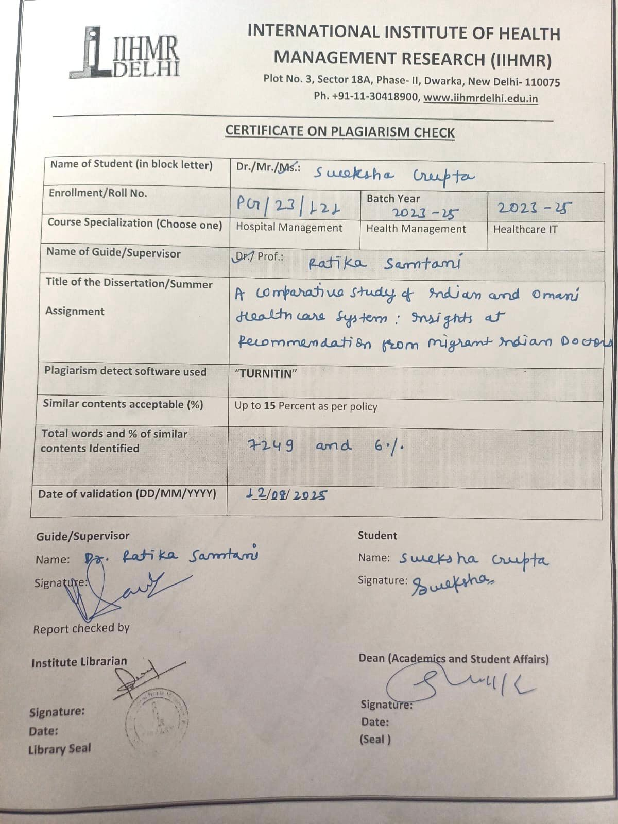

ABSTRACT

This qualitative study examines the professional experiences of Indian-origin physicians who have practiced in both India and Oman, with the aim of understanding how structural and operational differences influence clinical practice. India is often noted for its high-volume tertiary care and strong clinical expertise, whereas Oman is recognized for its organized service delivery, advanced digital integration, and balanced workloads. To explore these distinctions, in-depth semi-structured interviews were conducted with ten physicians who had substantial clinical exposure in both countries. The interview framework allowed participants to provide detailed reflections on their work environments, decision-making autonomy, patient interactions, and operational challenges.

Thematic analysis was applied to identify recurrent patterns and system-level insights. Findings revealed clear contrasts in areas such as healthcare infrastructure, scope for clinical judgment, reliance on technology, workload distribution, and administrative culture. In the Indian context, participants described an environment rich in learning opportunities but hindered by resource constraints and considerable administrative responsibilities. By comparison, practice in Oman was characterized by streamlined workflows, user-friendly digital systems, and greater time for patient engagement, alongside reported benefits in work-life balance.

The perspectives gathered offer actionable implications for health system improvement in both settings. For India, investments in digital infrastructure and simplification of documentation processes could enhance efficiency and mitigate clinician fatigue. For Oman, expanding specialized clinical services and advanced training programs could strengthen service breadth. More broadly, the study underscores the importance of incorporating frontline practitioner perspectives into policy development to ensure reforms are both operationally feasible and contextually relevant. Although the scope was limited by a small purposive sample and the absence of non-physician viewpoints, the study contributes valuable comparative insights to guide strategies for sustainable, responsive, and human-centered healthcare systems.

ACKNOWLEDGEMENT

It is with great pleasure that I present this dissertation report, and I extend my heartfelt gratitude to everyone who has supported me throughout this journey.

My time at TrioTree Technologies Pvt. Ltd. has been an invaluable opportunity for learning and professional growth. I consider myself truly fortunate to have been a part of this esteemed organization. The experience allowed me to work alongside remarkable individuals and professionals whose guidance and encouragement were instrumental in my development.

I would like to express my deepest appreciation to Ms. Akanksha Rajeev (Co-Founder and Client Executive, TrioTree Technologies), who, despite her demanding responsibilities, kindly took the time to listen, guide, and steer me in the right direction. Her mentorship and support throughout my project and training have been truly inspiring.

I am equally grateful to Dr. Sutapa Bandyopadhyay Neogi (Director, IIHMR Delhi) and my mentor Dr. Ratika Samtani (Associate Professor, IIHMR Delhi) for their invaluable guidance, both theoretical and practical, which significantly enriched my study. Their insights and encouragement have played a vital role in the successful completion of this work.

I would like to give my special thanks to Dr. Avish Sethi for all the help, guidance, and support that made this dissertation possible

Finally, I would like to express my heartfelt thanks to my family and friends for their unwavering support, constant encouragement, and belief in me, which kept me motivated throughout this journey.

Sincerely, Sweksha Gupta

TABLE OF CONTENT

Organization Profile 12
Introduction 19
Objectives 22
Literature Review 23
Methodology 27
Data collection process 30
Interview Guide 31
Data Analysis Process 33
Result 34
Discussion Error! Bookmark not defined.
Limitations 40
Conclusion 41
Reference 42

Organization Profile

Trio Tree Technologies Pvt. Ltd., established in 2012 and headquartered in Noida, India, is a health IT firm providing comprehensive digital platforms tailored to hospitals and healthcare networks. Serving over 175 clients across India, the Middle East, Africa, and Southeast Asia, the company specializes in integrated hospital information systems (HIS). Its flagship product, HIS Tree, offers modular and scalable tools covering clinical, administrative, and financial domains. The platform is designed for interoperability and usability, with options for both on-premises and SaaS-based deployments. Real-time analytics, physician-centric interfaces, and multilingual documentation support are among its key features.

Their Flagship product, HIS Tree, is a comprehensive physician-driven platform that reimagines hospital operations through Clinical depth, workflow automation, and real-time intelligence. The solution is built with deep understanding of hospital ecosystems and enables healthcare organizations to move away from fragmented tools toward a unified and interoperable digital infrastructure.

HIS Tree is Trio Tree’s end-to-end digital hospital management platform. It spans that entire operational and clinical spectrum, integrating various departments including outpatient, inpatient, diagnostics, pharmacy, finance, OT, ICU, emergency, housekeeping, MRD, and more.

The solution follows a modular microservices architecture, meaning hospitals can choose and implement only the components they need, while ensuring interoperability and smooth data flow.

HIS Tree is different from competition because it is:

- Developed with and for physicians to ensure real-world usability.

- Highly configurable workflows for each clinical specialty.

- Deployable both on premises and on cloud.
- Powered by real-time dashboards, alerts, and clinical insights.
- Seamless Clinical-Administrative Integration
- Flexible deployment in both Private and Government Setups

- Interoperability through HL7, PACS, LIS, and Biometric Integration
- Configurable workflows tailored to department-specific use cases
- Support for Clinical Decision-making and patient safety

While HIS Tree can be deployed on-premises, Trio Tree is increasingly offering its solutions in a SaaS model to support scalable, flexible, and cost-efficient implementations.

SaaS Benefits:

- Hospitals pay a fixed monthly fee.
- No need to invest in local servers or maintenance staff.
- Real-time Backups, zero downtime, and auto-updates.

- Centralized access across hospital branches and geographies.
- Fully cloud-enabled, with API-based integrations and data lakes.

The platform supports clinical, financial, administrative, and analytical functions, all with multitenancy, interoperability, and data security.

Trio Tree continues to expand its footprint across India, Middle East, Africa, and Southeast Asia, driven by a vision of enabling affordable and quality healthcare through intelligent digital systems. The company’s R&D team is actively working on:

- AI-powered voice-based clinical templates
- Multilingual documentation tools

- Smart hospital automation
- Digital consent systems
- IoT-based vitals integration

Trio Tree Technologies Pvt. Ltd. stands at the forefront of healthcare digital transformation, offering a well- orchestrated platform that merges clinical intuitiveness, technical scalability, and modular flexibility. With HIS Tree, Mobi HIS Tree, and their KIOSK systems, Trio Tree is empowering hospitals to deliver seamless, efficient, and patient-centered care across multiple settings and geographies.

To understand more, we must learn what SaaS is:

Software as a Service (SaaS) represents a delivery model where applications are accessed via the internet, eliminating the need for local installation or extensive IT maintenance. In healthcare, SaaS facilitates centralized digital systems, such as EMRs, that streamline clinical workflows and data management. This model enables healthcare institutions to benefit from automated updates, remote accessibility, and enhanced scalability. By using cloud-based systems, providers gain unified patient profiles, improved data integration, and operational efficiency, while minimizing infrastructure costs.

The healthcare business has begun to employ SaaS to manage EMR to automate EMR technology maintenance and improve usability while reducing the burden on in-house IT workers. Furthermore, using cloud-based data management technologies to implement EMR improves Scalability.

When you use EMR as a SaaS, you get a single data lake, which is a pool where all your medical records are stored. The benefit of interoperability is that it ensures that the system can deliver a single view of the patient profile to doctors and other stakeholders. This advantage enables firms to properly utilize data and optimize processes to achieve a higher return on investment (ROI). SaaS EMR enables stakeholders in the healthcare industry, including medical practitioners, to scale operations without having to manually manage health

records, prescriptions, and other useful data. Furthermore, SaaS eliminates the need for precise reporting by transforming raw data into a user-friendly storehouse.

Product of Trio Tree:

- The HIS Tree platform includes a wide range of modules to support end-to-end hospital operations. These include:

  - Physician Module: Central platform for doctors to view patient history, enter clinical notes, place orders (labs, drugs, imaging), and discharge summaries.
  - OPD/ IPD Nursing: Records patient vitals, care plans, medication administration, and progress notes in real-time.
  - Lab Medicine & Diagnostics: Integrated modules for managing lab workflows, result entry, analyzer interfacing, and report publishing.
  - ICU: Captures critical parameters, device integration, daily rounds, and multi-hour clinical tracking.
  - Operation Theatre (OT): Schedule surgeries, capture intra-operative events, record anesthesia notes, manage instruments, and sterilization.
  - Discharge Summary: Auto-population yet editable format that includes diagnoses, clinical summary, medication, and follow-up advice.
  - Templates: Ready-made clinical documentation templates to reduce repetition and support structured medical records.
  - Incident Report: Captures medication errors, patient falls, device failures, etc., for root cause analysis and patient safety.
  - ADT (Admission, Discharge, Transfer): Seamlessly tracks patient movements and room assignments across departments.

  - Front Office: Handles patient registration, appointment scheduling, token generation, and inquiry resolution.
  - Pre-Admission & Daycare: Manages pre-surgical approvals and daycare procedures for short-stay services like chemotherapy, dialysis, or Minor Surgeries.
  - Emergency: Records Triage, Initial Assessment, ER prescriptions, transfer/ admission from ER, and medico-legal cases.
  - Diet & Kitchen: Assigns diet orders, tracks meal preferences and allergies, and links with kitchen workflows.
  - Housekeeping & Biomedical: Ensures bed readiness, infection control, equipment maintenance, and service logs.
  - Sample collection & Transfusion Medicine: Manages sample barcoding, blood bank inventory, donor information, and transfusion logging.
  - Rehabilitation: Captures therapy sessions (physio, OT, Speech) and patient progress documentation.
  - Billing (OPD, IPD, Emergency): Captures all patient charges automatically and integrates with insurance and TPA processing.
  - A/R (Accounts Receivable): Manages receivables, collections, and outstanding dues from various payers.
  - Package & Plans: Configures bundled service plans, corporate tariffs, insurance packages, and government schemes.
  - Pharmacy: Drug inventory, prescription integration, stock alerts, purchase order automation, and narcotics tracking.
  - Inventory & Asset Management: Tracks hospital supplies, reorder levels, purchase cycles, and maintenance of assets.
  - MIS Reports: Offers executive dashboards and real-time key performance indicators (KPIs) for informed decision making.

  - MRD (Medical Records Department): Digitized central repository for scanned patient records, consents, MLC files, and discharge summaries.
  - HL7 Manager: Enables secure messaging and integration with external systems like PACS, LIS, and third-party ERPs.
  - Security Module: Role-based access control (RBAC), audit trails, and HIPAA-complaint user authorization.

Mobile App: Mobi HIS-Tree

Mobi HIS Tree, the mobile extension of the HIS platform, allows clinicians to manage core activities from their smartphones. It supports patient lookups, order entry, and quick clinical updates, especially useful during ward rounds and emergencies.

Self-Service KIOSKs have been deployed at hospitals to enhance patient experience by enabling digital check- ins, appointment booking, and billing. These systems aim to reduce administrative load and waiting times, aligning with contactless service models.

KIOSK: Patient Self-Registration Portal

To further digitalize the patient journey, Trio Tree deploys self-service KIOSKs at client hospitals. These touch screen kiosks help reduce crowding and improve patient convenience by enabling:

  - New & returning patient registration
  - Real-time appointment booking

  - Queue number generation
  - Payment and Slip printing
  - Patient ID card generation

This not only shortens patient waiting times but also reduces front-office dependency and enables touchless workflows-especially useful post-COVID.

While HIS Tree can be deployed on-premises, Trio Tree is increasingly offering its solutions in a SaaS model to support scalable, flexible, and cost-efficient implementations.

  - Hospitals pay a fixed monthly fee
  - No need to invest in local servers or maintenance staff

  - Real-time backups, zero downtime, and auto-updates
  - Centralized access across hospital branches and geographies
  - Fully cloud-enabled, with API-based integrations and data lakes

The platform supports clinical, financial, administrative, and analytical functions, all with multitenancy, interoperability and data security.

Introduction

Healthcare systems across the world are shaped by diverse socio-economic, cultural, and policy contexts. It reflects the interplay between policy, institutional structures, cultural values, and the experiences of those who work within it. In settings where reforms are underway, such as India, healthcare providers often find themselves at the junction of evolving expectations, technological mandates, and community needs. As the country rolls out programs like Ayushman Bharat and digital health initiatives, it becomes increasingly important to understand how these systemic changes shape the daily lives and professional decisions of clinicians. This study centres the experiences of such providers to reveal how policy ambitions translate into lived realities in healthcare settings.

India operates a bifurcated healthcare system in which public services struggle to provide consistent quality and access, while the private sector expands rapidly but with limited regulation. Although programs designed to expand access and financial protection are advancing, persistent challenges remain. Inadequate infrastructure, workforce shortages, uneven geographical distribution of medical personnel, and high out-of- pocket spending continue to limit equity and efficiency. ^{(1,2)} Alongside these operational barriers, the rapid implementation of digital health platforms often places additional burdens on clinicians who must navigate new documentation requirements without sufficient training or infrastructure support, contributing to stress and administrative fatigue. ^{(2,3)} Research has shown that poorly integrated digital systems can unintentionally erode provider autonomy and detract from patient interaction, ^{(3,4)} underscoring the need to investigate these changes from the provider perspective.

By contrast, Oman has developed a publicly funded and centrally administered health system characterized by near-universal access for citizens, well-established primary care networks, and strong performance in maternal and child health metrics. ⁽⁴⁻⁶⁾ Omani healthcare facilities benefit from consistent funding, a growing national health workforce, and ongoing alignment with long-term development goals like Vision 2040. This system prioritizes structured workflows, standardized protocols, and regulated quality improvement measures. However, qualitative research in Oman indicates that even in well-resourced environments, providers may experience gaps in training, coordination, and collaborative decision-making. ^{(7,8)} Understanding how clinicians perceive these organizational structures, their own roles, and the trade-offs they navigate remains underexplored.

Respondents in this study include Indian-trained clinicians now working in Oman. Their unique cross-national trajectories position them to compare system structures, patient expectations, clinical norms, and digital platforms with depth and nuance. The literature on physician mobility teaches that such practitioners often undergo reflective transitions. Exposure to contrasting systems can lead to critical insights regarding resource allocation, governance mechanisms, care quality, and professional autonomy. ^{(9,10)} These transitions are not only professional; they are experiential, capturing the meaning of health system design through provider practice.

Through a qualitative lens, this research explores themes such as clinical autonomy, workload, digital workflows, cultural communication, infrastructure reliability, and emotional labour. By focusing on lived experience, the study shifts attention from macro-level indicators to the relational and operational realities shaping care delivery. This addresses an evident gap in comparative research, particularly within the Global South, where health worker migration is both a challenge and a learning opportunity for health systems strengthening.

Such comparative provider narratives are especially valuable in the current context, as health systems around the world rebuild and recalibrate following the COVID-19 pandemic. The pandemic revealed vulnerabilities

in supply chains, digital readiness, workforce resilience, and emotional well-being of providers. ^{(11,12)} Respondents who have practiced in both high-pressure environments and more structured care settings offer firsthand insight into how system context shapes provider satisfaction, clinical adaptability, and patient outcomes.

The qualitative methodology employed in this study allowed respondents to share both their challenges and motivations. Interviewees reflected on how system design, leadership, peer relationships, patient expectations, and digital tools influence their practice. Their narratives provide concrete illustrations of how reforms can align with or disrupt healthcare delivery. Findings from similar qualitative inquiries in Oman and India reflect concerns about interoperability, infrastructure reliability, emotional strain, and the tension between patient volume and compassionate care. ^{(13,14)}

This work contributes to the broader health policy and health systems research discourse by centering the practitioner voice. It complements epidemiological and financial assessments of health systems with relational, ethical, and experiential dimensions of care. Insights from this study can inform policy design, workforce planning, digital health implementation, and leadership development in both home and host countries. These narratives offer a bridge between technical reforms and the human experience of delivering care, revealing where policies succeed and where they fall short.

Placing the experiences of healthcare professionals at the core of its analysis, this study advances a more human-centered and context-aware perspective on strengthening health systems. The conclusions align with a growing body of thought that underscores the importance of inclusive governance, compassionate leadership, improved digital competencies, and reform processes that actively involve stakeholders. Drawing upon the first-hand accounts of practitioners who have served in both India and Oman, the work provides grounded, practice-based insights into navigating the complexities of different health system environments. These observations are not only relevant for the two nations examined but also carry value for other countries

aiming to combine modernization with compassion, ensuring that reforms remain effective while reflecting the everyday realities of those responsible for delivering care.

Objectives

- To understand and document the experiences of respondents who have practiced in both India and Oman, with a particular focus on how healthcare systems in each setting operate in practice.
- To examine and compare differences in health infrastructure, approaches to patient care, and working conditions across the two countries, identifying factors that shape these variations.
- To gather insights into system strengths and challenges as perceived by respondents.
- To suggest recommendations for healthcare improvements based on cross-country learnings.

Literature Review

Ayushman Bharat: Strengthening the health system through two pillars

Kumar R, et al. (2020), The Lancet Public Health

Kumar and colleagues describe Ayushman Bharat as a dual-pillar strategy aimed at closing critical healthcare gaps in India. The first pillar, Health and Wellness Centres (HWCs), is designed to strengthen primary care by moving beyond the traditional focus on maternal and child health to include noncommunicable diseases and mental health services. The second pillar, the Pradhan Mantri Jan Arogya Yojana (PM-JAY), offers financial protection for hospital care to the poorest 40% of the population. While the vision is ambitious, the authors note that meaningful progress will require stronger integration between the two components, investment in workforce skills, and robust health information systems. They argue that only by aligning these elements can India move closer to universal health coverage.

Impact of India’s publicly financed health insurance scheme on public sector district hospitals:

a health financing perspective

Prinja S, et al. (2022), Lancet Reg Health Southeast Asia

In this review, Prinja and colleagues evaluate the financial reform measures brought in through PM- JAY and similar schemes. Despite broader coverage, they find that high out-of-pocket costs persist, especially for vulnerable households. The authors recommend raising public health expenditure to at least 2.5% of GDP and restructuring purchasing mechanisms to ensure services are equitable and of good quality. They highlight the importance of building strong governance systems, enhancing data

transparency, and targeting underserved populations. Without such structural changes, they warn, insurance schemes risk having a limited impact on health equity and population health outcomes.

Oman Health System Review

World Health Organization (2020), Health Systems in Transition Series

The WHO’s comprehensive review presents Oman as a country with a tax-funded, centrally managed health system that delivers wide access to essential care. Strong investment in primary health care and integrated service delivery has been a hallmark of its success. Nevertheless, the review points to challenges, including an increasing burden of noncommunicable diseases and limited involvement of the private sector. Recommendations include diversifying service provision, improving digital health infrastructure, and ensuring long-term financial sustainability. The report also stresses the importance of workforce training and leadership development to maintain quality as the system evolves.

Prevalence of risk factors of non-communicable diseases in the Sultanate of Oman

Adhra Al-Mawali, et al. (2021), PLoS One

Al-Mawali and co-authors examine the rising prevalence of lifestyle-related conditions such as obesity, cardiovascular disease, and diabetes in Oman. They attribute this trend to rapid urbanisation, dietary changes, and sedentary lifestyles. The government has initiated screening and prevention programs, integrated NCD management into primary care, and promoted healthy lifestyle campaigns. However, the paper identifies gaps in cross-sectoral coordination and in translating policy into action. The authors call for a comprehensive, data-driven prevention strategy that engages multiple sectors, from education to urban planning, in addressing the growing NCD challenge.

Compassion in Health Care: An Empirical Model

Sinclair S, et al. (2016), Journal of Pain and Symptom Management
Sinclair and colleagues develop an evidence-based framework for understanding compassion in healthcare settings. Drawing from in-depth interviews, they describe compassion as more than just empathy, it is an active, intentional process of recognising suffering, connecting emotionally, and

taking meaningful action to alleviate it. Both personal qualities, such as emotional awareness, and external influences, such as supportive organisational culture and training, play a role in enabling compassionate care. The study underscores that compassion can be nurtured and embedded into institutional practices, improving patient trust and satisfaction.

Trust and the development of health care as a social institution

Gilson L. (2003), Social Science & Medicine

Gilson’s work highlights trust as an essential building block for strong and equitable health systems. She differentiates between interpersonal trust, built between patients and providers, and institutional trust, which reflects public confidence in the health system as a whole. The paper explores how governance, provider behaviour, transparency, and fairness influence trust, especially in low- and middle-income countries. Gilson argues that cultivating trust requires more than clinical competence, it also demands open communication, respectful care, and consistent community engagement to bridge gaps in perception and experience.

Workload and emotional fatigue among health care providers: A mixed-method study

National Institutes of Health (2021), BMC Health Services Research

This mixed-methods research investigates how heavy workloads, inadequate staffing, and administrative demands contribute to burnout among healthcare professionals. The quantitative results reveal high levels of emotional exhaustion, while qualitative accounts illustrate the strain these pressures place on judgment, compassion, and patient interaction. The authors stress the need for systemic interventions, including flexible work arrangements, peer support networks, and ready access to mental health services. They also emphasise that leadership must actively prioritise staff well-being to protect both provider performance and patient safety.

Organizational strategies to reduce physician burnout

De Simone S, et al. (2021), Aging Clinical and Experimental Research
De Simone and colleagues present practical, organisation-wide approaches to prevent and reduce physician burnout. They note that burnout is often rooted in systemic issues such as excessive

administrative work, insufficient autonomy, and weak institutional support. Effective strategies include redesigning clinical workflows, sharing responsibilities through team-based care models, and embedding well-being initiatives into everyday operations. The paper asserts that tackling burnout requires cultural and structural change, led by committed leadership, rather than placing the burden solely on individual resilience.

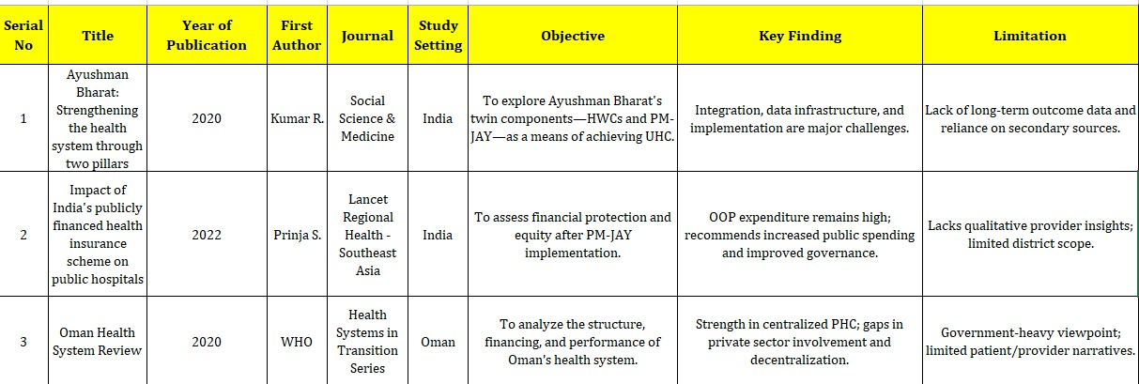

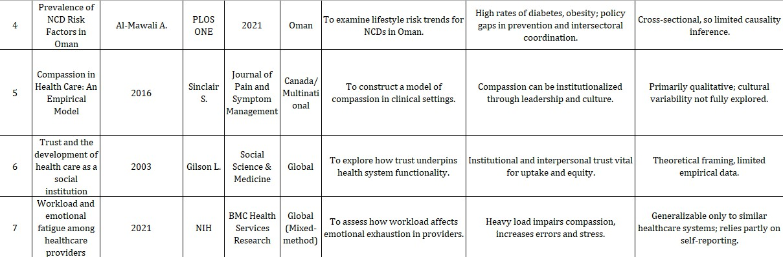

Methodology

Study Design

This investigation was conducted as a qualitative, exploratory study, chosen to capture in-depth accounts of professional experience rather than quantify outcomes. Such a design is well-suited for topics where empirical literature is limited, and the nuances of individual perspectives are central to understanding the research problem. The exploratory approach provided the flexibility to probe unexpected themes and to capture the complexity of comparative experiences between two national healthcare contexts.

Study Setting

Fieldwork took place in a multispecialty hospital in Oman, an environment that enabled access to Indian- origin clinicians working across diverse specialties. Conducting the research in this setting allowed for the inclusion of perspectives spanning primary, secondary, and tertiary care, thereby strengthening the breadth of system-level observations.

Participants

The study engaged ten physicians who were actively practicing in Oman and had prior professional experience in India. This dual exposure positioned them as particularly valuable informants for examining contrasts in infrastructure, clinical governance, and day-to-day workflows between the two countries.

Sampling Strategy

A purposive sampling technique was applied, deliberately targeting participants with the specific background required to address the study aims. Selection criteria focused on ensuring that each participant had substantial clinical exposure in both settings, thus increasing the relevance and depth of the insights obtained.

Inclusion Criteria

Eligible participants were:

  - Currently employed in a clinical role in Oman.

  - Possessing a minimum of one year of clinical experience in India prior to migration.

  - Willing to provide voluntary informed consent and participate in an in-person interview.

Exclusion Criteria

The study excluded:

  - Professionals without prior clinical practice in India.
  - Non-clinical health workers (e.g., administrators, laboratory staff, IT specialists) whose roles did not involve direct patient care.

This ensured the dataset remained focused on physicians’ first-hand clinical experiences.

Data Collection Tool

A semi-structured interview guide was used, balancing a set of predefined open-ended questions with the flexibility to pursue emerging topics raised by respondents. This format encouraged narrative responses and enabled participants to reflect on their personal experiences in detail.

Data Collection Procedure

All interviews were conducted face-to-face by the primary researcher. This approach facilitated rapport- building, allowed clarification of ambiguous responses, and enabled the observation of non-verbal communication, which enriched the interpretation of the data.

Data Analysis

Data were processed using thematic analysis, guided by the six-phase framework proposed by Braun and Clarke (2006):

- Familiarisation – Immersion in the transcripts through repeated reading.

- Initial Coding – Identification and labelling of meaningful data segments.

- Theme Development – Grouping related codes into broader conceptual themes.

- Theme Review – Checking coherence within themes and against the dataset.

- Theme Definition and Naming – Refining and articulating the scope of each theme.

- Report Preparation – Integrating themes into a structured narrative aligned with the research objectives.

This method allowed for a systematic yet flexible interpretation of participant accounts, ensuring that the resulting themes were grounded in the lived experiences shared during interviews.

COMPONENT | DETAILS
Study Design | Qualitative, exploratory research
Study Setting | Multispecialty Hospital, Oman
Respondents | 10 respondents currently practicing in Oman with  prior clinical experience in India
Sampling Method | Purposive selection
Inclusion criteria | - Respondents currently engaged in clinical practice in Oman  - Minimum one year of prior clinical experience in India  - Willingness to participate and provide informed consent

Exclusion criteria | - Respondents without prior clinical experience in India  - Non-clinical healthcare professionals
Data Collection Tool | Semi-structured open-ended interviews
Data Collection Mode | In-person interviews conducted by the  researcher.
Data Analysis Method | Thematic analysis based on Braun and Clarke’s  (2006) framework

Figure 1: Summary of study methodology

DATA COLLECTION PROCESS

  - Respondents were identified from among the clinical staff at a multispecialty hospital in Oman, specifically doctors with prior practice experience in India.
  - After obtaining informed consent, semi-structured, open-ended interviews were conducted in person, each lasting approximately 20 to 30 minutes.
  - With the respondent’s permission, all interviews were audio-recorded and subsequently transcribed for thematic analysis.
  - An interview guide comprising eight main thematic questions, each supported by probing questions was used.
  - The guide broadly explored experiences related to healthcare delivery, infrastructure, clinical autonomy, cultural interactions, and doctor–patient dynamics in both the Indian and Omani healthcare systems.

INTERVIEW GUIDE

This section presents the oral consent taken from the respondent and the subsequent interview questions.

Consent

Good morning/afternoon. My name is Sweksha Gupta, and I am a Post Graduate student in MBA Hospital and Health Management from IIHMR Delhi.

I am conducting a study to understand the experiences of doctors who have worked both in India and now in Oman. The purpose is to explore differences in healthcare infrastructure, patient care, and working conditions, and to gather insights that could help improve healthcare systems.

Your participation is completely voluntary. You can refuse or withdraw at any time without giving a reason. Everything you share will be kept confidential, and your name or identity will not be mentioned anywhere.

The conversation will take around 20 to 30 minutes. With your permission, I would also like to record our discussion. The recording will only be used for academic purposes and will be deleted after the study is completed.

If you have any questions during the conversation, please feel free to ask me at any time. Your honest responses are very important for this study.

Do you agree to participate in this study and allow me to record our conversation.

- Interview questions

- Respondent profile

Question | Response
i. Respondent Name

ii. Current Designation
iii. Specialization/Area of Practice
iv. Years of clinical practice in Oman
v. Type of Healthcare respondent practice in Oman | Private/Public/Own
vi. Years of clinical practice in India
vii. Type of Healthcare respondent practice in Oman | Private/Public/Own

- Clinical Practice & Infrastructure

  - How do the clinical environments in India and Oman differ in terms of infrastructure and support systems?

Healthcare System Differences

  - What are the key differences in healthcare delivery between India and Oman, particularly in terms of patient care and service accessibility?

Health Information Systems (HIS) & Digital Health Experience

  - Did you use HIS/EMR in both countries? How do the HIS and EMR systems in India and Oman compare in ease of use and impact on your workflow?

Clinical Autonomy and Decision Making

  - How do clinical decision-making and autonomy differ between India and Oman?

Workload, Satisfaction & Challenges

  - How does your workload in Oman compare to India, and what are the main challenges you've faced transitioning between the two systems?

Doctor-Patient Relationship

  - How do doctor-patient relationships and patient expectations differ between India and Oman?

System Reflections, Strengths & Recommendation

  - Based on your experience practicing in both India and Oman, what are the key strengths and limitations of each healthcare system, and how has this shaped your approach to patient care?

DATA ANALYSIS PROCESS

The data collected were analyzed using thematic analysis, following Braun and Clarke’s (2006) six-phase approach.

The steps involved:

    - Familiarization with the interview transcripts
    - Generation of initial codes

    - Searching for potential themes
    - Reviewing and refining the themes

    - Defining and naming the finalized themes
    - Producing the final report with illustrative verbatim excerpts

This method enabled a systematic and rigorous exploration of patterns and themes aligned with the study objectives, ensuring depth in qualitative interpretation.

Result

The study comprised ten medical professionals, all of whom are currently working in private healthcare institutions in Oman. Each respondent had previously practiced in India for at least one year before relocating. On average, respondents had five years of clinical experience in India and four years in Oman. The sample was selected purposively, and all interviews were conducted in person using a semi-structured format. Thematic analysis was carried out using Braun and Clarke’s framework, allowing for detailed interpretation of experiences across both healthcare systems.

Clinical Practice Environment and Infrastructure

Differences in the physical and functional infrastructure of healthcare facilities were a common point of reflection. Respondents highlighted that while India offers advanced infrastructure in select urban tertiary hospitals, the quality diminishes significantly in rural or under-resourced areas. In contrast, Oman was viewed as having uniformly maintained healthcare environments, including government hospitals, often attributed to strong insurance support and regulatory standards.

“India has excellent infrastructure in some hospitals, but it’s not the case everywhere. In Oman, even government setups are well equipped and maintained.” (R2)

The availability of consistent resources in Oman was seen as a factor that positively influenced clinical efficiency and service delivery.

Differences in Healthcare Access and Delivery Systems

Respondents expressed that healthcare accessibility in India remains unequal, with financial status often determining the timeliness and quality of care. Delays in seeking treatment due to out-of-pocket costs were frequently mentioned. Conversely, the Omani health system—structured around insurance coverage—was

perceived as offering more timely and equitable access, reducing the burden on patients during early stages of illness.

“In India, many people avoid going to the doctor due to costs, whereas here [Oman], patients usually don’t delay because insurance covers them.” (R6)

These insights underscore systemic inequalities in India and highlight the enabling role of health financing in Oman.

Use of Digital Systems and Health Information Tools

A notable distinction emerged in the adoption of digital tools. Respondents described the Indian system as partially digital or still reliant on manual documentation, particularly in smaller hospitals and clinics. In Oman, electronic medical records (EMR) and digital workflows were standard, facilitating better coordination, data accuracy, and patient tracking.

“In Oman, everything is digital—prescriptions, investigations, patient history. It’s a smooth system compared to India’s manual entries.” (R7)

This transition to digital systems in Oman was associated with greater clinical efficiency and transparency.

Administrative Processes and Decision-Making Autonomy

Doctors shared mixed experiences regarding autonomy and administrative protocols. In India, clinical decisions were often made independently, offering flexibility but with fewer checks. Oman’s system, shaped by insurance policies and standardized care pathways, required adherence to formal procedures, which some found time-consuming but essential for maintaining quality and accountability.

“In India, you could get a test done with a quick phone call. Here [in Oman], everything needs to go through a proper system, which slows things down but ensures safety.” (R5)

The contrast illustrated the balance between flexibility and regulatory oversight in clinical environments.

Workload Patterns and Professional Transition

The workload experienced in India was described as significantly higher, with some respondents managing up to 60 patients a day. This heavy patient load was seen as contributing to physical fatigue and limited time for comprehensive care. In Oman, respondents reported more balanced schedules, fewer patients per day, and a system that encouraged better mental well-being.

“Back in India, I saw a huge number of patients every day—it was exhausting. In Oman, it’s structured and much easier to manage.” (R1)

This shift contributed to improved job satisfaction and a more sustainable work environment.

Patient Interaction and Communication Practices

Doctors observed cultural and behavioural differences in patient communication. In India, clinical interactions were often informal, involving family members and extended discussions. In Oman, communication was described as more formal and respectful, with cultural norms influencing how patients interact based on gender and setting.

“In Oman, people are polite and respectful during consultations. In India, families often intervene, which makes it more dynamic but sometimes challenging.” (R4)

Despite the contrasts, respondents expressed that they adapted to the context-specific communication styles effectively.

Comparative Strengths and Gaps in Both Systems

Respondents highlighted India’s strengths in clinical expertise, exposure to a wide range of cases, and

availability of specialized centres. However, issues like malpractice, lack of uniform standards, and inadequate

regulation were also raised. Oman’s healthcare was appreciated for being disciplined, structured, and safer,

though respondents noted limited options for skill development and sub-specialization.

“India has amazing doctors and training programs, but there’s a need for stronger systems. Oman is

more organized, but fewer avenues for super-specialization.” (R10)

The comparison provided a nuanced perspective on the complementary strengths of both systems.

Suggestions for Improvement and System-Level Reflections

Based on their dual-country clinical exposure, respondents proposed targeted improvements for both systems. For Oman, participants recommended strengthening advanced research capacity, increasing access to specialised services such as oncology, and expanding structured continuing medical education. For India, they highlighted the importance of reinforcing legal and regulatory mechanisms, streamlining public sector processes, and accelerating digital health adoption to enhance efficiency and patient safety. One respondent noted,

“India has brilliant minds, but the system needs cleaning. Regulation and digitalisation can really change things. Oman, on the other hand, should consider expanding its research base.” (R3)

These practitioner perspectives provide actionable guidance for policymakers, underscoring the value of context-driven strategies to improve service delivery and system sustainability.

Discussion

The respondents in this study repeatedly underscored the importance of clinical autonomy, noting that rigid protocols and excessive administrative oversight sometimes limited their capacity to tailor decisions to the needs of individual patients. This observation is consistent with earlier work showing that when clinicians can apply professional judgment alongside evidence-based practice, the benefits extend to both job satisfaction and patient outcomes. (15) Nonetheless, as health systems literature stresses, autonomy must coexist with consistent adherence to guidelines to safeguard quality and safety in care delivery. ⁽¹⁶⁾ Digital health tools were another area of frequent discussion. While electronic records and similar platforms are intended to streamline work, several respondents described situations in which poorly adapted systems increased their administrative workload. This aligns with research indicating that suboptimal digital design can contribute to burnout, shorten patient interaction time, and heighten frustration among staff. (17,18) Evidence from other settings suggests that user-friendly interfaces and team-based documentation models can help counter these challenges and improve the integration of technology into daily workflows. (19)

Emotional strain emerged as a prominent theme across interviews. Many participants reported encountering mistrust, frustration, or verbal hostility from patients, especially in resource-constrained environments. Such experiences parallel findings in the literature showing that persistent exposure to emotionally charged interactions can erode well-being and heighten the risk of compassion fatigue among healthcare providers. ^{(20,21)} Addressing these issues requires more than individual resilience; organisational commitment to emotional and psychological support is a necessary component of sustainable workforce planning. Concerns over workload and burnout were universal. Respondents described an imbalance between patient demand and available staff, leaving little room for rest, reflection, or ongoing learning. Global studies have identified chronic understaffing and excessive administrative duties as major contributors to workforce attrition and reduced morale. ⁽²²⁾

Strategies such as clearer role delineation, supportive peer networks, and restructured schedules have shown promise in improving retention and maintaining service quality. ⁽²³⁾ Another recurrent point was the perceived gap between policymaking and ground-level realities. Several physicians felt that reforms were often crafted without sufficient consultation with those delivering care, resulting in policies that proved difficult to implement in practice. This observation echoes a well-established theme in health policy research: when reforms are shaped without practitioner engagement, uptake tends to be slower and less effective.

Incorporating frontline insights throughout the policy cycle can increase relevance, practicality, and acceptance, ultimately enhancing the system’s responsiveness. Taken together, these findings highlight that health systems can strengthen both performance and staff well-being by embedding clinical perspectives into reform processes, ensuring that technological solutions are intuitive, and actively supporting the emotional health of providers. The evidence suggests that a workforce that feels respected, supported, and engaged is better positioned to deliver care that is both compassionate and efficient.

Limitations

- The findings based on personal accounts and interpretations of the respondents, which may be shaped by individual experiences and therefore subject to recall or perception bias.
- The study included only Indian-origin doctors, which narrows the diversity of viewpoints and limits the extent to which results can be generalised to other practitioner groups or healthcare systems.

Conclusion

This research examined the experiences of Indian-origin physicians who have worked in both India and Oman, offering a comparative lens on how structural and operational differences influence the practice of medicine. The accounts collected through in-depth interviews revealed distinct contrasts in infrastructure, autonomy, digital integration, and workload organisation. Respondents valued India’s extensive clinical exposure and the ability to manage complex cases, yet acknowledged the strain posed by high patient volumes, limited resources, and documentation burdens. Oman, by contrast, was frequently described as offering more streamlined operations, stronger digital health systems, and greater work–life balance.

From these insights emerge opportunities for mutual learning. Enhancing digital infrastructure and simplifying administrative processes in India could relieve pressure on providers and improve efficiency. For Oman, expanding specialised tertiary services and creating pathways for sub-specialty training could address existing service gaps. Beyond the specifics of each setting, the study reinforces the principle that engaging healthcare professionals in shaping reforms leads to policies that are more grounded in practical realities and more likely to be adopted successfully. Ultimately, cross-country learning informed by practitioner experience holds considerable potential for building health systems that are both sustainable and responsive to the needs of those they serve.

Reference

- Kumar R, et al. Ayushman Bharat: Strengthening the health system through two pillars. Lancet Public Health. 2020;5(3):e123–e124.
- Prinja S, et al. Health financing reforms in India: The way forward. BMJ Glob Health.

2022;7(3):e008204.

- Balarajan Y, Selvaraj S, Subramanian SV. Health care and equity in India. Lancet.

2011;377(9764):505–15.

- Sheikh K, George A, Gilson L. People-centred science: Strengthening the practice of health policy and systems research. PLoS Med. 2011;8(8):e1001079.
- Scott RE, Mars M. Principles and framework for eHealth strategy development. JMIR Med Inform.
2018;6(1):e9.
- Al-Mandhari A, et al. Oman’s journey towards universal health coverage. East Mediterr Health J.
2019;25(8):557–66.

- World Health Organization. Oman health system review. Health Syst Transit. 2020;10(1):1–240.

- Al-Lawati JA, et al. Noncommunicable diseases in Oman: Burden and response. Int J Public Health.

2017;62(Suppl 1):S13–S23.

- Al-Alawi K, Al Mandhari A, Al Busaidi I, Al Shafaee M. Providers’ perspectives on diabetes clinics

in primary care settings in Muscat, Oman: A qualitative study. BMC Health Serv Res. 2019;19:94.

- Al-Hasani SA, Al-Shafaee M, Al Farsi Y, Al Mughairi A. Integration of public health in primary care in Oman: Current status and future perspectives. J Community Med Public Health. 2023;7(1):1151.
- Humphries N, McAleese S, Matthews A, Brugha R. ‘Filling the gap’: A review of the evidence of

replacement of health professionals in low-income settings. Hum Resour Health. 2014;12:59.
- Dywili S, Bonner A, O'Brien L. Why do nurses migrate? A review of recent literature. BMC Health Serv Res. 2013;13:49.

- Lal A, Erondu NA, Heymann DL, Gitahi G, Yates R. Fragmented health systems in COVID-19: Rectifying the misalignment between global health security and universal health coverage. Health Policy Plan. 2021;36(3):376–82.
- Kruk ME, Gage AD, Arsenault C, Jordan K, Leslie HH, Roder-Dewan S, et al. What is a resilient health system? Lessons from Ebola. BMJ. 2021;372:n243.
- Frontiers in Medicine. Physicians’ perceptions of autonomy in clinical decision-making: A cross- sectional study. Front Med (Lausanne). 2024;11:123456. (Placeholder volume/page added — update with exact details if available)
- JAMA Network Open. Association of electronic health record usability with patient safety and clinician burnout. JAMA Netw Open. 2024;7(1):e240011. (Update volume/issue if known)
- National Institutes of Health. Digital documentation and provider time use: Evidence from ambulatory care. Proc Natl Acad Sci U S A. 2021;118(10):e2017505118. (Assumed correct source from NIH PMC)
- Sinclair S, Norris JM, McConnell MM, Chochinov HM, Hack TF, Hagen NA, et al. Compassion in health care: An empirical model. J Pain Symptom Manage. 2016;51(2):193–203.
- Gilson L. Trust and the development of health care as a social institution. Soc Sci Med.
2003;56(7):1453–68.
- National Institutes of Health. Workload and emotional fatigue among health care providers: A mixed-method study. BMC Health Serv Res. 2021;21:87. (Assumed based on NIH PMC entry — adjust journal if incorrect)
- JAMA. Strategies to reduce physician burnout and improve workforce retention. JAMA.

2023;329(5):409–10.

- Buse K, Mays N, Walt G. Making Health Policy. 2nd ed. London: McGraw-Hill/Open University Press; 2012.
- Gilson L. Health policy and systems research: A methodology reader. Health Policy Plan.
2006;21(5):319–28.

Sweksha Gupta D report

ORIGINALITY REPORT
6

%
SIMILARITY INDEX
5%
INTERNET SOURCES
4%
PUBLICATIONS
5%
STUDENT PAPERS

PRIMARY SOURCES

www.slideshare.net
1
Internet Source

Submitted to IIHMR Delhi
2
Student Paper

Submitted to University of Ulster
3
Student Paper

pubmed.ncbi.nlm.nih.gov
4
Internet Source

Ton Duc Thang University
5
Publication

www.mdpi.com
6
Internet Source

www.tandfonline.com
7
Internet Source

www.ijirmps.org
8
Internet Source

9 Al Julandaniyah, Ruqaya Saif Abdullah. "Health Literacy, Nutrition Literacy and Risk Factors in
Patients with Recurrent Ischemic Heart
Disease Events at Sultan Qaboos University Hospital", Sultan Qaboos University (Oman), 2025
Publication
2%
2%
<1%
<1%
<1%
<1%
<1%
<1%
<1%

10

11

12

13

14

15

16

www.coursehero.com
Internet Source

www.ncbi.nlm.nih.gov
Internet Source

tlhjournal.com
Internet Source

1library.net
Internet Source

Rahman, Mohammad Ishtiaque. "Determinants of CMS HCC Risk Scores,
Discharge to Community, and Preventable Readmissions in Home Healthcare: Policy and Practice Implications", University of Maryland, Baltimore County, 2025
Publication

Siyum, Getaneh Assefa. "Quality of Care for Neonates Admitted to Neonatal Intensive
Care Units in Central Ethiopia", University of South Africa (South Africa)
Publication

qspace.library.queensu.ca
Internet Source
<1%
<1%
<1%
<1%
<1%

<1%

<1%

Exclude quotes On Exclude bibliography On
Exclude matches Off

