Summer Internship Report

At

Manipal Hospital
(April 22nd to June 28th, 2024)

A Report

By
Mr. Shiv Nishad

PGDM (Hospital and Health Management)
(2023-2025)


International Institute of Health Management Research, New Delhi

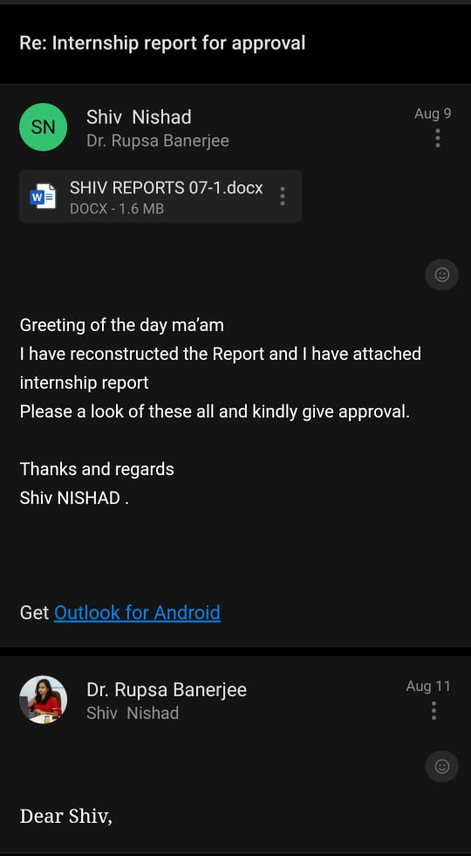
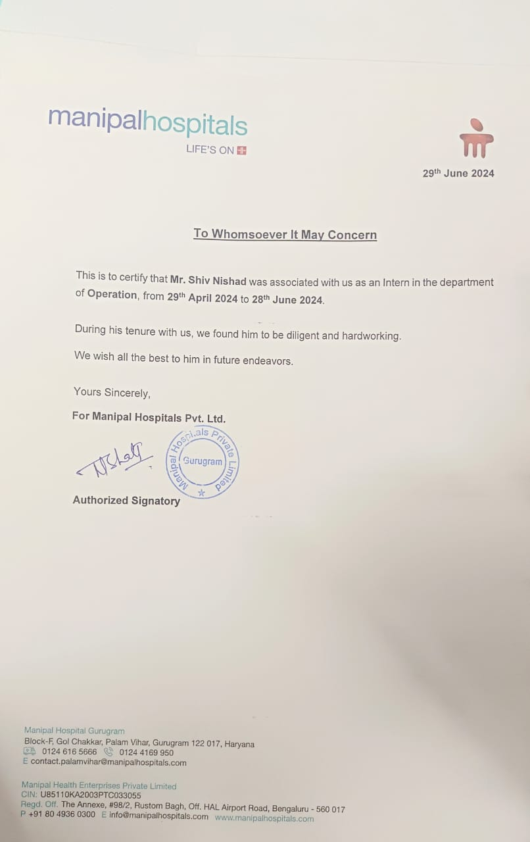
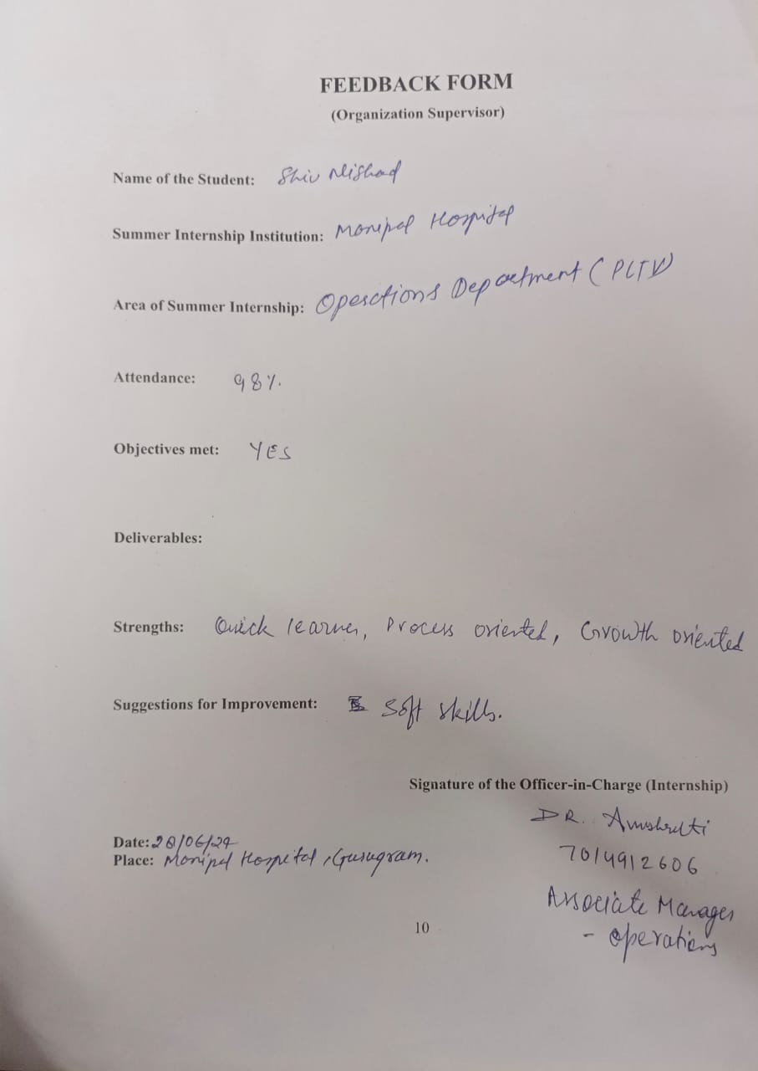
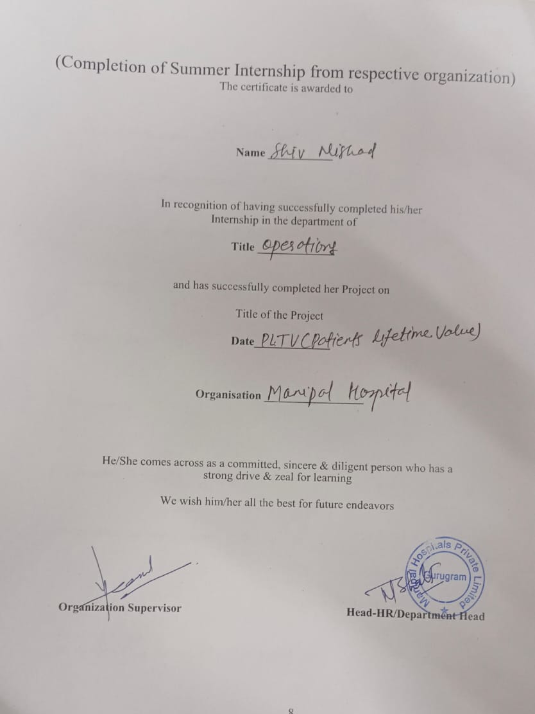
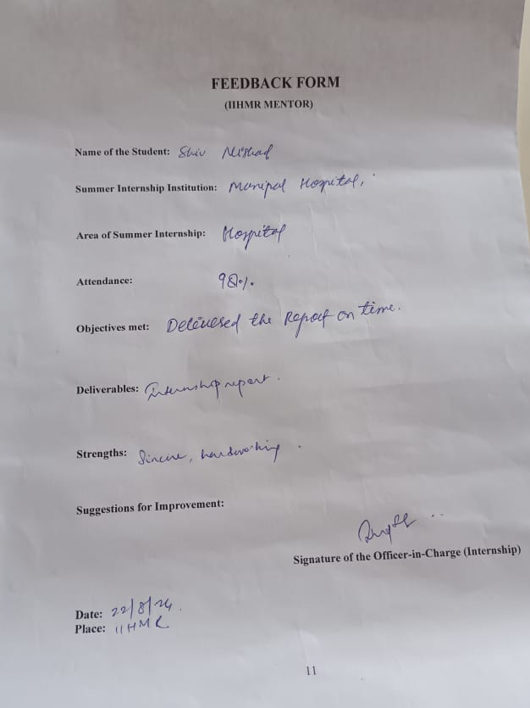
ACKNOWLEDGEMENT
I This report is an outstanding prospect to convey my gratefulness to those many people whose timely help and guidance went a long way in finishing this project.

I would like to express my sincere thanks Manipal Hospital Gurugram for giving me an opportunity to explore the practical knowledge practiced by the company.

I received a lot of advice and assistance from these folks, whose help was crucial to the project's success. I could not have accomplished anything without this advice and assistance. They assisted me in this undertaking, for which I am grateful.
I would like to take this opportunity to thank the Manipal Hospital, Palam Vihar in Gurugram, and Ms. PRERNA SHARMA (Operations manager) for their genuine interest in the project and willingness to share their opinions despite their extremely busy schedules. I consider it a privilege to have worked at the hospital in Palam Vihar, Gurugram - 122017, under their skilled leadership.
The entire staff at Manipal Hospital deserves my sincere thanks and obligation for their outstanding support and assistance during the entire operation.
And I would also like to thanks to my mentor Mr. VARUN PANDAY (Patient care manager), Mr. MUKESH KUMAR JHA (OPD supervisor) and Ms. VAIDEHI ,Ms. POOJA and Mrs. Arpit ( Excellence and Services Team) for their guidance and support throughout the whole process of my internship.
My sincere appreciation is extended to my mentor (Assistant Professor) Ms. RUPSA BANEJEE Ma’am Furthermore, I would like to thank INTERNATIONAL INSTITUTE OF HEALTH HEALTHCARE AND HOSPITAL MANAGEMENT for giving me the opportunity. I owe a debt of appreciation to mentor for allowing me to work on this research and for providing me with all the guidance and support necessary to complete the project on "A STUDY ON PATIENT LIFETIME VALUE IN IPD." I owe her a debt of appreciation for her helpful advice and guidance.
First and foremost, this big task cannot be completed without my friends and family's everlasting support.

SL.NO. | OUTLINE OF THE CHAPTER | PAGE NO.
1. | PROFILE OF THE HOSPITAL
2. | INTRODUCTION TO THE STUDY
3. | OBJECTIVES
4. | REVIEW OF LITERATURE
5. | METHODOLOGY - COLLECTION OF DATA FROM PRIMARY & SECONDARY SOURCES
6. | RESULTS OF THE OBSERVATION (ANALYSIS)
8. | DISCUSSION AND RECOMMENDATIONS
9. | CONCLUSION
10. | REFERENCES / BIBLIOGRAPHY
 | APPENDIX

PART-A


ORGANIZATION PROFILE
Introduction:-

- MEANING OF MANIPAL

The names "munn" and "palla" are combined to form the anglicised name "Manipal." Munn and palla are the Tulu words for "mud" and "lake," respectively.
- VISION & MISSION OF MANIPAL:-

- VISION -- The goal of Manipal Hospitals is to become a preeminent healthcare organisation recognised for its cutting-edge facilities, patient-cantered approach, clinical excellence, and research and innovation. They want to be known as a trusted partner in their patients' healthcare journeys and to offer them high-quality, inexpensive, and easily accessible healthcare services. Manipal Hospitals is working to accomplish this goal by utilising cutting-edge medical technology, adopting best practises, and assembling a group of compassionate and highly skilled healthcare workers.

- MISSION -- The objective of Manipal Hospitals is to offer patient-cantered healthcare services that are high-quality, accessible, and affordable. By utilising the most advanced medical technologies, implementing best practises, and assembling a group of highly skilled and sympathetic healthcare professionals, they provide the greatest results for their patients. Manipal Hospitals also pledges to support medical innovation and research, educate, and develop its staff and medical students, help the underprivileged in the community, and advance environmental sustainability by eco-friendly techniques.

The overall goals of Manipal Hospitals' vision and mission are to deliver high-quality healthcare that is easily accessible, reasonably priced, and patient-cantered while also making a positive impact on the expansion and advancement of the healthcare sector and society at general.
- INTRODUCTION

Manipal Hospitals is the name of a network of hospitals in India with a range of specialties. It has grown into one of the top healthcare organisations in the country since its inception in 1953. The hospital network is owned by the Manipal Education and Medical Group (MEMG), a healthcare conglomerate that also has ownership over a number of other healthcare and educational organisations.
Manipal Hospitals provide services in gastroenterology, orthopaedics, cardiology, neurology, and a variety of other medical disciplines. The facilities are outfitted with state-of-the-art machinery and cutting-edge medical technology to give patients the finest possible care. Manipal Hospitals' highly qualified and competent medical team, many of whom obtained their training at some of the finest medical schools in the world, is an additional plus.
Manipal Hospitals do more than only provide medical care; they also do research and instruct medical students. The hospital network works with several international organisations and has been involved in a lot of research projects.
In general, Manipal Hospitals is a reputable and well-known healthcare institution in India that provides excellent medical services to individuals from all over the country and abroad.

- SCOPE OF SERVICE
The hospital offers a wide variety of affordable medical services, as follows:
- Internal medicine
- 24-hour emergency room
- Five operating rooms to dialysis, intensive care, and paediatrics’

- CLINICAL SERVICES ----------------------------------------------

- Bariatric Surgery
- Cath Lab
- Cochlear Implant Surgery
- Day Care Services
- Dental Sciences
- Dialysis
- Laparoscopic Surgery
- Intensive Care Unit
- Medical & Surgical Gastroenterology
- Neonatal Intensive Care Unit
- Neonatology
- Neurosurgery
- Obstetrics and Gynaecology
- Ophthalmology
- Orthopaedic Surgery including Joint Replacement & Arthroscopic Surgery
- Otorhinolaryngology
- Respiratory Medicine
- Spine Surgery
- Urology
- Vascular Surgery

- ALLIED MEDICAL SERVICES -----------------------------------------------------

- Ambulance
- Blood Bank
- Dietetics
- Occupational Therapy
- Physiotherapy
- LABORATORY SURVICES ---------------------------------------------------

- Clinical Biochemistry
- Clinical Microbiology & Serology
- Clinical Pathology
- Haematology
- DIAGNOSTIC SERVICES ---------------------------------------------------------------

- Colour Doppler
- CT Scanning
- Mammography
- MRI
- Ultrasound
- X-Ray
- Audiometry
- Interventional Radiology

- OTHER DIAGNOSTIC SERVICES ---------------------------------------------------

- 2 D Echo
- Audiometry
- EEG
- ECG
- Holter Monitoring
- Spirometry
- Treadmill Testing
- Urodynamic Studies

- OTHER FACILITIES ---------------------------------------------------------------------

- Ambulance
- Mortuary
- SPECIALTIES

- MADICAL SPECIALTIES

- Internal Medicine
- IVF
- Critical Care
- Emergency and Trauma
- Endocrinology
- Fatal Medicine Multi Organ Transplantation
- Plastic & Cosmetic Surgery
- Rheumatology
- Paediatrics
- Cardiology
- Dermatology
- Gastroenterology
- Medical Oncology
- Nephrology
- Neurology

- SURGICAL SPECIALTIES

- ENT
- General Surgery
- Surgical Oncology
- Neurosurgery
- Cardiothoracic Surgery
- Vascular Surgery
- Urology Surgery
- Dental Surgery
- Paediatric Surgery

- ORTHER SPECIALTIES

- Anaesthesiology
- Psychiatry
- Microbiology
- Palliative Medicine

LEARNINGS
My Learnings in two month from operations department and they are :
- The Outpatient Department (OPD) streamlines patient registration and appointment scheduling through a thorough understanding of workflow.
- After patient reach in the hospital:
- Patients after registration go for the further thinks like Consultation, laboratory, radiology, procedure, follow-up and also can go for the admission.
- Services Offered like:
- A number of services provide, such as diagnostic testing, minor treatments, and consultations.
- Each Specialist have their own care coordinator.
• Operational Efficiency:
- Waiting time period for patients are reduced by managing.
- Overseeing a number of patient in large and making sure everything runs well.
• Patient Interaction:
- Strategies for managing a large number of patient requirements and efficient patient communication.
- The significance of patient involvement and education in their care regimens.
2. The Inpatient Department (IPD) :
The admission techniques used to admit patients and admit them to the suitable wards with procedures.
So, the medical staff’s relationship with the admissions department is good.
It shall continue a supervising role through the process of treatment programs.
Interdisciplinary role Id The role of functional interdisciplinary
The facts about releasing patients are the following: Releasing patients is not the same as discharging them; Releasing patients also involves final consultations and documentation; Releasing patients implies patient participation.
The importance of patient education in addition to Discharge planning for the care when the patient is discharged from the hospital.
3. Intensive Care Unit (ICU):
- Ensure that he or she coordinates the process within a vocational setting that involves high risk and pressure.
⎫ Taking care of the patients in critical condition and attending to their needs an all-important necessity.
Secaucus Conditions pertain to the following: Information on the roles of sophisticated machines in the provision of health care.
⎫ Counselling services for the employees, their families, and dependents.
⎫ A working together is referred to as excellent team co-ordination which means that in the team of healthcare professionals are physicians, nurses and specialists etc.
⎫ Fine more of workmate expertise in talking over the phone when there is an emergency.

4. High Dependency Unit (HDU)
Patient monitoring is designed for patients who require more attentive attention than they would receive on a regular ward, but not as much as they would in an intensive care unit.
- ⎫ listening to what patients need and modifying care plans on the dot .
⎫ Hand-off communication between the active unit and other wards within the hospital.
⎫ Explain how the patient’s care and needs in particular will be maintained during the procedures.
⎫ Constructing health as a resource rather than a cost and organizing health care so as to give optimal care to the patients.
⎫ To maintain the patients’ needs, it should ensure to offer the available resources for the hospital.
.
5. The assisted living facility
The Nursing Process: ·
⎫ Gaining an insight into the various responsibilities as well as the daily activities of the nursing team.
⎫ Coordinating some complex care related tasks such as administering medicine and monitoring patients’ temperature as well as any other symptoms they may be experiencing.
Patient Interaction:
⎫ Effective ways of performing or educating/persuading the patient and the families/relatives.
⎫ Providing with information and emotional support for the patients.
6. Hospital Specializations Variety of disciplines:
Gaining an insight into the various responsibilities as well as the daily activities of the nursing team.
⎫ Coordinating some complex care related tasks such as administering medicine and monitoring patients’ temperature as well as any other symptoms they may be experiencing.
Patient Interaction:
⎫ Effective ways of performing or educating/persuading the patient and the families/relatives.
⎫ Providing with information and emotional support for the patients.
7. Managing an Outpatient Department Operational Management:
Greater awareness of the patient movement after its entry at the hospital, stabilization, and distribution.
⎫ Firstly the patients attend the billing section for registration, then proceed to the schedule for consultant, from there they go to the consult doctor and then proceed to either get a LAB or RADILOGRAOHY or PROCDURE.
⎫ After make everything he plan for pharmacy
⎫ They have to follow consultant patients after which they are told by the physician what to do.
8.Patient Care Coordination:
- Arranging for primary care doctors and specialists to provide care together.
- Organizing referrals and follow-up visits to ensure continuity of services of patients to come back.
- Using quality assurance procedures will help to brings the highest standards of patient care.
- Gathering and evaluating patient input to enhance outpatient department services.

Combined Learnings from Observations
Encompassing the full spectrum of patient services from admission to discharge, or comprehensive patient care.
realizing how important it is to implement a patient-centered approach throughout all areas.
1. Interdepartmental Coordination:
Meaning that I get to discover how the different departments work hand in hand to ensure that the patients are given the best care.
⎫ Clearly identifying how one can ensure that the necessary communication and cooperation with other departments are achieved.
2. Operational Efficiency:
Promoting the identification of work process areas that could be made efficient in order to spare time. ·
⎫ Reduction methods concerning efficient practices to cut time delays.
⎫ Description before OT, Radiology etc to some patients so that they tell us the time to fix.
⎫ Evaluating business process for improvement where there is an opportunity to achieve value added. ·
⎫ Initiating measures that will help promote efficiency in operations with the view of cutting down on the time wasted waiting.
3. Patient safety and excellent care:
Adhering to policies and procedures that address the safety of the patients as a basic requisite for any healthcare institution.
⎫ Responses the call bell , assisting the patient for repositioning.
⎫ Acquiring knowledge on the application of quality control plans in the medical industry.
4. Expertise in Medicine
⎫ Caught up in the skills of handling advanced medical technologies and methodologies. The CT issues posed by care being informed about the different applications and treatments there are in the management of diseases.
⎫ I have come to realize that the management of crisis is the way in which new learners are trained in the management of crisis especially in ICUs and home dying units.
⎫ The topic: ‘Decision making and problem solving; elements critical to fast moving intensive care’.
5. Patient Education and Engagement:
Techniques for educating patients about their conditions and the treatments that are avail

- The importance of patient involvement in their own treatment for improved outcomes.
6. Documentation and Compliance:
and maintaining legal compliance in medical documentation
- The need of accurate and comprehensive patient records maintenance. identifying moral dilemmas able.
.
7. Resource Management:
- Using hospital resources efficiently to provide the best care available. balancing the needs of patient care with available funds and available resources.
8. Continuous Improvement:
- Keeping an eye on ongoing efforts to improve hospital services and patient care.
- Loops for feedback and quality enhancement are crucial.

Learnings from PLTV Project and Observational Experience

1. Patient Lifetime Value (PLTV) Project-Specific Learnings
- Understanding PLTV Concepts:
  - Comprehending the importance of PLTV in healthcare.
  - Learning how patient retention and engagement impact long-term value.
- Patient Discharge and Follow-Up Process:
  - Mastering the process of identifying patients scheduled for discharge.
  - Reviewing discharge summaries to understand follow-up schedules and recommended tests.
- Effective Patient Communication:
  - Developing skills to communicate discharge summaries and follow-up requirements to patients.
  - Learning to pitch follow-up appointments and lab test collections effectively.
- Service Coordination:
  - Coordinating follow-up appointments and lab test collections.
  - Ensuring smooth transition of information between departments.
- Data Management and Reporting:
  - Compiling and managing data on patient interactions and follow-up conversions.
  - Creating detailed reports and maintaining accurate records in Excel.
- Follow-Up and Retention Strategies:
  - Implementing strategies to improve patient follow-up adherence.
  - Developing personalized care plans and educational materials to enhance patient retention.
- Conversion Tracking and Analysis:
  - Tracking conversion rates for follow-up bookings and lab test collections.
  - Analysing data to identify trends and areas for improvement.
- Revenue and Growth Analysis:
  - Monitoring revenue generated from follow-up services and lab tests.
  - Analysing growth metrics related to patient retention and service utilization.
- Continuous Improvement:
  - Gathering feedback and refining approaches to improve patient engagement.
  - Regularly analysing data to optimize processes and strategies.
These learnings provide a well-rounded understanding of hospital operations, patient care processes, and the critical role of interdepartmental collaboration in delivering high-quality healthcare services.

PART-B

IPD PLTV CONVERSION (PATIENT LIFETIME VALUE)

- INTRODUCTION;

Patient Lifetime Value (PLTV) is a metric used to estimate the financial value of a patient over their lifetime. It is a projection of the expected revenue that a patient will generate for a healthcare provider, hospital, or medical practice. PLTV considers various factors such as the patient's treatment history, potential future healthcare needs, and their likelihood to continue seeking care from the same provider. In this article, we will explore the meaning of PLTV, its importance, and how it is calculated.
PLTV is an important metric in healthcare because it helps providers understand the long-term financial value of each patient. By knowing the expected revenue that a patient will generate over their lifetime, healthcare providers can make informed decisions about how to allocate resources and invest in patient acquisition and retention strategies. PLTV can also help providers identify which patients are most valuable to their business and focus their efforts on retaining them.
The calculation of PLTV considers several variables, such as the patient's age, gender, medical history, and treatment patterns. PLTV is typically calculated using a combination of historical data, such as the patient's past healthcare utilization and spending, and predictive modelling based on factors such as demographics, medical conditions, and socio-economic status.
PLTV can be calculated using various methods, such as using the patient's average annual spending or projecting future spending based on their treatment patterns. One common method is to use a discounted cash flow (DCF) analysis, which considers the time value of money and calculates the present value of the expected future cash flows from the patient. This method considers the estimated costs of care, the probability of future healthcare utilization, and the expected revenue generated by the patient over their lifetime.
To calculate PLTV, healthcare providers need access to comprehensive patient data, such as electronic medical records, insurance claims data, and demographic information. Providers can also use data analytics and machine learning techniques to analyse large amounts of patient data and identify patterns and trends that can help predict future healthcare utilization and costs.
In addition to helping providers allocate resources and make strategic decisions, PLTV can also help providers identify patients who are at risk of leaving their practice or seeking care from a competitor. By identifying these patients early on and implementing targeted retention strategies, providers can improve patient loyalty and increase their PLTV.

- NEED FOR PLTV

There are several reasons why healthcare organizations should consider calculating and monitoring their patients' lifetime value: -
Financial Planning: Knowing a patient's lifetime value can help healthcare organizations plan for future revenue and expenses. It can help them allocate resources more effectively and make informed decisions about investments in technology, facilities, and personnel.
Patient Retention: Understanding a patient's lifetime value can help healthcare organizations identify their most valuable patients and focus on retaining them. By providing high-quality care and excellent customer service, organizations can increase the likelihood that patients will return for future care, and thus increase their lifetime value.
Marketing: Knowing a patient's lifetime value can also help healthcare organizations target their marketing efforts more effectively. They can focus on attracting and retaining patients with the highest lifetime value, rather than casting a wide net and hoping for the best.
Patient Outcomes: By tracking a patient's lifetime value, healthcare organizations can also identify areas where they can improve patient outcomes and reduce costs. For example, they can identify patients who are at high risk of readmission and take steps to prevent it, thus reducing costs and improving outcomes.
Overall, understanding a patient's lifetime value is essential for healthcare organizations that want to provide high-quality care, retain their most valuable patients, and achieve long-term financial sustainability.

- INCREASE PATIENT LIFETIME VALUE

The following is a look at how healthcare providers can increase lifetime patient value through enhanced communication.
1. Communicate proactively to increase patient revenue
It is impossible to optimize patient value if you only communicate on an “as-needed” basis or simply respond to inbound prospective patient inquiries. In healthcare, patients have greater trust in a provider when they have genuine interest in the patients’ well-being and maintain regular interaction. What is the takeaway? Go beyond standard appointment reminders.
Proactive health communication includes sending out secure links to post-treatment care plans, Rx refill directives, impending screenings and other preventative care information that is based on age, health history, and other factors.
In addition to demonstrating that you care about your patients in a more holistic way, regular proactive communication creates an opportunity to increase incremental telephony-based reimbursements and improves relationships.
2. Identify patient segments
Communication is most effective when tailored to your audience. Patients have different needs, interests, and concerns. Gather data and insights on your patients to learn more about individual preferences, such as what types of communication they want, how they prefer to receive it, and whether they share information with others.
You can gather data based on how patients interact with your facility directly from your cloud-based communications platform and the various supported channels: web chat, inbound calls, social media, telehealth / video conferencing, SMS, and other communication methods. The integrated reporting capabilities of the cloud communications platform enables providers to measure and expand the data gathered by developing real-world data-supported surveys to further refine and capture specific insights that can be utilized to improve patient service delivery.
Satisfaction levels are additional dimensions on which you can segment your patients for ideal communication. Patients happiest with your healthcare organization are most likely to share their positive experiences with others. Leverage their satisfaction to generate word-of-mouth referrals.
3. Listen and learn
Many providers send follow-up emails after appointments directing patients to complete lengthy surveys that have been mailed from third-party agencies like Press Ganey. While providers are generally required to have a minimum level of these types of patient satisfaction surveys completed, the results are only reported long after the patient encounter.
To generate faster and actionable patient feedback beyond these multi-page surveys, invite patients to provide feedback directly via phone-based surveys that can be facilitated directly from your cloud communications platform – which includes the contact canter capabilities. This is an approved approach by the same Federal agencies that approve patient sentiment capture via snail-mailed hard copy survey completions.
4. Offer comprehensive cross-platform support
Communication takes place through a wide variety of channels. In-person, phone, email, web forms, social media and chat are primary ways through which patients communicate with providers. It is important to offer your patients omnichannel, cross-platform opportunities. Doing so ensures they can interact with you in the way they prefer or the manner that is most convenient at any time.
Unfortunately, historical strategies for offering multi-channel support were cumbersome and inefficient. Each channel functioned in a silo, with limited ability to correlate ongoing support across channels. Providers and patients were frustrated by this reality.
Now, you can create efficient, comprehensive, cross-channel support with a cloud-based solution from RingCentral. Equip your support agents with the ability to seamlessly shift service from
one channel to the next. Capture data from each interaction such that agents can easily analyse a patient’s case history regardless of the platforms through which they interact.
5. Provide 24/7 information and staff access
Sometimes, patients have questions or want information at night or when your practice is closed. There are a few ways you can offer access to information and communication during odd hours. The following are two key options:

- Patient health portals
A customized portal allows you to give patients information on their medical history, previous appointments, upcoming appointments, prescriptions, and more. You can also provide web chat features for 1:1 chat session during normal facility operational hours.
- AI chat
For 24-hour modelling, some of the questions patients have can be answered by an AI chat bot. AI bots can detect common types of questions and give scripted answers, or direct patients to follow-up contacts or resources. They can fill any gaps when your practice does not offer live chat or 24-hour support access.

- CALCULATE PATIENT LIFETIME VALUE
The PLTV equation is simple:
- P LTV = V x N x Y
In this equation, V= the average value of a given appointment with the patient (i.e., the cost to the patient and/or their insurance for the visit). N= the number of these appointments the patient has each year. And Y= however many years of that relationship you would like to calculate or project.
This is, of course, only an estimate of potential RADIOLOGY
PATIENTS PLAN TO DISCAHRGE FROM IPD(WARD)
LTV, but it should give you a decent idea of potential lifetime value.
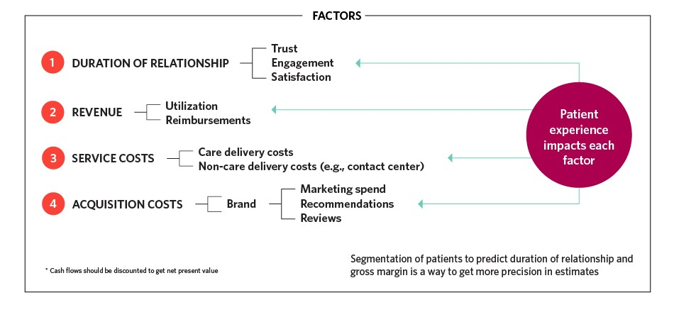

- PATIENT LIFETIME VALUE SERVICE PROCESS
WORKFLOW OF PLTV

AFTER CONSULTATION

REVIEW
EEG LAB
RADIOLOGY
AUDIOMETRY

FOLLOW-UP
PFT

PLAN FOR ADMISSION IN IPD (WARD)

REVIEW
MEET THEM AND BOOK THEIR APPOINTMENT AT SAME TIME AND BOOKING FOR SAMPLE COLLECTION FROM HOME TO THE LAB ADVICED PATIENTS
PREPARED CHART OF DISCHARGE PATIENTS WITH THEIR DISCHARGE SUMMARY FOR FOLLOW-UP
PATEINTS PLAN TO DISCHARGE FROM IPD(WARD)

- AFTER CONSULTATION

- Doctor consultation: After consulting with a doctor, the doctor prescribes certain medicines, lab, and radiological tests to the patient after understanding the patient's ailment. In some cases, the doctor asks the patient to do the lab or radiological test immediately and show me the report. In some cases, the doctor says take this medicine now and will show me lab or radiology tests during follow-up.

Prescription ---------------------------------------------------------------------------------
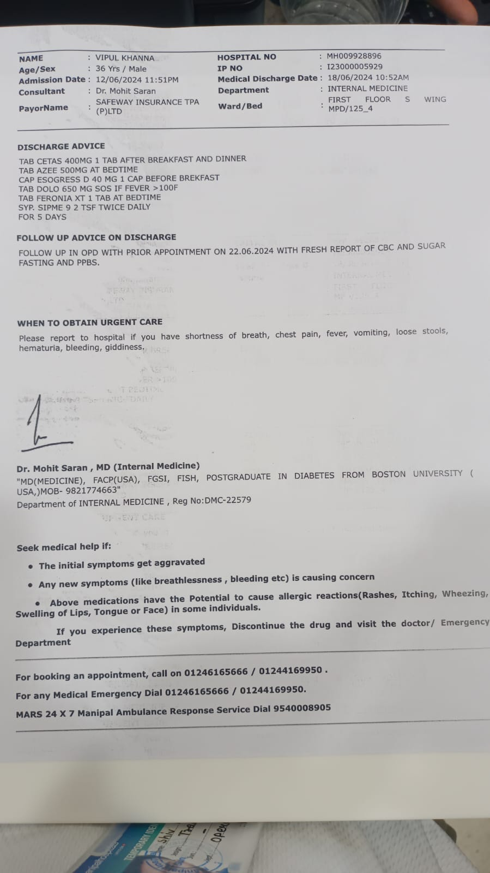

FIGURE 2.2
- Guiding a Patient for Tests: If, the doctor asks the patient to do this lab test or radiology test immediately and shows the report immediately. Then we instruct them that the billing of all these tests will be done at the billing counter. And the lab tests will be done in the lab and the radiology tests will be done in the radiology, and we go with the patient to guide the lab and radiology and we ask the lab or radiology staff to rush the tests so that the patient's report comes quickly, so that the patient can show his report to the doctor immediately.

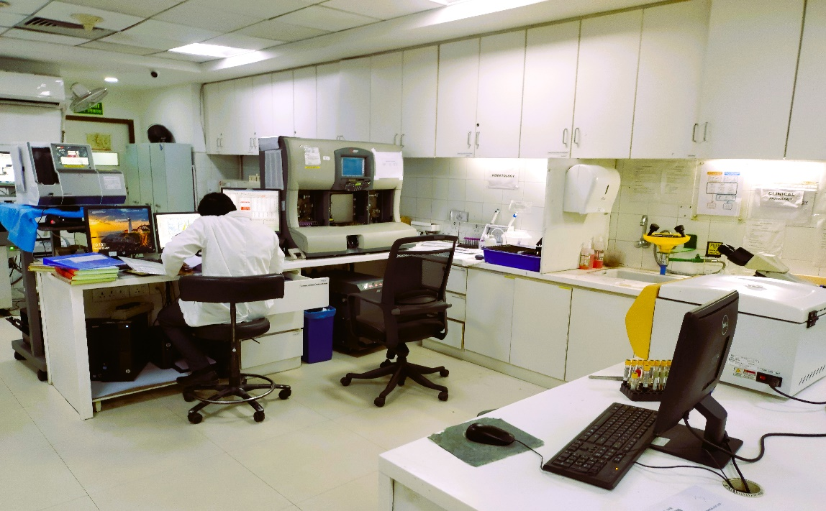
FIGURE 2.3

- RADIOLOGY INVESTIGATION

- X-RAY CHEST PA
- X-RAY SHOULDER SINGLE VIEW
- X-RAY ANY REGION LATERAL VIEW
- X-RAY FOOT AP AND OBLIQUE
- X-RAY LUMBAR SPINE AP AND LATERAL
- X-RAY LUMBAR SPINE FLEXION AND EXTENSION
- X-RAY PELVIS INCLUDING HIP JOINTS AP
- X-RAY KNEE SINGLE-AP & LATERAL
- X-RAY ANKLE AP AND LATERAL
- X-RAY NASAL BONE LATERAL
- X-RAY CLAVICLE (SINGLE SIDE)
- X-RAY CERVICAL SPINE AP AND LATERAL
- X-RAY DORSAL SPINE AP AND LATERAL
- X-RAY SHOULDER AP AND LATERAL
- X-RAY BOTH KNEES AP
- X-RAY ELBOW AP AND LATERAL
- X-RAY FEMUR AP AND LATERAL
- X-RAY WRIST AP AND LATERAL
- X-RAY KNEES (BOTH) AP & LATERAL STANDING
- X-RAY BEDSIDE
- USG TVS - EARLY PREGNANCY SINGLETON
- USG BREASTS
- USG TRANSRECTAL / TRANSVAGINAL
- USG ABDOMEN & PELVIS
- USG KUB
- USG NT SINGLETON
- USG SCROTUM / SMALL PARTS
- USG FOLLICULAR STUDY (PER SITTING)
- USG THYROID
- USG GUIDED FNAC
- USG PELVIS
- USG GROWTH SCAN SINGLETON
- USG ANOMALY SINGLETON
- USG SCAN - Operating Room
- USG BED SIDE
- CT UROGRAM
- CT PNS CORONAL AND AXIAL PLAIN WITH HRCT
- CT CORRELATIVE STUDY
- CT BRAIN PLAIN
- CT LUMBOSACRAL SPINE
- CT ENTEROGRAHY
- CT CERVICAL SPINE
- CT ABDOMEN AND PELVIS (CONTRAST)
- CT CHEST HRCT
- CT CHEST PLAIN AND CONTRAST
- CT ANGIOGRAM ANY SINGLE REGION
- CT ABDOMEN AND PELVIS (PLAIN)
- CT FACIAL BONES
- C-ARM 30 MIN
- C-ARM 60 MIN
- MRI LUMBAR SPINE
- MRI BRAIN
- MRI CERVICAL SPINE
- MRI DORSAL SPINE
- MRI SPINE FOLLOW UP
- MRI KNEE JOINT
- MRI EXTREMITIES
- MRI SHOULDER JOINT
- MRI CONTRAST
- MRI BRAIN AND MRV
- MRI MRCP
- DOPPLER ARTERIAL LOWER BOTH EXTREMITIES
- DOPPLER VENOUS LOWER BOTH EXTREMITIES
- DOPPLER RENAL ARTERY
- DOPPLER CAROTID & VERTEBRAL ARTERIES

- NIC
- ECG
- ECHO
- TMT
- DSE
- HOLTER
- STRESS ECHO

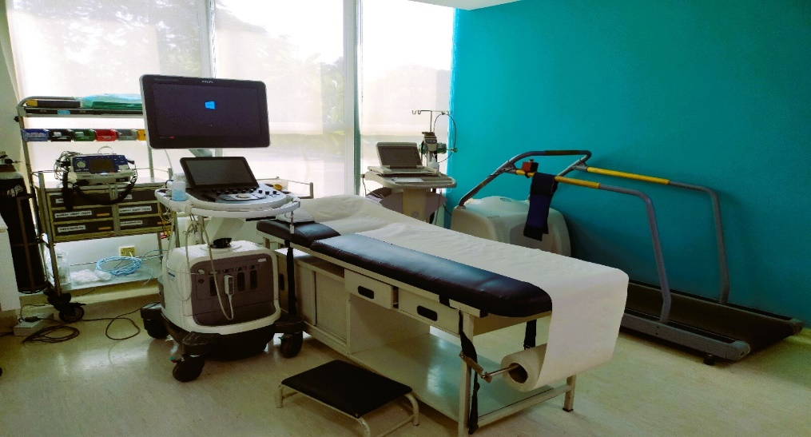

FIGURE 2.5

- PHARMACY HOME SERVICE

When the doctor prescribes the medicine to the patient, we guide the patient to get the medicine from the pharmacy. And those medicines that the patient does not get from the pharmacy because the tablet is not available, at that moment we ask the staff at the pharmacy to deliver the medicine to the patient's house free of charge.

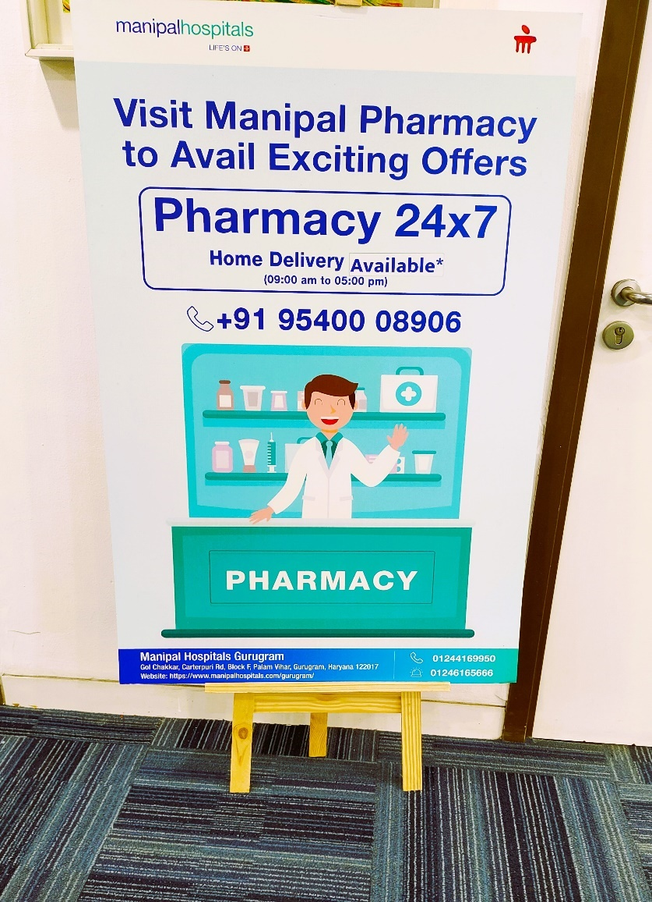
FIGURE 2.6

- MEANING OF STUDY ; The Patient Lifetime Value (PLTV) design program aims at increasing the time patients will spend within the health facility and the kind of services given to them in the long-run due to follow-ups. This makes the work important because it covers the transition between discharge and subsequent care, gradually getting the patients the follow up care that they require because it will improve patient health therefore promoting hospital expansion. Here are the key components that outline the meaning of this study.

- REVIEW OF LITERATURE

CUSTOMER LIFETIME VALUE: A REVIEW
Currently, businesspeople agree with the idea that customers represent some kind of assets, which should be controlled and which value should be assessed. The concept discussed by Wen Chang from Fudan University & Hsing Wu Institute of Technology, Chen Chang from Jin-Wen University of Science and Technology & Qianpin Li from Edith Cowan University, concerns the significance of CLTV. CLTV models can be viewed as efficient tools for the measurement of the firm’s customer bond, thus, being indispensable for organizations which aim at providing customer-oriented services.
Thus, this paper offers a critical analysis of prior literature on the development and uses of CLTV. Customer profitability as one of the components of this concept is defined as the number of gross revenues for a certain period of the time minus the expenses related to a customer. It is useful to note that this measure is essential for establishing the value of the customer regarding the company.
Customer profitability can be looked at from the historical and the future perspectives. It is historically like the field often called profit and loss account and categorized by the commonly used term GW1, gross contribution margin and is derived by deducting the product cost from the total revenue. With the exclusion of other expenses such as selling, general and administrative expenses, the operating profit obtainable from that customer is established. Another more developed procedure is to calculate the customer return on assets by customer profitability divided by the ASSET like account receivables and stock. Furthermore, in the prospective analysis customer profitability is defined by the profit that a customer potentially generates in the future and more often defined as: The lifetime value of a customer. This comprises forecasted future benefits from a customer’s transactions in terms of profit, which have been discounted to the current period’s value. Another related concept is customer equity which focuses on the quantity of the customer, the price that can be charged per unit of the customer’s purchase and other costs that are incurred to acquire, invest in and retain the customer.
As a result, in today’s commercial world, marketing has become more and more tactical, and marketing efforts are expected to have a financial rationale. Scholars identified a concept referred to as CLTV, which provides a valuable approach that establishes links between marketing activities and financial outcomes, for instance, how alterations in customers’ buying behaviors (for example, increased purchasing rate or retention) affects profit in the future. Reinartz and Kumar (2000) identified three main reasons for the growing interest in CLTV research: the increase in the significance of customer management processes in business environments; the acknowledgment of CLTV as the significant research area by the Marketing Science Institute; the dearth of studies on CLTV..

TAKEN FROM: - SOCIAL BEHAVIOR AND PERSONALITY, 2012, 40(7), Page no -1057- 1058
file:///C:/Users/Asus/Downloads/SBP----CUSTOMERLIFETIMEVALUEAREVIEW.pdf

CUSTOMER LIFETIME VALUE
----------------------------------------------------------------------------------------------------
Prof R Ramakrishnan, HOD, Dept of Management Studies, Muthayammal College of Engineering, Rasipuram 637408
Customer Lifetime Value (CLTV) a marketing metric that projects the value of a customer over the entire history of that customer's relationship with a company. It is the current value of the likely future income flow generated by an individual purchaser. It is variously referred to as lifetime customer value or just lifetime value, and abbreviated CLTV, LCV, or LTV). Customer Lifetime Value (CLTV) determines the value of a customer to the firm over the life cycle of the customer. It seeks to maximize profit by analysing customer behaviour and business cycles to identify and target customers with the greatest potential net value over time. A Profitable customer is one that overtime yields a revenue system that exceeds by an acceptable amount of the company's cost stream of attracting, selling and servicing that customer over time. This paper looks at the various concepts connected with Customer Lifetime value.
TAKEN FROM: - Page no - 2 of 8
file:///C:/Users/Asus/Downloads/5SSRN-id1747726-CustomerLifetimeValue.pdf

CUSTOMER LIFETIME VALUE: MARKETING MODELS AND APPLICATIONS
-------------------------------------------------------------------------------------------------
PAUL D. BERGER is Professor and Chairman of the Marketing Department at the School of Management, Boston University.
NADA I. NASR is a doctoral student in Marketing at the School of Management, Boston University.

Since the early eighties, the field of marketing has undergone a major directional change in both its theory and practice a tum toward relationship marketing (Morgan & Hunt, 1994). Ac the core of relationship marketing is the development and maintenance of long-term relation- ships with customers, rather than simply a series of discrete transactions, achieved by creating superior customer value and satisfaction. Ideally, a loyalty that benefits both parties is fostered One pitfall of this growing concern to maintain strong and long-lasting relationships, however, is to do it at the expense of profitability. Overly enthusiastic with the concept of have gotten involved in losing relation- ships Relationship marketing is costly. It might not pay to maintain king-term relationships, at least not all the time and not with all customers. Customers with low switching costs and short time-horizons might not be financially attractive to the firm (Jackson, 1985).
Ultimately, marketing is the art of attracting and keeping profitable customers (Kotler & Armstrong, 1996). A company should not try to pursue and satisfy every customer. What makes a customer profitable? Kotler and Armstrong (1996) define a profitable customer as "a per- son, household, or company whose revenues over time exceed, by an acceptable amount, the company costs of attracting, selling, and servicing that customer This excess is called customer lifetime value (CLTV).
Customer lifetime value should be an important construct in designing and budgeting several marketing decisions such as customer acquisition programs (Dwyer, 1989). Recognizing its importance, many researchers in direct marketing have studied CLTV and its man-2 aerial applications (Dwyer, 1989: Hughes & Wang, 1995; Keane & Wang, 1995; Wang & Spiegel, 1994). A growing interest in CLTV is expected in other marketing areas for two reasons First, at a time when marketing methods are becoming more interactive, from frequent-user- club services to web pages, it is not surprising that marketing talk begins to sound like direct-- marketing talk (Blasberg & Deighton, 1996).
Second, changes in technology make it feasible to understand and track customer behaviours in ways that were practices, or even impossible. in the past (Jackson, 1995)

Previous research in CLTV has extolled the virtue of its them in a variety of marketing decision problems, primarily focusing acquisition decisions or the acquisition/retention cost trade- off (Blatt berg & Deighton, 1996; Wang & Spiegel, 194) Determining or calculating CLTV was done solely by considering specific numerical cases. Researchers considered a particular setting, with specific input parameters, and computed CLTV to use it in the decision-making problem prompting the CLTV determination
In this paper, a systematic general approach to the computation of CLTV is offered. General mathematical models are provided to calculate CLTV in a variety of typical cases. The major contribution of this paper is that it is less context- specific than previous discussions of CLTV, and that it provides general mathematical formulations of CLTV. while additionally tying together the specific assumptions underlying a formulation and, indeed, the formulation. Though not exhaustive, the cases treated deal with the large majority of typical practices. The choice of cases is based on both a systematic theoretical taxonomy and on assumptions grounded in customer behaviour
In addition to the introduction, this paper has four sections. First, we introduce a general way to determine CLTV. Second, we treat five general cases, offering a mathematical model to compute CLTV in each case. Each general case is followed by a numerical example. Third, we discuss some managerial applications of the use of a general model of CLTV. As an illustration, we consider an example in which a general model of CLTV is used to optimize the allocation. of a promotional budget between Acquisition and Retention. Finally, we offer conclusions and suggest areas for future research.

TAKEN FROM: - JOURNAL OF INTERACTIVE MARKETING j VOLUME 12 / NUMBER 1 / WINTER 1998. Page no – 18.
https://arkonas.com/wp-content/uploads/2014/11/Customer-Lifetime-Value.-Marketing-Models-and-Applications.pdf

- OBJECTIVES

- To find total conversion of patient from IPD consultations.
- To identify and address inefficiencies in the patient discharge and follow-up process.
- To ensure timely and efficient scheduling of follow-up appointments and lab test collections.
- To improving patient engagement.
- To create and implement strategies to retain patients for a longer duration
- To monitoring revenue generated from follow-up services and lab tests.

Overall, the objective of Patient Lifetime Value measures a patient's financial value and aims to promote patient-cantered decision-making within healthcare organisations by identifying opportunities to increase income and patient retention as well as resource allocation.

- METHODOLOGY

The method mainly used to complete this project on patient lifetime value study is the primary data / information of Manipal Hospital - Palam Vihar, Gurugram which I have collected myself during my two months internship there. I have collected and observed the entire process of PLTV for precise concepts and accurate statistical data.
In the project report, I also included references to the data and flow from earlier months to gather further details. Examining every aspect of the circumstance and doing a situational analysis are the goals. The technique involves the general research plan, the sampling process, the fieldwork that was conducted, and lastly the analysis process. Observation has been used to gather the primary data. Referred for secondary data are PLTV data from the previous

- Population: 1126 IPD discharge patients in 2-month internship from April 29th to June 27th 2024

The sampling Frame: IPD Patients scheduled for discharge who have follow-up appointments, lab tests, or radiology tests advised.
- Sampling method: Selecting patients based on their scheduled discharge date for practical access.
- Data Collection: Primary data was obtained through observation, whereas secondary data was obtained through previous records.
PROCESS OF COLLECTIN DATA

1. Identification of Patients for Discharge
- Daily Check: Access the hospital system daily to identify patients scheduled for discharge.

2. Review of Discharge Summary
- Discharge Summary Analysis: Review each patient’s discharge summary to determine:
  - The number of days until the advised follow-up appointment.
  - Any recommended lab tests.
  - Any advised radiology tests.

3. Patient Interaction
- Meeting with Patients: Meet with each patient before their discharge to discuss:
  - The details of their discharge summary.
  - The importance of following the advised follow-up schedule.
  - The recommended lab and radiology tests.
- Pitch for Services: Offer services for:
  - Booking follow-up appointments.
  - Arranging home collection for lab tests.

4. Appointment and Service Booking
- On-Site Booking: For patients who agree, book their follow-up appointments and arrange home collection for lab tests immediately.
- Forwarding Information: Forward the discharge summary to the appropriate department for processing home collection for lab tests.

5. Data Collection and Reporting
- Daily Data Compilation: Compile data throughout the day on patient interactions, including:
  - Number of patients approached.
  - Number of patients who agreed to book appointments.
  - Number of patients who agreed to home collection for lab tests.
  - Number of patients who did not agree to either service.
- Excel Reporting: Enter this data into an Excel spreadsheet for record-keeping and further analysis.

6. Follow-Up Coordination
End-of-Day Reporting: At the end of each day, send the compiled data to the operational head, manager, and call team.
- Call Centre Coordination: Ensure the call centre team follows up with patients who did not book an appointment or agree to home collection services.

7. Continuous Improvement
- Feedback Loop: Gather feedback from the operational head, manager, and call centre team to refine the approach and improve patient engagement strategies.
- Process Optimization: Analyse data regularly to identify trends and optimize the process for better patient engagement and increased follow-up adherence.
By following this methodology, you ensure a systematic approach to managing patient follow-ups, enhancing patient care continuity, and improving overall PLTV
- Here is the process of appointment booking:-
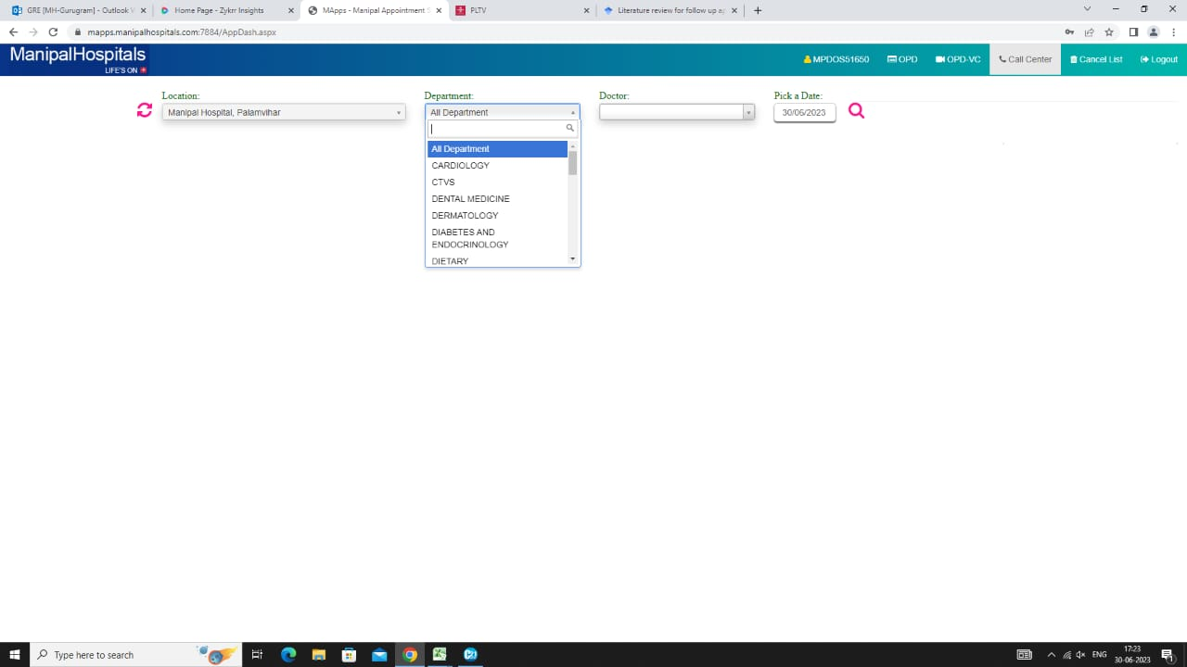

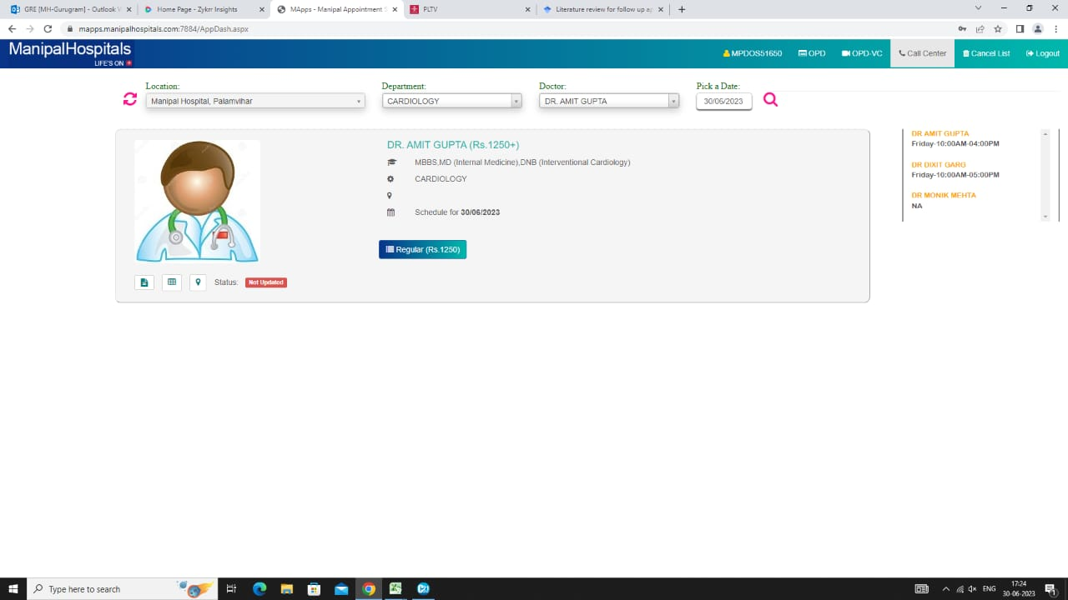
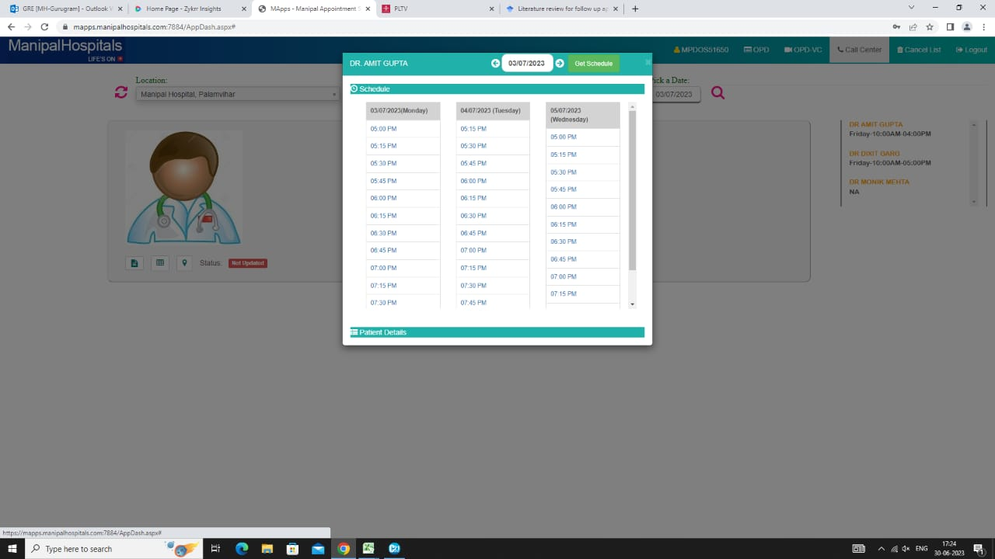
- Method of data collection in excel format: -
I feed this data on the daily basis after meet with all the patients who going to discharge daily complete the round and after that.


- RESULTS AND OBSERVATIONS (ANALYSIS).

The process of categorizing, organizing, altering, and summarising data in order to get research results and test hypotheses is known as analysis.
This section's major goal is to deal with the analysis and interpretation of the 0000000 data points [N = 0000] that were gathered throughout the internship period. The study was conducted to determine after consultation how many tests and medicine the doctors were prescribed, as well as how much admissions were prescribed. Additionally, Manipal Hospital in Palam Vihar, Gurugram, is looking for possible solution why not all patients are converted to buy medicine from here and tested.
Data presentation: To provide a solid foundation for the discussion of the study, a proper step-by-step methodology was used here, and the data was tabulated, arranged, organized, analysed, and interpreted using descriptive and inferential statistics. The study's findings are provided in the manner that follows.

- PLTV CALCULATION OF RETENTION OF PATIENTS: Through this chart we analysis data of follow-up patients, this chart show the how many patients had advised for follow-up, lab test, radiology and procedure
- By this chart calculate the revenue growth
- To follow the loyal patients.

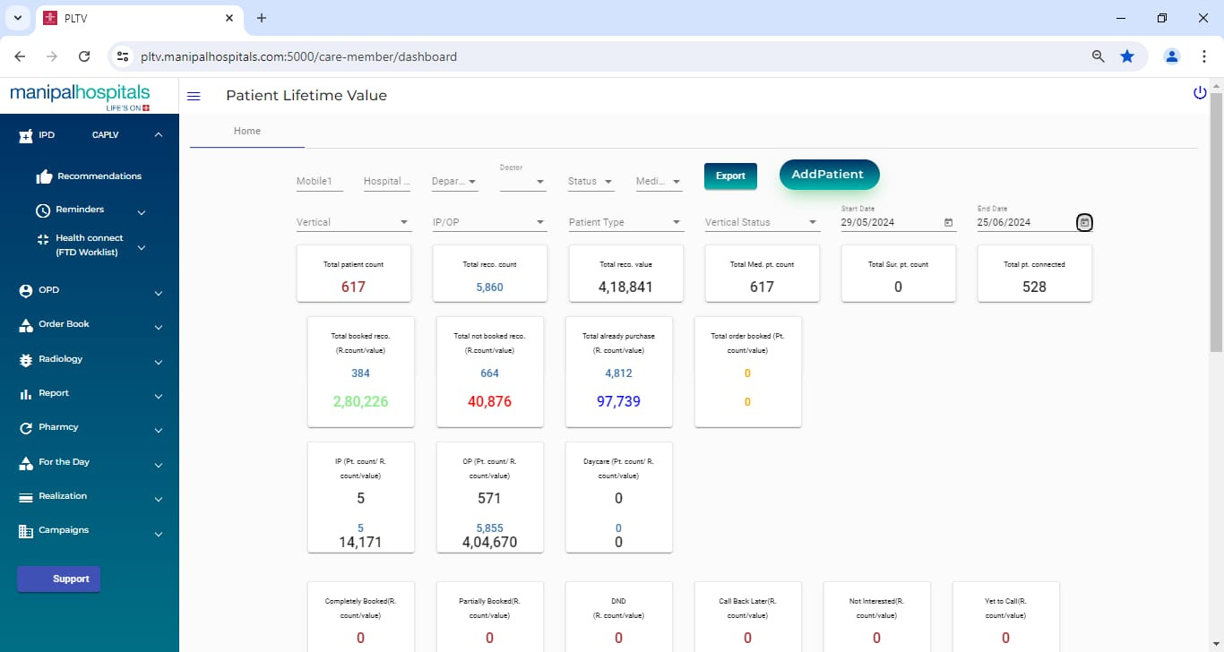

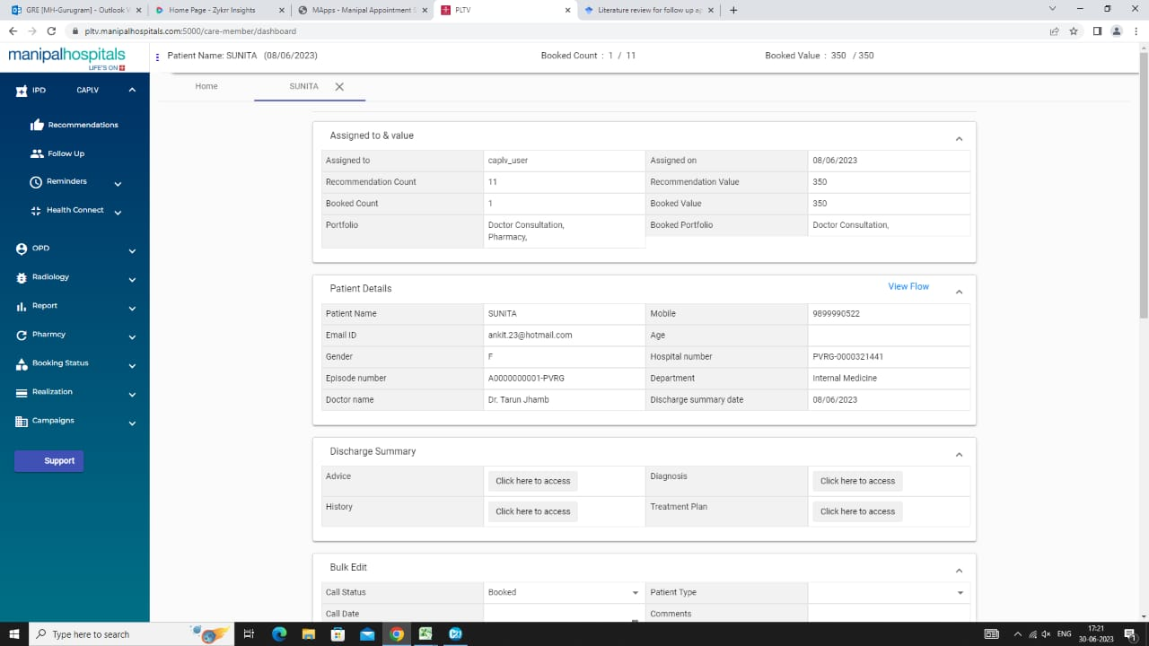

- DISCUSSION AND RECOMMENDATIONS

- DISCUSSION: -
This study's primary goal is to see, how patients are guided in the OPD following doctor consultation. The burden to discuss the study falls on me as a third-year bachelor's student in hospital management. The present discussion is on the study of, “PROJECT REPORT ON “A STUDY ON PATIENT LIFETIME VALUE IN OPD”

- RECOMMENDATIONS
My recommendations are as follows considering the data I have just stated,

There should be improved integration of centralised PLTV software.

Need for more manpower for PLTV.

According to the specific doctor, more persons are needed to keep accurate PLTV data.

Try to maintain regular PLTV data in an optimum manner.

Try to maintain Excel sheet for PLTV for the per months.

Try to maintain the expenses of PLTV procedures.

Employees must be more engaged in their work responsibilities.

Establish SOPs for PLTV.

- CONCLUSION

Project research looked at how patient Lifetime Value refers to a healthcare organization over their lifetime as a customer. It considers various factors such as the revenue generated through medical devices, treatments, procedures, and potential future referrals.
PLTV analysis helps in understanding the financial impact of individual patients on the hospital's revenue. It is calculating the total revenue generated from a patient's visits, treatment, and other services.
Evaluating PLTV can provide insights into the effectiveness of different treatments and services offered by the hospital by identifying the most profitable services or treatments.
PLTV can help in developing patient retention strategies by identifying high-value patients, hospitals can tailor their communication, follow-up care, and support to enhance patient satisfaction and loyalty, thus increasing the likelihood of long-term relationship and higher PLTV.
PLTV can help hospitals make decisions on how to allocate their resources. Hospitals can dedicate resources, like as specialised equipment or staff, to high-value patients, ensuring the greatest care for those who significantly contribute to the PLTV.





