Internship Training at

International Institute of Health Management Research
A STUDY ON FEEDING HABITS AND EATING BEHAVIORS AMONG CHILDREN OF PARENTS BELONGING TO ALPHA GENERATION IN NEW DELHI, INDIA.
by

Name – Dr Manvi Verma

Enroll No. – PG/23/059

Under the guidance of

Dr. Vinay Tripathi

PGDM (Hospital & Health Management) 2023-25


International Institute of Health Management Research New Delhi

Internship Training at

International Institute of Health Management Research
A STUDY ON FEEDING HABITS AND EATING BEHAVIORS AMONG CHILDREN OF PARENTS BELONGING TO ALPHA GENERATION IN NEW DELHI, INDIA.
by

Name – Dr Manvi Verma

Enroll No. – PG/23/059

Under the guidance of

Dr. Vinay Tripathi

PGDM (Hospital and Health Management) 2023-25

International Institute of Health Management Research New Delhi

(Completion of Dissertation from respective organization)
The certificate is awarded to

Name Dr MANVI VERMA

in recognition of having successfully completed his/her internship in the department of

Title

A STUDY ON FEEDING HABITS AND EATING BEHAVIORS AMONG CHILDREN OF PARENTS BELONGING TO ALPHA GENERATION IN NEW DELHI, INDIA.

and has successfully completed his Project on

Date – 16/06/2025

Organization: International Institute of Health Management Research

She comes across as a committed, sincere & diligent person who has a strong drive & zeal for learning.

We wish her all the best for future endeavors.

Training & Development Zonal Head-Human Resources

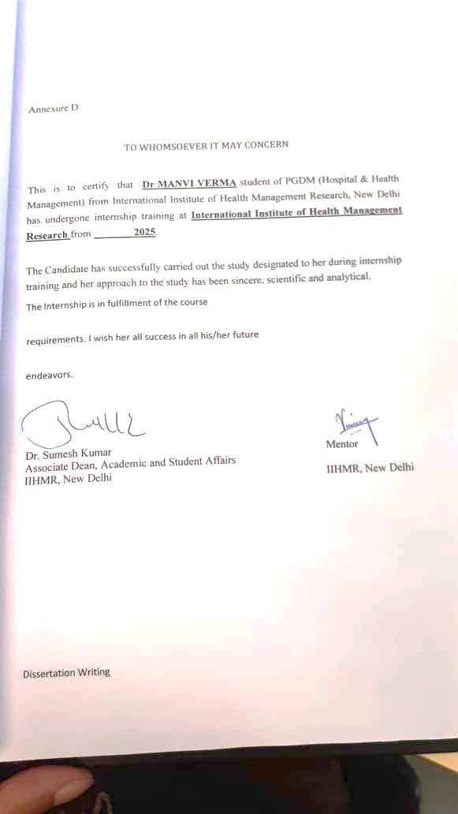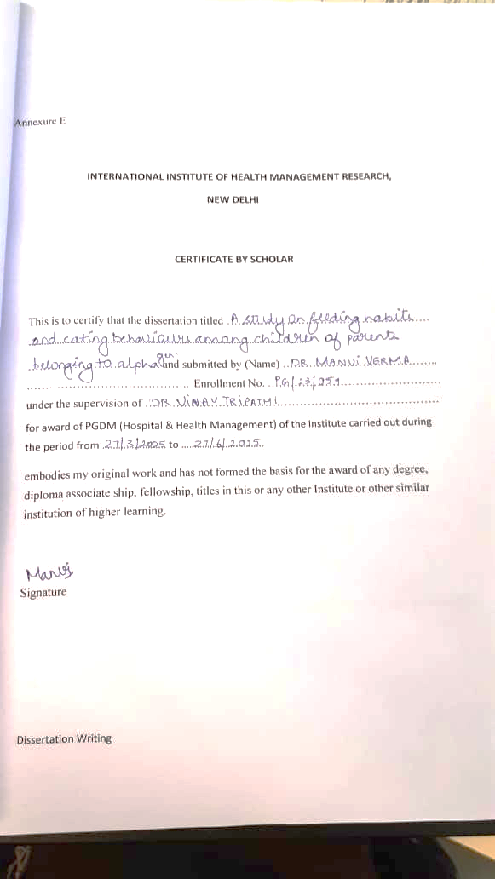




S.No. | Content | Page No.
1 | Introduction | 3-4
2 | Objectives and Rationale | 5
3 | Review of literature | 6-17
4 | Methodology | 18-20
5 | Result | 21-32
6 | Discussion | 34-35
7 | Conclusion | 36
8 | bibliography | 37-38
9 | Annexures | 39-43
Index

List Of Graphs
S.No. | Content | Page No.
1 | Figure 1 | 23
2 | Figure 2 | 24
3 | Figure 3 | 24
4 | Figure 4 | 25
5 | Figure 5 | 25
6 | Figure 6 | 26
7 | Figure 7 | 27
8 | Figure 8 | 28
9 | Figure 9 | 28
10 | Figure 10 | 29
11 | Figure 11 | 29
12 | Figure 12 | 30
13 | Figure 13 | 30
14 | Figure 14 | 31
15 | Figure 15 | 31
16 | Figure 16 | 32
17 | Figure 17 | 33
ABSTRACT
This dissertation explores the feeding habits and eating behaviors of children aged 2–6 years belonging to the Alpha generation in urban slum communities of New Delhi. With rapid technological exposure, shifting parenting styles, and evolving socioeconomic contexts, Generation Alpha presents unique challenges in nutrition and development. Using the Child Eating Behavior Questionnaire (CEBQ) and the Child Feeding Questionnaire (CFQ), this cross-sectional study surveyed 384 households to assess parental feeding practices, children’s eating behaviors, and their associations with demographic variables such as caregiver education, employment, family structure, and screen time. Results indicate that while most children demonstrated a high enjoyment of food and responsiveness to satiety, difficulties such as fussiness and emotional undereating were prevalent. Parental monitoring was the most common feeding practice, with moderate levels of restriction and pressure to eat, influenced by education level, caregiver type, and gender of the child. Weak but notable correlations were observed between fussiness and parental monitoring, as well as emotional undereating and pressure to eat. Findings highlight that children’s eating behaviors and parental feeding practices are interconnected yet shaped by broader social and technological environments. The study underscores the need for context-specific interventions and parental guidance to promote healthy dietary patterns in early childhood among disadvantaged urban populations.

INTRODUCTION
Childhood is a very important phase of human life. They have an extended childhood with rapid growth till first 2 years, slowed down for the next seven to ten, and then a rapid growth during puberty. This extended childhood gives children time to learn. Jean Twenge, a social psychologist in his work wrote, “We know that what causes generations to differ goes beyond the events children experience (such as wars and depression) and includes changes in technology they used as a children (radio, television, personal computers, internet, phone). With the convergence of technology around 2009 was when the Generation Z hit puberty and since then each day has come up with something new. The generation after the Generation Z was the one which was born hand in hand with technology and devices since there birth or maybe even conception. The technology has a major effect on the food habits of the children and also on the way they have been brought up by there parents. Play-based childhood has shifted to phone- based childhood and parents have grown more overprotective of their children in outer world and have given them independence in the virtual world.
With such significant changes, the feeding habits and eating behaviors of the children have changed altogether across generations. Whereas Generation Z still had their childhood without phones, Generation Alpha is characterized with unprecedented technological advancements and also changes in the parent generation such as the parents of Generation Z are not so much technologically adept even now in comparison of parents of Generation Alpha. Apart from the technological factors, other factors such as economical factors, social factors etc. also have an impact on the changing feeding patterns and eating habits in the childhood.
The age of 2 years- 6 years accounts for the motor development and the development of brain in the child. 90% of the brain is developed till the age of five years in the children. Emotional learning and social learning are also a significant part of the childhood. The feeding habits and eating behaviors are crucial factors influencing health and development of children.
This study aims to unravel the intricacies of childhood nutrition in the children of the Alpha generation age 2years- 6 years among the urban slum population of New Delhi exploring nutrition, screen time, employment status of children, family size, etc. in turn focusing on the relationship between all the factors and the feeding habits and eating behaviors of the children. By investigating the feeding habits and eating behaviors of children in this specific demographic and geographic setting, this research aims to shed light on emerging trends, potential challenges, and opportunities for promoting healthy dietary practices in the next generation of Indian children.

The research focuses on parental decision making and influence on the dietary patterns of children which is a major factor along with digital media influence, socioeconomic factors, cultural factors, food accessibility and availability etc. using Child Eating Behaviour Questionnaire and Child Feeding questionnaire.
Child Eating Behaviour Questionnaire includes 8 parameters under which analysis is to be done namely, Food Responsiveness (FR), Enjoyment of Food (EF), Emotional Overeating (EOE), Emotional Undereating (EUE), Satiety Responsiveness (SR), Slowness in Eating (SE), Food Fussiness (FF), Desire to Drink (DD). These seven are inclusive in two major categories which are Food Approach behaviour and Food Avoidant Behaviour. Each parameter comprises of questions which helps in the assessment of variation in eating style among children.
Child Feeding Questionnaire on the other hand, captures parents' perceptions and concerns about child obesity, as well as their attitudes and practices related to feeding. It includes seven factors which are Perceived Responsibility, Perceived Parent Weight, Perceived Child Weight, Parents’ Concern about Child Weight, Monitoring, Restriction and Pressure to Eat.
Combining CFQ and CEBQ:
Together, these tools offer a comprehensive understanding of the parent-child feeding relationship:
- CFQ reveals the "how and why" of parenting around food.
- CEBQ reveals the "how and what" of children’s eating responses.

OBJECTIVES:
To Characterize the Prevalence of Specific Eating Behaviors in Children.
To Describe Common Parental Feeding Practices.
To Investigate Associations Between Child Eating Behaviors and Parental Feeding Practices.
To Identify Demographic Differences in Child Eating Behaviors.
To Identify Demographic Differences in Parental Feeding Practices.
To Explore the Relationship Between Screen Time and Eating-Related Behaviors/Practices.

RATIONALE:
The need for the study is to understand the evolved feeding patterns in the newer generations and the parental influence along with socio- economic, technological and cultural influences ascertaining to the involvement of digital consumptions from early ages which might impact the behavior of the children in terms of their feeding behaviors and attachment styles of the parents with respect to the children. Not only that, the demographics such as living conditions, presence of other members of the family and employment of the parents etc. also affect the overall development of the child right from early childhood and to also study about the parental beliefs, attitudes and practices towards their children providing a demarcation between what has changed through the generations.

LITREATURE REVIEW:
1. Rylatt, L., & Cartwright, T. (2016). Parental feeding behaviour and motivations regarding pre-school age children: A thematic synthesis of qualitative studies. Appetite, 99, 285–297.
• Aim: This research aimed to offer a comprehensive overview of how parents feed and motivate their pre-school children (aged 18 months to 6 years) to inform the development of effective nutritional guidance.
◦ Methodology: The researchers conducted a thematic synthesis, as described by Thomas and Harden (2008), of eight recent qualitative studies published from 2007 to 2014. They used a rigorous selection process, quality assessment tools (CASP and COREQ), and a three-step synthesis process: inductive line-by-line coding, organization into descriptive themes, and creation of analytical themes. The studies synthesized primarily focused on populations in the UK and US, often involving low-income families.
◦ Key Findings: The synthesis identified six key parental feeding behaviors: modeling, rewards, pressure and encouragement, repeated exposure, creativity, and restricting intake. It also revealed four broad motivational themes: promoting good health (balance, variety, weight management); fostering positive relationships (child involvement, parental engagement); practicalities and constraints (time, cost, culinary skill); and emotional motivations (problem avoidance, emotional involvement). Practicalities and emotional motivations were found to have a greater impact on low-income parents. The research highlighted a complex interaction where behaviors are influenced by motivations, such as role-modeling and limiting intake reflecting a desire for good health, while rewards and creativity help manage practical challenges. Parents face a "difficult balancing act" between ensuring their children's happiness and healthy eating.
◦ Conclusion: The authors suggest that effective nutrition counseling should tap into parents' strong desire to ensure their children's good health and foster positive relationships, while acknowledging the significant practical and emotional challenges they face. Recommendations include advising parents on non-food rewards and balanced dietary control to encourage independent eating in children.
◦ Limitations: There is a risk of missing studies, subjectivity in quality assessment, and limited generalizability due to the qualitative approach and geographical focus (UK and US).
2. Nanu, E. D., & Nijloveanu, D. M. (2015). Attachment and Parenting Styles. Procedia - Social and Behavioral Sciences, 203, 199–204.
◦Aim: This study aimed to evaluate the links between different types of adult attachment and parenting styles. Methodology: A cross-sectional study was conducted with 74 adult participants. Data were collected using the Adult Attachment Questionnaire (adapted from Bartholomew & Horowitz, 1991) and a self-developed Parental Styles Questionnaire (Nanu, 2015). Parenting styles were defined through the dimensions of responsiveness, demandingness, and communication, which characterize authoritative, authoritarian, and permissive styles.
Key Findings: Statistical analysis confirmed a strong correlation between adult attachment styles and parenting styles. Notably, the study found a significant positive association between secure adult attachment and an authoritative parenting style. The authors note that this aligns with other research showing that secure partner attachment is positively linked to authoritative parenting styles and negatively linked to authoritarian and permissive styles. Conversely, attachment anxiety and avoidance were linked to less responsive caregiving, which was also associated with decreased authoritative parenting and increased authoritarian and permissive parenting. It is suggested that responsiveness to a partner mediates the relationship between attachment and parenting styles.
Conclusion: The study highlights the important connection between adult attachment styles and the parenting approaches individuals adopt. It suggests that psychological interventions aimed at enhancing emotion regulation in parents with insecure attachment styles may improve parenting skills and parent-child relationships.

3. Jansen, P. W., Roza, S. J., Jaddoe, V. W. V., Mackenbach, J. D., Raat, H., Hofman, A., Verhulst, F. C., & Tiemeier, H. (2012). Children's eating behavior, feeding practices of parents and weight problems in early childhood: results from the population-based Generation R Study. International Journal of Behavioral Nutrition and Physical Activity, 9(1), 130.
◦Objective: The aim was to validate findings from smaller studies by exploring the connections between the eating behaviors of preschoolers, parental feeding practices, and body mass index (BMI) or weight categories (underweight, overweight, obesity) in a large, population-based cohort of four-year-old children. Methodology: This research was a population cohort study embedded within the Generation R Study in Rotterdam, the Netherlands. Parents completed the Child Eating Behaviour Questionnaire (CEBQ) and the Child Feeding Questionnaire (CFQ) around their child's fourth birthday. The CFQ assessed monitoring, restriction, and pressure to eat, while the CEBQ evaluated food approach and avoidant food behaviors. Children's BMI was measured objectively. Linear and multinomial logistic regression analyses were used to examine associations.
Key Findings: There were strong associations between young children's eating behaviors, parental feeding practices, and children's BMI. Underweight and overweight children exhibited distinct eating behaviors compared to those of healthy weight. The links between children's eating habits and BMI remained significant even after accounting for parental feeding practices, suggesting independent effects. Notably, responsiveness to food was linked to a higher average BMI, while responsiveness to satiety and fussiness were linked to a lower average BMI. Parental restriction was positively associated with child BMI, whereas pressure to eat was negatively associated. The consistency of these findings with studies on older children suggests these associations are established early.
Conclusion: The authors recommend that interventions to prevent or address unhealthy child weight should begin early in life, focusing on altering the behaviors of both children and their parents. They suggest that early assessment of eating and feeding patterns could help identify children at risk for unhealthy weights.
Limitations: The cross-sectional design of the study prevents definitive causal conclusions. Additionally, the reliance on mothers' subjective reports of children's eating habits introduces bias, although objective anthropometric measures were employed.
4.Ahmed, I., Shahi, V., & Sharma, J. (2024). Correlation between screen time, eating habits and academic performance in pediatric population of NCR region. International Journal of Contemporary Pediatrics, 11(11), 1583–1589.
◦ Objective: This study aimed to assess the relationship between excessive screen time, dietary habits, body weight (measured by body mass index), and academic performance in children aged 3 to 19 years in the NCR region of India.
Methodology: A descriptive observational cross-sectional study was carried out from January to June 2023, involving 510 participants who completed a questionnaire survey. Data collection tools included the Adolescent Sedentary Activity Questionnaire (ASAQ), the Food Frequency Questionnaire (FFQ), and academic performance was evaluated using a Likert scale grading system (A, B, C, D) based on past exam scores. Participants' BMI was also calculated.
Key Findings: The study found that a significant portion (44.1%) of participants ate meals while watching screens. It was observed that increased screen time was linked to poor eating habits and higher BMI, with 77.5% of the overweight group spending more than two hours per day on screens. Regarding academic performance, the study identified a strong negative correlation between school performance and screen time (r=-1.73). Children exposed to screens for over two hours had a lower average grade (76.6%) compared to those who did not use screens (91.5%). Although adolescents had higher average daily screen time, younger children had relatively more screen time during meals.
Conclusion: The study concludes that excessive screen time adversely affects children's overall health and school performance. It highlights that eating in front of screens contributes to unhealthy dietary patterns. Limitations: The cross-sectional design limits causal inferences. The reliability of data from Google Forms and social media sharing is considered risky, and non-random sampling from a single geographic area limits generalizability, potentially introducing selection bias.
5. Schiffer, Z. (2024, April 11). Inside the debate over The Anxious Generation. Platformer.
◦ Context: This piece explores the intense controversy over Jonathan Haidt's bestseller, The Anxious Generation, which argues that smartphones and social media are the leading causes of a crisis in young people's mental health.
◦ Haidt's Thesis: According to Haidt, the ubiquitous availability of the internet in discreet areas has significantly changed adolescents' everyday lives and paths to development, rendering them "sick" and diverting them from the course to successful adulthood. His suggested remedies are four "foundational reforms": no smartphones prior to high school, no social media prior to age 16, phone-free schools, and more free play and real-life responsibility.
◦ Key Criticisms:
▪ Lack of Scientific Evidence for Causation: Psychology instructors Candice L. Odgers and Andrew Przybylski are adamant in challenging Haidt's core argument, saying that science does not confirm the idea that digital technologies are "rewiring our children's brains" or responsible for a mental illness epidemic.
They contend that a lot of the data is correlative, and some even postulate "reverse causation" (i.e., teenagers who already have mental health issues spend more time on social media).
Przybylski specifically calls out Haidt's "vote counting" research style, focusing on quantity over quality, and states that the mean correlation between screen time and well-being is a "rounding error".
▪ Alternative Explanations: Opponents claim Haidt oversimplifies the mental health crisis by pinning it on social media almost exclusively while ignoring other key factors including academic pressure, 24/7 news, global warming, political polarization, economic woes, and school shootings, which he discusses little.
▪ Unsubstantiated Solutions: Przybylski and others argue there is no empirical basis for support of Haidt's age bans, that they might even have the unintended consequence. Phone-free schools, although common sense, are also empirically unfounded. ▪ Methodological Concerns: A few critiques from academia and Reddit refer to "egregious cherry-picking," "narrow windows on things," and Haidt's alleged admission of lacking time to "wait for science to catch up.". ▪ Autonomy vs. Overprotection: Critics point out a seeming irony in Haidt's work: as he speaks about more independence for children, his suggested bans are viewed as removing more independence from children.
◦ Haidt's Defense: Haidt defends his research by claiming that he and his co-author have assembled many experimental studies backing his argument, and contends that the specific timing and global nature of mental health declines directly implicate smartphones and social media as the causes. He also argues that critics do not have a proper alternative explanation for the trends.
◦ Overall Theme: The piece highlights the nuance of the problem, warning against a "moral panic" that can result in poorly informed policy choices.

6. Nagpal, J. (n.d.). Parenting Styles and Challenges. In New-age Parenting. Macmillan Publishers India Ltd.
◦ Focus: This piece presents the idea of parenting styles, with a focus on control as a defining feature of parenting within the work of Diana Baumrind.
◦ Parenting Styles: It outlines four main parenting styles, based on Maccoby and Martin (1983):
▪ Indulgent (Permissive/Non-directive): Such parents are very responsive and less demanding, hardly ever disciplining the child and expecting low maturity and self-control. They are permissive, avoid conflict, are warmth-giving, communicate effectively, and tend to behave like friends, assuming children should be able to have an easy childhood.
▪ Authoritarian: (Referenced as a style, but information not given in this excerpt).
▪ Authoritative: (Referenced as a style, but information not given in this excerpt).
▪ Uninvolved (Neglectful): (Referenced as a style, but information not given in this excerpt).
◦ Positive Parenting: The article highlights the "indisputable role" that positive parenting plays in developing a "well-rounded personality" and enabling social and emotional growth in children. It spotlights "The 3Fs" of successful parenting: Friendliness, Firmness, and Fairness.
7. Berge, J. M., Tate, A., Trofholz, A., Fertig, A. R., Miner, M., Crow, S., & Neumark-Sztainer, D. (2017). Momentary Parental Stress and Food-Related Parenting Practices. Pediatrics, 140(6), e20172295.
◦ Objective: The present study focused on investigating the relation between earlier-in-the-day momentary parental variables (stress and depressed mood) and later-evening food-related parenting practices (feeding practices and meal content) in a sample of low-income families with preschool children. It distinguished itself by employing ecological momentary assessment (EMA) to detect real-time variation.
◦ Methodology: Findings were based on Phase I of the "Family Matters" study, a mixed-methods, cross-sectional analysis of 150 5- to 7-year-old children living in 150 families.
The sample was racially and ethnically diverse (African American, Hispanic/Latino, Hmong, American Indian, Somali, and White) and predominantly low-income.
Over an 8-day period, parents completed EMA surveys four times a day via iPad minis, reporting on current stress, depressed mood, and later, their feeding practices (restriction, pressure-to-eat) and types of food served (homemade, preprepared, fast food).
◦ Key Findings: Higher parental stress and depressed mood earlier in the day predicted pressure-to-eat feeding practices and lower homemade food prevalence being served at dinner on the same night. These transitory variables did not relate to parental restriction, however.They further indicated effect modification across racial/ethnic groups: Somali and American Indian parents had a greater likelihood of participation in pressure-to-eat behaviors when stressed/depressed, whereas African American and Hispanic/Latino parents had a greater likelihood of preparing less homemade food when stressed/depressed.
◦ Conclusion: The authors conclude that momentary depressed mood and parental stress affect daily food-related parenting practices. They suggest that healthcare clinicians speak with parents about this impact during well-child visits and propose future interventions might employ real-time EMA to address these momentary influences, possibly tailoring interventions to specific groups.
◦ Strengths: EMA use yielded rich, real-time data capturing dynamic behaviour change, and the diversity, low-income status, and immigrant status of populations included.
◦ Limitations: The total sample size for the study was fairly small (although EMA produced a great number of data points), and some of the scale items had not previously been validated with EMA or immigrant samples.
8. Haidt, J. (n.d.). The Anxious Generation:
◦ Core Argument: This report, synthesizing main points of Jonathan Haidt's The Anxious Generation, positions the contemporary crisis in youth mental health as a "great rewiring" due to two concurrent problems: technological changes (the emergence of the "phone-based childhood") and a "catastrophic shift toward overprotecting children and encroaching on their independence in the actual world" (the erosion of "play-based childhood").
◦ Guidelines for a Healthier Childhood: Haidt suggests some grounding reforms to remedy these problems, many of which are collective action:
▪ Postpone smartphone access: Encourage providing children with only simple phones prior to high school, and urge parents to coordinate this with other parents in their community so they are not pressured socially.
▪ Restrict early screen exposure: Recommend no or minimal screen exposure for infants (0-18/24 months) and restricted screen exposure for young children (ages up to 5 or 6).
▪ Four Foundational Reforms: These fundamental steps are: 1) No smartphones until high school, 2) No social media until 16, 3) Phone-free schools, and 4) Much more unsupervised play and childhood autonomy.
◦ Expected Impact: Haidt argues that these reforms are significant in that they address "collective action problems," which allows for individual parents and schools to more easily institute them. He expects that if a community implements all four, there may be "substantial improvements in child and adolescent mental health within two years.".
9. Bowne, M. (2009). A comparative study of parental behaviors and children's eating habits. Journal of Pediatric Health Care, 23(2), S10–S16.
◦ Purpose: The aim of this study was to examine the body mass index of children aged 3-5 years and parental behaviors and parenting styles to see whether they have any effect on children's eating habits and their BMIs as a whole.
◦ Methodology: A survey study with 80 families drawn from four preschool/child care centres in South Dakota, Illinois, and Georgia was carried out. The survey, using Robinson et al.'s (1995) adapted tool, gathered data on parenting style and behaviour (according to Baumrind's classification: authoritarian, authoritative, permissive, and uninvolved/neglectful), child and parent BMI, eating habits of children, and demographic information.
◦ Key Findings: This study established a high level of difference between parenting styles and kids' eating behavior: most authoritative parents described their children as "very good" to "good" eaters, while permissive parents mostly labeled their kids as "fair" eaters.
The researcher predicted that permissive parents will give more food requests and eschew coercive strategies such as threats or bribes, and authoritative parents encourage self-regulation with clear rules and consciousness of hunger/satiation cues.
In line with previous studies, studies emphasized that controlling and rigid parental styles during meals may hinder children from acquiring self-control over eating.
Authoritative parenting was linked to the lowest rate of overweight children.
The research also documented a large negative correlation between the educational levels of parents and their BMIs, which could indicate that higher education is associated with a better understanding of a healthy lifestyle.
◦ Limitations: The cross-sectional design means it is not possible to make inferences regarding cause and effect. Self-reports of height and weight can lead to inaccuracies. Using self-report for discipline and care practice is at risk of social desirability bias. The small sample and the over-representation of white families mean the findings are not generalisable.
10. Birch, L. L., Fisher, J. O., Grimm-Thomas, K., Markey, C. N., Sawyer, R., & Johnson, S. L. (2001). Confirmatory factor analysis of the Child Feeding Questionnaire: a measure of parental attitudes, beliefs and practices about child feeding and obesity proneness. Appetite, 36(3), 201–210.
◦ Objective: The main objective of this study was to validate and establish the factor structure of the Child Feeding Questionnaire (CFQ) which is a tool used to measure parents' beliefs, attitudes, and practices about child feeding and obesity susceptibility.
◦ Methodology: The research employed confirmatory factor analysis in three independent parent samples (n=394, n=148 mostly non-Hispanic White parents, and n=126 mostly Hispanic parents). The CFQ has 31 items that are supposed to assess seven factors: perceived responsibility for feeding, perceived parent weight, perceived child weight, parental worries about child weight, restriction, pressure to eat, and monitoring. The CFQ can be used for parents of children in the range of about 2 to 11 years. The theoretical basis for the CFQ is Costanzo and Woody's (1985) model of domain-specific parenting, which posits that parents' control over eating is related to their worries about a child's development and risk for eating/weight disorders.
◦ Key Findings: The study was able to validate a seven-factor model for the CFQ with an acceptable fit for all three samples, necessitating only slight adjustments for the Hispanic sample.
The internal consistencies for the seven factors were all above 0.70, reflecting good reliability.
Most importantly, four of the seven factors showed correlation with weight status in children, giving the instrument initial validity.
Precisely, factors concerned with parental concerns (perceived parent weight, perceived child weight, and child weight concern) were positively correlated with the weight status of the child.
In terms of parental control behaviors, parents of more overweight children reported using less pressure to eat and more restriction of access to food. The authors point to earlier experimental research demonstrating that setting external controls, for example, forcing children to consume food or limiting consumption of particular foods, can interfere with children's own self-regulation of energy consumption and sensitivity to internal hunger/satiety signals and is associated with increased childhood weight. Variations of Hispanic sample response to the non-Hispanic White samples on restriction and pressure-to-eat items were in line with previous literature regarding Mexican American mothers' feeding styles.
◦ Conclusion: The CFQ is a standardized tool in measuring parents' attitudes, perceptions, and child feeding practices specifically concerning obesity proneness. The results highlight the possible significance of parental feeding practices as an environmental influence in the pathogenesis of childhood obesity.
◦ Limitations: The research recognized that because of its cross-sectional nature, it was unable to determine causal directions between child weight status and feeding habits, in which future longitudinal studies would be necessary. It also called for further validation in populations of another ethnicity, including African Americans.
11. Duncanson, K., Burrows, T., & Collins, C. (2016). Parenting style and child feeding practices each influence child dietary intake, but it is unknown whether they influence one another or are modifiable. Children, 3(4), 28.
◦ Objective: The objective of this research was to assess child feeding and parenting styles in the Feeding Healthy Food to Kids (FHFK) Randomised Controlled Trial (RCT) and to cross-sectionally test composite scores based on these measures. It also aimed to establish the effects of intervention and the 12-month stability of these measures. ◦ Methodology: It entailed a 12-month longitudinal intervention trial (FHFK RCT) among 146 parent-child dyads (children between the ages of 2.0-5.9 years) living in rural, low socio-economic parts of New South Wales, Australia. Parents also reported on the Child Feeding Questionnaire (CFQ) (measuring seven domains of responsibility, monitoring, restriction, and pressure to eat) and Longitudinal Study of Australian Children (LSAC) parenting questions (measuring six domains such as warmth, inductive reasoning, parental efficacy, and overprotection) at baseline, 3, and 12 months. Composite child feeding and parenting style scores were created and compared.
◦ Key Findings: The study found that all CFQ child feeding domains, except monitoring, remained consistent between baseline and 12 months. Similarly, all parenting style domains, except overprotection, showed consistency over the 12-month period. These findings suggest that child feeding practices in parents of preschoolers may be more stable than previously thought.
The research found a strong correlation (r = 0.42, p < 0.0001) between the composite child feeding score and the composite parenting style score.
Although there were no significant effects of intervention on individual dimensions of child feeding or parenting style overall, warmth increased strongly and overprotection also increased in the intervention group at 12 months.
Out of 24 possible links between child feeding practice domains and individual parenting style dimensions, five were statistically significant; for instance, inductive reasoning and warmth were associated with responsibility and monitoring, as would be predicted in authoritative parenting.
◦ Conclusion: The writers conclude that child feeding practices remained consistent within the 12 months, and the CFQ was found to be a valid measure, suggesting that such practices may be less receptive to change than expected. Although composite scores have potential for examining relationships between child feeding, parenting, and health outcomes, further development and validation need to be carried out prior to widespread application.
◦ Limitations: The cross-sectional design of most similar studies restricts direct comparison. The weightings of the composite score require further work, and the parenting style score was based on general survey questions and not a widely validated measure of parenting style, which may restrict its use.
12. Shloim, N., Edelson, L. R., Martin, N., & Hetherington, M. M. (2015). Parenting Styles, Feeding Styles, Feeding Practices, and Weight Status in 4–12 Year-Old Children: A Systematic Review of the Literature. Frontiers in Psychology, 6, 1849.
◦ Objective: The objective of this systematic review was to identify, review, and incorporate current quantitative studies (between 2010-February 2015) examining the associations among parenting styles, feeding styles, feeding practices, and child obesity among 4- to 12-year-old children. The review also aimed to determine limitations in the literature and provide recommendations for future studies and interventions.
◦ Methodology: The review was conducted according to PRISMA, electronically searching four databases and incorporating 31 appropriate quantitative peer-reviewed articles (7 longitudinal, 23 cross-sectional, 1 randomised controlled trial).
Inclusion was restricted to studies where participants' mean age was between 4 and 12 years and where child BMI or weight change was an outcome.
The quality of included articles was rated using an adapted rating scale. The review made a distinction between general parenting styles, context-specific feeding styles, and specific feeding practices.
◦ Key Findings:
▪ Parenting Styles: Longitudinal studies repeatedly found robust associations between parenting style and child weight. Uninvolved, indulgent, or extremely protective parenting styles were repeatedly linked with increased child BMI, whereas authoritative parenting was related to healthy BMI. Authoritative parenting, which set clear standards for a healthy diet with restrictions on some foods, was universally found to be protective of obesity and linked to healthier children and parental supervision of eating.
▪ Feeding Styles: Indulgent feeding styles were consistently linked with a heightened risk of obesity in cross-sectional studies. Feeding styles tended to have a more stable relationship with risk of obesity than more broad parenting styles.
▪ Feeding Practices:
• Restriction/Controlling Feeding: Typically associated with increased child BMI, especially in cross-sectional research. This tends to indicate "reverse causality," whereby restriction is a reaction by parents to a child's weight status or eating habits. Nonetheless, there were a few studies that showed restriction to have a protective influence on unhealthy weight increase in young children.
• Pressure to Eat: Typically linked to lower child BMI. This practice was commonly used by parents of lighter children or picky eaters and differed by ethnicity and income.
• Child Intake Monitoring: There was no direct correlation between monitoring and child BMI in most studies, although there was a single longitudinal study linking it with reduced weight and improved diet quality among older preschoolers. ◦ Moderating Factors: The review noted that child characteristics (e.g., inhibitory control, appetitive temperament), ethnicity, age, and socioeconomic status can serve as modifying factors that can alter the association between parenting/feeding practices and child BMI. ◦ Conclusion: The review concludes that although certain feeding practices are associated with risk of obesity, such as restrictive practices with higher BMI and pressure-to-eat with lower BMI, these might frequently be parental reactions to a child's characteristics or weight status. A major need is for more longitudinal research to clarify the interplay between parent and child in feeding and to develop "gold standard" measures and uniform definitions within the field. ◦ Limitations: The review was based on English peer-reviewed papers only, which might have excluded some relevant studies. One of the limitations that were noted were the inconsistencies in defining and measuring parenting and feeding constructs, and overdependence on parent self-report, which can result in bias or inaccuracy. The cross-sectional design of most studies had the constraint of limiting causal inference.

13. Scaglioni, S., De Cosmi, V., Ciappolino, V., Parazzini, F., Brambilla, P., & Agostoni, C. (2018). Factors influencing children's eating behaviour. Nutrients, 10(6), 706.
• Aim: The aim of this narrative review was to elucidate and discuss the most important factors affecting children's food choices and eating habits to offer paediatricians useful means for preventive nutritional care.
◦ Methodology: The review searched electronic databases (PubMed, Medline, Embase, Google Scholar) in a systematic way for English-language reports from 2011 to January 2018 on determinants of children's feeding behaviors in industrialized nations.
It targeted mechanisms like parental feeding behavior, eating environment at home, media exposure, and socioeconomic status, ranging from age 6 months through 19 years. The ecological model of Urie Bronfenbrenner, which posits that human behaviour is shaped by the interaction of environmental factors and personal characteristics, served as a conceptual framework.
◦ Key Findings:
▪ Parental Role and Strategies: Parent food habits and feeding strategies were recognized as the most prevailing determinants of children's eating behaviour and food intake. Parents must model good food habits and introduce their children to a wide variety of healthy food options.
▪ Parenting Styles: The review outlines Baumrind's four parenting styles: Authoritative (demanding and responsive, high control and warmth), Authoritarian (demanding and directive, low responsiveness), Permissive (less demanding, high responsiveness), and Rejecting/Neglecting (neither demanding nor responsive).
▪ Early Feeding Experiences: These, such as in-utero flavour exposure and breastfeeding, are important determinants of subsequent taste preferences. Breastfeeding is thought to engender less controlling, more responsive maternal feeding behavior, supporting self-regulation of energy consumption. Gradual, repeated exposure to a wide variety of foods, especially fruits and vegetables, is important for enhancing later diet quality.
▪ Media Inputs (Obesogenic Environments): Media is recognized as a key factor. Research indicates connections between TV watching and increased overweight, poor diet, and changed taste. Family meal benefits can be reversed by watching TV during meals. Child-directed TV food advertising of fast food is associated with greater fast-food consumption in preschoolers.
▪ Socioeconomic Status (SES) and Education: Low SES is highly correlated with obesity in high SES countries. Levels of maternal education are linked to healthy eating habits, e.g., highly educated mothers have children who eat more fruits and vegetables. Child social disadvantage has been shown to predispose to risky behavior and increased BMI in adulthood.
▪ Family Meals: Eating a minimum of three family meals a week is correlated with lower overweight, fewer unhealthy food intakes, fewer disordered eating symptoms, and greater healthy food consumption.
◦ Conclusion: The authors' conclusion is that parental food habits and feeding practices are the main drivers of children's eating habits, and thus parents are an important target group for preventive nutrition intervention programmes that also take into account socioeconomic status and educational level. It is important for paediatricians to understand the mechanisms of food habits to encourage healthy consumption habits.
◦ Limitations: As a narrative review, it mentions the complexity of combining intricate interactions when numerous studies are being included.

METHODOLOGY

STUDY DESIGN:
A cross- sectional quantitative study with pre-formed questionnaire (Children Eating Behavior Questionnaire, Child Feeding Questionnaire) and questionnaire related to demographics.
STUDY AREA: New Delhi
STUDY POPULATION:
Primary caregivers of the alpha generation children aged 2-5 years in urban disadvantaged neighborhoods and low-income communities in 10 districts of New Delhi.
STUDY PERIOD: April 2025 to June 2025
SAMPLE SIZE AND SAMPLING:
384 households, identified via traditional statistical techniques for cross-sectional evaluations with a 95% certainty level and 5% margin for error.
Sample Size: n = Z² p (1 – p) / e²
Where: n = required sample size, Z = Z-score (based on confidence level), p = estimated proportion (e.g., 0.5 if unknown), e = margin of error (e.g., 0.05 for ±5%).
95% confidence → Z=1.96
5% margin of error → e=0.05
Estimated proportion p=0.5
n= 384.16
Required sample size ≈ 384 participants
Purposive Sampling (Non-probability sampling method) will be used for this study.

EXCLUSION CRITERIA:
Couples who are not residing in the area.

INCLUSION CRITERIA:
Caregivers of children between 2-6 years.
Couples with at least 1 child between 2-6 years.
Couple residing in the location area.

DATA COLLECTION METHODS:

1. Child Feeding Questionnaire (CFQ)
The Child Feeding Questionnaire (CFQ) is a validated, self-report instrument designed to assess parental beliefs, attitudes, and practices related to child feeding. It is typically completed by the primary caregiver (often the mother) of children aged 2 to 11 years.

Key Dimensions Measured:
- Perceived responsibility
- Concern about child’s weight
- Restriction (limiting access to certain foods)
- Pressure to eat
- Monitoring (keeping track of child’s food intake)
The CFQ helps researchers understand how parental feeding practices may influence children's eating behaviors and weight outcomes. It is especially useful in studies exploring feeding style patterns, parent-child dynamics, and socio-cultural influences on nutrition.

2. Child Eating Behavior Questionnaire (CEBQ)
The Child Eating Behavior Questionnaire (CEBQ) is a widely used, standardized tool developed to assess various eating behaviors and traits in children aged typically 2 to 6 years, though it has been used for slightly older children as well.
Key Dimensions Measured:
- Food responsiveness
- Enjoyment of food
- Emotional overeating
- Emotional undereating
- Satiety responsiveness
- Slowness in eating
- Food fussiness
- Desire to drink
The CEBQ is valuable for identifying children’s appetitive traits and potential risks for obesity or disordered eating. It allows researchers to examine how children's eating behaviors are shaped by parental practices, temperament, or environment.
3. A questionnaire related to basic demographics including:
Parent-Related Variables: Age, Gender, Educational qualification, Employment status (working/non-working, full-time/part-time), Marital status, Socioeconomic status (household income range, if applicable), Type of family (nuclear, joint, single-parent, extended)
Child-Related Variables: Age, Gender, Screen Time

DATA COLLECTION TOOLS:
Pre- formed questionnaire.

DATA ANALYSIS:
• Data were entered into Microsoft Excel and cleaned to correct errors and fill in missing values. • Data analysis provided a summary of the feeding habits, eating behaviors and demographics and the correlation amongst each other.

RESULTS AND ANALYSIS

The analysis of the Children's Eating Behavior Questionnaire (CEBQ) and Child Feeding Questionnaire (CFQ) provides valuable insights into children's eating behaviors and parental feeding practices.
- Demographics:

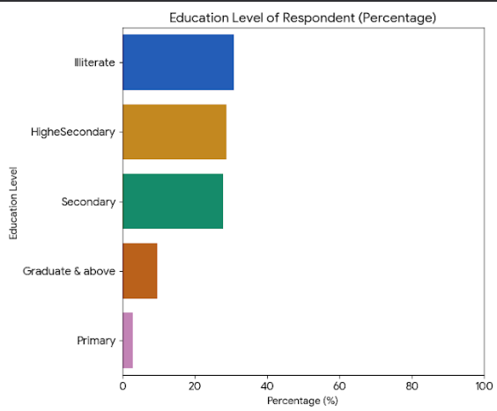 Fig 1

- The graph shows the education level of the primary caregiver in the population of the urban slum areas of New Delhi, out of which 30.8% population is Illiterate followed by people who have studied till Primary which is 2.8% which is the least, people who have studied till secondary are 27.9%, higher secondary counted for 28.7% which was the maximum and 9.6% people counted for Graduate and above.

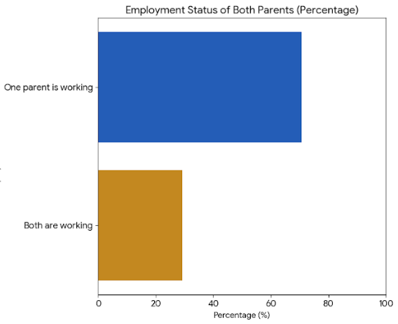Fig. 2
- The graph depicts the employment status of the parent whether both are working or only one parent is working which is male in majority of cases. In this population, 70.7% counted for only one parent working and remaining 29.2% counted for both parents working.

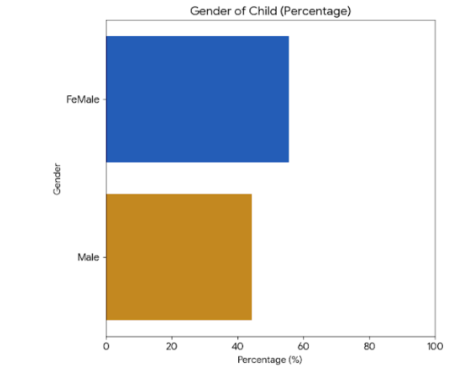Fig. 3

- The percentage distribution for Gender of Child accounted for female child is 55.6% and male child is 44.3%.
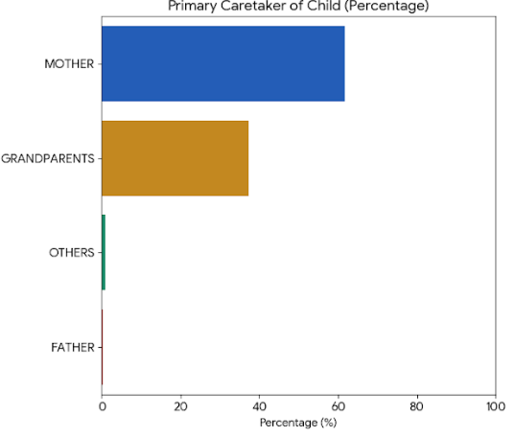Fig. 4

- The Primary Caretaker of Child is the mother in 61.6% of the population which is the maximum, followed by Grandparents which is 37.3% and Others such as any other family member accounted for 0.7% and father was the primary caregiver of only 0.2% of the children aged 2-6 years in the urban slum population of New Delhi which is the least.

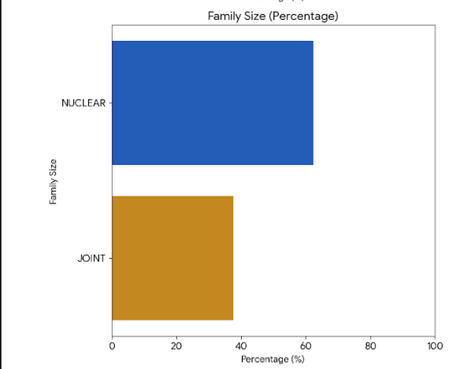Fig. 5
The Percentage Distribution for Family Size is nuclear family which constitutes of mother, father and child/children is 62.4% and Joint family which includes parents, grandparents, children, etc. is 37.5%.

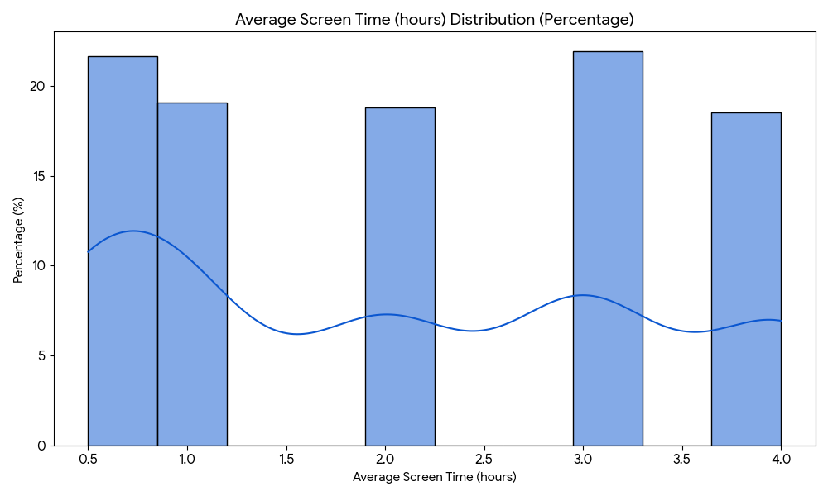Fig. 6

- This histogram visualizes the percentage of children falling into different ranges of average screen time. The y-axis shows the percentage of the total observations and x- axis shows the average screen time. For range 0-1 hours the percentage is 21.6%, 1-2 hours is 19.06%, 2-3 hours is 18.7%, for 3-4 hours is 21.9% which is the maximum and for 4-5 hours is 18.5%.

- CEBQ (Child Eating Behaviour Questionnaire)
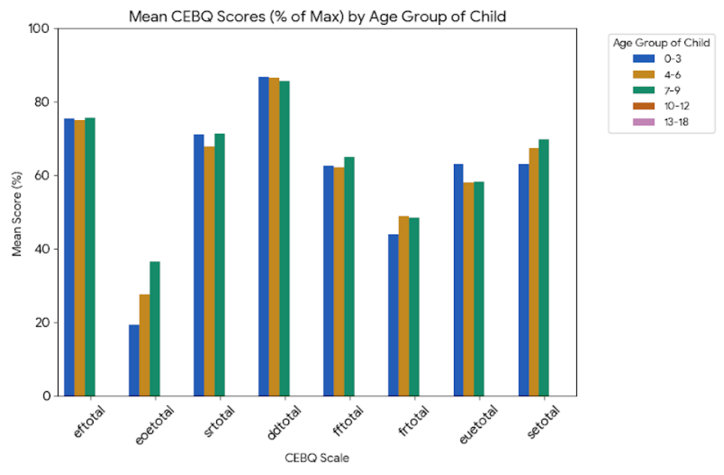Fig. 7
CEBQ: Emotional Overeating, Satiety Responsiveness, and Fussiness appear to be highest at age 6, while Emotional Undereating is highest at age 2, where EF total is Emotional Fussiness, EOE total is Emotional Overeating, SR total is Satiety responsiveness, DD total is Desire to Drink, FF total is Food Fussiness, FR total is Food Responsiveness, EUE total is Emotional Undereating plotted on x-axis against mean score on y-axis for different age range of children.

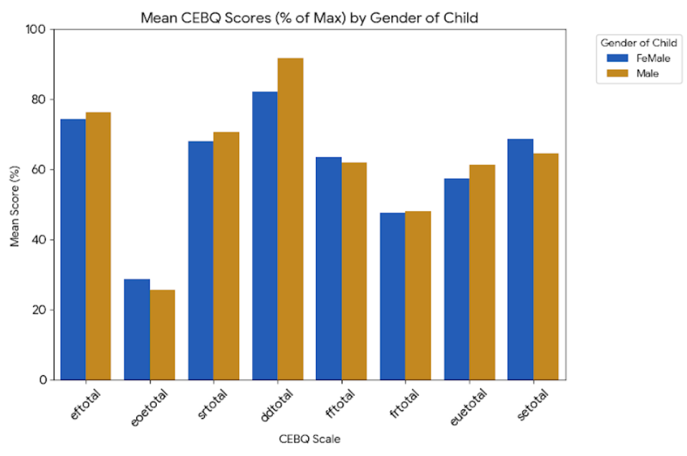Fig. 8
CEBQ: Male children show slightly higher average scores (as % of max) in Enjoyment of Food, Desire to Drink, and Food Responsiveness compared to Female children which is a Food Approach behavior. Female children, on the other hand, show slightly higher averages in Emotional Overeating and Satiety Responsiveness and Food Fussiness out of which is fussiness and Satiety responsiveness are Food avoidant behavior.

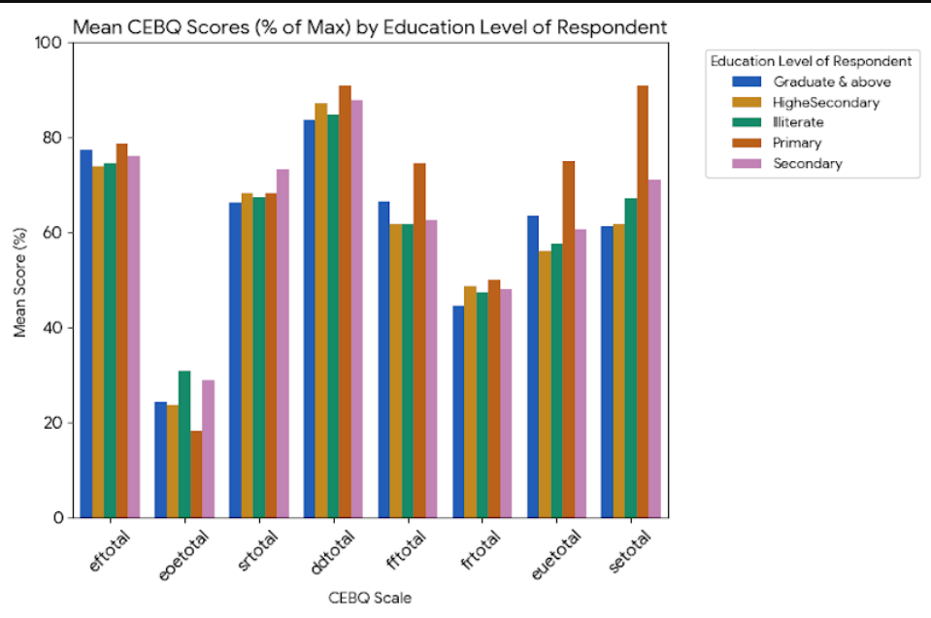Fig. 9
CEBQ: Children of parents with 'Primary' education show the highest average scores (as % of max) in Satiety Responsiveness, Fussiness, Emotional Undereating, and Food Responsiveness among the five levels of education which are Illiterate, Primary, Secondary, Higher Secondary and Graduate & above.

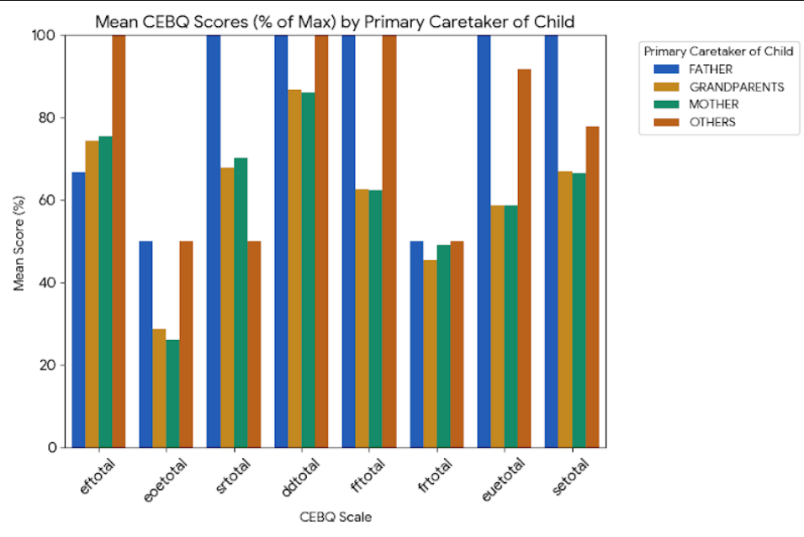Fig. 10

- CEBQ: Children primarily cared for by 'Father' or 'Others' show noticeably higher scores (as % of max) in Satiety Responsiveness, Fussiness, and Emotional Undereating.
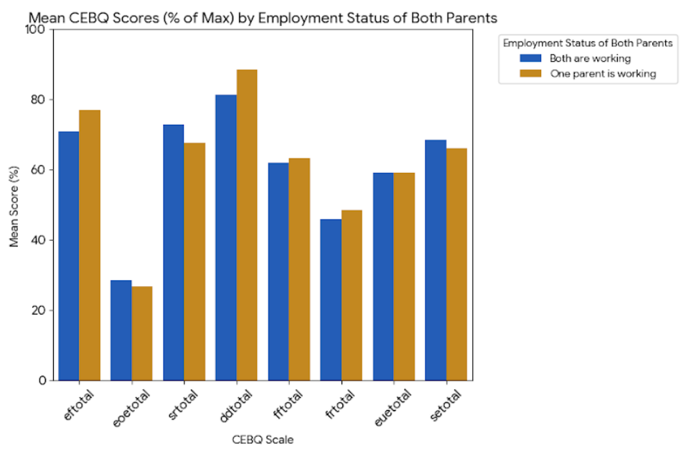Fig. 11

- CEBQ: Children of 'Both Are Working' parents show slightly higher Satiety Responsiveness and Fussiness (as % of max). Children of 'One Parent Is Working' tend to have slightly higher Enjoyment of Food and Food Responsiveness.
3) CFQ (Child Feeding Questionnaire)

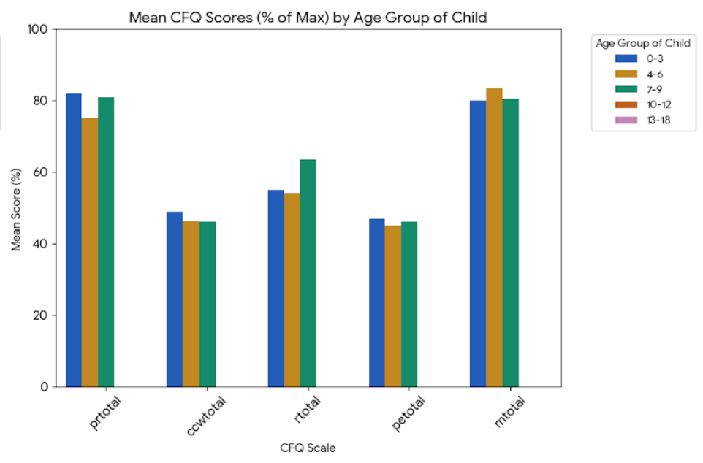Fig.12
CFQ: Parental Restriction is highest at age 6, and Pressure to Eat is highest at age 3. Monitoring peaks at age 5 among PR total which is Perceived Responsibility, CCW total is Concern for Child Weight, R total is Restriction, PE total is Pressure to eat and M total is Monitoring among children aged 2- 6 years.

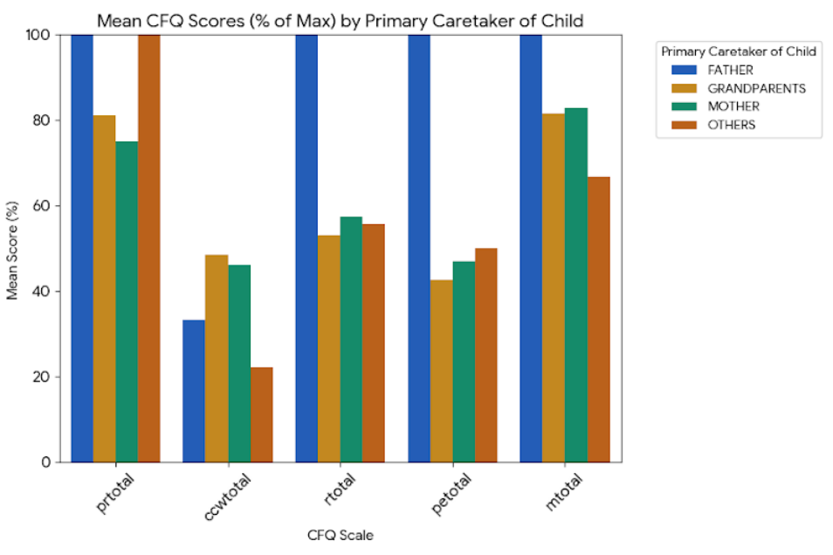Fig.13
CFQ: 'Father' caregivers exhibit the highest levels of Restriction and Pressure to Eat. 'Mother' and 'Grandparents' show similar levels of Pressure to Eat and Monitoring.
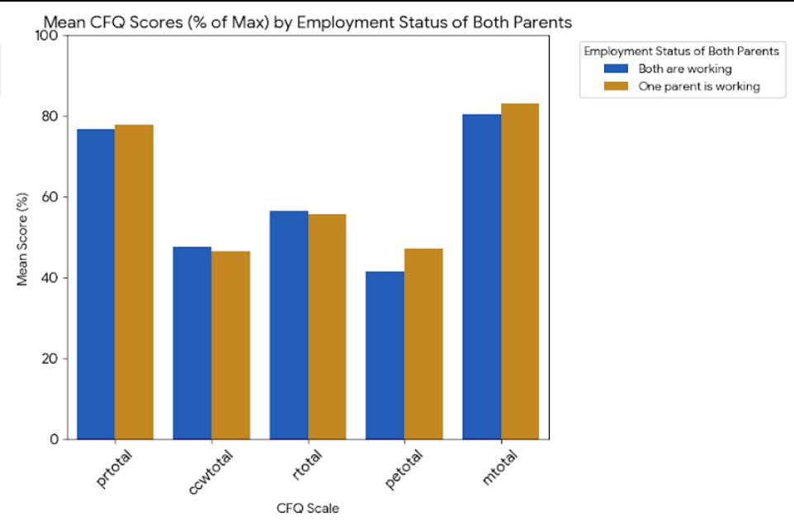Fig. 14
CFQ: Parental 'Restriction' is similar across both groups. However, 'One Parent Is Working' tends to have slightly higher 'Pressure to Eat' and 'Monitoring'.

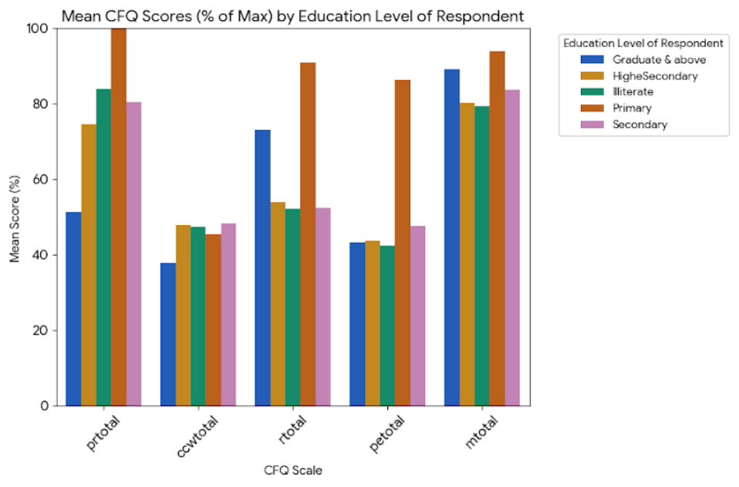Fig.15
CFQ: Parents with a 'Primary' education also report higher Restriction and Pressure to Eat. In contrast, 'Graduate & Above' educated parents show higher Monitoring.

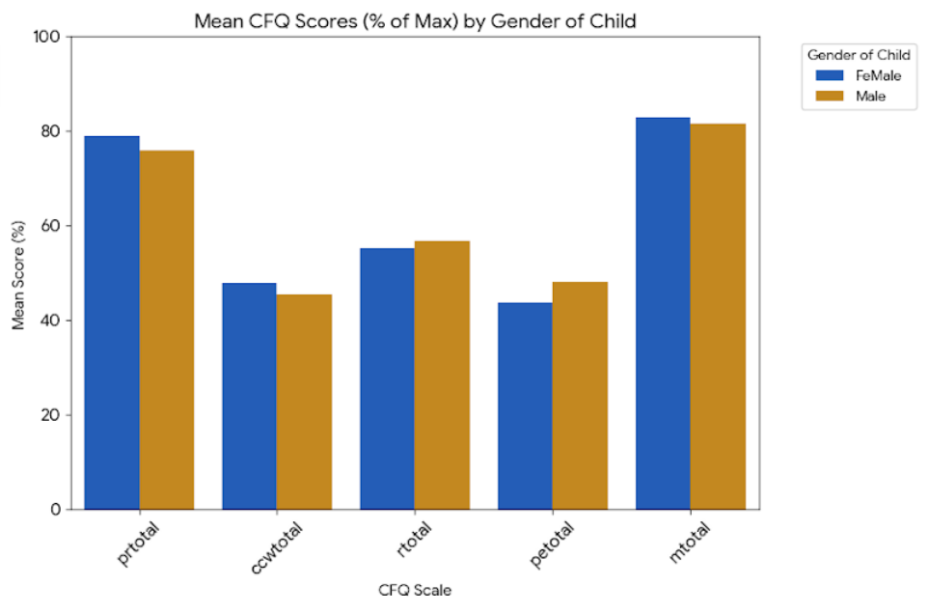Fig.16

CFQ: Male children have slightly higher mean scores for Pressure to Eat and Restriction from parents, while Female children have slightly higher scores for Monitoring.

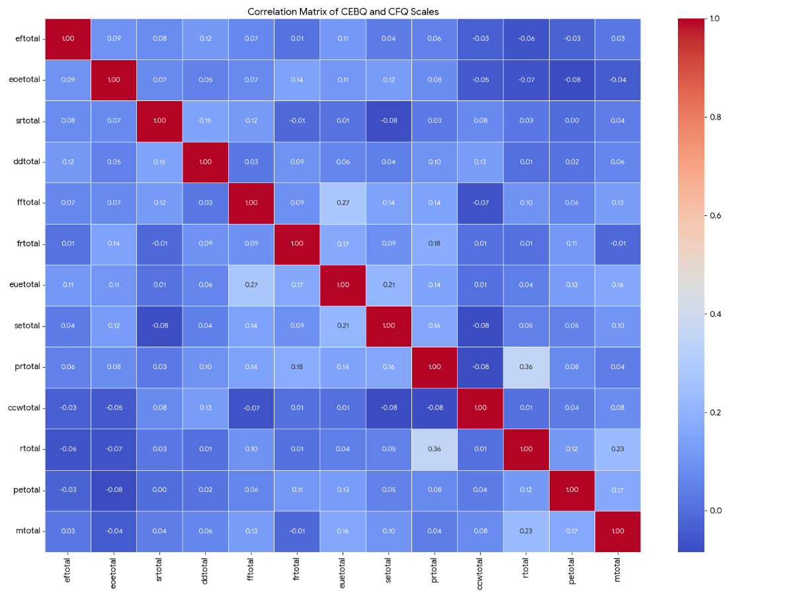Fig.17

The correlation analysis reveals interesting relationships between children's eating behaviors and parental feeding practices:
Positive Correlations:
• Fussiness and Monitoring (0.194): Fussiness in the child is weakly positively related to parental monitoring. This indicates that parents may enhance monitoring of food consumption when their child shows fussy eating.
•Emotional Undereating and Fussiness (0.291): There is a significant positive correlation, showing that children who eat less when upset are more likely to be fussy. This can point to a possible connection between the ability to control emotions and food acceptance.
• Emotional Undereating and Pressure to Eat (0.125): There is a weak positive correlation, which implies that parents may put more pressure on eating when their children are likely to undereat emotionally. This may be an attempt by parents to achieve sufficient intake.
• Restriction and Monitoring (0.228): A low positive correlation reveals that those parents who limit specific food groups also monitor their children's eating more tightly. This implies a consistent method of food control.

Weak or No Significant Correlations:
- Emotional Overeating and Desire to Drink with CFQ scales: Emotional Overeating shows very weak correlations with CFQ scales (e.g., -0.066 with Restriction, -0.081 with Pressure to Eat), and Desire to Drink also exhibits very weak correlations (e.g., 0.008 with Restriction, 0.015 with Pressure to Eat). This suggests that these specific child behaviors, in this sample, are not strongly linked to the measured parental feeding practices.
- Monitoring and Child Eating Behaviors: Monitoring shows weak correlations with most CEBQ scales (e.g., 0.027 with Enjoyment of Food, -0.010 with Food Responsiveness).

DISCUSSION
This study targets children's eating behaviors (CEBQ) and child feeding practices (CFQ), identifying a number of important patterns and connections:
1. Demographic and Behavioural Landscape:
•Parental Employment and Education: The majority of the dataset is defined by those families with one working parent (approximately 70.8%), indicates that a large number of children may have one parent staying mostly at home. Respondent education levels are also mixed, with a high percentage (greater than 30%) reporting as Illiterate, pointing to potential health literacy and health information access implications.
•Child Demographics and Care: The gender ratio of children is fairly even, with a slight female dominance (approximately 55.6%). Primary caregivers are predominantly mothers (approximately 61.6%), with grandparents being the next major group (approximately 37.3%), indicating the important role of extended family in child care. Joint families are less prevalent (approximately 62.4%) compared to nuclear families due to the migratory population.
•Screen Time Habits: One of the interesting findings here is the distribution of mean screen time, where more than 80% of children had 4 or fewer hours of screen time per day out of which majority is reported while consuming food.
2. Children's Eating Behaviors (CEBQ Scales):
•Positive Relationship with Food: Children in the sample generally display a high "Enjoyment of Food" (75.3% of max) and are quite "Satiety Responsive" (69.2% of max). This suggests that, broadly speaking, children enjoy eating and Enjoyment of Food is a Food Approach Behaviour in contrast to Satiety Responsiveness which is a Food Avoidant behaviour in children.
•Shared Feeding Difficulties: "Fussiness" is at a moderate level (62.8% of max), whereas "Emotional Undereating" (59.1% of max) also emerges as significant, implying that emotional states often affect children's appetite and intake both leading to Food Avoidant Behaviour in almost half the sample size.
•Lower Emotional Overeating: "Emotional Overeating" is fairly low (27.3% of max), common in younger groups since complex emotional eating behavior will establish itself later. "Food Responsiveness" (47.8% of max) shows some food approach susceptibility.
3. Parental Feeding Practices (CFQ Scales):
•High Monitoring: Mothers in the sample show a high level of "Monitoring" (82.2% of maximum) about what and how much they eat, implying active monitoring of what and how much their children eat has also been shown to be associated with Parental Warmth and Authoritative Parenting Style.
•Moderate Control: "Restriction" (55.9% of max) and "Pressure to Eat" (45.6% of max) are both at moderate levels. This shows that parents are actively applying strategies to control their children's eating, possibly in reaction to perceived feeding difficulties indicative of Authoritarian Parenting Style.
•Lower Concern about Child Weight: "Concern About Child Weight" is quite a bit lower (46.8% of max) than some other parenting practices.
4. Relationship between Child Eating Behaviors and Parental Feeding Practices
•Child Fussiness and Parental Response: The weak but positive correlation between "Fussiness" (child behavior) and "Monitoring" (parental practice) indicates that as fussiness increases, monitoring is increased by parents.
• Emotional Eating Linkages: An interesting positive relation between "Emotional Undereating" and "Fussiness" points to a possible clustering of these difficult eating behaviors. In addition, a weak positive association between "Emotional Undereating" and "Pressure to Eat" indicates parents' attempts to persuade intake when children consume less because of emotions indicative of Permissive parenting Style.
•Steady Control: The moderate positive relationship between "Restriction" and "Monitoring" suggests that parents who limit some foods also tend to monitor their child's overall food consumption more closely.
•No Strong Direct Relationships: Notably, the analysis shows very weak or no significant correlations between "Emotional Overeating," "Wanting to Drink," and most of the parental feeding practices (CFQ scales). Likewise, "Monitoring" tends to have weak relationships with most of the child eating behaviors (CEBQ scales). This is consistent with current research showing that certain feeding behaviors may be generalizable across the board or that the associations are more complicated and indirect than straightforward linear correlations indicate. The chi-square analyses also confirmed this, indicating no statistically significant correlation for the particular pairs examined (Fussiness and Monitoring, Emotional Undereating and Monitoring, Monitoring and Perceived Responsibility, Food Responsiveness and Restriction, Enjoyment of Food and Restriction).
5. Group Differences in Behaviors and Practices:
•Gender-Specific Trends: Small differences appear by gender, with male children having higher means on food approach behaviors (e.g., responsiveness, enjoyment), whereas female children score slightly higher on emotional overeating and satiety responsiveness. Parents' self-report practices also differ, with a little more restriction and pressure for male children, and more monitoring for female children along with involvement from technology.
•Age-Related Transitions: Food intake behaviors and feeding practices vary with age groups. For example, some difficult behaviors such as Emotional Overeating, Satiety Responsiveness, and Fussiness are apparently greater at approximately age 6 years, possibly as a function of development phases. Parental practices such as Restriction and Pressure to Eat vary with child age as well, showing adaptive parenting practices.
•Socioeconomic and Caregiver Factors: Parent education level is strongly associated with both child eating habits and feeding styles. Parents with less education have higher reports of child eating difficulties (e.g., greater fussiness, emotional undereating) and use more restrictive and pressuring feeding styles. Likewise, the identity of the primary caretaker (e.g., Mother vs. Father vs. Grandparents) is associated with unique patterns in child eating behaviors and parental feeding behaviors, highlighting the role of the immediate care environment.

CONCLUSION
Although children tend to like food and react to satiety, difficulties such as fussiness and emotional undereating are common. Parents actively track and, to some degree, limit and pressure their children with food. The correlations seen indicate that parental practices tend to change in reaction to particular child eating behaviors.
Most importantly, the chi-square tests revealed that the direct statistical relationships between the respective pairs of CEBQ and CFQ total scores under investigation were not statistically significant at the 0.05 level. This implies that although these practices and behaviors do co-occur and show a logical connection (as is indicated by the correlation coefficients), their categorical distributions are not significantly interdependent at a statistically significant level according to these tests. This might suggest that more subtle or non-linear associations are present, or that these particular parental behaviors are implemented across a range of child eating tendencies without significant, direct statistical dependence in terms of frequency counts.
In addition, demographic characteristics like gender, age, parents' educational level, work status, and main caregiver have been found to greatly influence both children's diet and the feeding behaviors utilized by their caregivers. These results highlight the complex nature of child feeding processes and further the need to take into account environmental and social contexts in the study of children's eating behavior.

BIBLIOGRAPHY
- Scaglioni, S., De Cosmi, V., Ciappolino, V., Parazzini, F., Brambilla, P., & Agostoni, C. (2018). Factors influencing children's eating behaviour. Nutrients, 10(6), 706. https://doi.org/10.3390/nu10060706
- Rylatt, L., & Cartwright, T. (2016). Parental feeding behaviour and motivations regarding pre-school age children: A thematic synthesis of qualitative studies. Appetite, 99, 285–297. https://doi.org/10.1016/j.appet.2016.01.018
- Shloim, N., Edelson, L. R., Martin, N., & Hetherington, M. M. (2015). Parenting styles, feeding styles, feeding practices, and weight status in 4–12 year-old children: A systematic review of the literature. Frontiers in Psychology, 6, 1849. https://doi.org/10.3389/fpsyg.2015.01849
- Duncanson, K., Burrows, T., & Collins, C. (2016). Parenting style and child feeding practices each influence child dietary intake, but it is unknown whether they influence one another or are modifiable. Children, 3(4), 28. https://doi.org/10.3390/children3040028
- Birch, L. L., Fisher, J. O., Grimm-Thomas, K., Markey, C. N., Sawyer, R., & Johnson, S. L. (2001). Confirmatory factor analysis of the Child Feeding Questionnaire: A measure of parental attitudes, beliefs and practices about child feeding and obesity proneness. Appetite, 36(3), 201–210. https://doi.org/10.1006/appe.2001.0398
- Bowne, M. (2009). A comparative study of parental behaviors and children's eating habits. Journal of Pediatric Health Care, 23(2), S10–S16. https://doi.org/10.1016/j.pedhc.2008.09.006
- Haidt, J. (n.d.). The anxious generation. [Manuscript in preparation or Book if published - update when available]
- Berge, J. M., Tate, A., Trofholz, A., Fertig, A. R., Miner, M., Crow, S., & Neumark-Sztainer, D. (2017). Momentary parental stress and food-related parenting practices. Pediatrics, 140(6), e20172295. https://doi.org/10.1542/peds.2017-2295
- Nagpal, J. (n.d.). Parenting styles and challenges. In New-age parenting. Macmillan Publishers India Ltd. [No date available – use "n.d."; add publication year when available.]
- Schiffer, Z. (2024, April 11). Inside the debate over The Anxious Generation. Platformer. https://www.platformer.news/p/inside-the-debate-over-the-anxious-generation
- Ahmed, I., Shahi, V., & Sharma, J. (2024). Correlation between screen time, eating habits and academic performance in pediatric population of NCR region. International Journal of Contemporary Pediatrics, 11(11), 1583–1589. https://doi.org/10.18203/2349-3291.ijcp20242407
- Jansen, P. W., Roza, S. J., Jaddoe, V. W. V., Mackenbach, J. D., Raat, H., Hofman, A., Verhulst, F. C., & Tiemeier, H. (2012). Children's eating behavior, feeding practices of parents and weight problems in early childhood: Results from the population-based Generation R Study. International Journal of Behavioral Nutrition and Physical Activity, 9(1), 130. https://doi.org/10.1186/1479-5868-9-130
- Nanu, E. D., & Nijloveanu, D. M. (2015). Attachment and parenting styles. Procedia - Social and Behavioral Sciences, 203, 199–204. https://doi.org/10.1016/j.sbspro.2015.08.279

APPENDIX

- INFORMED CONSENT
Namaste. I am Dr Manvi Verma. I am connected with the International Institute of Health Management (IIHMR) Delhi. You have been selected randomly to participate in this survey, and we would like to carry out an interview with you. The name of the study is “Feeding Habits and Eating Behavior of children of 2-6 years of newer generation in relation to first time parents”
We are trying to study the feeding habits and eating behaviors of children of 2-6 years of newer generation in first time parents Delhi. The interview is anticipated to take approximately 10-15 minutes. I will ask questions concerning:
Some personal details.
Your child’s feeding habits and eating behaviors and your parenting style.
The information you provide will remain entirely confidential and will not be disclosed to any external parties. They will exclusively be used for research purposes. Your name, address, and other personal information will be removed from the survey, and only a code will be used to connect your identity to your answers without disclosing your identity.
Your participation in the survey is voluntary. Should I ask a question you would rather not respond to, just let me know, and I will move on to the next question, or you can choose to conclude the interview.
If you have any questions about this survey OR If you have any further questions about this survey, don’t hesitate to contact me.For more information - manviv_2325@iihmrdelhi.edu.in
1.Do you agree to participate in this survey?
Yes/ No
- The age of your child is between 2 to 6 years.
Yes/ No

Child Feeding Questionnaire (CFQ) – Yes/No
Instructions: Please answer the following questions about your feeding habits with your child. Check Yes or No for each statement.
1. Do you encourage your child to eat even when they say they're not hungry?
Yes/ No
2. If your child says “I’m not hungry,” do you still try to get them to eat?
Yes/No
3. Do you believe your child should always finish all the food on their plate?
Yes/No
4. Do you limit how many sweets your child eats?
Yes/No
5. Do you intentionally keep certain foods out of your child’s reach?
Yes/No
6. Do you often say “no” to foods your child asks for?
Yes/No
7. Do you keep track of how many sweets your child eats?
Yes/No
8. Do you keep track of how many snacks your child eats?
Yes/No
9. Do you keep track of how much high-fat food your child eats?
Yes/No
10. Are you concerned that your child will become overweight?
Yes/No
11. Are you concerned about your child needing to diet to stay healthy?
Yes/No
12. Are you concerned that your child eats too much when not under your supervision?
Yes/No
Child Eating Behavior Questionnaire (CEBQ)
Instructions: Answer the following questions based on your child's eating behaviors. Check Yes or No.
13. Does your child often ask for food even when it's not mealtime?
Yes/No
14. If given the opportunity, would your child always be eating?
Yes/No
15. Does your child eat more when others are eating around them?
Yes/No
16.Does your child often stop eating before finishing a meal because they feel full?
Yes/No
17. Does your child frequently leave food on their plate at the end of a meal?
Yes/No
18. Does your child sometimes skip meals if they have had a snack recently?
Yes/No
19. Does your child eat more when they feel anxious, upset, or angry?
Yes/No
20. Does your child eat more when they get bored?
Yes/No
21. Does your child eat more when they’re annoyed?
Yes/No
22. Does your child take more than 30 minutes to finish a meal?
Yes/No
23. Does your child eat more and more slowly as the meal goes on?
Yes/No
24. Does your child refuse new foods at first?
Yes/No
25. Does your child often say “I don't like it” before even tasting a new food?
Yes/No
26. Does your child appear to enjoy eating?
Yes/No
27. Does your child look forward to mealtimes?
Yes/No
28. Does your child eat less when they are tired?
Yes/No
29. Does your child eat less when they are upset or sad?
Yes/No
30. Does your child frequently ask for a drink throughout the day (e.g., water, juice)?
Yes/No

Demographics
- Area Name: ___________
- Education level of the respondent: Illiterate / Primary/ Secondary/ Higher Secondary/ Graduate & above
- Employment Status of Both Parents:
- Occupation of parent/s: One parent is working/ Both are working/ None
- Monthly household income (approx.):
- Family size: _______ members
- Child
Age of child:
Gender of child: Male/ Female

Average Screen Time of Child ( in hours):
Primary Caregiver of Child: Mother/ Father/ Grandparents/ Others



