DISSERTATION REPORT at IIHMR, DELHI

A Report on

Assessing KAP related to food eating habits and physical activity among Post Graduate Students in New Delhi

By Anamika Singh
PG/23/015
Health Batch

Under the guidance of Dr Nidhi
PGDM (Hospital and Health Management) 2023-2025



International Institute of Health Management Research New Delhi

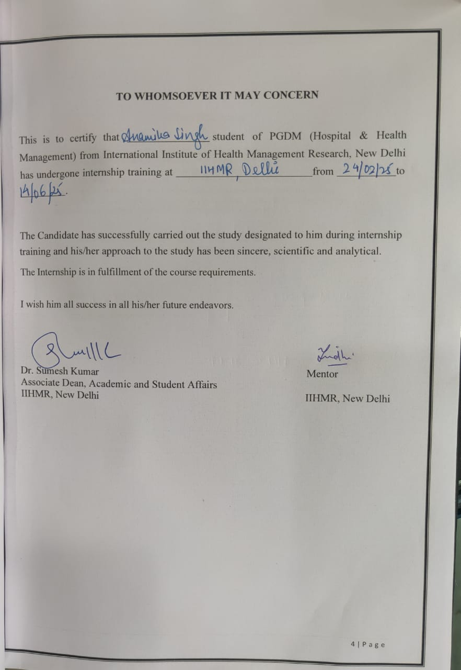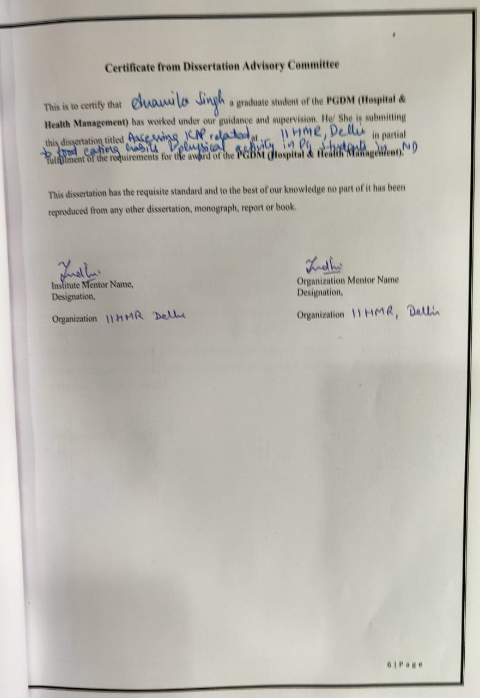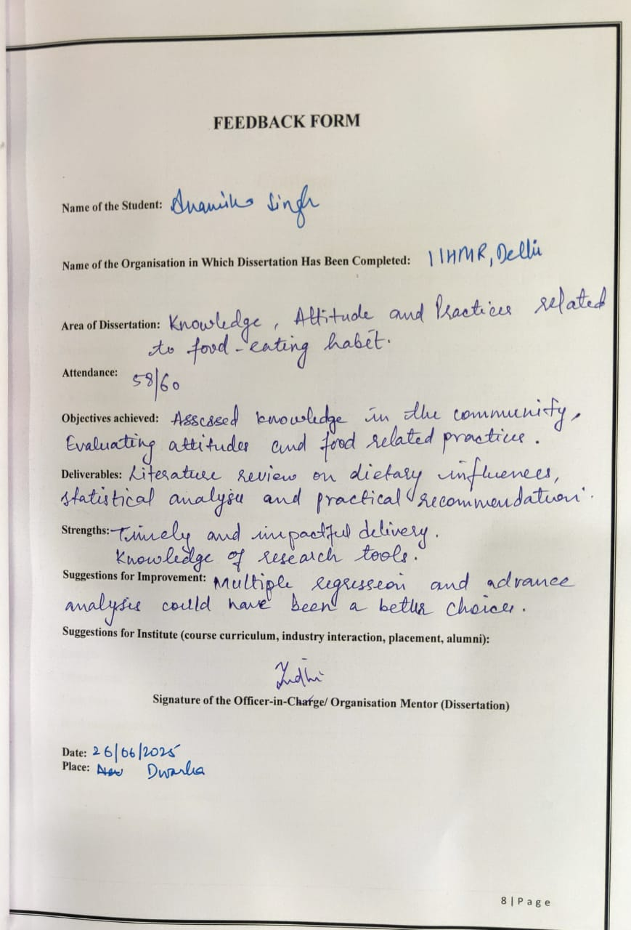

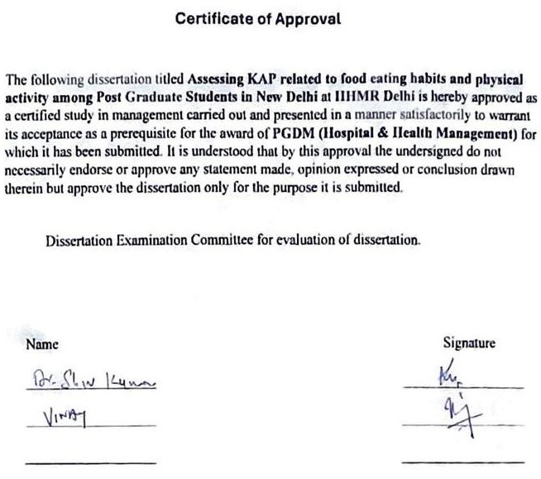
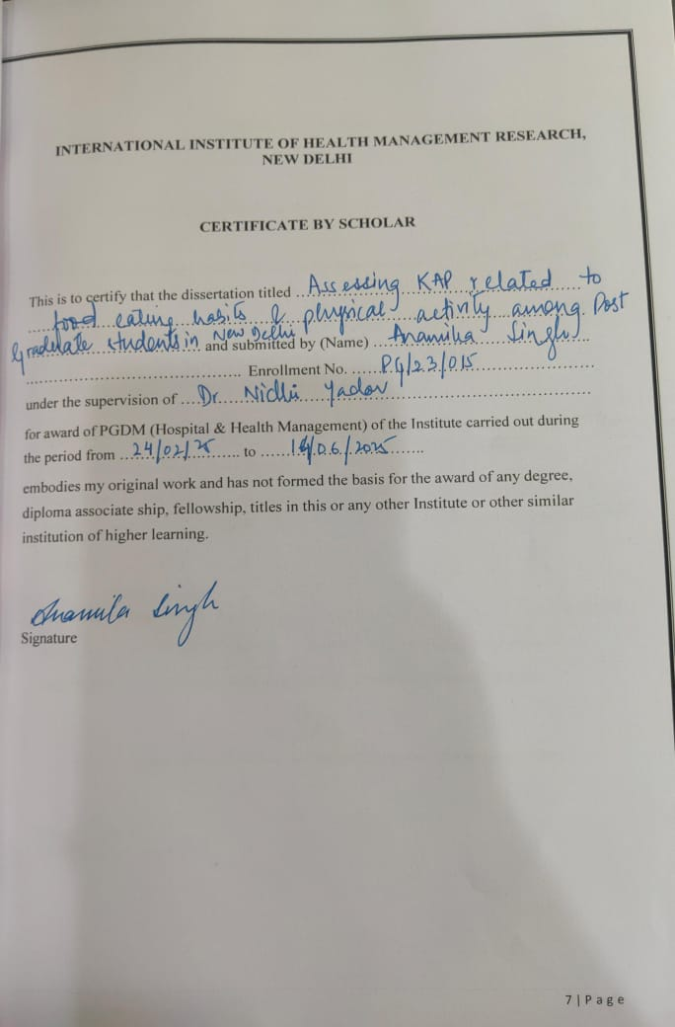
Contents
- Abstract 12
- Introduction 12
  - Research Question 13
  - Objectives 13
  - Rationale of the study 14
- Methodology 14
  - Study Area 14
  - Study Population 15
  - Study Period: 15
  - Data Collection Methods 15
  - Inclusion Criteria 16
  - Exclusion Criteria 16
  - Data Collection Tools and Techniques 16
  - Data Analysis 16
  - Ethical Considerations 16
  - Expected Outcomes 16
3.11 Limitations of the Study 18
- Review of Literature 18
- Results 18
- Discussion 32
- Conclusion 34
- Recommendations 35
- Tools 37
  - Informed Consent 37
  - KAP Survey/Questionnaire 38
- References 41

Table of Figures

S.No | Figure Despcription | Page No
1 | Knowledge Question 1 | 21
2 | Knowledge Question 2 | 22
3 | Knowledge Question 3 | 22
4 | Knowledge Question 4 | 22
5 | Knowledge Question 5 | 23
6 | Knowledge Question 6 | 24
7 | Attitude Question 7 | 25
8 | Attitude Question 8 | 25
9 | Attitude Question 9 | 25
10 | Attitude Question 10 | 26
11 | Attitude Question 11 | 26
12 | Attitude Question 12 | 26
13 | Practice Question 13 | 27
14 | Practice Question 14 | 27
15 | Practice Question 15 | 27
16 | Practice Question 16 | 28

Table Description

S.No | Table Description | Page No
1 | Demographic profile of Respondents | 19
2 | Mean Knowledge Scores | 20
3 | Mean Attitude Score | 16
4 | Mean Practice Scores | 23
5 | Final KAP Score Summary | 26
6 | Knowledge Questions Frequency and Percent
7 | Attitude Interpretations of Questions | 28
8 | Practice Interpretations of Questions | 29
9 | Correlation Analysis | 30

Table of Abbreviations

Short Form | Full Form/Meaning
KAP | Knowledge, Attitudes, and Practices
PGDM | Post Graduate Diploma in Management
IIHMR | International Institute of Health Management Research
SPSS | Statistical Package for the Social Sciences
WHO | World Health Organization
IIT | Indian Institute of Technology
SRB | Scientific Review Board (or your specific board)

Assessing KAP related to food eating habits and physical activity among Post Graduate Students in New Delhi

Abstract

To address the issue of poor eating habits among students, it is essential to examine the underlying knowledge, attitudes, and practices (KAP) that shape their dietary behaviors. This study investigates the KAP of postgraduate students residing in New Delhi, focusing on their understanding, perceptions, and lifestyle choices related to nutrition and physical activity.
The aim is to uncover the disconnects between what students know, believe, and actually do when it comes to healthy living. Although numerous awareness initiatives exist, unhealthy eating patterns and a lack of physical activity continue to be widespread among young adults. This research adopts a descriptive cross-sectional methodology, using a structured KAP questionnaire to evaluate students’ nutritional awareness, health-related mindsets, and everyday habits. The outcomes of the study are intended to expose knowledge-practice gaps and attitudinal challenges, ultimately guiding more tailored and impactful health promotion efforts in academic communities.

Introduction
In recent years, the emphasis on maintaining healthy eating habits and engaging in regular physical activity has grown substantially due to its significant impact on long-term health outcomes. However, despite ongoing awareness efforts, unhealthy dietary patterns and sedentary lifestyles remain widespread—particularly among young adults such as postgraduate students. This situation calls for a deeper exploration of the underlying factors influencing their dietary behaviors and lifestyle decisions. One well-established model used to examine such behaviors is the Knowledge, Attitudes, and Practices (KAP) framework.
Food eating habits refer to the regular choices individuals make regarding what, when, and how they consume food. These habits encompass food preferences, portion sizes, meal timing, snacking patterns, and are influenced by various factors such as culture, environment, emotional state, and social surroundings. These patterns, developed over time, play a critical role in shaping an individual’s nutritional status and overall health. [4]
The transition to postgraduate education often brings increased independence, along with changes in daily routines. Students are more likely to face academic stress, irregular schedules, limited culinary skills, and widespread availability of convenient but unhealthy street food. This makes them particularly vulnerable to poor eating behaviors. For instance, a study in Hong Kong revealed that adolescents' eating behaviors were shaped by family traditions, peer

influence, and personal health beliefs [3]. Similar patterns have been observed in India, where the interplay of cultural diversity, rapid urbanization, and limited nutritional literacy complicates efforts to maintain a healthy diet [2].
Within the KAP framework:
- Knowledge refers to an individual’s understanding and awareness about nutrition, food safety, and physical activity. This includes familiarity with dietary guidelines, nutrient needs, and the risks associated with unhealthy eating.
- Attitudes encompass personal feelings, beliefs, and perceptions toward healthful eating and exercise, which may not always align with one’s knowledge [1]. Positive attitudes can reinforce good practices, while negative ones may hinder change.
- Practices are the actual behaviors people engage in—such as food choices, meal preparation, hygiene habits, portion control, eating frequency, and levels of physical activity [2].
Understanding the KAP of postgraduate students can uncover gaps in knowledge, identify attitudinal barriers, and reveal patterns in behavior that affect health outcomes [1]. For example, research suggests that although students may demonstrate moderate awareness of healthy eating, their actual practices often fall short, indicating a disconnect between what they know and what they do.
Thus, evaluating the KAP related to food habits and physical activity among postgraduate students in New Delhi can offer essential insights. These findings can guide the development of tailored health education initiatives, interventions, and policy recommendations aimed at encouraging sustainable healthy lifestyles in this important demographic group.

Research Question
What is the knowledge, attitude, and practices (KAP) related to food eating habits and physical activity among the Post Graduate students in New Delhi, and how do these factors influence their dietary and lifestyle behaviors?

Objectives
    - To assess the knowledge of postgraduate students in New Delhi regarding healthy eating patterns and physical activity.
    - To examine the attitudes of postgraduate students towards healthy eating and regular physical activity.
    - To analyze the eating and physical activity practices of postgraduate students.

Rationale of the study

Assessing the knowledge, attitudes, and practices (KAP) related to food eating habits among postgraduate students is crucial for several reasons. These future healthcare leaders will play a significant role in promoting public health and managing healthcare services, making their dietary habits and understanding of nutrition vital. By identifying gaps in their knowledge, attitudes, and practices, targeted interventions can be developed to enhance their ability to advocate for healthy eating within healthcare settings. This study aims to provide insights into how these students' dietary behaviors can be improved, ultimately contributing to better health outcomes for both themselves and the communities they serve.

Methodology
This study will adopt a descriptive cross-sectional design to assess the Knowledge (K), Attitude (A), and Practice (P) related to food eating habits among Post graduate students residing in New Delhi. A cross-sectional study is suitable as it provides a snapshot of dietary behaviors and perceptions at a specific point in time.

Study Area
The study will be conducted in various postgraduate institutions located in New Delhi. These institutions represent a diverse student population with varied backgrounds, which allows for a comprehensive understanding of their food and physical activity behaviors. Selected institutes were IIT, Delhi

Study Population
The target population for this study includes postgraduate students enrolled in various academic programs across New Delhi. The inclusion of both males and females across disciplines ensures a broad representation of food eating habits.

  - Study Period: March to June 2025

Data Collection Methods

A structured KAP questionnaire consisting of closed-ended and open-ended questions covering:
- Knowledge: Awareness of balanced diets, food groups, and nutrition-related diseases.
- Attitude: Perception of healthy eating, fast food consumption, and meal planning.
- Practice: Actual dietary habits, frequency of meal consumption, and food sources.
  - Mode of Data Collection: Online Surveys: Google Forms for respondents.

Study Design | Cross-Sectional Study
Sample Size (n) | 96
Formula Used | n=Z2*p*(1-p)/d2  where
Z-value | 1.96 (for 95% confidence level)
Prevalence (p) | 0.5 (based on previous studies)
Margin of Error (d) | 0.1 (10%)
Calculation | n=(1.96)2*0.5*(1-0.5)/(0.1)2 N=3.84*0.25/0.01  =96.04
Sampling Method | Convenience Sampling

Inclusion Criteria:
- Students currently enrolled in a postgraduate program.
- Individuals willing to participate and provide informed consent.

Exclusion Criteria:
- Individuals not willing to provide informed consent.

Data Collection Tools and Techniques
A structured, self-administered questionnaire will be used for data collection. The questionnaire will consist of four sections:

    - Demographics – age, gender, course of study, socioeconomic status.
    - Knowledge – questions related to nutrition guidelines, food groups, and benefits of physical activity.
    - Attitudes – Likert scale-based questions assessing personal beliefs and perceptions about healthy eating and exercise.
    - Practices – frequency of meal consumption, street food consumption frequency, physical activity frequency, and type.

The questionnaire will be pre-tested on a small sample to ensure clarity and reliability.

Data Analysis
Data will be entered and analyzed using SPSS software. Data will be entered and analyzed using SPSS software. Descriptive analysis of sociodemographic data, knowledge, and attitude and practice data was done using pie charts of frequency and percentage.

Ethical Considerations
- Obtain ethical clearance from the Scientific Review Board (SRB) before commencing the study.
- All collected data will be treated with strict confidentiality and used solely for research purposes.
- Participants will be enrolled only if they meet the inclusion criteria and voluntarily agree to take part in the study.
- The study’s benefits, potential risks, and the voluntary nature of participation will be explained clearly, and written informed consent will be secured from all willing participants.
- Participants’ names or signatures on the consent forms will not be linked to any
identifiers in the research instruments.

- Safeguard against undue influence: Participation should be completely voluntary and free from coercion or external pressures, such as academic incentives or dependency on the researcher.
- Ensure informed and voluntary participation: Participants must be provided with all necessary information about the study, including its purpose, procedures, risks, and benefits, and assured of their right to withdraw at any stage.
- Be aware of power dynamics: Researchers must acknowledge and address any inherent power imbalances, such as those between faculty and students or healthcare providers and patients, to prevent participants from feeling compelled to join.
- Respect participants' autonomy: Individuals should have the freedom to make informed choices about their participation without any influence or persuasion.
- Empower participants to make independent decisions: They should be encouraged to ask questions, seek clarifications, and decline or discontinue participation without any negative consequences.
- Avoid deceptive or coercive practices: Recruitment and data collection should be conducted honestly, without making false claims or applying psychological pressure.
- Communicate transparently: All study materials, especially consent forms, should be written in plain, understandable language and provide a truthful account of the research process.
- Uphold privacy and confidentiality: Personal data must be securely stored, with access limited to authorized research personnel only.
- Obtain specific consent for data usage: Apart from participation consent, participants should be informed and give explicit approval regarding how their data will be stored, handled, and possibly shared.
- Anonymize data wherever possible: Direct identifiers like names or addresses should be removed to enhance participant privacy.
- Restrict data access: Data should only be shared with individuals who are directly involved in the research and have a legitimate need to access it.
- Verify informed consent for secondary data: Review original consent documentation from previous studies to ensure it permits the use of anonymized data for future research.
- Implement robust data protection protocols: Ensure anonymization techniques are applied and that data is stored securely with access restricted to essential personnel.
- Evaluate data quality: Be mindful of potential inconsistencies due to changes in clinical practices or data collection methods over time, and acknowledge these limitations in analysis.
- Justify use of secondary data: Clearly explain the relevance and benefits of using existing data for the current research question, emphasizing minimal burden on participants.
- Engage with affected communities: If previous data involves specific communities, consider consulting community representatives about the reuse of their data.
- Clarify data ownership: Confirm legal and ethical ownership of previously collected data to ensure appropriate permissions for its use in the current research.

Expected Outcomes
The study aims to:

- Highlight the level of awareness postgraduate students have about nutrition and physical activity.

- Understand their attitudes and willingness to make lifestyle changes.
- Identify gaps between knowledge and actual practice.
- Provide recommendations for awareness campaigns or institutional policy changes to promote healthier lifestyles in student communities.

3.11 Limitations of the Study
- The use of self-reported data may introduce bias (e.g., underreporting unhealthy habits).

Review of Literature

Importance of Healthy Eating and Physical Activity
Adopting balanced diets and engaging in regular exercise are crucial for long-term well-being and chronic disease prevention. Yet, poor eating patterns and inactivity are widespread among youth, particularly postgraduate students, due to lifestyle freedom, study pressure, and disrupted daily schedules. [5]
A nutritious diet and consistent physical activity are essential for preventing chronic conditions and promoting lifelong wellness. Nevertheless, many young adults, particularly postgraduates, develop poor habits due to personal independence, academic stress, and disorganized routines. [6]
The International Journal of Behavioral Nutrition and Physical Activity reports that 65% of urban dwellers are inactive, compared to 50% in rural areas. This reflects a notable urban- rural contrast in lifestyle patterns. [7]
According to the National Institute of Nutrition (NIN), regions in North India, including Delhi, consume fewer calories, protein, and carbohydrates than the national average.
However, fat intake is higher, with visible fats contributing 24% of energy. Fruits and vegetables offer under 3% of daily energy—indicating dietary imbalance. [8]
Data from the National Family Health Survey (NFHS-5, 2019–21) reveals an increase in obesity rates nationwide. The trend spans both urban and rural areas and affects all age groups. NFHS-5 also reports growing meat consumption, especially among men, and that 52% of women eat leafy greens daily. [9]

Factors Influencing Eating Habits
Eating behaviors are driven by cultural norms, environment, emotions, and social ties. Students are prone to unhealthy diets due to stress, poor cooking abilities, and street food access. Research in Hong Kong and India shows family, peers, urban growth, and lack of awareness shape student food choices. [3]

Gaps Between Knowledge and Practice
Studies reveal that students often know about healthy eating but fail to act accordingly, showing a gap between knowledge and behavior. Negative attitudes, like low motivation or false beliefs about street food safety, further hinder good dietary habits.

Although national surveys provide broad data, few specifically examine the KAP of postgraduate students in urban settings like Delhi. This group is often overlooked in large studies yet may engage in risky habits due to stress, fast food culture, and a lack of physical activity.

Results

N=95

Demographics |  | Count | %
Gender | Female | 57 | 60.0%
 | Male | 38 | 40.0%
Year of Study | 1st Year | 9 | 9.5%
 | 2nd Year | 86 | 90.5%
Field of Post-Graduation Study | Arts | 2 | 2.1%
Field of Post-Graduation Study | MBA | 60 | 63.2%
 | Medical Science | 7 | 7.4%
 | MTech | 6 | 6.3%
 | Others | 12 | 12.6%
 | Science | 8 | 8.4%
Name of College | IIHMR, Delhi | 48 | 50.5%
 | IIT, Delhi | 47 | 49.5%
Living place during study | College Hostel | 14 | 14.7%
 | PG/Flat/Others | 37 | 38.9%
 | With Family | 44 | 46.3%
Food Preference | Eggetarian | 11 | 11.6%
 | Non-vegetarian | 39 | 41.1%
 | Vegetarian | 45 | 47.4%
Smoking | Never | 73 | 76.8%
 | Occasional | 18 | 18.9%
 | Regular | 4 | 4.2%
Alcohol Frequency | Never | 52 | 54.7%
 | Occasional | 42 | 44.2%
 | Regular | 1 | 1.1%
Table 1: Demographic profile of Respondents

A total of 95 participants were included in the study. The demographic details are summarized below:

- Gender: The majority were female (60.0%), while male participants comprised 40.0% of the sample.
- Year of Study: Most participants were in their 2nd year (90.5%), with only 9.5%
from the 1st year.
- Field of Post-Graduation Study: The largest group belonged to MBA (63.2%), followed by Science (8.4%), Medical Science (7.4%), MTech (6.3%), Others (12.6%), and Arts (2.1%).
- Name of College: Participants were nearly equally distributed between IIHMR, Delhi (50.5%) and IIT, Delhi (49.5%).
- Living Place During Study: A significant proportion lived with family (46.3%), followed by those in PGs/flats/others (38.9%), and college hostels (14.7%).
- Food Preference: Most participants were vegetarian (47.4%), followed by non- vegetarian (41.1%), and eggetarian (11.6%).
- Smoking Habits: A majority (76.8%) had never smoked, while 18.9% smoked occasionally and 4.2% were regular smokers.

Alcohol Consumption: Over half (54.7%) never consumed alcohol, 44.2% drank occasionally, and only 1.1% reported regular consumption.

Knowledge

Statistics
Knowledge
N | Valid | 95
N | Missing | 0
Mean |  | 4.937
Median |  | 5.000
Mode |  | 6.0
Std. Deviation |  | 1.4203
Table 2: Mean Knowledge Scores

Out of the total participants (N = 95), there were no missing responses for the knowledge section.
- The mean knowledge score was 4.94, indicating a moderately good level of knowledge among respondents.

- The median score was 5.00, which shows that half the participants scored 5 or above.
- The mode was 6.0, suggesting that the most common score achieved by participants was 6.
- The standard deviation was 1.42, indicating a moderate level of variation in knowledge scores among participants.
- This suggests that, overall, participants had a reasonably good understanding of the topic measured, with most scoring near or above the average.
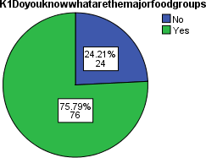

Figure 1. Knowledge Question 1
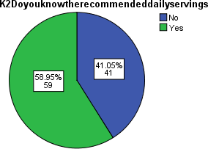
Figure 1: Knowledge Question 2

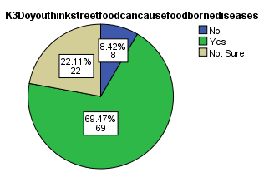
Figure 3: Knowledge Question 3

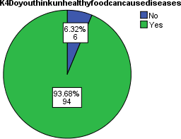
Figure 4: Knowledge Question 4

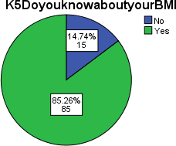
Figure 5: Knowledge Question 5

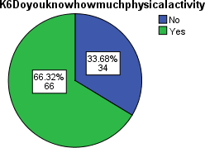

Figure 6: Knowledge Question 6

Attitude

Statistics
Attitude
N | Valid | 95
N | Missing | 0
Mean |  | 19.916
Median |  | 21.000
Mode |  | 21.0
Std. Deviation |  | 3.4631
Table 3: Mean Attitude Score

All 95 participants responded to the attitude section, with no missing data.
- The mean attitude score was 19.92, indicating a generally positive attitude among respondents.
- The median score was 21.00, showing that at least half the participants had a high attitude score.
- The mode was also 21.0, meaning the most frequently occurring attitude score was at the higher end of the scale.
- The standard deviation was 3.46, suggesting moderate variability in participants' attitude scores.

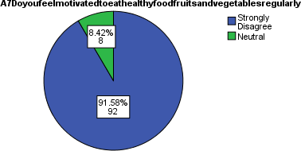
Figure 7: Attitude Question7

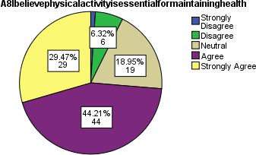

Figure 8: Attitude Question 8
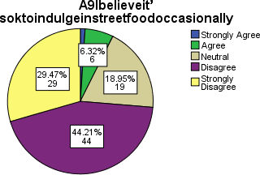

Figure 9: Attitude Question 9
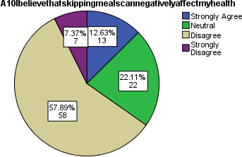
Figure 10: Attitude Question 10

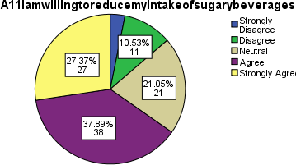

Figure 11: Attitude Question 11
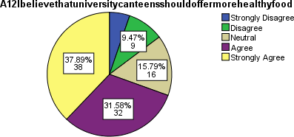
Figure 12: Attitude Question 12

Statistics
Practice
N | Valid | 95
 | Missing | 0
Mean |  | 8.4737
Median |  | 8.0000
Mode |  | 10.00
Std. Deviation |  | 2.11299
Table 4: Mean Practice Scores

All 95 participants completed the practice section, with no missing data.
- The mean practice score was 8.47, suggesting a moderate level of healthy practices among the participants.
- The median score was 8.00, meaning that half of the participants had scores below or equal to 8.
- The mode was 10.00, indicating that the most frequently occurring score was at the higher end of the scale.
- The standard deviation was 2.11, reflecting a moderate spread in practice scores.

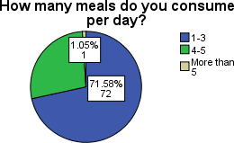
Figure 13: Practice Question 13

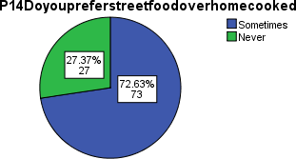
Figure 14: Practice Question 14
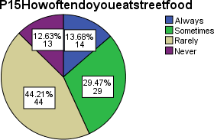
Figure 15: Practice Question 15
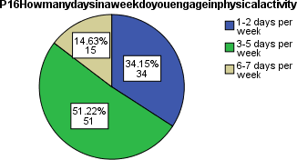
Figure 16: Practice Question 16

Domain | Mean ± SD | Score Range | % of Max Score | Interpretation
Knowledge | 4.94 ± 1.42 | 0 – 6 | 82.3% | High knowledge
Attitude | 19.92 ± 3.46 | 6 – 30 (Likert) | 66.4% | Moderately positive attitude
Practice | 8.47 ± 2.11 | 0 – 10 | 84.7% | Good dietary practices
Table 5: (n = 95) Final KAP Score Summary

Among the 95 valid respondents, the mean knowledge score was 4.94 ± 1.42 (out of 6), indicating a high level of knowledge regarding healthy eating and nutrition. The average attitude score was 19.92 ± 3.46 (out of a maximum of 30), reflecting a moderately positive attitude towards healthy food choices. The mean practice score was 8.47 ± 2.11 (out of 10), suggesting that respondents generally engage in good dietary practices. These findings indicate that while knowledge and practices are strong, there remains room to further reinforce positive attitudes to improve overall behavior change.

Knowledge Question | Correct (n) | Correct (%) | Incorrect (n) | Incorrect (%)
K1. Major food groups | 72 | 75.8% | 23 | 24.2%
K2. Recommended daily servings | 56 | 58.9% | 39 | 41.1%
K3. Unhealthy causes diseases | 85 | 89.5% | 10 | 10.5%
K4. Importance of Breakfast intake | 89 | 93.7% | 6 | 6.3%
K5. Know about your BMI | 81 | 85.3% | 14 | 14.7%
K6. Physical activity guidelines | 63 | 66.3% | 32 | 33.7%
Table 6: Knowledge Questions Frequency and Percent

- The highest awareness was on the importance of breakfast intake (93.7%), followed by unhealthy diets causing diseases (89.5%), and knowledge of BMI (85.3%).
- The lowest correct response rate was for recommended daily servings (58.9%), showing a possible gap in nutritional specifics.
- Overall, knowledge appears to be good in general concepts (e.g., breakfast, BMI, and health risks) but relatively weaker in quantitative guidelines, such as servings per day or physical activity recommendations.
This data supports the idea that while students have a general understanding, targeted education may be needed on specific guidelines and actionable practices.

Attitude Item | Mean ± SD | Media n | Mode | Min– Max | Interpretation
A7: Feel  motivated to eat healthy food/fruits/vegeta bles regularly | 1.17 ±  0.56 | 1.00 | 1.0 | 1–3 | Low motivation toward healthy eating

A8: Believe physical activity is essential for maintaining health | 3.95 ±  0.92 | 4.00 | 4.0 | 1–5 | Strongly positive belief
A9: It’s okay to  indulge in  unhealthy food occasionally | 3.95 ±  0.92 | 4.00 | 4.0 | 1–5 | Acceptance of occasional indulgence
A10: Skipping meals negatively affects health | 3.47 ±  1.08 | 4.00 | 4.0 | 1–5 | Moderate agreement
A11: Willing to reduce intake of sugary beverages | 3.76 ±  1.07 | 4.00 | 4.0 | 1–5 | Positive health intention
A12: University canteens should offer more healthy food | 3.87 ±  1.18 | 4.00 | 5.0 | 1–5 | Strong desire for healthier campus options
Table 7: Attitude Interpretations of Questions

- Participants show strongly positive attitudes toward physical activity, reducing sugary drinks, and improving campus food options (A8, A11, A12).
- There's a general acceptance of occasional unhealthy eating (A9), which is realistic and common in student populations.
- The lowest attitude score was for motivation to eat healthy regularly (A7), with a mean of just 1.17, indicating a significant gap between belief and action.
- Moderate agreement exists for the negative effects of skipping meals (A10).

This contrast highlights the attitude-behavior gap—while students recognize the importance of healthful behaviors, daily motivation and consistency may be lacking.

Practice Item | Mean ± SD | Media n | Mod e | Min– Max | Interpretation
P13: Meals consumed per day | 4.08 ±  1.11 | 4.00 | 5.0 | 1–5 | Most students consume 4+ meals daily – a healthy meal pattern.
P14: Preference for street food over home-cooked | 1.27 ±  0.45 | 1.00 | 1.0 | 1–2 | Majority prefer home-cooked food  – a healthier dietary habit.
P15: Frequency of eating unhealthy/street food | 1.56 ±  0.88 | 2.00 | 2.0 | 0–3 | Moderate consumption – occasional intake of unhealthy food.
P16: Days/week engaged in physical activity | 1.56 ±  0.88 | 2.00 | 2.0 | 0–3 | Low to moderate physical activity  – lifestyle change recommended.
Table 8: Practice Interpretation of Questions

The practice-related responses of postgraduate students indicate a mix of healthy intentions and moderate lifestyle habits. Most students reported consuming four or more meals a day (Mean = 4.08), reflecting a regular eating pattern. A significant majority preferred home- cooked meals over street food (Mean = 1.27), showing a preference for healthier choices. However, a moderate frequency of street or unhealthy food consumption (Mean = 1.56) still persists, with both median and mode at 2, suggesting occasional indulgence. Physical activity levels were also found to be relatively low, with students engaging in physical exercise about 1 to 2 days a week on average (Mean = 1.56). These results highlight that while students demonstrate good food-related practices overall, consistent physical activity and reduced intake of unhealthy food need further improvement.

 |  | Knowledge | Attitude | Practice
Knowledge | Pearson Correlation | 1 | .393** | .208*
 | Sig. (2-tailed) |  | .000 | .044
 | N | 95 | 95 | 95
Attitude | Pearson Correlation | .393** | 1 | .346**
 | Sig. (2-tailed) | .000 |  | .001
 | N | 95 | 95 | 95
Practice | Pearson Correlation | .208* | .346** | 1
 | Sig. (2-tailed) | .044 | .001
 | N | 95 | 95 | 95
**. Correlation is significant at the 0.01 level (2-tailed).
*. Correlation is significant at the 0.05 level (2-tailed).
Table 9: Correlation Analysis

Pearson correlation analysis revealed a moderate positive correlation between knowledge and attitude (r = 0.393, p < 0.001), indicating that respondents with higher knowledge levels tended to have more positive attitudes toward healthy eating. A weak but statistically significant correlation was found between knowledge and practice (r = 0.208, p = 0.044), suggesting that higher knowledge is associated with slightly better dietary practices. Additionally, a moderate positive correlation was observed between attitude and practice (r = 0.346, p = 0.001), showing that more favorable attitudes were linked to better eating behaviors.

Discussion

The current study assessed the knowledge, attitude, and practice (KAP) of postgraduate students in New Delhi regarding healthy eating and physical activity. Findings revealed a relatively high level of knowledge, positive attitudes, and moderately good practices, but with clear gaps between awareness and actual behavior—consistent with national and international literature.
Healthy eating and physical activity are known pillars of disease prevention and long-term well-being. Yet, as outlined in earlier studies, young adults, including postgraduate students, are increasingly exposed to unhealthy behaviors due to academic pressures, irregular schedules, and accessibility to convenience foods. The high mean knowledge score (4.94 out of 6) in this study reflects a sound awareness among students about the importance of healthy diets and physical activity. However, similar to the gaps identified in the literature, especially NFHS-5 and NIN data, this knowledge did not always translate into consistent healthy practices.
The attitude score (mean: 19.9/26) showed that participants had a favorable perception towards healthy behaviors, yet practices like regular fruit and vegetable intake, eating breakfast, or avoiding high-fat snacks were not uniformly followed—echoing findings from NFHS-5, which indicated imbalanced diets, increased fat intake, and low fruit and vegetable consumption, especially in urban North India.
This research also reinforces previous studies’ insights that urban youth exhibit higher inactivity rates and poor dietary diversity, despite being more exposed to health information. Cultural and emotional influences, convenience eating, and academic lifestyle disruptions continue to drive unhealthy consumption patterns. Similar observations were noted in both national data (NIN, NFHS-5) and international contexts such as Hong Kong, where peer and environmental factors were major influences.
Importantly, the significant correlations found between knowledge, attitude, and practice in this study align with past research. A moderate positive correlation between knowledge and attitude (r = 0.393), and attitude and practice (r = 0.346), underscores that better awareness leads to improved perceptions, which can positively impact behavior, though the relationship with actual practice (r = 0.208) remains weaker—suggesting other psychological and behavioral barriers.
Furthermore, the lack of a strong correlation with age and gender in this study implies that health promotion strategies should focus less on demographics and more on behavior change motivation, environmental support, and accessibility to healthy options. Despite high awareness, the practice gap persists, likely due to convenience eating, low perceived risk, and limited food preparation skills.
As highlighted in the literature, postgraduate students are underrepresented in large-scale nutritional studies, yet this population is vulnerable due to lifestyle stress and evolving food environments. This study adds to that evidence base and suggests that targeted nutritional education programs—that not only improve knowledge but also address attitudes and practical barriers—are essential in this group.

Conclusion
The present study aimed to assess the knowledge, attitude, and practice (KAP) related to food eating habits and physical activity among postgraduate students in New Delhi. The findings revealed that participants possessed a high level of knowledge regarding healthy eating and physical activity, with a mean knowledge score of 4.94 out of 6. The attitude scores indicated a generally positive perception toward adopting healthy dietary behaviors, while the practice scores reflected moderately good implementation of those behaviors in daily life.
Furthermore, statistically significant correlations were found between knowledge, attitude, and practice scores, reinforcing the notion that improvements in knowledge and attitude can influence healthier behaviors. Despite this, variation in practice indicates the need for more targeted and behavior-focused interventions.
These findings underscore the importance of sustained nutritional education and behavior change communication, even among educated populations. Integrating health promotion programs at the university level and fostering an environment that supports healthy choices could bridge the knowledge–practice gap and encourage long-term wellness among youth.

Recommendations

Train
Train healthcare professionals, community workers, and educators to raise awareness about obesity, nutrition, and the importance of regular physical activity. These trained individuals can conduct workshops, school sessions, and community health camps to reach families and youth with practical health tips and preventive care strategies.

Integrate
Incorporate obesity and lifestyle-related disorder prevention into current national health programs like NP-NCD (National Programme for Prevention and Control of Non- Communicable Diseases) and POSHAN Abhiyaan. This integration ensures that healthy lifestyle promotion becomes a regular part of routine healthcare services and maternal-child health programs.

Launch
Implement broad national and state-level public health campaigns to educate citizens about the benefits of eating balanced diets and engaging in physical activity. Use multimedia platforms, including TV, social media, and radio, to reach diverse audiences and normalize healthy behaviors.

Use
Develop and promote simple, easy-to-understand health messages in local languages to increase public understanding. Use visuals and relatable scenarios to explain concepts such as portion control, healthy cooking, and active lifestyles, improving health literacy across populations with varying educational backgrounds.

Enforce
Mandate clear and visible food labeling that informs consumers about salt, sugar, trans fat, and calorie content. Enforcement of such regulations helps individuals make informed decisions and increases pressure on food manufacturers to reformulate unhealthy products.

Tax
Impose taxes on sugary drinks, high-fat snacks, and ultra-processed foods to discourage excessive consumption. Evidence suggests that even a modest price increase can reduce intake, especially among youth and low-income groups, while generating revenue for health promotion activities.

Ban or Restrict
Limit or prohibit advertising and marketing of unhealthy food products—particularly those high in sugar, salt, and fat—especially to children through TV, internet, and school-related channels. This helps reduce the influence of persuasive food marketing on vulnerable age groups.

Make
Ensure that healthy foods like fruits, vegetables, whole grains, and low-fat dairy products are widely available and affordable in public spaces such as school cafeterias, workplace canteens, vending machines, and food courts. Encourage institutions to adopt nutrition policies.

Build
Invest in infrastructure that supports active lifestyles. This includes safe walking and cycling paths, gyms and sports facilities in schools, open parks, and recreational spaces in workplaces and neighborhoods to encourage regular movement and reduce sedentary behavior.

Tools

Informed Consent

INTERNATIONAL INSTITUTE OF HEALTH MANAGEMENT RESEARCH DELHI

Understanding KAP Related to Food Eating Habits and Physical Activity Among Post Graduate Students in New Delhi

Introduction

We invite you to participate in a research study that explores the knowledge, attitude, and practices (KAP) related to food eating habits and physical activity among postgraduate students in New Delhi.

Study Description

This brief survey aims to understand how students perceive and practice healthy eating and physical activity. It will take approximately 7–10 minutes to complete. The questionnaire includes questions on:
•Your age, gender, and academic background
•Your knowledge and understanding of healthy eating and physical activity
•Your personal attitudes and beliefs towards these topics
- Your current eating habits and physical activity routine

Benefits

This study involves minimal risk. You may reflect on your lifestyle choices, which could cause slight discomfort or self-awareness. The findings may help in designing better awareness programs and strategies for promoting healthier lifestyles among students.

Confidentiality

All information provided will remain confidential. This survey is anonymous, and no identifying details will be collected. Responses will be coded and securely stored for research purposes only.

Consent

By filling this form, you confirm that you are a postgraduate student residing in New Delhi, and that you have read and understood this form and have filled this form voluntarily.

KAP Survey/Questionnaire
Section A: Demographic Information
- Age:
-[ ]18-25
-[ ] >25
- Gender:
-[ ] Male
-[ ] Female
-[ ] Other
- Year of Study:
  - [ ] 1st Year
  - [ ] 2nd Year
  - [ ] Postgraduate
- Field of Post-Graduation
-[ ] Science
-[ ] Arts
-[ ] BBA/MBA
-[ ] Engineering
-[ ] Medical Science
-[ ] Others

- Living place during study?
-[ ] With Family
-[ ] College hostel
-[ ] PG/Flat/others

- Food habit
-[ ] Vegetarian
-[ ] Non-vegetarian
-[ ] Eggetarian

- Smoking
-[ ] Regular
-[ ] Occasional
-[ ] Never

- Alcohol frequency
-[ ] Regular
-[ ] Occasional
-[ ] Never

Section B: Knowledge
- Do you know what are the major food groups in a balanced diet? [ ] Yes [ ] No [ ] Not Sure
- Do you know the recommended daily servings of fruits and vegetables for adults or children? [ ] Yes [ ] No [ ] Not Sure
- Do you think street food consumption/trans-fat can increase the risk of developing non-communicable diseases (NCDs) such as cardiovascular disease? [ ] Yes [ ] No [ ] Not Sure
- Do you know about your BMI? [ ] Yes [ ] No [ ] Not Sure
- Do you know how much physical activity is recommended for adults per week? [ ] Yes [ ] No[ ] Not Sure
- Do you know the recommended daily water intake for adults? [ ]Yes [ ]No [ ] Not Sure

Section C: Attitude
Please indicate your level of agreement:
1 = Strongly Disagree | 2 = Disagree | 3 = Neutral | 4 = Agree | 5 = Strongly Agree

Statement | 1 | 2 | 3 | 4 | 5
- Do you feel motivated to eat healthy food (fruits and vegetables) regularly?
- I believe
physical activity is essential for maintaining health, including mental health
- I believe it’s ok to indulge in street food occasionally if we maintain a healthy lifestyle?
- I believe that skipping meals can negatively affect my
health.

- I am willing to reduce my intake of sugary beverages.
- I believe that university canteens should offer more healthy food options.

Section D: Practice
- How many meals do you consume per day?
-[ ] 1-3
-[ ] 4-5
-[ ] More than 5
- How often do you eat street food?
  - [ ] Daily
  - [ ] 2–3 times a week
  - [ ] Once a week
  - [ ] Rarely
  - [ ] Never
- How many days in a week do you engage in physical activity or strength training exercise(at least 30 minutes)?
-[ ] 0 days per week
-[ ] 1–2 days per week
-[ ] 3–5 days per week
-[ ] 6–7 days per week

- Do you track your daily food intake or physical activity using any apps or journals?
-[ ]Yes
-[ ]No
- Do you prefer street food over home-cooked? [ ] Always [ ] Never [ ] Sometimes

References
- Sethi S, Rastogi M. Perception of healthy eating: role of knowledge, attitude, and practices. SALT J Sci Res Healthc. 2023 Sep 11;3(2):16–23.
- Ravula P, Kasala K, Das A. Knowledge, attitudes, and practices of vulnerable populations for achieving sustainable dietary practices in India. SAGE Open. 2024;14(3). doi:10.1177/21582440241266695
- Liu KSN, Chen JY, Sun KS, Tsang JPY, Ip P, Lam CLK. Adolescent knowledge, attitudes and practices of healthy eating: findings of qualitative interviews among Hong Kong families. Nutrients. 2022 Jul;14(14):2857.
- S, Murthy P, Arora M. Knowledge, attitude, and behaviours on diet, physical activity, and tobacco use among school students: A cross-sectional study in two Indian states. F1000Res. 2021 Jul 7;10:544. doi: 10.12688/f1000research.51136.2. PMID: 34745560; PMCID: PMC8543165.
- Hansaram, Nemkholam C, Jitendra KS, Neelima R, Babita S. Food Safety Knowledge, Attitudes, and Practices (KAP) Among Nursing Students: A Cross-Sectional Survey. Indian J Nutri. 2022;9(1): 246.
- Press Information Bureau. Towards a Fit and Healthy India: Combating Obesity Through Collective Action [press release]. 2024 May 29 [cited 2025 Jun 16]. Available from: https://www.pib.gov.in/PressReleaseIframePage.aspx?PRID=2107179**
- Bauman AE, Reis RS, Sallis JF, Wells JC, Loos RJF, Martin BW. Correlates of physical activity: why are some people physically active and others not? Lancet. 2012 Jul 21;380(9838):258-71.
- National Institute of Nutrition. Dietary Guidelines for Indians – A Manual. 2nd ed. Hyderabad: Indian Council of Medical Research; 2011.
- Press Information Bureau. Towards a Fit and Healthy India: Combating Obesity Through Collective Action [press release]. 2024 May 29 [cited 2025 Jun 16]. Available from: https://www.pib.gov.in/PressReleaseIframePage.aspx?PRID=2107179**

