DISSERTATION REPORT
At
AKHIL SYSTEMS PVT. LTD.

Patient and Caregiver Experience In The EHR Enabled Health System In Urban India – A Narrative Review

A Report
By
Aditi Nasa
PG/23/005


INTERNATIONAL INSTITUTE OF HEALTH MANAGEMENT RESEARCH,
New Delhi

DISSERTATION REPORT
At
AKHIL SYSTEMS PVT. LTD.

Patient and Caregiver Experience In The EHR Enabled Health System In Urban India –
A Narrative Review

A Report
By
Aditi Nasa
PG/23/005

INTERNATIONAL INSTITUTE OF HEALTH MANAGEMENT RESEARCH,
New Delhi

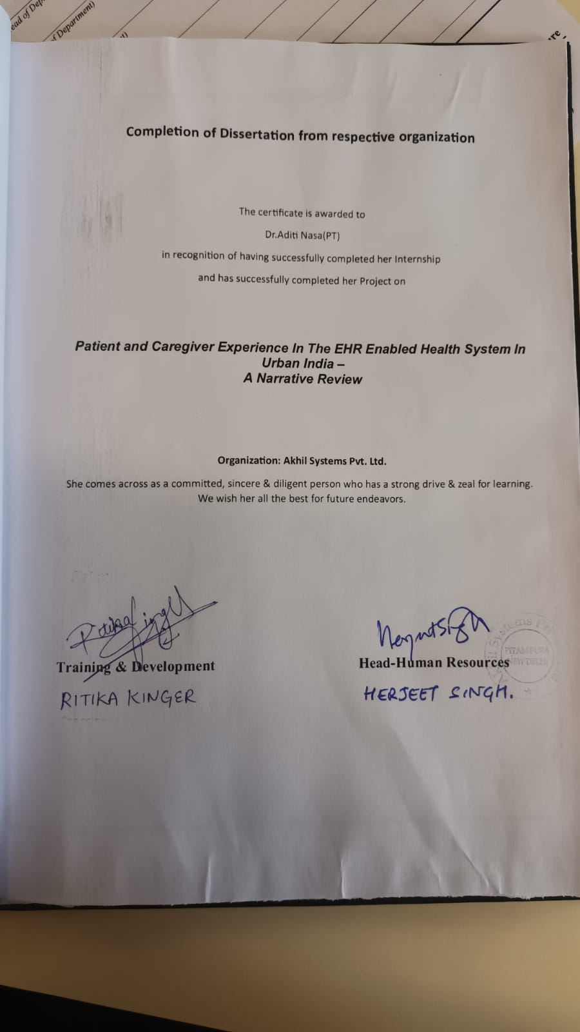

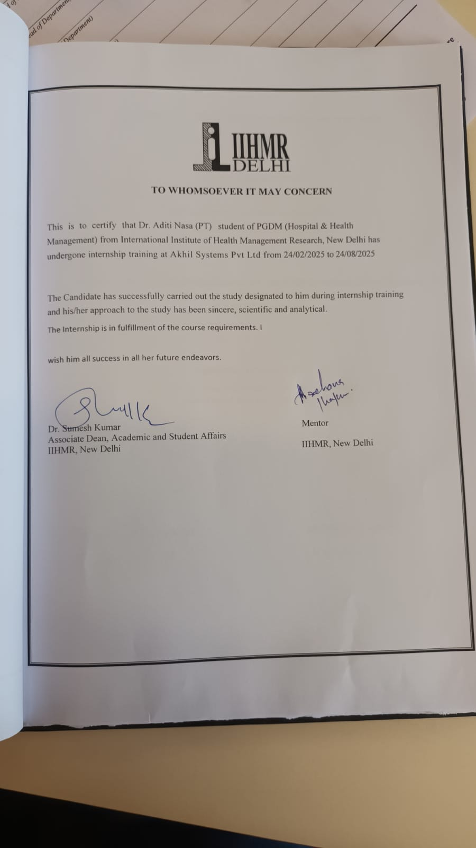
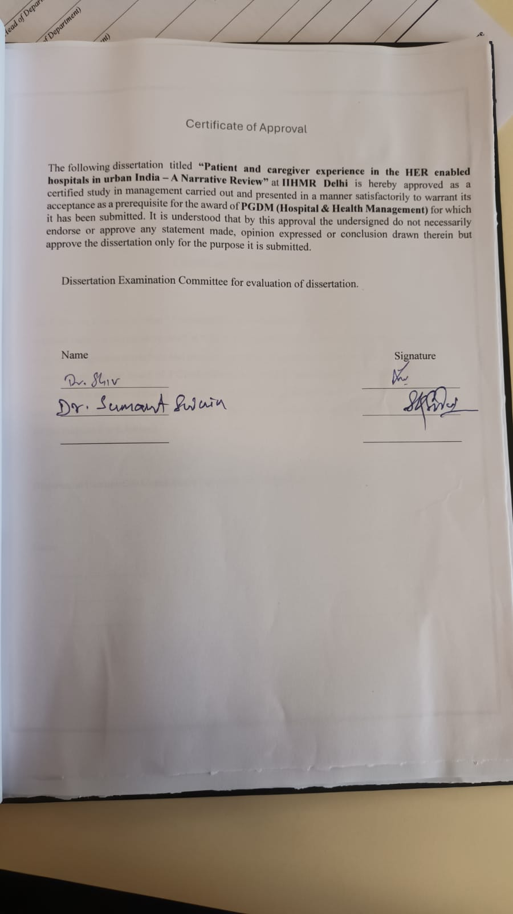

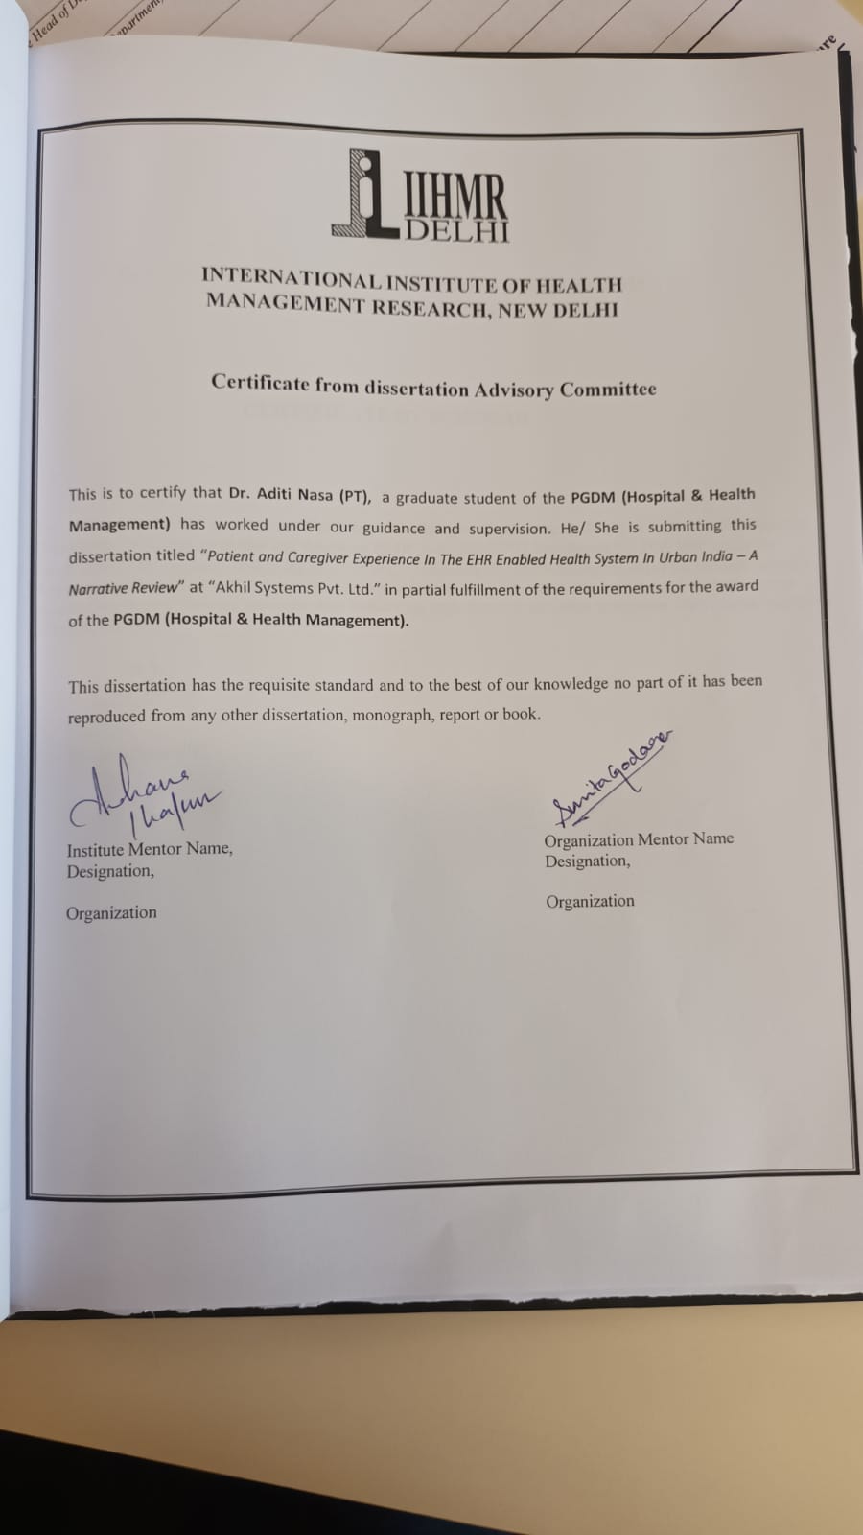

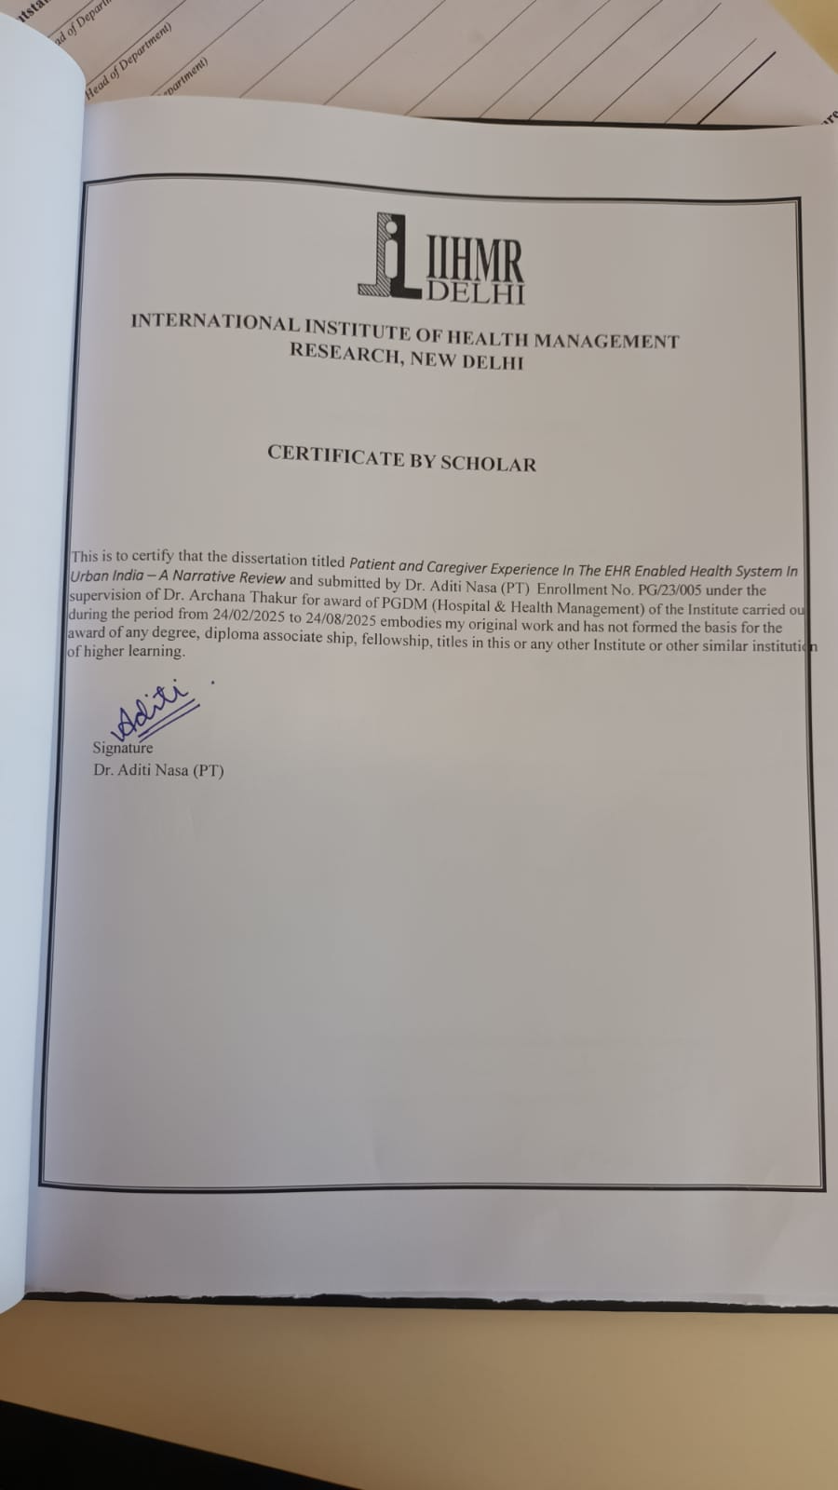

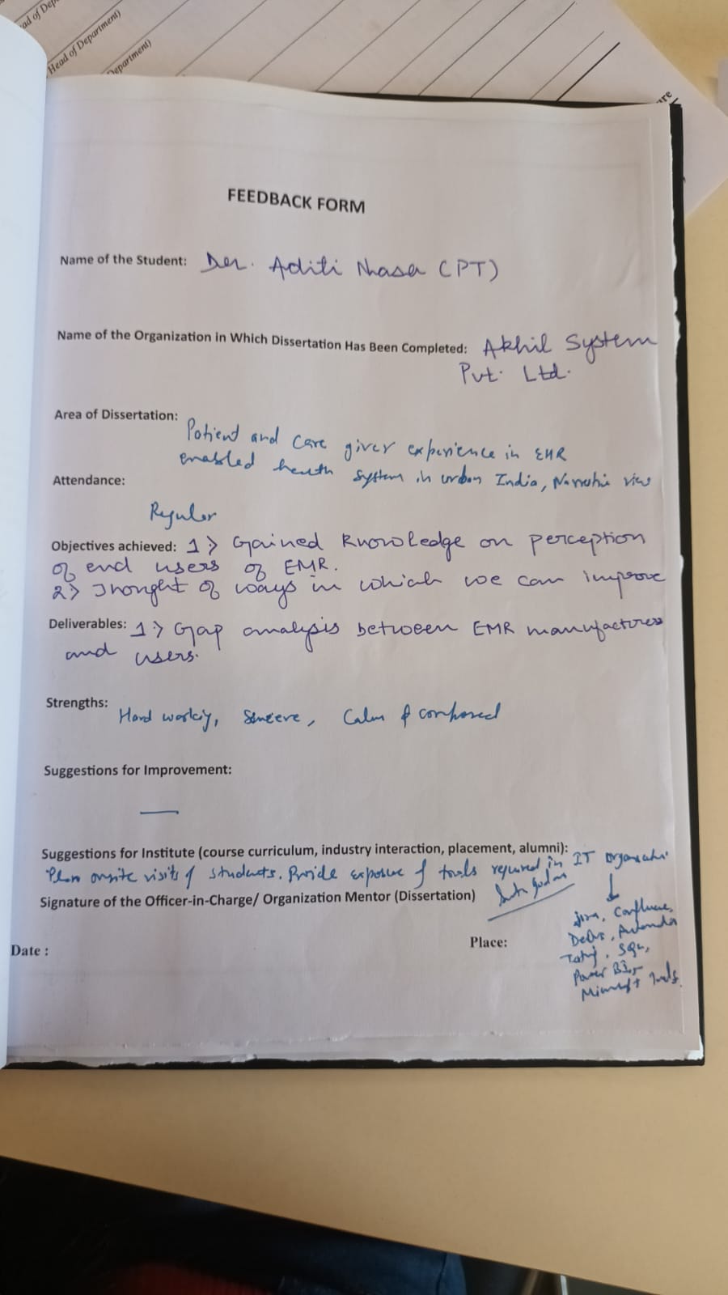

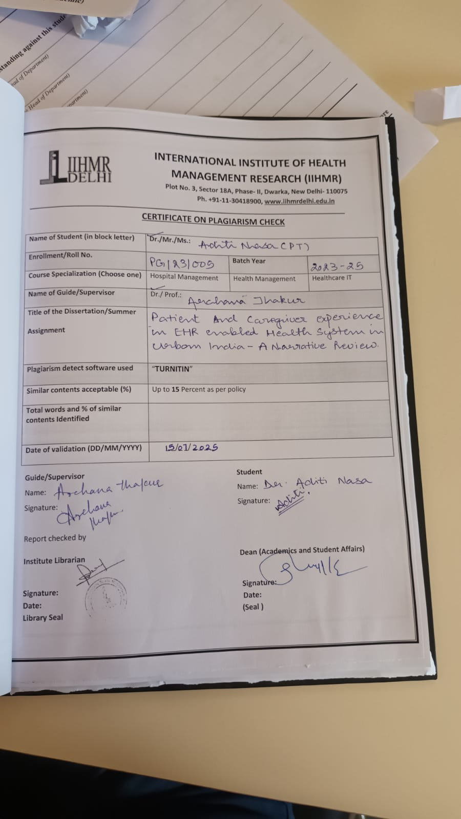

ACKNOWLEDGEMENT

After giving some thought to the extremely intense and event-filled previous two months, I would like to thank everyone who helped me get to this day of results. The following individuals were essential to making this internship happen. This Internship was a golden opportunity for learning and self-development. I consider myself fortunate for have been provided with this opportunity to learn and grow in Public Health Sector.

I would like to take this opportunity to express my deepest gratitude and appreciation to all those who have supported me throughout my internship journey.
I would like to express my gratitude towards IIHMR DELHI for providing me with the opportunity to work with Akhil Systems Pvt. Ltd and my mentor Dr. Archana Thakur for incessantly guiding me.

I am grateful to Mr. Sanjay Jain and Mrs. Rekha Jain for their desire to involve me in relevant tasks, patience, and collaborative spirit that has all made a significant difference in my learning process. I am grateful for the confidence they had on me and the chances they gave me to help the team achieve its goals.

I am immensely grateful to Dr. Sunita, my mentor, whose unwavering guidance and support throughout the internship has been instrumental in shaping my understanding of the Public Health landscape. His expertise and encouragement not only facilitated my learning but also helped me contribute meaningfully to the ongoing projects and have been instrumental in my development as a budding professional. I am grateful for my metors’ willingness to share his time, knowledge, and experiences, that has contributed significantly to the quality and depth of this study.
The pleasant workplace culture made each day pleasurable and fruitful. Their invaluable advice, insightful feedback, and encouragement have been instrumental in shaping this dissertation

Furthermore, I am grateful for the opportunity to explore Public Health that has been enlightening and has broadened my horizons, making me more aware health systems in SEA counties and the potential of strengthened health systems.
I would also like to extend my appreciation to my fellow interns, with whom I had the pleasure of collaborating. Their enthusiasm and dedication made the internship experience even more enjoyable, and I am thankful for the knowledge exchange we had.
I look forward to utilizing this experience as a foundation for my future endeavors in the field of digital health and public health.

Thankyou

List Of Abbreviations

EHR | Electronic Health Records
WHO | World Health Organization
MDGs | Millennium Development Goals
TB | Tuberculosis
USAID | U.S. Agency for International Development
SHA | System of Health Accounts
MoH | Ministry of Health
MCH | Maternal and Child Health
IMR | Infant Mortality Rate
NMR | Neonatal Mortality Rate
EPI | Expanded Programme on Immunization
HAQI | Healthcare Access and Quality Index
SEA | South – East Asian
CHE | Current Health Expenditure
THE | Total Health Expenditure
OOPE | Out Of Pocket Expenditure
DCS | Department of Census and Statistics
HIS | Health Information System
DHIS | Digital Health Information System
GDP | Gross Domestic Product
NCDs | Non-communicable Disease
PHC | Primary Healthcare
SNG | subnational governments
HRH | Human Resource for Health
ANMs | Auxiliary Nurse Midwife
FY | Financial Year
UHC | Universal Health Coverage
CHC | Community Health Center

Abstract

Electronic Health Records (EHRs), accelerated by India’s Ayushman Bharat Digital Mission (ABDM), are transforming both patient and caregiver experiences in urban settings. EHR systems enable healthcare providers to access comprehensive medical histories, laboratory reports, prescriptions, and clinician notes instantly, reducing redundant testing, enhancing diagnostic accuracy, and streamlining care delivery (ETGovernment.com, PMC). For patients, particularly those with chronic conditions, this translates to fewer hospital visits, reduced waiting time, and overall smoother interactions during routine and emergency care.
EHR-linked online patient portals (e.g. via ABHA and Driefcase) further empower patients to request refills, view test results, schedule appointments, and communicate with providers without phone calls or in-person visits (ETGovernment.com). Patients in a northern-India urban study highlighted easy record access (87 %), system efficiency (54 %), and portability (31 %) as key benefits, while expressing concerns around data privacy and potential loss of human touch in consultations (PMC).
From a caregiver standpoint, EHRs reduce administrative burden, improve documentation quality, lower transcription errors, and support faster care coordination. Yet successful adoption hinges on training healthcare professionals— as emphasized by stakeholders who advocated for hands-on digital health training and alignment with ethical and legal frameworks under ABDM (ncbi.nlm.nih.gov).
In urban India, EHRs significantly enhance patient satisfaction, communication, and continuity of care, while supporting more efficient and accurate service delivery. The digital shift promises smoother experiences for both patients and providers, though ongoing attention to privacy, usability, and interpersonal engagement remains essential.

Table Of Contents

Table of Contents

1.ACKNOWLEDGEMENT 2
2.LIST OF ABBREVATIONS 11
3.Approval From Mentor 12
4.Table Of Contents 13
5.INTRODUCTION 14
6.REVIEW OF LITERATURE 15
7.OBJECTIVES 17
8.METHODOLOGY 17
9.RESULTS 18
10.LIMITATIONS 19
11.DISCUSSION 20

INTRODUCTION

Changes in Electronic Health Records (EHRS) from paper-based systems have made people meaningful changes in interaction with healthcare. These digital systems allow healthcare providers to store and manage the patient's information more efficiently, but more importantly they have changed how patients experience care on day-to-day basis.
With EHRS, doctors and nurses can quickly pull a patient's medical history, laboratory results, prescriptions and other important details. It helps to again ask for the same question or to avoid repeating the tests already done. This also means that the providers have a complete picture while taking decisions, which can lead to rapid, more accurate treatment. For patients, who often translate to low trips, low delays and a feeling that their care team is well prepared.
One of the most useful characteristics for patients is the ability to stay in contact with their healthcare providers outside the appointments. Through online portals associated with EHR, people can send messages, see test results, visit schedule, and even request prescriptions refill. This type of access reducing the requirement of phone calls and is waiting on hold, which makes the communication more convenient and timed-especially for those who require regular followers.
EHRS also encourages patients to join more in their health. Being able to look at your medical records, review the doctor's notes, and helps people to play a more active role in tracking treatment plans and managing their conditions. This is particularly valuable for individuals living with chronic diseases, who need to live on top of their care. Informed and involved feeling can also make people more assured about their health that they are about their health.
Behind the curtain, EHR helps healthcare providers to do more effective work
Behind the scenes, EHRs help healthcare providers work more efficiently. They reduce the amount of paperwork and make processes like billing and check-ins smoother. While patients may not always see this part directly, they benefit from the time saved and the fewer chances for mix-ups or delays.
India's commitment to digital health is evident thru tasks just like the Ayushman Bharat virtual project (ABDM), which goals to set up a country wide, requirements-based totally EHR system, complete with unique health IDs for every citizen. The promise of EHRs consists of saving time, lowering clinical mistakes, and streamlining healthcare strategies, in the long run leading to smoother care reviews. however, the actual-world effect on patients and caregivers, specially regarding aspects like ease of use, trust, communication, and average delight, requires close examination.
Research question
How does the use of Electronic Health Records affect patient experience and caregiver experience in urban India.

REVIEW OF LITERATURE

- In Kerala (2020), a qualitative study on hybrid patient-held records in urban Primary Health Centres (PHCs) focused on non-communicable disease (NCD) patients and their caregivers. Patients reported that having access to both digital and paper records helped them keep better track of medications and test results, making them feel more in control of their health. Caregivers, on the other hand, shared how they brought the records to appointments or during emergencies, which helped them stay more engaged and confident in managing care. However, low literacy levels still posed a challenge for consistent usage.

Thisqualitative examine investigated using "hybrid" patientheld facts (combining digital andpaper codecs)in city numberone health Centres(%) particularly for patients with non-communicable diseases (NCDs) and their caregivers.
patient angle: patients usually had a positive revel in. They located that andpaper data helpedthem efficaciously track their medications and take a look at effects. This access to their fitness facts made them experience more empowered and "on top of things" in their own fitness management. This highlights the importance of affected person get admission to and know-how of their fitness statistics for self-efficacy.
Caregiver attitude: Caregivers discovered the hybrid information in particular useful at some point of appointments and emergencies. Being able to with n statistics helped them stay greater engaged within the care manner and boosted their self fected person's health. This underscores the critical position of caregivers in tics can aid them.
Demanding situations: A enormous mission diagnosed become the effect of low literacy stages. This barrier hindered regular usage of the information, suggesting that digital health solutions want tobedesignedwith various literacy ranges in mind or be accompanied via robust aid structures.

- A study conducted in Chandigarh (2022) explored the uptake of Digital Health IDs among 419 adult participants through a mixed-methods approach. The findings showed that 78% had enrolled, and their willingness to engage with digital records was closely tied to their awareness, trust in data security, and the perceived usefulness of the platform. An interesting aspect was that younger family members often helped elderly patients in using the digital tools, showing that family involvement plays a key role in digital health adoption.

This combinedechniques study tested theAdoption virtual health IDs amongst a sample of 419 person members. It aimed to understand factors influencing their willingness to interact with virtual fitness statistics.
Enrollment fee:A excessive enrollment fee of 78% suggests a standard willingn numberof population to include virtual health tasks, attheleast in terms of preliminary adoption.
Elements Influencing Engagement: The take a look at recognized key determinants for engagement with virtual information:
Attention: members' expertise and information of digital fitness IDs and s were important.
Acceptastruewith in statistics protection: worries approximately the privateness and protection of their fitness statistics substantially motivated their willingness to use the platform. that is a not unusual barrier to digital adoptionarent facts managing regulations.
Perceived Usefulness: If contributors noticed a clean and tangible gain from using the platform (e.g., comfort, better care coordination), they had been much more likely to engage
Role of Family Involvement: An important finding was the intergenerational support observed. Younger family members frequently assisted elderly patients in navigating and utilizing digital health tools. This highlights the potential for family networks to facilitate digital health adoption, especially among demographics less familiar with technology. It suggests that strategies to promote digital health should consider involving family units.

3. A Karnataka-based study (2020) reviewed the CPHM app used for maternal and child health (MCH) data through mixed-method design. Although this data focuses more on accuracy, the study explored discrepancies in data entry and emphasized the need for strong digital infrastructure, which affects the patient's trust and care.

Focus: The study of this mixed-tiers reviewed the community-based patient-accepted mother and child health (CPHM) app, especially to assemble and manage its use to collect and manage data.
Primary emphasis: While the main focus of the study was on data accuracy within the app, its findings have widespread implications for patient trusts and care of care.
Main revelation: Studies revealed discrepancies in data entry within the CPHM app. This affects the reliability of the data collected directly.
Implications: Anomalies underline the important requirement for a strong digital infrastructure. A strong and reliable digital system is required not only for accurate data, but also to maintain and maintain the trust in the information provided in the digital health system. If the data is incorrect or incredible, the patient and care will lose confidence in the system, potentially return to traditional paper-based methods or disintegrate.
4. In Telangana (2021), a study by 75 urban PHCS found that 83% digitized the vaccination records, most of the features were not using EMR for prescriptions or extensive patient management. This meant that carers still had to carry paper records for drugs and referrals. Patients appreciated the rapid access to the vaccination records, but there was no significant improvement in care coordination, especially from the carer's point of view.

This study, organized in 75 urban PHCs, assessed the range of digitization, especially focused on the vaccination record and comprehensive use of electronic medical records (EMRS).
Progress in vaccination records: A positive discovery was that 83% of the features had successfully digitized the vaccination records. It indicates progress in specific areas of health record digitization.Limited EMR Adoption: Despite progress in immunization records, the study revealed a significant gap: most facilities were not using EMRs for general prescriptions or broader patient management. This suggests a fragmented approach to digitization, where specific functions are digitized but a comprehensive EMR system is lacking.
Caregiver Burden: As a result of limited EMR adoption for broader management, caregivers still had the burden of carrying paper records for medications and referrals. This defeats some of the potential benefits of digitization, as it doesn't reduce the physical burden on caregivers.
Patient Appreciation vs. Care Coordination: While patients appreciated faster access to immunization records (a specific benefit of digitization), the study found "no significant improvement in care coordination," especially from the caregiver's perspective. This highlights a crucial point: simply digitizing records doesn't automatically translate to improved care coordination. A comprehensive, integrated EMR system that facilitates seamless information exchange among providers and patients is necessary to achieve true care coordination benefits.

OBJECTIVES
To assess the overall impact of Electronic Health Records (EHR) on patient and caregiver experience in healthcare settings of urban India.

METHODOLOGY

The study will employ secondary desk review as a method of data collection and conduct systematic literature search on PUBMED to identify relevant studies. We will develop an appropriate search strategy using key words (“Patient” OR “caregiver”) AND (“experience” OR “satisfaction”) AND (“electronic health records” OR EHR) AND India through an iterative process. The review will focus on studies conducted in last five years (2020-2025)— observational and experimental — which have evaluated patient and caregiver experience in secondary and tertiary care hospitals located in urban part of India; case studies, case series, editorials, viewpoint, commentaries, non-English language, reviews, studies with abstract will be excluded. A data extraction sheet, developed in Microsoft excel spreadsheet, will include relevant variables related to study characteristics, methodology, relevant outcomes, and limitations. We will summarize our findings using words, tables, graphs, and thematic diagram wherever applicable.

RESULTS

Study Title (Year) | Setting & Design | Participants | Patient Experience Highlights | Caregiver Experience Highlights | Key Insights
Perception towards electronic health records & uptake of Digital Health IDs (2022, Chandigarh) (ijmr.org.in) | Mixed-methods: 419 participants surveyed at Chandigarh PHC + screening camps; followed by in-depth interviews. | 419 adults ≥18 yrs | • 78% enrolled in Digital Health ID• Uptake tied to awareness, security trust, usefulness | • Younger family members guided elderly through registration and app use | Highlights that trust, awareness, and familial support are crucial
Patient-held hybrid records in urban PHCs (2020, Kerala) | Qualitative interviews (Feb–Nov 2020) with patients, caregivers, and staff across urban PHCs in Kerala | 20 NCD patients, 15 caregivers, 17 HCPs | • Patients used hybrid records to monitor meds and lab results• Felt more in control of their care | • Carers carried records for appointments and emergency visits• Increased caregiver engagement and confidence | Hybrid records facilitated shared coordination but literacy was a challenge
CPHM App consistency for MCH data (2020, Karnataka) | Sequential mixed-methods at Gumballi PHC: compared digital vs paper MCH records and interviewed frontline staff | PHC MCH records; ~10–15 workers | — (focus on data accuracy, not experience) | — | Found discrepancies in data entry; implementation needs better infrastructure
What is stopping PHCs going digital? (2021, Telangana) | Mixed-method study at 75 urban PHCs in Nalgonda district: surveys + interviews (Dec 2018–Feb 2019) | PHC managers and district health officials | • Immunization records were digitized in 83% of PHCs• Patients saw faster record retrieval during immunization visits | • No EMR use for prescriptions—caregivers still relied on paper for meds and referrals• Care coordination didn’t improve | While digital immunization helped patient convenience, lack of full EMR limited caregiver benefits
EMR adoption in Indian urban hospitals (2020, multicity) | Policy review + cross-sectional survey across public/private urban hospitals; included CHW interviews | Doctors, administrators, CHWs | • Private hospitals reported improved access to patient history and faster billing• Patients appreciated clearer documentation and fewer lost files | • CHWs and caregivers reported smoother information flow when visiting private hospitals• Some carers found EMR unfamiliar and wanted training | EMRs improved clinical efficiency and record clarity in private hospitals, but usability and adoption training remain critical

LIMITATIONS

Variation in the types of EHR: Clinics and hospitals may have varied EHR system architectures, features, and integrations, which could result in inconsistent customer experiences. This variety makes it challenging to draw general conclusions on the impact of EHRs.
We will make all attempts to systematically conduct literature search, include all revenant literature on PUBMED between the years 2020 and 2025 and highlight important findings related to how EHR affects patient and caregiver experience; however, being a narrative review, chances of authors’ bias will be high.

EHR structures garnered mixed critiques. whilst docs in hospitals observed that EMRs ought to keep time.
Many additionally suggested gadget complexityand sluggish interfaces, main to increased workload. previous experience with EMRs appeared to facilitate adaptation and usability for clinicians. however, reviews ofnavigationstruggles, misplaced statistics,and power troubles endorse that the contemporary layout and capability of a few EHR systems aren't constantly intuitive or green.
Get admission to & equity digital health adoption is drastically encouraged with the aid of demographic elements, elevating issues approximately getentryo and equity. aged sufferers (over 65 years), individuals with lower earnings, muchless schooling, andpeople surprising with computers are muchless inall.

Lkelihood to utilize EHRs effectively. urban India continues toface socioeconomicdisparities, in which elements consisting of gender, language, earnings, and digital literacy at once impact equitable access to and advantages from EHRs. This highlights the want for inclusive layout and implementation techniques to bridge the digital divide.

Variation in the types of EHR: Clinics and hospitals may have varied EHR system architectures, features, and integrations, which could result in inconsistent customer experiences. This variety makes it challenging to draw general conclusions on the impact of EHRs.
We will make all attempts to systematically conduct literature search, include all revenant literature on PUBMED between the years 2020 and 2025 and highlight important findings related to how EHR affects patient and caregiver experience; however, being a narrative review, chances of authors’ bias will be high.

DISCUSSION
This narrative evaluate presents a complete assessment of how electronic health statistics (EHRs) are influencing the reports of patients and caregivers in urban India between 2020 and 2025. Thwidespread enhancements and chronic challenges in the adoption and utilization of digital health systems.
Impacts of EHRs one of the most terrific benefits diagnosed is the advanced gemission to scientific history and reduced want patients to repeatedly provide their clinical info at each go to. doctors appreciated the capacity to speedy access beyond reviews, which no longer only saved time but additionally facilitated more informed decision-making. For caregivers, EHRs contributed to faster registration techniques and greener comply with-u.s.in certain medical institution settings. The digitization of immunization records, in Telangana %, became undoubtedly obtained by means sufferers due pronounced feeling greater on top of things in their care when the usage of hybrid records to screen medications and lab results, and caregivers observed elevated engagement and self-assurance in coping with care via this information.
5.2 challenges and boundaries regardless of the benefits, numerous good sized challenges prevent the most suitable affected person and caregiver enjoy with EHRs. a prime issue revolves around and privateness of facts. patients expressed consistent fears regarding statistics misuse, unauthorized get entry to, and the safety of stored information. This highlights a crucial need for robust records governance frameworks and recognition campaigns to construct confidence in virtual health systems.
Person-friendliness and workload also emerged as areas desiring improvement. even as some clinicians observed EHRs time-saving, said system complexity, gradual interfaces, and the weight of twin statistics entry. this could lead to accelerated screen time for doctors, doubtlessly lowering non-public interplay with sufferers. system delays and unreliable internet connectivity were also assets of frustration for each patients and healthcare carriers.
Get entry to and equity gift every other vital barrier. The overview suggests that older adults (above sixty five years), people with constrained schooling, and those lacking laptop familiarity face vast difficulties in knowledge or using EHR-related applications. This underscores a virtual divide, wherein socioeconomic factors like gender, language, and profits disproportionately have an effect on get admission to to and benefits from EHRs in urban India.
Furthermore, sectoral disparities in EMR adoptionmmonly proven better gadget implementation and higher affected person delight compared to public hospitals, which frequently struggled with insufficient infrastructure, budgetary constraints, and shortage of skilled IT team of workers. The partial digitization located in lots of % also constrained the holistic blessings for caregivers, as paper facts had been nevertheless important for prescriptions and referrals.
Implications for coverage and practice The findings propose several key areas for intervention. firstly,comprehensive focus campaigns are crucial to educate the general public about the blessings and protection features of digital fitness IDs and EHRs, fostering greater consider and encouraging adoption. Secondly, addressing
infrastructural barriers consisting of unreliable net connectivity and presenting good enough technical guide is crucial for the effective implementation of virtual health solutions. Thirdly, there's a clean need foruser-friendly EHR designs that cater and digital proficiencies, in particular for elderly suffererspeople with restrained technological exposure.

Training packages for both healthcare carriers and caregivers are important to beautify usability and confidence in the usage of EHR systems. ultimately, policymakers ought to cope with the
sectoral disparities to make certain equitable get right of entry to and benefits from EHRs across all healthcare settings, including public hospitals, byng allocating enough budgets and educated employees. Standardization and complete digitalizationata, wherein feasible, can also enhance the utility of hybrid structures and decrease confusion.
This narrative review, whilst presenting precious insights into patient and caregiver stories with EHRs in urban India, is subject to positive barriers:
Variant in EHR Implementation: The studies blanketed on this overview probable function extraordinary varieties of EHR systems across diverse hospitals. This inherent version makes it challenging to attract definitive and directly similar conclusions about patient and caregiver experiences throughout all settings. The functionality, interface, and integration stages ofconsiderably impact consumer experience.
Feasible Biasbe a capacity for booklet bias, wherein available studies might disproportionately cognizance on a hit EHR effects or positive stories. negative studies or demandingsituations encountered for the duration of EHR implementation may be underreported, main to an incomplete photo of the general effect.
Database Used for look at choice: the hunt method changed into limited to unmarried database (PubMed) for article selection. whilst PubMed is a complete clinical database, relying solely on itmay haveexcluded relevant research posted in different databases or regional journals, probably limiting the scope and generalizability of the findings.
The digital transformation of healthcare in urban India via electronic health records (EHRs) is undoubtedly improving elements of affected person care, mainly in terms of get admission to to clinical records andstreamlined methods. patients normally recognize the performance and clarity presented by digital documentation. but, this evaluation highlights numerous crucial gaps that require instant attention to make sure that the advantages of this digital shift are universally realized and that the affected person and caregiver experience is clearly better.
Key areas traumatic cognizance consist the want for more complete schooling programs for each healthcare providers and thesturdy measuresto makecertain stronger information protection and build trust in virtual systems, and higher digital guide mechanisms. Crucially, making EHR systems greater user-friendly and accessible is paramount. This consists of designing interfaces that accommodate various stages of virtual literacy and addressing the precise needs of prone populations, including the elderly andthose with limited education. best by addressing these challenges can India make sure that sufferers and caregivers from all backgrounds can similarly enjoy the ongoing digital revolution in healthcare.

REFERENCES
1. Gandhi AP, Soundappan okay. notion closer to electronic health statistics & uptake of digital fitness IDs a few of the city citizens in northern India: a mixed‐techniques have a look at. Indian J Med Res. 2024;159(1):fifty one‐60.
2. Joseph G, Kissinger P, Johnston R, et al. patients’, carers’ and healthcare providers’ views of patient held hybrid data in urban primary fitness centres in Kerala, India: a qualitative exploratory observe. BMJ Open. 2022;12(eleven):e064189.
3. Shilpa R, Binu A, Mahmood N, et al. Assessing the implementation of a cellular app based digital health report: a mixed method have a look at from South India. J Educ fitness Promot. 2020;nine:102.
4. Barigela R, Kodali PB, Hense S. what's stopping primary fitness centers to go virtual? Findings of a combined method observe at a district degree fitness gadget in Southern India. Indian J network Med. 2021 Jan–Mar;46(1):ninety seven–one zero one.
Saleh H, Stålsby Lundborg C.
Perceived blessings and barriers of medical doctors concerning electronic clinical report systems in an Indian personal zone healthcare facility. Ann Glob health. 2025;? (epub in advance of print).

