Dissertation training
at

International Institute of Health Management Research, New Delhi

"Awareness, Perception, and Acceptability of Menstrual Cups Among Women Aged 18–50 in Delhi-NCR: A Survey"
by

Name- Dr. Shreya Aggarwal

Enroll No.- PG/23/114

Under the guidance of

Dr. Divya Aggarwal
Associate Dean- Training & Capacity building & Associate Professor

PGDM (Hospital & Health Management) 2023-25


International Institute of Health Management Research New Delhi

Dissertation training at

International Institute of Health Management Research

"Awareness, Perception, and Acceptability of Menstrual Cups Among Women Aged 18–50 in Delhi-NCR: A Survey"
by

Name- Dr. Shreya Aggarwal

Enroll No.- PG/23/114

Under the guidance of

Dr. Divya Aggarwal
PGDM (Hospital & Health Management) 2023-25

International Institute of Health Management Research
New Delhi

ii

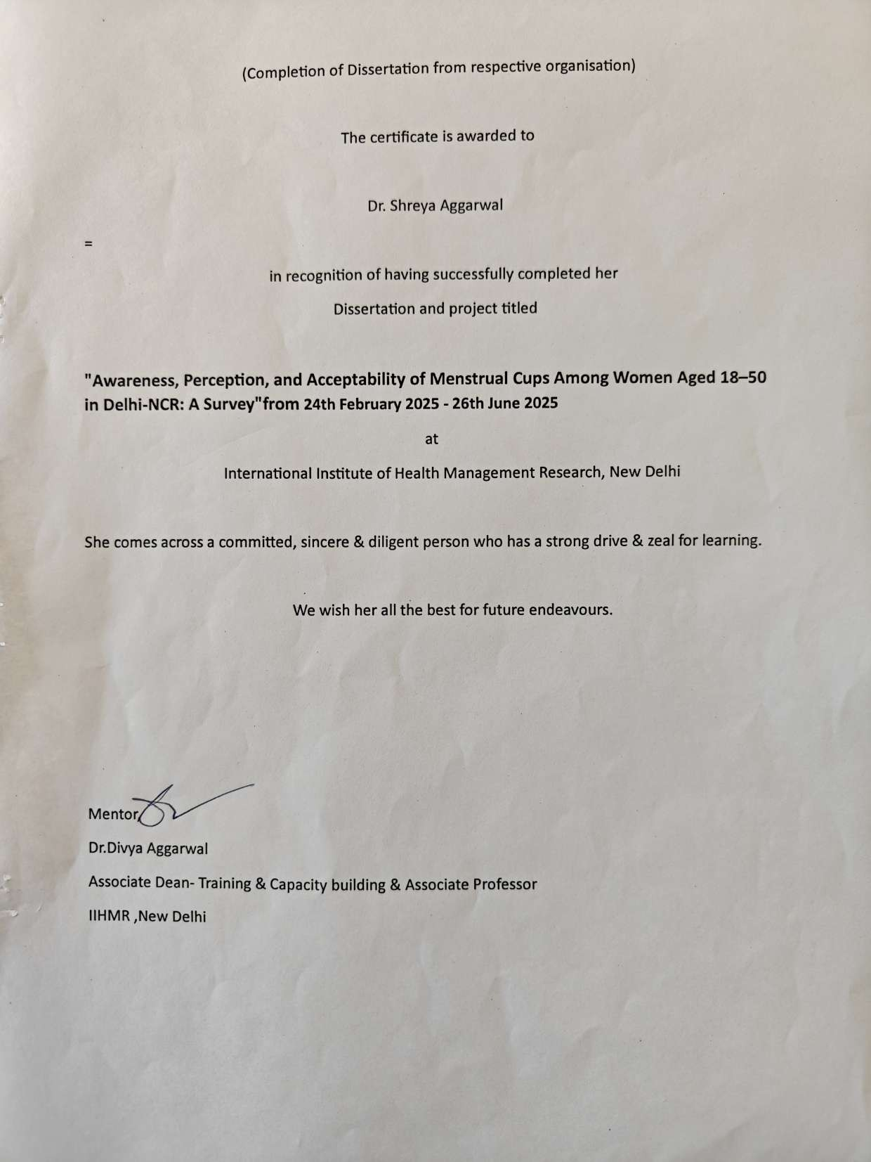

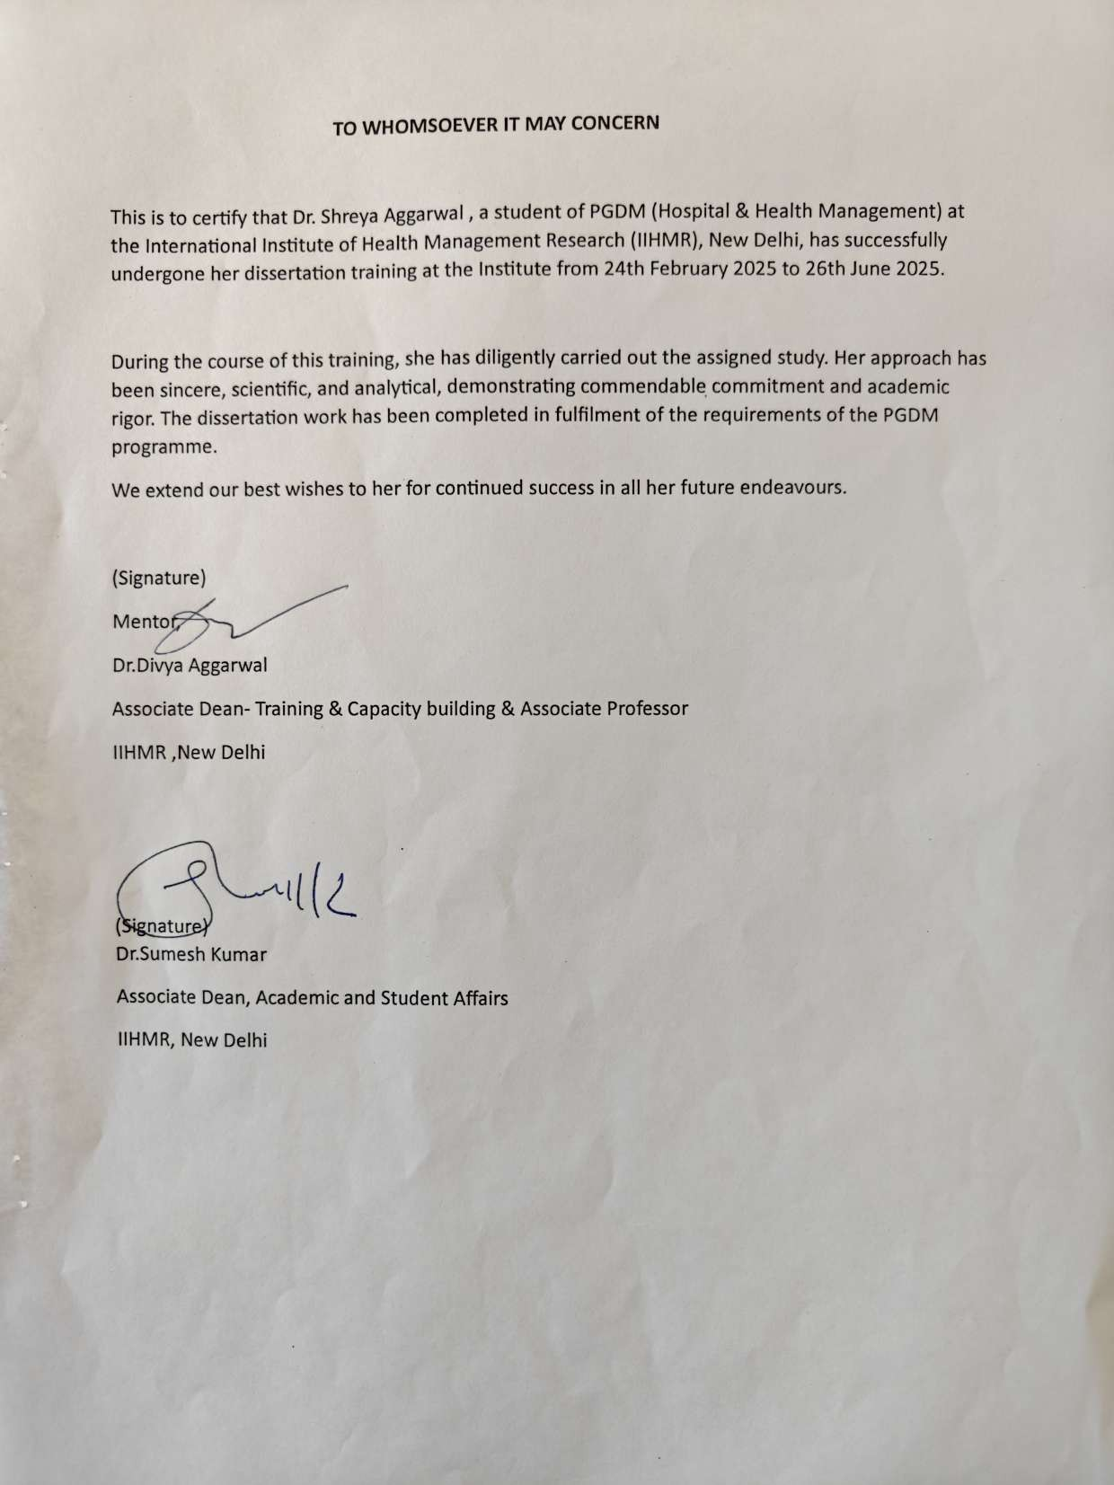

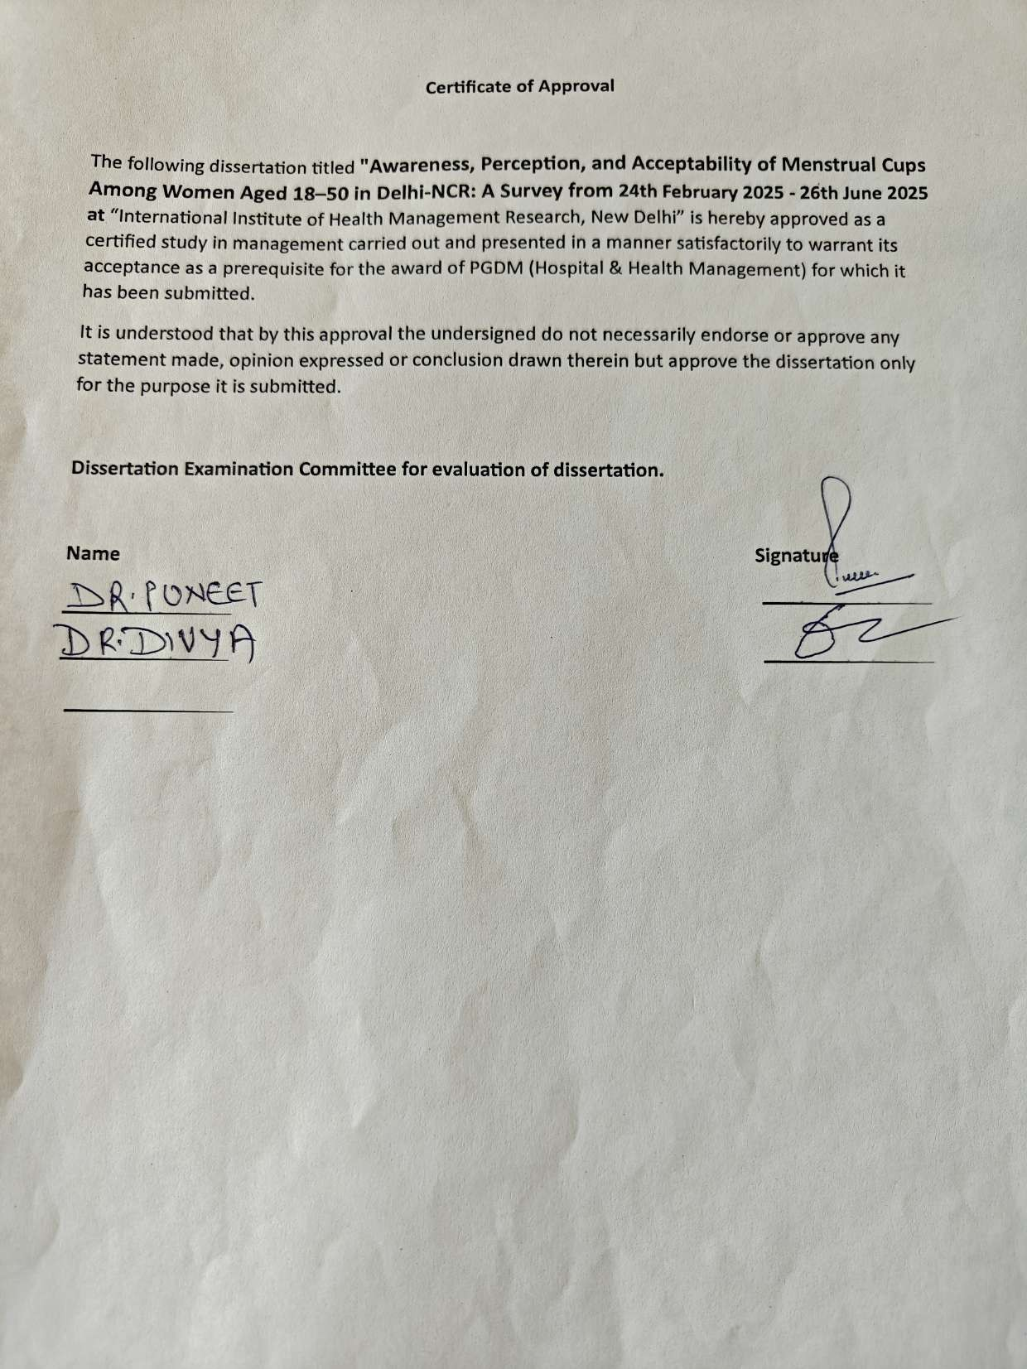

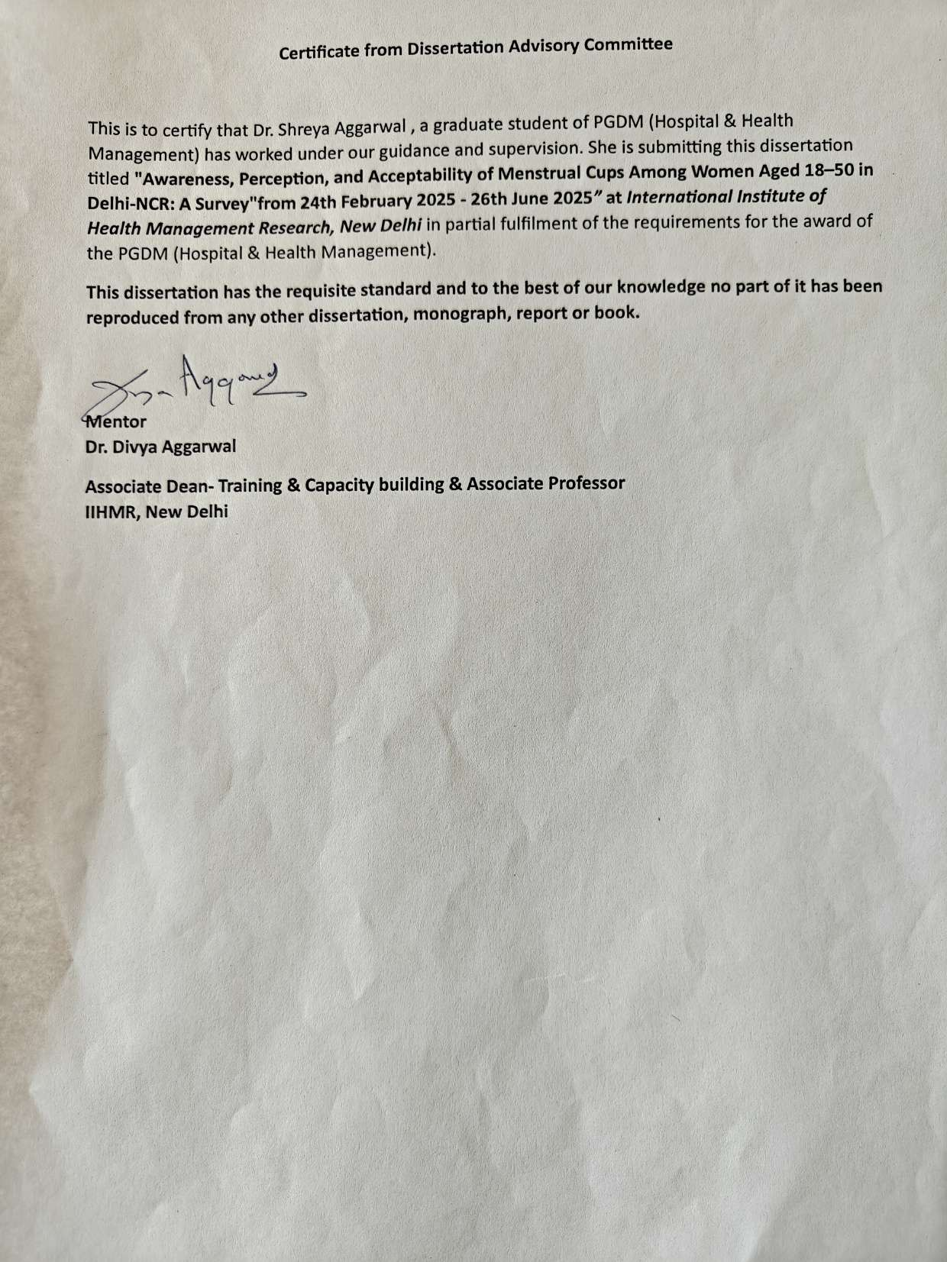

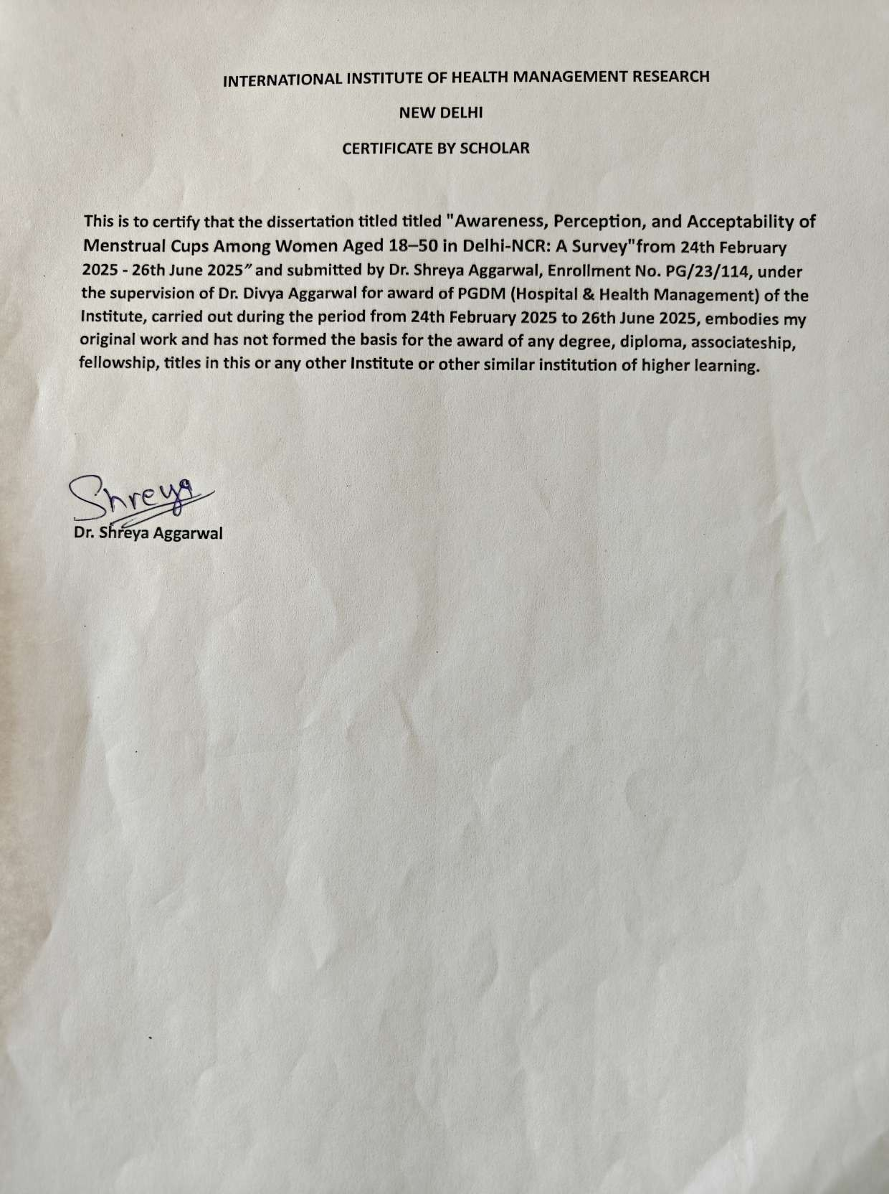

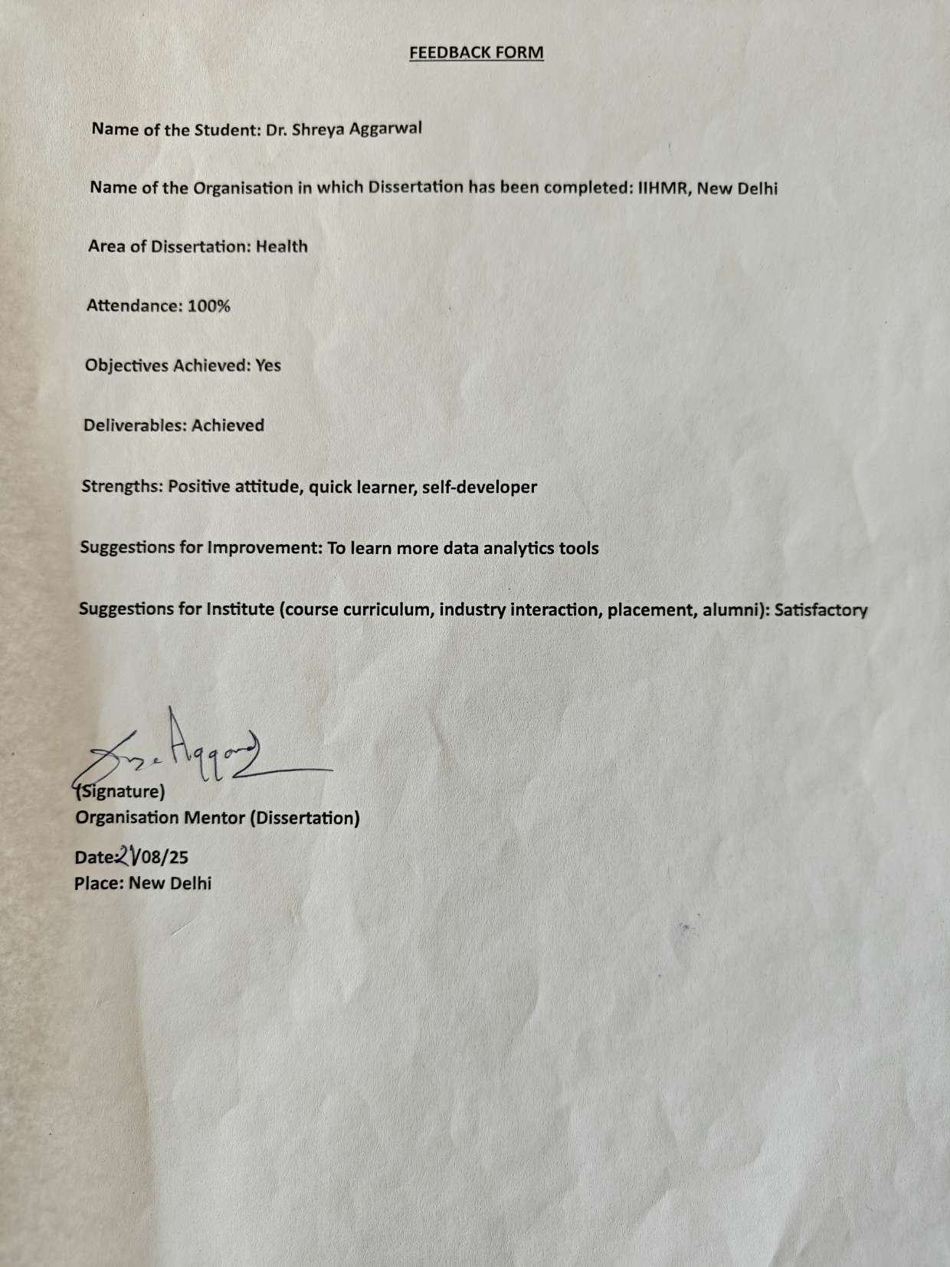

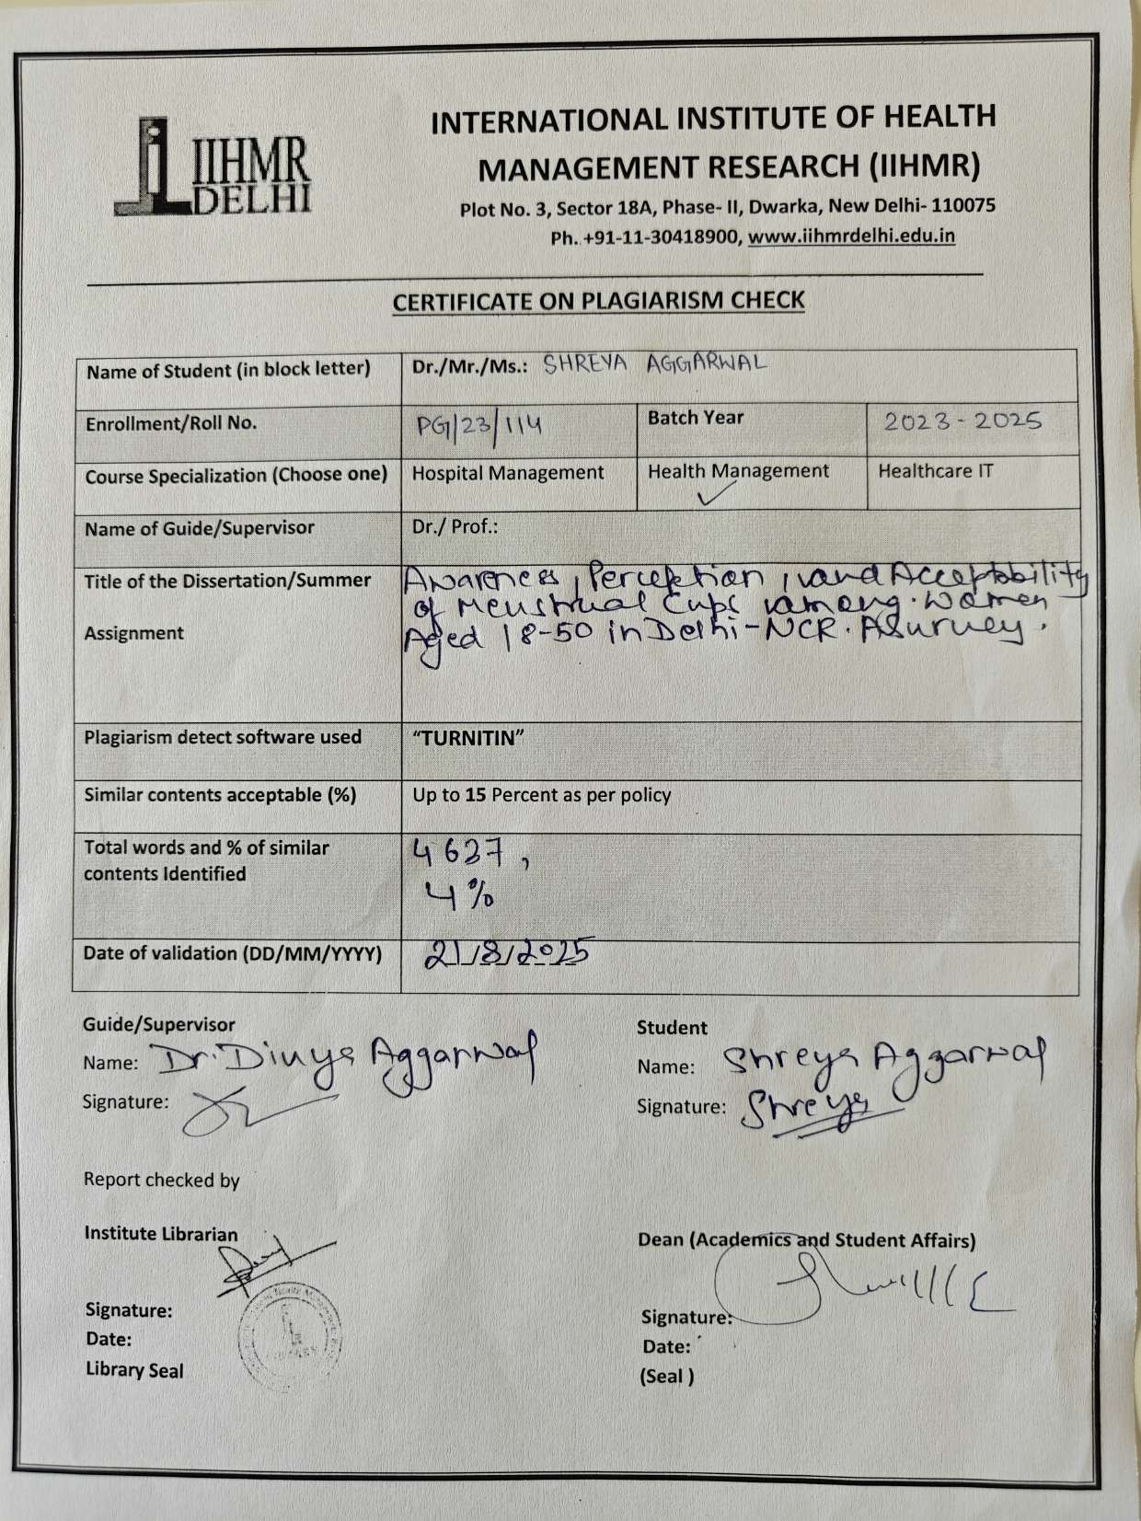

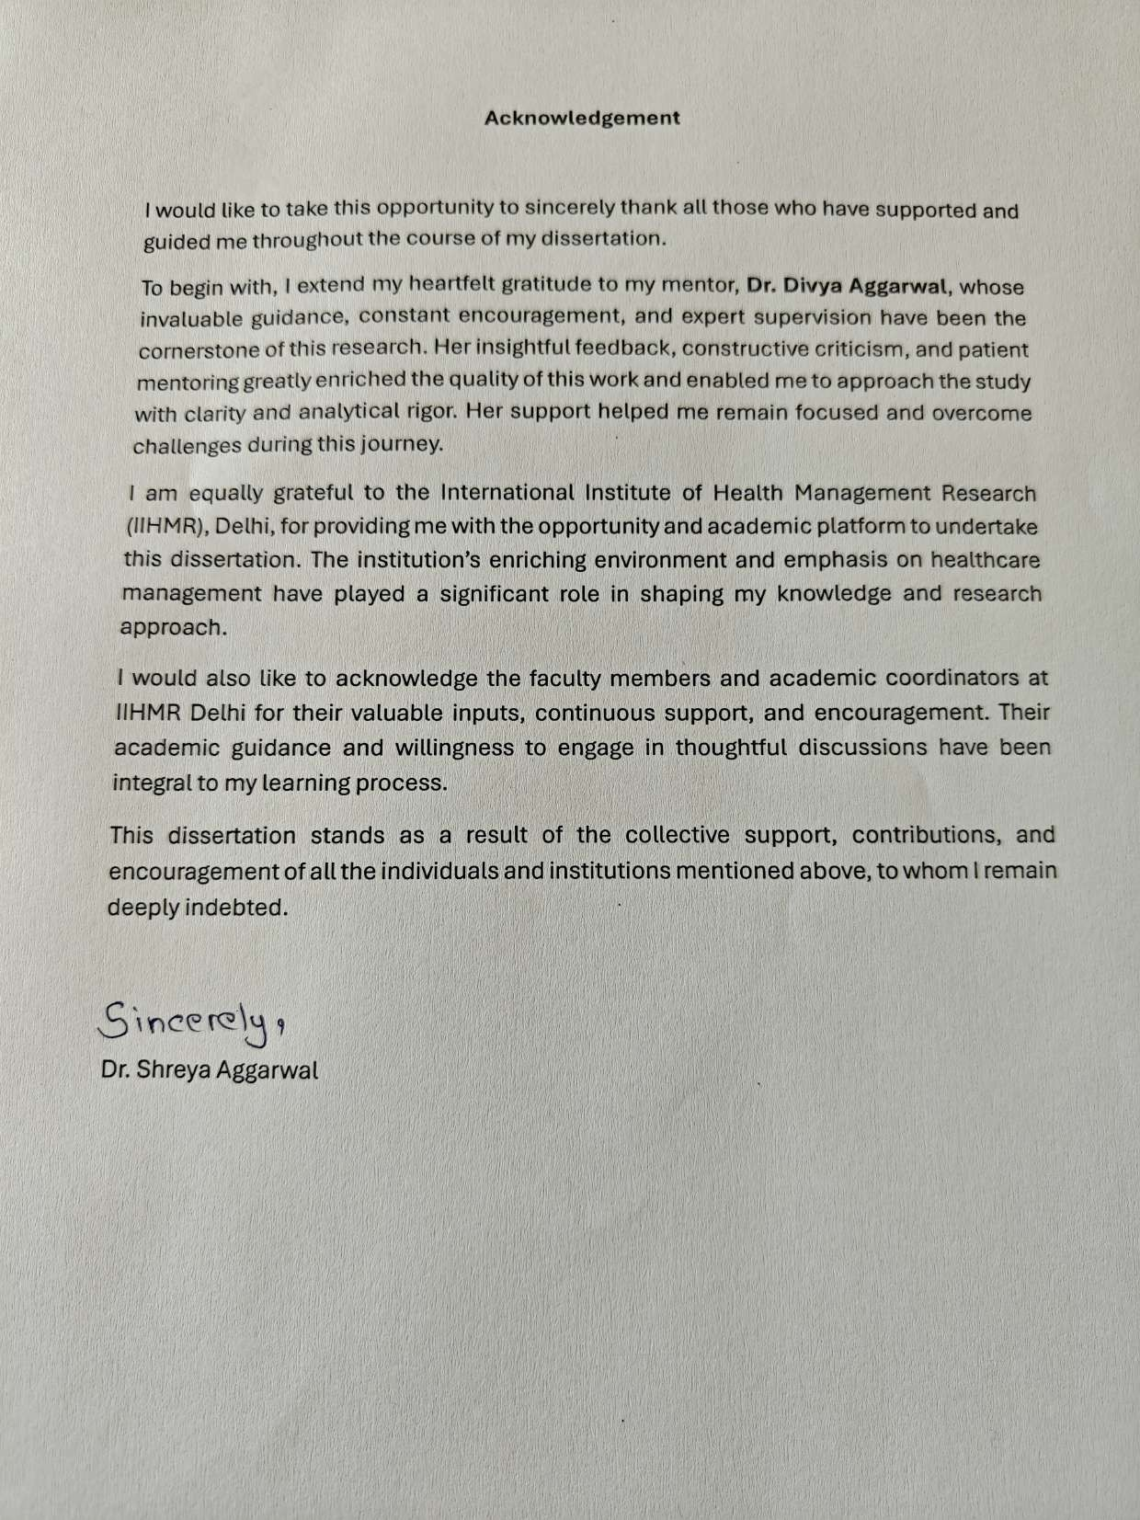

Abstract

Background: Menstrual health remains a critical aspect of women’s well-being, yet in India it continues to be shaped by stigma, silence, and limited awareness of sustainable alternatives. Disposable sanitary pads and tampons dominate usage, but their environmental burden and recurring costs highlight the need for more sustainable solutions. Menstrual cups, being safe, affordable, and eco-friendly, offer a viable alternative, though adoption remains limited.
Aim: This study aimed to assess awareness, perceptions, and acceptability of menstrual cups among women aged 18–50 years in the Delhi-NCR region, and to explore the socio- demographic determinants influencing these outcomes.
Methods: A cross-sectional descriptive survey design was adopted, with a sample of 384 women selected through randomized sampling. Data were collected over three months using a structured, pre-tested questionnaire distributed both online and offline. Descriptive statistics were used to summarize responses, while Chi-square tests were applied to examine associations between socio-demographic variables and menstrual cup awareness, knowledge, and acceptability.
Results: Awareness of menstrual cups was significantly associated with age and education, but not with occupation or income. Usage knowledge was significantly linked to age and household income, while education and occupation showed no effect. Acceptability was mixed: approximately half of the respondents expressed willingness to try menstrual cups, while a substantial minority rejected them due to myths, cultural taboos, and concerns about insertion, hygiene, or leakage.
Conclusion: The findings suggest that although awareness is rising, practical knowledge and cultural acceptance remain key barriers. Interventions should focus on younger women and those from less educated or lower-income backgrounds, emphasizing practical

demonstrations and culturally sensitive messaging. Promoting menstrual cups could advance both women’s health and environmental sustainability in India.

Keywords: Menstrual health, Menstrual cups, Awareness, Perception, Acceptability, Delhi-NCR, Sustainable menstrual products

Acknowledgement

I would like to take this opportunity to sincerely thank all those who have supported and guided me throughout the course of my dissertation.
To begin with, I extend my heartfelt gratitude to my mentor, Dr. Divya Aggarwal, whose invaluable guidance, constant encouragement, and expert supervision have been the cornerstone of this research. Her insightful feedback, constructive criticism, and patient mentoring greatly enriched the quality of this work and enabled me to approach the study with clarity and analytical rigor. Her support helped me remain focused and overcome challenges during this journey.
I am equally grateful to the International Institute of Health Management Research (IIHMR), Delhi, for providing me with the opportunity and academic platform to undertake this dissertation. The institution’s enriching environment and emphasis on healthcare management have played a significant role in shaping my knowledge and research approach.
I would also like to acknowledge the faculty members and academic coordinators at IIHMR Delhi for their valuable inputs, continuous support, and encouragement. Their academic guidance and willingness to engage in thoughtful discussions have been integral to my learning process.
This dissertation stands as a result of the collective support, contributions, and encouragement of all the individuals and institutions mentioned above, to whom I remain deeply indebted.

Dr. Shreya Aggarwal

Acronyms/ Abbreviations

NCR | National Capital Region
NGO | Non-Governmental Organization
PMS | Premenstrual Syndrome
SRB | Scientific Review Board
WHO | World Health Organisation
UHC | Universal Health Coverage

Dissertation Report- "Awareness, Perception, and Acceptability of Menstrual Cups Among Women Aged 18–50 in Delhi-NCR: A Survey"
Section 1 – Introduction

Background and Context

The first objective of the study was to assess the level of awareness of menstrual cups among women in the Delhi-NCR region and to examine its association with selected socio- demographic variables. The analysis revealed that age and educational qualification were significantly associated with awareness of menstrual cups, while occupation and monthly household income did not show any significant association.
Specifically, women belonging to older age groups reported a significantly higher level of awareness compared to their younger counterparts (p = 0.0402). This suggests that exposure to health-related information and accumulated life experience over time may play a role in shaping knowledge about alternative menstrual products. Similar findings have been reported in earlier studies, where older women demonstrated greater familiarity with menstrual health innovations due to increased interactions with healthcare professionals and broader access to informational resources.
Educational qualification also emerged as a strong predictor of awareness (p = 0.0013). Women with higher levels of education were more likely to have heard about menstrual cups compared to those with lower educational attainment. This reinforces the well-established role of education in enhancing health literacy, access to information, and openness to adopting newer health-related practices. Formal education often provides not only direct exposure to health education but also equips women with the ability to critically evaluate new information from media, peers, and health campaigns.

On the other hand, occupation did not show a statistically significant association with awareness (p = 0.2905). This indicates that whether women were employed, students, homemakers, or engaged in other professions, their level of awareness about menstrual cups did not differ significantly. This could be explained by the fact that awareness may be more dependent on individual information-seeking behavior and social exposure rather than professional engagement.
Similarly, monthly household income was not significantly associated with awareness levels (p = 0.5321). This finding suggests that awareness is not directly linked to financial status.
Even women from lower-income groups demonstrated awareness, highlighting that access to information about menstrual cups may not necessarily require higher economic standing. In today’s context, widespread use of digital platforms and social media could be contributing to the dissemination of knowledge across income groups, thereby reducing the influence of financial disparities on awareness.
Overall, these findings suggest that education and age are the most critical determinants of menstrual cup awareness, while occupation and income do not play a major role. This highlights the importance of targeting awareness interventions towards younger women and those with lower educational backgrounds, as they are more likely to lack knowledge about menstrual cups

Rationale

Menstrual health is not only a medical but also a social and environmental concern. In India, reliance on disposable pads and tampons creates long-term economic and ecological costs. Each woman’s lifetime disposal of thousands of single-use products contributes to the national waste crisis. Moreover, the cultural stigma around menstruation perpetuates silence, restricting opportunities for informed choice.
Menstrual cups provide a compelling solution—they are affordable, durable, and eco- friendly. Yet their usage remains low due to misinformation, cultural myths, and practical concerns. Issues related to insertion, hygiene, virginity, and safety are common reasons for hesitation. The Delhi-NCR region, with its socio-economic diversity, provides a unique opportunity to study both enablers and barriers to adoption.
This study is essential because it will:

- Identify socio-demographic determinants (such as age, education, income, and occupation) that influence awareness and acceptability.
- Highlight misconceptions and barriers preventing adoption.

- Provide evidence to design targeted educational interventions and awareness programs.
The findings are expected to strengthen both public health strategies and sustainability goals, by encouraging safe and eco-friendly menstrual practices.

Aim

The central aim of this study is to assess the awareness, perceptions, and acceptance of menstrual cups among women aged 18–50 years in Delhi-NCR, and to analyze how socio- demographic factors influence their knowledge, attitudes, and willingness to adopt menstrual cups as a sustainable alternative to disposable menstrual products.

Objectives

- To assess the level of awareness of menstrual cups among women in Delhi-NCR and to examine its association with socio-demographic variables such as age, education, occupation, and monthly household income.
- To evaluate women’s knowledge and perceptions regarding menstrual cup usage, including sources of information, beliefs, and misconceptions.
- To determine the acceptability of menstrual cups by exploring willingness to try, current usage patterns, and barriers to adoption.

Review of Literature

Menstrual health has become an important area of research in recent decades, with growing attention toward the development and adoption of sustainable menstrual hygiene products. Among these, menstrual cups have emerged as a promising alternative to disposable pads and tampons due to their economic, environmental, and health benefits. However, their uptake has remained relatively low, particularly in low- and middle-income countries like India, due to limited awareness and prevailing socio-cultural barriers.

Global Evidence

International studies have demonstrated that menstrual cups are a safe, acceptable, and effective menstrual product. A landmark systematic review and meta-analysis by van Eijk et al. (2019) compiled evidence from over 40 studies and concluded that menstrual cups had similar or better performance than pads or tampons in terms of leakage, with high levels of user satisfaction and no increase in adverse outcomes such as infections. Randomized controlled trials conducted in Africa and Europe further highlighted that once women became familiar with the product, most expressed a willingness to continue use. These findings suggest that initial hesitation often diminishes after experiential learning and appropriate guidance.
Beyond individual health outcomes, menstrual cups have also been shown to positively impact school attendance and participation in daily life. Studies conducted in Kenya and Nepal found that providing menstrual cups to adolescent girls reduced school absenteeism related to menstruation and improved comfort during activities, demonstrating the potential of menstrual cups to support broader educational and social outcomes.

Indian Context

In India, the acceptance of menstrual cups remains low despite their availability. Cross- sectional surveys consistently report that awareness is much higher than actual usage. For example, studies conducted among medical and nursing students across Kerala, Tamil Nadu, and Maharashtra revealed that although 60–80% of participants had heard of menstrual cups, only 5–15% had ever tried them. A recent study in Delhi-NCR (Chawla et al., 2025) similarly highlighted high awareness but very limited adoption, with cultural taboos and misinformation identified as key barriers.
Education and socio-economic status play an important role in shaping awareness. Research indicates that women with higher educational attainment are more likely to have heard about menstrual cups, reflecting the influence of health literacy and information access. However, education alone does not guarantee usage knowledge—many women remain uncertain about insertion, cleaning, and safety despite being aware of the product. This distinction between awareness and practical knowledge is a recurring theme in the literature.

Perceptions and Barriers

Perceptions toward menstrual cups are influenced by cultural beliefs, myths, and personal experiences. A common misconception in India is that menstrual cups may compromise virginity or harm reproductive health. Other frequently cited barriers include fear of pain during insertion, concerns about hygiene, and worries about leakage in public or professional settings. These attitudes mirror findings from other low- and middle-income countries, where cultural taboos around vaginal insertion often discourage use.
On the other hand, women who adopt menstrual cups often report positive experiences, including comfort, affordability, and convenience during travel or sports. Many also recognize their long-term cost benefits compared to pads and tampons. Environmental

concerns are another motivator, especially among younger women who are more conscious of sustainability.

Knowledge Gaps and Need for Research

The existing literature points to three clear gaps:

- Awareness vs. Usage Gap – Many women know about menstrual cups but do not use them due to lack of practical guidance.
- Socio-cultural Barriers – Myths, taboos, and discomfort with vaginal insertion continue to restrict adoption.
- Limited Indian Evidence – While global studies demonstrate safety and acceptability, there is a shortage of India-specific data, especially in metropolitan settings like Delhi-NCR where socio-economic and cultural diversity may shape adoption differently.

Summary

In summary, menstrual cups are a proven, safe, and sustainable menstrual product, yet their uptake in India remains minimal. Research consistently shows that education, age, and income influence awareness and knowledge, while acceptability is mediated by cultural perceptions and confidence in usage. Addressing these barriers requires targeted health education campaigns, peer demonstrations, and involvement of healthcare providers. This study builds upon existing evidence by systematically exploring awareness, perception, and acceptability among women in Delhi-NCR, filling an important gap in both research and practice

Methodology

Research Questions

This study was guided by the following research questions:

- What is the current level of awareness and knowledge regarding menstrual cups among women aged 18–50 years in the Delhi-NCR region?
- How do women perceive menstrual cups, and what beliefs, benefits, and barriers influence their attitudes toward their use?
- To what extent are menstrual cups considered acceptable as an alternative to conventional disposable menstrual products?
- How do socio-demographic factors such as age, education, occupation, and household income influence awareness, perceptions, and acceptability of menstrual cups?

Research Design

A cross-sectional descriptive survey design was adopted for this study. This design was considered appropriate as it allows for the collection of data at a single point in time, enabling the measurement of prevalence and exploration of associations between socio-demographic variables and menstrual cup-related outcomes. Cross-sectional studies are also cost-effective and feasible, making them suitable for assessing health-related behaviors in diverse populations.
To minimize bias and ensure representation, participants were selected using a randomized sampling strategy. The required sample size was calculated at 384 women, ensuring sufficient power to detect statistically meaningful associations. Ethical clearance was

obtained prior to data collection, and all participants provided informed consent after being briefed about the study objectives and procedures.

Data Collection Tool

Data were collected using a structured and pre-tested questionnaire developed specifically for this research. The tool was designed after reviewing relevant literature and in consultation with subject experts in public health and gynecology to establish content validity. A pilot test was carried out with 10 women from the target population, and their feedback was used to refine wording, structure, and clarity.
The final questionnaire comprised four sections:

- Socio-demographic Profile – Information on age, educational attainment, occupation, and household income.
- Awareness and Knowledge – Items assessing prior awareness of menstrual cups, sources of information, and knowledge of correct use, insertion, and maintenance.
- Perceptions and Attitudes – Questions exploring myths, cultural or personal barriers, and perceived facilitators for adoption.
- Acceptance and Usage – Items examining willingness to try menstrual cups, current or previous usage, and user experiences where applicable.

Data Collection Procedure

The study was conducted over a period of three months, using a hybrid approach to reach participants with varying levels of digital access.

  - Online data collection: A Google Form version of the questionnaire was distributed via social media platforms (WhatsApp, Instagram, Facebook, LinkedIn) and through email networks.
  - Offline data collection: For participants with limited internet access, paper-based questionnaires were administered in community centers, workplaces, and colleges.
Before participation, respondents were clearly informed about the voluntary nature of the study and assured of confidentiality. No personal identifiers were collected, and data were securely stored to maintain anonymity.

Assessment framework Data Analysis
Completed questionnaires were coded and compiled in Microsoft Excel for analysis. Data cleaning and validation were performed prior to statistical analysis to ensure accuracy and completeness.
  - Descriptive statistics were used to summarize socio-demographic characteristics and responses, expressed in frequencies, percentages, means, and standard deviations.
  - Inferential statistics were applied to examine associations between socio- demographic variables and awareness, knowledge, and acceptability outcomes. Specifically, the Chi-square test was used for categorical data.
  - A significance level of p < 0.05 was applied for determining statistical significance.

The results were presented in tables, charts, and graphs to aid interpretation. Findings from this analysis provided the basis for identifying key barriers and facilitators influencing

menstrual cup adoption and informed recommendations for awareness and policy interventions.

Section 4 – Results

Descriptive Analysis

A total of 384 women aged 18–50 years from the Delhi-NCR region participated in this study. Data were analyzed to explore levels of awareness, knowledge, perceptions, and acceptability of menstrual cups across socio-demographic variables.

DESCRIPTIVE ANALYSIS RESULT
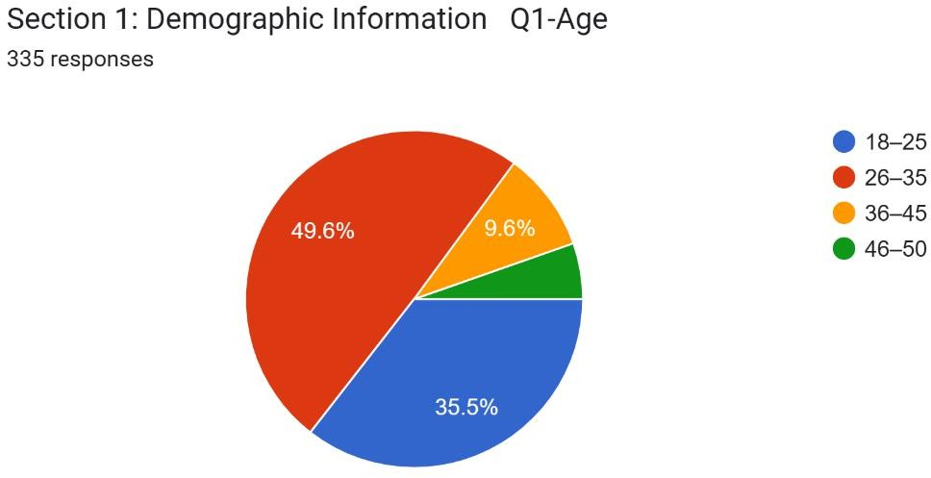

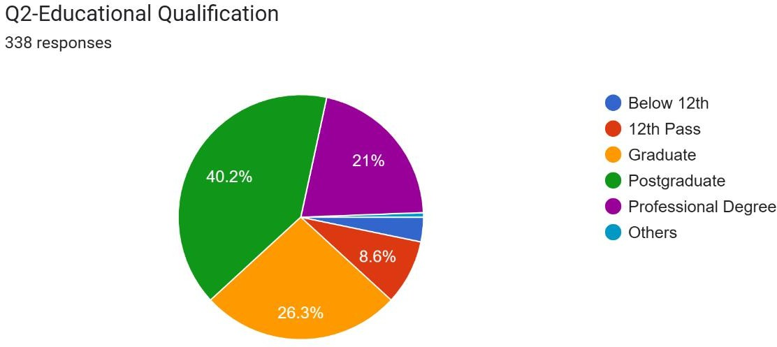

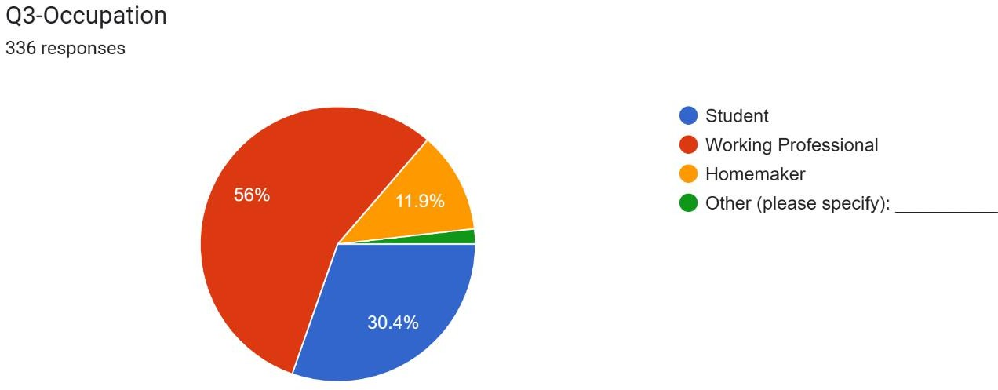

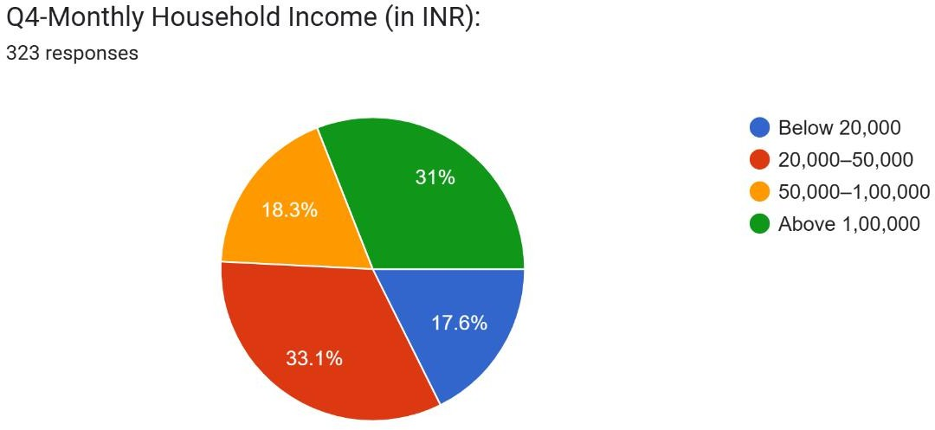

Section 2: Knowledge and Awareness
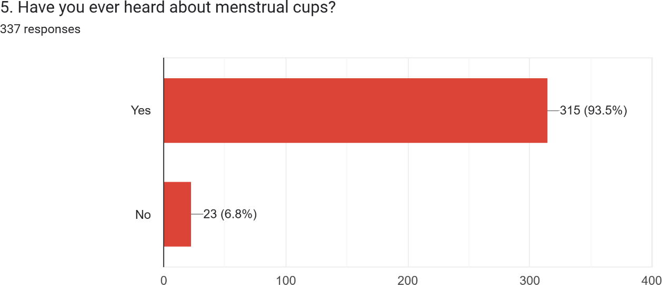

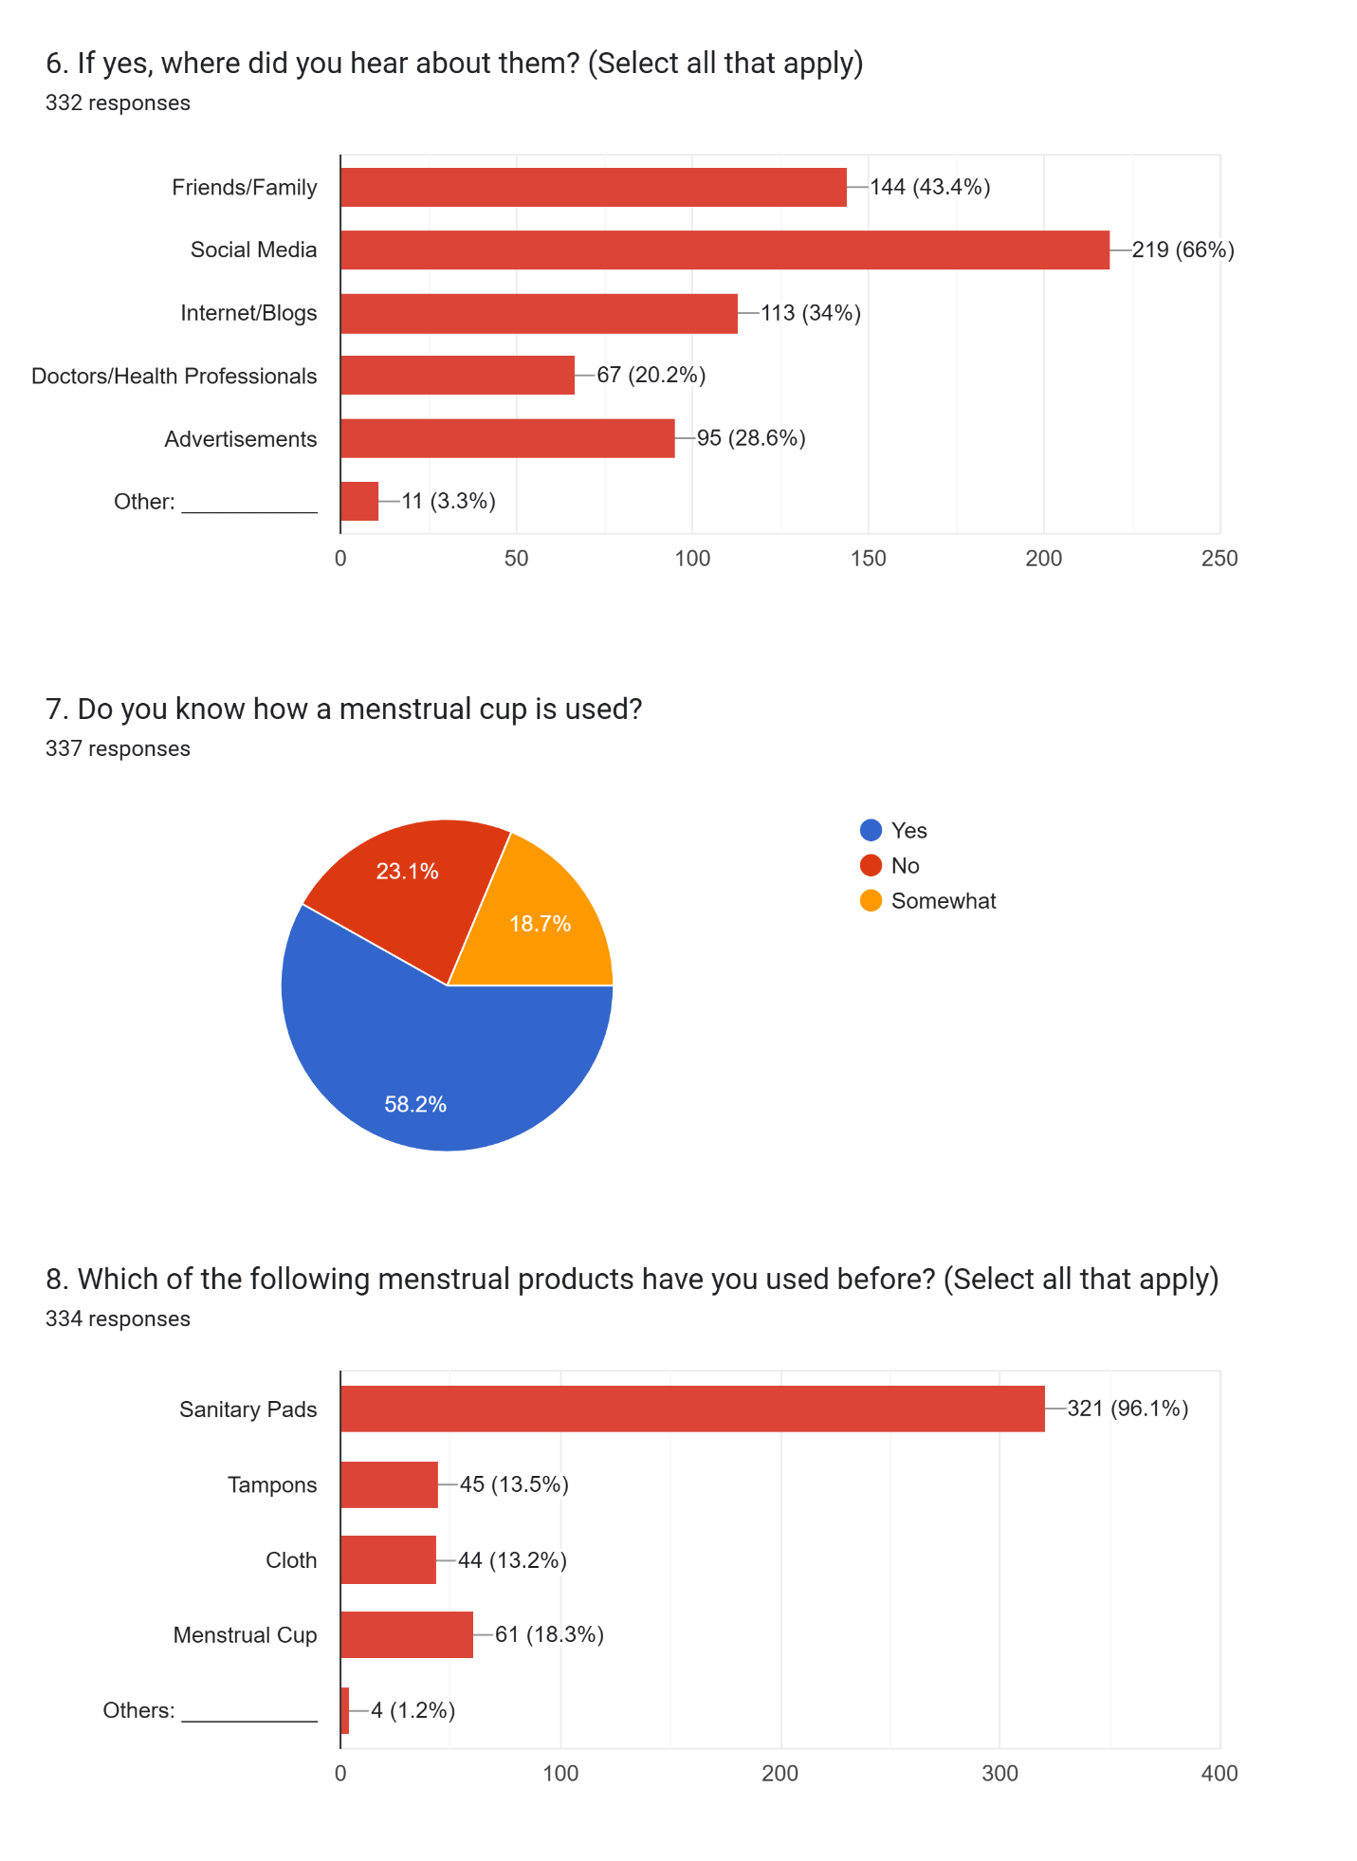

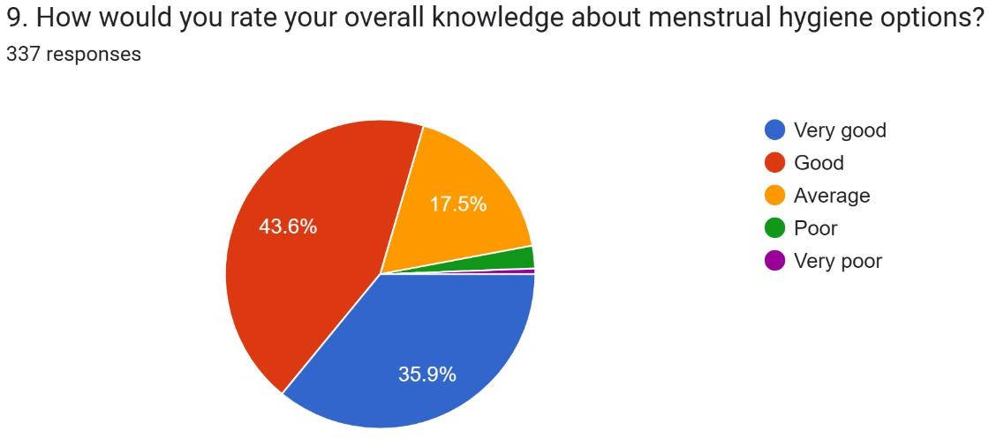

Section 3: Perceptions and Attitudes
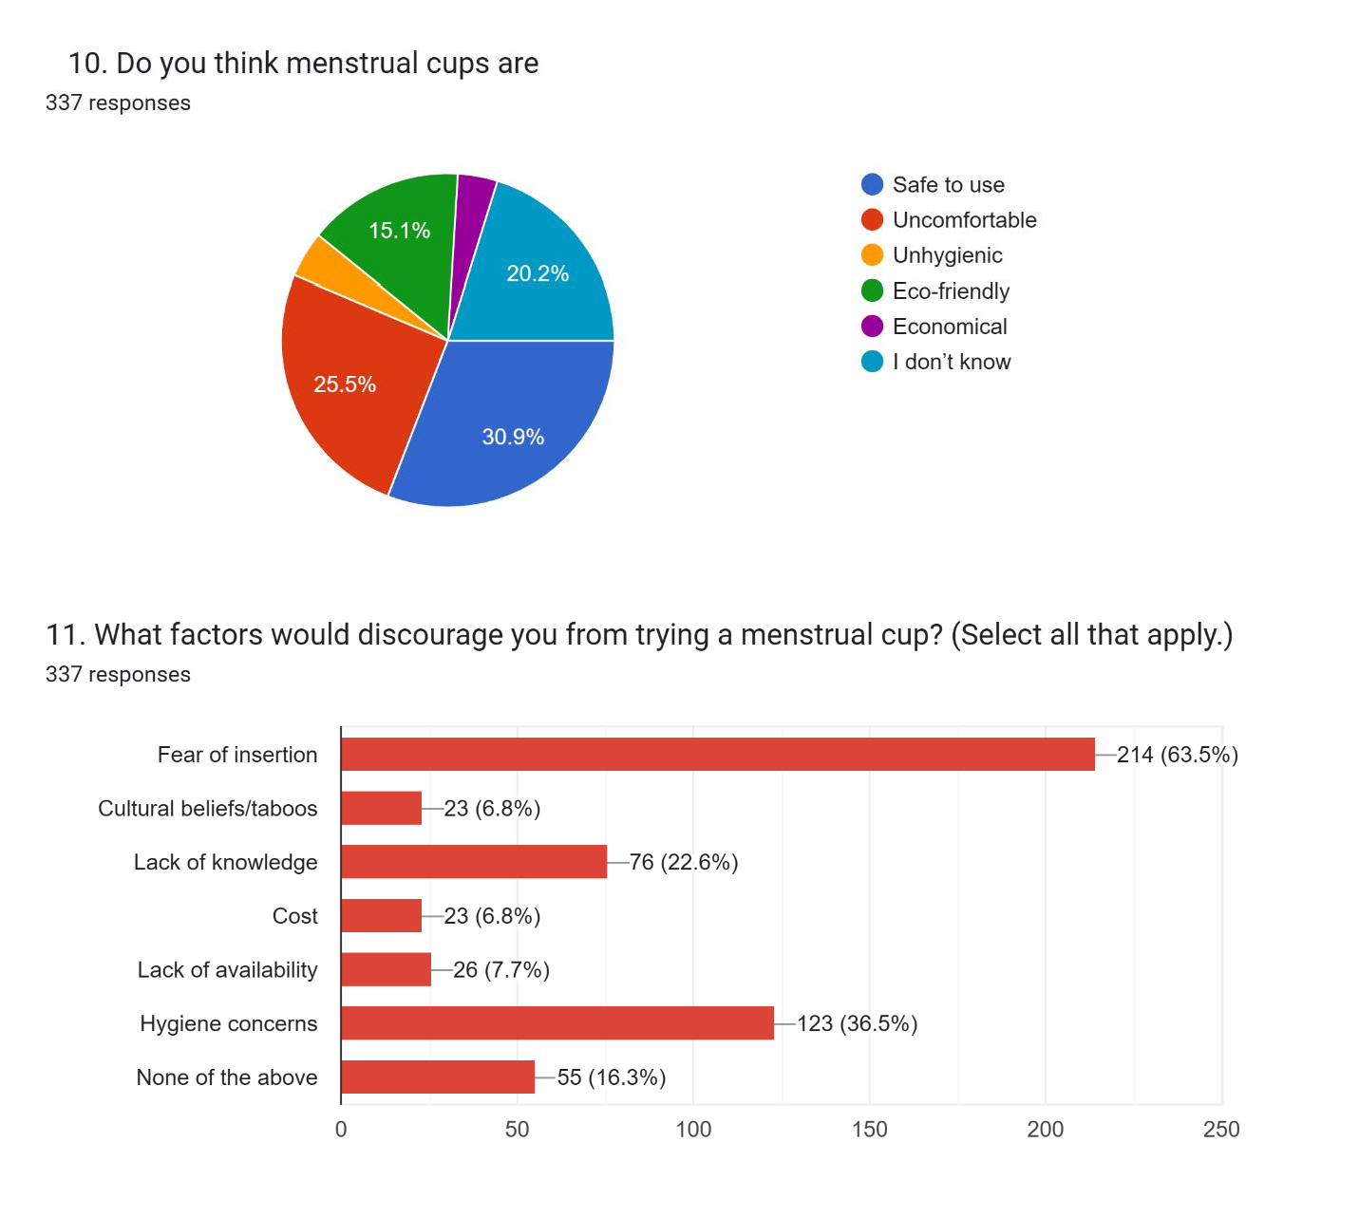

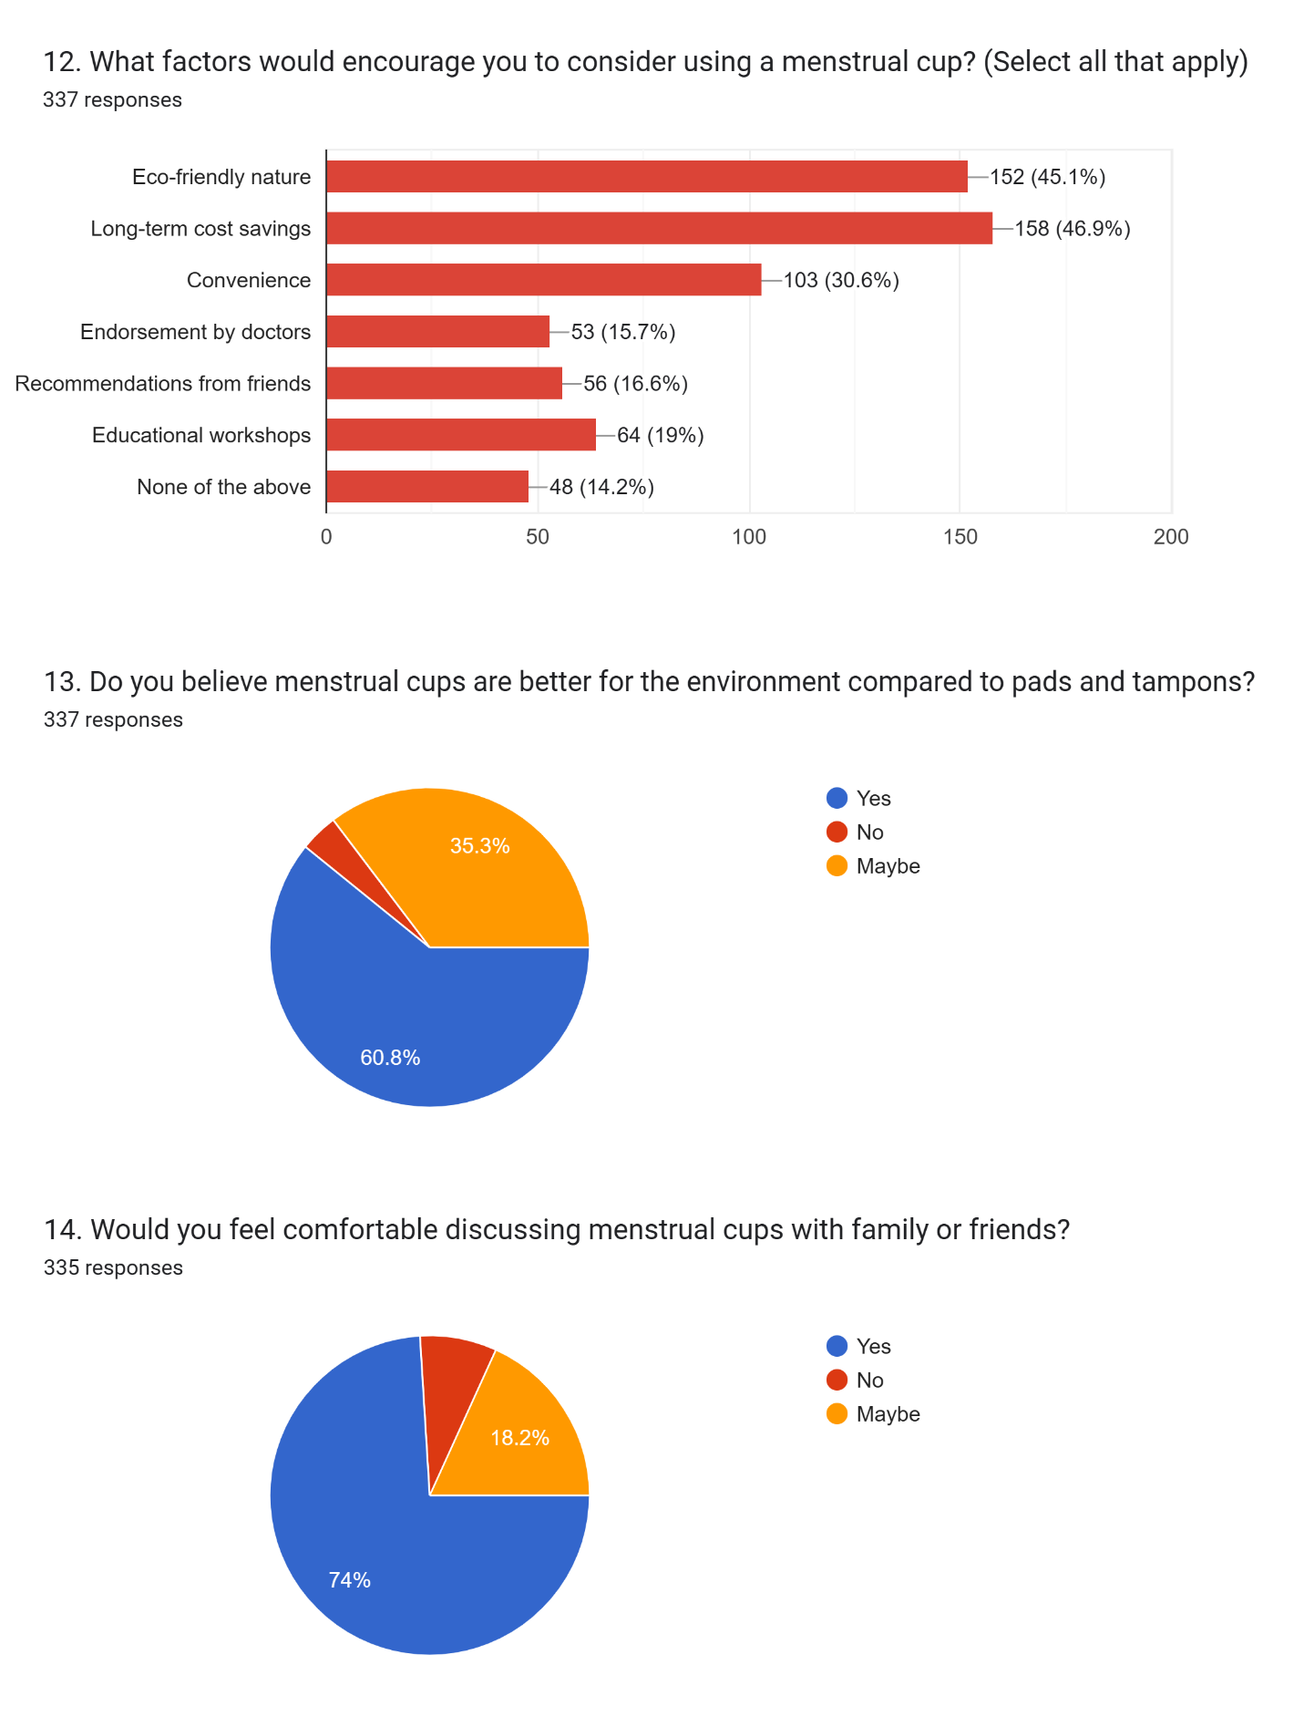

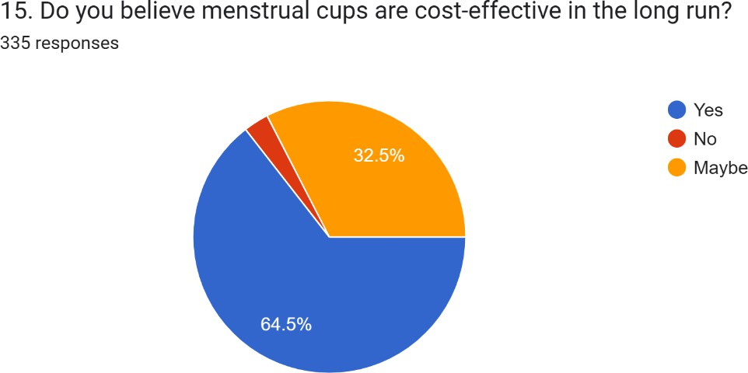

Section 4: Acceptance and Usage
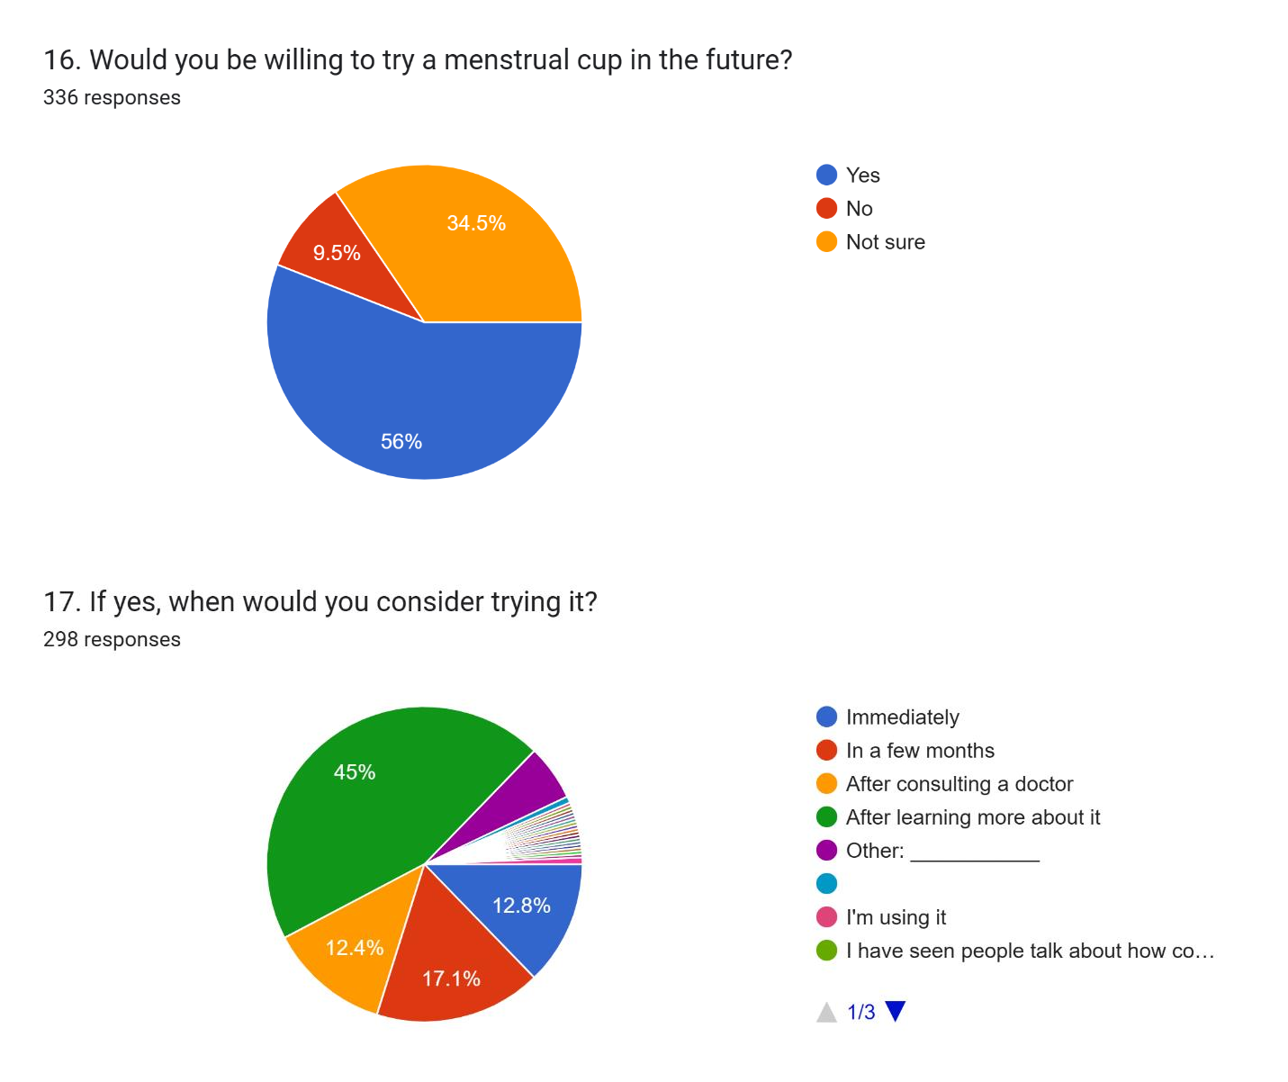

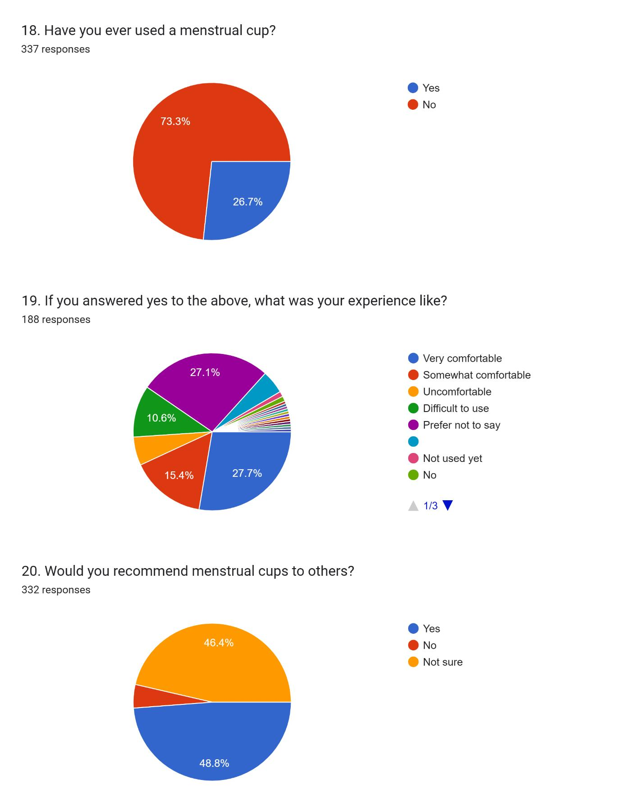

Objective 1: Awareness of Menstrual Cups

Awareness was examined in relation to socio-demographic factors. The Chi-square test revealed significant associations between awareness and age as well as educational qualification.
- Age: Women in the older age group (30–50 years) demonstrated higher levels of awareness compared to younger participants (18–29 years), with the difference statistically significant (p < 0.05). This suggests that exposure over time and greater life experience may contribute to better awareness.
- Education: A clear positive association was observed between education and awareness (p < 0.05). Participants holding graduate or postgraduate degrees reported greater awareness than those with secondary or higher secondary education, reaffirming the role of education in improving health literacy.
- Occupation: No significant relationship was observed (p > 0.05). Awareness did not vary notably between students, homemakers, or working women, indicating that employment status is not a key determinant.
- Household Income: Similarly, income level did not show a significant association (p

> 0.05). Awareness levels were broadly comparable across low-, middle-, and high- income households.
Interpretation: Awareness appears to be shaped primarily by education and age, rather than by occupation or income. This indicates that exposure to accurate information and educational attainment are stronger predictors of awareness than economic status or professional engagement.

Table 1. Awareness of Menstrual Cups by Demographic Factors

Variable | Association with Awareness | p-value | Significance
Age | Yes | <0.05 | Significant
Educational Qualification | Yes | <0.05 | Significant
Occupation | No | >0.05 | Not Significant
Household Income | No | >0.05 | Not Significant

Objective 2: Knowledge of Menstrual Cup Usage

Knowledge of correct usage (insertion, removal, cleaning, and reusability) was also examined across demographics. Significant associations were found with age and monthly household income, but not with education or occupation.
- Age: Older women (30–50 years) displayed better practical knowledge compared to younger women, with the association significant at p = 0.0468. This may be due to accumulated experience, greater openness to discussion, or reliance on peer networks.
- Income: Higher-income groups reported significantly greater knowledge (p = 0.0247). Financial stability may allow better access to healthcare providers, digital platforms, or peer circles where practical information is shared.
- Education: Despite its positive influence on awareness, educational qualification was not significantly linked to usage knowledge (p = 0.0912). This indicates that formal education does not necessarily translate into practical menstrual health skills.
- Occupation: No significant differences were observed (p = 0.0812), suggesting that employment type does not directly influence usage knowledge.

Interpretation: Practical knowledge requires more than awareness—it appears linked to age and resources (income), rather than academic achievement. This highlights the importance of hands-on demonstrations and practical training in bridging the knowledge gap.

Table 2. Knowledge of Menstrual Cup Usage by Demographic Factors

Variable | Association with Knowledge | p-value | Significance
Age | Yes | 0.0468 | Significant
Household Income | Yes | 0.0247 | Significant
Educational Qualification | No | 0.0912 | Not Significant
Occupation | No | 0.0812 | Not Significant

Objective 3: Acceptability of Menstrual Cups

Acceptability was assessed by examining willingness to try menstrual cups, existing usage, and outright rejection.
- Approximately 45–50% of participants expressed willingness to try menstrual cups, with openness higher among women who were educated and in the older age group.
- Around 25–30% were hesitant but expressed openness to guidance, indicating that practical demonstrations and health counseling could convert this group into potential adopters.
- Between 20–25% rejected menstrual cups outright, citing reasons such as cultural taboos, myths regarding virginity, concerns over insertion, and fear of leakage.

Interpretation: Acceptability is indirectly influenced by awareness and usage knowledge. Women with higher awareness and correct knowledge were more willing to try or adopt menstrual cups. Conversely, misinformation and cultural concerns limited adoption in hesitant and rejecting groups.

Table 3. Acceptability of Menstrual Cups

Response Category | Approx. % of  Participants | Key Reasons Identified
Willing to Try | 45–50% | Higher among educated and older women
Hesitant but Open to Guidance | 25–30% | Concerns about safety, hygiene, and insertion
Not Acceptable/Rejected | 20–25% | Myths, taboos, misconceptions

Summary of Results

- Awareness: Significantly shaped by education and age, not by occupation or income.
- Usage Knowledge: Significantly shaped by age and income, but not by education or occupation.
- Acceptability: Closely tied to awareness and usage knowledge, with cultural myths and lack of practical confidence remaining major barriers.

These findings collectively demonstrate that awareness does not automatically lead to usage knowledge or acceptance, and bridging this gap requires targeted, practical, and culturally sensitive interventions.

Section 5 – Discussion

The purpose of this study was to examine women’s awareness, perceptions, and acceptance of menstrual cups in Delhi-NCR, and to analyze how these outcomes vary by socio- demographic characteristics. The findings add to a growing body of research on sustainable menstrual health products and provide important insights into barriers and opportunities for menstrual cup adoption in India.

Awareness of Menstrual Cups

The results showed that awareness was significantly influenced by age and educational attainment, with older women and those holding higher educational qualifications demonstrating greater familiarity with menstrual cups. This highlights the role of both life experience and educational exposure in shaping health literacy. Women with higher levels of education are more likely to encounter accurate health information through formal channels, peer discussions, and digital media.
These findings are consistent with prior research in Kerala, Maharashtra, and Tamil Nadu, which also found a positive association between education and awareness of menstrual cups (Devan et al., 2022; Gokhale et al., 2024). Studies from South India similarly revealed that while awareness is increasing, gaps remain among younger and less educated populations. The association with age may also reflect accumulated exposure to healthcare systems, peer conversations, and digital information sources over time.

Interestingly, awareness was not associated with occupation or household income. This suggests that information about menstrual cups transcends professional and financial categories, likely due to the widespread reach of digital platforms and peer-to-peer discussions. This finding echoes results from studies conducted in other metropolitan areas, where digital media campaigns had a broad influence across socio-economic groups.

Knowledge of Menstrual Cup Usage

While education contributed to awareness, it did not translate into greater practical knowledge of usage. Instead, usage knowledge was significantly associated with age and household income. Older women and those belonging to higher-income groups reported better understanding of how to correctly insert, remove, and clean menstrual cups.
This suggests that practical knowledge is influenced less by formal schooling and more by

access to resources—such as healthcare professionals, online demonstrations, and supportive peer groups. Higher-income women may have greater access to digital health information or the ability to purchase menstrual cups for trial use. These findings align with international literature, where experiential learning and resource availability were found to be essential for successful adoption (Howard et al., 2011; Beksinska et al., 2015).
The lack of association between education and usage knowledge reveals a critical gap: awareness campaigns may succeed in generating recognition, but without practical demonstrations, women remain hesitant or unsure of correct use. Similar results were noted in a Kenyan study (Phillips-Howard et al., 2016), where hands-on demonstrations were necessary to convert awareness into confidence and sustained use.

Acceptability of Menstrual Cups

Acceptability was indirectly shaped by awareness and usage knowledge. While almost half of participants expressed willingness to try menstrual cups, a considerable proportion remained hesitant or rejected them outright. The main reasons for rejection included cultural taboos, misconceptions about virginity, concerns about hygiene, and fear of leakage.
These barriers mirror findings from both Indian and global contexts. Research among college women in South India (Shanmugham et al., 2023) highlighted similar myths, while studies in Sub-Saharan Africa also found that cultural attitudes toward vaginal insertion limited adoption despite demonstrated benefits (Masika et al., 2020). Conversely, women who had tried menstrual cups frequently reported positive experiences, including affordability, convenience during travel or sports, and reduced waste—consistent with prior evidence from South Africa and Kenya (Beksinska et al., 2015; Phillips-Howard et al., 2016).
Overall, the findings support the idea that acceptability depends not only on awareness but also on confidence in usage. Without bridging the gap between “knowing about” and “knowing how,” menstrual cup adoption will remain limited.

Public Health Implications

The results highlight several key implications:

- Targeted Awareness Campaigns – Efforts should focus on younger women and those with lower educational levels, who demonstrated lower awareness in this study. School- and college-based programs can serve as important entry points.
- Practical Demonstrations – Usage knowledge was significantly associated with income, suggesting that women from lower-income groups lack access to practical

information. Workshops, community demonstrations, and peer-led models could help bridge this gap.
- Holistic Messaging – Promotion strategies must emphasize not only hygiene and health benefits but also economic savings and environmental sustainability, as these motivators were recognized by many participants.
- Healthcare Provider Involvement – Doctors, nurses, and community health workers should be engaged in awareness programs, as endorsement from trusted professionals can help counter myths and cultural hesitations.

Limitations

The study has several limitations.

  - First, the use of non-probability sampling restricts the generalizability of the findings to the broader Delhi-NCR population.
  - Second, the cross-sectional design limits causal inference; longitudinal data would be required to track how awareness and acceptance evolve over time.
  - Third, the focus on Delhi-NCR means results may not reflect the experiences of rural populations or other cultural contexts in India.
Despite these limitations, the study provides valuable baseline evidence for designing

targeted interventions in urban Indian settings.

Future Research

Future studies should adopt mixed-methods and longitudinal designs to capture both statistical associations and nuanced personal experiences.
  - Qualitative research can explore cultural taboos, misconceptions, and personal stories in depth.
  - Intervention-based studies are needed to evaluate the effectiveness of awareness campaigns, school programs, or NGO-led initiatives in improving knowledge and acceptance.
  - Longitudinal studies could track whether women who initially adopt menstrual cups continue long-term use, and what factors influence sustained adoption.
  - Expanding research to rural and semi-urban settings would offer a broader understanding of socio-cultural influences in India.
Conclusion

  - This study explored the awareness, perceptions, and acceptability of menstrual cups among women aged 18–50 years in Delhi-NCR. In doing so, it addressed a significant gap in menstrual health research within India, where most women continue to rely on disposable pads and tampons despite the availability of sustainable alternatives.
  - The findings highlighted three key insights. First, awareness of menstrual cups is strongly influenced by age and education, with older and better-educated women demonstrating greater familiarity. Second, practical knowledge of usage is more closely tied to age and household income, suggesting that financial resources and lived experiences provide greater access to accurate information and confidence in handling menstrual cups. Third, acceptability is mediated by awareness and usage knowledge—while nearly half of participants were open to trying menstrual cups,

misconceptions, cultural taboos, and fears around insertion and hygiene remain significant barriers.
  - These results reaffirm that awareness alone is insufficient to drive adoption.

Without practical demonstrations, peer support, and culturally sensitive messaging, women are unlikely to translate awareness into sustained use. The study therefore underscores the need for multi-dimensional interventions that combine education, demonstration, and advocacy.
  - From a public health perspective, menstrual cups represent a safe, cost-effective, and environmentally sustainable alternative to conventional menstrual products. Their adoption can reduce menstrual waste, contribute to the achievement of Sustainable Development Goals (particularly SDG 3 and SDG 12), and empower women by offering them greater freedom and comfort during menstruation. In the Indian context, promoting menstrual cups also provides an opportunity to challenge long- standing menstrual taboos and normalize open discussion around women’s health.
  - The study’s findings should inform policy, NGO initiatives, and awareness campaigns. Programs must be designed to target younger women and those from less educated or lower-income backgrounds, as these groups showed the largest knowledge and acceptability gaps. Healthcare providers should also be engaged as trusted sources of guidance to dispel myths and provide reassurance.
  - Although limited by its cross-sectional design and focus on an urban setting, this research provides a valuable baseline for future inquiry. Longitudinal and qualitative studies are needed to capture evolving perceptions and the lived experiences of menstrual cup users. Further, intervention-based research could assess the effectiveness of awareness and demonstration campaigns in improving adoption rates across diverse populations.

  - In conclusion, this study demonstrates that while menstrual cups are a viable, sustainable, and empowering menstrual hygiene option, their acceptance in Delhi- NCR is constrained by gaps in awareness, usage knowledge, and cultural acceptance. Bridging these gaps requires practical education, culturally sensitive messaging, and strong advocacy. By addressing these barriers, menstrual cups can move from being a niche product to a mainstream solution, contributing not only to women’s health and dignity but also to environmental sustainability and social progress.
References

- ResearchGate. Awareness, Acceptability, and Feasibility of the Menstrual Cup Among Working Women [Internet]. ResearchGate; 2025 Apr 25 [cited 2025 Jul 4]. Available from: https://www.researchgate.net/publication/390458925_Awareness_Acceptability_and_Feasibility_of_the_Menstrual_Cup_Among_Working_Women
- Menstrual Hygiene Management. WaterAid India; [date unknown]. Available from: https://www.wateraid.org/in/sites/g/files/jkxoof336/files/informed-product-choice-and-disposal_1.pdf
- Mildcares.com. Reusable vs. Disposable: The Environmental Impact of Menstrual Product - Mildcares.com [Internet]. Mildcares.com; 2025 Jan 18 [cited 2025 Jul 4]. Available from: https://mildcares.com/blogs/news/reusable-vs-disposable-the-environmental-impact-of-menstrual-products
- American Chemical Society. Is food waste the key to sustainable, plastic-free diapers and sanitary pads? [Internet]. American Chemical Society; 2024 Mar 19 [cited 2025 Jul 4]. Available from:https://www.acs.org/pressroom/presspacs/2024/march/is-food-waste-the-key-to-sustainable-plastic-free-diapers-and-sanitary-pads.html
- Nua. Why Menstrual Cups Are an Eco-Friendly, Cost-Effective, and Healthy Period Solution [Internet]. Nua; 2025 Apr 29 [cited 2025 Jul 4]. Available from: https://nuawoman.com/blog/why-menstrual-cups-are-an-eco-friendly-cost-effective-and-healthy-period-solution/
- ResearchGate. Menstrual Cup Awareness and Future Usage Possibilities of Consumers: A Cross-sectional Study | Request PDF [Internet]. ResearchGate; 2025 May 24 [cited 2025 Jul 4]. Available from: https://www.researchgate.net/publication/376162438_Menstrual_Cup_Awareness_and_Future_Usage_Possibilities_of_Consumers_A_Cross-sectional_Study
- PubMed Central. Bridging the Knowledge Gap: Awareness, Attitudes, and Practices Regarding Menstrual Cup Usage Among Medical Students in Chennai, India [Internet]. PubMed Central; 2025 Apr 22 [cited 2025 Jul 4]. Available from: https://pmc.ncbi.nlm.nih.gov/articles/PMC12096921/
- PubMed Central. Awareness and acceptance of menstrual cups and the factors associated with it among healthcare professionals in Wolaita Zone, South Ethiopia [Internet]. PubMed Central; 2025 Jan 15 [cited 2025 Jul 4]. Available from: https://pmc.ncbi.nlm.nih.gov/articles/PMC11751893/
- IIJLS. Knowledge Regarding Menstrual Cups and its Usage among Adolescent Girls [Internet]. IIJLS; 2023 Dec 23 [cited 2025 Jul 4]. Available from: https://iijls.com/currentissue/Knowledge_Menstrual_Cups_Usage_Adolescent_Girls.pdf
- PubMed Central. Knowledge, Attitude and Practices Regarding Menstrual Cup Among Females in an Urban Setting of South Kerala [Internet]. PubMed Central; [date unknown] [cited 2025 Jul 4]. Available from: https://pmc.ncbi.nlm.nih.gov/articles/PMC10350547/
- ResearchGate. Awareness and Adoption Rates of Menstrual Cups Among Adolescents and Young Women [Internet]. ResearchGate; 2025 Jun 20 [cited 2025 Jul 4]. Available from: https://www.researchgate.net/publication/392777105_Awareness_and_Adoption_Rates_of_Menstrual_Cups_Among_Adolescents_and_Young_Women
- PubMed Central. Factors Associated with Exclusive Use of Hygienic Methods during Menstruation among Adolescent Girls (15–19 Years) in Urban India: Evidence from NFHS-5 [Internet]. PubMed Central; [date unknown] [cited 2025 Jul 4]. Available from: https://pmc.ncbi.nlm.nih.gov/articles/PMC11046189/
- Storyboard18. World Menstrual Hygiene day: Tata Trusts' new campaign flips the narrative around menstruation [Internet]. Storyboard18; 2025 Jun 6 [cited 2025 Jul 4]. Available from: https://www.storyboard18.com/advertising/world-menstrual-hygiene-day-tata-trusts-new-campaign-flips-the-narrative-around-menstruation-69152.htm
- MSJ Online. Effectiveness of structured teaching programme regarding knowledge about uses of menstrual cup among nursing students [Internet]. MSJ Online; 2024 Feb 9 [cited 2025 Jul 4]. Available from: https://www.msjonline.org/index.php/ijrms/article/download/13148/8556/60321
- ICCRJNR. effectiveness of the menstrual cup education package on knowledge and attitude among college [Internet]. ICCRJNR; 2023 Apr 12 [cited 2025 Jul 4]. Available from: https://iccrjnr.com/downloads/ICCRJNR080102.pdf
- ResearchGate. Acceptability and feasibility of using menstrual cups as an alternative menstrual hygiene product: a tertiary care-based prospective study [Internet]. ResearchGate; 2025 Jun 3 [cited 2025 Jul 4]. Available from: https://www.researchgate.net/publication/392271750_Acceptability_and_feasibility_of_using_menstrual_cups_as_an_alternative_menstrual_hygiene_product_a_tertiary_care-based_prospective_study
- PubMed Central. Acceptability and feasibility of using vaginal menstrual cups among schoolgirls in rural Nepal: a qualitative pilot study [Internet]. PubMed Central; 2021 Jan 25 [cited 2025 Jul 4]. Available from: https://pmc.ncbi.nlm.nih.gov/articles/PMC7831234/
- Journal of Chemical Health Risks. “A Qualitative Study – “This is Why Women reject to use a Menstrual Cup – Experiences of Non-Users” [Internet]. Journal of Chemical Health Risks; 2024 Feb 2 [cited 2025 Jul 4]. Available from: https://www.jchr.org/index.php/JCHR/article/view/2626

