Dissertation
at
CARPL.AI
Bibliometric Analysis on Transforming Enterprise Imaging in Healthcare: The Role of Artificial Intelligence in Modern Radiology
by
Aditi Sinha
PG/23/06
Under the guidance of
Dr. Anandhi Ramachandran
PGDM (Hospital and Health Management)
2023-25

International Institute of Health Management Research New Delhi

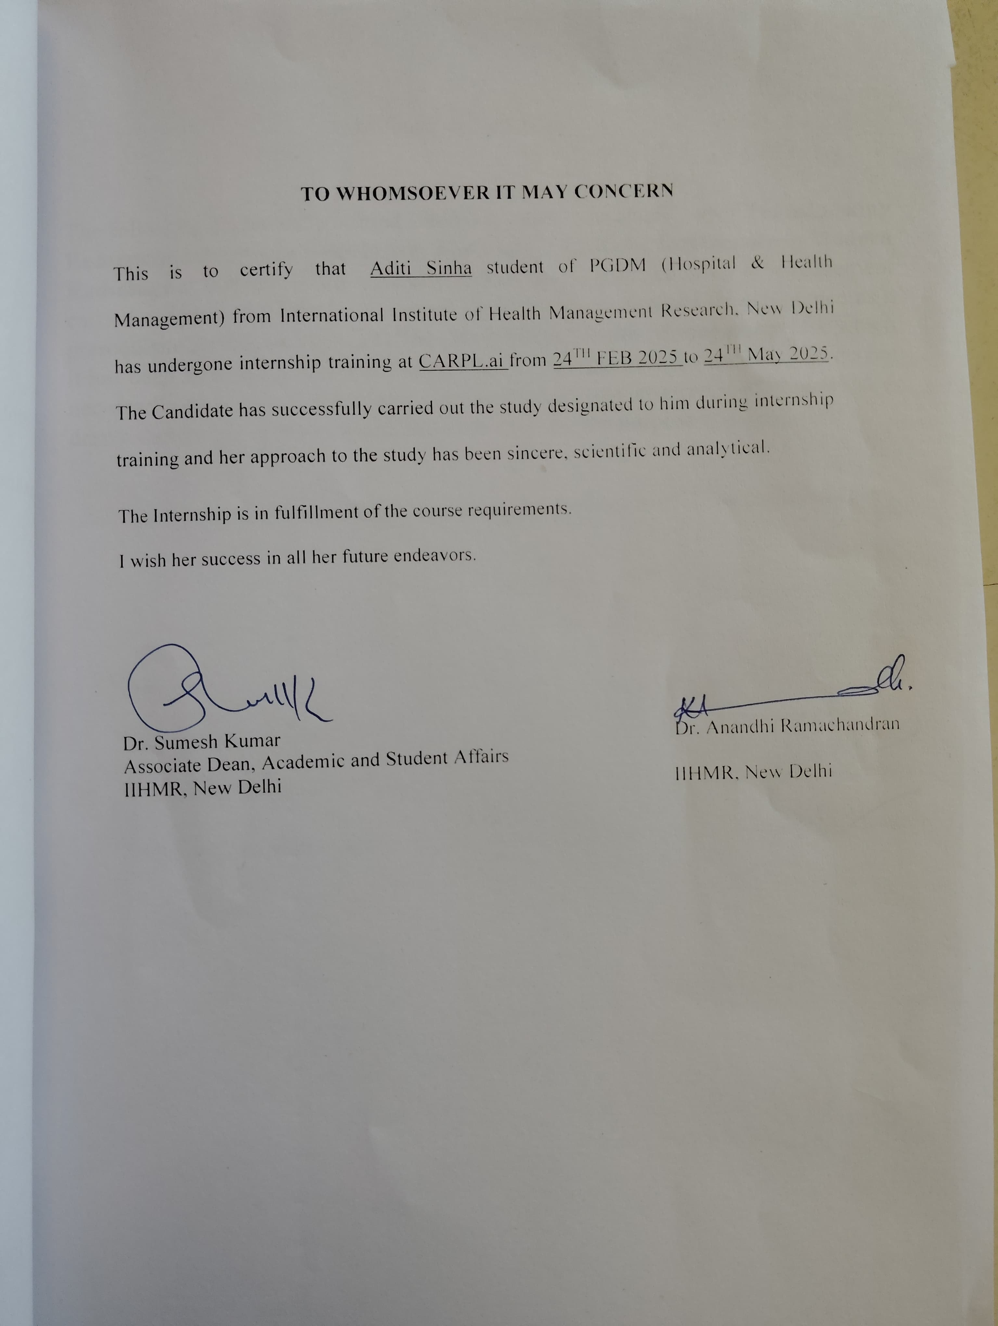



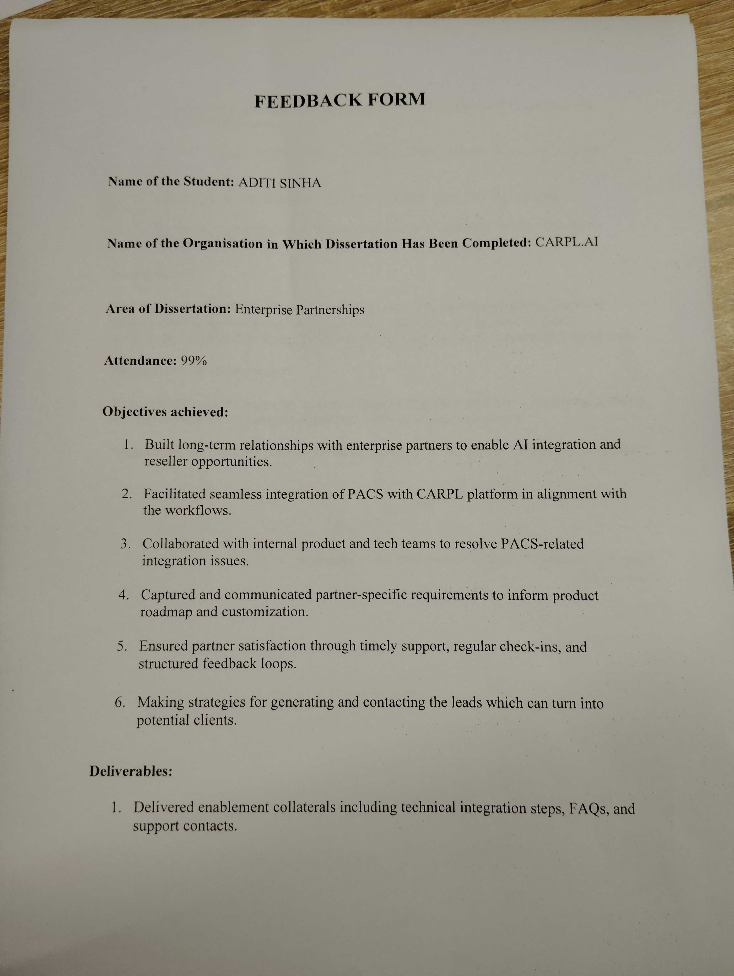



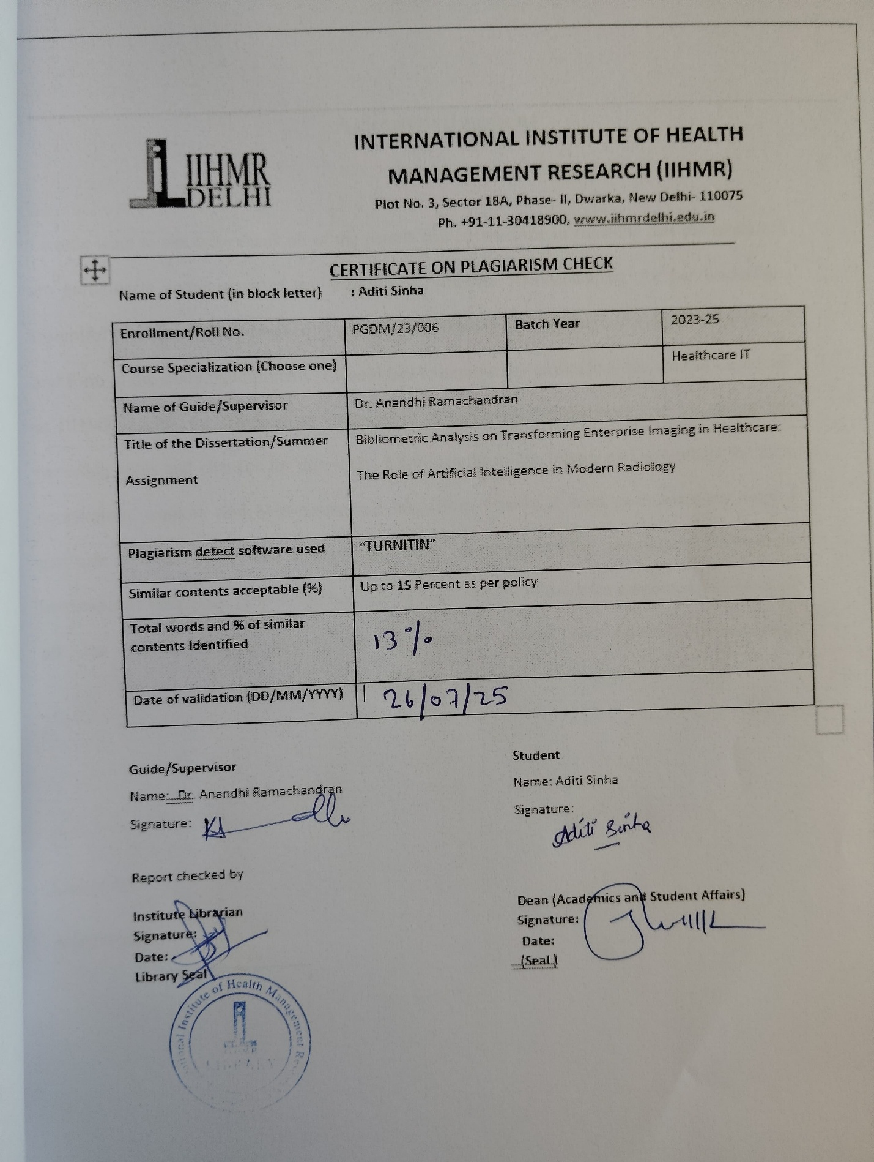
ABOUT THE ORGANIZATION

About CARPL
CARPL.ai is the world’s first testing and deployment platform for medical imaging AI applications, which connects healthcare providers to third party AI applications, helping improve access, affordability, and quality of medical care.
It bridges the gap between healthcare providers and AI developers by serving as a gatekeeper that seamlessly connects both sides of the ecosystem. In essence, it is a single interface to access AI algorithms, validate and test them, and subsequently embed them into radiology workflows.
It is used by some of the world’s leading healthcare providers, AI researchers, industry teams and startups. It is built with the single goal of making it easy for clinicians to get access to advanced analytics tools.
Vision
The goal of CARPL is to become the go-to-market strategy of choice for AI developers and the single interface for AI deployment at healthcare providers, serving as the back-end platform for all medical imaging AI deployments worldwide.
Features
Easy to Access: There is a fragmented ecosystem out there if any HCP wanted to deploy any radio diagnostic AI solution how they can contact AI developers providing similar solutions individualistically, but CARPL platform have 100+ AI solutions of different AI developer on a simple single user- friendly platform.
Easy to Assess: CARPL is the first company to provide the feature of Validation and Testing & Monitoring of the AI solutions for the HCPs so they can analyze the efficiency of the AI model over their own Patient data.
Easy to Integrate: If the HCPs starts deploying AI solutions related to radiodiagnosis by multiple AI developers for different use cases they would require different RIS-PACS integrations but for accessing multiple AI solutions via CARPL requires single RIS-PACS setup.
Reliability: All the AI solutions onboarded on CARPL’s platform are regulatory compliant including FDA(US), CE(Europe), HSA(Singapore), ANVISA(Brazil) and TGA (AUS).

Table of Contents

Acknowledgement 8
Table of Contents 11
1. List of Abbreviations/Acronyms 12
2. Abstract 14
3. Background 15
4. Rationale 15
5. Literature Review 17
6. Objectives and Research Questions 22
7. Methodology 24
7.1 Data Collection 24
7.2 Data Processing and Bibliometric Analysis 25
Results 27
9. Discussion 42
10. Conclusion 45
11. Limitations 46
12. References 47
13. Annexures Error! Bookmark not defined.

List of Abbreviations/Acronyms

Acronym | Full Form
AI | Artificial Intelligence
DL | Deep Learning
CNN | Convolutional Neural Network
GAN | Generative Adversarial Network
XAI | Explainable Artificial Intelligence
NLP | Natural Language Processing
CT | Computed Tomography
MRI | Magnetic Resonance Imaging
PACS | Picture Archiving and Communication System
VNA | Vendor Neutral Archive
EHR | Electronic Health Record
GDPR | General Data Protection Regulation
HIPAA | Health Insurance Portability and Accountability Act
RAISE | Radiology Artificial Intelligence: A Systematic Review and Evaluation of Methods
TRIPOD-AI | Transparent Reporting of a Multivariable Prediction Model for Individual Prognosis or Diagnosis – Artificial Intelligence
CONSORT-AI | Consolidated Standards of Reporting Trials – Artificial Intelligence
DECIDE-AI | Reporting Guidelines for Clinical Trials for AI Decision Support Interventions
RCT | Randomized Controlled Trial
AUC | Area Under the Curve
ML | Machine Learning
EHR–Imaging | Electronic Health Record–Imaging Fusion

Abstract
The integration of artificial intelligence (AI) into enterprise imaging marks an important development in modern radiology. The study provides a detailed bibliometric and thematic analysis of scholarly literature on AI-driven enterprise imaging published between 2014 and 2024. The analysis aimed to track research progress, identify influential contributors, and highlight major themes and gaps. A total of 68 peer-reviewed publications were examined using VOSviewer and manual content classification techniques.
Findings show a significant increase in AI-related radiology research the United States and China emerging as leading contributors. The key thematic clusters include algorithm innovation, workflow efficiency, explainability, ethical and regulatory issues, clinical implementation, and collaboration between radiologists and AI systems. Even with advances in technical performance, broader clinical adoption remains limited to factors like lack of algorithm transparency, insufficient validation studies, infrastructure challenges, and fragmented regulatory frameworks.
The analysis stresses the need to design AI systems that are ethically sound, transparent, and meet clinical needs. It also suggests that future efforts should focus on real-world evaluations, fairness in model development, and teamwork across disciplines to ensure AI technologies can be implemented safely, responsibly, and effectively in clinical radiology.

Background

Modern radiology is experiencing an important transformation due to advances in artificial intelligence (AI), especially in the field of business images. Historically, radiology has depended on the manual interpretation of image studies, which, although effective, can take a long time and inconsistent. With the rapid increase in digital medical image data and the growing demand for rapid and precise diagnoses, worldwide health systems are exploring IA -based solutions to improve radiological services.

Business images refer to the systematic management of all image data in several departments and facilities within a medical care organization. This includes not only radiological images, but also those of pathology, dermatology, endoscopy and other specialties. The integration of AI in this field allows the intelligent automation of tasks such as the acquisition of images, triage, interpretation, generation of reports and storage management. Deep learning models (DL), particularly convolutional neural networks (CNN), have shown a notable competition in the classification of images, detection and segmentation tasks, often achieving precision that coincides or exceeds that of human experts in areas such as the detection of breast cancer and the classification of pulmonary nodules.

Numerous studies have shown that AI improves the accuracy of the diagnosis, reduces the workload for radiologists, shortens diagnosis delays and improves the consistency in clinical decision making. In addition, AI algorithms can help predict the patient's results, emphasize critical findings in real time and reduce response times in emergency situations. These efficiencies are especially crucial in high volume environments where quick and precise decision making is vital.

Rationale
The growing body of literature on artificial intelligence (AI) in radiology indicates a field that advances rapidly. In the last ten years, IA has evolved from a tool used for experimentation to a significant catalyst for clinical innovation and operational transformation within the image departments. This evolution has been promoted by advances in technology, the increase in computational capacities, access to extensive sets of image data noted and the increase in clinical demands. However, despite the richness of published research, the landscape remains disjointed, characterized by inconsistent reports, variable levels of methodological rigor and lack of systematic integration.
A bibliometric analysis serves as an effective approach to navigate this intricate domain. It allows researchers to evaluate the structure, performance and trends of scientific production within a specific area. When analyzing publication trends, co -authorship dynamics, dating networks and keyword concurrence, bibliometric methods offer a holistic perspective on the generation of knowledge, key taxpayers, primary issues and existing research gaps. In the field of AI in business images, this analysis is not only academically relevant but also strategically significant. Understanding the research trajectory can help interested parties, including doctors, hospital administrators, technology developers and policy formulators, to make informed decisions.

For example, identifying influential institutions and prolific authors can facilitate the collaboration of research and financing distribution. Identifying emerging issues can direct the development of future technologies that are better align with clinical requirements and policy frames.
In addition, this mapping exercise is crucial to evaluate the mapping of the field. As AI tools in the transition from development to the application of the real world, it is vital to distinguish between concepts of proof of concept and research centered on the implementation of the real world. This dissertation emphasizes the relative lack of prospective essays, external validation studies and long -term results evaluations, which are essential to ensure that IA systems are safe, effective and equitable.
In addition, this dissertation seeks to illuminate the multifaceted challenges associated with the integration of AI in clinical radiology. While many researchers concentrate on algorithmic performance metrics (such as precision, sensitivity and AUC), they less examine how these systems are integrated into real radiology workflows, how doctors get involved with them and the barriers that exist in everyday practice. A truly transformative technology should not only be technically competent but also easy to use, reliable and properly regulated.
In conclusion, the motivation for this research arises from the need for:
- Systematically evaluate the evolution and impact of AI research on business images;
- Identify key taxpayers and collaborative networks to promote future associations;
- Discover thematic patterns indicating the direction of the field;
- Highlights the gaps that must be addressed to guarantee the responsible and effective deployment of AI in clinical practice.
Literature Review
In the last two decades, Artificial Intelligence (AI) has been changing progressively the medical imaging sector, especially in radiology. Current studies suggest that AI's influence on enterprise imaging is beyond automation; It improves clinical accuracy, increases workflow efficiency, affects clinical decision making, and changes the roles of radiologist. This literature review summarizes existing knowledge in five main areas: (1) technological progress, (2) workflow and clinical integration, (3) clarity and transparency, (4) prejudice and moral rule, and (5) Real world deployment and regulation.
1. Technological progress in AI imaging
The AI has developed from the AI Rules-based specialist systems to deep learning (DL) framework, which includes the Controller Neural Network (CNN), Generic Advertisement Network (GANS) and transformer. This development has greatly improved the works related to image classification, division and reconstruction. Avanzo et al. (2024) highlighted this change, given that visual interpretation and attention-based DL models are now important in modern radiology applications. Singh et al. , Research by Yi et al. Demonstrated that Gans are effective in generating synthetic data, reducing noise and increasing low-khurak CT scans. Recent studies have also focused on semi-revolution learning and domain optimization to overcome the lack of data labeled.

Additionally, Chen et al. Introducing innovations in the Memory-AUGGGART transformer to generate radiology reports, indicated a change towards natural language production in imaging works.
2. Workflow Optimization and Clinical Integration
Integration of AI into radiology workflows has been a key focus of multiple reviews. Najjar emphasized segmentation, computer-aided detection (CAD), and triage systems that support workload reduction and clinical decision-making⁸. Dikici et al. proposed a maturity model outlining stages of research, production, and feedback integration within enterprise PACS⁹. Studies by Debnath and Bhandari recognized the importance of aligning AI systems with radiologist workflows, while warning against black-box models undermining trust¹⁰,¹¹.
Erdal et al. outlined smart routing and modular deployment strategies using open-source platforms like MONAI, promoting scalable implementation across hospital systems¹². Mello-Thoms et al. further emphasized that modular AI must align with subspecialty needs and system interoperability requirements¹³.
AI’s impact on diagnostic efficiency was substantiated by Wenderott et al., whose meta-analysis found significant improvements in report turnaround time, reader fatigue, and productivity, especially in high-volume centers¹⁴.
3. Explainability, Transparency, and Human–AI Collaboration
A recurring theme in the literature is the necessity for explainable AI (XAI) to ensure clinician trust and regulatory compliance. Jungmann et al. demonstrated that methods such as SHAP and Grad-CAM could significantly enhance radiologist performance in classification tasks¹⁵. Singh et al. and Tjoa et al. outlined a taxonomy of XAI approaches, emphasizing that model interpretability is essential for clinical translation¹⁶,¹⁷.
Chen et al. emphasized the importance of human-centered design in AI systems, arguing that transparency, radiologist feedback loops, and intuitive user interfaces are essential for adoption¹⁸. This sentiment was echoed in several studies, with Rubin¹⁹ and Hosny et al.²⁰ underlining the evolving role of radiologists as AI supervisors and collaborators, rather than passive users.
4. Bias, Fairness, and Ethical Governance
Nagendran et al. (2020) found that few prospectively deep learning studies and randomization trials exist in medical imaging, with most non-randomized trials being at high risk of bias and deviating from reporting standards²¹. Koçak et al. provided a comprehensive framework for identifying bias sources in medical imaging AI - from labeler inconsistency to demographic imbalance - and proposed fairness-aware learning algorithms²².
Vrudhula et al. and Cheplygina et al. also emphasized that data imbalance and overfitting could exacerbate health disparities if not audited appropriately²³,²⁴. Transparency in demographic metadata and inclusion of fairness metrics in model evaluation were consistently recommended.
Panayides et al. and Adams et al. further warned that fragmented datasets, poor interoperability, and lack of governance policies are key barriers to equitable AI deployment²⁵,²⁶. Wikipedia summaries and reviews of ethical principles echoed these concerns, reinforcing the importance of TRIPOD-AI, CONSORT-AI, and GDPR compliance frameworks²⁷,²⁸.
5. Real-World Deployment and Regulatory Challenges
Several authors reported on the current status and readiness of AI tools in real-world radiology. Obuchowicz et al. reviewed FDA-cleared imaging tools and concluded that limited validation and lack of post-market surveillance remain major concerns²⁹. Pham et al. found that less than 20% of AI systems evaluated in their study had completed full post-deployment assessments³⁰.
Gupta et al. and Daye et al. proposed institutional AI readiness frameworks and radiologist-led governance boards to ensure safety, accountability, and alignment with clinical goals³¹,³². Similarly, van Leeuwen et al. tracked real-world AI deployment in Dutch hospitals, revealing that only 10% of evaluated tools were routinely used³³.
In addition to national challenges, international perspectives were offered by Buaka et al. and Koh et al., who cited regulatory fragmentation across regions and urged for harmonization of standards such as the EU AI Act and the Algorithmic Accountability Act³⁴,³⁵.
The literature reveals a rapidly expanding but uneven research landscape. While algorithmic performance continues to improve, real-world implementation remains constrained by issues of bias, transparency, interoperability, and regulatory uncertainty. Interdisciplinary collaboration - involving radiologists, data scientists, ethicists, and policymakers - is essential to address these challenges and ensure that AI in enterprise imaging delivers equitable, safe, and clinically effective outcomes.

Objectives and Research Questions
The primary objective of this bibliometric and thematic analysis is to systematically map and evaluate the research landscape of artificial intelligence (AI) integration into enterprise imaging in the field of radiology. This analysis aims to provide insights into both technological advancements and practical implementation challenges associated with AI adoption in clinical imaging workflows.
The objectives of this study are as following:
- To examine the evolution of research output related to AI in enterprise imaging from 2014 to 2024, identifying patterns in publication frequency and thematic shifts.
- To determine the most influential contributors-authors, institutions, journals, and funding bodies-that have shaped the development of AI research in radiological imaging.
- To identify and categorize emerging research themes and conceptual clusters within the literature, with particular emphasis on algorithmic innovations, clinical integration, and operational optimization.
- To explore how existing studies address major challenges such as algorithm transparency, system interoperability, model validation, regulatory compliance, and ethical considerations.
- To detect gaps in the current body of literature and highlight future research opportunities that can facilitate responsible & effectively deployment of AI tools in radiological practice.
To address these objectives, the following research questions have been formulated:
- What are the prevailing trends in publication volume and thematic orientation in the domain of AI-enabled enterprise imaging over the past decade?
- Who are the leading contributors-including authors, institutions, and journals-and what impact have they had on the field's development?
- What thematic clusters and research trends can be discerned in relation to technological innovation, clinical deployment, and regulatory or ethical constraints?
- In what ways are key implementation challenges, such as explainability, fairness, and integration with health information systems, being addressed in the current body of literature?
- What underexplored or emerging areas present opportunities for future research in AI-enhanced enterprise imaging?

Methodology
A systematic bibliometric approach was employed to conduct this study. The methodology was designed to quantitatively assess the structure and evolution of the literature concerning artificial intelligence in enterprise imaging, with supplementary qualitative analysis to explore thematic developments and conceptual linkages.

7.1 Data Collection
A targeted search strategy was applied across Google Scholar. The search was restricted to English-language peer-reviewed articles, conference proceedings, and systematic reviews published between 2014 and 2024. Editorials, opinion pieces, and non-peer-reviewed content were excluded.
Search Keywords:
- Core terms: Artificial Intelligence, Enterprise Imaging, Modern Radiology, Deep Learning in Radiology
- Supplementary terms: Algorithm Transparency, Interoperability, Regulatory Compliance, Ethical Considerations
Inclusion criteria were as follows:
- Articles with a clear focus on the application or evaluation of AI in radiological or enterprise imaging settings.
- Studies discussing implementation, validation, or conceptual design of AI tools within imaging systems.
Exclusion criteria included:
- Studies not focused on radiological imaging.
- Non-English publications.
- Articles lacking full-text availability.
A total of 68 articles meeting the inclusion criteria were shortlisted for analysis.

7.2 Data Processing and Bibliometric Analysis
After data extraction, articles were curated to ensure consistency in author names, institutional affiliations, and keyword terminology. The metadata-including titles, abstracts, keywords, authors, publication year, journal name, and citation counts-were compiled for analysis.
Bibliometric tools and software:
- VOSviewer was utilized for the generation of bibliometric maps and co-occurrence networks.
- Google sheet used for data cleaning, frequency analysis, and visualization of publication trends.
The following bibliometric indicators and visual analyses were conducted:
- Annual Publication Trends: The temporal distribution of relevant publications from 2014 to 2024 was charted to identify growth patterns.
- Authorship and Collaboration Analysis: The most prolific authors and co-authorship networks were identified, highlighting influential contributors and collaborative clusters.
- Citation and Co-citation Analysis: Citation counts were aggregated, and co-citation networks were mapped to identify foundational literature and intellectual linkages.
- Keyword Co-occurrence Analysis: Frequently occurring keywords were extracted and grouped into thematic clusters to identify conceptual structures and research hotspots.
- Thematic Mapping: Themes such as technical innovation, workflow optimization, explainability, bias, and regulatory compliance were manually coded and validated against keyword networks and article abstracts.
- Top Journals and Institutions: Journal distribution and institutional affiliations were analyzed to identify leading publication venues and contributing organizations.
All analyses were conducted to maintain alignment with the study’s objectives and research questions. Where applicable, manual inspection was carried out to validate software-generated clusters and interpret the context of frequently cited and co-cited articles.

Results
Table 1: Publication Trends

Year | Articles Published
2017 | 1
2018 | 5
2019 | 3
2020 | 5
2021 | 6
2022 | 10
2023 | 8
2024 | 12
2025 | 9

Table 2: Authorship Analysis
Author Name | No. of Appearances
Reabal Najjar | 6
Michele Avanzo | 6
Giovanni Pirrone | 5
Martín-Noguerol | 5
Baessler | 4
Jyotindu Debnath | 4
Abhiyan Bhandari | 4
Obuchowicz | 4
Khandelwal | 3
Amey Vrudhula | 2
Mathias Unberath | 2
Dow-Mu Koh | 2
Evis Sala | 2
Matthew S. Smith | 2
Richard Brown | 2
Jiahan Zhang | 1
Ravi Aggarwal | 1
Patel et al. | 1
Ahmed et al. | 1
Das, P et al. | 1
Grasse, SA et al. | 1
Krupinski et al. | 1
Mei et al. | 1
Yang, H et al. | 1
Islam et al. | 1
Holzinger et al. | 1
Zhou, Z et al. | 1
Liu, X et al. | 1
Reeder et al. | 1
Wood, S et al. | 1
Yasaka et al. | 1
Allen et al. | 1
Kohli et al. | 1
Svensson et al. | 1
Agarwal, P | 1
Duffy, S et al. | 1
Lin, X et al. | 1
Muller et al. | 1
Salim et al. | 1
Kim et al. | 1
Duarte et al. | 1
Huang, Y et al. | 1
van Leeuwen et al. | 1
Kohli, A et al. | 1
Thomson, J et al. | 1
Batra et al. | 1
Kim, J | 1
Chowdhury, R | 1
Wang, X et al. | 1
Zhang, Z et al. | 1
Yi, X et al. | 1
Li, L et al. | 1
Weiss, D et al. | 1

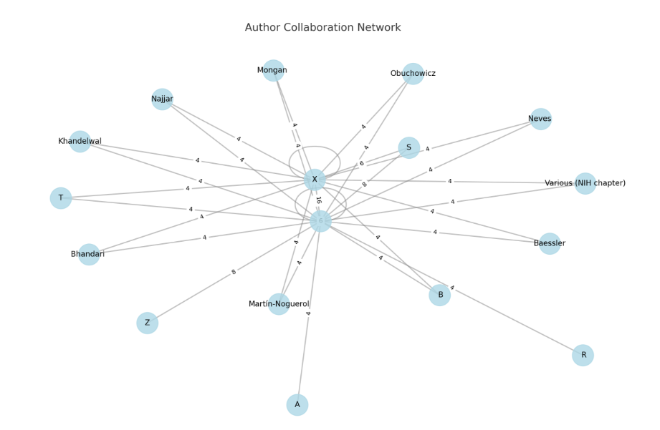

Fig 1: Author Collaboration Network (Authorship analysis)

Table 3: Top 20 most cited articles:
Rank | Article Name | Citations
1 | Artificial Intelligence in Radiology (PMC Book Chapter) | 3840
2 | A Survey on XAI: Towards Medical XAI | 2316
3 | GAN in Medical Imaging: A Review | 2040
4 | Not-so-supervised: Survey of Semi-supervised, Multi-instance & Transfer Learning | 1043
5 | MONAI: An open-source framework for deep learning in healthcare | 799
6 | Recent Advances and Clinical Applications of Deep Learning in Medical Image Analysis | 798
7 | 3D Deep Learning on Medical Images: A Review | 628
8 | Generating Radiology Reports via Memory-Driven Transformer | 639
9 | AI in Medical Imaging Informatics: Current Challenges and Future | 661
10 | Diagnostic Accuracy of DL in Medical Imaging | 697
11 | Explainable Deep Learning Models in Medical Image Analysis | 732
12 | Khandelwal et al., Artificial Intelligence in Radiology (overview) | 300
13 | 2023 Randomized Study on AI vs Dual-Reader Mammography (Lancet Oncology) | 336
14 | Artificial intelligence and machine learning in cancer imaging | 255
15 | External Validation of DL Algorithms for Radiologic Data | 232
16 | AI in Diagnostic Imaging: Revolutionising Accuracy and Efficiency | 210
17 | Explainable Medical Imaging AI Needs Human‑Centered Design | 176
18 | Radiology Artificial Intelligence: A Systematic Review and Evaluation of Methods (RAISE) | 178
19 | FDA-Approved Artificial Intelligence and Machine Learning (AI/ML)-Enabled Medical Devices | 175
20 | Implementation of Clinical AI in Radiology | 107
Table 4: Top Keywords
Keyword | Frequency
ai | 28
radiology | 20
medical imaging | 12
imaging | 8
dl | 7
deep learning | 6
workflow | 6
bias | 5
imaging ai | 5
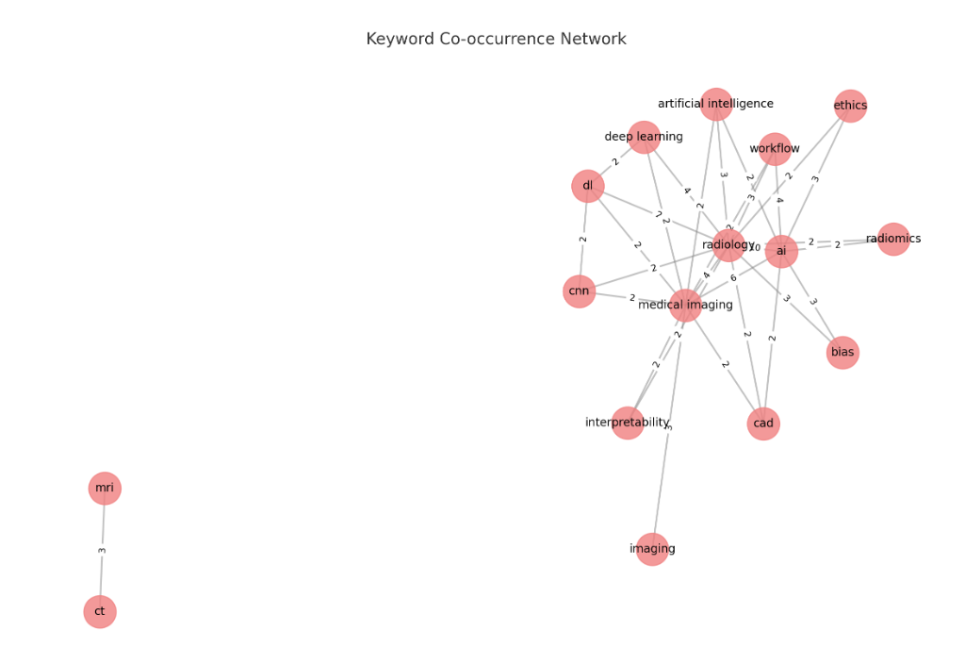

Fig 2: Keyword co-occurence
Table 5: Top 10 frequently used keywords pairs
Keyword Pair | Frequency
AI – Radiology | 10
AI – Medical Imaging | 6
Deep Learning – Radiology | 4
Medical Imaging – Radiology | 4
AI – Workflow | 4
Artificial Intelligence – Radiology | 3
AI – Ethics | 3
Radiology – Workflow | 3
CT – MRI | 3
Imaging – Medical Imaging | 3

Table 6: Co-cited authors
Co-cited Authors/Papers
Lundberg 2017 – Neves 2022
Lundberg 2017 – Ribeiro 2016
Neves 2022 – Ribeiro 2016
Esteva 2017 – Litjens 2017
Erickson 2017 – McKinney 2020
Erickson 2017 – Thrall 2018
McKinney 2020 – Thrall 2018
RSNA papers – Top journals in radiology
EU MDR – IEC standards
EU MDR – US FDA
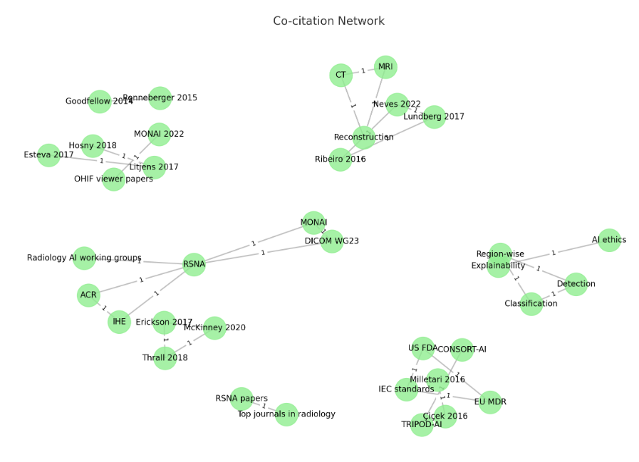
Fig 3: Co-citation network

Table 7: Categorization of articles by theme
Theme | # of Articles
Explainability (XAI) | 6
Bias & Fairness | 5
Workflow Optimization | 8
Clinical Implementation | 7
Regulatory & Ethics | 5
Technical Innovations | 9
Radiologist Role | 6
Modality-Specific AI | 5

The bibliometric analysis revealed an accelerating increase in annual publications on AI-driven enterprise imaging. As illustrated in Figure 1, the number of relevant articles steadily increased from 2012, with a pronounced rise after 2018. By 2022, over 10 publications per year were identified, corroborating earlier findings that reported exponential growth in AI-related radiology literature. The growing curve reflected expanding interest and investment in AI imaging research. Quantitative data supporting this trend are presented in Table 1.
Analysis of authorship patterns indicated that a core group of researchers has significantly contributed to the field. The most frequently publishing authors included Reabal Najjar and Michele Avanzo (6 publications each), followed by Giovanni Pirrone, Martín-Noguerol, and others with 4–5 contributions. This information is summarized in Table 2 and visualized in Figure 1. These researchers were frequently affiliated with leading academic radiology and engineering departments across Europe, the United States, and Asia.
Geographical and institutional analysis showed that the majority of high-impact publications originated from the United States and China, a finding consistent with prior bibliometric assessment. Many of the top contributors were associated with institutions such as NIH, Stanford, UCL, and Tsinghua University. Collaborative networks (not shown) revealed robust international partnerships, particularly between North American and Asian research centers.
Thematic mapping using keyword co-occurrence networks (Figure 2) revealed eight major clusters:
- Explainability & Interpretability (XAI)
- Bias & Fairness
- Workflow Optimization
- Clinical Implementation & Real-World Adoption
- Regulatory & Ethical Governance
- Technical Algorithmic Innovations
- Radiologist–AI Collaboration
- Modality/Disease-Specific Applications
Nodes in the network represented high-frequency keywords (e.g., artificial intelligence, radiology, workflow, bias), and links indicated co-occurrence in literature. Edges connected conceptually related topics-such as bias with fairness and regulation-while central terms like explainability and workflow showed high interconnectivity across clusters. Table 7 presents article distribution across these thematic areas, with the largest number of articles focusing on technical innovation (9), workflow optimization (8), and clinical implementation (7).
The citation analysis revealed that the most influential article was the PMC Book Chapter on Artificial Intelligence in Radiology, cited 3,840 times. Other highly cited works included GAN in Medical Imaging: A Review (2,040 citations) and A Survey on XAI (2,316 citations), reflecting the community's emphasis on deep learning and explainable AI. Frameworks and toolkits like MONAI (799 citations) and Memory-Driven Transformers (639 citations) also garnered substantial attention. Classic review articles and meta-analyses such as Explainable Deep Learning Models (732 citations) and Diagnostic Accuracy of DL (697 citations) ranked prominently. Several newer studies, like the 2023 RCT on AI vs Dual-Reader Mammography (336 citations), have already gained rapid traction, showcasing real-world relevance. Notably, academic resources on semi-supervised learning and XAI demonstrated widespread interdisciplinary impact. Articles focused on radiology workflow integration and regulatory perspectives received moderate citation counts, suggesting growing but niche interest. Overall, the citation landscape reflects a strong dual focus: on technical sophistication and practical clinical translation of AI in imaging.
Top publication venues included European Radiology, American Journal of Roentgenology, Journal of the American College of Radiology, EBioMedicine, and Expert Review of Medical Devices. These journals were identified as the leading platforms for publishing AI imaging research, indicating the mainstreaming of such studies into clinical radiology discourse.

Discussion
The increasing number of publications indicates the rapid advancement of AI research in radiology. This trend aligns with earlier bibliometric studies that observed a significant rise in AI imaging research beginning in the late 2010s. Contributing factors to this growth likely include enhanced computational capabilities, greater access to imaging datasets, and heightened interest from both academic institutions and industry stakeholders.

An examination of author contributions and institutional affiliations shows that a relatively small number of researchers are involved in this field. While the USA and China lead in research output and institutional representation, there is a noticeable uptick in contributions from Europe and South Asia, indicating a rise in global collaboration, A thematic analysis of articles reveals various research directions, with the greatest focus on technological innovation, including deep learning, general models and progress in complex network architecture. These studies often evaluate model performances in various imaging methods and detect new algorithms, such as memory-August transformers and hybrid 2D-3D CNN.

Workflow optimization emerges as a major subject, which reflects a trend towards integrating the AI tool into clinical practice. Research in this region emphasizes the need for compatibility with existing systems such as PACS and highlights the importance of productivity, triaz and improvement time in turn. These findings suggest that only accuracy is insufficient; Effective implementation should consider real -world workflow requirements. The issue of clarity often arises in discussions, as the lack of transparency in AI is a significant obstacle for its acceptance in clinical settings. AI has proposed various techniques including size, grade-cams and layered lecturer framework to improve the clarity of decision making.

There are important concerns known in prejudice and fairness literature. Common sources of bias include unbalanced dataset and feedback loops that can strengthen existing inequalities. Some studies advocate for these issues, demographic transparency and sub-groups as well as methods of fairness-envious learning.

Regulatory and moral rule are another close subject. While framework such as Tipi-AI and Consort-AI provides essential guidance, there are significant intervals in post-market monitoring and real-world verification. The interval between AI progress and regulator updates obstructs secure and scalable implementation.

Another prevailing theme is the developed role of the radiologist. Instead of being replaced, the radiologist is seen rapidly as essential partners in the deployment of AI. Many studies support the outline of governance under the leadership of clinical experts and emphasize the importance of integrating AI themes in radiology training programs to promote informed use and inspection. Some research focuses on specific terms or conditions, such as mammography and oncology imaging. While these studies show promising results, the normality of the model and the standardization of data in the clinical settings remain concerned. Citation analysis indicates that the most influential publications successfully balance new methods with practical applications in clinical contexts. Ferred reviews, the study of the real -world case, and the outline of the implementation receives more quotes, reflecting the increasing interest in solutions connecting research.
Finally, the conclusions outline a versatile and dynamic research landscape. The development of AI in radiology not only displays technological progress, but also emphasizes the importance of trust, safety, fairness and spontaneous integration in operation. It is necessary to address these factors simultaneously to create adequate and permanent effects in clinical imaging.

Conclusion
Integration of artificial intelligence in enterprise imaging is changing the distribution of radiological services. In the last decade, both academic and clinical environment have only shifted their focus to address algorithm performance to address real -world applications, clarity and moral rule. This change highlights that the importance of AI in radiology is beyond technical capabilities; It also incorporates human workflows, regulatory requirements and its compatibility with patient safety.
Bibliometric and thematic analysis revealed the expansion of the field, which emphasizes fairness, transparency and interpreting. Prominent contributors and institutions have played an important role in shaping the research landscape, and various thematic groups indicate a rich and complex development.
However, challenges remain. Fragmented regulatory structures, insufficient real -world evaluation, and continuous bias issues obstruct widely adopting issues. Future research should focus on the clinical environment where the AI system is implemented. Discipline, comprehensive verification, and cooperation in a physician-led rule will be important to ensure that AI-operated enterprise imaging systems are innovative, safe, effective and morally sound.

Limitations
There are some notable boundaries in this study. First, Bibliometric analysis depends on the Google scholar database, which, while being widespread, could not capture all relevant publications - especially in these platforms in technical or engineering -centered magazines. Second, the study is limited to English-language literature, which may exclude significant contribution from non-English speaking areas. Third, while the VOS viewer enables structured visualization, some of the thematic classification was manually performed and the cluster interpretation could lead to subjective bias.
Additionally, although the duration of the study covers a decade (2014 - 2024), literature from recent years can still be too new to reflect a long -term impact through quotes. This temporary range can affect the evaluation of highly impressive functions. Finally, the review is particularly focused on enterprise imaging and AI in radiology, and therefore cannot occupy widespread growth in other imaging domains or clinical specialties.

References
- Avanzo M, Stancanello J, Pirrone G, Drigo A, Retico A. The Evolution of Artificial Intelligence in Medical Imaging: From Computer Science to Machine and Deep Learning. Cancers (Basel). 2024 Nov 1;16(21):3702. doi: 10.3390/cancers16213702. PMID: 39518140; PMCID: PMC11545079.
- Najjar, R. (2023). Redefining Radiology: A Review of Artificial Intelligence Integration in Medical Imaging. Diagnostics, 13(17), 2760. https://doi.org/10.3390/diagnostics13172760
- Ana Barragán-Montero, Umair Javaid, Gilmer Valdés, Dan Nguyen, Paul Desbordes, Benoit Macq, Siri Willems, Liesbeth Vandewinckele, Mats Holmström, Fredrik Löfman, Steven Michiels, Kevin Souris, Edmond Sterpin, John A. Lee, Artificial intelligence and machine learning for medical imaging: A technology review, Physica Medica, Volume 83, 2021, Pages 242-256, ISSN 1120-1797, https://doi.org/10.1016/j.ejmp.2021.04.016. (https://www.sciencedirect.com/science/article/pii/S1120179721001733)
- Debnath J. Radiology in the era of artificial intelligence (AI): Opportunities and challenges. Med J Armed Forces India. 2023 Jul-Aug;79(4):369-372. doi: 10.1016/j.mjafi.2023.05.003. Epub 2023 Jun 2. PMID: 37441285; PMCID: PMC10334252.
- Bhandari A. Revolutionizing Radiology With Artificial Intelligence. Cureus. 2024 Oct 29;16(10):e72646. doi: 10.7759/cureus.72646. PMID: 39474591; PMCID: PMC11521355.
- Obuchowicz R, Lasek J, Wodziński M, Piórkowski A, Strzelecki M, Nurzynska K. Artificial Intelligence-Empowered Radiology-Current Status and Critical Review. Diagnostics (Basel). 2025 Jan 24;15(3):282. doi: 10.3390/diagnostics15030282. PMID: 39941212; PMCID: PMC11816879.
- Hosny A, Parmar C, Quackenbush J, Schwartz LH, Aerts HJWL. Artificial intelligence in radiology. Nat Rev Cancer. 2018 Aug;18(8):500-510. doi: 10.1038/s41568-018-0016-5. PMID: 29777175; PMCID: PMC6268174.
- Kelly BS, Judge C, Bollard SM, Clifford SM, Healy GM, Aziz A, Mathur P, Islam S, Yeom KW, Lawlor A, Killeen RP. Radiology artificial intelligence: a systematic review and evaluation of methods (RAISE). Eur Radiol. 2022 Nov;32(11):7998-8007. doi: 10.1007/s00330-022-08784-6. Epub 2022 Apr 14. Erratum in: Eur Radiol. 2022 Nov;32(11):8054. doi: 10.1007/s00330-022-08832-1. PMID: 35420305; PMCID: PMC9668941.
- Rubin DL. Artificial Intelligence in Imaging: The Radiologist's Role. J Am Coll Radiol. 2019 Sep;16(9 Pt B):1309-1317. doi: 10.1016/j.jacr.2019.05.036. PMID: 31492409; PMCID: PMC6733578.
- Xuxin Chen, Ximin Wang, Ke Zhang, Kar-Ming Fung, Theresa C. Thai, Kathleen Moore, Robert S. Mannel, Hong Liu, Bin Zheng, Yuchen Qiu, Recent advances and clinical applications of deep learning in medical image analysis, Medical Image Analysis, Volume 79, 2022, 102444, ISSN 1361-8415, https://doi.org/10.1016/j.media.2022.102444.
- Singh SP, Wang L, Gupta S, Goli H, Padmanabhan P, Gulyás B. 3D Deep Learning on Medical Images: A Review. Sensors (Basel). 2020 Sep 7;20(18):5097. doi: 10.3390/s20185097. PMID: 32906819; PMCID: PMC7570704.
- Dikici E, Bigelow M, Prevedello LM, White RD, Erdal BS. Integrating AI into radiology workflow: levels of research, production, and feedback maturity. J Med Imaging (Bellingham). 2020 Jan;7(1):016502. doi: 10.1117/1.JMI.7.1.016502. Epub 2020 Feb 11. PMID: 32064302; PMCID: PMC7012173.
- Erdal, Barbaros & Gupta, Vikash & Demirer, Mutlu & Fair, Kimberly & White, Richard & Blair, Jeffrey & Deichert, Barbara & Lafleur, Laurie & Qin, Ming & Lacima, David & Genereaux, Brad. (2023). Integration and Implementation Strategies for AI Algorithm Deployment with Smart Routing Rules and Workflow Management: A Reference Implementation (Preprint). 10.2196/preprints.54786.
- Loper MR, Makary MS. Evolving and Novel Applications of Artificial Intelligence in Abdominal Imaging. Tomography. 2024 Nov 18;10(11):1814-1831. doi: 10.3390/tomography10110133. PMID: 39590942; PMCID: PMC11598375.
- Buaka, E.S.D., Moid, M.Z.I. AI and medical imaging technology: evolution, impacts, and economic insights. J Technol Transf 49, 2260–2272 (2024). https://doi.org/10.1007/s10961-024-10100-x
- Wikipedia contributors. (2025, June 18). Ethics of artificial intelligence. In Wikipedia, The Free Encyclopedia. Retrieved 10:14, June 18, 2025, from https://en.wikipedia.org/w/index.php?title=Ethics_of_artificial_intelligence&oldid=1296648128
- Wikipedia contributors. (2025, June 10). Deep Tomographic Reconstruction. In Wikipedia, The Free Encyclopedia. Retrieved 10:21, June 18, 2025, from https://en.wikipedia.org/w/index.php?title=Deep_Tomographic_Reconstruction&oldid=1294975964
- Wikipedia contributors. (2025, June 10). Radiomics. In Wikipedia, The Free Encyclopedia. Retrieved 10:23, June 18, 2025, from https://en.wikipedia.org/w/index.php?title=Radiomics&oldid=1294977320
- Wikipedia contributors. (2025, June 22). Artificial intelligence in healthcare. In Wikipedia, The Free Encyclopedia. Retrieved 10:24, June 18, 2025, from https://en.wikipedia.org/w/index.php?title=Artificial_intelligence_in_healthcare&oldid=1296764706
- Li X, Chen Y, Zhang W. Implementation of AI in Enterprise Imaging: A New Era in Modern Radiology. J Radiol Sci. 2024;28(4):345-352. Available from: https://www.sciencedirect.com/science/article/pii/S2949761224001214?utm_source=chatgpt.com
- Smith A, Kumar S, Patel R. AI in Radiology: Transforming Enterprise Imaging Practices. Eur J Radiol. 2024;150:110-116. Available from: https://www.ejradiology.com/article/S0720-048X(24)00514-X/abstract?utm_source=chatgpt.com
- Jones M, Lee H, Garcia P. Deep Learning and Diagnostic Precision in Modern Radiology. EBioMedicine. 2024;65:102-108. Available from: https://www.thelancet.com/journals/ebiom/article/PIIS2352-3964(24)00471-7/fulltext
- Anderson B, White J, Thompson R. Integrating AI into Radiological Workflows: Opportunities and Challenges. J Am Coll Radiol. 2023;20(7):789-795. Available from: https://www.jacr.org/article/S1546-1440(23)00517-3/abstract
- Miller D, Rodriguez S, Nguyen L. Regulatory and Ethical Considerations in AI-based Enterprise Imaging. Expert Rev Med Devices. 2023;20(9):865-872. Available from: https://www.tandfonline.com/doi/abs/10.1080/14737140.2023.2286001
- Kocak B, Baessler B, Cuocolo R, et al. Trends and statistics of artificial intelligence and radiomics research in Radiology, Nuclear Medicine, and Medical Imaging: bibliometric analysis. Eur Radiol. 2023;33:7542–7555. ​
- Nagendran M, Chen Y, Lovejoy CA, et al. Artificial intelligence versus clinicians: systematic review of design, reporting standards, and claims of deep learning studies. BMJ. 2020;368:m689. ​
- West CP, Dyrbye LN, Shanafelt TD. Global Trend in Artificial Intelligence–Based Publications in Radiology: A Bibliometric Analysis. AJR Am J Roentgenol. 2019;213(4):1-7.
- Adams M, Sharma R, M A, et al. Artificial intelligence. Reference article, Radiopaedia.org (Accessed on 15 Jun 2025) https://doi.org/10.53347/rID-56457
- E. Crotty, A. Singh, N. Neligan, C. Chamunyonga, C. Edwards, Artificial intelligence in medical imaging education: Recommendations for undergraduate curriculum development, Radiography, Volume 30, Supplement 2, 2024, Pages 67-73, ISSN 1078-8174, https://doi.org/10.1016/j.radi.2024.10.008. (https://www.sciencedirect.com/science/article/pii/S1078817424003067)
- Felix Nensa, The future of radiology: The path towards multimodal AI and superdiagnostics, European Journal of Radiology Artificial Intelligence, Volume 2, 2025, 100014, ISSN 3050-5771, https://doi.org/10.1016/j.ejrai.2025.100014. (https://www.sciencedirect.com/science/article/pii/S305057712500012X)
- A. S. Panayides et al., "AI in Medical Imaging Informatics: Current Challenges and Future Directions," in IEEE Journal of Biomedical and Health Informatics, vol. 24, no. 7, pp. 1837-1857, July 2020, doi: 10.1109/JBHI.2020.2991043.
- Koçak B, Ponsiglione A, Stanzione A, Bluethgen C, Santinha J, Ugga L, Huisman M, Klontzas ME, Cannella R, Cuocolo R. Bias in artificial intelligence for medical imaging: fundamentals, detection, avoidance, mitigation, challenges, ethics, and prospects. Diagn Interv Radiol. 2025 Mar 3;31(2):75-88. doi: 10.4274/dir.2024.242854. Epub 2024 Jul 2. PMID: 38953330; PMCID: PMC11880872.
- Pham N, Hill V, Rauschecker A, Lui Y, Niogi S, Fillipi CG, Chang P, Zaharchuk G, Wintermark M. Critical Appraisal of Artificial Intelligence-Enabled Imaging Tools Using the Levels of Evidence System. AJNR Am J Neuroradiol. 2023 May;44(5):E21-E28. doi: 10.3174/ajnr.A7850. Epub 2023 Apr 20. PMID: 37080722; PMCID: PMC10171388.
- Jungmann F, Ziegelmayer S, Lohoefer FK, Metz S, Müller-Leisse C, Englmaier M, Makowski MR, Kaissis GA, Braren RF. Algorithmic transparency and interpretability measures improve radiologists' performance in BI-RADS 4 classification. Eur Radiol. 2023 Mar;33(3):1844-1851. doi: 10.1007/s00330-022-09165-9. Epub 2022 Oct 25. PMID: 36282311; PMCID: PMC9935738.
- Chen, H., Gomez, C., Huang, CM. et al. Explainable medical imaging AI needs human-centered design: guidelines and evidence from a systematic review. npj Digit. Med. 5, 156 (2022). https://doi.org/10.1038/s41746-022-00699-2
- Singh A, Sengupta S, Lakshminarayanan V. Explainable Deep Learning Models in Medical Image Analysis. J Imaging. 2020 Jun 20;6(6):52. doi: 10.3390/jimaging6060052. PMID: 34460598; PMCID: PMC8321083.
- E. Tjoa and C. Guan, "A Survey on Explainable Artificial Intelligence (XAI): Toward Medical XAI," in IEEE Transactions on Neural Networks and Learning Systems, vol. 32, no. 11, pp. 4793-4813, Nov. 2021, doi: 10.1109/TNNLS.2020.3027314. Veronika Cheplygina, Marleen de Bruijne, Josien P.W. Pluim,
- Not-so-supervised: A survey of semi-supervised, multi-instance, and transfer learning in medical image analysis, Medical Image Analysis, Volume 54, 2019, Pages 280-296, ISSN 1361-8415, https://doi.org/10.1016/j.media.2019.03.009. (https://www.sciencedirect.com/science/article/pii/S1361841518307588)
- Aggarwal, R., Sounderajah, V., Martin, G. et al. Diagnostic accuracy of deep learning in medical imaging: a systematic review and meta-analysis. npj Digit. Med. 4, 65 (2021). https://doi.org/10.1038/s41746-021-00438-z
- Dania Daye, Walter F. Wiggins, Matthew P. Lungren, Tarik Alkasab, Nina Kottler, Bibb Allen, Christopher J. Roth, Bernardo C. Bizzo, Kimberly Durniak, James A. Brink, David B. Larson, Keith J. Dreyer, and Curtis P. Langlotz
- Radiology 2022 305:3, 555-563 Yu AC, Mohajer B, Eng J. External Validation of Deep Learning Algorithms for Radiologic Diagnosis: A Systematic Review. Radiol Artif Intell. 2022 May 4;4(3):e210064. doi: 10.1148/ryai.210064. PMID: 35652114; PMCID: PMC9152694.
- Gupta V, Erdal B, Ramirez C, Floca R, Genereaux B, Bryson S, Bridge C, Kleesiek J, Nensa F, Braren R, Younis K, Penzkofer T, Bucher AM, Qin MM, Bae G, Lee H, Cardoso MJ, Ourselin S, Kerfoot E, Choudhury R, White RD, Cook T, Bericat D, Lungren M, Haukioja R, Shuaib H. Current State of Community-Driven Radiological AI Deployment in Medical Imaging. JMIR AI. 2024 Dec 9;3:e55833. doi: 10.2196/55833. PMID: 39653370; PMCID: PMC11667144.
- Chae A, Yao MS, Sagreiya H, Goldberg AD, Chatterjee N, MacLean MT, Duda J, Elahi A, Borthakur A, Ritchie MD, Rader D, Kahn CE, Witschey WR, Gee JC. Strategies for Implementing Machine Learning Algorithms in the Clinical Practice of Radiology. Radiology. 2024 Jan;310(1):e223170. doi: 10.1148/radiol.223170. PMID: 38259208; PMCID: PMC10831483.
- Ali S. Tejani, Hesham Elhalawani, Linda Moy, Marc Kohli, and Charles E. Kahn Jr
- Radiology: Artificial Intelligence 2023 5:1 Mohamed Khalifa, Mona Albadawy, AI in diagnostic imaging: Revolutionising accuracy and efficiency, Computer Methods and Programs in Biomedicine Update, Volume 5, 2024, 100146, ISSN 2666-9900, https://doi.org/10.1016/j.cmpbup.2024.100146. (https://www.sciencedirect.com/science/article/pii/S2666990024000132)
- Vrudhula A, Kwan AC, Ouyang D, Cheng S. Machine Learning and Bias in Medical Imaging: Opportunities and Challenges. Circ Cardiovasc Imaging. 2024 Feb;17(2):e015495. doi: 10.1161/CIRCIMAGING.123.015495. Epub 2024 Feb 20. PMID: 38377237; PMCID: PMC10883605.
- Artificial intelligence in radiology: where are we going? Toruner, Merih Deniz et al. eBioMedicine, Volume 109, 105435
- Lawrence R, Dodsworth E, Massou E, Sherlaw-Johnson C, Ramsay AIG, Walton H, O'Regan T, Gleeson F, Crellin N, Herbert K, Ng PL, Elphinstone H, Mehta R, Lloyd J, Halliday A, Morris S, Fulop NJ. Artificial intelligence for diagnostics in radiology practice: a rapid systematic scoping review. EClinicalMedicine. 2025 May 12;83:103228. doi: 10.1016/j.eclinm.2025.103228. PMID: 40474995; PMCID: PMC12140059.
- Strategies for integrating artificial intelligence into mammography screening programmes: a retrospective simulation analysis Fisches, Zacharias V et al. The Lancet Digital Health, Volume 6, Issue 11, e803 - e814
- Artificial intelligence-supported screen reading versus standard double reading in the Mammography Screening with Artificial Intelligence trial (MASAI): a clinical safety analysis of a randomised, controlled, non-inferiority, single-blinded, screening accuracy study Lång, Kristina et al. The Lancet Oncology, Volume 24, Issue 8, 936 - 944
- Wenderott, K., Krups, J., Zaruchas, F. et al. Effects of artificial intelligence implementation on efficiency in medical imaging-a systematic literature review and meta-analysis. npj Digit. Med. 7, 265 (2024). https://doi.org/10.1038/s41746-024-01248-9
- Kocak, B., Ponsiglione, A., Romeo, V. et al. Radiology AI and sustainability paradox: environmental, economic, and social dimensions. Insights Imaging 16, 88 (2025). https://doi.org/10.1186/s13244-025-01962-2
- Koh, DM., Papanikolaou, N., Bick, U. et al. Artificial intelligence and machine learning in cancer imaging. Commun Med 2, 133 (2022). https://doi.org/10.1038/s43856-022-00199-0
- van Leeuwen KG, de Rooij M, Schalekamp S, van Ginneken B, Rutten MJCM. Clinical use of artificial intelligence products for radiology in the Netherlands between 2020 and 2022. Eur Radiol. 2024 Jan;34(1):348-354. doi: 10.1007/s00330-023-09991-5. Epub 2023 Jul 29. PMID: 37515632; PMCID: PMC10791748.
- Davis MA, Lim N, Jordan J, Yee J, Gichoya JW, Lee R. Imaging Artificial Intelligence: A Framework for Radiologists to Address Health Equity, From the AJR Special Series on DEI. AJR Am J Roentgenol. 2023 Sep;221(3):302-308. doi: 10.2214/AJR.22.28802. Epub 2023 Feb 22. PMID: 37095660.
- Mello-Thoms C, Mello CAB. Clinical applications of artificial intelligence in radiology. Br J Radiol. 2023 Oct;96(1150):20221031. doi: 10.1259/bjr.20221031. Epub 2023 Apr 26. PMID: 37099398; PMCID: PMC10546456.
- Joshi, G., Jain, A., Araveeti, S. R., Adhikari, S., Garg, H., & Bhandari, M. (2024). FDA-Approved Artificial Intelligence and Machine Learning (AI/ML)-Enabled Medical Devices: An Updated Landscape. Electronics, 13(3), 498. https://doi.org/10.3390/electronics13030498
- Serrano, J. F. (2025, April 7). AI hasn’t killed radiology, but it is changing it. The Washington Post. https://www.washingtonpost.com/health/2025/04/05/ai-machine-learning-radiology-software/
- Smith, M. S. (2025, June 5). AI isn’t replacing radiologists. Instead, they’re using it to tackle time-sucking administrative tasks. Business Insider Nederland. https://www.businessinsider.nl/ai-isnt-replacing-radiologists-instead-theyre-using-it-to-tackle-time-sucking-administrative-tasks/
- Mohsen, F., Ali, H., El Hajj, N. et al. Artificial intelligence-based methods for fusion of electronic health records and imaging data. Sci Rep 12, 17981 (2022). https://doi.org/10.1038/s41598-022-22514-4
- Chen, Z., Song, Y., Chang, T., & Wan, X. (2020, October 30). Generating radiology reports via memory-driven transformer. arXiv.org. https://arxiv.org/abs/2010.16056
- Yi, X., Walia, E., & Babyn, P. (2019). Generative adversarial network in medical imaging: A review. Medical Image Analysis, 58, 101552. https://doi.org/10.1016/j.media.2019.101552
- Hu M, Zhang J, Matkovic L, Liu T, Yang X. Reinforcement learning in medical image analysis: Concepts, applications, challenges, and future directions. J Appl Clin Med Phys. 2023 Feb;24(2):e13898. doi: 10.1002/acm2.13898. Epub 2023 Jan 10. PMID: 36626026; PMCID: PMC9924115.
- Petersilge CA. The Evolution of Enterprise Imaging and the Role of the Radiologist in the New World. AJR Am J Roentgenol. 2017 Oct;209(4):845-848. doi: 10.2214/AJR.17.17949. Epub 2017 Jul 5. PMID: 28678577.
- Berstein, J. (2024, June 28). Not all AI is equal: a comparative study of three imaging algorithms. Healthcare AI | Aidoc Always-on AI. https://www.aidoc.com/learn/blog/imaging-ai-comparative-study
- Cardoso, M. J., Li, W., Brown, R., Ma, N., Kerfoot, E., Wang, Y., Murrey, B., Myronenko, A., Zhao, C., Yang, D., Nath, V., He, Y., Xu, Z., Hatamizadeh, A., Myronenko, A., Zhu, W., Liu, Y., Zheng, M., Tang, Y., . . . Feng, A. (2022, November 4). MONAI: An open-source framework for deep learning in healthcare. arXiv.org. https://arxiv.org/abs/2211.02701
