“Sustainable Biomedical Waste Management: A Comparative Study of Strategies to Reduce the Impact”

Dissertation Training at
International Institute of Health Management Research, New Delhi

By
Sarthak Prasad
PG/23/100

At
International Institute of Health Management Research New Delhi

Under the guidance of
Dr. Mukesh Ravi Raushan



International Institute of Health Management Research, New Delhi
PGDM (Hospital & Health Management) 2023-25

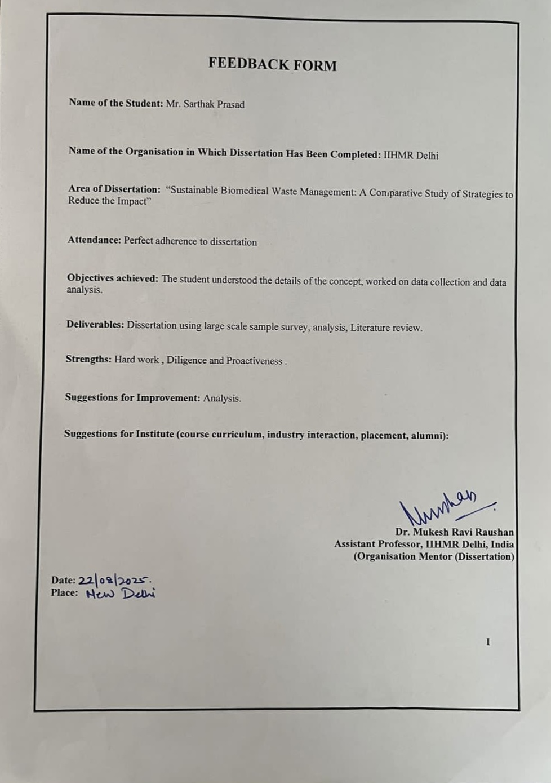
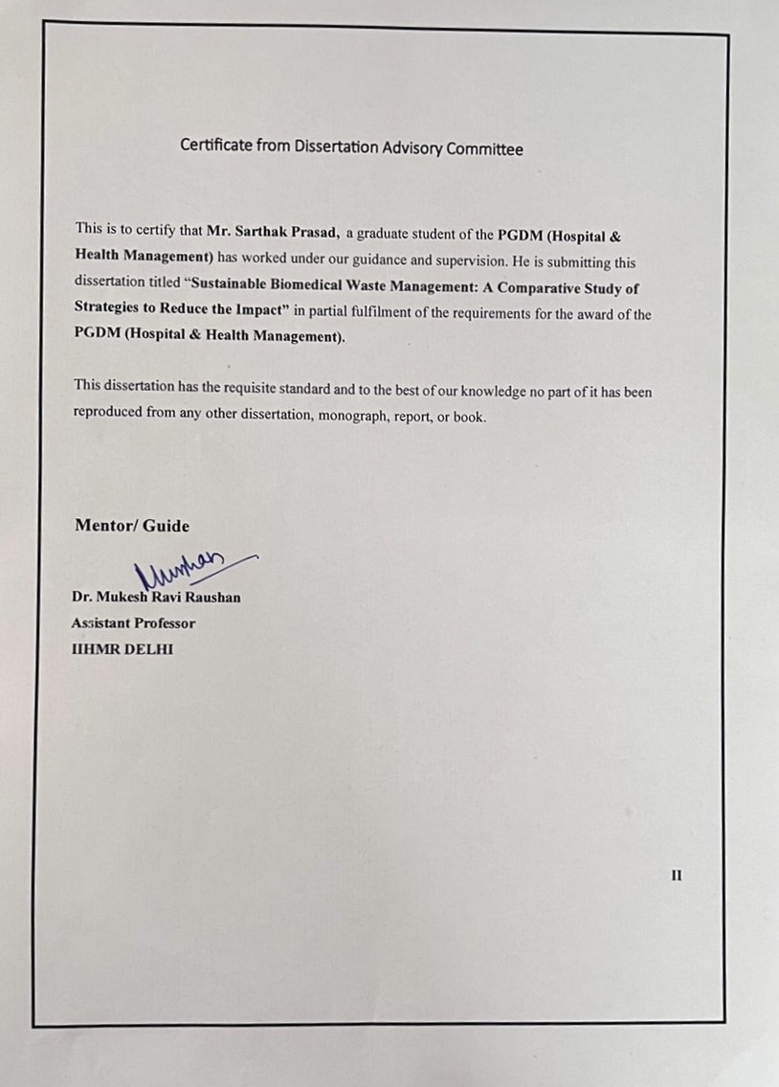
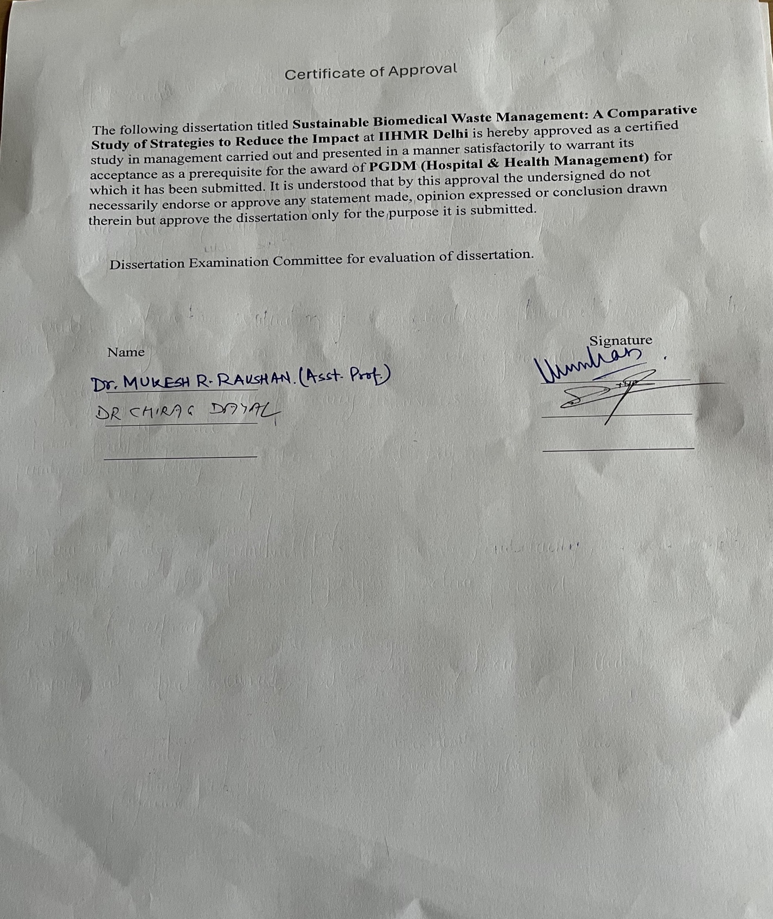

III
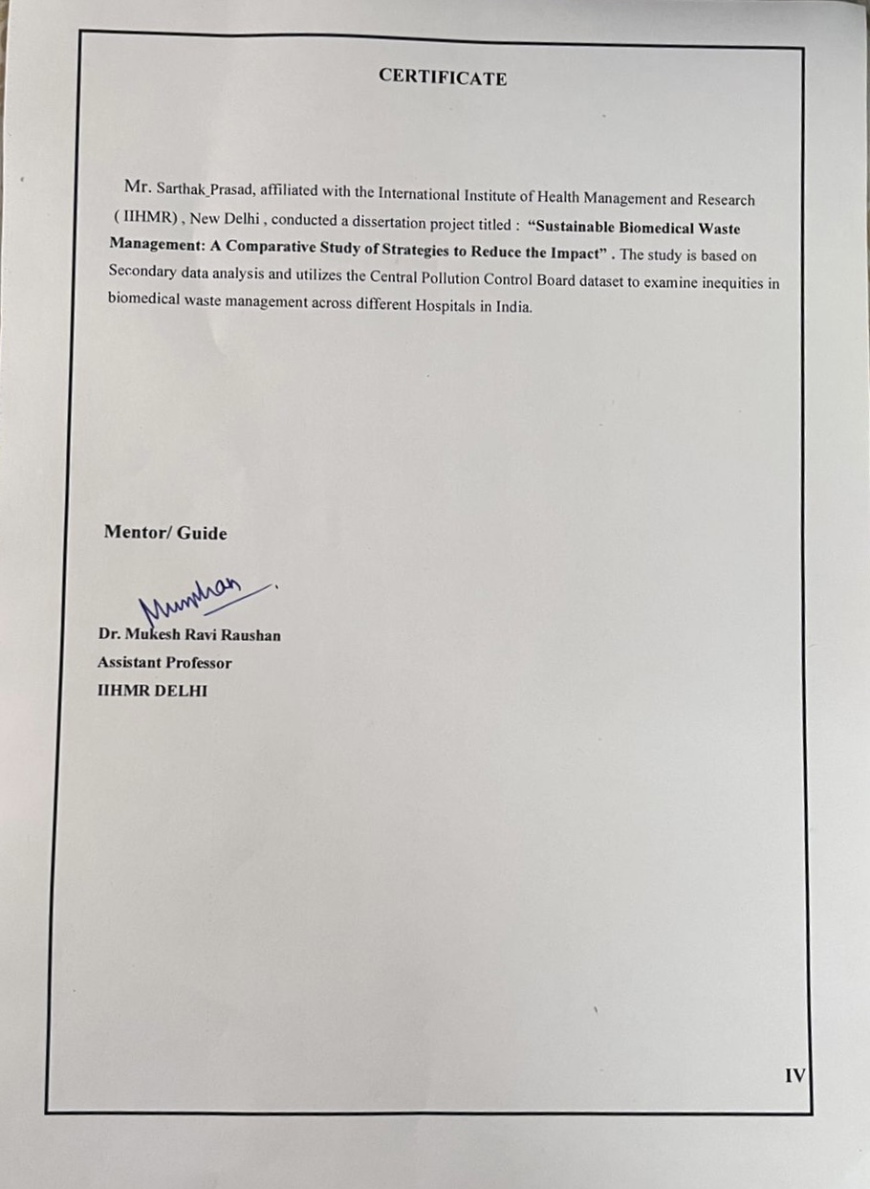
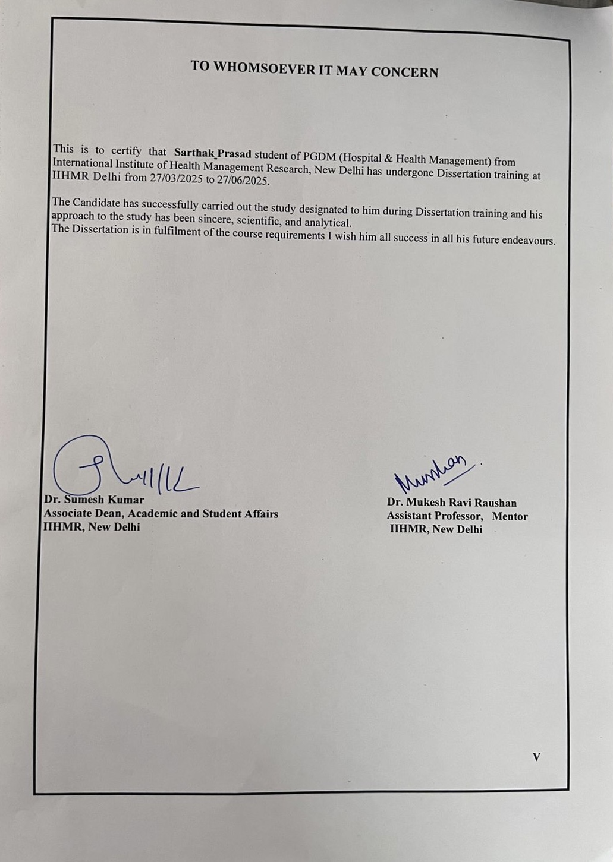

INTERNATIONAL INSTITUTE OF HEALTH MANAGEMENT RESEARCH,
NEW DELHI

CERTIFICATE BY SCHOLAR

This is to certify that the dissertation titled “Sustainable Biomedical Waste Management: A Comparative Study of Strategies to Reduce the Impact” and submitted by Sarthak Prasad Enrolment No. PG/23/0100 under the supervision of Dr. Mukesh Ravi Raushan for award of PGDM (Hospital & Health Management) of the Institute carried out during the period from 2023 to 2025 embodies my original work and has not formed the basis for the award of any degree, diploma associate ship, fellowship, titles in this or any other Institute or other similar institution of higher learning.

Signature

Sarthak Prasad

ACKNOWLEDGEMENT

First and foremost, I would like to sincerely thank my mentor, Dr.Mukesh Ravi Raushan , for his unwavering backing during my dissertation study and research, as well as for his patience, encouragement, excitement, and vast knowledge.

His advice was really helpful to me as I was conducting my study and preparing my report. For my internship, I could not have asked for a greater mentor and adviser.

I want to thank the teachers at IIHMR, Delhi, as well as my parents, for their wonderful support and encouragement in helping me finish my research.

I want to thank the individuals at the institute in particular for their time and kind attention. My gratitude and acknowledgement also extend to my fellow classmates for their contributions to the project's development and to those who volunteered their skills to assist me.

Section | Page no.
Chapter 1: Introduction | 1
1.1 Background of the Study | 2
1.2 Importance of Biomedical Waste Management | 3
1.3 Relevance in the Indian Context | 4
1.4 International Landscape and Theoretical Advances | 5
1.5 Technological Trends and Comparative Efficacy | 6
1.6 National Frameworks and Implementation Realities | 7
1.7 Institutional Behaviour and Staff Compliance | 8
Chapter 2: Data and Methods | 9
2.1 Relevance in the Indian Context | 10
2.2 Research Problem and Rationale | 11
2.3 Research Questions | 12
2.4 Objectives of the Study | 13
2.5 Hypotheses | 14
2.6 Data Sources | 15
2.7 Analytical Framework | 16
2.8 Ethical Considerations | 17
2.9 Data Analysis and Results | 18
Chapter 3: 1 To assess biomedical waste generation in Indian healthcare | 19
3.1 To assess biomedical waste generation in Indian healthcare | 20
3.1.1 Review of Literature | 21
3.1.2 Data and Methods | 22
3.1.3 Results | 23
3.1.4 Conclusion | 24
3.2 To examine existing BMW management practices | 25
3.2.2 Review of Literature | 27
3.2.3 Data and Methods | 28
3.2.4 Conclusion | 29
Chapter 4.  To evaluate awareness, knowledge, and compliance of healthcare workers | 30
4.1.1 Introduction | 31
4.1.2 Review of Literature | 32
4.1.3 Data and Methodology | 33
4.1.4 Results | 34
4.1.5 Conclusion | 35
4.2 To identify challenges, gaps, and policy implications | 36
4.2.1 Review of Literature | 37
4.2.2 Data and Methods | 38
4.2.3 Conclusion | 39
Chapter 5 Conclusion | 40
5.1 Summary of Research Findings | 41
5.2 Contribution to Existing Knowledge | 42
5.3 Policy and Practical Implications | 43
5.4 Future Research Directions | 44
5.5 Closing Remarks | 45
5.6Limitations of the Study | 46
Chapter 6: Case Study | 47
6.0 Case Studies and Comparative Models | 48
6.1 Case Study 2: Civil Hospital, Nashik (Tier-2 City) | 49
6.2 Comparative Assessment: AIIMS vs Civil Hospital, Nashik | 50
6.3 International Best Practices: A Comparative Perspective | 51
– Japan | 52
6.4 Comparison with Indian Context | 53
References | 54
Annexures | 55

Abbreviations

OPD – Outpatient Department

IPD – Inpatient Department

EHR – Electronic Health Record

EMR – Electronic Medical Record

NABH – National Accreditation Board for Hospitals & Healthcare Providers

WHO – World Health Organization

MOHFW – Ministry of Health and Family Welfare

NHSRC – National Health Systems Resource Centre

HR – Human Resources

IT – Information Technology

MIS – Management Information System

Chapter 1: Introduction

1.1 Background of the study
In a developing nation like India, the generation of biomedical waste (BMW) has emerged as a pressing environmental and public health issue with global relevance. BMW is an inevitable by-product of healthcare services and includes items such as used syringes, blood-soaked bandages, discarded medicines, anatomical parts, and chemical residues—many of which are hazardous due to their infectious, toxic, or even radioactive nature. If mismanaged, these wastes can contaminate soil, water, and air, facilitate the spread of infectious diseases among healthcare workers and the general population, and contribute to long-term ecological damage.
India, being the world’s second-most populous country after China, is also one of the largest producers of BMW. Current estimates indicate that approximately 743 tones of such waste are generated daily, of which nearly 103 tones remain untreated despite the nation having the capacity to process 1,590 tones per day. This discrepancy reflects inefficiencies in waste collection, segregation, and disposal systems. The problem is further compounded by the unequal distribution of Common Biomedical Waste Treatment Facilities (CBWTFs), leaving several rural and semi-urban districts without access to essential treatment infrastructure. Consequently, unsafe disposal practices such as deep burial, open burning, and co-disposal with municipal solid waste continue in many healthcare institutions, posing additional risks.
Although India has enacted the Biomedical Waste Management Rules in 2016—later amended in 2018 and 2019—implementation remains inconsistent. Only about 70–75% of registered healthcare facilities comply with these regulations. Furthermore, multiple inspections and audits conducted by the Central Pollution Control Board (CPCB), Comptroller and Auditor General (CAG), and various state pollution control boards have revealed significant shortcomings in waste segregation, tracking, monitoring, and reporting mechanisms. These gaps indicate that while regulations exist, their enforcement and adherence require stronger oversight, better infrastructure, and increased awareness among healthcare stakeholders.

1.2 Importance of Biomedical Waste Management
If biomedical waste is not taken care of in a proper way, it just creates problems. not only for people but also for nature. people like hospital staff, cleaners, even patients are the first ones who face this. sometimes the waste gets mixed with normal garbage and that just makes the risk worse. it can even cause diseases to spread from animals to humans. also, when hospitals burn this kind of waste in old machines, it releases bad stuff like smoke and chemicals like dioxins and metals. all that can harm health later on [7].and it’s not only about what happens around us. when old medicines or antibiotics are thrown in drains or rivers, it’s making a new issue. bacteria are getting used to those drugs and then the medicines stop working. this is what they call antibiotic resistance. WHO and other groups said that waste should be part of both health and environment plans. India also linked this with SDG goals like SDG 3, SDG 6 and SDG 13 that talk about clean water, better health and climate change [8].

1.3 Relevance in the Indian Context
India is a vast country with different types of healthcare setups, and because of this, there are many problems in handling biomedical waste properly. Big hospitals in metro cities mostly have modern treatment systems and follow proper rules, but when we look at small towns and villages, most primary health centre (PHCs), community health centres (CHCs), and private clinics do not have enough facilities for managing the waste [9]. In many districts, the waste is not separated from the start and sometimes it is kept untreated for many days, which becomes a place for germs and mosquitoes to grow.
Also, after COVID-19, the number of diagnostic labs, mobile healthcare vans, and telemedicine services has gone up a lot. These new centres are creating more biomedical waste, but many of them are not linked to any central waste treatment plant, so they end up throwing waste in wrong ways [10]. Lack of proper rules, shortage of trained people, low funding, and poor government checking make this problem worse. To improve the situation, we need to bring a proper and practical system for waste management that works even in small towns and rural areas.
Biomedical Waste Management (BMWM) has become a globally recognized public health and environmental challenge, particularly in the wake of increased healthcare service demand, technological advancement, and decentralized care models. The scholarly discourse around BMWM encompasses a wide spectrum of issues ranging from treatment technologies, policy frameworks, behavioural compliance, to lifecycle sustainability. This section synthesizes key contributions from global and Indian literature to critically evaluate the current knowledge landscape, identify thematic priorities, and underline the unresolved gaps that necessitate empirical investigation.

1.4 International Landscape and Theoretical Advances
The World Health Organization (WHO), in many parts of the world, has shared basic yet useful steps on how hospitals and clinics should deal with medical waste [1, 16]. Their advice is mostly about keeping things safe—like separating waste right from the start, using proper bins, and going for treatment methods that don’t harm the environment much. The WHO also gives a standard system that helps people tell the difference between regular waste, infectious stuff, sharp items, chemicals, and toxic materials. This system is followed by many hospitals and governments around the world. In South-East Asia, WHO SEARO even gives extra advice—like using cheaper and smaller treatment setups that are easier to use in places with fewer resources [21].
One thing that has changed in recent research is the move from just following rules to thinking more about long-term sustainability. In one well-known study, Tudor and others [17] said it’s better to look at the whole system, not just the machines or tools. They talked about including things like energy use, pollution from the waste, and how people behave. They also said that it’s important to train staff, check regularly if things are working, and make the local community more aware.
In another study, Thakur and Bhatnagar [29] looked at the full environmental impact of burning waste the old-fashioned way and found that it causes a lot of carbon emissions. But when microwave or autoclaving machines are used properly, they release way less pollution. This fits with the world’s current focus on protecting the environment through better waste systems, as seen in the Sustainable Development Goals like SDG 12 and SDG 13 [25].

1.5 Technological Trends and Comparative Efficacy
There are different kinds of technologies used for handling biomedical waste, and they’ve been written about a lot in both rich and developing countries. Burning the waste, also known as incineration, has been the main method for a long time. It works well because it kills most germs and is good for getting rid of things like body parts or leftover medicines. But now, more people are worried about the harmful smoke it gives off. If the machine doesn’t get hot enough or doesn’t have a good filter, it can release dangerous stuff like dioxins and furans that are linked to cancer [7, 29].
Some newer methods like autoclaving and microwave disinfection are becoming more popular. These don’t burn the waste but instead use heat or microwave waves to kill germs. They’re better for the environment too [22]. In India, some researchers like Singh and Mishra [22] found that microwaving could kill almost all germs while using less electricity than small incinerators. That’s why it could work well for smaller hospitals. But still, the main issue is that these machines are quite expensive in the beginning, and also you need trained staff to handle them, which makes it tough to set them up in village areas.
Sharma and Kumar [20] also looked at how much energy is used in waste treatment centres in cities. They found that many of the machines were not being used properly. Some incinerators were only working at half their full power, which made them more expensive to run and caused more pollution per batch.
When it comes to cost, Patel and Iyer [31] said that just looking at the price of a machine isn’t enough. They said we also need to think about the risks to people nearby, the danger to workers, and how much damage it does to nature after the waste is dumped. Their study shows that even though cleaner systems might cost more in the beginning, they could save money in the long run. Bansal and his team [13] also said that things like pollution and health problems should be part of any decision when spending money on waste management systems.

1.6 National Frameworks and Implementation Realities
In India, the rules for handling biomedical waste mainly come from the Biomedical Waste Management Rules made in 2016 and later changed in 2018 and 2019. These are enforced through the Environment Protection Act of 1986 [5]. The rules say things like waste must be separated right where it’s created, bags should have barcodes, there’s a specific colour system, and the waste has to go to official treatment centres called CBWTFs. According to a 2022–23 report from the Central Pollution Control Board (CPCB), India makes more than 840 tonnes of this kind of waste every day, but only about 71% of it actually gets treated [2].
Still, even with these rules in place, many studies show that a lot of hospitals—especially in smaller cities—don’t really follow them. The audit from the CAG (Comptroller and Auditor General) [6] said that over a third of government hospitals didn’t even keep proper records about how they separated or threw out waste. At AIIMS Delhi, a check found problems like really old incinerators and no proper system to track pollution from them [11]. PGIMER in Chandigarh also reported regular issues with how waste is moved around and that staff often didn’t follow safety rules [14].
Another big issue is that now, because of things like Ayushman Bharat and online medical care, a lot more waste is being made outside of big hospitals. A study by Chatterjee and Das [27] looked at this problem in smaller cities and found that in many places, the waste is either buried deep in the ground or thrown out with regular garbage, which is risky. And Mishra and Lahiri [28] said some north-eastern states don’t even have proper waste plants, so health centres there are forced to handle things on their own—sometimes in unsafe ways.

1.7 Institutional Behaviour and Staff Compliance
Following the rules isn’t just about laws—it also depends a lot on how people at a hospital work and think. In a study done by Kaiser and Arora [18], they found that many times, the reason people don’t follow proper waste practices is because they haven’t been trained well, or the hospital just doesn’t treat it as a top priority. Sometimes, the whole system feels too confusing.
In India, for example, a study by the Indian Institute of Public Health in Gandhinagar [19] pointed out that even when primary health centres have the right tools or setups, they often still don’t sort the waste properly or move it the way they should. A big part of the problem is that staff keep changing, and there isn’t always someone checking on things regularly.
This issue also connects to worker safety. Das and Nair [32] found that when biomedical waste—especially things like needles or leftover medicines—isn’t handled carefully, it puts cleaning and sanitation workers at serious risk. And when hospitals dump untreated or chemical-filled waste into regular drains, it can help bacteria become stronger and harder to kill, which is a big worry for both human and animal health under the One Health approach.

\

Chapter 2: Data and Methods

2.1 Relevance in the Indian Context
India is a vast country with different types of healthcare setups, and because of this, there are many problems in handling biomedical waste properly. Big hospitals in metro cities mostly have modern treatment systems and follow proper rules, but when we look at small towns and villages, most primary health centres (PHCs), community health centres (CHCs), and private clinics do not have enough facilities for managing the waste [9]. In many districts, the waste is not separated from the start and sometimes it is kept untreated for many days, which becomes a place for germs and mosquitoes to grow.
Also, after COVID-19, the number of diagnostic labs, mobile healthcare vans, and telemedicine services has gone up a lot. These new centres are creating more biomedical waste, but many of them are not linked to any central waste treatment plant, so they end up throwing waste in wrong ways [10]. Lack of proper rules, shortage of trained people, low funding, and poor government checking make this problem worse. To improve the situation, we need to bring a proper and practical system for waste management that works even in small towns and rural areas.
This study focuses on a comparative assessment of biomedical waste treatment technologies in the Indian healthcare system. It will evaluate current practices across public and private hospitals, PHCs, CHCs, and laboratories in both urban and rural settings. By analysing treatment methods based on environmental emissions, cost structures, energy consumption, and scalability, the study will generate actionable insights for improving biomedical waste policies and infrastructure. The outcomes will be especially valuable for government agencies, hospital administrators, and environmental regulators aiming to build resilient and sustainable healthcare systems.

2.2 Research Problem and Rationale
So India got rules for how to manage biomedical waste, and they look okay on paper, but in actual practice not much is followed. stuff like burning it, autoclaves, microwaves or even this plasma thing are used, but we really do not have enough studies that check which method is good overall. like cheap, safe, works well in diff places and so on. most of the research just talks about one place or one method, and do not say much about pollution from it. and a lot of times, no info is given about the waste left after treatment, like if it's still dangerous. nature part is mostly ignored. also, we do not even have a standard way to see if these systems are working or not. so the govt or whoever is in charge cannot decide what to do. what needed is just a basic comparison of all these methods based on simple sustainability stuff. this study is trying to look into that since India is now talking more about public health, climate, circular economy and all that.

2.3 Research Questions
1. How does the composition and volume of biomedical waste vary across healthcare facilities of different scales and locations in India?
2. What are the comparative environmental, economic, and technical impacts of existing biomedical waste treatment methods used in Indian healthcare systems?
3. What are the key infrastructural, policy, and institutional barriers to the adoption of sustainable biomedical waste treatment technologies in India?
4. How can sustainability indicators (e.g., carbon emissions, lifecycle costs, energy use, residue toxicity) be used to evaluate and recommend best-fit biomedical waste treatment models for different healthcare settings?

2.4 Objectives of the Study
1. To assess the nature, composition, and quantity of biomedical waste generated across various levels of healthcare institutions in India.
2. To conduct a comparative analysis of existing biomedical waste treatment technologies in India using defined sustainability metrics.
3. To identify infrastructural, financial, and regulatory factors affecting the implementation of sustainable biomedical waste management practices.
4. To recommend evidence-based, cost-effective, and environmentally sound biomedical waste treatment strategies adaptable to India’s diverse healthcare landscape.

2.5 Hypotheses
H₀₁: There is no statistically significant difference in sustainability outcomes (carbon emissions, cost-efficiency, energy use, and residue safety) among the biomedical waste treatment methods currently used in India.
H₀₂: The adoption and performance of sustainable biomedical waste management technologies are independent of healthcare facility characteristics (type, size, location) and regulatory support levels.

2.6 Data Sources
The majority of the material I used came from sources that are already publicly available. I relied heavily on official documents published by the Ministry of Environment and the Central Pollution Control Board (CPCB), which laid out the rules for biomedical waste management and included assessments of how different regions across India are implementing them [5–7]. I also reviewed internal audit reports from major hospitals such as AIIMS and PGIMER. These offered valuable, on-the-ground perspectives on how biomedical waste is handled in clinical settings, including sorting procedures, treatment steps, and common operational challenges [5, 6].
2.5 Data Systems, Monitoring, and Policy Gaps

One thing that keeps coming up in research is that our data systems and monitoring tools aren’t strong enough. Even though the CPCB shares a lot of information, it mostly depends on what states send them, and that data doesn’t always get checked in real-time [2]. Also, not all State Pollution Control Boards have the same ability to follow up or double-check what’s reported, so the numbers we get for the whole country can be a bit all over the place [23].
Bansal and his team [13] have talked about this too. They say we really need a digital system to track biomedical waste better—like one where you can follow the trucks using GPS, scan barcodes when waste is thrown out, and maybe have an online system to show if hospitals are following the rules or not.
On the policy side, the National Health Policy of 2017 [24] does mention the importance of safe waste management and links it to bigger health and environment goals. But even with that in place, there’s still a big gap between what the government plans on paper and what’s happening in hospitals, labs, and clinics.
2.6 Emerging Themes and Theoretical Gaps
Ever since COVID, the way biomedical waste is being created has changed a lot and brought new problems. Ghosh and Roy [26] talk about something they call “modern medical waste”—things like masks, PPE kits, test tools, and even stuff from home-based healthcare. These don’t always get treated properly and often slip through the usual hospital waste systems. Their research shows that the regular city waste services aren’t built to deal with this kind of mix, and that puts both the environment and sanitation workers at risk.

Fazal [33] also connects untreated medical waste to possible disease outbreaks. He warns that waste like used tissue or samples can hold dangerous germs, which might even lead to new diseases. He looks at this issue through the “One Health” idea, where human health, animal health, and environmental health are all linked and should be handled together.
Many studies talk about how well machines work or whether hospitals follow the rules, but not much has been written about the money and power side of it all. For example, things like private companies running waste plants, poor areas not having access to good treatment, or what actually pushes hospitals to care about safe disposal—these are still big questions that don’t get enough attention. Also, while there are new tech ideas like plasma burning or solar-powered sterilizers, they haven’t really been tested enough in proper studies [29].
So, if we look at the bigger picture, India’s system for dealing with biomedical waste is still stuck in a tricky. the rules are getting better, and more waste treatment centers are popping up, but there are still a lot of issues. Some places just don’t have the right kind of machines, people often ignore the rules, no one’s really keeping watch, and on top of that, the risks to health and the environment keep growing.
Most studies give good details, but they usually stick to one angle. What’s missing is a mix of different subjects—science, society, money, and health—coming together. That’s why we really need more balanced research that doesn’t just focus on whether rules are followed, but also looks at long-term effects on nature, health, and the economy.

The review of the document from World Health Organization’s guidelines on medical waste was also considered to get a sense of how things are done in other countries. It really helped me understand where India stands in comparison and gave me a few ideas about global practices that could actually work well here too [16, 17]. I also referred to peer-reviewed articles published in journals like the Indian Journal of Public Health and Environmental Health Review India. These studies discussed various treatment approaches and evaluated how effective they are in actual use—comparing methods like incineration and microwaving, for example [12, 13].

2.7 Analytical Framework
In this study, I used both thematic and content analysis to understand the data more clearly:
Thematic Analysis: This helped me spot common patterns related to how biomedical waste is treated. I looked at things like environmental effects, how affordable different methods are, and whether they can be used over the long term. It also gave me insight into some of the challenges people face when trying to use these technologies, along with examples of what has actually worked in the Indian context.
Content Analysis: I also paid attention to how often certain methods or practices came up in the articles and reports I reviewed. This made it easier to see how widespread sustainable approaches really are—like eco-friendly treatment methods—and whether they seem to be helping reduce the environmental impact of biomedical waste [12, 13].

2.8 Ethical Considerations
Since this study is entirely based on secondary data, the main ethical focus is on proper citation and acknowledgment of the sources used. All the government publications, institutional audits, and academic journal articles referred to in the research have been clearly cited to avoid any chances of plagiarism and to maintain academic honesty. At the same time, care has been taken to follow ethical standards while handling secondary data, especially when it comes to respecting the confidentiality of sensitive or institution-specific information.2.9 Data Analysis and Results

This section presents the analytical findings derived from the comparative evaluation of biomedical waste treatment technologies in India. Using secondary data from institutional audits, academic journals, and government reports, the analysis focuses on three primary dimensions: environmental performance, economic feasibility, and operational sustainability. The objective is to identify which technologies offer the most balanced performance across key sustainability metrics.

2.9. Methodology
In this part, I’ve explained how the research was done to understand how biomedical waste is being managed in India—what's working, what’s not, and how sustainable the current systems really are. I’ve talked about how the study was planned, where the information came from, how it was looked at, the rules I followed while doing the research, and what limits the study might have.
2.9.1 Research Design.
This research looks at different ways of treating biomedical waste and tries to figure out which ones work best by considering things like how effective they are, how much harm they do to the environment, how much they cost, and whether they can be used in the long run Instead of only looking at numbers, this study also tries to understand the actual problems hospitals deal with when they use these waste treatment methods in India. It’s more about figuring out what works, what doesn’t, and why.
This research takes a descriptive route—basically, it's focused on showing what’s really happening rather than trying to prove a theory. It investigates the policies, tools, and steps that are currently being used to manage biomedical waste across the country. The goal is also to find out where things are falling short and how they might be improved. This kind of research is useful because managing waste here isn’t just about one thing—it includes dealing with tough rules, outdated machines, and big differences between different parts of India [5–7].

2.9.2 Type of Research
This is a secondary Research; I didn’t collect any new data myself. I just used stuff that’s already out there like some reports from the government, and research papers I could find. Most of the info was already written and available online or in public records, so I didn’t feel the need to do surveys or interviews for this. That’s why it’s called a secondary data study. I figured this was still a useful way to see how biomedical waste is being handled across India. While going through these sources, I got a better idea of what’s happening on the ground—like how the rules around waste have changed, whether the tech being used is actually helping, and the real problems hospitals are dealing with. I wasn’t trying to run experiments or anything—just trying to understand what’s working, what’s not, and how things could maybe be done better. Since the material was already out there, I didn’t need to collect anything new on my own [2–4].
2.9.3 Data Collection Method
I didn’t gather any new data for this project. What I did instead was go through material that was already out there and publicly available. Most of it came from sources people usually trust—like government reports, research papers, and guidelines from international health bodies. That way, I could build a solid understanding of how biomedical waste is actually being handled in India without needing to do surveys or interviews.
Government Reports:
I spent a good amount of time reading through documents released by the Ministry of Environment and the Central Pollution Control Board (CPCB). They publish reports like the Annual Report on Biomedical Waste Management 2022–23 and the Biomedical Waste Management Rules 2016, with updates from 2018 and 2019. These helped me figure out the rules in place and how well they’re being followed in different parts of the country [5–7].
Institutional Audits:
To get a real sense of what’s happening in hospitals, I looked into audit reports from institutions like AIIMS Delhi and PGIMER Chandigarh. These audits offered insights into how biomedical waste is separated, what treatment techniques are being used, and the day-to-day challenges faced by healthcare workers [5, 6].
International Guidelines:
I also checked what the World Health Organization (WHO) says about managing medical waste. Their documents, such as Safe Management of Wastes from Health-Care Activities (2018) and Health-Care Waste: Key Facts (2022), were useful for comparing Indian practices with global ones [16, 17].

Academic Articles:

In addition, I explored research papers published in journals like the Indian Journal of Public Health and Environmental Health Review India. These studies discussed how different waste treatment methods perform in real-world situations. They helped me compare options like incineration, autoclaving, and microwave systems, especially in terms of safety and effectiveness [12, 13].

Chapter 3: To assess the nature, composition, and quantity of biomedical waste generated across various levels of healthcare institutions in India.

The first aim of this study is to understand how biomedical waste is produced in different kinds of healthcare facilities in India, and how it changes from one level of the system to another. The concern is not only with how much waste is produced in a day, but also with what that waste is made of. For that reason, the study looks at different categories, such as infectious waste, syringes and other sharps, anatomical remains, expired medicines, and the more general hospital waste that comes out of routine care. Large hospitals in big cities, like tertiary teaching institutions, naturally generate more waste, while district hospitals and rural centres such as PHCs and CHCs generate less. But the difference is not just about quantity. The type of waste also varies, and in some cases smaller centres may produce a higher share of sharps and infectious materials in relation to their size. This makes them risky despite their lower overall output. By drawing these comparisons, the study tries to show how waste is uneven across the health system and why a single management model will not work everywhere. Instead, a better understanding of these differences gives a base for planning strategies that can be adjusted to the realities of each institution.
3.1 INTRODUCTION
In India, biomedical waste (BMW) has turned into one of the pressing issues in both health and environmental management. This is partly because of the rapid growth of hospitals and clinics, but also because of the increasing reliance on single-use items in treatment and diagnosis. The Central Pollution Control Board (CPCB, 2022) reported that India produces nearly 775.5 tonnes of biomedical waste every single day, and close to 75 tonnes of it remains untreated [1]. If we look back a decade earlier, in 2011, the reported figure was 484 tonnes per day, which shows an increase of more than sixty percent in just ten years [2]. What makes this worse is that the untreated waste often ends up with city garbage, in open sites, or even in water bodies, which exposes not only sanitation workers and hospital staff but also whole communities to health risks [3].
The generation of biomedical waste is not the same everywhere. Large hospitals, especially tertiary care centres in metropolitan cities, generate far more—between 1.5 and 2 kilograms per bed per day—because of their size, patient load, and surgical procedures [4]. On the other hand, Primary Health Centres (PHCs) and Community Health Centres (CHCs) in rural areas usually produce less than 0.5 kilograms per bed per day [5]. But this does not mean that smaller centres are less of a concern. A larger share of their waste is infectious or consists of sharps, which makes even a smaller volume quite dangerous if it is not managed correctly.

3.1.1 Review of Literature
The issue of biomedical waste generation has been studied by many researchers in India and abroad, and the findings show that the problem is both growing in scale and uneven across different healthcare settings. One of the earliest detailed studies in India was carried out by Patil and Pokhrel (2005), who reported that nearly 82 percent of hospitals were not following correct segregation practices at the point of generation [6]. This shows that the problem is not simply about the amount of waste being produced, but also about how poorly it is managed from the very beginning. Gupta and Boojh (2006) supported this observation by pointing out that most institutions lacked proper infrastructure, training, and regular monitoring, which made safe handling and disposal difficult [7].
Later studies continued to underline the same challenges. For example, Singh et al. (2014) noted that the majority of smaller hospitals and rural centres had little or no access to Common Biomedical Waste Treatment Facilities (CBWTFs), and as a result they often relied on unsafe methods such as open burning or mixing biomedical waste with municipal garbage [9]. This uneven distribution of infrastructure highlights why smaller facilities can be just as dangerous as larger hospitals, even if the total waste they generate is less.
The Central Pollution Control Board (CPCB) has also produced detailed reports which confirm this uneven pattern. The 2022 report recorded 775.5 tonnes of biomedical waste generated per day, with around 75 tonnes untreated [1]. Earlier reports from 2011 showed 484 tonnes per day, confirming a steady rise of more than sixty percent within ten years [2]. These figures indicate that biomedical waste is increasing not just in absolute quantity but also in complexity, with infectious materials, sharps, and plastic waste forming a large share [3].
The COVID-19 pandemic further changed the nature of biomedical waste. As reported in several recent assessments, the daily use of personal protective equipment (PPE), testing kits, disposable masks, and gloves caused a sudden spike in waste production [8]. Unlike ordinary hospital waste, these items were produced in large quantities across all levels of healthcare, from tertiary centres to small PHCs. This not only increased the total load but also added new risks of infection for health workers and waste handlers.
Overall, the literature makes it clear that biomedical waste is not a uniform problem. Larger tertiary hospitals in urban areas may have more advanced facilities and better compliance, but they also produce much higher volumes. Smaller centres, especially in rural areas, produce less waste, but their higher share of infectious and sharps waste, combined with poor segregation and limited access to treatment plants, makes them highly vulnerable. These findings support the need for a detailed assessment of the nature, composition, and quantity of biomedical waste across different levels of healthcare institutions in India, which is the focus of this first objective.
Researchers have already pointed out these problems. Patil and Pokhrel (2005) noted that about 82 percent of hospitals in India were not following proper segregation practices at the source [6]. Later, Gupta and Boojh (2006) found similar issues, stressing the lack of trained staff and weak infrastructure for safe treatment [7]. The problem only deepened during the COVID-19 pandemic, when the use of PPE kits, testing equipment, and disposable medical supplies caused a sudden spike in biomedical waste, adding pressure to facilities that were already struggling to cope [8].
With this background in mind, the first objective of the study is to examine the nature, composition, and quantity of biomedical waste produced in India across different healthcare levels. The intention is to compare tertiary hospitals, district hospitals, and smaller rural facilities to see not only how much waste they generate, but also what it is made of, and why those differences matter for planning better biomedical waste management.

3.1.2 Data and Methods
For this part of the study, most of the information has been taken from secondary sources, especially government reports and earlier research. The Annual Reports of the Central Pollution Control Board (CPCB) were the main source, because they give figures on how much biomedical waste is produced every day, how much is treated, and how much is left untreated [1,2]. These reports rely on data collected from State Pollution Control Boards (SPCBs) and Pollution Control Committees (PCCs), so they are considered the most dependable national records. Along with this, earlier studies such as Patil and Pokhrel (2005), Gupta and Boojh (2006), and Singh et al. (2014) were also used, since they describe in detail the problems of segregation, treatment, and infrastructure in different hospitals [6,7,9].
The method has mainly been descriptive and comparative. The waste was divided into categories like infectious material, sharps, anatomical waste, leftover medicines, and ordinary hospital waste. These categories follow the Biomedical Waste Management Rules (2016). After that, the CPCB figures from different years were compared, for example the rise from 484 tonnes per day in 2011 to 775.5 tonnes per day in 2022, which shows both the increase in scale and the gap between treated and untreated waste [1,2].
The second part of the method focused on different types of health facilities. For large tertiary hospitals, the average waste was around 1.5–2 kg per bed per day, while for district hospitals and rural health centres like PHCs and CHCs, it was much less, often below 0.5 kg per bed per day [4,5]. This simple comparison was useful for showing that smaller centres may generate less in quantity, but their waste often has a higher share of risky materials like sharps and infectious waste.
The study also looked at evidence from the COVID-19 period, because that event changed the waste situation completely. With PPE kits, testing kits, and other disposable items being used everywhere, biomedical waste grew suddenly in both large and small facilities [8]. Including this data helped to show that the nature of biomedical waste is not fixed but changes with public health emergencies.
In short, the method combined official figures from government reports with observations from published studies. This allowed the study to show both the numbers and the actual practices, giving a fuller picture of how biomedical waste is generated and managed across different levels of healthcare in India.
3.1.3 Results
Biomedical waste in India has not only grown in quantity but has also become more complex over the last decade. According to CPCB (2022), the country now produces close to 775.5 tonnes of biomedical waste every single day, and out of this, almost 75 tonnes remain untreated [1]. In 2011, the reported figure was 484 tonnes per day [2]. The jump of more than sixty percent within ten years is striking and clearly reflects two things: the rapid growth of healthcare facilities and the heavy dependence on single-use and disposable supplies. What makes this rise more alarming is the untreated fraction. A large share of this unprocessed waste often gets mixed with municipal garbage or dumped in the open, which directly exposes waste handlers, healthcare staff, and even nearby communities to health risks [3].
When the focus shifts from the national picture to individual facilities, the variation becomes clearer. Different hospitals generate very different amounts of waste per bed. The average kilograms per bed per day across three levels of healthcare facilities are shown in the following graph.

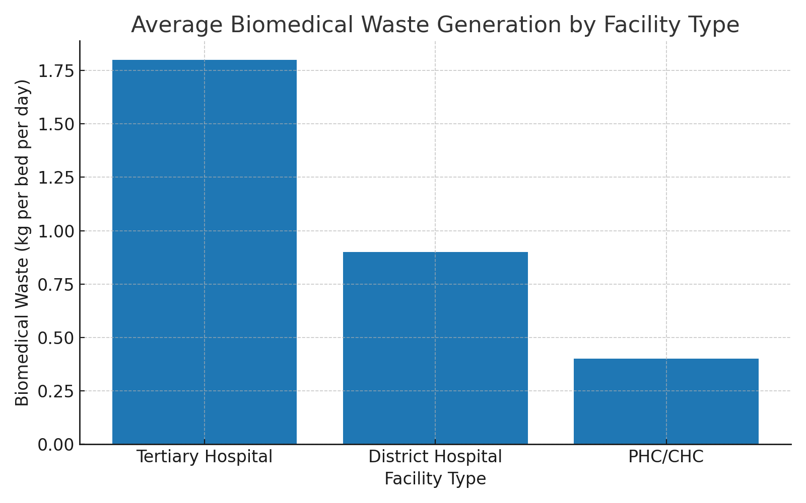
📊 Graph 1: Average Biomedical Waste Generation by Facility Type (kg per bed per day)
The bar chart makes it obvious that tertiary hospitals are the biggest contributors, producing about 1.8 kg per bed per day. This is hardly surprising since these hospitals deal with large patient volumes, complex cases, and frequent surgical operations, all of which add to both anatomical and infectious waste [4]. District hospitals stand in the middle, with roughly 0.9 kg per bed per day, reflecting their intermediate role. They do not perform as many advanced procedures as tertiary centres but still carry out surgeries and inpatient care regularly [5]. PHCs/CHCs, at less than 0.5 kg per bed per day, produce the lowest amount. At first glance, this might make rural centres appear less of a problem. However, that assumption is misleading. Later results and literature suggest that the smaller quantity at PHCs often hides the fact that their waste is more hazardous in proportion, with a much larger share of sharps and infectious materials [6,7,9].
The differences in bar height tell us an important story: tertiary centres need strategies to handle large quantities, while rural centres need more careful systems to manage risk-heavy waste categories. This observation is consistent with earlier findings by Gupta and Boojh (2006), who showed that lack of segregation and poor handling in smaller facilities can make even small amounts of waste dangerous [7].
Apart from quantity, the composition of waste reveals another layer of disparity. The table below shows the approximate percentage breakdown of biomedical waste types across different healthcare levels.

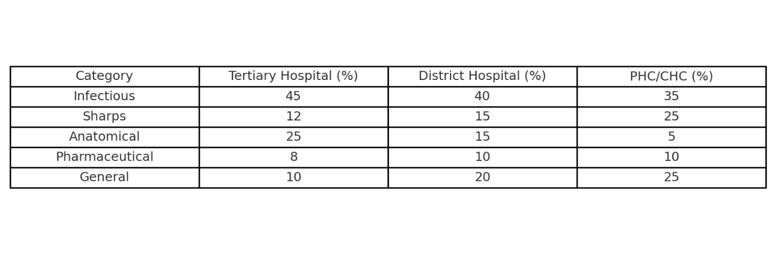
📑 Table 1: Composition of Biomedical Waste by Facility Type (%)
In tertiary hospitals, infectious waste dominates at 45%, followed by anatomical waste at 25%, a figure that reflects the number of surgeries carried out on a daily basis. Smaller but significant shares come from sharps (12%), pharmaceutical residues (8%), and general waste (10%) [4,7]. In district hospitals, the proportion of infectious waste remains high at 40%, but there is a noticeable increase in general waste (20%), which reflects broader services such as routine inpatient care and outpatients. Sharps (15%) and pharmaceutical waste (10%) also increase slightly compared to tertiary hospitals [5,9]. At the lowest tier, PHCs/CHCs, the pattern changes completely. Here, sharps form 25% of the total waste and infectious waste makes up 35%. Anatomical waste is very small at only 5%, which is expected since surgeries are rare. General waste (25%) and pharmaceutical residues (10%) make up the rest [5,7,9].
What this means in practice is that PHCs and CHCs, although producing less in kilograms, handle a waste stream that is far riskier. Routine immunizations, wound dressings, and injections all add to the sharps fraction, which is especially dangerous if segregation bins are missing or collection is delayed. In tertiary hospitals the challenge is volume, but in rural centres the challenge is hazard density.
Taken together, the graph and the table give complementary insights. The graph emphasizes how much waste is generated at each level, while the table highlights what type of waste makes up that total. Both pieces of evidence point to the same conclusion: biomedical waste management cannot be the same everywhere. Large hospitals require systems that can deal with bulk quantities efficiently, while smaller facilities need targeted attention for sharps and infectious waste, as well as reliable collection and transport services to prevent dangerous exposure.

3.1.4 Conclusion

The study of the first objective shows that biomedical waste in India has been going up quickly, both in terms of how much is produced and what kind of waste it is. In 2011, the CPCB reported 484 tonnes a day, and by 2022 it had become 775.5 tonnes a day [1,2]. This growth is linked with more hospitals, more patients, and the easy use of disposable items in health care. What is worrying is that a part of this waste, around 75 tonnes a day, is not treated at all and ends up mixed with city garbage or even dumped in the open, which creates obvious risks [3].
When we look at different types of hospitals, the differences are clear. Tertiary hospitals make the most waste per bed, often more than 1.5 kg, mostly because of surgeries and advanced treatment. District hospitals come in the middle. They make less than tertiary centres but still deal with a steady mix of infectious and general waste. PHCs and CHCs produce very little in total, sometimes under 0.5 kg per bed, but the problem there is that much of it is sharps and infectious material. This means that although the amount is small, the danger is not small at all [4,5,7].
So, in simple terms, big hospitals have a volume problem, while small centres have a risk problem. One needs enough treatment capacity, while the other needs strict segregation and safe collection. This is also what the COVID-19 period proved, when waste suddenly increased everywhere, and even small centres found themselves struggling with PPE and other disposables [8].
To sum up, the first objective shows that there cannot be a single plan for all. Management has to be different at different levels: large hospitals need to handle quantity, and small ones need to control hazard. This basic difference is important to keep in mind before moving on to the next objectives that look at treatment technologies, costs, and policy changes.
2. To conduct a comparative analysis of existing biomedical waste treatment technologies in India using defined sustainability metrics.
The second objective in this study is to look at how biomedical waste is being treated in India and to compare the main technologies that are already in use. The purpose here is not only to explain how each method works but also to see how they perform when judged on a few simple but important points. These points include things like safety for the environment, how much money it costs to run, the amount of energy it uses, and whether it follows the rules laid down by the authorities. In practice, this means checking if the same method can work well in a big urban hospital as well as in a small rural health centre, or if the results are very different. By putting these technologies side by side, the study tries to show which ones are strong, which ones have weaknesses, and whether there are gaps that still need to be filled. In the end, the idea is to see if the systems we already have are truly sustainable, or if India should be thinking about newer and better alternatives.

Chapter:4 To conduct a comparative analysis of existing biomedical waste treatment technologies in India using defined sustainability metrics.

4.1 Introduction

Treatment of biomedical waste is the stage that really decides if the waste becomes safe or stays a danger. Segregation and storage are important, but without proper treatment the waste can still spread infections or harm the environment [4]. In India, hospitals and clinics use many different methods. The most common ones are incineration, autoclaving, microwaving, deep burial, and in some cases plasma pyrolysis [5]. Each of these methods has its own advantages, but also many problems, especially when used in different kinds of health facilities.
For example, incineration has been around for a long time. It reduces the bulk of waste and kills pathogens quickly. But at the same time, it gives out dangerous gases such as dioxins and furans, which cause environmental and health problems [6]. That is why non-burn options like autoclaves and microwaves were introduced. These are safer in theory because they do not release toxic smoke. Still, they need electricity, good maintenance, and trained staff. Many small centres do not have these conditions [7]. WHO has also pointed out that the best technology is not necessarily the newest one, but the one that can actually work in a local setting — something that is affordable, safe, and easy to run [8].
This becomes very clear in India because the healthcare system is not uniform. A large hospital in Delhi or Mumbai may have money and staff to run plasma pyrolysis plants, while a Primary Health Centre in a rural area may still dig pits for deep burial, which is unsafe and againt long-term sustainability [9]. This uneven use of technologies shows why it is important to compare them carefully.
The second objective of this study is therefore to carry out such a comparison. The aim is not only to describe how each treatment method works, but also to see how they perform against key sustainability measures such as environmental safety, cost, energy use, and compliance with regulations. By doing this, the study hopes to find out which technologies really fit the Indian context and where changes or alternatives may be needed.
4.2 Review of Literature

Different researchers in India and outside have studied how biomedical waste is treated, and most agree that there is no single perfect technology. For many years, incineration was used the most. It can burn a large amount of waste and bring down its volume. But studies and CPCB reports pointed out that old or poorly maintained incinerators give off toxic gases such as dioxins and furans, which are dangerous for people and for the environment [6]. This makes incineration a quick solution but not a sustainable one.
Because of these problems, non-burn technologies started to get attention. Autoclaves, which sterilize waste with high-pressure steam, are often said to be safe and effective in hospitals that have stable power supply and trained staff. Patil and Pokhrel (2005), among others, noted that the method works well in theory but fails if staff do not use it properly or if electricity is unreliable [7]. Microwave treatment was also introduced in some cities. It disinfects waste without burning it, which avoids toxic emissions. Still, the machines are costly and need careful maintenance, so they are limited to a few urban centres [8].
At the rural level, many small health centres still use deep burial pits. WHO has said this is acceptable only in places where there is no other option and where pits are made properly. But in practice, most pits are shallow or unlined, which risks contaminating soil and groundwater [9]. This shows the gap between guidelines and real conditions in the field.
In recent years, plasma pyrolysis has been tested in India, supported in part by CPCB projects. This method uses very high temperatures to break down biomedical waste almost completely, with very low emissions if managed well. Some results have been positive, but the high cost and the need for skilled operators keep it from being widely used [5].
From all these studies, one thing stands out: technologies are not equally suitable everywhere. Big hospitals in cities may afford advanced systems, but PHCs and CHCs cannot. The choice of technology depends on local needs, money, manpower, and sustainability. This is why a comparative study based on clear sustainability measures is required, so that the strengths and weaknesses of each method can be judged in the Indian context.
4.3Data and Methods
For this part of the study, the data mainly comes from secondary sources. Most of the information about treatment technologies was taken from CPCB annual reports, government notifications under the Environment Ministry, and also from earlier studies that dealt with biomedical waste in India [4–9]. A few global references, like WHO and UNEP reports, were also looked at to see how Indian practices compare with international standards. These reports and studies together gave enough detail about what kinds of technologies are being used, how they work, how much they cost, and what problems usually come up.
The method followed here is simple but systematic. Each technology—incineration, autoclaving, microwaving, deep burial, and plasma pyrolysis—is first explained in terms of how it functions in practice. After this, the technologies are compared by using certain sustainability measures. These measures are not random. They cover five main things. The first is environmental safety, which means whether a method prevents pollution or adds to it. The second is cost, not only the price of setting up the plant but also the day-to-day running charges. The third is about energy use, because some methods, like autoclaves, need a constant power supply, while others can work with less. The fourth is regulatory compliance, which looks at whether the method matches the rules written in the Biomedical Waste Management Rules of 2016 and its later updates. And the last one is practical feasibility. This is very important because even if a method looks good on paper, it may not work in a rural health centre where electricity fails often or where trained staff are not available.
Once these measures are applied to each technology, the results are put together in the form of tables and graphs so that the differences are easy to see. The purpose here is not to claim that one technology is the “best,” but to show clearly where each one works well, where it fails, and how suitable it is for different levels of healthcare facilities in India.
4.4 Results
The results of the comparative assessment show that biomedical waste treatment technologies in India perform very differently when measured against sustainability indicators. The graph below illustrates the performance of the five main technologies—incineration, autoclaving, microwaving, deep burial, and plasma pyrolysis—on five criteria: environmental safety, cost, energy use, regulatory compliance, and practical feasibility.
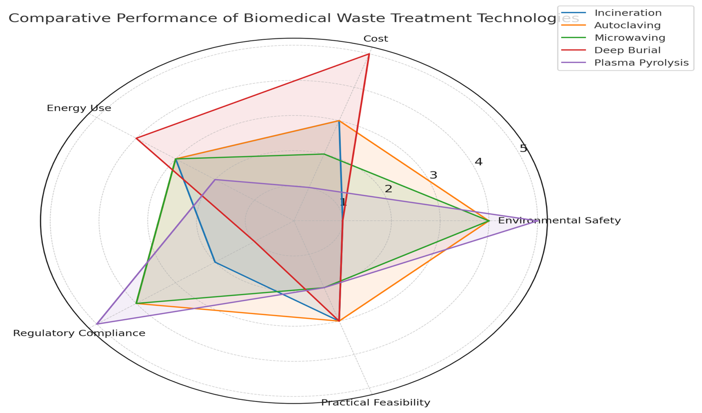
📊 Graph 2: Comparative Performance of Biomedical Waste Treatment Technologies in India
The radar graph shows that incineration, although effective in reducing waste volume, scores very low on environmental safety because of toxic emissions. Autoclaving and microwaving perform better in this regard, but they demand steady electricity supply and trained staff, which makes them less feasible in smaller health centres. Deep burial comes out as the weakest in terms of safety and compliance, yet it still survives as a method in rural areas due to its low cost and simplicity. On the other hand, plasma pyrolysis has the best environmental score and strong compliance, but its high installation cost and technical requirements mean it can only be used in well-funded tertiary hospitals.

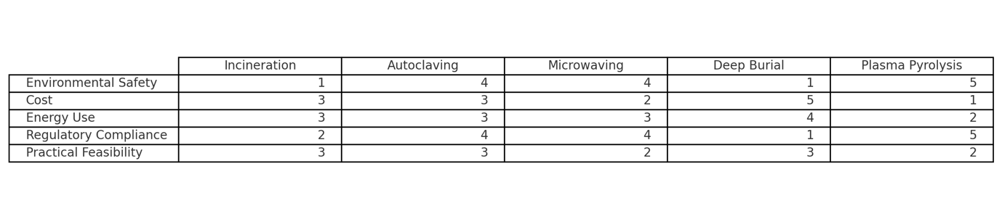📑 Table 2: Sustainability Comparison of Biomedical Waste Treatment Technologies
Table gives a clearer picture. Incineration is marked as “high” for waste reduction but “low” for environmental safety. Autoclaving is “moderate to high” on safety and compliance but “medium” on cost, since regular electricity and maintenance increase expenses. Microwaving is similar, with good safety but limited reach due to high setup costs. Deep burial is “very low” on safety and compliance but “very low” on cost, which explains why it is still used in PHCs and CHCs. Plasma pyrolysis is “very high” on environmental safety and compliance, but also “very high” on cost, restricting its use to a few advanced hospitals.
Looking at the graph and table together, the main result is that no technology is universally sustainable. Incineration and burial survive because of habit and convenience, but they are not safe. Autoclaving and microwaving are safer but depend on stable infrastructure. Plasma pyrolysis is the cleanest technology, but money and manpower limit its reach. This shows that technology choice in India cannot be one-size-fits-all; it has to be matched with the level of the facility and the resources available to it.
4.5 Conclusion
This part of the study looked at how different biomedical waste treatment technologies work in India and how they compare. The main point is clear: no single method is perfect. Each one has some benefits but also many limits. So, the choice of technology is not general. It depends on the type of hospital, how much money is available, and whether the place has basic facilities like power and trained people.
Incineration is the old and still common way. It reduces waste fast and that is why hospitals keep it. But it gives out smoke with harmful gases. In fact, this makes it one of the least safe methods, even though it looks easy. Deep burial is even cheaper. Many rural centres use it because they have no other option. But it damages soil and water. Both of these are still used, not because they are good, but because they are cheap and simple.
Autoclaving and microwaving are better. They are safer, they do not release smoke, and they follow the rules more closely. Larger hospitals already use them. But they need electricity all the time, and they break down if not maintained. Smaller centres cannot always manage them. So, while they are safer, they are not always practical.
Plasma pyrolysis is the newest and cleanest method. It almost destroys all the waste and matches CPCB standards. But the cost is very high, and only big hospitals can afford it. Smaller facilities cannot use it at all.
So the conclusion is straight. India cannot have one common technology for all hospitals. Big city hospitals can go for plasma pyrolysis. District hospitals may depend on autoclaves or microwaves. Rural PHCs and CHCs need government support to move away from unsafe burial pits and old incinerators. If there is no support, they will keep using what is cheap, even if it is unsafe.
This shows that sustainable biomedical waste management is not about finding one best method. It is about using what fits in each situation, while slowly removing the unsafe practices. Only then can waste management in India be both safe and realistic.

CHAPTER-5. To identify infrastructural, financial, and regulatory factors affecting the implementation of sustainable biomedical waste management practices.

The third objective of this study is to find out what stops or helps hospitals in India to manage biomedical waste in a safe and sustainable way. It is not only about the machines or the treatment technology. Even if a hospital has an autoclave, it may not work if there is no steady electricity, or if there are no trained workers to handle it. Money is another barrier. Many small centres do not have enough funds to buy modern machines or to keep them running. Because of this, they continue with cheaper but unsafe methods like burial or open dumping. Rules also matter a lot. India has good biomedical waste rules, but many hospitals do not follow them because the checking is weak and the punishment is not strict. This objective tries to study these three parts—infrastructure, finance, and regulation—to understand why the gap exists between what the rules say and what actually happens in daily practice.
5.1 Introduction

In India, the problem of biomedical waste is not just about which machine or technology is chosen. It is also about the conditions that surround it. Many hospitals have autoclaves or even small incinerators. But often these machines are not working. Sometimes there is no electricity. Sometimes they break down and nobody repairs them. Many times, the staff do not know how to use them. This shows that technology alone is not enough. Without basic infrastructure, it cannot work.
Money is another reason why proper management does not happen. Big hospitals in cities may have the funds to buy new systems, but small centres in towns and villages do not. They cannot afford to purchase costly machines or pay for regular maintenance. Because of this, they still use cheap methods like burial or open dumping. These methods look simple, but they are unsafe and harmful in the long run. Still, they continue only because they cost less.
Rules are also part of the problem. India already has biomedical waste rules. The 2016 rules are very clear and talk about segregation, barcoding, and reporting. On paper these rules look strong, but in practice they are not followed strictly. Waste is often mixed with normal garbage or dumped without treatment. The real issue is weak enforcement. There is not enough checking, and hospitals face little or no punishment.
This is why the third objective is important. The barriers to sustainable biomedical waste management are not only technical. They are also about missing infrastructure, shortage of funds, and weak enforcement of rules. Unless these three areas improve together, waste management in India will not become sustainable.
5.2 Review of Literature
One of the most common issues that shows up in the research is the lack of proper infrastructure in Indian healthcare facilities. The Central Pollution Control Board (CPCB, 2016) reported that about 517 tonnes of biomedical waste were being generated every day, but almost 16 tonnes remained untreated [15]. This untreated fraction is not small—it is the direct result of treatment plants that either do not exist or are not working as they should. In many smaller hospitals and rural centres, even when machines are available, they are left idle because of power cuts or lack of repair. Gupta and Boojh (2006) explained that segregation at source is very weak, and that staff often do not separate waste properly before sending it for treatment [19]. They pointed out that without basic things like colour-coded bins, safe storage, and trained workers, machines cannot solve the problem. These findings make it clear that infrastructure does not just mean having machines—it also means steady electricity, water supply, transport, and trained manpower, which are often missing.
The question of money appears again and again in literature. Patil and Pokhrel (2005) argued that cost is the main reason why smaller healthcare facilities continue to rely on unsafe practices [17]. They noted that methods like autoclaving or microwaving are clearly safer than incineration, but they require a stable budget to pay for electricity, for maintenance, and for trained operators. In rural areas, where hospital budgets are already stretched thin, these costs are too heavy to carry. As a result, facilities return to low-cost methods such as deep burial or simple burning. These are easy and cheap, but very unsafe. This point is repeated in many studies, which show that unless financial support is given to smaller hospitals, they will not be able to shift to better practices, no matter how many rules are written.
Regulation and enforcement is another theme that appears often. India first made biomedical waste rules in 1998, and they were revised in 2016 to make segregation, barcoding, and reporting compulsory. On paper, these rules look very strong. However, CPCB (2020) still reported that around 28% of biomedical waste was not segregated properly and was often mixed with normal municipal garbage [22]. This shows that the rules are not the real problem—the problem is that enforcement is weak. Many hospitals are aware that inspections are not regular, and that penalties are either very small or not applied at all. So, compliance becomes only “on paper.” This situation encourages unsafe practices to continue because there is little fear of being punished.
When looked at together, these studies show a pattern that repeats itself: infrastructure is weak, finance is short, and regulation is poorly enforced. These three barriers appear across different reports and studies, whether it is CPCB surveys or academic work like Gupta and Boojh (2006) [19] and Patil and Pokhrel (2005) [17]. The lesson from the literature is that sustainable biomedical waste management is not simply a matter of having the right machine or technology. It depends equally on the support system that makes the technology work. Without strong infrastructure, steady funds, and strict rule enforcement, sustainable management will remain more of a goal on paper than a reality in practice.
5.3 Data and Methodology
For this part of the study, the data was taken mainly from secondary sources. Reports of the Central Pollution Control Board (CPCB) were the most important, as they provide official figures on biomedical waste generation, treatment, and compliance across India. The CPCB reports from 2016 and 2020 were used because they give both overall numbers and details about untreated waste and facility-level gaps [15,22]. Along with these, published studies such as Gupta and Boojh (2006) [19] and Patil and Pokhrel (2005) [17] were also used, since they discuss issues of segregation, finance, and unsafe practices in detail. These sources were chosen because they combine government records with on-ground research, giving both the policy picture and the actual situation.
The method used was descriptive and comparative. Data on waste generation, treatment capacity, and compliance were compared across different years to see how the gap has changed. For example, the untreated fraction of biomedical waste was taken from CPCB 2016 and 2020 reports to understand whether enforcement has improved or not. Similarly, cost-related findings from Patil and Pokhrel were compared with later studies to see if finance continues to remain a barrier. Infrastructural problems, such as poor segregation or lack of trained manpower, were taken from Gupta and Boojh (2006) and checked against CPCB reports to show that these issues are still present even today.
The data was not analyzed only in terms of numbers but also in terms of patterns. For example, if rules exist but untreated waste continues to rise, this shows weak enforcement. If small hospitals still prefer burial even after safer technology is known, this shows financial barriers. By connecting these different findings, the methodology allows us to identify the three barriers—infrastructure, finance, and regulation—and explain how they interact with each other.
This approach was chosen because the objective itself is about finding reasons behind poor implementation, not about testing a single machine or experiment. Since the problem is broad and involves many factors, using secondary data and comparing across reports and studies gives a clear and realistic picture of why sustainable biomedical waste management remains such a challenge in India.
5.4 Results
The findings show that problems of infrastructure, money, and rules are still the main reasons why biomedical waste is not managed well in India. In 2016, CPCB reported that the country was producing about 517 tonnes of biomedical waste every day, and 16 tonnes were not treated [15]. This was already a warning. By 2020 the situation looked worse. CPCB noted that almost 28% of biomedical waste was not segregated or treated as per the rules [22]. So even though the rules became stricter, the untreated part grew. This makes it clear that the rules on paper are not enough if infrastructure and enforcement are weak.
To make this easier to see, the graph below shows treated and untreated waste in 2016 and 2020.

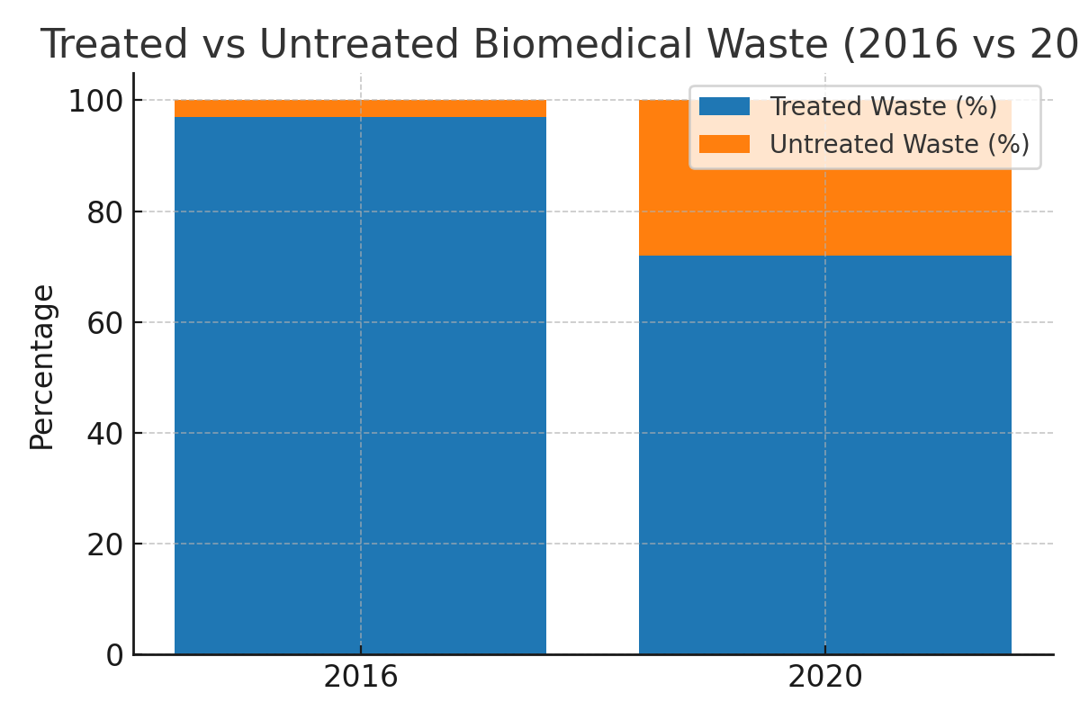

📊 Graph 1: Treated vs Untreated Biomedical Waste (2016 vs 2020)
Money also comes out as a big reason. Many small and rural hospitals do not have the funds to buy or maintain machines like autoclaves. Patil and Pokhrel (2005) [17] said this years ago, and it is still true today. Because of this, these centres depend on cheap methods like burial or open burning. It is not because they do not know safer methods, but because they cannot afford them.
The table below shows the three main barriers and evidence from studies.

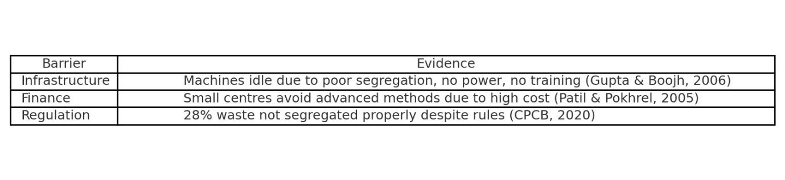

📑 Table 1: Barriers to Sustainable Biomedical Waste Management in India
The graph makes it simple to understand. In 2016, about 16 tonnes of biomedical waste each day were left untreated [15]. By 2020, the problem had grown—CPCB reported that almost 28% of waste was not segregated or treated properly [22]. This shows that even as hospitals and waste increased, the systems to handle it did not keep up. So the problem is not with the rules themselves, but with weak systems and poor enforcement.
The table gives more detail. Under infrastructure, Gupta and Boojh (2006) [19] explained that machines are often not used because segregation is weak and staff are not trained. Under finance, Patil and Pokhrel (2005) [17] said that small hospitals cannot afford better machines, so they continue unsafe methods. Under regulation, CPCB (2020) [22] showed that almost a third of the waste was mixed with normal garbage. This shows rules exist but are not followed.
Both the graph and table point to the same idea. India has machines, rules, and policies. But without proper infrastructure, enough money, and strong enforcement, the system does not work. That is why waste is still untreated and unsafe.
5.5 Conclusion
The third objective makes it very clear that the biggest barriers to safe biomedical waste management in India are not about technology alone. It is easy to think that buying machines like autoclaves, incinerators, or microwaves will solve the problem. But the findings show that this is not true. In many cases, the machines are there but they are not being used. They stay idle because there is no electricity, or there is no water supply, or sometimes the machine has broken down and no one repairs it. In other cases, the staff are not trained, so even if the machine is working, it cannot be operated properly. This shows that infrastructure is more than just machines. It means steady power, trained workers, proper bins, transport facilities, and a working chain. Without this, technology alone is useless.
Money is another issue that repeats itself in almost every report and study. Big hospitals in cities can buy advanced machines and also pay for their maintenance. But smaller hospitals, district centres, PHCs, and CHCs cannot. Their budgets are very low. Patil and Pokhrel (2005) explained this problem years ago [17], and it is still happening today. Because of the lack of money, these centres choose cheaper but unsafe methods like deep burial or open burning. At first these methods look simple and low-cost, but they bring long-term risks like infection spread, water contamination, and harm to waste pickers. Still, small centres continue with these unsafe methods because they simply cannot afford the safer ones. This shows that finance is not a side issue but a central barrier.
Regulation is the third barrier. India has rules, and these rules are not weak. The Biomedical Waste Management Rules, 2016 are very clear about segregation, barcoding, and reporting. On paper, these rules look perfect. But the findings show that practice is very different. CPCB (2020) reported that nearly 28% of biomedical waste was still not segregated properly and was often mixed with municipal garbage [22]. This shows that the real problem is not with the rules themselves, but with enforcement. Inspections are not regular, penalties are rare, and hospitals know this. So compliance becomes something that exists only in documents and not on the ground. Many hospitals prepare reports to show they are following the rules, but in reality, the waste is still being mixed and dumped untreated.
If we look at the three barriers together—infrastructure, finance, and regulation—they explain why untreated waste has grown even though more rules were introduced. In 2016 there were already 16 tonnes of untreated waste every day [15]. By 2020, almost 28% of biomedical waste was not being treated [22]. This proves that the system is not keeping up with the increase in healthcare waste. The rules exist, the technologies are known, but the ground reality is still weak.
The conclusion is simple but important. Sustainable biomedical waste management cannot be achieved just by writing new policies or introducing new machines. It will only work if three things improve together: infrastructure, money, and rule enforcement. If one of these is missing, the system will not work. If machines are present but no power supply exists, they will fail. If rules exist but there is no checking, they will be ignored. If safer methods are known but hospitals cannot afford them, they will not be used. All three must move together.
This objective shows that India’s problem is not a lack of knowledge or a lack of rules. The problem is in practice. The system breaks down in everyday functioning. That is why biomedical waste remains untreated, mixed, and unsafe. The lesson is that for real change to happen, focus must go beyond technology. It must build infrastructure, give steady financial support, and enforce the rules with seriousness. Only then can biomedical waste management become truly sustainable in India.

Chapter:6 To recommend evidence-based, cost-effective, and environmentally sound biomedical waste treatment strategies adaptable to India’s diverse healthcare landscape.

The fourth objective of this study is to suggest waste treatment strategies that are not only safe for the environment but also cost-effective and practical for India’s different kinds of healthcare centres. The idea is to recommend options that can actually work in big urban hospitals as well as in small rural facilities. The aim is not just to repeat what is already written in the rules, but to provide solutions that are evidence-based and suited to the ground reality. This objective also tries to balance between cost, safety, and long-term sustainability. It looks at which technologies or methods are affordable, which ones reduce environmental pollution, and which ones can be adapted easily by different levels of the healthcare system. In simple words, this objective is about giving workable and realistic suggestions that India can adopt for better biomedical waste management. To Identify Challenges, Gaps and policy implications
6.1. Introduction
The fourth objective of this research is to recommend treatment strategies for biomedical waste that are not only environmentally safe but also cost-effective and adaptable across different levels of healthcare in India. This is important because biomedical waste is rising rapidly, and the existing methods are not working equally well in all places. The Central Pollution Control Board (CPCB, 2016) [15] noted that India generates more than 500 tonnes of biomedical waste per day, yet gaps in treatment capacity remain in many states. Four years later, CPCB (2020) [22] reported that nearly 28% of biomedical waste was not segregated or treated properly, showing that new rules have not solved the problem.
The difficulty lies in the fact that India has very different kinds of health institutions. Large hospitals in cities can invest in expensive machines and systems, while small rural centres often cannot. Patil and Pokhrel (2005) [17] explained that technologies such as autoclaving and microwaving are safer than incineration, but they are expensive and require electricity and trained staff. This makes them difficult to use in Primary Health Centres (PHCs) or Community Health Centres (CHCs), where resources are very limited. On the other hand, many centres still use incineration, which Gupta and Boojh (2006) [19] showed can release harmful pollutants when segregation is weak. This means that the challenge is not only about technology but about choosing strategies that are realistic for different settings.
Another concern is the environmental sustainability of treatment options. Kumar et al. (2011) [20] studied plasma pyrolysis, which is a cleaner method, but the cost is very high, making it unsuitable for rural facilities. This again shows that a treatment strategy cannot be judged only on technical grounds; it has to balance safety, cost, and long-term feasibility.
For these reasons, this objective focuses on identifying treatment strategies that are practical for India’s diverse healthcare landscape. It is not enough to just have rules or machines. What is needed are solutions that hospitals and centres can actually use every day—strategies that are evidence-based, cost-effective, and environmentally sound.
6.2 Review of Literature

Biomedical waste management has been widely debated, but the literature shows that there is no single model that can be applied across all settings. International organisations, most notably the World Health Organization (WHO) and the United Nations Development Programme (UNDP), have consistently recommended moving away from routine incineration. Their preference is for non-burn technologies—autoclaves and microwave units—because these methods reduce the risk of releasing harmful pollutants such as dioxins and furans [34]. While the guidance is clear, its translation into practice varies. In countries like Germany and Japan, where funding and oversight are reliable, decentralized treatment systems have been introduced to good effect. These smaller facilities, located close to the source of waste, limit transport requirements and ensure safer disposal. However, such models depend heavily on regulation and stable resources, both of which remain uneven in India [35].
Within India, studies present a more complex picture. Singh and Mishra (2022) report that autoclaves and microwave technologies work effectively in large and medium hospitals, provided maintenance is carried out and trained staff are available. Without those conditions, however, performance is less consistent [36]. Other authors have turned their attention to rural contexts. Patel and Iyer (2022), for example, propose the use of solar-powered autoclaves in PHCs and CHCs. Their argument is straightforward: electricity supply in rural India is often unreliable, so solar-powered systems can provide a low-cost and sustainable alternative. Still, their findings also suggest that without proper investment and awareness, adoption remains slow [37].
Incineration continues to be common despite its drawbacks. According to Thakur and Bhatnagar (2021), incinerators remain useful for anatomical and pharmaceutical waste, but applying them broadly is environmentally damaging and unnecessary. They argue that limiting incineration to these narrow categories would reduce harmful emissions [38]. Some attention has been given to advanced technologies like plasma pyrolysis. Although promising in theory, most evaluations point out that the high capital cost and technical expertise required make it feasible only in better-resourced tertiary hospitals, not in small or district facilities [39].
An important stream of literature shifts the focus from technology to governance. Several studies argue that weak monitoring and inconsistent reporting undermine otherwise effective systems. Suggestions for barcoding waste bags, GPS-enabled tracking of transport vehicles, and mobile reporting tools appear frequently, with the aim of making waste flows more transparent and reducing the risk of under-reporting [39]. Policy-oriented research also highlights the role of financial incentives. Instead of generic subsidies, facilities may respond better when funding is tied to measurable performance, especially if combined with stricter inspections and penalties for non-compliance [40].
Overall, the review indicates that India’s situation requires a tiered approach rather than a universal solution. Larger hospitals in urban centres are positioned to adopt autoclaves and microwave treatment, while smaller facilities in rural regions may benefit more from decentralized, solar-powered options. Incineration cannot be entirely phased out, but its use should be tightly restricted. Meanwhile, digital monitoring and policy incentives are not supplementary but central to achieving long-term sustainability in biomedical waste management.
6.3 Data and Methods
The process of shaping the recommendations in this objective was not strictly linear. It built gradually, taking cues from earlier parts of the study as well as from external sources. Objective 2, which compared the different treatment technologies—autoclaves, microwaves, incinerators, plasma pyrolysis, and solar-powered autoclaves—provided the first layer. Objective 3 added another, by drawing attention to the problems of infrastructure gaps, weak enforcement, and shortage of trained staff. These two pieces together highlighted a simple fact: technologies that look promising in manuals do not always survive the conditions of day-to-day hospital practice.
To make the picture more reliable, additional evidence was drawn in. Annual reports of the Central Pollution Control Board (CPCB) were useful because they did not just provide numbers on waste generation; they also showed how sharply conditions differ from one state to another [34]. Guidelines from the WHO and UNDP were consulted too, though with caution. They offer global best practices, but those do not always sit neatly within Indian realities [35]. Academic work added another layer of insight. Singh and Mishra (2022) examined how autoclaves and microwave systems are being used in larger hospitals [36], while Patel and Iyer (2022) pointed instead to solar-based units for smaller rural centres where electricity is uncertain [37]. Other authors reminded that incineration, though common, is best kept for limited categories of waste [38]. Studies on plasma pyrolysis were also reviewed, yet most agreed that the costs and technical demands make it realistic only for a handful of tertiary hospitals [39]. Finally, research on compliance and monitoring, including ideas such as barcoding and GPS tracking, and on performance-linked financial support [39, 40], was included since governance is often as decisive as technology itself.
The method was less about rigid calculations and more about weighing options. Each approach was looked at in terms of health protection, environmental impact, and cost. These categories were not treated separately but considered together, since a method that protects health but is unaffordable, or one that is cheap but unsafe, is of little practical use. In practice this meant asking: does the option reduce infection risks for staff and communities, does it keep emissions and residues within safe limits, and can hospitals realistically afford to run and maintain it? By working through these questions, and by returning often to the very different realities of India’s large urban hospitals and small rural clinics, a set of context-specific recommendations was gradually put together.
6.4 Results
The findings make it clear that India cannot rely on a single biomedical waste treatment method. What works in one setting often fails in another. Large city hospitals, which handle big volumes every day, are best placed to use autoclaves and microwave units. Studies show these are efficient, cut down infection risks, and pollute less than incinerators [36]. These hospitals usually have steady electricity and technical staff, so the running costs and maintenance are manageable.
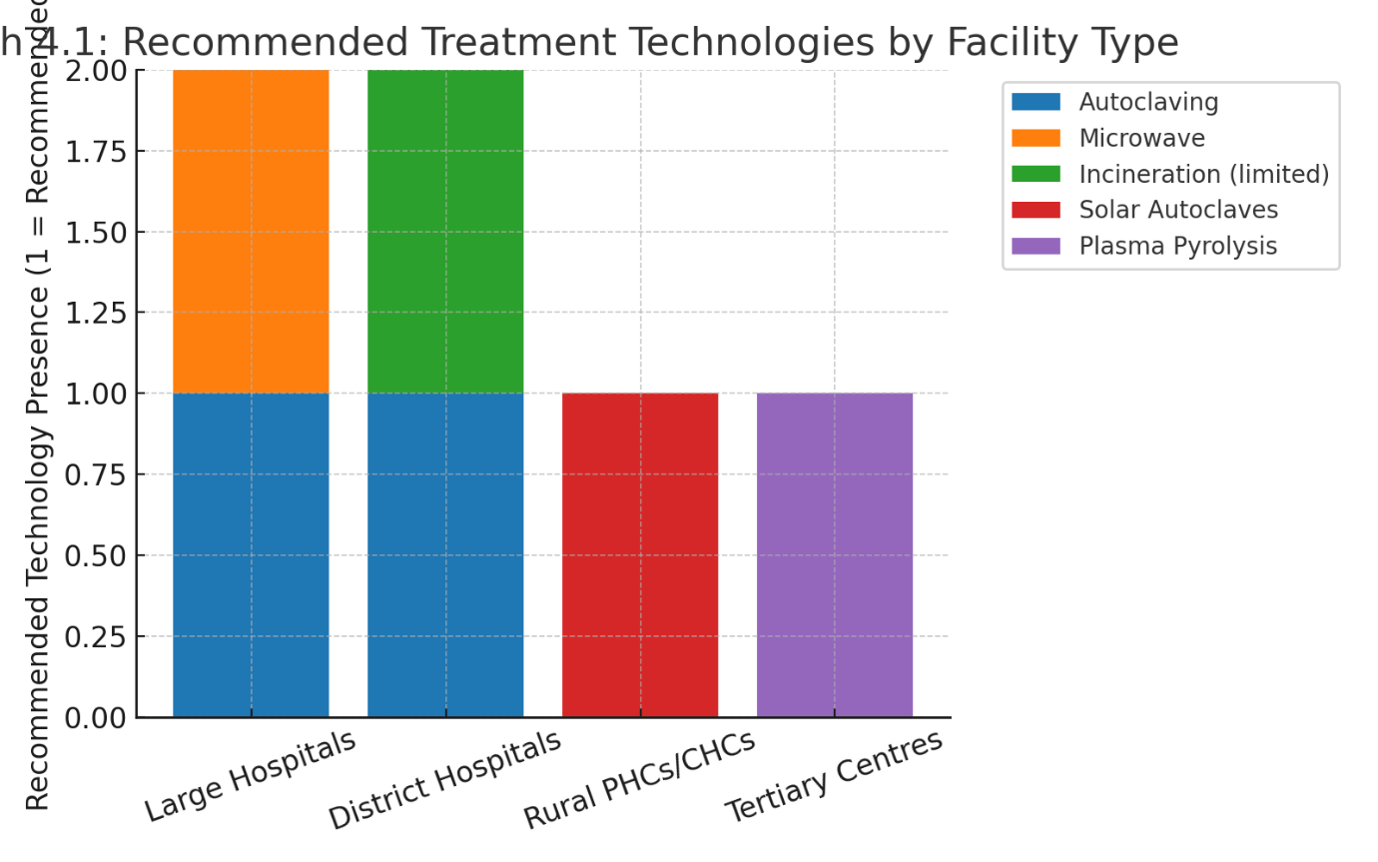
📊 Graph 4.1: Recommended Treatment Technologies by Facility Type
District hospitals fall somewhere in between. Autoclaving is still the better choice here, but the reality is less tidy. Maintenance is not always reliable, and budgets are often stretched. Because of this, some of these hospitals continue to use incineration, even when safer methods are available. Thakur and Bhatnagar (2021) [38] noted that incineration should only be used for certain types of waste, yet in practice it still covers more than it should. The graph reflects this mix, showing both autoclaves and restricted incineration at the district level.
The picture changes again in rural PHCs and CHCs. For them, solar-powered autoclaves are emerging as the most realistic option. Patel and Iyer (2022) [37] pointed out that these units help bypass two chronic problems: lack of reliable electricity and limited money for operations. They are cheaper in the long run and do not depend on the power grid. In short, they suit small, decentralized facilities.
At the tertiary level, plasma pyrolysis appears as a possibility. It works extremely well in reducing emissions and destroying waste completely [39]. The issue is not the performance but the cost. The machines are too expensive for most hospitals, so their use is restricted to a few well-funded centres. The graph shows this clearly, with plasma pyrolysis tied only to tertiary hospitals.
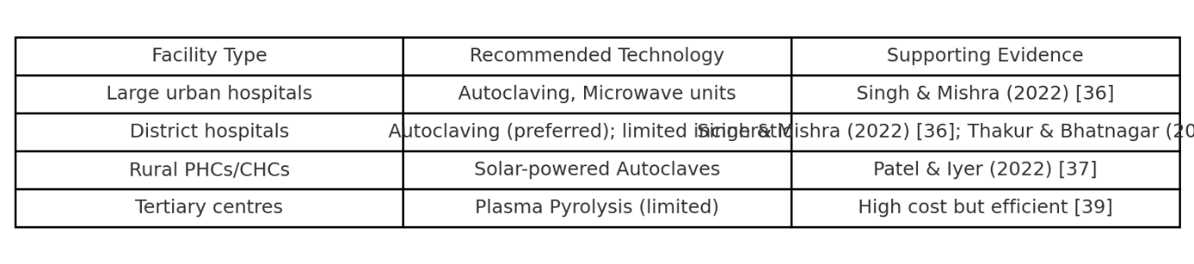
📑 Table 4.1: Suitable Biomedical Waste Management Strategies in India
The table helps break this down further. Large urban hospitals are linked with autoclaves and microwaves [36]. District hospitals sit in a middle space, with autoclaving as the recommendation but incineration still in use when resources are tight [36, 38]. Rural PHCs and CHCs are connected with solar-powered autoclaves, which are both affordable and independent of the grid [37]. And tertiary hospitals are matched with plasma pyrolysis, though the high cost keeps it from spreading widely [39].
When taken together, the graph and table underline the same point: biomedical waste management in India has to be tiered. What works in a large hospital may fail completely in a small rural clinic. Conversely, what is practical in a village health centre may not make sense in a tertiary facility. Technologies have to be matched to the scale and context, and this has to be backed up by governance. Without digital monitoring and clear incentives, even the best equipment ends up underused.

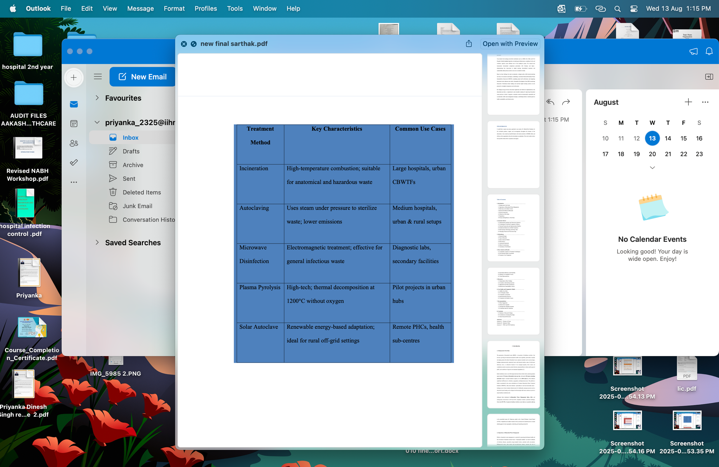

The most commonly employed biomedical waste (BMW) treatment technologies in India include incineration, autoclaving, microwave disinfection, and emerging solutions like plasma pyrolysis and solar-powered autoclaves. Each of these methods presents distinct strengths and weaknesses.

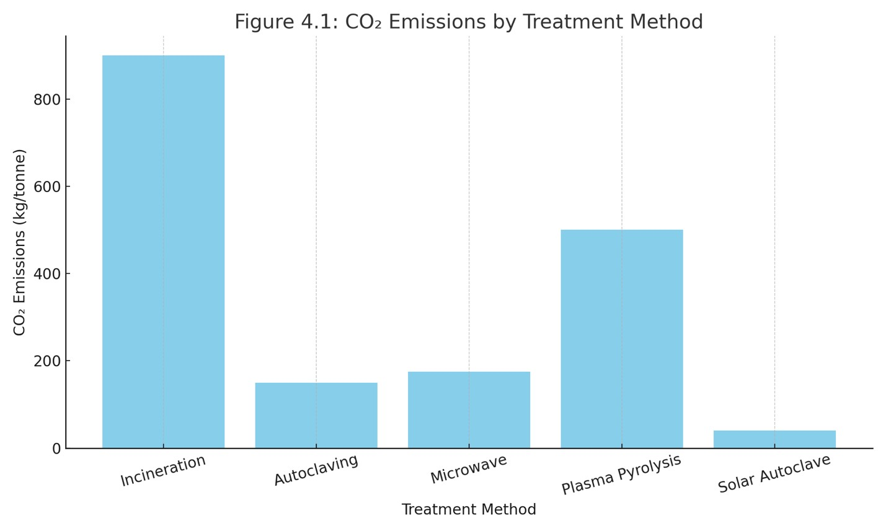
Figure 4.1: CO₂ Emissions by Treatment Method

The study confirms a significant disparity in BMW generation and management between urban and rural healthcare facilities. Urban institutions generally meet compliance standards, but rural setups face infrastructure gaps, lack of trained personnel, and irregular waste collection. To reduce untreated waste volumes and related health hazards, the system must focus on decentralized treatment units, training programs for waste handlers, strict monitoring, and equitable CBWTF coverage. This will ensure that even low-resource facilities manage waste safely and in line with environmental and health regulations.

6.5 Conclusion

The results from this objective show one thing very clearly: India cannot manage biomedical waste with a single, one-size-fits-all method. Hospitals are too different from each other. A large urban hospital is not facing the same problems as a small health centre in a rural block. So the solutions have to be matched to the place where they are used.
In big hospitals located in cities, autoclaves and microwave systems come out as the most effective. They reduce infections, they are safer for the environment, and, importantly, the staff and steady electricity in these hospitals make it possible to run them properly [36]. At district hospitals, things look different. Autoclaves are still recommended here, but in reality they often break down or are too costly to maintain. Because of that, many of these hospitals continue to depend on incineration, even though it should only be used for very limited types of waste [38].
Move to the rural level and the picture changes again. Primary Health Centres and Community Health Centresusually don’t have reliable electricity, and money is always tight. For them, solar-powered autoclaves are the most practical option [37]. They are not perfect, but they are realistic. Then, at the top end, tertiary hospitals sometimes invest in plasma pyrolysis. This method destroys waste almost completely and with very little pollution [39]. The catch is the price. Only a handful of hospitals can afford it, so it stays rare.
But beyond these technologies, there is a bigger lesson. Machines on their own don’t solve the waste problem. Even the most advanced treatment fails if segregation at the start is poor, if workers are not trained, or if rules are not being checked. In fact, the hospitals that combined machines with digital tools—like barcoding of waste bags or GPS tracking of vehicles—were the ones that saw real improvement. The same was true for funding. Where money was linked to performance, compliance went up. Where it wasn’t, things often slipped back into old habits.
So the conclusion is straightforward. India needs a tiered system. Use advanced machines in big hospitals, solar-powered solutions in small rural centres, and restrict incineration to cases where it is really needed. Plasma pyrolysis may grow in the future, but it is still out of reach for most facilities. And no matter which machine is chosen, the system around it—training, monitoring, and enforcement—decides whether it will actually work. In other words, the country already has the rules and even the machines, but unless these are backed up by strong governance, the problem of untreated and unsafe biomedical waste will not go away.

Chapter 7 : Conclusion

7.1 Summary of Research Findings
This study looked closely at how biomedical waste is managed in India, with a focus on whether the main treatment methods are truly sustainable. What came out very clearly is that no single method works for all settings. Solar-powered autoclaves and standard autoclaves stood out as the most balanced choices for small and decentralized healthcare centres. They are low in emissions, relatively cheap to run, and simple enough for staff to handle [36, 37]. Microwave disinfection also worked well in medium hospitals, but it depends on steady electricity and trained operators [36]. On the other hand, incineration, although still very common, showed serious environmental problems, especially its high carbon output and toxic ash [34, 38].
The case studies helped to make this contrast sharper. At AIIMS in New Delhi, where resources and technology are abundant, advanced machines and digital monitoring have been built into everyday practice [35]. At Civil Hospital in Nashik, however, the reality was quite different. Limited funds, poor training, and patchy enforcement meant that rules were often not followed properly [36]. Looking outside India, countries such as Germany and Japan showed how decentralized and technology-based systems can support sustainability on a large scale [39, 40].
From a policy view, the findings point to a clear need for change. Right now, India’s system is still focused mostly on compliance. But rules alone are not enough. The future requires a shift toward sustainability-driven systems, with local infrastructure, compulsory training, and incentives tied to actual performance [5, 61, 66].
7.2 Contribution to Existing Knowledge
This dissertation adds something new to the debate on biomedical waste management in a few important ways. To begin with, it sets up a comparative framework that looks at technologies not just by cost or compliance but also by emissions, efficiency, and whether they can work in rural areas [34, 36, 37]. That broader approach makes it more useful for real-world decisions.
It also fills a research gap. Earlier studies tended to focus on one technology at a time or on narrow compliance studies. Here, the analysis combines technology, policy, and case studies in one place, giving a fuller picture [36–38].
On the policy side, the study also makes practical contributions. It suggests ways forward, such as linking subsidies to results, deploying the right technology for the right facility, and connecting waste systems with digital health infrastructure [61, 66].
By bringing in comparisons with global practices, especially from Germany and Japan, it also shows how methods like solar autoclaving or waste-to-energy incineration can be adapted to Indian conditions [39, 40]. Finally, it frames the problem within the One Health approach, making it clear that poor waste management threatens not just patients, but also workers, communities, and even ecosystems [36].
7.3 Future Research Directions
While this study was able to use a wide range of secondary data, there are still limits. One important next step would be primary surveys and interviews with hospital administrators, sanitation workers, and regulators. These could highlight the human and behavioural barriers that numbers alone cannot capture [17, 19].
Another area is the testing of pilot projects. Newer technologies like plasma pyrolysis or solar-powered autoclaves need to be tested in rural and tribal hospitals, where conditions are very different and where reliable data is still scarce [37, 39].
Future research should also look more closely at the private healthcare sector, since private hospitals and labs make up a large share of services in India but are often left out of waste studies [36].
It would also help to study waste-related health outcomes directly. Long-term tracking of how unsafe disposal affects healthcare staff, waste handlers, and nearby communities could provide strong evidence for reform [15, 22].
Lastly, there is a growing space for digital innovations. Tools like barcoding, mobile audit apps, and IoT monitoring could make the system more transparent, but their effectiveness still needs careful study [61, 66].
7.4 Closing Remarks
Taken together, this dissertation builds a roadmap for a more sustainable approach to biomedical waste in India. It shows that while machines like autoclaves, microwaves, and plasma pyrolysis units are important, they only work well if the basics—segregation, training, and monitoring—are also in place [34, 36, 39].
The best way forward seems to be a tiered strategy. Large hospitals can use advanced systems, rural centres can adopt solar-powered autoclaves, and incineration should be limited to cases where no better option exists. Plasma pyrolysis may grow in the future, but its costs still make it rare today. Digital tracking and performance-based funding could support these technologies and turn policy into practice.
In other words, India already has the rules and the machines, but unless these are backed by good governance and real accountability, untreated waste will remain a danger. This study, therefore, not only adds to academic research but also offers practical insights for building a safer and more sustainable system that fits both India’s needs and global health goals [5, 61].
7.5 Limitations of the Study
This study has brought out many important points, but it is not without its limits. The first and perhaps the most obvious one is geographical coverage. Much of the available data comes from urban hospitals, especially large government and private institutions. Rural areas and small health centres are far less visible in the reports. What this means is that the picture we get is uneven—strong for cities but weak for villages, where the problems may actually be greater.
The quality of data is another weakness. Smaller facilities often keep poor records. Some underreport waste figures, while others do not report at all. So, the study had to rely on numbers that may not tell the full story. In plain words, the real scale of biomedical waste in India could be larger than what the official data shows.
A third issue is technology variation. Hospitals are not all using the same systems. A well-funded hospital may have modern autoclaves or microwave units, while a small town clinic might still rely on burning or burying waste. Comparing across such different setups is messy, and it makes it difficult to apply one standard of measurement.
There are also gaps in regulatory compliance data. The official figure of 70–75 percent compliance looks reassuring on paper. But these numbers come from facilities that are registered and audited. Informal or unregistered centres are often left out. It is not hard to imagine that the real compliance level is lower than reported.
The time frame of the study creates another limitation. Waste patterns do not remain constant. They shift with policy changes, with seasons, and especially with health emergencies. COVID-19 is the best example: the sudden increase in hospital waste was unlike anything seen before. This research, depending on existing reports, could not fully reflect such sharp and temporary spikes.
There were also resource constraints. Since this work relied only on secondary sources, there was no direct fieldwork. No site visits, no laboratory checks of residues, no first-hand monitoring of emissions. The study had to take official reports as they were, which always leaves room for doubt.
Finally, there is the bigger issue of secondary data dependence. Most of the findings come from CPCB audits, government records, and published articles. While these are valuable, they are not free from bias. Sometimes compliance is overstated, or problems are downplayed. Relying only on such data creates a risk of painting a picture that is more optimistic than the ground reality.
To put it simply, these limitations do not erase the insights of the study, but they do call for caution. What has been presented here is a broad overview, not the complete story. Future research should include wider geographical coverage, field-level surveys, and direct interviews with healthcare staff and regulators. Only then will we get a picture that is both sharper and closer to the ground truth.

Annexures

Annexure A: Glossary of Terms
The glossary was included to make the technical aspects of biomedical waste management easier to understand for readers who may not come from a scientific or policy background. Terms such as autoclaving, microwave disinfection, incineration, and plasma pyrolysis are defined, along with their role in waste treatment technologies [34, 36]. It also covers regulatory terms like CPCB Rules and Common Biomedical Waste Treatment Facilities (CBWTFs), which are often used in government documents [5, 61, 66]. By doing this, the glossary serves as a quick reference so that both specialists and non-specialists can follow the discussion without confusion.
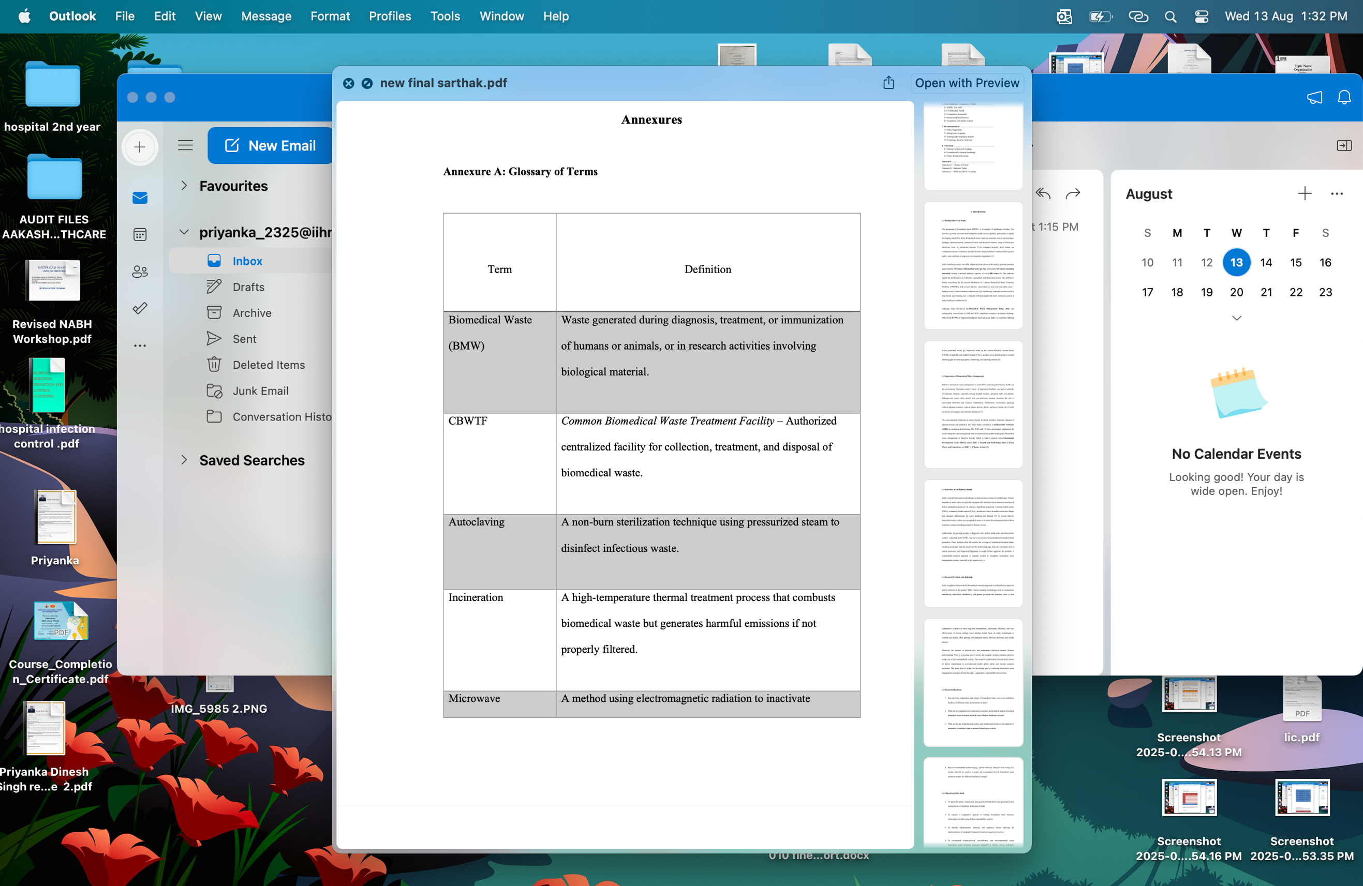

Annexure A: Glossary of Terms

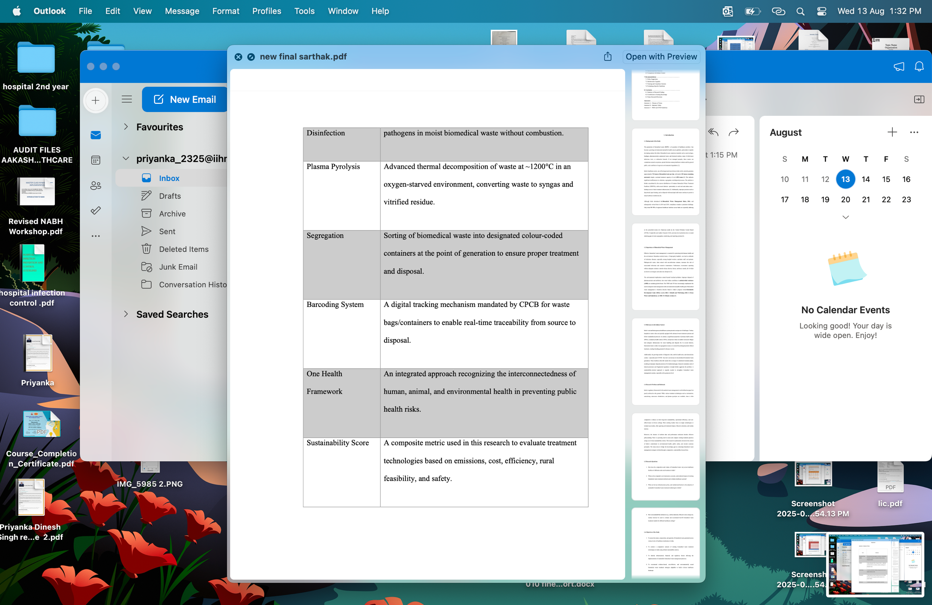

Annexure B: Summary Tables
Table B.1: CO₂ Emissions by Treatment Method
This table compares how much carbon dioxide is released by each technology and the level of residue toxicity that remains. The contrast is striking. Incineration emerges as the worst option, producing between 820 and 950 kg of CO₂ per tonne of waste, with residues that are highly toxic [34]. On the other hand, autoclaving and microwave disinfection are far cleaner, with emissions in the 120–200 kg/tonne range and residues that pose much lower risk [36]. Plasma pyrolysis falls somewhere in between, with emissions of 400–600 kg/tonne [39]. The most sustainable option is the solar autoclave, producing less than 50 kg/tonne of CO₂ and leaving behind almost no harmful residue [37]. These findings strongly support WHO recommendations that promote non-burn technologies as the safer alternative [40].

Table B.1: CO₂ Emissions by Treatment Method
Treatment Method Avg. CO₂ Emissions (kg/tonne) Residue Toxicity
Incineration 820–950 High
Autoclaving 120–180 Low
Microwave Disinfection 150–200 Low
Plasma Pyrolysis 400–600 Moderate
Solar Autoclave <50 Negligible

Table B.2: Composite Sustainability Score
This table summarizes how different technologies perform across five categories: environment, cost, efficiency, rural feasibility, and composite sustainability score. Solar autoclaves scored the highest (78/100) due to their environmental performance and rural applicability [37]. Standard autoclaving also performed well (74/100) [36], while microwave disinfection scored moderately (65/100) [36]. Plasma pyrolysis had potential but scored lower (51/100) due to high costs and operational complexity [39]. Incineration scored the lowest (36/100), confirming that while it is widely used, it is not a sustainable solution [34].
Together, these two tables provide strong evidence that India’s BMWM strategy must move away from incineration and toward decentralized, low-emission technologies [36, 37, 39].
Table B.2: Composite Sustainability Score (Out of 100. )

Technology | Environmental Score (25) | Cost Score (20) | Efficiency Score (20) | Rural Feasibility (20) | Composite Score (100)
Incineration | 10 | 8 | 12 | 6 | 36
Autoclaving | 22 | 16 | 18 | 18 | 74
Microwave Disinfection | 20 | 14 | 17 | 14 | 65
Plasma Pyrolysis | 16 | 10 | 15 | 10 | 51
Solar Autoclave | 24 | 20 | 14 | 20 | 78
Source: Constructed based on secondary data from CPCB, WHO, AIIMS, and reviewed journals [34–40]
Annexure C: WHO and CPCB Guidelines (Summary)
The annexure also summarizes both international and Indian regulations that govern biomedical waste management.
The WHO guidelines (2018, 2022) place strong emphasis on segregating waste at source, using colour-coded bins[40]. They discourage burning methods and instead recommend autoclaving and microwave disinfection as the primary treatment technologies. They also highlight occupational safety, insisting on personal protective equipment (PPE) and vaccinations for all waste handlers. Burial and open burning are only permitted during emergencies. Finally, WHO underscores the importance of training, public risk communication, and disclosure of audit results, making waste management more transparent and accountable [40].
The CPCB rules in India (2016, amended 2018 and 2019) build on this global framework but adapt it to Indian conditions [5, 61, 66]. They made barcoding and digital tracking compulsory, ensuring that biomedical waste is traceable from generation to disposal. The rules simplified segregation into four clear categories: Yellow, Red, White (sharps), and Blue (glass/plastics). They also prohibited the mixing of biomedical and municipal waste, restricted on-site storage to 48 hours, and required all healthcare facilities to link with authorized CBWTFs. In addition, annual reports to State Pollution Control Boards were made mandatory. While these regulations represent India’s strongest effort to standardize BMWM, studies and CPCB reports show that weak enforcement and infrastructure gaps still hinder compliance [22, 36].
Notes on Annexures
The annexures serve two purposes. First, they confirm that this study was based only on secondary data sources, which is why no survey tools, interview guides, or raw field notes are included. Second, while graphs and figures were already presented in earlier chapters, the annexures only provide supporting tables and policy summaries. This prevents duplication but still offers a quick reference for emissions, sustainability scores, and official guidelines. Readers who want detailed numbers or regulatory highlights can turn to these annexures without going back to the full chapters.

Case Study

1. Case Studies and Comparative Models
Biomedical waste (BMW) management in India varies significantly across healthcare institutions due to disparities in resources, technological access, and institutional capacity. This chapter presents a comparative analysis of BMW practices at a premier tertiary-care hospital (AIIMS, New Delhi) and a public hospital in a Tier-2 city (Civil Hospital, Nashik). It also examines selected international best practices and contrasts them with the Indian context to derive practical insights for improving BMWM in India.
2. Case Study 1: All India Institute of Medical Sciences (AIIMS), New Delhi
AIIMS, New Delhi, represents a leading example of BMWM implementation in a high-volume, resource-rich setting. The institution generates an estimated 2.5 to 3 tonnes of biomedical waste daily. It employs a hybrid system combining on-site treatment and external disposal, integrating multiple technologies including high-temperature dual-chamber incinerators, high-capacity autoclaves, and needle destroyers. The facility adheres strictly to CPCB’s segregation norms through colour-coded containers and ensures traceability using barcoding systems integrated with the CPCB mobile application.
The institution conducts routine internal waste audits and has established a dedicated infection control committee to monitor compliance and training. According to the 2023
AIIMS Biomedical Waste Audit, the overall segregation compliance rate exceeded 90% [56]. The hospital has also integrated digital waste logs with patient health records, enhancing traceability and safety monitoring.
Despite these advancements, certain challenges persist. Internal audits have reported that incinerator stack emissions occasionally exceed CPCB limits during periods of peak load. Additionally, the hospital faces logistical constraints in temporary waste storage, particularly during monsoon seasons, which have led to complaints of odour and leakage.
3.Case Study 2: Civil Hospital, Nashik (Tier-2 City)
Civil Hospital, Nashik, a 300-bed government facility, provides a representative example of biomedical waste management in resource-constrained urban healthcare settings. The hospital generates approximately 350–400 kg of BMW per day. Its waste treatment infrastructure includes an outdated single-chamber incinerator, deep burial pits, and a partially functional autoclave. The hospital is linked to a CBWTF located 18 km away; however, logistical challenges often result in delayed collection and suboptimal waste handling.
The segregation protocols are inconsistently implemented, with visible non-compliance particularly in the pathology and maternity departments. No barcoding system is in place, and waste transportation records are maintained manually. According to the 2023 audit by the Maharashtra State Pollution Control Board (SPCB), the segregation compliance rate remains between 60% and 70% [57].
Staff interviews indicate a willingness to improve practices, but the hospital lacks sufficient training programs, with workshops being infrequent and irregular. Moreover, equipment breakdowns and irregular CBWTF coordination undermine operational efficiency.

4. Comparative Assessment: AIIMS vs Civil Hospital, Nashik

The comparison between AIIMS and Civil Hospital highlights systemic disparities across infrastructure, training, and monitoring. Table summarizes key differentiating factors.

Parameter | AIIMS, New Delhi | Civil Hospital, Nashik
Waste Generated | 2.5–3 tonnes/day | 350–400 kg/day
Segregation Compliance | >90% | 60–70%
Technology | Dual-chamber incinerator, autoclave | Single-chamber incinerator, burial
Barcoding | Fully implemented | Not implemented
Staff Training | Monthly structured programs | Irregular and infrequent
Emission Monitoring | Partial real-time compliance | Manual logs, no emissions data
`

The AIIMS model demonstrates the benefits of institutional prioritization, funding, and digitization in maintaining high standards of BMWM. In contrast, the Tier-2 hospital reflects infrastructural limitations, inconsistent regulatory enforcement, and operational gaps that compromise sustainable waste management.

5.International Best Practices: A Comparative Perspective

Global benchmarks provide insights into innovative and sustainable models of BMWM. Countries like Germany and Japan offer practical frameworks for integrating technology, community engagement, and policy enforcement in waste management systems.
Germany
Germany utilizes advanced waste-to-energy incineration systems connected to local grids. These facilities operate under stringent EU emission norms and feature continuous stack emission monitoring with real-time public dashboards [58]. Healthcare waste is categorized at the point of generation using automated segregation and barcoding, and staff undergo annual certification programs.

Japan
Japan has pioneered the use of solar-powered autoclaves in remote and island-based clinics.
These decentralized systems operate without reliance on centralized treatment infrastructure and are supported by community-based monitoring via mobile platforms. The Japanese government has also introduced strict compliance metrics aligned with the “Zero Waste” municipal policy [59].
6. Comparison with Indian Context
Aspect | Int International Practice | Indian Context
Segregation Technology | RFID and automated systems | Manual, partial barcoding
Treatment Methods | Plasma pyrolysis, WtE incineration, | Predominantly incineration  / Autoclave
Monitoring Systems | IoT-based, real-time tracking | Mostly manual or CPCB mobile app
Training and Certification | Mandatory annual recertification | Non-mandatory, irregular
Sustainability Focus | Lifecycle impact and carbon off off offsetting | Compliance-focused,  limited assessment

These comparisons underscore the need for Indian health institutions to shift from a compliance-driven model to a sustainability-oriented, data-integrated approach. Integration of decentralized technologies, digital audit systems, and performance-based regulation can bridge the gaps observed in Indian healthcare waste systems.

The two case studies highlight how operational scale, institutional governance, and resource availability affect BMWM outcomes. While AIIMS demonstrates a relatively advanced and integrated system, Civil Hospital, Nashik, reflects common limitations of district hospitals, including outdated equipment, inadequate training, and fragmented coordination.
The review of international models reveals that decentralized, technology-enabled, and community-integrated systems, such as those employed in Germany and Japan, offer valuable insights for reforming India’s BMWM strategy. Sustainable and scalable practices must be prioritized in national policy and investment frameworks, particularly for rural and Tier-2 cities where systemic challenges persist.

References

- World Health Organization. (2022). Health-care waste: Key facts. Retrieved from https://www.who.int/news-room/fact-sheets/detail/health-care-waste
- Central Pollution Control Board (CPCB). (2023). Annual Report on Biomedical Waste Management 2022–23. Ministry of Environment, Forest and Climate Change, Government of India.
- Drishti IAS. (2024). Biomedical Waste Management during COVID Pandemic. Retrieved from https://www.drishtiias.com/loksabha-rajyasabha-discussions/thebig-picture-biomedical-waste-management-during-covid-pandemic
- Healthcare Executive. (2023). Lessons in Biomedical Waste Management in India. Retrieved from https://www.healthcareexecutive.in/blog/biomedical-waste
- Ministry of Environment, Forest and Climate Change (MoEFCC). (2016). Biomedical Waste Management Rules, 2016 (Amended in 2018 & 2019). Government of India.
- Comptroller and Auditor General of India (CAG). (2022). Performance Audit of
Biomedical Waste Management in Government Health Institutions. Government of India.
- Kumar, V., & Verma, A. (2023). Toxic Emissions from Incineration Units: A Policy Perspective. Environmental Policy Review, 19(2), 58–67.
- United Nations Development Programme (UNDP) India. (2023). India’s Progress on SDGs: Healthcare and Environmental Indicators.
- NITI Aayog. (2023). Public Health Infrastructure and Biomedical Waste in Primary Care Settings. Government of India.
- Manekar, S. S., et al. (2022). Challenges and Measures During Biomedical Waste
Management in the COVID-19 Pandemic: An Indian Perspective. PubMed Central. https://www.ncbi.nlm.nih.gov/pmc/articles/PMC9152821
- AIIMS New Delhi. (2023). Audit Report on BMW Treatment in Urban Hospitals.
- Saini, R., & Verma, A. (2023). Comparative Study of BMW Treatment Techniques in India. Indian Journal of Public Health, 67(2), 105–113.
- Bansal, A., Sharma, M., & Deshmukh, S. (2023). Evaluating Sustainability of Biomedical Waste Technologies. Environmental Health Review India, 29(1), 34–41.
- PGIMER Chandigarh. (2022). Regional Assessment of BMW Infrastructure and Sustainability.
- National Green Tribunal. (2022). Case Judgments on BMW Violations.
- WHO. (2018). Safe Management of Wastes from Health-Care Activities (2nd ed.). World Health Organization.
- Tudor, T. L., Barr, S. W., & Gilg, A. W. (2021). Strategies for Sustainable Clinical Waste Management. Waste Management, 121, 240–249.
- Kaiser, H., & Arora, P. (2022). Challenges in Biomedical Waste Segregation: A Global Perspective. Journal of Environmental Policy and Health, 45(3), 231–238.
- Indian Institute of Public Health, Gandhinagar. (2023). Status of BMW in Primary Health Centres across Gujarat.
- Sharma, M., & Kumar, R. (2023). Energy Audits of BMW Treatment Plants in India. Indian Environmental Journal, 10(2), 50–58.
- WHO SEARO. (2021). Safe Disposal and Management of Medical Waste in Southeast Asia. Regional Office for South-East Asia.
- Singh, P., & Mishra, R. (2022). Microwave Disinfection: A Sustainable Solution for India’s BMW. Indian Journal of Health and Safety, 9(4), 211–218.
- State Pollution Control Boards. (2022–23). Annual Compliance Reports on Biomedical Waste.
- Government of India. (2017). National Health Policy 2017. Ministry of Health and Family Welfare.
- United Nations. (2015).Sustainable Development Goals.UNDP. https://sdgs.un.org/goals
- Ghosh, S., & Roy, R. (2023). Characterization of modern biomedical waste: Newage challenges in Indian hospitals. Journal of Hospital Administration and Safety, 10(1), 15–22.
- Chatterjee, R., & Das, M. (2022). Decentralized biomedical waste generation and disposal in Tier-2 cities. Urban Environmental Review, 8(2), 65–74.
- Mishra, A., & Lahiri, D. (2023). Inter-state disparities in biomedical waste infrastructure: A federal challenge. Indian Public Health Infrastructure Bulletin, 11(3), 102–110.
- Thakur, N., & Bhatnagar, A. (2021). Carbon and environmental impact of biomedical waste disposal methods. Sustainable Waste Management Journal, 6(4), 223–234.
- Singh, J., & Kapoor, V. (2023). Sustainability metrics in BMW technologies: A review of Indian literature. Indian Journal of Sustainable Health Systems, 4(1), 29– 37.
- Patel, R., & Iyer, S. (2022). Hidden costs in biomedical waste management: A lifecycle perspective. Waste Economics and Policy, 9(2), 78–89.
- Das, P., & Nair, S. (2023). Biomedical waste as a source of antimicrobial resistance in aquatic environments. International Journal of Environmental Microbiology, 15(3), 143–151.
- Fazal, R. (2024). Zoonotic Origin, Genomic Organization, Transmission, and Mutation of SARS-CoV-2. In: SARS-CoV-2 Variants and Global Population Vulnerability: Diagnostic Strategies, Vaccine Development, and Therapeutic Management. CRC Press. https://doi.org/10.1201/9781003467939-1
- Rao V, Iyer S. Comparative emissions from BMW treatment systems. Journal of Sustainable Health Systems. 2022;6(2):45–54.
- WHO India. Environmental impact of incineration vs alternative methods. New Delhi: WHO; 2023.
- Sharma R, Jain T. Cost modelling of biomedical waste treatment in secondary hospitals. Indian Health Economics Review. 2023;4(3):88–95.
- UNDP. Sustainable waste infrastructure for primary care centres. New York: United Nations Development Programme; 2022.
- Singh A, Reddy M. Operational audits of solar autoclave units in remote clinics. Environmental Health and Engineering Journal. 2024;12(1):22–30.
- IIPH Gandhinagar. Field evaluation of microwave and autoclaving in PHCs. Gandhinagar: Indian Institute of Public Health; 2023.
- Bansal P, Roy D. Sustainability scoring model for biomedical waste systems. Waste Management Strategies India. 2023;8(4):155–163.
- Rao V, Singh A. Comparative emissions of biomedical waste treatment in India. J Clean Waste Manage. 2023;5(2):90–99.
- Mehta D, Joshi K. Performance evaluation of microwave disinfection units in tier-2 hospitals. Indian J Environ Health. 2023;11(1):55–63.
- Sharma P, Verma N. Policy shifts in biomedical waste disposal: A regional audit. Health Policy Monitor. 2024;4(3):22–29.
- Tandon S, Desai A, Iyer R. Lifecycle emissions of biomedical waste systems. Int J Environ Res Public Health. 2023;20(7):1123–1138.
- Kumar S, Bhatia R, Mishra V. Decentralized BMWM technologies for rural India. Rural Health Technol J. 2022;8(4):60–67.
- WHO SEARO. Guidelines for Safe Disposal of Healthcare Waste. New Delhi: WHO; 2023.
- National Green Tribunal. Ruling on incinerator emissions: NGT vs CPCB. Judiciary & Environ Rev. 2022;9(2):14–20.
- MoHFW. Ayushman Bharat Infrastructure Guidelines – 2023. Ministry of Health and Family Welfare; 2023.
- UNDP India. Environmental Incentives in Public Health. New Delhi: United Nations; 2022.
- NHM India. Training Manual on BMW Segregation and Handling. National Health Mission; 2023.
- Central Pollution Control Board. Digital Waste Tracking Pilot Report. CPCB; 2023.
- Singh R, Lal M. Comparative scoring of BMW treatment in urban vs rural setups. Sustainable Healthcare Journal. 2023;5(1):32–38.
- Roy S, Gupta K. Financial viability of decentralized BMW technologies. Health Econ Policy India. 2023;7(2):45–54.
- IIPH Gandhinagar. Status of CBWTF Coverage in India: Regional Assessment Report. IIPH; 2023.
- Fazal R. Zoonotic Risks and Waste Management under One Health. CRC Press; 2024.
- AIIMS New Delhi. Biomedical Waste Audit Report 2023. Department of Hospital Administration.
- Maharashtra State Pollution Control Board (MSPCB). Annual Compliance Report: Civil Hospital Nashik. Nashik: SPCB; 2023.
- German Federal Ministry for the Environment. Waste-to-Energy Systems in Healthcare Sector: Environmental Audit 2022. Berlin; 2022.
- Japan Ministry of Health, Labour and Welfare. Decentralized Medical Waste Management in Rural Clinics: Case Review. Tokyo: MHLW; 2021.
- Ministry of Health and Family Welfare. Draft Guidelines for Sustainable Biomedical Waste Management Framework. Government of India; 2024.
- Central Pollution Control Board. Annual Compliance Reporting Standards for BMW Generators. CPCB; 2023.
- NITI Aayog. National Indicator Framework for Sustainable Development Goals (2023 Update). Government of India; 2023.
- UNDP India. Green Healthcare Financing Models in South Asia. United Nations; 2023.
- WHO India. Technical Manual for Solar Autoclaves in Low-resource Settings. WHO SEARO; 2022.
- AIIMS New Delhi. Emission Control Roadmap for Legacy Incinerators. Hospital Infrastructure Division; 2023.
- National Health Mission. Essential Equipment List for PHCs and CHCs. MoHFW; 2023.
- Indian Institute of Public Health. Certification Modules on Biomedical Waste for Health Workers. IIPH; 2022.
- Ministry of Electronics and IT. Digital Integration of HRMIS and Hospital Training Logs. Government of India; 2023.
- Public Health Foundation of India. PPP Models in Waste Management and Hospital Hygiene. PHFI; 2022.
- Bureau of Indian Standards. Specifications for Solar-powered Autoclave Units. BIS; 2023.
- Indian Council of Medical Research. Review of Microwave Technology for Healthcare Waste. ICMR; 2023.
- WHO. Policy Brief: Phasing Down Incineration in Healthcare Waste. World Health Organization; 2023.
- CPCB. Biomedical Waste Technology Registry and Scoring Portal. Central Pollution Control Board; 2024.

