Internship Training

At

International Institute of Health Management and Research

Digital tools used in Healthcare Education: A Narrative Review

by

Dr. Sharbari Dutta
Enrolment Number: PG/2021-23/094

Under the guidance of
Dr. Anandhi Ramachandran

PGDM (Hospital & Health Management)
2021-23


International Institute of Health Management Research
New Delhi

Internship Training

at

International Institute of Health Management and Research

Digital tools used in Healthcare Education: A Narrative Review

By

Dr. Sharbari Dutta
Enrolment Number: PG/2021-23/094

Under the guidance of
Dr. Anandhi Ramachandran

PGDM (Hospital and Health Management)
2021-23

International Institute of Health Management Research
New Delhi

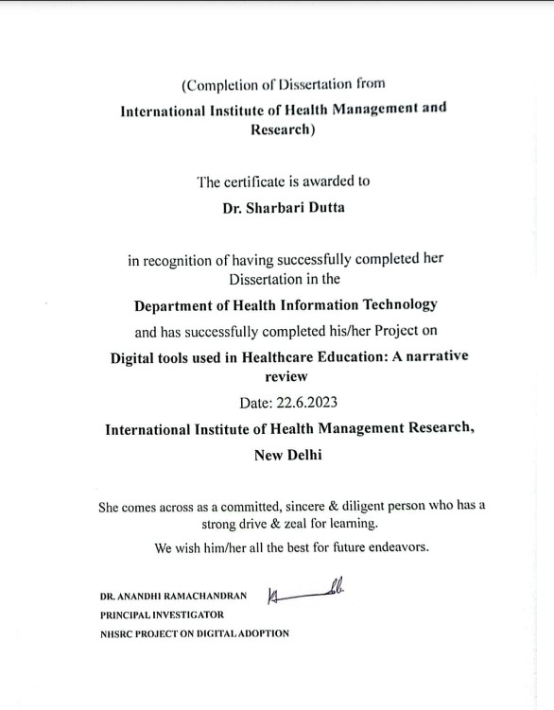

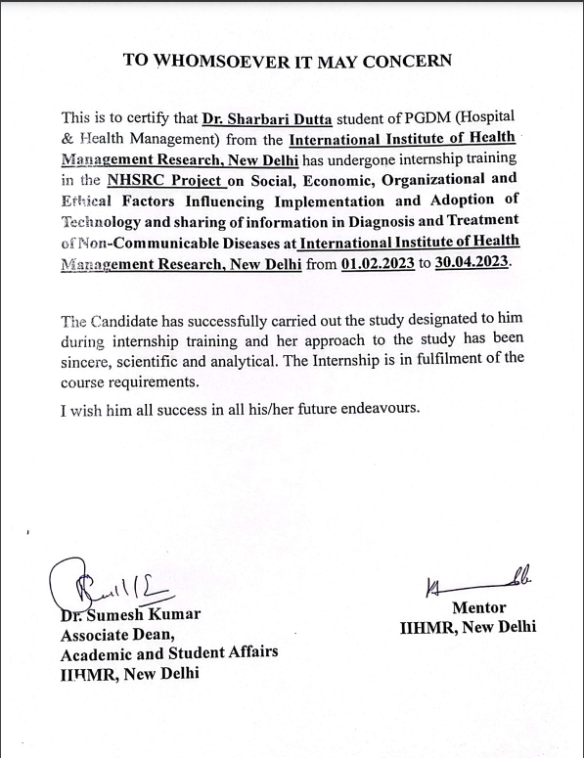
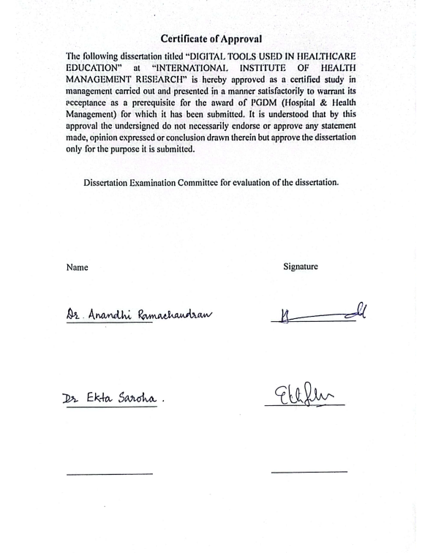

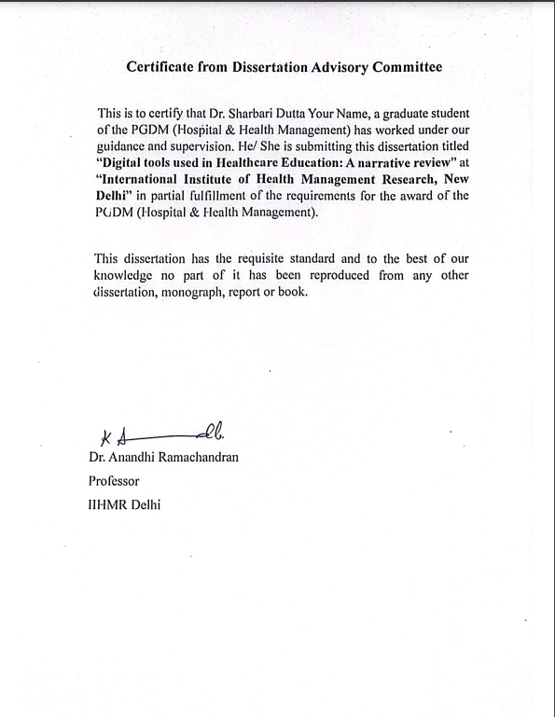

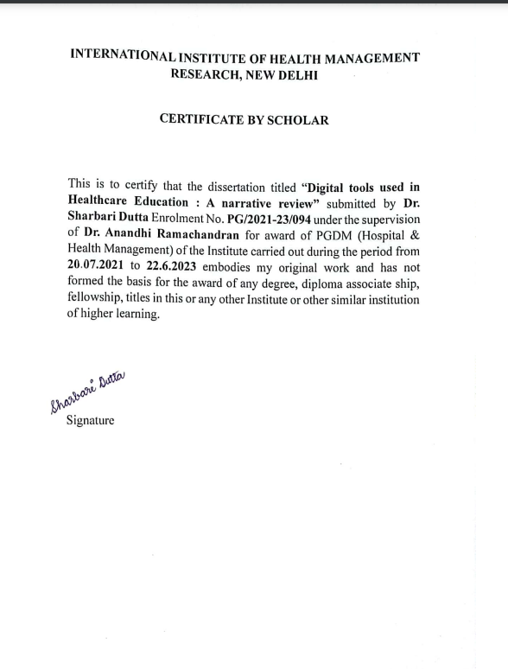

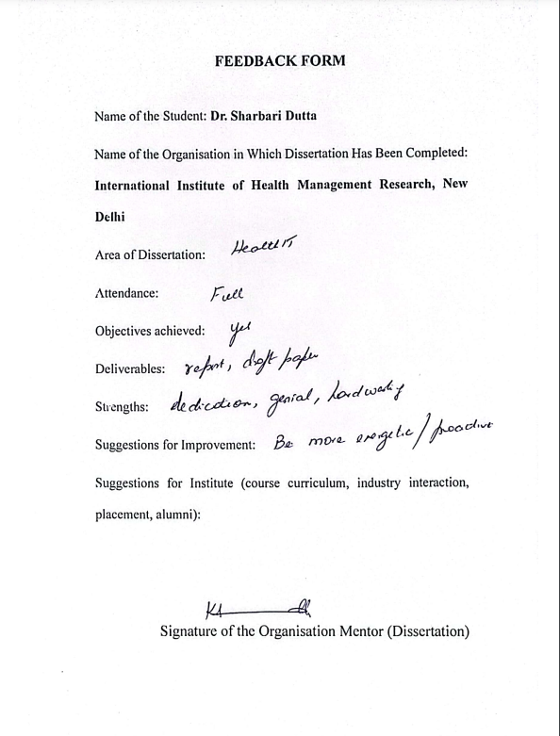
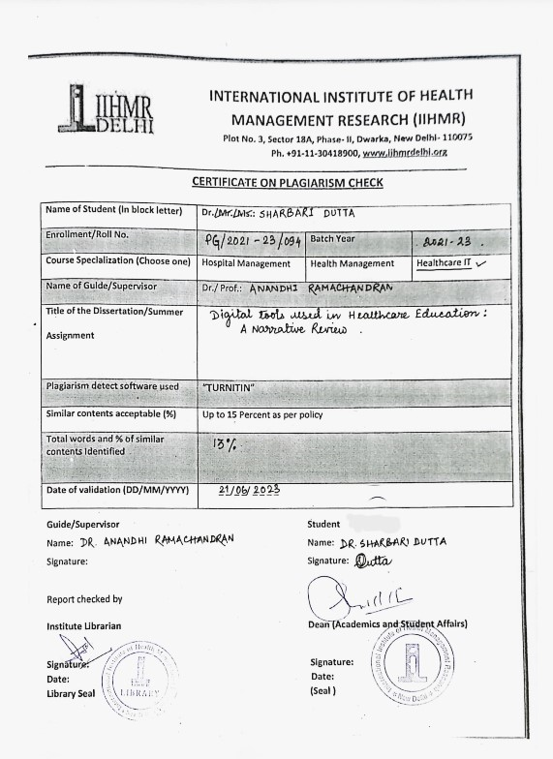

ACKNOWLEDGEMENTS

This has been a whirlwind for the past two years PGDM in Health and Hospital Management has shown me the highs and lows but overall it has been an extremely good learning curve in my life. From online and hybrid mode classes in the first year to fully offline classes and examinations in the second, the group presentations and report writing, the Internship at Fortis Memorial Research Institute taught me how hospitals run in India to the Health Information Technology classes which enlightened my digital acumen. Everything will be a remarkable jewel down the memory lane. The dissertation and project of NHSRC Digital adoption is what has taught me the importance of field visits in public health.
All of this has been possible for me because of my father
Mr. Uttam Kumar Dutta whose undying support has brought me where I am today and my mother, Mrs. Sharmistha Dutta whose trust in my abilities gives me courage and confidence. I am extremly grateful to them.
IIHMR Delhi has been a second home for the past 2 yrs for me and it has been because of certain eminent faculties and staff who have guided us on the way. Dr Sutapa Banerjee ma’am for being the efficient backbone of the institution, Dr Sumesh Kumar Sir, Dr Siddharth Sekhar Mishra Sir, Dr Pankaj Talreja sir, Dr B.S Singh sir, Dr. Nikita Sabherwal Ma’am, Divya Agarwal Ma’am for taking our classes and teaching us the management aspect of Healthcare and research.
Last but not the least my Health IT Teacher, my mentor in college and my dissertation, my project PI Dr Anandhi Ramachandran Ma’am and my teacher, guide and project Co-PI Dr Rupsa Banerjee Ma’am who have been instrumental in guiding me throughout the journey at various points in time.
I will be forever indebted to all of these eminent faculties and my friends and coworkers for the completion of my dissertation.

Special thanks to Dr. Nehadur Rahman Mallick and Dr. Palla Gayatri for helping me the past few months in the field visits for our NHSRC Project and also in my dissertation.

TABLE OF CONTENTS
CHAPTER | CONTENTS | PAGE NO.
I | LIST OF TABLES | 4
II | LIST OF FIGURES | 4
III | LIST OF ABBREVIATIONS | 5
CHAPTER 1 | OVERVIEW OF THE ORGANISATION | 6-12
1.1 | INTRODUCTION: | 6
1.2 | FOUR CORE ACTIVITIES ARE… | 7
1.3 | FEATURES OF THE ORGANIZATION | 8
1.4 | AIM OF THE ORGANIZATION | 8
1.5 | MISSION | 10
1.6 | VISION | 11
CHAPTER 2 | PROJECT OUTLINE AND ABSTRACT | 13-15
2.1 | BACKGROUND | 13
2.2 | OBJECTIVE | 13
2.3 | METHODOLOGY | 14
2.4 | DATA ANALYSIS | 14
2.5 | EXPECTED OUTCOME | 14
2.6 | ETHICAL CONSIDERATIONS | 15
2.7 | ABSTRACT | 16
CHAPTER 3 | INTRODUCTION AND OBJECTIVE | 17-19
CHAPTER 4 | REVIEW OF LITERATURE | 20-28
CHAPTER 5 | METHODOLOGY | 29-30
CHAPTER 6 | RESULTS | 31-38
CHAPTER 7 | DATA INTERPRETATION | 39-43
CHAPTER 8 | DISCUSSION | 44 -51
CHAPTER 9 | STRENGHTHS AND LIMITATIONS OF THE STUDY  FUTURE RESEARCH  CONCLUSION | 52-54
CHAPTER 10 | REFERENCES | 55-57
ANNEXURE 5 | PLAIGIARISM REPORT | 58-62

TABLE OF GRAPHS
SL. NO | GRAPH | PAGE NO
1 | Distribution of Articles based on Specialities | 32
2 | Distribution of Articles based on Countries | 32
3 | Distribution of Articles based on Continents | 33
4 | Distribution of Articles based on Study Design | 33
5 | Distribution of Articles based on Year of Publication | 34
6 | Distribution of Articles based on Course Learning Objectives | 36
7 | Distribution of Articles based on Instructional methods | 37
8 | Distribution of Articles based on Learning Assessments | 37
9 | Various Digital tools used in the studies | 38
10 | Assessment of Outcomes of digital tool implementation | 30

TABLE OF FIGURES
SL. NO | GRAPH | PAGE NO
1 | Overview of organisation -view | 1
2 | PRISMA FLOWCHART | 31
2 | CONSUME-CONTRIBUTE- CREATE DIAGRAM | 48

LIST OF ABBREVIATIONS
SL. NO | ABBREVIATION | FULL FORM
1 | PRISMA | Preferred Reporting Items for Systematic Reviews and Meta-Analysis
2 | NHS | National Health Service
3 | TEL | Technology-enhanced learning
4 | VP | virtual patient
5 | ChatGPT | Chat Generative Pretrained Transformer
6 | AR | Augmented Reality
7 | VR | Virtual Reality
8 | MR | Mixed Reality

Chapter 1

OVERVIEW OF THE ORGANISATION



Fig 1: IIHMR Delhi
1.1 Introduction:
In 2008, IIHMR University launched the International Institute of Health Management Research (IIHMR), New Delhi. Under the Societies Registration Act of 1958, IIHMR University was established in October of 1984. IIHMR-Delhi is critical to the optimal function of healthcare sector both in India and in the Asia-Pacific region especially in response to the growing demands of sustainable operation and administration solutions.
IIHMR Delhi is an institute of higher education that promotes research in the field of health and hospital management; helps develop expertise to formulation of policies; develops strategies and their effective implementation; promotes individual and institutional abilities to build a robust and efficient healthcare domain. Capacity building is not just limited to academic programs, but the multi-dimensional approach expands to management development programs, knowledge-based and skills-based training and development courses, research studies seminars/webinars and workshops.
1.2 Four core activities are…
- Academic postgraduate and doctoral courses in health and hospital management to meet in response to the emerging needs of the industry.
- Research related to framing of health policies and programs at national and global level.
- Management development programs to provide continued education and executive programs for working professionals to help them enhance their knowledge and upgrade their skills in response to the increasing demand of highly skilled healthcare professionals.
- Technical consultations to the flagship programs at state and national level to address the gaps in planning as well as strategizing.

1.3 Features of the Organization
The Institute is an autonomous body of international stature with the vision to shape tomorrow’s healthcare and has been developing leaders for several years by educating students in the fields of health, hospital, and health information technology.
Over the years IIHMR-Delhi has made its name in the national and global platform for carving out skilled and vibrant, socially aware healthcare management professionals. The institute has progressed as a leader in research, capacity building, community programs, and policy framing in the field of health care. Through its cutting-edge academic program, infrastructure accomplished by multidisciplinary faculty, and research, IIHMR has carved out a space for itself.
1.4 Aim of the Organization
IIHMR emphasizes the management aspects of health care, equipping students with skills in strategic planning, operations management, human resources management, and organizational behavior specifically tailored for the healthcare industry.
The institute's research programs cover health systems management, which includes understanding the structure, functions, and governance of health systems, as well as policies and regulations that govern the delivery of health care services.
IIHMR's programs offer training in hospital administration, covering topics such as hospital operations management, quality management, patient safety, and health care accreditation.
The institute provides insights into healthcare financing, including health insurance systems, reimbursement mechanisms, health economics, and cost-effectiveness analysis in healthcare.
With the growing importance of information technology in health care, IIHMR offers training in health information systems, health data management, health analytics, and the use of technology to improve health care delivery.
IIHMR incorporates economics training into their programs to develop an understanding of economic principles and their applications in health care decision-making, resource allocation, and health care policy analysis.
Several governmental and civil society organizations have contacted the IIHMR to offer technical assistance for capacity building and policy research requirements that will lead to the creation of creative and equitable health care solutions. Overall, IIHMR-Delhi strives to bridge the gap between theory and practice in health management by offering a comprehensive range of educational programs, conducting research, and providing support in policy formulation and implementation. They aim to strengthen health systems, improve health care delivery, and contribute to the overall advancement of the health care sector. IIHMR engages in research and advocacy activities to support the development and implementation of effective health policies and plans. They work towards promoting evidence-based decision-making, fostering collaborations with stakeholders, and advocating for equitable and sustainable health systems. Threats to the public health, natural disasters, armed conflicts, and related humanitarian crises are all addressed by IIHMR. This involves conducting research, providing technical expertise, and offering support in areas such as emergency preparedness, disaster management, and health system resilience. In addition to their Masters and doctoral programs, IIHMR-Delhi offers highly specialized and popular Management Development Programs (MDP). These programs are designed to cater to the educational needs of health professionals, both in-service aspirants and those from the country and overseas. The MDPs cover various topics in health management and provide practical knowledge and skills to enhance leadership and management capabilities.

1.5 Mission
IIHMR Delhi conducts research to generate knowledge and insights into health management practices and challenges. Their research activities contribute to evidence-based decision-making, policy formulation, and the development of innovative solutions for improving health care delivery. The institute provides training programs to develop skilled professionals who can effectively manage health care systems and programs. Their training programs cover a wide range of topics, including health management, health systems, hospital administration, health economics, and information technology, among others.
IIHMR Delhi offers consultancy services to organizations in the health care sector. They provide expertise, guidance, and solutions to address specific challenges and improve management practices. Their consultations may include areas such as strategic planning, process optimization, quality improvement, and operational efficiency. IIHMR Delhi actively engages in institutional networking at national and global levels. They collaborate with other organizations, academic institutions, and international bodies to exchange knowledge, share best practices, and foster collaborations in the field of health management. This networking helps in keeping pace with global developments, adapting to emerging trends, and promoting knowledge sharing.
By focusing on research, training, consultation, and institutional networking, IIHMR Delhi strives to contribute to the improvement of health care management and overall health standards, both at the national and global levels.

1.6 Vision
IIHMR is a premier institute dedicated to contributing to social equity and development by supporting programs aimed at the poor and deprived populations. Through its educational, research, and consulting initiatives, the institute aims to improve the health and well-being of marginalized communities and address healthcare disparities. IIHMR offers postgraduate and doctoral programs to meet the increasing demand for healthcare professionals in the field of public health, both at the national and global levels. These programs provide comprehensive education and training to equip students with the knowledge and skills necessary to address complex health challenges. IIHMR recognizes the importance of continuous learning and offers operational management development programs and administrative programs for working professionals. These programs enable healthcare professionals to upgrade their knowledge and expertise, keeping them abreast of the latest developments and trends in the healthcare industry. IIHMR places a strong emphasis on knowledge dissemination. The institute actively shares research findings, best practices, and expertise with the broader healthcare community. By disseminating knowledge and information, IIHMR aims to contribute to evidence-based decision-making and the advancement of healthcare management practices.

IIHMR's commitment to quality, responsibility, trust, transparency, and the dissemination of knowledge and information is reflected in its efforts to enhance healthcare management education, research, and program management. Through its initiatives, the institute strives to make a meaningful impact on social equity, support underserved populations, and improve the overall healthcare sector, both nationally and globally.

CHAPTER 2
PROJECT OUTLINE

2.1 BACKGROUND
Student-centered active learning and the development of clinical competency have become crucial elements of the education of future doctors to make them capable of sustainably coping with future problems, with the objective of providing patients with the best care possible. For the assessment of students' competency, new trends in teaching and assessment methods include Google Forms to collect students' answers, YouTube live streaming, and Google Art and Culture (an online art museum). These techniques also include computer-aided instruction, virtual patients, augmented reality, human patient simulations, and virtual reality.
Digital technology advancements will pave the path for a revolution in healthcare education by enabling individualised, interactive, and effective learning.¹

2.2 OBJECTIVE
To identify studies exploring digital tools in healthcare education and their impact in learning.

2.3 METHODOLOGY
- RESEARCH DESIGN: Literature based Narrative Review.
- DATABASES: Pub Med, Cochrane Library, Google scholar, JGATE,
- DATA COLLECTION METHOD: Secondary data analysis
- SEARCH TERMS: Combination of terms Digital; Students; Healthcare; Medical; Dental; Nursing; Pharmacy; Paramedical; Ayush; Homeopathy; Education; Teaching; Training; Capacity Building; Self learning.
- ELIGIBILITY CRITERIA
Inclusion Criteria:
1.English Language articles only
2.Articles related to healthcare, Medical and Dental education.
3. : Articles published from 2010-2023
Exclusion Criteria:
1.Articles describing development of teaching method
2.Articles describing development of teaching method and its impact is not included
3.Articles in languages other than English.
4.Grey literature-reviews, editorial, notes, blogs, newspaper, articles.
- STUDY DURATION: Articles published from 2010-2023
- 2.4 Data Screening method : Modified PRISMA guideline
- Data Analysis Tools: Ms. Excel..
- 2.5 EXPECTED OUTCOME: Identification of digital tools that have an impact on healthcare education. Number of publications that highlight the adoption of digital tools.

- 2.6 ETHICAL CONSIDERATIONS: Since data is collected from secondary data sources, ethical clearance for data collection was waived. The study has been approved by the IIHMR Institutional Scientific review board for this study.

ABSTRACT
Technology has entered every aspect of human life, enabling easier access to higher education in the twenty-first century and a platform for lifelong learning. The usage of digital tools and the trends of its effect on education among medicine and healthcare students in developed and developing nations are not yet narrowed down. Through computerised databases like Pub Med, Cochrane Library, Google Scholar, and JGATE, a thorough literature search was carried out. The search was limited to papers that were published between January 2010 and May 2023. A total of 23547 studies were identified through database searching with 12474 articles identified from Google scholar, 9507 from PubMed, 568 articles from Cochrane and 998 articles from JGATE. Of these, 15698 studies screened using title and abstract. 4111 full text articles were screened. Themes were identified and studies were classified based on the identified themes and the descriptive analysis of the shortlisted articles. Utilizing augmented reality, virtual reality, mixed reality, or mobile learning (mLearning) to improve the immersive nature of education and learning.
Virtual patient simulation or gamification and use of applications for learning as students can manipulate virtual representations of these images, practice diagnosing conditions, and develop skills in medical image analysis and interpretation. Students can practice surgical techniques, medical interventions, and patient interactions in a safe and controlled virtual environment. These simulations provide valuable hands-on experience, enhance procedural skills, and improve decision-making abilities.

CHAPTER 3
INTRODUCTION
Medical education and training is undergoing a digital revolution from the traditional method of education and training to e-learning, making learning possible without any time and place restrictions. By providing more inexpensive, standardized, timely, and accessible medical education and appropriate training, the use of digital technology in the education of health professionals can tackle the issues linked to the health workforce.²
Technology has entered every aspect of human life, enabling easier access to higher education in the twenty-first century and a platform for lifelong learning. Today's society is accustomed to technology-enhanced learning (TEL), which integrates information and communication technology (ICT) into teaching and learning. Technology growth has a significant impact on many fields, including medical education and training, which has its own demands and introduces new requirements.³
Recent published material showcasing the effectiveness of various digital education modalities is widely available and serves as proof that the use of digital training and education has increased significantly. Finding research gaps throughout the entire spectrum of pertinent information can help us uncover pertinent research topics and minimise research waste. We can assess important concerns with regard to digital health education by establishing a map of the existing research, then developing a conceptual framework outlining essential modules of digital education and concentrating on particular research questions across a broad research framework.²
The usage of digital tools and the trends of its effect on education among medicine and healthcare students in developed and developing nations are not yet narrowed down. The COVID-19 pandemic's social isolation policies have altered how education is delivered globally, even to health professionals. During this time, a lot of medical colleges and other healthcare-related educational institutions had to rely on digital learning. Because of this fast transformation, research and evidence are even more important in the training of digital health practitioners.⁴
There is a transition in both undergraduate and postgraduate curriculum including training, learning and demonstrating competencies in the learner.
Firstly, the medical knowledge boom that is brought on by published literature, doctors are unable to retain all the information they need to give their patients the best possible care. An estimated 600,000 publications in the biomedical field are published annually, making it practically impossible for a student to keep up with them. Even if he reads two articles a day for a year, he would be 800 years behind.⁵
Secondly, ‘Digital natives’ is a term coined by Prensky defining the new generation of young individuals with digital expertise accustomed to technology enhanced learning platforms and their expertise in different types of technology integration. Physicians need to be life long learners and this concept applies to the new generation of digital natives as well though they prefer digitalization even in the aspect of in taking knowledge.⁶
Finally, the field of medicine is emerging with technologically enhanced methods of care delivery. Basic information acquisition, improved decision-making, improved psychomotor skill coordination, handling rare or crucial situations, learning how to train a team, and developing diagnosing perceptions are among the objectives of digitalizing medical education. Various technologies can be applied to improve these unique goals.⁴
Some of the platforms that are available to transform the changing educational landscape include online self-paced e-learning courses, educational web-based applications, chatbots with artificial intelligence like ChatGPT (Generative pretrained Transformer), podcasts and videos with flipped classrooms, mobile devices with games and online peer assisted learning, simulations like part-time trainers, integrated simulators, virtual and augmented reality, and wearable technology like Google Glass.⁵

OBJECTIVE

To identify studies exploring digital tools in healthcare education and their impact in learning.

CHAPTER 4
REVIEW OF LITERATURE
- 1. In a paper titled Digital Education for Health Professionals: An evidence map, conceptual framework, and research agenda, Car LT et al. highlighted the significant modifications that have occurred in the field of education as a result of the introduction and widespread usage of digital technology. They looked for systematic reviews on the digital education of practising and student health care professionals on MEDLINE, Embase, Cochrane Library, CINAHL, and grey literature sources from 2014 January to 2020 July with the aim of identifying gaps and mapping the existing evidence and research priorities to enable robust and relevant research in digital health professions education. Two writers screened and extracted the data, and they then identified the important traits of the reviews, the calibre of the evidence, and recommendManal Kleib et al performed scoping review on undergraduate and graduate nursing students' education and training in digital health: a scoping review. The objective of this review is to collect and assess literature reporting on digital health teaching and learning courses, or other interventions, for nursing students at the undergraduate and graduate standards to note any gaps and reform the development plan of future educational interventions. Searches were conducted in Embase, CINAHL, ERIC, MEDLINE, Scopus, and Education Research Complete to retrieve potentially relevant studies using the Preferred Reporting Items for Systematic Reviews and Meta-Analysis (PRISMA) flow diagram. Quantitative data were analyzed using descriptive statistics. Reskilling the nursing workforce is essential in technology-driven care to lead the digital health future and improve patient care. Nursing informatics frameworks inform nursing education and practice but did not address the entire digital health spectrum.
- 2. From December 2021 to January 2022, students and instructors from four homoeopathic colleges in India participated in a multicentric, cross-sectional study by Gautam Pal et al. on the acceptance and difficulties of online homoeopathic medical education in India during the ongoing COVID-19 pandemic. The investigation came to the conclusion that due to lockdown and physical separation, digital schooling was the only option during the Covid 19 era. There are very few research on the integration of digital learning into homoeopathy curricula. The study determined that the use of digital education has been compelled to be adopted at all levels during the current SARS-CoV-2, lockdown, and physical distance age. The study's objective was to evaluate the difficulties, acceptance, and efficiency of online homoeopathic education in India. While teachers expressed concerns about the quality of interactions and participation in class, students praised eLearning for its flexibility, cost-effectiveness, frequency of lessons, capacity to complete the syllabus, and comfort level. Although the majority favoured the online format, many people did not see it as a viable alternative academic platform in the years to come. The most desired ac

- A study on digital health education was conducted by Holland Brown TM et al. The National Health Service (NHS) needs a workforce that is digitally capable and knowledgeable about the practical application of digital technology, such as wearables, artificial intelligence, and Internet of Things. Staff members who have received digital health education are better equipped to access modern, high-quality digital health interventions. Despite the fact that the government has given digital health a high priority, there is a discrepancy between the education that medical students and employees should have and what they really receive. Training, continuing professional development programmes, and medical school curricula must all integrate digital health education. Equitable access to healthcare information and services is made possible by improved digital access during the COVID-19 pandemic. Many doctors and paediatricians used remote video consultations during the COVID-19 pandemic to remotely track, monitor, and manage conditions as well as advise on appropriate health app use and advocate for improved patient access to digital solutions because the use of various health applications sharply increased during COVID-19 as patients self-monitored and managed their conditions. However, the majority of health applications did not meet government standards. Medical records should now include information about a patient's digital accessibility, environment, and literacy.

- A successful virtual reality-based medical simulation environment was studied by Sanchit Gupta et al. Medical education innovation is necessary. In today's world, manikin-based simulation is the gold standard for enhancing clinical training. However, creating and integrating a VR-based medical simulation environment into a curriculum can be a thrilling endeavour that improves future clinicians' learning opportunities. The newest technique of delivering medical case simulations that requires less infrastructure and offers better accessibility and flexibility is virtual reality (VR). VR is rapidly being included into medical curricula in some hospitals, but its widespread adoption would fundamentally alter how future medical professionals receive their training. a list of practical suggestions for developing and incorporating a VR-based medical simulation system within their curriculum.

- Carrie Tran et al. used an interprofessional virtual patient to conduct a mixed-methods study on how medical students learn about other professions while communicating remotely with a study group. To educate students for future clinical work, health care education must work in collaboration with other professions. The goal of the study is to see if using an interprofessional virtual patient (VP) case may help medical students learn about working together as a team in virtual settings and to see how they engaged with the VP while studying separately from their group. Interprofessional education is still a challenge in health care education. VPs and distance learning could be helpful additions to existing interprofessional learning strategies for students. The interprofessional vice president appeared to aid pupils' learning in a remote, online setting.

- Fernanda Loureiro conducted an exploratory study on Nursing Students' and Teachers' Digital educational technology (DET) use. Concerns about the individualization of treatment and instruction are brought up by DET ascent. Nursing care and the nursing teaching-learning process must undergo major changes as a result of the use of DET. With the intention of supporting an exploratory-descriptive, cross-sectional, and observational study with a quantitative methodology (descriptive and inferential statistics) was developed to examine how DET could improve the teaching-learning process. Following approval by the ethics committee, online questionnaires were used (n = 140 students and n = 23 professors). How DET could improve the teaching-learning process. Following approval by the ethics committee, online questionnaires were used (n = 140 students and n = 23 professors). According to the findings, low costs and access without time or location restrictions are the key advantages, while fewer interactions, less physical contact, and technical challenges are the main drawbacks. In general, there was no distinction in the use of DET between students and teachers. Men do, however, report more restrictions than do women. The application of DET in this example is still in its infancy. The results show that the main benefits are low costs and access without time or place limits, while the main disadvantages are fewer encounters, less physical contact, and technical difficulties. In general, there was no difference in how DET was used by teachers and students. However, men report having greater constraints than women. In this instance, DET is only beginning to be applied.

- Arun Sivananthan used mixed reality headsets to test the HoloLens 2's viability. COVID-19 has had a terrible impact in terms of the number of lives lost during the COVID-19 Pandemic to Deliver Remote Bedside Teaching. Due to the sufficiently stringent infection control regulations, medical trainees were unable to attend clinical teaching, which also had an effect on medical education. Lecture-based instruction has been easily converted to a digital platform, but bedside teaching has not. In this study, a mixed reality (MR) headset will be used to assess the practicality of remote bedside training. Respondents to the prequestionnaire (n=24; median 7, IQR 6-7) agreed that bedside education is crucial for training doctors. In postsession questionnaires, participants generally stated that they found the MR session to be valuable and helpful to their learning (median 6, IQR 5.25-7). When employing mixed reality instead of in-person training, there was an 83.3% decrease in PPE use and a 79.5% decrease in cumulative clinician exposure time. This study illustrates the viability of providing clinical bedside training using HoloLens. In terms of limiting trainee exposure to COVID-19, reducing the need for PPE, promoting more attendance, and offering straightforward and approachable real-time clinical training, this novel format offers significant advantages.
- Assunta Patano conducted a systematic review during the COVID-19 Pandemic, educational technology was used in orthodontics and paediatric dentistry. The traditional teaching methods used in medical education have been replaced with telematic and networking scholar and e-learning approaches over the past ten years. The purpose of the current systematic review was to assess the efficacy and acceptability of e-learning in the fields of orthodontics and paediatric dentistry among teachers and students. Between January 2005 and May 2021, a database search of the literature was done on the PubMed and Embase databases. A total of 172 publications were found through the electronic search, and 32 of them were chosen for qualitative study. A total of 19 papers examined the effectiveness of e-learning, and for the vast majority of the selected articles, there was no evidence of a distinction between e-learning and conventional methods in terms of adoption. A learner satisfaction survey was included in a total of 25 articles, and it revealed that all respondents were happy with e-learning. The results showed that e-learning is an effective method of instruction, boosting traditional teaching strategies, and that students' attitudes and perceptions were positive. The findings of the current study showed that e-learning techniques in the fields of orthodontics and paediatric dentistry had a high degree of acceptability and knowledge in comparison to frontal lecture approaches.
- A scoping review on the potential effects of artificial intelligence on nursing education was carried out by Christine Buchanan. Nursing is projected to undergo a revolution thanks to artificial intelligence (AI), which will impact management, clinical care, education, legislation, and research. The potential effects of AI health technologies (AIHTs) on nursing in general and nursing education in particular are being studied by researchers more and more. Synthesising this body of work, however, has not gotten much attention. A survey of the effects that already exist and those that AIHTs are expected to have on nursing education over the next 10 years and beyond was conducted. This scoping review followed a procedure that was first made public in April 2020. A well-known scoping review methodology was used to search the databases of MEDLINE, Cumulative Index to Nursing and Allied Health Literature, Embase, PsycINFO, Cochrane Database of Systematic Reviews, Cochrane Central, Education Resources Information Centre, Scopus, Web of Science, and ProQuest. In addition to utilizing these electronic resources, a targeted website search was conducted to find relevant grey literature. Two reviewers examined paper abstracts and full texts independently using predetermined inclusion and exclusion criteria. Included publications focused on nursing education and AI-infused digital health technology. The data was charted using a methodical methodology and then narratively categorized. The total number of articles found was 27, consisting of six quantitative or prototyping investigations, six explanatory papers, and one qualitative study. The group consisted of nurses, nurse educators, and nursing students at the entry-level, undergraduate, graduate, and PhD levels. Robotics, smart homes, predictive analytics, virtual or augmented reality, and virtual or augmented reality apps are just a few of the AIHTs that were discussed. The research divided the effects of artificial intelligence on nursing education into two main categories: those on clinical practise and those on academic institutions. Nursing education programmes in academic institutions and clinical practise environments urgently need to modify their curricula to better assist students at all educational levels, and instructors must adopt new and developing pedagogies that use AI. This is necessary to prepare nurses and nursing students for practise safely and effectively in the age of AI. Nursing students and practicing nurses must also be given the essential knowledge and skills in order to assess AIHTs successfully and safely implement those found to be appropriate to improve person-centered compassionate nursing care in clinical settings.

CHAPTER 5
METHODOLOGY
The study conducted was a Literature based Narrative Review.
SEARCH STRATEGY AND DATA SOURCES:
Through computerised databases like Pub Med, Cochrane Library, Google Scholar, and JGATE, a thorough literature search was carried out. The search was limited to papers that were published between January 2010 and May 2023 since before to this time, only very rudimentary tasks were performed on mobile devices for educational purposes. The structured search can be done using the following keywords: combination of terms Digital; Students; Healthcare; Medical; Dental; Nursing; Pharmacy; Paramedical; Ayush; Homeopathy; Education; Teaching; Training; Capacity Building; Self learning. Secondary data analysis was performed using MS. Excel and PRISMA. Based on the selection criteria, every study that was considered appropriate for inclusion used the PICO Strategy. The study is a narrative evaluation of the literature with secondary data collection and article summaries on the use of digital tools in the training of healthcare and medical professionals.
ELIGIBILITY CRITERIA
The Inclusion Criteria for this study were (1) Articles written in English alone and (2) Articles related to healthcare, Medical and Dental education. The Exclusion Criteria for the study were (1) Articles describing development of teaching method, (2) Articles describing development of teaching method and its impact (3) Articles in languages other than English and (4) Grey literature- like reviews, editorial, notes, blogs, newspaper articles, etc.
STUDY SELECTION:
The studies included virtual classrooms, web-based distance learning, videos, pictures and animations, and webinars for imparting knowledge. Smartphones, tablets, laptops, kindle books, wearable devices, mobile health applications, emails, instant messaging, academic electronic health records, and electronic charts are introduced to help check medication errors while teaching nursing students. Learning management systems like Canvas, and Moodle. Interactive simulations and Artificial Intelligence in medical education. ChatGPT , Chatbots, augmented reality , virtual reality have become a part of medical education. Social networking applications like Facebook, Twitter, Instagram have enhanced the awareness related to e-learningVirtual healthcare and clinical decision support systems are taught practically in medical and healthcare professions. mLearning is gaining importance as a form of instruction for speciality training as well as ongoing education in medicine and healthcare.
DATA EXTRACTION:
Two people independently extracted articles based on pertinent details regarding participants, intervention, comparators, outcomes, measures, and results from all included studies. They then double-checked their work for any errors.
ANALYSIS:
Modified PRISMA guideline, have been used for identification and screening of articles and Ms Excel have been used to analyse data.
CHAPTER 6
RESULTS
Title and abstracts screened (n)= 15698

Duplicate removed = 7849
Full text articles sought for retrieval (n) = 4111

Articles Included = 150
Articles searched across databases (n)= 23,547
google scholar= 12474
PubMed = 9507
Cochrane = 568
JGATE= 998
Articles excluded (n) = 11587
Not related to Teaching and Learning = 1358
Not about education or students = 1236
Not about digital literacy or increasing digital skills in education = 1367
S CREENING
IDENTIFICATION
INCLUDED

FIG 1. PRISMA FLOWCHART

Themes Identified
1. Course Learning Objectives
Develop digital skills.
Prepare for future practice.
Build discipline specific remote caring skills
Assess student or patients online
Create an online tool
Understand

2. Instructional Methods
Demonstration of remote care
Video conferencing
Online modules
Consultations with patients
Online discussion platforms
Reflection on learning

3. Learning Assessments
Performance-based assessments
Discussions
Critical reflections
Clinical cases
Development of online tools
Tests and quizzes
Presentations

4. Digital Tools Used
Offline digital education
Open online course
Recorded Videos/Live Webinars
Mobile education
Serious games and gamification
AR/VR/MR
Virtual patient
High fidelity mannequins
Blended education
AI Tools/applications/GPT

5. Outcomes of digital tool implementation
Knowledge
Skill
Satisfaction
Patient outcomes
Performance
Attitude
Behaviour

CHAPTER 7
DATA INTERPRETATION

A total of 23547 studies were identified through database searching with 12474 articles identified from Google scholar, 9507 from PubMed, 568 articles from Cochrane and 998 articles from JGATE. Of these, 15698 studies screened using title and abstract. 4111 full text articles were screened while The final synthesis featured just 150 papers. The direction of the literature in our review is shown in Figure 1.
Study characteristics
Graph 1 shows the percentage of studies in different specialties: Healthcare articles (32/150), Medical (44/150), Dental (16/150), Paramedical (10/150), Nursing (29/150), Pharmacy (17/150), Homeopathy (1/150), Ayush (1/150).
Graph 2 shows articles distribution from different countries USA(21/150), UK(12/150), Canada (16/150), Australia(3/150), Netherlands(2/150), India(11/150), Russia(3/150), France(3/150), Switzerland(3/150), Finland(2/150), Iraq(1/150), Norway(3/150), Japan (5/150), China(7/150), Singapore (6/150), Egypt(3/150), Turkey(3/150), Korea (2/150), Saudi Arabia(5/150), Czech Republic(2/150), New Zealand(7/150), Kazakhstan(2/150), Italy(4/150), Germany(4/150), Syria(4/150), Colombia(2/150), Ethiopia (4/150), Portugal (2/150), Iran (2/150), Spain(3/150).
Graph 3: shows the different continents of Europe (47/150), Asia (44/150), North America (37/150), Africa (11/150), Australia (9/150), South America (2/150)

Graph 4 shows different study designs adopted by the studies included in the review Cross sectional survey (10/150), Quantitative Study(9/150), Mixed methods (12/150), Randomized control trial (17/150), Cross sectional(21/150), Systematic review(30/150), Bibliometric analysis(2/150), Scoping review(28/150), Meta analysis (21/150).
Graph 5 shows years of publication of the studies. The studies of 2021 to 2023 are 90, 57 publications during 2018 to 2020 and 2015 to 2017 have only 3 publications.
Graph 6 shows the course learning objectives of the various studies. The objectives being develop digital skills (42/150), prepare for future practice(30/150), Build discipline specific remote caring skills(26/150), Assess student or patients online(21/150), Create an online tool(18/150), Understanding of content(13/150).
Graph 7 shows Instructional methods used in the articles with Demonstration of remote care (34/150), Video conferencing (33/150), Online modules (28/150), Consultations with patients (26/150), Online discussion platforms (2/150), reflection on learning (4/150),
One common form of online discussion assessment is through e-consults, which involve students seeking advice or feedback from instructors or peers using digital communication tools such as email, discussion boards, or chat platforms. E-consults provide a convenient way for students to ask questions, clarify concepts, or seek guidance on assignments or projects. Another form of assessment is through students providing feedback to their peers. This can be done through peer review processes, where students review and critique each other's work. Peer feedback helps foster critical thinking, collaboration, and the development of constructive communication skills. Graph 8 described the Learning Assessments of the studies. Performance based assessments (33/150), Discussions(32/150), Critical reflections (30/150), Clinical cases (27/150), Development of online tools(17/150), Tests and quizzes(6/150), Presentations (5/150). Overall, online discussion assessments, e-consults, peer feedback, group discussions, and learning community forums provide valuable opportunities for students to actively engage in their learning, collaborate with peers, and demonstrate their understanding and application of technology in meaningful ways. These assessments promote deeper learning, critical thinking, and the development of essential skills necessary for success in real-world settings. Students are assessed on their ability to gather comprehensive patient histories, perform accurate physical examinations, and formulate appropriate differential diagnoses.¹² These performance-based assessments in healthcare education aim to evaluate students' practical skills, clinical reasoning, communication abilities, professionalism, and their application of knowledge in realistic scenarios. By engaging in these assessments, students develop critical competencies required for effective healthcare practice.
Graph 9 demonstrates the various digital tools used in the studies like Offline digital education (20/150), Open online Course (18/150), Recorded vdeos/live webinars (18/150), Mobile education (17/150), Serious games and gamification (167/150), AR/VR/MR (15/150), Virtual patient(14/150),High fidelity mannequins (13/150) Blended education(13/150), AI Tools/Applications/ChatGPT(6/150). Students may be asked to watch a video related to the course content and then reflect on their observations, insights, and questions. This reflection can be done individually or in discussion forums, allowing students to engage in meaningful dialogue with their peers.
Utilizing augmented reality, virtual reality, mixed reality, or mobile learning (mLearning) to improve the immersive nature of education and learning.
Virtual patient simulation or gamification and use of applications for learning as students can manipulate virtual representations of these images, practice diagnosing conditions, and develop skills in medical image analysis and interpretation. Students can practice surgical techniques, medical interventions, and patient interactions in a safe and controlled virtual environment. These simulations provide valuable hands-on experience, enhance procedural skills, and improve decision-making abilities.
Blended learning on the other hand, offers a flexible and adaptable approach that leverages the benefits of both traditional and online learning. It can enhance student learning outcomes, promote active engagement, and prepare students for the digital age by integrating technology into the educational experience.
The integration of online approaches into the classroom can face barriers, including teachers' confidence in using technology. However, it has been suggested that these challenges can be overcome when faculty take an intentional approach in addressing them. With proper support and training, teachers can become more confident and adept at integrating technology effectively. Graph 10 described the Assessment of Outcomes of digital tool implementation: Knowledge (31/150), Skills (29/150), Satisfaction (25/150), Patient Outcomes (24/150), Performance (20/150), Attitude (13/150), Behaviour (8/150).
The perceived relevance of the technology used in online classrooms is crucial. If students do not perceive the technology as relevant to their educational or professional goals, they may become skeptical of its utility and struggle to envision its application in real-world practice. It is important for educators to demonstrate the relevance and practicality of the technology to foster student engagement and motivation. Concerns about assessment methods can create uncertainty and reluctance to engage with new technologies. The professional, social, and personal development of pupils might also be badly impacted by designs that don't provide possibilities for human interaction. Interpersonal relationships and group learning activities are valued by students. When online learning activities are devoid of human interaction, it can hinder their overall development and engagement. To address these barriers, it is important to provide clear communication about assessment expectations, ensure designs incorporate opportunities for human interaction, emphasize the relevance of technology to students' future careers, and explore alternative assessment methods that maintain a personal connection between instructors and students.

CHAPTER 8
DISCUSSION

Medical trainees are adult learners who have unique characteristics and preferences when it comes to learning. Medical graduates are often motivated by patient related problems and challenges and take responsibility for their own learning. They prefer learning that is directly applicable to their professional lives. Adult learners are motivated by their own personal goals, interests, and aspirations.⁶ They are driven by the relevance and value they see in the learning materials. They often have multiple commitments and time constraints, such as work, family, or other responsibilities. They need flexible learning options that can be integrated consuming medical literature followed by contributing the knowledge and creating medical content for which digital medium of education is the most flexible and user-friendly option.⁷
Medical trainees undergo a rigorous and structured educational process to become competent healthcare professionals. They undergo a rigorous curriculum that covers foundational sciences, clinical skills, and patient care. They learn through a combination of didactic lectures, laboratory sessions, small-group discussions, and clinical rotations.⁸ To engage with available resources, they can focus on problem-based learning approaches. They can seek out case studies, medical literature and textbooks that help them understand how to apply knowledge and skills in patient care. They can engage with resources that allow for self-paced learning, such as online courses, interactive tutorials, or e-books. They can also explore self-assessment tools or quizzes to gauge their understanding and progress. into their busy schedules. ⁷
The pattern that is often seen in medical and healthcare aspirants is consume-contribute-create cycle of learning and education.⁹
CONSUME
Comprehensive and in-depth information on a variety of medical topics can be found in medical textbooks. They serve as foundational resources for acquiring core knowledge. Medical journals contain the latest research findings, case reports, and evidence-based studies.⁷ Traditional lectures, whether in-person or recorded, are valuable educational resources. They provide structured learning experiences, often delivered by experts in the field, and cover a wide range of medical topics.⁸ Medical conferences bring together professionals from different specialties to present and discuss the latest research, innovations, and best practices. Medical podcasts, online tutorials, recorded lectures, surgical demonstrations, and medical animations, provide visual and interactive learning experiences.⁹ Platforms like YouTube and medical-specific websites host a vast array of video resources. Medical blogs written by professionals, experts, or trainees themselves provide a more informal and personalized approach to learning.¹⁰ Platforms like Twitter and Instagram have become popular mediums for medical education. Trainees can follow medical professionals, organizations, and hashtags related to their areas of interest. They can engage in discussions, participate in Twitter-based journal clubs, and access bite-sized educational content. Trainees can access interactive modules, online textbooks, question banks, and other resources that offer up-to-date information, rapid updates, and collaborative learning opportunities^{.11}
CONTRIBUTE
Your professional development can be greatly aided by contributing to educational platforms, particularly by publishing original research or case reports in peer-reviewed publications.12 The existing body of scientific literature can be improved and useful knowledge can be made available to a specific audience by contributing to traditional educational venues like peer-reviewed journals. This helps advance medical knowledge and allows other healthcare professionals to benefit from the research findings or clinical experiences.⁷ Actively contributing to educational platforms can help connect with other professionals in the field. Collaborating with colleagues, engaging in discussions, and sharing the research work can help build a network of like-minded individuals who share common interests and goals. This network can provide support, collaboration opportunities, and professional mentorship.⁶
CREATE
In the past, traditional educational tools frequently adopted a top-down strategy with significant separation between the learner and the educator^{.8} A more collaborative and empowering learning environment has been created as a result of the emergence of free, open access, and digital medical education approaches^{.12} Platforms for online medical education give students the opportunity to actively participate and share their expertise as well as consume information. Learners can engage in discussions, provide insights, and contribute to the creation of educational content. Trainees can create educational content such as blogs, podcasts, videos, or social media posts to disseminate valuable information, cases, or research findings.¹³ This allows them to contribute to the educational community and make a positive impact on their peers and future learners.¹⁴ Online communities, forums, and social media platforms provide avenues for collaboration, discussion, and knowledge sharing. Learners can connect with peers, seek guidance from experts, and engage in collaborative projects.¹⁵ This collaborative environment promotes a sense of community, support, and collective growth. Through blogs, videos, podcasts, and other mediums, learners can express their creativity, critical thinking, and problem-solving skills. This content creation not only benefits the learners themselves but also contributes to the diversity and richness of educational resources available to others.¹⁶
In comparison to other disciplines, medicine has produced the most research in this area, and the publication of multidisciplinary studies has increased recently. This would imply that a future-focused approach to successfully integrating remote caring into our digital economy involves teaching effective caring practises to students from a variety of care-related occupations.^{.17} As teachers continue to adopt more student-centered methods that utilize face-to-face time for in-depth thinking, engaging, and applying material, note-taking practises in the classroom may change.18 The way that students approach studying may change if they are given more responsibility for managing their own learning processes. Lecture transcription may become less of a challenge when instructors employ technology to offer offline courses, recorded lectures, e-learning materials, etc.¹¹
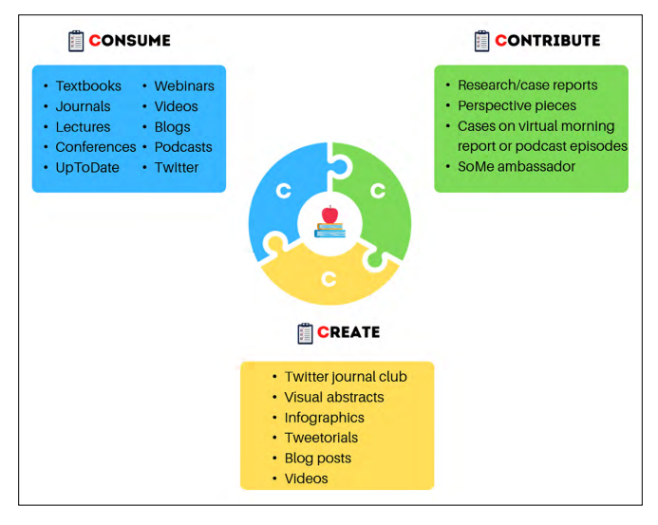
Fig 2: CONSUME-CONTRIBUTE-CREATE CYCLE Of Learning and education observed among medical and healthcare learners.

The effectiveness of VR for teaching medical students, nurses, and a variety of medical procedures, including clinical anatomy and radiation oncology, has been demonstrated in a number of prior studies.¹² Due in large part to the increased student involvement in the learning process, this technology is regarded as a more effective instructional tool than passive teaching approaches like learning from a textbook, slideshow, or lecture. ¹³
Our research found that students' growth can be positively impacted by the intentional inclusion of online digital technology in the clinical practises of healthcare professions.¹⁴ Overall, the research' findings indicate that students acknowledged the benefits of these digital techniques and expressed or demonstrated increased comfort and ability when implementing their newly acquired knowledge.¹⁵
ICT is largely interwoven into the numerous facets of teaching, learning, and information management in the universities that train healthcare professionals. While teaching, managing exam results, delivering lectures, and registering new students, college teachers use PowerPoint, word processors, electronic books, and social networking sites.¹⁶ It is, however, ineffectively incorporated into the creation of the lesson plan and the evaluation of the healthcare students. The challenges mentioned at remote locations were a lack of faculty experience, an unpredictable power supply, a lack of task-appropriate ICT gear, and insufficient teacher ICT training. Training the faculty members on how to effectively use contemporary ICT technologies for teaching and learning can overcome these hurdles and better train students.¹⁷
The most common learning objectives of using digital media for learning and education were to develop digital skills in students of the healthcare domain, prepare them for future clinical practice using digital devices, build domain and discipline-specific remote caring skills, create an online tool for imparting education or simply to improve understanding of students.¹⁸
Virtual patient simulation or gamification and use of applications for learning as students can manipulate virtual representations of these images, practice diagnosing conditions, and develop skills in medical image analysis and interpretation.²¹ Gamification in the classroom increases student engagement, fosters enthusiasm for the lesson, offers immediate feedback, and, in general, students learn better when they are having fun. Apps like EdApp, Edgagement, and WizIQ use gaming in the classroom to bring together the fun part of play with the content and concepts that students must learn.¹⁹
Academic accomplishment and digital education have a strong association, with mobile learning emerging as the most popular digital learning instrument.
To improve the immersive quality of education and learning, augmented reality, virtual reality, and mixed reality are primarily utilised to interactively instruct healthcare students and develop future clinical abilities. HoloLens Headset, for instance.¹⁸
AI tools and algorithms can alert students and healthcare professionals to discrepancies in medical records, enabling them to take the necessary steps to improve patient conditions. Enlitic CurieTM, Curie ENDEXTM, and Viz ai are additional technologies that assist healthcare professionals in comprehending how various treatment options interact with one another and impact a patient's health. MethdAI, Replika, automated essay scoring utilising clinical decision-making questions, evaluation of fundamental laparoscopic skills, grading of student case summaries, attendance monitoring, to name a few examples of how AI is applied in learning assessments include.¹⁷ A combination of transcription technologies like Otter.ai with chatbots like ChatGPT, Jasperchat, DialoGPT, etc. The most well-known of the list, ChatGPT, has a remarkable capacity for content creation. Along with personalised instruction, research support In order to evaluate student essays and papers and study a paper's sentence structure, vocabulary, grammar, and clarity, ChatGPT can be a useful tool. A substantial amount of textual data was used to train the Generative Pre-trained Transformer (GPT).¹⁹
Online discussion assessments, e-consults, peer feedback, group discussions, and learning community forums provide valuable opportunities for students to actively engage in their learning, collaborate with peers, and demonstrate their understanding and application of technology in meaningful ways.²¹

CHAPTER 9
STRENGTHS AND LIMITATIONS OF THE REVIEW:

The review includes the most recent data on eLearning's usefulness in health professions education and training as well as the use of digital tools in medical and healthcare education. These findings are supported by extensive search techniques, screening, data extraction, and assessment of the available data.¹⁸ However, despite being robust, the methodology may have introduced a number of biases during the evaluation process.
Although quality checks have been made to eliminate them, common biases like the researcher's bias may be present in the study eligibility criteria, identification of the research studies, data extraction, and study appraisal. Prior to the study's execution, the protocol was published and included explicit language regarding the eligibility requirements. Other databases, such as Scopus, were not included. The search method was developed using several categories for medical, paramedical, and healthcare subjects in the included databases, as well as for a number of other digital learning modes. In the first stage, titles and abstracts were checked before full text insertion. If the studies included lack certain data that might be connected to the study outcomes, data availability bias may develop. Risks of publication bias include the possibility of underrepresented data and a falsely positive outcome, as well as the possibility of bias in attrition and reporting. There were not enough studies included in the review comparisons to conduct the necessary subgroup analyses, which were crucial for the outcomes of the comparative groups.

FUTURE RESEARCH
The review has identified research gaps which can bring forward the effectiveness of the digital tools in medical and healthcare education more explicitly. Further research should be targeted approach of digital learning and training, assessment of digital competency, interactive instructional design with theoretical and practical approach, provide information regarding the effects of digital tools in learning and education of medical and allied health professionals based on patient outcomes, cost effectiveness of the digital methods and short- and long-term outcomes.¹⁹

CONCLUSION:
Digital teaching, learning, and assessment tools are here to stay. The healthcare industry is evolving new mLearning techniques. Due to the abundance of knowledge available nowadays, learning might be difficult.19 It might be difficult to sort among the abundance of information, both digital and conventional, that are available.20 As instructional content becomes more freely available, both education professionals and students must learn how to properly integrate the plethora of information with daily activities. As medical education has advanced, the distinction between learner and educator has grown increasingly hazy; as a result, the steps to success in either position are intimately related. There is a continuum to the process of knowledge dissemination, not just individual modalities. The modern era of digital media presents a wealth of chances to chart a path through patient care and suit the particular needs of adult learners, even while conventional forms of medical education and bedside instruction remain indispensable. Even if some people may still be unfamiliar with the digital world, students and teachers should explore its potential and seize its prospects.²¹

CHAPTER 10
REFERENCES

- Park JC, Kwon HJ, Chung CW. Innovative digital tools for new trends in teaching and assessment methods in medical and dental education. Journal of Educational Evaluation for Health Professions. 2021 Jun 29;18.
- Plch L. Perception of technology-enhanced learning by medical students: an integrative review. Medical science educator. 2020 Dec;30(4):1707-20.
- Jun Xin L, Ahmad Hathim AA, Jing Yi N, Reiko A, Noor Akmal Shareela I. Digital learning in medical education: comparing experiences of Malaysian and Japanese students. BMC medical education. 2021 Aug 4;21(1):418.1. Jun Xin, L., Ahmad Hathim, A.A., Jing Yi, N. et al. Digital learning in medical education: comparing experiences of Malaysian and Japanese students. BMC Med Educ 21, 418 (2021). https://doi.org/10.1186/s12909-021-02855-w
- Tudor Car L, Poon S, Kyaw BM, Cook DA, Ward V, Atun R, Majeed A, Johnston J, Van der Kleij RM, Molokhia M, V Wangenheim F. Digital education for health professionals: an evidence map, conceptual framework, and research agenda. Journal of medical Internet research. 2022 Mar 17;24(3):e31977.
- Guze PA. Using technology to meet the challenges of medical education. Transactions of the American clinical and climatological association. 2015;126:260.
- Kiesewetter J, Hege I, Sailer M, Bauer E, Schulz C, Platz M, Adler M. Implementing Remote Collaboration in a Virtual Patient Platform: Usability Study. JMIR Med Educ. 2022 Jul 28;8(3):e24306. doi: 10.2196/24306. PMID: 35900827; PMCID: PMC9377431.
- Nowell L, Dhingra S, Carless-Kane S, McGuinness C, Paolucci A, Jacobsen M, Lorenzetti DL, Lorenzetti L, Oddone Paolucci E. A systematic review of online education initiatives to develop students remote caring skills and practices. Medical Education Online. 2022 Dec 31;27(1):2088049.
- Buchanan C, Howitt ML, Wilson R, Booth RG, Risling T, Bamford M. Predicted Influences of Artificial Intelligence on Nursing Education: Scoping Review. JMIR Nurs. 2021 Jan 28;4(1):e23933. doi: 10.2196/23933. PMID: 34345794; PMCID: PMC8328269.
- Kaur G, Ambinder D, Goyal A. Consume, contribute, and create: succeeding as a learner and educator in the digital era. Methodist DeBakey Cardiovascular Journal. 2022;18(3):59.
- Han ER, Yeo S, Kim MJ, Lee YH, Park KH, Roh H. Medical education trends for future physicians in the era of advanced technology and artificial intelligence: an integrative review. BMC medical education. 2019 Dec;19(1):1-5.
- Liu DS, Sawyer J, Luna A, Aoun J, Wang J, Boachie L, Halabi S, Joe B. Perceptions of US medical students on artificial intelligence in medicine: mixed methods survey study. JMIR Medical Education. 2022 Oct 21;8(4):e38325.
- Pallavicini F, Pepe A, Clerici M, Mantovani F. Virtual Reality Applications in Medicine During the COVID-19 Pandemic: Systematic Review. JMIR Serious Games. 2022 Oct 25;10(4):e35000.
- Essel HB, Awuni T, Mohammed S. Digital technologies in nursing and midwifery education in Ghana: Educators perspective, practice and barriers. Library Philosophy and Practice. 2020:1-6.
- Han ER, Yeo S, Kim MJ, Lee YH, Park KH, Roh H. Medical education trends for future physicians in the era of advanced technology and artificial intelligence: an integrative review. BMC medical education. 2019 Dec;19(1):1-5.
- Kaur G, Ambinder D, Goyal A. Consume, contribute, and create: succeeding as a learner and educator in the digital era. Methodist DeBakey Cardiovascular Journal. 2022;18(3):59.
- Pal G, Chakrabarti I, Singh M, Michael J. Acceptance and challenges of online mode of homoeopathic medical education in India during current COVID-19 pandemic: A cross-sectional study.
- Gupta S, Wilcocks K, Matava C, Wiegelmann J, Kaustov L, Alam F. Creating a Successful Virtual Reality-Based Medical Simulation Environment: Tutorial. JMIR Med Educ. 2023 Feb 14;9:e41090. doi: 10.2196/41090. PMID: 36787169; PMCID: PMC9975916.
- Kleib M, Arnaert A, Nagle LM, Ali S, Idrees S, Kennedy M, da Costa D. Digital health education and training for undergraduate and graduate nursing students: a scoping review protocol. JBI Evid Synth. 2022 Dec 29. doi: 10.11124/JBIES-22-00266. Epub ahead of print. PMID: 36728743.
- Sivananthan A, Gueroult A, Zijlstra G, Martin G, Baheerathan A, Pratt P, Darzi A, Patel N, Kinross J. Using Mixed Reality Headsets to Deliver Remote Bedside Teaching During the COVID-19 Pandemic: Feasibility Trial of HoloLens 2. JMIR Form Res. 2022 May 17;6(5):e35674. doi: 10.2196/35674. PMID: 35389347; PMCID: PMC9116455.
- Kiesewetter J, Hege I, Sailer M, Bauer E, Schulz C, Platz M, Adler M. Implementing Remote Collaboration in a Virtual Patient Platform: Usability Study. JMIR Med Educ. 2022 Jul 28;8(3):e24306. doi: 10.2196/24306. PMID: 35900827; PMCID: PMC9377431.
- Holland Brown TM, Bewick M. Digital health education: the need for a digitally ready workforce. Arch Dis Child Educ Pract Ed. 2023 Jun;108(3):214-217. doi: 10.1136/archdischild-2021-322022. Epub 2022 Jun 13. PMID: 35697475.

