Dissertation Training

At

International Institute of Health Management Research, New Delhi

Predicting Development of Acute Kidney Injury (AKI) During Inpatient Admission

By

Akanksha Kumari

PG/23/007

Under the guidance of

Dr. Nishikant Bele

PGDM (Hospital & Health Management)
2023-25



International Institute of Health Management Research
New Delhi
Dissertation Training

At

International Institute of Health Management Research, New Delhi

Predicting Development of Acute Kidney Injury (AKI) During Inpatient Admission

By

Akanksha Kumari

PG/23/007

Under the guidance of

Dr. Nishikant Bele

PGDM (Hospital & Health Management)
2023-25

International Institute of Health Management Research
New Delhi
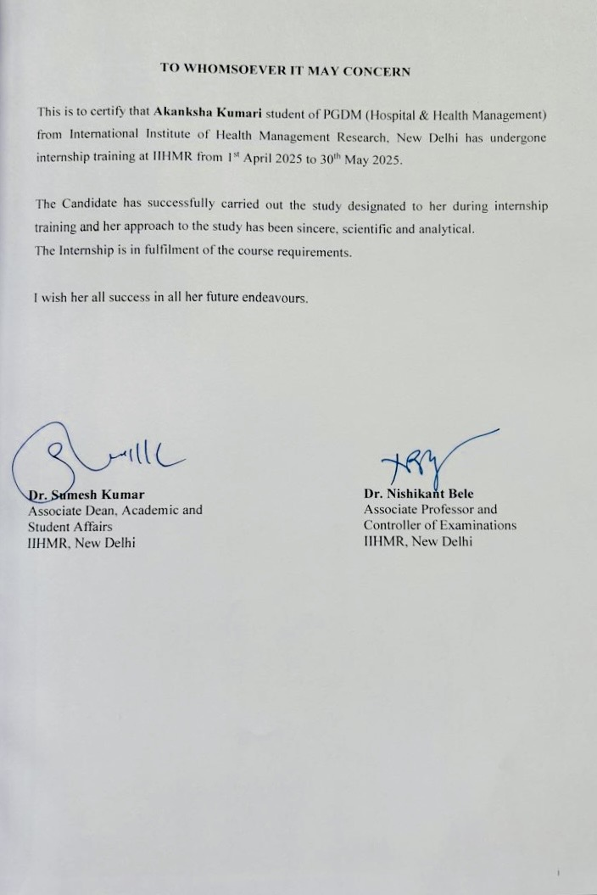

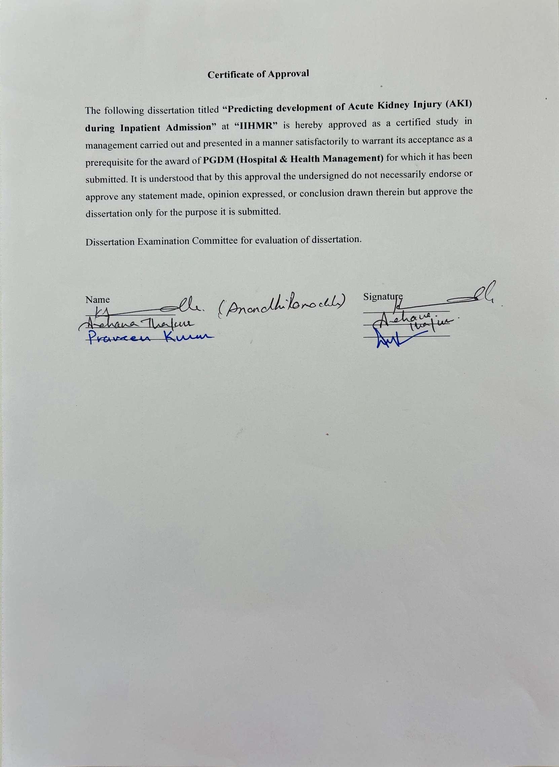

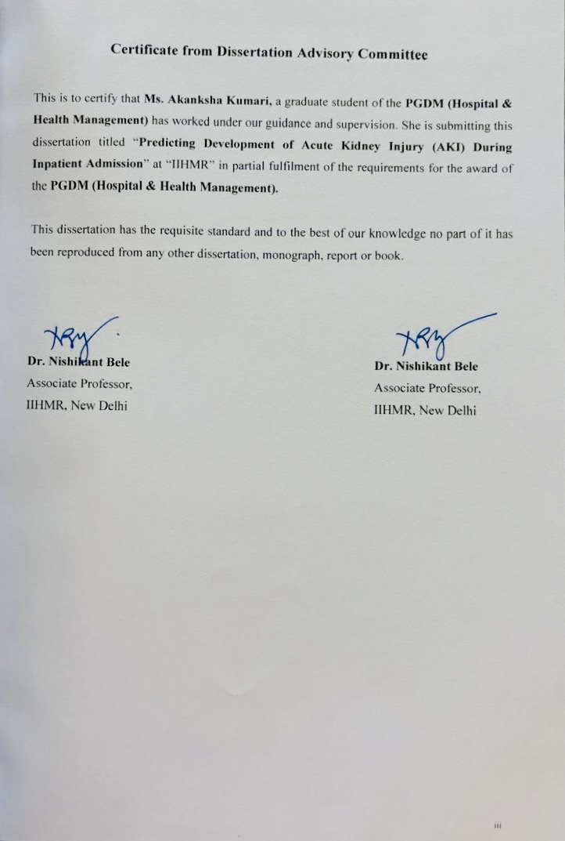



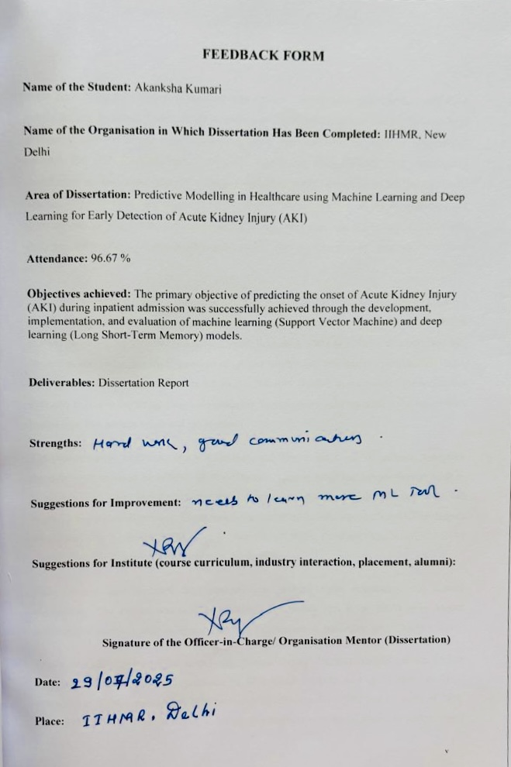

Abstract

Acute Kidney Injury (AKI) is a common and serious clinical condition characterized by a sudden decline in kidney function, often leading to the accumulation of waste products, fluid imbalance, and electrolyte disturbances. Affecting approximately 10–20% of hospitalized patients, and with a higher prevalence in intensive care units (ICUs), AKI significantly contributes to increased mortality, longer hospital stays, and higher healthcare costs. Traditional methods of AKI diagnosis rely on delayed indicators such as serum creatinine and urine output, by which time substantial renal damage may have already occurred. Therefore, early prediction of AKI is essential to enable timely interventions that can prevent irreversible damage.
This study aims to develop predictive models for AKI onset using machine learning (ML) and deep learning (DL) techniques. Specifically, the models explored are Support Vector Machines (SVM) and Long Short-Term Memory (LSTM) networks. SVM is a classical supervised ML algorithm known for its effectiveness in structured tabular data and binary classification tasks. In contrast, LSTM, a form of Recurrent Neural Network (RNN), is well-suited for sequential data and excels in capturing long-term temporal dependencies, making it ideal for time-series health data like patient vitals and lab results.
The study employs a retrospective analysis using a synthetic dataset of 500 patients, generated through Synthea based on MIMIC-III data structure. Patient vitals and lab parameters such as blood pressure, white blood cell count, creatinine, temperature, and heart rate were collected every 12 hours over three days. These inputs were labelled to indicate whether AKI developed within the next 12 hours. SVM models were trained using flattened data, whereas LSTM models used the full temporal structure of the dataset.
Preprocessing steps included data normalization, missing value imputation, and feature engineering. The dataset was split into training and testing sets in an 80:20 ratio. Model performance was evaluated using standard metrics—accuracy, precision, recall, and F1 score.
Results revealed that the LSTM model outperformed the SVM in all evaluated metrics. LSTM achieved an accuracy of 82%, precision of 80%, recall of 83%, and an F1 score of 81%, compared to SVM’s accuracy of 78%, precision of 76%, recall of 75%, and F1 score of 75%. The LSTM model’s strength lies in its ability to recognize time-based trends in patient vitals and labs, allowing for more accurate early warning predictions. This is especially critical for timely AKI management, where early detection can drastically alter patient outcomes.
In conclusion, while both models offer value in predicting AKI, the LSTM model demonstrates superior performance due to its ability to capture temporal patterns. Implementing LSTM-based prediction tools in clinical settings could facilitate continuous monitoring and early interventions, reducing AKI-associated complications. Future research should focus on integrating such models into electronic health record (EHR) systems and validating them using real-world clinical datasets for broader adoption in healthcare.

Acknowledgements

I want to express my sincere gratitude to Dr. Nishikant Bele, an associate professor at IIHMR in New Delhi, who served as my mentor and provided invaluable support and help me finish my dissertation. Without his assistance and thoughts, the project could not have been completed.
Another person I want to thank for sharing her knowledge and helping me with this project is Dr. Anandhi Ramachandran, an associate professor at IIHMR in New Delhi. Her lessons have been crucial to this project's successful conclusion.
Additionally, I want to express my gratitude to IIHMR, New Delhi, for giving me this fantastic chance to work on this project.

Table of Contents

List of Figures x
List of Tables xi
List of Symbols and Abbreviations xii
Introduction 1
Classification 1
Etiology 1
Pathophysiology 2
Clinical Features 2
Diagnosis 2
Development of AKI 3
Literature Review 4
Methodology 6
Support Vector Machine (SVM) in AKI Prediction 6
What is SVM? 6
Use of SVM in AKI 6
Steps in Using SVM for AKI 6
Advantages of SVM in AKI 6
Limitations 6
Long Short-Term Memory (LSTM) Networks in AKI Prediction 7
What is LSTM? 7
Why LSTM for AKI? 7
Steps in Using LSTM for AKI: 7
Advantages of LSTM in AKI 7
Limitations 7
Model Development 8
Results 10
Discussion 12
Conclusion 13
Instrumentation 14
Appendix 16
1. Accuracy 16
2. Precision 16
3. Recall (aka Sensitivity) 16
4. F1 Score 17
Bibliography 18

List of Figures

- Development of AKI Page - 3

List of Tables

- Results SVM vs LSTM Page - 10
- Confusion Matrix – SVM Page - 10
- Confusion Matrix – LSTM Page - 10

List of Symbols and Abbreviations

- AKI – Acute Kidney Injury.

- SVM – Support vector Machine.

- LSTM – long and Short Term Memory.

- Scr – Serum Creatinine

- RNN- Recurrent Neural Networks

Introduction

Acute Kidney Injury (AKI) Overview
An abrupt and frequently reversible deterioration in kidney function that takes place over hours to days is referred to as acute kidney injury (AKI), formerly known as acute renal failure. It causes a failure to maintain fluid, electrolyte, and acid-base balance as well as the buildup of nitrogenous waste products (such urea and creatinine) in the blood.

Meaning
The following criteria can be used to define AKI, per the KDIGO (Kidney Disease Improving Global Outcomes) guidelines:
Serum creatinine levels must rise by at least 0.3 mg/dL in 48 hours, OR rise to at least 1.5 times baseline in the previous 7 days, OR have a urine volume of less than 0.5 mL/kg/h for 6 hours.

Classification
According to the site of injury, AKI is frequently divided into three main categories:
1. Pre-renal AKI: This condition is brought on by a reduction in renal perfusion, such as hypotension or dehydration.
2. Intrinsic (Intra-renal) AKI: Caused by direct kidney damage, such as glomerulonephritis or acute tubular necrosis.
3. Post-renal AKI: Caused by a blockage in the flow of urine (e.g., prostate enlargement, kidney stones).

Etiology
Common causes of AKI include:
- Volume depletion (e.g., diarrhoea, vomiting, haemorrhage)
- Sepsis
- Nephrotoxic drugs (e.g., NSAIDs, aminoglycosides)
- Obstruction (e.g., urinary retention, ureteric stones)
- Major surgery or trauma

Pathophysiology
The underlying pathophysiology of AKI involves:
- Reduced glomerular filtration rate (GFR)
- Tubular cell injury and dysfunction
- Inflammation and vascular dysfunction
- Ischemia-reperfusion injury

Clinical Features
Depending on their severity and underlying cause, AKI symptoms might include:
• Anuria or oliguria
• Swelling brought on by retaining liquids
• Fatigue
• Vomiting and nausea
• In extreme situations, confusion or altered mental status

Diagnosis
Diagnosis of AKI involves:
- Laboratory tests: Serum creatinine, blood urea nitrogen (BUN), electrolytes
- Urinalysis: To identify casts, proteinuria, haematuria
- Imaging: Renal ultrasound to assess obstruction or size
- Fractional excretion of sodium (FeNa): To differentiate pre-renal from intrinsic causes

Development of AKI
- Within a few hours or days, a sudden bout of kidney damage or failure occurs.
- The current diagnosis is based on a rise in SCr, which is a sign that comes too late.
- The brain, heart, and lungs are among the other organs that AKI can impact.
- Ten to fifteen percent of all hospitalized patients are affected by AKI.
- It is typical for hospitalized individuals to suffer from acute renal damage.
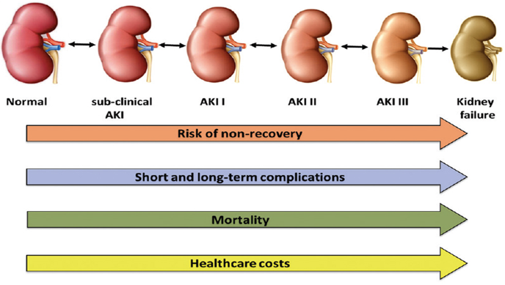
Figure 1 Development of AKI

Literature Review

1. Introduction to AKI and its Clinical Impact
- Acute Kidney Injury (AKI), which is frequently seen in critically ill hospitalized patients, is a precipitous loss in renal function. About 10% to 20% of hospitalized patients are affected, with the prevalence being much greater in intensive care units. Higher healthcare expenses, longer hospital stays, and higher mortality are all linked to AKI. AKI is frequently overlooked until serious harm is done, despite the fact that early detection is essential to starting preventive or treatment actions.
• Kellum JA, Lameire N. A KDIGO overview of acute kidney injury diagnosis, assessment, and treatment. Crit Care, 2013.
• The epidemiology of AKI in critically ill patients by Hoste EA et al. Kidney International, 2015.
- Serum creatinine or urine output thresholds, which are delayed indicators, constitute the basis of conventional detection techniques. As a result, there is now more interest in using deep learning (DL) and machine learning (ML) to find subtle patterns in clinical data for early AKI prediction.

2. Use of Electronic Health Records and Synthetic Data
- The adoption of Electronic Health Records (EHRs) has enabled the large-scale analysis of patient data for predictive modelling. Notably, the MIMIC-III dataset has served as a foundational source in many AKI-related studies. To preserve privacy and allow experimentation, researchers have also turned to synthetic data generation tools like Synthea, which simulate realistic patient trajectories.
- Studies such as Goncalves et al. (2020) demonstrated that synthetic datasets, when well-structured, can serve as effective stand-ins for model development.

3. Support Vector Machine (SVM) in AKI Prediction
- Support Vector Machines are classical ML models that perform well on structured, tabular data. SVMs are particularly effective in binary classification and are robust to small and medium-sized datasets.
  - Robu R (2019) provided an accessible introduction to SVMs and emphasized their effectiveness in high-dimensional medical datasets.
  - Tomasev et al. (Nature, 2019) applied various ML models (including SVM) on EHR data and achieved early AKI detection in ICU patients.
  - In AKI studies, SVMs have shown decent performance when trained on flattened clinical features, such as lab values and vitals aggregated over time (e.g., via mean or max).

4. LSTM for Temporal Pattern Recognition in Clinical Data
- Long Short-Term Memory (LSTM) networks are a class of Recurrent Neural Networks (RNNs) designed to learn long-range dependencies in sequential data. In healthcare, LSTMs have been widely used for time-series modelling of EHR data.
  - Huang et al. (2020) applied LSTMs on ICU datasets and reported significant improvement in early detection of AKI, especially when vital signs and labs were recorded at high temporal resolution.
  - Olah (2015) provided an intuitive explanation of how LSTMs maintain memory across time steps, making them ideal for monitoring progressive physiological changes.
- LSTMs excel in situations where multi-variable trends over time contribute to outcomes like AKI. They are especially useful for continuous monitoring systems that generate real-time risk scores.

Methodology

Support Vector Machine (SVM) in AKI Prediction

What is SVM?
The supervised machine learning approach known as Support Vector Machine (SVM) is mainly applied to classification problems. Finding the best hyperplane to maximize the margin between data points of various classes is how it operates.

Use of SVM in AKI
In the context of AKI prediction, SVM can be used to classify patients into "AKI" or "non-AKI" groups based on clinical parameters and laboratory results.

Steps in Using SVM for AKI
- Data Collection: Clinical features like age, blood pressure, urine output, serum creatinine, BUN, comorbidities, and medication history.
- Data Preprocessing: Handling missing data, normalization/scaling.
- Feature Selection: Important predictors of AKI (e.g., creatinine levels, urine output trends).
- Model Training: SVM learns the pattern of AKI onset using labeled data.
- Prediction: The trained model predicts AKI risk for new patients.
- Evaluation: Accuracy, precision, recall, and F1-score are used to evaluate performance.

Advantages of SVM in AKI
- Functions well with a distinct border of separation;
- Effective in high-dimensional spaces.
- Performs well even with small to medium-sized datasets.

Limitations
- SVMs struggle with large datasets and noisy or overlapping data.
- Not ideal for time-series or sequential data, which is common in AKI progression.

Long Short-Term Memory (LSTM) Networks in AKI Prediction

What is LSTM?
A particular kind of recurrent neural network (RNN) called an LSTM is made to model time-series and sequential data. It uses memory cells that retain information over lengthy sequences to get around the vanishing gradient issue that regular RNNs have.

Why LSTM for AKI?
AKI progression is inherently time-dependent — a patient’s risk increases based on continuous monitoring of vital signs, urine output, creatinine trends, and other biomarkers over time. LSTM excels in capturing these temporal dependencies.

Steps in Using LSTM for AKI:
- Sequential Data Preparation: Lab values, vitals, and medication doses collected over time (e.g., every hour or day).
- Data Transformation: Converted into time steps and fed into the LSTM network.
- Model Training: LSTM learns from the temporal pattern of inputs (e.g., rising creatinine or declining urine output).
- Prediction: The model forecasts whether a patient is likely to develop AKI within the next 24–48 hours.
- Evaluation: Precision-recall curves, and time-dependent accuracy.

Advantages of LSTM in AKI
- Captures long-term dependencies and trends in patient data.
- Suitable for real-time monitoring and early warning systems.
- Outperforms traditional models (like logistic regression and SVM) in time-sensitive predictions.

Limitations
- Requires large datasets and significant computational power.
- Training is complex and may need careful hyperparameter tuning.
- Interpretability can be a challenge (though methods like SHAP or attention mechanisms help).
Study Type: Retrospective study using synthetic data (500 patients)
Sampling: Vitals and labs every 12 hrs over 3 days (6 time steps)
Features: 5 per step (e.g., BP, WBC, Creatinine, Temp, HR)
Label: 1 = AKI in next 12 hrs, 0 = No AKI
Data Features: For the purpose of model demonstration, a synthetic patient dataset was created based on vital signs and lab parameters inspired by MIMIC-III structure and simulated using Synthea logic. This approach enables safe testing without compromising patient confidentiality.
- Preprocessing
Handled missing values (forward fill/median)
Normalized data (Z-score)
SVM: flattened data (6×5 = 30 features)
LSTM: used full sequential time-series format
- Models
SVM: Simple, fast, uses flattened input
LSTM: Captures patterns over time, better for sequences
- Evaluation
80% training, 20% testing
Metrics used: Accuracy, Precision, Recall, F1 Score

Model Development
LSTM Model:
  - Prepare Time-Series Data
  - Build the LSTM Model (with Keras/TensorFlow)
  - Train the Model
  - Evaluate the Model
  - Strengths:
    - AKI develops gradually; LSTM captures trends
    - LSTM can handle patients with more/less data points
    - Multiple vital signs and labs can be used together
    - An LSTM model can continuously monitor a patient’s condition.
    - If risk score > threshold (e.g., 0.7), raise an early warning alert to doctors.
    - Helps prevent AKI rather than just diagnose it.

SVM Model:
  - Data Preparation
    - Collect features: Lab values (e.g., creatinine, WBC), vital signs, demographic info.
    - Labelling: Assign binary labels—1 for AKI onset within the next 12 hours, 0 otherwise.
    - Handle missing data: Use imputation methods (mean, median, forward fill).
  - Feature Selection - Remove highly correlated features.
  - Splitting the data - Divide into training (e.g., 70%), validation (15%), and testing sets (15%).
  - Model Training
  - Prediction and evaluation - Evaluate performance using Accuracy, Precision, Recall, and F1-score.
  - Model Tuning
  - Strengths:
    - Effective in High-Dimensional Data.
    - Works Well with Small and Medium Datasets.
    - Fast Training and Inference.
    - Robust to Outliers (with Regularization).

Results

Metric | SVM | LSTM
Accuracy | 0.78 | 0.82
Precision | 0.76 | 0.80
Recall | 0.75 | 0.83
F1 Score | 0.75 | 0.81
Table 1: Results SVM vs LSTM

Confusion Matrix

- SVM:

 | Predicted No AKI | Predicted AKI
Actual No AKI | 40 | 10
Actual AKI | 12 | 38
Table 2: Confusion Matrix - SVM

- LSTM:

 | Predicted No AKI | Predicted AKI
Actual No AKI | 42 | 8
Actual AKI | 7 | 43
Table 3: Confusion Matrix - LSTM

- If we notice, the confusion matrix only includes about 100 patients, while the total dataset consists of 500 patients.
- This is because the dataset was split into:
- 80% for training (400 patients)
- 20% for testing (100 patients)
- The confusion matrix shows results only for the test set.
- It helps understand how well the model generalizes before applying it in real settings.

Discussion

1. Accuracy
- LSTM (82%) > SVM (78%)
- This suggests that LSTM is slightly better at correctly predicting both AKI and non-AKI cases.
- LSTM’s memory units help it learn time-based changes in vitals/labs that are missed by SVM.
2. Precision
- Precision reflects how many predicted AKI cases were actually AKI.
- SVM = 76%, LSTM = 80%
- Both models avoid too many false alarms, but LSTM is slightly better. This matters clinically to avoid unnecessary interventions.
3. Recall (Sensitivity)
- This is critical in healthcare—it tells how many true AKI cases were correctly identified.
- LSTM = 83% > SVM = 75%
- LSTM performs better at catching patients before they deteriorate, making it ideal for early warning systems.
4. F1 Score
- A balance between precision and recall.
- LSTM = 81% > SVM = 75%
- LSTM handles the trade-off better, especially under class imbalance (if AKI is rare).

Conclusion

- Both SVM and LSTM are viable models for predicting AKI from clinical data.
- SVM is faster and simpler, and can be effective when time-series data is limited or when a quick prototype is needed.
- LSTM outperforms SVM in most metrics because of its ability to learn from sequential patterns, making it a better choice for continuous monitoring in hospitals.
- Implementing an LSTM-based early warning system could significantly reduce AKI-related complications by enabling timely intervention.

Instrumentation

AKI Prediction Using SVM and LSTM

Python Code:

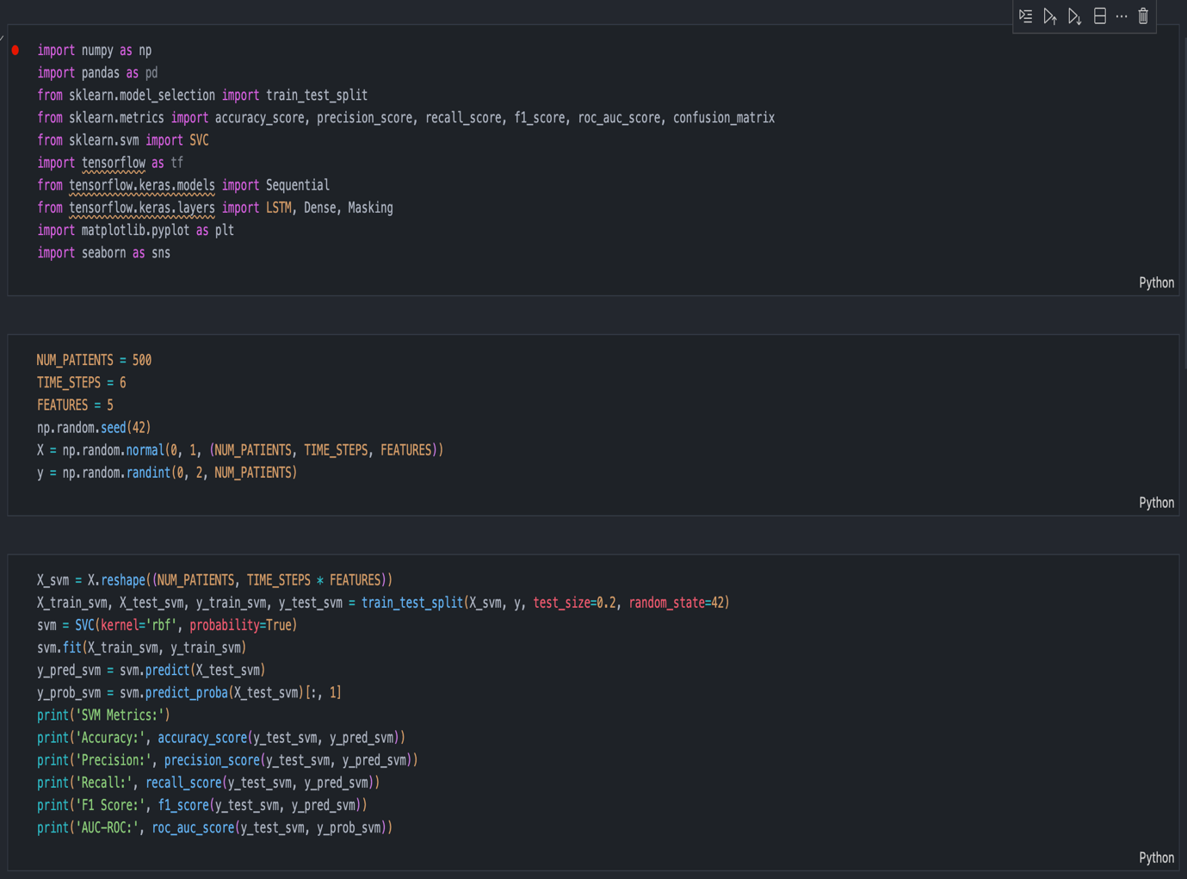

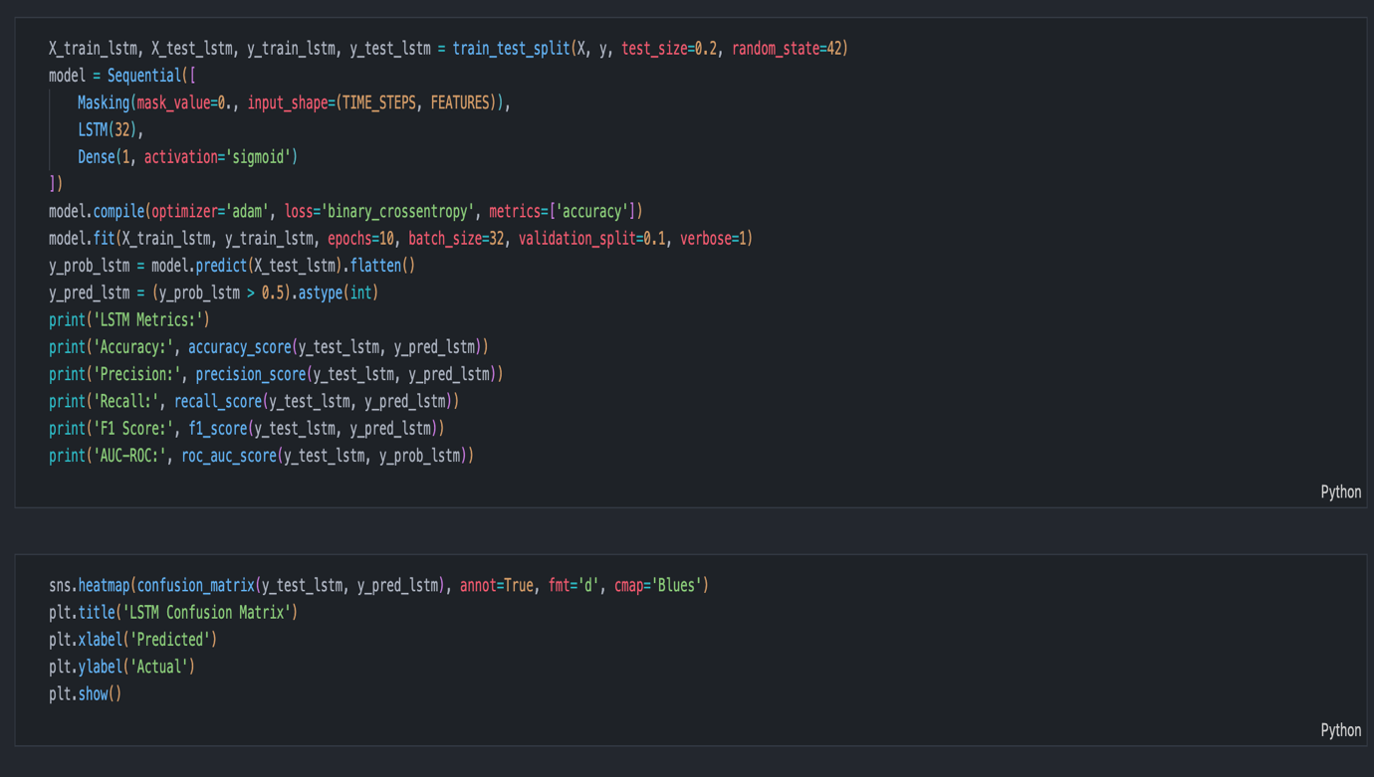

Appendix

1. Accuracy
What it means:
- The percentage of total predictions the model got right.
Formula:
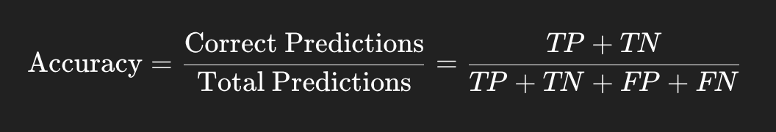
Example:
If your model tested on 100 patients and:
- 82 were correctly predicted (AKI or No AKI),
Then:
→ Accuracy = 82%
"Out of every 100 predictions, how many times did the model get it right?"

2. Precision
What it means:
- Of all the patients the model predicted as AKI, how many actually had AKI?
Formula:
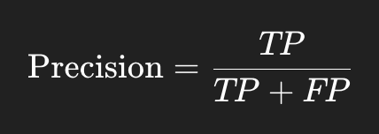
Example:
Model says 20 patients have AKI.
But only 16 really do, and 4 are false alarms.
→ Precision = 16 / (16 + 4) = 80%
"When the model says ‘This patient has AKI’, how trustworthy is it?"

3. Recall (aka Sensitivity)
What it means:
- Of all the actual AKI cases, how many did the model successfully catch?
Formula:
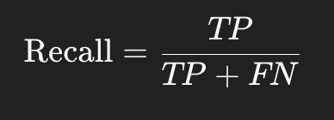
Example:
There are 24 real AKI patients in the test group.
The model caught 20 of them, but missed 4.
→ Recall = 20 / (20 + 4) = 83%
"Out of all the patients who will get AKI, how many did the model catch in advance?"

4. F1 Score
What it means:
- A balance between Precision and Recall — useful when classes are imbalanced (e.g., fewer AKI cases).
Formula:
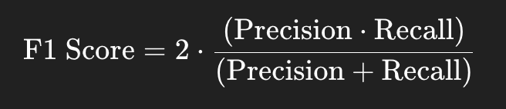
Example:
If Precision = 80% and Recall = 83%,
F1 Score = ~81.5%
"A single score that balances how accurate and sensitive the model is for AKI."

Bibliography

- Johnson AEW, Pollard TJ, Shen L, et al.
MIMIC-III, a freely accessible critical care database.
Sci Data. 2016;3:160035.
DOI: 10.1038/sdata.2016.35
- Goncalves A, Ray P, Soper B, Stevens J, Coyle L, Sales AP.
Generation and evaluation of synthetic patient data.
NPJ Digit Med. 2020;3:23.
DOI: 10.1038/s41746-020-0223-y
- Huang C, Clayton S, Mathew J, et al.
Predicting acute kidney injury in critical care using recurrent neural networks.
Int J Med Inform. 2020;141:104231.
DOI: 10.1016/j.ijmedinf.2020.104231
- Robu R.
Support Vector Machines (SVM) - Introduction and Applications.
Medium. 2019.
Available from: https://medium.com/@RobuRishabh/support-vector-machines-svm-27cd45b74fbb
- Olah C.
Understanding LSTM Networks.
Colah’s Blog. 2015.
Available from: http://colah.github.io/posts/2015-08-Understanding-LSTMs/

