Internship Training
at
Fortis Escorts Heart Institute, Okhla, New Delhi
Reasons of attrition of Nurses in a Delhi based hospital.
by
Tanurima Mondal
PG/21/118
Under the guidance of
Dr. Ratika Samtani
PGDM (Hospital & Health Management)
2021-23


International Institute of Health Management Research,New Delhi

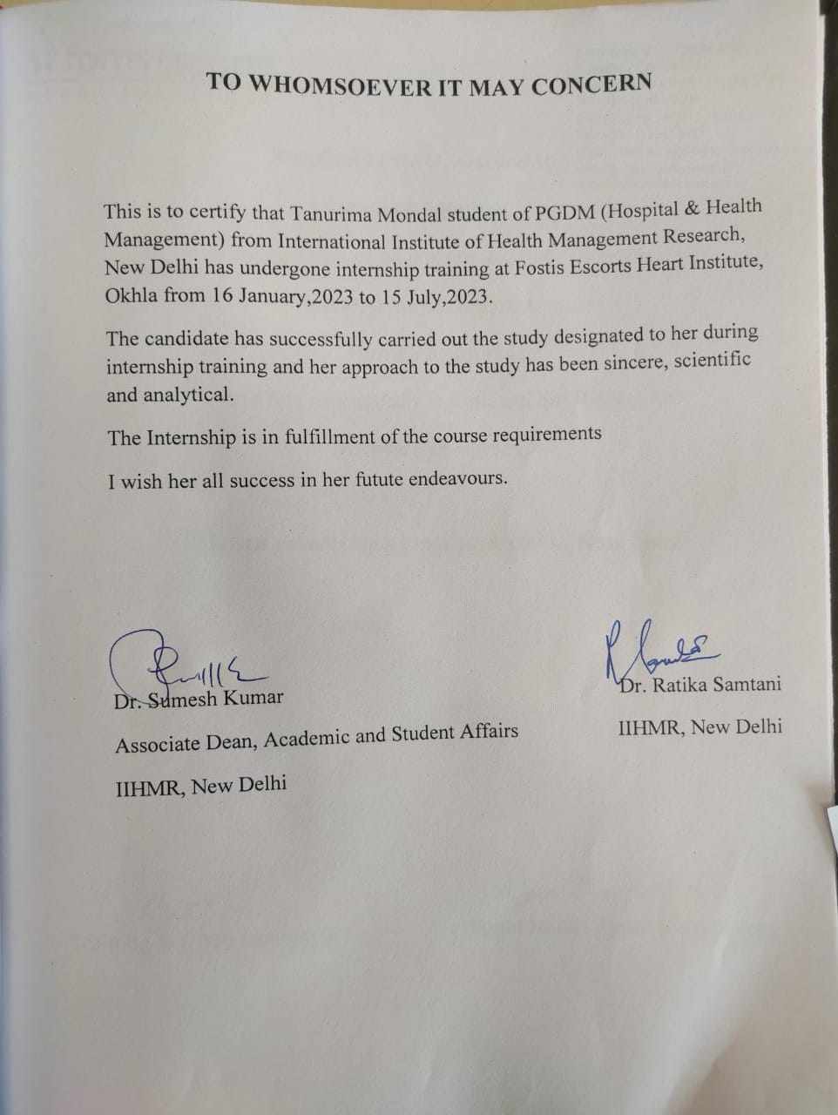

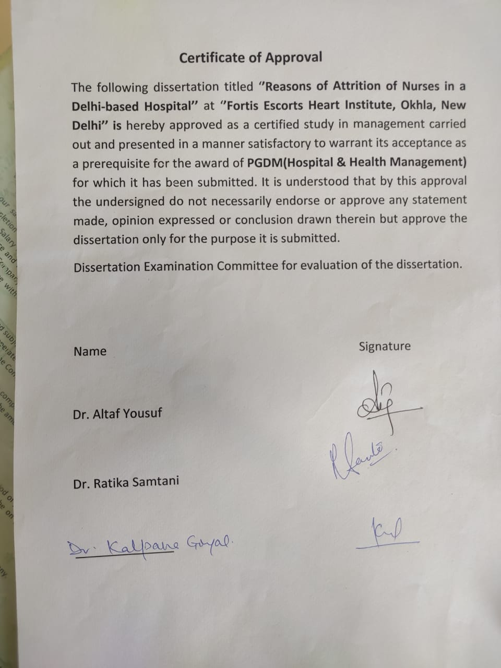

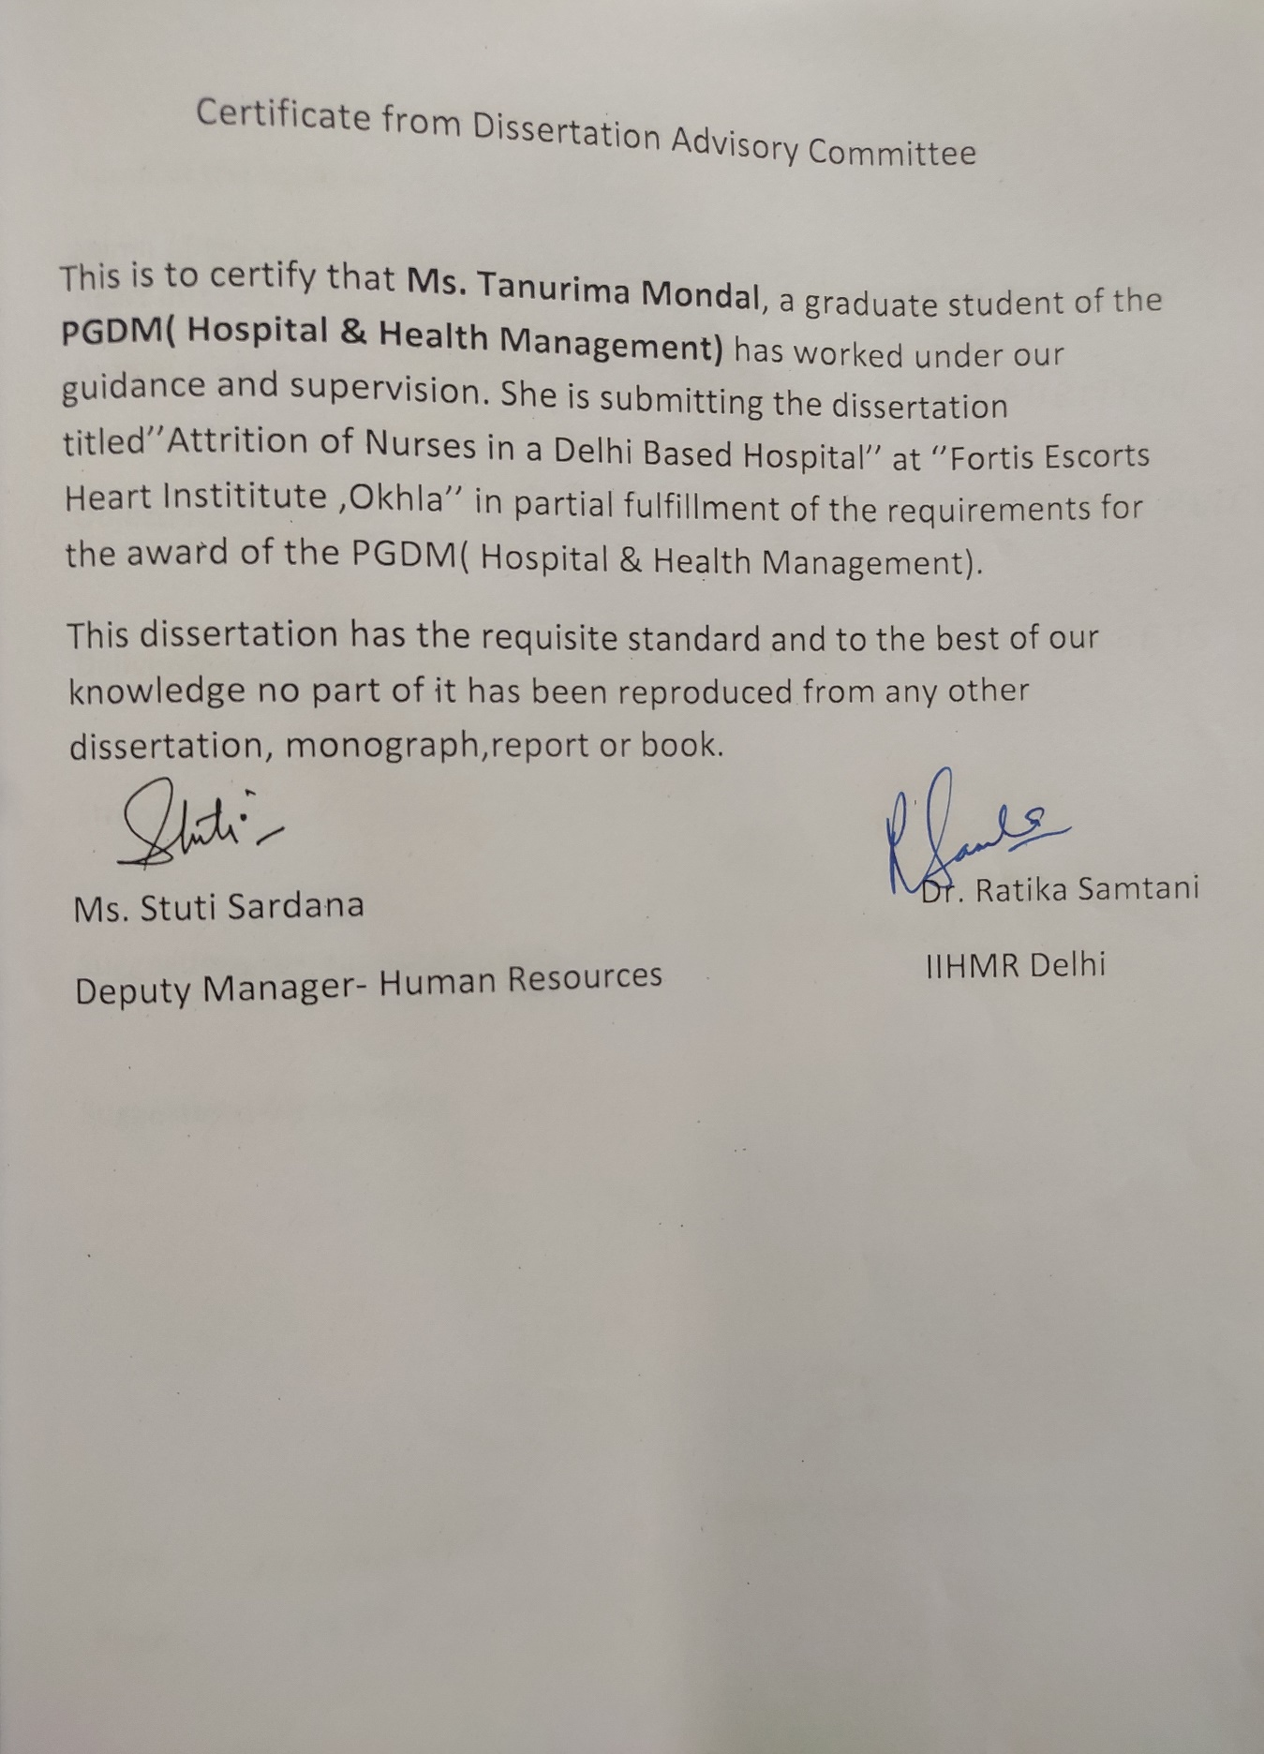
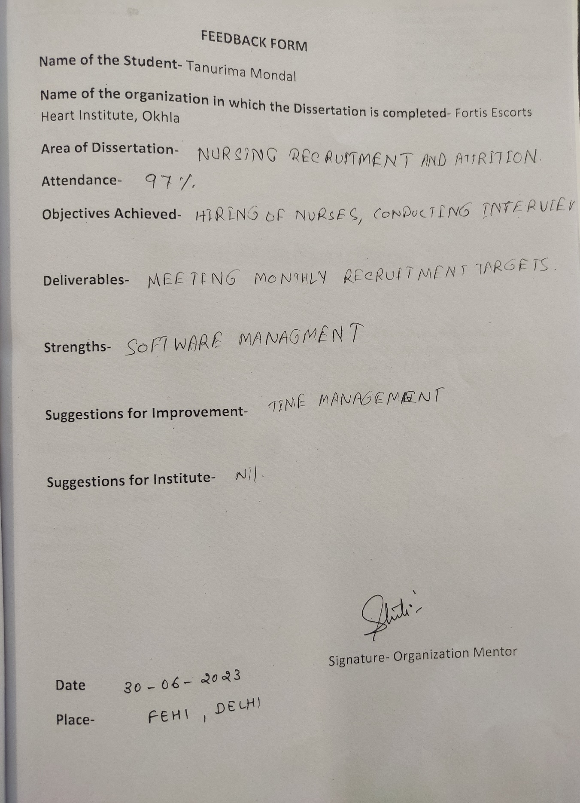
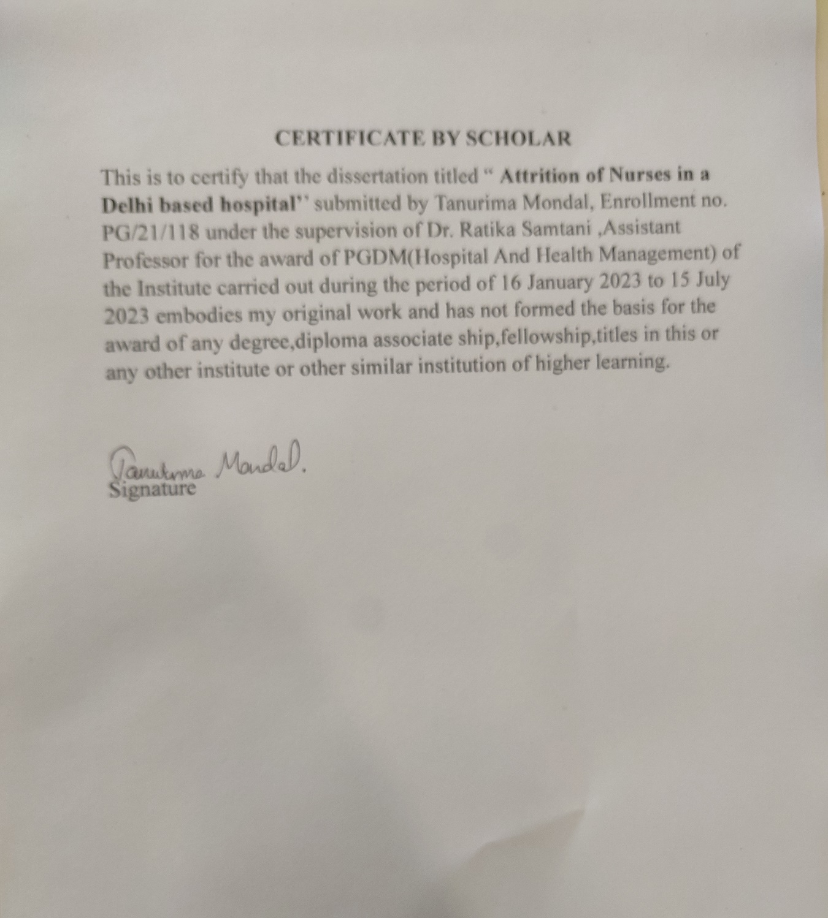

Acknowledgement

I express my sincere regards to Mr. Ravi Ranjan, Zonal Head- Human Resources of Fortis Escorts Heart Institute Okhla, New Delhi.
I feel to acknowledge my indebtness and sense of gratitude to my guide Ms. Stuti Sardana, Deputy Manager Human Resources,Fortis Escorts Heart Institute Okhla whose guidance and supervision given to me throughout the course of my internship as well as providing the necessary information regarding the project which shaped the present work as it shows.
My thanks and appreciation also goes to all the Departmental Heads of Fortis Escorts Heart Institute Okhla, whose deliverance and acquaintance of the insights of their departments gave me a wholesome knowledge.

I am immensely obliged to my institute IIHMR DELHI, for providing me the opportunity to pursue my internship from such a prestigious organization.I sincerely would like to thank Dr. Sutapa Neogi, Director of IIHMR DELHI, for her constant motivation and guidance for all our endeavours. I would like to extend my gratitude to Dr. Sumesh Kumar, Associate Dean Academics.I acknowledge with thanks the kind of patronage, inspiration and guidance which I have received from my faculty mentor, Dr. Ratika Samtani

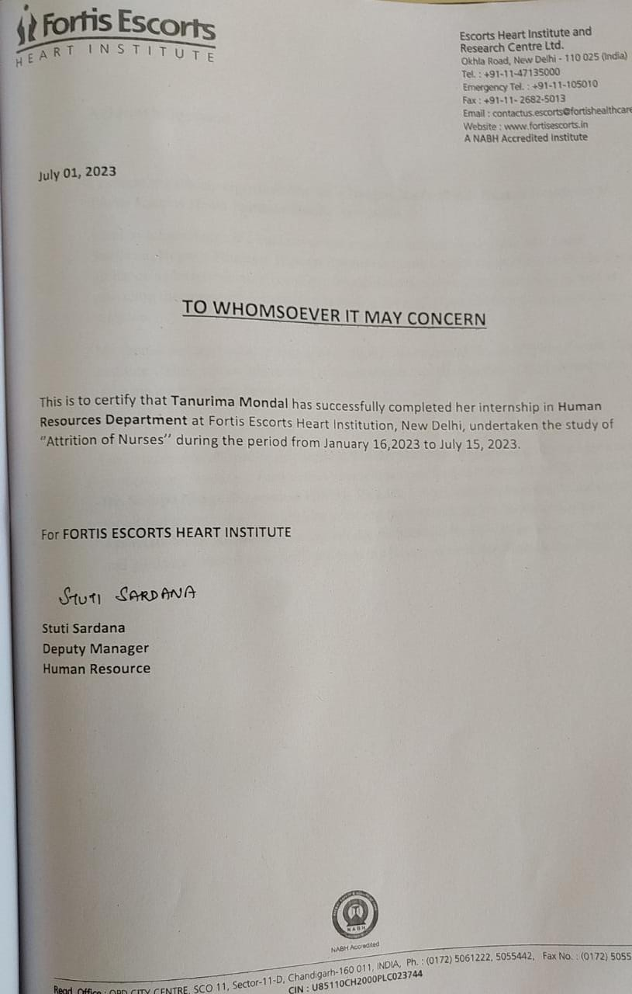
Table of Contents :

Sl. No. | Topic Name | Page Number
1. | Introduction | 6
2. | Organization Profile | 7
3. | Services provided by the Hospital | 8
4. | Departments Worked | 9
5. | Problems and issues in the Department | 6
6. | Observation/Learning | 10
7. | Projects undertaken other than Dissertation | 12
8.1 | Dissertation Project-Reason of Attrition of Nurses in a Delhi based Hospital | 13
8.2 | Introduction | 14
8.3 | Literature Review | 16
8.4 | Methodology | 18
8.5 | Objective | 19
8.6 | Results | 20
8.7 | Discussions | 30
8.8 | Conclusion | 31
9. | Supplementary- Quesstionnaire | 32
10. | Bibliography | 35

Acronyms/abbreviations

CTVS- Cardio Vascular Thoracic Surgery
MNGMT- Management
CNS- Chief of Nursing
ANS- Assistant Chief of Nursing
GDA- General Duty Assistant
ADMIN-Administration
GNM- General Nursing and Midwifery
B.Sc- Bachelor of Sciences (nursing)

Introduction:
2

With a bequest of over 33 years, Fortis Escorts Heart Institute, New Delhi has established itself as a poineer in the area of caridiac care, and is recognised for its record setting work and services to ennumerable cardiac patients. Equipped with clinical expertise and latest technology, Fortis Escorts Heart Institute has enriched numerous lives through its world class treatment and patient care. With Padma Shri and Padma Bhushan awardees serving as doctors, the hospital is recognised over the world as a centre of excellence, today.
Currently more than 200 cardiologists and 1600 employees work jointly to manage over 14500 admissions and 7200 emergency cases in a year. The hospital presently has an infrastructure comprising of around 310 beds, 5 Cath Labs besides a host of other world class facilities.

Organizational Profile
Organizational values

Patient Centricity Integrity

Teamwork Ownership

Innovation

Services provided by the hospital
Core specialities-
Cardiac Sciences- Cardiology (Adult & Paediatric)
Gastroenterogy, Hepatobiliary & Liver Transplant
Kidney, Urology & Kidney Transplant
Bone & Joint
Vascular Interventions
Other Specialities- Nephrology, Pulmonology, ENT, Mental Health & Behavioral Sciences, Liver & Digestive Diseases institute, Bone and Joint, Dentistry, General Surgery, Opthalmology,Paediatric cardiac surgery, cardiac surgery, Diabetology, Endocrinology,Internal medicine,critical care medicine,vascular suegery,Kidney and urology institute,Minimally invasive cardiac surgery, TAVR , Neurology, Interventional cardiology, organ donation, Radiology, preventive health checkup,physiotherapy,Nuclear medicine, Blood bank, Insomnia Clinic, Minimal Access Bariatric, GI surgery, Oncosurgery,Heart transplant, Preventive medicine,Plastic and cosmetic surgery, rheumatology, Organ transplant, anaesthesiology, electrophysiology, Advanced Heart failure programme.

Departments Worked
Human Resources Department-
The Human Resources Department is responsible for an array of personnel needs that both employers and employees come across. The role of this department is to handle all areas of operations that are employee related.
The main functions of this department in the hospital are:
- Recruitment
- maintaining both personal and professional details record of the employee
- employee orientation
- human resources information and payroll
- leave management of the employee
- maintaining organizational structure, formulating business goals according to the mission of the organization, keeping track of the flow of projects in each department
- employee benefits and compensation management
- training and performance assesment
- professional developement programs which includes business communication, patient service training,diversity ,inclusion and related programs
- staff morale and retention
- maintainning the code of conduct of the hospital staff
- rewards and recognition for performers
- compliance and legality

Problems & Issues in the Department
6

There are certain issues of concern in the department that creates disruption in the smooth workflow of it-

Scarcity of Healthcare professionals- Shortage of Healthcare Professionals like Physicians, Nurses.This shortage is a major challenge in HR starting from recruitment, selection,training ,performance monitoring and so on. Strict HR policies might lead to attrition , on the other hand lenient HR policy might lessen Patient flow in corporate hospitals.
8
Attrition rate- Attrition is too high when it comes to nurses. The other categories of staff too face attrition which create loss in manpower.
Employee Burnouts-The major challenge of HR in hospital is to help overcome employee burnouts and also maintain the employees’productivity
Training & Development- Planning and arranging regular and periodic trainning and development sessions for such a huge workforce of different categories of staff starting from medical, non medical, administrative, supportive and so on.

Observation / Learning
- The process of maintainning employee records are too manual, quick accessibility reduces due to that
- Trainning and Development sessions are made mandatory for staff to have a better orientation of their area of work
- Performance Appraisal is a critical and sensitive process that immensely effects the employee turnover
- Induction programmes create a huge impact on the new joiners
Timely audits and review meetings are immensely helpful to get an idea of the Departmental issues, achievements and shortcomings

Project Undertaken other than Dissertation
9

Nursing Recruitment
Solely undertook these responsibilities under the guidance of the organizational mentor

- Preliminary interview
- Selection tests
- Employment Interview
- Verification
- Selection Decision assisted the assistant Chief of Nursing
- Physical Medical Check-up initiation
- Job Offer
- On-Boarding
- Contract of Employment
- Evaluation of Selection Programs

Title of the Study
Reasons of Attrition of Nurses(Care Givers) in a Delhi Based Hospital

Abstract
Background
Attrition in human resources is the loss of manpower gradually. Higher attrition is a major concern for companies. Nurses in most hospitals and healthcare organizations have the maximum amount of patient contact other thanother employees. Therefore they play a big role in the financial aspects of these hospitals. The monetary calculation of losing one nurse is calculated to about twice the nurse’s annual remuneration. Loosing them, important manpower negatively affects the hospitals in various ways.
Methods
The study is conducted using qualitative and quantitative tools. The tools used in the study primarily includes variables such as years of age, sex, demographic details, years of experience in the institution, and annual income.Assessment of the attrition rate among staff nurses is analysed by usinga self-structured questionnaire and informalinterview method.Inclusion criteria- Existing nurses (incoming Nurses) and the nurses who are resigning(on notice period).Retention strategies used by the organization is also studied.
Results
According to the study, amongst 108 nurses who were on notice period, most of them had an experience of fresher to 2 years. Most of them stated that they wanted to go for abroad oppurtunities due to a better oppurtunity and higher salary. When asked about the issues concerned to their leaving they mentioned Health Insurance scheme, the premium deducted for this scheme is 1451 INR per month yet they are refused cashless treatment in the empanelled hospitals,not satisfied with the reimbursement policy of Health Insurance, decline of planned leave due to heavy workload,Gap in direct communication with the incharge, communication gap and inaccessibility to meet in person with the top management authority,Heavy workload, shortage of staff, double duties with no extra payment, tedious clerical work apart from clinical work
Conclusion
Nursing retention strategies to be taken such as Nursing day celebration, awards and recognition, acknowledgement of their day to day work . The other way of their retention can be a well planned salary structure according to their skill set, acknowledging who are working double shifts by giving monetary benefits.
Keywords- Nurses, attrition, retention, better oppurtunity, dissatisfaction, salary hike

Introduction
Staff nurses are referred as the pillars of the hospital sector, which is one of the speedy-growing global sectors. Most nations have a shortage of nurses;however, it is not as severe as it is in underdeveloped nations. While developing nations are unable tocompete with the higher salary of an advanced world, the advanced world fulfils its role by luring nurses from other nations. Only in a setting where a patient receives individualized, human-to-human care can human suffering be healed, and this is where a nurse performs. Now the burning issue the healthcare industry faces across the nation is “Reducing the Attrition and retaining the skilled and experienced Nursing staff. To develop retention strategies that address the reasons staff nurses leave a hospital, attrition analysis is a critical step. Inadequate salary, unfavorable working conditions, lack of management support, lack of opportunity for career progression, and high stress levels are a few major reasons staff nurses quit a healthcare organization. Organizations might create retention strategies based on the results of the attrition analysis.
Nursing attrition, the departure of nurses from their positions, is a pressing issue affecting healthcare systems globally. Understanding the reasons behind nurse attrition is essential for healthcare organizations to develop effective strategies for nurse retention. The present study aims to explore some of the common reasons for nurse attrition and the implications it has on the healthcare industry.One of the primary reasons for nurse attrition is the heavy workload and inadequate staffing levels. Nurses often find themselves overwhelmed with high patient ratios, extended working hours, and increased administrative tasks. This excessive workload leads to physical and mental exhaustion, contributing to burnout and job dissatisfaction. When nurses are constantly faced with overwhelming demands, they may seek employment opportunities elsewhere, leading to attrition.Nurses are driven by professional development and growth. A lack of career advancement opportunities can lead to frustration and job dissatisfaction, ultimately resulting in attrition. If nurses feel that their skills and expertise are not being utilized or recognized, they may seek opportunities in other healthcare settings that offer better prospects for career progression.Financial remuneration is an essential aspect of any profession, and nursing is no exception. Nurses often face challenges related to low salaries, inadequate benefits, and limited opportunities for financial growth. Considering the demanding nature of their work, the compensation package should be competitive to attract and retain skilled nurses. When nurses perceive that their compensation does not match their level of responsibility and expertise, they may opt to leave for better-paying positions elsewhere. Furthermore, maintaining a healthy work-life balance is crucial for nurses' well-being and job satisfaction. However, the demanding nature of nursing, including irregular shifts, long working hours, and high levels of stress, can make it challenging to achieve a balance between work and personal life. Nurses may experience strain in their relationships, have difficulties managing personal commitments, and suffer from burnout. These challenges can lead to attrition as nurses seek employment opportunities that allow for better work-life integration. It has been observed that nurses thrive in environments where they feel supported and valued for their contributions. A lack of support from supervisors, inadequate mentorship programs, and a failure to recognize nurses' efforts can lead to job dissatisfaction and attrition. Nurses who feel unappreciated and unsupported are more likely to seek opportunities where their skills and dedication are acknowledged.The culture of the workplace significantly influences job satisfaction and attrition rates. An unhealthy work environment characterized by poor communication, lack of teamwork, and conflicts among staff members can contribute to nurse attrition. Nurses who experience a toxic work culture may decide to leave in search of a more positive and supportive environment.Burnout is a significant concern in the nursing profession. Prolonged exposure to high-stress situations, emotional strain, and constant pressure can lead to physical and emotional exhaustion. Nurses experiencing burnout may feel disengaged, depersonalized, and experience a reduced sense of personal accomplishment. If not addressed, burnout can lead to attrition as nurses seek to prioritize their well-being and mental health.Nurse attrition poses significant challenges for healthcare organizations, leading to increased costs, decreased quality of patient care, and a loss of valuable expertise. It is crucial for healthcare institutions to recognize and address the factors contributing to nurse attrition. By improving work conditions, providing opportunities for career growth, offering competitive compensation packages, promoting work-life balance, fostering a supportive culture, and implementing measures to prevent burnout, healthcare organizations can reduce attrition rates and retain skilled nurses. Efforts to retain nurses will lead to improved patient outcomes and a more stable and satisfied nursing workforce.

Review of Literature
According to the study conducted by Gretchen Berlin, January 2022 a recent McKinsey survey, they found out that the reason for their leaving is not always for better salary hike but also about the support and recognition that they feel in their workplace, from their leaders, theirmanagers, teams,insufficientstaffing, gratitude.According to International Journal of Management, 2018, they found out that achieving low attrition rate is a big challenge as the demand exceeds the supply of nurses by a major mark.According to the study conducted by Thephilah Catherine 2019, Indian Journal of Community Health, they discussed the retention strategies like the nurse administration motivating the nurses by organizing programs for their upgradedway of life, service education programs should be organized for nurses to upgrade their educational level.According to the International Journal of Nursing Studies,2006, High nursing turnover can effect in a negative way on a hospital’s ability to meet the patient’concern(Ref). At the nursing unit level,high turnover affects the morale of nurses and the productivity of those who remain to provide care while the new staff nurses are hired and oriented.According to Human Resources for Health Article, 2017, Diversity of definitions of attrition and barely any studies distinguish between total and Voluntary attrition(Ref). Attrition and specifically voluntary attrition is underrecorded and less studied.According to the study conducted by Pedro Alberto Herrera Ledesma, Nursing turnover continues to present serious challenges at all levels of healthcare. Longitudinal research is needed to produce new evidence of the relationships between nurse turnover and related costs, and the impact on patients and healthcare team (Ref).
According to the Journal of Operations Management by Xiasong Peng, Yuan Ye, Xin Ding, states that the key factors impacting are nurse staffing, antecedents of nurse turnover,nursing turnover and their connection with patient care quality which is more directly affected by the nursing care(Ref).According to the study conducted by International Journal of Healthcare Management,2020,states that the organizational culture also impacts the nurses’turnover.The key factors include organizational culture, organizational climate and leadership, it will be possible to reduce nurses’turnover rates in different healthcare contexts.

According to the study conducted by Laureen J Hayes and L o Brien-Pallas, states that nursing turnover cost, that is costly, and the negative impact of nurse turnover was partially supported, which found out that the nurse’turnover is costly.According to the study conducted by the International Journal of Current Research,states that attrition may be voluntary or involuntary,though employer initiated events such as layoffs are not typically included in the definition.Due to the expenses associated with training new employees attrition is typically seen to have a monetary cost.According to the study conducted by Takawira c Marufu and Alexandra Collins 2021,identified that turnover factors are longstanding. To mitigate the impact of these factors, evaluation of current workforce strategies priority.
References:
-Gretchen Berlin, January 2022 a recent McKinsey survey,not always salary hike is the reason for attrition,recognition from organization and other key factors also matter.
- Thephilah Catherine 2019, Indian Journal of Community Health, they discussed the retention strategies like the nurse administration motivating the nurses by organizing programs
- International Journal of Nursing Studies,2006, High nursing turnover can effect in a negative way on a hospital’s ability to meet the patient’concern
- Human Resources for Health Article, 2017, Diversity of definitions of attrition and barely any studies distinguish between total and Voluntary attrition
Methodology

Study area:The study is conducted in a private hospital in Delhi.
Sample size & Study duration: Existing Nurses (incoming Nurses) and Nurses who have resigned (on notice period)during the three-month dissertation period is selected for the study which is 108.
Study type& Tools Used:The study is conducted using qualitative and quantitative tools. The tools used in the study primarily includes variables such as years of age, sex, demographic details, years of experience in the institution, and annual income.Assessment of the attrition rate among staff nurses is analysed by usinga self-structured questionnaire and informalinterview method.Inclusion criteria- Existing nurses (incoming Nurses) and the nurses who are resigning(on notice period).Retention strategies used by the organization is also studied
Data Collection Procedure: Official permission is takenfrom the concerned authorities for the collection of the data. Participants are educated about the reason of thestudy. A written consent is taken from them. Information on these variables are collected through interview methods. While conducting the interview, information is collected with strict confidentiality.
Data Analysis: The information gathered from the tools is statistically analysed to understand the possible reasons of attrition.

Objectives
The objectives of the study are:
(a) To gather information on the reasonsof attrition in the hospital from the view of existing nurses (new joiners) and Resigning nurses (on notice period)
(b)To determine the socio-demographic variables associated with attritionrates.
(c) To identify the measures implemented by the organization to increase employee satisfaction.

Result:

Sociodemographic Details of the Nurses-

Figure 1 : Age of the Nurses who are on notice period

According to figure 1, 35% of the nurses on notice period are in the age group of 25-30 years, while 34% are in the age group of 20-25 years.

Figure 2: Qualification of Nurses who are on notice Period

Figure 2 depicts the qualification of nurses on notice period amongst which 61% are B.Sc and 39% are GNM

1.Existing nurses- Fresher/ experienced(incoming nurses)
Resigning Nurses-Fresher/Experienced(outgoing nurses)
Figure 3:

Figure 3indicates the percentage of the incoming nurses amongst which are freshers are 59% and experienced are 40%.

Figure 3;

Figure 3 depicts the percentage of the freshers 20% and experienced 79%nurses who are on resignation period.

2. Demographic details- existing nurses and resigning nurses

S- Southern part of India
NE- North Eastern region of India
N- Northern Part of India
Figure 4;

Figure 4depicts the demographic location of the incoming nurses amongst which maximum of them belongs from the Southern part of India and then the rest of them from North East India.

Figure 5;

Figure 5 represents the demographic location of the nurses on notice period amonsgst whom more than 70 are from the Southern part of India

3. Time span of which you are willing to stay /stayed in this hospital
Figure 6:

Figure 6 represents that 56 nurses have stated that they want to stay for one year, 52 of them stated that they want to stay for 1-2 years amongst the existing nurses.

Figure 7;

Figure 7 depicts the nurses who planned to resign in the time period in months.Amongst them maximum number of them planned to resign within the time period of 12-15 months and 21-24 months.

4. Willingness to go to abroad after working here
Figure 8;

Figure 8 states the percentage of nurses willing to go abroad amongst the existing (incoming) nurses, 72% said yes for abroad and 27% were disintrested.

Figure 9:

Figure 9 states the percentage of nurses willing to go abroad amongst the nurses who are on resignation period, amonsgst them 60% were intrested for abroad oppurtunities while 39% were not

5. Willingness to come back in this hospital in future for those who are resigning

Figure 10:

Figure 10 states the number of nurses who are on notice period their willingness to come back here, 57 of them were willing rest were not.

6.Reasons of Leaving the Hospital-

a. Satisfied with the employee benefit schemes-

Figure 11:

Figure 11 depicts the satisfaction percentage of the nurses with the employee benefit schemes, 57% of them said they were satisfied 43% expressed their dissatisfaction.

Reasons of Dissatisfaction- Health Insurance scheme, the premium deducted for this scheme is 1451 INR per month yet they are refused cashless treatment in the empanelled hospitals ,not satisfied with the reimbursement policy of Health Insurance, decline of planned leave due to heavy workload

6 b. Communication barrier with the management

Figure 12:

Figure 12 represents the percentage of nurses who stated the communication barriers stated by the nurses, 61% of them had communication barriers while 39% said they did not.

Communication Barriers- Gap in direct communication with the incharge, communication gap and inaccessibility to meet in person with the top management authority like Chief Of Nursing and Assistant Chief of Nursing

6 c. Salary Dissatisfaction according to the workload
Figure 13:

Figure 13 depicts the salary satisfaction percentage amongst the nurses, 69% said they were not satisfied with their remuneration while 31% said they were satisfied.

Reasons of Dissatisfaction- Heavy workload, shortage of staff, double duties with no extra payment, tedious clerical work apart from clinical work

6 d. Do you get paid for double duties/extra shifts
Figure 14:

Figure 14 represents the payment percentage for the nurses for their double duties/ shifts, 62% of them stated that theydid not get extra payment for double duties while 38% stated that they got

6 e. How often do you have to work extra shifts in a month

Figure 15:

Figure 15 represents the percentage of nurses who has to work extra shifts on amonthly basis,48% stated that they had to work extra shifts on an average of 10 days, 35% stated that they had to work extra shifts for less than 35% and 17 % said that they had to work extra shifts for more than 10 days.

Discussions

- Most of the nurses who plan to resign are fresher to 2 years experienced
- These nurses plan to stay in the hospital for 1-2 years and look for better opportunity for salary hike.
- Amongst them most of them go for abroad opportunity due to the ease of the procedures and high end salary in Saudi Arabia and Middle East Countries and also Europe.
- They also stated that were not satisfied with the policies related to employee benefits including reimbursement policy of health insurance, cancellation of planned leaves during emergency
- . Most of them stated that they had a communication gap with the management due to inaccessibility of reaching to the top notch managerial authority in Nursing.
- . Most of them mentioned that the salary was not paid according to the heavy workload due to high bed occupancy rate.
- . They also complained for the extra clerical work that they have to do apart from clinical work
- . There was a concerned issue of no extra payment for extra shifts/ double duties.
- As for the retention strategies, Spandan (HR Induction), Virohan ( Nursing Induction) are strategically planned to create a long lasting impression of the hospital in the mind of new joiners and integrated training sessions are arranged for the already working nurses. The details of these sessions and strategies could not be share due to confidentiality purposes.

Conclusion

The study conducted can be concluded by the following factors

- Nursing retention strategies to be taken such as Nursing day celebration, awards and recognition, acknowledgement of their day to day work .

- The other way of their retention can be a well planned salary structure according to their skill set , acknowledging who are working double shifts by giving monetary benefits

- Overall by educating them and giving them good training and making their induction experience better by creating an impactful session which will create a long lasting impression of the hospital in their mind

Supplementary

Instrumentation

Quesstionnaire for Nurses

Questions for New Joiner-

1. Are you a- Fresher/ Experienced
2. How did you come to know about this Hospital?
3. Why did you choose to work here?
4. From which State do you belong?
5. Which state registration do you have?
6. How many years are you planning to stay in this Hospital?
7. How do you find the workload here- Heavy/ Moderate/ Manageable
8. Do you wish to go abroad after working here?
9. What is your family income- 1-3/3-5/more than 5 LPA
10. How is the work atmosphere of the hospital- Hospitable/Indifferent

Questions for those who are on Resignation period-
1. How many years of experience do you have?
2. Reason of leaving- Personal/ Professional
- kindly state the reason
3. How many years did you work here?
4. From which state do you belong?
5. What is your family income? 1-3/3-5/more than 5 LPA
6. How is the work atmosphere of the hospital? Hospitable/ Indifferent
7. How were the colleagues and superiors of your department? Cooperative/ Dictative
8. Do you wish to come back here in future?
9. Reason of resignation-
Factors:
a. Satisfied with the employee benefit schemes? Yes/no
If not, mention the reasons of dissatisfaction
b. Communication barrier with the management? Yes/no
If yes, mention the barriers
c. Salary Dissatisfaction according to the workload-Satisfied/Dissatisfied
If Dissatisfied , mention the reasons
d. Do you get paid for double duties/ extra shifts? Yes/no
e. How often do you have to work extra shifts in a month

Consent Form
1. During the course of this study the identity of the participants will be kept anonymous, do you wish to participate in this study?
2. The information obtained through this form will not be shared with anyone and will be kept confidential only with the researcher. Do you wish to continue?
3. The information obtained through this questionnaire will be strictly used only for the research purpose. Do you wish to continue?
4. The names of the participants will not be published instead a serial number will be provided for each participant for concealing their identity.
5. The participants can opt out from the study whenever they want to, but active participation is requested for better outcomes.

Bibliography

- Castro Lopes S, Guerra-Arias M, Buchan J, Pozo-Martin F, Nove A. A rapid review of the rate of attrition from the health workforce. Hum Resour Health. 2017 Mar 1;15(1):21. doi: 10.1186/s12960-017-0195-2. PMID: 28249619; PMCID: PMC5333422.
- Yarbrough S, Martin P, Alfred D, McNeill C. Professional values, job satisfaction, career development, and intent to stay. Nurs Ethics. 2017 Sep;24(6):675-685. doi: 10.1177/0969733015623098. Epub 2016 Jan 24. PMID: 26811397.
- McCalla-Graham JA, De Gagne JC. The lived experience of new graduate nurses working in an acute care setting. J Contin EducNurs. 2015 Mar;46(3):122-8. doi: 10.3928/00220124-20150220-17. PMID: 25723333.
- Light Irin C, Bincy R. Effect of stress management interventions on job stress among nurses working in critical care units. Nurs J India. 2012 Nov-Dec;103(6):269-71. PMID: 23923598
- Tang JH, Hudson P. Evidence-Based Practice Guideline: Nurse Retention for Nurse Managers. J Gerontol Nurs. 2019 Nov 1;45(11):11-19. doi: 10.3928/00989134-20191011-03. PMID: 31651984.
- Kelly LA, Gee PM, Butler RJ. Impact of nurse burnout on organizational and position turnover. Nurs Outlook. 2021 Jan-Feb;69(1):96-102. doi: 10.1016/j.outlook.2020.06.008. Epub 2020 Oct 4. PMID: 33023759; PMCID: PMC7532952.
- Williams MG. Attrition and retention in the nursing major: understanding persistence in beginning nursing students. Nurs Educ Perspect. 2010 Nov-Dec;31(6):362-7. PMID: 21280442.
- Chamanga E, Dyson J, Loke J, McKeown E. Factors influencing the recruitment and retention of registered nurses in adult community nursing services: an integrative literature review. Prim Health Care Res Dev. 2020 Sep 11;21:e31. doi: 10.1017/S1463423620000353. PMID: 32912372; PMCID: PMC7503170.
- Gebregziabher D, Berhanie E, Berihu H, Belstie A, Teklay G. The relationship between job satisfaction and turnover intention among nurses in Axum comprehensive and specialized hospital Tigray, Ethiopia. BMC Nurs. 2020 Aug 18;19:79. doi: 10.1186/s12912-020-00468-0. PMID: 32831645; PMCID: PMC7437041.
- Bae SH. Noneconomic and economic impacts of nurse turnover in hospitals: A systematic review. Int Nurs Rev. 2022 Sep;69(3):392-404. doi: 10.1111/inr.12769. Epub 2022 Jun 2. PMID: 35654041; PMCID: PMC9545246.

Ethical Considerations: All the credentials collected were kept confidential and was used for the purpose of research only. The questionnaire was anonymous. Informed consent was asked and the participant was free to quit the research survey if they want, as participation in this survey is completely voluntary.
