Dissertation Training

at

MyHealthcare Technologies Pvt Ltd.

Evaluating the Effectiveness of Hospital Information System Training:
Doctor and Nurse Training for OPD Registration, EMR Utilization, and Indentation Management
Hospital: AINU Hospital, Silliguri,West Bengal

by

Dr.Vaibhav Sethi
Enrollment No.- PG/23/125

Under the guidance of

Dr.Sumant Swain

PGDM (Hospital and Health Management)
2023-25


International Institute of Health Management Research New Delhi

Dissertation Training

at

MyHealthcare Technologies Pvt Ltd.

Evaluating the Effectiveness of Hospital Information System Training:
Doctor and Nurse Training for OPD Registration, EMR Utilization, and Indentation Management
Hospital: AINU Hospital, Silliguri,West Bengal

by

Dr.Vaibhav Sethi
Enrollment No.- PG/23/125

Under the guidance of

Dr.Sumant Swain

PGDM (Hospital and Health Management)
2023-25
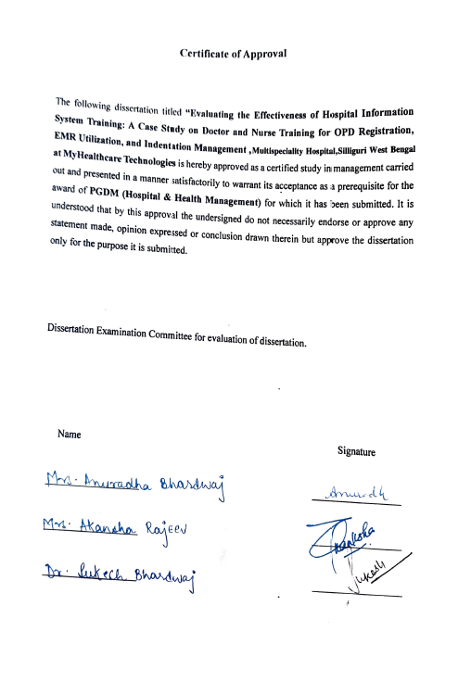

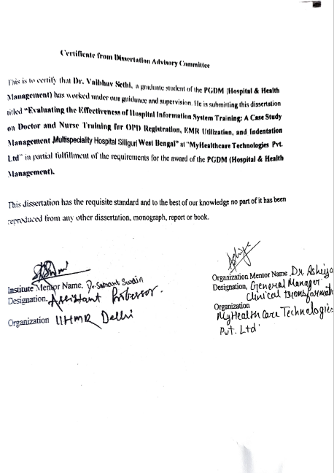
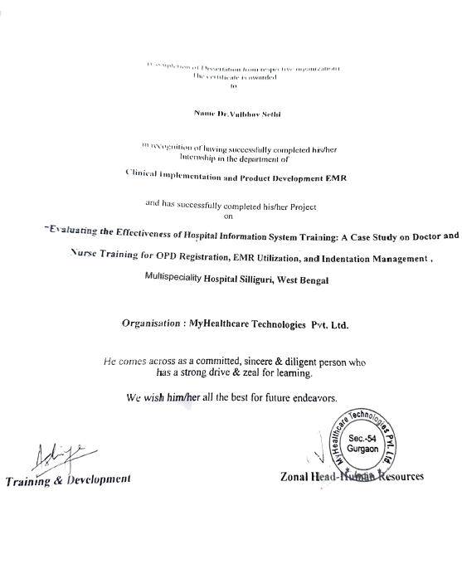

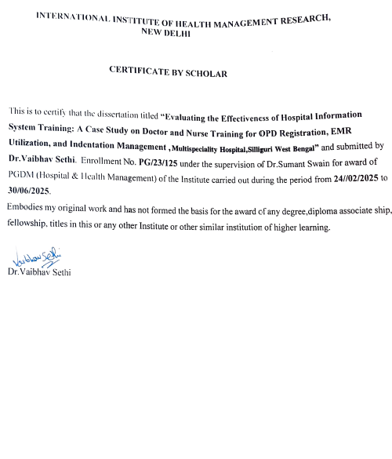

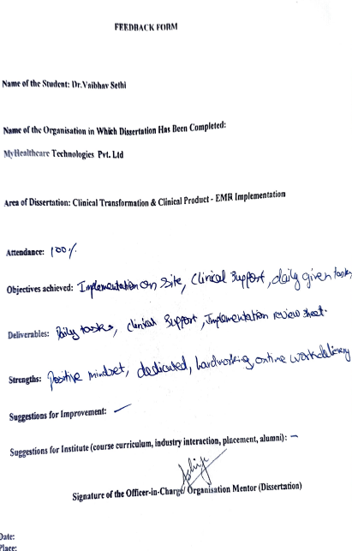

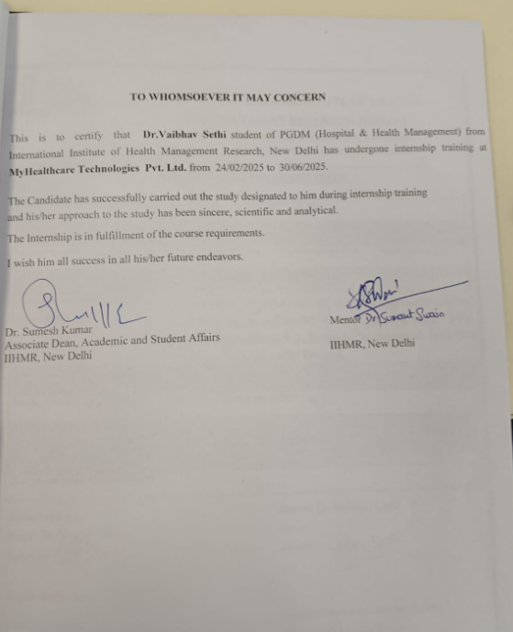
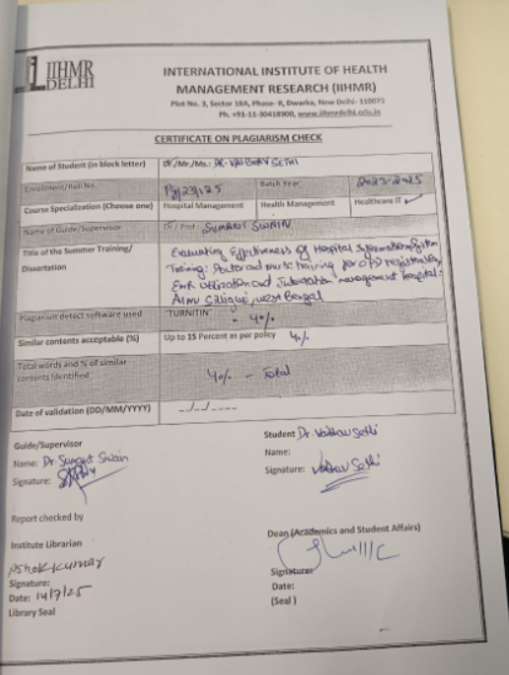

Acknowledgement:
Working on this dissertation has been a truly enriching experience, both in terms of learning and personal growth. I feel fortunate to have had the chance to carry out my research at MyHealthcare Technologies, where the practical exposure and guidance from experienced professionals added immense value to my work.
I'm genuinely thankful to the entire team at IIHMR Delhi—the faculty and staff—whose constant support and positive academic environment made it easier for me to focus on my research and expand my skill set. Their professionalism and encouragement created the right setting to explore my interests.
A special thanks goes to Dr. Sumant Swain, my mentor, for his invaluable advice and encouragement throughout the project. I also want to sincerely appreciate Mr. Shyatto Raha, Mrs. Divya Laroyia, Mr. Aneesh Nair, and Mr. Diwakar Bhowmik for their helpful insights and timely suggestions that played a crucial part in shaping my study.
I'm also grateful to Dr. Ashiya Mahran for her support and kind mentorship during this journey. Finally, I want to acknowledge my colleagues and the wider team at MyHealthcare Technologies, whose collaboration and encouragement made this work possible.
To everyone who helped me along the way—thank you. Your contributions, whether big or small, truly made a difference.

Table of Contents:
S. No. | Components | Page No.
1 | Abbreviations | 12
2 | Scope of the Project | 13
3 | About the Industry | 14
4 | About the Organization | 17
5 | Project Title | 34
6 | Abstract | 34
7 | Introduction | 35
8 | Research Objective | 42
9 | Research Questions | 42
10 | Review of Literature | 43
11 | Methodology | 45
12 | Result | 49
13 | Conclusion | 62
14 | Limitations | 63
15 | Recommendations | 63
16 | References | 65

List of Figures:
Figure 1 | MyHealthcare Data Driven Ecosystem | Page 19
Figure 2 | Application Data | Page 20
Figure 3 | MyHealthcare for Patients | Page 21
Figure 4 | Feedback Questionnaire | Page 50
Figure 5 | Pre- Post Test Questionnaire | Page 55

List of Tables:
Table 1 | Doctors’ Questionnaire | Page 50
Table 2 | Nurses’ Test Questions | Page 54
Table 3 | Thematic Analysis | Page 59

LIST OF ABBREVIATIONS
HMIS- Hospital Management Information System
OPD- Out-patient Department
IPD- In-patient Department
EMR- Electronic Medical Record
LIS- Laboratory Information System
RIS- Radiology Information System
ICD- International Classification of Disease
HIS- Hospital Information System
LASA- Look Alike Sound Alike
PACS- Picture Archiving and Communication System
SOAP- Subjective, Objective, Assessment, Plan

Scope of the Project:
The scope of this dissertation study is to assess the effectiveness of Hospital Information System (HIS) training within the doctors and nurses in outpatient registration, medication indentation and overall EMR utilization in AINU Hospital, Vishakhapatnam unit. The study will focus on evaluating the impact of HIS training programs on the proficiency and performance of doctors and nurses in overall EMR compliance. It will be conducted exclusively within the Vishakhapatnam unit of AINU Hospital, concentrating on the EMR utility for inpatients and outpatient consultations, which plays a crucial role in revenue management and patient service delivery. The project will adhere to a defined time frame for data collection, analysis, and reporting, encompassing both pre Go-Live training and post Go-live support to the clinical staff members of the hospital. Participant selection will include nursing staff members, all the in-house consultants, surgeons and relevant personnel engaged in utilizing HIS for OP & IP EMR. Evaluation methodologies will include both quantitative and qualitative approaches to measure outcomes such as medication indentation, usage of clinical forms, entering the vitals and staff confidence levels in system usage. The study will provide practical recommendations tailored to optimize HIS training effectiveness, aiming to enhance staff competencies and improve the performance of clinical staff members in tasks such as prescription writing, vitals entry, and medication indentation within AINU Hospital.

- ABOUT THE INDUSTRY:
The Growing Relevance of HMIS in Healthcare In today's healthcare environment, it is impossible to ignore the impact that digital tools such as Hospital Management Information Systems (HMIS) are having on operations. HMIS is an all-in-one piece of software that meets the needs of healthcare organizations in handling everything from patient care, administration, billing, and medical inventory in one efficient system. HMIS assembles all the necessary information in one system, including health records and financial records, making it easily accessible to those who need it most. How HMIS is Making an Impact Looking at an HMIS implementation, I can assure you that the impact is not only to help hospitals operate more efficiently, but can actually transform how patients utilize the healthcare system. Here are a few examples of how HMIS makes an impact: • Manage Patients Better: When a patient arrives at a hospital, registering any new patient, scheduling follow-ups, or establishing formal discretion paperwork, HMIS streamlines the process. Workers, like doctors or first contact staff, can find records, check lab test results, or review past visits from any computer in a matter of minutes, making them more responsive and efficient.
• No More Paper Charts: HMIS is used to not provide care, but it's used to house patient records digitally! No doctor wants to go to a medical records office and find a room of overstuffed clerical paper files; now, we make Electronic Health Records (EHR) available for teams to access, including patient background medications, allergies, lab reports, and providers involved in their patient care
- Enhanced Clinical Support: Many HMIS solutions include useful tools such as reminders and alerts which can assist clinicians during diagnosis or treatment. These capabilities help to reduce error and improve patient safety since it is difficult to miss an essential step in the course of care.
- Improved Financial Oversight: When it comes to billing and claim management, it's much easier using an HMIS. They maintain a record of everything from invoices to insurance payments, making it easier for providers to manage their revenue and reducing delays in claims processing.
- Stock Management: Whether it’s medications, supplies, instrumentation, or surgical equipment, keeping track of medical inventory is difficult. HMIS reduces this burden by monitoring stock levels, notifying users of low supplies, and often can automate stock reordering processes
- Data-Driven Decision Making: Another key benefit is that HMIS makes it easy to analyze performance. HMIS software can produce in-depth reports on all areas of hospital operations- patient outcomes, financial performance, quality metrics, etc.- that can help leaders make better decisions for long-term improvement.

HMIS Adoption in India
India is going through a substantial shift toward digital healthcare and HMIS is a piece of that shift.
• Government: The Government of India has highly encouraged public hospitals and clinics to implement HMIS incentivized by the National Health Mission (NHM). Overall the government is hoping that they will develop HMIS that will enable hospitals and clinics to manage health data and follow patients wherever they go.
• Private Sector: On the private sector side, large hospitals, multi-speciality hospitals, and even diagnostic labs are participating in HMIS. By adopting HMIS, hospitals will improve efficiencies and patient satisfaction scores. Tech-enabled healthcare is really starting to accelerate and is becoming standard operating procedure.

ABOUT THE ORGANIZATION:
MyHealthcare Technologies: Delivering a Healthcare Offering and Digital Ecosystem
MyHealthcare Technologies (MHT) is a future-focused health-tech firm that is committed to building a digital ecosystem that encompasses integrated, patient-centered care delivery. MHT collaborates with health systems—e.g. hospitals, health and community clinics—to create a connected ecosystem platform that includes in-person and virtual physician consultations, at-home diagnostic testing, pharmacy services, remote patient medical monitoring, vaccination clinics, and home and community health care. To integrate this all, at the heart of MyHealthcare Technologies philosophy is a desire to connect and bridge together the gaps and silos that exist in health care delivery by applying leading digital solutions. One of the companies main priorities is to create a more data-driven and accessible care model, allowing both the patient and care-giver to make informed health care decisions. Leveraging technology to create a continuous care model, where patient engagement is not only reactive but also proactive and personalized.

One of the key advantages of MyHealthcare’s model is the ability to have a consistent and secure record of a patient’s entire medical history. MyHealthcare records all patient interactions in the platform, including rings, prescriptions, consultations, lab reports, etc. This history shows the patient’s life progression over time, the evolving state or pattern of care delivered along that path, and ultimately allows for care to be fully teamed and coordinated. The company operates from headquarters in Gurgaon (Delhi NCR), but also has technology hubs in Bangalore and Dehradun. In addition, the company has established a commercial presence in multiple Asian countries (including Malaysia, Singapore, Indonesia, Vietnam, the Philippines, Thailand, Hong Kong, etc.) The digital management system established for MyHealthcare will support different aspects of clinical care. At its core is the 360-degree care management platform for physicians and clinicians. This platform has the ability to manage all aspects of clinic operations, as well as maintain EMR (electronic medical records) records and data. EMRs have been established or modified for different specialties, including general medicine, pediatrics, cardiology, endocrinology, and plans are in place for obstetrics and gynecology, oncology, ophthalmology, dentistry, and neurology.
One unique aspect of the platform is that it is cloud-based and is accessible via web and mobile interfaces to enable healthcare providers to connect with patients via highly secure video or audio calls and write or review prescriptions while they are away from the practice, and manage to monitor a patient's care even when not physically present. The integration of advanced AI and machine learning capabilities enable healthcare professionals to make faster, more accurate decisions by processing clinical data to come to clinically matched decisions against accepted standards of care from around the globe—ICD-10, SNOMED CT, etc. The platform has a library of a wide array of medical protocols and recognises over 19,000 medications, making it a significant driver for both emergency context and more complex clinical presentations. Access to a continuous history of a patient's clinical data provides for swift and informed decisions when every second counts. One of the most exciting aspects of the ecosystem is MyHealthcare@Home—our remote care solution designed to monitor patient health outside conventional hospital walls. With one command center, healthcare providers can monitor a diverse population – patients in home isolation or remote chronic condition monitoring..
Fig.1:
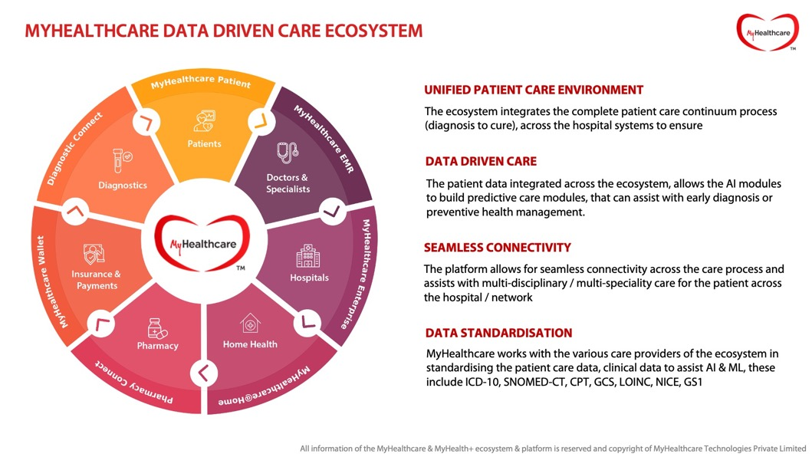
Key Components of the MyHealthcare Digital Ecosystem
- MyHealthcare has a number of distinct digital tools and platforms that work together to create a seamless, connected care journey for patients and care providers. This entails interacting with the patient in a singular eco-system that supports the entire care journey which includes booking an appointment, as well as managing pain and receiving treatment at home. Below are some of the important aspects of the ecosystem –
- Patient Platform (Web & Mobile): This is the way that patients interact with care professionals, with the options of web or mobile. Whether the patient is conducting a visit in person or online, uploading health records, or getting prescriptions filled after their consult, it has never been so easy for patients to access the level of care they require.
- Hospital Interface: This is a special portal for hospital teams to better manage patient and appointment data, along with overall coordination of care. This is the back end of the local work that is required, to enable the patient to have a better overall experience.
- MyHealthcare@Home Control Center: This centralized dashboard is built on the assumption that clinicians will need to monitor patients outside of the hospital, particularly patients who are travelling home to isolate from the hospital or are in a scenario of long-term remote care. It allows medical teams to monitor as many patients as required from one dashboard.
- Home Nursing Care System: Nurses making home visits can use this tool as a mobile platform, providing the clinician the ability to see which patient they are currently seeing, update patient data in real-time, and track vital parameters and patient care progress on either web or mobile devices.
- Remote Patient Monitoring (RPM): The suite of RPM tools allows clinicians to monitor patients health metrics including vital signs - without patients stepping into the hospital. This is useful for chronic care management or patients recovering at home
- Patient Feedback Collection System: MyHealthcare also values patient input. This system gathers feedback on the care experience, helping providers identify areas for improvement and ensure quality service delivery.
- Lead Management and CRM System: For hospitals and clinics looking to manage outreach and engagement, there’s a dedicated web-based CRM system. It helps healthcare providers track patient inquiries, follow up on leads, and maintain strong patient relationships.
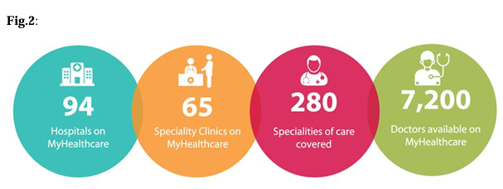
MyHealthcare Patient Platform: Simplifying Access to Quality Care
MyHealthcare patient platform helps people in different locations connect with doctors and easily manage their health better. Whether you need to book a virtual consultation or can visit the doctor, MyHealthcare supports the ability to book doctor appointments, upload health documents, share notes, receive prescribtions and more from one interface. Aside from the virtual consultations, the MyHealthcare platform provides multiple services to enable care at home, including the ability to book diagnostic tests, order medicines, arrange home care, or even be monitored remotely if you are recovering at home or under isolation. The virtual consultation structure is built with security and encryption to have peace of mind around patient privacy. Video appointments are run through the MyHealthcare mobile app which is very simple to use and is private. The doctor will be able to review the full medical history of the patient which includes all previous treatments, lab results and documents shared live while seeing the doctor which helps the doctor provide better care.
Fig.3:
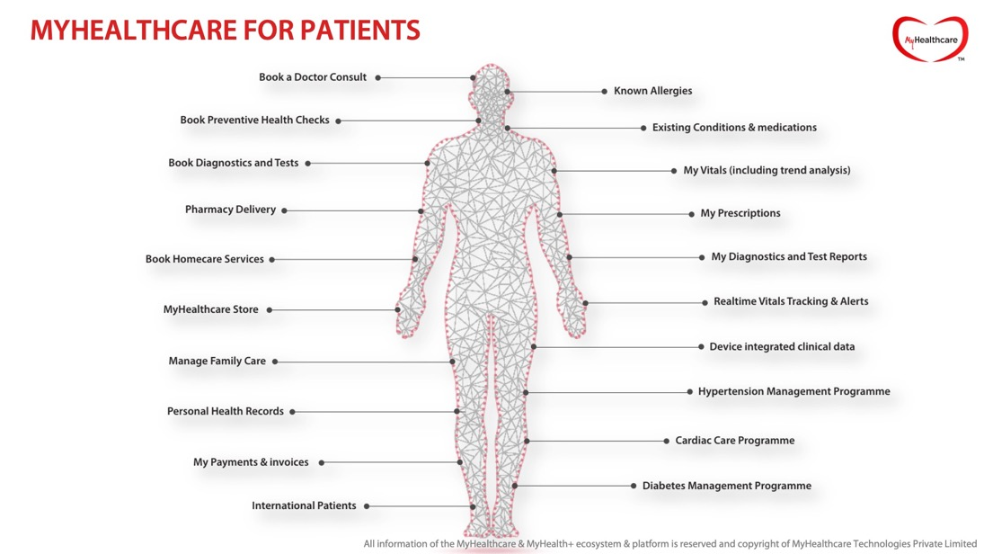
MYHEALTHCARE PATIENT APPLICATION

MyHealthcare Digital Ecosystem: Connecting Patients and Doctors Seamlessly
The MyHealthcare Patient App is more than a tool to book services, it is a complete digital solution for individuals and families to conveniently manage their health. The Patient App has a user-friendly design that allows users to register, book in-person and online doctor appointments, upload medical documents, and receive digital prescriptions. The patient experience extends beyond these tasks. Users can book lab tests, book preventive health care packages, order medicines, book home care services, monitor their health remotely, and more all through the app. To personalize the experience, the platform offers profile management, allows registration for family members, enables allergy tracking, and provides personal health record (PHR) maintenance functionality. Users can also integrate health devices for real-time vitals-tracking, to help users engage in more proactive chronic condition/acute condition management. Users can also take advantage of interest-based loyalty programs, promotional coupon codes, secure online payment options, and invoice access for convenience and engagement..
Physician-centric Tools for Smart Care Doctors were able to use the MyHealthcare Doctor Platform (for web and mobile), which integrates with the core hospital systems in HIS, LIS, RIS, PACS, allowing for clinicians to manage their outpatient and virtual consultations. Getting all patient data in one place has many benefits such as viewing patient demographics, test results, medical records, and documents uploaded by patients prior to and during the consultation – allowing the physician to make the consultation more successful. The doctor interface can also link to patient-facing tools such as Queue Management System, MyHealthcare@Home, and referral modules, allowing for a closed treatment loop. An innovative feature was Speech-to-Text EMR, where the doctor could dictate the patients’ notes, medications, and investigations directly into the EMR, reducing time. This is one of the first in India that uses EMR trained with medical terms, drug names, and diagnostics. Voice-based documentation using structured EMR templates has improved the quality, safety, and accuracy of care.
- Doctors will enjoy features including:
- Real-Time tracking of appointments (upcoming, missed, cancelled, done)
- Ability to conduct video, audio, or OPD consults
- Access to patient notes and clinical documents
- Alerts for consultations delayed at any point and 15-minute alerts before each appointment
- Smart reuse of previously prescribed medication for quick follow-ups.
- Upload prescription instantly with an image or a PDF.

Advanced Clinical Tools in the SOAP-Based EMR
The doctor EMR follows the SOAP format—Subjective, Objective, Assessment, Plan—allowing care teams to document every interaction in a structured and configurable way.
- Subjective section covers patient complaints and illness history (voice-enabled).
- Objective includes vitals, allergies, existing conditions, and prior history.
- Assessment enables diagnosis entry (auto-mapped to ICD-10), with image upload.
- Plan allows ordering medications, tests, and providing instructions—all aided by intelligent suggestions and templates.
Doctors can create order sets and disease-specific care protocols, reducing the time spent on routine documentation. The system even includes:
- Duplicate drug alerts
- Polypharmacy warnings (8+ active meds)
- Drug allergy alerts, integrated with databases like CIMS
- Device integration to view ECG, heart rate, blood pressure, glucose, etc.
The Doctor Dashboard shows appointment counts, OPD schedules, and enables the search of patients via name, mobile, or UHID. With the ability to block calendars, mark leaves, and manage emergency breaks, practice management becomes far more flexible.

MyHealthcare IPD EMR: For Inpatient Excellence
The In-Patient EMR system is tightly integrated with all major hospital systems, providing a cohesive view of admitted patients. For doctors managing IPD:
- CPOE (Computerized Physician Order Entry) streamlines lab, radiology, and procedural orders.
- Medication tools allow doctors to review, pause, resume, or discontinue treatments.
- Order sets help place grouped orders quickly.
- Allergy alerts are triggered based on drug ingredients.
- Drug database includes over 19,000 medications with dosage, route, schedule, and strength details.
- Duplicate test alerts help prevent unnecessary repeat orders.
This EMR ensures that inpatient care is structured, safer, and well-documented—supporting doctors in providing high-quality care with less administrative friction.
h) LASA alerts for all medications
i) Substitute recommendation based on item nature and payor configuration
j) View events of the past 24 hours
k) View laboratory and radiology report status. Radiology PACS images also on view as image
l) Patient longitudinal history view across all encounters (OPD, IPD, ER, Homecare)
m) Critical result / alert notification
n) Forms Builder (including progress notes), for creating customised forms
o) Medication Management: Manages medication reconciliation and provides doctors with patient’s drug history.
p) Operation Theatre: Schedule, reschedule or cancel patients’ surgical processes.
q) Clinical Notes: Doctor can create, edit, and delete clinical notes for patient. Additionally, he/she can view old notes details and form builders.
r) Configuration to auto post Admitting practitioner visits, Referral visits based on note recorded
s) Referral workflow: Initiate, accept, forward and complete referral
t) Patient Discharge: Doctor can initiate or cancel patient’s discharge using this tool. It also highlights patient discharge timeline.
u) SMART discharge summary which is configurable: Doctor can define summary formats as they like. This allows summary to automatically populate as configured and eliminates need to type it from scratch.
v) Patient History: Provides doctor with patient’s history and allows him to view trend graphs of his ongoing or past treatments
w) ICD 10 Diagnosis – full text search enabled ICD Codes based diagnosis recording
x) Alerts & Notifications – Provides timely alert based on highly configurable notification engine.
2. IPD- EMR for Nurses:
a) Order Management: Nurse can view, track, amend and even cancel the orders. Access control based.
b) Supplies: Acknowledge, ward supplies, return or approve return of drugs
c) Medication Administration Record: EMR IPD allows nurse to administer medication records and perform below mentioned activities:
• Administer Now
• Delay the task
• Unable to Administer
• Administer Missed Dose
• Start Infusion
• Complete Infusion
• Change Infusion Rate
• Administer from ward stock.
d) Patient Discharge: Give nursing clearance, view pending orders, view patient’s discharge timeline, and send discharge cancellation intimations.
e) Patient Transfer flow: Transfer request, approval, transfer out and transfer in
f) Operation Theatre:
• Prepare transfer for the procedure
• Prepare transfer checklist.
• Surgery Request
• Schedule or reschedule surgery.
• Check-in to OR
• Surgery Timeout
• Operative Notes, Anesthetist’s Notes, Nursing Notes
• Surgical Safety Checklist
• Checkout from OR
• Ward transfer port surgery
g) Charting: Vital, I/O charting and ICU charting.
h) Notes: Can create, edit, and delete clinical notes for patient. Additionally, he/she can view old notes details and form builders.
i) Blood Transfusion: Complete transfusion and activities related to blood transfusion such as:
• Barcoded Initiation of Blood Transfusion
• Complete or Stop Transfusion
• Adverse Events
• Return Blood Bag
• View Order Detail

MYHEALTHCARE EMERGENCY EMR
- Complete management of Ambulance starting from call receiving to dispatch, real-time tracking, and in-transit management of patients from command centre.
- Remote patient monitoring through device integrations, including on-demand virtual consultation.
- Single click Registration for Emergency and bulk patient registration.
- Triage and Vitals tracking with clinical markers, clinical alerts.
- Single screen ER workbench to order and monitor service status, report tracker, capture clinical notes, medicine administration, referral tracking and length of stay.
- Template and protocol-based order execution enabling faster and intime delivery of services for critical cases.
- Admission request tracker starting from the point of admission advice from the practitioner till the arrival in ward, which also helps track conversion.
- Discharge Initiation, ER Visit Summary with configurable templates which can be automated, Nursing clearance and discharge.

TITLE:
Evaluating the Effectiveness of Hospital Information System Training:
Doctor and Nurse Training for OPD Registration, EMR Utilization, and Indentation Management
Hospital: AINU Hospital, Silliguri,West Bengal
- Dr.Vaibhav Sethi
Abstract:
This study investigates the impact of training programs on the successful adoption of a new Hospital Information System (HIS) called MyHealthcare Enterprise Application (MHEA) at Asian Institute of Nephrology & Urology Hospital. MHEA is a comprehensive system designed to streamline workflows, improve operational efficiency, and enhance patient care.
The research employed a cross-sectional design with a purposive sample of 22, with 6 in-house surgeons & consultants and 16 nursing staff members. Data collection involved pre- and post-training surveys to assess changes in staff's familiarity, readiness, and confidence levels using the new HIS. Additionally, a semi-structured training feedback survey was conducted to evaluate the training program's quality.
The findings revealed positive outcomes from the HIS training program. Staff reported increased comfort levels with essential HIS tasks like patient consultation, vital entries, medication indentation and appointment management. Thematic analysis of training feedback highlighted the program's effectiveness in areas focusing on the functionalities majorly focusing on inpatient care, interactive sessions, and trainers' expertise.
This study emphasizes the crucial role of well-designed training programs in facilitating a smooth transition to a new HIS. By identifying areas for improvement, such as the need for additional training materials and more hands-on practice, future iterations of the training program can be optimized to ensure staff preparedness and maximize the benefits of MHEA for AINU Hospital.

INTRODUCTION:

The Role of Staff Training in HIS Adoption: A Case Study at AINU Hospital
Hospital Information System (HIS) can enhance how hospitals operate and deliver healthcare. HIS is more than software; HIS is a comprehensive system that supports numerous combinations of hospital operations, with a spectrum from patient workflow and clinical workflows to administrative and financial processes. After all, the health care environment can often be both complicated and fast-moving, and HIS has become an essential component of modern hospital operations. HIS can improve a hospital’s ability to increase patient safety, enhance service quality and maximize lower costs of delivery. A recent illustration of this reality has been AINU Hospital—think globally and provide a rich history in health care—once again implemented a HIS to improve operations. It is worth noting that using technology does matter in terms of successful implementation; however, it also relies greatly on preparing staff (especially doctors and nurses) to use it effectively. AINU has spent a significant amount of time and effort reinforcing training with the outpatient and inpatient team. The objective of this paper is to examine the significance of training staff in adopting their new HIS; and to study staff perceptions of readiness, self-reported confidence gained, barriers to training, and the extent to which the new system supports daily clinical workflows

The Rise of HIS in Modern Healthcare
In recent years, the healthcare industry has experienced an unprecedented transformation with the influx of digital technologies. This transformation has been in response to a wide definition of the term "digital," as well as massive government spending and enhancements in telecommunications infrastructure, all while serving demands for higher quality healthcare and greater efficiency. Hospital information systems (HIS) have emerged as a full-featured solution to clinico- and non-clinico hospital operations. First and foremost, HIS platforms obtain, store, and manage many different types of data associated with hospital activity, ranging from clinical (e.g., patient records, vital signs, diagnostic results) to non-clinical information (e.g. - finance, revenue cycle, administrative support, etc.). HIS platforms replace out-dated, paper-based information systems with much more manageable digital alternatives ( - e.g., easier to read, search/find, and most importantly - much more secure). For healthcare professionals, being able to 'find' accurate patient information at the 'right' time allows them to make better decisions and ultimately develop better treatment plans! For hospitals, HIS systems can contribute to savings in overhead, faster collection of revenue, efficiencies in provider operations, and improved quality of care delivery. Conversely, implementing HIS does not come without its challenges and difficulties. In some instances, healthcare providers have noted they received little user training and did not understand the full capability of the HIS. Without sufficient training and follow-up consultation, staff can easily lose tract of how best to use the HIS, resulting in little improvement to their operational efficiency. The acceptance of HIS by users, whether they be nurses, doctors, or support staff.That’s why identifying the factors that influence user adoption is essential. Once these are understood, hospitals can develop strategies that not only encourage adoption but also build confidence and improve overall satisfaction with the system.

MyHealthcare Enterprise Application (MHEA): A Smarter Digital Backbone
Among the many HIS solutions available today, the MyHealthcare Enterprise Application (MHEA) stands out for its intelligent, streamlined approach. Designed to make hospital management more efficient, MHEA brings consistency to healthcare operations by standardizing processes and improving coordination between departments.
One of its most notable features is the Single Screen HIMS—an all-in-one interface where users can access multiple functions without navigating through complex menus. This simplified design enhances productivity, especially in busy environments like OPDs or emergency care units. The platform is also equipped with tools that help hospital teams monitor performance, analyze trends in patient care, and align their operations with standardized clinical protocols.
By promoting data-driven decision-making, MHEA helps organizations not only improve service delivery but also better utilize resources and reduce unnecessary expenses. The platform runs on open-source technology and incorporates the latest advancements in automation, data privacy, and artificial intelligence. As a cloud-based SaaS solution, it minimizes the financial burden of traditional software by removing expensive licensing fees and maintenance costs tied to proprietary systems.

Conclusion
The healthcare sector is embracing digital transformation at a fast pace, and systems like HIS are at the heart of this change. But while the technology itself is essential, the human element—especially staff training and system acceptance—plays a decisive role in how effective these tools will be in real-world use. With hospitals like AINU taking the lead in this digital shift, understanding and optimizing the training and transition process becomes all the more critical. Ultimately, investing in the right tools and the people who use them can significantly elevate the quality, efficiency, and reach of healthcare services.
The following are some advantages of using the MyHealthcare Enterprise Application:
- Worklist-Based Single Screen: This method allows effective job management by giving each user access to a consolidated task list on a single screen.
- Point-of-Care Information: MHEA helps patients make educated decisions by providing precise, current, and thorough patient information at the point of care.
- Compliance with Healthcare IT Standards: MHEA complies with healthcare IT standards to guarantee smooth data transfer across various systems, facilitating a quicker and more accurate flow of information.
- Real-time Turnaround Time (TAT) Monitoring: MHEA makes it possible to track TATs in real-time, which enables patients to receive treatments more quickly.
- Improved Patient and Provider connection: MHEA makes healthcare more convenient by fostering better patient and provider connection and communication.
- Cost-cutting measures: MHEA lowers paperwork, offers quicker and simpler mobile device access to data online, and lowers overall costs.
- Workflow-Based Task Management: This improves workflow efficiency by allowing users to move between screens and handle tasks according to their roles and responsibilities.
- TAT and Escalation Alerts: To ensure that tasks are closed as soon as possible, MHEA automatically escalates activities that take longer than expected or call for quick attention.
- Notifications: Users are informed, and communication is enhanced via automated alerts that are sent when a task is completed.
- Streamlined Claim Processing: MHEA makes it possible for payers and insurance companies to process claims more quickly and accurately. This leads to fewer deductions and denies payments, which eventually improves financial returns.
The MyHealthcare Enterprise Application (MHEA) aims to provide healthcare organizations with an improved level of operational efficiency, application of practices, and enhancement in patient care, through its sophisticated technology stack and flexible workflow engine. The principal aim of the study is to explore whether the training programs were successful in providing end users the skills and knowledge ultimately needed to adequately use the Healthcare Management Information System (HMIS). In addition, studying how the users' acceptance and satisfaction were affected by the addition of new features to the HMIS. The purpose of this paper is to study the level of acceptance of HIS and its acceptability for hospital staff as well as clinicians. The study is designed to identify the barriers to HIS acceptance and recommend solutions to increase acceptance through an evaluation of the user's attitude, their knowledge, training requirements, and the studies assess the user's goals of acceptance and usability. The study's objective is to positively increase HMIS acceptance and user satisfaction with the MyHealthcare System resulting in the quality and efficiency of the healthcare services performed overall improved. Hospital information systems have the potential to enhance decision-making abilities, facilitate streamlined and timely processes, and improve quality in service healthcare services. However, it is necessary to evaluate and understand the issues of user acceptance, training, and usability that may impede user adoption and effective utilization.
However, addressing issues with user acceptability, training, and system usability is essential to ensuring successful adoption and usage. Healthcare organizations may create focused plans to maximize the advantages of these systems and eventually enhance patient care outcomes by knowing the elements driving HIS acceptance and implementation.
The project's goal is to improve the MyHealthcare System's HMIS uptake and user satisfaction. The initiative hopes to raise the organization's overall efficiency and quality of healthcare services by raising the adoption rate and satisfaction levels. The appraisal of new features and training programs will offer insightful information on HMIS’s advantages and potential areas for development. In order to better serve end users' demands as well as the goals of the healthcare organization, this input can subsequently be utilized to improve user assistance, train tactics, and further optimize the HMIS.

OP Consultation Workflow:
- Patient Registration: The process starts with patient registration. The patient enters their mobile number into a designated field on a website.
- Patient Lookup: The system checks if the patient is already registered.
If the patient is registered, a list of registered patients is populated, and the user can select the patient from the list. If not,
New Patient Registration: If the patient is not registered, the system prompts the user to register the patient.
- OP Bill Screen: Once the patient is selected or registered, the user clicks on an "OP Bill" button. This could be for an out-patient consultation bill.
- Encounter Creation: The user then clicks on the “Create New Encounter" button. An encounter is a meeting between a healthcare provider and a patient.
- Practitioner Selection: The user selects the practitioner, likely the doctor or other healthcare professional, involved in the consultation.
- Slot Selection: The user selects the time slot for the consultation.
- Consultation: After selecting the slot, the user clicks on a "Consult" button, which likely initiates the consultation for the booked time.
- Patient queue: Patient queue in the doctor’s dashboard displays the number of patients to be consulted by the practitioner in the day with 3 tabs, i.e., Worklist reflecting the number of patients yet to be consulted, Completed reflecting the number of consultations completed by the doctor and Pending reflecting the number of patients from previous days, whose consultation have not been completed.

Emergency EMR Workflow:
- Patient Registration: The process starts with entering the patient's UHID or demographic details (for known patients) or proceeding with Unknown Registration if details are not available.
- Patient Lookup: The system checks if the patient is already registered.
If the patient is registered, a list of registered patients is populated, and the user can select the patient from the list. If the patient is not registered:
New Patient Registration: If the patient is not registered, the system prompts the user to register the patient.
Unknown Registration: In case for emergency scenarios.
- Register/Create Visit: Once the patient is selected or registered, the user clicks on the “Register/Create Visit” button to begin the emergency visit.
- Vitals & Triage: Vitals are recorded and triage is done to assess the severity and prioritize care.
- Practitioner Selection & Bed Allocation: The emergency practitioner is selected based on triage or availability.
If Bed Required: Assign and allocate a bed.
- Clinical Assessment & Orders:
- Nursing Assessment followed by Doctors Assessment
- Place orders for labs, radiology, diagnostics, procedures or medications as needed.
- Fill relevant clinical forms or initiate referrals, surgery requests, blood units’ requests.
- Nursing Clearance: Once all care and orders are completed, initiate nursing clearance.
- Discharge or transfer to IP:
- If patient is stable and dischargeable:
- Click on “Initiate Discharge”
- Save and authorize the ER discharge summary.
- If admission required:
- Transfer patient to IPD with bed allocation.
- Invoice Generation: Generate the final invoice for emergency services rendered.

Objectives:
Primary Objective:
To evaluate the effectiveness of HIS training for doctors and nurses at AINU Hospital, Vizag Unit.
Secondary Objective:
To identify the challenges faced by the doctors and nurses in implementing HIS functions post-training and post Go-live.
Research Questions:
How effective is the HIS training in improving performance and reducing errors in OP & IP EMR use, and indentation?

Review of Literature:
Authors  (Year) | Study  Location | Salient Features
Sima Ajami and Zohreh Mohammadi-Bertiani (2012) |  | The study identified inadequate training as a major cause of HIS failure. Literature searches across libraries, databases, and search engines identified relevant articles focusing on training's impact on user satisfaction and HIS success. From over 75 results, 41 articles were selected for analysis. The findings emphasized user training as a key factor for HIS adoption and highlighted the challenges of user resistance due to job insecurity from lack of training. The study suggests that involving users in HIS design and implementation can be a solution to overcome these challenges.
Leila Ahmadian, Nafise Dorosti, Reza Khajouei and Sadrieh Hajesmaeel Gohari (2017) | Kerman, Iran (Hospitals - both academic and non-academic) | According to the survey, the most common and important issues facing university hospitals had to do with the surrounding human environment, specifically the "negative attitude of society about employing HIS, lack of incentive to use system."  Recommendations like- Implement strategies to address human environment and human factors (e.g., in-service training, incentives), Increase user motivation and satisfaction with HIS were proposed.
Rully Sumarlin (2018) | Dewi Sri Hospital Karawang, Indonesia | The aim of the study was to improve the quality of medical treatment delivered by physicians and hospital staff. In order to evaluate the system's installation and effect on the entire delivery of health services at Dewi Sri Hospital, the study included user interviews and observations. The goal of the research was to pinpoint areas in need of development and raise the system's efficiency in assisting in the delivery of high-quality healthcare.
B. K. Murthy, P. K. Srivastava, A. S. Cheema (2014) | PGIMER, Chandigarh | Even with effective planning and staggered implementation, there is still concern about the challenges associated with using and implementing HIS. This includes administrative obstacles including lack of ownership, user acceptance, stakeholder involvement, and technical issues like data security, unauthorized access, secret information, and the integration of medical software to prevent double entry. Although these approaches don't fully achieve the objectives of the HIS, they can lessen this by using data entry operators or offline and duplicate entries. This study discusses the challenges faced during the implementation of HIS in a super specialty hospital.
Nirmala Kumari, et al. | Tertiary Care Hospital, India | Examines factors affecting HIS acceptance among nurses, highlighting the role of age, education, and computer training. Emphasizes the need for user-friendly systems and proper training.
Sinju D'Costa, Rajesh Kumar Sinha | Southern India | Assesses user satisfaction with an HIS-integrated EMR in a super-specialty hospital. Identifies usability challenges like slow networks and lack of training. Recommends regular evaluations for better adoption.
Ganesh-Babu  B.Subburaman, Karthikeyan M. | Aravind Eye Care System, India | Discusses successful HMIS implementation at Aravind Eye Hospitals, emphasizing systematic planning, staff training, and workflow alignment.
S. B. Bhardwaj, S. K. Vishwakarma | India | Evaluates HIS adoption challenges in Indian hospitals. Highlights benefits like reduced errors and improved patient satisfaction. Suggests a roadmap for better implementation.
N. Kumar, A. Singh, R. Gupta | India | Provides a roadmap for EHR adoption, addressing ICT infrastructure, regulations, interoperability, and training needs in the Indian context.
S. Kumar, P. Kumar, A. K. Jain | Haryana, India | Discusses the implementation of e-Upchaar, an HMIS for public health facilities. Highlights improvements in patient registration, drug dispensing, and data management.

Research Methodology:
Type of Study: Cross-sectional Design
This study employs a cross-sectional design. Data will be collected from a specific sample of in-house consultants & surgeons and nursing staff at AINU Hospital at a single point in time. This design is particularly suited to investigate the immediate impact of the new Hospital Information System (HIS) training program on staff's familiarity, readiness, and perceived confidence level.

Study Population: Nursing staff and in-house doctors & consultants.
The target population for this study comprises all full-time nursing staff members & in-house consultants at AINU Hospital, Vizag Unit who will be utilizing the new HIS in their daily tasks.

Sample Size and Selection: Purposive Sample (n=22)
A purposive sampling technique will be employed to recruit a sample size of 22 participants. This method ensures the selection of individuals who best represent the target population – in this case, all nursing staff & doctors who will be directly affected by and working with the new HIS.

Inclusion Criteria:
All full-time nursing staff members and in-house surgeons & consultants AINU Hospital who will be using the new HIS.
Staff members scheduled to attend the HIS training program.
Staff members who have completed the training program.

Exclusion Criteria:
Any on-call consultants and staff members who will not be using the new HIS in their daily tasks will be excluded to ensure the data collected reflects the experiences of those directly impacted by the training program.
Staff members who are on leave or unavailable during the data collection period will be excluded to minimize participation bias and ensure data integrity.

Data Collection Method & Tool: Mixed Methods Approach
This study will utilize a mixed methods approach, combining quantitative and qualitative data collection methods to gain a more comprehensive understanding of the impact of the HIS training program.

A. Pre- and Post-Training Surveys:
Quantitative Tool: A structured questionnaire will be employed for both the pre- and post-training surveys. This questionnaire will utilize a standardized format with closed-ended questions to assess participants' self-reported:
- Familiarity with the new HIS: Questions will gauge participants' prior knowledge and experience with similar HIS systems or related software.
- Readiness to utilize the system: This section will assess participants' perceived preparedness to confidently apply the new HIS in their daily tasks after the training program.
- Perceived confidence level: The survey will measure participants' self-reported level of confidence in using the new HIS effectively to complete their billing tasks.

Implementation and Training Delivery:
- To establish a baseline understanding, an initial demonstration of HIS will be provided before implementing the system.
- This will be followed by a comprehensive training program focused on the key features and functionalities of the new HIS relevant to the OP billing staff's workflow.

Pre-Training Survey: The pre-training survey will be administered to all participants before they commence the HIS training program. This will capture their baseline knowledge, readiness, and confidence levels regarding the new system.

Post-Training Survey: The identical survey will be administered again approximately two weeks after the HIS implementation. This timeframe allows participants to gain initial hands-on experience with the system following the training program. The post-training survey results will be compared to the pre-training data to assess the effectiveness of the training program in improving participants’ familiarity, readiness, and perceived confidence level in using the new HIS.

B. Training Feedback Survey:
Qualitative Tool: A semi-structured questionnaire will be used to collect feedback from participants immediately after the HIS training program. This survey will include a combination of closed-ended and open-ended questions to gather insights on:
- Content: The clarity, comprehensiveness, and relevance of the training content to the OP billing staff's needs.
- Delivery: The effectiveness of the training delivery methods (e.g., instructor presentation, hands-on exercises) in facilitating learning.
- Overall Satisfaction: Participants' general impressions and satisfaction level with the training program.

The open-ended questions in the training feedback survey will allow participants to elaborate on their experiences and provide valuable qualitative data beyond the pre- and post-training quantitative results. This comprehensive approach using mixed methods will provide a richer understanding of the training program's impact on the OP billing staff.

Results:
The study interviewed a total of 22 participants. All the participants agreed that the training they attended was important for them and the objectives of the training session were clearly indicated. Out of all the participants, 6 were doctors with 3 surgeons and 3 in-house doctors and 16 were full-time nursing staff members who took the training for the complete HIS.
When asked about the effectiveness of the training, 19 agreed that the training was very effective, 3 stated that the training was somewhat effective and none of the participants felt that the training was ineffective. There was 100%, i.e. 22 agreements to the statement that the training program improved their understanding and confidence in using the platform. 17 of them agreed that they have acquired necessary skills to influence the improvement of HIS data and the remaining 5 were not so sure about it.
When asked about the follow-up support after the training, all 22 of the participants agreed that they did receive the follow-up support after the training and no one said that they did not receive the follow-up support.
When the participants were asked to rate how optimistic are you about the upcoming HIS system, 14 of them rated level 5 which was the highest level, 4 rated level 4 and the remaining rated level 3 and there were no responses for level 2 and level 1.
17 of the total participants strongly agreed to the statement that the training program adequately prepared them to use the new HIS for their daily tasks, 4 of them agreed and the remaining 1 was neutral about it. No participant disagreed with the statement.

Results:

Table 1: Doctors’ Questionnaire
Hospital Information System (HIS) Doctor's Assessment Form
Question | Options
Section 1: Doctor’s Profile & Pre-Training Readiness
Your Specialty | Nephrology
Your Specialty | Urology
Your Specialty | Others
How many years of experience do you have? | Less than 1 year
How many years of experience do you have? | 1–3 years
How many years of experience do you have? | 3-5years
How many years of experience do you have? | More than 5 years
Have you used a Hospital Information System (HIS) before this training? | Yes
 | No
Which tasks were you familiar with before HIS training? (Select all that apply) | Prescription making
 | Diagnosing and entering order sets
 | Managing patient history
 | Viewing test results and previous records
 | Navigating the HIS dashboard for patient consultations
Section 2: Prescription-Making & Order Management Efficiency
How do you enter a patient’s diagnosis in HIS? (Before & After Training) | Manually writing each time
 | Using order sets/templates
 | Copying previous entries and modifying them
How frequently do you use pre-saved Order Sets for common conditions? | Always
 | Often
 | Sometimes
 | Rarely
How easily can you add medications to a patient’s prescription? (Before & After Training) | Manually enter every time
 | Use saved favourites
 | Use a combination of manual entry and saved favourites
How useful is the ability to copy-paste previous prescriptions for follow-ups? | Very useful
 | Somewhat useful
 | Neutral
 | Not useful
Can you easily edit a prescription after finalizing it in HIS? | Yes
 | No
Section 3: Patient History & Personal Details Management
How efficiently can you view and edit patient history in HIS? (Scale 1–5) | Past Medical History: 1, 2, 3, 4, 5  Past Surgical History: 1, 2, 3, 4, 5  Family History: 1, 2, 3, 4, 5  Social History: 1, 2, 3, 4, 5
Can you view and modify patient demographic details within HIS? | Yes, easily
 | Somewhat, with difficulty
 | No
Does HIS allow you to quickly reference past records and consultation notes? | Yes
 | No
Section 4: Dashboard Usability & Consultation Workflow
How effective is the HIS dashboard for managing all patient records in one place? (Scale: 1 = Not effective, 5 = Very effective) | 1
 | 2
 | 3
 | 4
 | 5
Can you quickly switch between different patient records during consultation? | Yes, very easily
 | Somewhat, but it takes time
 | No, it is difficult
How well does HIS integrate with other hospital systems (e.g., lab reports, radiology results)? | Very well
 | Somewhat
 | Poorly
How easily can you start a new consultation using HIS? | Easily, all tools are available in one place
How easily can you start a new consultation using HIS? | Somewhat easy, but switching screens takes time
How easily can you start a new consultation using HIS? | Difficult, the system is not user-friendly
Section 5: Pre- and Post-Training Challenges & System Adoption
What challenges did you face before HIS training? (Select all that apply) | Difficulty in entering prescriptions
 | Navigating patient records
 | Editing patient history
 | Copying past prescriptions
 | Placing lab test orders
What challenges do you still face after HIS training? (Select all that apply) | Slow system response
 | Navigation between screens is not intuitive
 | Difficulty in entering data quickly
 | Lack of customization for personal preference
Do you feel HIS training improved your workflow efficiency? (Scale: 1 = No improvement, 5 = Significant improvement) | 1
 | 2
 | 3
 | 4
 | 5
Do you feel additional HIS training is required for better adaptation? | Yes
 | No
What specific improvements would you suggest for HIS usability? | Open-ended response

Fig.4:

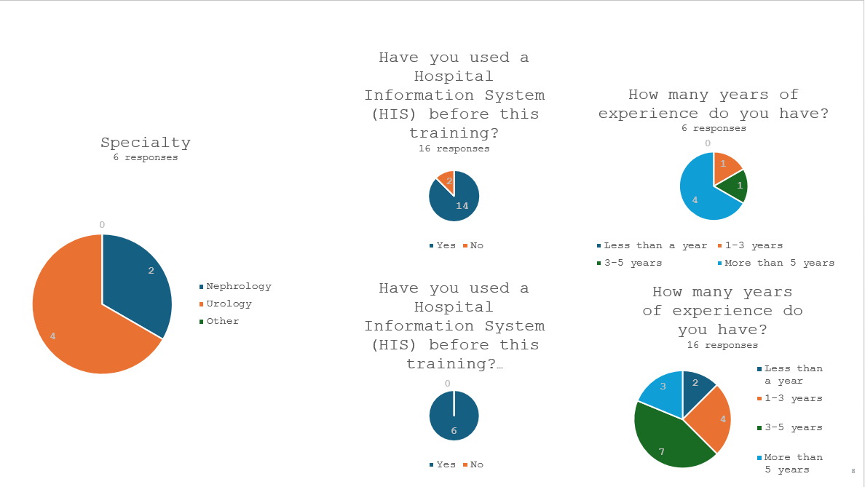

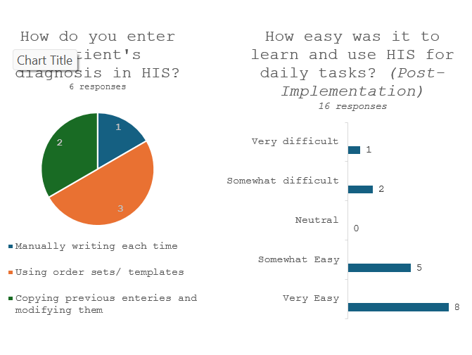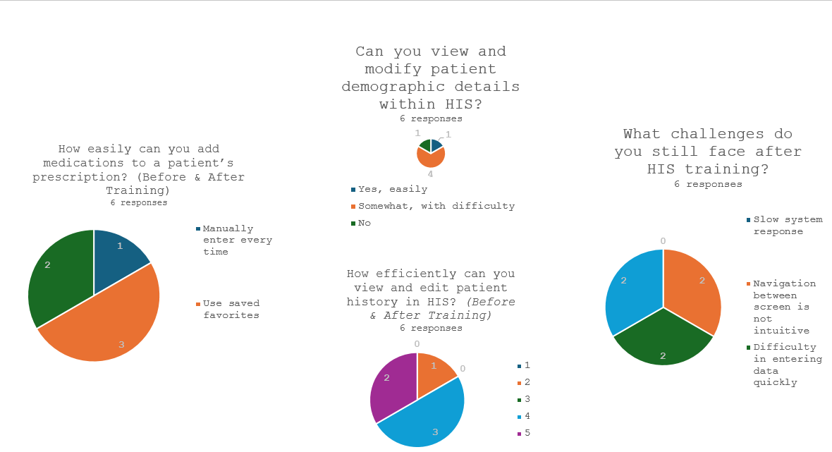

Results:
The survey responses reveal that 19 out of 22 participants found it extremely easy to log in to the HMIS platform, 3 found it somewhat easy to log in and there were no neutral responses to it. Neither did any participant find it difficult to login to the HMIS platform. When asked about task related questions most of the respondents feel very comfortable with tasks such as Vital entries, clinical forms, Medicine indentation. However, there is less comfort with tasks like Medicine administration reconciliation and nurse patient handover, indicating these areas may require additional training or system improvements. Overall, the HIS appears to perform well for basic functions like vital entry & clinical forms but may benefit from enhancements in more complex functionalities like MAR chart and ISBAR forms.
When asked the questions to check your understanding about the software like-
In the “dashboard” the users found OP EMR the most useful with a higher compliance rate in OP as compared to IP EMR.
A significant majority of users have used the pin screen feature and all of the users found it helpful for quickly accessing frequently used items, indicating its effectiveness in enhancing user efficiency.
The responses indicate a positive impact of the MyHealthcare HIS platform on work efficiency among respondents, with 88% reporting noticeable improvements, when talking about the EMR compliance rate in the hospital.

Table 2: Nurses’ Questions
Hospital Information System (HIS) Nurse Assessment Questionnaire
Questions | Responses
Section 1: Nurse Profile & Work Experience
Department Assigned | Nephrology
Department Assigned | Urology
Department Assigned | Other
Years of nursing experience | Less than 1 year
Years of nursing experience | 1-3 years
Years of nursing experience | 3-5 years
Years of nursing experience | More than 5 years
Have you used HIS before this implementation? | Yes
Have you used HIS before this implementation? | No
How were nursing tasks managed before HIS? | Paper-based documentation
How were nursing tasks managed before HIS? | Verbal communication for medication orders
How were nursing tasks managed before HIS? | Manual recording of vitals and progress notes
How were nursing tasks managed before HIS? | Physical files for patient history retrieval
Section 2: Pre vs. Post HIS Comparison
Task: Patient Vitals Entry | Pre-HIS: Handwritten records
Task: Patient Vitals Entry | Post-HIS: Entered digitally
Task: OPD Patient Registration & Admission | Pre-HIS: Manual forms
Task: OPD Patient Registration & Admission | Post-HIS: Automated entry in HIS
Task: Medication Indenting & Orders | Pre-HIS: Manual indent requests
Task: Medication Indenting & Orders | Post-HIS: Digital indenting & tracking
Task: Medication Delivery & Administration | Pre-HIS: Manual tracking
Task: Medication Delivery & Administration | Post-HIS: Real-time tracking in HIS
Task: Nursing Progress Notes | Pre-HIS: Handwritten
Task: Nursing Progress Notes | Post-HIS: Digital documentation
Task: Discharge Clearance | Pre-HIS: Manual clearance
Task: Discharge Clearance | Post-HIS: Digital approval
Task: Patient History Access | Pre-HIS: Paper file search
Task: Patient History Access | Post-HIS: One-click access
Section 3A: Workflow Efficiency & Time Savings
Time to complete task: Vitals Entry | ___ min (before)
Time to complete task: Vitals Entry | ___ min (after)
Time to complete task: Medication Indent | ___ min (before)
Time to complete task: Medication Indent | ___ min (after)
Time to complete task: Patient History Retrieval | ___ min (before)
Time to complete task: Patient History Retrieval | ___ min (after)
Time to complete task: Discharge Clearance | ___ min (before)
Time to complete task: Discharge Clearance | ___ min (after)
Has HIS reduced documentation workload? | Yes, significantly
Has HIS reduced documentation workload? | Somewhat
Has HIS reduced documentation workload? | No
Section 3B: Usability & Training
How easy was it to learn & use HIS? | Very easy
How easy was it to learn & use HIS? | Somewhat easy
How easy was it to learn & use HIS? | Neutral
How easy was it to learn & use HIS? | Somewhat difficult
How easy was it to learn & use HIS? | Very difficult
Which HIS features improved your efficiency the most? | How easy was it to learn & use HIS?
Which HIS features improved your efficiency the most? | Medication indent & tracking
Which HIS features improved your efficiency the most? | Digital documentation
Which HIS features improved your efficiency the most? | Easy access to past records
Which HIS features improved your efficiency the most? | Nursing clearance automation
Major difficulties faced during transition to HIS? | Initial difficulty navigating
Major difficulties faced during transition to HIS? | System response is slow
Major difficulties faced during transition to HIS? | Lack of pre-implementation training
Major difficulties faced during transition to HIS? | Data entry takes longer
Is additional HIS training required? | Yes
Is additional HIS training required? | No
Section 4: Challenges & Improvements
Challenges faced before HIS | Difficult to manage paper records
Challenges faced before HIS | Medication errors due to manual indent
Challenges faced before HIS | Slow patient record retrieval
Challenges faced before HIS | Time-consuming clearance process
Challenges still faced after HIS | System speed issues
Challenges still faced after HIS | Difficult screen navigation
Challenges still faced after HIS | Too many data steps
Challenges still faced after HIS | Lack of customization
Has HIS improved overall care & workflow? | Yes, significantly
Has HIS improved overall care & workflow? | Somewhat
Has HIS improved overall care & workflow? | No
Additional features suggested? | Open-ended response

Fig.5:
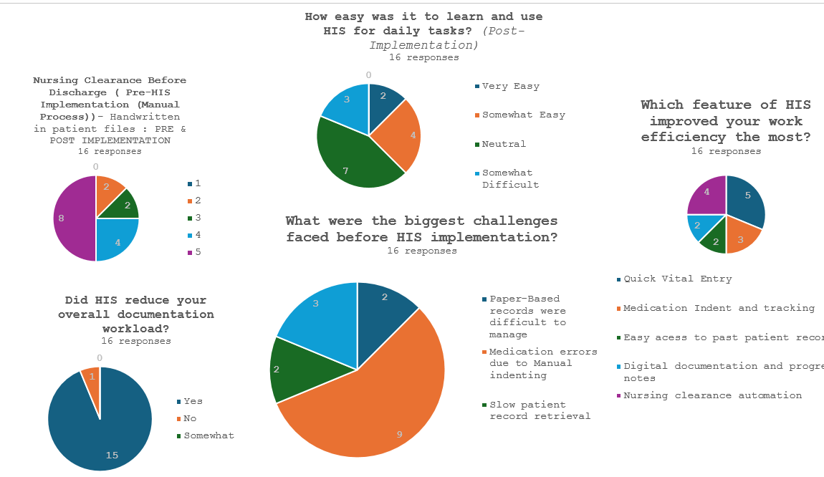

Thematic Analysis
Table 3:
Themes | Sub-themes | Codes
Aspects of HMIS Training Found Most Useful | Vitals features | Color coded values  BMI auto calculated  Trend graph  Critical Alert  Filter based on specialty
Aspects of HMIS Training Found Most Useful | Clinical Forms | Documentation of initial assessment  Daily progress notes  Operative Notes  Score Forms
Aspects of HMIS Training Found Most Useful | MIS Reports and Dashboards | MIS Reports, Dashboards
Aspects of HMIS Training Found Most Useful | Overall Usability | Everything  Whole Process  User-Friendly Environment
Perception of Training Materials | Usefulness and Quality | Good  Sufficient  Helpful  Useful  Intermediate  Very Helpful  Very Effective  Supportive  Informative
Perception of Training Materials | Areas for Improvement | Require More Material  Better Than Last HIS  Cash Refund Tough
Conduct of Training Sessions | Interactivity | Interactive  Allowed to Ask Questions  Clarification Round
Conduct of Training Sessions | Organization and Structure | Well Organized  Time for Practice  Hands-On Training
Perception of Training Resources | Trainer Knowledge and Clarity | Well Knowledgeable  Clear Concepts  Clarity in Speech  Explained All Functionalities
Perception of Training Resources | Trainer Friendliness and Support | Friendly  Helpful  Fruitful  User-Friendly Manner
Overall Satisfaction with HIS Training | Satisfaction Level | Satisfied
Overall Satisfaction with HIS Training | Preparedness and Benefits | Prepared to Handle HIS  Benefit to Self-Learning and Development  Organizational Benefit  Intent to Receive Additional Training

EMR Features: Users predominantly found the EMR features most useful. These functionalities, including trend graphs, MAR Chart, and the ease of entering vitals, were critical in enhancing efficiency and reducing clinical data entries’ burdens.
Training Materials: The training materials were generally well received, with many users finding them useful and sufficient. However, there were suggestions for additional materials, especially concerning specific complex features like OT workflow, LIS integration.
Training Sessions: The training sessions were praised for their interactivity and organization. Users appreciated the hands-on practice time and the opportunity to ask questions, which helped in clarifying doubts and reinforcing learning.
Trainer Effectiveness: The trainers were praised for their knowledge and clarity. Their ability to explain concepts clearly and their supportive approach contributed significantly to the positive training experience.
Overall Satisfaction: Overall satisfaction with the HIS training was high. Users felt well-prepared to handle the new system and recognized the training's benefits for their personal and organizational development. The willingness to undergo additional training reflects a commitment to continuous improvement and adaptation.

Conclusion:
The findings of this study indicate an overall favorable response to the adoption of the MyHealthcare HIS platform. Staff users reported high levels of satisfaction with the system's general usability and essential functions. They specifically valued how the platform made daily tasks easier, including patient registration, billing processes, and document management. A significant factor contributing to this achievement was the organized training initiative. Participants emphasized the usefulness of the training sessions, attributing their increased confidence to the clear materials, interactive format, and the trainers' knowledge, all of which prepared them to utilize the system effectively.
Even with this overall achievement, certain limitations in the system were highlighted. Several users reported difficulties in navigating specific sections of the interface, especially when handling more complicated financial transactions. Moreover, the positive feedback on the pin screen feature indicates that providing additional choices for personalization might enhance user experience even more.
For sustained success, ongoing focus on user feedback and consistent communication will be crucial. The supportive mindset of employees and their willingness for further training establish a solid basis for continuous enhancements and lasting system integration.

Study Limitations
The study has identified valuable insights though some limitations should be noted when considering the findings. The sample was relatively small (n=25 outpatient billing team members AINU Hospital) which indicates we likely did not capture all of the experiences that were reported and that some experiences (positive or negative) perhaps our representation of the staff, missed some perspectives. In future studies, consideration of including a larger diverse sample would likely provide the research with a more comprehensive understanding of the use and perceptions of the system in a multi-departmental context.
Recommendations for Improvement
The HIS training met its purpose, but there are areas for improvement. The following recommendations are made based on the feedback from the participants, and the implications of the study findings when relevant:
· Develop supplementary learning resources: Consider developing supplementary learning materials such as handy reference tools or quick guides, and video walk-throughs, and FAQ learning sheets particularly for more complicate elements such as refunds. This will allow the team to have multiple tools for reinforcing their understanding of the platform.
· More opportunities for practice: The more opportunities staff have to practice in a training space the more comfortable and confident staff will feel when using the platform independentl

References:
- Trikha S, Arora B, Sharma M, Thakur P. Implementing e–Upchaar: Hospital Management Information System for public health facilities in Haryana. Electron physician [Internet]. 2020 Jun 25 [cited 2025 Jun 23];12(2):7694–702. Available from: http://www.ephysician.ir/index.php/browse-issues/12/2/1169-7694
- Alharaibi MA, Alhifany AA, Asiri YA, Alwhaibi MM, Ali S, Jaganathan PP, Alhawassi TM. Prescribing errors among adult patients in a large tertiary care system in Saudi Arabia. Ann Saudi Med. 2021;41(3):147–156. doi:10.5144/0256-4947.2021.147.
- Kumari N, Suresh Kumar PK. A case study on acceptance of hospital information systems (HIS) among nurses in a tertiary care hospital. Int J Case Stud Bus IT Educ (IJCSBE). 2023;7(3):149-161. doi:10.5281/zenodo.8187284.
- Pai MMM, Ganiga R, Pai RM, Sinha RK. Standard electronic health record (EHR) framework for Indian healthcare system. Health Serv Outcomes Res Method [Internet]. 2021 Sep [cited 2025 Jun 23];21(3):339–62. Available from: https://link.springer.com/10.1007/s10742-020-00238-0
