Summer Internship Report
At

(22nd April –21st June, 2024)

A Report By
Ms. Simran Anand
Under the guidance of Dr. Divya Aggarwal

PGDHM (Hospital and Health Management) 2023-25



Institute of Health Management Research, New Delhi

ACKNOWLEDGEMENT

The past two months has been incredibly intense and full of experience, and reflecting on this I would like to express my gratitude to the people who have guided me to end up with this result day. This internship would not have been possible without the contribution of the following people.
First, I would like to express my gratitude towards IIHMR DELHI for providing me with the opportunity to work with IQVIA and my mentor Dr. Divya Aggarwal for incessantly guiding me.
I extend my sincere thanks to Mr. Kapil Dev Singh and Mr. Chandan Nagasuri, my managers and mentors, whose unwavering guidance and support throughout the internship have been instrumental in shaping my understanding of the Digital Health landscape. Their expertise and encouragement not only facilitated my learning but also helped me contribute meaningfully to the ongoing projects and have been instrumental in my development as a budding professional.
Their collaborative spirit, patience, and willingness to involve me in meaningful projects have truly made a difference in my learning experience. I am grateful for their trust and the opportunities they provided me to contribute to the team's objectives. The positive work environment fostered a sense of belonging and made every day an enjoyable and productive one.
I would also like to extend my appreciation to my fellow interns, with whom I had the pleasure of collaborating. Their enthusiasm and dedication made the internship experience even more enjoyable, and I am thankful for the knowledge exchange we had.
I cannot forget to mention the support and encouragement from my friends and family during this internship. Their unwavering belief in my abilities provided me with the motivation to push myself beyond boundaries and make the most out of this opportunity.
I look forward to utilizing this experience as a foundation for my future endeavours in the field of digital health and public health.

Thank you

(Organization Supervisor)

Name of the Student: Ms. Simran Anand

Summer Internship Institution: IQVIA, Delhi

Area of Summer Internship: Health System Strengthening

Attendance: Regular

Objectives met: Yes, all assigned objectives were met.

Deliverables: Simran supported the team on the Biomedical Equipment Survey project by analyzing human resource availability against IPHS standards.

Strengths: All given task were performed efficiently within the given timeframe.

Suggestions for Improvement:


Wishing her all the best for future

Vaishali Talani
Signature of the Officer-in-Charge
(Internship)

Date: 14th June 2024
Place: New Delhi, India

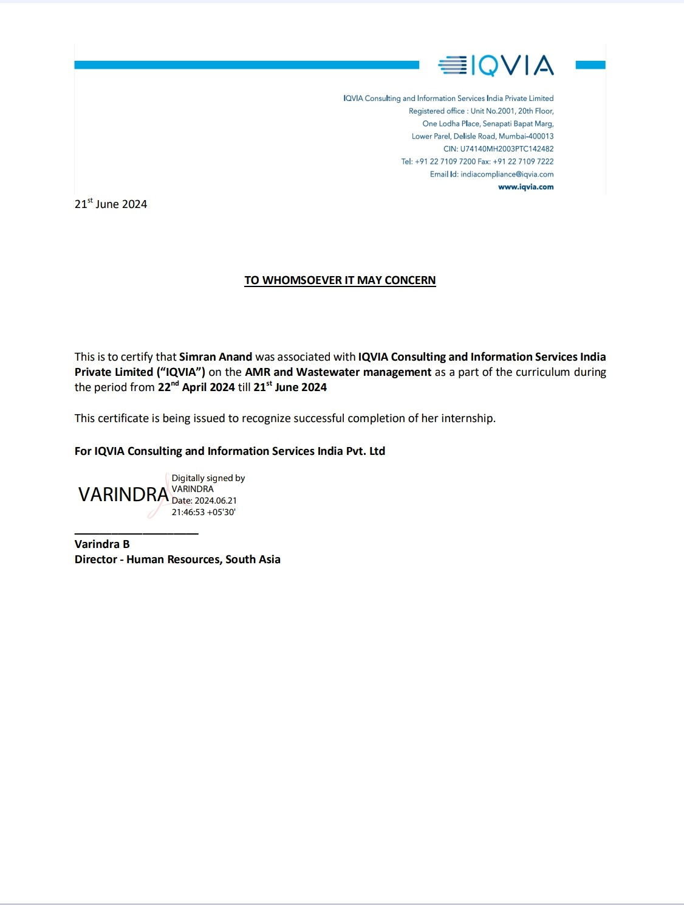

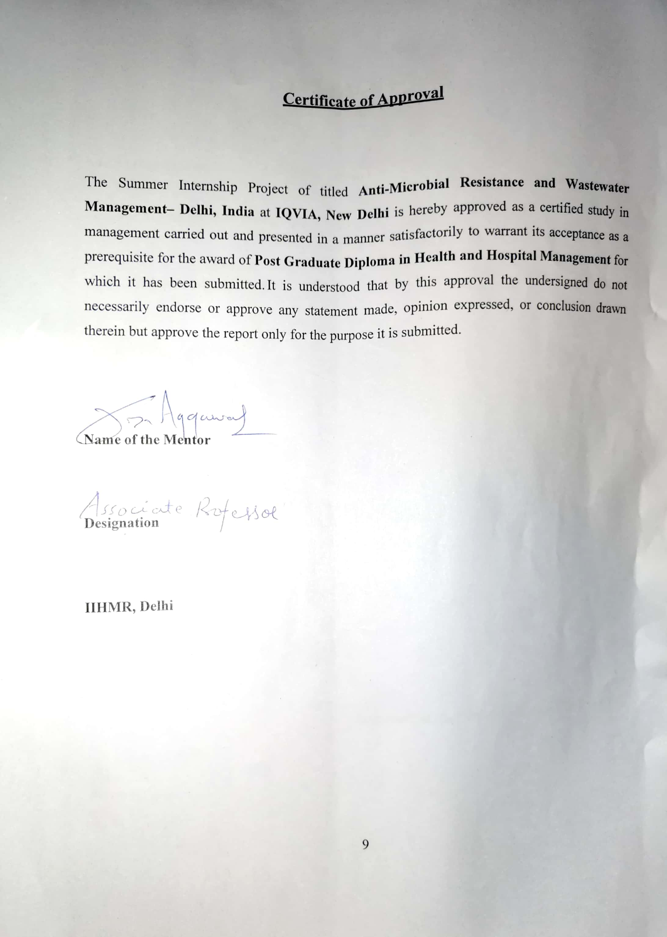

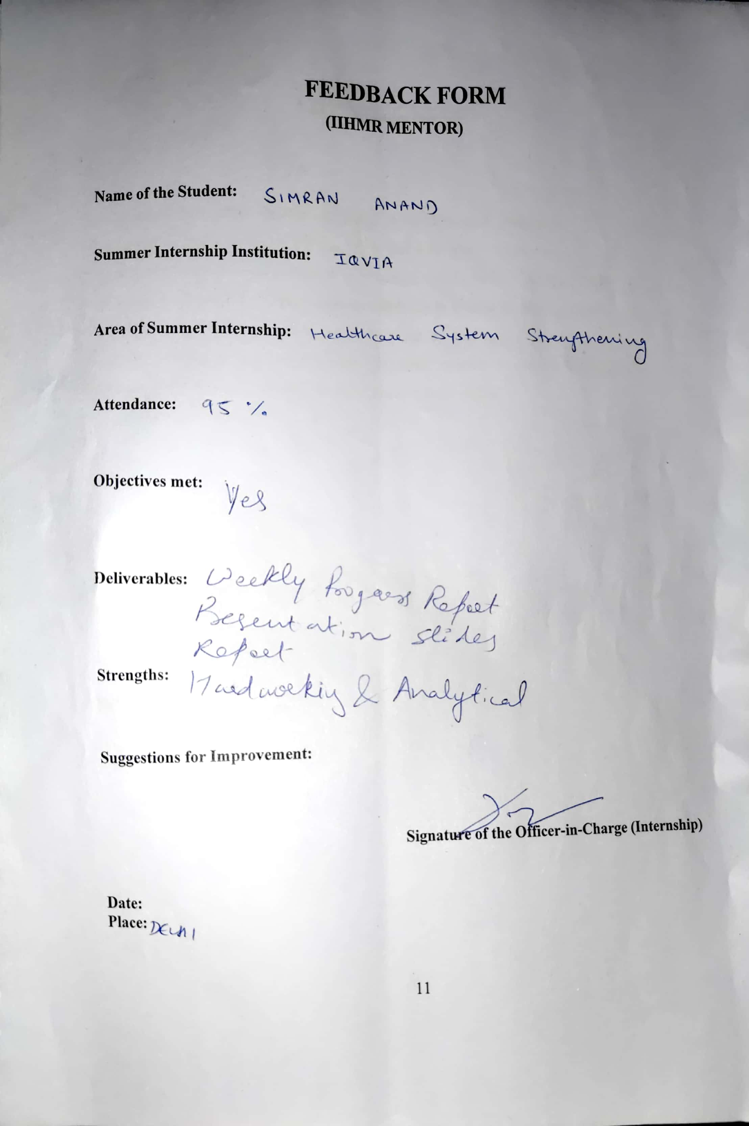

Table of Contents
Acknowledgement 2
List of Abbreviations 8
Observational Learnings 9
Project Report 12
Title 12
Statement of Problem and Hypothesis 13
Background 13
Rationale of the Study 14
Research Questions 14
Research Objectives 14
Research Methodology 15
Study Design 16
Review of Literature 16
Key Findings & Data Analysis based on ROL 17
Results 23
Gap Analysis 25
Recommendations 25
Conclusion 27
Limitations of the Research 28
Ethics and Consent 29
References 30

List of Abbreviations

Abbreviation | Full form
AMR | Anti-Microbial Resistance
ARG | Antibiotic Resistant Gene
ARB | Antibiotic Resistant Bacteria
WHO | World Health Organisation
WWTPs | Wastewater Treatment Plants
GLASS | Global Antimicrobial Surveillance System
CDC | Centre for Disease Control & prevention
ECDC | European Centre for Disease prevention & Control
HGT | Horizontal Gene Transfer
MBR | Membrane Bio-Reactors
ASP | Activated Sludge Process
GAC | Granular Activated Carbon
qPCR | Quantitative Polymerase Chain Reaction

OBSERVATIONAL LEARNINGS

Introduction
IQVIA is a top global supplier of clinical research services, technology solutions, and sophisticated analytics to the life sciences sector. IQVIA uses its analytics, big data resources, transformational technologies, and domain experience to build intelligent linkages across all facets of healthcare. With the speed and agility with which IQVIA Connected IntelligenceTM delivers potent insights, clients can expedite the clinical development and commercialization of cutting-edge medical solutions that enhance patient outcomes. IQVIA operates in more than 100 countries and employs about 86,000 people.

IQVIA is a world leader in safeguarding the privacy of individual patients. While generating and analyzing data on a scale that assists healthcare stakeholders in identifying disease patterns and correlating them with the exact treatment path and therapy required for better outcomes, the company employs a wide range of privacy-enhancing technologies and safeguards to protect individual privacy. In order to progress their search for cures, biotech, pharmaceutical, medical device, and government organizations, medical researchers, payers, and other healthcare stakeholders can benefit from IQVIA's insights and execution capabilities, which provide a deeper understanding of diseases, human behavior, and scientific advancements.

- MISSION
IQVIA envisions a future in which human inventiveness and data science breakthroughs combine to produce innovative ways to enhance human health. Our vision is this. where each obstacle is viewed as a chance to significantly influence patients, clients, and people. Find a fulfilling work and contribute to a healthier society.

- VALUES
- Creativity

- Teamwork

- Innovation

IQVIA possesses extensive proficiency in delivering advisory services to governments, international non-governmental organizations (NGOs), and multidimensional funding agencies in emerging markets. Their comprehensive
capabilities encompass strategic guidance, program management, national health surveys, commodity assessment and mapping, procurement and supply chain evaluation, in-country development, monitoring and evaluation, assessment of pharmaceutical markets, engagement with the private sector, ensuring access to medicines, policy and regulatory analysis, and health data analytics across different geographies.
The International Finance Corporation (IFC), a member of the World Bank Group, has engaged IQVIA to conduct a comprehensive market study and landscape assessment of the pharmaceutical market in Armenia to enhance their export readiness for pharmaceutical products in various international markets.
.
Learnings


During my internship at IQVIA Consulting, I had the opportunity to work on multiple projects- Market intelligence consultancy for the Armenian pharmaceutical sector
Regional support to address the outbreak of Coronavirus disease 2019 and potentialoutbreaks of other Communicable diseases
Using Digital Technology to improve National Health Financing in Asia and the Pacific

Role in IQVIA

During my internship at IQVIA, I had the opportunity to immerse myself in the Public health sector, gaining hands-on experience and enhancing my professional skills. The following self-assessment reflects on my key learning experiences, achievements, and areas for improvement.
Desktop research and assessment of documents available on government websites andother public domains

Proposal and report writing Data interpretation and entry

Conclusive Learnings Professional presentation Proposal writing
Report Making

Maintaining work-life balance

Coordination among team members for the timely achievement of goals Communication skills
Exposure to the corporate world

Time management Handling work pressure
Attending given deadlines

Making new connections with our colleagues

Engaging with people from varied areas of experience and expertise

Project Report

Narrative Review of Literature on
Anti-Microbial Resistance and Wastewater Management

Title
Anti-Microbial Resistance and Wastewater Management

Statement of the problem and hypothesis
Inefficient wastewater treatment processes contributing to the spread and of AMR bacteria in our environment.
This hypothesis suggests that wastewater acts as a reservoir for AMR because:
Wastewater contains sources of AMR: Wastewater carries residues of antibiotics, disinfectants, and bacteria from various sources like hospitals, agriculture, and households. These can all contribute to the development and spread of AMR.
Wastewater treatment plants can be breeding grounds: While they remove some contaminants, current treatment methods may not effectively eliminate all AMR bacteria, ARGs, or antibiotic residues. This allows them to persist and potentially even multiply within the treatment plant.
Release into the environment: Treated wastewater released back into waterways can introduce AMR bacteria and ARGs into the environment. This can impact aquatic ecosystems and potentially create a pathway for resistant bacteria to reach humans and animals.

Introduction:
The main problem that poses a huge danger to world health is antimicrobial resistance, or AMR. Both in terms of the financial cost and the effect on public health, low- and middle-income nations are probably going to be the most impacted. According to recent research, resistance networks play a significant role in the spread of AMR organisms. These networks are fueled by intricate relationships between clinical (such as human health, animal husbandry, and veterinary medicine) and environmental (such as the persistence of AMR in wastewater) factors. Since wastewater provides an optimal habitat for the persistence of antibiotic-resistant genes (ARGs) and AMR bacteria (ARBs), numerous studies have emphasized the importance of wastewater as a substantial environmental reservoir of AMR. The treatment procedure has little effect on ARGs, even though it can aid in eliminating or lowering the ARB load. The primary resistance mechanism in the majority of Gram-negative bacteria is horizontal gene transfer, which allows ARGs to proliferate among microbial communities in the environment because they are not degradable. Here, we examined recent research to show how wastewater contributes to the development, persistence, and spread of AMR in many contexts, especially those related to large- scale gatherings (such the Hajj and Kumbh Mela).
One of the best medical instruments is the antibiotic. Nevertheless, no significant new classes of antibacterial medications have been created since the discovery of fluoroquinolones in early 1970. The growing threat of antimicrobial resistance (AMR) pathogens coincides with this lack of growth. With several publications warning of the serious possibility of a post-antimicrobial era in which routine diseases might kill, antimicrobial resistance (AMR) is the main problem endangering public health. The Global Antimicrobial Surveillance System (GLASS) of the World Health Organization (WHO) recently reported elevated resistance levels in several common and dangerous bacterial diseases in various parts of the world. Currently, 700,000 people die each year from resistant illnesses, but the global resistance-associated mortality is estimated to top 10 million lives per year in 2050. According to reports from the US Centres for Disease Control and Prevention (CDC) and the European Centre for Disease Prevention and Control (ECDC), AMR infections cause 23,000 and 25,000 fatalities annually in high-income nations in the USA and Europe, respectively. AMR infections have killed 38,000 adults in Thailand and 58,000 children in India, respectively, in low- and middle-income nations.

Background:
Wastewater Treatment Processes: Before wastewater is released into the environment, pollutants such as toxins and pathogens are eliminated by wastewater treatment procedures. In order to lessen the wastewater's organic and inorganic burden, these procedures usually include physical, chemical, and biological treatment stages.
Antimicrobial Resistance (AMR): Before wastewater is released into the environment, pollutants such as toxins and pathogens are eliminated by wastewater treatment procedures. In order to lessen the wastewater's organic and inorganic burden, these procedures usually include physical, chemical, and biological treatment stages.

Rationale for the Study:
Transmission Pathways: Wastewater serves as a conduit for the transmission of antimicrobial- resistant bacteria and their genetic material into the environment. This can occur through the discharge of untreated or inadequately treated wastewater into water bodies, soil, and agricultural fields, where resistant bacteria can proliferate and spread.
Selection Pressure: The presence of antimicrobial agents in wastewater, either from domestic use (e.g., antibiotics excreted by humans and animals) or from industrial sources (e.g., pharmaceutical manufacturing), creates selective pressure favoring the survival and proliferation of antimicrobial-resistant microorganisms. Wastewater treatment processes may not effectively remove these agents, allowing resistant bacteria to persist and multiply.
One Health Perspective: The link between AMR and wastewater management underscores the interconnectedness of human health, animal health, and environmental health, as highlighted by the One Health approach. Antimicrobial-resistant bacteria originating from human and animal sources can enter wastewater, where they may interact with environmental bacteria, further amplifying the dissemination of resistance.
Public Health Implications: The dissemination of antimicrobial resistance through wastewater poses significant public health risks by reducing the effectiveness of antibiotics and other antimicrobial agents used to treat infections. This can lead to prolonged illness, increased healthcare costs, and higher mortality rates associated with drug-resistant infections.
Environmental Concerns: The presence of antimicrobial-resistant bacteria and residual antimicrobial agents in the environment can have adverse effects on ecosystems and wildlife. Additionally, the spread of resistance genes in environmental bacteria may compromise the efficacy of antimicrobial agents used in veterinary medicine and agriculture, with implications for food safety and security.

Research Objective:
- To investigate the link between improper wastewater treatment and the rise of AMR in India.

Research Questions:
- What is the prevalence of antimicrobial-resistant bacteria in wastewater?
- What are the potential health and environmental risks associated with AMR in wastewater?

Research Methodology:

- Defining the Objectives and Research Questions

  - Objectives: Specify what you aim to achieve with this review, such as identifying key research gaps, understanding current trends, or summarizing best practices.
  - Research Questions: Clearly pre-define the questions for the report on the basis of which results and key findings from the articles can be gathered and focus on what exactly you are looking for.

- Developing a Search Strategy

  - Databases: Relevant databases such as PubMed, Google Scholar, Indian Journal of Medical Research are used for searching relevant articles
  - Keywords: Combination of keywords and phrases such as "antimicrobial resistance," "wastewater management," "AMR” and "wastewater treatment plants" are used for searching relevant articles.
  - Search Strings: Detailed search strings are created using Boolean operators (AND, OR, NOT) to combine your keywords. For example:
    - "Antimicrobial resistance" AND "wastewater management"

- Inclusion and Exclusion Criteria

  - Inclusion Criteria:
    - Studies published within the last 10 years.
    - Articles that specifically address AMR in the context of wastewater treatment and management.
  - Exclusion Criteria:
    - Studies not directly related to AMR in wastewater.
    - Studies focused on only one area either Wastewater or AMR.
    - Studies not based on Indian Scenario.

- Article Selection

  - Initial Screening: Screening of the titles and abstracts of the identified articles to determine their relevance.
  - Full-Text Review: Retrieving and reviewing the full text of potentially relevant articles to confirm their inclusion.

- Data Extraction

  - Data Points: Extracting key information from each article, such as:
    - Key findings
    - Data from different locations of India
    - Conclusions and implications for wastewater management.

- Writing the Review

  - Results: Presentation of synthsized findings, justification of research, answers to the research questions.
  - Discussion: Discussion of implications of the findings, current challenges and gaps in the studies, and providing recommendations for improvement areas and potential future research directions.
  - Conclusion: A concise summary of the review and its key takeaways.

Number of Articles

During my Internship while working on the project, i had taken 20 articles based on my topic AMR and Wastewater Management out of which 10 articles are reviewed which are in direct context for my report based on my inclusion criteria.

Study Design: Secondary literature review

Review of Literature
The report emphasizes how wastewater plays a crucial part in the spread of antibiotic resistance and the necessity of stronger regulations, better treatment methods, and in-depth research to lessen this threat to global health. It highlights the intricate relationships that exist between human activity, environmental pollutants, and antibiotic resistance, underscoring the necessity of better waste management and treatment procedures to protect water quality.
The article highlights how crucial it is to address AMR from an Indian viewpoint by taking into account all aspects of the One Health concept, including people, animals, food, and the environment. The articles' findings highlight how crucial it is to address fecal contamination and enhance sewage treatment procedures in order to prevent the emergence of antibiotic resistance in aquatic ecosystems.
The article's main focus is on the Yamuna River's presence and spread of antibiotic-resistant bacteria (ARB) and genes. In addition to providing a thorough analysis of antimicrobial resistance (AMR) in urban river ecosystems, it looks at how sewage discharge affects the microbial water quality and antibiotic resistance in the river. It focuses on different treatment approaches, their effectiveness, and their effects on antibiotic-resistant bacteria (ARB) and antibiotic resistance genes (ARGs).
By understanding the interactions between the chemical, biological, and microbiological components of wastewater—which are essential for treatment optimization—the article explains how wastewater, especially from hospitals and urban treatment plants, contributes to the spread of antibiotic resistance in India and how effective advanced treatment techniques are in reducing this problem.
Antimicrobial resistance (AMR) prevalence and levels in E. coli isolates from wastewater treatment plants (WWTP) in South India are also examined in this study. It examines the resistance levels of various wastewater sources and evaluates how well the treatment procedures work

Key Findings and Data Analysis based on Literature Review-

- Global Challenge of AMR:

  - Antimicrobial resistance (AMR) is a significant global challenge with severe health and economic impacts. Wastewater treatment plants (WWTPs) are critical points for the spread and proliferation of AMR.

- Role of WWTPs:

  - WWTPs receive a wide variety of antimicrobial compounds and resistant bacteria from households, hospitals, and industries. These plants can act as reservoirs and mixing points for resistance genes.
  - The biological treatment processes in WWTPs promote bacterial growth and genetic exchange, potentially increasing ARG prevalence.

- Mechanisms of AMR Spread:

  - Several mechanisms facilitate the spread of AMR in WWTPs, including horizontal gene transfer (HGT) among bacteria. The presence of antibiotics in wastewater can select for resistant bacteria.
  - Soil and water, recipients of ARGs, serve as reservoirs and sources of clinical concern, further amplifying the spread of AMR.
  - Effluent from urban WWTPs contributes significantly to the spread of antimicrobial- resistant bacteria (ARB) due to the presence of residual antibiotics.
  - ARB and antimicrobial resistance genes (ARG) can spread both vertically (to new generations) and horizontally (between bacterial species).

- Impact of Treatment Processes:

Different treatment processes in WWTPs (e.g., activated sludge, membrane bioreactors) have varying efficiencies in removing antibiotic-resistant bacteria (ARB) and antibiotic resistance genes (ARGs). Some processes may not completely eliminate these contaminants, leading to their release into the environment.
- Activated Sludge: Commonly used in WWTPs, this process can reduce but not completely eliminate ARB and ARGs.
- Membrane Bioreactors (MBRs): Offer better removal efficiencies compared to conventional methods but are not foolproof.
- Advanced Treatment Technologies: Methods like ozonation, UV irradiation, and advanced oxidation processes show higher efficiencies in removing ARB and ARGs.

Effectiveness of Treatment Methods:

  - Biological treatment alone (Activated Sludge Process, ASP) achieves a reduction of 30-40% in coliforms and ARB.
  - Physicochemical treatment (done by ozonation) and a combination of ASP followed by ozonation achieve a reduction of 80-90% in coliforms and ARB.
  - Advanced oxidation techniques (ozonation) reduce ARG abundance by 40%.

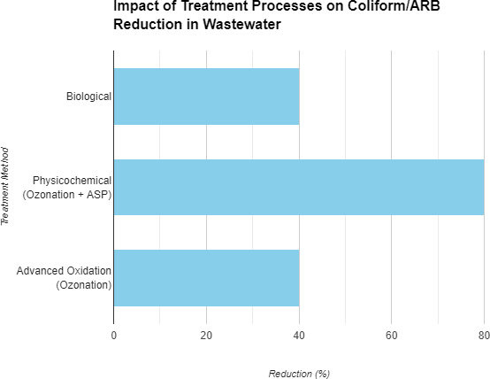

- Environmental and Human Health Risks:

The discharge of treated wastewater containing ARB and ARGs into natural water bodies poses risks to environmental and human health. This can lead to the contamination of drinking water sources and agricultural fields.

- Discharge into Water Bodies: Treated wastewater, if not adequately treated, can introduce ARB and ARGs into natural water bodies, leading to environmental contamination.
- Agricultural Impact: Use of treated wastewater for irrigation can lead to the contamination of crops with ARB and ARGs, posing a risk to food safety and human health.

- Sources and Propagation of AMR

- Hospital Wastewater: Exhibited slightly higher levels of antimicrobial resistance compared to domestic wastewater. Hospital wastewater is identified as a major contributor to AMR, underlining the importance of focused efforts to manage hospital effluents better.
- Wastewater from pharmaceutical manufacturing plants, agricultural practices and hospital effluents promotes AMR.
- Stress factors such as pH, antibiotics, heavy metals and temperature in wastewater environments propagate AMR in bacteria.

- Data on AMR Levels in Wastewater:

  - Antibiotic Concentrations: Wastewater contains various concentrations of antibiotics depending on the source and usage patterns.

The study investigates the prevalence and levels of antimicrobial resistance (AMR) in E. coli isolates from wastewater treatment plants (WWTP) in South India. It assesses the effectiveness of the treatment processes and compares resistance levels between different wastewater sources.

Prevalence of AMR in E. coli Isolates: The study tested 221 E. coli isolates from various wastewater treatment plants (WWTPs) in South India.

High Prevalence of AMR in E. coli Isolates:

- A total of 221 isolates of E. coli were examined for resistance to 16 different antibiotics.
- Resistance to cefazolin (CFZ) and ampicillin (AMP) ranged from 20% to 90%.
- Resistance to ciprofloxacin (CIP) and nalidixic acid (NAL) ranged from 15% to 75%.
- Resistance to chloramphenicol (CHL) ranged from 2% to 20%.

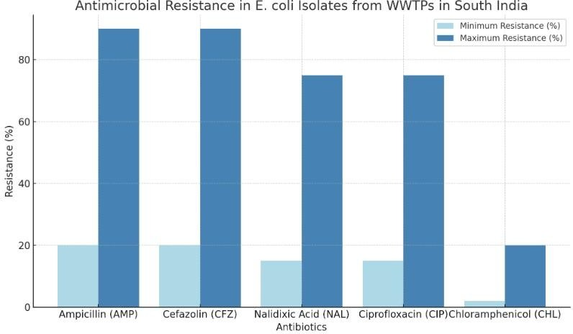

High levels of antimicrobial resistance were found in these isolates.

Resistance Levels:
Ampicillin (AMP): Resistance ranged from 20% to 90%. Cefazolin (CFZ): Resistance ranged from 20% to 90%. Nalidixic Acid (NAL): Resistance ranged from 15% to 75%. Ciprofloxacin (CIP): Resistance ranged from 15% to 75%.
Chloramphenicol (CHL): Resistance ranged from 2% to 20

  - Resistance Rates: Studies show varying resistance rates among bacteria isolated from wastewater, indicating the persistence and spread of AMR.

Human Health

- Gram-negative Bacteria: More than 70% of Acinetobacter baumannii, Klebsiella pneumoniae, and E. coli were resistant to third-generation cephalosporins and fluoroquinolones.
- Carbapenem Resistance: 71% of A. baumannii and 65% of K. pneumoniae exhibited carbapenem resistance.
- Colistin Resistance: In K. pneumoniae, resistance is linked to a high death rate of 70%, despite typically being less than 1%.
- Gram-positive Bacteria: 10.5% of Enterococcus fecium were vancomycin-resistant (VRE), and 42.6% of Staphylococcus aureus were methicillin-resistant (MRSA).

Food Animals

• Milk Production:
- Gram-negative bacteria resistance Bacilli: In West Bengal, 48% of cow and buffalo milk produced ESBL, while in Gujarat, 47.5% of the milk was resistant to oxytetracycline.
- Resistance in Gram-positive Organisms: Methicillin resistance was 21.4% in S. aureus and 5.6% in coagulase-negative staphylococci in Karnataka, while vancomycin resistance was 2.4% in S. aureus in West Bengal.

  - Fish Industry:
    - ESBL Producers in Tilapia: 48% of Enterobacteriaceae isolated from the gut in Maharashtra were ESBL producers.
    - Resistance in Seafood: 100% resistance to ampicillin in Vibrio cholerae and V. parahaemolyticus in Kerala; 67-96% resistance to ceftazidime.

• Poultry Industry:
- Broiler ESBL Producers: Rates range from 8.7% in Punjab to 9.4% in Odisha.
- Salmonella Species: Complete resistance to ciprofloxacin, gentamicin, and tetracycline has been documented in Bihar and West Bengal, with prevalences in broilers ranging from 3.3% in Uttar Pradesh to 23.7% in Bihar.
Environment

  - Water Sources:
    - Pharmaceutical and Hospital Effluents: High resistance rates in E. coli—25% from domestic water, 70% from mixed domestic and hospital waste, and 95% from hospital effluent alone.
    - Rivers: The Ganges and Yamuna showed 17.4% ESBL producers among Gram- negative bacteria, with the presence of resistance genes like blaNDM-1 and blaOXA- 48.
    - Ground and Surface Water: High rates of third-generation cephalosporin-resistant E. coli—17% in central India, 50% in east India, and 100% in south India.

  - Geographical Regions-
Prevalence of Resistant E. coli in Water Sources

E. coli resistant to third-generation cephalosporin has been found in drinking and
recreational surface and groundwater at variable rates:

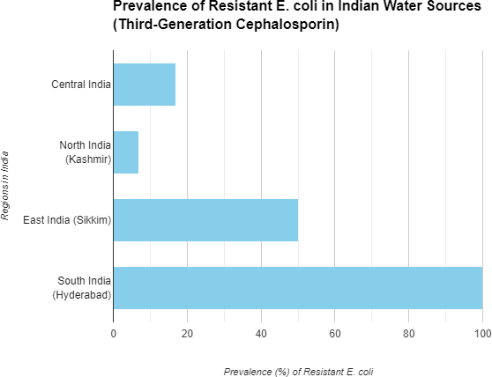

- center of India- 17%
- north India (Kashmir)- 7%
- east India (Sikkim)- 50%
- south India (Hyderabad)- 100%

- Mitigation Strategies:

Strategies to mitigate the spread of AMR through wastewater include advanced treatment technologies (e.g., ozonation, UV irradiation), proper antibiotic disposal, and reducing antibiotic usage.

- Advanced Treatment Technologies: Ozonation and UV irradiation are effective but can be costly and require specialized equipment.
- Antibiotic Stewardship: Reducing the use of antibiotics through stewardship programs can decrease the amount of antibiotics entering the wastewater.
- Proper Disposal: Encouraging proper disposal of unused antibiotics can reduce their presence in wastewater.

Results-

- By conducting a review of literature on multiple articles, it can be clearly said that improper wastewater treatment is a major cause of rise in Anti-Microbial Resistant bacteria in water bodies of India.

Potential Human Health Risk-

- Human Exposure to Resistant Pathogens:
  - Direct Contact: Individuals who work in or near wastewater treatment plants, or those who use reclaimed water for irrigation, are at risk of exposure to antimicrobial-resistant bacteria (ARB).
  - Recreational Activities: People engaging in recreational activities in water bodies receiving treated wastewater may be exposed to ARB.
- Transmission through Food and Water:
  - Contaminated Water Supply: Treated wastewater that enters drinking water sources can lead to the spread of ARB to humans.
  - Agricultural Use: The use of treated wastewater for irrigation can contaminate crops, which can then be consumed by humans, leading to ingestion of ARB.
- Antibiotic Effectiveness:
  - Treatment Challenges: Infections caused by antimicrobial-resistant bacteria are harder to treat, often requiring more expensive or toxic medications, longer treatment durations, and higher doses of antibiotics.
  - Increased Morbidity and Mortality: The reduced effectiveness of antibiotics can lead to higher rates of morbidity and mortality from bacterial infections.

Environmental Risks

- Ecological Disruption:
  - Microbial Community Imbalance: The release of ARB and antimicrobial resistance genes (ARGs) into the environment can disrupt natural microbial communities, affecting ecosystem functions such as nutrient cycling and decomposition.

- Resistance Gene Dissemination:
  - Horizontal Gene Transfer: ARGs can be transferred between different bacterial species in the environment, leading to the spread of resistance across various microbial populations, including pathogenic bacteria.

- Impact on Wildlife:
  - Aquatic Organisms: Aquatic organisms exposed to ARB and ARGs in contaminated water bodies may develop infections that are difficult to treat, potentially leading to population declines.

  - Bioaccumulation: ARB and ARGs can bioaccumulate in the food chain, affecting higher trophic levels, including predators and humans.

- Degradation of Water Quality:
  - Contaminant Persistence: The presence of ARB and ARGs in water bodies can degrade water quality, making it unsafe for human consumption, recreational use, and aquatic life.

- Antimicrobial Residues:
  - Environmental Persistence: Antibiotic residues in wastewater can persist in the environment, contributing to the selective pressure that drives the development and spread of AMR.

Gap Analysis:

- Sampling and Methodology:.
  - A detailed comparison of sampling and methodology across different studies and treatment systems is needed to standardize surveillance approaches.
- Antibiotic Resistance Profiles:
  - A comprehensive analysis of the types and frequencies of antibiotic resistances across various wastewater treatment plants and regions is necessary.
- Molecular Surveillance:
  - There is a need for studies that compare the effectiveness and accuracy of culture- based versus culture-independent methods in detecting AMR in wastewater.
- Environmental Impact and Public Health Risk:
  - A risk assessment model that quantifies the environmental spread of AMR and its direct and indirect effects on public health is required.
- Global Perspective:
  - A global surveillance network that monitors AMR in wastewater treatment systems worldwide is necessary to understand the global dynamics of AMR dissemination.
- Treatment Technologies and AMR:
  - Research is needed to evaluate the effectiveness of various wastewater treatment technologies in reducing AMR and to develop new technologies that specifically target AMR reduction.
In conclusion, while the provided articles offer valuable insights into AMR in wastewater treatment systems, there are significant gaps in the data regarding sampling methodologies, antibiotic resistance profiles, molecular surveillance methods, environmental impact assessments, global perspectives, and the relationship between treatment technologies and AMR.

Addressing these gaps is crucial for developing effective strategies to mitigate the spread of AMR through wastewater management.

Recommendations
- Enhanced Monitoring and Surveillance:
Implement robust monitoring programs to regularly assess the presence and prevalence of antibiotic-resistant bacteria in drinking water sources
Establish standardized testing protocols for antibiotic resistance in bacteria across different locations to enable better comparison and analysis
- Water Treatment Optimization:
Evaluate and optimize water treatment processes, such as granular activated carbon (GAC) filtration, to effectively remove antibiotic-resistant bacteria and reduce their presence in treated water
Consider the impact of different treatment steps, like chlorination, on the selection and survival of antibiotic-resistant bacteria in water systems
- Public Health Risk Mitigation:
Develop strategies to mitigate the public health risks associated with the presence of antibiotic- resistant bacteria in drinking water, especially for vulnerable populations in healthcare settings
Enhance the understanding of the transferability of antibiotic resistance traits from non- pathogenic bacteria to pathogens, emphasizing the need for preventive measures.

- Research and Collaboration:
Encourage further research on the transfer mechanisms of antibiotic resistance in water systems and the potential health implications for consumers.
Foster collaboration between researchers, water treatment facilities, and public health authorities to address the emerging challenges posed by antibiotic-resistant bacteria in drinking water.
By implementing these recommendations, it is possible to bridge the identified gaps in understanding, monitoring, and managing antibiotic-resistant bacteria in safe drinking water, thereby contributing to improved water quality and public health protection.
- Addressing Technological Challenges:
Overcoming challenges related to young key technologies required for retrofitting existing buildings into source separation-modified combined sewer systems (SMCS) is crucial. Efforts should focus on making these technologies more user-friendly and widely accepted to facilitate the transition

- Policy Changes and Systematic Planning:
Implementing SMCS requires systematic planning and a shift from damage-driven rehabilitation strategies to proactive measures. Policy changes at the governmental level are essential to incentivize the transformation of conventional sanitation systems into more effective SMCS
- Data Accuracy and Availability:
Enhancing data accuracy and availability is vital for successful implementation. Addressing uncertainties in estimations for levels, loads, and removal rates of AMR-causing substances is crucial. More research and data collection efforts are needed to ensure the reliability of simulation models and treatment processes
- Incentives and Legal Framework:
There is a lack of incentives and legal framework conditions for the widespread adoption of sanitation systems like SMCS. Governments and regulatory bodies should consider providing incentives, subsidies, or regulatory frameworks to encourage the implementation of advanced sanitation systems for AMR reduction
- Long-Term Sustainability:
Emphasize the long-term benefits of source separation-modified systems in reducing AMR emissions. Highlight the resource savings, recovery opportunities, and significant reduction in AMR compared to conventional sanitation systems.
  - Sampling and Methodology:
- Conduct a comprehensive review of sampling methodologies used in various studies to identify best practices and develop a standardized approach for future research.
- Compare the effectiveness of different sampling strategies in capturing a representative bacterial population within wastewater treatment systems.

  - Antibiotic Resistance Profiles:
- Perform a meta-analysis of existing studies to determine the most prevalent antibiotic resistances in wastewater treatment plants globally.
- Investigate the correlation between specific treatment processes and the prevalence of certain antibiotic resistances.

  - Molecular Surveillance:
- Evaluate the accuracy and sensitivity of culture-independent methods such as qPCR and metagenomics in detecting antibiotic resistance genes.
- Develop a cost-benefit analysis to determine the most efficient surveillance method for routine monitoring.

  - Environmental Impact and Public Health Risk:
- Establish a risk assessment framework to quantify the environmental spread of AMR and its potential impact on public health.
- Collaborate with epidemiologists to track the incidence of infections caused by antibiotic-resistant bacteria linked to wastewater treatment plants.

  - Global Perspective:
- Create an international database for sharing data on AMR in wastewater treatment systems to facilitate global surveillance and response.
- Organize international workshops or conferences to discuss findings and strategies for addressing AMR on a global scale.

  - Treatment Technologies and AMR:
- Research and develop new wastewater treatment technologies that specifically target the reduction of antibiotic-resistant bacteria and genes.
- Conduct pilot studies to test the efficacy of these new technologies in reducing AMR in wastewater effluents.

  - Policy and Information Sharing:
- Advocate for the implementation of policies that promote the One Health approach in managing AMR.
- Encourage interdisciplinary collaboration and information sharing among environmental scientists, clinicians, and policymakers.

  - Education and Awareness:
- Develop educational programs to raise awareness about AMR among the public, healthcare professionals, and agricultural workers.
- Disseminate information on proper antibiotic use and the importance of wastewater management in controlling AMR.
By addressing these gaps, researchers and policymakers can better understand the scope of AMR in wastewater treatment systems and implement effective strategies to mitigate its spread.

Conclusion-

Studying the relationship between inefficient wastewater treatment processes and the spread and evolution of AMR bacteria in the environment is critical for understanding the mechanisms driving antimicrobial resistance. It underscores the need for integrated approaches to mitigate the spread of resistance in both human health and environmental contexts.

By identifying the factors contributing to the dissemination of resistance, researchers and policymakers can implement targeted interventions to improve wastewater treatment efficiency, minimize environmental contamination, and preserve the efficacy of antimicrobial agents for future generations. Strategies such as improved wastewater treatment technologies, responsible use of antimicrobial agents, surveillance of antimicrobial resistance in environmental settings, and interdisciplinary collaboration among stakeholders are essential for addressing this complex global challenge.
This gap analysis of the literature on antimicrobial resistance (AMR) and wastewater management reveals several key areas where further research is needed:
- Quantification of AMR prevalence in wastewater: While the presence of AMR in wastewater is established, a comprehensive understanding of the prevalence and types of resistant bacteria in different wastewater streams is lacking.
- Efficacy of current wastewater treatment for AMR reduction: More research is needed to evaluate the effectiveness of existing wastewater treatment processes in removing or inactivating AMR bacteria and resistance genes.
- Development of improved wastewater treatment technologies: Studies should explore novel technologies specifically designed to target and reduce AMR in wastewater.
- Impact of environmental factors on AMR spread: A deeper understanding of how environmental factors, such as antibiotic residues and heavy metals, influence the spread and evolution of AMR in wastewater is crucial.
- Socio-economic considerations for AMR mitigation strategies: Research should integrate social and economic factors to develop sustainable and equitable wastewater management practices that address AMR concerns.
Addressing these knowledge gaps is crucial for developing effective strategies to mitigate the spread of AMR through wastewater. By focusing research on these areas, we can move towards a future with robust wastewater management systems that contribute to a global effort to combat AMR.

Limitations of the Study-
- Limited research in specific regions: The research on AMR and wastewater management might be concentrated in developed areas, neglecting data from developing areas where wastewater treatment practices might be less stringent.
- Focus on specific AMR or pathogens: The review might focus on well-studied AMR genes or pathogenic bacteria, overlooking the presence of less researched AMR threats in wastewater

- Standardization issues: Different methodologies used in various studies (e.g., AMR detection methods, wastewater sampling techniques) can make it difficult to compare and synthesize findings.

Ethics and Consent:
Since this study involves the review of existing literature and publicly available documents, no ethical approval or consent from participants is required.

References
- Akiba M, Senba H, Otagiri H, Prabhasankar VP, Taniyasu S, Yamashita N, Lee KI, Yamamoto T, Tsutsui T, Joshua DI, Balakrishna K, Bairy I, Iwata T, Kusumoto M, Kannan K, Guruge KS. Impact of wastewater from different sources on the prevalence of antimicrobial-resistant Escherichia coli in sewage treatment plants in South India. Ecotoxicol Environ Saf. 2015;115:203-
208. doi:10.1016/j.ecoenv.2015.02.018.You can access the article directly via this link: [https://www.sciencedirect.com/science/article/pii/S0147651315000627](https://www.sciencedir ect.com/science/article/pii/S0147651315000627)
- Kumar M, Ram B, Sewwandi H, Sulfikar, Honda R, Chaminda T. Treatment enhances the prevalence of antibiotic-resistant bacteria and antibiotic resistance genes in the wastewater of Sri Lanka, and India. Environ Res. 2020;183:109179. doi:10.1016/j.envres.2020.109179.You can access the article directly via this link: https://www.sciencedirect.com/science/article/pii/S0013935120300712
- Soni K, Jyoti KM, Chandra H, Chandra R. Bacterial antibiotic resistance in municipal wastewater treatment plant; mechanism and its impacts on human health and economy. Bioresour Technol Rep. 2022;19:101080. doi:10.1016/j.biteb.2022.101080.You can access the article directly via this link: https://www.sciencedirect.com/science/article/pii/S2589014X22001372
- Manisha Lamba, T.R. Sreekrishnan, Shaikh Ziauddin Ahammad,Sewage mediated transfer of antibiotic resistance to River Yamuna in Delhi, India,Journal of Environmental Chemical Engineering,Volume 8, Issue 1,2020,102088,ISSN 2213-
3437,https://doi.org/10.1016/j.jece.2017.12.041.(https://www.sciencedirect.com/science/article/p ii/S2213343717306802)
- Sambaza SS, Naicker N. Contribution of wastewater to antimicrobial resistance: A review article. J Glob Antimicrob Resist. 2023;34:23-29. doi:10.1016/j.jgar.2023.05.010.You can access the article directly via this link: https://www.sciencedirect.com/science/article/pii/S2213716523000851

