Dissertation Report
At
CK Birla Hospital
(March 1st to June 30th,2025)

Awareness, Perception, and Participation in Preventive Health Checkups:
A Case Study at CK Birla Hospital, Gurugram

A Report
By

Md Zaid Sultan
Roll No: PG/23/2025
Under The Guidance of
DR. Divya Aggarwal

PGDM (Hospital and Health Management)
2023-2025



International Institute Of Health Management Research,New Delhi
Dissertation Report
At
CK Birla Hospital
(March 1st to June 30th,2025)

Awareness, Perception, and Participation in Preventive Health Checkups:
A Case Study at CK Birla Hospital, Gurugram

A Report
By

Md Zaid Sultan
Roll No: PG/23/2025
Under The Guidance of
DR. Divya Aggarwal

PGDM (Hospital and Health Management)
2023-2025

International Institute Of Health Management Research,New Delhi

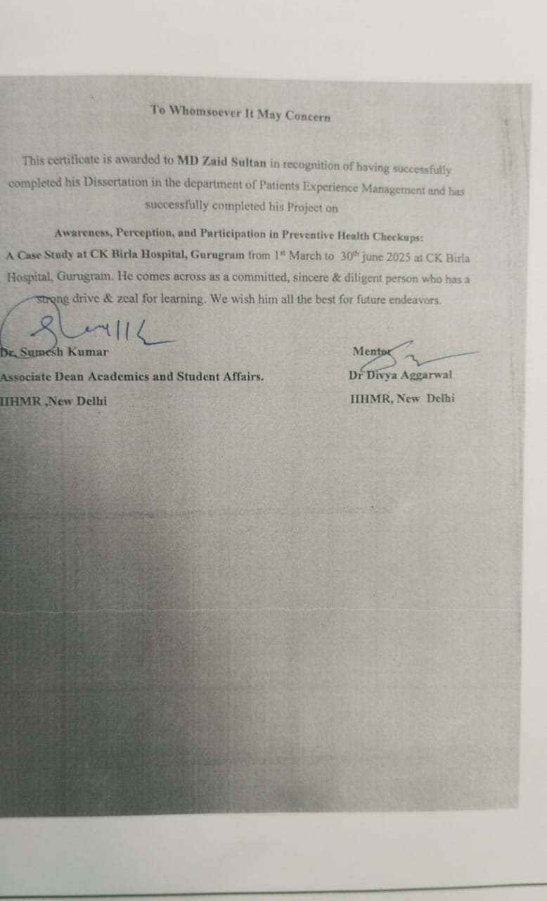
INTERNATIONAL INSTITUTE OF HEALTH MANAGEMENT RESEARCH, NEW DELHI
CERTIFICATE BY SCHOLAR
This is to certify that the dissertation titled Awareness, Perception, and Participation in Preventive Health Checkups:A Case Study at CK Birla Hospital, Gurugram and submitted by Md Zaid Sultan, Enrollment No-PG/23/060 under the supervision of DR.Divya Aggarwal for award of PGDM (Hospital & Health Management) of the Institute carried out during the period from 2023 to 2025 embodies my original work and has not formed the basis for the award of any degree, diploma associate ship, fellowship, titles in this or any other Institute or other similar institution of higher learning.

Md. Zaid Sultan

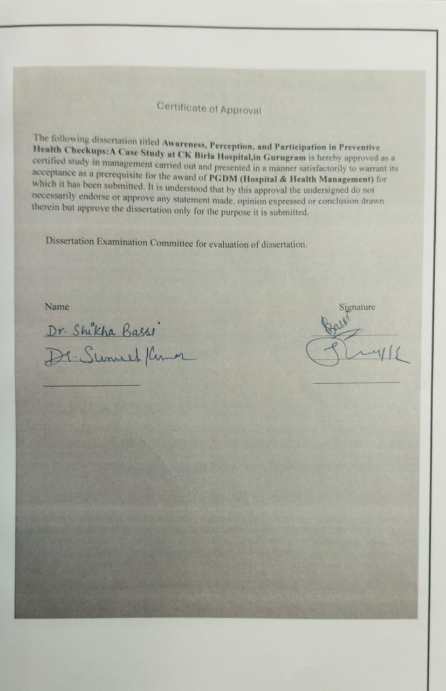

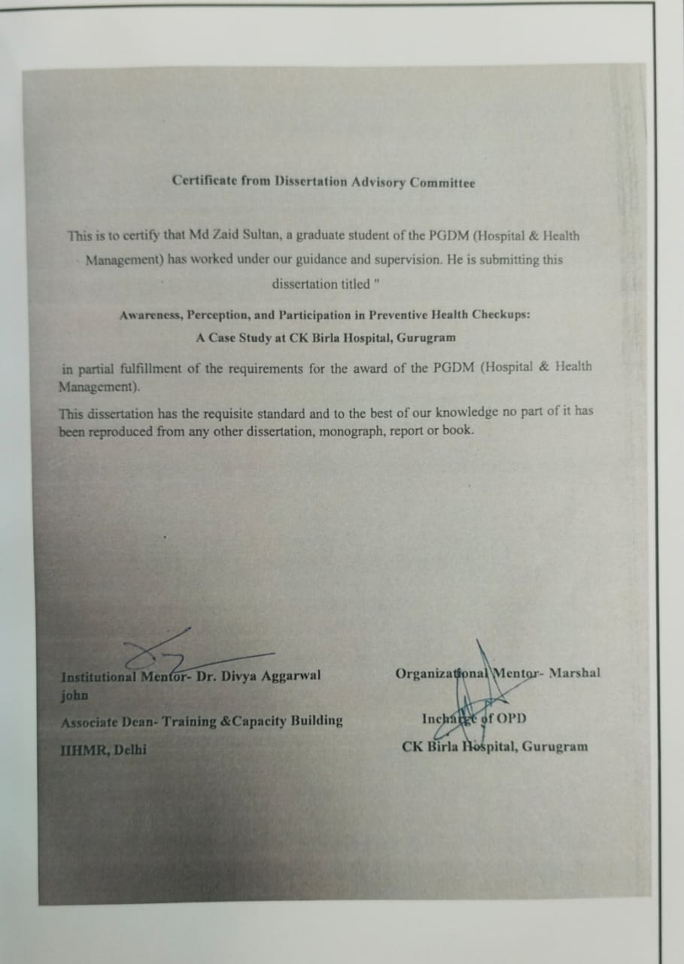
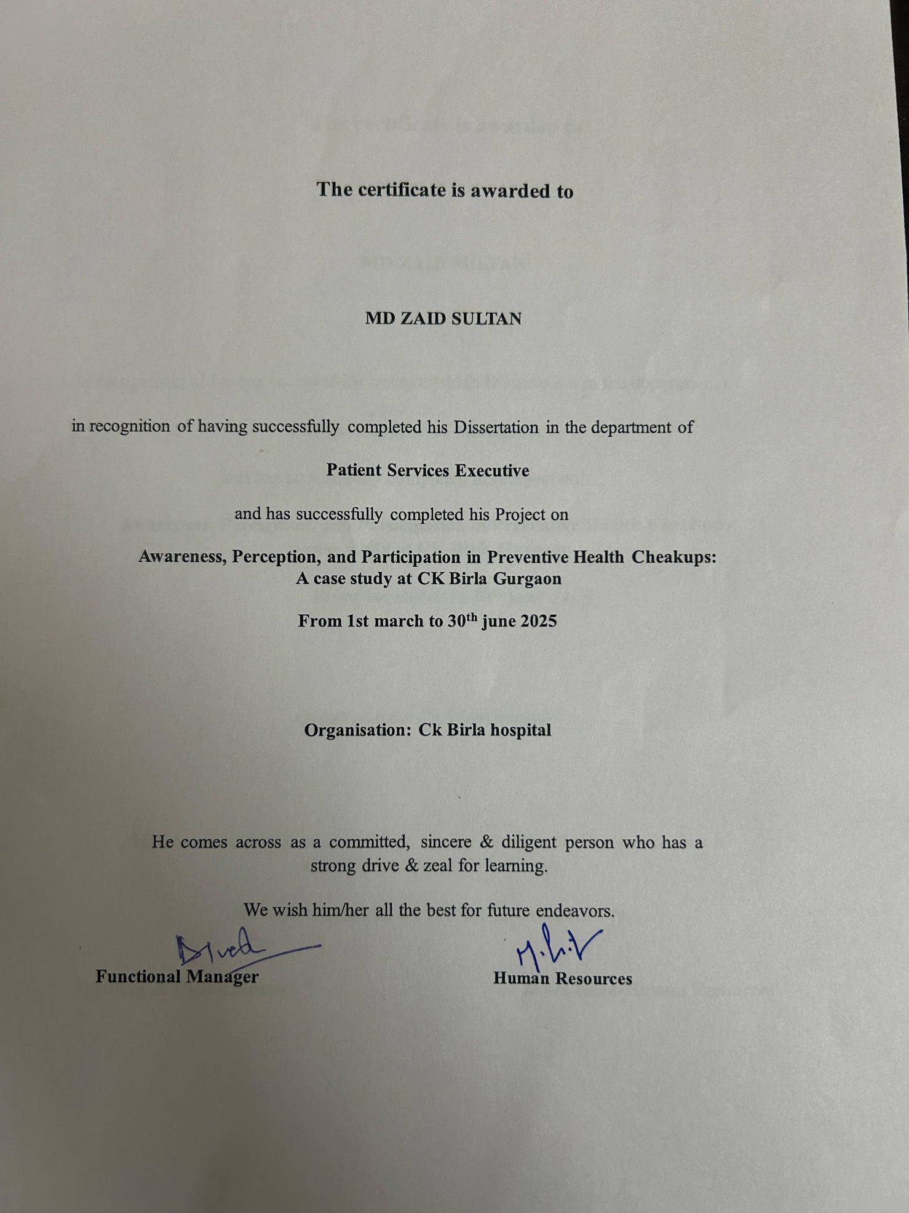
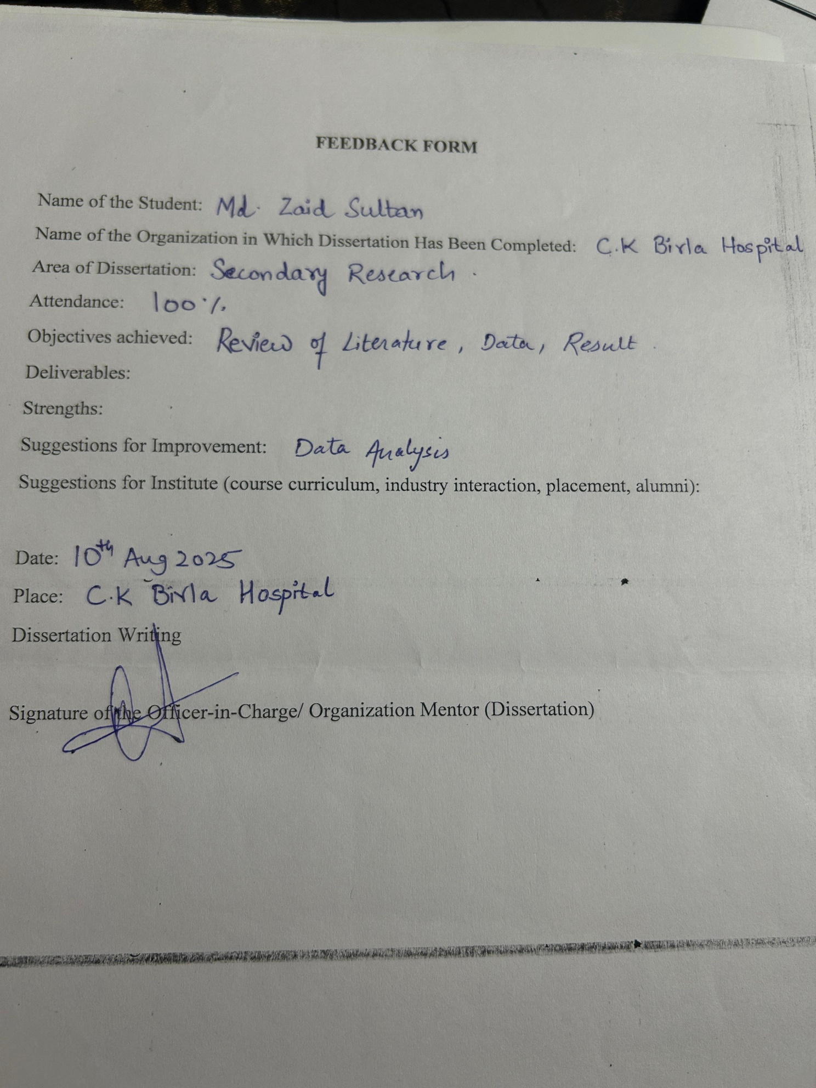

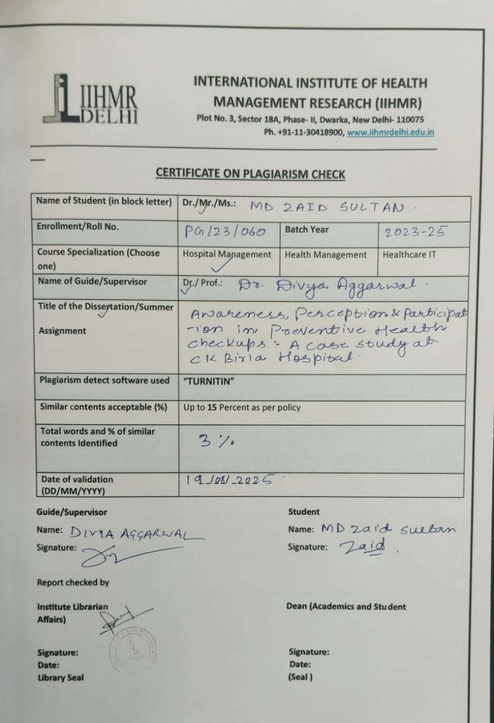 Acknowledgement

I take this opportunity to express my sincere gratitude to all those who supported and guided me throughout the course of this dissertation titled “Awareness, Perception, and Participation in Preventive Health Checkups: A Case Study at CK Birla Hospital, Gurugram.”

First and foremost, I would like to thank Dr. Divya Agarwal, my esteemed mentor, for her constant support, expert guidance, and valuable feedback at every stage of the research. Her encouragement and insightful suggestions greatly enriched the quality of this work.

I am also deeply thankful to the management and staff of CK Birla Hospital, Gurugram, for granting me permission to conduct this study and for providing the necessary resources and data access. I am especially grateful to the hospital’s Outpatient Department (OPD) team for their cooperation and assistance during data collection.

My sincere thanks to all the participants who willingly took part in the survey and shared their honest responses. Their input formed the foundation of this research.

I would also like to acknowledge the support of my faculty members, classmates, and administrative staff at my institute, whose encouragement and cooperation helped me complete this project on time.

Lastly, I extend my heartfelt appreciation to my Teammates & friends for their unwavering emotional support, patience, and motivation throughout this journey.
This report is a product of collaborative efforts, and I am truly grateful to everyone who contributed directly or indirectly to its completion.
I am grateful for the opportunity to have been associated with the team at CK Birla Hospital.



ABOUT CK BIRLA HOSPITAL
The CK Birla Hospital is a NABH accredited, multi-specialty hospital located in Gurgaon. It is a proud part of the $2.8 billion diversified CK Birla Group that has also been serving India’s healthcare needs for over 50 years.
The Gurgaon hospital is led by an experienced team of over 100 specialists. We are a proud partner to thousands of happy families & patients and continue to offer international standards of clinical care with a robust focus on safety, integrity and compassion. We rely on both international and national guidelines & protocols of healthcare delivery and bring world-class care closer to home.

VISION AND MISSION OF CK BIRLA: -
VISION
To transform the future of healthcare through outstanding clinical outcomes, research, education and compassionate care

MISSION
To bring global standard of clinical expertise and care to patient and families.

Table of content

1.Introduction….

2. About CK Birla Health Packages….

3. Literature Review….

4. Objectives of the Study….

5. Methodology….

Study Design

Sampling Technique

Data Collection Tool

Data Collection Procedure

Ethical Considerations

6. Results….

7.Discussion….

8. Actionable Solutions….

9.Conclusion….

10.References….

List of Acronyms
Acronym
PHC | Preventive Health Checkup
OPD | Outpatient Department
NCD | Non-Communicable Disease
WHO | World Health Organization
RWA | Resident Welfare Association
IEC | Information, Education, and Communication
EHR | Electronic Health Record
MOHFW | Ministry of Health and Family Welfare
SMS | Short Message Service
GDP | Gross Domestic Product
AYUSH | Ayurveda, Yoga & Naturopathy, Unani, Siddha, and Homeopathy
CKBH | CK Birla Hospital
SPSS | Statistical Package for the Social Sciences (if used for analysis)
HR | Human Resources (if hospital staffing is discussed)
CSR | Corporate Social Responsibility

Abstract

The study investigates awareness, perception, and participation in Preventive Health Checkups (PHCs) among patients at CK Birla Hospital, Gurugram, against the backdrop of India’s rising burden of non-communicable diseases (NCDs). With rapid urbanization, sedentary lifestyles, and poor health-seeking behavior, preventive healthcare has become critical. Despite CK Birla Hospital offering structured PHC packages, preliminary evidence suggested limited awareness and utilization.

A quantitative cross-sectional study was conducted from March–May 2025 in the hospital’s Outpatient Department (OPD), using a structured questionnaire administered to 140 adult respondents. Data were analyzed using SPSS v28, with descriptive statistics, chi-square tests, and logistic regression applied. While Cochran’s formula recommended a sample size of 384, 140 responses were considered acceptable for exploratory insights.

Findings revealed that only 37% of patients were aware of PHC packages, with hospital staff (40%) being the primary source of information, followed by family/friends (29%) and social media (19%). Major barriers included lack of awareness (57 respondents), cost (54), fear of diagnosis (43), and time constraints (38). Perceptions were divided: only 35% believed in early detection, while 36% were unsure, highlighting a significant knowledge gap. Socioeconomic and educational status strongly influenced awareness and participation, with higher-income and educated groups showing greater engagement.

The study concludes that despite availability, preventive healthcare remains underutilized due to communication gaps, financial barriers, and cultural perceptions. To bridge this divide, the hospital must adopt a multi-pronged strategy, including staff-led counseling, affordable packages, digital and community outreach, and culturally sensitive education campaigns. These measures can promote a shift from reactive treatment to proactive health management, ultimately improving community health outcomes.

1. Introduction
The Silent Epidemic:
Gurugram, India's boom town, On the surface, Gurugram stands as a symbol of modern India. As it has shiny offices and malls, slothful lifestyles, Yet behind this rapid urban growth lies a growing public health concern, long working hours, sedentary habits, high stress levels, and processed food consumption, and permanent stress is also driving a surge in non-communicable diseases (NCDs).
● An Indian dies every 4 minutes due to diabetes (ICMR, 2023).
● 33% of Gurugram's adults suffer from hypertension—above the national rate.
● 60% of all NCD deaths occur prematurely (before age 70).
With modern life becoming faster and more demanding, the importance of preventive healthcare is more critical than ever. With an ever-growing rate of lifestyle and non-communicable disorders such as diabetes, hypertension, cardiovascular disease, and obesity, the world is witnessing a remarkable shift in the health field away from curative towards preventive medicine. Many of these issues are linked to lifestyle choices: irregular physical activity, unhealthy eating habits, high stress, and, significantly, the neglect of regular health screenings.
Preventive health check-ups are designed to detect health problems early—before becoming serious or symptomatic. Check-ups are a vital tool for early diagnosis, effective management, and even prevention of serious diseases. Despite the clear benefits, many people still avoid them. Whether it’s fear of what might be found, lack of awareness, cultural beliefs, financial constraints, or simply a busy schedule, the reasons vary—but the result is the same: missed opportunities for early intervention.
This is especially puzzling in urban areas like Gurugram, where access to healthcare services is relatively good. And yet, utilization of preventive services remains surprisingly low.
CK Birla Hospital Gurugram is one of the major healthcare players in the area, highly reputed for the patient-centric approach and commitment to quality of care. The hospital has a variety of preventive health check-up packages for all age groups and risk categories. However, according to hospital perceptions and anecdotal evidence, it seems that a significant percentage of patients are either unaware of such services or simply do not utilize them.
Understanding how much people know about preventive health check-ups, how they feel about them, and whether they actually go for them is crucial for hospitals aiming to improve community health. It is true for a hospital like CK Birla that claims itself as a leader in both comprehensive and preventive healthcare services. If a significant number of patients are not taking advantage of these check-ups, it becomes essential to explore why.
By identifying the factors that discourage or encourage people to opt for preventive care—and linking these factors to social and demographic traits like age, gender, education, and income hospital administrators and health planners can create more targeted strategies to promote healthier behaviors.
This study sets out to fill that gap. Through structured data collection and careful analysis, it will explore how aware patients are of preventive checkups, what influences their choices, and how their backgrounds shape their attitudes and actions toward such care. Finally, The insights gained from this research will help the hospital fine-tune its communication, improve service delivery, and encourage more people to prioritize regular health check-ups in their lives.

The Hospital’s Initiative:
CK Birla Hospital launched preventive health packages in 2020, targeting early detection of diabetes, heart disease, and cancers. Despite discounted rates and social media campaigns, uptake remains low. This study investigates why.

ABOUT CK BIRLA HEALTH PACKAGE
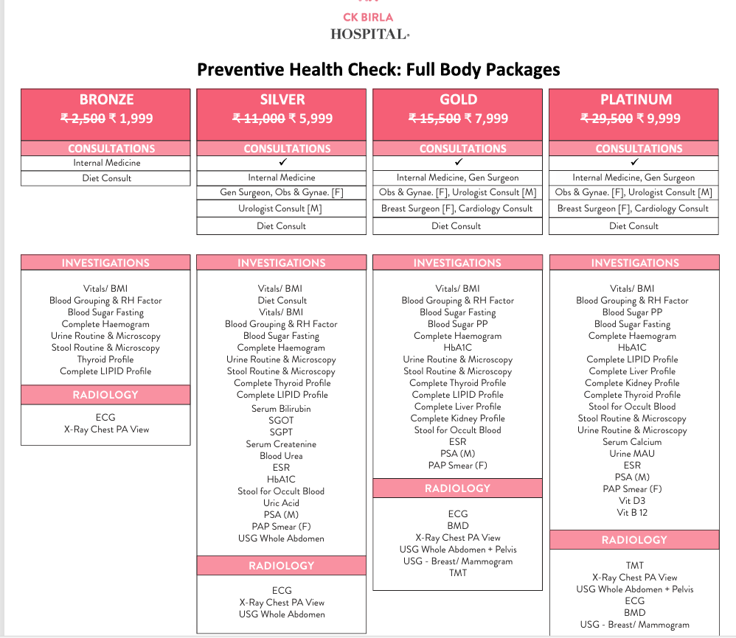

In response to India’s escalating burden of non-communicable diseases (NCDs), CK Birla Hospital, Gurugram, has pioneered a suite of comprehensive Preventive Health Check (PHC) packages. Designed to shift healthcare from reactive treatment to proactive wellness, these packages offer structured, affordable health assessments tailored to diverse needs and budgets.
Key Features of CK Birla’s PHC Packages:
- Four Tiered Options:
  - Bronze (₹1,999): Essential screening for basic metabolic health (diabetes, thyroid, lipids).
  - Silver (₹5,999): Expanded diagnostics including liver/kidney function and cancer markers (PSA for men, Pap smear for women).
  - Gold (₹7,999): Advanced prevention with cardiac stress testing (TMT), bone density (BMD), and mammography.
  - Platinum (₹9,999): Holistic evaluation covering vitamin deficiencies (B12, D3), tumor markers, and cardiac health.
- Gender-Specific Customization:
  - Women: Breast ultrasound/mammography, gynecologist consultations.
  - Men: Urologist consultations, Prostate-Specific Antigen (PSA) testing.
- Critical Diagnostics Included:
  - Cardiac: ECG, Treadmill Test (TMT)
  - Oncology: Stool occult blood, tumor markers
  - Metabolic: HbA1c, lipid profiles, thyroid panels
  - Organ Function: Liver, kidney, and ultrasound scans
- Value Proposition:
  - Packages discounted by 20-66% (e.g., Platinum slashed from ₹29,500 to ₹9,999).
  - Multi-specialist consultations bundled with diagnostics (Internal Medicine, Cardiology, Gynecology/Urology).
Why These Packages Matter:
- Early Detection: Identifies silent conditions like diabetes, hypertension, and cancers before symptoms manifest.
- Cost Efficiency: Up to 66% savings compared to à la carte pricing.
- Accessibility: Tiered pricing ensures broader socioeconomic reach.
"Prevention is the cornerstone of longevity. Our packages empower Gurugram residents to take control of their health proactively."
— CK Birla Hospital Preventive Care Team

Literature Review
The rise of non-communicable diseases (NCDs) in India has become a major public health concern. According to the world health organisation (WHO) NCDs are estimated to cause about 60% of total deaths in India, and most of these deaths take place prematurely, states the World Health Organization (2020). This growing burden has sparked a much-needed shift in focus—from treating illnesses to preventing them before they start.
Mohan et al. (2019) advocate for a comprehensive, multi-sectoral approach to NCD control, stressing the need for early detection and healthier lifestyle choices as key to reducing long-term health impacts. Despite, awareness and uptake of preventive health services continue to be urgently low among different population groups.
For instance, a study conducted by Kumar et al. (2020) in urban areas of Haryana found that less than 50% of those surveyed were aware of preventive health check-ups. This study also showed that people with higher education and income level were more likely to be known about this services.
Similar trend were seen at Sharma et al. (2022), in a tertiary care hospital in North India where the uptake of preventive checkups was limited, primarily due to lack of awareness and concerns were mainly over cost.
Supporting this pattern , Prashanth et al. (2019) reported low use of outpatient preventive care services in parts of South India The study pointed to poor health-seeking behavior and a general lack of community-level awareness as major contributing factors.
Pandve and Chawla (2017) added that preventive care is often sidelined in India’s healthcare system, more attention is given to treatment rather than early detection.
Beyond structural and financial hurdles, Joshi and Nair (2021) highlighted that psychological and cultural factors also play a critical role. Their qualitative research suggested barriers such as fear of being diagnosed with serious illness, and a belief among many that they are not personally at risk. These issues were present even among educated and employed individuals.
Although many initiatives like the National Health Portal (2022)which aim to increase public awareness and promote preventive screenings, digital tools still remain underutilized. The portal emphasizes that early health checkup can significantly reduces complications from chronic illness suchg as cancer, diabetes, hypertension etc.
Taken Together, these studies point to a clear need for more tailored, patient-focused strategies. Addressing both the informational gaps and emotional hesitations is essential. Enhancing accessibility, minimizing cost, and building public trust are critical to boosting participation in preventive health checkups—particularly in fast-growing urban areas such as Gurugram.

Objectives
- Quantify awareness: Measure patient knowledge of CK Birla’s preventive packages.
- Decode perceptions: Analyze attitudes toward routine health screenings.
- Identify barriers: Uncover obstacles to participation (cost, fear, accessibility).
- Drive change: Propose actionable solutions to bridge awareness-participation gaps.

Methodology

Study Design
- Approach: Quantitative cross-sectional study
- Duration: March 1 – May 31, 2025 (12 weeks)
- Location: General Outpatient Department (OPD), CK Birla Hospital, Gurugram
- Rationale: Snapshots patient perspectives during routine visits, avoiding emergency care bias.

Participants
- Included: 140 adults (≥18 years) from general OPD.
- Excluded: Emergency/specialized care patients (oncology, cardiology).

Data Collection:
- Structured questionnaire (demographics, awareness, barriers, participation).
- Sampling: Convenience sampling (march-june 2024).
- Ethics: Informed consent, anonymized data.

Analysis:
- SPSS v28 for descriptive/inferential statistics.
- Chi-square tests (α=0.05), logistic regression.
Cochran’s Formula for Sample Size calculation.
Cochran’s formula is used to calculate an ideal sample size when the population is large or unknown. The formula is:
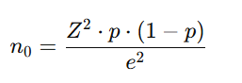
Where:
- n0 = Required sample size
- Z = Z-score (1.96 for 95% confidence level)
- p= Estimated proportion of the population with the attribute (0.5 is used when unknown, as it gives the maximum sample size)
- e = Desired level of precision (margin of error), usually 0.05 (5%)

Adjustment for a Finite Population (Optional)
If my total population size (N) is known and is relatively small, so I can adjust Cochran's formula as:
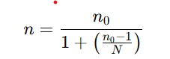
If, for example, the expected patient pool is N = 1000, then:
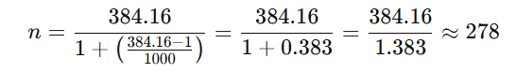

Although Cochran's ideal sample size is 384, for my project, but I have collected 140 responses. Therefore:
- My current sample (n = 140) is smaller than the ideal (n ≈ 384), but still acceptable for an exploratory or indicative study, especially if access or time was limited.
- This limitation should be acknowledged in the methodology section.

"The required sample size was calculated using Cochran’s formula for sample size determination. Assuming a 95% confidence level, 5% margin of error, and maximum variability (p = 0.5), the ideal sample size was found to be approximately 384 respondents. However, due to time and resource constraints, a total of 140 valid responses were collected for this study. While smaller than the ideal, this sample size is considered sufficient for drawing indicative conclusions in the given hospital setting."

Sampling Technique
- Method: Systematic random sampling
- Procedure:
  - Daily OPD list numbered sequentially
  - Sampling interval kk = Total daily patients / 15
  - Every k k-th patient invited
  - Replacement: Next eligible patient if refused
- Stratification: Implicit by age/gender via hospital’s natural patient flow

Data Collection Tool
- Instrument: Structured questionnaire (4 sections, 13 items)
Language: English
- Section | - Variables Measured | - Response Format
- A: Demographics | - Age, gender, education, occupation, income | - Multiple-choice + open-ended
- B: Awareness | - General checkup knowledge, CK Birla package awareness, information sources | - Dichotomous (Yes/No) + multiple-select
- C: Perception | - Belief in early detection, barriers (cost, time, fear, awareness) | - 3-point Likert + checkbox
- D: Participation | - Checkup history, recency, future intent | - Dichotomous + categorical

Data Collection Procedure
Step-by-Step Workflow:
- Screening: Research assistant reviewed OPD register daily at 9 AM
- Invitation: Every k k-th patient approached in waiting area
- Consent: Bilingual information sheet + written consent (Annexure II)
- Administration:
  - Self-filled questionnaire (literate patients)
  - Researcher filled itself by asking the information from them(illiterate patients)
- Duration: 5 to 6minutes per response
- Anonymity: No names/identifiers collected

Ethical Considerations
- Approval: SRB Committee, IIHMR Delhi
- Informed Consent:
  - Written consent before participation
  - Right to withdraw anytime
- Confidentiality:
  - Anonymous data entry
  - Locked storage of paper forms
- Risk Mitigation: Counseling referrals for distressed participants
Numbers don’t lie, but they need careful listening. Our methodology ensured every patient’s voice was captured without distortion."

Results
Demographics (n=140):
Variable | Category | %
Gender | Male | 52.1%
 | Female | 47.9%
Age | 18-30 years | 35.7%
 | 31-50 years | 42.1%
 | >50 years | 22.1%
Education | No formal | 24.3%
 | School | 28.6%
 | Graduate | 25.7%
 | Postgraduate | 21.4%
Income | <₹10,000 | 25.0%
 | ₹10,000-30,000 | 30.7%
 | ₹30,000-60,000 | 27.9%
 | >₹60,000 | 16.4%

This chart represents:
- 37% of respondents said they were aware of the health checkup packages.
- 63% said they were not aware, indicating a significant awareness gap.
It suggested that the majority of patients are unfamiliar with the hospital’s preventive health package, This highlight the need for stronger communication and outreach strategies.

This chart represents:
- Hospital staff was the most common source, cited by over 40% of respondents.
- Friends/Family followed at around 29%.
- Social Media contributed to about 19% of awareness.
- Others accounted for just 12%.
It highlights the critical role of hospital staff in spreading awareness, while digital platforms like social media remain underutilized as outreach tools.

This chart represents:
- Lack of awareness was the most common barrier, cited by nearly 58 respondents.
- Cost followed closely, with about 54 responses.
- Other significant barriers included “Other” reasons (49), fear of diagnosis (43), and lack of time (38).
It highlights that both informational (awareness) and financial (cost) challenges are major barriors for preventive health participation, suggesting a need for better education and affordable access.

This chart represents:
- 35% (49 respondents) believe in early detection.
- 28.57% (40 respondents) do not believe in it.
- A significant 36.43% (51 respondents) are not sure.
It indicates that over 64% of respondents are either unsure or do not believe in early detection, suggesting a need for better awareness and health education to promote proactive health-seeking behavior.

Discussion
The results of this research highlight significant information on the existing level of awareness, perception, and involvement in preventive health checkups (PHCs) at CK Birla Hospital, Gurugram. Despite the existence of tiered and economic PHC packages, the usage rate is low as only 37% of the 140 participants were aware of the hospital health packages.
This low awareness suggests a communication gap, particularly in light of the hospital's investment in promotional campaigns and discount pricing. The information indicates that hospital staff (40.38%) is the main source of awareness, followed by friends/family (28.85%) and social media (19.23%). This highlights the persistent supremacy of interpersonal communication over electronic outreach, particularly in healthcare.
One of the important observations is the multifactorial nature of barriers to participation. The major issues faced, as reported by the top responses, included lack of awareness (57), cost (54), fear of diagnosis, and insufficient time. This is consistent with national studies (e.g., Sharma et al., 2022; Joshi & Nair, 2021), which include economic burden and lack of information among key deterrents to preventive care.
Perception-based information indicates that 35% of participants had faith in early detection, whereas 36.43% were not sure, and 28.57% did not have any belief in it. This negative or unsure perception of preventive care could be the outcome of psychological barriers, bad health literacy, or earlier experience with healthcare, as advocated by Prashanth et al.
Notably, socioeconomic and educational factors had a strong influence on awareness and participation. Respondents with higher income and educational backgrounds were more likely to know about the packages and had better participation rates. For instance, those in the >₹60,000 income group had notably higher awareness and uptake, which further illustrates how preventive health is often a luxury perceived as optional by lower-income groups.
The hospital’s initiative—though well-designed—has not yet bridged the gap between service availability and behavioral acceptance. Digital channels such as WhatsApp, Instagram, and YouTube, which currently account for a small share of awareness, can be better leveraged through multilingual and culturally relevant messaging to improve reach and engagement.
In summary, this study underscores the urgent need for CK Birla Hospital to adopt a multi-channel, patient-centric strategy that addresses both informational and emotional barriers. More inclusive and accessible educational tools, financial flexibility, and community-level engagement are essential to improving participation in preventive health checkups and promoting a shift from reactive treatment to proactive health management.

Actionable Solutions:
1. Enhance Awareness & Education
Findings Supported:
- Only 37% are aware of CK Birla packages
- 57 people cited lack of awareness as a top barrier
- 36% are “Not Sure” about early detection benefits
Solutions:
- Health Education Counters at OPD areas to explain preventive care
- Multilingual posters and video content in waiting rooms

2. Engage Staff in Information Dissemination
Findings Supported:
- 40% of awareness comes from hospital staff
- Staff influence is the most trusted source
Solutions:
- Train reception and nursing staff to briefly mention packages during patient registration

3. Digital and Social Media Outreach
Findings Supported:
- Only 19% heard from social media
- 36% unsure about early detection = knowledge gap
Solutions:
- Use Instagram reels, YouTube shorts, and WhatsApp forwards with simple health facts
- Promote “Myth vs Fact” videos: e.g., “Preventive checkups don’t mean you're sick”

4. Address Cost as a Key Barrier
Findings Supported:
- Cost cited by 54 respondents as a barrier
- Higher awareness & participation in >₹60,000 income group
Solutions:
- Introduce tiered pricing or discounted group/family checkups
- Partner with employers to offer subsidized corporate packages
- Run monthly or quarterly health camp days offering basic screenings for free or low cost

6. Rebuild Trust and Reduce Fear
Findings Supported:
- 44 respondents fear diagnosis
- 36.43% are unsure about the value of early detection
Solutions:
- Use doctor videos to explain that early detection = better outcomes
- Run counseling sessions post-diagnosis to help patients cope

Conclusions:
The present study aimed to assess the level of awareness, perception, and participation in preventive health checkups (PHCs) among patients visiting CK Birla Hospital, Gurugram. The findings offer critical insights into the behavioral, informational, and socio-demographic factors influencing the uptake of preventive healthcare services in an urban, private hospital setting.
Despite the availability of well-structured and economically tiered PHC packages at CK Birla Hospital, the awareness level among patients remains significantly low. Only 37% of the 140 respondents were aware of these health packages. This clearly reflects a gap in hospital-patient communication and suggests that current promotional methods may not be effectively reaching the intended audience. Among those who were aware, hospital staff (40.38%) were the most cited source of information, underscoring the importance of interpersonal communication within the healthcare setting. However, digital platforms like social media, which have the potential for broader reach, were underutilized.
Participation in preventive checkups was further hindered by a range of barriers, both structural and psychological. The most common deterrents were lack of awareness, cost concerns, fear of diagnosis, and lack of time. These findings align with broader literature indicating that preventive care is often deprioritized due to financial limitations and low perceived risk, particularly among low-income groups.
In terms of perception, only 35% of respondents believed in the importance of early detection, while 36.43% were unsure, reflecting a significant knowledge and attitude gap. This uncertainty may be rooted in inadequate health literacy, cultural beliefs, or previous healthcare experiences. The belief in early detection was found to be closely linked with participation, reinforcing the need to improve patient education and awareness to encourage preventive behavior.
- It also brought out a distinct relationship between socio-demographic factors and preventive health behavior. Increased awareness and activity were found to be among those with higher incomes and education levels. This implies that inequality in health results from not only the accessibility of services but also the ability to perceive and take actions on health information.
- In totality, the research finds that there is a gap between availability of services and patient conduct. While CK Birla Hospital has proactively initiated the provision of preventive health care services, the same is hampered by poor community participation, inadequate health communication targeted at specific areas, and socio-cultural constraints. Closing this gap involves a multi-strata strategy encompassing: Strengthened communication by frontline staff
- Affordable and subsidized packages for low-income groups
- Culturally sensitive health education campaigns
- Greater use of digital tools and platforms
- Community outreach and mobile health units for broader access

References:

- World Health Organization. Noncommunicable diseases country profiles 2020. Geneva: WHO; 2020.
- Mohan V, Deepa M, Pradeepa R. Prevention of non-communicable diseases in India: Need for integrated, multi-sectoral approaches. Indian J Med Res. 2019;149(2):189–93.
- Kumar R, Singh M, Bansal R, Yadav R, Yadav V. A study to assess the awareness regarding preventive health check-up among adult population in urban area of Haryana. Int J Community Med Public Health. 2020;7(6):2367–71.
- Sharma R, Jindal A, Mahajan A. Preventive health check-up: A study on awareness and practices among patients attending tertiary care hospital in North India. J Fam Med Prim Care. 2022;11(1):123–8.
- Prashanth H, Chandrashekar M, Bhaskar D, Ramya S, Sowmya K. Awareness and utilization of preventive health services among patients attending outpatient department of a tertiary care hospital: A cross-sectional study. Int J Prev Curat Community Med. 2019;5(3):5–10.
- National Health Portal of India. Preventive Health Check-up [Internet]. Ministry of Health and Family Welfare; 2022 [cited 2025 Jun 15]. Available from: https://www.nhp.gov.in/
- Pandve HT, Chawla PS. Role of preventive health check-ups in India: A neglected aspect. J Community Health Manag. 2017;4(1):33–5.
- Joshi S, Rajasekharan Nair V. Barriers and facilitators for preventive health check-up: A qualitative study among employees of a tertiary care hospital in South India. Indian J Health Sci Biomed Res. 2021;14(3):247–52.

