Dissertation Training
At
Manipal Hospital, Gurugram
Haryana

Revenue Generation from Call Centre
By
Shiv Nishad
PG/23/103

Under the guidance of
Dr. Rupsa Banerjee

PGDM (Hospital and Health Management)
2023-25

International Institute of Health Management Research
New Delhi
NKKKKDKFJJ

Dissertation Report

At

Manipal Hospital

A Report

Revenue Generation from Call Centre
By

Mr. Shiv Nishad
PG/23/109

Under the guidance of
Dr. Rupsa Banerjee

PGDM (Hospital and Health Management)
(2023-2025)


International Institute of Health Management Research, New Delhi

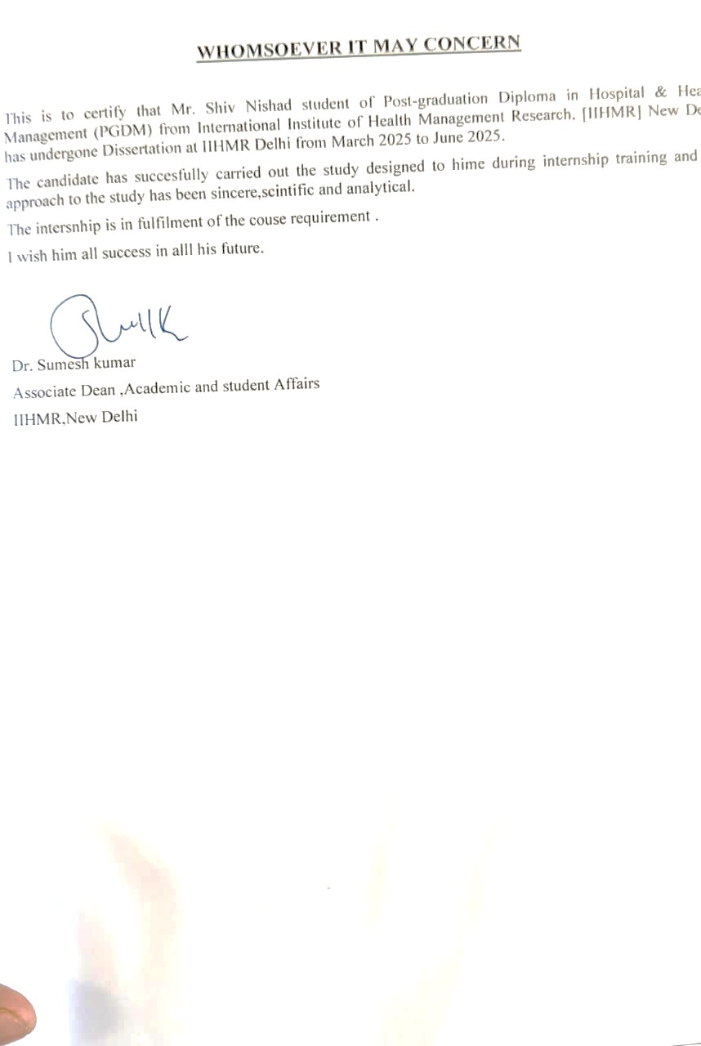

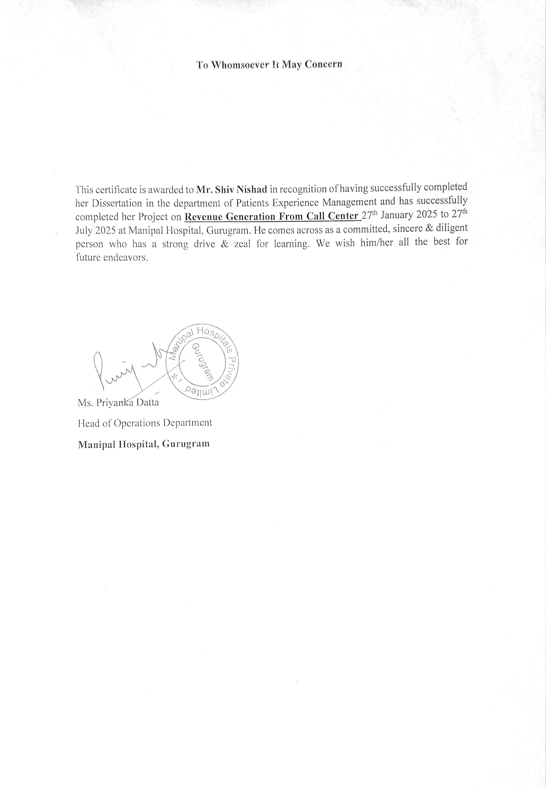

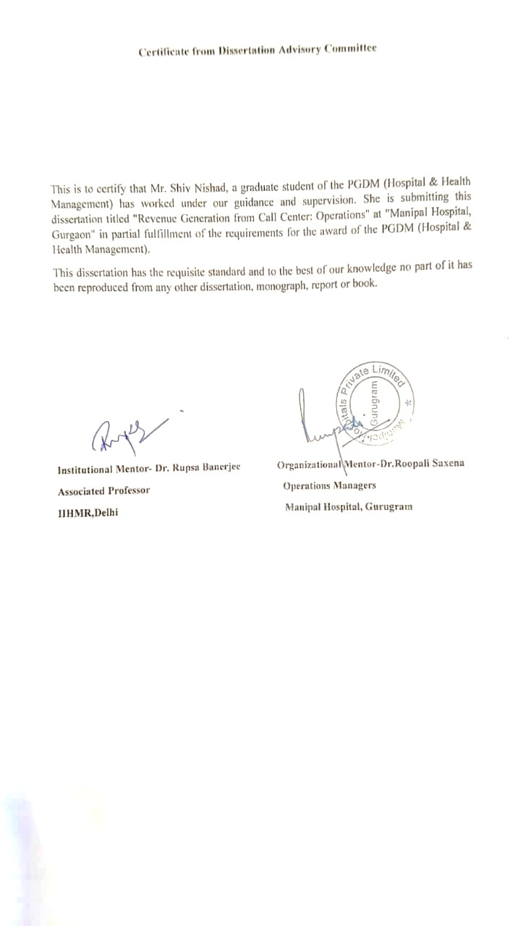

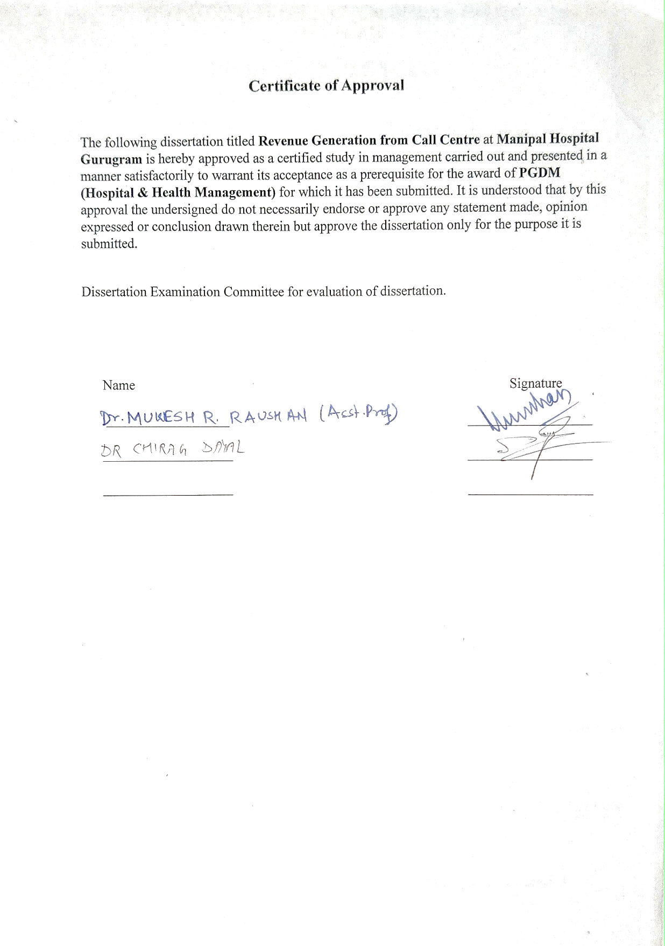
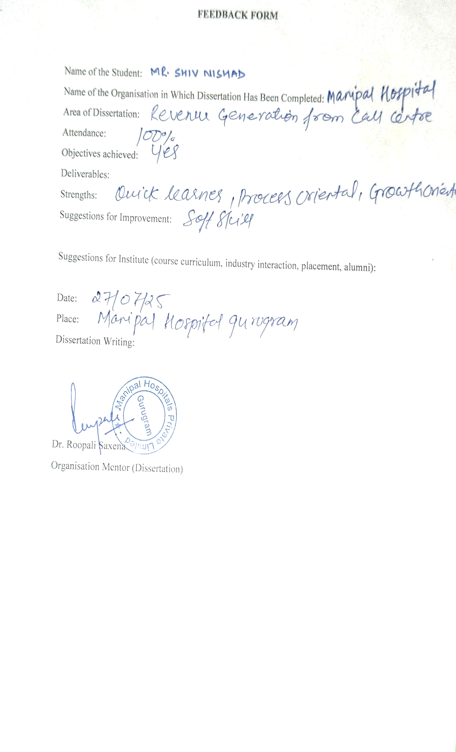


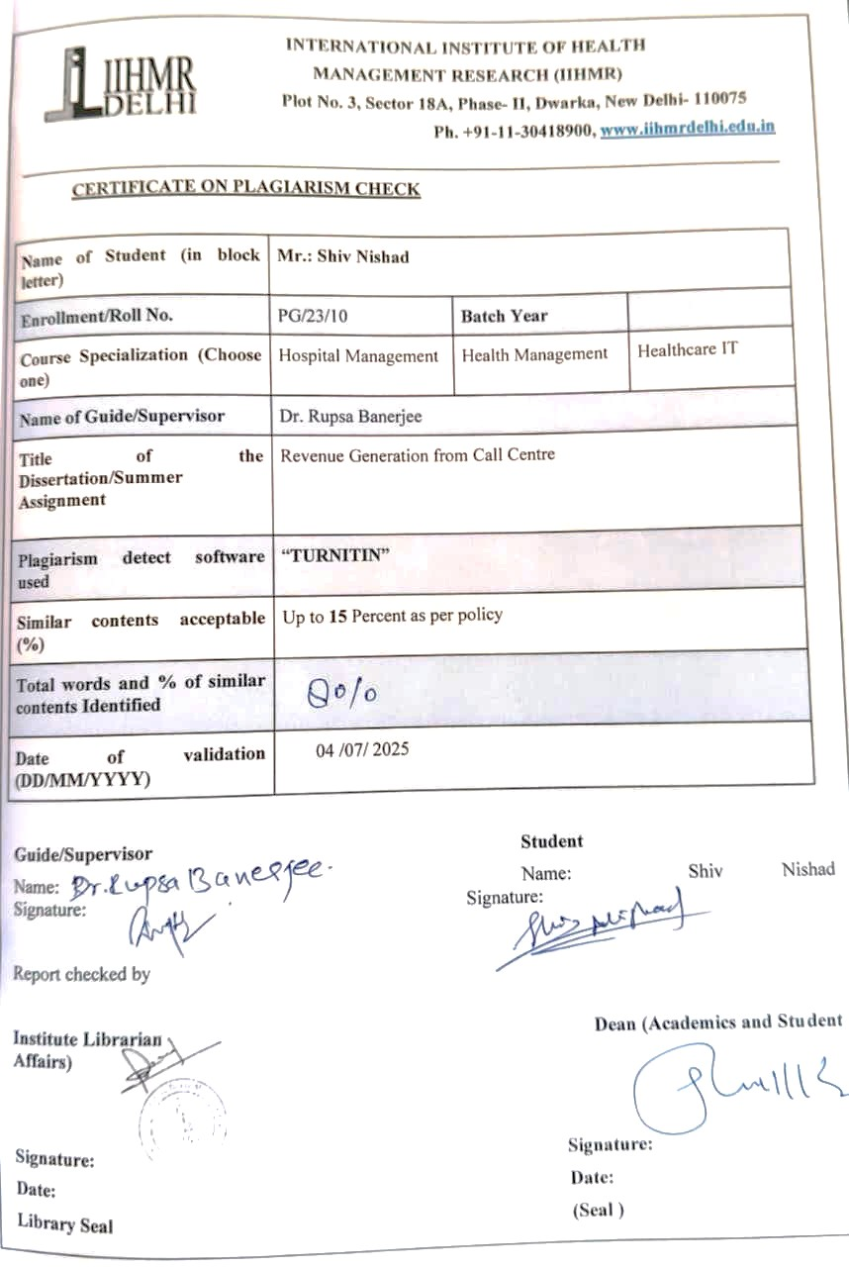

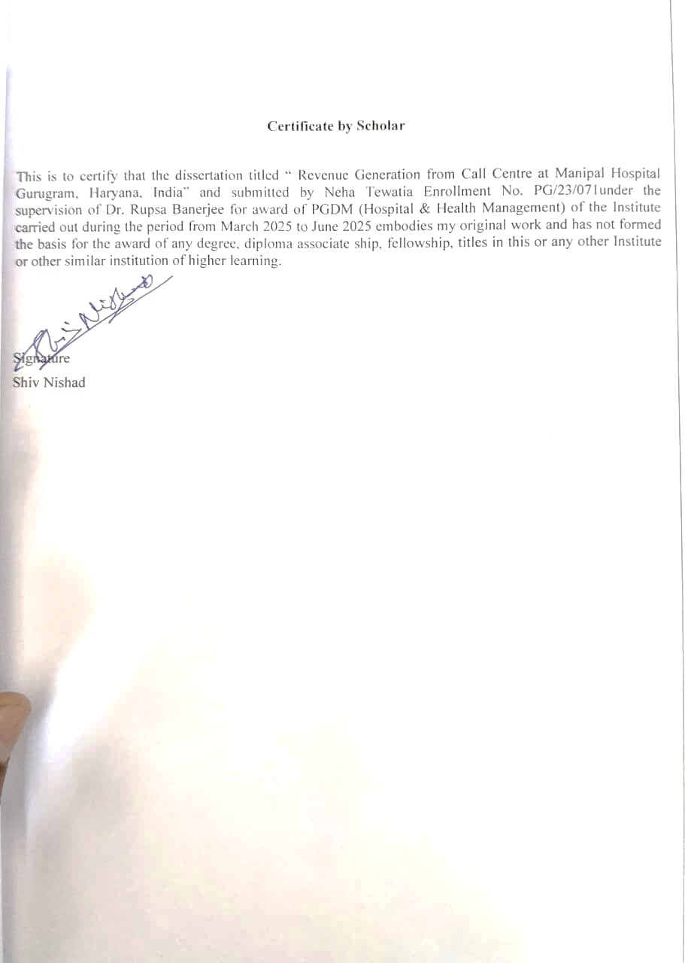

ACKNOWLEDGEMENT

This report is an outstanding prospect to convey my gratefulness to those many people whose timely help and guidance went a long way in finishing this project.
I would like to express my sincere thanks Manipal Hospital Gurugram for giving me an opportunity to explore the practical knowledge practiced by the company.
I received a lot of advice and assistance from these folks, whose help was crucial to the project's success. I could not have accomplished anything without this advice and assistance. They assisted me in this undertaking, for which I am grateful.
I would like to take this opportunity to thank the Manipal Hospital, Palam Vihar in Gurugram, and Dr. Roopali Saxena (Operations manager) for their genuine interest in the project and willingness to share their opinions despite their extremely busy schedules. I consider it a privilege to have worked at the hospital in Palam Vihar, Gurugram - 122017, under their skilled leadership.
The entire staff at Manipal Hospital deserves my sincere thanks and obligation for their outstanding support and assistance during the entire operation.
My sincere appreciation is extended to my mentor (Assistant Professor) Ms. RUPSA BANEJEE Ma’am Furthermore, I would like to thank INTERNATIONAL INSTITUTE OF HEALTH HEALTHCARE AND HOSPITAL MANAGEMENT for giving me the opportunity. I owe a debt of appreciation to mentor for allowing me to work on this research and for providing me with all the guidance and support necessary to complete the project on "A STUDY ON PATIENT LIFETIME VALUE IN IPD." I owe her a debt of appreciation for her helpful advice and guidance.
First and foremost, this big task cannot be completed without my friends and family's everlasting support.

Contents
Abstract: 13
MEANING OF MANIPAL 14
INTRODUCTION 15
SCOPE OF SERVICE 15
LEARNINGS 18
Literature Review 23
OBJECTIVES. 24
METHODLOGY. 24
FLOWCHART. 25
RESULTS. 26
OPD SCHEDULING AND OPERATIONAL ENHANCEMENT. 27
DISCUSSION 27
CHALLENGES 28
CONCLUSION. 28
References. 29

Figure 1 Numbers of calls in each month from February to May are likely. 26
Figure 2 This data approximately taken as per previous months. 27

Abstract:
The healthcare industry is increasingly recognizing the importance of call centres as a critical interface between patients and hospitals, serving as both a communication hub and a revenue-generating unit. This dissertation, conducted at Manipal Hospital, Gurugram, explores the role of hospital call centres in enhancing patient engagement, improving operational efficiency, and generating revenue through effective communication and lead conversion strategies.
The primary objectives of the study were to assess lead generation methods, examine patient conversion techniques, and evaluate the impact of call centre operations on patient satisfaction and hospital revenue. The methodology involved secondary data analysis of call logs, hospital records, and patient interaction reports from January to March 2025. Data were analyzed using Microsoft Excel, employing descriptive and comparative techniques such as pivot tables and bar charts to identify patterns in appointment bookings, diagnostic scheduling, and follow-up adherence.
The findings reveal that the call centre handled approximately 24,000 calls per month, averaging 800 calls per day, with the majority related to appointment scheduling, diagnostic inquiries, and follow-ups. A significant proportion of calls resulted in confirmed appointments, diagnostic bookings, or admissions, directly contributing to hospital revenue. Moreover, the centralized call centre model reduced patient waiting times, minimized no-shows through reminders, and improved coordination between departments. Challenges included high call volumes, occasional misinformation, and delays in departmental response during call transfers.

In conclusion, the study demonstrates that hospital call centres function not only as service units but also as strategic tools for revenue generation and patient relationship management. By strengthening patient communication, optimizing scheduling, and ensuring timely follow-ups, call centres contribute to both financial sustainability and enhanced patient experience. The findings underscore the potential of integrating call centre operations with hospital management systems to improve efficiency, patient satisfaction, and long-term patient loyalty.
The healthcare sector is getting to know the significance of call centres as the vital point of contact between hospitals and patients that is not only a communication centre but also a revenue-generating centre. This dissertation, set at Manipal hospital Gurugram, attempts to identify the role hospital call centres play in increasing their level of patient engagement, benefiting operation efficiency, and profitability by maximizing communication and lead conversion strategies.

The three main purposes of the study were to evaluate the lead generation methods, analyze patient conversion techniques and evaluate the effect of the call centres operations on patient satisfaction and the hospital revenue. The research design entailed the secondary data analysis of the call records, hospitalization entries, and interaction reports by patients who used the services of the hospital between January and March 2025. Microsoft Excel was used to analyze the data; descriptive and comparative tools (pivot table and bar charts) were used to determine trends in calendar appointment 4scheduling, diagnostic scheduling, and follow-up adherence.

The results demonstrate that the call centre received about 24000 calls on average monthly which translates to 800 calls around 1 day on average, and most of the calls involved making appointments, diagnostic requests and follow-ups. A large segment of the calls led to confirmed appointments, diagnostic booking, or admit, which was directly adding to the revenue of the hospital. Furthermore, the centralized call centre model decreased the waiting time in clinics, shortened the no-show strategy using reminders and aligned the departments. It was experiencing call volumes, frequent misinformation and including lagging in departmental on call transfers.

Finally, the given research shows that the role of the hospital call centres is not only to serve as service departments but also as strategic revenue-generating and patient-contact management tools. Call centres help achieve financial sustainability and a better patient experience by communicating with the patient, improving scheduling and follow-up.

PART-A

MEANING OF MANIPAL
The names "munn" and "palla" are combined to form the anglicised name "Manipal." Munn and palla are the Tulu words for "mud" and "lake," respectively.
VISION & MISSION OF MANIPAL:-

VISION -- The goal of Manipal Hospitals is to become a preeminent healthcare organisation recognised for its cutting-edge facilities, patient-cantered approach, clinical excellence, and research and innovation. They want to be known as a trusted partner in their patients' healthcare journeys and to offer them high-quality, inexpensive, and easily accessible healthcare services. Manipal Hospitals is working to accomplish this goal by utilising cutting-edge medical technology, adopting best practises, and assembling a group of compassionate and highly skilled healthcare workers.

MISSION -- The objective of Manipal Hospitals is to offer patient-cantered healthcare services that are high-quality, accessible, and affordable. By utilising the most advanced medical technologies, implementing best practises, and assembling a group of highly skilled and sympathetic healthcare professionals, they provide the greatest results for their patients. Manipal Hospitals also pledges to support medical innovation and research, educate, and develop its staff and medical students, help the underprivileged in the community, and advance environmental sustainability by eco-friendly techniques.

The overall goals of Manipal Hospitals' vision and mission are to deliver high-quality healthcare that is easily accessible, reasonably priced, and patient-cantered while also making a positive impact on the expansion and advancement of the healthcare sector and society at general.

INTRODUCTION
Manipal Hospitals is the name of a network of hospitals in India with a range of specialties. It has grown into one of the top healthcare organisations in the country since its inception in 1953. The hospital network is owned by the Manipal Education and Medical Group (MEMG), a healthcare conglomerate that also has ownership over a number of other healthcare and educational organisations.
Manipal Hospitals provide services in gastroenterology, orthopaedics, cardiology, neurology, and a variety of other medical disciplines. The facilities are outfitted with state-of-the-art machinery and cutting-edge medical technology to give patients the finest possible care. Manipal Hospitals' highly qualified and competent medical team, many of whom obtained their training at some of the finest medical schools in the world, is an additional plus.
Manipal Hospitals do more than only provide medical care; they also do research and instruct medical students. The hospital network works with several international organisations and has been involved in a lot of research projects.
In general, Manipal Hospitals is a reputable and well-known healthcare institution in India that provides excellent medical services to individuals from all over the country and abroad.

SCOPE OF SERVICE
The hospital offers a wide variety of affordable medical services, as follows:
Internal medicine
24-hour emergency room
Five operating rooms to dialysis, intensive care, and paediatrics’

CLINICAL SERVICES ----------------------------------------------

Bariatric Surgery
Cath Lab
Cochlear Implant Surgery
Day Care Services
Dental Sciences
Dialysis
Laparoscopic Surgery
Intensive Care Unit
Medical & Surgical Gastroenterology
Neonatal Intensive Care Unit
Neonatology
Neurosurgery
Obstetrics and Gynaecology
Ophthalmology
Orthopaedic Surgery including Joint Replacement & Arthroscopic Surgery
Otorhinolaryngology
Respiratory Medicine
Spine Surgery
Urology
Vascular Surgery

ALLIED MEDICAL SERVICES -----------------------------------------------------

Ambulance
Blood Bank
Dietetics
Occupational Therapy
Physiotherapy
LABORATORY SURVICES ---------------------------------------------------

Clinical Biochemistry
Clinical Microbiology & Serology
Clinical Pathology
Haematology
DIAGNOSTIC SERVICES ---------------------------------------------------------------

Colour Doppler
CT Scanning
Mammography
MRI
Ultrasound
X-Ray
Audiometry
Interventional Radiology

OTHER DIAGNOSTIC SERVICES ---------------------------------------------------

2 D Echo
Audiometry
EEG
ECG
Holter Monitoring
Spirometry
Treadmill Testing
Urodynamic Studies
OTHER FACILITIES ---------------------------------------------------------------------

Ambulance
Mortuary
SPECIALTIES

MEDICAL SPECIALTIES
Internal Medicine
IVF
Critical Care
Emergency and Trauma
Endocrinology
Fatal Medicine Multi Organ Transplantation
Plastic & Cosmetic Surgery
Rheumatology
Paediatrics
Cardiology
Dermatology
Gastroenterology
Medical Oncology
Nephrology
Neurology

SURGICAL SPECIALTIES
ENT
General Surgery
Surgical Oncology
Neurosurgery
Cardiothoracic Surgery
Vascular Surgery
Urology Surgery
Dental Surgery
Paediatric Surgery
ORTHER SPECIALTIES
Anaesthesiology
Psychiatry
Microbiology
Palliative Medicine

LEARNINGS
My Learnings in two month from operations department and they are :
- The Outpatient Department (OPD) streamlines patient registration and appointment scheduling through a thorough understanding of workflow.
After patient reach in the hospital:
- Patients after registration go for the further thinks like Consultation, laboratory, radiology, procedure, follow-up and also can go for the admission.
- Services Offered like:
- A number of services provide, such as diagnostic testing, minor treatments, and consultations.
- Each Specialist have their own care coordinator.
- Operational Efficiency:
- Waiting time period for patients are reduced by managing.
- Overseeing a number of patient in large and making sure everything runs well.
1.Patient Interaction:
- Strategies for managing a large number of patient requirements and efficient patient communication.
- The significance of patient involvement and education in their care regimens.
2. The Inpatient Department (IPD) :
- The admission techniques used to admit patients and admit them to the suitable wards with procedures.
- So, the medical staff’s relationship with the admissions department is good.
- It shall continue a supervising role through the process of treatment programs.
- Interdisciplinary role In The role of functional interdisciplinary
- The facts about releasing patients are the following: Releasing patients is not the same as discharging them; releasing patients also involves final consultations and documentation; releasing patients implies patient participation.
- The importance of patient education in addition to Discharge planning for the care when the patient is discharged from the hospital.
3. Intensive Care Unit (ICU):
- Ensure that he or she coordinates the process within a vocational setting that involves high risk and pressure.
- Taking care of the patients in critical condition and attending to their needs an all-important necessity.
- Secaucus Conditions pertain to the following: Information on the roles of sophisticated machines in the provision of health care.
- Counselling services for the employees, their families, and dependents.
- A working together is referred to as excellent team co-ordination which means that in the team of healthcare professionals are physicians, nurses and specialists etc.
- Fine more of workmate expertise in talking over the phone when there is an emergency.

4. High Dependency Unit (HDU)
- Patient monitoring is designed for patients who require more attentive attention than they would receive on a regular ward, but not as much as they would in an intensive care unit.
- Listening to what patients need and modifying care plans on the dot .
- Hand-off communication between the active unit and other wards within the hospital.
- Explain how the patient’s care and needs in particular will be maintained during the procedures.
- Constructing health as a resource rather than a cost and organizing health care so as to give optimal care to the patients.
- To maintain the patients’ needs, it should ensure to offer the available resources for the hospital.
5. The Assisted Living Facility
- The Nursing Process:
- Gaining an insight into the various responsibilities as well as the daily activities of the nursing team.
- Coordinating some complex care related tasks such as administering medicine and monitoring patients’ temperature as well as any other symptoms they may be experiencing.
- Patient Interaction:
- Effective ways of performing or educating/persuading the patient and the families/relatives.
- Providing with information and emotional support for the patients. 6. Hospital Specializations Variety of disciplines:
- Gaining an insight into the various responsibilities as well as the daily activities of the nursing team.
- Coordinating some complex care related tasks such as administering medicine and monitoring patients’ temperature as well as any other symptoms they may be experiencing.
- Patient Interaction:
- Effective ways of performing or educating/persuading the patient and the families/relatives.
- Providing with information and emotional support for the patients.
6. Managing an Outpatient Department Operational Management:
- Greater awareness of the patient movement after its entry at the hospital, stabilization, and distribution.
- Firstly the patients attend the billing section for registration, then proceed to the schedule for consultant, from there they go to the consult doctor and then proceed to either get a LAB or RADILOGRAOHY or PROCDURE.
- After make everything he plan for pharmacy
- They have to follow consultant patients after which they are told by the physician what to do.
7. Patient Care Coordination:
- Arranging for primary care doctors and specialists to provide care together.
- Organizing referrals and follow-up visits to ensure continuity of services of patients to come back.
- Using quality assurance procedures will help to bring the highest standards of patient care.
- Gathering and evaluating patient input to enhance outpatient department services.
- Combined Learnings from Observations
- Encompassing the full spectrum of patient services from admission to discharge, or comprehensive patient care.
- Realizing how important it is to implement a patient-centred approach throughout all areas.
Interdepartmental Coordination:
- Meaning that I get to discover how the different departments work hand in hand to ensure that the patients are given the best care.
- Clearly identifying how one can ensure that the necessary communication and cooperation with other departments are achieved.

Operational Efficiency:
- Promoting the identification of work process areas that could be made efficient in order to spare time. •
- Reduction methods concerning efficient practices to cut time delays.
- Description before OT, Radiology etc to some patients so that they tell us the time to fix.
- Evaluating business process for improvement where there is an opportunity to achieve value added.
- Initiating measures that will help promote efficiency in operations with the view of cutting down on the time wasted waiting.

Patient safety and excellent care:
- Adhering to policies and procedures that address the safety of the patients as a basic requisite for any healthcare institution.
- Responses the call bell, assisting the patient for repositioning.
- Acquiring knowledge on the application of quality control plans in the medical industry.

Expertise in Medicine
- Caught up in the skills of handling advanced medical technologies and methodologies. The CT issues posed by care being informed about the different applications and treatments there are in the management of diseases.
- I have come to realize that the management of crisis is the way in which new learners are trained in the management of crisis especially in ICUs and home dying units.
- The topic: ‘Decision making and problem solving; elements critical to fast moving intensive care’.

- Learnings from Revenue Generation from Call Centre and Observational Experience
- Revenue Generation from Call Centre Project-Specific Learnings
Understanding PLTV Concepts:
- Comprehending the importance of PLTV in healthcare.
- Learning how patient retention and engagement impact long-term value.
Patient Discharge and Follow-Up Process:
- Mastering the process of identifying patients scheduled for discharge.
- Reviewing discharge summaries to understand follow-up schedules and recommended tests.
Effective Patient Communication:
- Developing skills to communicate discharge summaries and follow-up requirements to patients.
- Learning to pitch follow-up appointments and lab test collections effectively.
Service Coordination:
- Coordinating follow-up appointments and lab test collections.
- Ensuring smooth transition of information between departments.
Data Management and Reporting:
- Compiling and managing data on patient interactions and follow-up conversions.
- Creating detailed reports and maintaining accurate records in Excel.
Follow-Up and Retention Strategies:
- Implementing strategies to improve patient follow-up adherence.
- Developing personalized care plans and educational materials to enhance patient retention.
Conversion Tracking and Analysis:
- Tracking conversion rates for follow-up bookings and lab test collections.
- Analysing data to identify trends and areas for improvement.
Revenue and Growth Analysis:
- Monitoring revenue generated from follow-up services and lab tests.
- Analysing growth metrics related to patient retention and service utilization.
Continuous Improvement:
- Gathering feedback and refining approaches to improve patient engagement.
- Regularly analysing data to optimize processes and strategies.
- These learnings provide a well-rounded understanding of hospital operations, patient care processes, and the critical role of interdepartmental collaboration in delivering high-quality healthcare services.

Part-B

REVENUE GENERATION FROM CALL CENTRE.
- Call centers Centralized call centers are becoming an important strategic element of hospitals, particularly multispecialty and tertiary care hospitals in the form of increasing the gap between patients and healthcare services. A hospital call Centre is a specialized hospital department that entertains a huge variety of patient calls like appointment booking, doctor consultations, health check-up related calls, admission related information, complaints and attend to them.
- These center are contacted by the trained call executives, who handle both inbound and outbound calls with real time coordination of the departments including OPD scheduling, diagnostics, billing and homecare services.
- As the healthcare industry becomes more competitive, patients have started expecting clear, fast, and concerned responses and communications. Thus, hospital call Centre performance has a direct impact on patient satisfaction, hospital reputation, and clinical outcome in a few situations.
- To assess the lead generation methods and patient conversion techniques and their effectiveness.
- To examines both patient experience quality and revenue generation results due to effective communication methods.

KEY POINT OF CALL CENTRE .
- Centralized Patient Dialog.
- It will give patients one option to make queries, appointment, reschedule an appointment, or to receive information.
- Lowers the confusions of having various department numbers
- Scheduling of Appointments & Follow-ups.
- Streamlines OPDs, diagnostics, surgeries and follow ups.
- Minimizes the no-shows by sending reminders (SMS/calls).
- Maximizes the doctor time and resource usage.
- Lead Conversion and Revenue
- The potential patients call the call centres and make or receive calls.
- Turn questions into bookings and hospital income.
- Measure the success of tracking marketing campaigns through acquisition of the leads source.
- Emergency Handling and Triage Service
- The call centre will be able to direct the patients quickly to ER, or reach the on-call doctors in case of an emergency.
- Has too little training to offer even simpler triage.
- 24x7-hour Patient Care.
- Several hospitals have got around-the-clock helplines, which are vital in:
- Medication queries
- Discharge instructions
- Guidelines about Lab report
- Feedback and Grievance Management
- Patient feedbacks, complaints or suggestions on improving the service could be captured through call centres.
- Increases service recovery and retention of the patient.
- Operational Efficiency.
- Decreases the number of walk-in inquiries at the front desk.
- Releases on-ground personnel to concentrate on activities in the hospital.
- Reporting and Data Collection
- Records important information about patient behaviour, calls and service demand.
- Assists hospital managers in the decision-making process and prediction

Literature Review

CALL CENTER.
Call centres may be regarded as “a service network in which agents provide…telephone-
Based services or, sometimes more generally online-services, with customers and servers
Being remote from each other” (Mandelbaum, 2004). Call centres have been referred to
as a type of helpdesk or “one-stop help shop”, in which call centre agents attempt to
Answer and solve client’s queries, concerns or complaints in a friendly and timely manner
(Badler, 2004), or provide information to the client and call centres may even deal with
sales aspects of a product (Mandelbaum, 2004). Thus, a call centre is described as a work
Environment in which the main business is conducted via a telephone whilst
Simultaneously using display screen equipment (DSE).
Call centres were originally regarded as a cheaper means of communication than ‘face-to-
face’ contact. However, in recent years with advanced telecommunications and computer
Technology, call centres are seen as a means of improving customer service facilities
(Cartwright, 2003).
The functions that call centres provide are varied. Multiple functions are blended into one
Office and according to a United Kingdom call centre study (ContactBabel, 2004), call
Centres may offer a wide range of services ranging from customer queries, telesales,
Marketing and information services, to reservations and balance enquiries.
In our thesis, we analyse the call centre of a specified hospital, in which activities are conducted.
Ankara i.e. GUven Hospital. The hospital calling centre assumes the post as the medical
The call flows over the call and consultation and appointment centre as well as domestic call traffic.
Centre. The three categories of calls fall in the category of consulting, appointment and
Domestic calls. The call rate coming on to the call centre is a variable rate that varies according to hours.
All the agents are multifunctional, in the sense that each one of them is able to provide service to every faction of calls.
Tasking). The exponential service time distribution is different in different types of calls.
Calls may drop during the waiting process in the call centre whatever their type of call is.
It is assumed that the abandonment rate and rates of arrival of the calls are exponential. Call
Centre recommends certain percent of the appointment calls to a physician that renders service in the
Call centre and certain percent of consulting calls to hospital units on the basis of
Customers’ requests. The call canter only offers service to a domestic call. Some
Percent of such diverted calls to doctor and hospital units back to call canter.
The process of diverting and returning of call canter, doctor and hospital units
Forms the call canter network of the hospital. This study has the objective of modelling
These call canter network so as to have the characteristics of the analysed system.
On this basis, the queuing network and simulation modelling of the system is carried out.
Approaches. They develop different models that have varied divert and returns rates.
Various number of agents is multi-tasking or service committed to supply service to a
On type of call. The comparison of the systems performance is done on these models.
The results in terms of metrics and other numerical analysis are provided.

OBJECTIVES.

- To assess the lead generation methods and patient conversion techniques and their effectiveness.
- To examines both patient experience quality and revenue generation results due to effective communication methods.
- To investigates the capabilities of call center regarding doctor OPD scheduling management and hospital operational enhancement.

METHODLOGY.

- Study Design: Primary Data Analysis from records like call log and hospital records.

- Study area: Manipal Hospital, Gurugram, Haryana -100+ bed multispecialty tertiary care institution known as it high OPD and diagnostic patient’s value

- Study sample: Caller patient records and call centre operational data- especially those who called to inquire about doctor appointment, services or had to follow-up needs.

- Sampling technique: All available records from JAN 2025 to March 2025.
- Data Collection Tool: Abstraction form to collect data from Hospital Management Information System (HMIS) and Call Centre Reports related to patient calls.OPD scheduling, and conversion logs.

- Method of data collection: Secondary data retrieved from internal call logs, patient interaction records, appointment schedules, and revenue reports.

- Data Analysis: Descriptive and comparative analysis using Microsoft Excel (e.g., pivot tables, bar charts, trend lines) Examination of gathered call centre records together with patient interaction logs aims to uncover lead generation patterns along with appointment scheduling approaches and patient conversion activities. We will use Microsoft Excel to create visual presentations from complex data that showcase how efficiently the call centre supports patient care at the hospital.

FLOWCHART.

INBOUND CALL

GREET THE CALLER AND IDENTIFY THE QUERY.

- CLASSIFY THE TYPES OF QUERY.
- APPOITMENT BOOKING
- SCHEDULING DOCTOR APPT.
- DIAGNOSTIC/TEST.
- SHARE PRICING AND TIMING.
- GENERAL ENQUIRY.
SHARE ESTIMATED/REPORTS/SLOTS/HOME COLLECTION/DOCUMENT/OTHERS.

ESCALATE TO CONCERN TEAMS.

FOLLOW-UP IF NEEDED.

CALL CLOSURE.

RESULTS.

Most of the problems are solved at the same time.
Many patients get their answer in just on call, no need to visit the hospital or call multiples times( those who just come for the appointment booking ,knowing the schedule of doctor and for the reports etc.)
Reduce the queue time.
We make sure the caller get connected to right department quickly.
We help patients for treatment, many calls result in booked appointments, lab test visits or admissions.
By these things it helps the directly the hospital serve more people and improve revenue.
Making lead data like which need appointment like MRI ,CT SCAN AND USG etc. we just booked appointment and make a Excel sheet of that person and feed it into data and after check that that patients who called ,patients does the diagnose from hospital or not .
The frequent questions and general problems we get to hear around can make the hospital know what should be fixed - such as delays in reports or problems in billing.
Number of call analyzed per month average is approx. = 24000 calls
Per day average = 800 callS
These calls are distributed into:

Figure 1 Numbers of calls in each month from February to May are likely.

Figure 2 This data approximately taken as per previous months.

OPD SCHEDULING AND OPERATIONAL ENHANCEMENT.
The call centre books appointment by checking availability on hospital HMIS.
Executive manage quick rescheduling and booking appointment and avoid the no show calls.
By managing appointment through call instead of walk-in, it makes smoother schedule of doctor and leading less crowding and better consultation.
More than 450-500 footfall of hospital is per day .
75% Patients are avail services from hospital.
Remaining 25% patients done diagnostic from outside.

DISCUSSION
- To ensure that every time your patients contacts the hospital, s/he is how the resolution is of high quality.
- In this service, the patients receive precision and authentic information through the inquiry handling specialists.
- It is very important in facilitating hassle free communication between the patients and the hospital departments. Fortunately, judging by the condition and observation, the call center is more than a place where calls are accepted it is actually the initial encounter point of patients and their families.
- Sometime during calling patients indicates that patients are more willing to talk to a person can answer them fast and correctly as opposed to walking to hospital itself so, patients can come at given follow-up time.
- We help patients for sample collection from her home.
- To help reduce queue by providing the information to the patients.
- This paper demonstrates that a call center in a hospital is not only a particular location of communication between two or more parties but also a potent source of increasing patient engagement and revenue. With the help of call logs research, appointment storage research, and follow-up research, the vital conclusion that the significant contribution of the call center to lead generation was made, as well as to patient conversion.
- To decreases the amount of workload within the in-hospital departments as it responds to routine enquiries over the phone. This saves the physical counters (such as billing, OPD, reception) to work more efficiently. What is more, the calls are usually followed by confirmed appointments or booking of tests, which indicates its effect on income.

CHALLENGES
- Too many calls at the same time.
- Departments no answering when calls are transferring, if the patients need information.
- Wrong information causes big issues.

CONCLUSION.
- It help in developing patient retention strategies by identifying high-value patients, hospitals can tailor their communication, follow-up care, and support to enhance patient satisfaction and loyalty, thus increasing the likelihood of long-term relationship and higher, so that make the make more revenue.
- We are not an answering point only, it is the voice of the hospital. It is an important source of guidance, support, and assistance to the patients and their families daily. This can be as simple as making an appointment or resolving a billing-related question, or it can be responding to an ICU inquiry, but whatever the patient needs, the call Centre will ensure that the appropriate assistance is availed and at the correct time.
- It will relieve the burden on the front desk, lead to enhanced patient satisfaction, and can even make the hospital more revenue, by assisting in conversions.
- Ultimately, a call center that is handled well enhances the reputation of the hospital and creates confidence in the patient. Indeed.

References.

- Deber RB, Schwartz B, Cayen L. Innovative revenue generation by Canadian hospitals. Healthc Manage Forum [Internet]. 1998 Spring [cited 2025 Jul 4];11(1):5–15. Available from:
- Agarwal S, Sripad P, Johnson C, Kumar V, Ranjan A, Gerdts C. Evaluation of a call center to assess post-discharge maternal and neonatal outcomes in Uttar Pradesh, India. BMC Pregnancy Childbirth [Internet]. 2018 [cited 2025 Jul 4];18(1):254. Available from:
- Amtelco. The role of hospital call centers [Internet]. McFarland (WI): Amtelco; [cited 2025 Jul 4]. Available from:
- Shah P, Mathew R, Kaur H, Patel T, Shah H, Shaikh F, et al. A study on hospital call centers: evaluating their role and effectiveness in patient experience and operational management. J Family Med Prim Care. 2024;13(5):847–53.
- SquadStack. Health call centers: why they’re essential for patient engagement [Internet]. SquadStack Blog. 2023 [cited 2025 Jun 15].
- Amtelco. The role of hospital call centers [Internet]. Resources. [cited 2025 Jun 15].
- 4. Global Healthcare Resource. Call center services [Internet]. [cited 2025 Jun 15]. Available from

