Dissertation Report
At
International Institute of Health Management Research, New Delhi
on
Topic: Inventory Analysis of Medical Supplies of IPD Pharmacy
in Tertiary Care Hospital
by
Anand Kumar
Roll no. PG/23/016

Under Guidance of
Mentor Dr. Archana Thakur


PGDM (Hospital & Health Management) 2023-25

International Institute of Health Management Research New Delhi
Acknowledgements

I want to express my deep gratitude to everyone who helped complete this dissertation.
First, I am thankful to my mentor, Dr. Archana Thakur Mam, for their invaluable guidance, support, and encouragement throughout this study. Their feedback and help with this project have been crucial in shaping this work.
I also appreciate my colleagues- Akhil Bokra, Simran Anand and Subash for their emotional support and understanding during this difficult process.
I acknowledge the other faculty at IIHMR for the support that made this research possible.
Finally, I thank all those who contributed to this project in various ways, whether through discussions, technical help, or simply offering encouraging words.

Thank you all for your support and contributions.

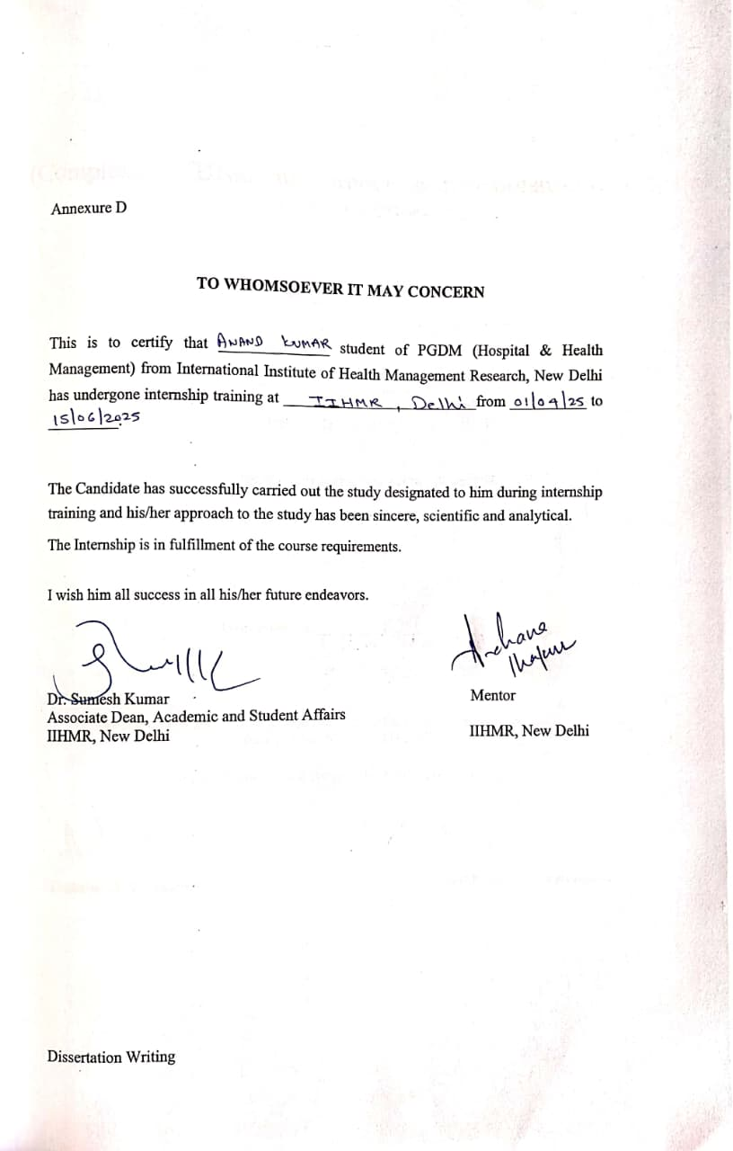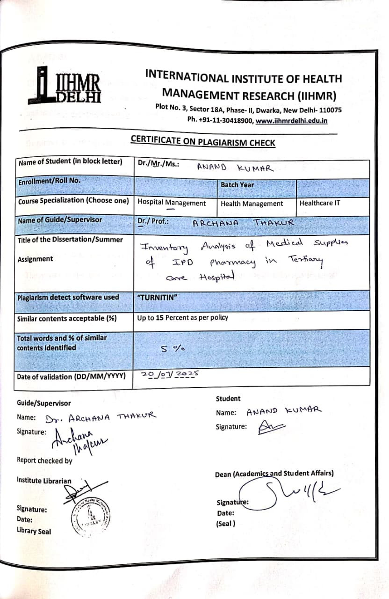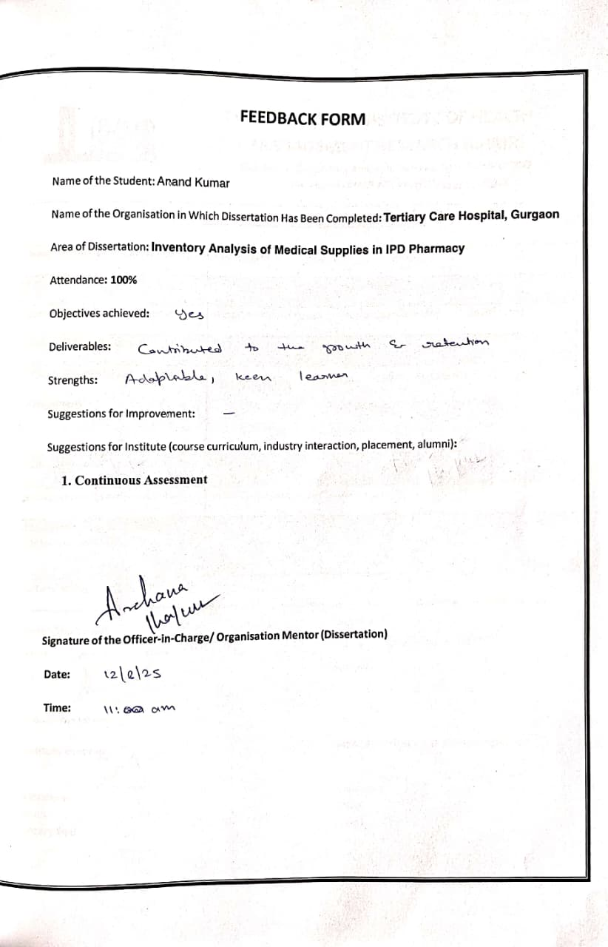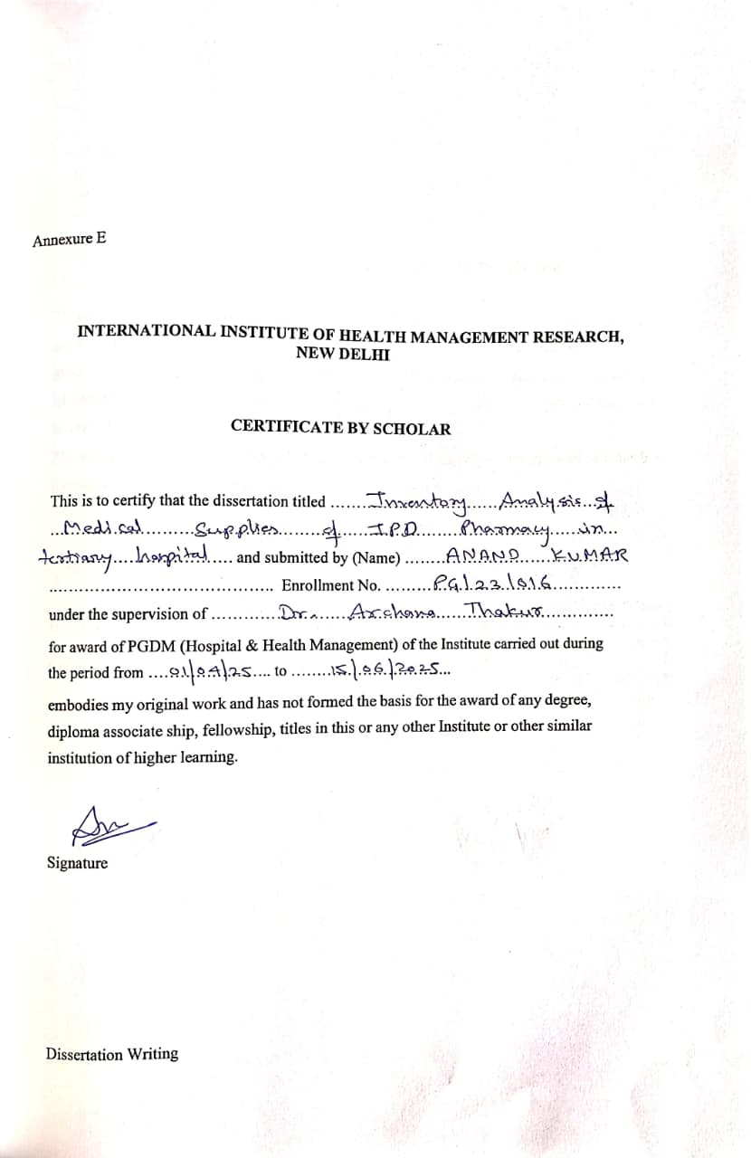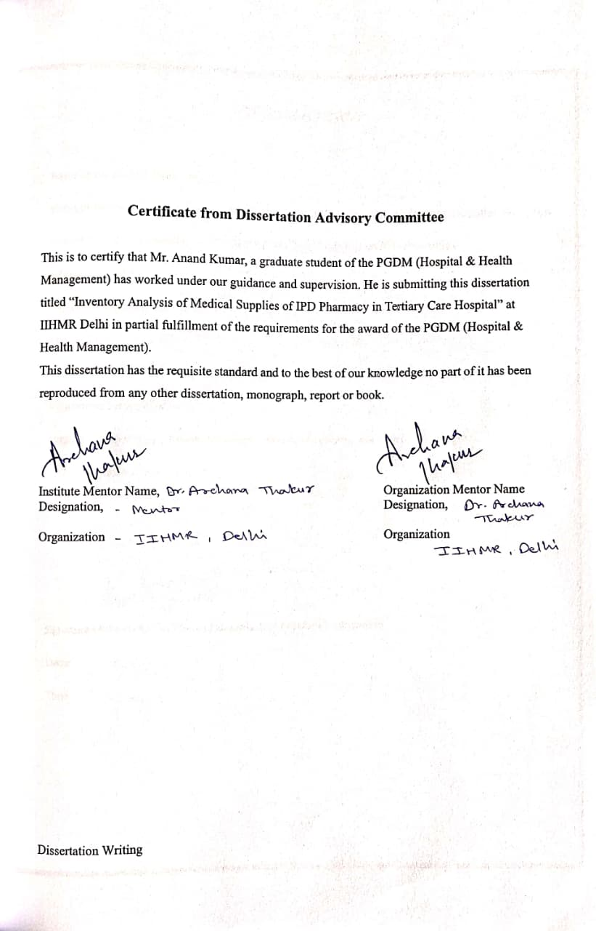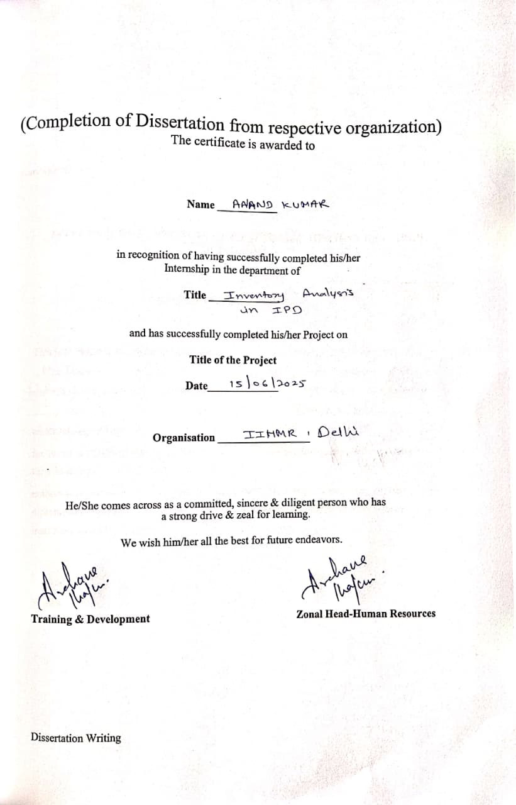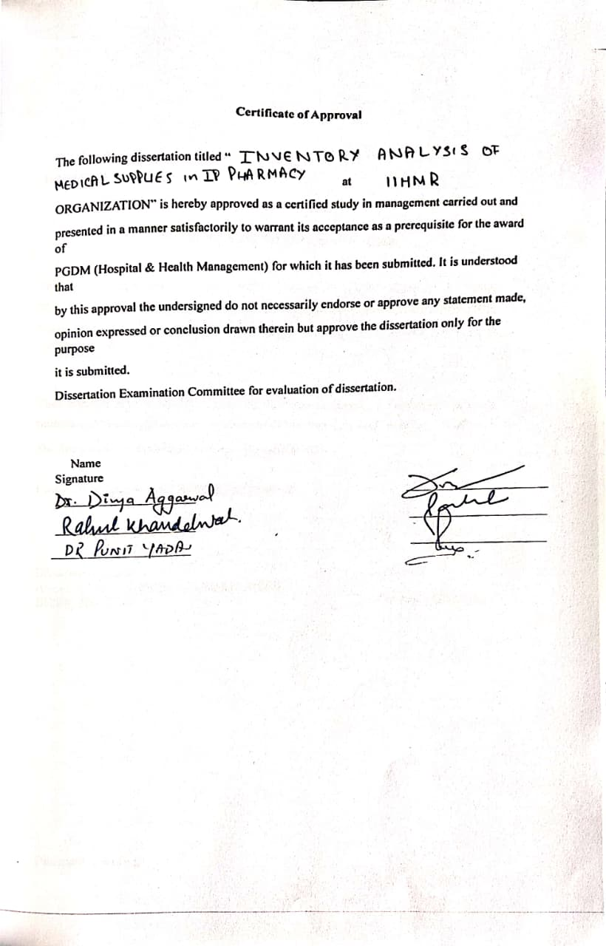
Abstract
Efficient inventory management in hospital pharmacies is crucial for keeping essential medicines available, reducing waste, and managing costs. This pilot study aimed to assess and improve inventory control of medicines in the inpatient pharmacy of a private tertiary care hospital. The main goal was to classify medicines by their cost significance and usage frequency to better guide procurement and stock management decisions.
The study used a quantitative, descriptive design relying on secondary data from the Hospital Management Information System (HMIS) for the months of March to May 2025. ABC analysis was performed to categorize medicines by annual consumption value, while FSN analysis grouped items by how frequently they moved. A combined ABC-FSN matrix was developed to identify critical drugs that need close monitoring. Medicines were sorted into A, B, and C classes based on cost, and into fast-, slow-, and non-moving groups according to daily usage rates, using clearly defined thresholds.
The results of this study should help pharmacy managers prioritize high-value and frequently used medicines, optimize inventory levels, and increase overall efficiency. The insights from the combined classification model can help reduce stockouts and overstocking, ensure better resource allocation, and support uninterrupted healthcare delivery in inpatient settings.
Table of Contents

S.no. | Header | Page no.
1. | Introduction | 6-8
2. | Review of Literature | 8-11
3. | Methodology | 11-14
4. | Results | 15-17
5. | Interpretations | 18-19
6. | Conclusion | 20
7. | Limitations | 20
8. | Recommendations | 21
9. | References | 36

Abbreviations:
ABC – Always Better Control
FSN – Fast-moving, Slow-moving, Non-moving
VED – Vital, Essential, Desirable
HML – High-cost, Medium-cost, Low-cost
ABC-VED – ABC and VED Combined Analysis
ABC-FSN – ABC and FSN Combined Analysis
ABC-VED-FSN – ABC, VED, and FSN Combined Analysis
SCM – Supply Chain Management
IPD – Inpatient Department
OPD – Outpatient Department
ICU – Intensive Care Unit
NICU – Neonatal Intensive Care Unit
PICU – Paediatric Intensive Care Unit
CSSD – Central Sterile Supply Department
HMIS – Hospital Management Information System
IV – Intravenous
CV – Cumulative Value
AF – A Category, Fast-moving
BS – B Category, Slow-moving
CN – C Category, Non-moving

Inventory Analysis
Introduction
Inventory analysis is essential for the smooth operation of hospital pharmacies. It helps keep stock levels balanced, reduces waste, and manages costs. In a tertiary care hospital, having essential drugs available affects both patient outcomes and how efficiently the hospital runs. Poor inventory management can result in overstocking, expired drugs, or important items being out of stock. All these issues can risk patient safety and resource use.
To manage pharmaceutical inventory well, several classification methods are applied. These techniques assist in making smart choices about purchasing and stocking. Common types of inventory analysis in hospitals include:
• ABC Analysis – Based on annual consumption value
• FSN Analysis – Based on frequency of use
• VED Analysis – Based on importance to patient care: Vital, Essential, Desirable
• HML Analysis – Based on price per unit: High, Medium, Low
• ABC-VED Matrix – Identifies vital and high-cost items for close monitoring
• ABC-FSN Matrix – Points out fast-moving, high-cost items for tracking
• ABC-VED-FSN Matrix – An effective method for managing critical and cost-efficient inventory
These methods are often combined to prioritize drug management and ensure resources are allocated efficiently.
Rationale
Efficient inventory management is essential for hospital operations, particularly in the pharmacy department. Timely access to medicines directly affects patient care. In tertiary care hospitals, where services are more complex and extensive, keeping the right stock of medical supplies is even more important. Overstocking can tie up capital and lead to waste from expired items. On the other hand, understocking can delay treatment and threaten patient safety.

Despite its importance, inventory management in hospital pharmacies often lacks proper evaluation tools and relies on manual tracking or old systems. This shortfall can cause problems, such as accumulating unused drugs or misplacing expensive items. As healthcare institutions face increasing pressure to provide quality services at lower costs, there is a rising need for data-driven methods to improve inventory.

These findings should help pharmacy and procurement teams with better planning, budgeting, and decision-making, ultimately enhancing healthcare delivery.
Overview of Supply Chain Management (SCM) in Hospitals
Supply Chain Management (SCM) in a hospital setting means managing medical supplies, pharmaceuticals, equipment, and related information from the source to the point of patient care. It ensures that the right product reaches the right location at the right time, in the right condition, and at the right cost. Effective SCM is vital for providing continuous healthcare services and ensuring patient safety.
Hospital supply chains are different from those in other industries. They deal with a wide range of critical and often perishable items, such as life-saving drugs, sterile instruments, and diagnostic supplies. This complexity needs a well-organized approach that balances cost-effectiveness with clinical urgency.
SCM in hospitals includes various tasks like purchasing medical items, managing vendors, controlling inventory, handling warehouse operations, distributing internally to departments like IPD, OT, and ICU, and following healthcare regulations.
Benefits of Effective SCM in Hospitals
- Continuous Availability of Critical Supplies- Ensures that essential drugs and materials are always on hand to support clinical care.
- Reduced Waste and Expiry- Helps avoid overstocking and minimizes financial loss due to expired items.
- Improved Cost Efficiency- Allows bulk purchasing, better vendor negotiation, and optimal resource utilization.
- Better Compliance and Documentation- Supports adherence to legal and regulatory standards, including NABH, audits, and pharmacy regulations.
- Enhanced Patient Safety and Care Quality- Reliable supply chains ensure that treatment is never delayed due to stock shortages.
- Disaster Preparedness- Maintains emergency stocks and rapid response capability during outbreaks or crises.

Objectives:
To conduct a pilot inventory analysis of medicines in the IPD pharmacy of a tertiary care private hospital over the months of March, April, and May. This includes:
- Performing ABC analysis to classify drugs based on their consumption value.
- Performing FSN analysis to categorize medicines based on their usage frequency.
- Developing a combined ABC-FSN matrix to identify and prioritize critical inventory.

Literature Review:
- Sood and Sood (2023)
This study was conducted in a tertiary care hospital to evaluate how well inventory control works using ABC and FSN analysis. In the ABC analysis, the researchers classified drugs based on their yearly consumption value. They found that 9.23% of items fell into Category A, accounting for 70.08% of the total drug cost. Category B contained 15.38% of drugs, contributing 20.14%, while Category C included 75.38% of items but only made up 9.78% of the total spending. The FSN analysis showed that 30.77% of items were fast-moving, 26.15% were slow-moving, and 43.07% were non-moving. These findings pointed to a strong need to manage slow-moving and non-moving items better and to implement stricter controls on drugs in the A and F categories. The combined matrix approach helped identify high-priority items, such as AF and BF categories, suggesting they should always be available, while CN items might be considered for phase-out.
- Gupta et al. (2014)
Conducted in a secondary-level hospital under Ballabgarh HDSS, this study looked at practical challenges in drug inventory systems. Although it did not explicitly use ABC or FSN matrices, it followed a consumption-based observational approach. The study uncovered significant problems such as overstocking of low-utility items, frequent stockouts of essential drugs, and poor use of real-time data for decision-making. About 32% of items were either underutilized or expired because of insufficient planning. The authors stressed the need to implement selective inventory control systems, conduct regular stock audits, and establish strong supply chain practices, even in hospitals with limited resources.
- Devnani, Gupta, and Nigah (2010)
This research introduced the ABC-VED matrix at a tertiary care referral institute to link financial importance with clinical urgency. The ABC analysis revealed that 13.3% of items in the A category accounted for 69.97% of the total value. The VED classification showed that 10.6% were vital, 43.3% were essential, and 46.1% were desirable. The combined matrix classified 17.4% of drugs as AV (A + Vital), which needed the highest level of control and monitoring. This method helped the institution plan procurement with better priorities. It concluded that the ABC-VED matrix offered a useful way to manage drug inventory while reducing both financial and clinical risks.
- Bhowmik et al. (2011)
This study took place in the pharmacy of a teaching hospital that provides specialized care. It used ABC analysis to look at how much was spent on drugs. Out of 250 drug items examined, 12% were in Category A, which made up 70.16% of the annual drug budget. Category B included 20% of items and accounted for 20.03% of the spending. Category C contained 68% of items but represented only 9.81% of the costs. The results showed that it was important to exercise careful control over Category A items because of their financial impact. The study suggested close monitoring, reliable forecasting, and regular stock reviews to improve inventory costs and minimize losses.
- Mekonnen et al. (2021)
This study conducted in an Ethiopian hospital presented a simple ABC, VED, and FSN matrix model to improve pharmaceutical inventory management. The ABC analysis showed that 14.1% of items (A) made up 72.2% of the value. The VED classification revealed that 11% were vital, 60% essential, and 29% desirable. The FSN analysis found that 35% were fast-moving, 40% slow-moving, and 25% non-moving. By combining these three methods, the researchers could identify high-cost, vital, and fast-moving drugs in the AVF category, which needed the most control. The study concluded that the combined matrix allowed for evidence-based prioritization, reduced stockouts by 26%, and cut down wastage by 18% within six months of implementation.
- Surve et al. (2019)
This study focused on injectables and IV fluids in a municipal care hospital using ABC and FSN tools. The analysis found that 15% of injectables accounted for over 70% of the total cost, placing them in Category A. About 40% of drugs were slow or not moving, yet they took up more than 50% of storage space, increasing the risk of expiry. The study pointed out that poor rotation practices and lack of regular audits caused most inventory issues. The authors recommended using FIFO/FEFO systems and regularly applying the ABC-FSN matrix to improve usage tracking and timely purchasing.
- Rahmawati et al. (2023)
This case study examined the Kanban system, a simple inventory management tool, in hospital pharmacy logistics. Unlike ABC or FSN methods, Kanban uses visual signals to trigger restocking based on real-time use. The study found a 25% reduction in overstocking and a 30% drop in losses due to expired items after implementation. It also noted better staff workflow and coordination between departments. The research concluded that Kanban was very effective in dynamic environments and worked well for hospitals managing high-frequency stock movement.
- Yusuf and Mekonnen (2023)
In a global framework study, the authors suggested combining demand forecasting tools with ABC and FSN analysis to improve pharmaceutical supply chains. They used data modeling to demonstrate that merging historical usage trends with selective inventory control lowered procurement costs by 22% in pilot facilities. The study highlighted that matching drug classification with automated stock tracking systems improves decision-making and ensures steady drug availability, particularly in public healthcare settings.
- Kumar and Shukla (2022)
Though this study was conducted in the retail pharmaceutical sector, it used ABC and FSN techniques to look at inventory consumption trends. It found that nearly 18% of products accounted for 75% of the revenue (A-category). More than half of the stock items were slow or non-moving, which tied up capital and shelf space. The researchers recommended monthly FSN audits and cost-based purchase controls to prevent overstocking and improve cash flow. These findings were seen as useful for hospital settings facing similar inventory issues.
- Patel and Shah (2020)
This study, carried out in a hospital pharmacy, used both ABC and FSN analysis to classify drug items and understand usage patterns. It showed that 23% of drugs fell into the A-F category (high-cost, fast-moving), which needed constant monitoring and immediate availability. In contrast, the C-N category items (low-cost, non-moving) took up unnecessary space and increased the risk of expiration. The study suggested monthly consumption audits, removal of obsolete items, and strict reordering controls for A-category drugs.

Methodology:
Study Design: This study will be a pilot descriptive analysis of inventory data of IPD pharmacy.
Pilot Inventory Analysis:
A quantitative assessment of inventory data using ABC, FSN, and ABC-FSN analysis was conducted to identify critical items based on cost and movement patterns.
Data Collection-
Source: Hospital Management Information System (HMIS) – Medical Store.
Nature of Data: Secondary and confidential; no hospital identifiers disclosed; for academic use only.
Time Frame: Data will be collected from March to May 2025 via HMIS.
Study setting: Medical store of the Hospital and IPD pharmacy.
Inclusion Criteria: Tablets, Capsules and Injectables
Exclusion criteria: All the other items than medicine will be excluded like: - Surgical Items: forceps, scalpels, scissors), surgical sutures, and implants, Medical Consumables: syringes, IV sets, catheters, gloves, bandages, dressings and others.

ABC Analysis – Steps and Data Required
To perform the ABC analysis, we first collected basic data for each drug, including its name, unit cost, and the quantity used over the year. Using this, the total cost for each item was calculated.
Once the total costs were determined, all drugs were arranged in order from the highest to the lowest cost. We then calculated the cumulative cost and its percentage contribution to the overall drug expenditure.
Based on how much each item contributed to the total cost, we grouped them into three categories:
- Category A included a small number of high-value items that made up about 70% of the total cost.
- Category B consisted of moderately important items contributing around 20%.
- Category C included the majority of low-cost items, together making up the remaining 10%.

FSN Analysis – Methodology
Data Source:
Three months of IPD pharmacy data (March to May), analyzed using standard criteria provided by the data source.
Classification Based on Daily Usage Frequency:
Fast-Moving (F): Usage > 40 items per day
Slow-Moving (S): Usage between 25–40 items per day
Non-Moving (N): Usage < 25 items per day or no usage
- 1 unit Item include = 1 Strip of tablets/capsules or 1 Vial/ Ampoule

Findings:
- ABC Analysis (Cost-Based Classification)
- The study will categorize all drugs into A, B, and C categories based on their annual consumption value.
- A-category drugs will be identified as the top contributors to total expenditure (typically 10–20% of items consuming ~70% of the drug budget). These are often high-cost and critical medicines like specialized antibiotics, anticancer drugs, or emergency injectables. These drugs are important because any stockout directly affects treatment quality and incurs high financial impact.
- B-category drugs will fall in the middle range — moderate in both value and volume. They require balanced control.
- C-category drugs will include a large number of low-cost items that contribute minimally to total expenditure. Though these drugs are less costly, overstocking them in large volumes can clutter inventory and increase wastage.
- FSN Analysis (Movement-Based Classification)
- FSN analysis will sort items based on how frequently they are issued or consumed.
- F-category (Fast-moving) drugs will include items that are used daily and in high demand — such as painkillers, IV fluids, and basic antibiotics. These are important because they need continuous availability; even a short-term stockout could disrupt patient care across multiple departments.
- S-category (Slow-moving) drugs will be those used occasionally — such as specialized medications needed for limited conditions.
- N-category (Non-moving) drugs will be items that have not been used or issued in the past few months.

- ABC–FSN Matrix (Combined Cost + Movement Analysis)
- The combination of ABC and FSN will generate 9 categories (e.g., AF, BS, CN), each representing a unique inventory behaviour.
- AF (A-category + Fast-moving) drugs will be identified as the most critical — high in both value and demand. These require strict monitoring, buffer stock, and frequent review to prevent any stockout or financial loss.
- CN (C-category + Non-moving) items are low-cost and unused. These items could be phased out, substituted, or purchased only when needed to reduce storage burden.
- Other combinations like BF (moderate cost, fast use) or AS (high cost, low use) will help fine-tune decisions on safety stock, ordering frequency, and shelf allocation.
- This matrix will serve as a decision-making tool to set different stock policies for different item groups, optimizing both cost and availability.

Study Results:
ABC Analysis – Results
The ABC analysis was performed on a total of 408 drug items issued from the IPD pharmacy during the period of March to May 2025.
- A total of 93 drugs were found in Category A, representing 23% of the total items. These contributed to a consumption value of ₹ 21,33,963 and accounted for 70.55% of the total pharmacy expenditure.
- 105 drugs were categorized under Category B, making up 26% of the total inventory. These items contributed ₹ 6,12,079, which is 19.37% of the total drug consumption value.
- The remaining 210 drugs were placed in Category C, accounting for 51% of the total drug items. These items contributed ₹ 3,08,621, representing 10.08% of the total expenditure.
The total cost of all 408 items across A, B, and C categories amounted to ₹ 30,54,663.

Drug Analysis | A | B | C | Total
Total consumption % | 70.55% | 19.37% | 10.08% | 100%
Value of Consumption | ₹ 21,33,963 | ₹ 6,12,079 | ₹ 3,08,621 | ₹ 30,54,663
No. of Items | 93 | 105 | 210 | 408
% of Items | 23% | 26% | 51% | 100%
Table 1 – ABC Analysis of Items
Figure 1 | Figure 2
FSN Analysis – Results
- The FSN analysis categorized all 408 drugs in the IPD pharmacy based on their movement frequency during the study period.
- A total of 163 drugs were classified as Fast-moving (F), accounting for 39.95% of the total drug items.
- 143 drugs were found to be Slow-moving (S), which made up 35.05% of the total inventory.
- The remaining 102 drugs were categorized as Non-moving (N), representing 25.00% of all items analyzed.
- The total drug expenditure across all FSN categories amounted to ₹ 30,54,663, distributed as follows:
Fast-moving drugs contributed ₹ 22,12,443 (72% of the total expenditure),
Slow-moving drugs accounted for ₹ 6,76,073 (22%),
And Non-moving drugs made up ₹ 1,66,147 (5%).
Category | No. of drugs | % of drugs | Drug Expenditure | % age of DE
F | 163 | 39.95% | ₹ 22,12,443 | 72%
S | 143 | 35.05% | ₹ 6,76,073 | 22%
N | 102 | 25.00% | ₹ 1,66,147 | 5%
Total | 408 | 100% | ₹ 30,54,663 | 100%

ABC–FSN Matrix – Results
Based on the combined ABC and FSN analysis of 408 drug items, the inventory was classified into nine distinct categories. The findings showed that:
- A total of 70 drugs were found in the A–F (Always–Fast-moving) category, representing 17.15% of the total items.
- 23 drugs were classified as A–S (Always–Slow-moving), which accounted for 5.64% of the total.
- Importantly, no drugs were found in the A–N (Always–Non-moving) category.
- In the B-series, 55 drugs were found in the B–F (Better–Fast-moving) category, making up 13.48% of the total.
- 36 drugs fell under B–S (Better–Slow-moving), which is 8.82% of the inventory.
- 14 drugs were found in B–N (Better–Non-moving), accounting for 3.43%.
- Among the C-category items, 38 drugs were classified as C–F (Control–Fast-moving), comprising 9.31% of the total.
- 84 drugs were grouped under C–S (Control–Slow-moving), which equals 20.59%.
- The highest number of drugs, 88 items, were found in the C–N (Control–Non-moving) category, representing 21.57% of the inventory.
In total, all 408 items were successfully categorized into the ABC–FSN matrix, offering a comprehensive overview of the hospital’s inventory distribution.
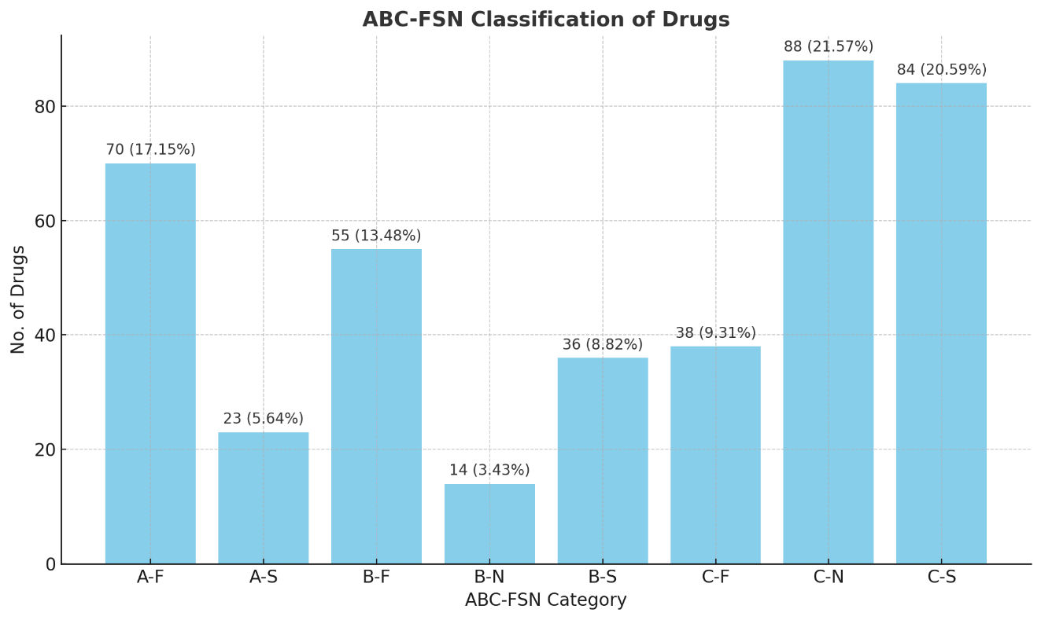
Interpretation:
The inventory analysis using ABC, FSN, and ABC–FSN matrix methods revealed several important patterns and insights regarding drug consumption and cost distribution in the IPD pharmacy.
ABC Analysis Interpretation
The ABC analysis showed that out of 408 drug items:
- Category A drugs, with 93 items or 23%, made up 70.55% of the total drug spending. This shows that a small number of items are responsible for most of the pharmacy budget, illustrating the Pareto principle, or the 80/20 rule. These items are important financially and should be monitored closely and managed carefully.
- Category B drugs, totalling 105 items or 26%, accounted for 19.37% of the spending. These items are of moderate cost and need standard stock control.
- Category C drugs included 210 items or 51%. They made up more than half of the inventory by count but only represented 10.08% of the spending. These low-cost items are plentiful but not as financially important, although they can affect storage space and expiry if not managed well.
FSN Analysis Interpretation
The FSN analysis, based on drug movement over the study period, revealed:
- Fast-moving drugs (163 items; 39.95%) made up the largest share of spending at 72%. This shows these medicines are crucial and used often, so they need to always be available with some extra stock.
- Slow-moving drugs (143 items; 35.05%) accounted for 22% of total costs. This indicates that many items in the inventory are used less often, but they still have a significant financial impact. These drugs may be specific to certain conditions and require a review based on demand.
- Non-moving drugs (102 items; 25.00%) contributed only 5% to spending. Even though they are inexpensive, not using them risks expiration and crowding on shelves. This highlights the need for review, redistribution, or rationalization.

ABC–FSN Matrix Interpretation
The combined matrix provided a detailed view of both cost and usage, showing:
- A–F (70 items; 17.15%) is the most critical category, consisting of high-cost and high-usage drugs. These require close control, ongoing monitoring, and priority stocking due to their dual impact.
- C–N (88 items; 21.57%) and C–S (84 items; 20.59%) together make up 42.16% of the inventory by count but add very little to the cost. These items may be overstocked and not used enough, leading to inefficiency in storage and rotation.
- No drugs were found in A–N (high-cost, non-moving). This is a positive sign of effective demand forecasting and responsible buying practices. It shows that all high-cost drugs are being used and none are sitting idle.
- B–N (14 items; 3.43%) and A–S (23 items; 5.64%) are also worth monitoring, as they include moderate-to-high-cost items with low movement. This suggests the need for justifying usage or controlling orders.

Overall Interpretation
The study shows that organized inventory classification helps identify important items, underused stock, and buying inefficiencies. High-cost, fast-moving drugs need constant monitoring. Non-moving items, even if they are low-cost, need to be reviewed. The lack of high-cost non-moving drugs indicates that the current system is working well. However, slow- and non-moving items in the B and C categories suggest there is still room for improvement.

Conclusion
The findings of this study show that using inventory control techniques like ABC, FSN, and the ABC-FSN matrix can greatly improve pharmacy operations and the overall healthcare system. By identifying high-cost, high-use drugs and marking non-moving, redundant stock, hospitals can gain better control over their inventory.
When inventory management principles are applied correctly, key costs like holding costs, ordering costs, and total inventory costs can be greatly reduced. This improves financial liquidity, allowing healthcare institutions to reinvest in infrastructure, technology, and patient services, which enhances their capacity for growth and quality care.
In addition, effective supply chain management (SCM) not only monitors costs but also protects capital. It prevents budget losses by controlling high-expenditure areas while ensuring the availability of life-saving drugs. SCM acts as both a gatekeeper and a whistleblower, ensuring transparency, efficiency, and accountability across departments.
Ultimately, optimizing inventory is not just about cutting costs; it is essential for improving operational efficiency and clinical excellence. Cost control should be seen as a key role of hospital supply chain management, with a direct impact on patient outcomes and organizational sustainability.
Limitations
The study provided meaningful insights; however, it was limited by the following factors:
- Minimal study duration:
The evaluation covered a period of three months, March to May 2025. This timeframe was insufficient to capture seasonal trends or changes in usage over a longer period.
- Concentration restricted to IPD pharmacy:
Data from stockrooms in OPD, Emergency, OT, or ICU were excluded from the study, which is concerning as these areas are within a tertiary hospital's ecosystem and would have considerable drug turnover.
- Lack of integration with clinical outcomes:
This study has only tracked the movement of stock as well as the costs incurred. Treatment results, patient outcomes, or any other advanced analyses related to inventory patterns were not conducted.

Recommendations:
- Prioritize Control on A–F Category Drugs
These items are both high-cost and high-consumption. They should be continuously monitored with automated alerts for reorder levels, minimal buffer stock, and tight procurement cycles to avoid both stockouts and overstocking.
- Phase Out or Restrict C–N and C–S Items
A large portion of items fell under low-cost but slow- or non-moving categories. These should be rationalized by:
- Removing them from routine stock
- Converting to on-demand or conditional ordering
- Reviewing clinical relevance in consultation with departments

References:
- Sood A, Sood AA. ABC, FSN Analysis of Drug Store of a Tertiary Care Hospital. Eur J Pharm Med Res. 2023;10(5):536–40.
Available from: https://www.researchgate.net/publication/371990198
- Gupta SK, Kant S, Srivastava R, Kumar V, Nongkynrih B. Inventory Management of Drugs at a Secondary Level Hospital Associated with Ballabgarh HDSS – An Experience from North India. J Health Popul Nutr. 2014;32(1):81–5.
Available from: https://www.researchgate.net/publication/272388639
- Devnani M, Gupta AK, Nigah R. ABC and VED analysis of the pharmacy store of a tertiary care teaching, research and referral healthcare institute of India. J Young Pharm. 2010;2(2):201–5.
Available from: https://www.ncbi.nlm.nih.gov/pmc/articles/PMC2884825/
- Bhowmik D, Dey A, Kumar KS. ABC Analysis of Hospital Pharmacy in a Tertiary Care Teaching Hospital. Res J Pharm Technol. 2011;4(5):703–6.
Available from: https://www.rjptonline.org/HTMLPaper.aspx?Journal=Research%20Journal%20of%20Pharmacy%20and%20Technology;PID=2011-4-5-16
- Mekonnen AB, Tadesse E, Basha GW, Wondimu A. How is Information from ABC–VED–FNS Matrix Analysis Used to Improve Operational Efficiency of Pharmaceuticals Inventory Management? Integr Pharm Res Pract. 2021;10:33–45.
Available from: https://www.tandfonline.com/doi/full/10.2147/IPRP.S310716
- Surve PK, Pise HN, Shinde AS. A Study to Review Drug Inventory and Pharmacy Management with Reference to I.V. & Injectables at a Tertiary Municipal Care Hospital. Pharma Innov J. 2019;8(12):342–50.
Available from: https://www.researchgate.net/publication/346672834
- Yuniar CR, Riana W, Maa’idah UN, Rakhmawati EA. Effectiveness of supply management using Kanban system in hospital pharmacy logistics: A case study. Airlangga J Innov Manag. 2023;4(2):125–35.
Available from: https://doi.org/10.20473/ajim.v4i2.47010
- Yusuf AM, Mekonnen AB. Optimizing pharmaceutical inventory management: A global framework for efficiency and cost reduction. Res Pharm Health Sci. 2023;9(1):45–53.
Available from: https://www.researchgate.net/publication/384987682
- Kumar A, Shukla AC. Selective inventory control using ABC and FSN analysis in retail sector: A case study. Int J Res Appl Sci Eng Technol. 2022;10(5):4810–8.
Available from: https://doi.org/10.22214/ijraset.2022.43648
- Patel B, Shah P. ABC and FSN analysis of drugs for inventory control in hospital pharmacy. Int J Pharm Sci Res. 2020;11(4):1765–70.

