Dissertation Training

At

EYE Q VISION PVT.LTD.

“Streamlining Patient Flow and Service Efficiency for Enhanced Patient Satisfaction’’

By

DR. YAMINI VERMA
PG/23/128
Under the guidance of
Dr. Ekta Saroha
Associate Professor
PGDM (Hospital and Health Management
2023-2025


International Institute of Health Management Research
New Delhi

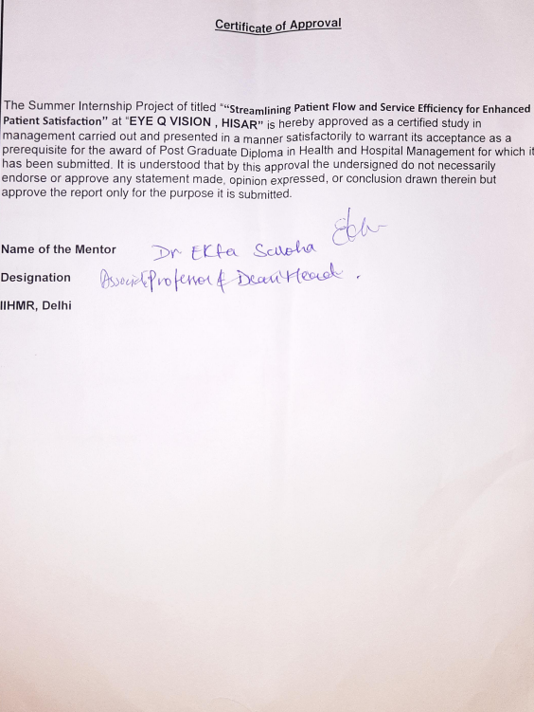

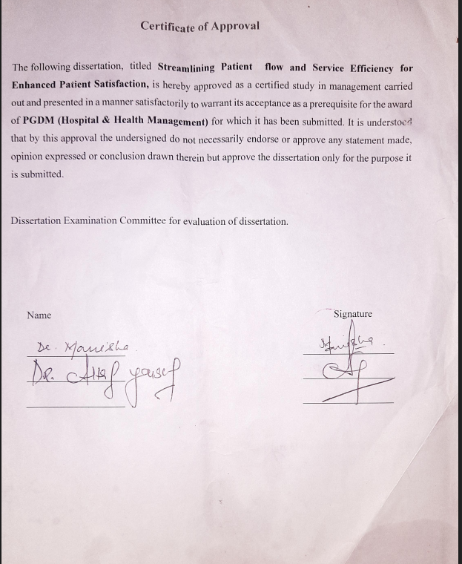

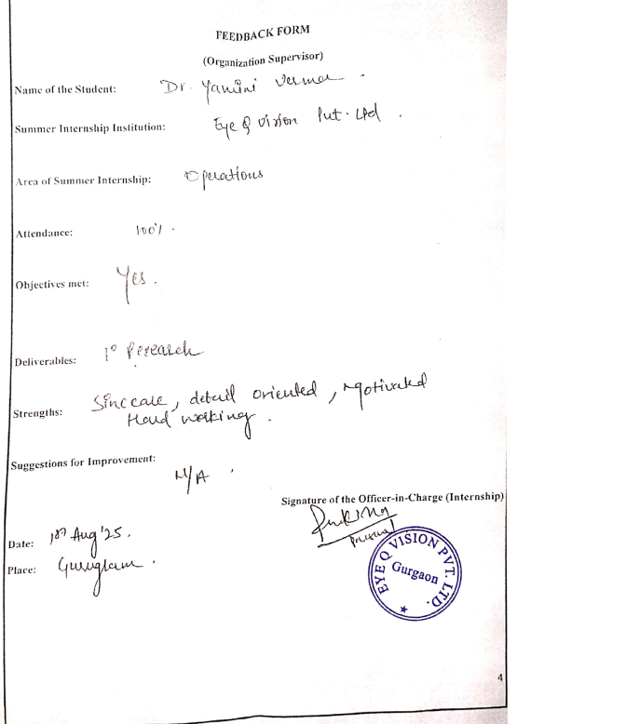
PVT.
PVT.
PVT.

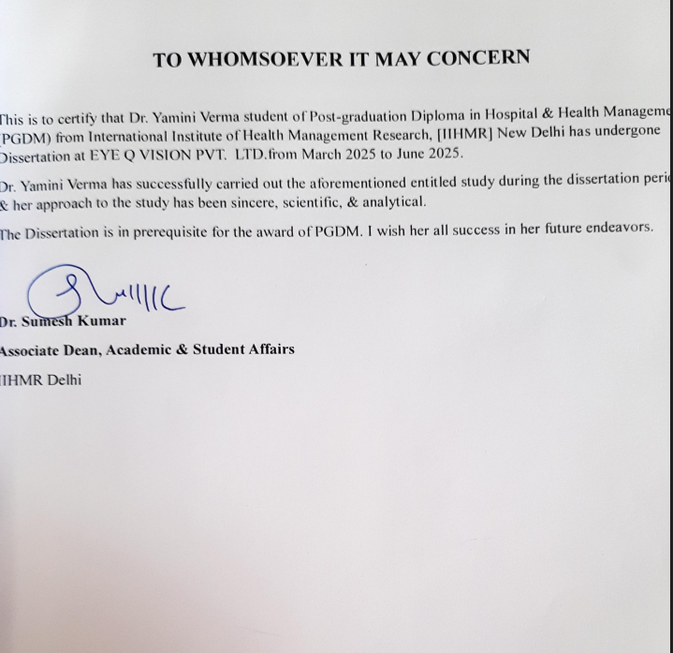
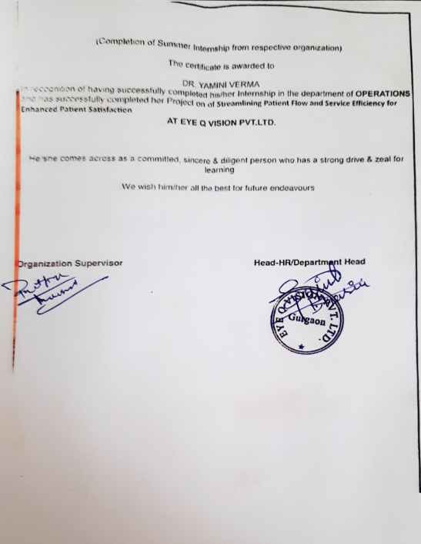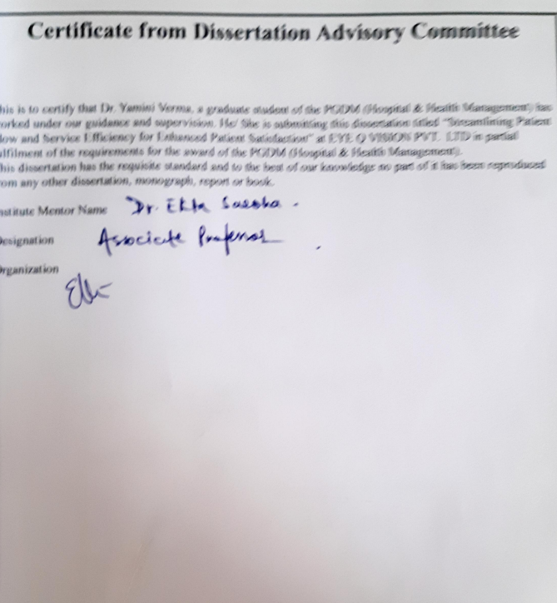

PVT.

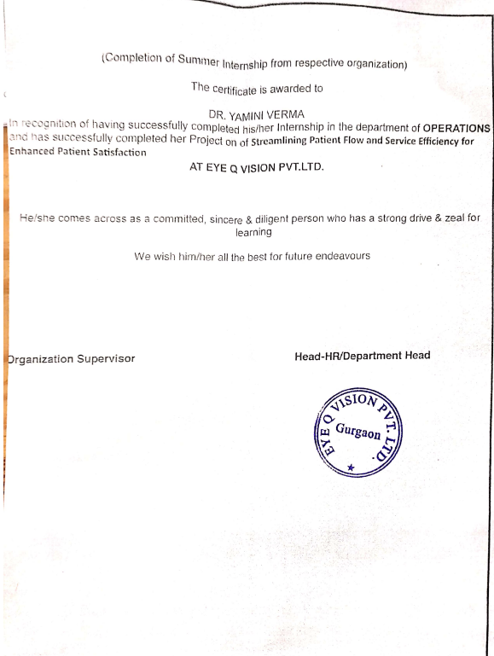

TO WHOMSOEVER IT MAY CONCERN

This is to certify that Dr. Yamini Verma student of Post-graduation Diploma in Hospital & Health Management (PGDM) from International Institute of Health Management Research, [IIHMR] New Delhi has undergone Dissertation at EYE Q VISION PVT. LTD.from March 2025 to June 2025.
Dr. Yamini Verma has successfully carried out the aforementioned entitled study during the dissertation period & her approach to the study has been sincere, scientific, & analytical.
The Dissertation is in prerequisite for the award of PGDM. I wish her all success in her future endeavors.

Dr. Sumesh Kumar
Associate Dean, Academic & Student Affairs
IIHMR Delhi

CERTIFICATE BY SCHOLAR

This is to certify that the dissertation titled “Streamlining Patient Flow and Service Efficiency for Enhanced Patient Satisfaction” and submitted by Dr. Yamini Verma Enrolment No PG/23/128 under the supervision of Dr. Ekta Associate Professor,IIHMR, NEW Delhi, India for award of PGDM (Hospital & Health Management) of the Institute carried out during the period from March 2025 to June 2025 embodies my original work and has not formed the basis for the award of any degree, diploma associate ship, fellowship, titles in this or any other Institute or other similar institution of higher learning.

Signature
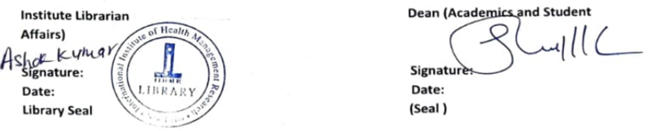
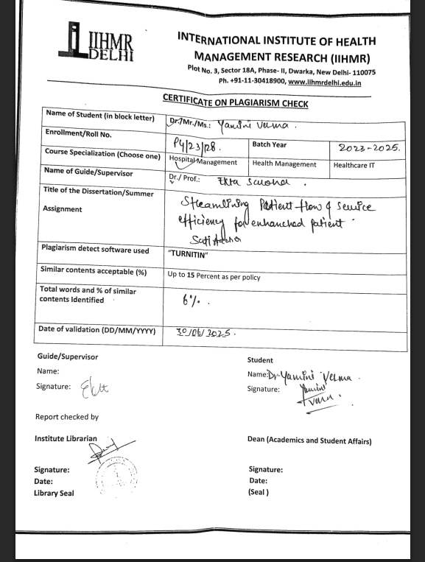

ACKNOWLEDGEMENT:

First and foremost, I would want to express my gratitude to Dr. EKTA SAROHA, my mentor, for her patience, support, excitement, and extensive knowledge throughout my summer internship study and research. Her guidance was very beneficial to me while I was doing my research and writing my report.
I am especially thankful to my mentor at Eye-Q, for their constant motivation, mentorship, and practical wisdom. Their approachability and willingness to share knowledge made my experience enriching and truly transformative.
I am incredibly thankful to my family and friends for their unwavering support, encouragement, and understanding especially during the challenging phases of this project. Their faith in me kept me motivated throughout.
Lastly, I would like to express my gratitude to everyone who contributed, directly or indirectly, to the successful completion of this dissertation. Each one of you holds a special place in this academic milestone.

Abstract

.
Outpatient (OPD) and Inpatient (IPD) departments at Eye-Q Hospital, with a focus on operational efficiency and service experience. A total of 300 patients were surveyed—200 OPD and 100 IPD—using a structured feedback form and assessed through the Net Promoter Score (NPS) system. The NPS scale classifies patients as Detractors (0–6), Passives (7–8), and Promoters (9–10), helping gauge their likelihood to recommend the hospital.
In the OPD, satisfaction was largely influenced by turnaround time (TAT) and staff interaction. Among the 200 OPD patients surveyed, 110 experienced a TAT of 45 minutes, 65 had a TAT of 60 minutes, and 45 had a TAT of 90 minutes. These durations accounted for the entire patient flow—from registration, procedure room testing, dilation, consultation, to optical/pharmacy services.
In the IPD, feedback varied due to differences in administrative processing and scheme-based approvals. Of the 100 IPD patients, 25 were Ayushman Bharat beneficiaries, 25 were under Haryana Government schemes, 25 were TPA-insured, 15 were cash-paying, and 10 were ECHS/DGHS patients. While the cataract surgery itself lasted 15–20 minutes, the overall experience time varied significantly depending on the approval and documentation processes involved in each patient category.
The results of the NPS were analyzed and compared to global standards to identify service strengths and gaps. The study aims to provide actionable insights for enhancing patient satisfaction and aligning Eye-Q's operations with international best practices.

Table of Contents

Acknowledgement…………………………………………………………………………..…………………7
List of Abbreviation………………………………………..………………………….…………………….…8
Overview……………………………………………………………………………………………………….9
Roles and responsibility…………………………………………………………………..…………………...10
Review of literature……………………………………………………………………………….………...…11 Abstract…………………………………………………….…………………………………………….……12
Synopsis………………….………………………..……………………………………………………...…...13 Introduction…………………………………………………………………………..……………………….14
OPD tat analysis……………………………………………………..………………….….…………………15
IPD tat analysis………………………………………………………………………………………………..17
Patient feedback and NPS analysis…………………………………………………………………………....20
Result based on NPS………..…………………………………………………………...………….…………21
Limitation………………………….…………..………………………………………………………………22
Recommendation.……………………………………………………………………………………………...22 Conclusion………………………………………………………………….………….………………..……..23
Refrences……………………………………………………………………….………………………..…….24 Annexure………………………………………………………………………….……….…………………..24

Acronyms/Abbreviations:

  Abbreviation | Full Form
  Abbreviation | Full Form
  OPD | Outpatient Department
  Outpatient Department
  IPD | Inpatient Department
  Inpatient Department
  TAT
  Turnaround Time
  AR
  Auto Refractometry
  NCT
  Non-Contact Tonometry
  OT
  Operation Theatre
  BP
  Blood Pressure
  TPA
  Third Party Administrator (Insurance)
  IOL
  Intraocular Lens
  EHR
  Electronic Health Record
  HIMS
  Hospital Information Management System
  AYBH
  Ayushman Bharat Pradhan Mantri Jan Arogya Yojana
  GOVT
  Government
  HRY GOVT
  Haryana Government Scheme
  IOP
  Intraocular Pressure
  QA
  Quality Assurance
  PFS
  Patient Flow System
  OTS
  Operation Theatre Scheduling
  Rx
  Prescription
i


OVERVIEW :

Founded with a mission to make world-class eye care accessible and affordable, Eye-Q Vision Private Limited stands as a beacon of excellence in ophthalmology. Established in 2007, Eye-Q has emerged as one of India's leading chains of super-speciality eye hospitals, committed to delivering high-quality, patient-centric services across urban and semi-urban regions.
Under the visionary leadership of Dr. Ajay Sharma, Founder and Chairman & Managing Director (CMD), and one of India’s most distinguished eye surgeons, Eye-Q has expanded its footprint to over 30 hospitals across Haryana, Uttar Pradesh, Uttarakhand, and Gujarat, along with 4 international branches in Nigeria, Africa. Each center is backed by a team of highly trained specialists from reputed institutions, bringing global standards of clinical care to every patient.
Eye-Q hospitals operate under the certification of ISO 9001:2015, reflecting their continuous commitment to quality assurance, clinical safety, and operational excellence.

🏥 Our Comprehensive Range of Services
At Eye-Q, we offer a wide spectrum of advanced diagnostic and therapeutic services tailored to meet individual patient needs, including:
- 👁️ Cataract Surgery
Advanced phacoemulsification and intraocular lens implant procedures.
- 👓 General Eye Care
Routine eye checkups, prescriptions, and preventive care.
- 🌫️ Glaucoma Treatment
Early detection and long-term management strategies.
- 🔍 Refractive Services
LASIK and other vision correction procedures.
- 🧠 Oculoplasty Services
Cosmetic and reconstructive eye surgeries.
- 🧒 Squint Surgery
Pediatric and adult strabismus correction.
- 🩺 Retina Treatment
Diagnosis and treatment of retinal diseases like diabetic retinopathy and macular degeneration.
- 🛍️ Optical Services
On-site spectacles and prescription lens services for patient convenience.

With a blend of clinical excellence, compassionate care, cutting-edge technology, and affordability, Eye-Q continues to redefine eye care delivery in India and beyond. This project aims to explore and analyze patient satisfaction across our services, helping us further enhance quality and patient experience.

MY ROLE AND RESPONSIBILITY

- End-to-End Patient Management
- Supervised the entire patient journey, from registration to discharge, ensuring a smooth and timely flow through every department.
- Assisted in monitoring turnaround times at each step and identifying process delays.
- 🔹 Registration and Admission Oversight
- Oversaw the registration process, ensuring accuracy in patient records and timely entry into the system.
- Coordinated with the IPD admission team, ensuring documentation and bed allocation were completed without delay.
- Discharge Coordination
- Managed the discharge process, ensuring the discharge summary was complete, clear, and handed over to the patient/caregiver on time.
- Coordinated with consultants and the billing department to ensure a timely discharge experience.
- 🔹 Medication and Prescription Monitoring
- Gained exposure to the medication protocols for various eye conditions (like cataract, glaucoma, etc.).
- Ensured proper communication between pharmacy, nursing staff, and patients regarding post-operative and discharge medication.
- 🔹 Data Analysis and Reporting
- Conducted real-time data analysis on patient satisfaction, TAT (Turnaround Time), and daily departmental operations.
- Assisted in preparing reports to support operational improvements and quality audits.
- 🔹 Stakeholder Engagement
- Regularly interacted with patients, caregivers, doctors, and support staff to understand service pain points and gather feedback.
- Used this feedback to help propose process enhancements to improve patient experience.

Review of Literature

1. Introduction
In today’s dynamic healthcare landscape, operational efficiency and patient satisfaction are key indicators of a hospital’s performance. Eye-Q Vision Private Limited, a leading chain of super-speciality eye hospitals, has consistently focused on providing affordable, high-quality eye care across India and abroad. With a strong presence in states like Haryana, Uttar Pradesh, Uttarakhand, and Gujarat — and international branches in Nigeria — Eye-Q is committed to patient-centric service delivery backed by technology and best practices.
During my tenure as a Management Trainee in the Operations Department, I was exposed to the real-time challenges and complexities of hospital management. My primary focus was on streamlining inpatient (IPD) and outpatient (OPD) operational processes, understanding end-to-end patient flow — from registration to discharge — and identifying areas of improvement in patient experience. Through direct interaction with patients, staff, and departmental leads, I gained critical insights into how healthcare delivery can be enhanced through process optimization.
This report presents a structured analysis of the operational framework at Eye-Q Hospital, with a focus on improving service delivery and patient satisfaction through evidence-based observation and data-supported recommendations.

2. Materials and Methods

2.1 Study Design
The study followed a descriptive and observational approach conducted over a three-month internship period. The aim was to analyze the existing operational workflow and patient satisfaction in the OPD and IPD wings of Eye-Q Hospital.

2.2 Location
The project was carried out at Eye-Q Hospital, where real-time patient interaction, process observation, and internal coordination were performed across registration, consultation, diagnostic testing, pharmacy, and discharge areas.

2.3 Tools & Techniques
.
- Patient Feedback Forms: Structured questionnaires were used to assess patient satisfaction post consultation and discharge.
- COUNSELLER

2.4 Sample Size

- OPD Patients: 200
- IPD Patients (Cataract cases focus): 100
Patients were selected based on their consent and completion of their consultation or surgical journey.

2.5 Study Duration
The study was conducted over 3 months as part of a structured internship training program in hospital operations.

III. OUTCOMES:

The study aims to assess patient satisfaction in both OPD and IPD at Eye-Q Hospital. In OPD, patients filled feedback forms based on their turnaround time (TAT) and interactions with staff. In IPD, satisfaction was influenced by staff behavior, surgery experience, and documentation time, which varied across Ayushman Bharat, TPA, Cash, Haryana Government, and ECHS/DGHS patients. Though cataract surgery itself takes only 15–20 minutes, administrative procedures affected overall experience. All patients rated their visit using the Net Promoter Score (NPS) scale (1 to 10), and these scores were compared to global standards to identify service gaps and improvement areas.

SYNOPSIS
Project Details

1) Duration of Project: a) Date of Internship Start (17/03/2025)
b) The day on which the internship ends (17/06/2025)

2) Topic: Streamlining Patient Flow and Service Efficiency for Enhanced Patient Satisfaction.

3) Goal of the Project
The following are the project's goals:
1. Measure patient satisfaction levels at EyeQ Hospital for both OP and IP services.
2. Compare the measured satisfaction levels with established global benchmarks to identify performance gaps.

4) The approach that will be used
- Study Design : Descriptive,cross seactional
- Data collection: feedback forms
- Study setting: Eye q vison , Hisar
- Population of study: OPD and IPD
Inclusion criteria :all those who have gone through consultation and admission discharge process
- Exclusion criteria : those who have taken ancillary services

Sample Size
Total sample size: 300 patients

OPD: 200 patients

IPD: 100 patients

Study Duration: 3 months

INTRODUCTION

Streamlining Patient Flow and Service Efficiency for Enhanced Patient Satisfaction

Comprehensive Report on OPD Patient Satisfaction and Turnaround Time Analysis
Overview
The objective of this segment of the study was to evaluate patient satisfaction levels in the Outpatient Department (OPD) of Eye-Q Hospital by analyzing their turnaround time (TAT) and overall service experience. The study emphasizes understanding patient perception using structured tools and mapping their journey through various stages of care. The data collected helps align operational processes with patient expectations and global service benchmarks.

Patient Sampling and Data Collection
A total of 200 OPD patients were selected through random sampling, covering different days of the week and various OPD time slots to capture a diverse representation of the patient load and service pattern. Data was collected in real time through EyeTech, the hospital’s patient flow software, which accurately logs time stamps for each stage of the patient journey.

Standard OPD Patient Flow at Eye-Q
The patient journey at Eye-Q Hospital OPD typically follows the sequence below:
[Reception / Registration]
↓
[Waiting Area – General]
↓
[Procedure Room – AR/NCT/Vision Testing]
↓
[Waiting Area – Consultation]
↓
[Doctor Consultation]
↓
[Pharmacy / Optical Services]
↓
[Exit / System Close]
Each of these steps contributes to the total turnaround time, and delays in any stage can significantly impact patient satisfaction.

Turnaround Time (TAT) Analysis
The TAT was calculated from the time of registration at reception to the final system log-out after completion of all services. The patient-wise distribution was as follows:
TAT Duration | NO. Of PATIENT
45 MINUTES | 110
1 HOUR | 65
1 HOUR 30 MINUTES | 25

NO. OF
PATIENT
The variation in TAT was largely influenced by:
- Patient load and waiting time in the procedure room
- Delays in dilation, where applicable
- Queue length at the consultation chambers
- Time taken at optical/pharmacy counters
These insights help the operations team identify areas where workflow can be optimized for better efficiency.

Feedback Collection & NPS Assessment
To assess satisfaction, each patient was given a structured feedback form at the end of their OPD visit. Patients rated their overall experience on a scale of 1 to 10, based on factors such as:
- Ease of registration
- Waiting time
- Staff courtesy and behavior
- Clarity of communication
- Doctor interaction
- Pharmacy/optical support
Using the Net Promoter Score (NPS) model, patient responses were categorized as:
NPS Category | Score Range | Interpretation
Retractors | 0–6 | Unhappy patients, unlikely to recommend
Passives | 7–8 | Satisfied but unenthusiastic patients
Promoters | 9–10 | Loyal, highly satisfied patients who promote the service
NPS was calculated using the standard formula:
NPS = % Promoters – % Retractors
The aggregated score helps gauge the likelihood of patient referrals and the emotional resonance of their care experience.

Insights & Observations
- Shorter TATs (≤ 45 minutes) corresponded with higher satisfaction and more promoter scores.
- Patients who waited over 1 hour 15 minutes typically shifted into passive or detractor zones, particularly if there was no communication regarding delay.
- The behavior of front office staff and optometrists was a strong influencing factor in satisfaction.
- Systematic flow disruptions, like consultation overlap or pharmacy delay, had a direct impact on feedback ratings.

Conclusion
This OPD study provides critical operational insight. Real-time TAT tracking using EyeTech, combined with structured feedback and NPS analysis, enables Eye-Q Hospital to quantitatively evaluate service quality and identify process improvement opportunities. Implementing targeted interventions at high-impact points like procedure rooms and discharge counters can significantly enhance patient experience and operational efficiency.

Discharge Time Analysis for IPD Patients

In this study, we analyzed the inpatient discharge turnaround time (TAT) across different panels for a sample of 100 IPD patients. The objective was to evaluate how the panel type affects the discharge time, especially considering administrative procedures like approval requirements. The panels included government schemes, insurance-related categories, and direct payment (cash) cases.

Patient Distribution by Panel
The patient sample was distributed across six key panel categories as follows:
Panel Type | No. of Patients | Discharge Time (Hours)
Ayushman Bharat | 25 | 2
Haryana Government | 25 | 1
Insurance | 20 | 2
ECHS (Ex-Servicemen) | 20 | 2
CASH (Direct Pay) | 10 | 1
Note: Discharge time is calculated from the moment discharge orders are issued by the treating consultant until the actual discharge of the patient from the hospital system.

The discharge process for IPD cataract patients varies based on the panel under which the patient is admitted. The differences arise due to administrative protocols, approval requirements, and communication workflows with external authorities. Below is a panel-wise elaboration of the discharge process, time involvement, and observations:

1. Ayushman Bharat Patients
- Discharge Time: ~2 hours
- Key Steps in Discharge Process:
  - After surgery, the case is uploaded to the Ayushman Bharat portal.
  - Details such as type of surgery, IOL (Intraocular Lens) power, and the lens box (with barcode) are scanned and submitted for verification.
  - This step typically takes 15–20 minutes, depending on internet speed and system availability.
  - Once submitted, the discharge summary is prepared, which includes surgery details, post-operative findings, and medication—this takes another 20 minutes.
  - Post-operative instructions are then explained to the patient. This includes:
    - Medications and dosage
    - Patch removal timing
    - Activity restrictions and eye care precautions
    - Next follow-up: Usually scheduled the next day, then after 7 days, and again at 21 days post-surgery
  - This instruction process takes 15–20 minutes.
Observation: The Ayushman discharge is slightly longer due to the mandatory documentation and real-time portal approvals. Despite streamlined coordination, system delays or file mismatches can increase turnaround time.

2. TPA & ECHS Patients
- Discharge Time: ~2 hours
- Key Steps in Discharge Process:
  - Once the surgery is completed, the discharge summary is drafted.
  - The lens box (with IOL power and type) is scanned.
  - All relevant documents are scanned and sent to respective coordinators:
    - Mr. Tapan (TPA Department)
    - Mr. Sujal (ECHS Department)
  - This approval and forwarding process consumes approximately 30 minutes.
  - Post-approval, the patient receives:
    - Post-operative instructions
    - Medication advice
    - Patch removal details
    - Follow-up schedule similar to Ayushman (next day, after 7 days, and after 21 days)
  - Instruction and counselling takes another 15–20 minutes.
Observation: Though these schemes also require approval, in-house coordination through dedicated personnel helps maintain efficiency. The scanning and dispatch of documents is the main bottleneck.

3. Haryana Government Patients
- Discharge Time: ~1 hour
- Key Steps in Discharge Process:
  - After surgery, a discharge summary is prepared and added to the patient file.
  - There is no external digital portal involved, so this step is faster.
  - The post-operative instruction session includes:
    - Proper use of medications
    - Precautions such as avoiding water entry, lifting heavy weights, etc.
    - Patch removal guidance
    - Follow-up schedule: next day, 7th day, and 21st day
  - The combined time for documentation and counselling is approximately 45 minutes.
Observation: Due to internal control and minimal third-party dependency, this discharge process is smoother and quicker.

4. CASH Patients
- Discharge Time: ~1 hour
- Key Steps in Discharge Process:
  - As there is no third-party approval, the discharge summary is made immediately after surgery.
  - Post-op instructions are similar to other panels and include:
    - Eye care precautions
    - Medication explanation
    - Patch handling and removal timing
    - Next-day follow-up details
  - Total time for summary preparation and instruction: approximately 45 minutes
Observation: These are the fastest discharges, mainly due to the absence of billing approvals and external documentation.

Standard Follow-up Schedule for Cataract Patients
All patients, regardless of panel, are scheduled for:
- Next-day check-up
- 1-week post-op visit
- 21-day post-op review
This consistent follow-up ensures proper healing, lens adjustment monitoring, and early detection of any
complications.
AYBH
ECHS
HRG GOVT.
Insurance
Cash
Patient Feedback Collection and NPS Analysis
To measure patient satisfaction and enhance the quality of care, structured feedback forms were provided to all patients (or their attendants) at the time of discharge. This process helped in assessing hospital services through a standardized scoring system and provided actionable insights for quality improvement.
Range | Category | Meaning
0 – 6 | Detractors
7 – 8 | Passives
9 – 10 | Promoters

Net Promoter Score (NPS) is a simple, yet effective metric that measures customer satisfaction and loyalty by asking one key question: “How likely are you to recommend our company/product/service to a friend or colleague?”. Based on their responses, customers are grouped into Promoters, Passives and Detractors, with NPS being the difference between the percentage of Promoters and Detractors.
Promoters (9-10): Loyal enthusiasts who will most likely recommend your business to others and help attract new customers.
Passives (7-8): Although satisfied, these customers are not devoted to your brand and may easily switch to a competitor if a better offer is on their radar.
Detractors (0-6): Unhappy customers who may affect your business reputation and growth through negative word-of-mouth

📊 Results Based on NPS Analysis
1. OPD (Outpatient Department)
- Sample Size: 200 patients
- Promoters (Score 9–10): 150
- Passives (Score 7–8): 25
- Detractors (Score 0–6): 25
- Net Promoter Score (NPS):
NPS=(150−25)200×100=62.5%
NPS = 62.5 %
🟢 Interpretation:
A strong NPS of 62.5% reflects high patient satisfaction and loyalty among OPD patients. Most patients were seen within 45 minutes, contributing positively to their experience.

2. IPD (Inpatient Department)
- Sample Size: 100 patients
- Promoters (Score 9–10): 60
- Passives (Score 7–8): 30
- Detractors (Score 0–6): 10
- Net Promoter Score (NPS):
NPS=(60−10)100×100=50%
NPS = =50%
🟡 Interpretation:
An NPS of 50% indicates moderate patient loyalty in IPD. Delays in discharge, especially for Ayushman, TPA, and ECHS patients, affected overall satisfaction.

🔍 Key Comparison:
Department | Promoters | Detractors | NPS
OPD | 150 | 25 | 62.5%
IPD | 60 | 10 | 50%

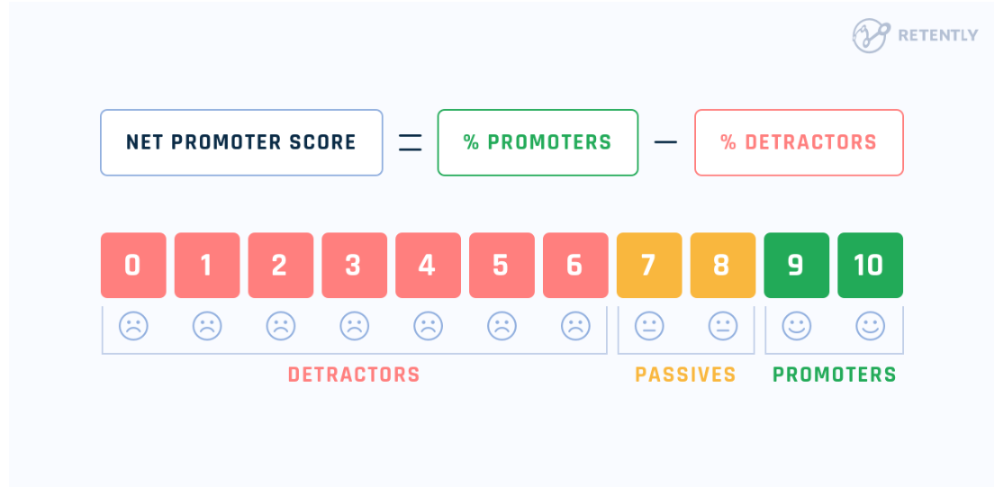

RECOMMENDATION

OPD Improvement Recommendations
- Smart Queue System: Digital tokens and real-time display to reduce waiting anxiety.
- Peak Hour Staffing: Increase staff on Mondays and Saturdays to manage rush.
- Timely Re-dilation Protocols: Train optometrists for discipline in dilation & follow-ups.
IPD Improvement Recommendations
- Early Discharge Planning: Begin documentation 24 hours prior.
- Panel-Specific SOPs: Create checklists for TPA, ECHS, Ayushman discharges.
- Pre-Discharge Counseling: Share billing estimates and timings a day in advance.

Limitations of Study `
OPD (Outpatient Department)
- Time-Bound Data Collection: Limited to 3 months—does not reflect seasonal or long-term trends.
- Rush Hour Bias: High patient load on Mondays and Saturdays may have skewed TAT data.
- Staff-Dependent Variability: Delays due to optometrists forgetting re-dilation or slow handovers.
- HMIS Accuracy Dependency: TAT tracking relies on timely and correct HMIS entries

Conclusion
The study highlights that Turnaround Time (TAT) directly impacts patient satisfaction and Net Promoter Score (NPS) in both OPD and IPD services.
- OPD NPS (62%) was higher than IPD (50%), indicating quicker service and better patient perception.
- However, delays during rush hours and occasional staff lapses affected OPD efficiency.
- IPD discharge delays, especially for Ayushman Bharat, TPA, and ECHS panels, reduced patient satisfaction due to prolonged waiting and documentation issues.
Overall, patient expectations are evolving, and satisfaction depends not only on treatment outcomes but also on service quality, transparency, and experience.
To improve NPS and satisfaction:
- OPD should focus on better crowd management and process automation.
- IPD must streamline discharge protocols and digital approval systems.

REFERENCES :
https://www.researchgate.net/publication/6339821_Patients'_Perspective_An_Important_Factor_in_Assessing_Patient_Satisfaction
https://www.gyanvihar.org/researchjournals/c3w/Chapter%205-14.pd
https://journals.plos.org/plosone/article/file?id=10.1371/journal.pone
https://pmc.ncbi.nlm.nih.gov/articles/PMC7294374/

Annexure
