Internship Training
At
National University of Singapore
‘Seeds of Sustainability: Positioning Millets at the Core of
Planetary Health Agenda’
by
Dr. Angelica Singh
PG/23/017

Under the guidance of
Dr. Ramon Lorenzo Luis Rosa Guinto, Dr. Anandhi
Ramachandran, Dr. Ratika Samtani
PGDM (Hospital & Health Management)
2023-25


International Institute of Health Management Research
New Delhi

Internship Training
at
National University of Singapore
‘Seeds of Sustainability: Positioning Millets at the Core of
Planetary Health Agenda’
by
Dr. Angelica Singh
PG/23/017

Under the guidance of
Dr. Ramon Lorenzo Luis Rosa Guinto, Dr. Anandhi
Ramachandran, Dr. Ratika Samtani
PGDM (Hospital & Health Management)
2023-25

International Institute of Health Management Research
New Delhi

The certificate is awarded to

Dr. Angelica Singh

In recognition of having successfully completing her

Internship in the department of
Public Health Research

and has successfully completed her Project on
‘Seeds of Sustainability: Positioning Millets at the Core of Planetary Health Agenda’

From
08/03/25- 08/06/25

at
Duke-National University of Singapore Medical School

She comes across as a committed, sincere & diligent person who has
a strong drive & zeal for learning.

We wish her all the best for future endeavours.

Dr. Ramon Lorenzo Luis Rosa Guinto
Associate Professor of Global and Planetary Health
Duke-NUS Medical School
National University of Singapore

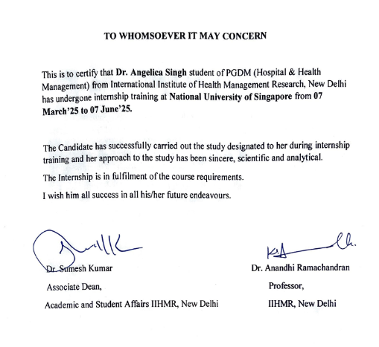

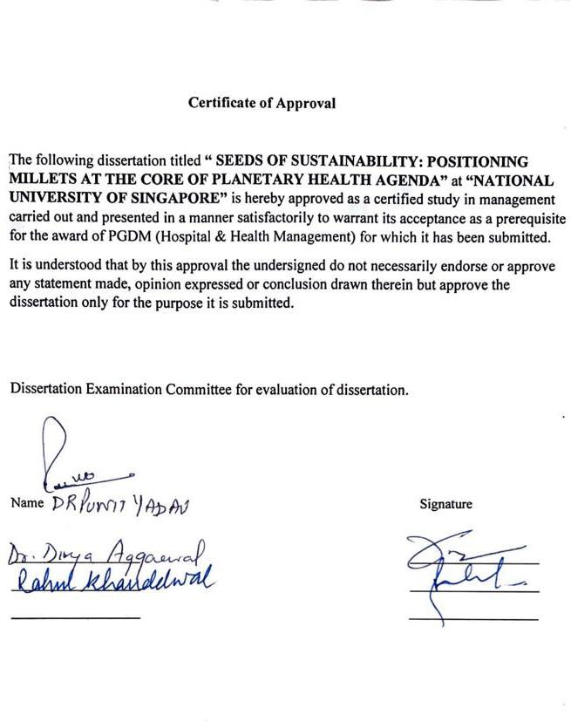

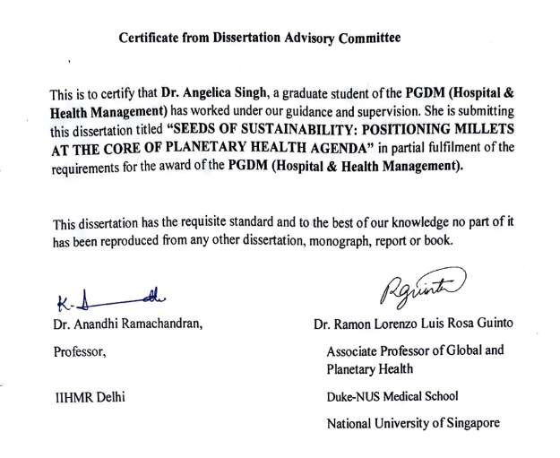

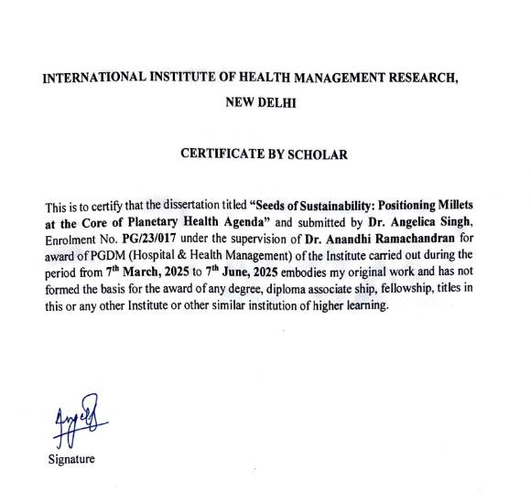

FEEDBACK FORM

Name of the Student: Dr. Angelica Singh

Name of the Organisation in Which Dissertation Has Been Completed: Duke-NUS Medical School (Virtual)

Area of Dissertation: Millets and Planetary Health

Attendance: Present in all Zoom meetings

Objectives achieved: Wrote a dissertation that applied various methodologies, frameworks, and disciplinary perspectives

Deliverables: Dissertation entitled “SEEDS OF SUSTAINABILITY: POSITIONING MILLETS AT THE CORE OF PLANETARY HEALTH AGENDA”

Strengths: Ability to listen to advice and suggestions, openness to learn new ideas and perspectives, and ability to translate plans into deliverables

Suggestions for Improvement: After writing the full dissertation, consider turning it into shorter articles that can be published in journals and other platforms

Suggestions for Institute (course curriculum, industry interaction, placement, alumni): None

Dr. Ramon Lorenzo Luis Rosa Guinto
Signature of the Officer-in-Charge/ Organisation Mentor (Dissertation)

Date: July 21, 2025 Place: Singapore/Online
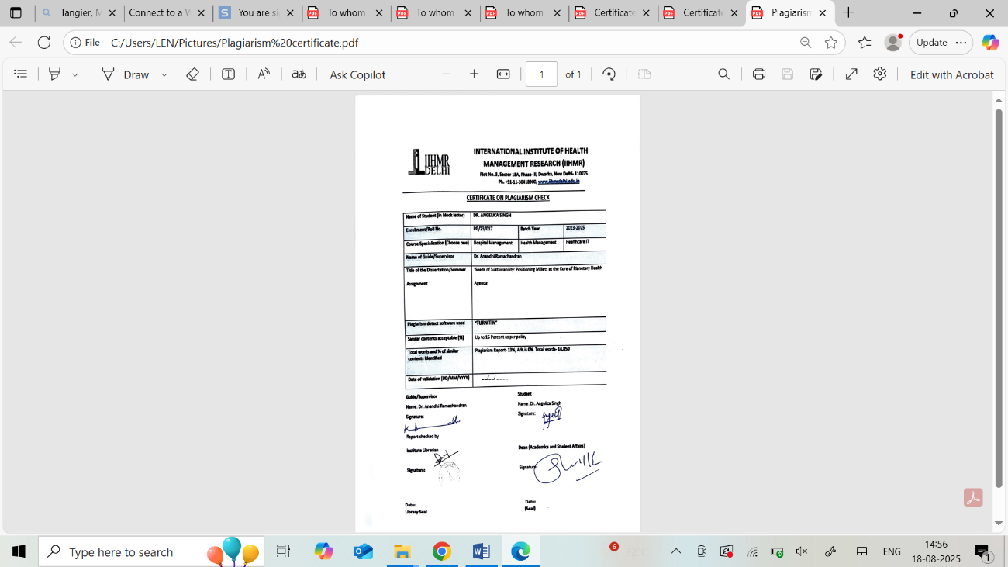

09/08/2025

ACKNOWLEDGEMENT
I would like to sincerely thank Dr. Ramon Lorenzo Luis Rosa Guinto, Associate Professor of Global and Planetary Health at Duke- NUS for his dynamic mentorship during the course of my dissertation. His insightful guidance, constructive feedback, and global perspective greatly enriched my understanding of planetary health and shaped the direction and depth of my research in meaningful ways. Working under his supervision has been a truly transformative academic experience. His mentorship has left an indelible mark on both my academic growth and personal outlook.
I would also like to express my heartfelt gratitude to Dr. Anandhi Ramachandran, for her strong academic support and mentorship. Her structured approach, meticulous attention to detail, and emphasis on conceptual clarity pushed me to think critically and refine my work at every stage. Her insightful feedback helped sharpen the analytical depth of my thesis. I am deeply grateful for her generosity with her time and dedication to my learning journey.
A special note of thanks to Dr. Ratika Samtani, for her continuous encouragement, timely guidance, and thoughtful feedback throughout this dissertation. Her practical insights and academic mentorship were crucial in refining my ideas and staying focused during challenging phases of the research. Her approachable nature and constant reassurance provided me with the confidence and instilled in me the belief to pursue my research with resilience and determination.
I would also like to extend my sincere appreciation to Dr. Sutapa B Neogi, director of IIHMR for granting me this opportunity to collaborate with NUS. It has inspired me to pursue excellence and think beyond borders in the field of health and policy research. This experience has added great value to my academic journey and professional aspirations.

ABSTRACT:
This dissertation places millets at the centre of the global health agenda by examining their potential to address the interrelated problems of agricultural sustainability, climate change, and malnutrition. The study uses the Policy Triangle Framework to critically analyse millet-related policies in India from 2017 to 2025 at the national and state levels. These policies include the Odisha Millets Mission, the Karnataka Organics and Millets Policy, the National Year of Millets (2018), the International Year of Millets (2023), and the integration of millet into PDS, POSHAN Abhiyaan, and NFSM.
The study's foundation is qualitative policy analysis, and its data is sourced from statistical databases, government reports, scholarly works, and documents from international agencies. The ecological fit of millet cultivation is also evaluated using the Planetary Boundaries Framework in relation to freshwater use, biodiversity, climate change, and land-system change.
According to research, millets are significantly better than traditional cereals like rice and wheat in terms of nutrition, the environment, and cost. However, millet mainstreaming is still hampered by Green Revolution-era policy legacies, infrastructure limitations, and barriers related to consumer perception. In addition to highlighting effective community-driven and legislative models from different states, the study identifies policy gaps in procurement, pricing, awareness, and inter-ministerial coordination.
The thesis comes to the conclusion that millets are a workable way to create resilient food systems by integrating a dual-lens analysis of policy and planetary health. To reach their full potential, strategic policy changes, enhanced market connections, public awareness initiatives, and cross-sectoral cooperation are necessary. Millets can be revolutionary in accomplishing the Sustainable Development Goals (SDGs) and advancing the long-term health of the planet by reorienting agricultural priorities with ecological and nutritional objectives.

Table of Contents
1. Introduction………………………………………………………………………14
2. Literature Review………………………………………………………………………………..18
The Nutritional and Health Benefits of Millets in Combating Malnutrition and Lifestyle Diseases…………………………………………………………………....................18
The Environmental Advantages of Millet Cultivation……………………………….19
Economic importance of millets……………………………………………………...20
2.4 Criticisms of Millets………………………………………………………………21
2.4.1 Antinutrients in Millets…………….............................................................21
2.4.2 Seasonal Suitability………………………………………………………...21
2.4.3 Processing Challenges……………………………………………………...22
2.4.4 Challenges and Barriers in Millet Adoption and Consumption……………23
2.5 Cost Benefit Analysis of Millets………………………………………………….24
2.5.1 The Paradox of Millets in India……………………………………………28
2.5.2 Millets in India- An Underutilized Nutritional Source…………………….32
2.5.3 Comparison of Millets with Wheat and Rice in India……………………..33
3. Planetary Boundaries Framework………………………………………………34
3.1 The Nine Planetary Boundaries………………………….. …………………...35
3.2 Applying the Planetary Boundaries Framework to Millets……………………35
3.2.1 Climate Change…………………………………………………………..35
3.2.2. Biosphere Integrity………………………………………………………35
3.2.3. Land-System Change……………………………………………………36
3.2.4. Freshwater Use…………………………………………………………..36
3.2.5. Biogeochemical Flows…………………………………………………..36
3.2.6. Ocean Acidification……………………………………………………..36
3.2.7. Atmospheric Aerosol Loading…………………………………………..36
3.2.8. Novel Entities……………………………………………………………36
3.2.9. Stratospheric Ozone Depletion…………………………………………..36
4. Policy landscape and Government Interventions for Millets in India: National and State-level analysis………………………………………………………………37
4.1 National Policies……………………………………………………………….37
4.2 Local Policies for Millets………………………………………………………38
4.3 Evaluating Policies through the Lens of the Policy Triangle Framework……..43
4.3.1 The Four Key Components of the Policy Triangle………………………40
4.4 Unpacking Policy Components with the Policy Triangle Approach…………..41
4.5 Case Study: Odisha Millet Mission- Reviving Millets from Farm to Plates….44
4.6 Identified Policy Gaps and Recommendations………………………………..46
4.7 Policy Roadmap for Advancing Millet Integration into Sustainable Food System in India………………………………………………………………………………..47
4.8 The Road Ahead: Future Outlook and Transformative Policy Imperatives…..49
4.9 Conclusion…………………………………………………………………….50
5. Strategies to Enhance Millet Promotion in India…………………………………………………………………………………. 51
6. Discussion………………………………………………………………………….53
6.1 Voices from the Ground- Empowerment through millets……………………..53
6.2 Synthesizing the Policy Triangle: Systemic Strengths and Weaknesses………53
6.3 The Planetary Fit: Ecological Promise and Policy Gaps……………………….54
6.4 Mainstreaming Millets: Turning Vision into Action…………………………...54
6.5 Limitations of the Study and Future Directions………………………………..54
6.6 The Final Word: A Future Rooted in Resilience……………………………….54
7. Conclusion………………………………………………………………………55
7.1 Millets and the Road to Achieving the Sustainable Development Goals……55
7.2 Impact of Millets on Health, Environment and Economy……………………56
7.2.1 Health Impact…………………………………………………………..56
7.2.2 Environmental Impact………………………………………………….56
7.2.3 Economic Impact……………………………………………………….56
8. Bibliography……………………………………………………………………..58

Chapter 1
INTRODUCTION
Millets are a group of ancient, small-grained cereals that have been cultivated for thousands of years across Asia and Africa. Its scientific name is Panicum sumatrense and it falls under the grass family of plants (FAO, 2023). These highly resilient crops, grown in arid and semi-arid regions, are known for their adaptability to harsh climatic conditions, including drought, high temperatures, and poor soil fertility. Unlike conventional cereals such as wheat and rice, millets require minimal water, have a low carbon footprint, and are naturally pest-resistant, making them a crucial component of sustainable agriculture (ICAR-IIMR, 2021; Muthamilarasan & Prasad, 2021).
Historically, millets were staple crops in many civilizations and were widely consumed before the Green Revolution, which shifted the focus toward high-yielding varieties of rice and wheat (Pingali, 2012). In times of famine and food shortages, millets played a vital role in ensuring food security, particularly in India, China, and Africa. However, with the rise of intensive farming practices and government policies favouring commercial cereals, millet cultivation significantly declined (Devi et al., 2014). Concerns about climate change, sustainable agriculture, and health-conscious diets have all contributed to the recent rise in popularity of millets. As modern food systems face increasing challenges such as soil degradation, water scarcity, and the rise of lifestyle diseases, millets are being reintroduced as a superfood with immense nutritional and ecological benefits (FAO, 2023).
Western nations, such as the US, Australia, and portions of Europe, have started introducing millets into their regular diets after realizing their rich micronutrient profile, high fiber content, and gluten-free status. Their inclusion in health stores, vegan diets, and functional food products like millet-based pasta, cereals, and snack bars is a result of the increased demand for plant-based foods due to growing awareness of plant-based nutrition, gut health, and sustainable food choices (UNEP, 2023; Global Panel on Agriculture and Food Systems for Nutrition, 2021).
Additionally, in line with the International Year of Millets 2023, which sought to revive millet consumption globally, international organizations such as the UN and the FAO have promoted millets as a climate-smart grain (FAO, 2023). Known as ‘Nutri cereals’, these ancient grains are known for their high nutritional content.
Millets are broadly categorized into major millets (such as sorghum, pearl millet, and finger millet) and minor millets (including foxtail millet, little millet, kodo millet, proso millet, brown top millet, fonio, teff, and barnyard millet). While major millets can be consumed after basic cleaning post-harvest, minor millets require initial processing to remove their outer layers, which, although rich in antioxidants, may need to be refined for consumption (ICRISAT, 2020).
Millets also contribute positively to planetary health, as they require fewer resources, enrich soil fertility, and emit significantly lower greenhouse gases compared to conventional cereals (Chivenge et al., 2015; ICRISAT, 2021). Given the global challenges of climate change and malnutrition, millets are emerging as a sustainable solution for ensuring food security, environmental conservation, and improved public health.
To create domestic and global demand and to provide nutritional food to the people, Government of India had proposed to the United Nations for declaring 2023 as International Year of Millets. The proposal of India was supported by 72 countries and United Nation's General Assembly (UNGA) declared 2023 as International Year of Millets on 5th March, 2021 (MoA&FW, 2023). This led to the Hon’ble Union Finance Minister making a Budget announcement on 1st February 2022: “2023 has been announced as the International Year of Millets. Support will be provided for post-harvest value addition, enhancing domestic consumption and branding of millet products nationally and internationally” (GoI, 2022). The International Year of Millets 2023, promoted by the United Nations and FAO (Food and Agriculture Organization of the United Nations), aimed to revitalize millet production and consumption, reinforcing their role in sustainable agriculture and nutrition policies worldwide. As science-backed evidence and consumer awareness continue to grow, millets are reclaiming their place as the grain of the future, helping bridge the gap between sustainable food systems and human well-being.
This thesis is organized into seven chapters. Chapter One introduces millets- their origin, classifications, and modern relevance. Chapter Two delves into the benefits, criticisms, and a cost-benefit analysis of millets, examining their nutritional value, environmental impact, and challenges in mainstreaming them. The Planetary Boundaries Framework is presented in Chapter 3 to assess how millets fit within global sustainability thresholds. The emphasis switches to the policy environment controlling millets in India in Chapter Four, utilizing the Policy key findings from national and sub-national initiatives and are analysed using the Triangle Framework. This section also includes a case study on the Orissa Millet Mission, highlighting its institutional innovations, community-based approach, and effects on farm livelihoods and household nutrition. The strategic routes and interventions required to more successfully promote millets are examined in Chapter 5. A critical discussion is provided in Chapter 6, combining knowledge from planetary and policy frameworks to rethink how millets can promote systemic change. It calls for a paradigm shift from marginal inclusion to mainstream adoption and identifies important advantages, obstacles, and opportunities for millet integration. The thesis is finally concluded in Chapter Seven by matching millets with important Sustainable Development Goals (SDGs), highlighting their intersectional benefits across Health, Environment, and Economy with a Venn diagram and a custom SDG-Millet Mapping, while also considering the urgency of action with only five years left until the 2030 SDG deadline.

Research Methodology

Research Design

Using the Policy Triangle Framework and a qualitative policy analysis methodology, this study critically investigates the development, composition, and effects of millet-related policies in India. By examining the four main factors that affect the creation and application of policies- Context, Content, Process, and Actors, this framework provides an organized perspective. A thorough and organized analysis of millet policies in India is made possible by the examination of each domain through a particular research question.

Data Collection Method
In-depth literature searches were carried out on three databases and official government websites as part of this study's structured literature survey methodology: Google Scholar, PubMed, and Scopus. Keywords and search terms utilized for the search encompassed variations and combinations of ‘Millet policies in India’, ‘Policy Triangle Framework in agriculture’, ‘National Year of Millets 2018’, ‘International Year of Millets 2023’, ‘Public Distribution System and Millets’, "POSHAN Abhiyaan and millets", ‘Production Linked Incentive Scheme for Millet-Based Products’, ‘Odisha Millets Mission’, ‘Millets and climate-resilient agriculture’, ‘Millets and malnutrition India’. Searches were augmented with Medical Subject Headings (MeSH) to ensure thematic depth. The literature was then synthesized using the Policy Triangle Framework, offering a multi-dimensional view of millet policymaking in India.

Sources of data
A secondary data collection method is used, focusing on academic and policy literature.
Sources include:
- Scholarly publications accessed through platforms such as PubMed and Google Scholar.
- Government reports and official documents issued by institutions such as the Ministry of Agriculture and Farmers' Welfare ( MoAFW), NITI Aayog, National Food Security Mission (NFSM), Ministry of Health and Family Welfare (MoHFW), and Indian Council of Agricultural Research (ICAR).
- Publications and reports from international organizations, including the Food and Agriculture Organization (FAO), National Bank for Agriculture and Rural Development (NABARD) United Nations Development Programme (UNDP), International Fund for Agricultural Development (IFAD).
- Grey literature such as working papers, research briefs, and case studies.
- Media reports and feature articles from reputed national publications such as The Hindu, The Indian Express, and Down To Earth.
- Statistical databases including AgriStat, FAOSTAT, IndiaStat, and datasets from the Ministry of Statistics and Programme Implementation (MoSPI).

Inclusion Criteria:
- Time Frame: Policies implemented or revised from 2017 to 2025, including India’s declaration of 2018 as the National Year of Millets and 2023 as the International Year of Millets.
- Geographical Scope: National-level schemes and state-specific millet missions in India (e.g., Karnataka, Odisha, Chhattisgarh, Tamil Nadu, Andhra Pradesh, Telangana).
- Policy Types: Nutritional, agricultural, and environmental policies integrating or promoting millets through MSP, PDS, ICDS, POSHAN Abhiyaan, PMFBY, and other targeted interventions.
- Policy Actors: Government ministries (MoA&FW, MoHFW, MoWCD, APEDA, ICAR), state agencies, FPOs, SHGs, and international bodies like FAO.
- Framework for Analysis: Qualitative policy analysis based on the Policy Triangle Framework (Context, Content, Process, Actors).

Exclusion Criteria:
- Policies outside India or those not directly related to millets.
- Policies formulated before 2017, unless still operational or referenced in new programs.
- Purely academic or agricultural innovations without formal policy backing.
- Consumer perception surveys or marketing strategies not tied to public policy instruments.
Research Objectives (based on the Policy Triangle Framework)
The primary objectives of the thesis are:
- To analyse the contextual factors (environmental, economic, and nutritional crises) that have influenced the policy prioritization of millets in India.
- To examine the content and components of India’s millet policies and assess their alignment with sustainability, nutrition security, and biodiversity conservation.
- To trace the evolution and implementation mechanisms of millet-related policies at national and state levels from 2017 to 2025.
- To identify and understand the roles and interests of key actors involved in shaping, promoting, and implementing millet policy in India.

Chapter 2
LITERATURE REVIEW

2.1. The Nutritional and Health Benefits of Millets in Combating Malnutrition and Lifestyle Diseases
Millets are a powerhouse of nutrition, offering an excellent solution to global malnutrition due to their rich composition of essential vitamins, minerals, and bioactive compounds (ICRISAT, 2022).These ancient grains are abundant in carbohydrates (65-75%), proteins (7-12%), fats (2-5%) and dietary fiber (8-15%) and play a crucial role in enhancing nutrition and improving nutrition in malnourished population, particularly in vulnerable populations such as children, pregnant women, and individuals suffering from dietary deficiencies (ICMR-NIN, 2022). They are rich in vital nutrients that are required for healthy growth and development, including iron, calcium, magnesium, phosphorus, and vitamin B. In many developing countries, including India, anemia is a major public health concern. Iron-rich millets, like finger millet (ragi), are especially effective in preventing anemia in women and children (ICAR-IIMR, 2021). While their high fiber content supports digestive health, calcium-rich millets help prevent osteoporosis and strengthen bones.
Millets are very helpful in the treatment of diabetes, obesity, and heart disease. They are a great dietary option for diabetic patients because of their low glycemic index, which guarantees a slower release of glucose into the bloodstream. The high fibre content in millets help in weight management by reducing hunger. A research conducted in National Institue of Nutrition( 2022) suggested that Postprandial Glucose levels were reduced by 20% on replacemwnt of Rice-based meals with millets. Finger Millets’ high fiber content (18%) slows down the absorption of sugar. One in three Indian adults are suffering from high BP. The Blood pressure is known to bereduced by 5-7% due to the presence of high potassium & Magnesium levels in Millets (ICMR, 2020). They also lower Cholesterol levels, which decreases the risk of cardiovascular conditions such as stroke & hypertension (Shevkani et al., 2017).
Millets are gluten- free, and they are an excellent option for people suffering from celiac disease and gluten intolerance (WHO, 2021).

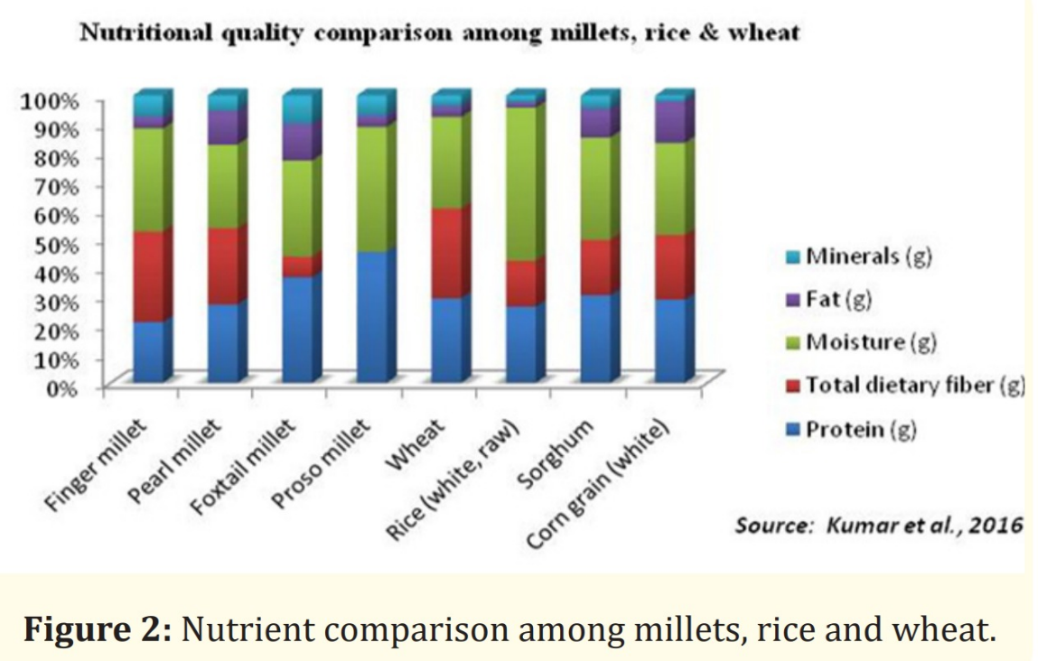
Fig-1 Nutritional Comparison of Millets with Wheat and Rice
(Source: Kumar et al., 2016)
India's Global Hunger Index (GHI) score of 28.7 in 2023 denoted a "serious" level of hunger, with the highest child wasting rate in the world at 18.7%, 19.3% wasted, and 35.5% stunted among children under five (Global Hunger Index, 2023). For malnourished populations, particularly in regions where staple foods lack essential micronutrients, the inclusion of millets in government-led food programs and public distribution systems can be instrumental in improving dietary diversity and overall nutritional status.
By integrating millet-based meals into school nutrition programs, mid-day meal schemes, and maternal health initiatives, governments can effectively address micronutrient deficiencies and improve the public health outcomes (MoWCD, 2023; POSHAN Abhiyaan, 2023).
2.2. The Environmental Advantages of Millet Cultivation
Millets are highly climate-resilient crops capable of thriving in extreme temperatures, often exceeding 40–45°C (104–113°F). Their ability to withstand such conditions is attributed to their C4 photosynthetic pathway, which enhances carbon fixation and reduces transpiration losses, making them more water-efficient than conventional grains like wheat and rice (ICRISAT, 2021).
They can obtain moisture from lower soil layers thanks to their deep root systems, which guarantees their survival in arid conditions. Millets have a shorter growth cycle (60-90 days) which is completed before extreme summer heat ( ICAR, 2022). There’s Heat- shock proteins which protects them from heat damage and helps them to adapt to stress caused due to heat even more. Millet leaves’ have small stomata and thick waxy cuticle which reduces water loss. Millets have genetically evolved over decades to withstand adverse climate (Chivenge et al., 2015).
Millet cultivation has a number of environmental benefits. Millet farming enhances biodiversity and also promotes resilient agriculture by increasing the microbial activity in soil and reducing pest and disease susceptibility when it’s grown with the other crops in combination with agroforestry (ICRISAT, 2020).
Millets are drought- resistant and require less water than wheat& rice. Some of its types can manage to survive with 300-500 Litres per kg, whereas rice requires 3000- 5000 Litres (ICRISAT, 2021). Millets are vital for conserving water, in areas where water levels are low and in desert areas. Millets also mitigate climate change, as it requires very little chemical fertilizers, which reduces the release of Nitrous oxide, a greenhouse gas 300 times more potent that Carbon Dioxide.
More than 30% of the world’s land where crops can be cultivated, is impacted by degradation of land, and millets help prevent it by restoring soil and their decreased dependency on fertilizers and pesticides (FAO, 2022). Millets help to generate regular incomes, for small- scale farmers. Millets are the food of the future because of their resistance to extreme climate and their ability to survive in infertile soils and with very less water input and ensure agricultural sustainability (UNEP, 2023). Therefore, making millets our staple grains can be beneficial for us and the planet.
2.3. Economic importance of millets:
The global market has advanced in growth greatly in the last few years from $ 11.67 billion to 12.36 billion in the span of year (2024-2025) with a compound growth rate annually (CAGR) of 5.9 %. Increased knowledge towards healthy food, millets, government support and agricultural sustainability has led to the growth.
The market is now expected to grow at 5.5% CAGR to reach $15.29 billion by the year 2029 due to factors like modernization, increased population worldwide, adapting to climate change and research and development. There’s also increased demand for millet- based products, awareness of consumers and culinary development recently and are seen as trends now. Farmer’s yearly income has increased by 10-20 percent, a study by IIM has suggested it (IIM, 2023).
Millets are cheaper in comparison to Wheat and Rice as they provide a good return on investment. Small- scale farmers have benefited from decreased cost of farming. Millets are also cheaper than wheat and rice in their original state. Theres higher cost- benefit ratio of millets as they are healthy and nutrient rich and provide fullness as well as health benefits. They are economical in aspects like cultivation, nutrion per rupee spent and reduced healthcare costs, though they might not always be cheaper per kilogram from Wheat and rice ( FICCI,2023).

Karnataka Mid- Day Meal- The Mid- Day Meal Scheme is now known as PM POSHAN. It provides school children with nutritious balanced food. Millet- based meals were started out in Karnataka as a part of midday meal program. Around 1500 adolescent children received these meals and it was found that there were massive improvements in nutrition in these children in comparison to fortified rice- based meals. This also suggested that with the right pricing support, it could be a better replacement to rice.
A Study by ICRISAT was done to determine the costing of replacing rice with millets in the PDS. The study showed that substituting one kg of rice with millets for one quarter of PDS beneficiaries ( approximately 200 million people) can lead to reduction of the cost of the program by 913 crores, which showcases millet as an economical and cheaper alternative food food distribution. Inititation of programs like IYM- 2023 solidifies the status of millets as the food of the future.
2.4 Criticisms of Millets
2.4.1 Antinutrients in Millets
Millets contain antinutrients like phytates, saponins, tannin and protease inhibitors( eg- trypsin,chymotrypsin, α- amylase with cysteine inhibitors. These compunds hinder the millet absorption in the human body and interfere with the enzymes responsible for disgestion (Rao et al., 2017; FAO, 2021). To be specific phytates and tannins prevent iron, calcium and zinc from being absorbed that can lead to micronutrient deficiencies in people who mainly consume millets in their diet as a staple (ICMR-NIN, 2022). Polyphenols like luteolin and apigenin have goitrogenic effects by interrupting with thyroid function and iodine absorption (Shevkani et al., 2017; Harvard School of Public Health, 2022).
These compounds are notably resistant to heat, remaining active post-cooking, unlike similar compounds found in cruciferous vegetables (FAO, 2021). Hence, excessive millet consumption may not be suitable for individuals with hypothyroidism (ICRISAT, 2022).
However, processing techniques such as milling, decortication, soaking, germination, fermentation, boiling, and roasting significantly reduce these antinutrients and enhance bioavailability of essential minerals (ICAR-IIMR, 2020; ICMR, 2022).
2.4.2 Seasonal Suitability
Millets are best suited for seasonal consumption due to their intrinsic warming or cooling properties. For instance, finger millet (ragi) and foxtail millet are considered appropriate for summer months, whereas varieties like pearl millet (bajra) are preferred during winter, aligning with traditional Indian dietary practices (NIN, 2022; Ministry of AYUSH, 2021).
Millets, though suitable for year-round consumption, exhibit certain seasonal characteristics based on their thermogenic properties, moisture content, and digestive profile. Traditional Indian dietary systems, particularly Ayurveda, and emerging nutritional science both suggest tailoring millet consumption to seasonal changes to enhance health benefits and reduce digestive stress (Ministry of AYUSH, 2021).

Winter-Suited Millets
Millets like bajra (pearl millet) and jowar (sorghum) are considered ideal for winter due to their warming properties. These grains are rich in energy-dense macronutrients, particularly carbohydrates and fats, which help maintain body warmth during cold weather (NIN, 2022). Additionally, these millets have higher fiber content, which supports satiety and slower digestion helpful for maintaining body heat in cooler months (ICMR-NIN, 2020).
“Bajra and jowar are often recommended for winter diets because they provide warmth and sustained energy release, which is especially beneficial in colder climates.” - (ICMR-NIN, 2022)

Summer-Suited Millets
Millets such as ragi (finger millet) and foxtail millet are traditionally consumed during the summer months as they are considered cooling and easy to digest (ICRISAT, 2021). These millets contain relatively lower fat content, and their mineral-rich profiles, especially in calcium and iron, are beneficial in maintaining electrolyte balance during high heat conditions (FAO, 2021). Ragi is also known to have a natural calming effect on the body, which makes it suitable for summer diets, especially for infants and the elderly (Ministry of AYUSH, 2021).
“Foxtail millet is light and cooling in nature, making it ideal for consumption during hot summer days, especially when prepared as porridge or upma.”- (FAO, 2021)

Monsoon and Transitional Seasons

During transitional weather, particularly the monsoon, little millet and barnyard millet are considered beneficial as they are light on digestion and rich in resistant starch, which supports gut health (ICRISAT, 2022). These millets are also less likely to ferment rapidly in the gut during humid conditions, thereby minimizing gastrointestinal discomfort common during the rainy season (ICMR, 2020).
“Barnyard millet is especially suitable during the rainy season due to its light digestibility and low glycaemic index, making it favourable for diabetic patients and those with sensitive digestion.” - (ICRISAT, 2022)
2.4.3 Processing Challenges
Millet varieties require distinct processing methods, complicating large-scale mechanization. Their small grain size and tight bran-endosperm binding make milling difficult, leading to higher breakage and flour loss (ICRISAT, 2021). Currently, whole grain flour is the most common millet product, which limits culinary flexibility and shelf life.
Additionally, the lack of large-scale mechanized processing units for millets limits efficiency and results in labour-intensive processing, further raising production costs (MoFPI, 2023).
These logistical and infrastructural constraints contribute to inconsistencies in grain quality, limited shelf life, and higher market prices, making millets less accessible to economically disadvantaged populations (ICAR-IIMR, 2022; FAO, 2023).
The limited availability and relatively low popularity in urban markets also restrict their widespread integration into mainstream diets.

2.4.4 Challenges and Barriers in Millet Adoption and Consumption
Despite the resurgence of interest in millets due to their nutritional, ecological, and economic benefits, several structural and behavioural barriers continue to hinder their widespread adoption and integration into mainstream diets. These challenges, if unaddressed, may undermine policy efforts aimed at promoting millets as climate-smart and nutrition-rich crops. Below is a critical overview of the major challenges and strategies to address them.

Sensory Acceptance and Culinary Adaptability

Millets possess a naturally coarse texture and an earthy flavour, which differ significantly from the more refined taste of polished rice and wheat (NABARD, 2022).

These sensory differences can be a deterrent, particularly for urban and younger populations who are accustomed to more processed staples.

Low palatability can limit consumer acceptance, making it difficult to scale millet consumption across diverse demographic segments.

Encouraging the development of millet-based ready-to-eat products such as cookies, noodles, pasta, and porridge with added flavourings and familiar culinary influences is a strategic approach to enhance millet consumption (FSSAI, 2023). Additionally, cooking demonstrations and social media campaigns can act as powerful behavioural nudges, normalizing millet consumption and increasing its appeal to a larger audience.

Short Shelf life of millets
Bajra and Jowar have smaller shelf life that is because they contain lipids in high amount and are also prone to rancidity (ICRISAT, 2021). This can be a major challenge of integrating millets into the PDS. Making investments on cold- chain logistics, ensuring air tight moisture- resistant packaging can be useful to solve this issue ( MoFPI, 2022).

Production
Production in Agriculture is low in comparison to high- yield varieties like Wheat and Rice which is an issue with the production of millets (ICAR, 2022).
Increasing agricultural research and development efforts to create high-yielding, pest-resistant millet varieties is one way to address this issue. In addition, policy measures such as MSP, input subsidies, and crop insurance tailored to millet cultivation would incentivize farmers to invest in millet farming (MoA&FW, 2023; FAO, 2023).

Inadequate Processing Infrastructure in Rural Areas

In rural and tribal areas, the lack of adequate processing infrastructure is a major obstacle. The absence of mechanized processing units means that manual labour, especially by women, remains high, reducing both productivity and scalability (WASSAN, 2022). Establishing decentralized processing units at the village or block level can address this issue, along with promoting skill development for women’s Self-Help Groups (SHGs) and Farmer Producer Organizations (FPOs) to add value to millet processing (MoRD, 2023).

Policy Legacy and Procurement Bias
The policy legacy of the Green Revolution, which heavily favoured rice and wheat through subsidized inputs, irrigation, and procurement support, has resulted in a procurement bias that continues to marginalize millets (NITI Aayog, 2023). This legacy has made millets scarce in public procurement and food subsidy schemes, limiting their market presence. Reforming public procurement policies to include millets under the PDS and ensuring consistent MSP coverage would be essential. Furthermore, shifting policy narratives to prioritize nutrition-sensitive agriculture, highlighting millets' role in combating malnutrition and promoting climate resilience, could help increase their inclusion (MoA&FW, 2023; ICAR-IIMR, 2022).

Knowledge Gaps and Cultural Stigma

Cultural stigma and knowledge gaps also hinder the widespread adoption of millets. Often seen as 'poor man's food' or inferior to polished grains, these perceptions, rooted in colonial-era policies and generational myths, reduce consumer demand (FAO, 2022). Mass awareness campaigns emphasizing the scientific and nutritional value of millets, along with their inclusion in school meal programs, hospital diets, and institutional catering, could help normalize their consumption and overcome the stigma associated with them (FICCI, 2023; POSHAN Abhiyaan, 2023).

2.5 Cost Benefit Analysis of Millets

Components | Benefits | Costs/Limitations | Net Impact
Nutrition | -High in dietary fiber, essential amino acids, iron,calcium,magnesium, zinc.  -Reduces dependency on fortified/ supplemented food.  Esimated saving 30-50 per kg on fortified replacement  (FAO, 2023). | -Presence of anti-nutrients (phytates, tannins, saponins) which impair mineral absorption. (Shevkani et al., 2017).  - May require additional processing to improve bioavailability. | Positive  Processing and cooking methods (fermentation, sprouting) mitigate most drawbacks (ICRISAT, 2021).
 | Low water requirement (30–40% less than rice) (ICRISAT,2018).  - Grows in rain-fed, marginal lands.  - Requires fewer pesticides & fertilizers.  Estimated saving: Rs.20–30 per kg on water and agro-inputs (MoA&FW, 2022). | Not suitable for all agro-climatic zones.  - Susceptible to yield loss without improved varieties (CRIDA, 2020). | Strongly Positive  Critical for climate-resilient farming systems (NITI Aayog, 2023).
  Environmental Sustainability
Economic Viability for Farmers | Government MSP for select millets.  - Increasing demand in health-conscious urban markets.  Additional income of Rs. 1000–1500 per quintal with MSP and value-addition (FAO, 2023). | Lower yield than rice/wheat (avg. 10–20 q/ha vs. 40–60 q/ha).  - Market linkages still developing. | Positive  High market value compensates for lower yields when supply chains are optimized. (FICCI, 2023).
Processing&Infrastructure | Opportunity for rural enterprises  - Employment for SHGs and women in value chain. (Ministry of Rural Development, 2022).  Potential income: Rs.20–30/kg in value-added products (ICRISAT, 2021). | Requires specific infrastructure (de-hullers, sorters).  - Milling losses due to small grain size.  - Shelf life challenges due to high fat content (ICAR, 2020). | Neutral to Slightly Negative  Scalable with investment in cold chains and processing tech.
Public Health Impact | Helps address lifestyle diseases: diabetes, obesity, cardiovascular disorders. (ICMR, 2020).  - Suitable for gluten-intolerant populations.  -Potential reduction in NCD treatment costs (long term). | -High-fiber diet may not suit individuals with IBS/digestive issues.  - Risk of goitrogenic effect in hypothyroid patients if consumed excessively (Harvard School of Public Health, 2022). | Positive  With dietary diversity and moderation, health benefits are substantial (FSSAI, 2023).
Cultural and Behavioural Acceptance | Culinary versatility (porridge, rotis, noodles, cookies, upma, etc.)  - Increasing inclusion in school meals, hospitals, and corporate canteens (ICDS, 2023). | -Perceived as ‘poor man’s food’ in some regions.  -Requires behavioural nudging for urban adoption (NABARD, 2022). | Positive  Improved with awareness campaigns, recipe innovations, and endorsements (FSSAI, 2023).
Policy Support | -Declared International Year of Millets 2023.  Inclusion in PDS and ICDS schemes.  - FSSAI’s ‘Eat Right Movement’ promoting millet-based diets.  Policy push ensures long-term demand and farmer incentives. | -Still not at par with rice/wheat in procurement volumes.  - Need consistent budgetary allocation (MoF, 2023). | Strongly Positive  Momentum building across ministries (Agriculture, Health, Education). (NITI Aayog, 2023).

Source: Compiled by author based on secondary data from FAO (2023), ICRISAT (2018, 2021), ICAR (2020), CRIDA (2020), FICCI (2023), NITI Aayog (2023), MoA&FW (2022), Ministry of Rural Development (2022), ICMR (2020), FSSAI (2023), and NABARD (2022).

Understanding Millets through Cost-Benefit Metrics:

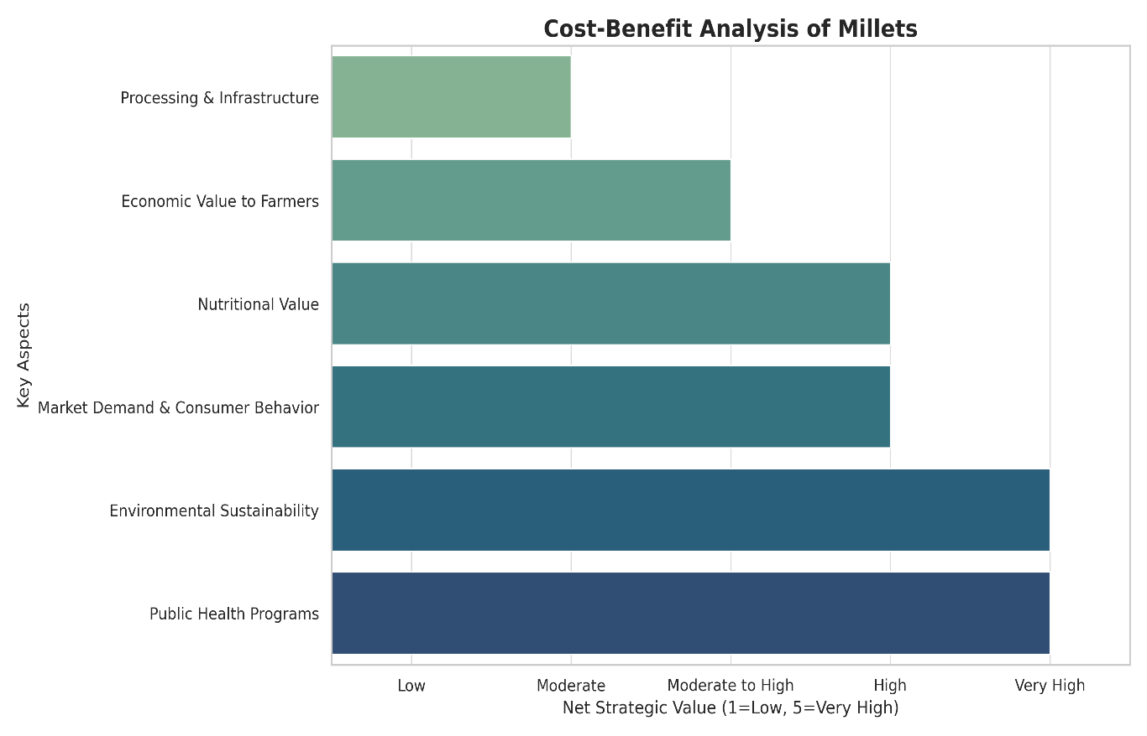

Fig-2: Graphical representation of Cost- Benefit Analysis for Millets
Source: Developed by author based on data from FAO (2023), ICRISAT (2021), ICAR-IIMR (2022), FICCI (2023), MoA&FW (2022), and Ministry of Rural Development (2022).

2.5.1 The Paradox of Millets in India: Rising Yields amidst declining Cultivation Area
India topped the global charts in millet production in 2022, generating 120 lakh tonnes out of the total 304.8 lakh tonnes cultivated worldwide. Niger and China followed, contributing 11% and 9% respectively. Combined, these three countries produced close to half of the global millet output.
Millet farming in India has experienced a substantial rise in productivity since 1966, with yields having more than doubled. By 2021–22, the average yield reached approximately 1,208 kg/ha.

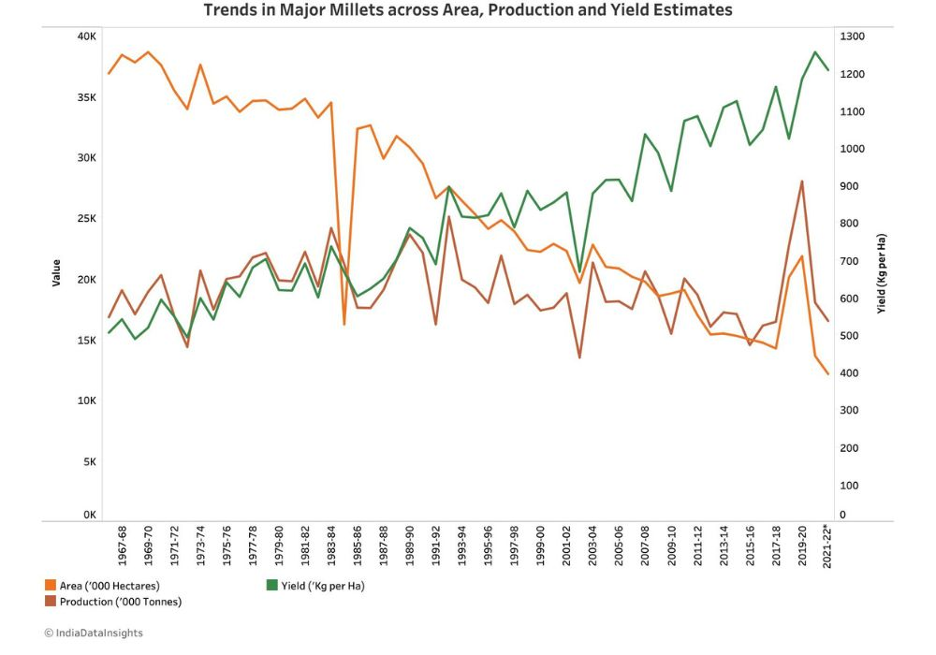
Fig-3: Trends in Major Millets across Area, Production and Yield estimates
Source: India Data Insights. Based on historical data from the Ministry of Agriculture & Farmers Welfare, Government of India (1967–2022).
Despite a consistent decline in the area under millet cultivation since 1971–72—most notably between 2006 and 2016- millet production in India has seen a 7% increase between 1966 and 2022.
The steady rise in millet yield over the years reflects the implementation of improved agricultural techniques in India in recent decades.

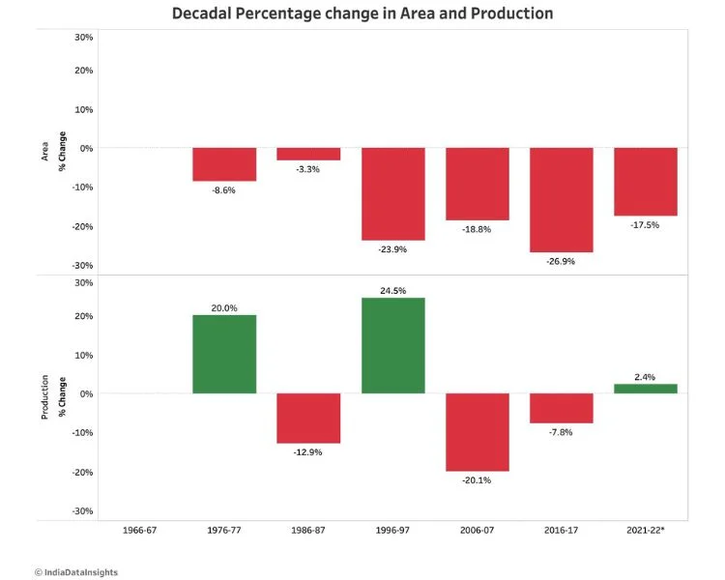
Fig- 4: Decadal Percentage change in Area and Production
Source: India Data Insights. Based on historical millet area and production data from the Ministry of Agriculture & Farmers Welfare, Government of India (1966–2022)

India holds the distinction of being the largest producer of millets in the world, contributing to over 40% of global millet production.

Production Stats:

As per the 2021–22 data:
- India produced over 17 million tonnes of millets
- Rajasthan alone accounted for ~26% of total millet production
- Pearl millet contributed around 58% of total millet output
The yield estimates for all types of millet have shown steady progress and increased by 600-1000 kg/hectare.

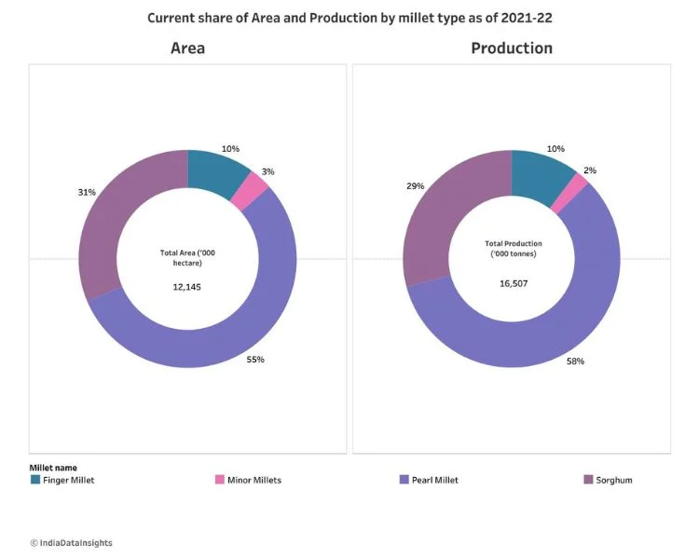
Fig-5 Share of Area and Production by millet type as of 2021-22

Source- India Data Insights. Based on 2021–22 millet area and production data from the Ministry of Agriculture & Farmers Welfare, Government of India.
In 2021-22, Pearl millet contributed 58% to the total millet production, followed by Sorghum (~29%) and Finger millet (~10%).

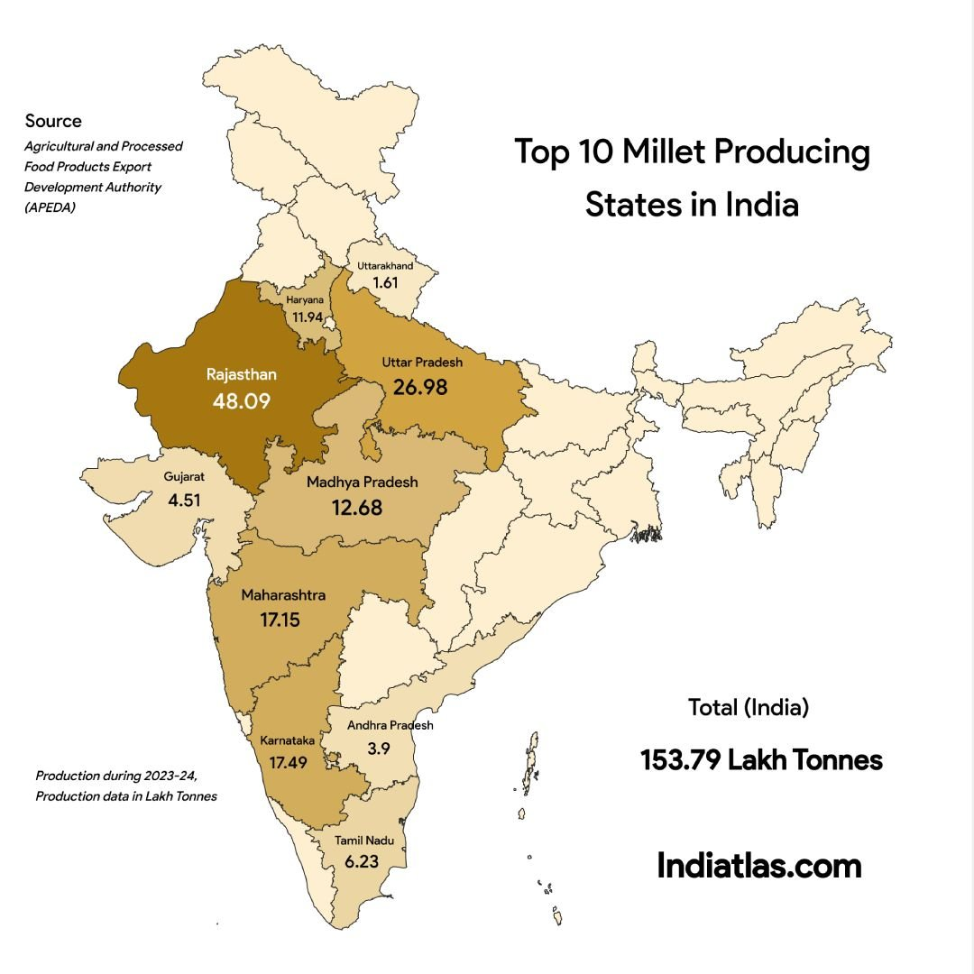
Fig-6 Leading Millet Producers across Indian states
Source- Agricultural and Processed Food Products Export Development Authority (APEDA), 2023; Graphic by IndiaAtlas.com. Data for 2023–24.
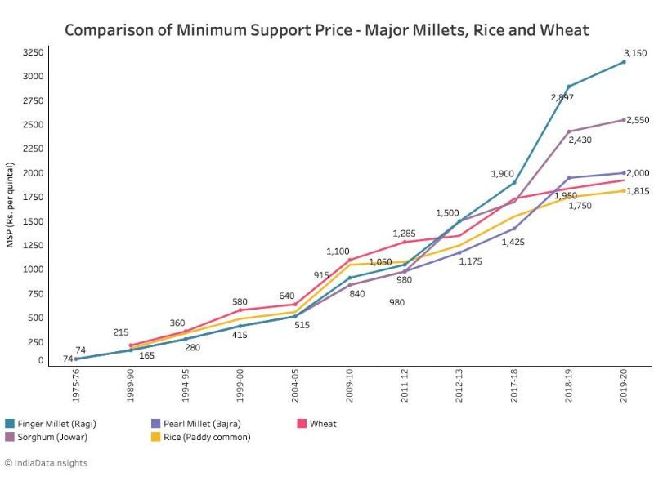
Fig- 7: Comparative Minimum Support Prices of Major Millets, Rice & Wheat
Source: India Data Insights. Based on historical MSP data from the Ministry of Agriculture & Farmers Welfare (1975–2020).
A review of trends from 1968 to 2022 reveals that millets have lagged behind rice and wheat in terms of cultivation area and output. Despite a marginal rise in area and production for rice and wheat, millets experienced a contraction in cultivated land and modest changes in production.
Nonetheless, the average yield of millets has improved, pointing to better farming practices and enhanced productivity, especially for Pearl millet. Importantly, Finger millet experienced the highest MSP increase among food grains-a 4000% rise since 1975, suggesting a strategic policy push to make millet farming more attractive and economically viable for farmers.
2.5.2 Millets in India- An Underutilized Nutritional Source
Millets are significantly underutilized in India when compared to wheat and rice, despite being nutritionally superior, climate-resilient, and historically important.
Despite being deeply embedded in India’s traditional food systems and agroecological landscape, millets have witnessed a significant decline in consumption over the past few decades. In the 1960s, the per capita annual consumption of millets in India stood at approximately 32.9 kg. However, this figure sharply declined to just 4.2 kg/person/year by 2010 and has remained low ever since (ICRISAT, 2013).
Earlier the policy interventions were majorly focused on subsidizing and promoting the high- yielding varieties during the Green Revolution like wheat and rice by investing in irrigation, chemical fertilizers and the use of MSP, which caused the marginalisation of millets (Pingali, 2012; DeFries et al., 2015). Millets lacked policy attention. It is now that things have changed and millets are part of the PDS and procurement procedures.
Furthermore, dietary changes, urbanization, and perceptions of status and wealth all contributed to a slow shift in consumer preferences toward polished grains. Convenience, marginalizing millets both economically and culturally (Basavaraj et al., 2010). The relatively lower agricultural yield of millets was another important factor in their decline.
Compared to high-yielding rice and wheat varieties, millets frequently yielded lower returns per hectare, which made them less appealing to farmers (ICAR-IIMR, 2021). The millet cultivation reduced due to yield disparity and market negligence. The implementation of the International Year of millets and the government participation has now started out a change (FAO, 2023)
To restore millets' place in the national food basket, India has implemented programs like the National Millet Mission, integrated millets into the Public Distribution System and Integrated Child Development Services (ICDS), and targeted support for millets-based startups (MoA&FW, 2023).

2.5.3 A Comparative Analysis of Millets with Wheat and Rice in India
Parameter | Millets | Rice | Wheat
Cropping area(2021-22) | ~15 million ha | ~45 million ha | ~31 million ha
Production (2021-22) | ~18 million tonnes | ~130 million tonnes | ~110 million tonnes
Yield (kg/ha) | ~1,200–1,500 | ~2,700 | ~3,400
Per Capita Consumption (2010) | 4.2 kg/year | ~80–100 kg/year | ~60–70 kg/year
MSP Procurement (2022-23) | <5% of production | ~50% | ~40%
Govt. Procurement Support | Minimal | Extensive | Extensive
Inclusion in PDS & Mid-Day Meals | Limited & recent | Widespread | Widespread
Public Awareness | Low | Very High | Very High

Table 2.5.3
Source: Compiled from ICRISAT (2020), ICAR-IIMR (2021), and MoA&FW (2022) data.
After weighing the observable advantages and disadvantages of millet promotion, the conversation shifts to a more systemic question: How long-term sustainable is millet cultivation? The Planetary Boundaries Framework provides a widely accepted standard for evaluating agricultural methods in light of Earth's ecological boundaries in order to address this. An emerging paradigm known as "planetary health" acknowledges the connection between the health of Earth's natural systems and human well-being. It casts doubt on the notion that ecological constraints can be ignored while pursuing human advancement. The term "planetary health," which was coined by the Rockefeller Foundation Lancet Commission, emphasizes how the very systems that support modern civilization are now threatening the fundamentals of human health, including clean air, fertile soil, safe food, drinkable water, and a stable climate (Whitmee et al., 2015).
The thesis will now adopt the Planetary Boundaries framework which will help us to understand the revival of millets in all key aspects- nature, environment and the nine planetary boundaries like the use of freshwater, greenhouse gas emissions and ozone depletion. It will enable us to Ascertain if millets are truly the crops of the future and the crops of agricultural and ecological sustainability.

Chapter 3
PLANETARY BOUNDARIES FRAMEWORK
Nine planetary boundaries are proposed by the planetary boundaries concept, which allows humanity to flourish and continue to evolve for future generations.
The safe boundaries of human activity on Earth's major environmental systems are outlined in the 2009 Planetary Boundaries Framework, which was first presented by Johan Rockström and 28 other top scientists.
In 2023, researchers quantified all nine boundaries and found that six had already been transgressed, increasing the risk of irreversible ecological damage.
Though immediate consequences may not be apparent, exceeding these limits threatens both natural ecosystems and human societies. The boundaries are interconnected- crossing one can trigger negative effects on others, making it essential to consider them collectively when shaping sustainability policies.
Since September 2024, the Potsdam Institute for Climate Impact Research has been publishing the Planetary Health Check, an annual report tracking Earth’s environmental stability.
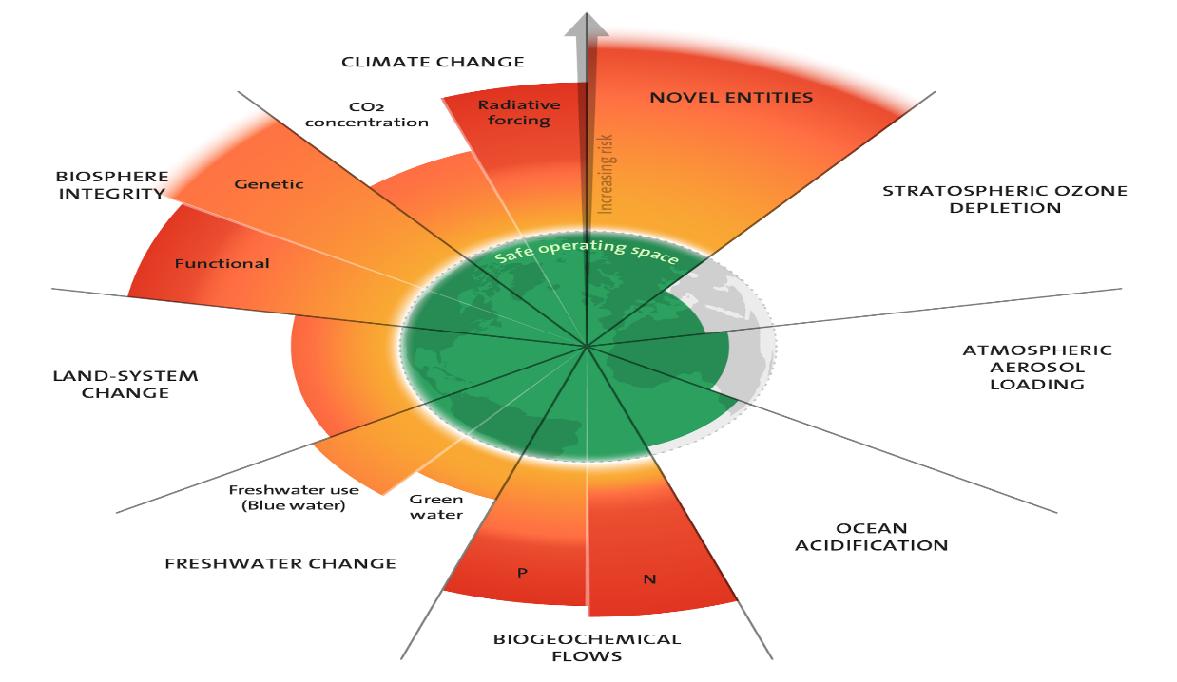

The 2023 update to the Planetary boundaries (9 Boundaries assessed and 6 crossed) Licensed under CC BY-NC-ND 3.0. Credit: "Azote for Stockholm Resilience Centre, based on analysis in Richardson et al 2023".
3.1 The Nine Planetary Boundaries:
a. Climate Change – The concentration of greenhouse gases in the atmosphere must remain within safe levels to prevent global warming beyond 1.5–2°C.

b. Biosphere Integrity (Biodiversity Loss & Extinction) – The loss of species and ecosystems must be minimized to maintain Earth's biological diversity.

c. Land-System Change- Uncontrolled deforestation and land conversion for agriculture and urbanization can disrupt natural ecosystems.

d. Freshwater Use- Sustainable management of freshwater resources is necessary to prevent water scarcity.

e. Biogeochemical Flows (Nitrogen & Phosphorus Cycles) – Excessive use of fertilizers leads to nutrient pollution, causing dead zones in water bodies.
f. Ocean Acidification – Increasing CO₂ emissions make oceans more acidic, harming marine ecosystems and coral reefs.

g. Atmospheric Aerosol Loading – High levels of air pollutants affect climate and human health.

h. Stratospheric Ozone Depletion – The ozone layer must be protected to prevent harmful UV radiation from reaching the Earth's surface.

j. Novel Entities (Chemical Pollution & Plastic Waste) – The release of synthetic chemicals, plastics, and microplastics can disrupt ecosystems and human health.

3.2 Applying the Planetary Boundaries Framework to Millets
Here's a Planetary Boundaries Framework assessment for Millets using ‘+’ for positive/beneficial impact, ‘-’ for negative impact, and ‘±’ for neutral or minimal impact, based on the sustainability attributes of millet farming.
3.2.1. Climate Change (+)
a. Millets have a lower carbon footprint compared to rice and wheat.
b. Encourage millet cultivation in rain fed areas to reduce irrigation-related emissions.
c. Promote agro ecological practices to enhance carbon sequestration in millet farming.

3.2.2. Biosphere Integrity (+)
a. Millets support biodiversity as they require minimal pesticide use.
b. Promote diverse millet varieties (finger millet, pearl millet, sorghum) to maintain genetic diversity.
c. Encourage intercropping with legumes to enhance ecosystem resilience.

3.2.3. Land-System Change (+)
a. Millets can be grown on marginal lands, preventing deforestation for agricultural expansion.
b. Implement policies that incentivize millet cultivation over monocultures that degrade soil health.

3.2.4. Freshwater Use (+)
a. Millets are drought-resistant and need significantly less water than rice.
b. Promote rain fed millet farming to conserve groundwater.
c. Develop policies for water-efficient irrigation where necessary.

3.2.5. Biogeochemical Flows (Nitrogen & Phosphorus Cycles) (+)
a. Millets require minimal synthetic fertilizers, reducing nitrogen runoff and eutrophication risks.
b. Promote organic fertilizers and integrated nutrient management to maintain soil fertility.

3.2.6. Ocean Acidification (Less Direct Impact) (+)
a. Sustainable millet farming can reduce carbon emissions, indirectly mitigating ocean acidification.
b. Minimize synthetic fertilizer use to reduce nitrogen leaching into water bodies.

3.2.7. Atmospheric Aerosol Loading (Less Direct Impact) (+)
a. Unlike rice, millet farming does not involve paddy flooding, which reduces methane emissions and air pollution from stubble burning.
b. Encourage sustainable millet processing to minimize dust and emissions.

3.2.8. Novel Entities (Chemical Pollution & Plastics) (+)
a. Limit chemical inputs in millet farming to prevent soil and water contamination.
b. Promote biodegradable and sustainable packaging for millet-based products.

3.2.9. Stratospheric Ozone Depletion (Minimal Direct Impact) (±)
a. Millet cultivation has negligible influence on ozone depletion.
b. Avoid the use of ozone-depleting substances in pest control.

Policy as a Conduit for Sustainability- By analysing millets through the lens of the Planetary Boundaries Framework, this thesis has illuminated their environmental advantages in comparison to conventional cereals. However, for these benefits to be realized at scale, the role of public policy becomes critical. The next section thus examines how India’s policy architecture- at both national and state levels- has evolved to support millet-based interventions, and to what extent these policies align with the sustainability priorities highlighted in the planetary framework.

Chapter 4
POLICY LANDSCAPE AND GOVERNMENT INTERVENTIONS FOR MILLETS IN INDIA: A NATIONAL AND STATE-LEVEL ANALYSIS

4.1. National Policies
National Year of Millets (2018)
In recent years, the Indian government has undertaken transformative initiatives to mainstream millets into the national and international food discourse, underscoring their nutritional and ecological benefits. The government renamed them as Nutricereals during the National year of Millets 2018, to drive policy shift, that marked a significant achievement in its course (MoA&FW, 2018; ICAR-IIMR, 2020). This rebranding guided it towards nutritional security and in combating malnutrion amongst vulnerable population like women and Children (ICMR-NIN, 2022).
International Year of Millets (2023)
India approached the United Nations to declare 2023 as the International Year of Millets in 2019. It was done to promote and produce millets globally. The UNGA formally adopted it in March 2021 FAO, 2023). It also focused on food diversification, rural empowerment through millets and Climate resilience. School workshops, publishing Millet specific recipe books, cooking contest, fairs are a few initiatives which the government started out following International year of Millets (APEDA, 2023)
Public Distribution System (PDS) Integration under NFSA
At the national level, the Government of India simultaneously prioritized millet integration into food welfare programs, particularly the Public Distribution System (PDS) under the National Food Security Act (NFSA). By including coarse grains like jowar, bajra, and ragi in the legal definition of "foodgrains," the government paved the way for millet distribution through the PDS (MoCAFPD, 2021). However, challenges in procurement logistics, storage infrastructure, and consumer preferences have limited implementation (NITI Aayog, 2023).
Decentralized Procurement Scheme
To address these barriers, the Ministry of Consumer Affairs, Food and Public Distribution issued circulars encouraging states to procure local millets under the Decentralized Procurement Scheme and initiated pilots in millet-rich states like Karnataka and Odisha (MoCAFPD, 2022). States were granted flexibility to substitute rice and wheat with regionally grown millets, enhancing nutritional security in climate-vulnerable areas (MoA&FW, 2022).
Under the POSHAN Abhiyaan, which was introduced in 2018 to combat malnutrition, millets also gained strategic significance. In ICDS centers, millets were added to hot cooked meals and Take-Home Rations (THR). To address nutritional deficiencies in
The PLISMBP (Production Linked Incentive Scheme for Millet-Based Products) was launched from FY 20222-2023 to FY 2026- 2027 with 800 crore allocation for millet processing, by the government. This scheme targets Ready-to-Eat (RTE) and Ready-to-Cook (RTC) products using at least 15% millets and requires 10% annual sales growth from beneficiary enterprises (MoFPI, 2023). Importantly, it mandates domestically sourced ingredients, directly benefiting millet farmers.
To de-risk millet cultivation, the Pradhan Mantri Fasal Bima Yojana (PMFBY) provides crop insurance against natural calamities, pests, and diseases. Millet crops are notified in several states with farmer-friendly premium rates, 2% for Kharif, 1.5% for Rabi, supported by satellite-based claim assessments and mobile platforms (MoA&FW, 2022).
India’s export strategy, led by APEDA, includes millet branding, GI-tagging, recipe books, and embassy-led promotions, boosting millet exports past $75 million in 2022–23 to countries like UAE, Japan, and the USA (APEDA, 2023). These initiatives have created upstream demand and value chain resilience for FPOs and SMEs.
At the research level, the Indian Council of Agricultural Research (ICAR) and its All India Coordinated Research Project (AICRP) on millets have driven varietal innovation, agronomic trials, and biofortification efforts for crops like sorghum, pearl millet, and finger millet (ICAR-AICRP, 2022). Krishi Vigyan Kendras (KVKs) have played a crucial role in farmer training and technology transfer, while ICAR’s mobile apps and advisories have ensured outreach to grassroots stakeholders.

4.2 Local Policies for Millets
While national-level policies have played a catalytic role in repositioning millets as “Nutri-Cereals,” much of the tangible progress in millet promotion and integration has emerged from state-led innovations. These local policies are grounded in the socio-ecological realities of each region and reflect a nuanced understanding of both agro-ecological diversity and cultural dietary patterns. Below is a detailed analysis of key state-level millet missions in India:

Karnataka: Organics and Millets Policy (2017)

Karnataka pioneered India’s state-level millet policy with the launch of the Karnataka Organics and Millets Policy 2017, positioned the state as the ‘Millet Capital of India’ by integrating organic farming and millet value chains, supported by KAPPEC and platforms like International Trade Fair of Organics and Millets (ITFOM) (GoK, 2021). Bengaluru emerged as a hub for millet start-ups, hosting millet cafés and food festivals (MoA&FW, 2022).becoming the first state to formally integrate millets into its agricultural strategy.
Implementation has been led by agencies like KAPPEC (Karnataka State Agricultural Produce Processing and Export Corporation), with active support from NGOs, academia, and millet entrepreneurs.

Odisha: Odisha Millets Mission (OMM)
Started in 2017 Odisha Millets Mission, is known for its bottom- up technique. The mission’s focus is on climate- resilient agriculture, processing that is led by community and mainstreaming millets into the PDS and ICDS (WASSAN, 2023). The mission was brought about across 177 blocks in 19 districts. The success of OMM lies in its governance with a common direction across departments of tribal welfare, health and agriculture (ICRISAT, 2022).

Chhattisgarh: Millet Mission (2021)
Chhattisgarh Millet Mission was launched in 2021. Its focus was to increase production of millets in tribal majority areas like Bastar and Sarguja. The mission provides farmers with Rs 9,000 per hectare subsidy, free seed kits and market contacts as incentives, with their 170 Crore budget (Government of Chhattisgarh, 2022).

Tamil Nadu: Millet Mission (2021–22)
In the year 2021–2022, Tamil Nadu started its Millet Mission, to increase millet promote sustainable agriculture. Seed distribution, millet machinery subsidies, and support for intercropping and organic production systems are some of the ways the mission helps farmers (Government of Tamil Nadu, 2022).
There is also the Puratchi Thalaivar MGR Nutritious meal programme, which is meant for school going children. The main aim is to fight malnutrition and increase their knowledge in Rural areas (MoWCD, 2023).

Andhra Pradesh: Millets Board Act (2020)
The main pillar of this act was establishing a Millets Board that is committed to do its job well- which is to bring back and increase the millet production, especially in areas and states with water shortage (Government of Andhra Pradesh, 2021). Also, the Board is instrumental in establishing sustainable value chains that link farmers to changing consumer markets by aggressively promoting contract farming models and market connections with food processing industries.

Andhra Pradesh has made sure that the promotion of millets is not exposed to interdepartmental fragmentation or political cycles by enshrining millet policy within a legislative framework. Instead, the Act provides continuity, clarity, and convergence across sectors- making it a model for other states seeking to mainstream millets into their long-term agricultural and nutritional agendas (ICRISAT, 2022). Telangana: Mini-Mission on Millets (2018).
The Telangana Mini-Mission on Millets, initiated in 2018, focuses primarily on integrating millets into child and maternal nutrition programs. The mission currently operates in six districts, targeting children aged 3- 6 years through Anganwadi centers and local procurement systems (Government of Telangana, 2022).
Special attention is given to millet-based meal innovation, hygiene practices, and farmer-market linkages. The program supports millet cultivation by tribal farmers and ensures that production is absorbed into government-run nutrition programs, helping reduce both food insecurity and child undernutrition (MoWCD, 2022).
Telangana's emphasis on community involvement, coupled with dietary inclusion in early childhood care, illustrates how millet policy can be made nutrition-sensitive and region-specific.

National Linkage: Inter-State Stock Transfers

To support local missions and address uneven production-distribution dynamics, the Food Corporation of India (FCI) has initiated inter-state stock transfers of millets. For example, millet-rich states like Odisha and Karnataka supply to millet-deficient states like Maharashtra and Uttar Pradesh via the central pool, ensuring equity in access and reinforcing the national millet ecosystem (MoCAFPD, 2023).
These state-level initiatives demonstrate the rich diversity in millet policy design across India. While some states like Odisha and Chhattisgarh focus on tribal livelihoods and nutrition, others like Karnataka and Andhra Pradesh are driving market-oriented and institutional approaches. Such regional diversity not only enhances millet adoption but also allows for adaptive, participatory policy models that can be scaled or replicated nationwide.
4.3 Evaluating Policies through the Lens of the Policy Triangle Framework
The Policy Triangle Framework, developed by Gillian Walt and Lucy Gilson in 1994, is a widely used analytical tool for understanding the various dimensions and dynamics of public policy. It offers a holistic perspective by emphasizing that policy is not only about what is written (content), but also about how it is made (process), who makes it (actors), and the environment in which it operates (context).
This framework is especially valuable in health and agricultural policy analysis, where multiple stakeholders, institutions, and socio-political factors interact in shaping outcomes.

4.3.1 The Four Key Components of the Policy Triangle:

Context- Refers to the social, economic, political, cultural, and institutional environment in which the policy is formulated and implemented. Examples: Political stability, international influences, resource availability, public awareness, or existing health/agricultural systems.
- Content- This is the substance of the policy itself- the actual strategies, objectives, programs, or regulations laid out in the document. Examples: Subsidies for millet farming, inclusion in public distribution systems, nutrition targets, or climate-smart agriculture initiatives.

Process- Involves how the policy is initiated, developed, implemented, and evaluated. Examples: Stakeholder consultations, policy design phases, feedback mechanisms, and policy revision cycles.

Actors- Includes all individuals, organizations, or institutions involved in or affected by the policy. Examples include private businesses, government ministries, farmer associations, non-governmental organizations, research institutes, and international organizations like the FAO.

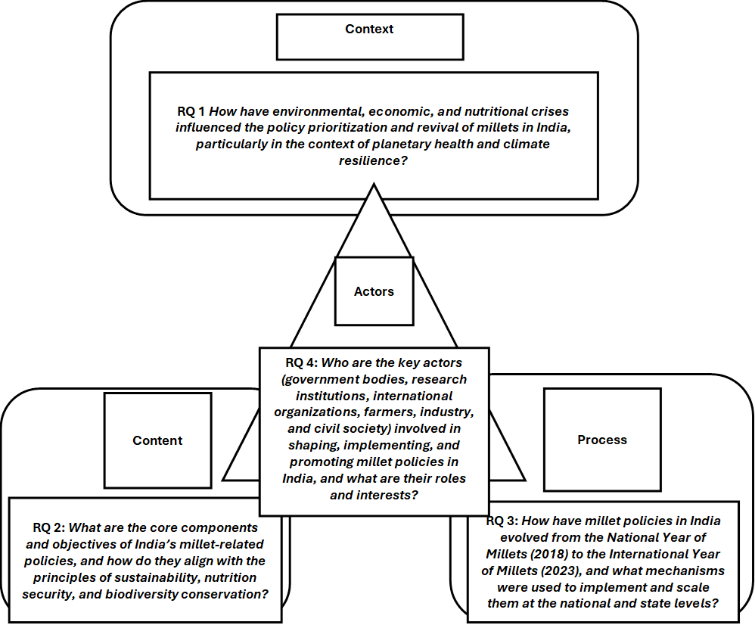
Fig-8 Analytical Framework Using Walt & Gilson’s Policy Triangle Model to guide Policy analysis for millet-related policies in India
Source: Adapted by author from Walt & Gilson (1994), contextualized for this study.
4.4 Unpacking Policy Components with the Policy Triangle Approach
RQ1: Context- Millets at the Intersection of Environmental, Economic, and Nutritional Crises
India’s renewed millet movement is shaped by converging environmental, economic, and nutritional crises. Water-intensive farming under the Green Revolution led to ecological degradation, including soil fertility loss and groundwater depletion (Swaminathan & Bhavani, 2013). Millets, being low-input and climate-resilient, emerged as ideal candidates for sustainable agriculture (FAO, 2021).
Economically, smallholder farmers have suffered due to volatile markets and high cultivation costs of rice and wheat. Millets offer a low-risk alternative, especially in rainfed regions (ICRISAT, 2020).

RQ2: Content- Evolution of India’s Millet Policies
Firstly, efforts have been made by the government over the years to revive millet cultivation like distributing seeds that are much better, training for farmers on agro economic context and integration into government schemes like NFSM, which has a sub mission focused on millets. Secondly, millets are been integrated into Welfare programs to improve the security of nutrition.
Thirdly, making use of the PLISMBP scheme to encourage market reach and value chain growth. This focuses on increasing the FPOs and promotion of Ready –to- Eat and Ready –To- Cook products (MoFPI, 2023). Fourthly, the policy shift now is counteracting the tendency towards monoculture (ICRISAT, 2022). Lastly, Research and Development by organisations like ICAR and IIMR is done to mainstream millets. Such efforts are commendable. These have played an important role in improving the varieties of millets, and processing technicalities. However implantation hurdles persist (ICAR-IIMR, 2021).

RQ3: Process - Policy Formulation and Implementation Mechanisms
Top- down and bottom- up approach are used in India to carry out policy implementation. For reference in Orissa and Karnataka, millets were promoted and embraced too under decentralised procurement frameworks and millets were included in the ICDS and PDS schemes. This approach permitted states to customise procurement, storage and delivery services to local conditions (MoCAFPD, 2022)
These missions were grounded in the socio-ecological realities of each state and focused on tribal inclusion, climate-resilient agriculture, and decentralized processing (WASSAN, 2023; Government of Karnataka, 2021; Government of Chhattisgarh, 2022).
The government also adopted digital and behavioural strategies, including mass awareness campaigns, millet recipe contests, and international millet trade expos. These campaigns aimed to reshape public perception and enhance millet acceptability among urban consumers (FSSAI, 2023).
Further, the policy process was supported by collaborations with civil society organizations, startups, and private food processors, who played a key role in developing scalable, market-ready millet products and supply chain models. These partnerships brought innovation into millet marketing, processing, and community engagement (NABARD, 2022).
Crucially, research institutions such as ICAR-IIMR have provided the backbone for policy implementation through initiatives like the ‘Millet Revolution’, which disseminates high-yielding cultivars and sustainable farming techniques to farmers via Krishi Vigyan Kendras (KVKs) and mobile advisory platforms (ICAR, 2021; ICAR-IIMR, 2021).
Collectively, these inter-ministerial, community-based, and science-led processes have transitioned millet promotion from isolated pilot efforts to a system-wide, multi-stakeholder movement. However, disparities in inter-state implementation capacity and inconsistent funding allocation still pose challenges to sustained mainstreaming.
RQ 4: Actors- Mapping the Multi-Stakeholder Ecosystem Driving India’s Millet Policy Landscape
The millet policy ecosystem in India is shaped by a diverse constellation of actors, each playing distinct yet interlinked roles in the formulation, implementation, and advocacy of millet-centric strategies. These actors contribute distinct institutional capacities and agendas to the developing millet movement, operating at various levels from local to global.
IIMR and Nutrihub: Building the Millet Innovation
The Government of India has named the Indian Institute of Millets Research (IIMR), which operates under the auspices of the Indian Council of Agricultural Research (ICAR), the Global Centre of Excellence for Millets (ICAR-IIMR, 2023). IIMR has led important studies on post-harvest technologies, biofortification, and varietal improvement. Its technology incubation center, Nutrihub, functions as a business incubator fostering millet-based start-ups across the country. More than 120 millet-based product launches, including snacks, breakfast cereals, flours, and instant mixes, have been facilitated by Nutrihub as of 2024, and the company has assisted more than 350 start-ups (Nutrihub, 2024). These innovations bridge the gap between traditional crops and modern consumer preferences, making millets aspirational for urban markets. Through fund-of-funds mechanisms, mentorship networks, and buyer-seller meetings arranged by APEDA and Nutrihub, the government has helped the startup ecosystem flourish.
India's global millet advocacy efforts have received support from international organizations like the Food and Agriculture Organization (FAO), particularly during the International Year of Millets 2023.

Challenges in the Millet Value Chain: From Seeds to Shelf
Concerns regarding ecological resilience and genetic erosion have arisen as a result of high-yielding hybrids replacing a variety of local millet landraces at the farm level (ICRISAT, 2022). Moreover, the absence of assured procurement policies beyond select states disincentivizes farmers from allocating larger land area to millets.
The lack of primary processing centers at the farm gate such as dehullers, sorters, and solar dryers creates logistical bottlenecks, especially for minor millets that require multiple steps for processing (MoFPI, 2023). Without decentralized infrastructure, farmers rely on distant processing units, leading to quality loss and higher transportation costs. Further, millets’ low shelf life owing to their unsaturated fat content poses challenges for government procurement under the Public Distribution System (PDS). Bajra and jowar, for example, are highly prone to rancidity if not stored in optimal conditions (ICRISAT, 2021).
On the consumer end, limited awareness and culinary unfamiliarity persist, despite promotional campaigns. While urban demand for health foods is growing, affordability remains a concern for lower-income consumers. According to a FICCI (2023) study, millet-based products often cost 20-30% more than rice or wheat-based alternatives, especially in processed formats. Bridging this price gap will require targeted subsidies, incentives to processors, and consumer education.
Before we get into analysis of gaps and recommendations, let’s dive into a successful state-led model, The Odisha Millets Mission.
It depicts how millet-centric policies can be applied in practicality.

4.5 Case Study: Odisha Millets Mission

Background

Rice production and cultivation has been given more importance in Odisha. But the bad effects of rice monoculture on Nutrition and environment kept growing and the government had to take a call. The OMM was started out in 2017. It focused on reviving millets production, processing and consumption in Odisha’s tribal regions.

Objective of the Mission
The goal of OMM by 2023 is to increase the cultivation of millets upto 2 lakh hectares from 25,000 hectares which was at the start. Odisha could be the Millet hub of India. It has resulted in better dietary diversity, improved health status of people and increased millet production.
Implementation
Three separate phases were used to implement the OMM, each of which focused on a vital component of millet revival:

- Phase 1: Awareness and Capacity Building
Farmer and Consumers awareness about the benefits of millets.
- Phase 2: Enhancing Production and Productivity
Good quality seeds, fertilisers were given. Focus was on improved seed varieties. Farmers got support in agricultural practices like maintain soil health, pest control and post- harvest dealing
- Phase 3: Market Creation and Urban Outreach Increase in Production for market development. Purpose was to create value chains that would consist of processing, packaging, marketing and PPP establishment. Millet on Wheels was initiated using mobile vans to deliver millet- based food to customers.
Impact and Achievements
- Millet cultivation expanded to over 65,000 hectares
- More than 60,000 farmers adopted millet farming, many of them from tribal communities
- A variety of millet-based products- snacks, drinks, baked goods entered both local markets and online platforms

By encouraging the regular consumption of micronutrient-rich millets, the initiative has demonstrated positive nutritional outcomes, particularly for women and children. Additionally, it has supported rural livelihoods, agro-biodiversity, and climate-resilient farming.

Conclusion of the Case Study
This study showed how millets are capable of its revival again, through rural empowerment, sustainability and nutrition.

4.6 Identified Policy Gaps and Recommendations:

Policy Gap Identified | Recommendation | Target Stakeholders
Limited procurement of millets under PDS despite inclusion in NFSA | Expand and enforce procurement mandates for millets at both central and state levels; incentivize states through fiscal support for decentralized procurement. | MoCAFPD( Ministry of Consumer Affairs, Food and Public Distribution), State Civil Supplies Departments.
Inadequate processing infrastructure, especially in rural/tribal areas | Establish decentralized millet processing units and common facility centers with SHG/FPO ownership | MoRD, State Rural Livelihood Missions, NABARD, MSME Ministry.
Low consumer awareness and cultural stigma toward millets | Launch national behaviour change campaigns and millet recipe contests; promote millet-based meals in schools, hospitals, and corporate canteens | FSSAI, MoWCD, MoHFW, MoE
Insufficient R&D investment in high-yielding and climate-resilient millet varieties | Strengthen funding for varietal development and biofortification through ICAR and State Agricultural Universities | ICAR, IIMR, State Agriculture Departments
Poor market linkages and lack of value chain integration | Support millet FPOs with credit, capacity-building, and direct market access; promote contract farming and private sector linkages. Mandate millet products in e-commerce, school canteens, and supermarkets. | SFAC(Small Farmers’ Agribusiness Consortium), APEDA, MoA&FW, State Agriculture Marketing Boards
Limited urban market access and shelf-stable millet products | Incentivize startups under PLISMBP; develop millet-based RTE/RTC products using modern packaging technologies. | MoFPI, Nutrihub, Startup India, State Innovation Councils
Fragmented inter-ministerial coordination | Create a National Millet Coordination Taskforce to ensure convergence across agriculture, nutrition, commerce, and education sectors Create a National Millet Coordination Taskforce to ensure convergence across agriculture, nutrition, commerce, and education sectors. | NITI Aayog, MoA&FW, MoHFW, MoFPI, MoWCD
Weak institutionalization of millet policies at the state level | Encourage states to adopt millet-specific legislation or long-term missions like AP Millets Board Act or Odisha Millets Mission. | State Governments, Legislative Assemblies
Lack of data on millet consumption, production, and nutrition outcomes | Integrate millet tracking into NFHS, NSSO, and ICDS-MIS databases to generate evidence for policy advocacy. | MoHFW, MoSPI, NITI Aayog
Millets not adequately mainstreamed in climate-resilient agriculture frameworks | Embed millets within national climate action plans, agrobiodiversity conservation schemes, and regenerative agriculture policies. | MoEFCC, MoA&FW, ICAR
Source- Made by the author on the basis of secondary analysis of MoA&FW (2023), NITI Aayog (2023), ICAR-IIMR (2022), FAO (2023), FSSAI (2023), and other policy reports.
The identified policy gaps are linked to actionable measures down below.
4.7a: Strategic Policy Roadmap for Advancing Millet Integration into Sustainable Food Systems in India
Stage | Action Required | Stakeholders | Expected Outcome
Short- Term | Expand decentralized millet procurement | State government, FPOs | More Tribal Millet farmers integrated into PDS
Mid- Term | Invest in Processing & Cold infrastructure | MoFPI, SHGs | Lower post- harvest losses and better product quality
Long- Term | Integrate Millets into dietary guidelines & food labelling laws | FSSAI, MoHFW | Shift in public dietary behaviour and urban adoption
Source: Developed by author based on gaps identified in literature and policy reports from MoA&FW, FAO, and ICAR (2023).

4.7b: Gap-Based Implementation Roadmap for Millet Mainstreaming in India

Gap Addressed(Linked to Table 4.6) | Strategic Action Steps | Timeline | Lead Stakeholders
Limited procurement under PDS | Expand decentralized procurement in millet-rich states; update PDS guidelines | Short-term | MoCAFPD, State Civil Supplies Depts
Inadequate processing infrastructure | Set up millet processing clusters with SHG/FPO ownership in blocks | Medium-term | MoRD, NABARD, State Agri. Dept.
Low consumer awareness and stigma | Nationwide behaviour change campaigns (media + school curriculums) | Short-term | FSSAI, MoHFW, MoWCD
Low investment in millet R&D | Allocate dedicated millet research funding; incentivize biofortified & climate-resilient varieties | Long-term | ICAR, IIMR, SAUs
Poor market linkages | Support FPOs with aggregation support and millet-specific marketing platforms | Medium-term | SFAC, APEDA, State Agri. Boards
Lack of shelf-stable millet products | PLISMBP expansion; promote innovation for RTE/RTC millet-based food | Short to Medium | MoFPI, Nutrihub, Startups
Weak inter-ministerial coordination | Form a National Millet Taskforce; create shared monitoring indicators | Immediate | NITI Aayog, MoA&FW, MoFPI
Lack of millet-focused state policies | Encourage state millet missions or legislative boards (e.g. AP model) | Medium-term | State Govts, Legislative Assemblies
Inadequate data on millet consumption and impact | Integrate millet tracking into NFHS, NSS, ICDS-MIS, and PDS dashboards | Medium to Long | MoSPI, MoHFW, NITI Aayog
Poor alignment with climate action frameworks | Incorporate millets in NAPCC, PMKSY, and agroecological policy instruments | Long-term | MoEFCC, MoA&FW, ICAR
Sources: Developed by author based on policy analysis and synthesis of recommendations
from MoA&FW(2023), NITI Aayog( 2023), IIMR-ICMR( 2022), and FAO reports(2023).
4.8 The Road Ahead: Future Outlook and Transformative Policy Imperatives
The multifaceted engagement across ministries, research institutions, start-ups, farmer cooperatives, and international agencies has helped re-anchor millets in India’s agricultural and nutritional policy discourse. Yet, to move from isolated interventions to a fully integrated millet economy, the future of policy must evolve from promotional to structural embedding millets within the core design of food systems transformation.
Looking ahead, the establishment of Millet Value Chain Clusters (MVCCs) at the district level represents a strategic imperative. These clusters would integrate key nodes across the millet economy improved seed supply chains, farmer capacity building, decentralized processing infrastructure, and digital traceability thereby closing the loop from farm to fork. Regionally tailored clusters would also address agro-ecological variation, enabling adaptive production models that preserve local biodiversity while improving yields (ICRISAT, 2022).
Research and Development (R&D) investment must be diversified to prioritize minor millets such as little millet, kodo millet, and brown top millet which remain underrepresented in varietal improvement programs despite their ecological and nutritional significance. Increasing allocations for biofortification, drought-resilient hybrids, and participatory breeding programs will ensure equity and resilience across millet species (ICAR-IIMR, 2023).
Storage innovations will also be central to system resilience. Given the susceptibility of millets to rancidity due to their high fat content, particularly in dehusked forms like bajra and jowar, there is a pressing need for affordable shelf-life extension technologies. Vacuum sealing, nitrogen flushing, and improved cold chain logistics must be scaled, especially in procurement-heavy states integrating millets into the Public Distribution System (MoFPI, 2023).
On the demand side, millet integration into national dietary guidelines, institutional catering, and clinical nutrition protocols will help normalize their consumption and drive long-term dietary shifts. For example, millet-specific meal plans can be integrated into guidelines under the National Institute of Nutrition (NIN), POSHAN Abhiyaan, and even hospital-based therapeutic diets (MoHFW, 2023).
Behavioral nudges through millet recipe innovation, culinary contests, and targeted marketing especially by urban millet startups must be coupled with affordability interventions. Millet-based foods remain 20–30% more expensive than rice- or wheat-based alternatives in processed form, creating a cost barrier for economically disadvantaged households (FICCI, 2023). Fiscal incentives for startups, price controls in government programs, and bundling millets with other subsidized food grains could help overcome this hurdle.
A robust monitoring architecture is also required to assess the outcomes of millet schemes. Real-time dashboards, district-level performance scorecards, and outcome-based indicators such as changes in dietary diversity, farmer incomes, and women’s SHG participation would ensure accountability and course correction.
Finally, to sustain momentum beyond celebratory years like the International Year of Millets (2023), policy frameworks must adopt a long-term, whole-of-government and whole-of-society approach. Embedding millets into the mainstream is not simply a matter of production incentives or awareness campaigns, but a reorientation of food systems toward ecological regeneration, nutritional sufficiency, and economic inclusion.
Through sustained structural reforms and systems thinking, millets can truly emerge as the backbone of India’s climate-resilient and nutrition-sensitive agriculture in the decades to come.
4.9 Conclusion
Although millet policies in India are conceptually sound and contextually urgent, systemic, infrastructural, and behavioral gaps hinder their implementation, according to the Policy Triangle Framework. A clear scale-up plan, intersectoral convergence, and persistent political will are necessary for India's millet renaissance.
Policies must go beyond pilots and promotions if millets are to become a mainstay of national diets and climate-resilient agriculture. They need to be incorporated into long-lasting production, perception, and procurement systems. When used properly, millets can be a key component of India's efforts to meet its climate targets, nutrition goals, and inclusive rural development.

Chapter 5
STRATEGIES TO ENHANCE THE PROMOTION OF MILLETS IN INDIA
To revive millet consumption and production in India, a comprehensive multi-pronged strategy is essential. This involves not only increasing awareness among consumers but also providing robust institutional and policy support across the value chain from farm to fork.
One of the foremost strategies is to amplify public awareness through coordinated campaigns that showcase the health, nutritional, and environmental benefits of millets. Leveraging mass media and social media platforms can play a pivotal role in reshaping consumer perceptions and positioning millets as aspirational and modern (NITI Aayog, 2023). Celebratory events like ‘Millet Day’ in schools, colleges, and community settings can further help educate younger generations and embed millet awareness early in life (FAO, 2023).
The integration of millets into national nutrition programs, such as the Mid-Day Meal Scheme and Integrated Child Development Services (ICDS), serves as a powerful vehicle for normalization. Ensuring regular inclusion of millet-based meals in school and anganwadi menus not only improves nutritional intake but also creates steady demand for millet production (Ministry of Women and Child Development, 2022). Capacity building for school authorities and anganwadi workers in terms of millet preparation techniques and nutritional knowledge - is crucial for effective implementation (ICAR, 2021).
To incentivize production at the grassroots level, the government must offer financial support to farmers, particularly through assured Minimum Support Prices (MSP) and procurement mechanisms.
Furthermore, innovation in value-added millet products such as snacks, breakfast cereals, and ready-to-cook meals can enhance marketability and meet modern dietary preferences (FSSAI, 2023).
The lack of processing infrastructure remains a significant bottleneck. Establishing millet processing clusters through public-private partnerships can improve post-harvest value addition and local entrepreneurship (APEDA, 2023). Training programs for rural youth and women’s groups especially Self-Help Groups (SHGs) and Farmer Producer Organizations (FPOs) in branding, processing, and marketing of millet products can further empower communities and promote decentralized growth (NABARD, 2022).
On the global front, there is significant scope for export promotion and branding. With growing international demand for gluten-free and sustainable foods, India can be positioned as the “Millet Capital of the World.” This requires targeted investments in export-quality packaging, certification, and branding aligned with international standards (MoCI, 2023). India's agro-export profile can be raised by entering the health food market, which will also help local millets gain international recognition.
Finally, mainstreaming millets in the Public Distribution System (PDS) and urban retail chains can ensure equitable access and affordability. Their inclusion in PDS is already being piloted in states like Karnataka, Odisha, and Chhattisgarh under state millet missions (MoCAF&PD, 2023). Furthermore, encouraging the availability of millet through supermarkets, internet resources, and institutional canteen requirements can normalize its consumption among middle-class and urban populations (FAO & WHO, 2023). When combined, these tactics provide a comprehensive plan for turning millets from a marginalized crop group into a widely accepted option for rural livelihoods, climate resilience, and nutritional security.

Chapter 6
DISCUSSION

Reimagining Millets for Planetary Health and Policy Transformation
The preceding chapters showed how millet promotion is becoming a top policy priority in India, with a focus on rural empowerment, nutrition, and sustainability. This chapter summarizes the main findings from the policy and planetary analyses, emphasizing both areas that require more attention and those that have been accomplished.
6.1 Voices from the Ground: Using millets to empower Women
Kandhamal Self-Help Group (SHG) member Rekha Devi considers this change: "We hardly made enough before the mission." Together with my SHG sisters, I currently own a millet café. We serve dignity and health. OMM (2023). Her experience serves as a prime example of how millet policies have opened doors for women's empowerment at the grassroots level by tying economic security, dignity, and health together. Rekha participated in a program that enabled rural women to lead local value chains through millet-based businesses as a member of a women's Self-Help Group (SHG) in Kandhamal, Odisha, a district with a tribal majority.
The OMM gave gender-inclusive livelihood development top priority in addition to encouraging the production of indigenous millets in a climate-resilient manner. In an industry that has historically been marginalized, women like Rekha were able to co-create respectable jobs through targeted capacity-building, access to revolving funds, community kitchens, and procurement links.
These days, SHG-run millet cafés and food kiosks offer wholesome meals, encourage dietary diversity, and challenge societal views of millet as a "poor man's grain." They are emblems of grassroots entrepreneurship.
Their efforts promote public health objectives and local economies while elevating women as planetary health agents.

6.2 Synthesizing the Policy Triangle: Systemic Strengths and Weaknesses
The Policy Triangle Framework makes it clear that although millet policies have had ambitious content- from scheme integration to rebranding, the context is still a major limitation. Rice and wheat are still given priority by enduring legacy biases from the Green Revolution era, which have an impact on infrastructure development, consumer behavior, and public procurement.
Significant differences between states are revealed by the process dimension. Missions in Chhattisgarh, Karnataka, and Odisha show that participatory, decentralized models work better than top-down initiatives. However, because of fragmented execution, limited convergence, and institutional inertia, other states fall behind.
Although they are varied and competent, actors from various sectors from ministries and FPOs to SHGs and start-ups lack unified coordination. The analysis emphasizes the necessity of a cohesive millet ecosystem with specialized implementation capacity and stronger inter-ministerial ties. Insights from both frameworks are combined in the thematic synthesis shown in the above table, which also identifies systemic advantages and disadvantages as well as strategic levers for increasing millet adoption in India's food systems.
6.3 The Planetary Fit: Ecological Promise and Policy Gaps
The Planetary Boundaries Framework's application demonstrates that millets are naturally compatible with ecological resilience.

6.4 Mainstreaming Millets: Turning Vision into Action
Tribal communities, women-led businesses, and Self-Help Groups (SHGs) are essential to the production, distribution, and processing of millet. By putting these stakeholders at the center, community-led resilience and equitable participation are guaranteed.

Immediate action is required to close the awareness-accessibility gap. Even though public awareness campaigns have increased knowledge, millet-based foods are still difficult to find in many institutional and urban settings. This gap can be closed and millet consumption normalized by increasing its availability through stores, internet marketplaces, and government agencies like school canteens.

Also, a change in policy metrics is necessary. Agricultural policy must adopt a systems-thinking approach that places a higher priority on resilience, biodiversity, and ecological regeneration than it does on yield outputs and monocultural efficiency. Millets are stepping stones to a sustainable future, not just crops. Bold measures are needed to realize this potential and integrate them into India's food and nutrition narrative from the periphery.

6.5 Limitations of the Study and Future Directions
Although this thesis makes use of extensive secondary data, primary fieldwork could provide additional context for the application of millet policy. Future research could examine: Adoption trends at the household level in states that support millet Impact of millet inclusion in PDS and MDM schemes over time comparative frameworks for evaluating millets in Latin America, Southeast Asia, and Africa
6.6 The Final Word: A Future Rooted in Resilience
The future of India's millet renaissance hinges on a shift in our perceptions of resilience, diversity, and equity in food systems. Millets provide a silent revolution. Public will, planetary awareness, and policy ambition will determine whether they remain on the periphery or gain prominence.

Chapter 7
CONCLUSION
7.1 Millets and the Road to Achieving the Sustainable Development Goals
The Sustainable Development Goals (SDGs) are a universal set of 17 goals adopted by the United Nations in 2015 as part of the 2030 Agenda for Sustainable Development. These goals provide a blueprint for achieving a better and more sustainable future for all, addressing global challenges such as poverty, inequality, climate change, environmental degradation, peace, and justice. Millets have an impact on 7 SDGs out of the 17.
Each SDG is interconnected, emphasizing the need for integrated approaches that balance social, economic, and environmental dimensions of development. 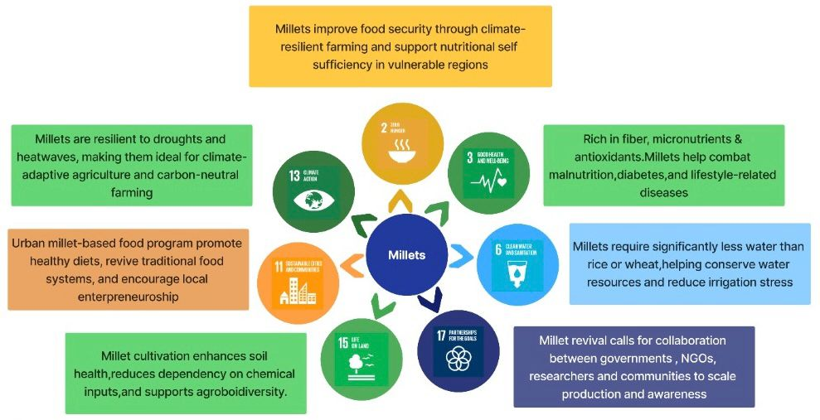

Fig-9 Millets: A Catalyst to Achieving Seven Sustainable Development Goals
Source: Developed by author using information from the United Nations SDG Framework, ICRISAT (2022), FAO (2023), and ICAR-IIMR (2023).

7.2 Millets impact on Economy, Health and Environment

7.2.1 Health Impact
- Nutrient-Rich: They are rich in Vitamin B, iron, zinc, calcium and magnesium.
- Combating NCDs: They prevent the occurrence of obesity, diabetes, and cardiovascular diseases.
- Tackling malnutrition in Vulnerable population
- Gluten-Free Substitute: Ideal for people with celiac disease or gluten intolerance.
- Better Gut Health: A high fibre diet helps with digestion and lowers the risk of gastrointestinal problems.
7.2.2 Environmental Impact
- Require less water: Millets require 70% less water than paddy.
- Climatic Resilience: They can very well thrive in dry regions and very high temperatures.
- Reduced Carbon Footprint: Require chemical fertilizers and pesticides and lead to reduced emission of greenhouse gases.
- Improved Soil Health: Millets help to preserve the health of the soil.

7.2.3 Economic Impact
- Support to Small Farmers: Millets provide high return on investment for marginalised farmers.
- Rural and Women empowerment: Millet run cafes are now being opened especially by women.
- Public Procurement and Inclusion: Integration into Public Distribution System (PDS), midday meals, and ICDS programs.
The Venn diagram showcases the inter relationship between Health, Economy and Environment and how millets are good for us, the economy and the planet.
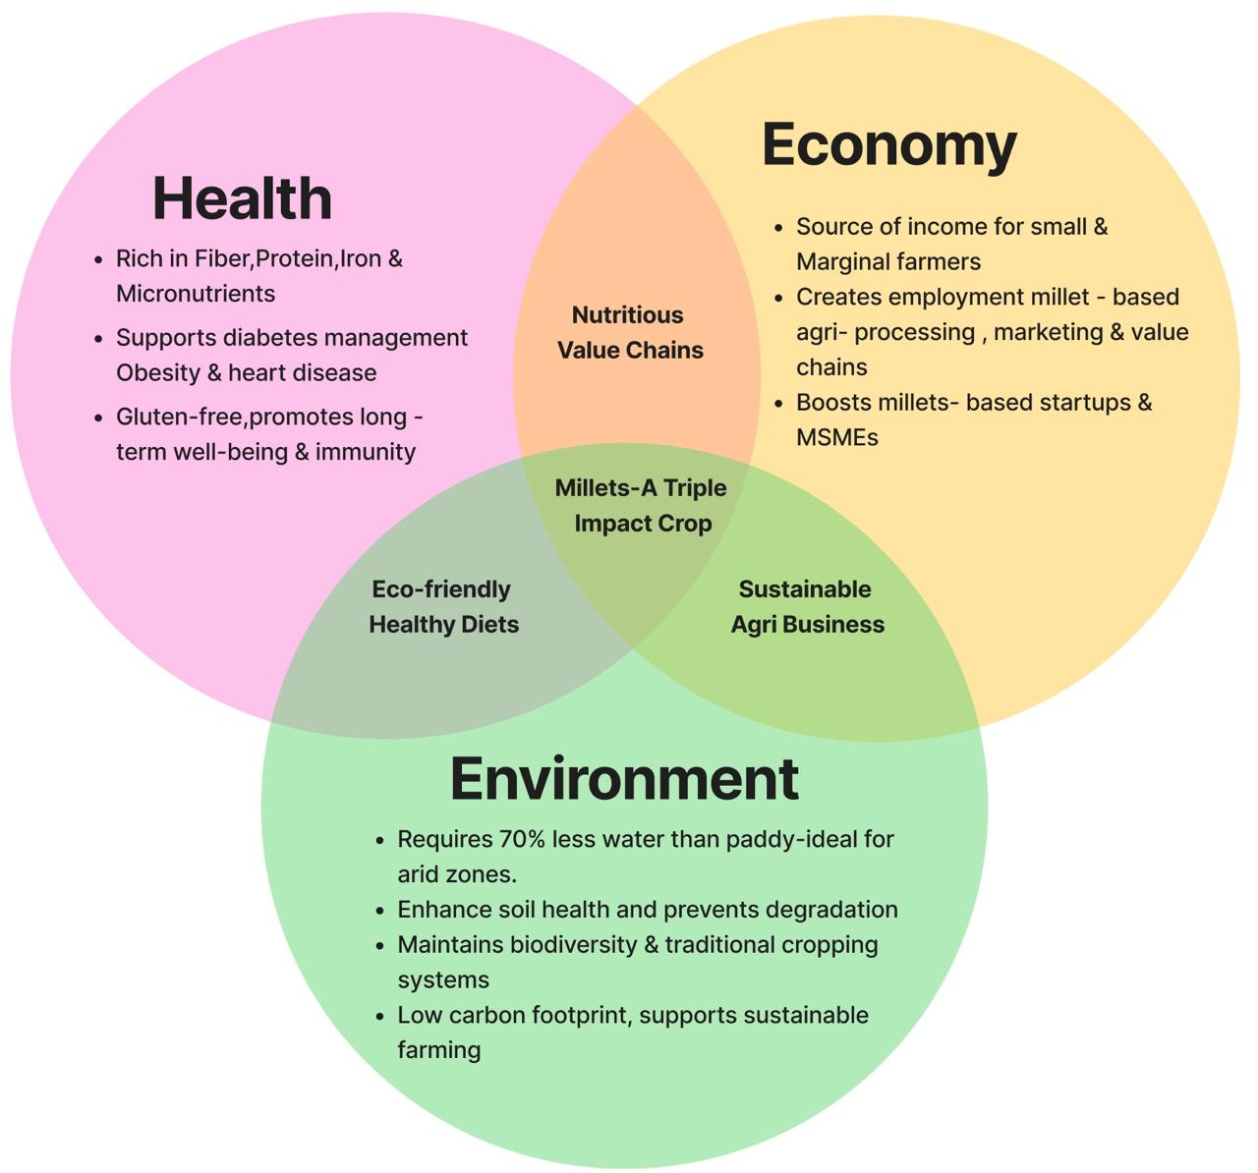

Fig-10: Millets- A Triple Win for Health, Economy and Environment
Source: Made by author on the basis of sources from Ministry of Agriculture & Farmers Welfare reports, FAO (2023), ICRISAT (2022), ICAR-IIMR (2023), and FSSAI (2023).
Food in the future needs to be nutrient-dense, culturally anchored, and climate resilient. According to this vision, millets are seeds for a sustainable future rather than a holdover from the past.
Millets are not just food, they are systems interventions. They represent an opportunity to create a future where climate resilience, biodiversity, food equity, and economic justice intersect. The real question is not whether millets can solve our problems- but whether our policies and societies are ready to let them.
In this context, the title ‘Seeds of Sustainability’ is not poetic flourish- it is policy truth. Millets represent the very seeds from which ecological renewal, nutritional equity, and rural empowerment can sprout. By positioning them at the ‘core of planetary health agenda’, this thesis offers not an idealistic vision, but an evidence-based imperative. Millets are no longer marginal, they are mission-critical. This framing reclaims their rightful place in the global food discourse- as agents of change in a world hungry for sustainable solutions.

Bibliography:
- Satyavathi CT, Ambawat S, Khandelwal MK, Srivastava RK. Pearl millet: a climate-resilient nutricereal for mitigating hidden hunger and providing nutritional security. Front Plant Sci [Internet]. 2021 Sep 13 [cited 2025 Jun 20]; 12:659938. Available from: https://www.ncbi.nlm.nih.gov/pmc/articles/PMC8475763/
- Muthamilarasan M, Prasad M. Small millets for enduring food security amidst pandemics. Trends Plant Sci [Internet]. 2021 Jan; 26(1):33–40 [cited 2025 Jun 20]. Available from: https://pubmed.ncbi.nlm.nih.gov/32900620/
- Jacob JT, Krishnan S, Antony U, Bhavyasri V, Aruna M, Mishra FH, Nepolean T, Satyavathi CT. The nutrition and therapeutic potential of millets: a comprehensive review. Food Sci Nutr [Internet]. 2024 [cited 2025 Jun 20]; 12(1):999–1012. Available from: https://pubmed.ncbi.nlm.nih.gov/38746941/
- Ministry of Agriculture and Farmers Welfare. Pradhan Mantri Fasal Bima Yojana: Operational Guidelines (Revised) [Internet]. New Delhi: Ministry of Agriculture & Farmers Welfare; October 2018 [cited 2025 Jun 20]. Available from: https://pmfby.gov.in/pdf/Revised_Operational_Guidelines.pdf
- APEDA. Annual Report on Millet Promotion and Export Strategy 2023-24 [Internet]. New Delhi: Agricultural and Processed Food Products Export Development Authority; 2024 [cited 2025 Jun 20]. Available from: https://apeda.gov.in/sites/default/files/annual_report/APEDA_Annual_Report_English_2023-24.pdf
- Indian Council of Agricultural Research. Annual Progress Report: AICRP on Small Millets and Sorghum (2019–20) [Internet]. Bengaluru: ICAR-AICRP on Small Millets; 2020 [cited 2025 Jun 20]. Available from: https://www.millets.res.in/aicsip19/Small_Millets/report19/1-SM-Breeding-Kharif-Report-agm20.pdf
- International Crops Research Institute for the Semi-Arid Tropics (ICRISAT). Advancing the mainstreaming of millet in Odisha’s agrifood system: policy brief [Internet]. Patancheru (IN): ICRISAT; 2024 Dec [cited 2025 Jun 20]. Available from: https://oar.icrisat.org/12919/1/Odisha_Millet%20Policy%20Brief.pdf
- Revitalizing Rainfed Agriculture Network (RRA Network). Procurement of millets in Odisha: lessons and challenges. Policy Brief PB1RRAN0121 [Internet]. Bhubaneswar (IN): RRA Network; 2021 Jan [cited 2025 Jun 20]. Available from: https://vikalpsangam.org/wp-content/uploads/2014/05/Odisha-Millets-Policy-Brief-LEISA.pdf
- ICRISAT. Millets for Nutrition and Climate Resilience: Research Strategy 2022–2027 [Internet]. Hyderabad (IN): International Crops Research Institute for the Semi-Arid Tropics; 2022 [cited 2025 Jun 20]. Available from: https://oar.icrisat.org/13166/1/ICRISAT%20Annual%20Report%202022.pdf
- Government of Karnataka, Department of Agriculture. Organic Farming and Millets Programmes (Raitha Siri Scheme) [Internet]. Bengaluru (IN): Government of Karnataka; 2019 [cited 2025 Jun 20]. Available from: https://raitamitra.karnataka.gov.in/storage/pdf-files/eng1920.pdf
- Pavan R, Paramesh S. Millets: a nutritional powerhouse for ensuring food security [Internet]. ResearchGate; 2023 [cited 2025 Jun 20]. Available from: https://www.researchgate.net/publication/384189977_Millets_a_nutritional_powerhouse_for_ensuring_food_security
- Chandrasekhar A, Mishra S. Health benefits of millets and their role in preventing non-communicable diseases. J Med Life Sci [Internet]. 2024 [cited 2025 Jun 20]. Available from: https://pmc.ncbi.nlm.nih.gov/articles/PMC11091339/
- NABARD. International Year of Millets 2023 [Internet]. Mumbai: NABARD; 2023 [cited 2025 Jun 20]. Available from: https://www.nabard.org/international-year-of-millets-2023.aspx
- Basavaraju A, Shankara MH, Vinay Kumar R, Kiran S, Mohan Kumar TL, Savitha CM. A comprehensive review of constraints and suggestions in minor millet production and marketing. Int J Agric Extension Soc Dev [Internet]. 2024 Aug; 7(8):473–476. Available from: https://www.researchgate.net/publication/385720502_Production_Trend_Constraints_and_Future_Strategies_of_Millets_in_Odisha
- Vikaspedia. Chhattisgarh Millet Mission [Internet]. New Delhi: NIC; [cited 2025 Jun 20]. Available from: https://health.vikaspedia.in/viewcontent/health/nutrition/state-missions-and-initiatives-to-promote-millets/chhattisgarh-millet-mission?lgn=en
- The Business Research Company. Millets Market Size, Trends and Global Export Potential by 2025 [Internet]. 2023 [cited 2025 Jun 20]. Available from: https://www.thebusinessresearchcompany.com/report/millets-global-market-report#:~:text=Millets%20Market%20Size%202025%20And,(CAGR)%20of%205.9%25
- Government of Andhra Pradesh. The Andhra Pradesh Millets Board Act, 2020 [Internet]. New Delhi: India Code; 2020 [cited 2025 Jun 20]. Available from: https://www.indiacode.nic.in/bitstream/123456789/15194/1/the_andhra_pradesh_millets_board_act_2020-converted.pdf
- Rao K, Sharma R. A study on the economic and health benefits of millets [Internet]. ResearchGate; 2023 [cited 2025 Jun 20]. Available from: https://www.researchgate.net/publication/379654282_A_STUDY_ON_THE_ECONOMIC_AND_HEALTH_BENEFITS_OF_MILLETS
- Ministry of Food Processing Industries (India). Operational guidelines on Production Linked Incentive Scheme for Millet-Based Products (PLISMBP) [Internet]. New Delhi (IN): MoFPI; 2022 Nov [cited 2025 Jun 20]. Available from: https://www.mofpi.gov.in/sites/default/files/operation_guidelines_on_production_linked_incentive_scheme_for_millet_based_products_0001_0.pdf
- Indian Institute of Millets Research (ICAR-IIMR). Annual report 2022–23 [Internet]. Hyderabad (IN): ICAR-IIMR; 2023 [cited 2025 Jun 20]. Available from: https://www.millets.res.in/annual_report/ar22-23.pdf
- Ministry of Women and Child Development (India). POSHAN Abhiyaan: First progress report [Internet]. New Delhi (IN): NITI Aayog; 2020 [cited 2025 Jun 20]. Available from: https://www.niti.gov.in/sites/default/files/2020-02/POSHAN_Abhiyaan_first_progress_report_6_Feb_2019.pdf
- Nutrihub-TBI @ ICAR-IIMR. Nutrihub innovation highlights report 2023–24 [Internet]. Hyderabad (IN): Nutrihub; 2024 [cited 2025 Jun 20]. Available from: https://www.icrisat.org/storage/file-managers/file-66f654f1614ca3.48559673.pdf
- Ministry of Rural Development (India). Empowering rural enterprises through SHGs and FPOs: NABARD impact report 2022–23 [Internet]. New Delhi (IN): MoRD; 2023 [cited 2025 Jun 20]. Available from: https://www.nabard.org/auth/writereaddata/tender/1804243435nabard-impact-report-22-23.pdf
- Agri-business ecosystem of Farmer Producer Organizations [Internet]. Hyderabad (IN): National Institute of Agricultural Extension Management; 2022 [cited 2025 Jun 20]. Available from: https://www.manage.gov.in/fpoacademy/reports/Agri-business%20ecosystem%20of%20FPOs.pdf
- ICAR-National Institute of Agricultural Economics and Policy Research. Farmer Producer Organizations in India: Challenges and Prospects (Policy Paper 40) [Internet]. New Delhi: ICAR-NAEPR; 2023 [cited 2025 Jun 20]. Available from: https://ageconsearch.umn.edu/record/344991/files/pp40.pdf
- NITI Aayog. Promoting millets in diets: Best practices across States and Union Territories of India [Internet]. New Delhi (IN): NITI Aayog; 2023 Jul [cited 2025 Jun 20]. Available from: https://www.niti.gov.in/sites/default/files/2024-07/Report-on-Promoting-Best-practices-on-Millet-26_4_23.pdf
- Stockholm Resilience Centre. Planetary Boundaries Framework [Internet]. Stockholm: SRC; [cited 2025 Jun 20]. Available from: https://www.stockholmresilience.org/research/planetary-boundaries.html
- Down to Earth. Millets in PDS: A Game Changer for Combating Malnutrition and Climate Change [Internet]. 2024 [cited 2025 Jun 20]. Available from: https://www.downtoearth.org.in/food/millets-in-pds-a-game-changer-for-combating-malnutrition-climate-change-87350
- UNEP. Millets: Small Grains, Big Impact in Climate Action [Internet]. Nairobi (UNEP); 2024 [cited 2025 Jun 20]. Available from: https://www.researchgate.net/publication/384206763_Millets_Small_Grains_Big_Impact_in_Climate_Action
- The Rockefeller Foundation–Lancet Commission on Planetary Health. Safeguarding human health in the Anthropocene epoch: report of The Rockefeller Foundation–Lancet Commission on planetary health. Lancet. 2015; 386(10007):1973–2028. doi:10.1016/S0140-6736(15)60901-1. Available from: https://www.thelancet.com/journals/lancet/article/PIIS0140-6736(15)60901-1/fulltext
- United Nations Environment Programme (UNEP). Technologies for climate change mitigation – agriculture sector [Internet]. Roskilde (DK): UNEP Risø Centre; July 2012 [cited 2025 Jun 20]. Available from: https://orbit.dtu.dk/files/10267141/Technologies_for_Climate_Change_Mitigation_Agriculture_for_upload.pdf
- Swaminathan MS. Millets and pseudocereals: a treasure for climate-resilient agriculture ensuring food and nutrition security [Internet]. ResearchGate; 2023 [cited 2025 Jun 20]. Available from: https://www.researchgate.net/publication/381361801_Millets_and_pseudocereals_A_treasure_for_climate_resilient_agriculture_ensuring_food_and_nutrition_security
- Ghatak A, Chaturvedi P, Nagler M, Roustan V, Lyon D, Bachmann G, et al. Pearl Millet: a climate-resilient nutricereal for mitigating hidden hunger and providing nutritional security. Frontiers in Nutrition [Internet]. 2021 Jul 4 [cited 2025 Jun 20]; 10:1198023. Available from: https://pubmed.ncbi.nlm.nih.gov/34589092/
- Chaturvedi P, Govindaraj M, Weckwerth W. Sorghum and pearl millet as climate-resilient crops for food and nutrition security. Front Plant Sci [Internet]. 2022 Mar 11 [cited 2025 Jun 20]; 13:851970. Available from: https://pubmed.ncbi.nlm.nih.gov/35360320/
- Jacob JT, Krishnan S, Antony U, Bhavyasri V, Aruna M, Mishra FH, et al. Promoting millets: charting a journey from food security to health. Indian J Community Med [Internet]. 2024 [cited 2025 Jun 20]; 49(5):665–668. Available from: https://pubmed.ncbi.nlm.nih.gov/38425966/
