Dissertation Report
at
Piramal Swasthya Foundation

(March 3rd – June 3rd,2025)
A Report
By
Nikhil Kumar
PG/23/073
On
Pattern and Determinants of Complementary Feeding Practices among children aged 6-23 months.
Under guidance of
DR. Sukesh Bhardwaj
PGDM (Hospital and Health Management)
2023-2025

International Institute of Health Management Research, New Delhi

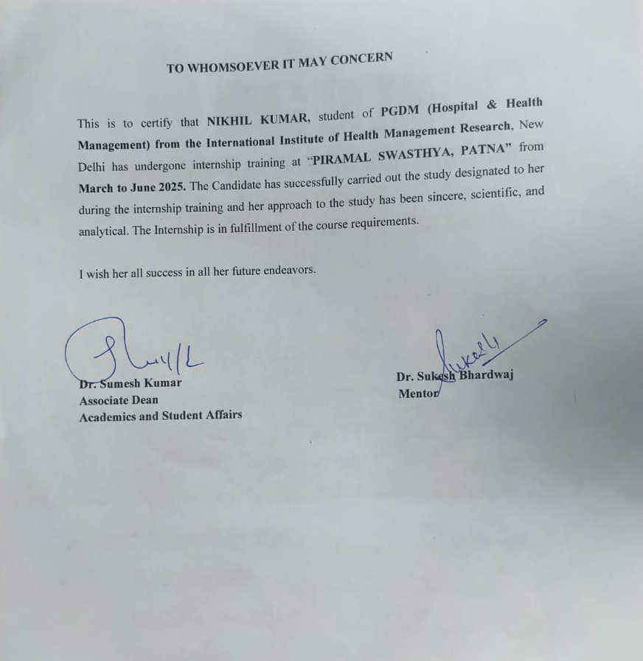

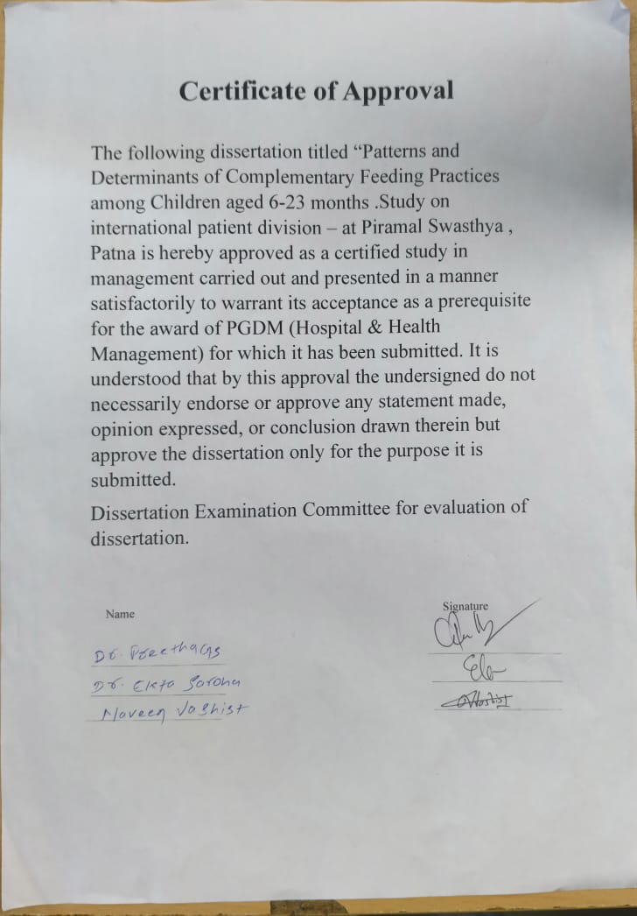

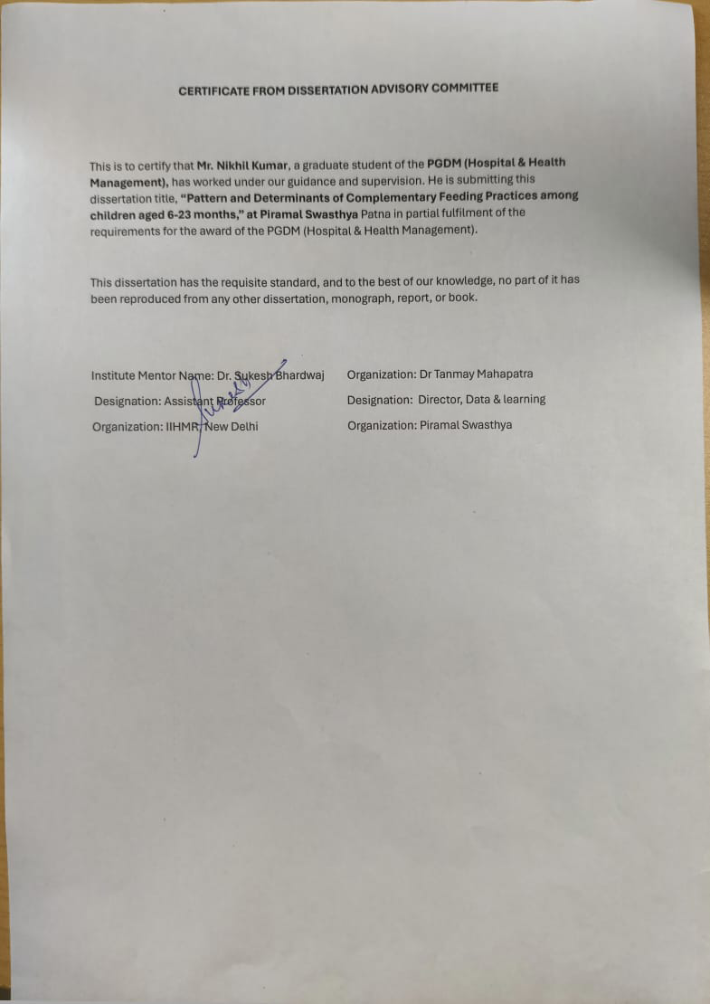

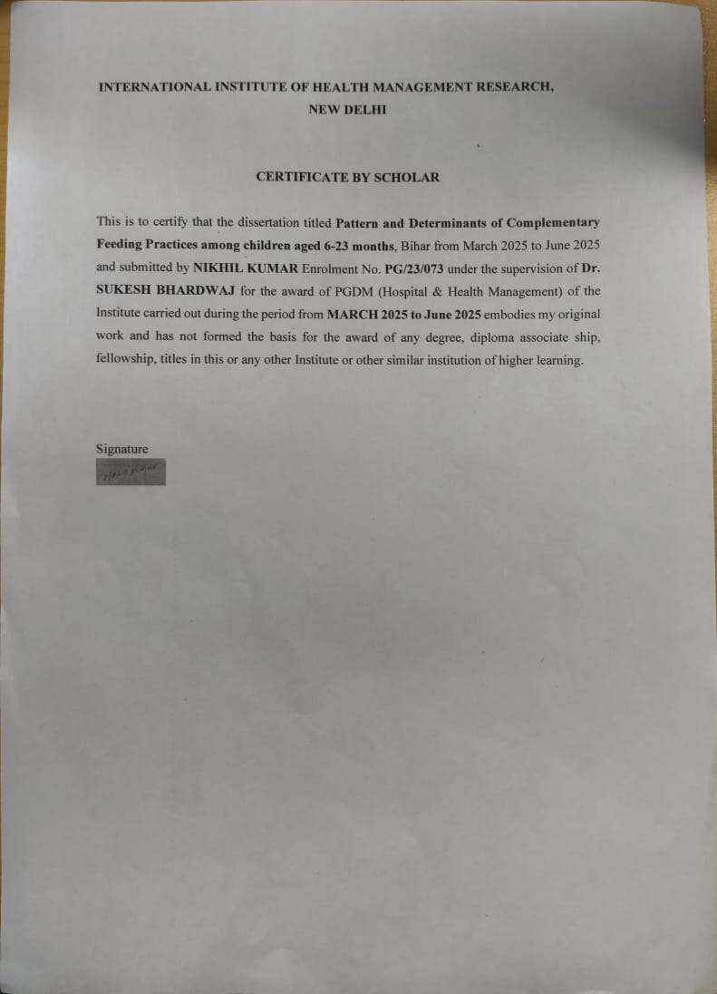

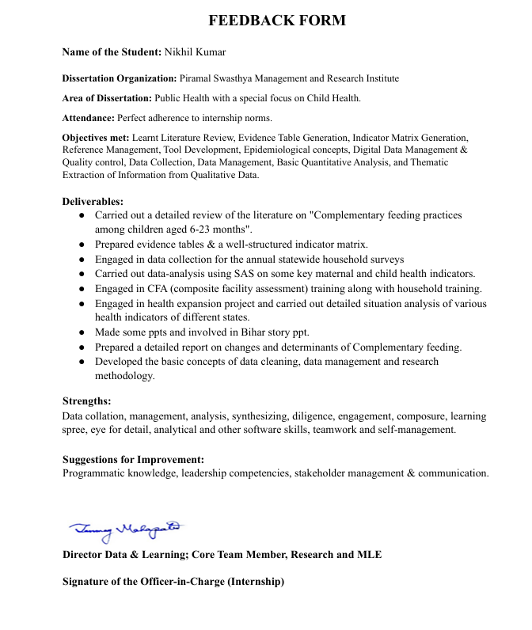

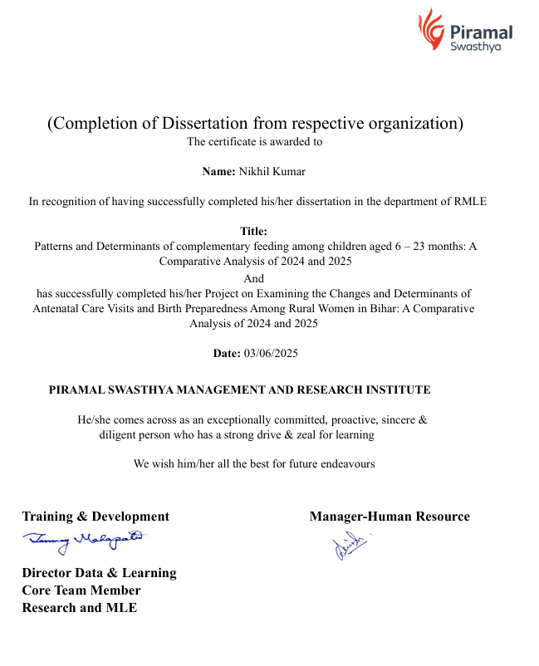

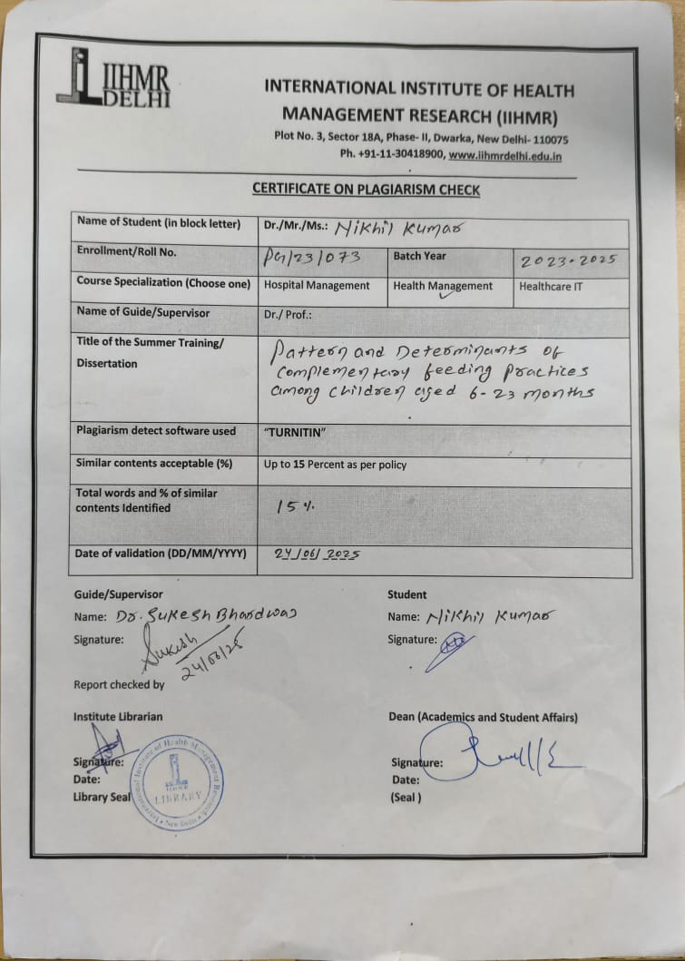

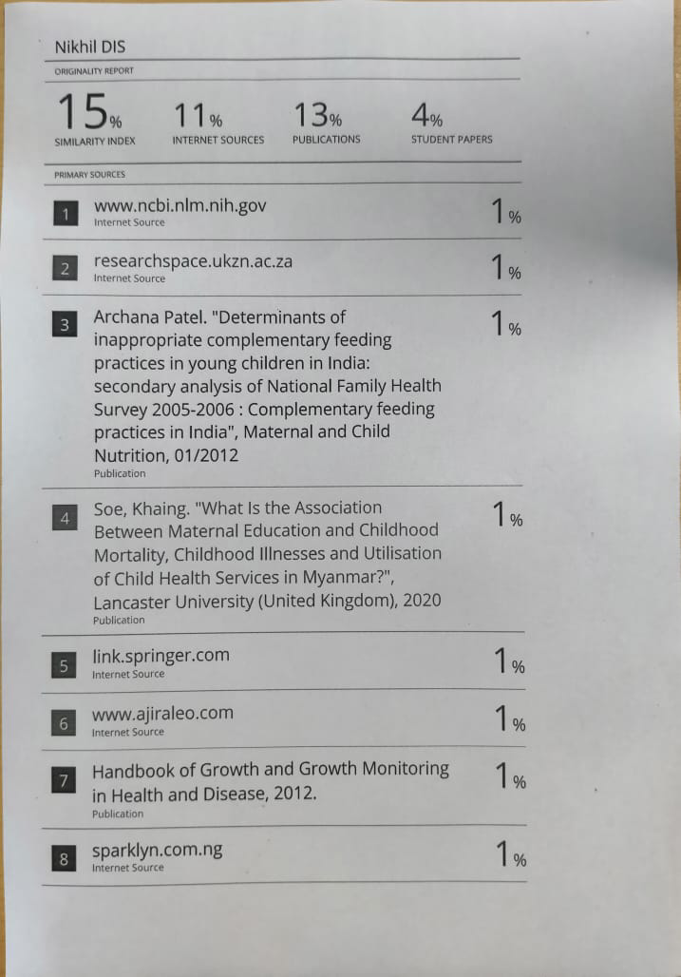
Abstract
Building on the detailed abstract, this extended overview delves deeper into the context, challenges, and significance of examining complementary feeding practices among children aged 6–23 months in Bihar. Complementary feeding (CF)—the introduction of solid and semi-solid foods alongside breast milk starting at six months—is a pivotal phase in a child’s nutritional journey, crucial for meeting the escalating energy and micronutrient needs necessary for optimal growth, immunity, and cognitive development. Inadequate or delayed CF, as well as nutritionally poor diets, are directly linked to growth faltering, stunting, wasting, and developmental delays, outcomes that are particularly prevalent in low-resource settings.
Globally, improving CF practices is central to achieving the Sustainable Development Goals (SDGs), especially those targeting hunger and health. Despite WHO and UNICEF guidelines, millions of children in low- and middle-income countries, including India, continue to suffer from poor infant and young child feeding practices, contributing to a significant burden of undernutrition1. India, with the world’s largest population of undernourished children, faces acute challenges in this domain. According to NFHS-5 (2019–21), only 45.9% of Indian children aged 6–8 months receive timely CF, and just 11.3% of those aged 6–23 months meet the minimum acceptable diet (MAD) criteria—figures that are even lower in Bihar. Bihar, one of India’s most populous and socioeconomically disadvantaged states, exhibits some of the country’s worst child nutrition indicators. Only 42.1% of infants receive timely CF, and a mere 9.6% meet the MAD standard, reflecting widespread deficiencies in both feeding frequency and dietary diversity. The prevalence of stunting (42.9%) and wasting (22.4%) among children under five further underscores the chronic and acute malnutrition endemic to the state. These alarming statistics are rooted in deep-seated poverty, food insecurity, maternal illiteracy, early marriage, adolescent pregnancies, and entrenched cultural practices that hinder optimal feeding.
The rural majority in Bihar faces additional barriers, including limited access to diverse and nutritious foods, low maternal literacy, and pervasive traditional beliefs that often prioritize inadequate foods such as rice water or diluted pulses. Despite the existence of national and state-level nutrition programs—such as POSHAN Abhiyaan, Integrated Child Development Services (ICDS), and Janani Suraksha Yojana (JSY)—their reach and effectiveness are hampered by systemic issues: understaffed Anganwadi Centres, irregular food supplies, insufficiently trained frontline workers, and weak health infrastructure.
A critical bottleneck remains the implementation gap: while robust policies and frameworks exist on paper, their translation into effective, equitable service delivery is inconsistent across districts. Frontline workers like ASHAs and AWWs, who are crucial for nutrition counselling and program delivery, often lack adequate training, incentives, and supervision, limiting their ability to drive behaviour change at the community level1. Furthermore, gendered household dynamics often mean that mothers are not the sole decision-makers regarding child nutrition, with elder family members and patriarchal norms influencing feeding practices. This study addresses these multifaceted challenges by systematically analyzing the patterns and determinants of CF practices across 13 diverse districts in Bihar. By collecting and examining recent field data, the research identifies key socio-demographic factors, including caste, religion, maternal education, occupation, Self-Help Group (SHG) membership, and health service access, that shape complementary feeding behaviours. The study’s robust design, encompassing both urban and rural contexts, provides a granular understanding of the enablers and barriers to appropriate CF, offering actionable insights for policymakers, program designers, and community stakeholders. The findings are expected to inform the design of locally relevant, culturally sensitive, and sustainable interventions, supporting the effective implementation of the Bihar Nutrition Strategy (2019–2025) and contributing to India’s broader nutrition goals under the National Nutrition Mission and the SDGs. By highlighting district-level disparities and structural inequalities, the study underscores the need for targeted, evidence-based strategies that prioritize high-risk populations and strengthen frontline worker capacity. Ultimately, the research aims to break the intergenerational cycle of malnutrition in Bihar, positioning investments in complementary feeding as essential for building the state’s human capital and securing its developmental future.

ACKNOWLEDGEMENTS

I received a fantastic opportunity to learn and advance my career during my internship with the Piramal Swasthya Foundation in Bihar. I consider myself really lucky to have been involved, and I am appreciative of the opportunity to interact with so many amazing individuals and experts that helped me during my internship.
In addition to providing the resources I needed to complete my project successfully, I would like to sincerely thank Dr. Tanmay Mahapatra (Director, Data and Learning, Piramal Swasthya Management and Research Institute), Dr. Devashish Singh (Senior RMLE leader), and Dr. Shuchi Sree Akhouri (Senior RMLE leader) for their invaluable advice, support, and input. I sincerely appreciate what they have contributed.
I want to sincerely thank my mentor, Dr. Sukesh Bhardwaj (Assistant Professor, IIHMR Delhi), Dr. Sutapa Bandyopadhyay Neogi (Director, IIHMR Delhi), and Dr. Sumesh Kumar (Associate Dean Academics and Student Affairs, IIHMR Delhi) for their invaluable advice, which was crucial to both the theoretical and practical aspects of my study.
I see this as a major turning point in my professional growth. I'm determined to make the most of the abilities and information I've acquired, and I'll keep trying to get better in order to meet my professional goals. I'm excited to work with each and every one of you in the future.
Sincerely,
Nikhil Kumar

ACRONYMS/ABBREVIATIONS

BPCR-birth preparedness and complication readiness.
ANC-antenatal care.
ASHA- Accredited Social Health activist.
MCP- Mother Child protection card
NFHS- National Family Health Survey
NHM- National Health Mission
MMR-maternal mortality rate
SBA-skilled birth attendant.
PNC-post natal care.
THR- Take Home Ration.
WASH- Water and sanitation hygiene.

OBSERVATIONAL LEARNINGS

ORGANIZATION PROFILE:
Piramal Foundation creates creative answers to problems that stand in the way of India's economic potential being fully realized. India has started the process of guaranteeing universal health coverage, and Piramal Swasthya is helping with that by using its experience and knowledge of creating ground-breaking solutions that have a big impact. The goal of Piramal Swasthya is to close the gaps in public healthcare by supporting and enhancing the Government of India's plan to achieve universal health coverage. One of the biggest non-profits in India's primary public healthcare sector, Piramal Swasthya focuses on non-communicable diseases, maternal health, and child and adolescent health.
With more than ten years of expertise, Piramal Swasthya has managed a number of healthcare innovations at scale that are meeting the primary healthcare requirements of the majority of India's underprivileged and marginalized communities. Through 35 creative public healthcare delivery schemes, Piramal Swasthya operates in 21 Indian states and has provided services to over 112 million beneficiaries to date. Over 2500 workers, including more than 250 physicians, are employed by Piramal Swasthya and collaborate with Seva Bhav. The Group's key values—Knowledge, Action, Care, and Impact—direct the organization as it fulfils its social obligations.

DISSERTATION JOURNEY
During my two-month internship I gained practical knowledge in data collection and research methodologies. This experience encompassed several key areas, each contributing to a comprehensive understanding of the field.
Data collection and questionnaire design: I was introduced to the practical aspects of data collection for research studies This included exposure to different types of questionnaires and learning how to conduct in-depth interviews. These skills are essential for gathering accurate and relevant data from study participants.
SAS Software: I learned the basics of SAS software, focusing on SAS syntax, recoding, and data analysis. This included practical exercises that helped me understand how to manipulate and analyze data using SAS, a critical tool for any data analyst.
Microsoft excel: My training in Microsoft Excel covered data management techniques, including the use of pivot tables, conditional formatting, VLOOKUP, HLOOKUP, and data validation. These skills are crucial for organizing and analyzing large datasets efficiently.
Epidemiology and Research Methodology: I gained knowledge in epidemiology and various research methodologies This required learning about a variety of study designs, such as case-control, cohort, and cross-sectional studies. I also learned about key epidemiological concepts like relative risk, incidence, and prevalence. Understanding these methodologies is fundamental for conducting robust and credible research.
Field visit: I participated in field visits that provided practical insights into conducting research studies in real-world settings. These visits included a trip to the sub-divisional hospital in Danapur, where I gained a brief yet informative understanding of hospital operations. Observing how a hospital functions helped contextualize the data collection process within healthcare settings.
FACILITY VISIT: SUB-DIVISIONAL HOSPITAL DANAPUR
Date: May 15, 2025
Location: Sub-Divisional Hospital, Danapur.
Facilitator: Prashant sir
This report details my field visit to the Sub-Divisional Hospital in Danapur, where I had the opportunity to learn about the functioning of a government hospital in Bihar. Seema Ma’am, the hospital manager, graciously provided insights into the various services offered and the daily operations of the facility.
Understanding of Hospital Departments:
- OPD (Outpatient Department): This is the first point of contact for patients seeking medical consultation for non-emergency conditions.
- IPD (Inpatient Department): This department is for patients who require hospitalization for treatment or surgery.
- Labor Room: This specialized unit is equipped for childbirth and deliveries. It provides a sterile and well-equipped environment for mothers and newborns.
- C-Section Room: This dedicated room is designed for conducting caesarean sections, a surgical procedure for childbirth.
- Immunization Room: This department focuses on preventive healthcare by administering vaccines to children and adults according to recommended schedules.
- Vaccine Storage Room: This temperature-controlled room ensures proper storage and preservation of vaccines to maintain their effectiveness.
Family Planning and Antenatal Care:
The hospital offers family planning services to help individuals and couples make informed choices about their reproductive health. I learned about various family planning methods available like condoms, vasectomy, tubectomy, antaraa etc.
I also gained valuable insights into antenatal care, the crucial care provided to pregnant women throughout their pregnancy. This includes regular checkups, monitoring fetal development, and ensuring the well-being of both mother and baby. During these checkups, various measurements are taken, such as:
- Fundal height (distance between the pubic bone and the top of the uterus)
- Blood pressure
- Weight
- Fetal heart rate
Interaction with Staff and Nurses:
- The hospital staff and nurses played a vital role in my learning experience. They generously elaborated on their specific roles and responsibilities within their respective departments. Their explanations provided a deeper understanding of the daily operations and the dedication required to serve patients effectively.
HOUSEHOLD SURVEY
Date: May 24, 2025
Location: Sahnaura, Barh District, (Patna)
Facilitator: Prashant sir
On a recent visit to Sahnaura village in Barh district, Patna, I had the opportunity to learn about the process of conducting a household survey with the guidance of an Anganwadi worker. The primary focus was on understanding how to create a comprehensive survey chart and the methodology for gathering accurate data. During this visit, I observed the usage of three different questionnaires tailored for infants aged 0-5 months, 6-11 months, and 12-23 months. . The interviews were conducted with mothers of children aged 0-23 months.
- 0-5 months old: Focused primarily on breastfeeding practices and postnatal care.
- 6-11 months old: Included questions about the introduction of complementary foods in addition to breastfeeding.
- 12-23 months old: Covered a broader range of topics including continued breastfeeding, family planning, variety in complementary foods, and growth monitoring.
What we learn ?
- How to make a complete survey chart
- understand the structure and sections of the questionnaire for different age groups of infants.
- observe the data collection process and interview techniques.
The survey is designed to gather comprehensive information about the health and well-being of infants in different age groups. The questionnaire is divided into several sections, each targeting specific aspects of maternal and child health. These sections include:

- socio-demographic information
- This section collects basic information about the family, such as the parent's age, education, occupation, and household composition. This data helps in understanding the socio-economic context of the family.
- Antenatal care and birth preparedness
- Questions in this section focus on the care received by the mother during pregnancy, including antenatal visits, vaccinations, and preparations made for the birth. This helps in assessing quality and accessibility of maternal health services.
- Birth history of youngest child
- This part records details about the youngest child's birth, such as the place of birth, type of delivery, and any complications during birth. It provides insight into the birthing practices and outcomes in the community.
- Post-natal care and breast feeding
- The postnatal care section includes questions about the care received by both mother and child after birth, while the breastfeeding section focuses on the initiation and exclusivity of breastfeeding.
- Complementary feeding practices
- This section gathers information on the introduction of complementary foods to infants, including the types of foods given, the frequency of feeding, and any difficulties faced by the caregivers. It helps in assessing the nutritional status of infants
- Family planning
Questions in this section address the family's knowledge and use of family planning methods, which is important for understanding reproductive health practices in the community.
At last, I want to conclude that the household survey visit to Sahnaura village provided a comprehensive understanding of how to conduct a detailed survey on maternal and child health. Learning to create a full survey chart, understanding the structure of the questionnaire, and observing the data collection process were invaluable experiences. The systematic approach to gathering information ensures that the data collected is reliable and useful for improving health interventions in the community.
SESSIONS LEARNINGS DURING INTERNSHIP PERIOD
Month 1:
- Introduction to SAS Installation: Learned how to install and set up SAS software.
- Introduction to Data Cleaning and Management: Covered basic techniques for cleaning and managing data.
- Lecture on Literature Review: Explored how to conduct a literature review of research papers.
- Research Methodology Class: Attended a session on prevalence, incidence rate, and risk ratio.
- SAS Interface: Detailed lecture on SAS interface, including log, result, and code windows; learned to create libraries and import data.
- Data Cleaning in SAS: Learned to clean and manage raw data; calculated BMI.
- Research Methodology Class: Continued learning about risk ratio, incidence proportion, exposed and unexposed groups, and population at risk.
- Literature Review Class: Learned to create MeSH terms related to our topics.
Month 2:
- Excel Pivot Tables: Created pivot tables and various charts.
- SAS Functions: Learned basic SAS functions such as PROC SORT, PROC FREQ, and PROC MEAN.
- Questionnaire Design: Understood the format of questionnaires and reviewed a toolkit for maternal and child health questionnaires.
- Excel Conditional Formatting: Applied conditional formatting in Excel.
- Recoding in SAS: Learned recoding techniques in SAS.
- Study Designs: Gained an understanding of various study designs, including cohort, case-control, cross-sectional, and ecological studies.
- Data Validation in Excel: Learned data validation techniques.
- Sociodemographic Indicators: Identified indicators from maternal and child health questionnaires.
- Study Designs: Continued discussions on different study designs.
- Excel Functions: Used SUBTOTAL, SUM, MAX, MIN, and AVG functions.
- Recoding in SAS: Recoded sociodemographic indicators and calculated frequencies.
- Qualitative and Quantitative Studies: Detailed lecture on these study types and their application in research.
Month 3:
- VLOOKUP and HLOOKUP: Learned these lookup functions in Excel.
- Indicator Matrix: Understood how to find variables and definitions for various indicators in maternal and child health questionnaires.
- Incidence Rate and Confounding Factors: Continued learning about these topics.
- Mentor Meeting: Discussed how to find indicators for various research topics.
- Excel Functions: Learned COUNTIF, SUMIF, and IF functions.
- Research Methodology: Covered topics like ecological fallacy, differential recall bias, data validity, precision, incubation period, latency period, and temporal ambiguity.
- Descriptive Analysis in SAS: Conducted descriptive analysis of various indicators using SAS software.
LIMITATIONS:
Within the two-month internship period, it is challenging to finish a research project on time. Even though we have access to the data collection needed for our research topic, doing proper analysis in a short amount of time is challenging. As part of our observational learning, we conducted home surveys at a rural community and an institutional delivery location. Accordingly, we have been working with the questionnaire instrument for a certain age group, although we are unaware of its development. Some limitations were noted during the study in relation to my research project on maternal health , namely the antenatal care and birth preparedness, among infants aged 0 to 5 months.

Introduction-

Complementary feeding (CF) refers to the process of introducing solid and semi-solid foods into an infant’s diet alongside breast milk, typically starting at six months of age.(1) This period is critical because, by six months, breast milk alone is no longer sufficient to meet a growing child’s energy and nutrient requirements, especially for micronutrients such as iron, zinc, vitamin A, and calcium. Appropriate complementary feeding ensures not only adequate physical growth but also supports cognitive development, builds immunity, and reduces the risk of infections and chronic diseases later in life.(1) Inadequate or delayed introduction of CF, or feeding of nutritionally poor diets, can lead to growth faltering, stunting, wasting, and developmental delays.(2)
Globally, improving complementary feeding practices has been a central focus in achieving Sustainable Development Goals (SDGs), particularly Goal 2 (Zero Hunger) and Goal 3 (Good Health and Well-being). Organizations such as the World Health Organization (WHO) and UNICEF have issued comprehensive guidelines on the timely, adequate, and safe introduction of complementary foods. Despite these efforts, millions of children, especially in low- and middle-income countries, continue to suffer the consequences of poor infant and young child feeding practices.
India, home to the largest number of undernourished children in the world, faces considerable challenges in this domain. According to the National Family Health Survey (NFHS-5, 2019–21), only 45.9% of Indian children aged 6–8 months were introduced to CF on time, and only 11.3% of children aged 6–23 months received a minimum acceptable diet (MAD).(2) This national picture is further worsened when we zoom in on Bihar, one of India’s most populous and socioeconomically disadvantaged states.
In Bihar, the data paints an even more alarming picture. (3)Only 42.1% of children aged 6–8 months receive timely CF, and a mere 11% meet the minimum dietary diversity—consuming food from at least four of the seven WHO-recommended food groups. Just 9.6% meet the Minimum Acceptable Diet criteria, reflecting a combination of poor feeding frequency and lack of food variety. Additionally, 42.9% of children under five in Bihar are stunted, and 22.4% are wasted, indicating chronic and acute malnutrition, respectively (NFHS-5, Bihar State Report, 2021). (4)These figures are among the worst in the country and are indicative of systemic challenges rooted in poverty, illiteracy, food insecurity, and cultural practices.
The situation is further compounded in rural Bihar, where most of the population resides.(4) Many families live below the poverty line and have limited access to diverse and nutritious foods. Women’s literacy levels remain low in several districts, and early marriage and adolescent pregnancies are common, often leading to poor maternal and child health outcomes. Moreover, awareness about the importance of complementary feeding remains limited.(5) Traditional beliefs and feeding practices—such as feeding only rice water, animal milk, or diluted pulses—fail to provide adequate nutrition to infants and young children.
Despite the presence of national and state-level schemes like POSHAN Abhiyaan, Integrated Child Development Services (ICDS), and Janani Suraksha Yojana (JSY), the reach and impact of these programs vary significantly across districts. Anganwadi Centres (AWCs), which are supposed to provide supplementary nutrition and health education to mothers, often face issues of understaffing, irregular supply of food, and lack of proper training among workers.(5) Moreover, while community health workers such as ASHAs and AWWs are instrumental in counselling mothers, their knowledge and motivation are sometimes limited due to poor incentives and workload burden.
To tackle these challenges effectively, it is crucial to understand the pattern and determinants of complementary feeding practices across different regions of Bihar.(5) There is a need for a data-driven approach that can identify the socio-demographic factors—such as caste, religion, maternal education, occupation, SHG membership, and access to health services—that influence whether children receive timely and adequate complementary feeding. Such information is essential for policymakers, program designers, and community-level stakeholders to tailor interventions that are culturally appropriate, locally relevant, and sustainable.(2)
This study, therefore, seeks to fill this critical gap by examining the complementary feeding practices among children aged 6–23 months across 13 districts of Bihar. By analyzing both the current feeding patterns and the socio-demographic determinants affecting them, the study aims to provide actionable insights that can support improved maternal and child nutrition policies and interventions in the state. In doing so, it contributes to Bihar’s ongoing efforts under Bihar Nutrition Strategy (2019–2025) and India’s broader goal of eliminating malnutrition in all its forms.(2)
Given the magnitude of the problem, it becomes evident that complementary feeding is not merely a matter of individual behavior but deeply intertwined with systemic health, social, and economic determinants. In Bihar, where more than 88% of the population resides in rural areas (Census 2011), the burden of undernutrition continues to challenge both the health system and community structures. The persistence of high fertility rates, adolescent motherhood, and low female autonomy further exacerbates the poor nutritional status of children.(4)
One of the major bottlenecks in addressing these issues is the implementation gap—while programs exist on paper, their reach, coverage, and effectiveness remain inadequate on the ground. (4)For instance, despite the ICDS framework mandating the provision of weaning foods and nutrition counselling through Anganwadi Centres, frequent interruptions in supply chains, poor attendance of frontline workers, and limited maternal participation significantly reduce program impact. Moreover, frontline workers such as ASHAs and AWWs, though pivotal, often lack adequate training and supportive supervision, especially in imparting behaviour change communication around infant and young child feeding (IYCF).(6)
The POSHAN Abhiyaan, launched in 2018, represents India’s flagship strategy to combat undernutrition by converging various health and nutrition services at the grassroots level. Under this initiative, Bihar has made attempts to strengthen capacity-building, real-time monitoring, and multi-sectoral coordination. However, disparities between districts remain stark, with remote and marginalized areas lagging in achieving key nutrition indicators. The Bihar Nutrition Strategy (2019–2025), developed in alignment with POSHAN Abhiyaan, provides a framework for improving child nutrition outcomes. Yet, without district-level evidence on barriers to complementary feeding, efforts may fail to reach the most vulnerable.(6)
It is also important to recognize the gendered dimensions of feeding practices. In many households across Bihar, mothers are neither the sole nor the primary decision-makers regarding child nutrition. Elder family members, socio-cultural norms, and patriarchal structures often determine what, when, and how a child is fed. This makes it even more critical to engage entire households and communities, rather than targeting mothers alone, in any nutrition behaviour change initiative.(3)
The current study is thus not just timely but essential. By focusing on 13 districts across 9 Commissionerates in Bihar, it captures a wide geographic and socio-cultural variation that reflects the complexity of the state’s nutritional landscape. With a robust sample size and attention to important demographic categories (such as caste, religion, SHG membership, maternal occupation, and advice from health workers), this study provides a granular understanding of both the enablers and barriers to appropriate complementary feeding.(3)
The insights generated through this study are expected to have significant programmatic and policy relevance. They can guide local health departments, Anganwadi supervisors, NGO partners, and community platforms like Self-Help Groups (SHGs) in prioritizing high-risk populations and customizing interventions. Moreover, evidence from this study can help policymakers address structural inequalities, reinforce accountability mechanisms in nutrition programs, and strengthen frontline worker capacity in delivering quality IYCF counselling.(1)
Ultimately, the findings of this study aim to contribute toward a long-term vision of breaking the intergenerational cycle of malnutrition in Bihar. By ensuring that every child receives the right nutrition at the right time, the state can take a decisive step toward achieving the broader goals of POSHAN Abhiyaan, the National Nutrition Mission, and the Sustainable Development Goals. A well-nourished child today is not only healthier but better prepared for education, economic productivity, and active citizenship—making investments in complementary feeding an investment in Bihar’s human capital and future development.(4)
Rationale-

Complementary feeding (CF) is a pivotal component of child nutrition, representing the transitional phase when an infant begins to receive foods other than breast milk—starting at around six months of age(1). This phase is critical for the healthy growth, development, and survival of children. Proper complementary feeding practices, including the timely introduction of diverse and nutrient-rich foods with appropriate frequency, have been proven to prevent malnutrition, support brain development, reduce morbidity, and improve long-term health outcomes.(1) Despite this, complementary feeding practices in India remain far from optimal, with wide variations across states and regions. According to the National Family Health Survey (NFHS-5, 2019–21), only 45.9% of children aged 6–8 months in India received timely complementary feeding. More alarmingly, just 11.3% of children aged 6–23 months across the country were fed a minimum acceptable diet (MAD), which includes both dietary diversity and meal frequency.(2) These figures highlight widespread deficiencies in feeding practices during a child’s most vulnerable and formative years. The situation is even more concerning in Bihar, one of India’s most socioeconomically disadvantaged states. As per NFHS-5, only 42.1% of infants aged 6–8 months in Bihar are introduced to complementary feeding on time. Further, just 11% of children aged 6–23 months meet the minimum dietary diversity criteria, and only 9.6% receive a minimum acceptable diet. These figures are among the lowest in the country, reflecting a high burden of child undernutrition. Compounding the issue, 42.9% of children under five in Bihar are stunted and 22.4% are wasted—both indicators of chronic and acute malnutrition.(7)
Despite the presence of multiple nutrition programs such as POSHAN Abhiyaan, Integrated Child Development Services (ICDS), and Janani Suraksha Yojana (JSY), the uptake and effectiveness of these services remain inconsistent across Bihar’s districts. Deep-rooted challenges such as poverty, food insecurity, maternal illiteracy, social inequality, early marriage, and cultural taboos significantly influence child feeding behaviours. Furthermore, systemic barriers—including weak health infrastructure, gaps in service delivery, and inadequate training among frontline workers—restrict the impact of state and national interventions. Currently, limited data exists on the specific socio-demographic and contextual factors that determine complementary feeding behaviours at the district or community level in Bihar.(5) Without such evidence, program planners and decision-makers struggle to design locally tailored interventions that address the unique barriers experienced by different population subgroups.(5)
This study aims to bridge that knowledge gap by analysing complementary feeding patterns among children aged 6–23 months across 13 districts of Bihar, covering both urban and rural contexts. By examining key socio-demographic variables such as religion, caste, maternal education and occupation, SHG membership, and counselling by health workers, the study seeks to understand which factors facilitate or hinder appropriate CF practices.(8)

The rationale for this study is grounded in the urgent need to:
Provide empirical evidence on the current status of complementary feeding in Bihar using recent and relevant field data.(8)
Identify determinants and disparities that influence timely initiation, frequency, and dietary diversity of CF among different groups.(5)
Inform policy and practice by recommending targeted interventions for improved child nutrition outcomes.
Support the implementation of state-specific strategies, such as the Bihar Nutrition Strategy (2019–2025), and contribute to India’s goals under the National Nutrition Mission and the Sustainable Development Goals (SDGs).(5)
Literature Review-

Complementary feeding is a crucial nutritional practice that begins around six months of age, marking a transition from exclusive breastfeeding to the inclusion of solid and semi-solid foods in a child’s diet. According to the World Health Organization (WHO), this period is considered a "critical window" for preventing malnutrition and promoting optimal growth and development. During this phase, children require energy and nutrients in amounts greater than what breast milk alone can provide. Poor complementary feeding practices, including delayed initiation, inadequate meal frequency, and lack of dietary diversity, are recognized
risk factors for undernutrition, which can lead to stunting, wasting, micronutrient deficiencies, and developmental delays (WHO, 2009).(1)
Globally, complementary feeding practices vary widely, with the lowest indicators often found in low- and middle-income countries. Data from UNICEF and WHO suggest that in many regions, less than one-third of children receive diets that meet minimum dietary diversity standards. Inappropriate feeding practices are estimated to contribute to nearly one-third of all child malnutrition cases worldwide.(9)
In the Indian context, the National Family Health Survey (NFHS-5, 2019–21) reveals serious gaps in child nutrition. Only about 46% of children aged 6–8 months receive timely complementary feeding, and a mere 11.3% of children aged 6–23 months are given a minimum acceptable diet. Despite numerous national programs, such as POSHAN Abhiyan, ICDS, and the Mid-Day Meal Scheme, these statistics suggest that critical feeding practices are not being implemented at scale.(9)
The problem becomes more pronounced in Bihar, one of the most nutritionally challenged states in India. NFHS-5 data indicate that only 42.1% of infants in Bihar receive CF at the appropriate time, and fewer than 10% meet the combined standards of feeding frequency and dietary diversity. Several studies suggest that Bihar’s poor performance is linked to a combination of socioeconomic, cultural, and systemic factors. For instance, Kumar et al. (2022) noted that cultural taboos and lack of awareness often result in late initiation of complementary feeding, with children frequently fed only carbohydrate-rich foods like rice or dal water. These diets are insufficient in protein, fat, and essential micronutrients, which are vital for cognitive development and immunity.(9)
A study by Singh, Jain, and Gupta (2020) examined the influence of maternal education on child feeding practices in northern India, highlighting that higher levels of maternal literacy are associated with better feeding decisions.(10) Mothers with limited education are less likely to understand the importance of food diversity and may lack access to counselling or nutrition-related information. Similarly, Senarath et al. (2012) emphasized the role of health service access, noting that children whose caregivers had interactions with trained health workers were more likely to receive appropriate complementary foods.(10)
In recent years, the role of community networks, such as Self-Help Groups (SHGs), has been explored in promoting healthy behaviours, including complementary feeding. SHG participation has been positively associated with improved knowledge and practice, as these groups often serve as platforms for health education.(11) Evidence from various state-led evaluations shows that advice provided during antenatal care (ANC), postnatal visits, or Village Health, Sanitation, and Nutrition Days (VHSNDs) significantly increases the likelihood of timely and diversified feeding.(7)
Despite these insights, there remains a limited amount of district-level or community-specific data that systematically examine the underlying socio-demographic determinants of complementary feeding, particularly in resource-constrained settings like rural Bihar. Factors such as caste, religion, economic status, mother’s occupation, and interaction with frontline workers continue to be under-studied, especially in terms of their statistical influence on CF outcomes.(7)
Hence, existing literature underscores the need for more localized and evidence-driven research. A comprehensive understanding of the patterns and predictors of complementary feeding can help bridge the policy-to-practice gap and guide interventions tailored to Bihar’s unique social and cultural context. By investigating these determinants in a structured manner, this study contributes to filling the knowledge void and supports the development of targeted nutrition strategies.(10)
Objectives-
- To understand the current situation and pattern of complementary feeding practice among children aged 6-23 months.
- To determine the sociodemographic factors affecting complementary feeding among children aged 6-23 months.
Methodology-
This study utilized a cross-sectional analytical design based on secondary data collected during 2024 and 2025 across 13 randomly selected districts from all 9 Commissionerate’s in Bihar. A multi-stage stratified sampling method was employed, selecting 45 blocks per district, and 25 Anganwadi Centres (AWCs) per block, with six interviews conducted at each AWC—resulting in a sample of approximately 6,750 respondents. For this study, only mothers of children aged 6–23 months were included, with a final analytical sample of around 4,500 mothers. Data collection was conducted using a structured and pre-tested questionnaire covering socio-demographic factors and infant and young child feeding practices, including timely initiation of complementary feeding, meal frequency, dietary diversity, and minimum acceptable diet. The study excluded mothers of children outside the age group, those unwilling to participate, or with incomplete data. Data were analyzed using SAS software, with descriptive statistics, bivariate analysis, and multivariate logistic regression applied to identify determinants of complementary feeding. Ethical considerations were maintained through informed verbal consent, confidentiality, and adherence to field-level public health research protocols.
Results-
The descriptive findings from the study provide an overview of the socio-demographic characteristics of mothers, as well as feeding practices followed for children aged 6–23 months in selected districts of Bihar. The analysis includes data from both 2024 and 2025, enabling observation of trends and variations over time.
1. Socio-Demographic Profile of Respondents
A majority of the mothers surveyed across both years were unemployed, with nearly 95% in 2024 and 94.5% in 2025 reporting no formal occupation. A small portion (approximately 2%) were involved in agricultural or non-agricultural labor, and an equally minor percentage reported salaried jobs or small businesses. Most mothers belonged to nuclear families, and a considerable number were associated with Self-Help Groups (SHGs)—a factor positively correlated with improved feeding practices.
2. Continuation of Breastfeeding
Breastfeeding practices remained strong in the study population. In 2024, about 95% of mothers continued to breastfeed their children between 12–23 months of age. A similar pattern was observed in 2025, indicating consistent adherence to WHO recommendations on extended breastfeeding. Among infants aged 6–11 months, the continuation of breastfeeding was reported by approximately 95.5% of respondents, showing that breastfeeding remained a culturally and socially accepted norm in Bihar.
3. Initiation of Complementary Feeding
The study assessed the age-appropriate initiation of complementary feeding among infants aged 6–8 months. In 2024, a large proportion of children in this age group had been introduced to cereal-based semi-solid foods, suggesting general awareness among mothers about the recommended age to start CF. However, the data from children aged 9–11 months revealed that a subset had still not started on complementary foods, indicating a delay in initiation for some households.
4. Feeding Frequency
Age-specific feeding frequency was analysed to determine whether children were receiving meals in alignment with national and international guidelines. Among children aged 6–8 months, the minimum recommended frequency of two meals per day was observed in a considerable number of cases. For those aged 9–11 months, three or more meals per day were recorded in the majority, though some variation across districts was noted.
5. Dietary Diversity
One of the most significant gaps observed in the study was in the area of dietary diversity. The percentage of children aged 6–23 months who had consumed foods from at least four out of seven food groups the previous day remained alarmingly low. This indicates that while meal frequency may be adequate in some cases, the variety and nutritional quality of food remains poor. Commonly consumed foods included rice, dal, and occasionally milk; however, the inclusion of fruits, vegetables, and protein-rich foods like eggs or meat was rare, particularly in rural households.
6. Minimum Acceptable Diet (MAD)
The proportion of children meeting the Minimum Acceptable Diet—which combines both dietary diversity and feeding frequency—was also low across both years. This composite indicator revealed that very few children received meals that were both frequent and diverse, highlighting a serious gap in child nutrition practices in Bihar.
7. Influence of Socio-Demographic Factors
The descriptive data further revealed that children of mothers who were members of SHGs or who had received feeding advice from frontline health workers were more likely to meet feeding guidelines. These mothers initiated CF more appropriately and offered more frequent and slightly more varied meals. However, disparities persisted among different socio-religious groups, with children from non-Hindu communities and marginalized caste groups sometimes showing better CF initiation practices but not always better dietary diversity.

These descriptive results highlight both strengths and gaps in complementary feeding practices in Bihar. While breastfeeding continuation remains robust, initiation and quality of complementary feeding are inconsistent and often inadequate. These findings set the foundation for further analysis into the factors influencing feeding behaviours, which are explored through regression modelling in the following sections.

Results Regression-

To better understand the factors influencing complementary feeding (CF) practices, multivariate logistic regression analyses were conducted using data from both 2024 and 2025. The key outcomes assessed included:
- Timely initiation of complementary feeding (6–8 months)
- Achievement of minimum dietary diversity
- Receiving a minimum acceptable diet (MAD)
Adjusted Odds Ratios (AOR) were calculated to identify the strength and direction of association between feeding outcomes and various socio-demographic variables.
1. Timely Initiation of Complementary Feeding (6–8 months)
The analysis revealed several statistically significant predictors for the timely introduction of complementary foods:
Religion:
Children from non-Hindu households had 51% higher odds of receiving complementary feeding at the recommended age compared to those from Hindu families (AOR = 1.51). This suggests cultural or community-level variations in feeding behaviors that may influence earlier adoption of feeding guidelines.
Caste:
Interestingly, children from marginalized caste groups (Scheduled Castes/Scheduled Tribes/OBCs) were slightly more likely to receive timely CF compared to those from non-marginalized communities (AOR = 0.83). This could reflect the impact of targeted nutrition interventions in disadvantaged communities, although the association was modest.
Self-Help Group (SHG) Membership :
Mothers who were part of SHGs were 27% more likely to introduce complementary foods on time (AOR = 1.27). SHGs appear to act as effective platforms for health education and community support, encouraging better maternal behaviour regarding infant feeding.
Advice from Health Workers:
Receiving specific advice or counselling on child nutrition from frontline workers such as ASHAs or Anganwadi Workers was a strong positive predictor. In 2024, this variable showed a 57% increase in the odds of timely CF (AOR = 1.57), while in 2025, the effect remained significant with an AOR of 1.78, indicating the consistent role of frontline counselling across years.
Minimum Dietary Diversity
When analyzing dietary diversity—defined as consumption of food from at least four out of seven food groups the following determinants stood out:
Religion:
In 2025, children from non-Hindu backgrounds showed a marginal increase in odds of dietary diversity (AOR = 1.03), though the confidence interval crossed 1, indicating that the effect was not statistically significant.
Caste:
Non-marginalized groups had 15% higher odds of providing dietary diversity compared to marginalized communities (AOR = 1.15). This trend may reflect better access to a variety of foods and nutritional knowledge among socially advantaged families.
SHG:
AOR for dietary diversity among SHG-member mothers was 1.24, suggesting a positive, though moderate, influence of group membership on feeding diversity. These groups likely provide platforms for nutrition-related discussions and knowledge-sharing.
Advice from Health Workers:
The strongest determinant for dietary diversity was receiving nutritional advice. Mothers who received such advice were found to be 2.5 times more likely to feed their children a diverse diet (AOR = 2.48). This finding highlights the importance of health education and the need to strengthen behavior change communication at the community level.
Discussion-
This study offers an in-depth understanding of complementary feeding (CF) practices among children aged 6–23 months across 13 districts of Bihar and reveals a complex mix of progress and persisting challenges. One of the key strengths identified is the continued prevalence of breastfeeding, which remains widely practiced among mothers in both younger (6–11 months) and older (12–23 months) age groups. This practice is in line with global recommendations and reflects a strong cultural acceptance of breastfeeding as a foundational component of early child nutrition. However, the initiation of complementary feeding at the recommended age of six months remains inconsistent. While a considerable proportion of infants aged 6–8 months had started receiving solid or semi-solid foods, a subset of children—particularly in the 9–11-month group—had not yet been introduced to complementary foods, pointing toward delays that can lead to nutrient deficiencies and growth setbacks.
Another major concern highlighted in the study is the low prevalence of dietary diversity and minimum acceptable diet (MAD). Despite adequate meal frequency in some cases, the nutritional quality of complementary foods remains poor, with diets predominantly consisting of rice, dal, and milk. The inclusion of vegetables, fruits, and animal-based proteins was found to be limited, particularly among children from low-income or marginalized households. This lack of variety limits children’s intake of essential micronutrients necessary for healthy physical and cognitive development.
Regression analysis revealed that receiving advice from frontline workers and maternal involvement in Self-Help Groups (SHGs) were significantly associated with better feeding practices. Mothers who were counseled were more likely to introduce CF on time and offer a more diverse diet to their children. This finding underscores the critical role of community-level platforms and interpersonal communication in influencing positive behavior change. Socio-demographic variables such as religion, caste, and maternal occupation also emerged as influential factors, suggesting that complementary feeding practices are shaped not only by knowledge but also by social and economic conditions.
Despite existing national programs like POSHAN Abhiyaan and ICDS, the study points to implementation gaps and unequal outreach across districts. Many mothers still lack access to nutrition counseling, and food insecurity continues to restrict diet quality. Therefore, efforts must focus on improving frontline worker training, strengthening SHG engagement, ensuring food availability, and addressing social inequities to enable all children in Bihar to receive appropriate and timely complementary feeding.

Reference

1. World Health Organization. Infant and young child feeding: model chapter for textbooks for medical students and allied health professionals. Geneva: WHO; 2009.

2. International Institute for Population Sciences (IIPS), ICF. National Family Health Survey (NFHS-5), 2019–1: India. Mumbai: IIPS; 2021.

3. International Institute for Population Sciences (IIPS). National Family Health Survey (NFHS-5), Bihar State Report 2021. Mumbai: IIPS; 2021.

4. Kumar R, Sharma P, Verma S. Determinants of complementary feeding practices among children in northern India: a community-based study. Indian J Public Health. 2022;66(2):123–9.

5. Singh A, Jain P, Gupta R. Maternal education and complementary feeding practices in northern India: evidence from a cross-sectional study. J Family Med Prim Care. 2020;9(4):1895–901.

6. Senarath U, Dibley MJ, Agho KE. Factors associated with nonexclusive breastfeeding in five East and Southeast Asian countries: a multilevel analysis. J Hum Lact. 2012;28(2):262–72.

7. Kumar R, Sharma P, Verma S. Determinants of complementary feeding practices among children in northern India: a community-based study. Indian J Public Health. 2022;66(2):123–9.

8. Senarath U, Dibley MJ, Agho KE. Factors associated with nonexclusive breastfeeding in five East and Southeast Asian countries: a multilevel analysis. J Hum Lact. 2012;28(2):262–72.

9. Government of Bihar. Bihar Nutrition Strategy 2019–2025. Patna: Department of Social Welfare, Government of Bihar; 2019.

10. Ministry of Women and Child Development. POSHAN Abhiyaan: operational guidelines. New Delhi: Government of India; 2018.

11. Ministry of Health and Family Welfare. Janani Suraksha Yojana: features & operational guidelines. New Delhi: Government of India; 2017.

