DISSERTATION REPORT
AT

IIHMR Delhi

A REPORT ON

ENHANCING MALNUTRITION DETECTION AND MITIGATION THROUGH DIGITAL HEALTH SOLUTIONS: A SCOPING REVIEW

BY

DR. DEEPANSHI RAJPUT (PT)

PG/23/028
Under the guidance of

Dr. ALTAF YOUSUF MIR

(Associate Dean - Placement & Alumni Relations

Associate Professor)

PGDM (HOSPITAL AND HEALTH MANAGEMENT)
2023-2025


International Institute of Health Management Research, New Delhi
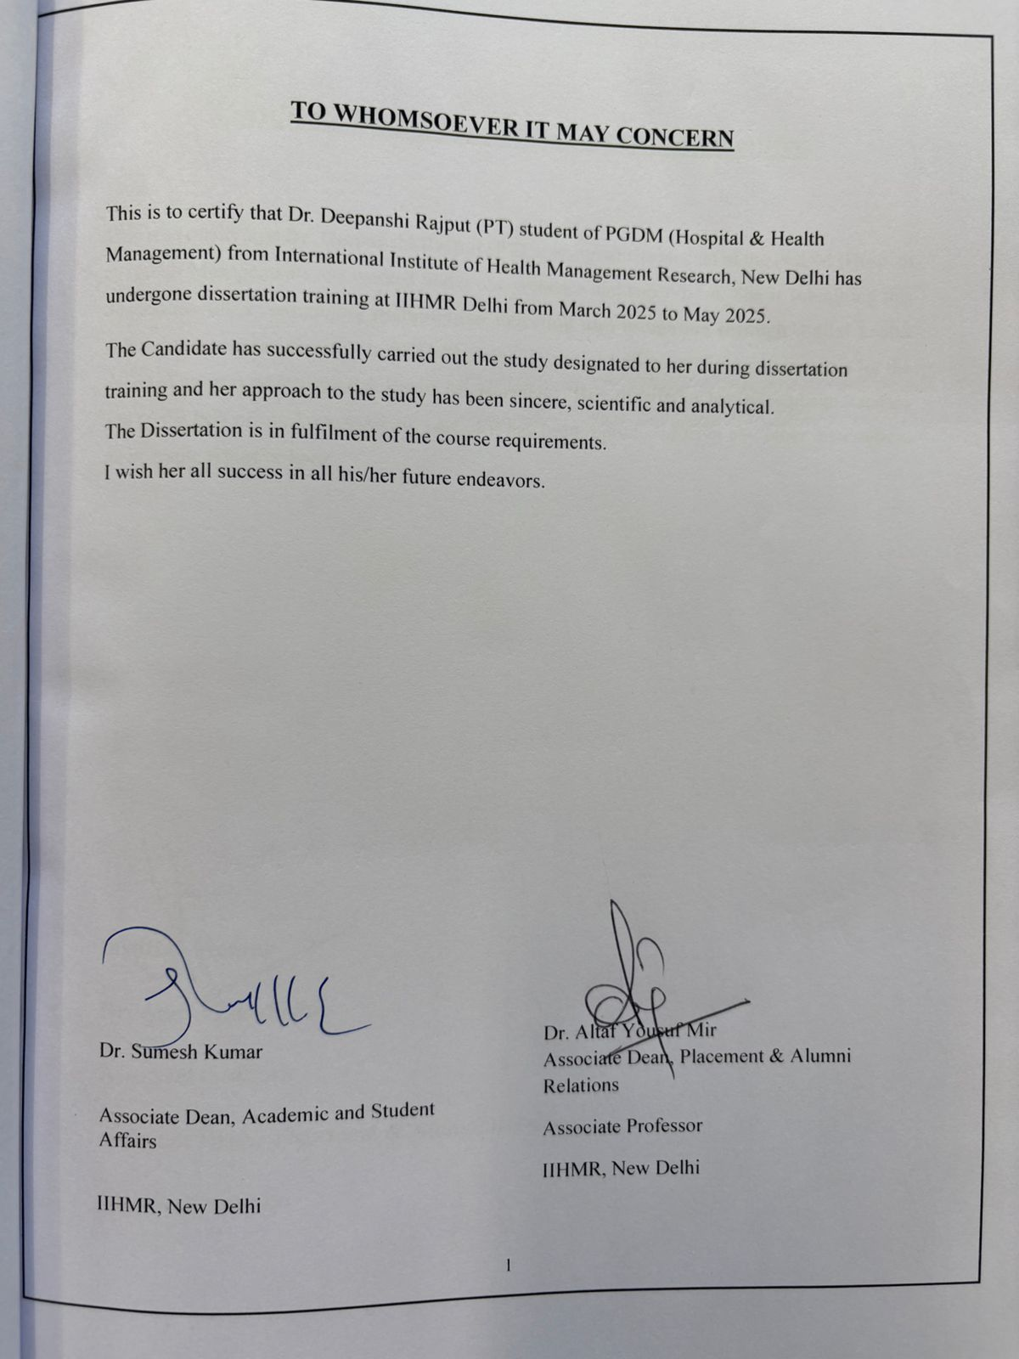

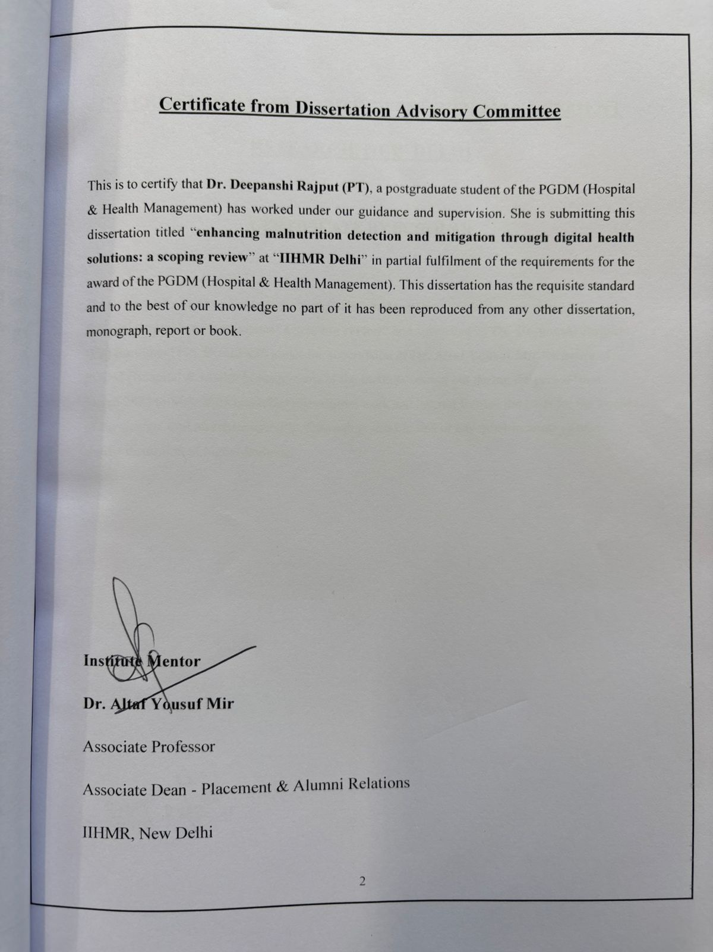
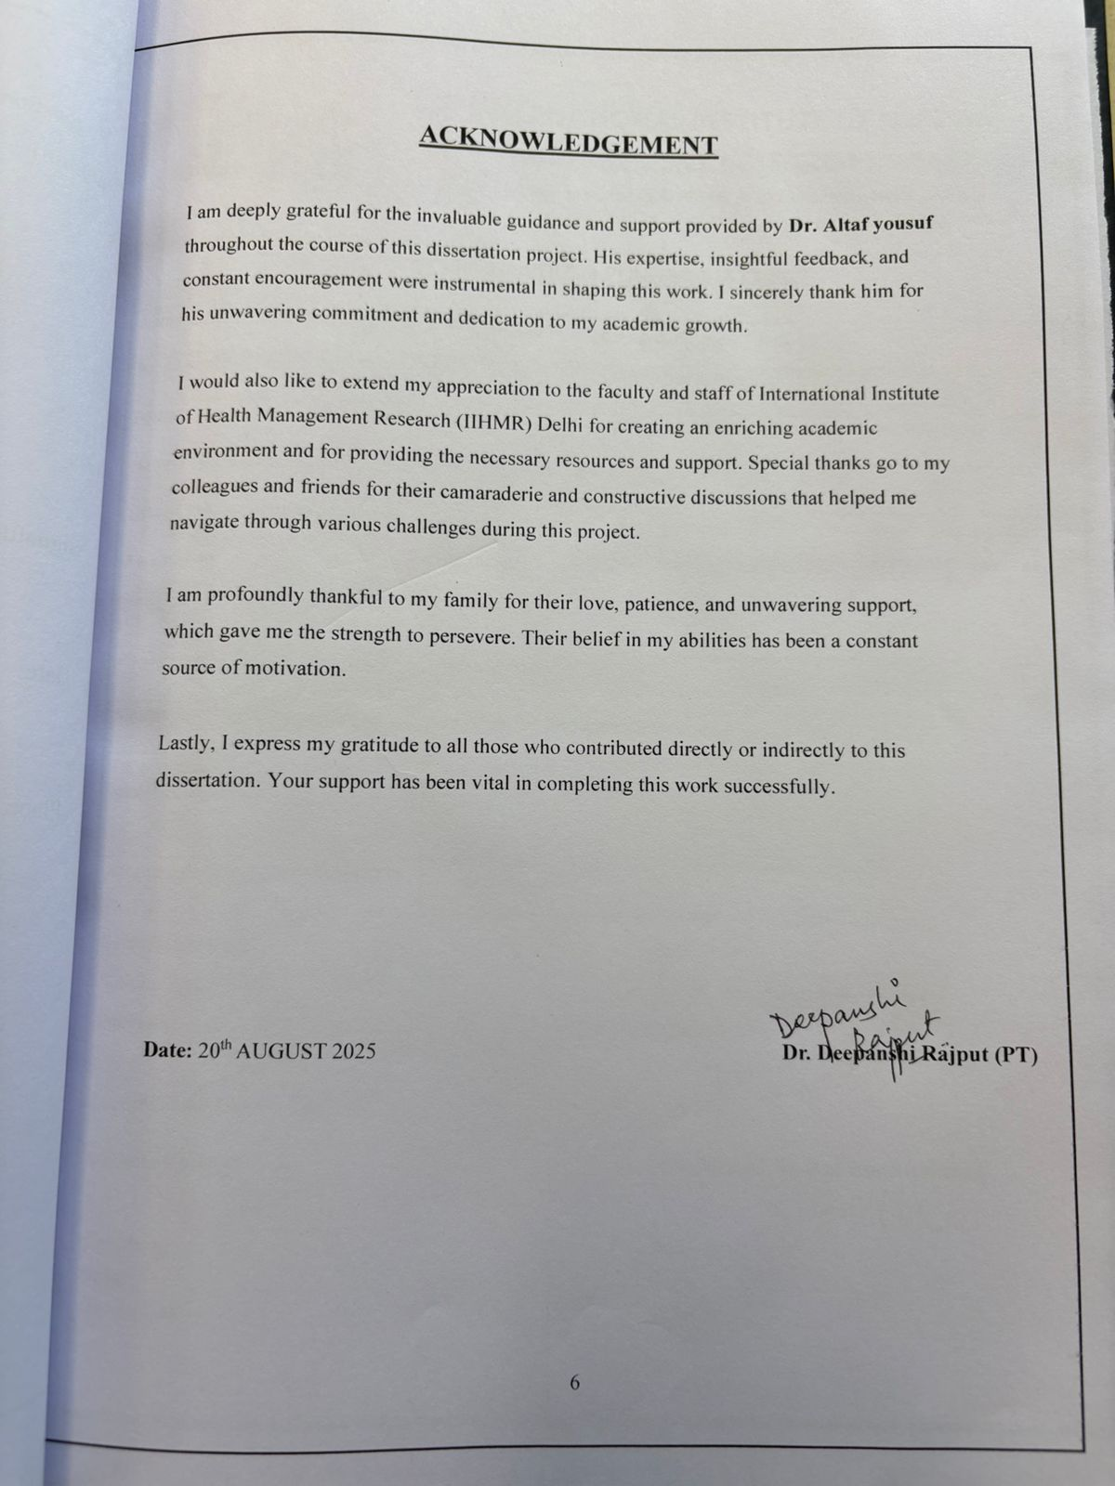
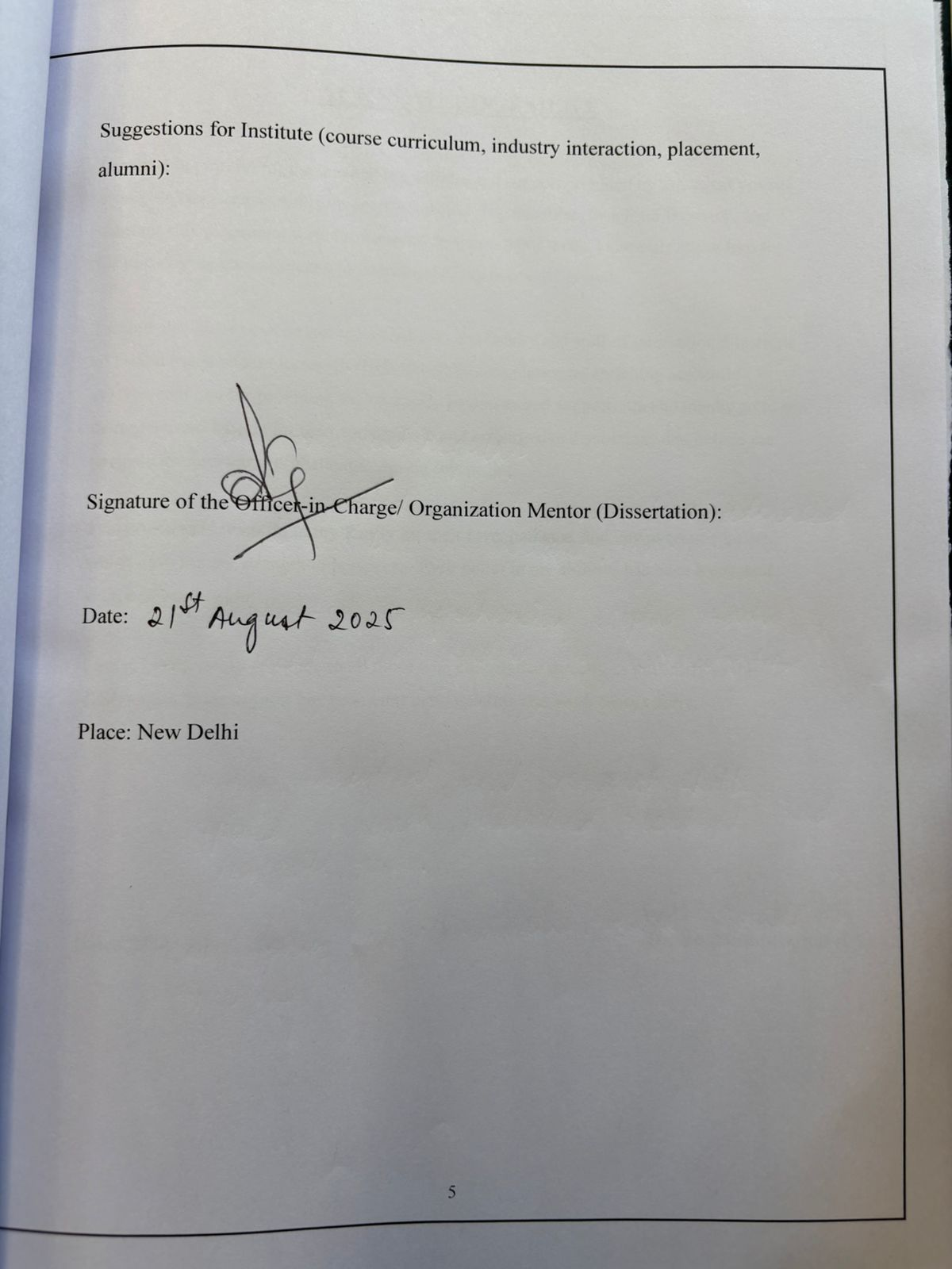
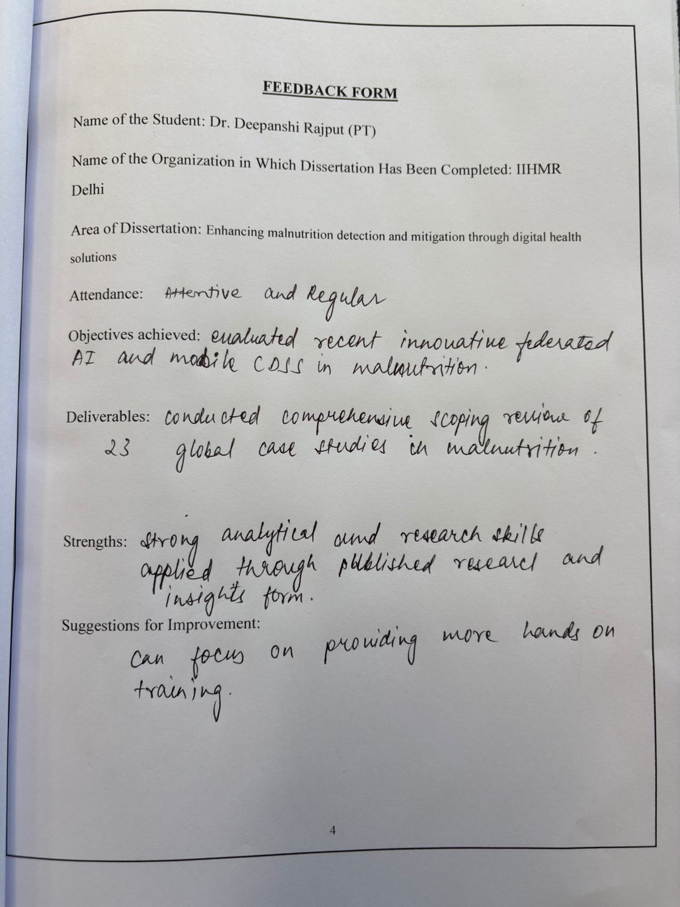
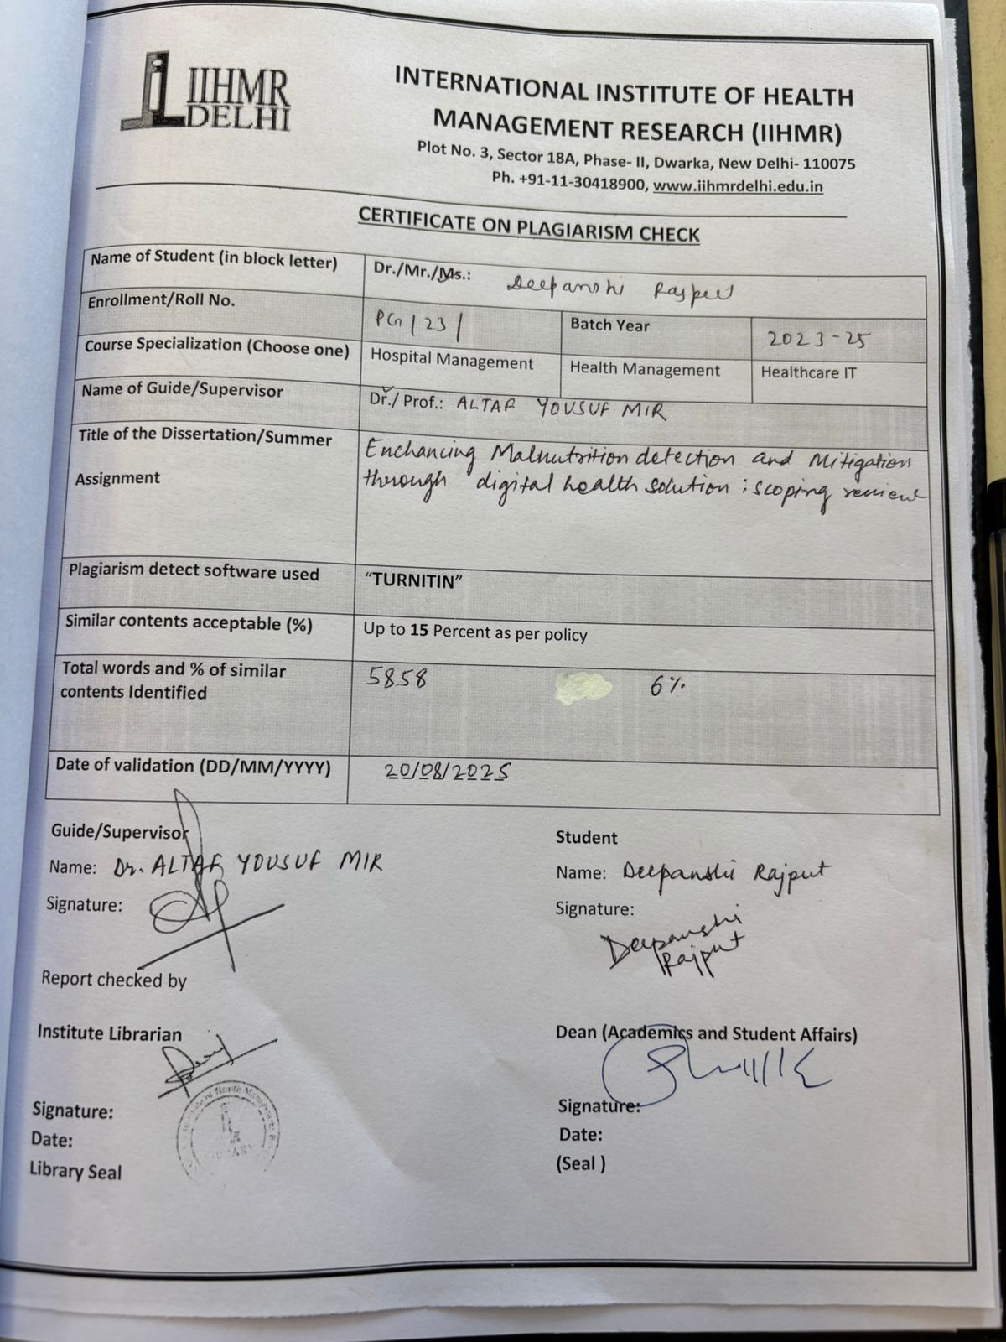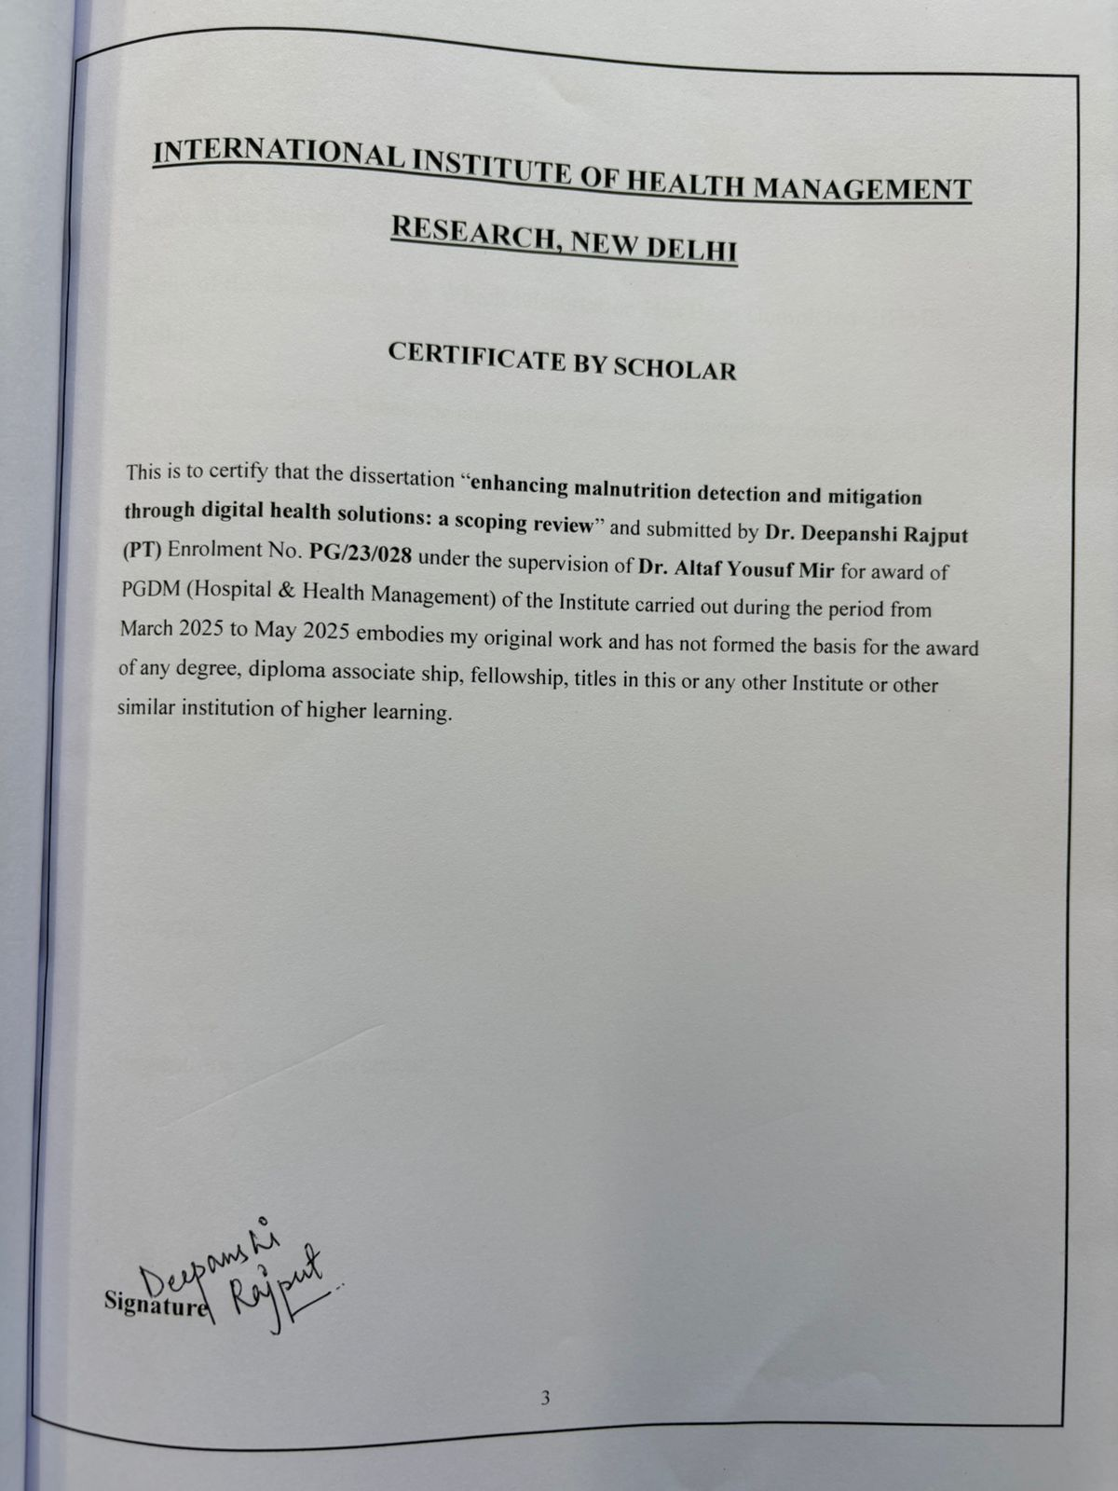
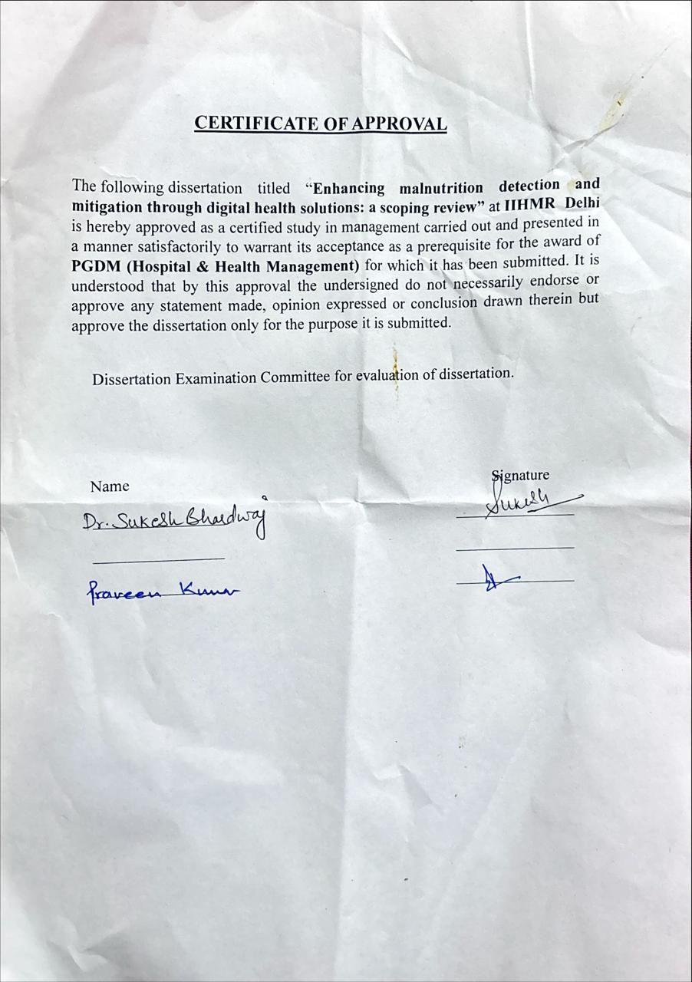
TABLE OF CONTENT
S.no | TOPICS | Page no.
1. | Certificate from dissertation Advisory Committee | 2
2. | Certificate by scholar | 3
3. | Feedback form | 4
4. | Acknowledgement | 6
5. | About IIHMR | 8
6. | List of Abbreviation | 11
7. | List of tables | 11
8. | Abstract | 12
9. | Introduction | 13
10. | Methodology | 14
11. | Results | 16
12. | Gap identified | 20
13. | Opportunities | 21
14. | Discussion | 22
15. | Bibliography | 24

LIST OF ABBREVIATIONS
S.no | Abbreviation | Full form
1. | UNICEF | United Nations International Children's Emergency Fund
2. | WHO | World Health Organization
3. | mHealth | Mobile health
4. | PRISMA - ScR | Preferred Reporting Items for Systematic Reviews and Meta-Analyses extension for Scoping Reviews
5. | PCC | Population–Concept–Context
6. | PNST | Pediatric Nutrition Screening Tool
7. | STAMP | Screening Tool for the Assessment of Malnutrition in Pediatrics
8. | STRONGkids | Screening Tool for Risk on Nutritional Status and Growth
9. | E – Kindex | Electronic Kids Dietary Index
10. | CNNs | Convolutional Neural Networks
11. | DHIS2 | District Health Information Software System
12. | IBDA | Image-based dietary assessment
13. | 3DO | 3D optical
14. | CHWs | Community health workers
15. | EHR | Electronic health record
16. | RUTF | Ready – to – use therapeutic food
17. | ICT | Information and communication technology

LIST OF TABLES

S no | Tables | Page no
1. | Table of complied studies | 16

ABSTRACT

Malnutrition remains a critical global health issue, with a disproportionate impact on children under five, and traditional methods for its detection and management are often inadequate. This scoping review, conducted in accordance with PRISMA-ScR Guidelines, aims to map the existing evidence on digital interventions for preventing, detecting, and managing malnutrition in this age group, with the goal of identifying current trends and proposing future directions to improve child nutrition outcomes. We sought to answer two key questions: "What types of digital tools are being developed for acute malnutrition screening and early detection in children under five, and how effective are they?" and "How are digital solutions transforming interventions, and what significant challenges impede their widespread adoption?" The methodology explored digital solutions such as mHealth apps and AI tools, in any geographical context, by searching databases including PubMed, BMC, and Elsevier, along with gray literature from organizations like WHO and UNICEF. The search covered sources published from 2010 to 2025, and included a total of 19 peer-reviewed articles and 5 gray literature sources. Our review found that a diverse range of mobile and AI-based tools are being developed for screening and data collection, showing early promise in improving data accuracy and providing personalized guidance. However, significant challenges to their widespread adoption persist, including limited digital literacy among frontline workers, technical issues, and concerns regarding data privacy. In conclusion, while digital health offers immense potential for enhancing malnutrition efforts in young children, future research and policy must focus on addressing these implementation barriers to maximize the global impact of these technologies.

INTRODUCTION

Malnutrition, in all its forms, continues to be one of the most pressing global health challenges. It includes both undernutrition—such as wasting, stunting, and micronutrient deficiencies—and overnutrition, which appears as overweight and obesity. According to the latest joint estimates from UNICEF, the World Health Organization (WHO), and the World Bank (2025 edition), millions of children under five are still affected worldwide. In 2024 alone, about 150.2 million children were stunted (too short for their age), 42.8 million were wasted (too thin for their height), and more than 37 million were overweight or obese. The consequences are devastating, going far beyond health: malnutrition raises healthcare costs, lowers productivity, and limits educational achievement, ultimately slowing social and economic progress.(1,2)
Traditional approaches to tackling malnutrition face many barriers, especially in resource-limited settings. These include shortages of trained health workers, difficulties in reaching remote populations, and challenges in collecting and monitoring data in real time. Data is often collected only at long intervals, which means seasonal variations and urgent needs are missing as a result, timely interventions become difficult, emphasizing the urgent need for more innovative and scalable solutions.
In recent years, digital technologies have created new possibilities to overcome these gaps. Mobile health (mHealth) apps, telemedicine platforms, and data analytics tools have shown real promise in improving nutrition-related services.(3,4) They can make data collection faster and more accurate, provide tailored dietary guidance, enable remote consultations, and give individuals and communities greater control over their nutritional well-being.
This scoping review will map the current evidence on digital health solutions for malnutrition detection and mitigation. Unlike a systematic review, which answers one narrowly focused question, a scoping review is designed to take a broader view. It will explore what types of digital tools are currently being used, what outcomes have been reported, and what limitations still exist. By charting this landscape, the review aims to identify knowledge gaps, guide future research, and provide a stronger foundation for designing evidence-based digital health strategies to more effectively fight malnutrition at a global level^{.(1,5,6)}
METHODOLOGY
This scoping review was undertaken using the PRISMA-ScR (Preferred Reporting Items for Systematic Reviews and Meta-Analyses extension for Scoping Reviews) guidelines to provide methodological rigor and transparency.
Research Questions:
The review was informed by two central questions:
- What types of digital tools are developed for acute malnutrition screening and early detection in children under five, and how effective are they?
- In what ways are digital solutions transforming malnutrition interventions, and what major barriers hinder their widespread adoption?
Eligibility Criteria (PCC Framework)
To define the focus of the review, we applied the Population–Concept–Context (PCC) framework:
• Population: Children under five years of age.
• Concept: Technology-based health solutions (e.g., health apps on phones, artificial intelligence-powered tools) for prevention, screening, early detection, diagnosis, or treatment of malnutrition.
• Background: All kinds of geographical locations were included to provide an international perspective.
Sources of Information and Search Approach
The search strategy was formulated with reference to a medical librarian to make it as comprehensive as possible. Various sources were consulted:
• Databases searched: PubMed, BMC, and Elsevier (peer-reviewed journals)
• Grey literature: International organization reports and publications like those of the World Health Organization (WHO) and UNICEF.
• Other sources: Screening reference lists of included studies by hand.
The search covered literature published between 2010 and 2025. The primary keywords and combinations included:
"Malnutrition" AND "Digital health" AND "children under 5"
Study Selection and Data Charting
• All records were imported to Covidence (a reference management software).
• Duplicates were removed.
• Titles and abstracts were screened by two independent reviewers against inclusion criteria.
• Potential related studies were downloaded as full text and assessed by the aforementioned reviewers.
• Differences were decided by discussion and on occasion by reference to a third reviewer.
One data charting form was created to pull out the following information:
• Characteristics of studies (year, country)
• Definition of the digital solution.
• Type of malnutrition outcome included.
• Key findings.
• Reported barriers and facilitators of implementation.
Synthesis of Results
Data that were extracted were synthesized to form a descriptive summary. Findings were structured by:
• Kind of digital solution
• Point of application within the malnutrition care continuum (e.g., screening, prevention, treatment)
• Filled out reported outcomes forms
This narrative synthesis was then used to answer research questions as well as to reveal knowledge gaps that existed to inform future inquiries.

Below is the compiled list of all studies included in this review, categorized according to relevant thematic areas.
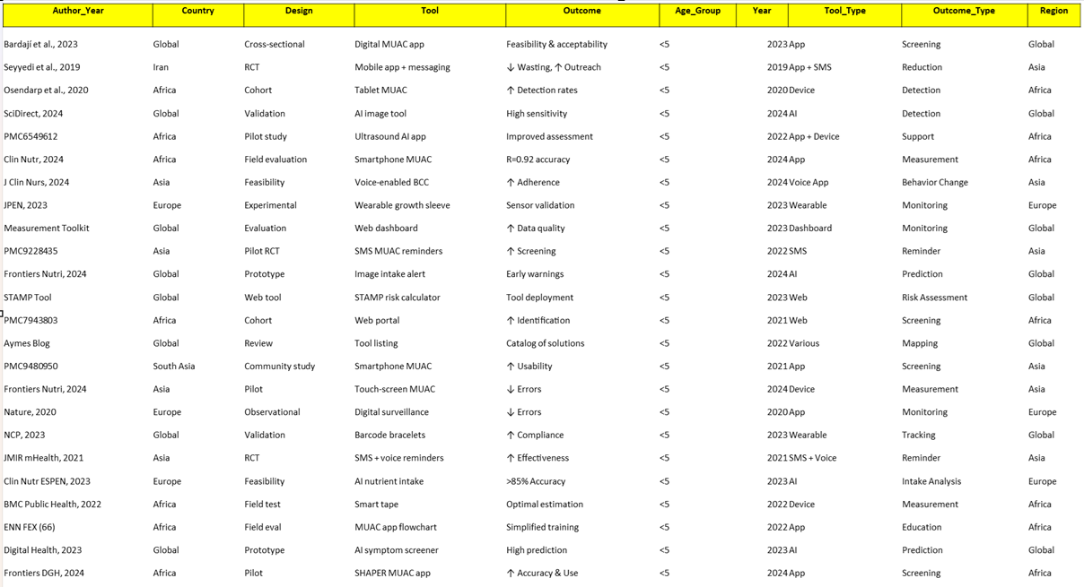

RESULTS
Digital Resources: Promoting Precision and Accessibility
Digital health technology is transforming how we deliver care for malnutrition by providing solutions to improve the accuracy, efficiency, and access of nutritional assessment, diagnosis, and intervention. They broadly fall under mHealth apps, artificial intelligence-powered diagnosis platforms, and comprehensive data systems.
- Rise of Approved Screening Apps
Several evidence-based screening instruments for child malnutrition have been converted into mobile apps to enhance access and decrease human error. Examples include the Pediatric Nutrition Screening Tool (PNST), Screening Tool for the Assessment of Malnutrition in Pediatrics (STAMP), and Screening Tool for Risk on Nutritional Status and Growth (STRONGkids),^{(4,7,8)} which are increasingly found on apps as well as hospital wards.
For example, a Chinese-developed mobile phone-based pediatric nutrition risk screening app automatically calculates Z-score values using anthropometric indicators, disease risk, and nutrition consumption with immediate real-time risk stratification. The E-Kindex (Electronic Kids Dietary Index) and Toddler NutriSTEP are other software packages utilized within communities for dietary analysis and risk screening for malnutrition.^{(3,9,10)} The STAMP software particularly shows high inter-rater reliability and can be widely applied to ensure standardized screening by various health practitioners.
- Innovative Image-Based Diagnosis⁽¹¹⁾
Computer vision and artificial intelligence are facilitating non-invasive screening of malnutrition by analyzing images. Software such as the MAAP AI tool and NutriAI are being created to screen for malnutrition from a single facial or body photograph of a child. Facial and skeletal patterns are examined by these computer-based apps to give accurate measurements and link with WHO growth indicators^{.(12)}
There are studies using convolutional neural networks (CNNs) with high accuracy to classify children as healthy or as malnourished on the basis of their facial pictures with values above 90% correct classification within certain datasets. This technology is especially useful within those situations where conventional measurements are impossible because of cultural or financial limitations, as this presents a quicker and cheaper screening solution.
- Proactive Forecasting Using Artificial Intelligence
AI goes well beyond single diagnosis to large-scale forecasting analysis. An AI system developed especially for Kenya with assistance from Microsoft's AI for Good Research Lab is able to pinpoint acute malnutrition hotspots four to six months in advance. The model integrates clinical health data from government District Health Information Software System (DHIS2) with satellite imagery of vegetation from space.⁽¹³⁾
The system has been extremely successful with 89% accuracy for one-month forecasting and 86% for six months. This provides governments and relief agencies with significant lead time to plan ahead on a proactive basis, to deploy resources appropriately and to deliver essential life-saving supplies to at-risk areas before a disaster reaches crisis proportions.⁽¹⁴⁾

- Support for Digital Dietary Assessment
Digital tools are also being developed to streamline the process of assessing a child's dietary intake, which is a key component of nutritional assessment. Image-based dietary assessment (IBDA) apps like MyFoodRepo allow users to snap a picture of a meal, which the app then uses to estimate nutrient content and volume. Other tools use motion sensors on wearable devices to capture eating occasions.
While some prototype tools like FoodBear and myBear have faced usability issues, they highlight the potential for incorporating features like photography, gamification, and rewards to make dietary assessment more engaging and accurate for children.^{(12,14,15)}
- Anthropometric Measurement Nuances
Conventional anthropometric measurements are time-consuming and need trained professionals. Digital solutions are overcoming these issues by collecting data automatically and with increased accuracy.
Examples include the use of automated weighing scales with Bluetooth connectivity that send a child's weight automatically to a phone-based application, thereby avoiding manual entry of data. There is also evidence of using 3D optical (3DO) imaging technology for obtaining accurate body circumferences, which could yield more precise and noninvasive measurements.^{(16,17)}
Mobile-based apps such as WHO Anthro and others deployed on the DHIS2 system automatically derive Z-scores from raw values to ensure standardized and systematic analysis of data, which is essential for tracking growth and detecting malnutrition.
Digital Interventions: Shifting Program Implementation and Scale
Digital health solutions are not only reshaping the way malnutrition is identified but are essentially transforming how interventions and programs are delivered. They enable a move away from large-scale, top-down approaches to more decentralized, dynamic, and community-based models—ultimately enhancing the scalability and sustainability of nutrition programs.
- Move Towards Decentralized and Caregiver-Led Models
Digital tools are empowering community health workers (CHWs) and caregivers by decentralizing the delivery of malnutrition care. Mobile applications act as digital job aids, offering CHWs features like automated task scheduling, clinical decision support, and access to pictorial health education materials.⁽¹⁵⁾
For instance, in a pilot initiative in rural Bangladesh, CHWs used a tablet-based app to deliver preventive nutrition services to mothers and children. The app streamlined data entry, automatically calculated micronutrient dosages, and provided step-by-step guidance during counseling sessions—significantly improving care quality at the household level. This model not only eases the load on formal healthcare systems but also shifts control to those closest to the children, promoting a sustainable, community-led approach to care.
- Improved Program Management and Data Quality
Digital platforms significantly enhance the efficiency and data quality of large-scale nutrition programs. Previously, data collection was done manually on paper—leading to delays, errors, and fragmented reporting. Now, with digital tools, information is captured in real-time and synced instantly to a centralized database.
This enables program managers to track vital indicators—like the number of children screened, therapeutic feeding coverage, and supply chain activity—through live dashboards. For example, UNICEF’s NutriDash platform offers a global snapshot of essential nutrition interventions, helping countries monitor progress and identify areas needing increased investment. By automating data capture and analysis, these systems reduce human error, improve accuracy, and provide a reliable single source of truth, which enhances accountability and supports evidence-based decision-making.^{(7,8,18,19)}
- Enabling Proactive Public Health
Digital interventions, especially those using AI and big data—are helping shift public health strategies from reactive to proactive. Predictive models combine data from multiple sources such as health records, satellite imagery, and climate data to identify emerging malnutrition hotspots.
This allows governments and aid agencies to deliver resources like ready-to-use therapeutic food (RUTF) and medical supplies to at-risk areas before a full-blown crisis unfolds. A successful example comes from Maharashtra, India, where an AI-driven image recognition tool monitors meal quality in tribal schools. By analyzing over 2,100 data points related to food temperature and appearance, the system flagged discrepancies between planned and actual meals—leading to ^{(20,21)} better compliance and reduced malnutrition rates among children.
- The Complementary Role of Telehealth
Telehealth is playing an increasingly critical role in malnutrition interventions, especially in underserved or remote regions. It enables remote consultations for caregivers, giving them access to personalized dietary guidance from registered dietitians without needing to travel.
It also allows CHWs to consult with senior healthcare professionals on complex cases, such as children with multiple health conditions. For instance, the COD20 online platform supports virtual outpatient services and video consultations with specialists. This kind of remote assistance not only ensures continuity of care but also builds the skills of local healthcare workers, making the broader system more adaptable and resilient.^{(2,8,18)}
- ICT-Based Nutrition Education and Behavior Change
Information and Communication Technology (ICT) offers a powerful way to deliver targeted nutrition education and foster lasting behavioral change. Through mobile apps, interactive websites, and social media, users can engage with tools like gamification, quizzes, and personalized push notifications that make nutrition education more fun and effective.
For example, the FoodBear and myBear apps use photography and rewards to motivate children to monitor their food intake, while SMS services send daily tips to caregivers on best feeding practices and hygiene. By tailoring content to factors like age, culture, and dietary habits, ICT-based interventions can effectively promote healthier behavior from an early age.^{(4,7,19,22)}

GAPS IDENTIFIED
Digital health solutions are not only redefining how malnutrition is identified but are also transforming the delivery of nutrition interventions by shifting from large-scale, top-down strategies to decentralized, community-based models that enhance scalability and sustainability. These digital tools empower community health workers (CHWs) and caregivers by decentralizing care, offering features like automated task scheduling, clinical decision support, and visual education resources. A pilot project in rural Bangladesh, for example, used a tablet-based app to assist CHWs in delivering preventive services, automating data entry and supplement dosage, and providing counseling guidance, ultimately improving care at the household level and fostering a sustainable, caregiver-led model. In parallel, digital platforms have significantly boosted the efficiency and data quality of nutrition programs by replacing paper-based systems with real-time, centralized data capture. Platforms like UNICEF’s NutriDash enable real-time tracking of indicators such as child screenings and feeding coverage, minimizing errors and offering a single source of truth to support accountability and data-driven decision-making. Furthermore, the integration of AI and big data has enabled a proactive public health approach; predictive models use data from sources like health records, climate data, and satellite imagery to identify malnutrition hotspots, allowing governments to preemptively deliver resources such as RUTF and medical supplies. In Maharashtra, India, an AI-powered image recognition tool monitoring school meals identified discrepancies in food quality, leading to improved compliance and reduced malnutrition rates. Telehealth has emerged as a vital complementary tool, facilitating remote consultations for caregivers and CHWs, enabling access to personalized dietary advice and expert guidance in remote regions through platforms like COD20, which supports virtual outpatient care and specialist consultations. Lastly, Information and Communication Technology (ICT) has proven effective in promoting nutrition education and behavior change through mobile apps, interactive websites, and social media. Apps such as FoodBear and myBear use photography and rewards to encourage children to track food intake, while SMS-based services send daily feeding and hygiene tips to caregivers. By tailoring content to users’ age, cultural background, and dietary habits, ICT-driven interventions help establish long-term healthy behaviors from an early age.

OPPORTUNITIES

Based on current literature surrounding digital health interventions for malnutrition, several important opportunities for future research have emerged to address the remaining gaps. First, there is a strong need for research focused on user-centered design and co-creation. Efforts should be made to develop digital nutrition tools with simplified user interfaces and intuitive navigation, particularly for populations with low digital literacy. A key area of exploration is co-design, where developers work directly with end users to ensure the cultural relevance and usability of apps. Additionally, more studies are needed to understand which features—such as gamification, peer challenges, or personalized notifications—are most effective at maintaining long-term user engagement and encouraging sustainable behavior change.
Secondly, rigorous evaluation of the efficacy and impact of these tools is critical. There is a clear opportunity to design and conduct long-term randomized controlled trials (RCTs) that move beyond short-term feasibility and focus on clinical outcomes like reduced malnutrition risk scores, rather than just knowledge improvement. Future research should also work toward developing new evaluation methods that go beyond self-reported data and incorporate objective measures of nutritional status and health.
Another vital research avenue is exploring how to integrate digital interventions into existing healthcare systems. This includes identifying scalable models for expanding successful pilots into broader national or regional programs and investigating technical and logistical challenges such as data interoperability between apps and electronic health records (EHRs). Studies should also involve ongoing collaboration with diverse stakeholders — health professionals, caregivers, and patients—to ensure solutions are both effective and practical for real-world use.
Finally, ethical and equitable access must be prioritized. More research is needed to build robust, transparent data privacy and security frameworks, along with clear communication strategies to help users understand how their personal data is managed. Equally important is addressing the digital divide. Future studies should identify ways to make digital interventions accessible across different socio-economic groups, including through low-cost mobile solutions and partnerships with local organizations to provide internet access and technical support.

DISCUSSION

Holistic Approach to Research on Digital Nutrition
The opportunities for research proposed here signal a necessary shift within digital nutrition as a field. The original emphasis on developing mobile apps as a stand-alone solution to malnutrition is giving way to a more holistic, integrated strategy. The proposed areas for research—from user-oriented design to long-term effectiveness and systems-level integration—highlight an understanding that an effective digital intervention is not just a piece of technology, but an essential component within a broader healthcare ecosystem.
The Building Block of Usability and Trustworthiness
At its heart, every successful digital health tool depends on the end user. Opportunities to study user-centered design, co-creation, and equitable access are central because they address two of the most persistent challenges: low engagement and high dropout rates. An app can offer the most sophisticated features, but if it’s not intuitive, especially for users with limited digital literacy will struggle to gain traction. Similarly, if users don’t trust how their data is being handled, adoption will remain low. This research rightly recognizes that the digital divide goes far beyond access to technology; it also involves issues of literacy, trust, and cultural relevance.
Going Beyond Short-Term Returns to Lasting Impact
Long-term trials and the development of more meaningful evaluation metrics are crucial for establishing the credibility and clinical impact of digital nutrition tools. While short-term studies might demonstrate quick gains—like temporary weight loss—only long-term research can show whether those changes are sustained and translate into reductions in serious health risks, such as diabetes. Moving from basic indicators like increased nutrition knowledge toward measurable clinical outcomes will allow researchers to generate the kind of evidence that earns the trust of healthcare providers and policy decision-makers.
Scaling Solutions for Real-World Integration
Opportunities for integrating these tools into healthcare systems also acknowledge the real challenge of moving from a successful pilot to a scalable national program. Complex issues like data interoperability—ensuring an app can integrate with electronic health records—require focused, technical research. Just as importantly, this effort depends on collaboration among all stakeholders, from app developers and dietitians to policymakers and community leaders. As highlighted, success is not just about technology itself, but about how well it fits within the health system and the lives of the people it's designed to support.
In conclusion, the research opportunities outlined suggest the next generation of digital nutrition interventions will be more evidence-driven, user-focused, and system-ready—leading to a more sustainable and equitable path forward in the fight against malnutrition.

BIBLIOGRAPHY
1. UNICEF, WHO, WORLD BANK. Level and trend in child malnutrition. World Health Organization [Internet]. 2023 [cited 2025 Aug 19];4. Available from: https://www.who.int/publications/i/item/9789240073791
2. Levels and trends in child malnutrition: UNICEF/WHO/World Bank Group joint child malnutrition estimates: key findings of the 2023 edition [Internet]. [cited 2025 Aug 19]. Available from: https://www.who.int/publications/i/item/9789240073791
3. UNICEF Digital Health and Information Systems 2024 Annual Report | UNICEF Digital Impact [Internet]. [cited 2025 Aug 19]. Available from: https://www.unicef.org/digitalimpact/reports/unicef-digital-health-and-information-systems-2024-annual-report
4. Teo CH, Ng CJ, Lo SK, Lim CD, White A. A Mobile Web App to Improve Health Screening Uptake in Men (ScreenMen): Utility and Usability Evaluation Study. JMIR Mhealth Uhealth [Internet]. 2019 Apr 15 [cited 2025 Aug 19];7(4):e10216. Available from: http://www.ncbi.nlm.nih.gov/pubmed/30985280
5. WHO Guideline on the Prevention and Management of Wasting and Nutritional Oedema (acute Malnutrition) in Infants and Children under 5 Years. 2024;208.
6. WHO guideline on the prevention and management of wasting and nutritional oedema (‎acute malnutrition)‎ in infants and children under 5 years [Internet]. [cited 2025 Aug 19]. Available from: https://www.who.int/publications/i/item/9789240082830
7. Levine DM, Co Z, Newmark LP, Groisser AR, Holmgren AJ, Haas JS, et al. Design and testing of a mobile health application rating tool. NPJ Digit Med [Internet]. 2020 Dec 1 [cited 2025 Aug 19];3(1):1–7. Available from: https://www.nature.com/articles/s41746-020-0268-9
8. Osei E, Mashamba-Thompson TP. Mobile health applications for disease screening and treatment support in low-and middle-income countries: A narrative review. Heliyon [Internet]. 2021 Mar 1 [cited 2025 Aug 19];7(3):e06639. Available from: https://www.sciencedirect.com/science/article/pii/S2405844021007428
9. mHealth Data Interoperability | Open mHealth [Internet]. [cited 2025 Aug 19]. Available from: https://www.openmhealth.org/
10. Digital Health Application for Acute Malnutrition | Nutrition | World Vision International [Internet]. [cited 2025 Aug 19]. Available from: https://www.wvi.org/nutrition/mhealth-CMAM-app
11. Velez M, Quintiliani LM, Fuertes Y, Román A, Heaton B. Photo-Enhanced Health Promotion Messages to Target Reduction in Dietary Sugar among Residents of Public Housing. Nutrients. 2023 Jun 1;15(11).
12. Dimidi E, Belogianni K, Whelan K, Lomer MCE. Gut Symptoms during FODMAP Restriction and Symptom Response to Food Challenges during FODMAP Reintroduction: A Real-World Evaluation in 21,462 Participants Using a Mobile Application. Nutrients. 2023 Jun 1;15(12).
13. Limketkai BN, Mauldin K, Manitius N, Jalilian L, Salonen BR. The Age of Artificial Intelligence: Use of Digital Technology in Clinical Nutrition. Curr Surg Rep [Internet]. 2021 Jul 1 [cited 2025 Aug 19];9(7):20. Available from: https://pmc.ncbi.nlm.nih.gov/articles/PMC8186363/
14. Liou L, Scott E, Parchure P, Ouyang Y, Egorova N, Freeman R, et al. Assessing calibration and bias of a deployed machine learning malnutrition prediction model within a large healthcare system. NPJ Digit Med [Internet]. 2024 Dec 1 [cited 2025 Aug 19];7(1):1–7. Available from: https://www.nature.com/articles/s41746-024-01141-5
15. Besculides M, Mazumdar M, Phlegar S, Freeman R, Wilson S, Joshi H, et al. Implementing a Machine Learning Screening Tool for Malnutrition: Insights From Qualitative Research Applicable to Other Machine Learning–Based Clinical Decision Support Systems. JMIR Form Res [Internet]. 2023 [cited 2025 Aug 19];7:e42262. Available from: https://pmc.ncbi.nlm.nih.gov/articles/PMC10375393/
16. Serón-Arbeloa C, Labarta-Monzón L, Puzo-Foncillas J, Mallor-Bonet T, Lafita-López A, Bueno-Vidales N, et al. Malnutrition Screening and Assessment. Nutrients [Internet]. 2022 Jun 1 [cited 2025 Aug 19];14(12):2392. Available from: https://pmc.ncbi.nlm.nih.gov/articles/PMC9228435/
17. Di Martino F, Delmastro F, Dolciotti C. Explainable AI for malnutrition risk prediction from m-Health and clinical data. Smart Health [Internet]. 2023 Dec 1 [cited 2025 Aug 19];30:100429. Available from: https://www.sciencedirect.com/science/article/pii/S2352648323000570
18. Paulsen MM, Hagen MLL, Frøyen MH, Foss-Pedersen RJ, Bergsager D, Tangvik RJ, et al. A Dietary Assessment App for Hospitalized Patients at Nutritional Risk: Development and Evaluation of the MyFood App. JMIR Mhealth Uhealth [Internet]. 2018 Sep 7 [cited 2025 Aug 19];6(9):e175. Available from: http://www.ncbi.nlm.nih.gov/pubmed/30194059
19. Jones D, Sowerbutts AM, Burden S. Exploring Individuals’ Views and Feedback on a Nutritional Screening Mobile App: Qualitative Focus Group Study. JMIR Form Res [Internet]. 2024 Dec 18 [cited 2025 Aug 19];8(1):e63680. Available from: http://www.ncbi.nlm.nih.gov/pubmed/39693128
20. The State of Food Security and Nutrition in the World 2024 - UNICEF DATA [Internet]. [cited 2025 Aug 19]. Available from: https://data.unicef.org/resources/sofi-2024/
21. Joint Child Malnutrition Estimates (JME) 2025 - UNICEF DATA [Internet]. [cited 2025 Aug 19]. Available from: https://data.unicef.org/resources/jme/
22. Defining Pediatric Malnutrition [Internet]. [cited 2025 Aug 19]. Available from: https://aspenjournals.onlinelibrary.wiley.com/doi/epdf/10.1177/0148607113479972?getft_integrator=mendeley&src=getftr&utm_source=mendeley

