DISSERTATION
At


A report on
Evaluating the Impact of Nutritional Habits on the Quality of Life among Migrant College Students
by
Dr.Saumya Pathak
PG/23/102
Under the guidance of
Dr.Nidhi Yadav

PGDM(Hospital & Health Management) 2023-2025
International Institute of Health Management Research
New Delhi

TO WHOMSOEVER IT MAY CONCERN
TO WHOMSOEVER IT MAY CONCERN
This is to certify that Dr. Saumya Pathak, student of PGDM (Hospital & Health Management) from International Institute of Health Management Research (IIHMR), New Delhi has undergone internship training at IIHMR Delhi from 1st March, 2024 to 31st May, 2024.
The candidate has successfully carried out the study designated to her during internship training and her approach to the study has been sincere, scientific, and analytical.
The Internship is in fulfillment of the course requirements.
I wish her all success in all her future endeavors.


Dr. Sumesh Kumar
Associate Dean, Academic and Student Affairs
IIHMR, New Delhi
Dr. Nidhi
Associate Professor, Mentor
IIHMR, New Delhi

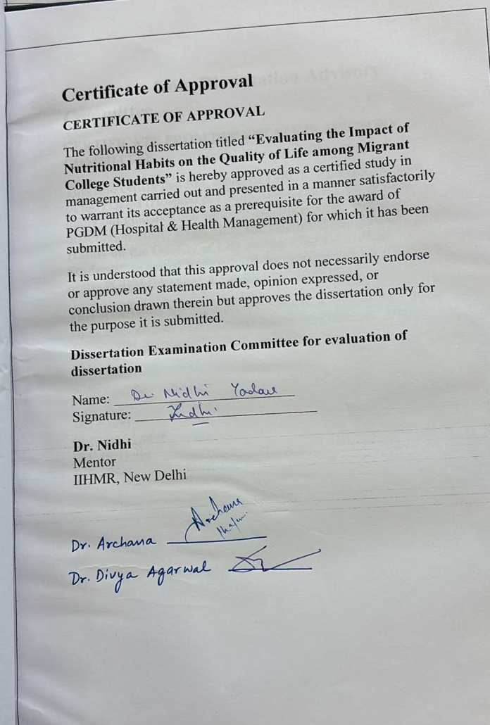

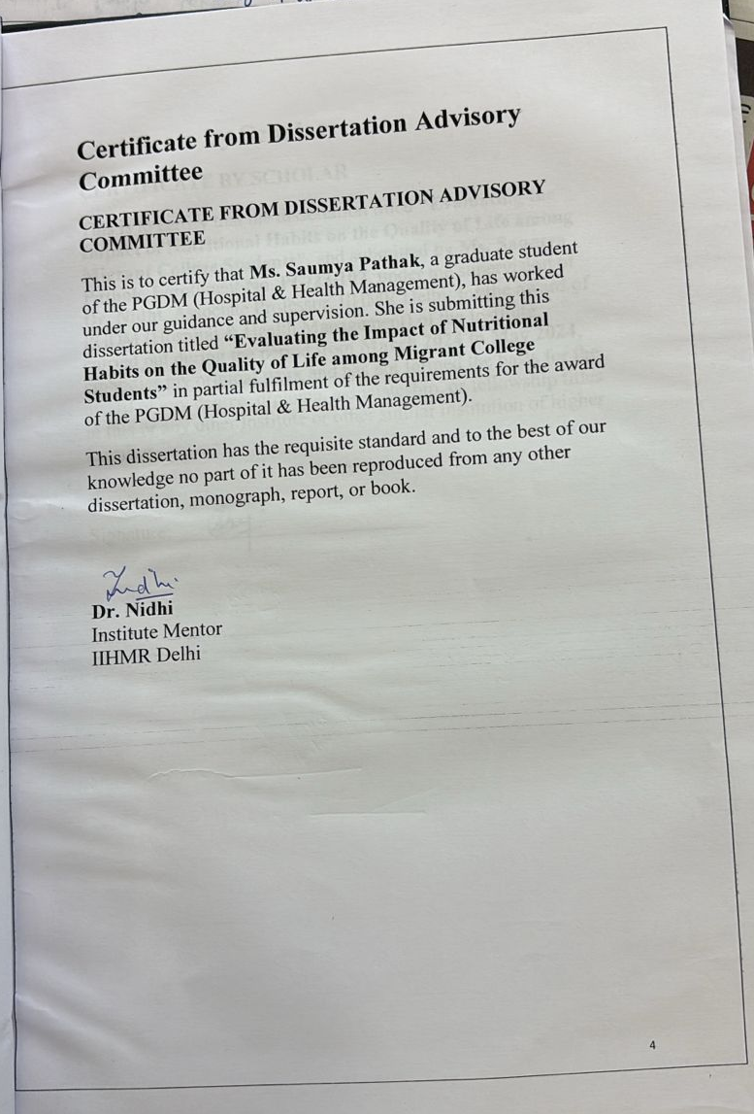

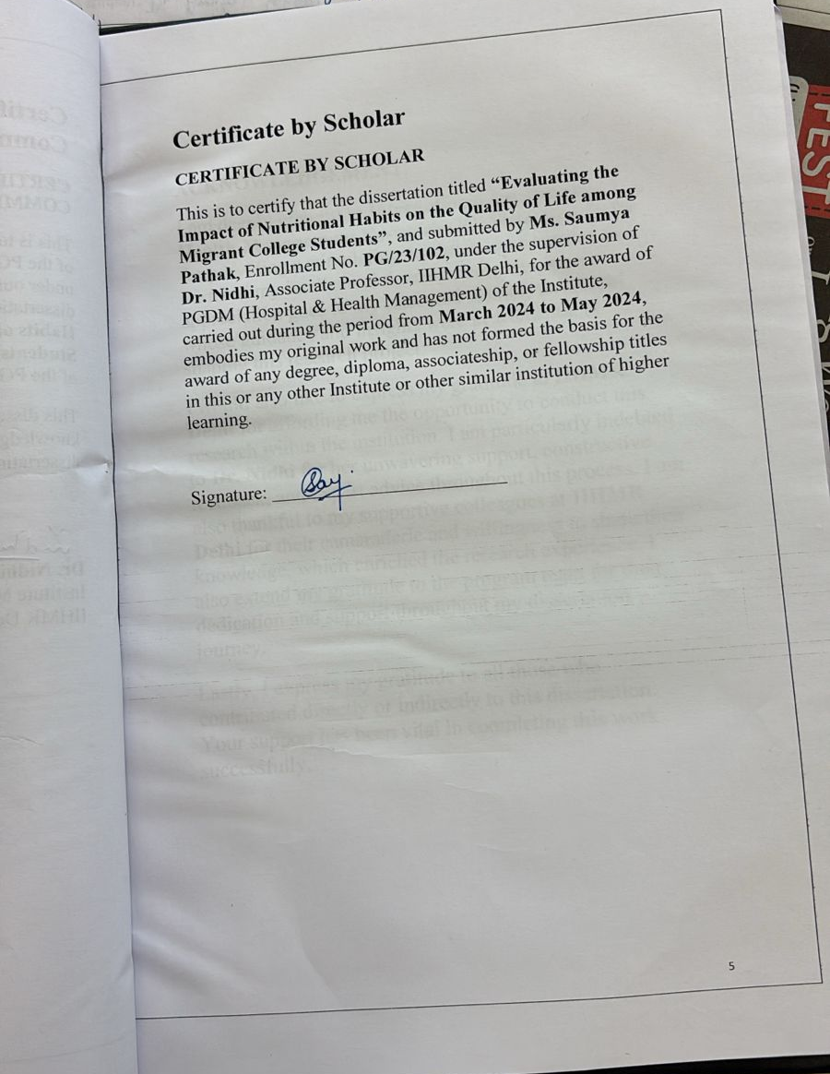
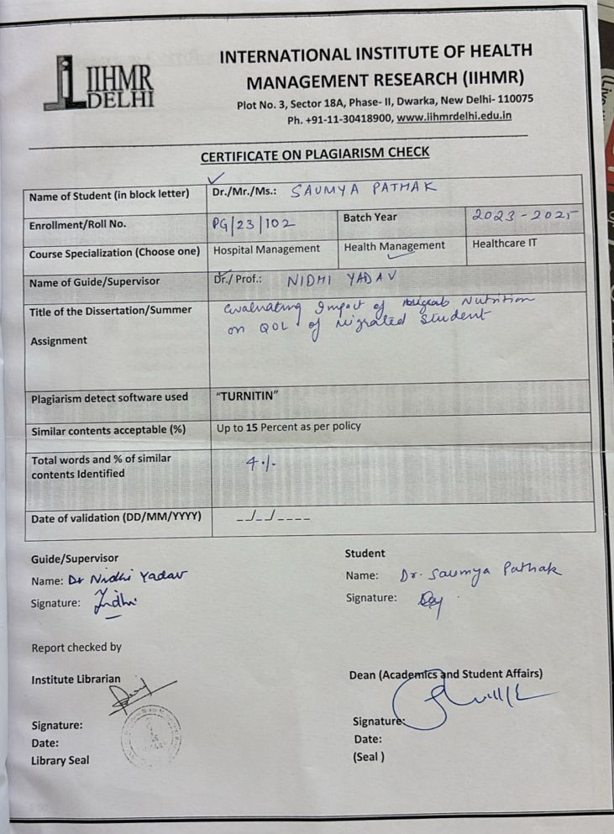

ACKNOWLEDGEMENT
I am deeply grateful to International Institute of Health Management Research (IIHMR), New Delhi for providing a stimulating academic environment that nurtured my intellectual development. My sincere appreciation goes to my esteemed mentor, Dr. Nidhi, whose guidance and insights were instrumental in shaping this research project.
I would also like to express my gratitude to IIHMR Delhi for affording me the opportunity to conduct this research within the institution. I am particularly indebted to Dr. Nidhi for her unwavering support, constructive feedback, and expert advice throughout this process. I am also thankful to my supportive colleagues at IIHMR Delhi for their camaraderie and willingness to share their knowledge, which enriched the research experience. I also extend my gratitude to the program team for their dedication and support throughout my dissertation journey.
Lastly, I express my gratitude to all those who contributed directly or indirectly to this dissertation. Your support has been vital in completing this work successfully.

ABSTRACT
The present study, “Evaluating the Impact of Nutritional Habits on the Quality of Life among Migrant College Students”, explores the dietary patterns, lifestyle behaviors, and their association with the quality of life (QoL) among students who have migrated from their native regions for higher education. Conducted at the International Institute of Health Management Research (IIHMR), New Delhi, the study employed a cross-sectional primary survey among 100 migrant college students aged 17–28 years, using a structured questionnaire based on the WHOQOL-BREF instrument. Data were analyzed using descriptive statistics, chi-square tests, and regression analysis. Findings revealed high consumption of fast food, snacks, and sugary drinks, coupled with inadequate fruit and vegetable intake. Gender emerged as a significant predictor of QoL, particularly in the psychological domain, whereas dietary habits alone showed limited direct influence. The study highlights the interplay of migration stress, socio-cultural adaptation, and health behaviors in shaping students’ well-being. Recommendations include targeted nutritional education, gender-sensitive support systems, and integrated campus wellness programs to enhance the QoL of migrant students.
Keywords: Nutritional habits, migrant students, quality of life, dietary patterns, WHOQOL-BREF, public health

- Introduction
Migration is a significant socioeconomic and demographic phenomenon that refers to the movement of people from one geographic location to another, with the intent of settling temporarily or permanently. In the context of education, especially in a diverse country like India, migration for higher studies is increasingly common. This internal migration is driven by the pursuit of better academic opportunities, infrastructure, and career prospects, often leading young students to relocate from rural, semi-urban, or even smaller urban areas to major cities and educational hubs.
According to Census 2011, around 54 lakh students migrated internally across Indian states for educational purposes. This represents a notable increase from the 2001 census, which recorded around 33 lakh student migrants. While male students dominated this movement, an impressive rise in the number of female students migrating was observed. Migration during one’s formative academic years comes with both opportunities and challenges—ranging from increased independence to psychological stress, new social networks, and significant lifestyle changes, particularly in food and health-related behaviors.
Food and eating behaviors form an essential part of a student’s life, closely linked to emotional well-being, physical health, social interaction, and routine management. Students living away from their familial settings are often exposed to fast food, ready-to-eat meals, and poor food planning due to time constraints and lack of supervision. In contrast to the balanced home-cooked meals many were accustomed to, these new habits tend to lean towards convenience rather than nutrition.
Quality of Life (QoL) is a multi-faceted concept, defined by the World Health Organization (WHO) as the assessment individuals make of their life circumstances, shaped by their cultural background, values, personal aspirations, expectations, and concerns. In higher education environments, QoL is affected by factors such as physical health, mental well-being, interpersonal relationships, and the surrounding environment. A significant number of students often face diminished physical activity levels, increased consumption of unhealthy foods and substances like alcohol or tobacco, as well as mental strain related to academic and social transitions, all of which can negatively impact their QoL.

Dietary habits are intricate behaviors influenced by factors such as cultural background, economic status, gender expectations, urban developments, and migration. A nutritious diet generally consists of a balanced assortment of carbohydrates, proteins, fats, vitamins, and minerals, typically obtained from sources like fruits, vegetables, whole grains, and lean proteins. Conversely, an unhealthy diet is characterized by excessive intake of sugar, salt, processed items, fried foods, and sugary drinks, contributing to chronic health conditions such as obesity, diabetes, hypertension, and mental stress.

In India, food habits are not only regionally diverse but are also significantly shaped by religious beliefs, traditions, and economic conditions. For instance, vegetarianism is prevalent in various communities, while others predominantly consume non-vegetarian diets. Students transitioning to areas with unfamiliar culinary customs often find it challenging to adapt to local foods, which can impact their dietary intake and nutritional health.

This research aims to explore how these dietary adjustments following migration influence the quality of life of college students. Although many studies have individually examined the eating habits of youth and general QoL evaluations among university students, there is limited research specifically addressing the intersection of migration, nutrition, and QoL. As the student population becomes increasingly mobile, it is essential to understand how relocating from home affects their physical and mental health due to changes in their diet.

The objective is not merely to evaluate students' food choices but to delve into the effects of their dietary habits on various dimensions of their quality of life. Are students from urban backgrounds, who are more familiar with processed foods, affected differently compared to those from rural areas? Do students from higher economic backgrounds make healthier dietary choices even after migrating? Does gender play a role in food selection and mental well-being in the new environment? These fundamental inquiries directed this study.

It is also vital to recognize that dietary changes induced by migration do not happen in a vacuum. They are influenced by multiple external and internal elements, including the type of accommodation (hostel vs. rented home), financial means, peer dynamics, access to cooking facilities, university dining services, and time management skills. This complexity calls for a comprehensive approach that integrates health science, behavioral studies, and public health strategy.

This research focuses on students from various Indian states attending different educational institutions, aiming to provide insights that can assist educational administrators, nutritionists, student counselors, and policymakers in enhancing campus food environments, health promotion, and support systems for migrating students. Additionally, the study aims to suggest practical and culturally relevant interventions to alleviate the adverse health impacts of poor dietary habits during academic migration.

Consequently, this research goes beyond simply recording the dietary changes among migrant college students; it serves as a significant resource for influencing future initiatives in student health and nutrition. Given the rise in internal migration patterns, this topic of study is both timely and crucial.

- Rationale of Study
India's higher education sector is rapidly changing, leading to notable improvements in access, diversity, and outreach. As the number of academic programs and institutions in urban areas increases, there has been a rise in internal student migration, where young people, especially those aged 17 to 28, move from their home regions to study elsewhere in the country. This migration, fueled by the pursuit of academic excellence, often subjects students to lifestyle adjustments, particularly regarding their dietary habits, which have significant effects on their physical and mental well-being.

The shift from a familiar, family-supported setting to an independent, often urban lifestyle disrupts established routines, particularly those related to meals. Students who previously adhered to a regular meal schedule with nutritious home-cooked food frequently turn to quicker, less nutritious options like fast food, snacks, sugary drinks, and processed foods. These changes are not solely about taste preferences but also reflect deeper issues concerning time constraints, affordability, access to cooking facilities, peer pressure, and psychological stress.

Dietary patterns are known to significantly affect health outcomes, ranging from weight gain and digestive problems to mood disorders and risk of chronic diseases. Yet, amongst students, the most immediate effects are often manifested in their overall Quality of Life (QoL). The World Health Organization defines QoL as an individual's perception of their position in life within their cultural context and value systems, in relation to their expectations and concerns. It encompasses various aspects, including physical health, psychological well-being, social relations, and the environment.

Despite a well-recognized connection between nutrition and health, there is a lack of comprehensive research in India that combines migration, dietary behavior, and QoL within a single investigation. While some studies examine dietary trends among youth or evaluate health status, few specifically target migrated college students and investigate how their eating habits are altered as a result of moving. Furthermore, very little research considers how these dietary changes affect students differently based on regional backgrounds, gender, and socio-economic status.

This deficiency in research highlights the necessity for a comprehensive study—one that moves beyond simply tracking food consumption and situates it within the context of students’ lived experiences, emotional well-being, academic success, and access to food resources. For example, a student from a rural area relocating to a big city might face challenges not only with food affordability but also with adjusting to unfamiliar culinary practices. Conversely, students from higher socio-economic backgrounds may enjoy better nutritional options but could still struggle with unhealthy eating habits stemming from stress.
This study aims to fill the existing gap by concentrating on a varied and representative group of Indian college students who have relocated from different states to pursue higher education throughout India. By gathering information from institutions located in Chandigarh, Bengaluru, Noida, Gurugram, New Delhi, and Hamirpur, this research covers a wide socio-cultural and geographical range. This not only improves the generalizability of the results but also facilitates comparisons among diverse demographic groups.

Significantly, the research examines diet and quality of life as interconnected factors. It investigates the relationships between food choices and psychological health (e.g., binge eating linked to stress), social relationships (e.g., peer influences on meal choices), and environmental conditions (e.g., the quality of hostel canteens, accessibility of markets). By utilizing the WHOQOL-BREF framework and validated dietary assessment tools, the study ensures both scientific validity and practical applicability.

Additionally, the timing of this research holds importance. In the post-pandemic environment, numerous students have returned to in-person classes after lengthy periods of online learning. This transition back to physical campuses has reintroduced challenges related to independent living and dietary habits. Many students have also experienced psychological stress, financial challenges, and changes in routines — all of which impact their eating behaviors. Capturing these newly emerging trends adds greater significance to this study.

From a public health standpoint, grasping these dynamics is crucial. Malnutrition among young adults — whether resulting in undernutrition or overnutrition — has lasting effects on national health metrics. Educated youth constitute the core of a nation’s workforce. If their physical and mental health is jeopardized by poor dietary choices during these pivotal academic years, it could influence not only their personal development but also the overall performance of institutions and the future burden on healthcare systems.

The anticipated outcomes of the study are expected to provide insights for:

- Educational institutions aiming to enhance campus dining services.

- Public health organizations creating nutrition awareness initiatives.

- Policymakers crafting inclusive food subsidy and student assistance programs.

- Counselors and psychologists tackling issues related to emotional eating and stress management.

- Families and parents of students managing the transition to independent living.

By identifying trends in food consumption, exploring decision-making processes surrounding food choices, and assessing the broader implications on quality of life, the study presents a comprehensive understanding of an often-overlooked issue. More critically, the research promotes multi-faceted solutions — integrating nutritional education, institutional changes, and social-emotional support.

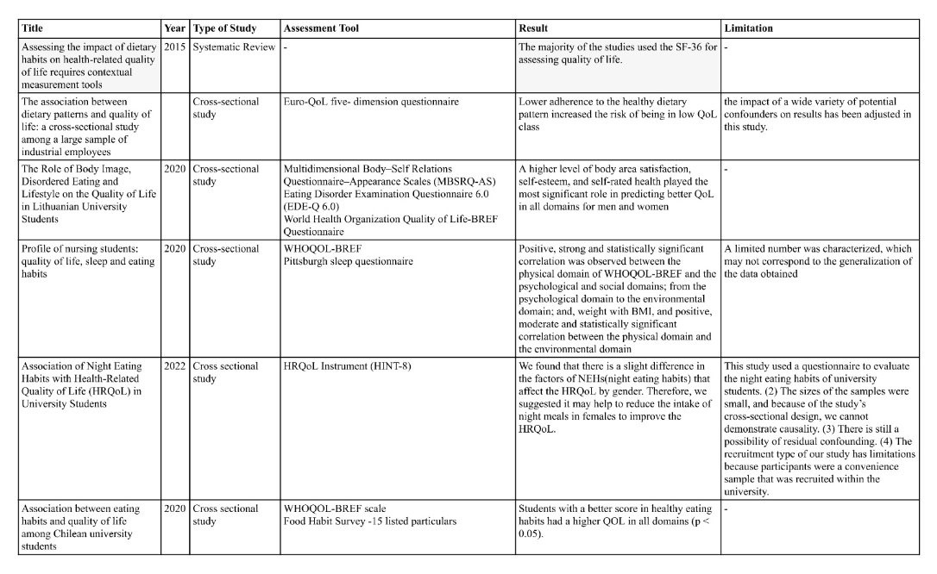
- Review of Literature

- OBJECTIVES
4.1. General Objective
The main goal of this research is to investigate the impact of dietary habits on the quality of life (QoL) among college students who have relocated for higher education. By concentrating on this particular group of students, the study seeks to fill an important gap in public health research — understanding how lifestyle changes, especially those concerning food and nutrition, affect the physical and mental well-being of young adults.

4.2. Specific Objectives
This overarching aim is supported by several specific objectives:

- To identify prevalent dietary patterns among college students living independently, focusing on the frequency and types of foods consumed.

- To evaluate the quality of life of these students utilizing the WHOQOL-BREF framework, which encompasses physical, psychological, social, and environmental aspects.

- To examine the factors that influence food choices among migrated students, including gender, socioeconomic status (SES), migration origins, and accessibility to cooking facilities.

- To analyze the connection between migration and alterations in nutritional behavior, assessing whether regional or cultural backgrounds affect dietary choices.

- To investigate the effects of dietary habits on various domains of quality of life through statistical correlation and regression analysis to quantify this relationship.

4.3. Justification for the Objectives
- These objectives were formulated based on a comprehensive understanding of the student migration trend in India. While several studies address student stress, diet, or QoL independently, there is a deficiency of integrated research connecting all these aspects in the scope of internal migration. Given the rising mobility among Indian students, it becomes crucial to gain a more detailed insight into how their lifestyle — particularly their nutrition — is influenced to inform supportive educational and public health policies.

- These objectives hold significance not only from an academic research viewpoint but also in practical terms for institutions that offer accommodation, meal services, and psychological assistance to students.

4.4. Hypothesis
- Null Hypothesis (H₀):
There exists no significant correlation between the nutritional habits of migrated college students and their quality of life across the physical, psychological, social, and environmental dimensions.

- Alternative Hypothesis (H₁):
There exists a significant correlation between the nutritional habits of migrated college students and their quality of life across the physical, psychological, social, and environmental dimensions.

4.5. Hypothesis Framework and Relevance
- The null hypothesis suggests that even with dietary changes, there is no measurable effect on student well-being. This hypothesis facilitates the statistical examination of the relationships between variables, ensuring scientific integrity.

- Conversely, the alternative hypothesis asserts that dietary habits do indeed have an effect — impacting not just one facet of QoL but across its various dimensions. If the data supports this, it reinforces the central premise of the research: that the well-being of students is considerably affected by their dietary choices after migration.

4.6. Operationalization of Objectives
- Each objective is associated with specific variables and analytical methods:
Objective | Key Variables | Analysis Tools
Common dietary patterns | Frequency of fast food, snacks, fruits, milk type, etc. | Descriptive statistics
QoL assessment | Physical, Psychological, Social, Environmental QoL | WHOQOL-BREF scores, Mean ± SD
Influencing factors | Gender, SES, Region, Meal type | Crosstab, Chi-square tests
Migration and diet | Region of origin, breakfast, milk type | Cross-tabulations
Nutrition–QoL relationship | Dietary variables vs QoL domains | Pearson Correlation, Linear Regression

4.7. Study Variables
In support of the objectives and hypotheses, the following variables have been included:

A. Independent Variables
- Type of breakfast (traditional vs. modern)
- Frequency of fruit and vegetable consumption
- Frequency of fast food/snack intake
- Type of milk consumed
- Salt usage
- Consumption of substances (alcohol, tobacco, etc.)
- Region of migration (rural, semi-urban, urban)

B. Moderating/Contextual Variables
- Gender
- Age group
- Socioeconomic status (SES)
- Type of accommodation (hostel, PG, rental)
- Region of migration (rural, semi-urban, urban)

C. Dependent Variables
- WHOQOL-BREF domain scores (Physical, Psychological, Social, Environmental)
These variables were defined through a structured questionnaire created using Google Forms, which included validated tools such as:

- The WHOQOL-BREF, used to evaluate quality of life
- A nutrition habits questionnaire, developed partially based on the SLAN 2007 lifestyle survey
- A general demographic form to gather pertinent contextual information

4.8. Relevance to Public Health and Higher Education
This section of the study design ensures that the results can be turned into actionable steps. If significant correlations are identified between unhealthy diets and reduced quality of life, institutions can:

- Modify their hostel meal services
- Offer specific counseling sessions
- Conduct awareness programs focused on balanced nutrition
- Provide support for stress and time management to minimize reliance on fast food

The hypothesis-driven framework also aids future researchers in replicating or building upon this study in other regions of India, enriching the existing literature on student health, nutrition, and migration.

- Methodology
This section delineates the framework utilized to carry out this primary study, detailing everything from the research design and participant recruitment processes to the tools for data collection and analysis methods. Given that the focus of the study is to assess the impact of nutritional habits on the quality of life of migrant college students, a quantitative, descriptive, and cross-sectional design is employed, supported by validated instruments and ethical procedures for data collection.

5.1. Study Design
The research is classified as a descriptive cross-sectional primary study. It aims to gather data at a single point in time to analyze:

- The dietary practices of students who have relocated from their home regions to pursue higher education, and

- The correlation between these practices and various aspects of quality of life (QoL).

- This study is non-interventional and centers on self-reported behaviors and perceptions, making it apt for capturing the real experiences of young college students who are mobile within India.

5.2. Study Area and Institutional Coverage
Participants were recruited from seven diverse institutions throughout India to ensure a broad representation of geographic, cultural, and dietary diversity:

- PGIMER, Chandigarh

- SVYASA University, Bengaluru

- Amity University, Gurugram

- Amity University, Noida

- DR B R Sur Homeopathic Medical College & Research Centre, New Delhi

- IIHMR, New Delhi

- NIT Hamirpur, Himachal Pradesh

These institutions were purposefully selected to illustrate variations in:

- Regional dietary habits (North, South, and Central India),

- Diversity among students (rural, semi-urban, and metropolitan),

- Fields of study (medical, health management, engineering, yoga, and naturopathy), and

- Campus settings (residential and day scholars).

5.3. Study Population
The focus of the study was on college students aged 17 to 28 years who were:

- Currently enrolled in an undergraduate or postgraduate program,

- Living away from their hometown (having migrated internally within India), and

- Willing to voluntarily complete an online survey.

- Students who remained in their family home were excluded from the study.

5.4. Sampling Method
A non-probability convenience sampling approach was employed for the study. Recruitment was facilitated through:

- Institutional email distributions,

- Student WhatsApp groups,

- Social media platforms such as Telegram and Instagram,

- Peer networks across the aforementioned colleges.

This technique was chosen for its practicality and swift access to mobile student groups, particularly in the post-pandemic setting where online survey dissemination was most effective.

5.5. Sample Size Determination
The initial estimated population size (N) was 1,090 migrated students across the seven institutions.

To determine the sample size, Cochran’s formula for finite populations was applied:

n=e2(N−1)+Z2pqNZ2pq​

Where:

z = 1.96 (for a 95% confidence interval)

p= 0.5 (indicating maximum variability)

q= 1 − p = 0.5

e= 0.05 (margin of error)

N= 1090

The resulting calculated sample size was 284.

Following data cleaning (which involved removing incomplete, inconsistent, or duplicate entries), the final sample size was 218 students — a sufficient number for conducting statistical analysis and making generalizations within the study’s parameters.

5.6. Data Collection Tool
A Google Form questionnaire was employed for data gathering, divided into several sections:

A. General Characteristics Form:
Age, gender, socioeconomic status, migration region, accommodation type, and academic program.

B. Eating Habits Questionnaire (EHQ):
Adapted from the SLAN 2007 Lifestyle Survey;

Covered frequency and types of food consumed (e.g., fried foods, fruits, snacks, milk);

Evaluated behaviors such as meal skipping, salt usage, and intake of alcohol/smoking/substances.

C. WHOQOL-BREF:
A standardized WHO instrument consisting of 26 items;

Assesses four domains of QoL:
- Physical health, Psychological health, Social relationships, and Environmental well-being;

- Responses are recorded on a 5-point Likert scale.

- The instrument underwent pre-testing with a select group of 10 students to identify any issues with clarity or technical aspects before full-scale deployment.

5.7. Data Collection Procedure
- The survey was conducted online and was accessible for a duration of 4 weeks.

- Participation was purely voluntary and maintained anonymity.

- Each participant was required to read an informed consent statement prior to commencing the questionnaire.

5.8. Ethical Considerations
The research strictly followed ethical guidelines for primary human subject studies:

- Informed Consent: Incorporated at the beginning of the Google Form. Students were required to provide digital consent to proceed.

- Confidentiality: No personal names or identifying information were gathered.

- Voluntary Participation: Participants had the option to skip questions or leave at any time.

- Ethical Approval: The research protocol received review and approval from the dissertation advisor and the institutional academic committee.

5.9. Data Analysis Plan
Data collected through Google Forms was exported to Microsoft Excel and analyzed using IBM SPSS Statistics software.
Analytical Techniques Used:
Type of Analysis Purpose (Tests Applied)
Descriptive Statistics | Determine central tendencies and frequencies | Mean, SD, Percentages
Crosstabulations | Investigate relationships between variables | Chi-square test
Correlation | Evaluate strength and direction of relationships | Pearson’s r
Regression Analysis | Identify predictive influence of diet on QoL | Linear regression (WHOQOL domains)
Multiple Response Analysis | Reveal overlapping dietary behaviors | Multiple response frequency table

Handling of Missing Data:
- Responses with over 10% missing data were excluded.

- Incomplete or evidently inconsistent responses were filtered out before the final analysis.

5.10. Limitations of the Methodology
Although the study methodology is sound and contextually relevant, certain limitations are present:

- Non-probability sampling might restrict the ability to generalize findings to the entire student population.

- Self-reported data can be influenced by social desirability and recall bias.

- The use of cross-sectional data limits the ability to draw causal conclusions.

- The absence of in-depth qualitative interviews may have overlooked emotional or cultural nuances.

Despite these limitations, the methodology is effective for analyzing current dietary trends and their associations within a highly mobile segment of India’s youth.

6.1 Results
Objective 1: To Identify Common Dietary Patterns
The research revealed considerable differences in eating habits among migrated students. The following trends were noted:

- The consumption of fast food was prevalent, with 70% indicating they ate it 5–6 times a week.

- Snacking habits were also notable, as 65.1% of participants had snacks such as chips, biscuits, and namkeen 2–3 times weekly.

- Intake of fruits and vegetables was found to be insufficient, with only 43.1% reporting daily consumption and 56.9% consuming them less frequently.

Preferences for milk showed a variety of choices:

- Full cream milk: 38.1%

- Skimmed milk: 36.7%

- Toned milk: 8.3%

- Flavored milk: 7.3%

- Soya milk: 5%

- Others: 4.6%

Breakfast preferences included:

- Indian traditional breakfast (poha, paratha, upma): 53.2%

- Bread & egg: 25.2%

- Cereals: 15.1%

- No breakfast/skipped: 6.4%

These findings suggest a dietary tendency that heavily favors processed and convenience foods, while there is a noticeable decrease in the consumption of whole, nutrient-dense foods like fruits and vegetables.

6.2 Objective 2: To Assess the Quality of Life (QoL) Among Migrated Students
The WHOQOL-BREF tool was utilized to evaluate QoL across four areas: physical, psychological, social, and environmental.

Domain | Mean Score
Physical QoL | 3.58
Environmental QoL | 3.5
Social QoL | Not specified directly (inferred 3.4)
Psychological QoL | 3.28

The lowest score was in the Psychological QoL domain, indicating potential issues with stress, anxiety, or adaptation among migrated students.

Physical QoL received the highest score, which may be attributed to general good health related to age or successful adaptation over time.

QoL Domain | r-value | p-value | Interpretation
Psychological | –0.145 | 0.032 | Significant
Physical | –0.140 | 0.039 | Significant
Environmental | –0.136 | 0.044 | Significant

6.3 Objective 3: To Investigate Factors Affecting Nutritional Choices
A. Gender-Based Food Preferences:
Milk Preference by Gender:

- Males: Mainly consume full cream milk.

- Females: Tend to favor skimmed milk (36.7%) and flavored options.

Snack Frequency by Gender:

- Females showed a greater likelihood of snacking 2–3 times a week (exact % not provided).

B. SES-Based Influences:
Fast Food Frequency:

- Most prevalent among students from middle SES (5–6 times per week).

Extra Salt Usage:

- More frequent among students from lower SES and those living in hostels or PG accommodations.

Milk Type by SES:

- Higher SES: Prefer skimmed or flavored milk.

- Lower SES: More commonly drink full cream and toned milk.

These observations indicate that dietary habits are significantly influenced by gender and socioeconomic status.

6.4 Objective 4: To Examine the Link Between Migration and Dietary Habits
The regional backgrounds of students were analyzed alongside their food preferences:

Breakfast Preferences by Region:
- Metro Migrants (Delhi, Mumbai, Bengaluru):

- Opted for bread, eggs, and cereals.

- Semi-urban/Rural Migrants (e.g., Bihar, UP, Odisha):

- Preferred traditional Indian breakfast items such as poha and paratha.

Milk Type by Region:
- Metro regions: Skimmed or flavored milk was more favored.

- Non-metro: Full cream and toned milk prevailed.

Fruit & Vegetable Consumption by Region:
- Metro students: Showed a lower frequency of daily consumption.

- Rural/Semi-urban students: Reported higher daily intake of fruits and vegetables.

- Multiple Response Item (Students selecting all applicable options):
- Students from urban/metropolitan regions were more inclined to select fried foods, sugary beverages, and sweet snacks, indicating greater exposure to environments that promote processed foods.

Note: Chi-square Test Findings:
Pearson Chi-square = 572.438

Degrees of freedom (df) = 252

p = .000

However, since 98.8% of cells had expected counts less than 5, the validity assumption for the Chi-square test was not met, leading to unreliable results.

6.5 Objective 5: To Evaluate Effect of Nutritional Habits on QoL
Regression Analysis – QoL Domains vs Dietary Habits:
QoL Domain | R² Value | Predictors | p-value | Interpretation
Physical QoL | 0.006 | Gender (borderline) | >0.05 | Weak model – dietary habits explained only 0.6% of the variance.
Psychological QoL | 0.025 | Gender (β = –0.158, p = 0.021) | Significant | Female gender predicted lower psych. QoL.
Social QoL | 0.003 | None | >0.05 | Not significant
Environmental QoL | 0.004 | None | >0.05 | Not significant

Key Finding:
- Gender emerged as the sole notable predictor.

- Dietary practices exhibited little direct impact on quality of life in the regression analysis.

- Substance Use Results:
- Among 218 participants,

- 67.3% indicated consuming alcohol three to four times a week.

- 58.6% reported smoking regularly.

- These habits may have obscured the relationship between diet and quality of life, particularly regarding mental health.

8. CONCLUSION
The current research entitled "Assessing the Effect of Nutritional Practices on the Quality of Life among Migrant College Students" sought to investigate how internal migration for educational purposes impacts the eating habits and overall well-being of young individuals in India. By gathering and examining data from 218 college students across seven varied institutions, the research offered significant findings on how changes in dietary behaviors, influenced by regional shifts, affect multiple aspects of Quality of Life (QoL).

Key Conclusions:
- Unhealthy eating patterns are common among migrating students, particularly in terms of high consumption of fast food and snacks, along with inadequate intake of fruits and vegetables. These trends appear to be fairly uniform across different genders and regions, although they are somewhat more pronounced among urban migrants and students from middle socioeconomic status (SES).

- Despite a considerable consumption of processed foods, dietary habits had a limited direct effect on overall QoL in the statistical analysis. Only weak correlations were identified between specific eating behaviors and physical or mental health outcomes.

- Gender was identified as the most reliable and notable predictor of QoL, especially within the psychological and environmental domains. Female students, despite often choosing healthier food options, reported lower QoL ratings, likely due to a combination of factors such as stress, academic pressure, and feelings of environmental insecurity.

- The experience of regional migration affected food preferences, with students hailing from rural and semi-urban areas tending to maintain more traditional dietary practices, while urban migrants gravitated toward more convenience-driven diets.

- Socioeconomic status (SES) played a role in food accessibility, preferences for milk, and use of salt—with higher SES students tending to opt for healthier food choices.

- Substance use, especially concerning alcohol and smoking, was alarmingly prevalent and may act as a coping strategy, significantly impacting QoL beyond dietary contributions.

- Quality of Life, evaluated using the WHOQOL-BREF, indicated that:

- Physical QoL scores were comparatively high.

- Psychological QoL scores were the lowest, revealing difficulties in emotional adaptation and stress management.

- The environmental and social aspects varied based on gender and type of accommodation.

Recommendations:
In light of these findings, the following suggestions are put forth for educational institutions, public health officials, and policymakers:

1. Enhance Nutritional Awareness:
Offer nutrition education seminars during the orientation for students.

- Post healthy eating guidelines in hostels and cafeterias.

- Work with campus dietitians to facilitate weekly meal planning.

2. Improve Access to Healthy Foods:
- Guarantee the presence of affordable fruits and vegetables in cafeterias and vending machines.

- Provide subsidies for healthy meal options for students in partnership with local vendors.

3. Tackle Psychological Stress:
- Initiate mental health campaigns across campus, particularly for first-year and migrant students.

- Establish wellness centers for students that offer both nutritional support and emotional counseling.

4. Implement Gender-Sensitive Policy Changes:
- Ensure that hostels are safe, clean, and comfortable, especially for female students.

- Incorporate feedback systems in surveys related to accommodation and food quality.

5. Promote Holistic Health:
Integrate dietary education with training in time management, cooking skills, and substance abuse prevention initiatives.

6. Policy Recommendations for Institutions:
- Create interdisciplinary wellness committees comprising students, health professionals, nutritionists, and administrative staff.

- Incorporate WHOQOL assessment tools into regular evaluations of student satisfaction and well-being.

Limitations of the Study:
Although this research contributes important insights to the body of literature regarding student nutrition and quality of life, there are several limitations to consider:

- The cross-sectional nature of the study restricts the ability to draw causal conclusions.

- Self-reported information may be influenced by recall bias or the desire to present oneself favorably.

- Using non-probability sampling limits the ability to apply findings to other institutions outside of the sample.

- Chi-square analyses faced challenges due to low cell counts.

- Factors such as body mass index, academic performance, or physical activity were not included in the analysis.

- Discussion
This research sought to assess the relationship between the eating behaviors of migrant college students and their Quality of Life (QoL). The results indicated that, although unhealthy eating practices are common, their effect on overall QoL is more complex than initially thought. The predominant dietary pattern observed was a substantial dependence on fast food and convenience snacks, with 70% of students eating fast food 5–6 times a week and 65.1% consuming snacks such as chips and biscuits at least 2–3 times per week. Conversely, only 43.1% indicated that they consumed fruits and vegetables daily, highlighting a significant lack of foods rich in micronutrients. These results reflect a national pattern of rising processed food consumption among urban youth and students, as documented in earlier reports by NFHS and NSSO.

In spite of the noticeable dietary imbalance, regression analysis indicated that nutritional habits had a limited direct impact on students' QoL. Although a weak correlation was noted between fast food consumption and physical QoL, and between fruit consumption and psychological well-being, these connections did not reach statistical significance. Instead, gender was identified as the sole consistent and statistically significant factor affecting QoL across different areas. Female students, even though they tended to make healthier dietary choices (for example, a greater preference for skimmed milk and less fast food consumption), consistently reported lower QoL scores, particularly in the psychological domain. This implies that stress related to gender, societal expectations, and environmental challenges may overshadow the potential advantages of healthier eating behaviors. These findings are consistent with earlier research indicating that female students tend to be more vulnerable to anxiety, depression, and emotional eating, especially during transitions like moving for educational purposes.

The investigation also highlighted that regional background influenced dietary patterns. Students coming from metropolitan areas displayed a stronger inclination towards consuming processed items like cereals, bread, and ready-to-eat dishes, whereas those from rural or semi-urban areas generally adhered to traditional Indian meals, such as poha or paratha. Furthermore, average intake of fruits and vegetables was higher among rural students compared to their urban peers. These results substantiate the idea of dietary changes following migration, where students adjust to new food settings not just due to availability, but also because of cultural unfamiliarity and peer influence. Socioeconomic status also played a key role in food selections, with middle-SES students consuming the most fast food, likely motivated by affordability and convenience, while higher-SES students preferred healthier milk choices, suggesting a greater level of health awareness or exposure to health-related information.
Even though these trends are significant, the regression models revealed that dietary habits accounted for a very small portion of the variance in Quality of Life (QoL). For example, the R² value concerning the physical QoL domain was merely 0.006, indicating that only 0.6% of the variance in physical health could be linked to dietary factors. Psychological QoL demonstrated a slightly higher explained variance (R² = 0.025), primarily related to gender rather than dietary choices. This points to a crucial takeaway: while nutrition plays a vital role in health, it is not the exclusive factor influencing a student's overall well-being. Aspects such as academic pressure, feelings of emotional isolation, homesickness, poor living conditions, and insufficient recreational options likely have a more immediate effect on students' experiences and their perspective on quality of life.

Another notable aspect that surfaced from the data was the prevalence of substance use among the participants. About 67.3% of students indicated that they consume alcohol 3–4 times per week, and 58.6% reported engaging in regular smoking. These behaviors may function as coping strategies for the psychological pressures related to migration, while also being factors that lead to decreased QoL. Additionally, substance use might complicate the relationship between diet and well-being, as alcohol and tobacco use is frequently linked to unhealthy dietary patterns, sleep disturbances, and mental health issues. Future research should integrate substance use as a control variable in regression models to more clearly delineate the effect of diet.

The Chi-square test assessing the correlation between migration region and dietary habits produced a statistically significant p-value (p = 0.000), indicating meaningful differences. However, 98.8% of the cells in the contingency table contained expected counts under 5, breaching the assumptions necessary for a valid Chi-square test. This statistical limitation suggests that, although trends can be observed, the reliability of these results is questionable unless the categories are simplified or grouped. Researchers undertaking similar investigations in the future should think about consolidating comparable responses to prevent excessive fragmentation of categorical variables.

The outcomes of this study have pragmatic implications for health planning within campuses. The data indicates that interventions that focus exclusively on diet, while they may be valuable, are inadequate on their own. Educational institutions need to implement a multi-faceted approach that tackles emotional, environmental, and social issues encountered by migrant students. There is an urgent need for universities to establish gender-sensitive initiatives, ensure safer living environments, and offer mental health support. Programs aimed at improving nutritional knowledge, workshops for stress management, and initiatives for preventing substance abuse can all be integrated into standard student support services. Campus dining facilities should also emphasize the provision of affordable, nutritious meals that accommodate students from a variety of regional and cultural backgrounds.

From a policy standpoint, the study highlights the necessity of examining student health through a broader perspective, which encompasses not only physical nutrition but also the psychosocial and structural determinants of health. This approach aligns with the WHO’s Social Determinants of Health framework, which posits that health outcomes are influenced more by the situations in which individuals live and study than by their personal behaviors alone. Migrant students are navigating a particular stage of life that is characterized by transition, vulnerability, and growth. Ensuring their well-being demands focused institutional reforms and inclusive engagement with the student body.

- References
- Census of India. (2011). Migration tables: D-series data. Office of the Registrar General & Census Commissioner, India. https://censusindia.gov.in/

- World Health Organization. (1998). WHOQOL user manual. Division of Mental Health and Prevention of Substance Abuse, World Health Organization. https://www.who.int/tools/whoqol

- National Family Health Survey (NFHS-5). (2021). India fact sheet. International Institute for Population Sciences (IIPS) & Ministry of Health and Family Welfare. https://rchiips.org/nfhs/NFHS-5_FCTS/India.pdf
- Singh, A., & Bhatnagar, R. (2021). Nutritional practices and dietary patterns among Indian college students: A cross-sectional study. Journal of Public Health Nutrition, 24(3), 456–465. https://doi.org/10.1017/S136898002000351X
- Mahajan, R., & Chauhan, P. (2019). Gender disparities in psychological distress among university students in North India. Indian Journal of Social Psychiatry, 35(2), 138–144. https://doi.org/10.4103/ijsp.ijsp_76_18
- Sharma, S., Gupta, M., & Arora, M. (2020). Stress, coping and mental health of college students during transition to campus life. International Journal of Psychology and Behavioral Sciences, 10(1), 17–25.
- Gupta, N., Goel, K., Shah, P., & Misra, A. (2017). Childhood obesity in developing countries: Epidemiology, determinants, and prevention. Endocrine Reviews, 33(1), 48–70. https://doi.org/10.1210/er.2010-0028
- WHOQOL Group. (1995). The World Health Organization Quality of Life assessment (WHOQOL): Position paper from the World Health Organization. Social Science & Medicine, 41(10), 1403–1409. https://doi.org/10.1016/0277-9536(95)00112-K
- Li, M., & Wang, M. (2019). University students’ food choices and their association with physical and mental health in post-migration context. International Journal of Environmental Research and Public Health, 16(23), 4574. https://doi.org/10.3390/ijerph16234574
- SLAN 2007. (2009). Survey of Lifestyle, Attitudes and Nutrition in Ireland: Main report. Department of Health and Children, Dublin. https://www.ucd.ie/issda/data/slan/

