Summer Internship Report
At
Sitaram Bhartia Institute of Science & Research
(April 22nd to June 21st, 2024)
A Report
By
Komal Bisht

PGDM (Hospital and Health Management)
2023-2025


International Institute of Health Management Research,
New Delhi

TABLE OF CONTENT

1 | Acknowledgement | 3
2 | Observational learning
2.1 | Introduction about the organization | 4-7
2.2 | Work done during internship | 8-10
3 | 12 rights of medication administration  Introduction | 11-14
4 | Rationale of the study | 15
5 | Aim & Objective | 16
6 | Methodology | 17-18
7 | Result | 19-25
8 | Discussion | 26-27
9 | Conclusion | 28
10 | Reference | 29
11 | Annexure | 30-31

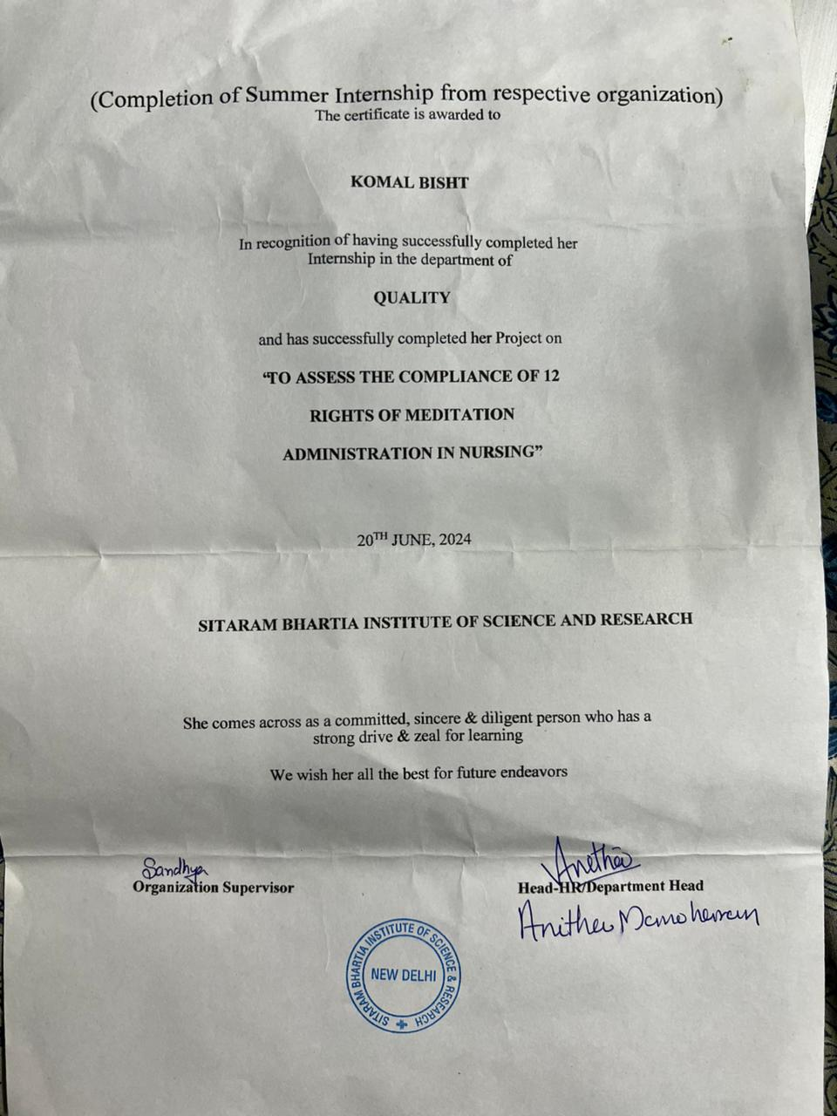

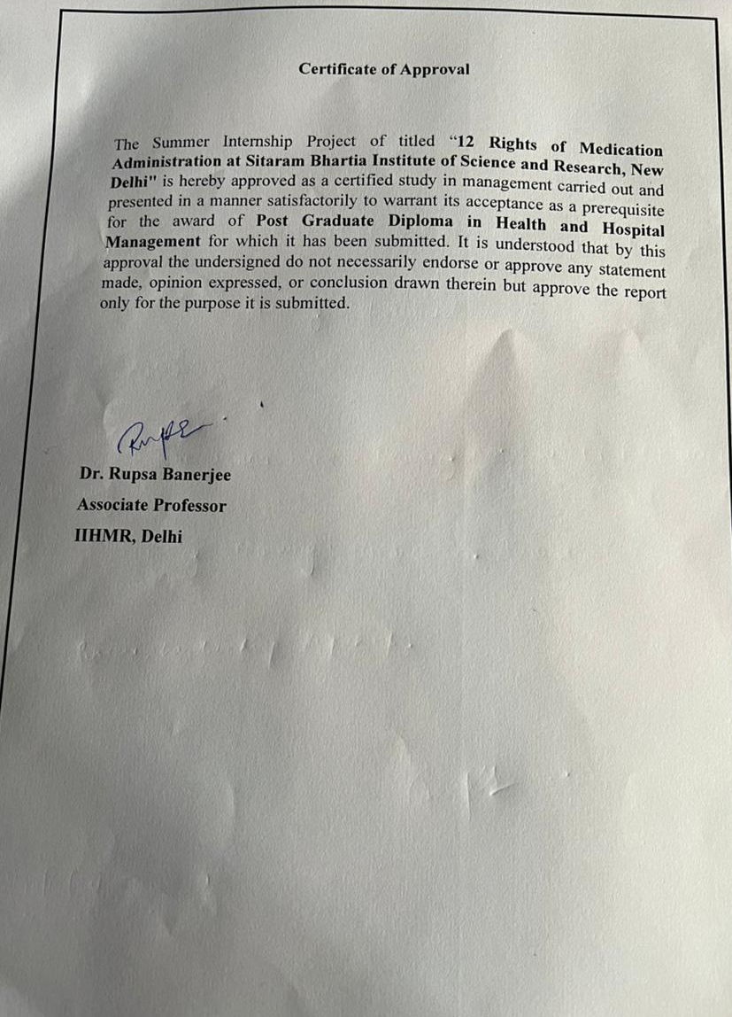

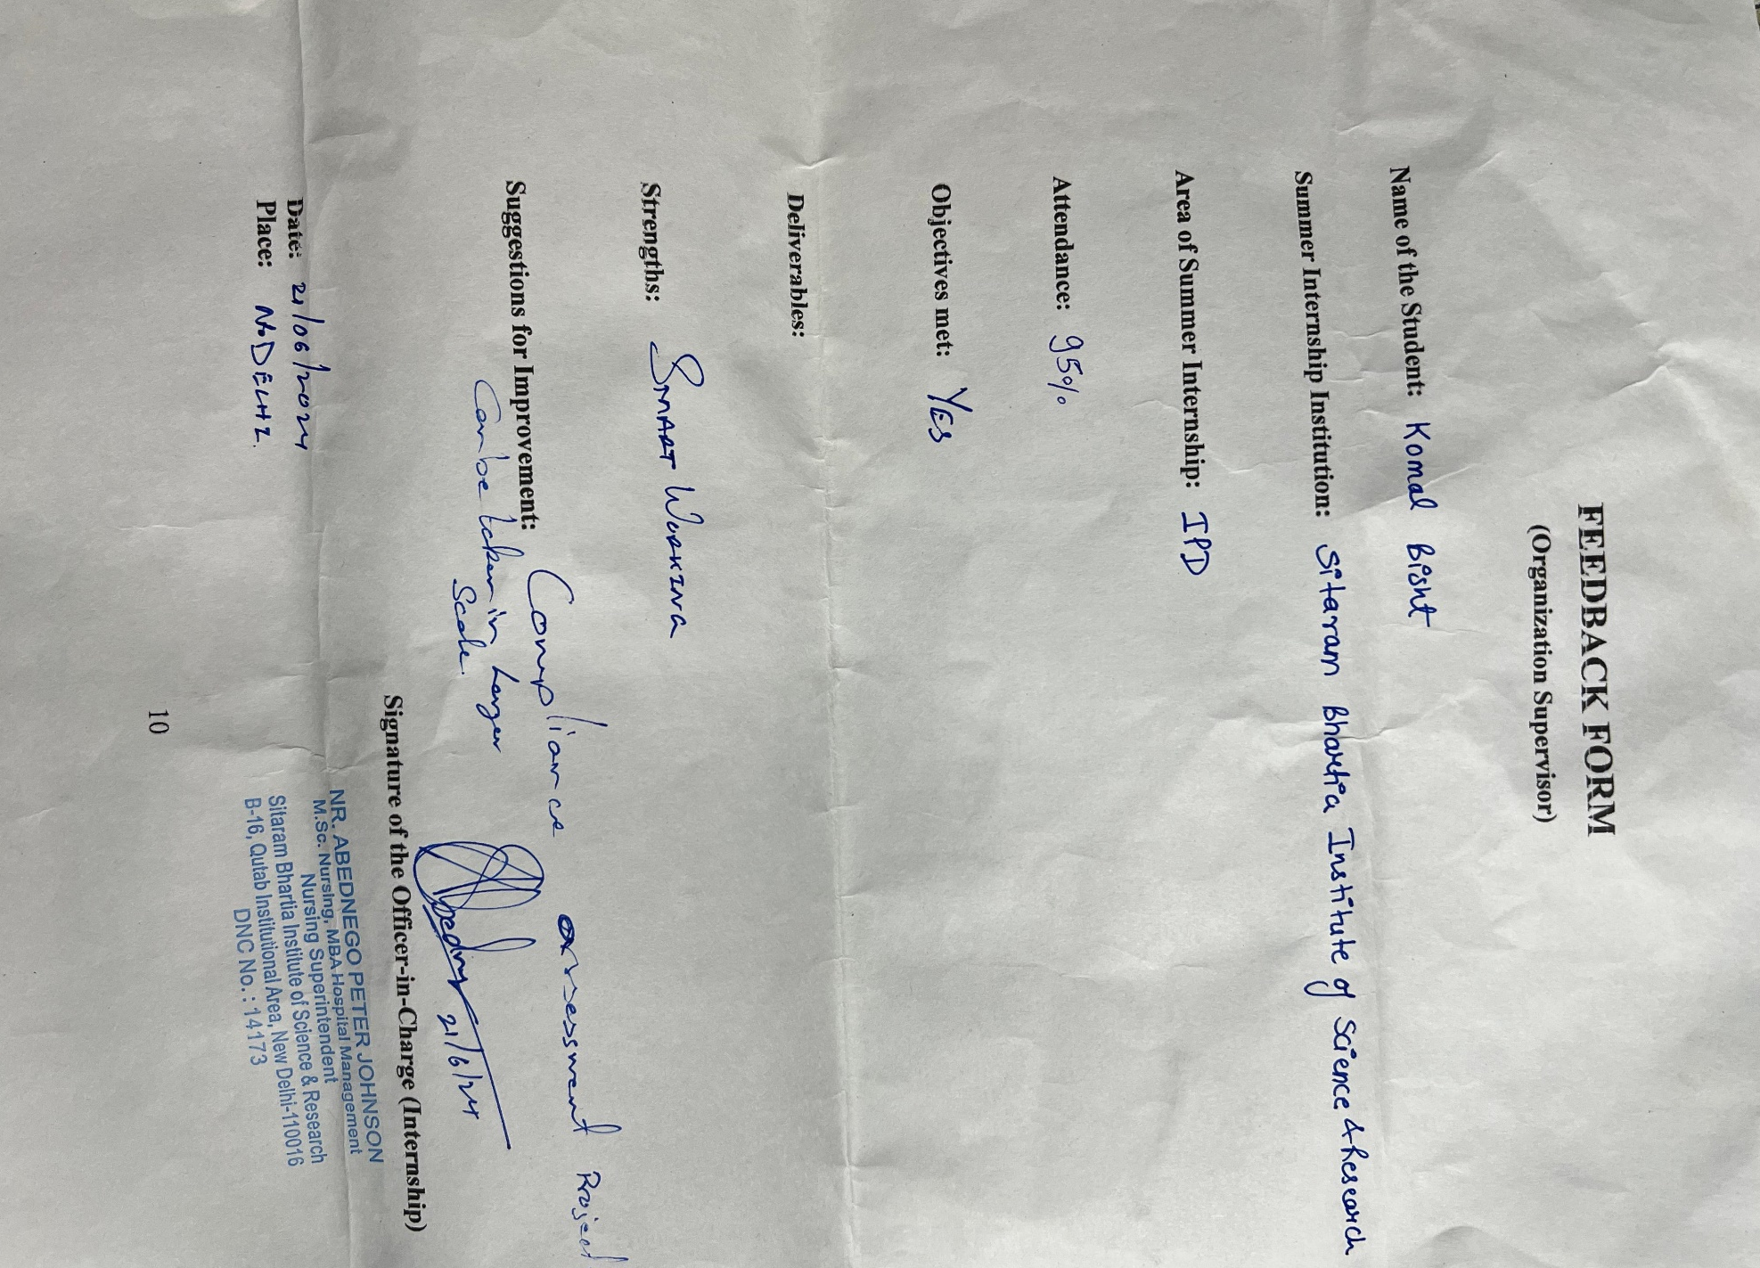
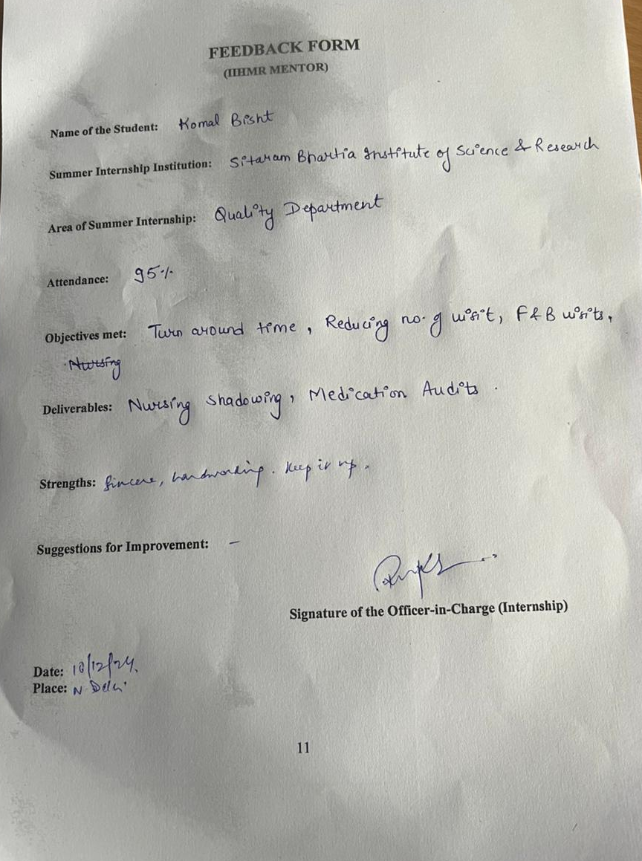

ACKNOWLEDGEMENT

This report is an outstanding prospect to convey my gratefulness to those many people whose timely help and guidance went a long way in finishing this project.
I would like to express my sincere thanks Sitaram Bhartia Institute of Science and Research for giving me this chance to learn the on-ground knowledge practiced by the hospital.
This project would not be completed without the guidance and support of my mentor Rupsa Banerjee, Assistant Professor, IIHMR Delhi.
I am fortunate to work with the institute as an intern. I am grateful to the Quality department of Sitaram Bhartia Institute of Science and Research for assisting me to get the information and priceless experience.
Lastly, I would like to thank my colleagues, supervisor and all those people who helped me with the completion of this project.
Working on this project was an enlightening experience for me

OBSERVATIONAL LEARNING
Introduction about the Organization

The Sitaram Bhartia Institute of Science and Research (SBISR) was founded in 1979, initially with a focus on medical research. Over the years, it has evolved into a well-known medical institute that integrates medical research with exceptional patient care. Their mission is to provide high-quality medical care with a strong emphasis on ethical medical practices, always putting the patient's interests first.
Sitaram Bhartia Hospital is a multispecialty hospital established in 1994 by Dr. Sitaram Bhartia in New Delhi, India. The hospital has approximately 120 beds and offers a wide range of medical services in various specialties. Care including obstetrics, high-risk pregnancies and laparoscopic surgery. disease. assistance. and peritoneal dialysis. medicine, gastroenterology, ophthalmology, psychiatry and psychology. It is renowned for its approach to the patient and providing quality care in a comfortable and modern environment.
OBSERVATIONAL LEARNING
Work Done during Internship
  - Time motion study of nurses
Shadowing nurses provides insights into the dynamic nature of their work environment and the diverse responsibilities they shoulder. Here's a breakdown of the observed tasks:
- Multitasking: Nurses often manage multiple tasks at once, such as administering medication, responding to patient calls, and collaborating with doctors.
- Patient Care: This encompasses a wide range of activities, from providing comfort measures to hygiene assistance and wound care.
- Nursing Assessments: Regularly evaluating patients' physical, emotional, and social needs is crucial for comprehensive care planning.
- Vital Sign Monitoring: Regularly checking and recording vital signs allows nurses to identify potential health problems and monitor patients' conditions.
- EMR Updates: Accurate and timely documentation of patient care details within the electronic health record system is essential for communication and continuity of care.
- Discharge and Admission Management: Nurses play a key role in ensuring smooth transitions for patients entering or leaving the hospital, including preparing discharge instructions and admission paperwork.
- Attendant Communication: Nurses communicate effectively with patient attendants or family members, addressing concerns, providing updates, and ensuring support for patients.
  - Time motion study of GDA
Time motion study: learned about the efficiency and effectiveness of various tasks performed by GDAs, such as cleaning, maintenance, and assisting passengers. This experience provides an understanding of the importance of time management and task prioritization.

  - Net Promotor Score
- NPS round- Patient feedback obtained through NPS rounds can guide targeted quality improvement efforts, focusing on areas identified as opportunities for enhancement by patients themselves. NPS rounds emphasize the importance of patient-centered care.
- During the Net Promoter Score (NPS) rounds, it was noted that the majority of patients expressed satisfaction with their experiences and demonstrated a willingness to openly communicate their concerns without reservation. Such receptiveness to feedback reflects a commitment to quality improvement and highlights the importance of ongoing efforts to prioritize patient satisfaction within the healthcare setting.
  - Number of Visits in IPD rooms
- Collaboration Opportunities: The data can reveal patterns in staff visits. If nurses and doctors frequently visit a room around the same time, collaborative rounds might be implemented to reduce interruptions.
- Task Batching: By understanding staff visit types and durations, hospitals can explore opportunities to batch similar tasks. For example, housekeeping staff could clean multiple rooms on a floor consecutively to minimize disruptions.
- Streamlined Workflow: The data can help design a workflow that minimizes unnecessary interruptions while ensuring patients receive timely care.
- Improved Patient Satisfaction: Reduced disruptions and a more efficient care delivery system can lead to higher patient satisfaction.
- Staff Efficiency: Analyzing visit data can help optimize staffing schedules and improve staff productivity.

  - TAT ( Turnaround time)
Created monthly TAT report that included information from lead sources, Obs, and Non Obs calls, follow up calls, and a newly developed time conversion algorithm.

  - Medical Auditing
The hospital's electronic health record (HIS) system should be filled with key data from both the initial assessments performed by nurses and doctors across various departments, including pediatrics, obstetrics and gynecology, medicine, and surgery.
- We're focusing on data collection, not physically filling something.
- The data comes from assessments, not general patient information.
- We're specifying the HIS system (electronic health record) as the data source.

12 RIGHTS OF MEDICATION ADMINISTRATION

INTRODUCTION

Safeguarding Lives - The 12 Rights of Medication Administration in Hospitals

In medication administration, nurse play a unique role and have a unique responsibility because they frequently check last to make sure the medication is given and prescribed correctly. (Elliot et al, 2010) Drug organization is a center liability of enrolled medical caretakers. According to International Council of Nurses (2012), registered nurses worldwide are educationally prepared, morally responsible, and professionally accountable for performing their duties safely. Nurture consistently experience the difficulties of securely overseeing meds in the conveyance of medical services for patients (Kim and Bates, 2013). The drug organization process includes various wellbeing experts and wellbeing shoppers. The interaction is installed and entrapped with other nursing liabilities (Sitterding et al., 2014). In addition, protected and compelling organization of prescriptions is more than just 'doling out medications' (Davis et al., 2005) on the grounds that the intricacy and capriciousness of contending requests on attendants' time influence their work on (Sitterding et al., 2014).
The literature on medication administration focuses on errors, issues, and deficiencies, which diverts attention from safety enablers that skilled nurses use every day.

Treating a Patient - Determining that a patient is being treated implies that the recipient has consented to the treatment. This is best done by the physician asking the patient to say their full name out loud and then looking at the hospital bracelet to match the name and photo ID number if applicable. If there are at least two patients on the ward with different or similar names, it is best not to say their first or last name. Physicians are encouraged to use electives that require reasonable effort to verify the patient's characteristics. (Elliott et al., 2010).
[The right way] [Patients can take medication in different ways; each has its own disadvantages, including how long the medication takes to work. Will something happen? Oral, intramuscular, intravenous, topical, and subcutaneous injection are various delivery methods. The emergence of new drug delivery methods such as intrathecal drug delivery, patient-controlled analgesia (PCA), central venous catheterization, and epidural infusion have made drug delivery more common in modern medicine. (2010) Elliot et al. In order to understand how to safely administer medications to patients, especially those who use them infrequently, doctors need to be aware of the latest developments in medicine.
Right time-A large amount of medication according to the time prescribed by the doctor. The principle of this "rule" is that caregivers should prescribe the medication as close as possible to the scheduled time, allowing a difference of no more than thirty minutes, to avoid adverse effects such as altered bioavailability or other toxic effects. (2010) Elliott et al. For example, antibiotics should be takeas a slowacting antibiotic to prevent vancomycin flush syndrome (an allergic reaction that can be controlled by reducing the rate of vancomycin infusion or stopping the medication altogether). (2010) Elliott et al. This type of error occurs when a doctor prescribes the wrong amount of medication to a patient without ensuring that the dose is appropriate for the patient, even if the medication is correct and the patient's identity is verified. This may be due to incorrect unit conversions, missing decimals, or arithmetic errors. (2010) Elliot et al. This study focuses on behavioral strategies to help reduce medication errors, including talking to pharmacy staff, using calculators to help with math, and sometimes talking to patients or their families about the daily doses they are given in the hospital.(et al., Martyn JA, 2019)
Prescription Medication- When participants check the prescription and packaging, ask the patient directly if they have any allergies, and check the expiration date on the prescription, Confirm that they are taking the correct medication. However, it is not always easy to check the expiration date due to the small print and irregular writing on the drug packaging, which can be a problem when combined with good light vision. Participants asked doctors to order certain drugs such as antibiotics and antibiotics to meet the needs of the patient. Participants provide information to doctors about appropriate drugs and the launch of products. Participants also counsel patients and use the services of hospitals and pharmacies to guide their practices. In summary, participants use various techniques to ensure that the right drug is given to the right patient. (Martyn, J.A. et al
Right to Refuse - The ability to refuse medication in healthcare is an important part of the patient's right to control. Respect for the patient. Ethics It is this right that doctors must obtain approval before prescribing medication, given the Code of Ethics. If the patient can make their own decision, the doctor should record the patient’s refusal and discuss it with the doctor. This will allow the doctor to address any concerns the patient may have or explore other treatment options. Incorrect or inadequate information can lead to inappropriate decisions and poor outcomes. Therefore, make sure that the medication is correctly prescribed, with the start and end date, and that you sign for it after receiving it.
Accurate assessment: Before giving the patient medication, you should assess the patient to make
sure, that they need the medication. If the patient is taking more than one medication, you should
make sure there are no contraindications. Finally, a baseline assessment (incremental behavioural
assessment) should be carried out if necessary. Their decisionmaking skills will improve with
experience and they will also be more cooperative during medication.
You should inform them of any side effects or symptoms and when to seek medical attention.
Medications should be reviewed regularly and, if necessary, they should be kept under constant
surveillance. In addition to the nutritional status of individuals receiving care or assistance, the
medications they have used in the past should also be checked. It is recommended to confirm the
expiration date before taking the medication. Go to the pharmacy. Prescribing can increase accuracy, patient safety and quality of care by prescribing the correct medication without the need for the
pharmacist to explain or write the prescription. conditions of those under care. Because the nurse
knows the patient condition very well. Medication errors can occur if a doctor's doctor asks another
doctor to give the patient's medication.

RATIONALE OF THE STUDY

Rationale for Achieving Compliance with the 12 Rights of Medication Administration
Preventing Medication Errors: Numerous countries have conducted population-based studies that have revealed extremely high rates of medication errors and avoidable deaths. An efficient medication error reporting system is the foundation of safe practice and a measure of safety progress. The 12 Rights serve as a comprehensive checklist to ensure accurate and safe medication administration, minimizing the risk of errors throughout the process.
Better Patient Outcomes: According to the World Health Organization, patient outcomes may be more directly impacted by medication adherence than by the specific treatment. Health outcomes, total healthcare costs, and life quality and duration can all be impacted by medication adherence.
Healthcare professionals can improve patient outcomes and lower medication errors by following to the 12 Rights. This entails fewer negative drug reactions as well as enhanced patient safety and health in general.
Standardized Practice: The Medication Practice Standard aims to delineate the responsibilities of nurses in relation to medication practices, encompassing administration, dispensing, storage, inventory control, and disposal. The 12 Rights create a standard operating procedure for various healthcare environments. Standardization reduces ambiguity and encourages patient safety best practices.
Enhanced Patient Trust: Patients develop faith in their healthcare professionals and the healthcare system when they are certain that their prescriptions are being provided correctly. A strong commitment to patient safety is demonstrated by achieving a high compliance rate, which improves the patient experience.
- In conclusion, one of the most important patient safety initiatives is to attain a high compliance rate with the 12 Rights of Medication Administration. In addition to potentially lowering healthcare costs, it decreases pharmaceutical errors, enhances patient outcomes, encourages standardized practice, and builds trust. (National Coordinating Council for Reporting and Preventing Medication Errors)

Aim:
To attain a compliance rate for Standard Patient Safety conformance with the 12 Rights of Medication Administration” Universal Protocol

Objective:
  - To assess the current baseline compliance rate with the 12 Rights of Medication Administration within the target population.
  - To identify and address any barriers that may hinder adherence to the 12 Rights protocol.
  - To explore the factors that influence adherence to the 12 rights, such as workload, staffing levels, and access to resources.

METHODOLOGY
Study Design:
A descriptive study is the suitable approach for the research on achieving compliance with the 12 Rights of Medication Administration for several reasons
  - Developing a baseline understanding:
A descriptive research provides an overview of current knowledge, attitudes, and behaviors around medication administration rights. This core information is critical for identifying opportunities for improvement. We may assess the level of knowledge healthcare professionals have about each right by assessing their responses to knowledge-based questions.

  - Identifying Knowledge Gaps and Areas for Improvement: Examining knowledge questions will identify areas of deficiency in comprehension. This allows you to discover which locations might benefit the most from targeted training campaigns or educational initiatives.

Study Setting:
Sitaram Bhartia Institute of Science and Research, Delhi
Nursing wards 1B (Mother and Child Care), 2A (Surgery) and 2B (General Medicine)

Study Duration:
22nd April to 21st June

Study Population:
This study will target a specific population of healthcare professionals at Sitaram Bhartia Hospital, New Delhi. The participants will be registered nurses (RNs) directly involved in medication administration duties during the standard workday shift, from 9:00 AM to 5:00 PM.

Study Sample and Selection Criteria:
Target Population: Registered nurses (RNs) working at Sitaram Bhartia Hospital, New Delhi, who are directly involved in medication administration duties.
Sample Size: (N= 80)
Selection Criteria:
- Inclusion Criteria:
  - Registered nurses (RNs) currently employed at Sitaram Bhartia Hospital.
  - Directly involved in medication administration duties during the standard workday shift (9:00 AM to 5:00 PM).
- Exclusion Criteria:
  - Nurses not directly involved in medication administration (e.g., research nurses, nurse educators).
  - Nurses on leave or unavailable during the data collection period.
Sampling Method: Convenience Sampling
Since the data is collected by approaching nurses directly during their shifts, it falls under convenience sampling as the easily accessible nurses become sampling frame.
In the study, there is no predefined list of nurses who administer medication is not available. Instead, data collection would be done by directly approaching nurses who are on duty and available during data collection period (9 AM to 5 PM). It falls under convenience sampling as the readily available nurses become sampling frame.

Method of Data Collection:
The study will employ a direct observation method to assess nurses' compliance with the 12 Rights of Medication Administration. Observer will visit all three nursing stations at Sitaram Bhartia Hospital during working shifts (9 AM to 5 PM). Nurses who are actively administering medication to patients will be observed by trained observer. The observer will use a standardized checklist containing the 12 Rights. For each right, the observer will mark a "1" if the nurse follows it correctly and a "0" if they deviate from the standard procedure.
RESULT

  - Department of surgery (Nursing ward 2A)
- Adherence of 12 Rights of medication administration in all three nursing wards
A total of 80 medication administration audits were collected from the 3 nursing wards, out of which 61% (49/80) have shown 100% compliance, 29% (23/80) have shown 85-95% compliance and 10% (8/80) have shown less than 85% compliance to the 12 rights of medication administration. Thus, out of total 80 audits, 39% were non compliant.

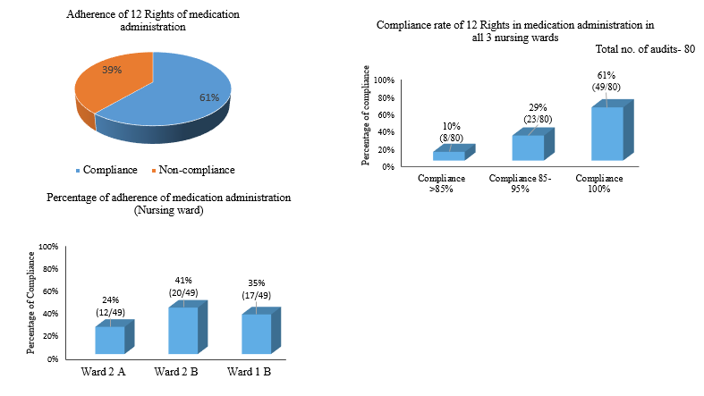
Figure 1. Compliance of 12 rights of medication administration in all 3 nursing wards

Nursing ward 2A showed 24% (12/49) of compliance, ward 2B showed 41% (20/49) of compliance and ward 1 B showed 35% (17/49) of compliance among all three wards.

- Adherence rate of each Right of medication administration

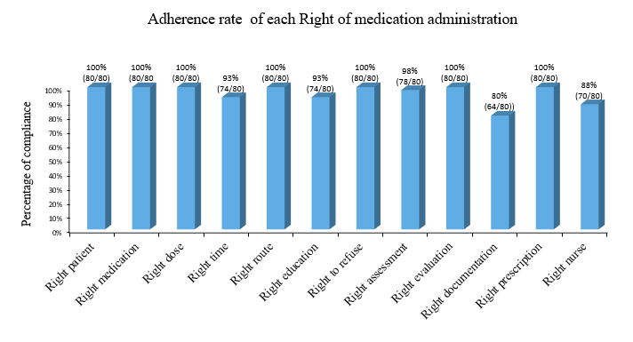

Figure 2. Compliance of each right of medication administration
The data shows adherence to several medication administration rights. In all instances (80 out of 80), nurses followed the Proper patient, medication, dosage, route, right-to-refuse and prescription. 5 rights out of 12 namely- right time (74/80), right education (74/80) and right assessment (78/80), right documentation (64/80) and right nurse (70/80) showed lower compliance rate.

- Nursing ward 2 A
A total of 32 medication administration audits were collected from 2A, out of which 38% (12/32) have shown 100% compliance, 41% (13/32) have shown 85-95% compliance and 22% (7/32) have shown less than 85% compliance to the 12 rights of medication administration. Thus, out of total 32 audits, 62% were non compliant.

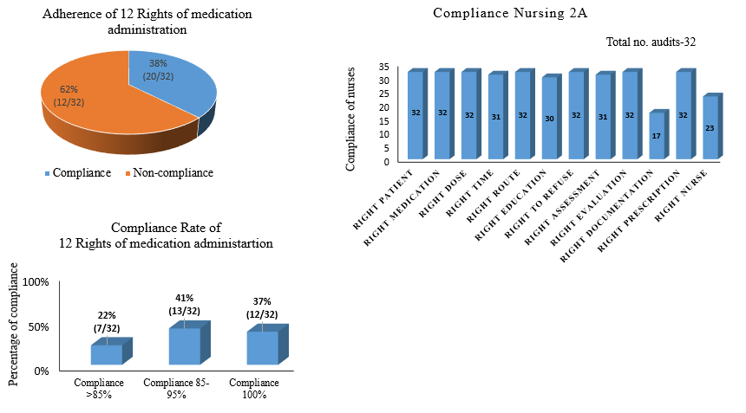
Figure 3. Compliance of 12 rights of medication administration in Ward 2A

In nursing ward 2A, 5 rights out of 12 namely- right time (31/32), right education (30/32), right assessment (31/32), right documentation (17/32), and right nurse (23/32) showed lower compliance rate.

- Nusring ward 2 B
A total of 27 medication administration audits were collected from 2B, out of which 74% (20/27) have shown 100% compliance, 22% (7/27) have shown 85-95% compliance and 4% (1/27) have shown less than 85% compliance to the 12 rights of medication administration. Thus, out of total 27 audits, 26% (7/27) were non compliant.

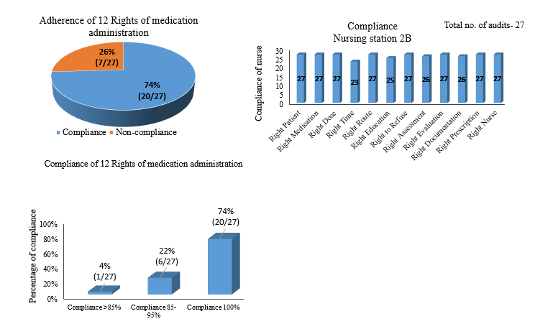
Figure 4. Compliance of 12 rights of medication administration in Ward 2 B

In nursing ward 2 B, 4 rights out of 12 namely- right time (23/27), right education 25/27), right assessment (26/27) and right documentation (26/27) showed lower compliance rate.

- Nursing Ward 1 B

A total of 21 medication administration audits were collected from 1B, out of which 81% (17/21) have shown 100% compliance, 19% (4/21) have shown 85-95% compliance and 0 have shown less than 85% compliance to the 12 rights of medication administration. Thus, out of total 21 audits, 19% (4/21) were non compliant.

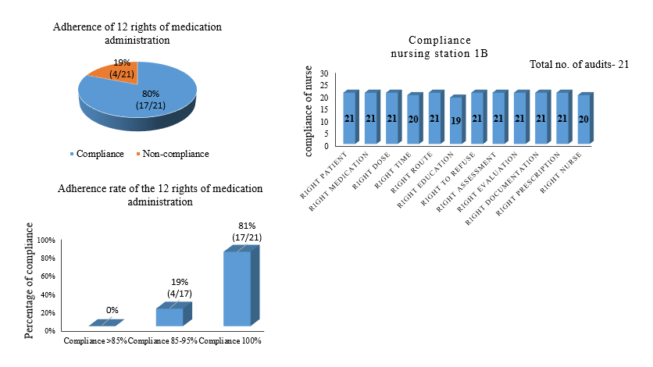

Figure 4. Compliance of 12 rights of medication administration in Ward 2 B

In nursing ward 1 B, 3 rights out of 12 namely- right time (20/21), right education (19/21) and right nurse (20/21) showed lower compliance rate.
The graph shows the compliance of the Department of Surgery 2A (Nursing ward) to the 12 Rights of Medication Administration. Overall, compliance appears to be high, with scores ranging from 17 to 32. However, there are areas for improvement, particularly in Right Documentation (scoring 17) and Right Nurse (scoring 23).

DISCUSSION
An analysis of medication administration compliance across nursing wards revealed areas for improvement, particularly in right documentation, medicine administration timing, right nurse assignment, right education, and right assessment. There were 8 instances (10.0%) where compliance fell below the desired 85% threshold. In 23 observations (28.75%), compliance ranged between 85% and 95%. However, on a positive note, nearly two-thirds (49 observations or 61.25%) achieved a perfect 100% compliance rate, indicating strong adherence to the 12 Rights in many instances. This information can be used to target improvement efforts in specific areas and ensure the highest possible medication safety for patients.
There is generally high compliance with the 12 Rights of Medication Administration across the nursing wards, there are still areas for improvement.
Right Documentation: Across all nursing wards, this seems to be an area of concern, with lower compliance rates compared to other rights. Proper documentation is crucial for maintaining accurate records of medication administration, which is important for patient safety and care. Nurse should receive additional training and support in documentation practices, emphasizing the importance of thorough and timely documentation.
Right Time: Adherence to administering medication at the right time is slightly lower compared to other rights. Timely medication administration is crucial for optimal therapeutic effects and patient outcomes. It's important to identify the reasons behind the delays and address them accordingly. This could involve better scheduling, minimizing interruptions, and improving time management practices among nursing staff.
Right Education and Assessment: These rights also show room for improvement, with slightly lower compliance rates. Proper patient education regarding medications and thorough assessment of patient needs are integral parts of safe medication administration. Nurses should undergo continuous training to enhance their communication skills, patient education techniques, and assessment abilities.

Recommendation for improvements –
- Nurses should generally begin bringing their computers on wheels (COW) with them while visiting patient sites this will decrease errors and ensure timely documentation.
- The computer system is less in number and usually in the mornings, doctors are using the computers. This creates hindrance as nurses are unable to access the computers they need to perform their duties. We need a solution to ensure both doctors and nurses have the tools they need to function optimally.
- Organize frequent training sessions for nurses that concentrate on medication delivery procedures, education and rights documentation. Assess compliance on a regular basis and give tailored feedback to improve performance. To find areas that need improvement and provide nurses with effective support, conduct frequent audits.

CONCLUSION
As we all know, giving medication is one of the most challenging professions, requiring careful attention at all levels; therefore, nurses are granted a number of privileges to help reduce complexity and make the procedure safe and secure.
Medication administrators must strive to offer great treatment while effectively protecting patients' rights. In any clinical context, the patient's well-being and the quality of care must take precedence. However, nurses are not the only ones in duty of defending rights; the entire healthcare system must function well.
Although our study found that drug administration compliance is usually higher throughout nursing wards, there are specific areas that need to be improved to ensure the patient's safety.
Right documentation revealed the most significant area for improvement, emphasizing the need for increased training and assistance for nurses. Similarly, compliance with appropriate timing, education, and assessment fell short. To promote compliance in these areas, the research suggests focusing training programs on the rights with the lowest adherence rates. Furthermore, continuing education for all nurses is essential. Implementing these recommendations will help nursing staff achieve even better levels of drug administration compliance, resulting in the greatest potential outcomes for patients.

REFERENCE

  - Elliott M, Liu Y. The nine rights of medication administration: an overview. Br J Nurse. 2010 Mar 11-24;19(5):300-5.
  - Martyn JA, Paliadelis P, Perry C. The safe administration of medication: Nursing behaviours beyond the five-rights. Nurse Educ Pract. 2019 May;37:109-114.
  - Kim, J., Bates, D.W., 2013. Medication administration errors by nurses: adherence to J.-A. Martyn, et al. Nurse Education in Practice 37 (2019) 109–114 11
  - The 10 Rights of Drug Administration [Online]. Nurseslabs. Available from: https://nurseslabs.com/here-are-7-medication-safety-tips-new-nurses-must-know
  - Rights Of Medication Administration [Online]. The Legal Vidya. Available from: https://blog.sisfirst.com/anesthesia-and-patient-safety-5-rights-of-medication-administration
  - Sitterding, M.C., Ebright, P., Broome, M., Patterson, E.S., Wuchner, S., 2014. Situation awareness and interruption handling during medication administration. West. J. Nurs. Res. 36 (7), 891–916.
  - Davis, L., Keogh, S., Watson, K., McCann, D., 2005. Dishing the drugs: a qualitative study to explore paediatric nurses' attitudes and practice related to medication administration. Collegian: J. Roy. Coll. Nurs. Australia 12 (4), 15–20.
  - Patient Safety - Position Statement, vol. 3 International Council of Nurses, Geneva.
  - National Coordinating Council for Medication Error Reporting and Prevention. (https://www.jointcommission.org/resources/for-consumers/speak-up-campaigns/preventing-medicine-errors/)
  - Hanson A, Haddad LM. Nursing Rights of Medication Administration. [Updated 2023 Sep 4]. In: StatPearls [Internet]. Treasure Island (FL): StatPearls Publishing; 2024 Jan-. Available from: https://www.ncbi.nlm.nih.gov/books/NBK560654/

ANNEXURE

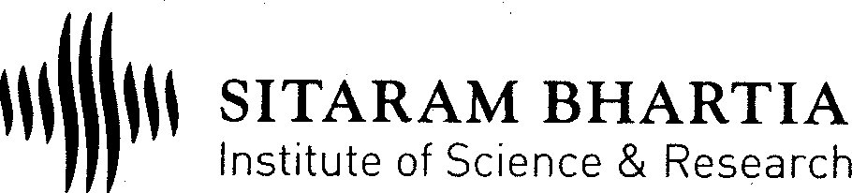
Medication Administration Audit Sheet
Date
Time (In HRS)
CR No.
Room No
Name of the Dept.
(Nursing)
Assigned Nr/Dr (Emp ID)
Instruction * Mark Given : "1" for Implemented & Mark "0" for not implemented.
* Method : "EA" - EMR/Doc/ Audit & "WO" - With Observation. Use " / " to Differentiate.
1 | Right Patient
2 | Right Medication
3 | Right Dose
4 | Right Time
5 | Right Route
6 | Right Education
7 | Right to Refuse
8 | Right Assessment
9 | Right Evaluation
10 | Right Documentation
11 | Right Prescription
12 | Right Nurse
Total Score per Patient -
Remarks
………………………………………………………………  Signature of Auditor (Emp ID & Date) | ………………………………………………………………  Signature of NS (Emp ID & Date)

