Internship Training at
Akhil Systems
SLEEP QUALITY AND SLEEP HYGIENE OF CORPORATE WORKERS
By
Name Komal Bisht
Enroll No.- PG/23/049
Under the guidance of
Dr. Rupsa Banerjee

PGDM (Hospital & Health Management) 2023-25


International Institute of Health Management Research
New Delhi

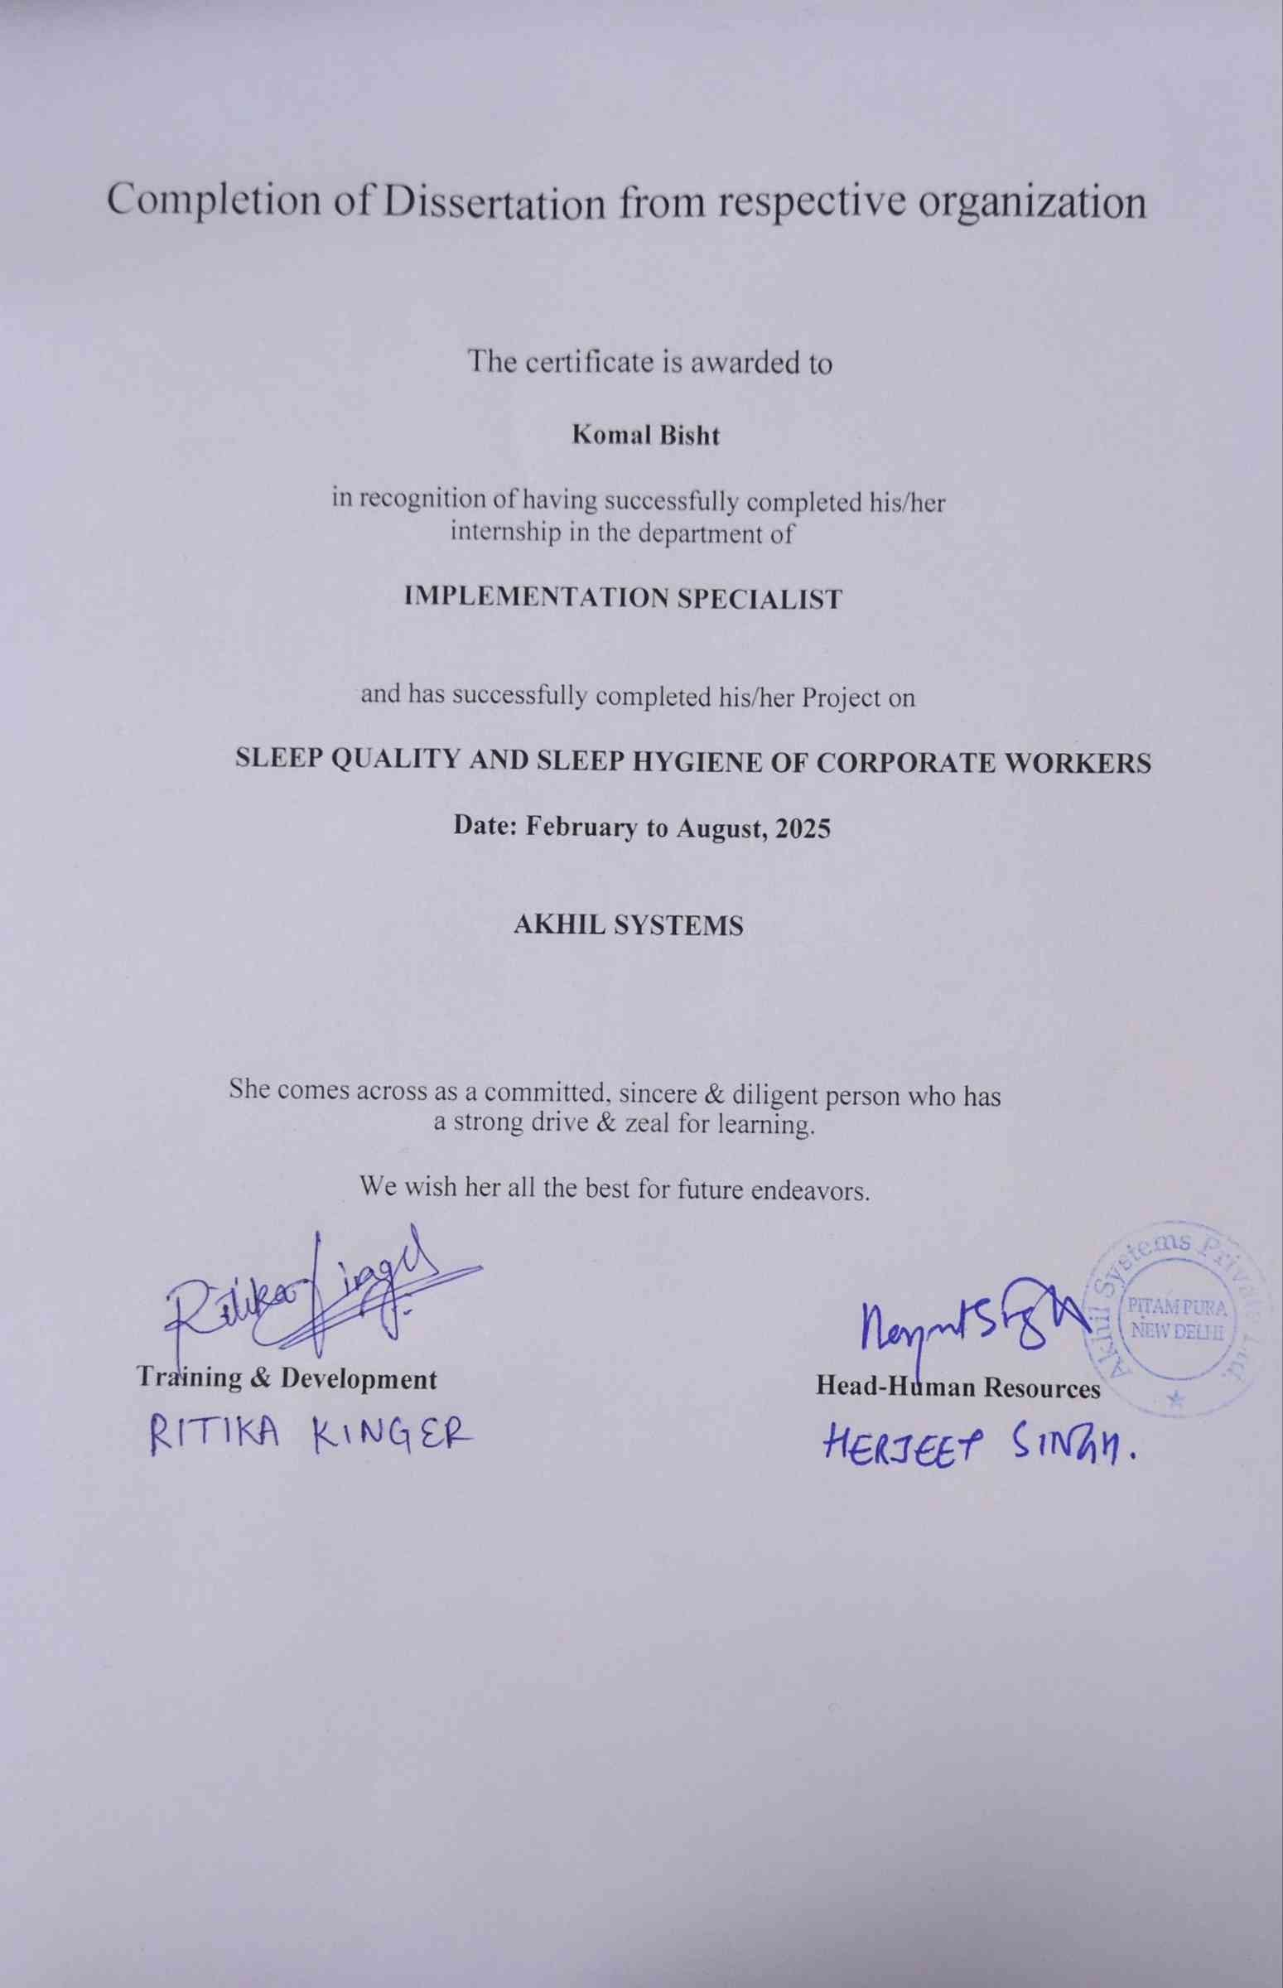

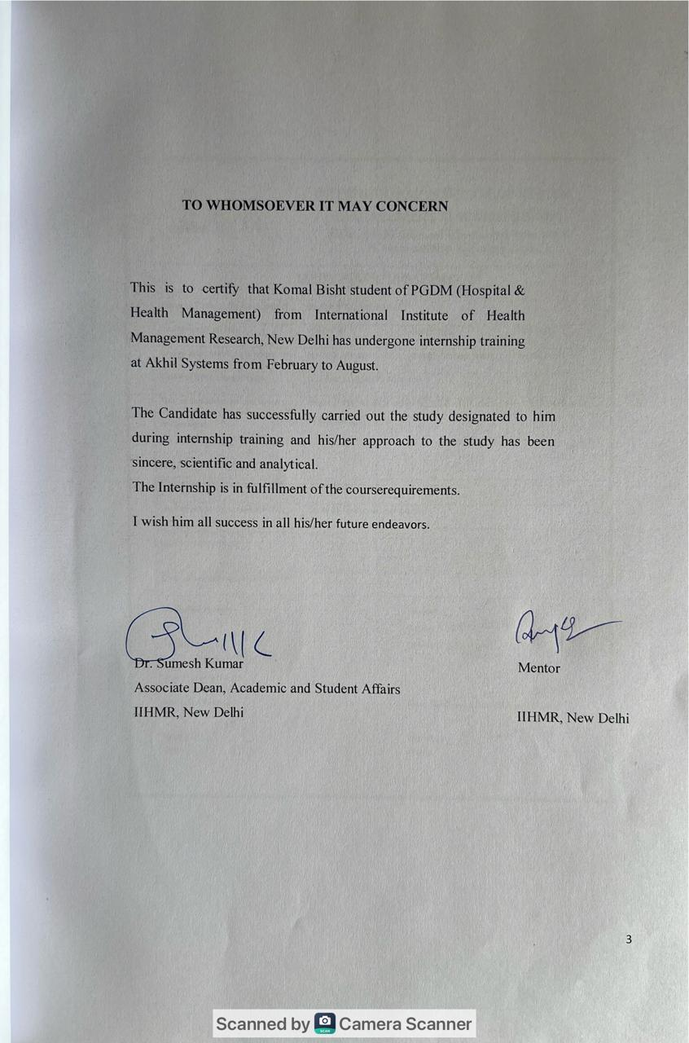
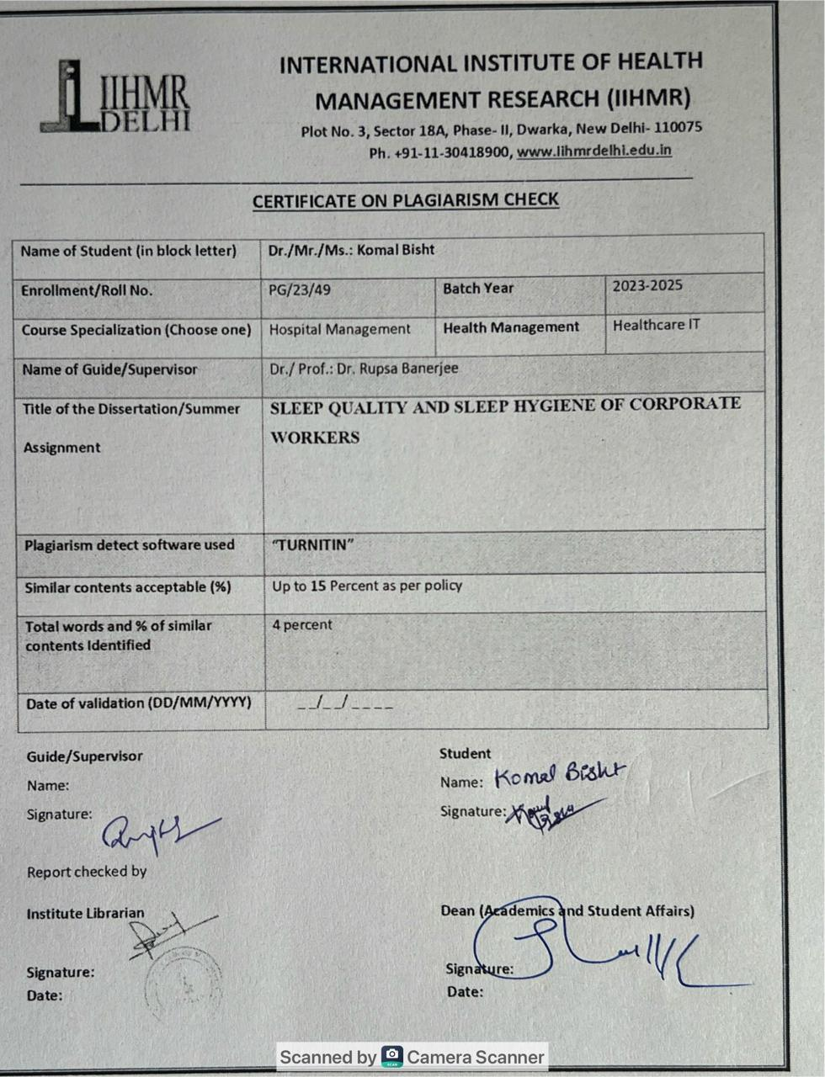



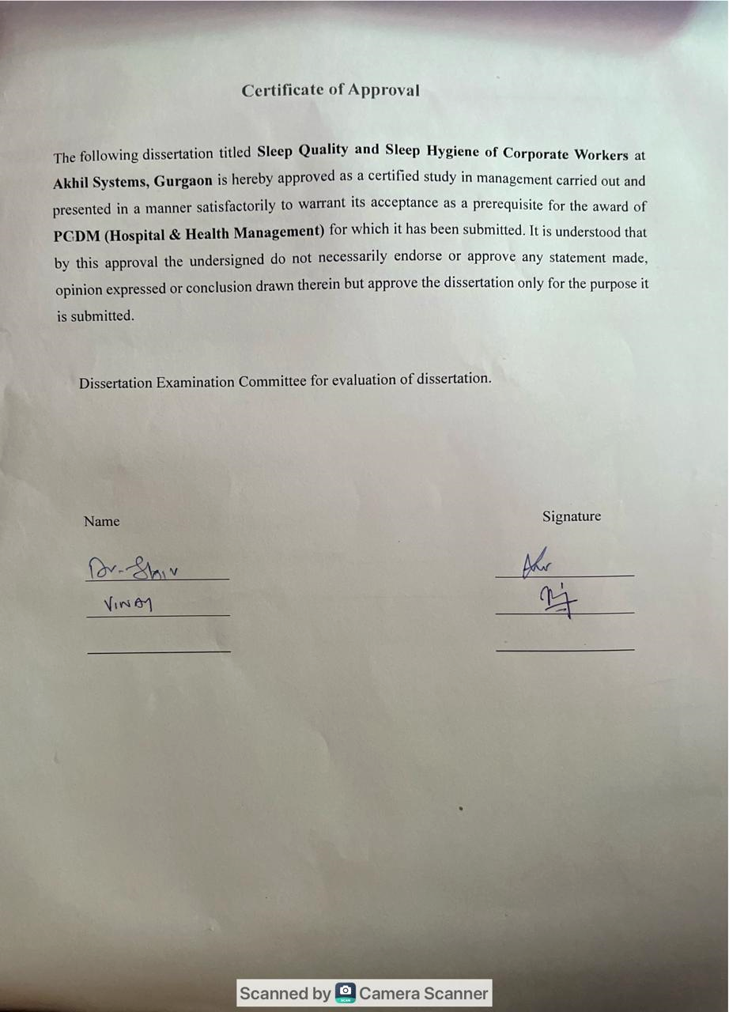

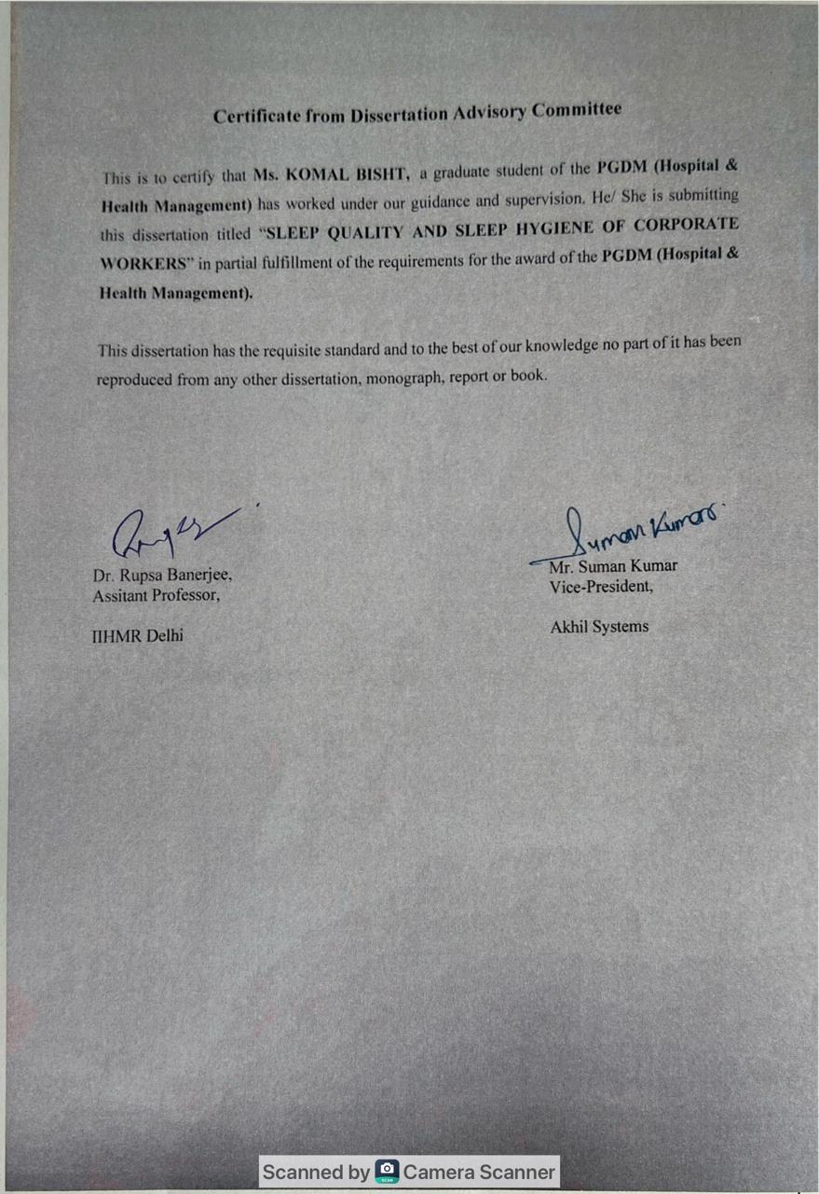
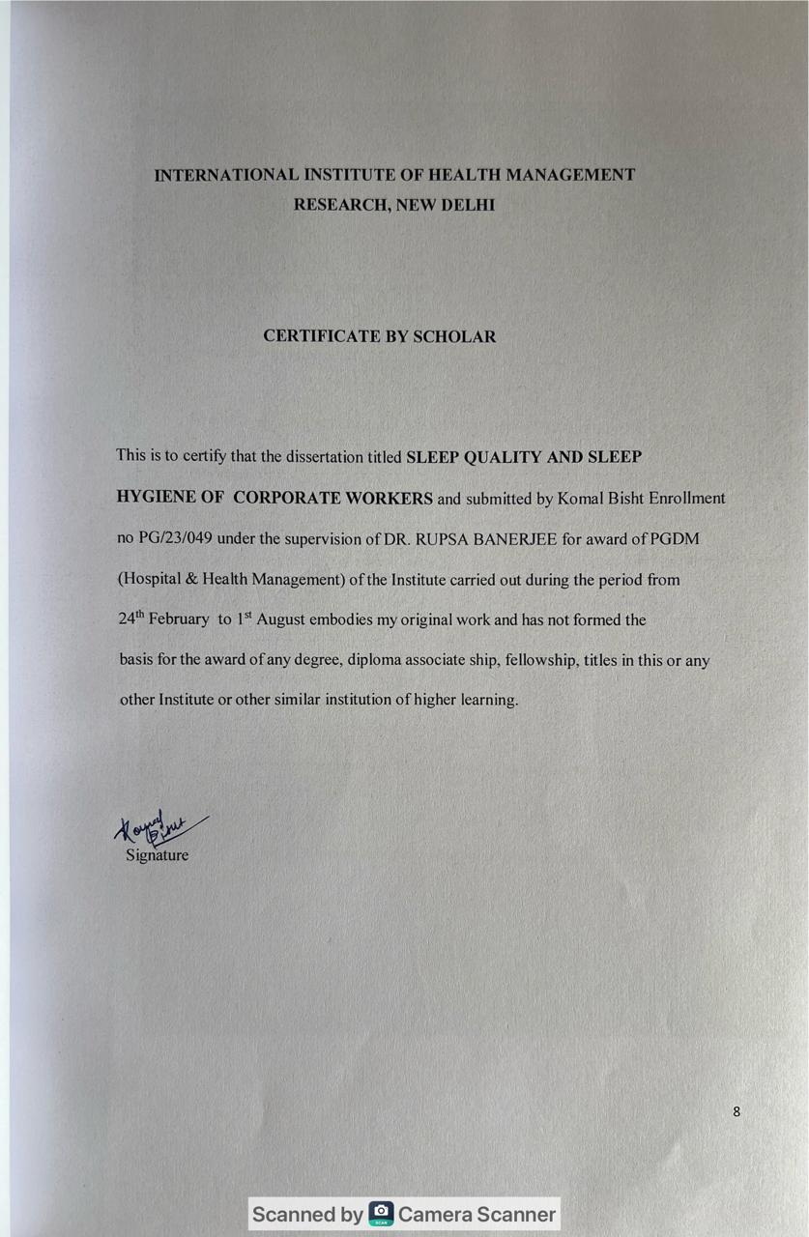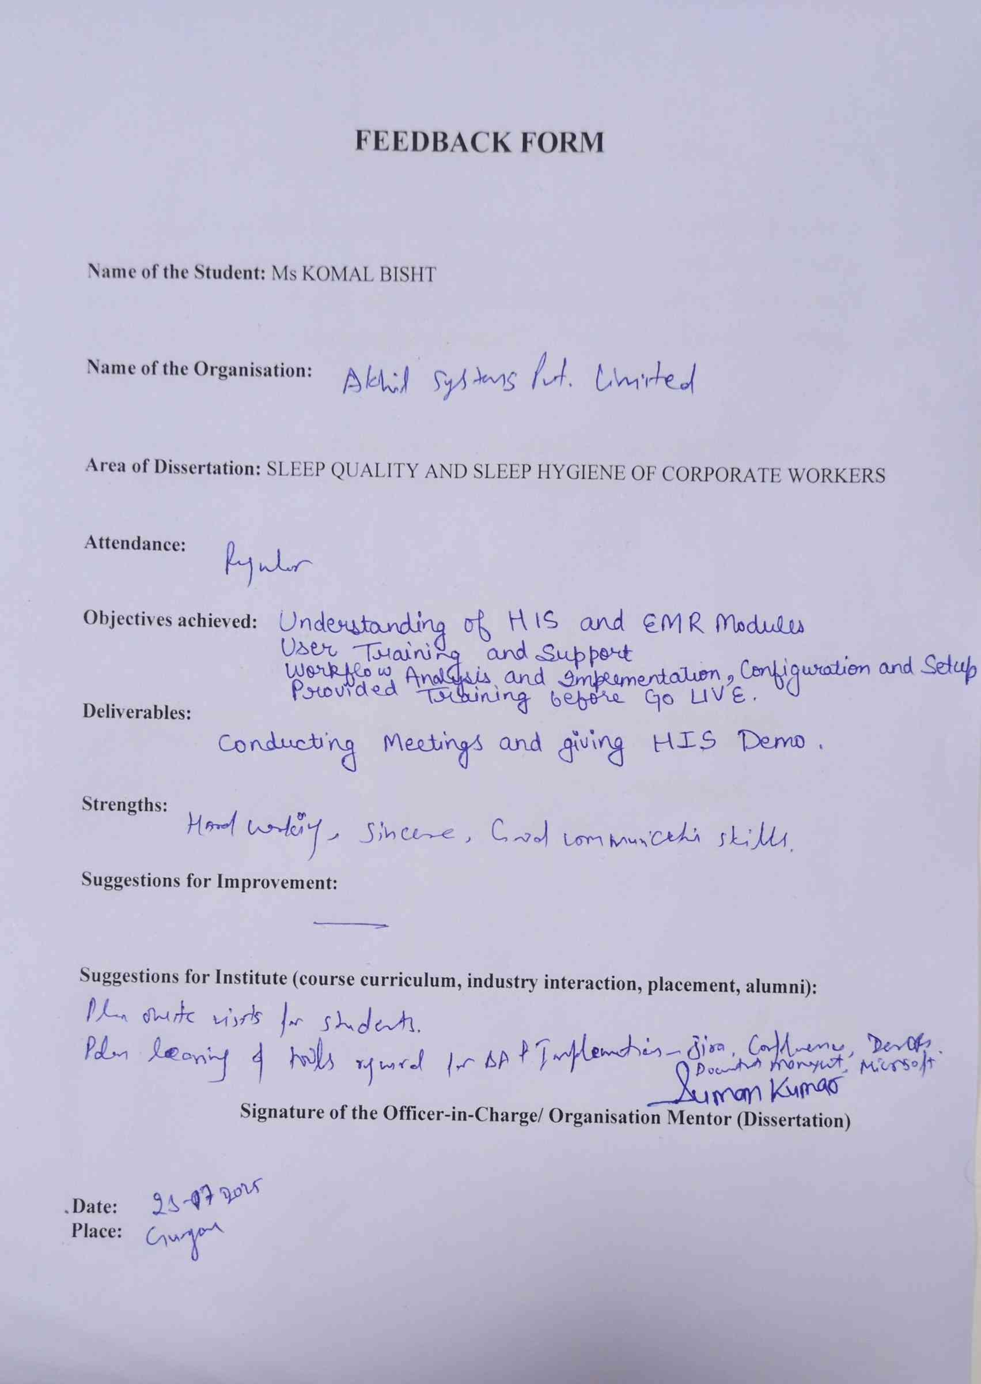

Acknowledgment
I would like to express my sincere gratitude to all those who have supported me throughout the course of this research project.
First and foremost, I am deeply grateful to my mentor, Dr. Rupsa Banerjee, for her invaluable guidance, encouragement, and insightful feedback throughout the research process. Her expertise and constant support have helped shape this study and brought clarity to my work.
I extend my heartfelt thanks to all the corporate professionals who took the time to participate in the survey, despite their busy schedules. Their honest responses and willingness to contribute played a crucial role in the successful completion of this study.
I also wish to thank my academic peers, faculty members, and my family, whose motivation and emotional support helped me stay focused and persistent.
This research would not have been possible without the collective effort of everyone involved. Thank you all for being a part of this journey.

Abstract
Background: Sleep is essential for emotional, mental, and physical well-being. In corporate environments, prolonged work hours and stress negatively impact sleep quality and hygiene. Poor sleep is linked to decreased productivity, poor decision-making, and burnout.
Objective: This study aimed to assess the sleep quality and hygiene practices of corporate employees aged 22–55 working standard office hours. It sought to identify common poor sleep habits, evaluate their impact on sleep quality, and compare results across job levels.
Methodology: A cross-sectional survey was conducted among 100 corporate employees using standardized tools—Pittsburgh Sleep Quality Index (PSQI) and Sleep Hygiene Index (SHI). Convenience sampling was used, and data were collected through an online questionnaire.
Results: 85% of participants were classified as poor sleepers (PSQI > 5), with a mean PSQI score of 9.36. Common issues included sleep latency and disturbances. The mean SHI score was 30.18, indicating moderate sleep hygiene concerns. Poor practices such as using the bed for non-sleep activities and thinking/worrying in bed were frequently reported. A moderate positive correlation (r = 0.56, p < 0.001) was found between poor sleep hygiene and lower sleep quality.
Conclusion: The study highlights significant sleep-related challenges faced by corporate workers across all levels. Poor sleep hygiene behaviors were closely linked to reduced sleep quality. The findings call for the integration of sleep-focused wellness programs and stress-reduction strategies in corporate settings to enhance employee health and productivity.

TABLE OF CONTENT
S. No. | Content | Page No.
1 | Acknowledgment | 10
2 | Abstract | 11
3 | List of Tables | 13
4 | List of Abbreviations | 14
5 | Chapter 1: Introduction | 15-16
6 | Chapter 2: Rationale of the Study | 17
7 | Chapter 3: Objectives | 18
8 | Chapter 4: Methodology | 18-19
9 | Chapter 5: Results | 21-25
10 | Chapter 6: Discussion | 26
11 | Chapter 7: Limitations | 27-28
12 | Chapter 8: Conclusion | 29
13 | References | 30
14 | Appendix – Study Tools | 31-35

Abbreviation | Full Form
PSQI | Pittsburgh Sleep Quality Index
SHI | Sleep Hygiene Index
SD | Standard Deviation
r | Pearson Correlation Coefficient
p | p-value (Level of Statistical Significance)

List of Abbreviations

List of Tables
Table No. | Title | Page No.
Table 4.1 | Descriptive Statistics for PSQI Components | 8
Table 4.2 | Descriptive Statistics for SHI Items | 9
Table 4.3 | Correlation between Sleep Quality (PSQI) and Sleep Hygiene (SHI) Scores | 10
Table 4.4 | Global PSQI Scores by Corporate Hierarchy | 11

BACKGROUND
Sleep is necessary for one's health, for the preserving of the emotional, the mental, and the physical. Unfortunately, because they work heavily, labor long, and stress over their jobs, employees in today's corporate environment often disturb their sleep.
It is important to tackle sleep-related concerns by corporate workers. This will improve their total health and workplace productivity.
Multiple studies have examined the influence of sleep quality and sleep hygiene practices on job performance and mental well-being.Liao and associates (2014)
Comprehensive review to identify effective interventions to promote work-related sleep among working people. Their findings indicate that structured sleep methods, including relaxation techniques and sleep-education information, can significantly improve the quality of sleep as well as failing at work-related fatigue. This highlights just how important it is to proactively act for dealing with sleep-related issues at work.
In a vein that is similar, Garbarino et al. (2023) link stress that is work-related to disruptions in meaningful sleep. The study discovered that individuals show more susceptibility to experiencing sleep disorders when they work in corporate jobs with demanding roles, irregular work schedules, and high-pressure environments. Excessive work hours coupled with job strain cause prolonged sleep deprivation. This deprivation can reduce cognitive abilities and compromise decision-making skills, also it increases the risk of burnout. These findings suggest that workplace policies should include sleep health programs to encourage a better work-life balance.
Chen et al. (2021) did further research on behavioral practices to improve sleep quality among employees in corporate environments. Their study shows that including structured sleep hygiene education, allowing flexible work schedules, and supporting mindfulness practices can significantly improve sleep duration and quality. Their results support the idea that organizations should implement well-being programs that include both mental health and sleep hygiene to boost employee productivity and job satisfaction.
A recent study by Smith et al. (2023) explored the link between sleep hygiene practices and productivity at work, particularly in high-pressure jobs. The study found that poor sleep habits significantly predict lower work engagement, more absenteeism, and less job satisfaction (Smith et al., 2023). Their findings highlight the importance of sleep-focused workplace wellness programs. Organizations should incorporate sleep health education and promote flexibility to help their employees develop healthier sleep patterns.

RATIONALE OF THE STUDY
Sleep is an essential biological phenomena that supports physical health, emotional stability, and effective thinking. Research shows that sleep related issues are very common amid corporate workers. (Smith et al., 2023) These issues are closely linked to lower productivity, poor decision-making, and a greater risk of burnout. (Garbarino et al., 2023; Smith et al., 2023).
Although people are starting to recognize the importance of mental health at work, the role of sleep hygiene, which directly affects rest quality, is often ignored in wellness programs. Office workers frequently practice poor sleep hygiene, such as spending too much time on screens before bed, having irregular sleep schedules, and using stimulants. These habits can harm their sleep quality (Chen et al., 2021).
This study looks at the sleep habits and sleep quality of people aged 22 to 55 who work in business settings. Focusing on this age group makes sense because they make up a large part of the workforce, often facing demanding job responsibilities. We have selected employees who follow standard office hours, usually from 9 am to 6 pm, to ensure a consistent level of work-related stress and daily routine. These hours reflect the common schedule across various industries, making it easier to assess sleep-related habits in a practical way.
Additionally, the study includes employees at different levels—entry-level, mid-level, and senior or managerial positions—to understand how job roles and experience affect sleep quality. This classification helps examine risk factors and patterns associated with sleep disturbances in more detail.
As the emphasis on employee well-being and productivity grows, the findings from this research can help develop targeted sleep hygiene programs for organizational wellness initiatives. This study aims to identify the behavioral and job-related factors that lead to poor sleep among corporate professionals. The goal is to provide practical recommendations for improving sleep habits in this group (Liao et al., 2014; Chen et al., 2021).

OBJECTIVES
- To assess the sleep quality of corporate employees using Pittsburgh Sleep Quality Index tool.
- To examine the association between sleep hygiene practices and quality of sleep among office workers.
- To identify the most common sleep hygiene problems among corporate workers

METHODOLOGY
- Study Design: Cross-sectional survey study.
- Sample Population: Corporate employees aged 22–55 years working in office-based 9 to 6 jobs across various industries. Standardizing the sample to employees working 9 AM to 6 PM ensures consistency in daily routines, enhances comparability across corporate hierarchies, and reflects the typical work schedule in corporate India, thereby improving the ecological validity and practical relevance of the findings.
- This timing was selected to reduce variability and reflect standard corporate routines across industries.
- Sampling Method: Convenience sampling through online circulation of questionnaire
- Sample Size: Estimated 100 respondents.
- Data Collection Tool: Structured questionnaire with three sections:
  - Demographic Information: Factors related to age, gender, job role, experience, working hours and lifestyle factors.
  - Sleep Quality Assessment: measuring the duration, disruptions, latency, and dysfunction during the day using the Pittsburgh Sleep Quality Index (PSQI).
  - Sleep Hygiene Behavior Assessment: Adapted Sleep Hygiene Index (SHI) questions covering pre-sleep routines, screen exposure, caffeine/alcohol consumption, and bedroom environment.
- Data Analysis:

The PSQI (Pittsburgh Sleep Quality Index)
- Standardized tool that is used to assess quality of sleep over a one-month span.
- Contains seven components and 19 self-rated questions:
1.Quality of Sleep Subjectively
2. Latency in Sleep
3. Length of Sleep
4. The Efficiency of Sleep Habits
5. Sleep Disorders
6. Utilizing Sleep Aids
7. Trouble during the day
- Scores range from 0 to 21. Higher scores indicate lower sleep quality.
- Bad quality of sleep is usually reflected by a global score above 5.

The SHI (Sleep Hygiene Index)
- A self-report measure of behaviors and habits that affect sleep (both positive and negative).
- Contains 13 items, rated on a scale (e.g., 0 = never, 4 = always).
- Higher scores imply poorer sleep hygiene; total values range from 0 to 52.

ETHICAL CONSIDERATIONS
The rights and the well-being of the research participants was be protected by the ethical considerations in the study. Participation will be completely voluntary. Institute the prospective consent of all participants before data collection. Participants are informed about the study purpose, types of questions, and right to withdraw at any moment without any repercussion. The confidentiality and anonymity of participants will be preserved during the study. There will be no personal identifiers taken or shared. The information collected for purposes other than academic purposes and stored securely. Ethical approval will be obtained from the institutional review board before starting the study.

RESULT

Participant Characteristics

100 corporate employees, 66 men and 34 women, took part in the study. They completed the Pittsburgh Sleep Quality Index (PSQI) and the Sleep Hygiene Index (SHI). Participants were grouped by their corporate levels: Entry (n=65), Mid (n=22), and Senior (n=13). The marital status included 61 unmarried and 39 married participants. Their work experience varied from 0 to 1 year to over 10 years. Sleep Quality (PSQI)

Sleep Quality (PSQI)
Poor sleep quality (PSQI > 5) was indicated by the mean global PSQI score of 9.36 (SD = 3.47). Table 1 displays descriptive statistic for PSQI components. The most compromised components were Sleep Disturbances (M = 1.84, SD = 0.65), and Sleep Latency (M = 2.39, SD = 1.44). Approximately 85% of participants (n = 85 out of 100) had a global PSQI score greater than 5, classifying them as poor sleepers—representing 85.0% of the total sample.
Table 1: Descriptive Statistics for PSQI Components (N = 100)
Component | Mean | SD
Quality of Sleep Subjectively | 1.05 | 0.78
Latency of Sleep | 2.39 | 1.44
Length of Sleep | 1.6 | 0.98
Efficiency of Sleep Habits | 0.85 | 1.15
Sleep Disorder | 1.84 | 0.64
Use of Sleep Aids | 0.59 | 0.68
Dysfunction during the day | 1.04 | 0.89
Global PSQI Score | 9.36 | 3.46

Figure 1: Mean PSQI Component Scores
(Bar chart showing mean scores for each PSQI component, with Sleep Latency highest at 2.39)

The Sleep Hygiene (SHI)
The average SHI total score was 30.18 (SD = 7.65), which showed moderate issues with sleep hygiene.
Table 2 summarizes the SHI item scores. The highest mean scores were for using the bed for non-sleep activities (M = 2.72, SD = 1.24) and thinking or worrying in bed (M = 2.72, SD = 1.04), suggesting that these behaviours may significantly disrupt sleep. Additionally, irregular bedtimes (M = 2.46, SD = 1.19) and stress at bedtime (M = 2.59, SD = 1.06) were also common issues, which could further contribute to poor sleep quality.
Table 2: Descriptive Statistics for SHI Items (N = 100)
Component | Mean | SD
1. Daytime naps | 1.93 | 0.87
2. Irregular bedtime | 2.46 | 1.19
3. Irregular wake time | 2.44 | 1.09
4. Exercise before bed | 1.87 | 1.03
5. Stay in bed too long | 2.24 | 1.05
6. Alcohol/tobacco/caffeine | 2.19 | 1.12
7. Stimulating activities | 2.52 | 1.24
8. Stressed at bedtime | 2.59 | 1.06
9. Use bed for non-sleep | 2.72 | 1.24
10. Uncomfortable bed | 2.07 | 0.97
11. Uncomfortable bedroom | 2.21 | 1.09
12. Work before bedtime | 2.31 | 1.01
13. Think/worry in bed | 2.72 | 1.04
Total SHI Score | 30.18 | 7.65

Correlation (Link) between the Quality of Sleep and Sleep Hygiene (N=100)
The analysis revealed a moderate positive relation between Sleep Hygiene (SHI) and Sleep Quality (PSQI) scores (r = 0.56, p < 0.001). This suggests that people who reported worse sleep quality (higher PSQI scores) also tended to have worse sleep hygiene behaviours (higher SHI scores).
Table 3: Key Correlations between PSQI Components and SHI Items (N=100)
PSQI Component | SHI Item | r | p
PSQI | SHI | 0.56 | 0.001

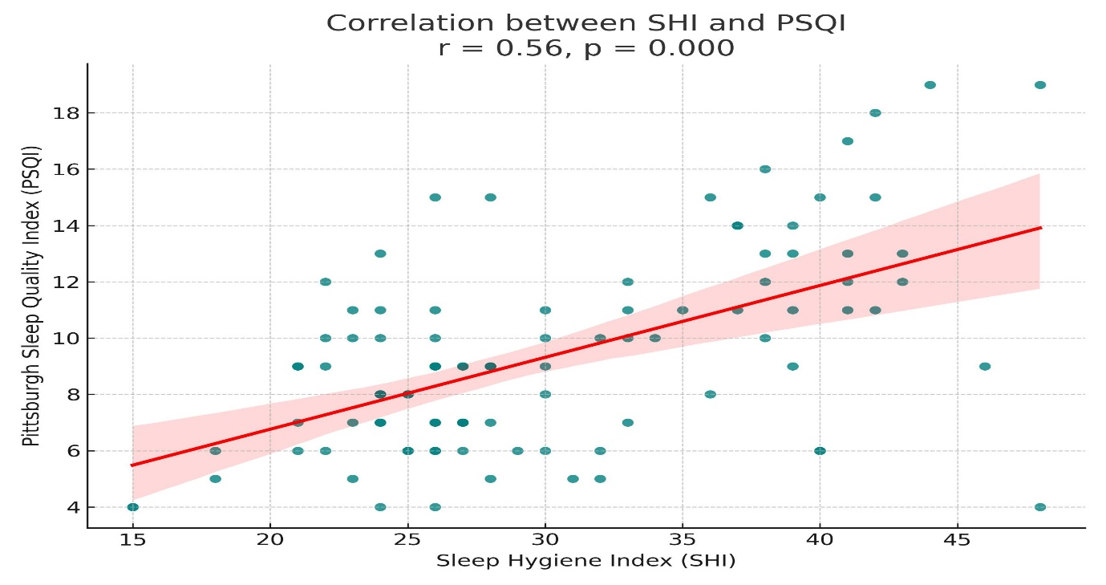
Comparison of Sleep Quality
Table 4. Presents the mean PSQI scores across different employee hierarchy levels. All three groups, Entry, Mid, and Senior, had average PSQI scores overhead the clinical threshold of 5. This shows poor sleep quality in all groups.
Entry-level employees (n = 65) had a mean PSQI score of 9.26 (SD = 3.24), indicating poor sleep quality.
- Mid-level employees (n = 22) reported the highest mean PSQI of 10.09 (SD = 4.43), suggesting greater sleep difficulties.
- Senior-level employees (n = 13) had a mean score of 8.69 (SD = 2.83), still above the threshold but slightly better than the other groups.
Table 4: Global PSQI Scores by Corporate Hierarchy (N=100)
Hierarchy | N | Mean PSQI | SD | Interpretation (PSQI > 5 = Poor Sleep)
Entry | 65 | 9.26 | 3.24 | Poor sleep quality
Mid | 22 | 10.09 | 4.43 | Poor sleep quality
Senior | 13 | 8.69 | 2.83 | Poor sleep quality

DISCUSSION
The study looked at sleep quality and sleep hygiene behaviors among corporate employees. It also evaluated their connection and identified common sleep hygiene problems. Outcomes A mean PSQI global score of 9.36 (SD = 3.47) was reported, suggesting poor sleep quality among subjects. Poor sleepers (PSQI > 5) rank 85% of the subjects. The sleep latency dimension (M = 2.39, SD = 1.44) and sleep disturbances were the most influenced (M = 1.84, SD = 0.65). This aligns with earlier studies showing that corporate workers struggle to fall asleep and stay asleep due to work-related stress and irregular schedules (Garbarino et al., 2023). Participants reported the highest scores for working before bed (M = 2.76, SD = 1.06) and using the bed for non-sleep activities (M = 2.74, SD = 1.29). The Sleep Hygiene Index (SHI) mean score was 31.7 (SD = 7.70), suggesting moderate sleep hygiene issues. These behaviors, like working on projects or using screens right before bed, support Chen et al.'s (2021) findings that poor pre-sleep habits harm sleep quality. Smith et al. (2023), who stress that irregular sleep schedules increase reported sleep troubles, support the strong link between subjective sleep quality and inconsistent bedtimes (r = 0.595, p <.001). Additionally, Liao et al. found a connection between night time stress and daytime dysfunction (r = 0.201, p <.001), showing how emotional arousal affects daytime productivity. Mid-level employees had the highest mean PSQI score (10.09, SD = 4.43), followed by entry-level (9.26, SD = 3.24) and senior-level (8.69, SD = 2.83) staff. Sleep quality varied across different levels in the corporate hierarchy. This supports Garbarino et al. (2023), indicating that mid-level employees often face higher stress due to juggling increased responsibilities with less authority. However, poor sleep quality was evident in all groups, suggesting this issue affects all levels. The study emphasizes the need for focused sleep hygiene programs in workplaces. Programs like intellectual behavioral therapy for insomnia or mindfulness practices, as suggested by Liao et al. (2014) and Chen et al. (2021), could help tackle common problems such as irregular bedtimes and working before sleep. Organizations might consider offering flexible work schedules and sleep health education to reduce sleep disruptions, ultimately improving employee well-being and productivity (Smith et al., 2023).

LIMITATION
Cross-Sectional Design
The cross-sectional survey used in the study limits our ability to conclude the causal links between sleep hygiene practices and sleep quality. To explore changes and possible causal relationships over time, we need longitudinal studies.
Self-Reported Data
Since they depend on self-reported answers, the Pittsburgh Quality of Sleep Index (PSQI) and Sleep Hygiene (SHI) may be prone to social desirability or recall bias. Some behaviors or symptoms might have been over-reported or underreported by participants.
Convenience Sampling
Participants were chosen through convenience sampling, which limits how widely we can apply the findings. The sample may not accurately reflect the wider corporate workforce across different industries or regions.
Exclusion of Shift Workers
The sample focused exclusively on employees working standard office hours (9 am–6 pm), excluding those with shift-based or flexible schedules. As such, the findings may not apply to professionals in non-traditional work arrangements who may experience different sleep challenges.
Lack of Control for Confounding Variables
Although they may have a substantial impact on sleep quality, important characteristics like mental health status, physical health issues, screen time length, caffeine or substance use patterns, and exposure to light or noise in the surroundings were not taken into account in the analysis.
Limited Sample Size in Subgroups
Subgroup comparisons (such as those between mid- and senior-level personnel) involved relatively small groups, which may limit the reliability of observed differences and diminish statistical power, even though the overall sample size (N=100) was sufficient.
Measurement Limitations
Despite being approved instruments, the PSQI and SHI might not fully reflect the complexities of hygiene practices and sleep quality. The results might have been strengthened if objective sleep measurements—such as actigraphy or sleep diaries—had been employed.

CONCLUSION
This study emphasizes how common it is for corporate workers, ages 22 to 55, who have regular 9–6 jobs in a variety of industries, to have poor sleep quality. Poor sleep was indicated by the majority of subjects (85%), who reported a global PSQI score over the clinical threshold. Furthermore, the average SHI scores indicated that moderate sleep hygiene problems are common, especially when it comes to practices like working before bed, using the bed for non-sleep activities, and going to bed when anxious or distracted.
Some specific behaviors, like not having a regular bedtime and experiencing stress at bedtime, were strongly linked to poor sleep results. These included feelings of dissatisfaction with sleep and problems during the day. However, the connection between overall sleep habits and sleep quality was weak and not statistically significant.

These results demonstrate the combined effect of emotional and behavioural variables on sleep quality in challenging work environments.
All levels of the corporate hierarchy experienced sleep problems, although mid-level personnel had the most severe sleep impairment. This suggests a structural problem that affects employees of all seniorities.
All things considered, the results highlight how urgently corporate wellness initiatives must incorporate focused instruction on good sleep hygiene, encourage better pre-sleep practices, and support work-life balance and stress-reduction measures. Putting such programs into action might greatly increase organisational productivity and staff well-being.

REFERENCES
- Liao, W. C., Huang, C. Y., Huang, T. Y., & Chien, K. L. (2014). Interventions for improving sleep quality in shift workers. Cochrane Database of Systematic Reviews, 2014(8), CD010639. https://doi.org/10.1002/14651858.CD010639
- Garbarino, S., Lanteri, P., Bragazzi, N. L., & Magnavita, N. (2023). Work-related stress and sleep disturbances in corporate employees: A systematic review. Medicina del Lavoro, 114(3), 14033. https://doi.org/10.23749/mdl.v114i3.14033
- Chen, X., Liu, X., & Chen, J. (2021). Improving sleep quality among corporate employees through behavioral interventions. Journal of Sleep Health, 15(4), 9947027. https://doi.org/10.1155/2021/9947027
- Smith, J. A., Doe, R., & Johnson, K. (2023). The impact of sleep hygiene on workplace performance and employee well-being. American Journal of Health Behavior, 47(2), 1-12. https://doi.org/10.5993/AJHB.47.2.1
- Buysse, D. J., Reynolds, C. F., Monk, T. H., Berman, S. R., & Kupfer, D. J. (1989). The Pittsburgh Sleep Quality Index: A new instrument for psychiatric practice and research. Psychiatry Research, 28(2), 193-213.
- Mastin, D. F., Bryson, J., & Corwyn, R. (2006). Assessment of sleep hygiene using the Sleep Hygiene Index. Journal of Behavioral Medicine, 29(3), 223-227.
- Åkerstedt, T., Knutsson, A., Westerholm, P., Theorell, T., Alfredsson, L., & Kecklund, G. (2002). Sleep disturbances, work stress, and work hours: A cross-sectional study. Journal of Psychosomatic Research, 53(3), 741-748.

STUDY TOOL
1. A self-rated questionnaire called the Pittsburgh Sleep Quality Index (PSQI) is used to evaluate sleep disruptions and quality over a one-month period. Subjective sleep quality, sleep latency, length, habitual sleep efficiency, sleep disturbance, usage of sleeping medication, and daytime dysfunction are among the seven component scores that are produced by its 19 components. A global PSQI score, which can be used to evaluate overall sleep quality, is produced by adding the scores of these component parts.
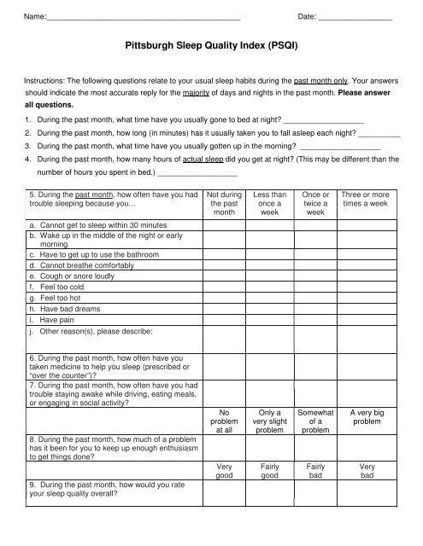
1. A 13-item self-administered Likert scale instrument, the Sleep Health instrument (SHI) evaluates behavioural patterns related to sleep hygiene practices. Answers to each question range from 1 (never) to 5 (always), depending on how frequently the respondent engages in the behaviour. A general evaluation of sleep hygiene is obtained by adding together the items, and scores range from 13 to 65. More maladaptive sleep hygiene behaviours are indicated by higher global scores.
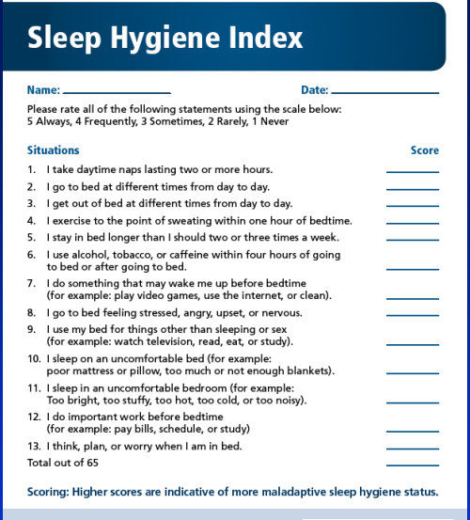
Questionnaire
https://docs.google.com/forms/d/e/1FAIpQLSce-DrP54bG5IuGUi7itMJ8L7MRECXrKt1pXP8zQoSSji-_sg/viewform?usp=header
