**A MARKET RESEARCH REPORT**

**On**

**Indian Scenario of Probiotics**

**International Institute of Health Management Research**

**Delhi**

*In partial fulfillment for the award of degree of*

**PGDM in Healthcare Management**

Submitted by

**Akanksha Gupta**

Roll No- PG/21/008

Under the supervision of

**Umesh Parasher**

At

MY HEALTHCARE

# 

# DECLARATION

I hereby declare that the project entitled “UNDERSTANDING CONSUMER PERCEPTION AND ADOPTION OF PROBIOTIC PRODUCTS IN THE INDIAN MARKET”: A SECONDARY STUDYis submitted as dissertation report to IIHMR Delhi for, under the supervision of project guide Ms. Sonia Arora has been carried out by me at **MyHealthcare Technologies Pvt. Ltd**. under the guidance of Mr Umesh Parasher.

- **Akanksha Gupta**

ACKNOWLEDGEMENT

I am extremely thankful to everyone at My Healthcare Technologies Pvt Ltd for sharing generously their valuable insight and precious time which motivated me to do my best during dissertation. My learning and dissertation writing would not have been possible without in-depth discussions with Shytto Raha, Divya Laroyia and Umesh Parasher. I express my gratitude towards them for providing timely guidance, inspiration & unconditional support during my study. I am grateful to Sonia Arora and for their active cooperation and support as this study could not have been possible without their constant support and mentoring. I am highly grateful to Divya Aggarwal and Dr. Anandhi Ramachandra along with all the faculty members and staff for giving me this opportunity to learn and to add to my phenomenal experience. Without their cooperation and guidance, it would not have been possible to conduct my study and complete my training successfully.

* **Akanksha Gupta**

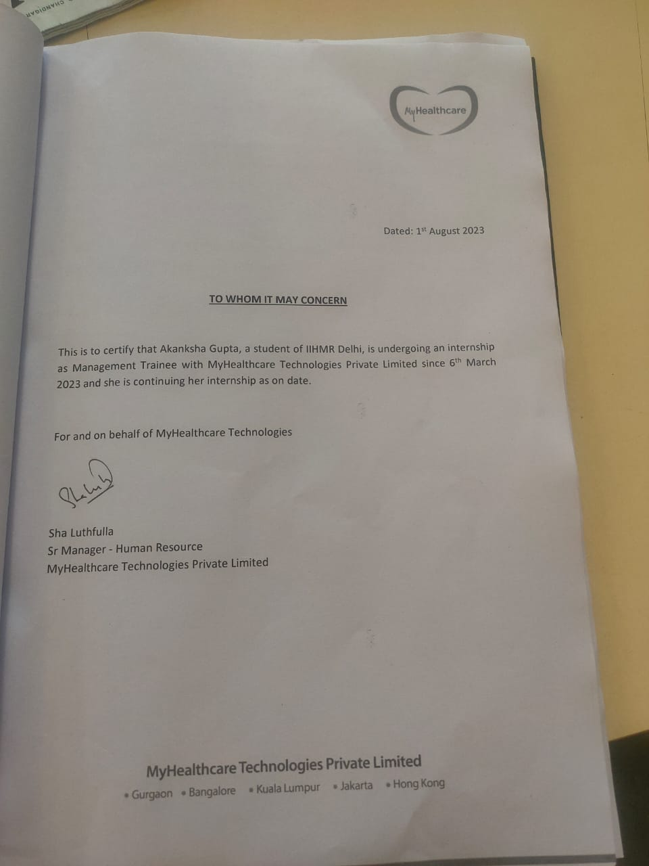

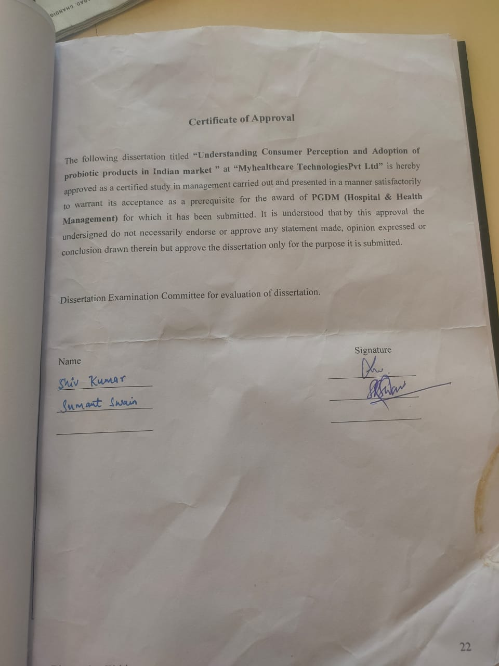

|  |  |  |
| --- | --- | --- |
| Sr. No. | Contents | Page Number |
| **1.** | **Introduction** | **7** |
| **2.** | **Review of Literature** | **9** |
| **3.** | **Need of Market Research** | **11** |
| **4.** | **Components of Market Research** | **13** |
| **5.** | **Probiotics** | **24** |
| **6.** | **Global Market research- Probiotics** | **27** |
| **7.** | **Indian Scenario** | **29** |
| **8.** | **Challenges faced In the Indian Market** | **34** |
| **9.** | **Conclusion** | **35** |

**1. Introduction**

*MyHealthcare Technologies is a digital health tech company, that works with hospitals, clinics in building out an integrated, digital patient care ecosystem – with patient centric care delivery at its core, the platform builds a complete healthcare ecosystem around a patient or their families across doctor consultation (physical or virtual), diagnostics at home, pharmacy at home, home healthcare, remote patient monitoring, preventive health, vaccination programs and more. MyHealthcare works employing the most recent developments in digital technology, to close the gap in healthcare delivery, and provides a data-driven care continuum method. Through all interventions and services, the ecosystem aids in creating an organised repository of a patient's clinical data and longitudinal history offered through the MyHealthcare Ecosystem. MyHealthcare is headquartered in Gurgaon (Delhi NCR), with its technology centers in Bangalore and Dehradun. It has sales offices across India, Malaysia, Thailand, Singapore, Indonesia, Philippines, Vietnam, and Hong Kong. * *MyHealthcare’s digital The healthcare ecosystem improves patient participation and equips them with the knowledge of their own and their families' healthcare requirements.. The platform is integrated into a 360-degree clinical management system for doctors and nurses, which includes a practice management platform, patient management platform, EMRs for OPD and specialty EMRs for General Physician / Internal Medicine, Pediatrics, Endocrinology & Cardiology; with soon to be available EMRs for Obstetrics & Gynecology, Oncology, Dentistry, Ophthalmology and Neurology. The cloud-based solution allows clinicians, doctors, nurses to manage their patient’s care through digital platforms such as web and mobile. A built-in virtual consultation platform allows doctors to consult their patients over a secure video or audio call, review the patient records and complete a prescription remotely. MyHealthcare’s EMR ecosystem has been built in augmented intelligence and artificial intelligence to analyze a patient’s clinical history, map diagnosis to globally accepted standards such as ICD-10 and SONMED-CT. Its proprietary voice.ai (clinically trained voice to text engine), allows doctors to dictate their clinical notes, patient records and helps improve their efficiency in managing patient care. The My Healthcare ecosystem has an extensive library of care protocols and has mapped the core attributes for over 19,000 drugs. The availability of a patient’s longitudinal history helps in the management of a patient’s Emergency care needs. The integrated care platform helps in improving patient experience and delivers better clinical outcomes. * *The MyHealthcare@Home ecosystem delivers connected care platform to manage patients from a centralized command Centre. The scalable platform can monitor a large pool of patients from a single location, including remote patient monitoring and home isolation monitoring.

1. *MyHealthcare AI works with clinical data, treatment protocols and big data generated from its partner hospitals, to build augmented intelligence modules that work in identification of a diagnosis and offer a complete cure process protocol.* MYHEALTHCARE DOCTOR OPD EMR *The MyHealthcare Doctor Platform helps doctors manage their virtual consultation and OPD consultations seamlessly, from a user-friendly web or mobile platform. The MyHealthcare Doctor Platform is integrated with all clinical platforms of a hospital such as the Hospital Information System (HIS), Laboratory Information System (LIS), Radiology Information System (RIS) and Picture Archiving and Communication System (PACS). The MyHealthcare Doctor ecosystem is integrated with the MyHealthcare patient platform, MyHealthcare@Home platform, the Queue Management System and Doctor Referral platform.* *The MyHealthcare Doctor EMR allows the doctor to view all patient demography details, test reports, clinical documents, patient uploaded documents and patient notes uploaded prior to the consult. The doctor can use the platform to view the patient journey from the time they book an appointment, arrival at the hospital, their clinical assessment and delivery of an e-prescription. The MyHealthcare Doctor EMR is a cloud-based solution, using the best-in-class data security protocols, ready masters for drugs, tests, templates, copy from previous prescription and voice enabled. The MyHealthcare Doctor Platform comes with Speech to Text EMR. This allows the doctors to dictate the prescription notes, medicines, and tests. The platform has been launched for the first time in India and is able to decipher clinical terms, medicine names, diagnostics tests, etc. By implementing EMR, patient data can be tracked and analysed over an extended period by associated healthcare providers. It also helps them to boost the quality and safety of patient care by implementing best practices such as care protocol and real-time clinical decision support system .

1 The Myhealthcare doctor platform helps provides better manage care for patients and provide better care by :

At the point of care, doctors may provide accurate, full, and up-to-date patient information. They can also facilitate rapid access to patient records for better coordinated and effective treatment. Finally, they can safely share electronic information with patients and other physicians.

• Assisting healthcare professionals in safer care delivery, medical error reduction, and improved patient diagnosis.

• Improving convenience in healthcare as well as interactions between patients and providers.

• Making prescription safer and more dependable.

• Assisting in the promotion of clear, comprehensive documentation and precise, efficient coding and invoicing

• Reducing expenses through decreased paperwork, more safety, fewer duplicate tests, and enhanced health. • Improving the privacy and security of patient data.

**UNDERSTANDING CONSUMER PERCEPTION AND ADOPTION OF PROBIOTIC PRODUCTS IN THE INDIAN MARKET: A SECONDARY STUDY**

**INTRODUCTION**

Growing interest has been shown in the subject of how probiotic products are perceived and used by consumers, particularly in the context of the Indian market. When taken in sufficient quantities, probiotics are live bacteria that have a number of positive health effects. They have attracted a lot of interest because of their ability to strengthen the immune system, promote gut health, and treat several digestive diseases.

The demand for probiotic products has significantly increased as the Indian populace grows more health-conscious and seeks preventive healthcare treatments. To effectively serve this market sector and ensure the successful introduction and promotion of probiotic goods, it is essential to comprehend consumer perception and adoption patterns.

The purpose of this study is to offer important insights into the variables affecting consumer perception and probiotic adoption. Through the use of secondary research, this study intends to offer useful insights into the aspects impacting consumer perception and uptake of probiotic products in the Indian market. We will explore into many elements such as consumer awareness, knowledge, attitudes, and purchase behaviour towards probiotic goods through the analysis of available literature, market data, and consumer surveys.

The Indian market is a distinctive fusion of various ethnic origins, eating customs, and health ideologies. Investigating how these elements affect customer perception and adoption is therefore crucial. Additionally, in order to help firms modify their strategies and products, we will look into how marketing tactics, product labelling, and product qualities affect consumer decision-making.

This secondary study will also offer insight on any obstacles and difficulties consumers may encounter in acquiring probiotic goods, such as price sensitivity, accessibility, and scepticism towards product claims. By identifying these challenges, industry participants can develop focused strategies to address them and encourage probiotics to be accepted more widely. The results of this study will add to the body of knowledge already available on consumer behaviour in the Indian market and offer insightful information to firms, marketers, and policymakers. This study seeks to close the gap between consumer perception and probiotic product acceptance in order to promote evidence-based decision-making and the expansion of the probiotic market in India.

The findings of this study will advance our understanding of consumer behaviour in the Indian market and provide businesses, marketers, and policymakers with useful data. To encourage evidence-based decision-making and the growth of the probiotic market in India, this study aims to bridge the gap between consumer perception and probiotic product acceptance

**2. Review of Literature**

Businesses must have a comprehensive grasp of both supply and demand since markets are continuously changing. Therefore, the main purpose of market research is to provide businesses a thorough understanding of consumers and the market so they may create goods and services that meet customers' demands more effectively than the competitors. Answering questions and assisting in the acquisition of new knowledge are the major goals of market research. The most important instrument for broadening people's knowledge in any topic is research. The complexity of the market has significantly increased as a result of the market environment's dynamic character. It is no longer possible to make significant judgements given the market's and the business environment's growing complexity. Making important judgements based only on intuition is no longer practical given the rising complexity of the market and the corporate environment. To make wise judgements, decision-makers must have a thorough understanding of the market and its participants. Data about consumers, competitors, and market trends are collected and analysed as part of market research. This helps the client to determine the volume of demand for its items with greater accuracy. It affects choices to focus capital investments on initiatives that will provide the highest return on that investment, such launching a new shop or tapping into a new market. Consumer input is obtained via market research Consumer input is obtained via market research. It is crucial for the consumer to learn what they think about the company's selection of goods, brands, and services. This makes it possible for the company to exceed expectations and surpass the competition. It aids in the creation of a strategic business strategy for the company that all employees may work to implement. For instance, using this data to develop a successful marketing strategy that targets promotions to particular client segments or to have an impact on range planning for new locations. The size and performance of marketplaces may also be learned via research. It can give a firm information about its main rivals, what they're up to, and their proportion of the market. Opportunities that may exist on a global, national, and local context can also be identified along with :

Gaining more market share in one's current markets is known as market penetration.

Market expansion through entry into new nations or retail industries

Product development is the process of acquiring or creating new goods or brands.

Diversification is changing the course of the company entirely.

*Businesses must have a comprehensive grasp of both supply and demand since markets are continuously changing. Therefore, the main purpose of market research is to provide businesses a thorough understanding of consumers and the market so they may create goods and services that meet customers' demands more effectively than the competitors. Answering questions and assisting in the acquisition of new knowledge are the major goals of market research. The most important instrument for broadening people's knowledge in any topic is research. The complexity of the market has significantly increased as a result of the market environment's dynamic character. It is no longer possible to make significant judgements given the market's and the business environment's growing complexity.: *

*With the development of the market and the competition raised there arose a requirement for risk assessment to stay away from the dangers of market fall. The significance of data arose much than ever and effortlessly. So as to confine data from various sources the data analysis and market research were evolved. Market research is a major factor to maintain competitiveness. In an attempt to understand whether the essential deliverables are being received from the market plans the strategists developed the researching procedure which duly developed to market research. Marketing Plans: How to Prepare Them, How to Use Them (Malcolm McDonald, 2007).

The systematic gathering and comprehension of information about people using statistical and analytical methods and techniques of the applied social sciences is known as market research, which is also known as social and opinion research (ICC/ESOMAR 2008). Market research is any organised effort to find out more about target markets or customers

**3. Need for Market Research**

It is crucial for every decision maker to recognise and comprehend the clients, what they are looking for in terms of goods and services, and their purchasing power or ability. The system has been extensively fragmented as a result of market globalisation, widening the divide between consumers and decision-makers. Retaining customers is one of the essential components of a successful business. Most people lose their customer base as a result of failing to respond to the constantly shifting needs and expectations of their clients.

Considering this, market research can be broadly classified into:

Problem identification research

Problem solving research

Classification helps in providing a better perspective to the problem at hand. However, there are no strict rules when it comes to the two types of market research. A research project can involve both the types simultaneously. (Anderson, 1984)

*For example*,

* 1. Market research to understand the prevalence of vulvo vaginal atrophy in Malaysia and the growing demand for its treatment. (***Problem Identification Research***).

2. Quantifying the proportion of female patients with vulvo vaginal atrophy who favour hormone replacement therapy and classifying them based on their purchasing power. (Research on Problem Solving)

1. Identifying key players in the market who have products for the treatment of vaginal atrophy (***Problem*** ***Identification Research***).
   1. Preference of the consumers and identifying a price that will be feasible and competitive (***Problem*** ***Solving Research***).
   2. Quantitative research is frequently statistically based, heavily focused on the assessment of market phenomena, and numerically oriented. A bank may, for instance, ask its clients to rank the quality of its overall service as outstanding, okay, terrible, or extremely poor. This will deliver numerical data that can be statistically evaluated. Every responder to quantitative research is subjected to the same set of inquiries as a general rule. The methodology is quite regimented and often includes a sizable number of surveys and interviews.Perhaps the most common quantitative technique is the ‘market research survey’. These are basically projects that involve the collection of data from multiple cases – such as consumers or a set of products. Quantitative surveys can be conducted by using post (self-completion), face-to-face (in-street or in-home), telephone, email or web techniques. The questionnaire is one of the more common tools for collecting data from a survey, but it is only one of a wide ranging set of data collection aids.
   3. Qualitative research explains how or why things are the way they are. For instance, a market researcher may stop a customer who just bought a certain kind of bread and inquire about the decision-making process. Unlike quantitative research, there are no predetermined questions in qualitative research; rather, a subject guide (or discussion guide) is employed to thoroughly examine numerous themes. The interviewer's (and moderator's) and respondent's conversation is strongly influenced by the respondents' own ideas and emotions.
   4. Qualitative procedures come in a variety of forms, much as quantitative techniques. This kind of research is typically conducted in person. Focus groups, often known as market research group talks, are one of the most well-known approaches. These typically consist of 6 to 8 targeted respondents, a study moderator whose job it is to pose the necessary questions, elicit responses, and promote debate, an observation area that is typically hidden behind one-way mirrors, and equipment for recording audio and/or video.

**4. Components of Market Research**

**Market information**

One may learn about the pricing of various items on the market, as well as information on supply and demand circumstances, through market information. By assisting their customers in understanding the sociological, legal, and technological elements of markets, market researchers play a larger role than was previously recognised.

**Market segmentation**

The division of the market into subgroups with comparable incentives is known as market segmentation. It is mostly used to segment markets based on distinctions in geography, demographics, personalities, product usage, and gender.

**Market trends**

The rising or downward movement of a market over an extended period of time is referred to as a trend. If one is starting with a fresh idea, it could be harder to estimate the market size. In this situation, a sizable number of potential clients must be contacted to collect the data.

**SWOT Analysis**

A SWOT analysis is a written appraisal of a company's strengths, weaknesses, opportunities, and threats. The SWOT analysis should be applied throughout the whole life cycle of the organisation, not only in the beginning. To comprehend the competition and how to design the marketing and product mixes, a SWOT analysis may also be employed. One should have knowledge about their own competition, consumers, goods, etc. in addition to only the target market. (S. Castell and J. Thompson, 2005)

**4.1 Types of Market Research**

Primary research and secondary research are the two categories into which market research is often divided. Quantitative information is derived from figures and numbers in the form of charts, statistics, graphs, and tables, whereas qualitative market research information is obtained by actually speaking to people and soliciting their comments and/or opinions.

**Primary research**

One is gathering the fundamental market research data whenever they speak with clients or rivals. This will primarily contain qualitative data. For a firm, this is often the most useful market research data. It involves gathering information directly from pertinent sources. It is often gathered through focus groups, surveys, or in-depth interviews (CATI, CAWI).

**Surveys**

Surveys are one of the most basic forms of primary data collection. Surveys can be conducted through mail, telephone (CATI), online (CAWI) and face-to-face interviews. Factors like number of respondents, type of data to be collected, the time frame and the budget, influence the method of survey to be adopted.

**Mail survey**

Mail survey is an inexpensive mode of primary data collection, especially when the data has to be collected from a number of respondents belonging to varying regions of interest. Furthermore, questionnaires can be fairly long in the case of mail interviews. One of the major disadvantages of the mail surveys is the low response rates and the time it takes to get a response. Another issue that is faced is the misunderstood or skipped questions and the vagueness of the answer.

**Telephone survey**

Telephone surveys entail phoning respondents and asking them questions over the phone, as the name indicates. In doing so, the interviewer is able to motivate the respondent to take part in the survey and obtain timely answers to the questions. When the sample size is not too huge, this is a desirable mode.

Compared to the conventional telephone approach, computer-assisted telephonic interviewing (CATI) has become quite popular in recent years. A computerised questionnaire is used by CATI, and it is given to responders over the phone. In essence, the interviewer reads the computer-generated questions to the respondents and captures their responses immediately on the screen. The interviewer is led methodically by the computer, which displays one question at a time.

**Internet Survey**

This is one of the most practical ways to conduct a survey if the respondents have access to the internet. In addition to being quicker than postal surveys, it may also be more affordable depending on how it is hosted. With the extra advantages of interaction and speed, it offers all the core benefits of conventional offline interviewing methods. Contacting respondents and persuading them to do the online survey is the biggest drawback of internet surveys.

**In-person Interviews**

In-person interviews are an effective to complete a survey and to be able to immediately analyse the responses. However, it can prove to be costly if it involves a large sample size. Willingness of people to confide in a stranger can also be one of the issues that may arise during in-person interviews. (Kelly, J., 2002)

**Survey Strategies**

The survey process includes critical steps such as pilot surveys. Using focus groups or pilot surveys, it is possible to assess the reliability and efficiency of the questions being posed. This aids in improving the survey questions to make them more effective without making them difficult for respondents to understand. Just as crucial as the survey's methodology are the questions that are asked. In order to receive the most answers, it must be appealing to the intended audience.

There are several different methods to ask the responders a question:

**Multiple-choice questions**

This format first poses a question to the respondent and then provides multiple answer options to choose from. The multiple choice format also allows the respondent to choose one or more responses of their liking. This format is very easy for the respondent to understand. However, questions with more than one option selected are difficult to analyse.

For example,

Which brand of pharmaceutical products do you prefer?

* Pfizer * Bayer

* MSD * Ranbaxy

**Rating-scale questions**

In this type off questions, respondents are asked to indicate their level of agreement or acceptance with a statement. This provides a measurable or a quantifiable data which is easy to analyse and interpret. These Respondents may easily grasp these sorts of inquiries since they are so straightforward. They can't, however, be used to all kinds of surveys.

**Nomination surveys**

To identify Key Opinion Leaders (KOLs) or subject matter experts in a certain field, nomination surveys or studies are conducted. Respondents to nomination surveys typically work in the same industry. Respondents are asked to submit persons they believe to be experts in nomination surveys. (Pamela Salant and David A. Dillman, 1994)

**Secondary research**

Secondary research involves the research of data that has already been collected and is available in either electronic or published form. Secondary data is always collected, organized and analysed with a specific purpose. Therefore, its applications may be limited. However, Secondary research has the benefit of being less expensive and time consuming, especially if there are budget constraints. Secondary data is readily available from sources like government agencies, published articles, company reports and news articles. Although these sources are usually very reliable, data validation is an important part of secondary research.

***Table 1: Secondary data sources***

|  |  |
| --- | --- |
| ***Data Source*** | ***Examples*** |
|  |  |
| ***Internal Data*** | *Company reports, memos etc.* |
|  |  |
| ***Syndicated Data*** | *Syndicated services like AC Nelson* |
|  |  |
| ***Expert Advice*** | *Newspaper, reports* |
|  |  |
| ***Internet*** | *Search engines, portals and websites* |
|  |  |
| ***Industry Data*** | *Industry or trade associations* |
|  |  |
| ***Macro Data*** | *Government and international publications* |
|  |  |
| ***Market Research Report*** | *Independent market research firms* |
|  |  |

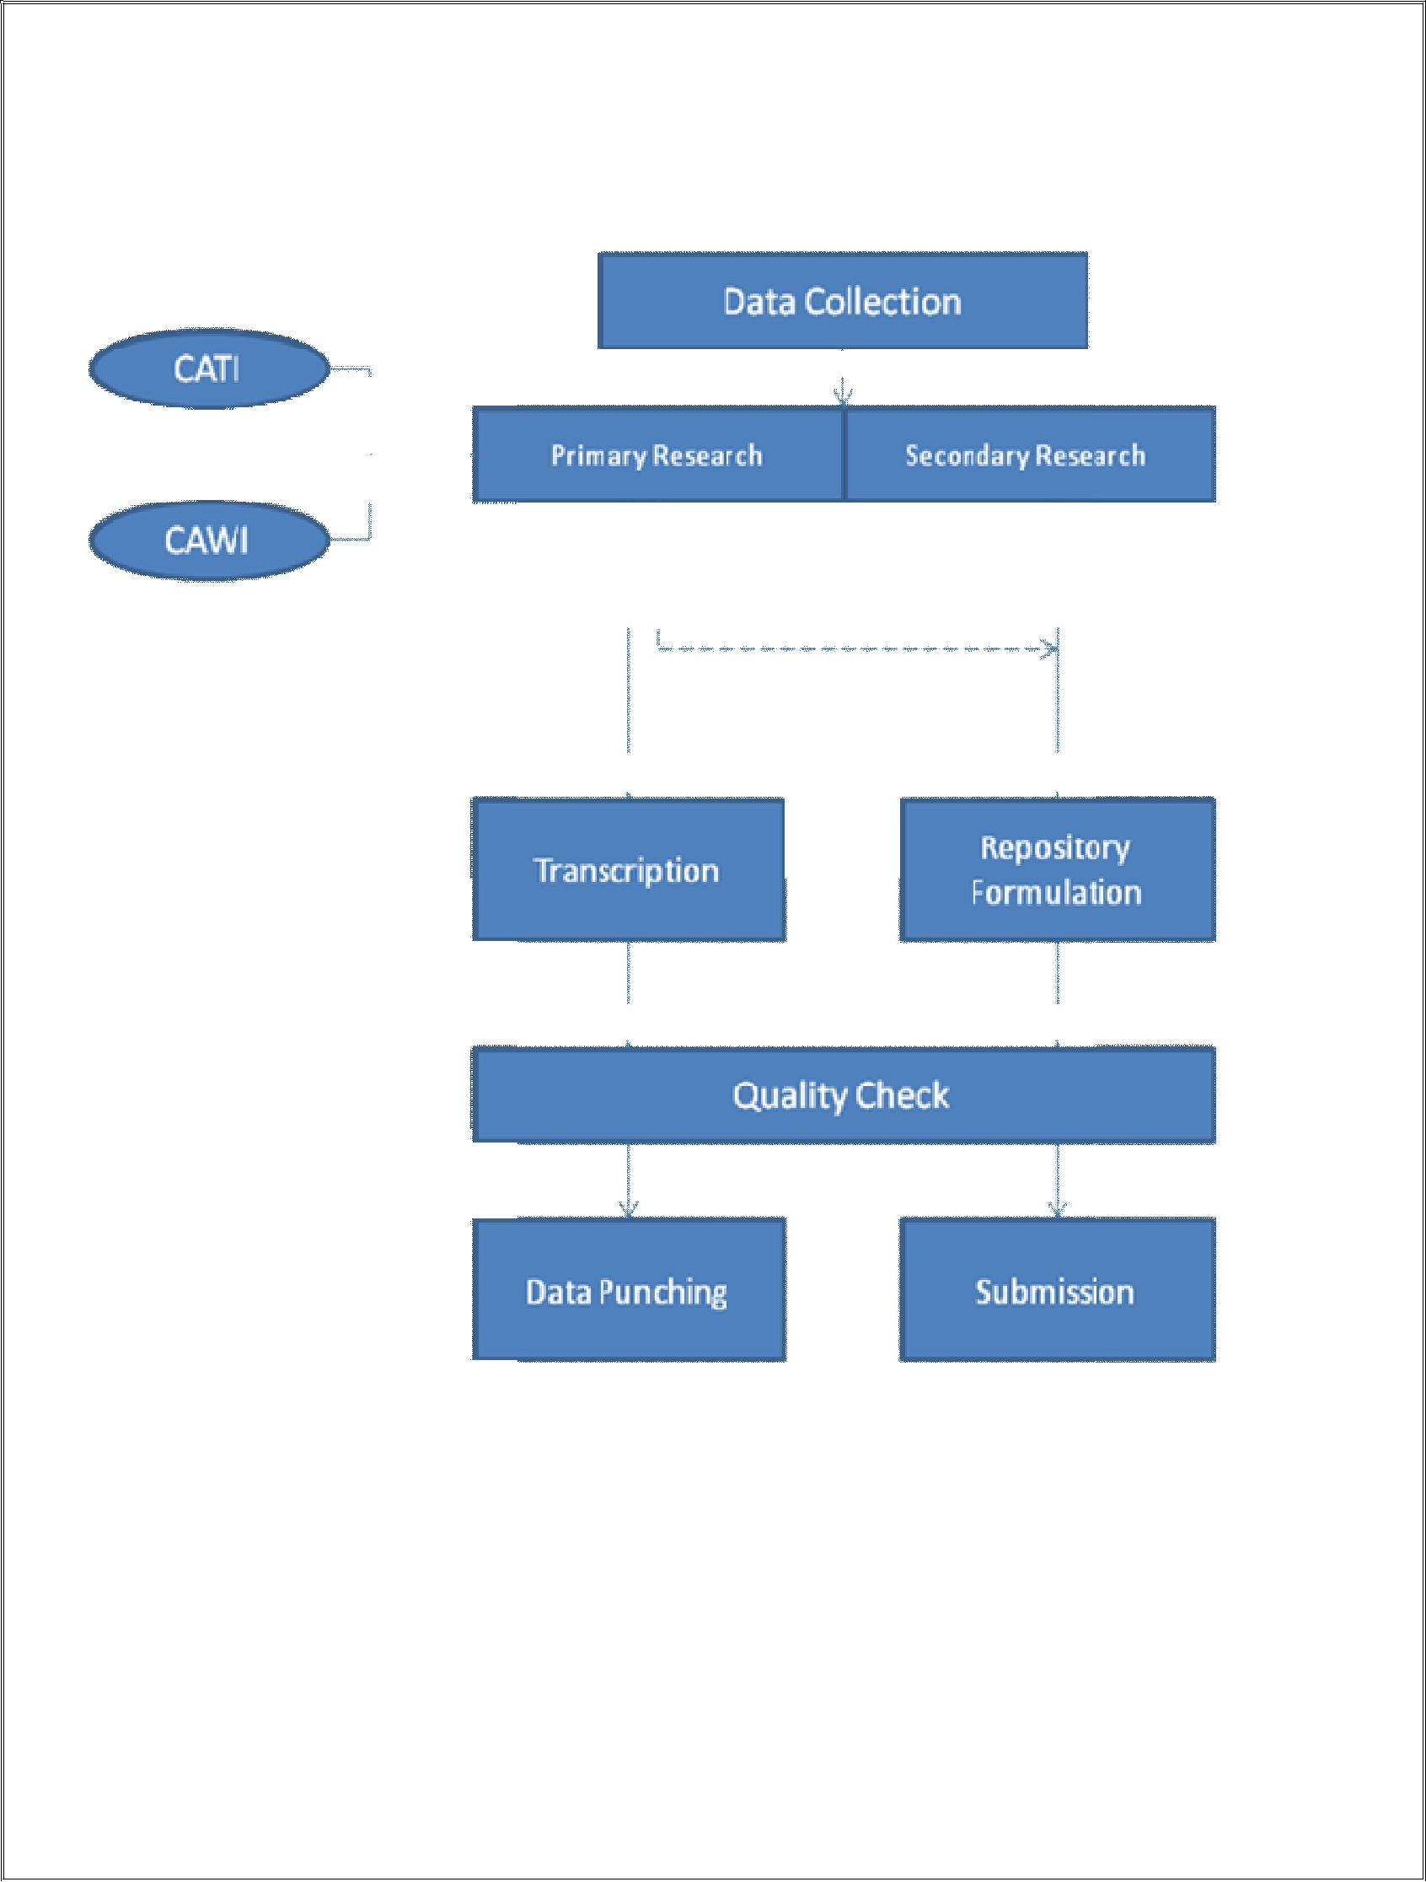

**Client-based Marketing Research**

In order to diagnose, choose, and implement marketing strategies and tactics for the client organisations, client-based marketing research involves the creation, analysis, and interpretation of data on organisations as well as on their respective environments. The method is demonstrated in Figure 3. The objective is to supply the clients with value points and to offer data, knowledge, and insights that are pertinent and usable. The terms "commissioned," "commercial," "market," or "practitioner" are frequently used to describe client-based marketing research. It will be a commercial transaction between the client organisation and the market research firm, in which the research is carried out by an employee of the market research agency, and there will undoubtedly be a charge involved if the client is another organization a profit-making agency. Whether the customer organisation is a for-profit business or nonprofit organisation has no bearing on this. However, it will be referred to as a "in-house" research study if the customer is already a part of the research organisation. In this case, there could or might not be a charge for the services provided. However, it will be distinct from the kind provided by an outside customer. There is also the additional category of applied or policy research, which, although not being for profit, nonetheless has clients. In this kind of study, an academic organisation conducts the research on behalf of a governmental organisation, a quasi-governmental organisation, or municipal authorities. Despite the fact that in recent years, professional market research firms have also been utilised for practical or policy research. Additionally, there has been a dramatic increase in a variety of non-profit customers, including educational institutions, political organisations, art galleries and museums, performing arts organisations, and even religious organisations. Client-based research is not always of a commercial character.

The worth or quality of research is determined by how well it succeeds in resolving or diagnosing and identifying problems for clients rather than by the level of scientific rigour that was used to conduct it. This is not to say that client-based research is not rigorous; it just means that rigour is a strategy for achieving the goal rather than the goal itself. After all, thorough research is more likely to assist in resolving the client's issue, yet thoroughness might vary and costs money. The level of rigour used will depend on how much is needed to sufficiently accomplish the project's objectives without sacrificing the work's quality

The solutions are often gathered into a report that gives the customer a list of suggestions and clear instructions. Academic researchers frequently offer advice to the industry as a whole rather than to a single organisation, although these suggestions are usually secondary to the study or testing of theoretical hypotheses and the improvement of our understanding of marketing phenomena.

Client-based research is never neutral, which is its second distinguishing trait. It is a partisan organisation that works for the customer. This is not to suggest that the study is not objective; rather, it is an instance of "partisan objectivity". The researcher's subjective preferences, feelings, or experiences should not be reflected in the facts, evidence, information, interpretation, or even hypothesis.

The research will always be centred on the customer's priorities while making sure that the client is given with relevant external information to support the validity of the study.

Interventionist research will predominately be client-based. The major goal will be to implement modifications and track their results, or to work with the customer to implement certain desired improvements. It is unusual for the study to propose making no changes, but even when it does, it still centres on the question of whether to make changes or not.

The researcher does not choose, create, or "own" the research problem when doing client-based research because it is done on behalf of a different party. The client is the one who has the issue and makes the first move.

The client will approach a research agency; the client and the agency will have a conversation in which the client will explain the issue they are facing, their perception of the situation, and in varying degrees of detail how the research is envisaged; the client is responsible for selecting the agency where the research is in a commercial context; the client will be the final decision maker in case an alternative course of action is being considered.

Time and budget restrictions always apply to client-based research. The researcher will have to stick to a budget, and there can be harsh consequences for missing deadlines. A report is frequently the primary result of client-based research. Reports may be presented in hard copy, in person, or more likely combination of two.

**Methodology**

Our client, a global healthcare consulting firm approached Growman Research Group for market research for Probiotics- Global and Indian Market

Extensive desk based conducted across India through government and other online source is conducted to develop information models on key research requirements. The study involved extracting and understanding the current market of Probiotics, challenges faced, future market, market access schemes, pipeline analysis along with the mapping of the key stakeholders and their interdependencies. The research will assist in delineating the market dynamics in terms of pricing, incentives, market access, cost assessment, product launch.

Two layered methodology was opted to extract and validate the data points by key professionals with 5-6 years of rich experience from bio-technology, food technology and pharmacy streams:

Government websites, research papers, international organizations, news articles were used to gather the information areas for probiotics in India.

**Survey Questions in Market Research**

1. What is your age group?
2. What is your area of residence?
3. Urban
4. Rural
5. Suburban
6. Do you know about probiotics?
7. Yes
8. No
9. Have you ever consumed probiotic drugs?
10. Yes
11. No
12. Do you know the health benefits of probiotic products?
13. When it comes to healthy foods, what all food comes to your mind?
14. Do you wish to consume probiotic products in future, if they have immense health benefits?
15. Yes
16. No
17. Do you continue food keeping health benefits in mind?
18. Yes
19. No
20. If you have used probiotic products, what brand comes to your mind?
21. Do you consider curd and yoghurt, one and the same thing?

Respondent Details:

Name:

Contact No.:

Designation:

Email:

**Key Opinion Leaders:**

In the healthcare industry or medical community, key opinion leaders (KOL) can be defined as the doctors or physicians, researchers, scientists, professors, working professionals who have a great influence on their peers work, practice and research. They are also known as thought leaders. They are the experts in their field. KOLs are famous and known for their impactful work. Generally KOLs are the members of many national and international associations, leading researchers, have published many research papers and articles, have received many awards.

**Process of KOL mapping:**

1. Identification of the need of KOL mapping by the client and deciding the area of expertise and the country in which the client wants to map the KOLs.
2. Deciding the number of surveys to be conducted and the KOL’s which are supposed to be targeted for taking the surveys.
3. The client hires a market research company (in this case Growman Research Group) and may or may not provide a questionnaire for the survey.
4. The project of KOL mapping is then analysed by the team and accordingly staff is allotted to the project. More the number of surveys more will be the employees working on it.
5. Then the listed of respondent with their contact details and speciality is generated through secondary research.
6. The respondents are contacted and appointments are fixed. At the fixed appointment CATI (Computer Aided Telephonic Interview) is conducted and the answers of the respondents are recorded.
7. Then the recordings are heard and transcription of the survey is done in the Microsoft Excel Sheet.
8. The transcripts are quality checked through secondary research.
9. These transcripts are uploaded on the client’s website along with respondent’s details.

**5. PROBIOTICS**

Probiotics are living microorganisms, primarily bacteria and certain yeasts, that, when taken in sufficient quantities, have positive effects on health. Because they support a balanced and healthy gut microbiome, these advantageous microorganisms are frequently referred to as "good" or "friendly" bacteria.

The gut microbiota, a huge community of many different bacteria that live in the human gastrointestinal system, is referred to as this. Digestion, immune system operation, and even mental health are all significantly influenced by the gut microbiome. By boosting the population of advantageous microorganisms, which can then bring about a number of health advantages, probiotics assist in maintaining the equilibrium of these gut bacteria.

Probiotics commonly come in the form of organisms from the Bifidobacterium and Lactobacillus genera, among others. Natural sources include fermented foods like yoghurt.. Additionally, probiotic supplements come in a variety of formats, including liquids, powders, pills, capsules, and tablets, making it simple for consumers to include them to their diets.

**What are probiotics used for?**

Probiotics are frequently used to stop antibiotic-induced cramps, flatulence, and diarrhoea. Both "bad" (harmful) and "good" (useful) microorganisms are eliminated by antibiotics. Digestive issues might result from a reduction in good microorganisms. Consuming probiotics might assist in replenishing the good bacteria. This may lessen the risk of diarrhoea.

Other diseases including vaginal yeast infections and urinary tract infections, as well as symptoms like diarrhoea from gastrointestinal ailments, may result from a reduction in helpful bacteria..

**Probiotics may also be used to:**

**•** Assistance with further diarrheal causes.

• Assist in preventing infections of the digestive system.

• Assist in reducing inflammatory immunological reactions, such in inflammatory bowel disease (IBD).

• Irritable bowel syndrome (IBS), skin infections, and colon cancer are among the conditions for which probiotics are being investigated.

**Are probiotics safe?**

When used properly, probiotics are often regarded as safe for the majority of healthy people. Live bacteria known as probiotics have been shown to have positive effects on health when taken in sufficient quantities. They can frequently be found in nutritional supplements as well as some meals (such as yoghurt, kefir, and sauerkraut).Probiotics are generally safe to consume and have no known side effects. There are a few things to bear in mind, though:Individual Differences: Probiotic effects might differ from person to person. While some people could see improvements in their health, others might not notice any real changes.

Underlying Health Conditions: It's critical to speak with your doctor before taking probiotics if you have a damaged immune system or major health issues.

They can provide you advice on whether probiotics are secure and appropriate for your particular circumstance.

Risks of contamination: Buying probiotics from reliable sources is crucial for safety. Products that have been contaminated may contain dangerous germs or other potentially damaging elements.

Probiotics can occasionally have modest adverse effects including gas, bloating, or upset stomach. These negative effects are often transient and disappear with continuous usage or dose adjustment.

Selecting the Best Strains: The body might respond differently to various probiotic strains. You can choose the best strain(s) for your unique health needs by speaking with a healthcare practitioner.

Dosage: It's important to take the medication as directed by your doctor or the label on the package. Probiotic use in excess might have undesirable consequences.

Yoghurts and Fermented Foods: Yoghurt and fermented foods, which are normally safe to eat as part of a balanced diet, naturally contain a lot of probiotics.

Probiotics should be used carefully and in accordance with the manufacturer's instructions or the advice of your healthcare professional, just like any other dietary supplement. Before beginning any new supplement or health regimen, it is always advisable to speak with a healthcare practitioner if you have any particular health issues or illnesses.

**Probiotics May Help Lots of Ailments**

• Studies suggest that probiotics may benefit a number of distinct ailments, while further research is needed. Yale University specialists assessed the study in 2011. They came to the conclusion that probiotics work best for:

treating ulcerative colitis and treating diarrhoea in children

• Preventing antibiotic-associated diarrhoea and infectious diarrhoea; • Treating necrotizing enterocolitis, an infection and inflammation of the intestines typically observed in babies; • Treating pouchitis, an intestinal inflammation that can occur after intestinal surgery;

Helping the immune system; treating and avoiding eczema caused by a cow's milk allergy; andProbiotics may be beneficial in other ways, according to the Yale University expert group, even if the evidence is not as strong. These include: managing IBS symptoms; managing vaginitis; treating diarrhoea brought on by the C. difficile bacterium; and managing Crohn's disease.

**Cautions About Probiotics :**

Probiotics are usually seen to be safe for the majority of individuals, however there are certain precautions and things to think about before using them:

Individual Differences: Each individual will respond to probiotics differently. What is effective for one person might not have the same impact on another. If you choose to take probiotics, keep an eye on how your body reacts and stop taking them if you have any negative effects.

Underlying Health Conditions: Before taking probiotics, talk to your doctor if you have a compromised immune system, significant health issues, or are receiving treatment. They may provide you advice on whether probiotics are risk-free and suitable for your particular medical condition.

Quality and Source: To make sure you're getting high-quality, live bacteria, buy probiotic supplements from renowned brands and suppliers. Some goods might contain dangerous germs or be less potent than what is stated on the label.

Start Slowly: It's a good idea to begin taking probiotics at a low dose and then gradually increase it to give your body time to respond. This might reduce the possibility of experiencing digestive pain.

Probiotic strain selection is crucial since they all have unique effects that should be in line with your own health objectives. To choose the strains that will serve your requirements the best, speak with a medical expert.

Examine the expiration date on probiotic items before using them if it has passed.

Storage: Comply with the probiotic product's prescribed storage guidelines. While some may not require refrigeration to keep their potency, others could.

Probiotics can occasionally have modest adverse effects including gas, bloating, or an upset stomach. Stop using the medication and seek medical advice if these adverse effects worsen or persist.

Combining with Medications: If you use prescription drugs, talk to your doctor before including probiotics into your regimen because there may be interactions that reduce the effectiveness of the drugs.

Children and babies: Probiotics can be helpful for children and babies, but it's important to choose products that are appropriate for their age and to seek the advice of a paediatrician.

**6. GLOBAL INDUSTRY ANALYSIS: PROBIOTICS MARKET**

High demand for probiotic yoghurt and rising functional food consumption are the primary factors driving the worldwide market for probiotics. The ongoing expansion of these substances has been greatly aided by rising consumer awareness of the importance of gut health. Over the next five years, market growth is anticipated to be constrained by challenges with price, culture cultivation, and lack of product specification standardisation.

The market's largest categories are probiotic foods and drinks, which are projected to expand at a CAGR of 6.8% from 2013 to 2018. In the food and beverage sector, probiotic demand is anticipated to reach USD 37.9 billion in 2018. The markets for dietary supplements and animal feed are also expanding significantly, in addition to food and drinks. Probiotics are often employed in dairy, non-dairy, cereals, baked goods, fermented meat products, dry meals, and other application segments. The greatest application market for probiotic foods is dairy products. According to estimates, the market for probiotic dairy products would be worth USD 32.2 billion in 2018, with a CAGR of 6.8% from 2013 to 2018. Additionally, probiotics are now recognised as a crucial component of the animal feed sector. By 2018, it is anticipated that the market for probiotics used in animal feed would surpass USD 3 billion.

Probiotics are most popular in Asia-Pacific, where sales are predicted to grow at a 7.0% CAGR from 2013 to 2018. With far more consumer awareness than in North America, Europe is another important market for probiotic goods, and probiotic demand there is anticipated. From 2013 to 2018, the demand for probiotics in Europe is anticipated to increase at a CAGR of around 6.7%. Probiotics sales in the Asia-Pacific area are dominated by China and Japan, with India and other countries also experiencing rapid expansion. Germany and the United Kingdom are the most alluring markets in Europe, with predicted CAGRs of over 6% each from 2013 through 2018. The markets in North America and rising nations like Brazil also have tremendous growing potential for demand.

BioGaia Biologics AB, Danisco, Chr. Hansen A/S, Nestle SA, Probi AB, Lifeway Foods Inc., and Yakult Honsha Co. Ltd. are a few of the market's major participants.

According to packaged food statistics from Euromonitor International, pro/prebiotic yoghurt (both drinking and spoonable combined) represented for one-fourth of worldwide food sales in 2000. Pro/prebiotic yoghurt (both drinking and spoonable combined) accounted for one-fourth of worldwide yoghurt sales by value in 2000, according packaged food statistics from Euromonitor International. In 2010, ten years later, it made up one-third. Sales of probiotic dietary supplements almost quadrupled globally in 2010, reaching US$2.2 billion, further indicating that probiotics are catching on like wildfire all over the world.

The goal of probiotic treatment is to restore the qualities of the digestive tract's native, out-of-balance microflora by ingesting certain strains of the beneficial flora. Probiotics have the potential to be candidate biotherapeutics in the treatment of inflammatory metabolic illnesses, including cardiovascular diseases like atherosclerosis, hypertension, and stroke, among others. This is now well acknowledged. The most potential probiotics growth markets are being targeted by a large number of food firms.

**7. PROBIOICS – AN INDIAN SCENARIO**

Probiotics is the fast growing, active sector of the functional food industry. India can play a significant part in the probiotic revolution as the world's top milk producer and home to the greatest number of cattle. Less than 1% of the global probiotic market turnover is now accounted for by India, a country whose probiotic sector is still in its infancy. However, the probiotic business is developing steadily, and the stage is being prepared for significant expansion in the near future. With an annual growth rate of 22.6% through 2015, India is poised to become a significant probiotic market. A few prominent participants in the Indian probiotic sector include Amul, Mother Dairy, Yakult Danone, and Nestle, as well as several smaller firms active in other markets.

With its introduction, the Indian probiotic market's revenue is anticipated to increase to $8 million by 2015. According to a 2010 Indian consumer study, probiotics are most commonly found in milk and fermented milk products, with the former accounting for 62% of the market and the latter for 38%.  
Amul was the first to break through at the national level in February 2007 with their probiotic ice creams prolife. On the other hand, Amul created probiotic lassi after seeing success in the probiotics market with their ice cream. 10% of its ice cream sales and 25% of its Dahi (Indian yoghurt) sales come from probiotic goods. Mother Dairy sells more than 25 lakh litres of milk per day from the largest milk (liquid/unprocessed) factories in Asia. The company's probiotic products include b-Activ Probiotic Dahi, b-Activ Probiotic Lassi, b-Activ Curd, and Nutrifit (Strawberry and Mango). 15% of the sales of their fresh dairy products are made up of probiotic goods. The first Dahi with Probiotics for Healthy Digestion in India was Nestle NESVITA. For a Healthy Stomach. Yakult, a probiotic beverage produced from fermented milk, Lactobacillus, and some sugar, is sold by Yakult Danone India Pvt Ltd (YDIPL), a 50:50 joint venture between Japan's Yakult Honsha and The French-Danone Group. The introduction of Yakult is anticipated to boost the probiotic category's popularity and expansion in India. Companies like Ranbaxy (Binifit), Dr. Reddy's Laboratories, which offers four probiotic brands, Zydus Cadila, Unichem, JB Chem, and Glaxo SmithKline are major participants in the probiotics medication business in India. Probiotics in the form of medications are universally acknowledged, but probiotic foods are still controversial. Although acceptance is increasing gradually, it will be a while before Indian consumers' attitudes change. With a market share of around 70% in 2011, Amul is the market leader and is expected to continue to hold that position. In 2011, Amul Probiotic's market share was more than twice as large as the combined market shares of major rivals Mother Dairy, Nestle, and Yakult. In the Indian probiotic market, Nestle and Mother Dairy are now in second and third place, respectively.

In 2011, probiotic yoghurt held the top spot with a market share of more than 50%, followed by probiotic ice cream and probiotic beverages.

By 2015, it's anticipated that sales of probiotic yoghurt will surpass 100,000 thousand packages. Amul now leads the market for probiotic yoghurt in India and is expected to do so for some time to come.

By the year 2015, sales of probiotic drinks will probably total fewer than 100,000 thousand bottles. Yakult has far more probiotic drink sales than Mother Dairy. Amul benefits from being the only participant in India's probiotic ice cream industry.

The chances of the market developing steadily seem good, notwithstanding the significant obstacles that must be overcome. Probiotics face no sales restrictions from government health officials since they are not prohibited by any health-related laws in India and because the Indian Council of Medical Research (ICMR) is still developing the rules for probiotic sales (ICMR status report on probiotics, 2009).

[**Yakult Danone India**](http://www.business-standard.com/search?type=news&q=Yakult+Danone+India)

* Yakult, a probiotic milk-like product from Japan, is distributed internationally and is available in 31 nations. Its distinctive distribution strategy in India involves hiring women, known as Yakult Ladies, who transport the beverage straight to clients' doorsteps in various locations using scooters fitted with cooler boxes. A particular strain of the bacteria Lactobacillus casei is used to ferment a combination of skimmed milk to create the product, which is sold in 65mL bottles in a number of nations. Minoru Shirota founded the business, which has now expanded its product range to include drinks containing the bacteria Bifidobacterium breve and even entered the cosmetics market utilising lactobacilli research.
* Yakult was initially introduced in Brazil in 1966 as a result of a sizable Japanese immigrant community following its successful debut in Japan and Taiwan. It is now offered in a variety of sizes in several nations, with 80mL bottles being typical in Japan, the Philippines, and South Korea and 100mL bottles in Hong Kong.
* In addition to skimmed milk powder, natural flavours, water, and live Lactobacillus casei Shirota strain, which provides 8 billion bacteria per 65mL bottle, standard Yakult also includes sugar (sucrose, dextrose) to balance sourness with sweetness. It is important to note that Yakult has a rather high sugar content of 18g per 100g, which is greater than the threshold designated as "HIGH" by the UK Food Standards Agency. Popular drinks like Coca-Cola and orange juice contain around 10g of sugar.
* A 50:50 joint venture between France's Danone and Japan's Yakult Honsha produces Yakult Danone India. Producing and selling probiotic health products in India is the company's primary emphasis. Beneficial microorganisms known as probiotics support a healthy digestive tract.
* When the market for probiotic goods was still developing, Yakult Danone India started promoting its probiotic drink in India in 2008. The business has been attempting to increase its footprint across the nation ever since.
* The use of women, referred to as Yakult Ladies, who serve as special agents is one of the novel characteristics of Yakult's distribution network in India. These Yakult Ladies may be seen in a number of locations, including Mumbai, Delhi, Jaipur, Chandigarh, Pune, and the national capital district of Delhi.

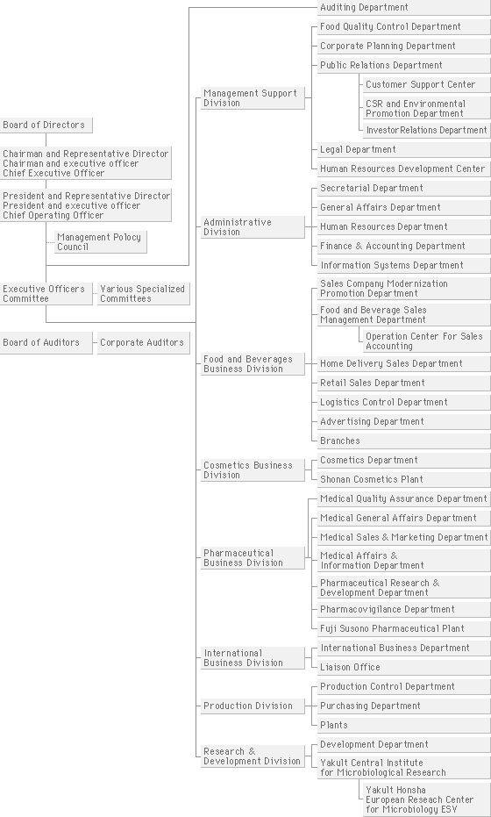

Figure Organizational chart of Yakult

**8. CHALLENGES IN INDIAN MARKET**

Probiotics confront a number of obstacles on the Indian market despite the rising recognition of their potential health advantages. Among the principal difficulties are:

Limited knowledge and comprehension: Probiotics are still relatively new to many Indian customers, and there is a dearth of general knowledge and comprehension regarding their advantages. It is crucial but not always easy to inform the public about probiotics' benefits for gut health and general wellbeing.

Cultural factors: Indians have very different eating habits and tastes than people in Western nations, where probiotics are more widely used. Although traditional Indian meals like yoghurt and buttermilk already naturally contain probiotics, the idea of taking probiotic supplements may not be well-liked by all.

Concerns about product quality and safety: A variety of products have entered the Indian probiotic market, and some of them may not adhere to required requirements. Due to the availability of low-quality or unregulated goods on the market, consumers may have doubts regarding the efficacy and safety of probiotics.

Cost and accessibility: High-quality probiotic products can be pricey, which limits their appeal to a wide percentage of the population, especially those with lower incomes. The cost of probiotics might be a major obstacle to their widespread use in India.

Distribution and accessibility: In India, particularly in rural areas, probiotic products may not be widely accessible. Probiotic products may not be as widely available in smaller towns and villages due to insufficient distribution networks.

Challenges with regulation: India's probiotic business is largely unregulated, which can result in variable product quality and health claims. The development of the probiotic market and customer confidence in these products might both be hampered by unclear rules.

Competition with conventional treatments: Ayurvedic and herbal therapies are widely accepted in Indian culture. It might be difficult to persuade customers to choose probiotics over conventional treatments for gut health.

Probiotics are live organisms, thus storage and temperature conditions can have an impact on how viable they are. It might be difficult to maintain the efficacy of probiotic products throughout the supply chain, particularly in a nation with a wide range of climatic conditions like India.

Probiotics are live organisms, thus storage and temperature conditions can have an impact on how viable they are. It might be difficult to maintain the efficacy of products throughout the supply chain, particularly in a nation with a wide range of climatic conditions like India.

Probiotic businesses must make significant investments in consumer education, raise the bar for product quality and safety, develop competitive pricing strategies, widen their distribution channels, and work with medical professionals to win their support and endorsement for the use of probiotics in order to overcome these obstacles. Furthermore, promoting clear laws and setting industry standards would raise the probiotic goods' dependability and reputation in the Indian market.

**9. CONCLUSION**

Thereby, with this study of market for Probiotics I’ve come to several conclusions including the sales and demand of probiotics in Indian market.

Also I’ve come to know the certain uses of probiotics and its needs in our daily life, and have to understand the procedure followed by Yakult to manufacture their own products.

The basic knowledge gained to me by this project is the working of Market research, its components, it’s need, several methods and ways to accomplish the task of market research either through primary or secondary research.

Thus I conclude by saying that Market research for global and Indian scenario for Probiotics is understood for now but it has a vast impact on the further coming industry in near future. Also market research plays an immense role for setting up the proper details and methods to process and manufacture any product made.

THANK YOU

Akanksha Gupta